EGI-InSPIRE

EGI-Repo: Guide for the Internal Technology Providers

Document identifier: | input.doc
Date: | 22/03/2011
Activity: | SA2
Lead Partner: | EGI.eu
Document Status: | FINAL
Dissemination Level: | PUBLIC
Document Link: | https://documents.egi.eu/document/427

Abstract
This document is a guide for Internal Technology Providers, which aims to provide all the necessary details for correctly constructing a release.xml file. It also introduces a utility for performing an online release.xml validation.

- Copyright notice
Copyright © Members of the EGI-InSPIRE Collaboration, 2010. See www.egi.eu for details of the EGI-InSPIRE project and the collaboration. EGI-InSPIRE (“European Grid Initiative: Integrated Sustainable Pan-European Infrastructure for Researchers in Europe”) is a project co-funded by the European Commission as an Integrated Infrastructure Initiative within the 7th Framework Programme. EGI-InSPIRE began in May 2010 and will run for 4 years. This work is licensed under the Creative Commons Attribution-Noncommercial 3.0 License. To view a copy of this license, visit http://creativecommons.org/licenses/by-nc/3.0/ or send a letter to Creative Commons, 171 Second Street, Suite 300, San Francisco, California, 94105, and USA. The work must be attributed by attaching the following reference to the copied elements: “Copyright © Members of the EGI-InSPIRE Collaboration, 2010. See www.egi.eu for details of the EGI-InSPIRE project and the collaboration”. Using this document in a way and/or for purposes not foreseen in the license, requires the prior written permission of the copyright holders. The information contained in this document represents the views of the copyright holders as of the date such views are published.
- Delivery Slip
 | Name | Partner/Activity | Date
From | Kostas Koumantaros | GRNET | 22/3/11
Reviewed by | Moderator:  Reviewers:
Approved by | AMB & PMB
- Document Log
Issue | Date | Comment | Author/Partner
1 | 15/11/2010 | First draft | Marios Chatziangelou IASA/GRNET  William Vassilis Karageorgos IASA/GRNET  Christina Boubouka ICCS/GRNET  Zarife Nafsika IASA/GRNET  Theofilopoulos Nikos IASA/GRNET
2 | 21/3/2011 | 2nd Draft | Marios Chatziangelou IASA/GRNET
3 | 22/3/2011 | Minor Corrections | Kostas Koumantaros GRNET
- Application area
This document is a formal deliverable for the European Commission, applicable to all members of the EGI-InSPIRE project, beneficiaries and Joint Research Unit members, as well as its collaborating projects.
- Document amendment procedure
Amendments, comments and suggestions should be sent to the authors. The procedures documented in the EGI-InSPIRE “Document Management Procedure” will be followed:
https://wiki.egi.eu/wiki/Procedures
- Terminology
A complete project glossary is provided at the following page: http://www.egi.eu/about/glossary/.
- PROJECT SUMMARY

To support science and innovation, a lasting operational model for e-Science is needed − both for coordinating the infrastructure and for delivering integrated services that cross national borders.

The EGI-InSPIRE project will support the transition from a project-based system to a sustainable pan-European e-Infrastructure, by supporting ‘grids’ of high-performance computing (HPC) and high-throughput computing (HTC) resources. EGI-InSPIRE will also be ideally placed to integrate new Distributed Computing Infrastructures (DCIs) such as clouds, supercomputing networks and desktop grids, to benefit user communities within the European Research Area.

EGI-InSPIRE will collect user requirements and provide support for the current and potential new user communities, for example within the ESFRI projects. Additional support will also be given to the current heavy users of the infrastructure, such as high energy physics, computational chemistry and life sciences, as they move their critical services and tools from a centralised support model to one driven by their own individual communities.

The objectives of the project are:
- The continued operation and expansion of today’s production infrastructure by transitioning to a governance model and operational infrastructure that can be increasingly sustained outside of specific project funding.
- The continued support of researchers within Europe and their international collaborators that are using the current production infrastructure.
- The support for current heavy users of the infrastructure in earth science, astronomy and astrophysics, fusion, computational chemistry and materials science technology, life sciences and high energy physics as they move to sustainable support models for their own communities.
- Interfaces that expand access to new user communities including new potential heavy users of the infrastructure from the ESFRI projects.
- Mechanisms to integrate existing infrastructure providers in Europe and around the world into the production infrastructure, so as to provide transparent access to all authorised users.
- Establish processes and procedures to allow the integration of new DCI technologies (e.g. clouds, volunteer desktop grids) and heterogeneous resources (e.g. HTC and HPC) into a seamless production infrastructure as they mature and demonstrate value to the EGI community.

The EGI community is a federation of independent national and community resource providers, whose resources support specific research communities and international collaborators both within Europe and worldwide. EGI.eu, coordinator of EGI-InSPIRE, brings together partner institutions established within the community to provide a set of essential human and technical services that enable secure integrated access to distributed resources on behalf of the community.

The production infrastructure supports Virtual Research Communities (VRCs) − structured international user communities − that are grouped into specific research domains. VRCs are formally represented within EGI at both a technical and strategic level.

TABLE OF CONTENTS
1 Introduction 6
2 EGI-REPO Relase XML file for internal TP 7
2.1 Section release:release 7
2.1.1 Section UMDmeta:UMDmeta 9
2.1.1.1 Section UMDmeta:packages 9
2.1.1.1.1 Type UMDmeta:package 9
2.1.2 Section repository:yumRepository 10
2.1.3 Section repository:aptRepository 10
2.1.4 Section repofile:yumRepofile 11
2.1.4.1 Section repofile:yumRepository 11
2.1.5 Section repofile:aptRepofile 12
2.1.5.1 Section repofile:aptRepository 12
2.2 release.xml example 13
3 EGI-REPO XML validator 14
4 References 15

Introduction
This document provides necessary information as well as examples that will enable internal Technology Providers (TP) to compose a well-formed release.xml file to escort a software release bundle. An explanatory description of all the xml fields and attributes required is included along with the introduction of a new tool, the XMLvalidator. Despite the fact that the XMLvalidator is still under development, we feel it will prove itself helpfull to TPs in order for them to produce a valid release.xml as it can spot any syntax (and in some cases, logical ones) xml errors that might exist in the produced file prior its submission. That way the internal TPs can avoid submitting invalid release.xml documents to the EGI repository.

EGI-REPO Relase XML file for internal TP
The release.xml document provides vital information in order for the repository to process a new release. For a meaningful release.xml file to be formed, six major logical sections must be indentified:
(a) The general release section,
(b) The UMDmeta section, (this is ONLY for products that are candidates for a UMD release)
(c) The YUM Repositories section,
(d) The APT Repositories section,
(e) The YUM repofiles section and
(f) The APT repofiles (known as .list files) section.

Each of these sections is defined by an xml element with the appropriate fields. Paragraph 2.1 includes a detailed description of all the sections mentioned, whereas paragraph 2.2, provides three examples of valid release.xml files. A high level view of such an XML file is shown in the figure below.

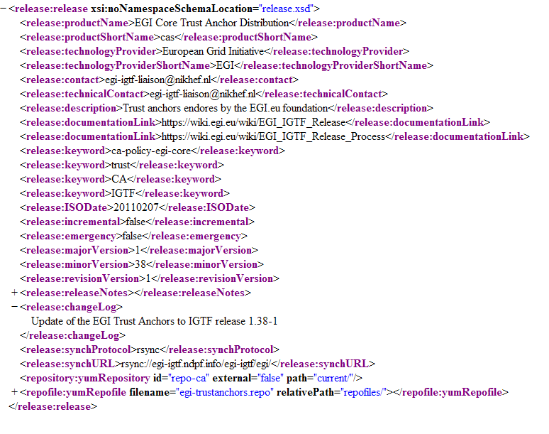

Note: All the elements/fields that appear in the release.xml file, should be declared following the specific order by which they are specified in paragraph 2.1.

Section release:release
The release:release section provides all the general details required for covering a new release submission to the EGI Repository. The point of interest for this section of the release.xml document is the distribution-related details of the release that is to be submitted, such as the name of the distribution, the provider responsible, the version of the release and so on. A detailed description of all the fields included in this section can be found in the table below:

Element or Attribute (a:) | Type | Occurrence | Mandatory | Description
productName | String  (no empty values allowed) | 1 | Yes | Full canonical name of the released product
productShortName | String  (only  [Aa-Zz],[0-9],[-,_] allowed)  i.e. No spaces, ‘$’, ‘@’, ‘%’, ‘&’ etc., are allowed | 1 | Yes | Common short name/acronym of the product. This will be used as the directory name under which the SW will be stored into. i.e, if the productShortName=CAs, then the said SW will be stored in the stagerollout/CAs/<MajorVersion> directory in the StageRollout phase and in the production/CAs/<MajorVersion> directory in the production phase).
technologyProvider | String  (no empty values allowed) | 1 | Yes | The organization/Technology provider that created the release
technologyProviderShortName | String  (no empty values allowed – no spaces) | 1 | Yes | Common short name/acronym of the Technology Provider
contact | String  (no empty values allowed – no spaces) | 1 | Yes | An email address to contact for release-related issues
technicalContact | String  (no empty values allowed – no spaces) | 1 | Yes | The technical contact is the person who is responsible for the automation of the issuance of this release.xml or has technical knowledge on the structure of the release.xml document.
description | String | 1 | No | A short description of the release
documentationLink | String | 1..N | Yes | One or more links to documentation of this release
Keyword | String | 1..N | No | One or more keywords for this release
ISODate | ISODate | 1 | Yes | he date of the release in ISO format (YYYYMMDD)
incremental | Boolean | 1 | Yes | A Boolean value that indicates whether the release is an incremental one or a non- incremental.
emergency | Boolean | 1 | Yes | A Boolean value that indicates whether the release is an emergent one or not.
majorVersion | Number | 1 | Yes | The major version for the release (e.g for version someSoftware 3.2.1, 3)
minorVersion | Number | 1 | Yes | The minor version for the release (e.g for version someSoftware 3.2.1, 2)
revisionVersion | Number | 1 | Yes | The revision version for the release (e.g for version someSoftware 3.2.1, 1)
releaseNotes | Text | 1 | Yes | The release notes text of the release
changeLog | Text | 1 | Yes | changeLog The change log text of the release
synchProtocol | Enum {rsync,ftp,yum} | 1 | Yes | The preferred protocol to be used for the synchronization
synchURL | String | 1 | Yes | The URL to be used for the synchronization (e.g.rsync://egi-igtf.ndpf.info/egi-igtf/egi/)
UMDmeta:UMDmeta | Complex | 0..N | No | This is only used for Technology Providers that submits releases which aims to be included into a UMD release.  At the time of the writing of this document, this section is used ONLY by the Bouncer service. For more details see section .
repository:yumRepository | Complex | 0..N | No | This element describes the YUM repository(ies) to be built on behalf of the TP and be used for downloading the release. For the element’s related attributes and sub-elements, see section 2.1.2 repository:yumRepository
repository:aptRepository | Complex | 0..N | No | This element describes the APT repository(ies) to be built on behalf of the TP and be used for downloading the release. For the element’s related attributes and sub-elements, see section 2.1.3 repository:aptRepository
repofile:yumRepofile | Complex | 0..N | No | This element describes the repofiles to be created for serving the yumRepository(ies) described above. For the element’s related attributes and sub-elements, see section 2.1.4 repofile:yumRepofile
repofile:aptRepofile | Complex | 0..N | No | This element describes the repofiles (actually .list in this case) to be created for serving the aptRepository(ies) described above. For the element’s related attributes and sub-elements, see section 2.1.5 repofile:aptRepofile

Section UMDmeta:UMDmeta
As it is already mentioned, this section, as well as the sections 2.1.1.1 & 2.1.1.1.1, are optional and are referring ONLY to candidate products for a UMD release.

Element or Attribute (a:) | Type | Occurrence | Mandatory | Description
targetPlatform | Enum | 1 | Yes | The platform under which, the product release it is available on.
targetArch | Enum | 1 | Yes | The arch under which, the product release it is available on.
capability | Enum | 0..N | No | Capabilities are optional, ** BUT HIGHLY ** recommended. It provides a list of the capabilites that this product implements, according to the UMD roadmap.  Used to create the association between products and capabilities.  The values for the Capability field will be an enumeration of normative terms taken from the UMD Roadmap. Each time the UMD Roadmap changes, so will the underlying XML schema
UMDmeta:packages | Complex | 1 | Yes | This section provides the list of metapackages & dependency packages, that constitute this product on the said platform-arch pair.

Section UMDmeta:packages
Element or Attribute (a:) | Type | Occurrence | Mandatory | Description
UMDmeta:package | Complex | 1..N | Yes | A list of one or many, metapackages & dependency packages, that constitute this product on the said platform-arch pair

Type UMDmeta:package
Element or Attribute (a:) |  | Type | Occurrence | Mandatory | Description
a: | pkgname | String  (no spaces) | 1 | Yes | The package name  i.e. for RPM: rpm -qp --qf "%{NAME}” $RPM
a: | version | String  (no spaces) | 1 | Yes | The package version  i.e. for RPM: rpm -qp --qf "%{VERSION}” $RPM
a: | release | String  (no spaces) | 1 | Yes | The package release  i.e. for RPM: rpm -qp --qf "%{RELEASE}” $RPM
a: | arch | String  (no spaces) | 1 | Yes | The package arch  i.e. for RPM: rpm -qp --qf "%{ARCH}” $RPM
a: | pkgtype | Enum  {metapackage, dependency} | 1 | Yes | The type of package
a: | filename | String  (no spaces) | 1 | Yes | The actual filename of the package
a: | url | String  (no spaces) | 1 | Yes | The url that will be used by the REPO for downloading the actual file.

Section repository:yumRepository
The repository:yumRepository section provides info about the YUM repositories that will be built within a given release structure. All the fields included in this section are fully described in the table below:

Element or Attribute (a:) |  | Type | Occurrence | Mandatory | Description
a: | id | String | 1 | Yes | A unique identifier for the yumRepository
a: | external | Boolean | 1 | Yes | “false” value indicates that the said YUM repository is an internal one, thus the ‘path’ value (see next field) should be a relative one. In this case the YUM repository will be (re)built in the location specified in the ‘path’ location  “true” value indicates that the said YUM repository is an external one, thus no action will be performed by the EGI Repo.
a: | path | String | 1 | Yes | An absolute path in the case of external repositories, or a relative path that indicates where the YUM repository has to be built, in the case of internal repositories. This path is relative to the synchURL provided in section 2.1 Release:Release.
a: | groupFile | String | 0-1 | No | This is an optional field that indicates the XML file that holds the grouping details, which will be used for the creation of the YUM repository (an example of this is the comps.xml file for the glite-UI node type).

Section repository:aptRepository
The repository:aptRepository section provides info about the APT repositories that will be built within a given release structure. All the fields included in this section are fully described in the table below:

Element or Attribute (a:) |  | Type | Occurrence | Mandatory | Description
a: | id | String | 1 | Yes | A unique identifier of the aptRepository
a: | external | Boolean | 1 | Yes | “false” value indicates that the said APT repository is an internal one, thus the ‘path’ value (see next field) should be a relative one. In this case the APT repository will be (re)built in the location specified in the ‘path’ location  “true” value indicates that the said APT repository is an internal one, thus no action will be performed by the EGI Repo.
a: | path | String | 1 | Yes | An absolute path in the case of external repositories, or a relative path that indicates where the APT repository has to be built. This path is relative to the synchURL provided in section 2.1 Release:Release.

Section repofile:yumRepofile
The repofile:yumRepofiles section provides info about the YUM repofiles that are requested by the TP and should be created in the EGI Repo. All the fields included in this section are fully described in the table below:

Element or Attribute (a:) |  | Type | Occurrence | Mandatory | Description
a: | filename | String | 1 | Yes | Provides the filename of a YUM repofile.
a: | relativePath | String | 1 | Yes | Provides the relative path, in which, the TP wishes, the repofile to be located. This path is relative to the synchURL provided in section 2.1 Release:Release.
repofile:yumRepository |  | Complex | 1..N | No | See section 2.1.4.1 repofile:yumRepository

Section repofile:yumRepository
The repofile:yumRepositories section actually contains the necessary information for each Repository entry that should be included in a single YUM repofile. All the fields included in this section are fully described in the table below:

Element or Attribute (a:) |  | Type | Occurrence | Mandatory | Description
repoid |  | String | 1..N | No | The ids that provide the association between this repofile entry, and one or more yumRepsitory entries defined at section Error: Reference source not found repository:yumRepository.
id |  | String | 1 | Yes | A unique name that describes each repository in a given repofile. This id will be written as [<id>] in the yum .repo file.
name |  | String | 1 | Yes | A human-friendly string describing the repository
baseUrl |  | String | 1 | Yes | The path to the directory of the packages. If its ‘type’ attribute (see next row) is relative, this path should be relative to the synchURL provided in section 2.1 Release:Release. In case the ‘type’ attribute (see next row), is absolute, that means that the repository is an external one.
a: | type | Enum {relative, absolute} | 1 | Yes | “relative”, means that the repository should be internal (relative to the repository.egi.eu).  “absolute”, means that the repository is an external one, nut it should also be included to the generated repofile.
enabled |  | Boolean | 1 | Yes | Used in the repo file to tell yum if this repository is by default enabled or not.
priority |  | Number | 0..1 | No | Integer value used by yum to sort out which of two or more packages from different repos takes priority
gpgcheck |  | Boolean | 0..1 | No | Used in the repo file to tell yum whether or not it should perform a GPG signature check on the packages gotten from this repository
gpgkey |  | String | 0..N | No | A URL pointing to the ASCII-armoured GPG key file for the repository. This option is used if yum needs a public key to verify a package and the required key hasn't been imported into the RPM database. If this option is set, yum will
protect |  | Number | 0..1 | No | Used in the repo file to tell yum if this repository is by default protected or not.

Section repofile:aptRepofile
The repofile:aptRepofiles section provides information about the APT repository files (known as .list) that are requested by the TP and should be created in the EGI Repo. A detailed description of all the fields included in this section can be found in the table below:

Element or Attribute (a:) |  | Type | Occurrence | Mandatory | Description
a: | filename | String | 1 | Yes | Provides the filename of a APT repofile (actually this is a .list file).
a: | relativePath | String | 1 | Yes | Provides the relative path, where the TP wishes, the repofile to be located. This path is relateive to the synchURL provided in section 2.1 Release:Release.
repofile:aptRepository |  | Complex | 1..N | No | See section 2.1.5.1 repofile:aptRepository

Section repofile:aptRepository
The repofile:aptRepositories section contains the necessary information for each Repository entry that should be included in the APT repofile. A detailed description of all the fields included in this section can be found in the table below:

Element or Attribute (a:) |  | Type | Occurrence | Mandatory | Description
repoid |  | String | 1 | No | The id that provides the association between this repofile (.list in this case - APT) entry, and one or more aptRepsitory entries defined at section 2.1.3 aptRepository:aptRepository.
baseUrl |  | string | 1 | Yes | The path to the directory of the debs. If its ‘type’ attribute (see next row) is relative, this path should be relative to the synchURL provided in section 2.1 Release:Release. In case the ‘type’ attribute (see next row), is absolute, that means that the repository is an external one.
a: | type | Enum {relative,absolute} | 1 | Yes | “relative”, means that the repository should be internal (relative to the repository.egi.eu).  “absolute”, means that the repository is an external one, nut it should also be included to the generated repofile.
entry |  | String | 1..N | Yes | This field is used to define the section names or components of interest for this APT repository.

release.xml example
According to the description of the XML elements presented above, this paragraph includes some examples of indicative release.xml documents.
- At [R 1] an example based on the CAs (Certificate Authorities) distribution is provided
- In addition, at [R 2] an example based on SAM tools is also available
- Finally, an indicative example of a product that is a candidate for a UMD release is provided at [R 4].

EGI-REPO XML validator
The EGI-REPO XMLvalidator, is an on-line tool that that can be used to validate a given release.xml in respect to its syntax. Validation is performed against the syntax rules defined in the supplementary XSD files. In case of a problem, the tool aims to prompt the TP (an internal or an external one), with all the possible errors that occurred during the given XML file validation procedure.
At the time of this writing, the XMLvalidator is under development and therefore available only for inspection or trial without any guarantee. The tool is accessible at the temporary location [R 3].

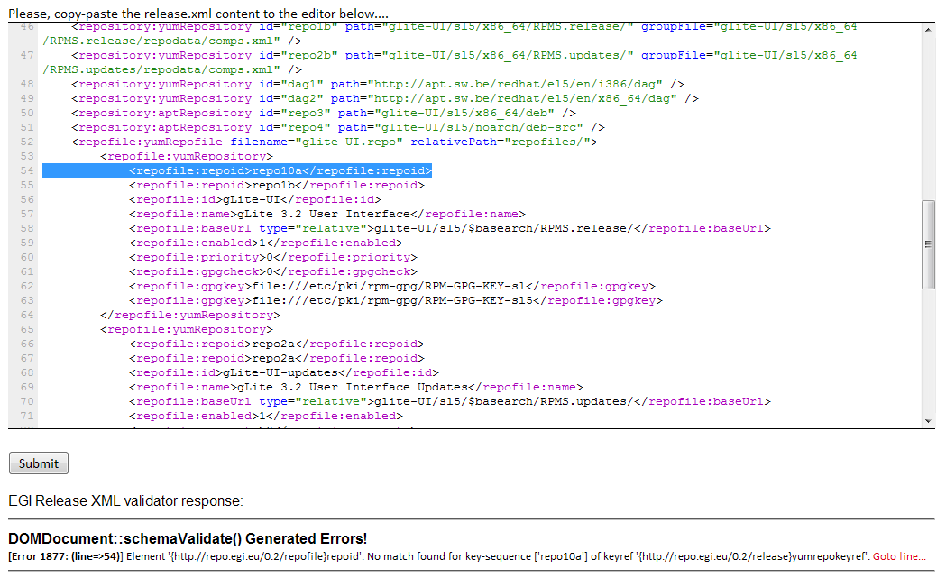

References
R 1 | https://trac.hellasgrid.gr/trac/wp5-egi-inspire.egi.eu/browser/trunk/extra_material/examples/internal-tp/cas/release-cas.xml
R 2 | https://trac.hellasgrid.gr/trac/wp5-egi-inspire.egi.eu/browser/trunk/extra_material/examples/internal-tp/sam/release-sam.xml
R 3 | http://admin-repo.egi.eu/XMLvalidator/
R 4 | https://trac.hellasgrid.gr/trac/wp5-egi-inspire.egi.eu/browser/trunk/extra_material/examples/internal-bouncer/release-ppa.xml
R 5

