EGI-InSPIRE

DMP0: METRICS PORTAL ROADMAP v1.0

 | Document identifier: | EGI-Metrics_Portal_Roadmap_v0.1.odt
 | Date: | 20/01/11
 | Activity: | JRA1
 | Lead partners for deliverable: | CESGA
 | Document status: | DRAFT
 | Document link: | http://www.egee.cesga.es/documents

Abstract: This document is intended to provide an overview of the Metrics Portal roadmap including new working plan and releases procedure.

- Copyright notice
Copyright © Members of the EGI-InSPIRE Collaboration, 2010. See www.egi.eu for details of the EGI-InSPIRE project and the collaboration. EGI-InSPIRE (“European Grid Initiative: Integrated Sustainable Pan-European Infrastructure for Researchers in Europe”) is a project co-funded by the European Commission as an Integrated Infrastructure Initiative within the 7th Framework Programme. EGI-InSPIRE began in May 2010 and will run for 4 years. This work is licensed under the Creative Commons Attribution-Noncommercial 3.0 License. To view a copy of this license, visit http://creativecommons.org/licenses/by-nc/3.0/ or send a letter to Creative Commons, 171 Second Street, Suite 300, San Francisco, California, 94105, and USA. The work must be attributed by attaching the following reference to the copied elements: “Copyright © Members of the EGI-InSPIRE Collaboration, 2010. See www.egi.eu for details of the EGI-InSPIRE project and the collaboration”. Using this document in a way and/or for purposes not foreseen in the license, requires the prior written permission of the copyright holders. The information contained in this document represents the views of the copyright holders as of the date such views are published.

- Delivery Slip
 | Name | Partner/Activity | Date
From | Alvaro Simon | CESGA/JRA1 | 18/01/11
Reviewed by | Moderator:  Reviewers:
Approved by | AMB & PMB

- Document Log
Issue | Date | Comment | Author/Partner
1 | 18/01/11 | First draft (v1.0) entering internal review. | A. Simon/CESGA
2 | 19/01/11 | New charts and gantt. | J. Lopez/CESGA
3

Content
1.Introduction 4
1.1.Purpose of the document 4
1.2.Application area 4
1.3.references 4
1.4.Document amendment procedure 4
1.5.Terminology 4
2.Executive summary 5
3.WBS 6
4.WBS Dictionary 7
5.LIST OF DELIVERABLES 9
6.LIST OF Milestones 10
7.schedule 11

Introduction

Purpose of the document
This document shows new Metrics Portal roadmap and future deliverables and milestones. A preview Gantt chart is displayed at the end of this document.

Application area
Readers can use this document to obtain general info about Metrics Portal status and future work.

references
[R6] http://www3.egee.cesga.es/gridsite/accounting/CESGA/egee_view.php | Accountig Portal
[R7] https://gus.fzk.de/pages/home.php | GGUS Portal
[R8] http://cic.gridops.org/index.php | CIC Portal
[R9] https://goc.gridops.org/site/list?id=112 | GOCDB

Document amendment procedure
This document may be updated as new services appear to be included into Metrics Portal or if new milestones are required.
Comments should be sent to the authors.

Executive summary
This document shows services “Metrics Portal V1” that is installed at CESGA. This document provides a brief future plan for this global service. All this information is generated and updated using a local wiki page only accessible by CESGA administrators.

METRICS PORTAL
The metrics portal is the culmination of the work initiated by the MIG (Metrics Implementation Group) and transferred to the Operations Automation Team (OAT) in EGEE-III and now to EGI. The main objective is to have a set of metrics that can help to measure project performance and keep track of its evolution. The portal automatically collects all the required data and calculates these metrics displaying all of them in a single place. The portal agglutinates information from different sources like GOCDB, GGUS, GSTAT, etc. using various connectors depending on the data provider. These connectors translate the information gathered from diverse producers and stores it into a local database. Using the metrics portal this information will be available from a common interface and full reports could be generated in just a few seconds.

Project life cycle
Metrics Portal releases are based on a project life cycle (see figure1). Each life cycle takes six months to complete, after this period of time a new release is distributed (see figure 2 for more details). This project management was selected to introduce in each release a specific number of metrics and to reach a continuous improvement.
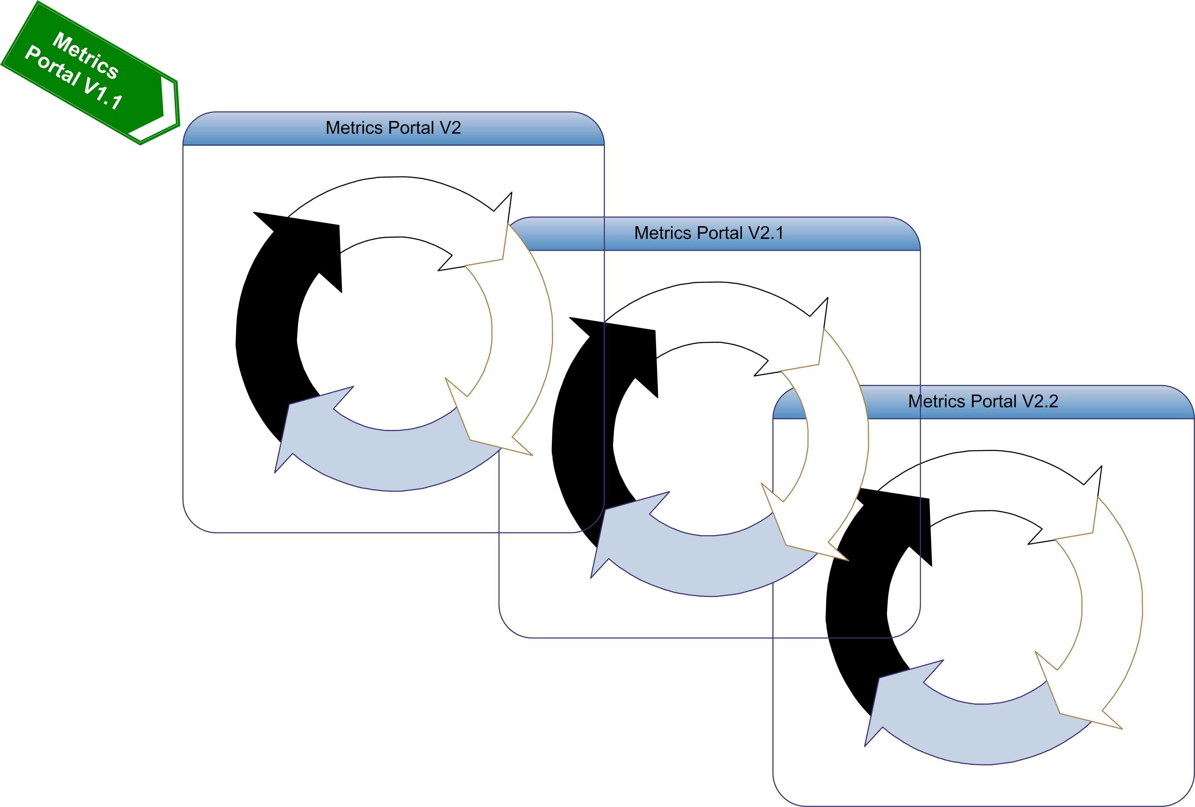Figure1

WBS

MP0 | Planning and Roadmap
MP1 | Current Metrics Portal revision
MP2 | Metrics Portal Framework
MP3 | Manual Metrics
MP4 | Accounting Metrics
MP5 | GGUS Metrics
MP6 | GSTAT Metrics
MP7 | ACE Metrics
MP8 | GOCDB Metrics

WBS Dictionary

Code | MP0
Name | Planning and Roadmap.
Definition | First step to specify requirements, WBS, WBS dictionary, list of deliverables and milestones and a schedule for the project.
Deliverables | DMP0.1 DMP0.2 DMP0.3
Milestones

Code | MP1
Name | Metrics Portal v1 revision
Definition | Fix any issue found in the current Metrics Portal.
Deliverables | DMP1
Milestones | MMP1

Code | MP2
Name | Metrics Portal Framework
Definition | The aim of this work package is to choose a good framework, fast and versatile, for the new portal.
Deliverables | DMP2
Milestones

Code | MP3
Name | Manual Metrics
Definition | This work package is assigned to deploy a database schema and interface to introduce manual metrics into the portal.
Deliverables | DMP3.1 DMP3.2 DMP3.3
Milestones | MMP2 MMP3 MMP4

Code | MP4
Name | Accounting Metrics
Definition | Description and implementation of required metrics available from the Accounting Portal.
Deliverables | DMP4.1 DMP4.2 DMP4.3
Milestones | MMP2 MMP3 MMP4

Code | MP5
Name | GGUS Metrics
Definition | This package is designed to set requirements and gather information from GGUS service to implement new metrics.
Deliverables | DMP5.1 DMP5.2 DMP5.3
Milestones | MMP2 MMP3 MMP4

Code | MP6
Name | GSTAT Metrics
Definition | This package is designed to set requirements and gather information from GSTAT service to implement new metrics.
Deliverables | DMP6.1 DMP6.2 DMP6.3
Milestones | MMP2 MMP3 MMP4

Code | MP7
Name | ACE Metrics
Definition | This package is designed to gather data from ACE service to implement new metrics such sites availability and reliavilibity.
Deliverables | DMP7.1 DMP7.2 DMP7.3
Milestones | MMP2 MMP3 MMP4

Code | MP8
Name | GOCDB Metrics
Definition | This package is designed to implement new metrics using GOCDBPI interface provided by GOCDB.
Deliverables | DMP8.1 DMP8.2 DMP8.3
Milestones | MMP2 MMP3 MMP4

LIST OF DELIVERABLES

Deliverable | Name | Description
DMP0.1 DMP0.2 DMP0.3 | Metrics Portal Project Plan v1.0 v1.2 v1.3 | Portal roadmap deliverables.
DMP1 | Metrics Portal v1.1 | Revision and fix of the current Metrics portal.
DMP2 | Framework selection | New framework is selected to deploy the Metrics Portal.
DMP3.1 DMP3.2 DMP3.3 | Manual Metrics v1 v2 v3 | Portal interface which detect and grant write access to activity leaders to introduce new metrics manually.
DMP4.1 DMP4.2 DMP4.3 | Accounting Metrics v1 v2 v3 | Metrics Portal should display metrics using stored accounting information.
DMP5.1 DMP5.2 DMP5.3 | GGUS Metrics v1 v2 v3 | GGUS and Metrics Portal teams should be in contact to deploy a stable interface between portals and store and display the desired metrics.
DMP6.1 DMP6.2 DMP6.3 | GSTAT Metrics v1 v2 v3 | Deploy a new set of metrics gathering information from GSTAT.
DMP7.1 DMP7.2 DMP7.3 | ACE Metrics v1 v2 v3 | Display new metrics using GOCDBPI interface.

LIST OF Milestones

Milestone | Description
MMP1 | Metrics Portal v1.1
MMP2 | Metrics Portal v2
MMP3 | Metrics Portal v2.1
MMP4 | Metrics Portal v2.2

Schedule

DATE | EVENT
31/01/11 | DMP0.1
28/02/11 | DMP1 DMP2 MMP1 (Metrics Portal v1.1)
31/03/11 | DMP3.1
30/04/11 | DMP4.1
31/05/11 | DMP5.1
30/06/11 | DMP6.1
31/07/11 | DMP7.1
31/08/11 | DMP8.1 MMP2 (Release 1)
30/09/11 | DMP0.2 DMP3.2
31/10/11 | DMP4.2
30/11/11 | DMP5.2
31/12/11 | DMP6.2
31/01/12 | DMP7.2
28/02/12 | DMP8.2 MMP3 (Release 2)
31/03/12 | DMP0.3 DMP3.3
30/04/12 | DMP4.3
31/05/12 | DMP5.3
30/06/12 | DMP6.3
31/07/12 | DMP7.3
31/08/12 | DMP8.3 MMP4 (Release 3)

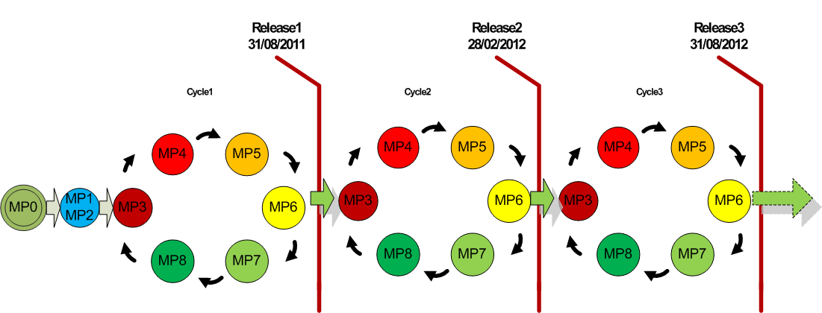Figure2

