EGI-InSPIRE
EGI Helpdesk and the NGI Support Units

EU MILESTONE: MS403

Document identifier: | EGI-MS-final
Date: | 05/11/2010
Activity: | SA1
Lead Partner: | EGI.eu
Document Status: | FINAL
Dissemination Level: | PUBLIC
Document Link: | https://documents.egi.eu/document/49

Abstract
This document aims at giving an overview of the infrastructure that is in place in EGI to support its users. The support infrastructure consists of a central part dealing with global issues and regional and topical subsystems inside various activities and in the NGIs. The central helpdesk also acts as a relay between the different areas of support.

- Copyright notice
Copyright © Members of the EGI-InSPIRE Collaboration, 2010. See www.egi.eu for details of the EGI-InSPIRE project and the collaboration. EGI-InSPIRE (“European Grid Initiative: Integrated Sustainable Pan-European Infrastructure for Researchers in Europe”) is a project co-funded by the European Commission as an Integrated Infrastructure Initiative within the 7th Framework Programme. EGI-InSPIRE began in May 2010 and will run for 4 years. This work is licensed under the Creative Commons Attribution-Noncommercial 3.0 License. To view a copy of this license, visit http://creativecommons.org/licenses/by-nc/3.0/ or send a letter to Creative Commons, 171 Second Street, Suite 300, San Francisco, California, 94105, and USA. The work must be attributed by attaching the following reference to the copied elements: “Copyright © Members of the EGI-InSPIRE Collaboration, 2010. See www.egi.eu for details of the EGI-InSPIRE project and the collaboration”. Using this document in a way and/or for purposes not foreseen in the license, requires the prior written permission of the copyright holders. The information contained in this document represents the views of the copyright holders as of the date such views are published.
- Delivery Slip
 | Name | Partner/Activity | Date
From | Torsten Antoni | KIT/SA1 | 01/10/2010
Reviewed by | Moderator: Steve Brewer  Reviewers: Gergely Sipos, Tiziana Ferrari | EGI.eu | 28/07/2010
Approved by | AMB & PMB |  | 22/10/2010
- Document Log
Issue | Date | Comment | Author/Partner
1.0 | 21/07/2010 | First draft (with lots of input from the NGIs) | Torsten Antoni / KIT
2.0 | 04/08/2010 | Incorporated comments from Tiziana Ferrari | Torsten Antoni / KIT
3.0 | 02/09/2010 | Incorporated further comments from Tiziana Ferrari | Torsten Antoni / KIT
4.0 | 01/10/2010 | In response to comments from the reviewers | Torsten Antoni / KIT

- Application area
This document is a formal deliverable for the European Commission, applicable to all members of the EGI-InSPIRE project, beneficiaries and Joint Research Unit members, as well as its collaborating projects.
- Document amendment procedure
Amendments, comments and suggestions should be sent to the authors. The procedures documented in the EGI-InSPIRE “Document Management Procedure” will be followed:
https://wiki.egi.eu/wiki/Procedures

- Terminology
A complete project glossary is provided at the following page: http://www.egi.eu/results/glossary/.
- PROJECT SUMMARY

To support science and innovation, a lasting operational model for e-Science is needed − both for coordinating the infrastructure and for delivering integrated services that cross national borders.

The EGI-InSPIRE project will support the transition from a project-based system to a sustainable pan-European e-Infrastructure, by supporting ‘grids’ of high-performance computing (HPC) and high-throughput computing (HTC) resources. EGI-InSPIRE will also be ideally placed to integrate new Distributed Computing Infrastructures (DCIs) such as clouds, supercomputing networks and desktop grids, to benefit user communities within the European Research Area.

EGI-InSPIRE will collect user requirements and provide support for the current and potential new user communities, for example within the ESFRI projects. Additional support will also be given to the current heavy users of the infrastructure, such as high energy physics, computational chemistry and life sciences, as they move their critical services and tools from a centralised support model to one driven by their own individual communities.

The objectives of the project are:

- The continued operation and expansion of today’s production infrastructure by transitioning to a governance model and operational infrastructure that can be increasingly sustained outside of specific project funding.
- The continued support of researchers within Europe and their international collaborators that are using the current production infrastructure.
- The support for current heavy users of the infrastructure in earth science, astronomy and astrophysics, fusion, computational chemistry and materials science technology, life sciences and high energy physics as they move to sustainable support models for their own communities.
- Interfaces that expand access to new user communities including new potential heavy users of the infrastructure from the ESFRI projects.
- Mechanisms to integrate existing infrastructure providers in Europe and around the world into the production infrastructure, so as to provide transparent access to all authorised users.
- Establish processes and procedures to allow the integration of new DCI technologies (e.g. clouds, volunteer desktop grids) and heterogeneous resources (e.g. HTC and HPC) into a seamless production infrastructure as they mature and demonstrate value to the EGI community.

The EGI community is a federation of independent national and community resource providers, whose resources support specific research communities and international collaborators both within Europe and worldwide. EGI.eu, coordinator of EGI-InSPIRE, brings together partner institutions established within the community to provide a set of essential human and technical services that enable secure integrated access to distributed resources on behalf of the community.

The production infrastructure supports Virtual Research Communities (VRCs) − structured international user communities − that are grouped into specific research domains. VRCs are formally represented within EGI at both a technical and strategic level.

- EXECUTIVE SUMMARY

This milestone “EGI helpdesk and the NGI support units” serves the purpose of regularly (roughly annually) giving a snapshot of the current status of the support infrastructure that has been defined and implemented in EGI. This is the first edition of this milestone and describes an infrastructure that is in the process of being set up. The support infrastructure of EGI is built upon the infrastructure of the EGEE project. As there are major differences between EGEE and EGI it is clear that a lot of workflows and tools need to be adapted to the new model adopted by EGI. The most significant difference is that the EGI infrastructure is made up of parts being governed by different projects, whereas EGEE was one project including everything from operations to middleware development and application support. In the EGI model each NGI is a separate entity with its own procedures and idiosyncrasies. The middleware, which is now provided by external middleware consortia, is consolidated by EGI into a Unified Middleware Distribution (UMD). EGI needs to provide the glue between all these different bodies.
Of course these changes also affect the user support activity and necessitate various adaptations here as well. The resource centres that used to belong to a ROC now are part of an NGI and need to be transferred to the NGI infrastructure once it has been put in place. Workflows need to be put in place to govern the ticket handling process between the central project-wide activities and the NGIs.
The area of middleware support has become more complex with the addition of other middleware stacks. The support infrastructures for these components need to be integrated with the EGI tools and processes. The area of application and user community support needs to be restructured as the resources for this area in EGI are very limited and resources from the NGI have to be integrated.
The milestone has two main parts, one dealing with technical infrastructure (chapter 2) used to provide distributed user support and the other dealing with the user support workflows and processes (chapter 3). Both these parts then have subsections dealing with the project-wide (2.1, 3.1) and the NGI activities (2.2, 3.2).
The EGI Helpdesk is the infrastructure used to aid the process of supporting users and operations staff in their daily work in the EGI infrastructure. It is a distributed conglomeration of various ticket systems and other tools relying on the GGUS helpdesk system as a central integration platform which all other tools (regional or topical) need to interface in order to allow structured communication between the various partners in the user support activity. The Ticket Process Management (TPM), EGIs first line support (the team that receives incoming tickets, performs a triage and assigns the tickets further to expert support units) works exclusively in the GGUS system, all other project-wide support groups at least show up as responsible units even if they do their work in a different tool that interfaces GGUS. Some project-wide groups, like the TPM and the COD (Central Operator-on-Duty) are well established, whereas in other areas like the community support, where the changes from EGEE to EGI were much more drastic, the full picture is only just starting to develop. The sections describing these areas of support therefore are still a bit vague in this first edition of this milestone. The second edition will hopefully show a clearer picture there.
Roughly a third of all NGIs answered to the request for input for this milestone and their answered vary in detail and complexity. This is to be expected at the beginning of a new project. NGIs that have been formed in countries that played an active role in EGEE of course have better developed infrastructures already in place on which they can build their NGI. During the first year of the project we expect the situation to change significantly as more of the newer and smaller NGIs catch up. The second edition of this milestone will show the progress made during year one of the project. Generally a large variation in the implementation of the NGI support workflow and tools is to be expected and does not pose a problem as long as the interfaces to EGI are properly functioning.
In compiling this milestone several issues that could not be dealt during the first few months of the project were discovered. They are summarised in the conclusions and progress on these issues will be reported in the second edition of this milestone.
TABLE OF CONTENTS
1 Introduction 10
2 Technical infrastructure 11
2.1 Central Support Infrastructure 11
2.1.1 Central Helpdesk 11
2.1.2 Community and Application Support 14
2.1.3 Middleware Support 14
2.1.4 Network Support 15
2.2 NGI Support Infrastructures 16
2.2.1 Albania 16
2.2.2 Croatia 16
2.2.3 Netherlands 16
2.2.4 France 17
2.2.5 Germany 17
2.2.6 Hungary 17
2.2.7 Italy 18
2.2.8 Poland 18
2.2.9 Portugal 18
2.2.10 Serbia 19
2.2.11 Slovakia 19
2.2.12 Switzerland 19
2.2.13 Turkey 20
3 Support procedures 20
3.1 Projectwide support units and processes 20
3.1.1 TPM 20
3.1.2 Grid Operations Oversight 21
3.1.3 Community and Application Support Processes 22
3.1.4 Middleware Support Processes 22
3.1.5 Network Support Processes 22
3.2 NGI support units and processes 23
3.2.1 Albania 23
3.2.2 Croatia 23
3.2.3 Netherlands 23
3.2.4 France 24
3.2.5 Germany 24
3.2.6 Hungary 24
3.2.7 Italy 24
3.2.8 Poland 25
3.2.9 Portugal 25
3.2.10 Serbia 26
3.2.11 Slovakia 26
3.2.12 Switzerland 26
3.2.13 Turkey 26
4 Conclusions 27
5 References 28

Introduction
This document gives a description of the operational procedures and NGI support units within the production infrastructure including the network support provided in EGI through its service providers.
Input for this document was provided by the various project-wide activities involved in user support and from the NGIs participating in EGI.
The milestone has two major parts separately describing the technical infrastructure and the support processes. Within each of these parts there is a section focussing on the project-wide infrastructure and a section dealing with the set-up in the NGIs.
This milestone is recurring annually and will of course grow in completeness and depth during the course of the project.

Technical infrastructure
In the following paragraphs we describe the technical infrastructure that is in place to support users and operations staff in the daily work on EGI. Section 2.1 focuses on the central helpdesk and its functionality. The next three paragraphs deal with central tools that have been put in place for community/application user support (2.1.2), middleware user support (2.1.3) and network user support (2.1.4). The chapter on the technical infrastructure closes with a section on the support tools in use in the NGIs (2.2). In this early stage of the project this part naturally is incomplete, but since this is a milestone recurring every year in the next version this will be updated and more complete.
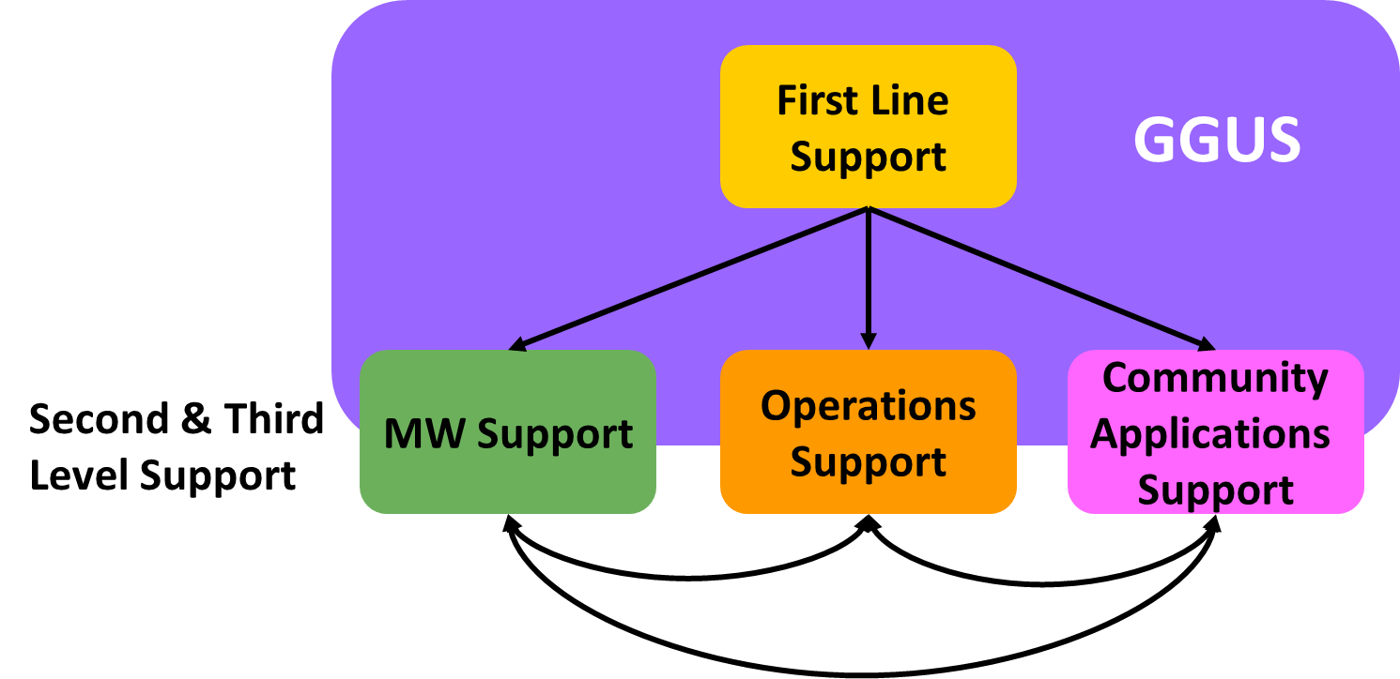
Figure 1: Central Helpdesk as relay between different areas of support
It is of utmost importance that the various parts of the user support infrastructure are properly integrated with each other. This is the aim of having a central helpdesk system, which acts as an integration platform between the different tools in use and provides the technical foundation for the overall support workflow (Figure 1).

Central Support Infrastructure

Central Helpdesk
The central tool for user support in EGI is the GGUS helpdesk [R 1]. It is hosted within the German NGI-DE and operated by a team at KIT (Karlsruhe Institute of Technology).The main components of the helpdesk are (Figure 2):
- A web front end that allows ticket creation and modification. It includes a search engine to effectively find tickets, by timeframe, category and lots of other options. The query results can be saved for further processing in various formats. The web front-end has different views for users and support staff, each tailored to the specific needs of these groups.
- An interface that can be used to connect other ticket systems to the central helpdesk. There are two variations of the interface, one based on web services and one based on messaging.
- A workflow engine, in which the workflows for the ticket handling process are implemented. These workflows can vary significantly depending on the specific ticket categories or areas of support.
- A user database in which the support staff is registered and the different access rights are documented.
- A ticket database containing the actual status and the complete history of all tickets created or having passed through the GGUS helpdesk.
The full functionality of the GGUS system is described in detail in the GGUS User Guide and the GGUS Helpdesk System Tutorial, both of which can be found in the documentation collection on the GGUS portal [R 2].
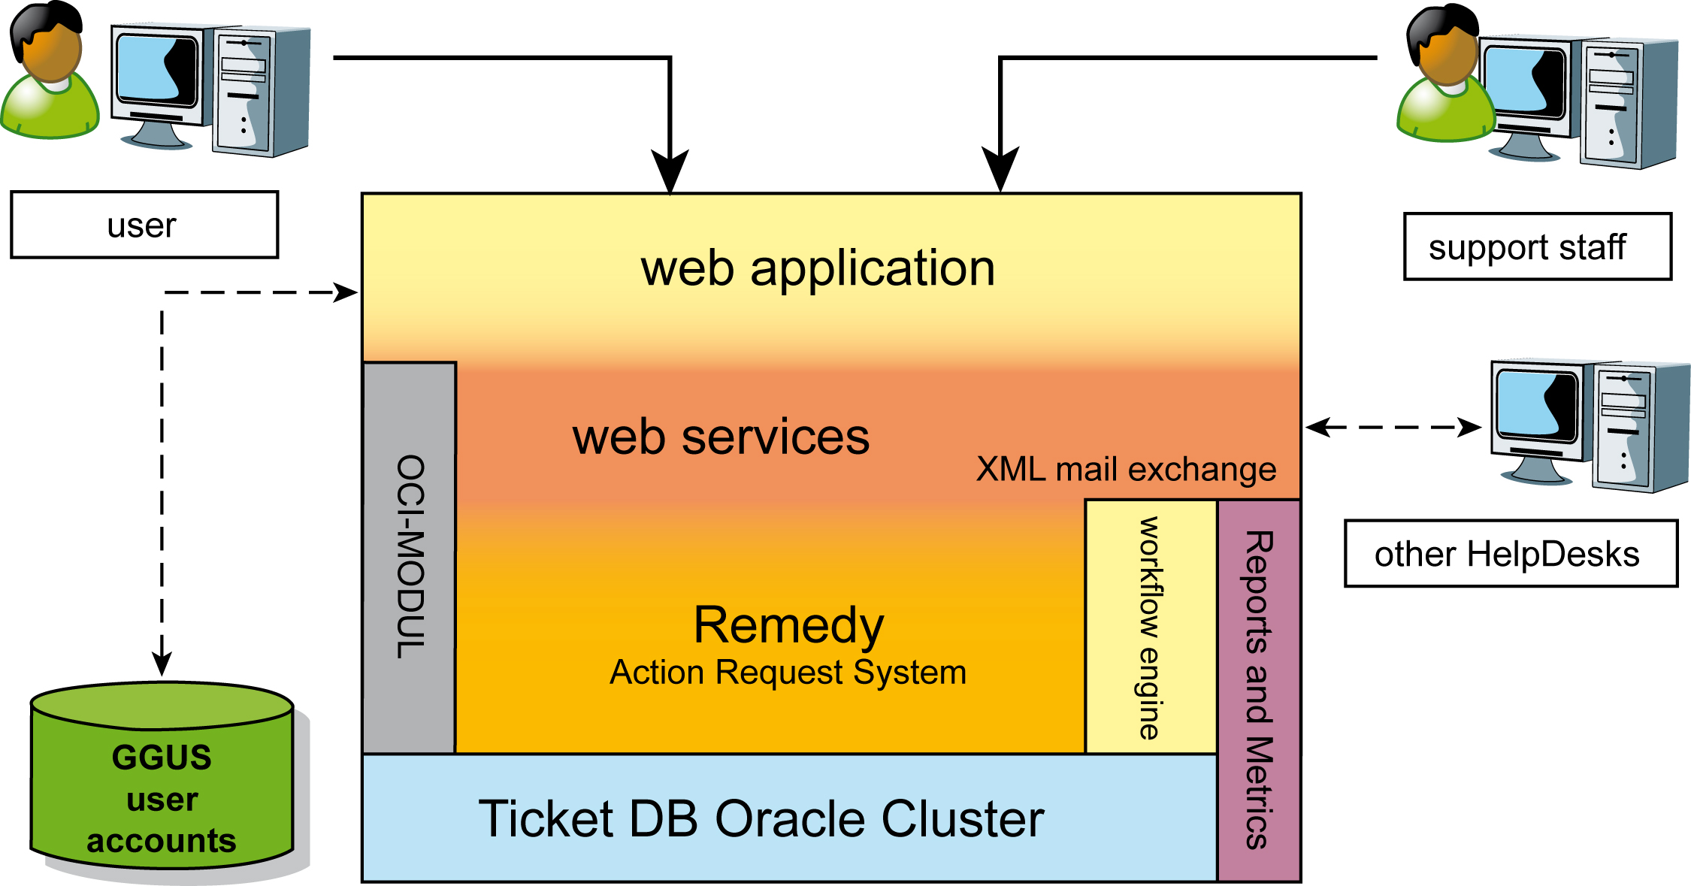
Figure 2: Schematic view of the architecture of the GGUS help desk system
All support units (a group responsible for a specific type of problem or area of support) with a project-wide responsibility are listed in the GGUS system and workflows have been defined and implemented steering what happens when a ticket is assigned to a specific support unit. These workflows vary depending on the scope of the support units and on the technical solution in place for the support unit. There are two main options (Figure 3):
- A support unit uses GGUS to implement their specific workflow. In this case the GGUS development team builds the workflows needed for this support unit and includes them in the GGUS system. This option is used for the project-wide first line support, the TPM (Ticket Processing Management) and for other mainly operations focussed central support units.
- A support unit relies on an additional external tool that is used to track user requests and issues. In this case an interface has to be defined between the two systems. This option is in use for middleware related support units and for some user communities. Another example of this use case is the COD, the Central Operator-on-Duty, a team responsible for monitoring the infrastructure an raising alarms in case of malfunction. For the COD work a different tool, the Operations Dashboard, is used. This Dashboard via an interface to GGUS can create tickets that get directly assigned to grid sites.
- 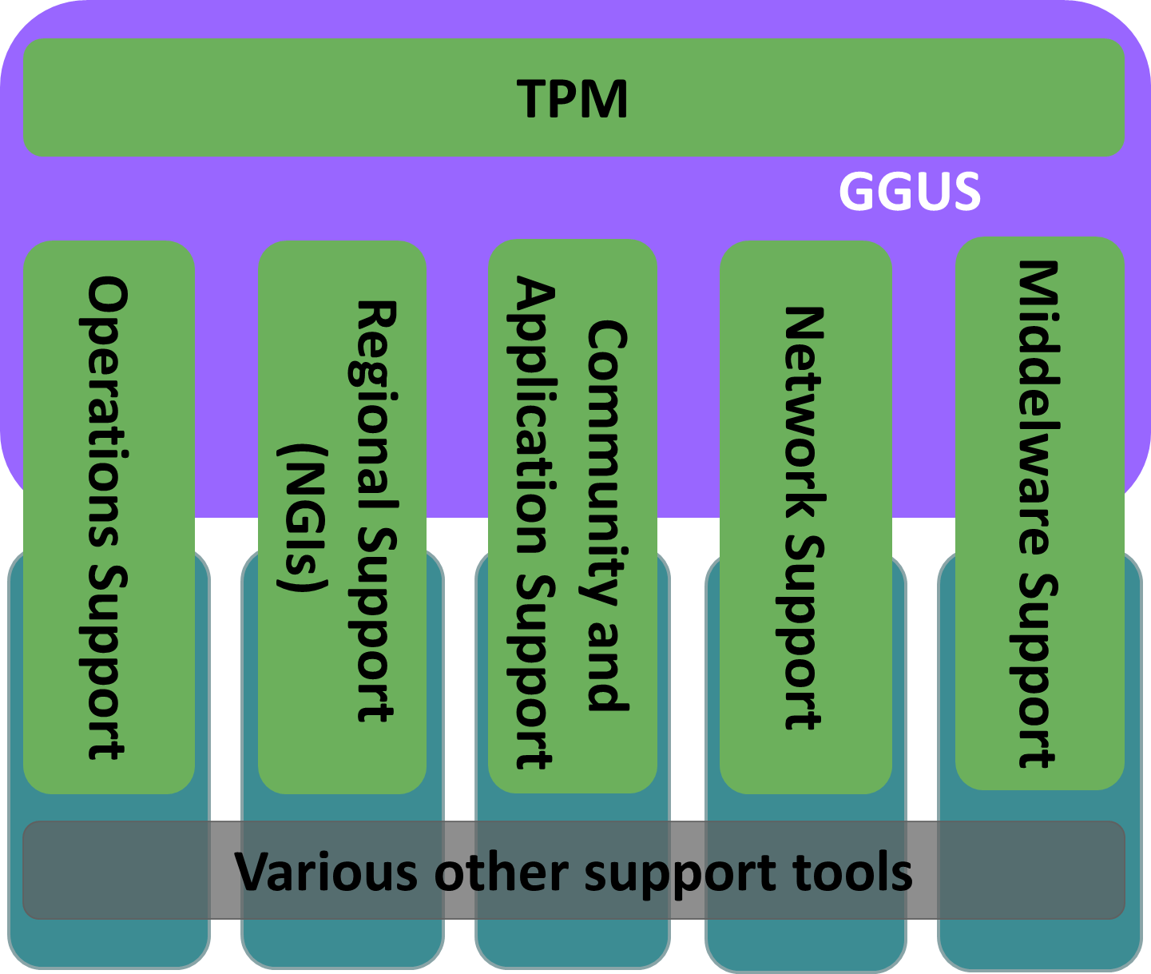
- Figure 3: Schematic view of the technical user support infrastructure in place in EGI, provided through GGUS and various other support tools interfacing GGUS
Regardless of which option was chosen in a specific case, for the user the whole system consisting of central helpdesk and its regional and topical satellite systems should behave like one integrated tool. The transfer of tickets between various tools has been implemented to be transparent to the user.
Currently, an evaluation of the legacy support units from EGEE is on-going. Some new support units from various areas (community/applications, middleware, network) have been created and a lot of legacy ones from EGEE are still valid. During the first year we will see a lot of changes here, but the year two version of this milestone will show a stabilised picture.
There is a clearly defined procedure creating NGI support units in GGUS and for migrating support units formerly belonging to a ROC to the respective NGI.
There are three options for NGIs to set up their support infrastructure:
- Direct use of GGUS (one support unit in GGUS for the whole NGI, no regional ticket system)
- regionalised GGUS (xGUS, customisable slimmed down version of the GGUS portal, allows to host regional support units in GGUS)
- Regional ticket system (with an interface to GGUS to allow for ticket exchange)

Because of the start of operations of many new NGIs, the following NGI support units have been created:
- NGIs using GGUS directly:
  - NGI_AEGIS (will move to regional view of GGUS)
  - NGI_AT
  - NGI_BY
  - NGI_HR
  - NGI_HU
  - NGI_IBERGRID
  - NGI_NDGF
  - NGI_NL
  - NGI_SI
  - NGI_SK
  - NGI_TR
- NGIs with regional ticket system interfaces to GGUS
  - NGI_CZ
  - NGI_FRANCE
  - NGI_GRNET
  - NGI_PL
- NGIs using the regional view of GGUS
  - NGI_DE
  - NGI_AEGIS (under construction)
For the transition period, during which all NGIs from a region are moving to their national helpdesk systems, the ROC helpdesks from EGEE-III will stay in place for those NGIs that have not finished the transition.

Community and Application Support
The application and community support activities fall into two basic categories. On the one hand there are support units related to specific VOs and specific applications. Currently in GGUS there are approximately 40 VO-specific support units for global VOs that have been active in EGEE. A review of all legacy support units that has to be performed shortly will show which of them are still valid and active.
On the other hand there are project-wide support units whose focus is on aiding all communities on various topics, like for example application porting or documentation. Also in this area there are some legacy support units from EGEE. Their validity also needs to be examined in an overall support unit review.
A new support unit called AppDB has been created. It deals with support issues concerning the EGI Application Database, in which successfully ported applications are stored.
NA3 is currently compiling a list of support contacts within the NGIs to get an overview of the level and quality of support that is offered by the NGIs and to be able to coordinate that effort and channel it into effective support units. MS301 describes the process for this in detail.
The community and application support is an area in which a lot of changes during the first period of the project are to be expected. This is caused by the reorganisation of the user communities into VRCs and the transition from ROCs to NGIs. Both of these changes necessitate a re-evaluation of the workflows in this area.

Middleware Support
One of the areas that changed the most in the transition from EGEE to EGI is middleware development, deployment and support. Whereas EGEE only supported one middleware stack (gLite) EGI is now aiming at bringing the main deployed middleware stacks closer together in a single distribution called UMD. Another difference is that in EGEE middleware development part of the project, whereas EGI now receives its middleware components from external technology providers (mainly EMI and IGE).
We already have a detailed picture of how the middleware user support will be organised between EGI and external technology providers, such as EMI (Figure 4). The second level support for middleware issues will be performed by the EGI body DMSU, the Deployed Middleware Support Unit, under the umbrella of the DMSU there will be second level support units for all the middleware components in use. All middleware related tickets will be routed through these support units in GGUS.

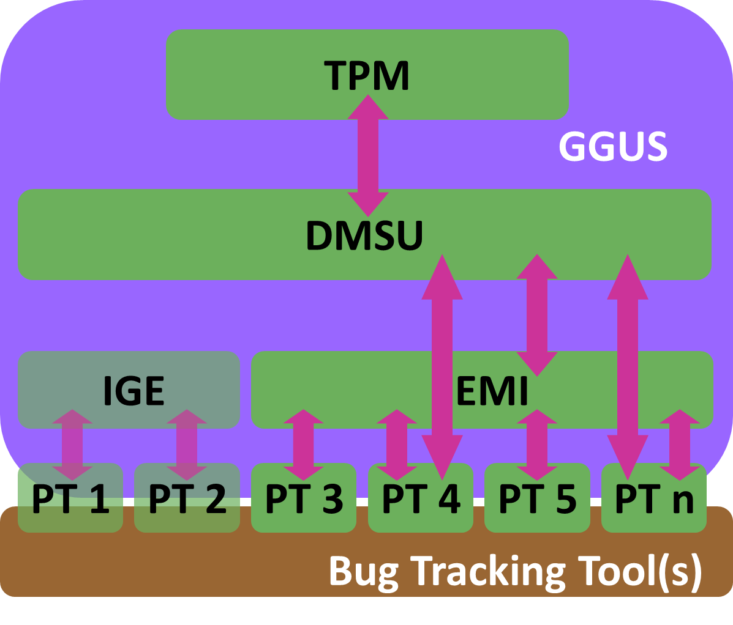
Figure 4: Tools and workflow for middleware user support; for middleware provided by EMI this is agreed and currently being implemented. For other external middleware providers a similar set-up will be implemented.
The third level support is then done by the technology provider, optionally using their own issue tracking systems. For EMI, support units will be created in GGUS on the level of the product teams or on the level of specific components. Additionally an overall EMI support unit has also been created, that can serve as a catch-all support unit and can be used for more general requests. This generic EMI support unit and the DMSU will always be in the loop when a ticket is assigned to a product team, thus enabling an overview over the tickets on the EGI and the EMI side.
This means that the GGUS system is not only used inside EGI, but also by EMI. Only on the level of the product teams a ticket will leave the GGUS system and will be transferred to the bug tracking tool used by this product team. These tracking systems will be interfaced with the GGUS system to enable a seamless tracking of the issue by the user.
The workflow described above has been defined in a series of meetings between the GGUS team and members of the DMSU and the EMI user support activity.
For IGE the initial workflow is simpler, as IGE decided to just have one third level support unit in GGUS. To this support unit all Globus related middleware bugs will be reported. This workflow might change in the future, once an increasing number of tickets require a more sophisticated set-up.
With the other possible future middleware providers, similar discussions have to be started once their software is in use in EGI.

Network Support
Network support will be provided by PerfSONAR-Lite_TSS, the downCollector, the Grid Job based approach to network monitoring, GGUS and PerfSONAR.
In addition to this set of tools, a permanent coordination between the Network Support Team within the NGIs, the NRENs, DANTE and the Network Support Coordination Team will be established to exploit synergies for PERT (performance) related issues. Further tools might be endorsed upon agreed consensus in the Network Support community.
Information about network troubleshooting tools is available at [R 3].
As special case is the support for the LHCOPN. For this a customised view of GGUS exists[R 4]. Currently discussions are on-going on how to improve the information flow between LHCOPN and the grid support infrastructure.

NGI Support Infrastructures
The following section is a collection of information that was gathered from the NGIs concerning their support infrastructures. The focus here is on the regionally used tools. This collection is currently incomplete, as the integration of a number of new NGIs into the infrastructure is currently an on-going process. The second edition of this milestone, due in year two of the project, will show the progress that will be made during the first year of the project.

Albania
There is only one gLite cluster integrated in SEE-GRID infrastructure. This cluster (AL-01-FIT) is situated in Faculty of Information Technology of Polytechnic University of Tirana (UPT).
The site was set up in framework of SEE-GRID initiative. As such, it was integrated in SEE-GRID regional infrastructure using its centralized services. The connectivity is via private ISPs through an optical fibre, with limited capacity that may go up to few Mbps.
Other clusters exist in the country, at least in departments of physics in Polytechnic University of Tirana and University of Tirana, but used for internal purposes.
The site AL-01-FIT is open for the research community and used for few gridification experiments. Because the size of actual grid users community is very small, located in the same capital city and intensify of grid calculations is not high, the user support system is based in direct contacts between interested end-users and site management team.
Until now there was no need for a local ticket system and the SEE-GRID ticket system was used in the past for specific cases related with the integration of the site in the regional infrastructure.
Beginning with EGI-InSPIRE, the considerations for AL-01-FIT are:
- use the global GGUS ticket system when necessary
- use direct contacts between local users and maintenance team
- prepare for implementation of a local ticket system in the future

Croatia
Croatian NGI (CRO NGI) uses GGUS for handling EGI tickets. As a part of the NGI creation the new support unit NGI_HR has been created. The aim of NGI_HR support unit is to deal with all kind of issues related to operations of grid sites.

Netherlands
The Dutch NGI NCF and the Belgian NGI BELNET have decided that in the EGI era for the time being the Dutch NGI will fulfil the ROD tasks as well as the first-line support tasks on behalf of the Belgian NGI for the sites in Belgium.
Although BELNET does not take part in EGI InSPIRE, BELNET contributes resources to the EGI infrastructure and therefore we give a description how things are setup in Belgium for the sake of completeness.
BELNET has a support email address where people can turn to.
In the Netherlands the BiGGRID organisation takes care of the operational responsibilities taken on by the NGI NCF. BiGGRID has a helpdesk email address, but users as well as site managers frequently contact the support email addresses of the Dutch NGIs operational partners SARA and NIKHEF. A person on duty monitors the incoming support emails and forwards the request to the appropriate person. Both at NIKHEF and SARA the support email addresses are linked to a trouble ticket system. These trouble ticket systems are not interfaced with GGUS.
Currently there is an activity going on to investigate different trouble ticket systems to be used by BiGGRID. However, there is no plan to integrate a BiGGRID trouble ticket system with GGUS. BiGGRID support people monitor GGUS directly for incoming tickets. This has worked satisfactorily for the last number of years.
BiGGRID support has not been grouped in different formal support units. The BiGGRID support team consists of a number of people knowledgeable about the services, middleware, and infrastructure etcetera. Incoming tickets are simply forwarded to the right person.

France
There is one specific NGI Support Unit dealing with incoming EGI tickets within the local helpdesk which is looked after by the French ROD team rotating shifts weekly. Outgoing tickets can be assigned to all EGI SUs.
The French region operates a “local” helpdesk based on Xoops/XHelp (eXtensible Object Oriented Portal System (http://www.xoops.org)), fully interfaced in both directions with GGUS since September 30 2008. Currently, it is used by the site IN2P3-CC as local helpdesk system, and its usage is restricted to the IN2P3 site to assign relevant tickets to local experts. In addition, the system is shared with other non-Grid application domains. Other sites in the French region are encouraged to use GGUS. For all these reasons, at the time of writing it cannot be considered a full regional ticketing system. The reference platform for the implementation of the French NGI helpdesk is currently under discussion.
In addition to the local ticketing system herein described, several sites deploy their own (local) ticketing systems, which are completely independent from GGUS and the regional one.

Germany
The German NGI-DE consolidates the grid resources offered to users in Germany bringing together the institutions from the former ROC-DECH and from D-Grid, a grid project funded by the German Research and Education Ministry. In the area of support infrastructure this meant combining the two independent helpdesk systems that have been in place for ROC-DECH and G-Drid and in the process keeping the useful functionalities from both systems. The NGI-DE helpdesk is the prototype of the regionalised view of GGUS and has recently been moved to production. NGI-DE will continue the strong collaboration with Switzerland, now in the form of SWING, the Swiss Grid Initiative. NGI-DE and SWING will work together in the field of user support. The Swiss grid sites will be supported through the NGI-DE ticket system.

Hungary
The aim of NGI_HU support unit is to deal with all kinds of issues related to operations of grid sites in Hungary. The operational tickets raised with the use of tools like Operations Dashboard as well as users' tickets related to site operations in Hungary should be addressed to NGI_HU support unit.
Ticket handling for NGI_HU is done with help of the ngi-support@listserv.niif.hu mailing list and with direct usage of GGUS.
There are two ways on how the ticket can reach NGI_HU support unit:
- Ticket can be created in GGUS and then it will be assigned to NGI_HU and will thus be propagated to ngi-ggus@listserv.niif.hu mailing list. Progress updates will be communicated to GGUS ticket by helpdesk staff.
- A request can be sent to ngi-support@listserv.niif.hu mailing list and then a ticket can be created in GGUS by helpdesk staff if needed.

Italy
The Italian regional ticketing system has currently 71 support units, one for each site of the production infrastructure, and 13 support units for other general departments, i.e. software support units, VO support units, first level support department (CMT), core grid services, etc.
The Italian NGI uses a local ticketing system based on XOOPS/XHELP. The interface to GGUS is completely based on web services, i.e. ticket propagation in both ways, from GGUS to Italy and from Italy to GGUS, are managed through a SOAP interface.
The system supports the direct assignment of tickets: when a ticket is explicitly assigned to an Italian support unit (e.g. a site) it’s automatically routed to the correct support department within xoops/xhelp and a notification is sent to the department’s supporters.
When a ticket is assigned to Italy but not to a particular site, it is kept on a general “GGUS” department and can be managed by the first line support or can be assigned to an internal department.
Moreover when a ticket is wrongly assigned to Italy it can be sent back to TPM and put in “Reassigned” state, an internal state which is closed in the Italian system but not in GGUS. The reason for using a dedicated state is that in this way it is possible to easily search for those particular tickets and also to receive updates to those tickets, if GGUS would send them.

Poland
NGI_PL is represented in GGUS system by NGI_PL SU. All issues assigned to NGI_PL SU are transferred to national helpdesk (http://helpdesk.plgrid.pl), which is fully integrated with GGUS. NGI_PL helpdesk is based on Request Tracker system (http://bestpractical.com/rt) and keeps the tickets status flow in accordance with GGUS. It has implemented synchronization of private and public comments, attachments, information about submitter, modifier etc. NGI_PL helpdesk also gives possibility to export tickets that cannot be processed locally to GGUS, reject the tickets incorrectly assigned to NGI_PL and synchronize after the onset of synchronization errors.
While transferred to NGI_PL helpdesk, the ticket can be assigned to one of support units including national TPM responsible for ticket processing, ROD responsible for operational tickets, sites support unit (experts and site administrators) and user support.
NGI_PL is ready to share the experiences of RT integration with GGUS with other NGIs.

Portugal
The support infrastructure for the Portuguese NGI (PT-NGI) and for the Spanish NGI (ES-NGI) is strongly connected through IBERGRID, a collaborative agreement established between the governments of the two countries. IBERGRID sets a common umbrella for the distributed operations and effort sharing on national and global EGI tasks. The integration of both NGIs in EGI is also performed as a single unique body (NGI_IBERGRID) instead of the two separate national entities.
The starring role on IBERGRID support model is played by first line support staff from both countries taking round-robin shifts on a weekly basis. Portugal provides one team while Spain provides two teams. The regional first line supporters are also involved on the ROD work which enhances further the local know-how on operational problems, and their solutions. The first line support, on a regular basis, checks the status of all open tickets via either GGUS or regional helpdesk, interacts with the site administrators, provides suggestions, and tries to decrease the average response time, and average solution time for all sites in the region.
Presently, IBERGRID staff is working with the GGUS support to change the regional SWE helpdesk to accept and handle tickets assigned to NGI_IBERGRID. This is foreseen to be working in the GGUS release of 21st July 2010. On a longer term, IBERGRID staff is planning to adopt a Request Tracker system integrated with GGUS. Currently, we advise all Portuguese users and site administrators to submit tickets via GGUS only.

Serbia
Serbian NGI_AEGIS support infrastructure consists of an NGI support mailing list, regional helpdesk, and GGUS NGI_AEGIS support unit.
The most of the support actions within the AEGIS are performed via NGI support mailing list, as well as older mailing lists used during the earlier Grid-related projects, currently being migrated and integrated into the new sustainable support structure. Beside the national mailing lists, a set of regional mailing list are still used by the community for announcements of major hardware interventions, upgrades of monitoring tools, replacement of services, service certificate updates, etc. However, we stress that even know for resolving the most urgent issues, lcg-rollout mailing list is still frequently used.
NGI_AEGIS also still provides some of the support through the regional SEE ROC Helpdesk, based on OneOrZero application, hosted by Romania (ICI). It was additionally expanded by regional support units, and synchronized with GGUS. Previously it was used in our region for Grid-Operator-on-Duty shifts and regional trouble tickets creation and management, and currently it still presents the place where regional and some national VO communities can easily find a path to the teams responsible for software management, VO core Grid services deployment and management, etc. It is synchronized with GGUS, and we expect that appropriate routing of tickets will be implemented in the near future so that each NGI team can deal with operational and other identified issues through the chosen NGI support channel.
In addition to the NGI_AEGIS support unit in GGUS, we also collaborate with GGUS developers in establishing a national view of GGUS for our NGI.

Slovakia
Operations support in SlovakGrid NGI is provided by Institute of informatics of Slovak Academy of Sciences (UI SAV). It includes:
- 1st line support unit (“on-duty” based), monitoring status of sites and supporting sites in solving operational problems. It is responsible also for training and middleware deployment support.
- ROD, provided by one person with deputy as a backup
- Security support: support for sites regarding operational security is provided by NGI security officer.
Slovakia currently relies on GGUS as helpdesk system. The GGUS support unit “NGI_SK” currently involves 1st line supporters and ROD.

Switzerland
The Swiss sites are currently gLite and ARC based. The gLite-based sites are collaborating with NGI-DE, the ARC-based with NDGF.
It is planned to slowly consolidate these two, currently independent clusters of sites into a national infrastructure while preserving the collaboration with the partnering NGI wherever deemed useful by both parties.
The NGI support unit is staffed by different groups depending on experience, coordinated by SWITCH (ngi-contact@swing-grid.ch)
The NGI helpdesk is based at CSCS, which is also acting as ROD within NGI-DE.

Turkey
All NGI_TR sites are managed centrally by NGI_TR Operation Centre, which is also responsible for managing national support infrastructure.
The aim of NGI_TR Operation Centre is dealing with all kinds of issues related to the operations of grid sites in Turkey. The operational tickets are raised with the use of tools like Operations Dashboard as well as users tickets related to the site operations in Turkey should be addressed to the NGI_TR Operation Centre.
Several expert offer support for problem solving. From managerial point of view the responsible person is TR-Grid operations manager who can be reached at grid-teknik@ulakbim.gov.tr (this is an operations management mailing list). Another person is responsible for assigning tickets within the NGI_TR and overseeing the process of solving problems.
Ticket handling for NGI_TR will be done through the NGI_TR helpdesk system after it has been fully integrated with GGUS. The NGI_TR helpdesk system is an RT system and it is ready for national users. Currently EGI tickets are handled temporarily through GGUS and EGEE-SEE Helpdesk.
There are three ways on how the ticket can reach NGI-TR support unit:
- Ticket can be created in GGUS and then it will be assigned to NGI_TR (temporarily through the EGEE-SEE helpdesk). After the integration of the NGI_TR helpdesk and GGUS thus will create a new ticket in NGI_TR helpdesk. All changes to the ticket in either of systems will be synchronized.
- A ticket will be submitted to NGI_TR helpdesk e-mail interface at helpdesk@grid.org.tr
- A person will be able to login the NGI_TR helpdesk web interface (https://rt.grid.org.tr) and to use features there for submitting a ticket.

Using your own helpdesk system will have some difficulties for checking every step of a ticket. One person should always check and control the integrity of GGUS and local helpdesk system. This person makes sure the interface with GGUS is working correctly and the process of solving problems is efficient. In particular he/she makes sure the troublesome tickets are handled to its end. He/she uses a reporting functionality to overview the state of tickets in NGI_TR helpdesk. He/she uses a similar feature in GGUS to compare.

Support procedures
Similar to chapter 3 this section on the support processes is first focussing on the project-wide support procedures and support units (support units responsible for a specific task or topic and covering the whole project) for user (4.1.1), operations (4.1.2), community/application (4.2), middleware (4.3) and network support (4.4). This is then followed by section 4.5 that describes the support processes in the various NGIs.

Projectwide support units and processes

TPM
In EGI two TPM teams (one in Italy and one in Germany) share the TPM effort alternately in biweekly shifts.
The TPM schedule is organised by the German team and can be found on the GGUS portal [R 5].
First-level support service hours are usually eight hours a day, Monday to Friday - excluding public holidays in the country of the TPM on shift.
The duty of the TPM is to (re-)assign tickets to the correct SU.
The TPM, before ticket assignment to a SU, must interact with the submitter to clarify the problem towards a solution, when possible.
Every ticket must be assigned by the TPM to the right SU within one working hour. This rule doesn't apply to tickets with submission time after 16hrs UTC, before 8 hrs UTC and during week-ends i.e. between Friday 16hrs and the following Monday 8am (UTC).
Tickets submitted as of 16hrs UTC should be assigned before 9am UTC the next working day.
GGUS allows Direct Site Notification for all tickets. These are cases transparent to the TPMs, directly assigned to the relevant NGI/ROC and emailed to the Site contact list. As a result, TPMs have fewer tickets to handle.
Some quality work items are added instead, namely to:
- Identify 'forgotten' tickets and act on them. The weekly escalation reports help to do this.
- Identify tickets revealing middleware bugs and assigning them to the DMSU.
- Act on submitter's 2nd and 3rd call for GGUS ticket escalation.
- Create FAQs on the gocwiki site from tickets with the 'Add to wiki' flag on or with a useful solution.
- TPM performance is monitored and can be reported to relevant EGI meetings.

Grid Operations Oversight
Primarily the grid operations oversight activity lies with the NGIs where for each NGIs of set of collaborating NGIs there is a ROD team who monitors the availability and reliability of sites. Here ROD stands for Regional Operator on Duty. These ROD teams respond to alarms raised in a dashboard. An alarm is raised in case a certain test ran at a site fails. The procedure is that if the alarms are open, which means that the problem is not solved, for more than 24 hours, a GGUS ticket is raised against the site. ROD teams will also monitor this progress that is made in solving the ticket. If this progress is not sufficient then an escalation procedure kicks in which eventually may lead to site suspension.
NGIs are free to do what they want in the first 24 hours after an alarm has been raised. The NGIs have a 1st line support group in place that will assist sites to solve their problems. NGIs are free in how they implement 1st line support. In some regions a group of 1st line supporters contact the site to help them solve the problem if an alarm is raised or sites can contact the 1st line support themselves.
The coordination of the grid operations oversight lies with the Netherlands and Poland since the start of EGI InSPIRE. To describe this activity in more detail, both NGIs will perform the following tasks:
- Ticket and alarm oversight by a COD team, where COD stands for Central Operator on Duty. The COD team monitors if alarms and tickets are handled correctly by the ROD teams and takes action if this is not the case.
- Metrics are being collected and interpreted which gives an indication of the quality of the operation of grid operations oversight.
- Organising the ROD forum activities, i.e. f2f meetings, phone conferences, coordinating ROD teams, etc. in order to maintain coherency in the implementation of procedures and discussing changes in procedures etcetera.
- Representing COD/ROD/1st line requirements in operational tools development groups.
- Tests run at each site a number of times per day to verify if the sites is still functioning properly. Not all test are critical and raise alarms if they fail. The grid operations oversight coordination activity will do recommendations on tests criticality.
- Reporting problems to middleware developers though the DMSU support unit in GGUS and handling GGUS tickets assigned to the COD support unit.
- The monitoring of the progress of the transition from the EGEE ROCs to EGI NGIs.

Community and Application Support Processes
As described in 2.1.2 an overall picture of the community and application support, especially within the NGIs is currently developing. That means that the overall processes of handling this infrastructure will develop as well during the first year of the project. MS301 and following milestones will increase the knowledge of this area.
How to integrate these activities in the in the overall support processes will also be defined in the coming months.
Figure 5 gives an overview of the possible routes of communication between users and the application and user support activity within EGI. The users have various options that they can choose between, depending on the type of request they have or also on their level of experience in user the EGI infrastructure. This figure also shows that the NGIs participating in EGI do also partake in this project-wide task.
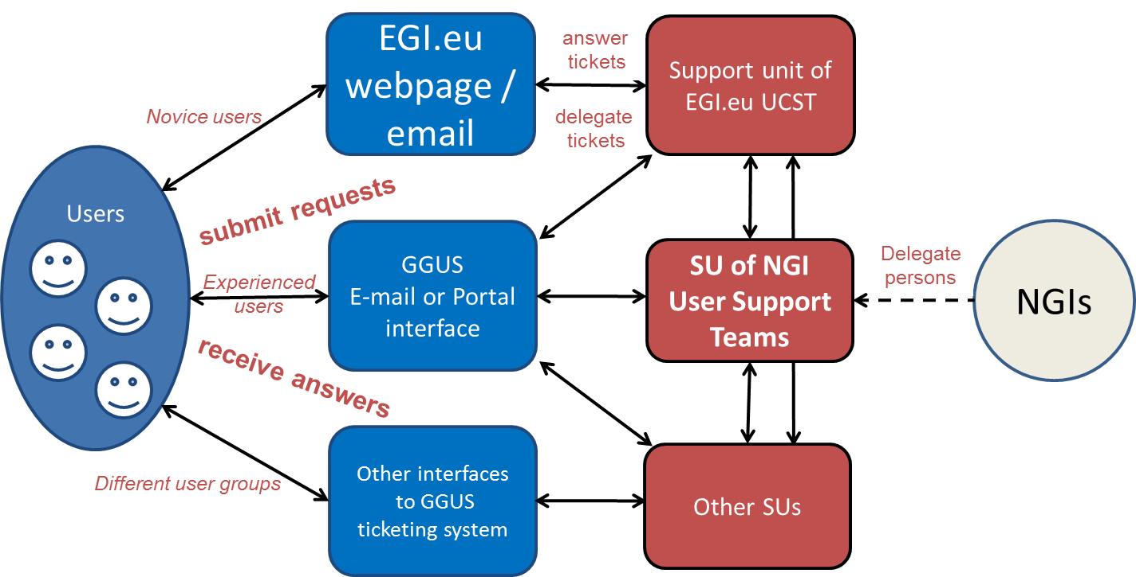
Figure 5: Schematic view of the possible ways of interaction of users with the application and user community support of EGI

Middleware Support Processes
As described in section 2.1.3 the infrastructure for middleware user support is well defined between EGI and the external technology providers supplying the middleware. The same true for the support processes. Middleware issues spotted by users of the EGI infrastructure will be assigned by the TPM to the DMSU. The DMSU will examine them and determine whether there is a problem with the service configuration, with its deployment model or with the software itself. In case of potential bugs the DMSU will assign the issue to the product team responsible for this component to get third level support. This process allows a detailed analysis and reporting of the quality of the support, which is important as this is an activity crossing project boundaries and governed by service level agreements.

Network Support Processes
The Network Support is implemented through a central coordination team based at GARR, the Network Support teams belonging to the NGIs, and a direct collaboration with the NRENs and DANTE (the manager of the GEANT European backbone).
The network support will focus on the deployment of the recommended, agreed tools, their proper operation, the collection and publication of the results through the Network Support Coordination web portal.
A unique contact point for performance related issues will be established, this easing the liaison between users, site administrators and network support team within the whole EGI community.
The main areas of support and monitoring functionality will be:
- Scheduled downtimes of sites
- Scheduled maintenances and downtimes of routing and network devices and their impact on the Grid infrastructure and the users.
- Troubleshooting of observed Grid services and resources access problems
- Publication of network monitoring information targeting the needs of users belonging to VOs and VRCs and site administrators. At this purpose, VRCs will be asked to rank the set of sites they are specifically interested in.
The exact definition of the general network support procedures will have to be agreed within the NGIs and NRENs community. A preliminary poll has been carried out to understand the procedures each NGI has in place with respect to Network Support. NGI support units and processes

NGI support units and processes
This section describes the support processes the NGI that responded to the request for input use for their internal user support and how those link into the EGI processes. It is the responsibility of all the NGIs to react on tickets that are assigned to their NGI’s support unit in GGUS according to the general guidelines that will be defined in the near future and formalised in SLAs.

Albania
The first line of NGI support process is the core team from Faculty of Information Technology of UPT in charge of the set-up and maintenance of the site. Following direct requests of end-users, the team has to:
- assure necessary interfacing with requested resources
- help end-users with the execution of grid jobs
- help end-users for gridification of applications

Due to the level of grid activities, formalization of procedures was not done in the past, and from now it is in consideration the implementation of EGI standards.

Croatia
The CRO NGI operational team is responsible for handling all NGI_HR tickets. Tickets can be created in GGUS and assigned to NGI_HR which generates notifications to the alias egi-fls@cro-ngi.hr. Alternatively users can send tickets directly to the alias. Operational team creates GGUS ticket if needed. SLAs are not defined at this point. Once the EGI OLA is defined we plan to follow it. Escalation follows EGI procedures.

Netherlands
The Dutch NGI NCF and the Belgian NGI BELNET have decided that in the EGI era for the time being the Dutch NGI will fulfil the ROD tasks as well as the first-line support tasks on behalf of the Belgian NGI for the sites in Belgium.
Although BELNET does not take part in EGI-InSPIRE, BELNET contributes resources to the EGI infrastructure and therefore we give a description how things are setup in Belgium for the sake of completeness.
BELNET has a support email address. There is no SLA between BELNET and its sites nor are there escalation procedures.
In the Netherlands the BiGGRID organisation takes care of the operational responsibilities taken on by the NGI NCF. There is a team at SARA consisting of about 5 people that fulfil the COD, ROD tasks and the first line support task. BiGGRID has a helpdesk email address, but users as well as sites frequently contact the support email addresses of the Dutch NGIs operational partners SARA and NIKHEF. A person on duty monitors the incoming support emails and forwards the request to the appropriate person.
Currently there is no formal SLA between the Dutch NGI and its sites. No formal escalation procedure is in place at the moment, but people can always contact BiGGRID management directly if so desired.

France
The first line support service is dealt by a dedicated team of 5 people taking shifts at assigning all incoming tickets acting as “French TPM”.
They assign incoming tickets specifically to the NGI SU, i.e the French NGI ROD, when tickets are opened for operational matters- tests failures. The sites are notified and react accordingly. They follow the ROD escalation procedure when created by RODs or regular GGUS escalation procedure for other tickets that are assigned to relevant experts in the NGI_France.
No other SLA in than the LCG ones on alarm and team tickets is observed.
Moreover, a status on tickets assigned for French sites is done regularly at internal bi weekly NGI meetings that all sites attend.

Germany
NGI-DE has set up several teams for the various participating resource centres that are responsible for the regional first line support for tickets originating in the region or being assigned through GGUS, as well as for the ROD. These teams work of a weekly rota and are responsible for a timely reaction to incidents and requests during normal office hours. They follow the service levels had are agreed for ROC and for the regional first line support. One of these teams is located within SWING, the Swiss Grid Initiative. This is part of NGI-DE’s collaboration with Switzerland.
There are also regional support teams for some VOs that help getting problems solved quickly, by being close to the VOs and the grid sites at the same time, e.g. GridKa employs local LCG experts co-funded by the LHC experiments.
Regional middleware support units exist for D-Grid specific software and for components with a regional flavour.

Hungary
The Hungarian support manager makes sure that the tickets from GGUS assigned to NGI_HU are being solved and that the process of solving problems is efficient. In particular he/she makes sure the troublesome tickets are handled to their ends. He/she uses a reporting functionality to overview the state of tickets assigned to NGI_HU (GGUS and to ngi-support@listserv.niif.hu). The Hungarian support staff needs to use one of the interfaces to submit a ticket, as described in 3.2.5. Then the person can use either of the interfaces she/he has an access to interact.

Italy
In the Italian NGI, the first line and second line support are provided by the same team.
About 15 people are involved in this activity. The work is organized in weekly shifts involving two supporters at a time.
In order to improve the efficiency, we are considering restructuring the service by reducing the number of people involved in the shifts.
The Italian NGI presently does not have specific SLAs for the support activity.
It adopted the common escalation criteria defined in EGEE.

Poland
Ticket processing flow in NGI_PL was designed based on EGI procedures. NGI_PL TPM was set up to manage registered in helpdesk non-operational tickets. For operational issues responsible unit is Regional Operator on Duty team which acts according to procedures written in Operational Procedure Manual (https://wiki.egi.eu/wiki/Operations:Manuals).
The timelines in ticket processing and sites' responsibilities are included in SLA which is in final draft and soon will be put in place.
Escalation process in non-operational cases requires that tickets should be acknowledged within 24h by Application Expert or Site Administrator and status updated every 3 working days. Oversight over user tickets is done by NGI_PL TPM. In case of exceed deadline for update, notification is send to assigned support unit. Tickets not solved within 30 working days are escalated to NGI_PL Operations Meetings.
Escalation process for operational issues, as was mentioned before, is consistent with EGI procedures.

Portugal
The first line support staff in IBERGRID is provided by 3 teams, one from Portugal and two from Spain, rotating shifts in a round-robin way. All first line support members are also involved on the ROD work.
The PT-NGI / IBERGRID support model follows the work-flow below:
- GGUS supports the NGI_IBERGRID Support Unit. This Support Unit triggers an email to the IBERGRID first line support staff which is responsible for acknowledging the ticket and for ensuring that it is properly routed and handled in time. In alternative, site administrators and users can also open tickets in the regional helpdesk but presently we request that all Portuguese users open tickets directly via GGUS.
- The first line support staff has the possibility to assign a ticket directly to a site, if this is not automatically done by the submitter; or reassign the ticket to other Support Unit or site (in GGUS or in regional helpdesk) if the original assignment was incorrect.
- The first line support, on a regular basis, checks the status of all open tickets, provides suggestions, tries to decrease the average response time and average solution time for all sites in the region.
- IBERGRID has also implemented central mailing lists for operational issues, and for user support. Through those mailing lists, site administrators and users can obtain community support from all IBERGRID members on a best effort basis.

The escalation procedures for tickets open by ROD staff are very well defined in the “Operational Procedures for ROD” Manual. For other kind of tickets, the escalation procedures are based on the site response time, and on the work involved to resolve the problem. The following steps can be achieved:
- Each Friday morning, the first line support staff reviews the open tickets to the region, and sends an operational status report. The problematic sites are invited to participate in the Monday's IBERGRID operational meeting, where they can collect or provide feedback.
- If a problematic site fails to participate in the Monday's IBERGRID operational meeting without justification, continued unresponsive along the week, and the problem remains unsolved, it reaches the first escalation step. In that case, a second request for participation in the next Monday's IBERGRID operational meeting is sent.
- If the problematic site continues unresponsive for more than two weeks, missed participation in two consecutive IBERGRID operational meeting without justification, and the problem continues unsolved, it reaches the second escalation step. A last warning is send to the site warning that the site suspension will be discussed on the next IBERGRID operational meeting.

The IBERGRID sites continue to cope with the previous EGEE SLAs in what regards availability, reliability and site response times, although such agreements could be reviewed in the future.

Serbia
Within the Serbian NGI_AEGIS, Grid sites are daily monitored by the national operations team from the Institute of Physics Belgrade (IPB), using the deployed monitoring infrastructure (national instance of NAGIOS/MyEGEE deployed at IPB, etc.). The operations team monitors performance of all sites according to the signed SLA, based on the last EGEE SLA document, which all certified Serbian sites have signed during their certification. Currently, the operations team is organized centrally by IPB, but in perspective the distributed monitoring shifts will be organized, involving the personnel from other participating institutes. NGI_AEGIS operations team handles first line support and performs continuous monitoring of the infrastructure.

As the first line of support, this team responds to all the issues reported via mailing lists, regional helpdesk, and GGUS. Depending on the issue, the team either resolves the problem (if it is related to the local resources) or alarms responsible people with appropriate advices related to the problem.

Slovakia
NGI 1st line support is “on-duty” based and covered by three people. We use pro-active mode of operation. On-duty supporter monitors status of sites using operational tools (NGI Nagios instance, Dashboard, Gstat) and notifies sites when problem is detected. 1st line support performs all mandatory tasks that are listed in operational procedures manual.
There are no SLA's in place yet, we will follow EGI Operations Level Agreements when they will be defined.
Escalations are handled according to escalation procedure defined in Operations Procedures Manual for Regional Operations.

Switzerland
The personnel of each site is responsible for the first line support. The NGI manager coordinates the individual sites. Today, there are no SLAs in place. Escalations are handled through the NGI manager.

Turkey
Since, all NGI_TR sites are managed centrally by NGI_TR Operation Centre, NGI_TR Operation Centre is responsible for managing national support infrastructure.
The first line support of NGI_TR is organised by NGI_TR Operational Centre and its system administrators. If the existing problem could not be solved by remote control of the sites, then the support of site local system administrators is taken from the local site.
Since the new SLAs between the NGI_TR and sites are not signed yet, this support is taken according to an official letter of intention between NGI_TR institutions. After the new SLA is being ready, SLAs should be signed between the NGI_TR Operation Centre and the other site institutions.

Conclusions
The main lesson to be learned from the exercise of writing this milestone is that the EGI infrastructure is a work in progress and that a lot of tools and workflows are not fully defined or implemented. This is no surprise since the transition from EGEE to EGI meant a major paradigm shift for scientific grid computing in Europe. Even though lot of the transition work already started in EGEE, the full scale of the changes only became visible during the first months of EGI.
The status of helpdesk activity mirrors this general picture. There are areas, where the tools are properly set up and the processes are well defined. Examples for this are the TPM and COD activities. Some other areas of user support are still in the process of being defined in detail.
In the middleware support activity for example the workflow and the tools are well defined for the middleware components provided by EMI and IGE, and will be extended to other external technology providers as required.
A huge variety exists in complexity and readiness the support infrastructures in the NGIs. Roughly a third of the NGIs answered the request for input for this milestone. Approximately the same number of NGIs has gone through the NGI validation procedure and is therefore connected to EGI support infrastructure, at least by having a single support unit for the whole NGI in GGUS. The NGI support infrastructures are the area of support that will take most time to properly establish. This is to be expected. There will continue be differences in the sophistication of the support infrastructures between mature and new NGIs and between large and small NGIs. This is no as long as the support infrastructure serves the NGI properly and interfaces correctly with the central tools.
In evaluating the input for this milestone and compiling a number of issues and areas of vagueness have been discovered:
- A review of legacy support units is needed to clean up the infrastructure and to streamline the support workflow.
- In EGEE a number of reporting and escalation procedures were implemented. These need to be evaluated and adapted to fit the needs of the EGI infrastructure.
- SLAs need to be defined and monitored between the various partners in the support activities. They should match the SLAs defined in related areas of EGI.
- The advisory bodies defined to gather requirements for the support processes and tools, mainly the USAG and the OTAG need to start their work to guarantee a timely response to need from within the project and from the user communities.
- Areas of user support that are not yet well defined concerning workflows and tools need to be identified and these issues need to be addressed.
These issues cannot and should not be addressed on the timescale of the compilation of a milestone, but the next edition of this milestone, due in year two of the project will report on the progress achieved in these areas.

References
R 1 | www.ggus.org – GGUS Portal
R 2 | https://gus.fzk.de/pages/docu.phpentation - Documentation collection on the GGUS portal
R 3 | https://eginet.garr.it/ - EGI network support web portal
R 4 | https://gus.fzk.de/pages/all_lhcopn.php - LHCOPN Dashboard in GGUS
R 5 | https://gus.fzk.de/pages/tpm.php - TPM schedule

