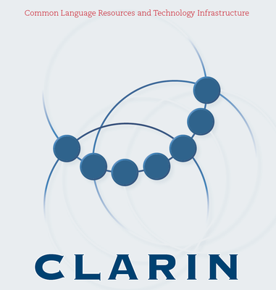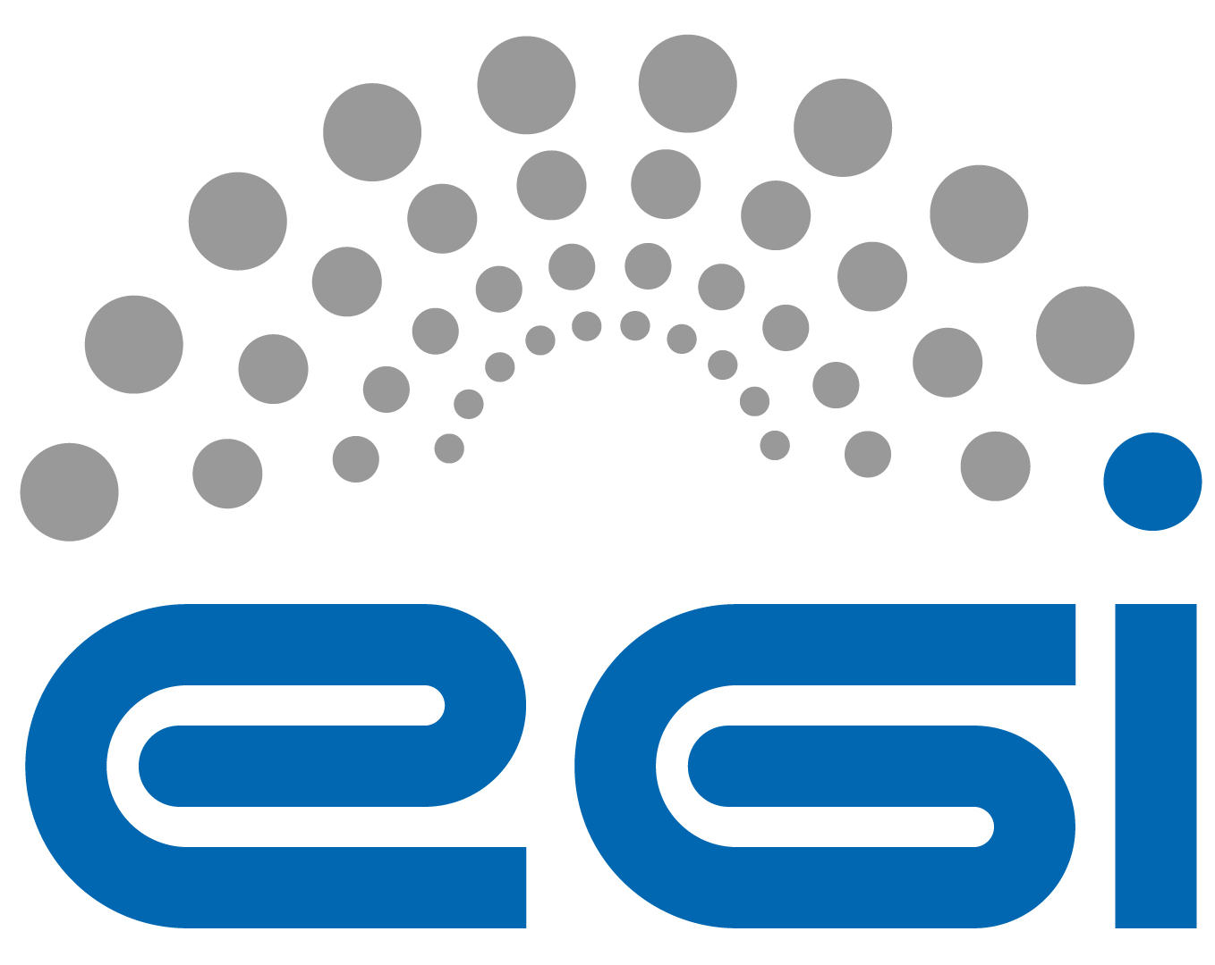

Letter of Intent for Cooperation

Emerging infrastructures in the arts, humanities and social sciences build largely on digital technologies. ESFRI and the European Commission (EC) support the cooperation of emerging digital infrastructures, particularly in the management of scientific information as outlined by the "Riding the Wave" report of the EC's High Level Expert Group on Scientific Data.

This letter underlines the intention of the signees to ensure that their infrastructures interact, to share their agendas in infrastructure development, and to continually explore opportunities for collaboration. The prime scope of this collaboration is to research, construct and operate infrastructure services for the arts and humanities.

Some of the topics for discussion may include the following:
- long-term data storage (i.e. bit preservation) and availability as live data (e.g. streaming of large images and videos, transaction management and version control)
- community annotation and curation of datasets (and therefore e.g. authority and version control, provenance tracking)
- multiple entry-points suiting the interfaces of virtual research environments (e.g. based on WebDAV or Cloud-like API's)
- hosting and monitoring of middleware services
- simple AAI for large (and potentially unbounded) user groups
- web service frameworks supporting features including secure access control, user-controlled interactive workflows, and computation near data
- connections to shared services in other countries and sectors (e.g. museums and libraries, commercial data providers, domain-specific services)

As one mechanism for ensuring ongoing interaction, the parties will explore and test the creation of Virtual Research Communities (VRC) through EGI - either through multiple channels (e.g. per discipline in the arts and humanities) or as a single shared VRC.

The signees constitute both key infrastructure as well as arts and humanities communities in Europe; however, they recognise that this collaboration will benefit greatly and, indeed, will only be sustainable through including other partners, including similar initiatives outside of Europe (e.g. Bamboo in the USA).

Signed by:

Steven Krauwer for CLARIN

Laurent Romary for DARIAH

Steven Newhouse for EGI

Riding the wave: How Europe can gain from the rising tide of scientific data. Final report of the High Level Expert Group on Scientific Data (European Commission). October 2010. http://cordis.europa.eu/fp7/ict/e-infrastructure/docs/hlg-sdi-report.pdf
Virtual Research Communities (VRC) in the European Grid Infrastructure (EGI). https://documents.egi.eu/document/253

