EGI-InSPIRE

ACCOUNTING PORTAL ROADMAP v1.0

 | Document identifier: | EGI-Accounting_Portal_Roadmap_v1.0.odt
 | Date: | 13/05/11
 | Activity: | JRA1
 | Lead partners for deliverable: | CESGA
 | Document status: | DRAFT
 | Document link: | http://www.egee.cesga.es/documents

Abstract: This document is intended to provide an overview of the Accounting Portal roadmap including its new working plan and release procedure.

- Copyright notice
Copyright © Members of the EGI-InSPIRE Collaboration, 2010. See www.egi.eu for details of the EGI-InSPIRE project and the collaboration. EGI-InSPIRE (“European Grid Initiative: Integrated Sustainable Pan-European Infrastructure for Researchers in Europe”) is a project co-funded by the European Commission as an Integrated Infrastructure Initiative within the 7th Framework Programme. EGI-InSPIRE began in May 2010 and will run for 4 years. This work is licensed under the Creative Commons Attribution-Noncommercial 3.0 License. To view a copy of this license, visit http://creativecommons.org/licenses/by-nc/3.0/ or send a letter to Creative Commons, 171 Second Street, Suite 300, San Francisco, California, 94105, and USA. The work must be attributed by attaching the following reference to the copied elements: “Copyright © Members of the EGI-InSPIRE Collaboration, 2010. See www.egi.eu for details of the EGI-InSPIRE project and the collaboration”. Using this document in a way and/or for purposes not foreseen in the license, requires the prior written permission of the copyright holders. The information contained in this document represents the views of the copyright holders as of the date such views are published.

- Delivery Slip
 | Name | Partner/Activity | Date
From | Alvaro Simon | CESGA/JRA1 | 10/05/11
Reviewed by | Moderator:  Reviewers:
Approved by | AMB & PMB

- Document Log
Issue | Date | Comment | Author/Partner
1 | 10/05/11 | First draft (v1.0) entering internal review. | A. Simon/CESGA
2
3

Content
1.Introduction 4
1.1.Purpose of the document 4
1.2.Application area 4
1.3.references 4
1.4.Document amendment procedure 4
1.5.Terminology 4
2.Executive summary 5
3.WBS 6
4.WBS Dictionary 7
5.LIST OF DELIVERABLES 9
6.LIST OF Milestones 10
7.schedule 11

Introduction

Purpose of the document
This document shows the Accounting Portal new roadmap and its future deliverables and milestones. A preview Gantt chart is displayed at the end of this document.

Application area
Readers can use this document to obtain general info about Accounting Portal status and future work.

references
[R1] http://accounting.egi.eu/gridsite/accounting/CESGA/egee_view.php | Accountig Portal
[R2] https://gus.fzk.de/pages/home.php | Accounting Portal (development)
[R3] http://cic.gridops.org/index.php | Operations Portal
[R4] https://goc.gridops.org/site/list?id=112 | GOCDB

Document amendment procedure
This document may be updated as new services are to be included into the Accounting Portal or if new milestones are required.
Comments should be sent to the authors of this document.

Executive summary
This document covers the “Accounting Portal V3” service that is installed at CESGA and provides a brief future plan for this global service. This document includes these sections:

WBS, WBS dictionary, list of deliverables, list of milestones and the schedule.

The development is based on the spiral model. Four complete cycles are defined, with a new release of the Accounting Portal at the end of each cycle (after 6 months).

Inside each cycle there are four steps. After each step a preview release including the additional views created will be available in the development version of the Accounting Portal for internal review.

The detailed schedule is presented in Section 8.

ACCOUNTING PORTAL

The EGI Accounting Portal is the global graphical front-end to EGI accounting data. Accounting statistics are available through this portal for the analysis of the different grid users, VO administrators an site administrators. This data is analysed to generate statistical summaries that are made available through a web interface.

Project life cycle

It is based on the spiral life-cycle model. Four complete cycles are defined, producing a new release of the Accounting Portal at the end of each cycle (see Figure 1).

Inside each cycle there are four steps: Design, Implementation, Release and Revision.
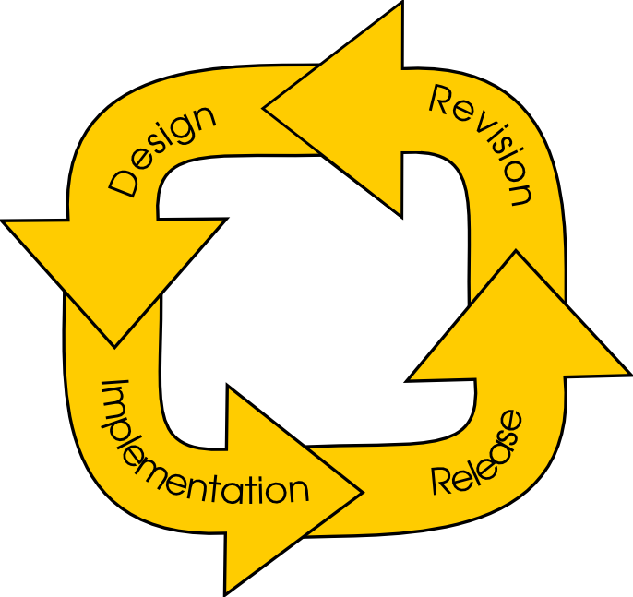

After each cycle dedicated meetings will be organized with activity leaders to define the set of views to implement and which are required by the NGIs.

Open tickets

- Foreign users accounting: GGUS https://gus.fzk.de/ws/ticket_info.php?ticket=66828&from=search
- Custom view with XML endpoint: Provide a XML endpoint to gather date from custom view queries. Related tickets: https://rt.egi.eu/rt/Ticket/Display.html?id=1802, https://rt.egi.eu/rt/Ticket/Display.html?id=1275

WBS

MP1 | Design
MP2 | Implementation
MP3 | Release
MP4 | Revision

WBS Dictionary

Code | MP1
Name | Design
Definition | Accounting Portal new design.
Deliverables | DMP1.1.1 DMP1.1.2 DMP2.1.1 DMP2.1.2 DMP3.1.1 DMP3.1.2 DMP4.1.1 DMP4.1.2
Milestones

Code | MP2
Name | Implementation
Definition | Accounting Portal internal improvements and new implementations.
Deliverables | DMP1.2.1 DMP1.2.2 DMP2.2.1 DMP2.2.2 DMP3.2.1 DMP3.2.2 DMP4.2.1 DMP4.2.2
Milestones

Code | MP3
Name | Release
Definition | Accounting Portal production releases, maintenance, OS upgrades and repository synchronization.
Deliverables | DMP1.3 DMP2.3 DMP3.3 DMP4.3
Milestones | MMP1.3 MMP2.3 MMP3.3 MMP4.3

Code | MP4
Name | Revision
Definition | Accounting Portal revision and shop-list review.
Deliverables | DMP1.4 DMP2.4 DMP3.4 DMP4.4
Milestones | MMP1.4 MMP2.4 MMP3.4 MMP4.4

LIST OF DELIVERABLES
Deliverable | Name | Description
DMP1.1.1 | New chart framework design v1 | Design of the pChart implementation for the Accounting Portal
DMP1.2.1 | New chart framework implementation v1 | Implementation of pChart framework into the current portal.
DMP1.1.2 | ActiveMQ connector design v1 | Desing to replace current central repository connector by ActiveMQ system.
DMP1.2.2 | ActiveMQ connector implementation v1 | Implementation of the new ActiveMQ connector.
DMP1.3 | Accounting Portal v4.0 (Canopus) | Accounting Portal release.
DMP1.4 | Accounting Roadmap v2 | AP Roadmap deliverable.
DMP2.1.1 | VO scope views design v1.  AP regionalization v1. | New VO scope view design.  Review and redesign the regional AP.
DMP2.2.1 | VO scope view implementation v1.  AP regionalization v1. | Implement the new views requested by the VOs.  Distribute the Regional Accounting Portal v1.
DMP2.1.2 | XML custom view for NA3 design v1 | Design an XML custom report for VRCs
DMP2.2.2 | XML custom view for NA3 implementation v1 | Implement the new endpoint for the VRCs based on XML.
DMP2.3 | Accounting Portal v4.1 (Deneb) | Accounting Portal release.
DMP2.4 | Accounting Roadmap v3 | AP Roadmap deliverable.
DMP3.1.1 | Contributed CPUs v1 | Design of contributed CPUs views.
DMP3.2.1 | Contributed CPUs v1 development v1 | Development of contributed CPUs v1
DMP3.1.2 | Parallel Job accounting v1 | Design of new views for parallel jobs using accounting repo database.
DMP3.2.2 | Parallel Job accounting development v1 | Implement the new parallel Jobs accounting views.
DMP3.3 | Accounting Portal v4.2 (Electra) | Accounting Portal release.
DMP3.4 | Accounting Roadmap v4 | AP Roadmap deliverable.
DMP4.1.1 | Local Jobs accounting v1 | Desing views for local jobs accounting.
DMP4.2.1 | Local Jobs accounting v1 development | Develop new views or queries for local jobs accounting.
DMP4.1.2 | Application domain accounting v1 | Design and requirements for the application domain accounting.
DMP4.2.2 | Application domain accounting implementation v1 | Implement new features for the application domain accounting within the Accounting Portal.
DMP3.3 | Accounting Portal v4.3 (Fomalhaut) | Accounting Portal release.
DMP3.4 | Accounting Roadmap v5 | AP Roadmap deliverable.

LIST OF Milestones

Milestone | Description
MMP1.3 | Accounting Portal v4.0 (Canopus)
MMP1.4 | Accounting Roadmap v2
MMP2.3 | Accounting Portal v4.1 (Deneb)
MMP2.4 | Accounting Roadmap v3
MMP3.3 | Accounting Portal v4.2 (Electra)
MMP3.4 | Accounting Roadmap v4
MMP4.3 | Accounting Portal v4.3 (Fomalhaut)
MMP4.4 | Accounting Roadmap v5

Schedule

DATE | EVENT
15/05/11 | DMP1.1.1
31/07/11 | DMP1.2.1
15/08/11 | DMP1.1.2
15/10/11 | DMP1.2.2
31/10/11 | DMP3.1 MMP1.1 MMP2.1 (Canopus release)
15/11/11 | DMP2.1.1
31/01/12 | DMP2.2.1
15/02/12 | DMP2.1.2
15/04/12 | DMP2.2.2
30/04/12 | DMP3.2 MMP1.2 MMP2.2 (Deneb release)
15/05/12 | DMP3.1.1
31/07/12 | DMP3.2.1
15/08/12 | DMP3.1.2
15/10/12 | DMP3.2.2
31/10/12 | DMP3.3 MMP1.3 MMP2.3 (Electra release)
15/11/12 | DMP4.1.1
31/01/12 | DMP4.2.1
15/02/13 | DMP4.1.2
15/04/13 | DMP4.2.2
30/04/13 | DMP3.4 MMP1.4 MMP2.4 (Fomalhaut release)



