EGI-InSPIRE
Deployed Middleware Support Unit Operations Procedures

EU MILESTONE: MS502

Document identifier: | EGI-MS502-final
Date: | 05/11/2010
Activity: | SA2.5
Lead Partner: | EGI.eu
Document Status: | FINAL
Dissemination Level: | PUBLIC
Document Link: | https://documents.egi.eu/document/69

Abstract
This document describes the workflow for the Deployed Middleware Support Unit from its daily operation to the weekly follow up meeting and its relation to the OMB and the TCB. Further, the procedures for the handling of issues and the responsibility as compared to the 1st and 3rd level support are defined.

- Copyright notice
Copyright © Members of the EGI-InSPIRE Collaboration, 2010. See www.egi.eu for details of the EGI-InSPIRE project and the collaboration. EGI-InSPIRE (“European Grid Initiative: Integrated Sustainable Pan-European Infrastructure for Researchers in Europe”) is a project co-funded by the European Commission as an Integrated Infrastructure Initiative within the 7th Framework Programme. EGI-InSPIRE began in May 2010 and will run for 4 years. This work is licensed under the Creative Commons Attribution-Noncommercial 3.0 License. To view a copy of this license, visit http://creativecommons.org/licenses/by-nc/3.0/ or send a letter to Creative Commons, 171 Second Street, Suite 300, San Francisco, California, 94105, and USA. The work must be attributed by attaching the following reference to the copied elements: “Copyright © Members of the EGI-InSPIRE Collaboration, 2010. See www.egi.eu for details of the EGI-InSPIRE project and the collaboration”. Using this document in a way and/or for purposes not foreseen in the license, requires the prior written permission of the copyright holders. The information contained in this document represents the views of the copyright holders as of the date such views are published.
- Delivery Slip
 | Name | Partner/Activity | Date
From | M. Gronager | NORDUnet/ TSA2.5 | July 27th 2010
Reviewed by | Moderator: Daniele Cesini  Reviewers: Ron Trompert | SA2 | July 21th 2010  July 14th 2010
Approved by | AMB & PMB |  | 17/08/2010
- Document Log
Issue | Date | Comment | Author/Partner
1.0 | June 17th 2010 | First Draft | M. Gronager / NORDUnet
2.0 | June 24th 2010 | Second Draft, first round of internal review | M. Gronager / NORDUnet
3.0 | July 8th 2010 | Third Draft, second round of internal rev. | M. Gronager / NORDUnet
4.0 | July 27th 2010 | AMB Review version | M. Gronager / NORDUnet
5 | August 16th 2010 | Final version | M. Gronager / NORDUnet

- Application area
This document is a formal deliverable for the European Commission, applicable to all members of the EGI-InSPIRE project, beneficiaries and Joint Research Unit members, as well as its collaborating projects.
- Document amendment procedure
Amendments, comments and suggestions should be sent to the authors. The procedures documented in the EGI-InSPIRE “Document Management Procedure” will be followed:
https://wiki.egi.eu/wiki/Procedures
- Terminology
A complete project glossary is provided at the following page: http://www.egi.eu/results/glossary/

- Project SUMMARY

To support science and innovation, a lasting operational model for e-Science is needed − both for coordinating the infrastructure and for delivering integrated services that cross national borders.

The EGI-InSPIRE project will support the transition from a project-based system to a sustainable pan-European e-Infrastructure, by supporting ‘grids’ of high-performance computing (HPC) and high-throughput computing (HTC) resources. EGI-InSPIRE will also be ideally placed to integrate new Distributed Computing Infrastructures (DCIs) such as clouds, supercomputing networks and desktop grids, to benefit user communities within the European Research Area.

EGI-InSPIRE will collect user requirements and provide support for the current and potential new user communities, for example within the ESFRI projects. Additional support will also be given to the current heavy users of the infrastructure, such as high energy physics, computational chemistry and life sciences, as they move their critical services and tools from a centralised support model to one driven by their own individual communities.

The objectives of the project are:

- The continued operation and expansion of today’s production infrastructure by transitioning to a governance model and operational infrastructure that can be increasingly sustained outside of specific project funding.
- The continued support of researchers within Europe and their international collaborators that are using the current production infrastructure.
- The support for current heavy users of the infrastructure in earth science, astronomy and astrophysics, fusion, computational chemistry and materials science technology, life sciences and high energy physics as they move to sustainable support models for their own communities.
- Interfaces that expand access to new user communities including new potential heavy users of the infrastructure from the ESFRI projects.
- Mechanisms to integrate existing infrastructure providers in Europe and around the world into the production infrastructure, so as to provide transparent access to all authorised users.
- Establish processes and procedures to allow the integration of new DCI technologies (e.g. clouds, volunteer desktop grids) and heterogeneous resources (e.g. HTC and HPC) into a seamless production infrastructure as they mature and demonstrate value to the EGI community.

The EGI community is a federation of independent national and community resource providers, whose resources support specific research communities and international collaborators both within Europe and worldwide. EGI.eu, coordinator of EGI-InSPIRE, brings together partner institutions established within the community to provide a set of essential human and technical services that enable secure integrated access to distributed resources on behalf of the community.

The production infrastructure supports Virtual Research Communities (VRCs) − structured international user communities − that are grouped into specific research domains. VRCs are formally represented within EGI at both a technical and strategic level.

- EXECUTIVE SUMMARY

This document describes the workflow for the Deployed Middleware Support Unit from its daily operation to the weekly follow up meeting and its relation to the OMB and the TCB. Further, the interaction with 1st and 3rd level support is defined.
The main tasks are defined as: Issue analysis, which is conducted by a small sub team, the assigners, within the DMSU. Issue resolution, which is conducted in collaboration with 1st level, internally in DMSU by the assigners, as well a larger pool of experts, the resolvers, and in collaboration with 3rd level support. Issue following up and management as well as coordination with the other units in EGI-InSPIRE, and partners. Finally, knowledge build up within EGI-InSPIRE on middleware component quality, expected patch delivery and possible workaround is an important DMSU task.
The tracking of all issues will be conducted using GGUS [R3].
The interaction with 1st level is centered around the delegation of middleware issues from the 1st level support to the DMSU and collaboration with the operators at 1st level on the resolution of configuration related issues.
The interaction with 3rd level support, which is a several project external units, will be centered on collaboration on patch requiring issues as well as following up on the resolution of these.
TABLE OF CONTENTS
1 Introduction 6
1 DMSU Operation workflow 7
1.1 Introduction to tasks 7
1.2 Ticket processing - a daily effort 8
1.3 DMSU, the OMB and the TCB 10
2 RelationSHIP WITH THE TPM 11
2.1 Division of responsibilities between TPM and DMSU 11
2.2 The delegation procedure 11
3 Relation to External software contributors 12
3.1 Division of responsibilities between 3rd level support and DMSU 12
3.2 The delegation and follow up procedure 12
4 Metrics 14
4.1 Ticket based metrics 14
4.2 Forecast based metrics 14
5 conclusions 15
6 References 16

Introduction
The purpose with this document is to clarify the role of the Second-line support, the Deployed Middleware Support Unit, DMSU, in EGI-InSPIRE.
This document describes the Deployed Middleware Support Unit’s Operations Procedures. i.e., the interaction with the EGI first line support and the interactions with the external software providers.

DMSU Operation workflow
The Deployed Middleware support unit (DMSU) provides a dedicated second-line support function for the middleware technologies used in production in the EGI-InSPIRE infrastructure, receiving issues from the EGI first line support and working with the external software providers to resolve the issues (the third line support). Further, the DMSU interacts with the EGI Technology Coordinatoin Board, TCB, in two ways: by providing feedback on the trends seen through the resolving of issues and by acting as a clarification and examination task force for the TCB looking into issues and worries not easily examined elsewhere. Further, DMSU liaise with the EGI COO and the NGI Operations Managers, to jointly assess the impact of issues on the production infrastructure and their severity.
The issues handled by the DMSU are mainly middleware-issues, i.e. issues relating to limitations or bugs in the deployed middleware that can be solved either through configuration tweaks, alternative component installations or by fixing the actual bug in the middleware.
The main rational and motivation of the creation of the DMSU is the shift from the EGEE-III project with project internal software development and expertise to a more sustainable setup with project external software development. This induces a need for a project internal software competence group enabling support of the deployed middleware, fixing of configuration issues and monitoring of the external software providers and their ability to deliver fixes. The DMSU enters naturally in the EGI-InSPIRE support workflow as a second-line support unit with specific expertise in the deployed software in the EGI-InSPIRE infrastructure.
The definition of the procedures and the workflow has used the statistics from the EGEE GGUS system from 2009 to assess proper procedures based on the assumed load of tickets pr week. Especially, the follow up scheme based on an ETA (estimated time of arrival) was introduced to keep the number of open tickets that need closer attention at the weekly meeting of the DMSU assigners (more details to follow) on a scale of 10 tickets. The gathering of statistics and further experience through the next year might drive recommendations to further changes to the workflow.
It is assumed that the workflow and the procedures will be aligned with the use of ITIL (Information Technology Infrastructure Library) in the EGI-InSPIRE project as to be defined in the D3.1 deliverable due in M3. This will be further clarified in the next revision of this document due in M14.
In the sections below, the interaction with first and third line as well as the TCB are clarified taking into account the different timescales of the interactions. However, first we define the grouping of the staff to clarify the organization of the task.

Introduction to tasks
The overall team involved in the DMSU counts around 24 people on 5 different partners. To manage this team a hierarchal structure has been established. The DMSU tasks can be divided into three categories:
- Work Package Task management
- Initial analysis, assignment and follow up of issues
- Resolving issues within the DMSU
The management of the DMSU task is undertaken by the TSA2.5 Task Leader, and involves day to day project management as well as managerial interaction with the EGI.eu CTO, the COO, the Operations Management Board, OMB, the TCB and the 3rd level support by the external software providers.
The initial analysis, assignment and follow up of issues are conducted by the Assigners, the Assigners are a group of senior representative from each of the partners capable of analysing the technical issues and delegate the resolving of these to either the 3rd level support or to a resolver.
The resolving of issues within the DMSU are carried on by either one of the assigners or by experts on different middleware components within the partners, i.e. the Resolvers. The quite large number of second level experts are expected to prove quite effective as the needed expert assistance will always be at hand. However, it is also expected that the majority of the issue resolving work will be conducted by the assigner group, with most time allocated to the TSA2.5 task, or delegated to the 3rd level support.
The picture below is a visualization of the different tasks of the DMSU and they are further elaborated on below.

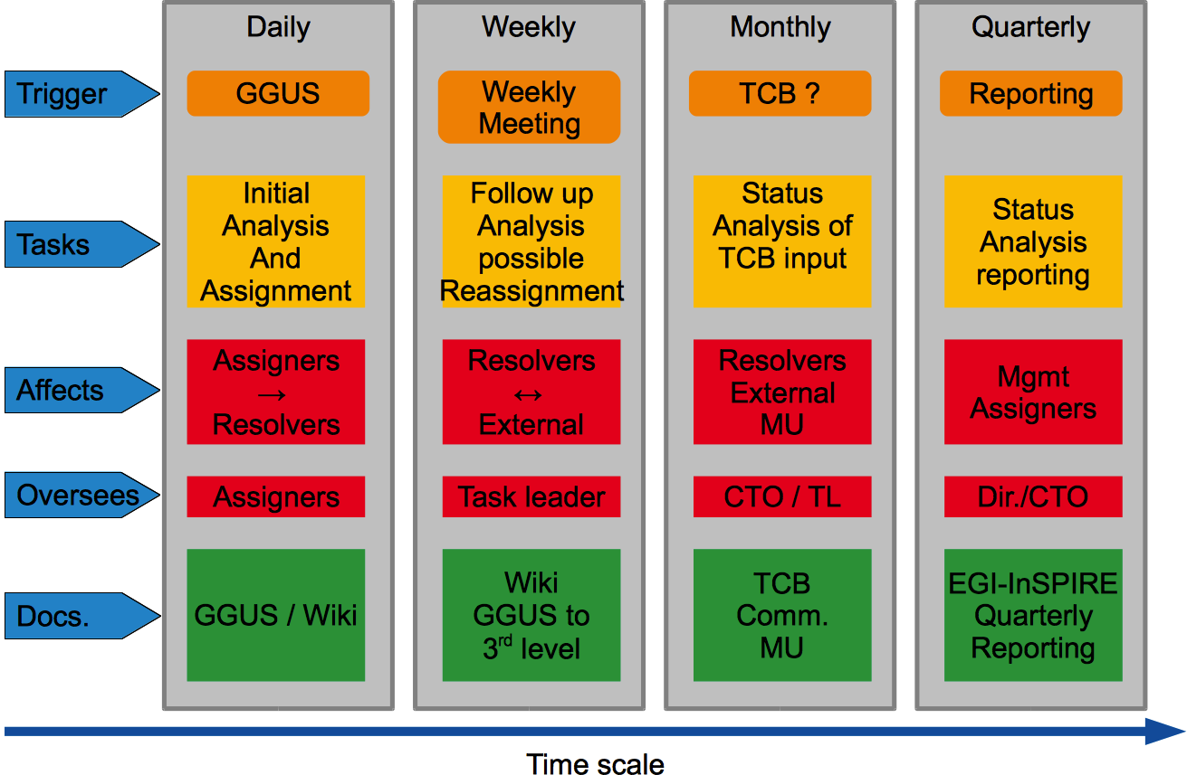
Figure 1. A visualization of the different tasks times lines of the DMSU

Ticket processing - a daily effort
The daily effort within the DMSU is driven by the tickets of issues as reported via GGUS. Within GGUS a support unit has been created, Deployed Middleware, and issues reported to the EGI First line support believed to be related to the middleware are hence assigned to the DMSU by the 1st line support (TPM) or the TSA1.7 NGI international support teams.
During the second project quarter the overall current 2nd line support setup in GGUS will undergo a revision to better support the workflow of the 1st, 2nd and 3rd line support units.
The tickets are assigned to the assigner with the best knowledge of the problem. Below is a matrix mapping the component knowledge to each partner and for use by the TPM in the delegation process, the so-called TPM DMSU Cheat Sheet. The TPM DMSU Cheat Sheet is updated when new components are added, other removed or when the task to partner mapping are changed. An updated version is kept on the egi wiki [R1].

Table 1. The DMSU Cheat Sheet for the TPM to map issue to expertise.
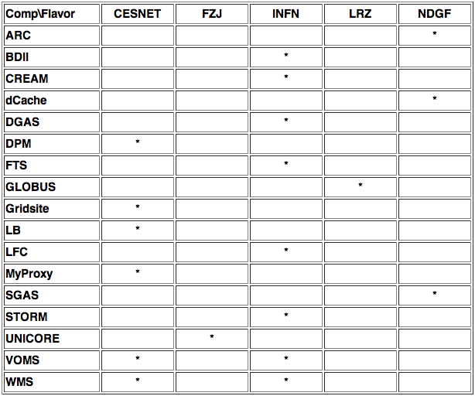

Once received from TPM the DMSU assigner analyses the ticket, and if the issues are considered to be a configuration issues or relates to a specific deployment scenario the Assigner assigns the ticket to either her-/him- self or to a Resolver with more expert knowledge of the affected component. Alternatively, if the reported issues are considered to be related to the middleware, e.g. a clear bug, the issues are assigned to the third level support with request of an ETA for the issue resolving, once the ETA has been determined and found reasonable by the assigner, the DMSU part of the ticket work is considered completed. The DMSU will, however, continue to monitor the assigned ticket.
The prototypical workflow from ticket creation, initial investigation to applied fix and deployment is illustrated below:
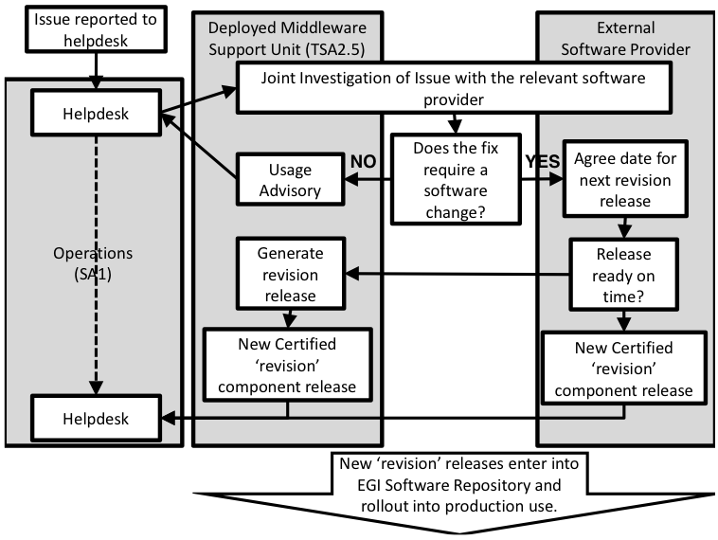
Figure 2. The workflow of tickets and the resulting fix.
The model of ‘direct assignment’ that is modelled in GGUS, mimics the current functionality of a Site and a Regional Operation Center, ROC, where DMSU acts as a ROC for 3rd level support, Sites. The exact implementation of this is currently being discussed with the GGUS team.
Ticket follow up, internal and for 3rd level - a weekly effort
Each week the open tickets assigned to the DMSU are discussed and evaluated. Tickets being resolved within the DMSU are followed up on, and open tickets with an ETA within the coming week are also marked for follow up by the appropriate assigner. Further, general trends are discussed and documented in the wiki for inclusion in the quarterly report and possible for discussion within the TCB. Issues that need to be raised at the TCB are tracked in the appropriate issue tracker.

DMSU, the OMB and the TCB
During the weekly work of the DMSU issues found and reported on the infrastructure are collected in the wiki and used for generating recommendations to the TCB. These recommendation are broader than incidents raised within a single ticket and longer term suggestions to changes in the middleware or in the way it is deployed and used. These recommendations are also discussed with the COO and the OMB at the appropriate monthly meeting, at the bi-weekly Monday operations meeting, or on the inspire-sa1 mailing list. Further, the TCB can raise questions to the DMSU of issues that require clarification. DMSU hence acts as a project internal expert group for clarification of issues raised in the TCB.
Issues raised by the OMB or the TCB uses the same workflow as the daily tickets to the DMSU; a ticket in GGUS is created and assigned to one of the DMSU resolvers for further clarification and followed up on a weekly basis.

RelationSHIP WITH THE TPM
The relationship between the DMSU and TPM, the 1st level support is clear in the sense that TPM delegates to DMSU all middleware related issues. However, in the TPM there is quite a bit of knowledge that has already been built up regarding middleware issues and the teams that can solve these. This expertise is used to target the ticket to the right DMSU Assigner, and might prove beneficial on a later stage if the DMSU becomes overloaded with work, as the TPM could hence delegate simple issues directly to 3rd level support. However this scheme will not be introduced the first year and will, if needed, hence be elaborated further on the an updated version of this document next year.
The purpose of having a tiered support levels is to ensure that the highly specialised and technical skills contained within the 3rd level support unit is not used to do tasks that can be done with more general support units at the 1st and 2nd level. The delegation scheme presented below guarantees optimal use of the resources.

Division of responsibilities between TPM and DMSU
When the TPM receives a ticket it is analysed with respect to:
- is the issue middleware related ?
- which component(s) are involved ?
If it is a middleware issue then based on the components involved the TPM uses the TPM-DMSU cheat sheet to assign it to the proper DMSU partner.
It is hence the responsibility of the TPM to check if the issues are related to the deployed middleware and if so which component that is most likely the culprit.
It is the responsibility of the DMSU to analyse the issue further, resolve it or delegate it to 3rd level using the ETA procedure to be described below.

The delegation procedure
For issues that are clearly a middleware bug a direct delegation from TPM to 3rd level might be introduced over time. The procedure is to be applied only to issues that are clearly related to middleware bugs and that are quite confined in their effect. Issues could be e.g. error message misspellings or understandability, random segmentation faults in client tools etc.
It is the goal of the DMSU to keep track of problems reported through the use of the infrastructure caused by the deployed middleware. It is hence important that the ownership of the reported issues stays within the DMSU, even though the issues are just a simple and easily correctable bug. In order to model this in GGUS a simple bug issue will always be assigned to the DMSU, however, it will be possible for the TPM to copy it straight to the assumed 3rd level support unit that can handle this issue. The 3rd level support, hence have the opportunity to resolve the bug or report an ETA for the bug right away and hence bypass the weekly follow up procedure from the DMSU assigners, as the bug is hence already resolved. The procedure hence follows the scheme established previously for the direct assignment of operations tickets between EGEE ROCs and EGEE Sites. The DMSU acts as a ROC with responsibility over some Sites, however if an issue is directly related to a certain component the TPM will notify the 3rd level directly, keeping the assignment of the issue at the DMSU level.

Relation to External software contributors
The real big change in moving from EGEE to EGI is the introduction of external software providers[R2]. It is no longer a task internal to a project to develop or maintain the middleware deployed on the infrastructure. This also means that knowhow and expertise to be able to choose the right products and how to deploy these in the most optimal way need to be built up and maintained within the EGI-InSPIRE project. The DMSU is partly covering this need; through the continuous resolution or monitoring of the external providers resolution of issues, problems, strengths and weaknesses are understood and collected within the DMSU and reported to the TCB.
The relationship that EGI has with these external software providers is defined at two levels:
- A general collaborative Memorandum of Understanding defining the relationship between the two independent activities.
- A Service Level Agreement that defines the operational relationship between the EGI.eu Technology Unit (which includes the DMSU and represents EGI in this relationship) and the technical activities within the software project. The SLA will include guidelines for TTF (time to fix) for different groups of issues.
This section described how the relationship to the external software providers is setup and what the responsibilities are.

Division of responsibilities between 3rd level support and DMSU
The responsibility of the DMSU is to:
- Examine and analyse an issue
- In case the issue can be resolved by reconfiguration, or an alternative deployment configuration, e.g. by suggesting to switch another and almost compatible component the responsibility of the resolution lies on the DMSU
- If the issue is caused by a middleware bug or by performance issues within the component an ETA is negotiated with the external software provider. The responsibility of following up and possibly reporting on the progress to TCB and other bodies within EGI (e.g. the operations activity) lies with SA2 or for the part of the solution that has to due with the deployment of the fixed component the responsibility lies at TSA1.3.
The responsibility of the external software provider is to:
- In case of a bug in the middleware, either recommend a possibly workaround or to resolve the bug within the ETA negotiated with the DMSU
- To notify in due time if an ETA cannot be met
The coordination body for resolving responsibility disputes between the DMSU and an external software provider is the TCB. The TCB is also responsible for establishing, managing, and monitoring the SLA with the external software providers.

The delegation and follow up procedure
The delegation and follow procedure is a three step procedure. It is initiated by an assignment of the EGI Helpdesk ticket from the DMSU and to the external software provider, possible with further information on the issue documented in the ticket, further, the DMSU requests from the external software provider an ETA for a solution of the issue. The first reply to the ticket is hence an ETA from the external software provider, the ETA includes the full cycle for a new bug fix component release to be ready for rollout. Depending on the ETA and the severity of the issue, the DMSU approves the ETA or requests a higher priority. Once the ETA has been negotiated the resolution of the issue starts at the external software provider and will then only be monitored and status checked once the ETA is near. The check will be part of an DMSU weekly meeting.
If everything goes according to plan the fixed component will be delivered to EGI-InSPIRE as part of a new release from the provider, be verified against the defined criteria, and then deployed into production following the defined rollout procedure (MS402). If the ETA cannot be fulfilled a possible new ETA is negotiated. ETAs are recorded and used in the metrics for the interaction with the external software provider. In the case of non-fulfilled ETAs the issue can be raised on TCB level.

Metrics
The metrics used to measure the success of the DMSU falls in two categories. The first is an automatic generated and ticket based metric, the other is based on the quality of the recommendations delivered by the DMSU on the general problems as seen on the infrastructure.

Ticket based metrics
The automatic generation of metrics from the EGI Helpdesk based on number of tickets, resolution times etc. has been used also in EGEE. The metrics suggested for the DMSU are:
- Number of tickets assigned to the DMSU assigners.
- Number and time for tickets to be resolved/closed by the DMSU resolvers.
- DMSU response time to tickets
- Number of tickets assigned to the external software providers (the 3rd line support)
- Number and time for tickets to be resolved/closed by the external software providers.
- Effectiveness of the external provider in accurately defining the ETA times for resolving the reported issues. Percentage of fixes provided by:
  - the initial ETA
  - any revised ETA
  - within a week of the agreed ETA
  - within a month of the agreed ETA.
The metrics are reviewed monthly and collected on a quarterly basis and included in the quarterly reporting.

Forecast based metrics
The forecast based metrics is an attempt to measure the quality of the recommendations issued by the DMSU to the TCB.:
- At the end of each quarter, starting from PQ2 (Project Quarter 2) and based on tickets and analysis conducted on behalf of the TCB a recommendation for changes / fixes to the providers of the deployed middleware is authored. The list is accompanied with risks if not following the recommendations / improvements expected if recommendations are followed. This analysis will be conducted in collaboration with SA1.
- At the end of each quarter, starting from PQ3 and based on the analysis from the former quarter comments on the results of following / not following the recommendations are summarized
The quality of these recommendations and how well they can be used as a guideline to the severity of the tasks are commented on by the COO and the Director. This assessment serves as the forecast based metrics.

conclusions
The operational procedures of the Deployed Middleware Support Unit, aka the EGI 2nd line support have been documented and the responsibilities of the DMSU as compared to the external partners have been specified. Further, the interaction between the DMSU and the 1st and 3rd line support have been specified. It is expected that the interfaces to the external partners will be further refined over the next months as it becomes more clear what services they can provide. A more throughout picture can hence be presented in the expected revision of this document next year.

References
R 1 | https://wiki.egi.eu/wiki/TSA2.5_Deployed_Middleware_Support_Unit#TPM_cheat_sheet
R 2 | https://edms.cern.ch/document/1006814
R 3 | https://gus.fzk.de/pages/docu.php

At the time of writing the TCB has not yet been defined and sat up, nor has the issue tracking system.

