EGI-InSPIRE

Ported Applications Website

EU MILESTONE: MS303

Document identifier: | EGI-InSPIRE-MS303-final
Date: | 05/11/2010
Activity: | NA3
Lead Partner: | EGI.eu
Document Status: | FINAL
Dissemination Level: | PUBLIC
Document Link: | https://documents.egi.eu/document/92

Abstract
This document describes the current status of the EGI Applications Database (http://appdb.egi.eu) and the future steps to be taken to produce a full-fledged, community driven portal, which will act as a point-of-reference for scientific software and tools that are available in the EGI infrastructure, as well as a registry of persons who were involved of the development of these high level applications. The database serves as an important tool to promote the significance of EGI in e-Science and to facilitate the reuse of applications and expertise that is available in NGIs.

- Copyright notice
Copyright © Members of the EGI-InSPIRE Collaboration, 2010. See www.egi.eu for details of the EGI-InSPIRE project and the collaboration. EGI-InSPIRE (“European Grid Initiative: Integrated Sustainable Pan-European Infrastructure for Researchers in Europe”) is a project co-funded by the European Commission as an Integrated Infrastructure Initiative within the 7th Framework Programme. EGI-InSPIRE began in May 2010 and will run for 4 years. This work is licensed under the Creative Commons Attribution-Noncommercial 3.0 License. To view a copy of this license, visit http://creativecommons.org/licenses/by-nc/3.0/ or send a letter to Creative Commons, 171 Second Street, Suite 300, San Francisco, California, 94105, and USA. The work must be attributed by attaching the following reference to the copied elements: “Copyright © Members of the EGI-InSPIRE Collaboration, 2010. See www.egi.eu for details of the EGI-InSPIRE project and the collaboration”. Using this document in a way and/or for purposes not foreseen in the license, requires the prior written permission of the copyright holders. The information contained in this document represents the views of the copyright holders as of the date such views are published.
- Delivery Slip
 | Name | Partner/Activity | Date
From | Gergely Sipos | EGI.eu | 30/07/2010
Reviewed by | Moderator: Jamie Shiers  Reviewers:  Sergio Andreozzi | CERN  EGI.eu | 26/07/2010
Approved by | AMB & PMB |  | 11/10/2010
- Document Log
Issue | Date | Comment | Author/Partner
1.0 | 15/07/2010 | First draft | Marios Chatziangelou, IASA  William Vassilis Karageorgos, IASA  Gergely Sipos, EGI.eu
2.0 | 15/07/2010 | Reference to DocDB entry inserted. Draft for internal review | Gergely Sipos, EGI.eu
3.0 | 21/07/2010 | Draft to review | Gergely Sipos, EGI.eu
4.0 | 30/07/2010 | Review response midifications | William Vassilis Karageorgos, IASA  Nafsika Zarife, IASA
- Application area
This document is a formal deliverable for the European Commission, applicable to all members of the EGI-InSPIRE project, beneficiaries and Joint Research Unit members, as well as its collaborating projects.
- Document amendment procedure
Amendments, comments and suggestions should be sent to the authors. The procedures documented in the EGI-InSPIRE “Document Management Procedure” will be followed:
https://wiki.egi.eu/wiki/Procedures
- Terminology
A complete project glossary is provided at the following page: http://www.egi.eu/results/glossary/.
- PROJECT SUMMARY

To support science and innovation, a lasting operational model for e-Science is needed − both for coordinating the infrastructure and for delivering integrated services that cross national borders.

The EGI-InSPIRE project will support the transition from a project-based system to a sustainable pan-European e-Infrastructure, by supporting ‘grids’ of high-performance computing (HPC) and high-throughput computing (HTC) resources. EGI-InSPIRE will also be ideally placed to integrate new Distributed Computing Infrastructures (DCIs) such as clouds, supercomputing networks and desktop grids, to benefit user communities within the European Research Area.

EGI-InSPIRE will collect user requirements and provide support for the current and potential new user communities, for example within the ESFRI projects. Additional support will also be given to the current heavy users of the infrastructure, such as high energy physics, computational chemistry and life sciences, as they move their critical services and tools from a centralised support model to one driven by their own individual communities.

The objectives of the project are:

- The continued operation and expansion of today’s production infrastructure by transitioning to a governance model and operational infrastructure that can be increasingly sustained outside of specific project funding.
- The continued support of researchers within Europe and their international collaborators that are using the current production infrastructure.
- The support for current heavy users of the infrastructure in earth science, astronomy and astrophysics, fusion, computational chemistry and materials science technology, life sciences and high energy physics as they move to sustainable support models for their own communities.
- Interfaces that expand access to new user communities including new potential heavy users of the infrastructure from the ESFRI projects.
- Mechanisms to integrate existing infrastructure providers in Europe and around the world into the production infrastructure, so as to provide transparent access to all authorised users.
- Establish processes and procedures to allow the integration of new DCI technologies (e.g. clouds, volunteer desktop grids) and heterogeneous resources (e.g. HTC and HPC) into a seamless production infrastructure as they mature and demonstrate value to the EGI community.

The EGI community is a federation of independent national and community resource providers, whose resources support specific research communities and international collaborators both within Europe and worldwide. EGI.eu, coordinator of EGI-InSPIRE, brings together partner institutions established within the community to provide a set of essential human and technical services that enable secure integrated access to distributed resources on behalf of the community.

The production infrastructure supports Virtual Research Communities (VRCs) − structured international user communities − that are grouped into specific research domains. VRCs are formally represented within EGI at both a technical and strategic level.

- EXECUTIVE SUMMARY

The EGI Applications Database (henceforth also referred to as AppDB in this document) is the descendant of the EGEE Applications Registry [R 4] portal, which was initially developed by the IASA regional coordination team during the course of the EGEE-III project. It provides a catalogue of applications that have been ported, or are being ported, within the infrastructure [R 1]. As such it enables new communities to discover and reuse EGI applications, thus avoiding duplication of effort. By the reuse of ported applications one of the main barriers of grid adoption is eliminated.
At the time of writing, the first release of the EGI Applications Database portal is in production, and it provides read-only access to the hosted applications and people data. The next step is to finalize the developments on the read-write mode of the portal and to provide an authentication mechanism for users through the EGI Single Sign On (SSO) system. The next release of the AppDB with these features is expected to be in production in the middle of September 2010.

TABLE OF CONTENTS
1 Introduction 7
2 Applications Database 8
2.1 Introduction 8
2.2 Portal Navigation 8
2.3 Current Status 12
2.4 AppDB Support Unit in Global Grid User Support (GGUS) 16
2.5 Next Steps 17
2.5.1 Upcoming version 17
2.5.2 Future versions 18
3 Conclusion 19
4 References 20

Introduction

This document describes the current status of the EGI Applications Database (http://appdb.egi.eu) and the future steps to be taken to produce a full-fledged, community driven portal, which will act as a point-of-reference for scientific software and tools that are available in the EGI infrastructure, as well as a registry of persons who were involved of the development of these high level applications. The database serves as an important tool to promote the significance of EGI in e-Science and to facilitate the reuse of applications and expertise that is available in NGIs.

Applications Database

Introduction
The EGI Applications Database portal’s [R 1] main goal is to provide all the necessary information about the applications running on the EGI Grid infrastructure thus enabling people to search for applications matching a pattern (such as scientific domain) – and also to contact the corresponding authors for guidance on application usage or further developments. Currently, it provides, among other information, the name, description, discipline and sub-discipline of applications, status, useful websites, abstract, scientific contact list, related publications and associated VOs. Moreover, since the EGI era started, the RESPECT [R 6] tools have also been registered in AppDB, making the database an even more valuable service for both application developers and end-users. Furthermore, during the EGEE to EGI transition process, the concept of storing personal profiles for each individual application developer and researcher was introduced, a feature that aims at simplifying the search for application developer experts who possess specialised knowledge.
By exploiting the above features, the portal aims to be community-driven, with information flowing inwards directly from involved individuals – NGI representatives, developers, and end-users alike. NGI representatives and developers on one hand should be responsible for keeping their applications’ information up-to-date, while end-users on the other could contribute by sending valuable feedback to the developers, or by posting details of their experience with software on the EGI Wiki pages deployed for this purpose, which will be advertised through the portal. In order to create the vibrant user community needed to achieve this aim, various techniques may be employed, such as the use of informative mailing lists, RSS feeds, and messaging facilities. Moreover, integration with widely-used social networking sites could also be employed at some future point, in order to minimizing the effort needed by users to stay connected.
Apart from information flow, another important aspect is integrity and quality of information. Eliminating obsolete entries makes it easier for end-users to find what they want, while keeping a log of updates for each entry may give a quick picture of how active a certain application is. Such issues have been provisioned for and are due to appear in later versions. More specifically, NGI representatives could have the final say in marking orphaned entries as obsolete, and end-users may be able to view eliminated entries in a separate historical view.
It should be noted that the EGI Application Database portal is the descendant of the EGEE Applications Registry portal [R 4]. This portal was connected to a central database located at INFN. This database was also accessed by another portal interface [R 5] developed and provided by the INFN Catania application porting team. Both, the EGEE Applications Registry portal and the INFN’s database remain accessible in read-only mode for historical reasons, until the users get used to the new portal.
The EGI Application Database portal, along with the physical database it is connected to, is developed, maintained and hosted by the Institute of Accelerating Systems and Applications, University of Athens (IASA).

Portal Navigation
The EGI Application Database user interface is divided in two main areas; a navigation pane on the left, and a data display pane on the right. Users can select the type of information they want to access from the navigation pane, which is subsequently displayed in the pane on the right.

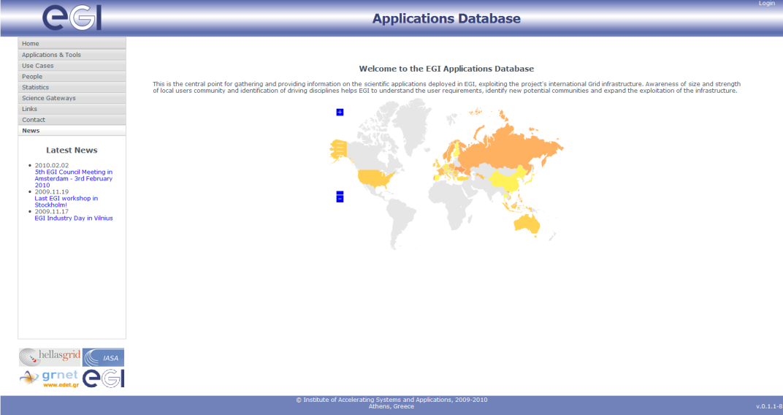
Figure 1. The main page of the AppDB portal, with the navigation pane on the left,
and the data display pane on the right.

The navigation pane contains the following categories:
- Applications and Tools: Allows access to the index of applications and tools, as well as the registration form for new entries [Fig. 1a]. Advanced and quick filters are located on the top of the page, assisting to user to find applications of interest based on his/her given criteria (i.e. discipline, sub-discipline, keywords, regionalized criteria etc.).
- Use Cases: A placeholder containing a link to the EGI Wiki portal, which may allow access to information on successful porting of individual applications in future releases [Fig. 1b].
- People: Allows access to the index of people profiles [Fig. 1c].
- Statistics: Allows access to statistics graphs about applications or people versus various parameters, such as disciplines, countries, etc. [Fig. 1d].
- Science Gateways: A placeholder for allowing access to existing or to be developed information portals within the identified scientific communities [Fig. 1e]. Please refer to section 2.5.2 for more information.

Moreover, there exists a few more tabs under the navigation pane, such as Links, Contact, and News, with self explanatory content. Further details about the features and functionality of the current version of the AppDB are provided in Section 2.3.

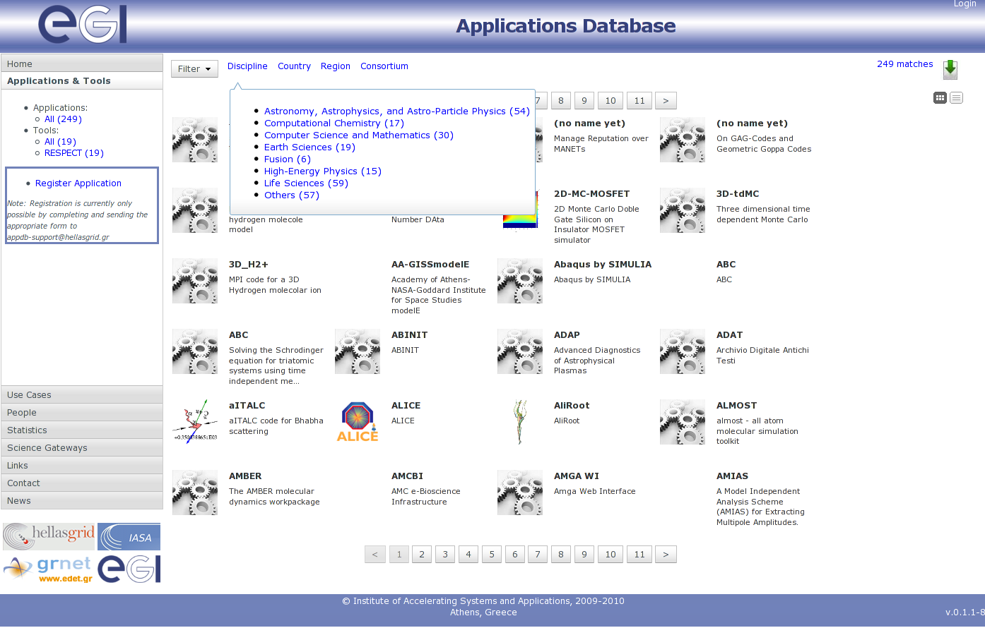
Figure 1a. Applications index, with the navigation pane opened at the
Applications and Tools tab. A toggle-able quick filter is also displayed in the display pane.

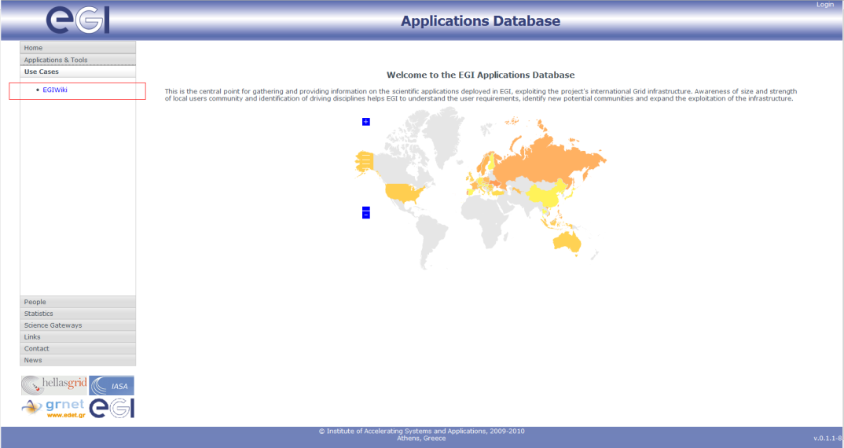
Figure 1b. Use cases opened at the navigation pane. A link to a page in EGI Wiki.

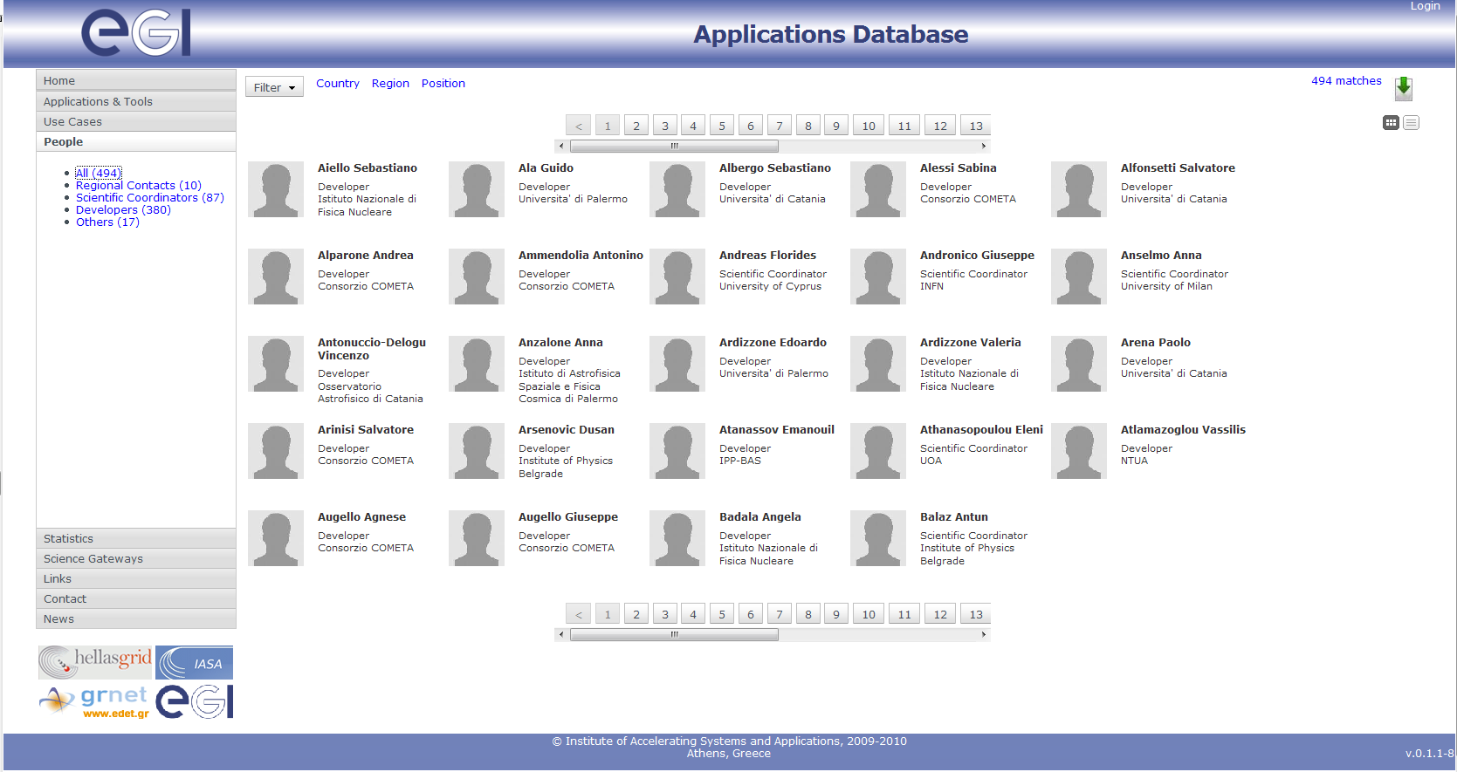
Figure 1c. People profile index, with the navigation pane opened at the People tab.

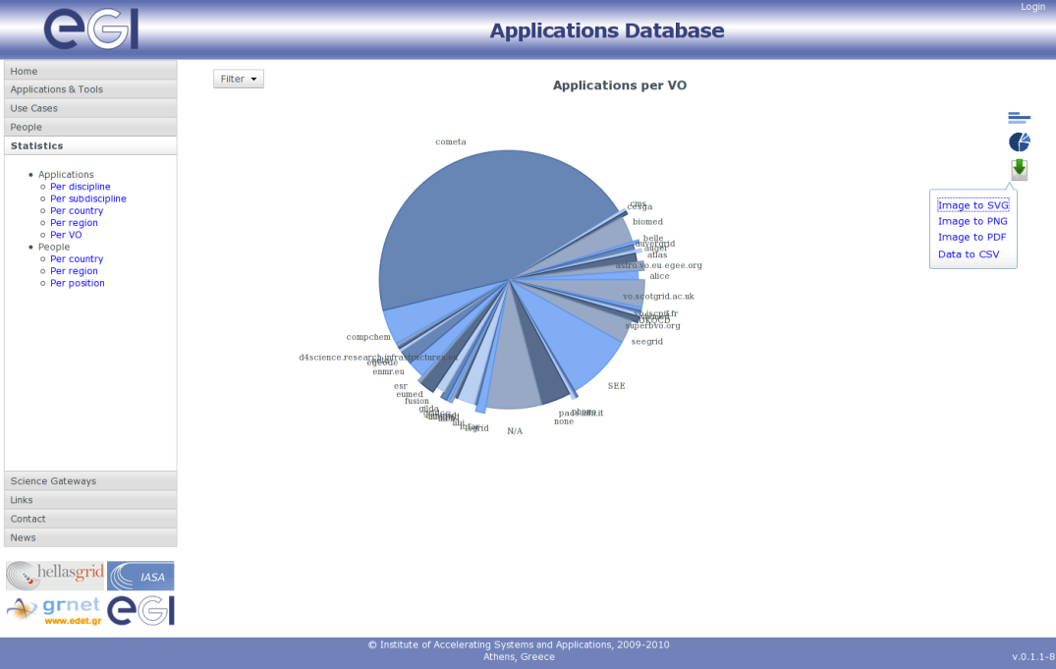
Figure 1d. Statistics pie chart sample, with the navigation pane opened at the Statistics tab.
The export button is activated and shown on the right.

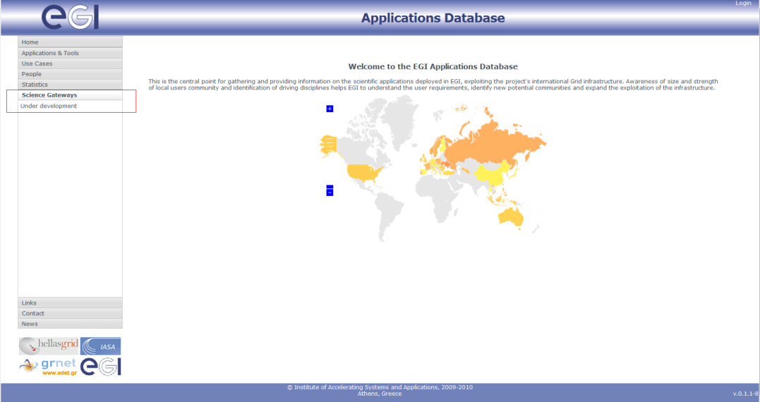
Figure 1e. Scientific Gateways opened at the navigation pane.

Current Status
The AppDB service is in production status since May 2010 [R 1], but it only offers read-only access to the applications and people data. The most important features and functions that are already provided by the service are:

- Features related to Applications and Tools
  - Name, logo, description, discipline, abstract, status, countries, VO data, etc.
  - List of associated researchers and publications
  - List of URLs such as website, documentation, etc.
- Features related to People’s profiles
  - Name, role, institute, country, contact information data
  - List of associated applications and publications (reverse lookup)
- User experience related features
  - people and application statistics graphs: Bar charts and pie charts of people or applications versus discipline, country, region, etc. [Fig. 4]
  - index page / statistics filtering: searching functionality is implemented through an extended data filtering mechanism
  - toggle-able quick filters: for ease-of-use, some properties deemed more important are offered as quick filters located on the top of the page
  - list of documents / publications for applications and people: documents are directly associated with applications, but reverse lookup is possible through people’s profiles
  - grid / list view for index pages: data index pages can be viewed in either a concise grid view, with an emphasis on the datum’s logo/image [Fig. 2a], or a more detailed list view [Fig. 2b] where one can easily see more information about the datum without having to access the properties window [Fig. 3]. Views can be switched through the icon buttons located on the top-right edge of the page
- Data export features
  - XML/CSV export of applications and people data: Simple and concise CSV files, aimed towards human readability, and more detailed XML files aimed towards automated data exchange and analysis
  - PDF/JPG/PNG/SVG export of aforementioned statistics graphs: JPG/PNG formats for general purpose use, scalable SVG format for better presentation, and PDF format for ease-of-use with editors such as LaTeX.
- Other features
  - discrimination between applications and tools: Software packages aimed towards improving application performance and use – such those offered by the RESPECT program – and which do not lead directly to publications, are considered tools and are managed in a different way
  - application links to websites, documentation, etc.
  - manual registration of new applications through an according form offered for download (this is a temporary feature, until the read/write mode of the AppDB is ready for deployment).

As far as the current AppDB content is concerned, the data is the same as it has been migrated from the EGEE Applications Registry plus the webpage of the RESPECT program; this consists of 249 applications, 19 tools, (from the RESPECT program), and 494 people profiles. The Applications Database is publicly accessible at http://appdb.egi.eu, and is also linked from the User Support section of the EGI.eu website [R 3].
One may notice that there are almost twice as many people registered in the database than there are applications, and that most applications are from development teams based in Italy. The former observation is due to the fact that there is usually more than one person involved in the development of a grid application, and there aren’t many applications registered yet from the same team. The large number of Italian applications can be attributed to the fact that the migrated data originating from INFN’s database, which was mainly populated by INFN’s staff. Both of these effects are expected to subside, once the write-enabled version of the AppDB is deployed and more data flows in by the developers, resulting in a better balanced view of applications.

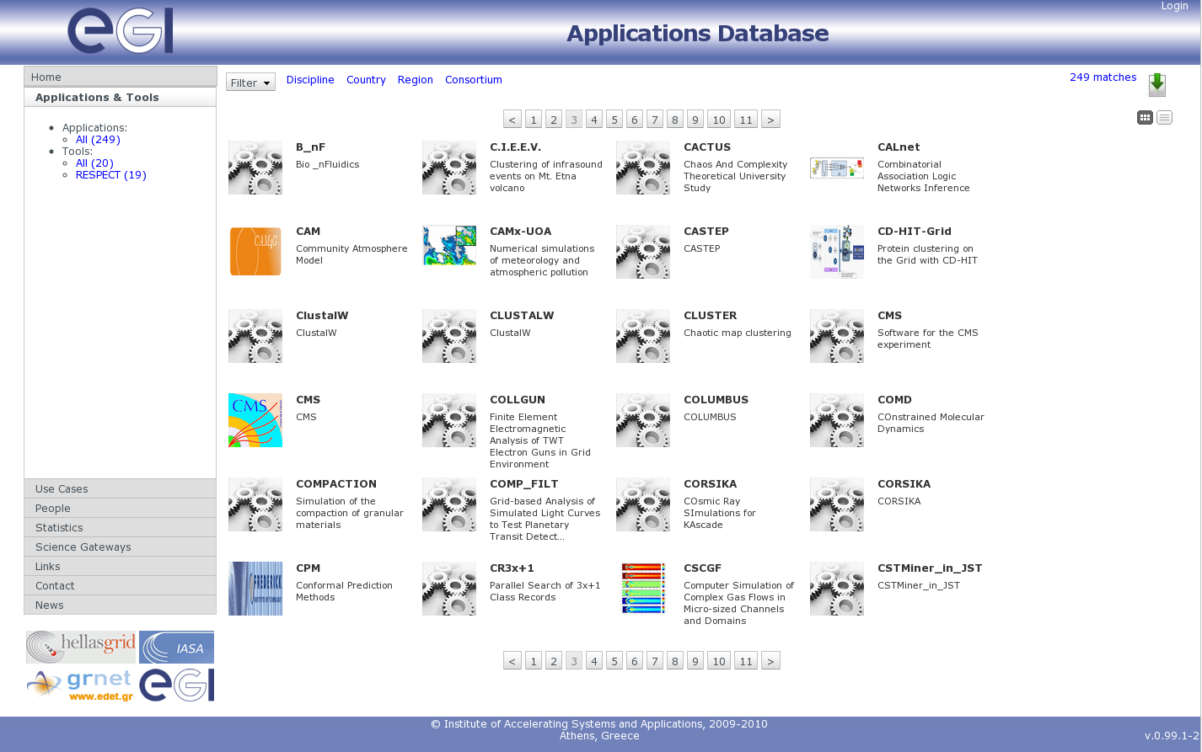
Figure 2a. Application browser (grid view)

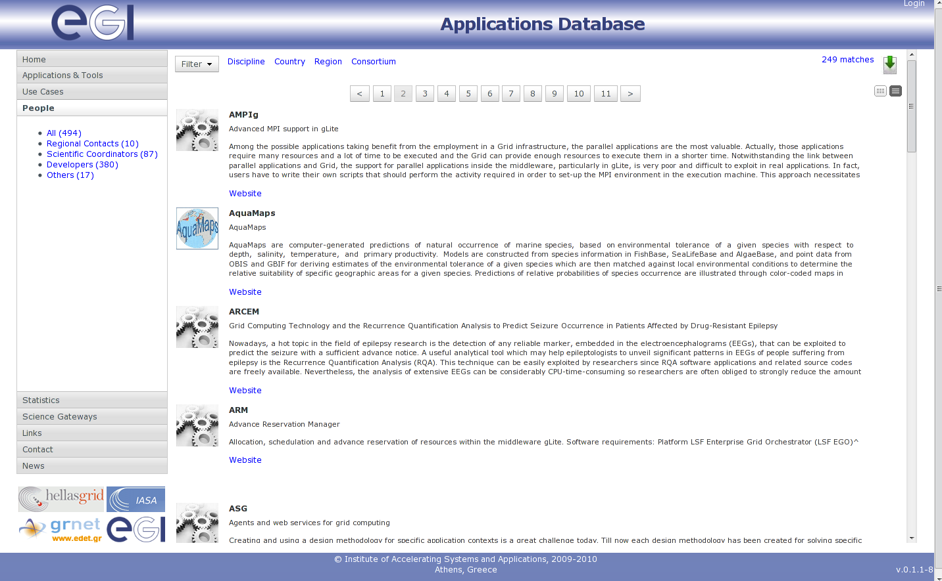
Figure 2b. Application browser (list view)

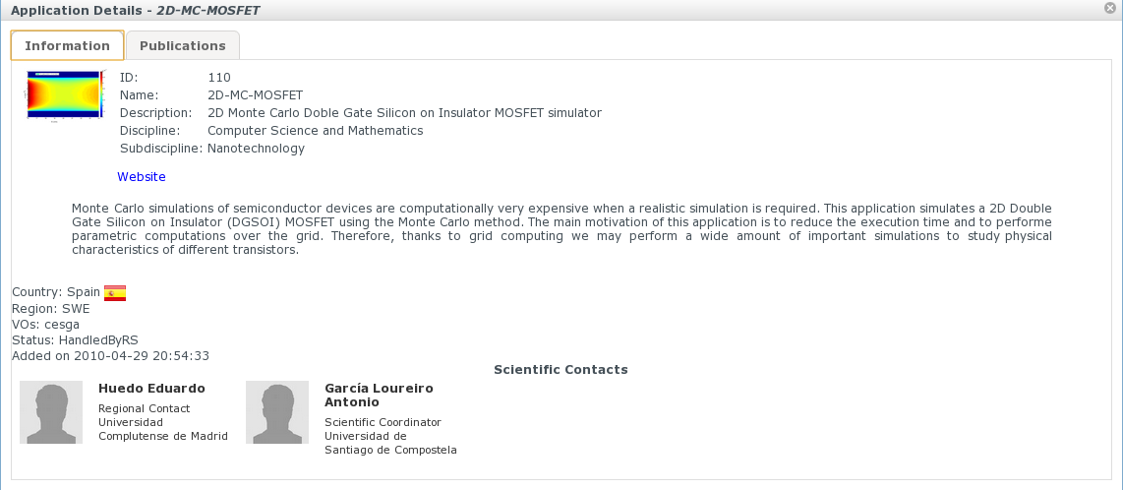
Figure 3. Application details card sample

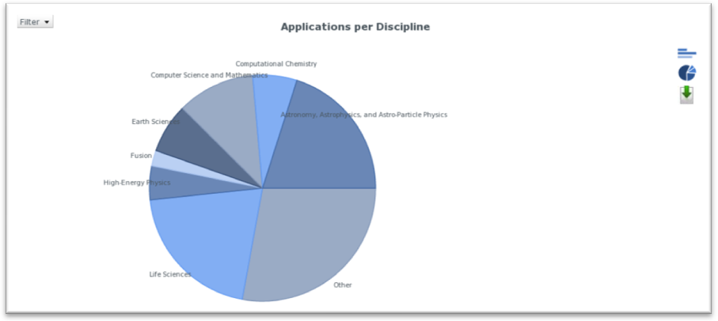

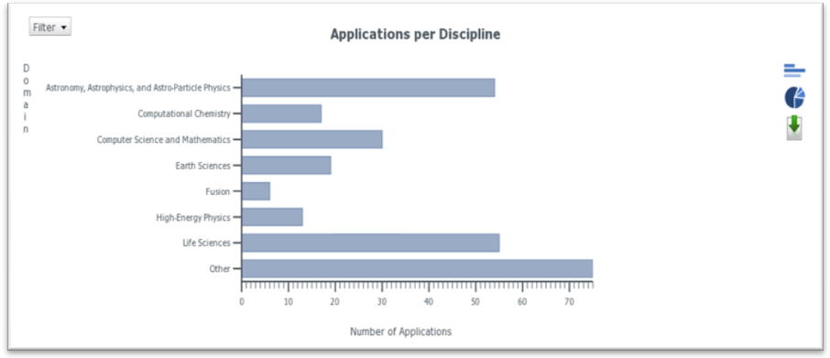
Figure 4. Statistics graph samples

AppDB Support Unit in Global Grid User Support (GGUS)
Communication with the AppDB support staff can be achieved in two ways:
- Through the NGI based mailing list appdb-support@hellasgrid.gr
- Through the AppDB Support Unit established in the Grid Global User Support (GGUS) system.
The main aim of the AppDB support unit is to deal with all kind of issues related to AppDB, such as issues concerning bugs, problems, requests for enhancements, requests for changes/modifications to the AppDB context etc.
In general, the contact procedure can be summarized in the creation of a ticket in GGUS, which gets assigned to the AppDB Support Unit, and an email notification which gets sent to the appdb-support@hellasgrid.gr mailing list.

Next Steps

Upcoming version
The development of the AppDB are focused on the following objectives:
  - Binding the AppDB with the EGI SSO system, and
  - Enabling write mode of the AppDB to users with SSO account to:
- Register new applications, instead of requesting that data be inserted for them by the AppDB support team
- Edit existing application data and associate people with applications [Fig. 5, 6]
- Edit their personal profiles
- Bookmark applications
  - Editing privileges based on users' role and additional permission granting based on a fine-grained control policy
These developments have already been initiated and are planned to be finalized no later than mid September, 2010. The prototype version of the new (upcoming) AppDB, can be accessed (upon request) at [R 2].

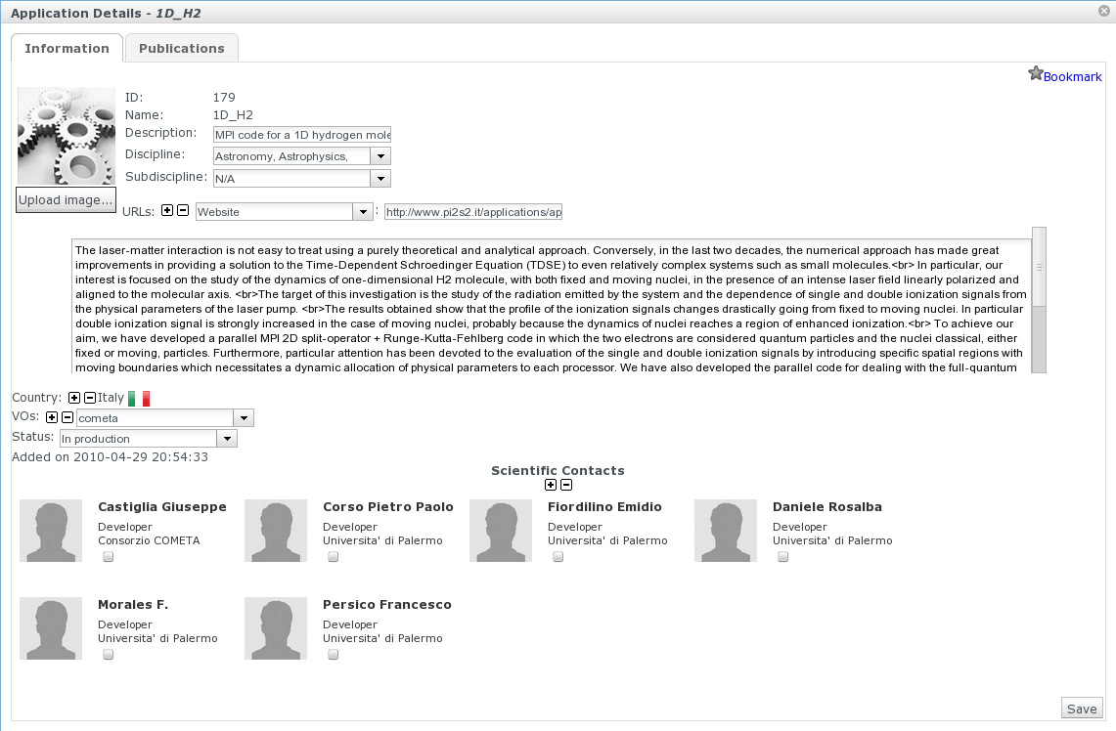
Figure 5. Application information editing card sample

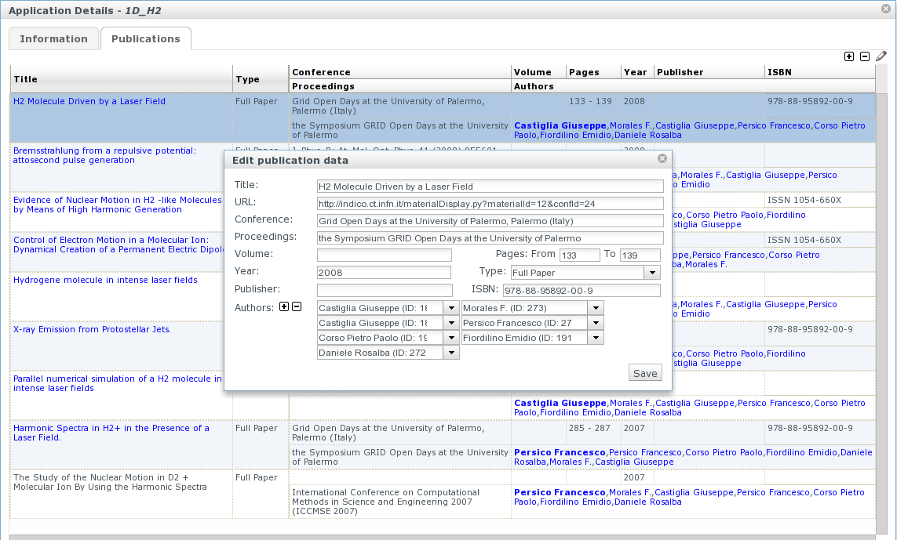
Figure 6. Publication editing card sample

Future versions
There are also plans to perform all the necessary enhancements and modifications needed in order to make the Applications Database also act as a registry for Science Gateways/Portals, which either exist, or will be developed within the identified scientific communities. For this purpose, an entry on the portal’s navigation panel has been reserved. We are going to promote this kind of development to the communities of interest, in three main ways:
  - In a “bulletin form”, through announcements in the Applications Database portal.
  - In a “periodic updates form”, through periodic informative emails, using scientific contacts information contained in the database.
  - In a “news form”, through the creation of discipline-based RSS channels.
Another issue for future development is browser support for IE 8. Currently known supported browsers are Firefox 3.x, Google Chrome 5.x, Safari 5, and Opera 10.x, with the first two most thoroughly tested. At the time being, IE support is rather basic, due to technical reasons attributed to the browser’s particularities. User requests and feedback will be evaluated and compared to the effort needed to implement IE support, in order to plan for its inclusion it in future releases.
One more issue that needs to be evaluated and finally be covered in a future release of the AppDB, it is about the establishment of a review process for the applications/tools that already exists in the AppDB. For example, this procedure should cover the way that obsolete entries get removed from the AppDB.

Conclusion

At the time of writing, the EGI Applications Database consists of 249 registered applications, 19 tools (from the EGEE RESPECT program), and more than 490 people/scientists profiles.
The first release of the EGI Applications Database portal is in production since mid of May 2010 and provides read-only access to hosted application and people data. The next step is finalizing development on the write-enabled mode of the portal, as well as providing an authentication mechanism to registered users through the EGI SSO system. The next release of the AppDB is expected to be in production in the middle of September 2010.

References
R 1 | EGI Application Database (AppDB):  http://appdb.egi.eu
R 2 | Prototype of the next release of AppDB (not publicly available):  http://appdb-dev.marie.hellasgrid.gr/
R 3 | User Support section of the EGI.eu website:  http://www.egi.eu/user-support
R 4 | EGEE Applications Registry:  http://appdb.egee-eu.org
R 5 | INFN interface to EGEE Application registry:  http://grid.ct.infn.it/egee_applications
R 6 | EGEE RESPECT program (Recommended External Software for EGEE Communities)  http://technical.eu-egee.org/index.php?id=290

