EGI-InSPIRE

Establishing the policy area of the website covering the policy bodies and collaborating projects

EU MILESTONE: MS205

Document identifier: | EGI-MS205-final
Date: | 04/11/2010
Activity: | NA2
Lead Partner: | EGI.eu
Document Status: | DRAFT
Dissemination Level: | PUBLIC
Document Link: | https://documents.egi.eu/document/93

Abstract
The purpose of this document is to describe how the EGI.eu website has been structured to reflect the establishment of policy development activity within EGI and interaction with external project and organisations.

- Copyright notice
Copyright © Members of the EGI-InSPIRE Collaboration, 2010. See www.egi.eu for details of the EGI-InSPIRE project and the collaboration. EGI-InSPIRE (“European Grid Initiative: Integrated Sustainable Pan-European Infrastructure for Researchers in Europe”) is a project co-funded by the European Commission as an Integrated Infrastructure Initiative within the 7th Framework Programme. EGI-InSPIRE began in May 2010 and will run for 4 years. This work is licensed under the Creative Commons Attribution-Noncommercial 3.0 License. To view a copy of this license, visit http://creativecommons.org/licenses/by-nc/3.0/ or send a letter to Creative Commons, 171 Second Street, Suite 300, San Francisco, California, 94105, and USA. The work must be attributed by attaching the following reference to the copied elements: “Copyright © Members of the EGI-InSPIRE Collaboration, 2010. See www.egi.eu for details of the EGI-InSPIRE project and the collaboration”. Using this document in a way and/or for purposes not foreseen in the license, requires the prior written permission of the copyright holders. The information contained in this document represents the views of the copyright holders as of the date such views are published.
- Delivery Slip
 | Name | Partner/Activity | Date
From | Damir Marinovic  Sergio Andreozzi | EGI.eu/NA2 | 23/08/2010
Reviewed by | Moderator: Catherine Gather  Reviewers: Per Öster | EGI.eu | 10/09/2010
Approved by | AMB & PMB |  | 27/9/10
- Document Log
Issue | Date | Comment | Author/Partner
1 | 5/8/2010 | Table of Content | Sergio Andreozzi, Damir Marinovic (EGI.eu)
2 | 5/8/2010 | Revised Table of Content | Sergio Andreozzi, Damir Marinovic (EGI.eu)
3 | 23/8/2010 | Full draft | Sergio Andreozzi, Damir Marinovic (EGI.eu)
4 | 23/8/2010 | Minor corrections | Sergio Andreozzi, Damir Marinovic (EGI.eu)
5 | 14/9/2010 | Revised following comments from reviewers | Sergio Andreozzi, Damir Marinovic (EGI.eu)
6 | 27/09/2010 | New screenshots | Sergio Andreozzi, Damir Marinovic (EGI.eu)
- Application area
This document is a formal deliverable for the European Commission, applicable to all members of the EGI-InSPIRE project, beneficiaries and Joint Research Unit members, as well as its collaborating projects.
- Document amendment procedure
Amendments, comments and suggestions should be sent to the authors. The procedures documented in the EGI-InSPIRE “Document Management Procedure” will be followed:
https://wiki.egi.eu/wiki/Procedures

- Terminology
A complete project glossary is provided at the following page: http://www.egi.eu/about/glossary/.
- PROJECT SUMMARY

To support science and innovation, a lasting operational model for e-Science is needed − both for coordinating the infrastructure and for delivering integrated services that cross national borders.

The EGI-InSPIRE project will support the transition from a project-based system to a sustainable pan-European e-Infrastructure, by supporting ‘grids’ of high-performance computing (HPC) and high-throughput computing (HTC) resources. EGI-InSPIRE will also be ideally placed to integrate new Distributed Computing Infrastructures (DCIs) such as clouds, supercomputing networks and desktop grids, to benefit user communities within the European Research Area.

EGI-InSPIRE will collect user requirements and provide support for the current and potential new user communities, for example within the ESFRI projects. Additional support will also be given to the current heavy users of the infrastructure, such as high energy physics, computational chemistry and life sciences, as they move their critical services and tools from a centralised support model to one driven by their own individual communities.

The objectives of the project are:
- The continued operation and expansion of today’s production infrastructure by transitioning to a governance model and operational infrastructure that can be increasingly sustained outside of specific project funding.
- The continued support of researchers within Europe and their international collaborators that are using the current production infrastructure.
- The support for current heavy users of the infrastructure in earth science, astronomy and astrophysics, fusion, computational chemistry and materials science technology, life sciences and high energy physics as they move to sustainable support models for their own communities.
- Interfaces that expand access to new user communities including new potential heavy users of the infrastructure from the ESFRI projects.
- Mechanisms to integrate existing infrastructure providers in Europe and around the world into the production infrastructure, so as to provide transparent access to all authorised users.
- Establish processes and procedures to allow the integration of new DCI technologies (e.g. clouds, volunteer desktop grids) and heterogeneous resources (e.g. HTC and HPC) into a seamless production infrastructure as they mature and demonstrate value to the EGI community.

The EGI community is a federation of independent national and community resource providers, whose resources support specific research communities and international collaborators both within Europe and worldwide. EGI.eu, coordinator of EGI-InSPIRE, brings together partner institutions established within the community to provide a set of essential human and technical services that enable secure integrated access to distributed resources on behalf of the community.

The production infrastructure supports Virtual Research Communities (VRCs) − structured international user communities − that are grouped into specific research domains. VRCs are formally represented within EGI at both a technical and strategic level.

- EXECUTIVE SUMMARY

The aim of this document is to describe how the EGI website was structured, provide an overview of the general policy development activities in EGI.eu, general description of the policy groups within EGI.eu and the description of EGI.eu collaboration with external partners. A summary of the main contents and the rationale behind it is provided while more detail is available on the website itself.

A well-structured website policy area will mainly help the NGIs and EIROs to quickly identify policy development activities and designated contact points to act on and cooperate with; to discover the policy documents produced by specific policy groups and to obtain a clear overview about external policy actions with project, international policy bodies, external resource providers and new Virtual Research Communities.

The landing page of the website policy area provides answers to key questions to let the reader understand definition, role and principles of EGI.eu policies. The website is then organized in sections for internal and external policy activities. The former refers to policies with impact within the EGI collaboration and are mainly defined by internal policy groups. The latter refer to policies involving relationships with external partners.

The URL structuring provides a stable and clear organization of the information and dedicated pages for individual policy groups and external partners. Consistent and clear structure ease the finding of the information and it is easy linking to them.
TABLE OF CONTENTS
1 Introduction 6
2 Website Organization for the Policy Area 7
3 Conclusion 13
4 References 14

Introduction

The purpose of this document is to describe how the EGI website was structured in order to provide general information about policy activities within EGI.eu, as well as EGI.eu collaboration with other projects or organizations.

Establishing a well-structured policy area in the EGI.eu website will mainly help the NGIs and EIROs to quickly identify policy development activities and designated contact points to act on and cooperate with; to discover the policy documents produced by specific policy groups and to obtain a clear overview about external policy actions with project, international policy bodies, external resource providers and new Virtual Research Communities.

In general, the policy content on the EGI website provides a broad overview and introduction to the policy activities, groups and documents, with content that remains fairly static. The EGI website and policy website area is maintained by a small team of administrators and content managers. Policy information that needs to be updated on a regular basis will be added to EGI wiki site. Thus, the policy area content needs to be balanced between the general information that is necessary for the audience to grasp the way policy development process works in EGI.eu and audience interested in more detailed and precise content and in specific policy documents of the concrete policy groups.

We emphasise that the primary goal, when it comes to the policy development process within EGI.eu, is to respond to all the requests and inputs of the relevant stakeholders involved and affected by EGI.eu policies. This will ultimately lead to well defined and well balanced policies which will represent the best interest of its key stakeholders (NGIs, EIROs etc.) and contribute to the sustainable grid infrastructure available to all European scientists and researchers and their international collaborators.

The document is structured as follows: Section 2 of this document describes the website organization for the policy area while Section 3 draws up conclusion.

Website Organization for the Policy Area

The goal of the EGI.eu policy development team is to support the development of policy within and external to EGI.eu in conjunction with EGI‘s stakeholders relating to governance, standardization and integration with other infrastructures. A proper communication about the policy development process, activities and collaborations is essential for more effective policy actions.

The importance and role of the policy activity is often misunderstood and underestimated. While the main target for the website policy area are NGIs and EIROs, a number of external parties will be interested in learning about the policy making activity of the EGI collaboration.

For this reason, the entry point page of the website policy area is dedicated to explaining the basics of the EGI.eu policy activity. Answers to the following key questions are provided:
- What are EGI.eu policies?
- Why are EGI.eu policies important?
- What are EGI.eu's policy development principles?

The website policy area is then divided in two main areas: internal policy activity and external policy activity. The internal policy actions have an impact within the boundaries of the EGI collaboration, while external policy actions focus mainly on collaboration with external entities.

Policy groups are created to define internal policies and procedures within a specific functional area (i.e., technology, operations, user community, policy and administration); they are working bodies responsible for developing EGI.eu strategic and operational policy framework and thus ultimately enabling stability and availability of generic e-Infrastructure. Each policy group has a well-defined responsibility, composition and operational procedures. It is chaired by an acknowledged expert in the subject area from the community that is responsible to the relevant senior EGI.eu manager for the successful execution of the group‘s remit [R3]. The policy groups that have been established via a Terms of Reference are:
- Technology
  - Technology Coordination Board (TCB)
- Operations
  - Operations Management Board (OMB)
  - Operational Tools Advisory Group (OTAG)
  - Operations Automation Team (OAT)
- User Community
  - User Community Board (UCB)
  - User Services Advisory Group (USAG)
- Security
  - Security Policy Group (SPG)
  - Software Vulnerability Group (SVG)
  - Security Coordination Group (SCG)
- Organizational
  - External Advisory Committee (EAC)

All the policy groups except the EAC are under the responsibility of EGI.eu and its governing bodies. The EAC is a policy group part of the EGI-InSPIRE project. For each policy group, a dedicated page is present describing: group name, contact details for the chair and secretary, functional area, purpose and links to the terms of reference, wiki page and the approved documents.

The external collaborations involve the definition of formal agreement between EGI.eu and external entities (e.g., European-funded projects, organizations) via Memorandum of Understandings (MoU) [R4]. A general page introducing the policy actions is presented. Moreover, specific pages for each party with which formal agreements exists is provided.

The external partners with which agreements are in the process of being defined fall in the following categories: 1) technology provider; 2) infrastructure provider; 3) dissemination/coordination actions; 4) virtual research community. In Table 1, we summarize the URL structure for the policy area of the website.
Table 1 URL Structure for the Policy Area
Relative URL | Content
/policy | General page about EGI.eu policies
/policy/internal | General page about policy groups
/policy/internal/[GROUP_NAME]_[ACRONYM] | Internal Policy Group - dedicated page
/policy/external | General page about external collaborations
/policy/external/[PARTNER_NAME] | External partner – dedicated page

In Figures 1,2,3 and 4 you can see sample screenshot of the policy area pages in the EGI.eu website.
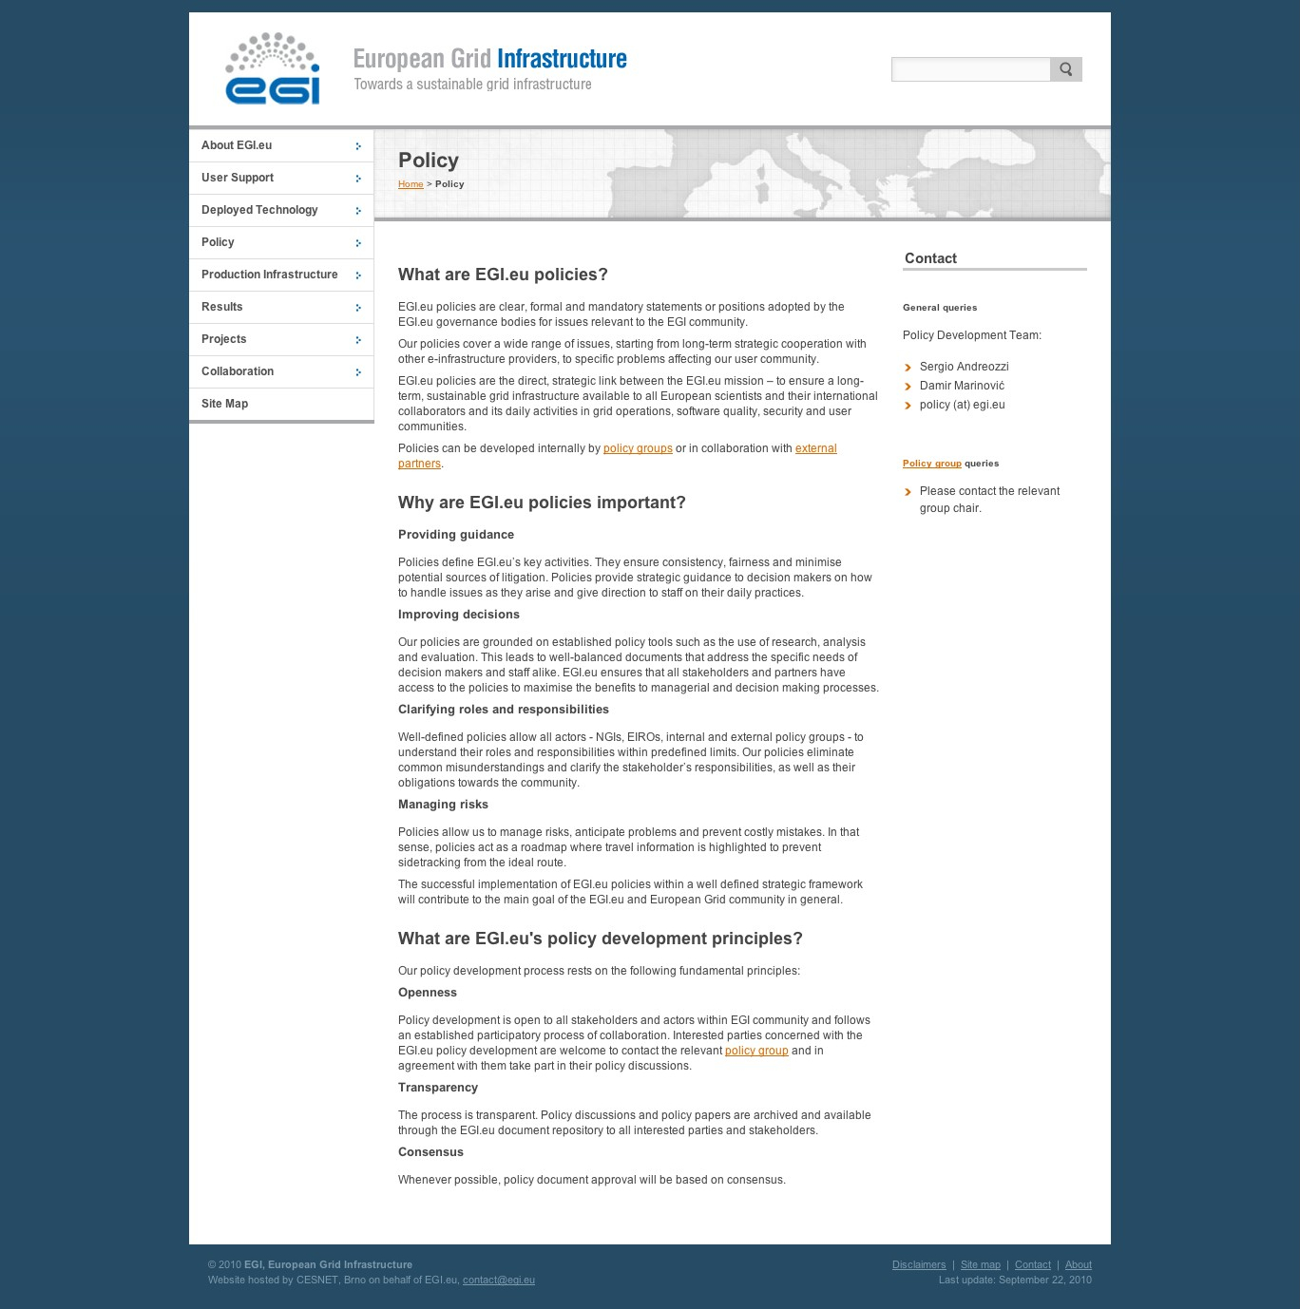
Figure 1 - General page about EGI.eu policies

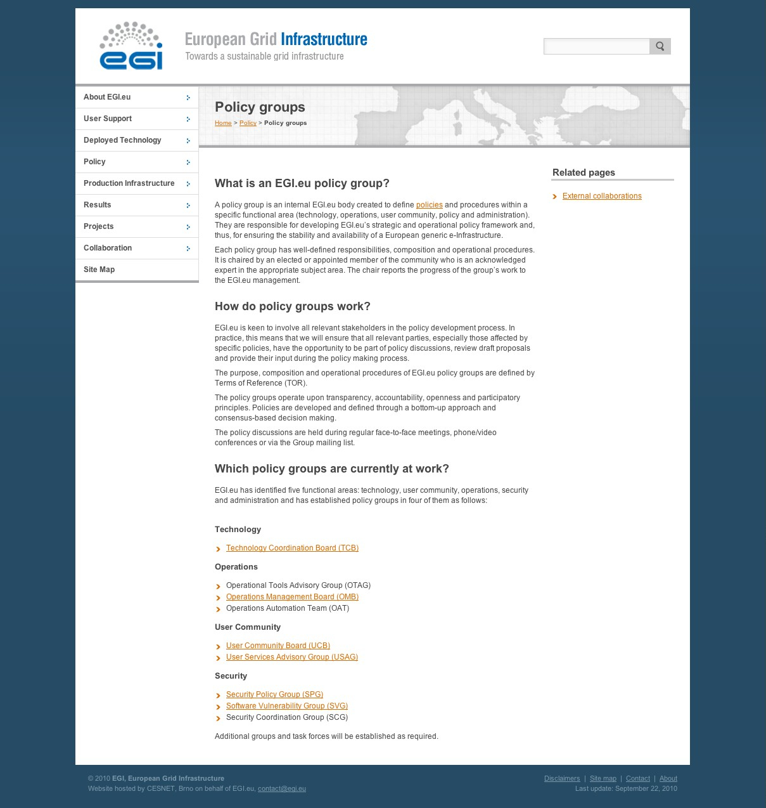
Figure 2 - General page about EGI.e policy groups

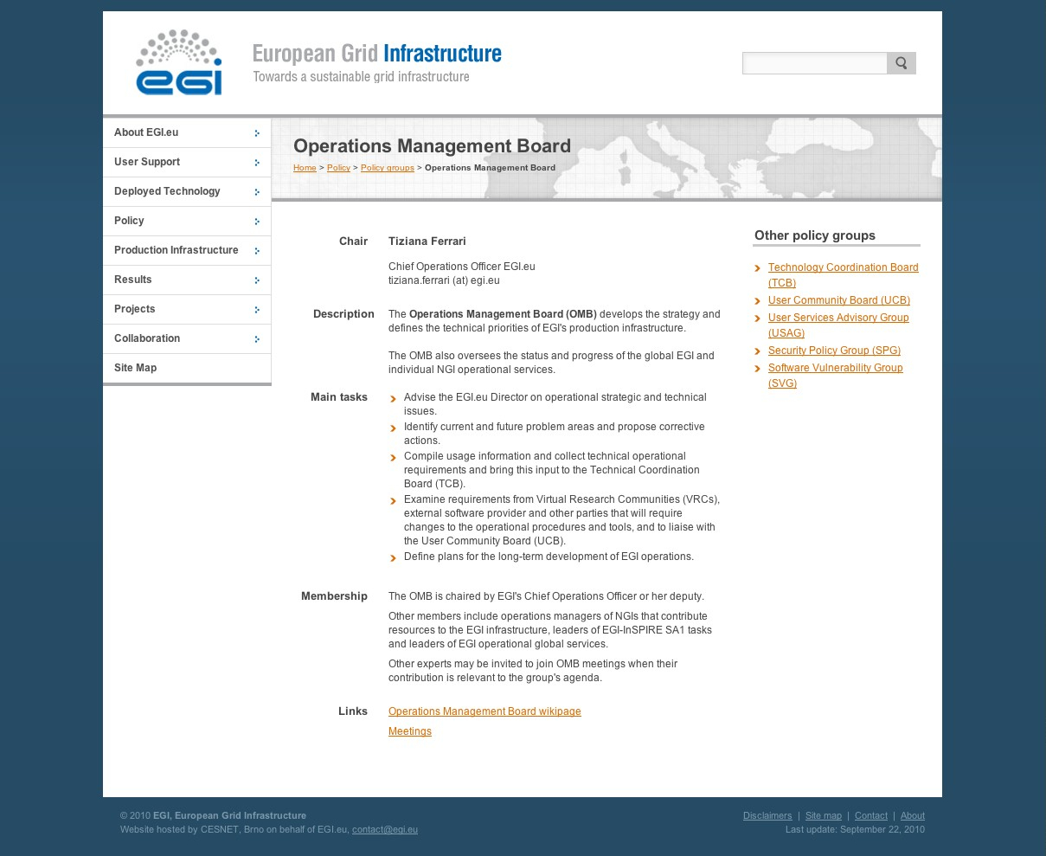
Figure 3 - Sample page about an internal policy group (OMB)

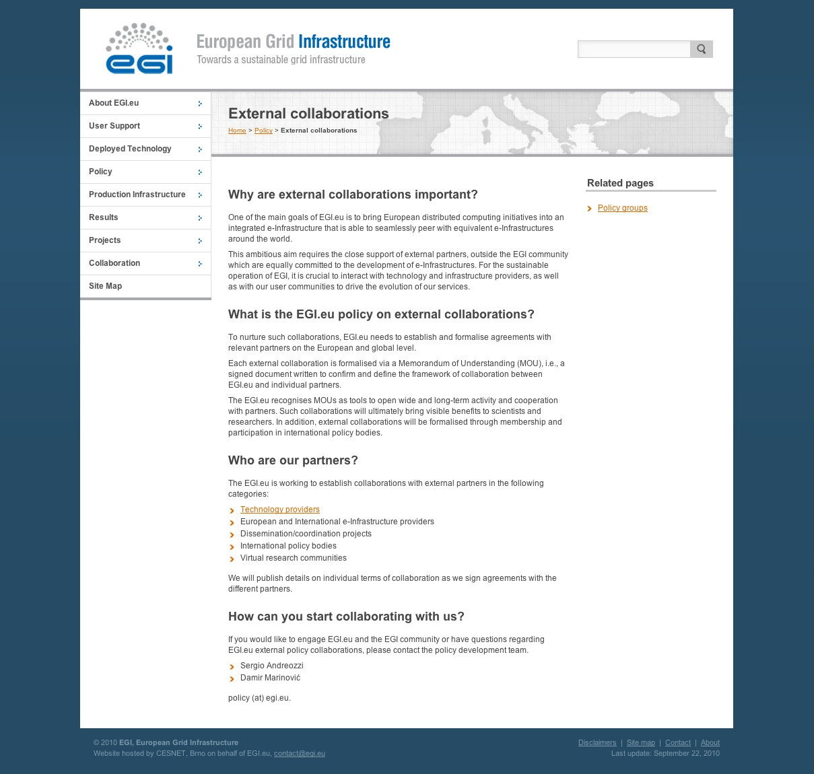
Figure 4 - General page about EGI.eu external collaborations

Conclusion

The goal of this document was to describe how the EGI website was expanded to include a dedicated policy area. The target audience and the rationale behind the organization of the information were explained. While the current EGI.eu website is a work in progress, the imposed structure of the policy area will enable the content to mature in a stable and clear organization enabling interested parties to locate the needed information for participating in the policy making activity of EGI.

References
R 1 | MS201 EGI Website https://documents.egi.eu/document/126
R 2 | EGI-InSPIRE Description of Work (DoW) https://documents.egi.eu/document/10
R 3 | MS206 Terms of Reference and initial composition of the policy related groups within EGI.eu https://documents.egi.eu/document/125
R 4 | Memorandum of Understanding (MoU) Framework https://documents.egi.eu/document/88

