EGI-InSPIRE

User Support Metrics

EU MILESTONE: MS304

Document identifier: | input.doc
Date: | 05/11/2010
Activity: | NA3
Lead Partner: | EGI.eu
Document Status: | FINAL
Dissemination Level: | PUBLIC
Document Link: | https://documents.egi.eu/document/94

Abstract
The purpose of this deliverable to define metrics for the monitoring of the efficiency and effectiveness of the user support processes of EGI-InSPIRE. The document focuses on metrics related to the Helpdesk system, because the Helpdesk provides a backbone for all the user support services and through this backbone a uniform monitoring of user services seems the most reasonable.

- Copyright notice
Copyright © Members of the EGI-InSPIRE Collaboration, 2010. See www.egi.eu for details of the EGI-InSPIRE project and the collaboration. EGI-InSPIRE (“European Grid Initiative: Integrated Sustainable Pan-European Infrastructure for Researchers in Europe”) is a project co-funded by the European Commission as an Integrated Infrastructure Initiative within the 7th Framework Programme. EGI-InSPIRE began in May 2010 and will run for 4 years. This work is licensed under the Creative Commons Attribution-Noncommercial 3.0 License. To view a copy of this license, visit http://creativecommons.org/licenses/by-nc/3.0/ or send a letter to Creative Commons, 171 Second Street, Suite 300, San Francisco, California, 94105, and USA. The work must be attributed by attaching the following reference to the copied elements: “Copyright © Members of the EGI-InSPIRE Collaboration, 2010. See www.egi.eu for details of the EGI-InSPIRE project and the collaboration”. Using this document in a way and/or for purposes not foreseen in the license, requires the prior written permission of the copyright holders. The information contained in this document represents the views of the copyright holders as of the date such views are published.
- Delivery Slip
 | Name | Partner/Activity | Date
From | Robert Lovas | MTA SZTAKI | 28/07/2010
Reviewed by | Moderator: Catherine Gater  Reviewers:  Sergio Andreozzi  Damir Marinovic | EGI.eu  EGI.eu  EGI.eu | 09/08/2010  09/08/2010
Approved by | AMB&PMB |  | 22/10/2010
- Document Log
Issue | Date | Comment | Author/Partner
1 | 16/06/2010 | Initial document | Steve Brewer/EGI.eu
2 | 09/08/2010 | First draft | Robert Lovas/MTA SZTAKI
3 | 05/09/2010 | Modifications and updates according to reviews and new document template | Imre Szeberenyi/BME
4 | 08/09/2010 | Update before review | Gergely Sipos/EGI.eu
5 | 05/10/2010 | Correcting typos as reviewer | Damir Marinovic/EGI.eu
6 | 06/10/2010 | Finalizing document, formatting | Karolis Eigelis/EGI.eu
7 | 07/10/2010 | Extend abstract, executive summary and conclusions | Gergely Sipos, Steve Brewer/EGI.eu

- Application area
This document is a formal deliverable for the European Commission, applicable to all members of the EGI-InSPIRE project, beneficiaries and Joint Research Unit members, as well as its collaborating projects.

- Document amendment procedure
Amendments, comments and suggestions should be sent to the authors. The procedures documented in the EGI-InSPIRE “Document Management Procedure” will be followed:
https://wiki.egi.eu/wiki/Procedures
This document is the first version of four milestone documents to be produced by the EGI-InSPIRE project about User Support Metrics: MS304, MS307, MS310, MS313. Updates will be made at project months 15, 27 and 39.

- Terminology
A complete project glossary is provided at the following page: http://www.egi.eu/about/glossary/.
- PROJECT SUMMARY
To support science and innovation, a lasting operational model for e-Science is needed − both for coordinating the infrastructure and for delivering integrated services that cross national borders.

The EGI-InSPIRE project will support the transition from a project-based system to a sustainable pan-European e-Infrastructure, by supporting ‘grids’ of high-performance computing (HPC) and high-throughput computing (HTC) resources. EGI-InSPIRE will also be ideally placed to integrate new Distributed Computing Infrastructures (DCIs) such as clouds, supercomputing networks and desktop grids, to benefit user communities within the European Research Area.

EGI-InSPIRE will collect user requirements and provide support for the current and potential new user communities, for example within the European Strategy Forum on Research Infrastructures (ESFRI) projects. Additional support will also be given to the current heavy users of the infrastructure, such as high energy physics, computational chemistry and life sciences, as they move their critical services and tools from a centralised support model to one driven by their own individual communities.

The objectives of the project are:

- The continued operation and expansion of today’s production infrastructure by transitioning to a governance model and operational infrastructure that can be increasingly sustained outside of specific project funding.
- The continued support of researchers within Europe and their international collaborators that are using the current production infrastructure.
- The support for current heavy users of the infrastructure in earth science, astronomy and astrophysics, fusion, computational chemistry and materials science technology, life sciences and high energy physics as they move to sustainable support models for their own communities.
- Interfaces that expand access to new user communities including new potential heavy users of the infrastructure from the ESFRI projects.
- Mechanisms to integrate existing infrastructure providers in Europe and around the world into the production infrastructure, so as to provide transparent access to all authorised users.
- Establish processes and procedures to allow the integration of new DCI technologies (e.g. clouds, volunteer desktop grids) and heterogeneous resources (e.g. HTC and HPC) into a seamless production infrastructure as they mature and demonstrate value to the EGI community.

The EGI community is a federation of independent national and community resource providers, whose resources support specific research communities and international collaborators both within Europe and worldwide. EGI.eu, coordinator of EGI-InSPIRE, brings together partner institutions established within the community to provide a set of essential human and technical services that enable secure integrated access to distributed resources on behalf of the community.

The production infrastructure supports Virtual Research Communities (VRCs) − structured international user communities − that are grouped into specific research domains. VRCs are formally represented within EGI at both a technical and strategic level.

- EXECUTIVE SUMMARY
The user community within EGI is supported by a number of services: Training Events, Training Repository, Applications Database, VO (Virtual Organisation) Services, Software Repository, Documentations, Consulting for New Communities, Application Porting Support, Requirements Gathering, and EGI/NGI (National Grid Initiative) Helpdesks for the above services. The Helpdesk is used as a backbone by users and by user support teams to initiate and deliver services.
In this deliverable, we define the EGI Helpdesk related metrics that can be used to optimise the user support process and monitor the performance of the support teams as part of the project’s quality assurance process.
Different approaches and practices to measuring helpdesk performance have been examined [R1][R2][R3], and the metrics have been defined in the following groups:
- SLA (Service Level Agreement) related metrics with common helpdesk performance metrics
- End user satisfaction related metrics based on surveys (strongly related to MS305)
- Efficiency metrics to discover the relationship between helpdesk operating costs and performance
- Metrics related to user follow-up (cross-subtasks metrics)
- Training evaluation (as one of the main focus points)

The metrics discussed in this document are a superset of those that are collected by NA3 on a quarterly basis for the project’s Quarterly Reports. The metrics that will be collected are introduced in the D1.1 - Quality Plan and Project Metrics document [R4]. On the other hand, the metrics discussed in this document are presented as discussion points to guide future planning. Collecting all of the metrics described here every three months in timely manner would not be viable for economic and technical reasons. Consequently, this document aims to initiate discussion between the stakeholders of EGI User Support and EGI technology providers on metrics that could be collected by the project in order to have a clear picture of the efficiency of user services and on the technology that enables the project to collect these matrices every three months.
TABLE OF CONTENTS

1 Introduction 7
2 User & Community Support mechanism 7
3 Design concerns 8
4 SLA related metrics 8
5 End user satisfaction related metrics 11
6 Operational cost vs. user support performance 14
7 Metrics related to user follow-up process 15
8 DEFINITIONS 16
Conclusion 16
9 References 18
10 Appendix: Training evaluation form 19

Introduction
This document describes the metrics related to Helpdesk in User Support. The defined metrics must be collected by the TNA3 activities and evaluated by the project management, the quality managers together with the WP leaders.

User & Community Support mechanism
The support mechanisms that EGI provides will be tuned to the different structures within each user community. For instance, for many large user communities, the VRC, or similar community-based coordinating body will provide the focal point for EGI.eu to engage strategically with their utilisation of the infrastructure and for a communities own support infrastructures to be integrated with EGI’s through the EGI Helpdesk so that the user has an integrated view of the combined EGI support function. Smaller communities, which rely much more on ad hoc support mechanisms within their own community for solving their community specific issues, will still be able to access the support mechanisms within EGI User Support coordinated by the User & Community Support.
The team in EGI.eu is responsible for coordination of these activities but mostly delivered by support teams in other EGI-InSPIRE partners or outside the project. Partners provide generic training and application porting support, to contribute entries into the application database, provide consultancy and support new communities.
Assistance for new users and new communities in their initial use of the production infrastructure is essential for the community to expand. All users will be encouraged to make contact through the EGI Helpdesk so that the activity associated with their request can be tracked and the response monitored. For new users and communities this initial interaction will be followed by a face-to-face meeting to understand their needs – if contact has not already been established on previous occasions. The NGIs contribute effort to distributed user-support teams. These are brought together as support units within the EGI Helpdesk.

The user community within EGI is supported by a number of services:
- Training Events
- Training Repository
- Applications Database
- VO Services
- Software Repository
- Documentations
- Consulting for New Communities
- Application Porting Support
- Requirements Gathering
- Helpdesk for the above listed services.

Design concerns
To avoid reaching false conclusions when measuring helpdesk performance due to an insufficiently comprehensive analysis, we suggest applying different measurement approaches. As the result, various summary reports will be needed in order to measure the performance of the User & Community support since the metrics introduced for measurement might be on five pillars:
- SLA related metrics with common helpdesk performance metrics (see Section 4)
- End user satisfaction related metrics based on surveys (see Section 5)
- Efficiency metrics to discover the relationship between help desk operating costs and performance (see Section 6)
- Metrics related to user follow-up as cross-subtasks metrics (see Section 7)
- Training evaluation as one of the main focus points (see Section 11 – Appendix )

The first four pillars are mostly orthogonal ones, and the training evaluation is listed separately as one of the most important key areas with their indicators. The End user satisfaction related metrics together with Training evaluation are based on surveys, and are strongly related to MS305: User Feedback and Recommendations. That is why these metrics are to be detailed in MS305. Most of the defined metrics have been assigned to project objectives and (sub)tasks, which can help interpret more correctly the metrics.
In case of automated monitoring (e.g. ticket resolution related metrics) the frequency of evaluation can be defined in a relatively wide range; monthly, quarterly, and yearly. However, the end user satisfaction and follow-up related metrics will be measured and evaluated only quarterly and yearly due to the nature of metrics, the training evaluation forms are evaluated right after the trainings.

SLA related metrics
Since the support teams within EGI.eu and the EGI-InSPIRE project may fail to promptly respond to support issues (identified as a risk with ‘medium’ probability of occurrence in the DoW); the SLA-related NA3 metrics and the related monitoring process must have crucial role in the quality management process in order to detect and (in the best case) avoid such situations. Some other related but important metrics can help discover the structure and behaviour of user community. E.g. what is behind the increasing number of users and increasing total usage time of applications/number of tickets at the same time? Is it caused by heavier activity from some top users instead of several new but inactive users, or do the new users generate more load and tickets? By answering these questions, the success (and quality) of the user and community support activities can be judged in a more objective manner.
NA3 Metrics – SLA objectives
The metrics presented in Table 1 can be obtained by traditional monitoring tools.

Objective | Task | Metric | Frequency | Target
Coordination of effective, responsive support for the EGI user communities (both individual VOs and those represented by VRCs) through the efforts of the national and specialist support units. | TNA3.3: NGI User Support Teams | - number of users of EGI resources (see Definitions)  - number of support tickets raised through NGIs and also number escalated to EGI | Monthly, Quarterly, Yearly | - 20% growth year on year for no. of users  - low % of tickets escalated to EGI; targeted sustainable reduction is 3-5%/ year from the 2nd year  - total number
Coordination of training, documentation and technical requirements from the user communities to improve the EGI user experience and services. | TNA3.2: User & Community Support Team | - uptime of EGI websites  - number of support tickets raised through GGUS (broken down into communities)  - meantime to resolve tickets  - meantime to resolve longest 10% of tickets  - number of new communities acquired (see Definitions)  - usage and availability of documentation (by material type, community, source), see Definitions  - number of requests for new training material  - number of tickets that required explanations not covered by existing available) documentation | Monthly, Quarterly, Yearly | - 99% Website uptime  - significant but realistic reduction in meantime resolution times each year; targeted sustainable reduction is 3-5%/ year from the 2nd year  - increasing number of new communities  - training session numbers increasing  - number of training material downloads  - tickets requiring (directly or indirectly) new documentation material to be made available: 20% diminishing over time.
Coordination of technical services to support the establishment and management of virtual organisations. | TNA3.4: Technical Services | - mean uptime of application database  - number of working items in app database  - mean uptime of trainers database  - number of trainers in database  - number of newly ported applications  - total usage time of all applications against hosting service (NGI) | Monthly, Quarterly, Yearly | - 99% application DB uptime  - increasing number of applications  - more and more trainers in the database  - increasing number of newly ported applications (see Definitions)  - total usage time of all applications including/excluding the most active 10% and 25% of users
To adhere to EU project management regulations | TNA3.1: Activity Management | - formal EU reports (deliverables) submitted in good time for internal review  - deliverables meet internal QA (Quality Assurance) standards  - mean time to return reviews of other deliverables  - total number of deliverables reviewed | Quarterly for project reports  As specified by the DoW for all other reports | - 100%  - 100%  - 2 weeks (time specified by project Quality Assurance)  - 100% of the documents allocated to NA3
Table 1. Metrics related to SLA objectives

End user satisfaction related metrics
Usually most of the widespread metrics in the Grid training and support are related to SLA objectives (meantime to resolve tickets, help desk availability, etc.) but in addition to formal SLA objectives, the measure of end user satisfaction is another essential factor to take into account, which can validate the quality management achievements.

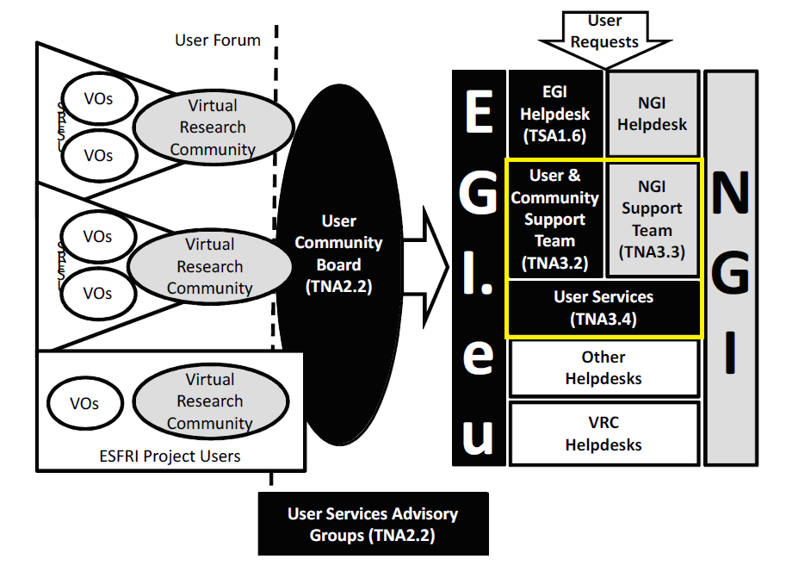
Figure 1 - TNA3 tasks
Following the bottom-up approach from the NGI to EGI.eu level, and the hierarchy of TNA3.3 – NGI support team, TNA3.2 – User & Community support team, and TNA3.4 – Technical services (see Figure), the most important relations are:
- End user → TNA3.3 – NGI support team
- End user (TNA3.3) → TNA3.2 – User & Community support team (escalated tickets)
- End user → TNA3.4 – Technical services
NA3 Metrics – End user satisfaction (helpdesk)
The metrics presented in Table 2 must be measured by anonymous surveys and evaluation forms quarterly and yearly.
Please note that the End user satisfaction related metrics together with Training evaluation are based on surveys, and are strongly related to MS305: User Feedback and Recommendations. That is why these metrics are to be detailed in MS305.
Objective | Task | Metric | Frequency | Target
Coordination of effective, responsive support for the EGI user communities (both individual VOs and those represented by VRCs) through the efforts of the national and specialist support units. | TNA3.3: NGI User Support Teams | - end user satisfactory level: response time  - end user satisfactory level: ‘usefulness’ of answers  - number of unsatisfied users | Quarterly, Yearly | targeted improvement is 3-5%/ year from the 2nd year
Coordination of training, documentation and technical requirements from the user communities to improve the EGI user experience and services. | TNA3.2: User & Community Support Team | - NGI User Support team members and end user satisfactory levels concerning escalated tickets to EGI.eu: response time  - NGI User Support team members and end user satisfactory levels concerning escalated tickets: ‘usefulness’ of answers  - number of unsatisfied users | Quarterly, Yearly | targeted improvement is 3-5%/ year from the 2nd year
Coordination of technical services to support the establishment and management of virtual organisations. | TNA3.4: Technical Services | - end user satisfactory level: availability time  - end user satisfactory level: ‘usefulness’ and quality of applications  - end user satisfactory level: quality of trainings including training material (see appendix) | Monthly, Quarterly, Yearly | targeted improvement is 3-5%/ year from the 2nd year
Table 2. End user satisfaction related metrics

Operational cost vs. user support performance
The metrics presented in Table 3 help understand the relationship between user support (help desk, training centers, repositories) operating costs and performance.

Task | Metrics | Frequency of survey | Target
TNA3.3: NGI User Support Teams | Metrics from Sections 4 and Error: Reference source not found for TNA3.3 divided by the related costs (or person-months) of TNA3.3 activities in the given period. | Yearly | targeted improvement is 3-5%/ year from the 2nd year
TNA3.2: User & Community Support Team | Metrics from Sections 4 and Error: Reference source not found for TNA3.2 divided by the related costs (or person-months) of TNA3.2 activities in the given period. | Yearly | targeted improvement is 3-5%/ year from the 2nd year
TNA3.4: Technical Services | Metrics from Sections 4 and Error: Reference source not found for TNA3.4 divided by the related costs (or person-months) of TNA3.4 activities in the given period. | Yearly | targeted improvement is 3-5%/ year from the 2nd year
Table 3. Cost efficiency metrics

Metrics related to user follow-up process
Additionally, special metrics might be introduced that enable to track the path of new users, and measure the number of users who are able to use finally the VO services, starting from the training calendar, through the training repository and the applications services (see the Figure 2 - 'Path' of new users).

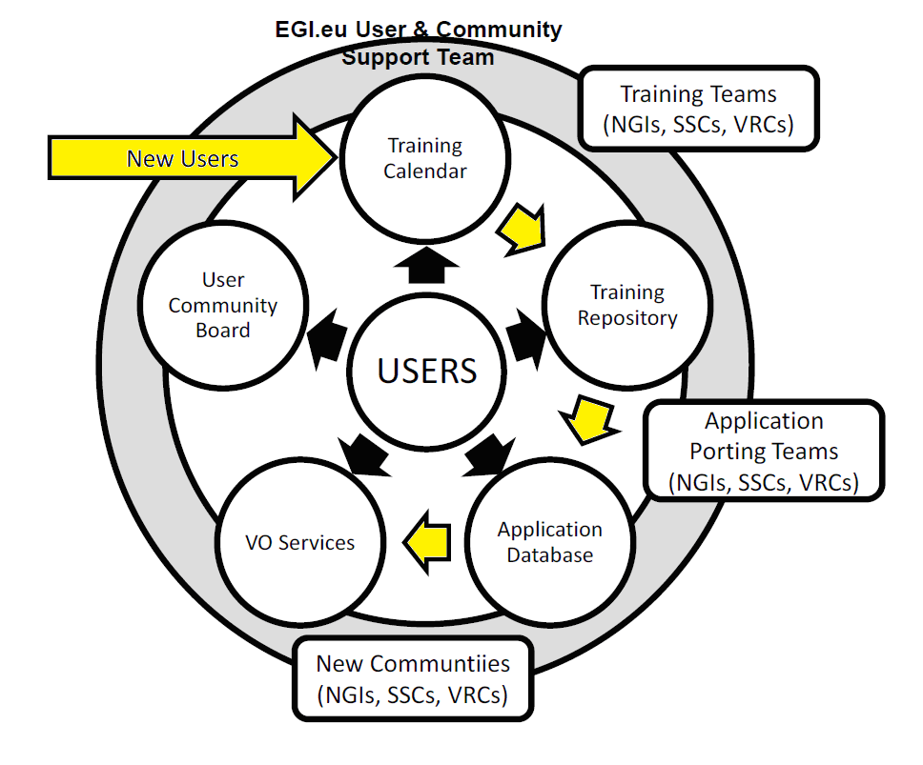
Figure 2 - 'Path' of new users
NA3 Metrics – User follow-up process
The metrics presented in Table 4 can be measured by anonymous surveys and evaluation forms yearly or by automatic monitoring tools.
Activity | Metric | Frequency of survey | Target
Training calendar | Number of users included in the training events | Yearly | targeted improvement is 3-5%/ year from the 2nd year
Training repository | Number of users (from the events) who used the training repository (after the training) as well | Yearly | targeted improvement is 3-5%/ year from the 2nd year
Application repository | Number of users (from the training repository users) who accessed the application repository after the training as well | Yearly | targeted improvement is 3-5%/ year from the 2nd year
VO services | Number of users (from the application repository users) who accessed the VO services after the previous steps as well | Yearly | targeted improvement is 3-5%/ year from the 2nd year
Heavy user support | Number of users (from the VO services users) who became heavy users after the previous steps | Yearly | targeted improvement is 3-5%/ year from the 2nd year
Table 4. Metrics related to user follow-up process

DEFINITIONS
Concept | Definition
EGI resources | Set of resources from the EGI production and other infrastructures that are accessible by the EGI users
Training materials | Set of electronic materials available at  http://www.egee.nesc.ac.uk/trgmat/index.html
New communities | Group of users from the same VO that executes a subset of the applications available after 1st May 2010
Newly ported applications | Set of applications available at http://appdb.eu-egee.org/ after 1st May 2010

Conclusion
The project will record and report metrics that will provide a regular overview on the performance, efficiency and end user satisfaction in User Support activities. Such information will be of benefit to the EC (European Commission), the EGI-Inspire project management, the quality managers, the WP leaders, and the individual partners too.

However, some statistics which at first glance seem to be impressive often turn out to be misleading when conditions are examined more closely. For example the number of users is increasing but they could be inactive. In order to avoid such situations, the provided metrics (Table 1) follow various approaches and involve different data sources. These could include: total usage time of all applications
including/excluding the most active 10% and 25% of users, the helpdesk SLA monitoring, user satisfaction surveys, cost vs. Performance analysis which would enable a better understanding of the underlying mechanisms, user needs, and costs structure.

The metrics discussed in this document are a superset of those that are collected by NA3 on a quarterly basis for the project’s Quarterly Reports. The metrics that will be collected are introduced in the D1.1 - Quality Plan and Project Metrics document [R4]. On the other hand, the metrics discussed in this document are presented as discussion points to guide future planning. Collecting all of the metrics described here every three months in timely manner would not be viable for economic and technical reasons. Consequently, this document aims to initiate discussion between the stakeholders of EGI User Support and EGI technology providers on metrics that could be collected by the project in order to have a clear picture of the efficiency of user services and on the technology that enables the project to collect these matrices every three months. This is an on-going process and will be reported in the next versions of this milestone document in project month 15, 27 and 39.

References
R 1 | ACTIVITY QUALITY ASSURANCE AND MEASUREMENT PLAN, MILESTONE: MSA1.3 (EGEE-III)  https://edms.cern.ch/file/926921/3.0/EGEE-III-MSA1_3-926921-v1_2.pdf
R 2 | USER SUPPORT PROCEDURES EUDELIVERABLE: DSA2.1 (ETICS-2)  http://etics.web.cern.ch/etics/deliverables/ETICS-DSA2.1-927479-User_Support-v1.0.pdf
R 3 | ACTIVITY QUALITY AND MEASUREMENT PLAN, MILESTONE MNA3.1 (EGEE-III)  https://edms.cern.ch/file/926608/1/EGEE-III-MNA3-1-ActivityQAplan-v3-0.pdf
R 4 | D1.1 - Quality Plan and Project Metrics  https://documents.egi.eu/document/55

Appendix: Training evaluation form

Rating | Poor | Fair | Average | Good | Very Good | Excellent | Comments
Introduction to Grid computing and the InSPIRE project
Subject 1
Subject 2
Subject 3 ......
Overall evaluation of the event
Usefulness of the knowledge learned
Competence of trainers
Fulfilment of training goals
Advertising & Registration
Facilities
Where did you hear about this event?
What did you most like about this event?
What did you least like about this event?
Which of the training subjects were the most useful to you?
Which of the training subjects did you find the least useful?
Is there anything else you would like the event to have covered?
Further Comments

