Staged Rollout Report
The Early Adopter team should fill the “grey” areas
NGI | NGI_IBERGRID
Site Name | IFIC-LCG2
EA team names | Álvaro Fernández, Pablo Briongos
EA team contacts | alvaro.fernandez@ific.uv.es, pablo.briongos@ific.uv.es
Product | WMS | Version | 3.3.4-sl5-x86_64 | RT ticket ID | 3295
The “outcome” is one of: OK, WARN, FAIL, NA (Not Aplicable), Nver (Not verified/Not tested).
Copy/paste any results from your commands where you see fit.
Metric | <OK|WARN|FAIL  |NA|NVer> | WEB URLs, Command used, other comments  (please always fill this table with as much information as possible, and as you see fit)
Release notes and other  documentation | OK | http://www.eu-emi.eu/kebnekaise-products/-/asset_publisher/4BKc/content/wms#Release_Notes
Installation or upgrading (specify which) | OK | Installation from scratch was successful
(RE-)configuration (if using yaim, specify command used) | OK | /opt/glite/yaim/bin/yaim -c -s site-info-stagerollout-ific-SL4.def -n glite-WMS  No error occurs during the yaim configuration
Functionality (including start stop of deamons, and which) | OK | /etc/init.d/gLite start | stop | restart | status | version  No errors reported
SAM/Nagios/Gstat or any other monitoring framework  (specify the name of the machine) | OK | cg08.ific.uv.es tested by nagios. Current Ibergrid nagios ( rnagios.ibergrid.cesga.es) includes 4 probes for:  -Certificate lifetime  -GridFTP check  -WMS Job State  -WMS Job Submit
Interaction integration with other components (specify which) | OK | With LB cg07.ific.uv.es
Behaviour in production environment (after a few days). Specify VO’s using the service when applicable | WARN | *Different MySQL libraries in compile time/runtime:  [root@cg08 grid-security]# service gLite restart  Starting glite-lb-bkserver ...Warning: MySQL library version mismatch (compiled '50077', runtime '50085')  * Segfault in CONDOR:  [root@cg08 grid-security]# dmesg  condor_gridmana[26988]: segfault at 0000000000000008 rip 00000000005133ac rsp 00007fff33029300 error 6  -------------------------------------------------------------------------  *1 week chart: VOS  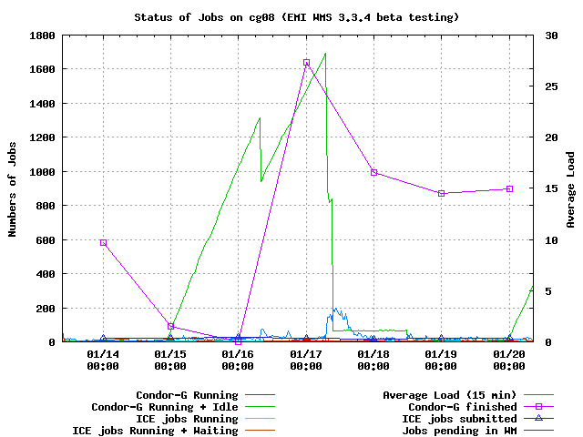
GGUS tickets opened: please insert the URLs of the tickets
Log files: usefulness, clarity, etc., any other comments on where/how to improve them. | OK
Error messages: please specify or comment any issues with error messages, if they are not correct, not clear, useful, etc. . | WARN | condor_gridmanager segfault as it was on previous versions, not supposing a hard issue

