EGI-InSPIRE

GENDER ACTION PLAN

EU DELIVERABLE: D1.6

Document identifier: | input.doc-final
Date: | 08/04/2012
Activity: | NA1
Lead Partner: | EGI.eu
Document Status: | FINAL
Dissemination Level: | PUBLIC
Document Link: | https://documents.egi.eu/document/982

Abstract
This document summarises the efforts made in Year 1 and 2 to promote gender equality in scientific projects and institutes within EGI-InSPIRE. The document also aims to give some recommendations for Year 3 and 4

.
Copyright notice
Copyright © Members of the EGI-InSPIRE Collaboration, 2010-2014. See www.egi.eu for details of the EGI-InSPIRE project and the collaboration. EGI-InSPIRE (“European Grid Initiative: Integrated Sustainable Pan-European Infrastructure for Researchers in Europe”) is a project co-funded by the European Commission as an Integrated Infrastructure Initiative within the 7th Framework Programme. EGI-InSPIRE began in May 2010 and will run for 4 years. This work is licensed under the Creative Commons Attribution-Noncommercial 3.0 License. To view a copy of this license, visit http://creativecommons.org/licenses/by-nc/3.0/ or send a letter to Creative Commons, 171 Second Street, Suite 300, San Francisco, California, 94105, and USA. The work must be attributed by attaching the following reference to the copied elements: “Copyright © Members of the EGI-InSPIRE Collaboration, 2010-2014. See www.egi.eu for details of the EGI-InSPIRE project and the collaboration”. Using this document in a way and/or for purposes not foreseen in the license, requires the prior written permission of the copyright holders. The information contained in this document represents the views of the copyright holders as of the date such views are published.
- Delivery Slip
 | Name | Partner/Activity | Date
From | Catherine Gater &  Erika Swiderski | EGI.eu/NA1 | 17/2/2012
Reviewed by | Moderator: Agnes Szeberenyi  Reviewers: Claire Devereux,  Oxana Smirnova, Vera Hansper | MTA-SZTAKI  STFC  LU,CSC | 13/3/2012
Approved by | AMB & PMB
- Document Log
Issue | Date | Comment | Author/Partner
1 | 21/02/2012 | First draft | E. Swiderski and C Gater/EGI.eu
2 | 20-3-2012 | Second draft after reviews | E. Swiderski
3 | 23-3-2012 | Final version | E.Swiderski
- Application area
This document is a formal deliverable for the European Commission, applicable to all members of the EGI-InSPIRE project, beneficiaries and Joint Research Unit members, as well as its collaborating projects.
- Document amendment procedure
Amendments, comments and suggestions should be sent to the authors. The procedures documented in the EGI-InSPIRE “Document Management Procedure” will be followed:
https://wiki.egi.eu/wiki/Procedures
- Terminology
A complete project glossary is provided at the following page: http://www.egi.eu/about/glossary/.
- PROJECT SUMMARY

To support science and innovation, a lasting operational model for e-Science is needed − both for coordinating the infrastructure and for delivering integrated services that cross national borders.

The EGI-InSPIRE project will support the transition from a project-based system to a sustainable pan-European e-Infrastructure, by supporting ‘grids’ of high-performance computing (HPC) and high-throughput computing (HTC) resources. EGI-InSPIRE will also be ideally placed to integrate new Distributed Computing Infrastructures (DCIs) such as clouds, supercomputing networks and desktop grids, to benefit user communities within the European Research Area.

EGI-InSPIRE will collect user requirements and provide support for the current and potential new user communities, for example within the ESFRI projects. Additional support will also be given to the current heavy users of the infrastructure, such as high energy physics, computational chemistry and life sciences, as they move their critical services and tools from a centralised support model to one driven by their own individual communities.

The objectives of the project are:

- The continued operation and expansion of today’s production infrastructure by transitioning to a governance model and operational infrastructure that can be increasingly sustained outside of specific project funding.
- The continued support of researchers within Europe and their international collaborators that are using the current production infrastructure.
- The support for current heavy users of the infrastructure in earth science, astronomy and astrophysics, fusion, computational chemistry and materials science technology, life sciences and high energy physics as they move to sustainable support models for their own communities.
- Interfaces that expand access to new user communities including new potential heavy users of the infrastructure from the ESFRI projects.
- Mechanisms to integrate existing infrastructure providers in Europe and around the world into the production infrastructure, so as to provide transparent access to all authorised users.
- Establish processes and procedures to allow the integration of new DCI technologies (e.g. clouds, volunteer desktop grids) and heterogeneous resources (e.g. HTC and HPC) into a seamless production infrastructure as they mature and demonstrate value to the EGI community.

The EGI community is a federation of independent national and community resource providers, whose resources support specific research communities and international collaborators both within Europe and worldwide. EGI.eu, coordinator of EGI-InSPIRE, brings together partner institutions established within the community to provide a set of essential human and technical services that enable secure integrated access to distributed resources on behalf of the community.

The production infrastructure supports Virtual Research Communities (VRCs) − structured international user communities − that are grouped into specific research domains. VRCs are formally represented within EGI at both a technical and strategic level.

- EXECUTIVE SUMMARY

This document summarises the efforts made in PY1 & PY2 to promote gender equality in scientific projects and institutes within EGI-InSPIRE. By 2015, Europe may be short of 400,000 ICT-practitioners. It is crucial to involve as many women as possible to support digital innovation and meet the goals of EU2020, and yet as statistics and research show, the imbalance of genders in science remains persistent. As EGI.eu is an umbrella organisation for European research institutes, it aims to expose and share ideas about Gender Equality in our community. Most of all, EGI aims to investigate and promote best practices that can help women in and towards a professional career, through the help of our partner institutes.

The Gender Action Activities are part of the tasks assigned to the project management activity, NA1 and also to NA2–External Relations. An EGI-InSPIRE GAP taskforce has been established to promote gender equality issues within the project and to drive forward the implementation of the GAP. The major channels for communicating these activities have been the GAP pages on the EGI website, the project newsletter, EGI events and the EGI blog and social media channels.

In addition to the EGI channels, an MoU was signed between EGI and e-ScienceTalk in June 2011, and this has provided opportunities to communicate materials produced by the EGI GAP team and to promote the message of gender equality. The e-ScienceTalk project tells the success stories of Europe’s e-Infrastructures, targeting four main audiences: policymakers working in government, science and industry; scientists with an interest in grid computing; students and the general public. EGI has published material through the GridCafé, e-ScienceCity and GridGuide websites, as well as in International Science Grid This Week, and on the GridCast blog.

The GAP has monitored the statistics for men and women attending and participating in the EGI events over the last 18 months, and also designed materials intended to promote discussion at these events on gender related issues. The team also attended two dedicated events on EGI’s behalf, including Women in Science, Innovation and Technology in the Digital Age 7-8 March, 2011, Budapest and the European Gender Summit in Brussels, 8-9 November, 2011, distributing materials to delegates and blogging about the events and the issues raised. This has led to EGI signing the Manifesto for Integrated Action on the Gender Dimension in Research and Innovation.

Future plans for GAP activities in PY2 and PY3 include continuing to collaborate with e-ScienceTalk at EGI and other events to feature female role models and their work, and to encourage discussion and comment on gender-related issues. The GAP webpages will be updated to include more dynamic and news-related content, featuring feeds from organisations and projects such as European Platform of Women Scientists and the European Centre for Women and Technology.
TABLE OF CONTENTS
1 INTRODUCTION 6
1.1 The European Comission and the issue of gender 6
1.2 the AIMS OF THE GENDER ACTION PLAN AFTER ProJECT YEAR 1-2 6
2 THE EGI- INspire gender action plan AFTER YEAR 1-2 7
2.1 THE EGI-INSPIRE GAP TASKFORCE 7
2.2 THE EGI-INSPIRE GAP TOOLS 7
2.2.1 CHANNELS OF PUBLICITY 7
2.2.2 COLLABORATION WITH e-SCIENCETALK 8
2.2.3 GAP STATISTICS AND REPORT ON ACTIVITIES 9
3 FUTURE PLANS and conclusions 12

Introduction

The European Comission and the issue of gender

By 2015, Europe may be short of 400,000 ICT-practitioners. It is crucial to involve as many women as possible to support digital innovation and meet the goals of EU2020. A study recently published in Science tracked the careers of 2,966 science and engineering faculty members from 14 universities in the UK from the time they were hired to when they left the university over the period 1990–2009. The study showed that overall men and women were retained as staff and promoted at the same rate. However, only 27% of incoming academics were women, meaning that there is an issue in hiring women in the first place and make academic education and career attractive for them.

As statistics and research like this show, the imbalance of genders in science is persistent – only 27% of those entering academia are women, and without a change to these figures, staff levels will not reach 50% until 2050. After 2010, when a new Action plan was set up by the EC to control and promote efforts towards equality, discussions about the topic started to focus on introducing recommendations about specific actions and best practices.

The Aims Of the Gender Action Plan after Project Year 1 & 2

As EGI.eu is an umbrella organisation for European research institutes, it has a responsibility to expose and share ideas about Gender Equality in our community. Most of all, EGI would like to investigate and promote best practices that can help women in and towards a professional career, through the help of our partner institutes. Project participants will be especially encouraged to target young women in the beginning of their scientific education to prevent them from falling out or choosing another career because of gender bias or lack of information.

As stated in D1.2 Gender Action Plan (GAP), the aims of EGI-InSPIRE’s gender action plan are:

- To promote the work of the EC in moving towards gender equality.
- To collaborate with other organisations working in this area where possible.
- To gather statistics on participation with the project itself.
- To act as conduit for information to project partners and the project’s audiences
- To actively feature work emanating from the grid user communities about women, by women and for women through the project’s dissemination channels.

The EGI-InSPIRE Gender Action Plan after Year 1 & 2

The EGI-InSPIRE GAP Taskforce
The Gender Action Activities are part of the tasks assigned to the project management activity, NA1 and also to NA2 –External Relations, but all the project participants are requested to make efforts in these areas.

The EGI-InSPIRE Gender Action Plan taskforce has been established to promote gender equality issues within the project and to drive forward the implementation of the GAP. It is led by the Deputy Director of EGI.eu, and the following members of EGI Project Office staff take part in the activities in different roles:

- Catherine Gater, Deputy Director of EGI.eu, Dissemination Manager (NA1 and NA2)
supervisor of the GAP, activities with e-ScienceTalk
- Sara Coelho, Communications Officer (NA2)
occasional blog posts, articles on the website
- Erika Swiderski, Project Office (NA1)
GAP activities at EGI conferences, travels to gender-related European events
- Viviane Lee
posters and flyers design

The EGI-INSPIRE GAP Tools

Publicity Channels
The main contact point for the GAP team and the source of gender-related information and news is the GAP website under www.egi.eu, found at http://www.egi.eu/projects/egi-inspire/gender_action_plan/.

The content includes:
- Introduction to the EGI-InSPIRE Gender Action Plan
- Direct link to the latest versions of the Plan
- Links to EC gender policy documents
- Selection of news items relating to the topics
- Recommendations

Other channels for the GAP messages:
- EGI-InSPIRE project newsletters
- EGI events
- EGI blog (http://www.egi.eu/blog/)
- EGI social media tools (Facebook, Twitter)

Collaboration with e-ScienceTalk

The e-ScienceTalk project tells the success stories of Europe’s e-Infrastructures, targeting four main audiences: policymakers working in government, science and industry; scientists with an interest in grid computing; students and the general public. An MoU was signed between EGI and e-ScienceTalk in June 2011, and this has provided opportunities to communicate materials produced by the EGI GAP team and to promote the message of gender equality.

The GridCafé website has been expanded by e-ScienceTalk to form part of the e-ScienceCity. This new website features introductions to grid computing, cloud computing and volunteer computing and also has a 3D counterpart in the NewWorldGrid virtual world. EGI features throughout the website in case studies. The ‘Grid people’ section is a great opportunity for female researchers and team members to be introduced, and the Chief Technical Officer, Tiziana Ferrari is already included. This section is currently under review, and will be made easier to find on the website.

The GridGuide website shows people the sites and sights behind grid computing, and features grid sites around the world. It includes information about projects, science, videos and profiles of the people working in grid to give an insight into careers in computing. EGI.eu has set up a profile on the GridGuide, and again the site features a profile for the Chief Technology Officer (CTO).

International Science Grid This Week is a free weekly online newsletter that promotes grid computing around the world by sharing stories of grid-empowered science and scientific discoveries. iSGTW now attracts more than 800 subscribers from 196 countries and territories, and regularly features work by EGI staff and users, both male and female. iSGTW takes gender issues into account when selecting content, and aims to achieve a balance in people featured, writers and the topics covered eg publishing articles on women in e-science for International Women’s Day, and a Pinterest board. Around 20% of iSGTW’s readership is female – there is no breakdown of gender in the download figures for the e-ScienceBriefings (about 3000 downloads). The e-ScienceBriefings do aim to reflect a gender balance when selecting people to interview for quotes, as does the GridCast team on the GridCast blog.

The GridCast blog features posts and interviews from major grid computing conferences in order to disseminate the outcomes of events and discussions to a wider audience. EGI staff and users, again both male and female, have blogged from several events through GridCast, including the EGI Technical and User Forums. This has included policy events that covered gender issues in science, such as the Innovation Convention in Brussels in December 2011. Video interviews with EGI staff and scientists have also been featured on the GridCast blog, including at the EGI Technical Forum in Lyon.

GAP Statistics

Available statistics from main EGI community conferences:

 | TF2010 | UF2011 | TF2011
Registered participants | 573 | 427 | 660
Female | 97/16,92% | 76/17,8% | N/A
Contributions | 288 | 196 | 132
Female | 31/10,7% | N/A | 16/12,12%
Speakers | N/A | 173 | 296
Female | N/A | 20/11,56% | 27/9,12%
Session Conveners | N/A | 34 | 34
Female | N/A | 5/14,7% | 7 /20,5%

TF 2010: EGI Technical Forum, 14-17 September 2010, Amsterdam
UF 2011: EGI User Forum, 11-14 April 2011, Vilnius
TF 2011: EGI Technical Forum, 19-23 September 2011, Lyon

These figures covering the previous 18 months show that around the same proportion of registered participants at the main EGI events were female for two out of the three events, at around 17%. Women were slightly under-represented in terms of contributions at 11 and 12%, and as speakers at 11 and 9%. However, the percentage of session convenors were slightly higher compared to the overall registration rate, at up to 20% at the Technical Forum in Lyon. However, overall the percentage of women attending these events when compared to figures from the EGEE phases of the project has not change substantially in several years, being on average less than 20%.

Report on activities

- EGI User Forum, 11-14 April 2011, Vilnius

The GAP Taskforce prepared a postcard (see below) to initiate a conversation on the gender imbalance in science. The postcards were disseminated during the conference and delegates were invited to provide feedback either on the postcards directly or via e-mail to contact@egi.eu. However, although discussions around the topic were stimulated with the staff at the booth, no formal ideas were sent to the team.

The lesson the GAP team learnt as a result is that instead of formulating questions about gender issues for general discussion via email, it may be more useful to showcase best practises.

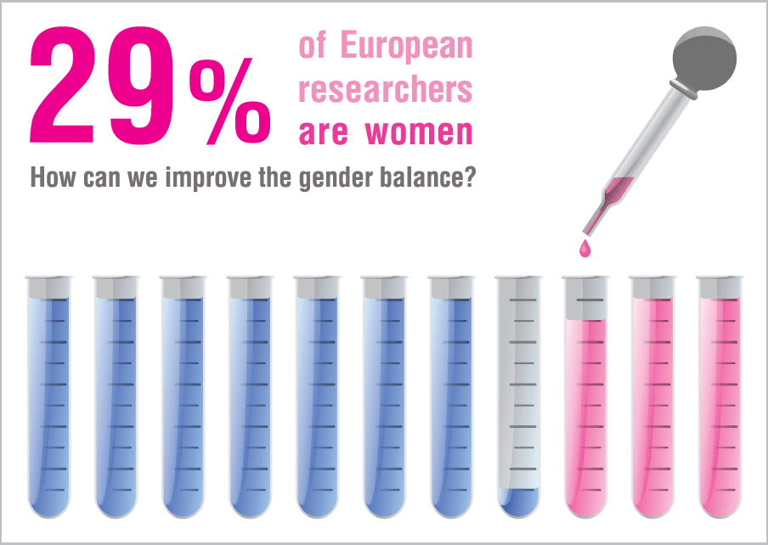

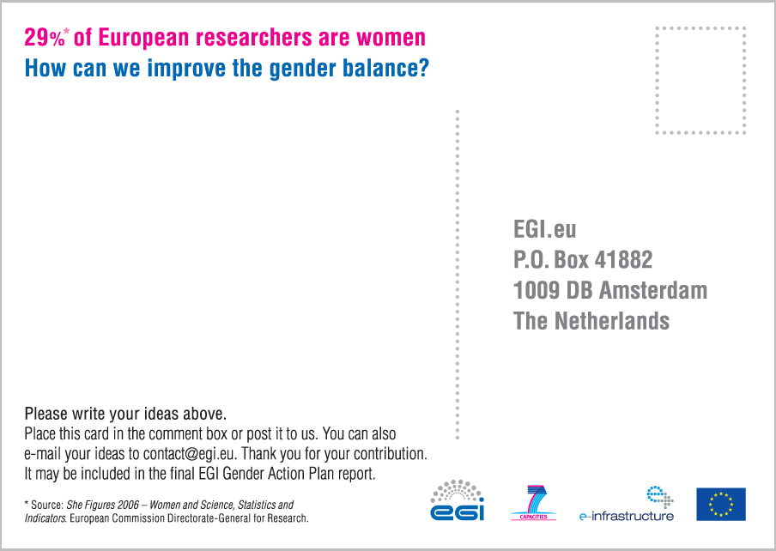

- Women in Science, Innovation and Technology in the Digital Age 7-8 March, 2011

The conference in Budapest was the first event where EGI.eu/EGI-InSPIRE had the opportunity to introduce itself during a gender equality event and also for two members of the taskforce (Sara Coelho and Erika Swiderski) to hear about some recommendations for solving the issue of the under-representation of women in research and senior positions.

The experience is recorded in two EGI blog posts, besides that it was the first event where EGI was introduced as an organisation that is aware of gender issues, the event generally helped to realise how the necessity for female scientists can be explained in a really practical way as gender equality is an important factor in economic sustainability.

- European Gender Summit in Brussels, 8-9 November, 2011

The second major gender-related event in 2011 was the European Gender Summit, organised by the European Science Foundation. The GAP Taskforce decided to disseminate EGI and its efforts towards gender equality by placing a postcard (see below) in more than 500 conference bags.
Erika Swiderski, who participated in the event, summarised the outcomes in a blog post, she found the poster session of the event particularly informative as many recent gender equality projects were presented.
Following the discussions and consultation during the Gender Summit, a special policy manifesto was prepared: Manifesto for Integrated Action on the Gender Dimension in Research and Innovation. Steven Newhouse, the Director of EGI and Catherine Gater, Deputy Director (and project coordinator for e-ScienceTalk) both agreed to sign and also circulating the Manifesto by the help of a news item on the EGI website.
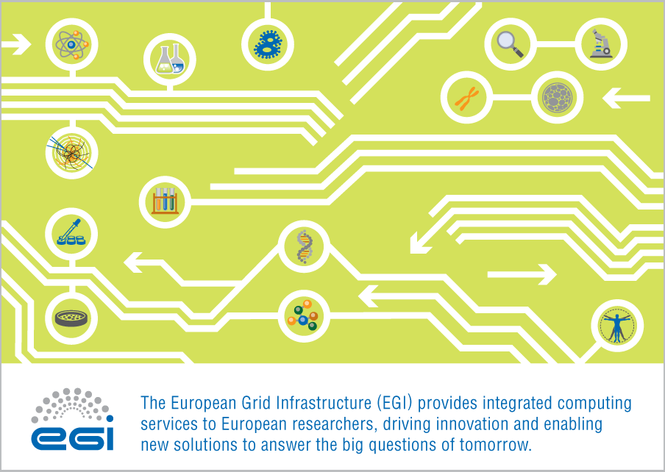

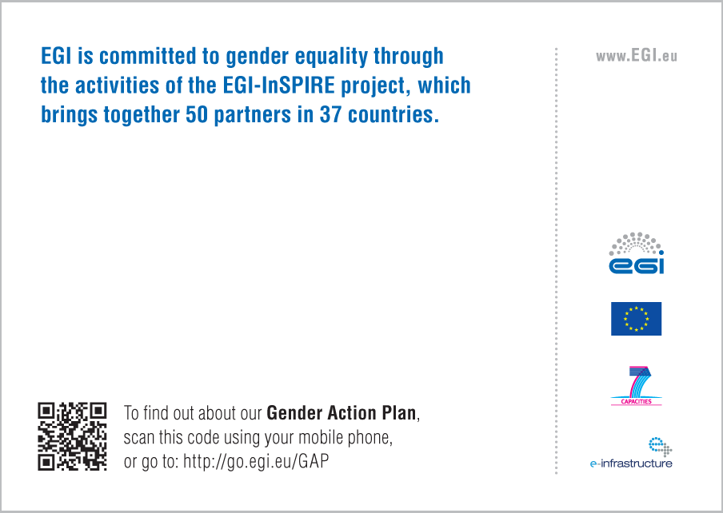

Conclusions and Future Plans
During the first two years of the EGI-InSPIRE project, it became clear that the main role of the Gender Action Plan should be disseminating ideas and recommendations that were raised during high-level European gender equality events. It is also important to follow the work of organisations and projects within the European community in these areas. The following organisations seem to showcase the most relevant issues and give the most useful recommendations that can be applied also to the diverse EGI scientific community.

- European Platform of Women Scientists
- The Gendered Innovations in Science, Health & Medicine, and Engineering
- European Science Foundation
- EU Women
- European Centre for Women and Technology

The most important task for the GAP taskforce is the implementation of a lively and interesting GAP area on the EGI website. This could be achieved by providing less static and more up-to-date content on the basis of news items and publications from the websites and newsletters of the above mentioned organisations, and dissemination of events organised and supported by them.
A specific, gender equality-related Virtual Team will be set up in PY3 (if there is enough interest in participation) to involve NGI representatives in planning and maximise impact, this may also help EGI to collect more extensive statistics.

The GAP taskforce in collaboration with the e-ScienceTalk team should take the opportunity at the EGI conferences and at other relevant events to conduct short interviews with participants to 1) introduce female scientists as possible role models 2) give an opportunity for people of the community to express their ideas and attitudes towards gender equality issues – one of the possible topics could be best practices in research centres and universities to help employees to balance between work and family life.

Kaminski, D. & Geisler, C. Science 335, 864–866 (2012).
Nature doi:10.1038/nature.2012.10053
https://documents.egi.eu/document/171
www.gridcafe.org
www.e-sciencecity.org
http://www.gridcafe.org/grid-people.html
www.gridguide.org/gridguide_content.php?id_ge=76
www.isgtw.org
www.isgtw.org/feature/hunting-viruses-finding-needle-haystack
www.gridcast.org
www.gridtalk-project.blogspot.com/2011/09/agnes-szeberenyi-on-kopi-application.html
http://www.egi.eu/blog/2011/03/10/gender_equalitysustainability.html http://www.egi.eu/blog/2011/03/07/in_budapest_searching_for_europes_cyberellas.html
http://www.egi.eu/blog/2011/11/18/quality_research_and_innovation_through_equality.html
http://gender-summit.eu/index.php?option=com_content&view=article&id=278:manifesto-text-a-petition&catid=20:manifesto&Itemid=42
http://www.egi.eu/about/news/news_0119_gender_manifesto.html
http://www.epws.org/
http://genderedinnovations.stanford.edu/
http://www.esf.org/
http://www.euwomen.org/EN.html
http://www.womenandtechnology.eu

