

EGI Value Creation
Value of the EGI Ecosystem
The value that EGI delivers to the European Research Area (ERA) is created thanks to the collaboration of many entities forming a unique ecosystem. In order to understand the role of each entity, identify the individual contribution to the value creation process, analyse the underlying patterns in place and the way to optimise them, it is essential to map the interactions and the related value exchange. This document presents a summary view of the roles within the EGI ecosystem, interactions taking place and the value perceived and the governance structures currently binding them. A more detailed analysis will be performed in a separate document.
EGI Ecosystem
Many entities live in the EGI ecosystem and engage in interactions receiving inputs from others, converting them into value using internal assets in order to generate an output. Participants interact playing roles that are classified as follows:
- Individual Researchers (IRs) | - Resource Infrastructure Providers (RPs)
- National Research Collaborations (NRCs) | - Technology Providers (TPs)
- European Research Collaborations (ERCs) | - EGI.eu
- Virtual Research Communities (VRCs) | - National Funding Bodies (NFBs)
- Resource Centres (RCs) | - European Funding Bodies (EFBs)

EGI Value Network Diagram
The diagram below offers a concise visual representation of the EGI value network relationships. The following table further below provides an overview of the value delivered between the entities of the ecosystem. Please complete the following table providing a weight to each relationship ranging on a scale from -2 to +2, determined based on the perceived value derived from the relationship. Space has also been provided for any additional values you feel are important.
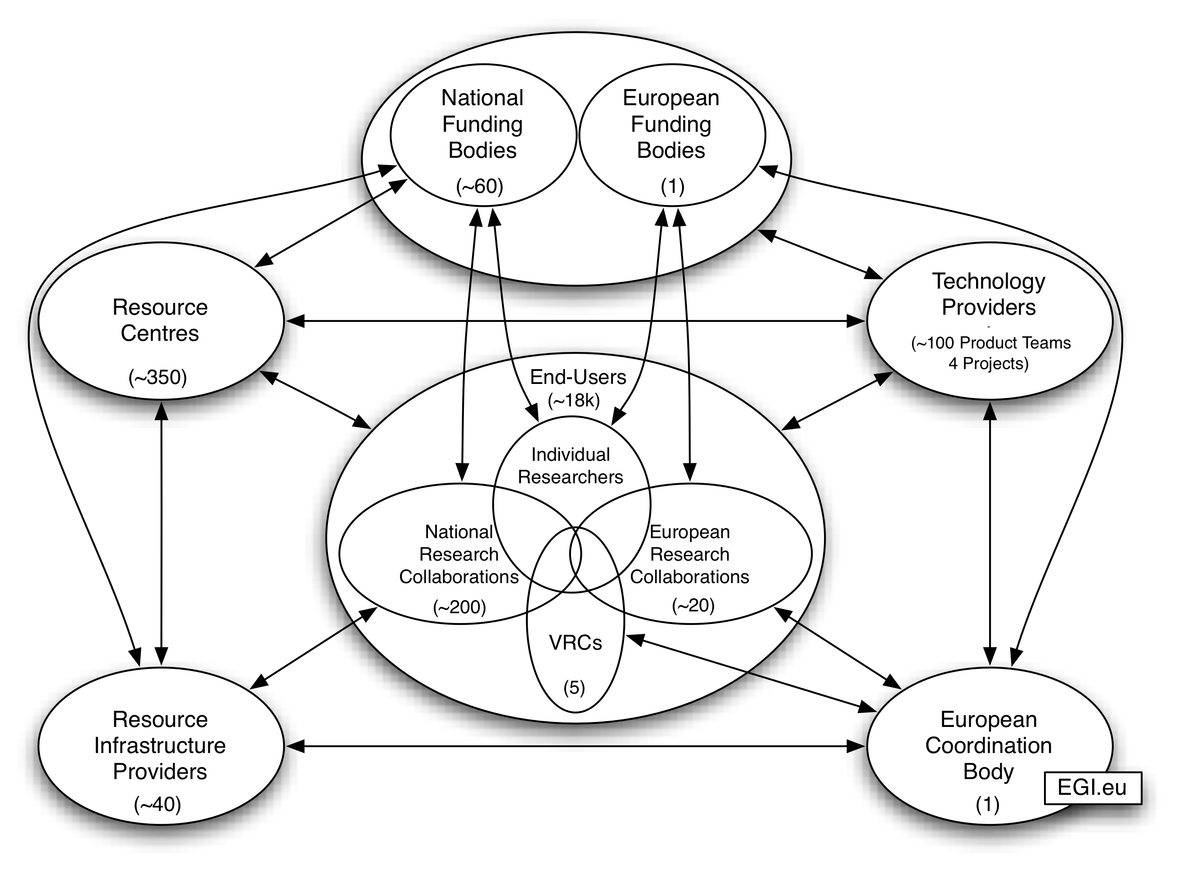
Figure 1: EGI Value Network Diagram
Relationship |  | Multiplicities | Value | Weight  (+2, +1, Neutral, -1, -2)
EGI.eu | Technology Providers | 1 ↔ 4 Technology Projects  1 ↔ ~30 Infrastructure-related Product Teams | ❑ TPs provide the necessary software and support to meet the needs of the community.
EGI.eu | Technology Providers |  | ❑ EGI.eu provides collected and prioritised requirements and feedback on behalf of the community.
EGI.eu | Technology Providers |  | ❑
EGI.eu | Resource Infrastructure Providers | 1 ↔ 40 | ❑ RPs provide EGI.eu with operational requirements and feedback.
EGI.eu | Resource Infrastructure Providers | 1 ↔ 40 | ❑ EGI.eu collects and prioritises requirements and then negotiates with technology providers on behalf of the RPs.
EGI.eu | Resource Infrastructure Providers | 1 ↔ 40 | ❑ EGI.eu provides central coordination to enable RPs to provide federated resources across Europe and beyond.
EGI.eu | Resource Infrastructure Providers | 1 ↔ 40 | ❑ EGI.eu provides a single, stronger voice at an EC level and visibility of national e-Infrastructure efforts in an international context.
EGI.eu | Resource Infrastructure Providers | 1 ↔ 40 | ❑ EGI.eu connects resource providers with local and remote research communities working in the same area.
EGI.eu | Resource Infrastructure Providers | 1 ↔ 40 | ❑
EGI.eu | Virtual Research Communities & European Research Collaborations | 1 ↔ ~20 | ❑ VRCs/ERCs provide requirements and feedback to EGI.eu for needed e-Infrastructure services on behalf of large community of users wishing to access federated services.
EGI.eu |  | 1 ↔ ~20 | ❑ EGI.eu provides collaboration tools to VRCs/ERGs to share applications, best practices, training material and requirements across Europe.
EGI.eu |  | 1 ↔ ~20 | ❑ EGI.eu collects and prioritises requirements and then negotiates with technology providers on behalf of the VRCs/ERCs.
EGI.eu |  | 1 ↔ ~20 | ❑ EGI.eu connects local and remote research communities working in the same area with resource providers.
EGI.eu |  | 1 ↔ ~20 | ❑
EGI.eu | European Funding Bodies | 1 ↔1 | ❑ The EC provides the necessary funding for EGI.eu to implement the EC’s strategic objectives.
EGI.eu | European Funding Bodies | 1 ↔1 | ❑ The EC provides guidance and a policy cabinet for shaping the strategic direction of EGI.
EGI.eu | European Funding Bodies | 1 ↔1 | ❑ EGI.eu supports the funding bodies in implementing strategic policies regarding e-Infrastructure to generate the expected social-economic impact for society at-large.
EGI.eu | European Funding Bodies | 1 ↔1 | ❑ EGI.eu provides feedback to the EC as well as highlights scientific results and innovation.
EGI.eu | European Funding Bodies | 1 ↔1 | ❑
Resource Infrastructure Providers | Resource Centres | 1 ↔1-50 | ❑ RPs provide national/regional coordination of operations, dissemination, policy and event organisation.
Resource Infrastructure Providers | Resource Centres | 1 ↔1-50 | ❑ RPs provide single, stronger voice at a national government level.
Resource Infrastructure Providers | Resource Centres | 1 ↔1-50 | ❑ RCs provide the necessary resources to form a national infrastructure for researchers to access.
Resource Infrastructure Providers | Resource Centres | 1 ↔1-50 | ❑
Resource Infrastructure Providers | National Research Collaborations | 1 ↔ ~5-50 | ❑ RPs provide a uniform interface to negotiate access to national computing resources for researchers.
Resource Infrastructure Providers | National Research Collaborations | 1 ↔ ~5-50 | ❑ RPs provide user support and consulting.
Resource Infrastructure Providers | National Research Collaborations | 1 ↔ ~5-50 | ❑ NRCs provide requirements and feedback on the services provided by the RPs.
Resource Infrastructure Providers | National Research Collaborations | 1 ↔ ~5-50 | ❑
Resource Infrastructure Providers | National Funding Bodies | 1 ↔ 1-5 | ❑ National funding bodies provide the necessary funding for resource infrastructure providers to coordinate and build the required framework needed by researchers.
Resource Infrastructure Providers | National Funding Bodies | 1 ↔ 1-5 | ❑ RPs support national funding bodies in implementing strategic policies regarding e-Infrastructure to generate the expected social-economic impact for society at-large.
Resource Infrastructure Providers | National Funding Bodies | 1 ↔ 1-5 | ❑ RPs highlight scientific results and innovation.
Resource Infrastructure Providers | National Funding Bodies | 1 ↔ 1-5 | ❑
Resource Centres | End-Users | Many ↔ Many | ❑ RCs provide access to commodity computing resources.
Resource Centres | End-Users | Many ↔ Many | ❑ RCs provide access to own custom high-performance computing resources.
Resource Centres | End-Users | Many ↔ Many | ❑ End-Users provide direct requirements and feedback.
Resource Centres | End-Users | Many ↔ Many | ❑
Resource Centres | National Funding Bodies | Many ↔ Many | ❑ National funding bodies provide the funding in order for RCs to purchase computing equipment.
Resource Centres | National Funding Bodies | Many ↔ Many | ❑ RCs support funding bodies in implementing strategic policies regarding e-Infrastructure to generate the expected social-economic impact for society at-large.
Resource Centres | National Funding Bodies | Many ↔ Many | ❑ RCs highlight scientific results and innovation.
Resource Centres | National Funding Bodies | Many ↔ Many | ❑
Technology Providers | End-Users | 1-4 ↔ Many | ❑ TPs provide custom open source software and support.
Technology Providers | End-Users | 1-4 ↔ Many | ❑ End-users provide requirements and feedback.
Technology Providers | End-Users | 1-4 ↔ Many | ❑
Technology Providers | European & National Funding Bodies | 1-4 ↔ Many | ❑ TPs develop the required software and services needed by the community.
Technology Providers | European & National Funding Bodies | 1-4 ↔ Many | ❑ Funding bodies provide the funding to maintain/innovate the technology needed by the community.
Technology Providers | European & National Funding Bodies | 1-4 ↔ Many | ❑ TPs develop innovative software products.
Technology Providers | European & National Funding Bodies | 1-4 ↔ Many | ❑
National Research Collaborations | National Funding Bodies | Many ↔ Many | ❑ National funding bodies support NRCs through national projects and research grants.
National Research Collaborations | National Funding Bodies | Many ↔ Many | ❑ NRCs achieve the scientific results and innovation for the benefit of society at-large, which are highlighted through direct communication and scientific publications.
National Research Collaborations | National Funding Bodies | Many ↔ Many | ❑
European Research Collaborations | European Funding Bodies | 1-20 ↔ 1 | ❑ European funding bodies support ERCs through EU-funded projects and research grants.
European Research Collaborations | European Funding Bodies | 1-20 ↔ 1 | ❑ ERCs achieve the scientific results and innovation for the benefit of society at-large, which are highlighted through direct communication and scientific publications.
European Research Collaborations | European Funding Bodies | 1-20 ↔ 1 | ❑
Individual Researchers | European & National Funding Bodies | Many ↔ Many | ❑ European and National funding bodies support individual users through individual research grants, which are dedicated to the individual despite organisational affiliation.
Individual Researchers | European & National Funding Bodies | Many ↔ Many | ❑ IRs achieve the scientific results and innovation for the benefit of society at-large, which are highlighted through direct communication and scientific publications.
Individual Researchers | European & National Funding Bodies | Many ↔ Many | ❑
CC Comments:
Name: _________________________________________________________________________

NGI/EIRO: ______________________________________________________________________

