e-ScienceTalk

Final Dissemination Report on GridCafe, GridGuide and GridCast

Document identifier: | D D2.5 - Final dissemination report on GridCafe, GridGuide, GridCast
Date: | 30/06/2013
Work package: | WP2
Lead Partner: | QMUL
Document Status: | FINAL
Dissemination Level: | PUBLIC
Document Link: | https://documents.egi.eu/document/1848

Abstract
This report focuses on the promotional strategies for GridCafé website, GridGuide and GridCast. During e-ScienceTalk, the suites of interactive websites have been expanded in content to cover new developments and players in the changing arena of grids. This report also covers the Real Time Monitor, the GridTalk Project YouTube channel and e-ScienceCity.

- Copyright notice
Copyright © Members of the e-ScienceTalk collaboration, 2010. See www.e-sciencetalk.eu for details of the e-ScienceTalk project and the collaboration. e-ScienceTalk is a project co-funded by the European Commission as an Support Action within the 7th Framework Programme. e-ScienceTalk began in September 2010 and will run for 33 months. This work is licensed under the Creative Commons Attribution-Noncommercial 3.0 License. To view a copy of this license, visit http://creativecommons.org/licenses/by-nc/3.0/ or send a letter to Creative Commons, 171 Second Street, Suite 300, San Francisco, California, 94105, and USA. The work must be attributed by attaching the following reference to the copied elements: “Copyright © Members of the e-ScienceTalk Collaboration, 2010. See www.e-sciencetalk.eu for details of the EGI-InSPIRE project and the collaboration”. Using this document in a way and/or for purposes not foreseen in the licence, requires the prior written permission of the copyright holders. The information contained in this document represents the views of the copyright holders as of the date such views are published.
- Delivery Slip
 | Name | Partner/Activity | Date
From | Z Qadir / C Chevalier | QMUL/WP2 | 24/06/13
Reviewed by | Moderator: C Gater  Reviewers: Project team
Approved by | AMB & PMB |  | 30/06/2013
- Document Log
Issue | Date | Comment | Author/Partner
1 | 25/06/13 | First draft | Z Qadir QMUL
2 | 30/06/13 | Final draft | C Gater, EGI
3
- Application area
This document is a formal deliverable for the European Commission, applicable to all members of the e-ScienceTalk project and its beneficiaries and collaborating projects.

- Document amendment procedure
Amendments, comments and suggestions should be sent to the authors.
- PROJECT SUMMARY

Over the last 10 years, the European Commission and governments have invested substantial funds in distributed computing infrastructures. Scientists have access to state-of-the-art computational and data resources located around the world, putting European research into a leading position to address the greatest challenges facing us today, such as climate change, pandemics and sustainable energy. The advent of the European Grid Infrastructure, combined with the blurring of boundaries between grids, clouds, supercomputing networks and volunteer grids, means that a clear consistent source of information aimed at non-experts is now more important than ever, through dissemination projects that cross national boundaries.

Objectives:

- e-ScienceTalk will build on the achievements of the GridTalk project in bringing the success stories of Europe’s e-Infrastructure to policy makers in government and business, to the scientific community and to the general public.

- e-ScienceTalk will work with EGI-InSPIRE and other collaborating projects to expand the scope of the existing GridTalk outputs, and to report on the interactions of grids with e-Infrastructures such as cloud computing and supercomputing.

- The project will explore options for the sustainability of e-ScienceTalk’s products.

- e-ScienceTalk will produce a series of reports aimed at policy makers to disseminate key policy issues underpinning grid and e-Infrastructure development in Europe. The project will also coordinate e-concertation activities.

- The GridCafé, GridCast and GridGuide suite of websites will cover new topics and explore novel web technologies; they will integrate closely with GridPP’s Real Time Monitor, combining live views of grid activity with the human aspects of computing.

- The growing weekly publication, International Science Grid This Week (iSGTW) will bring news and events to the existing and potential e-Science community.

- EXECUTIVE SUMMARY

As a dissemination project with international scope, e-ScienceTalk has a number of online educational and networking resources for different communities. During e-ScienceTalk, the suite of interactive websites has been expanded in content to cover new developments and players in the changing arena of grids.

The GridCafé project has been expanded upon by integrating it into an individual location within a larger ‘e-Science City’. This full e-ScienceCity website is now currently live with five new areas. This report highlights the results of our promotional efforts and also a marketing strategy implemented in the final year of the project. This activity has led to a significant increase in e-ScienceCity viewing statistics.

GridCasts continue to support a sense of community for participants in e-infrastructure and distributed computing across the globe, with traffic increasing from locations in south-east Asia and Latin America. During e-ScienceTalk, a greater focus was placed on promoting the GridCast through social media. As a result of increased tweeting, collaborations and increased effort to engage with bloggers during and after events, there has been many more ‘mini’ GridCasts in PY2 and PY3.

GridGuides have seen an increase in the number of sites covered, and the site has been actively promoted at conferences and through competitions. It has now been incorporated into e-ScienceCity as GridPort to make promoting it easier.

The Real Time Monitor (RTM) is increasingly being used as a visual tool for educators explaining the potential of the grid. During e-ScienceTalk, the RTM has attracted curiosity and interest at a number of outreach events and has also caught the attention of exhibit developers at the Science Museum, London. The RTM is currently being transformed for the Collider exhibit based around the Large Hadron Collider, which will be launched in November 2013.

Table of Contents
1 Introduction 6
1.1 e-ScienceTalk objectives 6
1.2 Target audience and main messages 6
2 GridCafe and e-ScienceCity 8
2.1 Background 8
2.2 Dissemination 9
2.3 Results 13
3 GridCast 14
3.1 Background 14
3.2 Dissemination 14
3.2 Results 16
4 GridGuide 17
4.1 Background 17
4.2 Dissemination 17
4.3 Results 18
5 Real Time Monitor 20
5.1 Background 20
5.2 Dissemination 20
5.3 Results 22
6 Conclusion 23
7 REFERENCES 24

Introduction

e-ScienceTalk’s main aim is to build on the significant achievements of GridTalk in bringing the success stories of Europe’s e-infrastructure to its audiences. The key challenges are to work with the new distributed computer e-Infrastructures and maintain and enhance the quality of existing outputs, while reaching out to new disciplines and regions. Outlined below are some of the key objectives of the e-ScienceTalk project.

- To disseminate the success stories and societal impact of grid computing and e-Infrastructures to researchers throughout Europe and beyond.
- To engage policy makers in grid and e-Infrastructures.
- To raise awareness amongst the general public of the existence of e-Infrastructures and how these networks contribute to the European Research Area.
- To communicate good practices and key successes to other projects.

e-ScienceTalk objectives

e-ScienceTalk’s aims, as outlined in the Description of Work [R1], are to increase awareness of the scientific impact of European grid and e-Infrastructure projects by providing interesting, useful and insightful material aimed at four main audiences:

1. Influential policy makers in European science, government and business.
2. European scientists in a position to develop or exploit grid computing and e-Infrastructures.
3. Members of the public in Europe and worldwide.
4. University and final year high school students i.e. the future users of the infrastructure.

Target audience and main messages

The project scope goes beyond the dissemination of grid computing to cover the broader e- Infrastructures e.g. volunteer, cloud, high performance computing. The principal messages communicated in the project have been:
- Grids and e-Infrastructures are enabling scientists in Europe and around the world to achieve results and make discoveries that would otherwise be impossible.
- Computing grids and e-Infrastructures are a daily part of the lives of scientists and Europe is in a leading position to exploit these infrastructures in disciplines from life sciences, to social sciences, to high energy physics.
- Use of e-Infrastructures is growing, with tens of thousands of users depending on grid computing projects in Europe alone and new projects proliferating across the globe.
- Funding for grid computing and e-Infrastructures has been, and remains, a worthwhile investment for Europe in order to support the European Research Area through the Digital Agenda.
- The technologies and infrastructure developed for distributed computing infrastructures have varied applications in business and government and Europe is benefiting from these.
- Grid computing and e-Infrastructures have had, and will continue to have, an important and positive impact on the lives of the general public, enabling scientific breakthroughs in areas such as understanding climate change, improving health and novel IT services.

GridCafe and e-ScienceCity

Background
The GridCafé website (gridcafe.org) was re-designed by the GridTalk project after being inherited from CERN (gridcafe.org/version1/index.html). The website was designed with the aim of explaining to a non-expert audience in a simple and stimulating fashion ‘what grid computing is and what it could soon be.’ e-ScienceTalk has expanded GridCafé’s scope and appeal through new media channels keeping it up-to-date and at the cutting-edge of grid and e-science dissemination. During e-ScienceTalk, the website was translated into several languages including Spanish, French, Chinese and Russian.

When the GridCafé website was first developed, it was a novel form of science communication that was nominated for awards. However, in order to fulfill the objective of keeping the GridCafé at the cutting edge the project explored interactive environments and new web tools. As an outreach platform for the field of e-science, the project wanted to explore how the virtual world could be used for instruction and educational purposes. Many e-Infrastructure research projects host virtual/Skype meetings, and the idea was to give a virtual space for these e-meetings and to examine e-learning technologies.

The content of the site has also been expanded to cover the interactions between grid computing and other forms of e- Infrastructure and distributed computing including clouds, supercomputing and data management (see Figure 1).
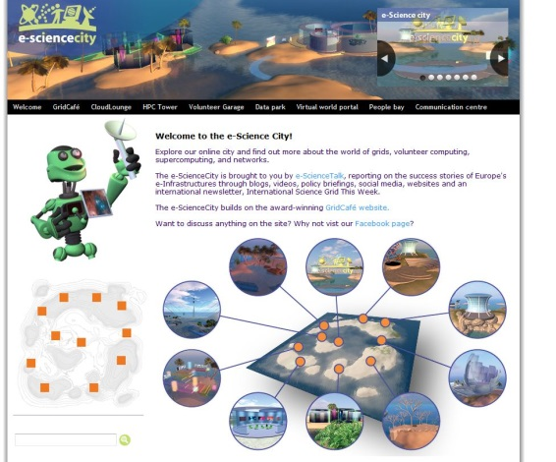

Figure 1: Screenshot of new e-ScienceCity

Dissemination

During PY1:
- One of the main aims of the project was to develop new technologies. During PY1, a new virtual e-ScienceCity island was proposed to be part of an OpenSim pilot. The aim was to create and evaluate a virtual venue dedicated to e-science and e-learning. In the first year, WP2 constructed the initial designs for an interactive 3D virtual environment, where users take the form of avatars that travel through the virtual space exploring the world of e-science.
- In May 2011, the e-ScienceTalk team introduced science communicators to the idea of a new virtual e-science world in a lively interactive session during the British Science Association (BSA) Conference. Catherine Gater previewed the new 3D GridCafé and initial first designs to a large audience of communicators at the conference (see Figure 2). Our project was also included in their annual report (see Figure 3).
- A five minute video (see Figure 4) was created to demonstrate the potential of the e-ScienceCity as a learning environment. The video was hosted on the e-ScienceCity website, and was demonstrated at the project review meeting in September 2011.
- Promotional materials such as a poster (see Figure 5) and an e-ScienceCity pull-up stand were also designed for the launch party.

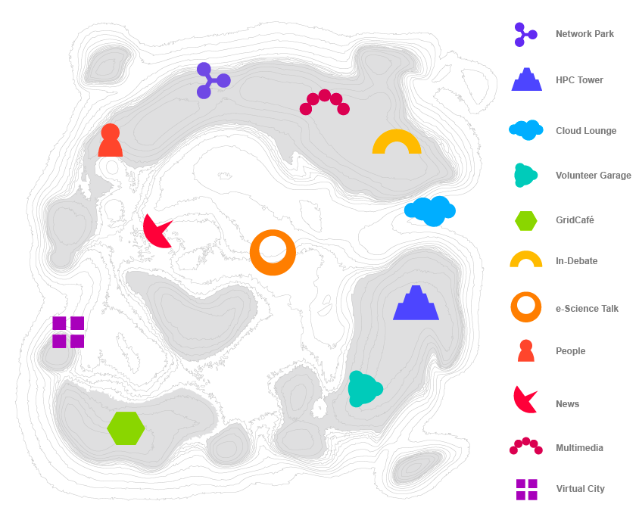
Figure 2: First designs for e-ScienceCity

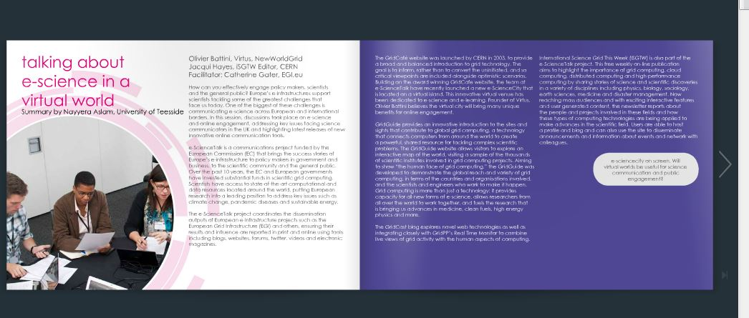
Figure 3: Article in British Science Association Report
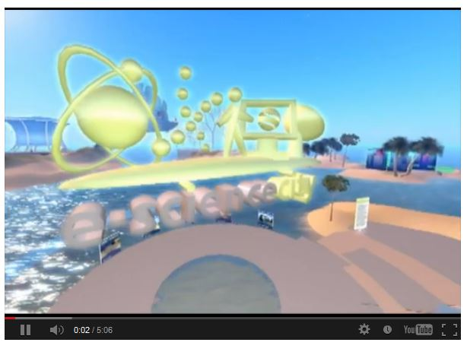

Figure 4: e-ScienceCity video developed for EC Project Review
During PY 2:
- The GridCafé website main content areas were migrated to the e-ScienceCity template at the end of PY1. The e-Science City (e-sciencecity.org) website was launched at the EGI-Technical Forum/9th e-Infrastructure Concertation meeting in Lyon in September 2011. The first area to be developed and promoted was Cloud Lounge (cloud-lounge.org). The site was also later promoted via social media at a more targeted audience at the CloudScapeIV forum in Brussels in February 2012.
- URL rewriting is fully supported among other optimisations.
- The third section of e-ScienceCity called Volunteer Garage (volunteer-computing.org), was published and launched at the ISGC’12 event in Taipei. It was also later promoted in an opening slide by Francois Grey at the Citizen CyberScience Summit in February 2012. Several tweets were sent to delegates at the meeting to invite them to visit the site.
- During Q6, the 3-D pilot of the GridCafé in collaboration with Virtus / New World Grid was also made available through the e-ScienceCity website.
- The text for the third new area for e-ScienceCity, HPC Tower (hpc-tower.org/) was developed in July 2012, and launched in time for the EGI Technical Forum in Prague in PY3.
- The project has used various communication tools to promote the new e-ScienceCity. The project enlisted the help of an intern at Queen Marys, University of London (QMUL) during the summer months. The intern was tasked with preparing and implementing a marketing strategy for PY3 to further promote the site to schools, universities and the wider public.
- At the end of PY2, APO Design had developed graphics for the 3D version of the People Bay, Communications and News sections.
- As part of a regular communications audit in July 2012, the Dissemination Officer sent out an email to all MoU partners introducing them to the new areas of the website and inviting them to link to the website.
- Technical Developments: The e-ScienceCity website was developed to be lightweight, faster and secure: it combines static pages with a general template, and has no database. The e-ScienceCity website was modified in order to host external domain names and internal URLs. A system has been designed to avoid duplicate content (same page with different URLs). A caching system was also developed in order to obtain a fully stand-alone version of the website, which could work on an USB stick.

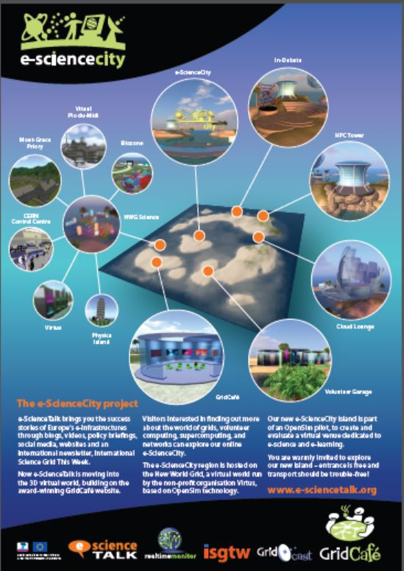
Figure 5: e-ScienceCity Poster for BSA Science Communication Conference

PY3
- The marketing plan developed by the QMUL Summer Intern, James Cook was implemented in the first six months of PY3. This included a number of marketing activities listed below:
  - Developing a Wikipedia page for GridCafe and e-ScienceCity and adding references to other grid and e-science related pages (e.g. http://en.wikipedia.org/wiki/Grid_computing)
  - Writing and scheduling tweets to promote the site on social media [e.g. Interested in e-ScienceCity (yesterday @CatherineGater's talk #econcertation)? Like us on http://fb.com/esciencecity]
  - Providing recommended e-ScienceCity hyperlinks to place within iSGTW and suggesting areas for internal linking across other e-ScienceTalk products
  - Designing and printing an offline school resources pack (see Figure 6)
  - Researching multimedia and games to be included in e-ScienceCity
  - Developing educational resources such as crosswords, puzzles etc. for e-ScienceCity
  - Filming and editing a video for GridCast to advertise grid computing resources at QMUL
- WP2 also developed a Communication Centre (e-sciencecity.org/communication-centre) within e-ScienceCity. This section aggregated all the news feeds from ISGTW and GridCast showing news bulletins on grids, clouds and supercomputing.
- During January 2013, the Data Park (e-sciencecity.org/data-park) section was launched. The text for the section was created by the Impact Reporter predominantly sourcing content from the November 2012 ‘Big Data’ e-ScienceBriefing.
- On January 21st 2013, an e-ScienceCity Facebook page was created, and the team now regularly post material to the page (see Figure 7).
- To ensure GridGuide’s sustainability, the project team moved the contents of GridGuide to People Bay (e-sciencecity.org/people-bay) in April 2013.
- Towards the end of PY3, some small visual changes were made to e-ScienceCity. Different characters now introduce the different sections of e-ScienceCity (e.g. the man holding a grid introduces Grids). Minor modifications were also made to the colour of the hyperlinks to make them more visible to visitors.

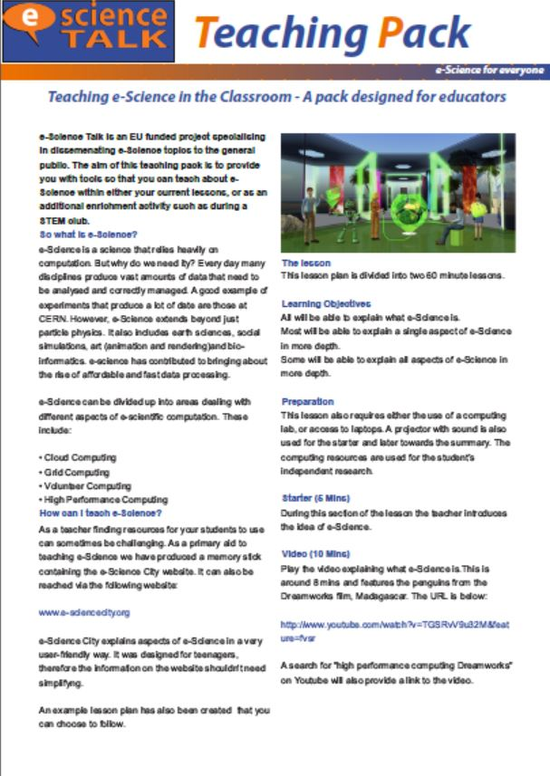
Figure 6: e-ScienceCity Teaching Pack

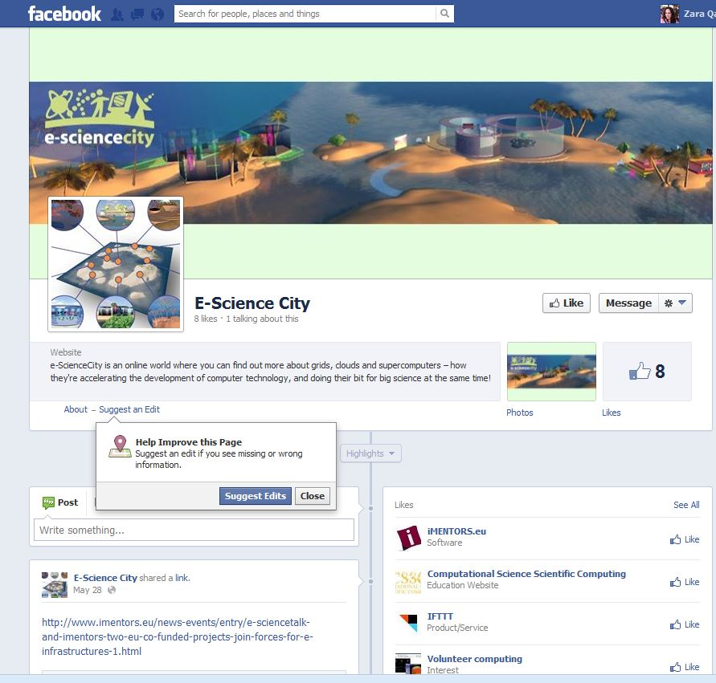

Figure 7: e-ScienceCity Facebook

Results

During the entire lifespan of e-ScienceCity, there has been a total number of 5,121 visitors and 19,553 page views. The increased promotion via a marketing campaign from January until April 2013 has significantly increased the number of visitors to e-ScienceCity (see Figure 8 below). The website was launched on September 19th 2011, and the graph below shows the pattern of visits since the launch. There has been a marked increase in visitors from PY2 to PY3 (1,869 to 3,252 unique visitors). Major spikes also coincide with promotion at conferences such as the EGI Community Forum in Munich (April 26th, 56 visitors) and during the 2013 conference season. This increase in online activity has been due to both onsite and offsite Search Engine Optimisation (SEO) techniques to drive up traffic. The D1.5 Final Impact and Sustainability Report will provide a more in-depth analysis of our dissemination findings including which areas are the most popular.

Figure 8: Visitors to e-ScienceCity
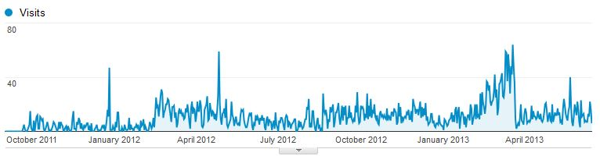

GridCast

Background
The GridCast activity (www.gridcast.org) was initially set up by the CERN IT Communication Team in an effort to communicate grid-related technologies in a more personal and interactive way. The site was initially created before the start of GridTalk, and was redesigned and re-launched in September 2009. In September 2010, the e-ScienceTalk project took over GridCast, and marketed it as a communication tool for all areas of e-science. GridCast (gridcast.org) combines blogs, videos and interviews from major grid computing, e- Infrastructure, and policy-related events providing scientists with an opportunity to blog and record podcasts about their experiences. GridCast is now more heavily promoted at conferences through Twitter. Outlined below are some of the main dissemination strategies used to promote the blog.

3.2 Dissemination
Prior to GridTalk, CERN had produced three GridCasts, from a variety of events, with entries from 19 bloggers and 25 podcasts in total. During e-ScienceTalk, there were over 555 blog entries and 226 podcasts (see Figures 10 and 11). The e-ScienceTalk project has now held over 44 major and mini GridCasts (PY1: 16, PY2: 16 and PY3: 14).

The main promotion for blog posts is via @e_scitalk and @iSGTW twitter accounts. To further promote the blog at conferences, APO Design produces a unique poster for each major event based around a theme or image representing the host city (e.g. a Lion for Lyon). A total of sixteen posters have been designed for ‘major’ GridCast events (see Figure 9). Every time a blog post is published at a meeting, a tweet is written to promote the blog using the conference hashtag (#). Blog posts are also further developed into articles for iSGTW, which further maximises exposure and traffic to the blog.

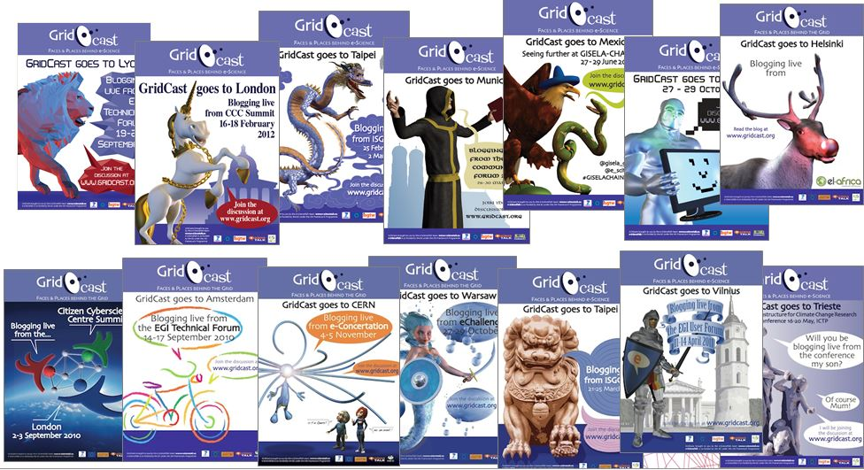
Figure 9: GridCast posters

For European Grid Infrastructure (EGI) alone, e-ScienceTalk produced 58 GridCast videos with 6,786 views in total. At both the EGI Tech Forum 2012 and EGI Community Forum 2013, the e-ScienceTalk team tweeted 77 times.

Figure 10: List of e-ScienceTalks “major” and “mini” GridCasts

PY1 | PY2 | PY3
- EIACT2010  - CHAIN  - Lifewatch  - PRACE/LinkSCEEM’11  - CLCAR 2011  - CloudscapeIII  - e-IRG Workshop  ISGC2011  - OGF31  - GISELA meeting 2011  - SC-Camp  EGI-User Forum 2011  - FET11  - Conference on role of e-infrastructure in Climate Change  - HealthGrid11  - TeraGrid2011 | - EGI Tech Forum 2011  - SC11  - 9th e-Infrastructure Concertation meeting  - eChallenges  - outGRID ITU High Level  - Citizen CyberScience  - CloudScapeIV  - ISGC2012  - ERF  - HealthGrid’12  - ICRI’12  - CRISP  - EGI Community Forum 2012 | - EGI Tech Forum 2012  - eChallenges  - EUDAT  - CRISP  - SC12  - CloudScapeV  - 10th eConcertation meeting  - ISGC 2013  - EGI Community Forum  - CAPRI  - E-IRG  - ISC'13

Figure 11: Breakdown of bloggers, entries and podcasts over three years

Year | Number of bloggers for  GridCast | Blog entries | Podcasts
1 | 59 | 244 | 56
2 | 46 | 181 | 30
3* | 100 (22 active bloggers) | 130 | 40
Total | 127 | 555 | 126
Year 3* is only 10 months.

The GridCast coordinator also tries to recruit experts in the field and provides advice to bloggers on how to promote their blog posts.

Results

Towards the end of GridTalk, the GridCast blog had received about 24 000 visits from 14 000 unique visitors (Source: Google Analytics). During e-ScienceTalk, the GridCast blog received 35,880 visits and 25, 876 unique visitors. The blog during this time has had 157,959 page views (Blogger stats June 15th). The peaks in activity generally correspond to the conference season (September/October and March/April). There has been an increase in page views in recent months (see Figure 12). During May 2013, the team witnessed the greatest amount of traffic to the blog (7,103 page views). One of the blog posts had a huge number of page views. “A new era for the post EMI: all together for MeDIA” received 1,652 views. This shows the potential of one well-promoted blog post. It is however difficult to predict which posts will generate high number of page views.

In February 2013, a blog post entry by Morris Riedel, as EMI Strategic Director & EUDAT Data Replication Task Force Leader was also picked-up from HPC In the Cloud (Cloudscape IV Spurs Discussion). The GridCast blog is read by a number of journalists, who follow @e_scitalk on Twitter. This also reinforces the importance of attracting high profile bloggers to contribute content and having an active and growing social media presence.

GridCast produces high quality videos, and all podcasts are also posted to the GridTalk project YouTube channel. Some videos have been incredibly popular due to the viral nature of YouTube. On May 2011, GridCast posted a video showing a robot ‘FET11 - ECCE Human Robot presented by Hugo Gravato Marques’ to YouTube, and received 189,870 views and 21,224 minutes of viewing time. The story behind how this occurred will be discussed in greater detail in the D1.5 Final Impact and Sustainability Report.
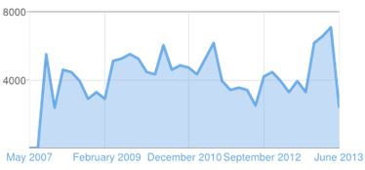
Figure 12: All time traffic to GridCast (Source: Blogger)

GridGuide

Background

The GridGuide (www.gridguide.org) gives a human face to the grid, showing the sites for grid computing. Users can listen to podcasts from grid sites worldwide, read about the ongoing work and watch interviews with researchers. GridGuide is the youngest of the GridTalk products. Individual sites are able to upload content themselves, allowing the GridGuide to grow independently but within the control of e-ScienceTalk. e-ScienceTalk has also encouraged other sites to contribute (e.g. PRACE, Supercomputing sites etc.)

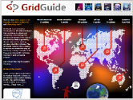
Figure 13: Screenshot of GridGuide

Dissemination

During GridTalk, the site gathered together 31 site guides, 52 people profiles, 19 slideshows, 27 videos, 250 items on 240 pages.

During PY1:
- The team during the first year of the e-ScienceTalk project encouraged people to contribute to GridGuide at events throughout the conference season.
- After substantial promotion at conferences, the number of sites listed on this communication tool increased to 37 in total (25 European and 12 non-European sites). More people profiles were listed on the site from 52 to 65 scientists.

During PY2:
- During the EGI Technical Forum in Lyon, both the Dissemination Officer and Impact Reporter liaised with the National Grid Initiatives to persuade them to join the site.
- As most traffic to GridGuide comes from other e-ScienceTalk products, cross-marketing with more internal links in GridCafe and iSGTW was carried out to help increase the visibility of this resource.
- In February 2013, a competition was launched to encourage existing sites to update and expand their GridGuide pages. In response, four sites updated content and were entered into the competition.
- During Q5, WP4 worked on developing MoUs with collaborating projects such SAGrid and REUNA to increase the number of non-European sites.
- At the end of PY2, an additional 25 sites were added to the GridGuide, bringing the total to 57 sites in total, 36 in Europe and 21 in Africa, the US and Asia.

During PY3:
- During Q10 and Q11, a further 45 sites were added to the site. At the end of PY3, there are 102 sites on the site. The additionalcontent has mainly been generated by the team. After numerous promotional activities and competitions, the e-ScienceTalk team made the decision to move the content over to e-ScienceCity. This will make it easier to market the resource and is also more sustainable as the site is then incorporated within the ongoing e-ScienceCity site. Each full GridGuide site has been migrated to GridPort (http://www.e-sciencecity.org/gridport).

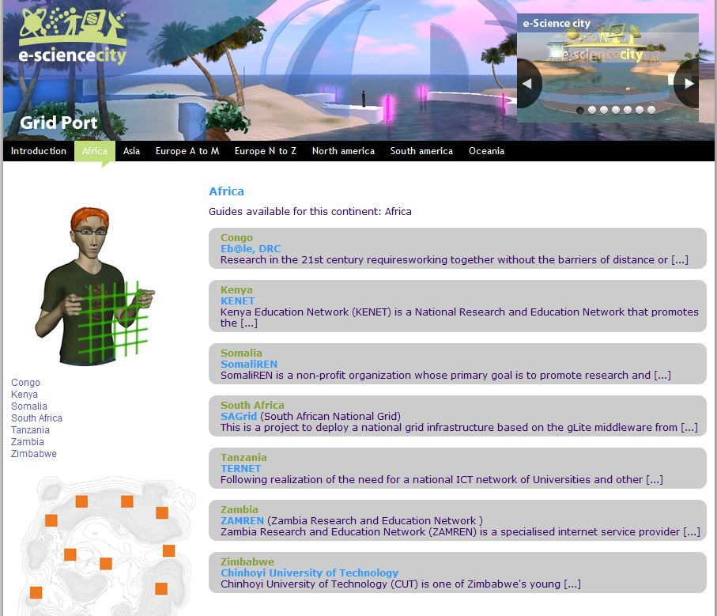

Figure 14: Screenshot of GridPort

Results

During e-ScienceTalk, the project has promoted the site numerous times. GridGuide has the lowest number of unique visitors (3,562) and page views of all the sites (6,023). Figure 15 shows the activity in Google Analytics. This may be due to an increase in use of LinkedIn and other social networking sites for scientists (e.g. http://www.researchgate.net/). The site may not be as relevant as it was when it was first proposed during GridTalk. Early promotions on June 2nd 2011 (187 visitors) were successful, but since then competitions and promotional activity have not worked to push up user-generated content activity on the site. GridGuide has now been successfully incorporated into e-ScienceCity as GridPort.

Figure 15: GridGuide visits during the e-ScienceTalk project

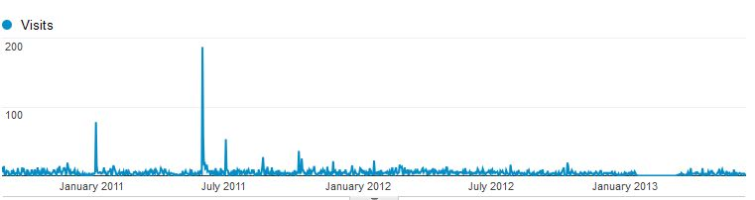

Real Time Monitor

Background

The RTM is a 3-D virtual globe that shows live information about the jobs the grid is processing. The Imperial College developers worked with GridTalk to produce a version of the RTM that integrates GridGuide information. By clicking on a site that is also in GridGuide, a site information box opens that includes a feed from the GridGuide pages. At a click, the visitor can see a full picture of information from the site, on a technical and human level. The RTM is widely used for demonstrating the grid at conferences and events across Europe and beyond and is an accessible and engaging way to understand more about the grid (see Figure 16).

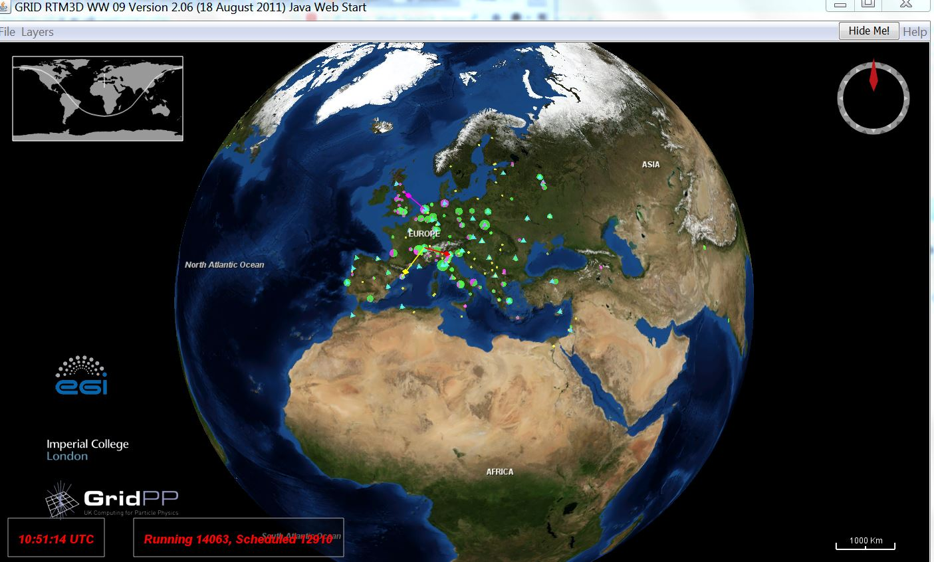
Figure 16: Screenshot of the Real Time Monitor

Dissemination

During the last three years, the RTM has appeared at a number of conferences.

During PY1:
- e-ScienceTalk attended and demo-ed the RTM at 15 events in nine months. Events included the EGI User Forum 2011 and the Royal Summer Society Exhibition (7,000 attendees).

During PY2:
- QMUL worked with the PANDA team at CERN to ensure that ATLAS data was published to the RTM, and these jobs were shown in the bleeding edge version.
- The GridCast team displayed the RTM at events attended by e-ScienceTalk, including SC11 and EGITF2011, and the EGI Community Forum in Munich (see full list Figure 17).
- During Q7, the Imperial team worked with CERN to add Phedex data transfer data to the RTM

Figure 17: RTM demos (PY2)
Month | Event ~approx. numbers of people
Sept 2011 | European Grid Infrastructure (EGI) Tech Forum Lyon ~300
Oct 2011 | All Hands Meeting UK ~150
Nov 2011 | Manchester Science Week ~90
Mar 2012 | Supercomputing'11 ~10,000
Mar 2012 | European Grid Infrastructure (EGI) Community Forum Munich ~400
Multiple dates | UK Particle Physics Masterclasses various locations ~300
Apr 2012 | IoP HEPP Meeting London ~150
May 2012 | Healthgrid Amsterdam ~40
July 2012 | Higgs Press Conference London ~100
July 2012 | LHC exhibition London ~500
July 2012 | Turingfest ~50

During PY3:
- The RTM was displayed at a number of events:

Figure 10: RTM demos (PY3)
Month | Event ~approx. numbers of people
Sept 2012 | EGI TF Prague ~300
Mar 2013 | Supercomputing'12 ~10,000
Mar 2013 | EGI CF Manchester ~400
Multiple dates | UK Particle Physics Masterclasses various locations ~40
June 2013 | ISC 2013
July 2012 | European Conference Computational Biology
July 2012 | 9th European Biophysics Congress.

During PY2, the UK Science Museum expressed an interest in including the Real Time Monitor in their LHC exhibition, Collider. Collider will open on the 13th of November 2013 and run for six months. Janusz Martyniak is working on a number of features that will make the RTM more accessible and visually appealing to the tens of thousands of visitors that will visit the exhibition. This includes technical improvements (e.g. optimising the code and solving issues with the JAVA code for the map), but it also includes some general aesthetic improvements requested by the museum (e.g. a full screen version, a globe that automatically jumps between locations, a recorded offline version, more data sources CMS-Phedex). This should be implemented by the e-ScienceTalk project review in time for the exhibition.

Results

The RTM has proved enormously successful and the project has reported in depth on the results of dissemination in two previous reports, D4.4 Annual Report Feedback and Metrics [R1] and D1.4 Impact sustainability repor.[R2] It is difficult to track the number of downloads but an IP analysis revealed a number of important institutions are running the RTM including some highly-recognised worldwide establishments (Österreichische Akademie der Wissenschaften, IstitutoNazionale di Fisica Nucleare - Sez. di Catania, RomaTre University, Oxford University, University of Glasgow, Max-Planck-Institut für Physik, the CC-IN2P). Demo-ing the RTM events has also increased awareness of the RTM. However, the biggest dissemination impact of the RTM will be a centrepiece demo at the UK Science Museum with a strong possibility of a world tour with the exhibition. Since Google Analytics code was implemented in December 2012, there have been 12,683 unique visitors and 33,693 page views of the site. On Tuesday October 23rd 2013, there was a huge spike in traffic (1,451) due to an event in the Czech Republic, which featured the RTM on its website (see Figure 11).

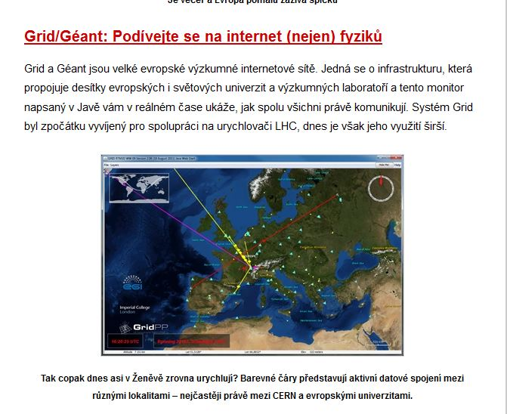
Figure 11: RTM on Czech website

Conclusion

The outreach hubs of GridCafe, e-ScienceCity and GridCast have all been promoted continuously during e-ScienceTalk through internal cross-marketing activities, and increased social media activity.

At the end of e-ScienceTalk, the project has established an online platform to promote e-science to a growing number of e-scientists. Dissemination is about promoting and advertising these projects further. The extensive marketing and promotion strategy devised for e-ScienceCity during PY3 has been extremely successful. Viewing stats have tripled between years, PY2 and PY3. It is difficult to say which particular initiative has been the most successful in increasing viewing statistics. Online SEO has also been instrumental in raising the site in Google rankings.

The RTM has been demo-ed around the UK over the last three years and has the potential to reach an even more diverse audience at the Collider exhibit at the London Science Museum. In the future, the RTM may even tour outside the UK reaching a worldwide audience.

The grid computing community have become increasingly reliant on GridCast to inform them on key developments in grid technologies, supercomputing and citizen cyberscience conferences around the globe. Advertising through posters and an elevated social media presence have increased activity on the blog although people still generally find out about the blog through word-of-mouth. Page views have increased significantly in recent months due to interest in one or two popular blog posts. The archive of blog posts from previous years is also still popular. Posting to YouTube has provided the means to reach an even bigger audience for individual podcasts.

All four products is discussed in more detail in the D1.5 Final Impact and Sustainability Report and D4.4 Feedback and Metrics Reports. [R3]

REFERENCES

R1 | D4.4_ Annual report on feedback and metrics  https://documents.egi.eu/document/1328
R2 | D1.4 Annual impact and sustainability report  https://documents.egi.eu/document/1297
R3 | D4.4 Final report on feedback and metrics  https://documents.egi.eu/document/1848

http://www.slideshare.net/SciCommConf/scc2011-talking-about-escience-in-a-virtual-world
Unfortunately these have subsequently been removed.
http://www.e-sciencetalk.org/briefings/EST-Briefing-24-Big-Data.pdf
http://gridtalk-project.blogspot.co.uk/2013/04/a-new-era-for-post-emi-all-together-for.html
http://www.hpcinthecloud.com/hpccloud/2012-02-28/cloudscape_iv_spurs_discussion.html
http://www.zive.cz/clanky/osm-zivych-map-ktere-vam-popisou-co-se-deje-ve-svete/sc-3-a-166010/default.aspx

