e-ScienceTalk

Marketing Strategy for iSGTW

EU DELIVERABLE: D3.3

Document identifier: | D3 3_Marketing_Strategy_final
Date: | 23/05/2011
Work package: | WP3: iSGTW
Lead Partner: | CERN
Document Status: | DRAFT
Dissemination Level: | PUBLIC
Document Link: | N/A

Abstract
This report provides an overview of the marketing strategy for International Science Grid This Week (iSGTW), which aims to increase its website traffic, the number of newsletter subscribers, and range of readers. It sets out five methods used to achieve this: through conferences and events; media partnerships; collaborating projects; online promotion, including the newsletter, search engines and social media; and setting up iSGTW as a social media site itself. It also looks towards sustainability of the website and newsletter for the future.

- Copyright notice
Copyright © Members of the e-ScienceTalk collaboration, 2010. See www.e-sciencetalk.eu for details of the e-ScienceTalk project and the collaboration. E-ScienceTalk is a project co-funded by the European Commission as an Support Action within the 7th Framework Programme. E-ScienceTalk began in September 2010 and will run for 33 months. This work is licensed under the Creative Commons Attribution-Noncommercial 3.0 License. To view a copy of this license, visit http://creativecommons.org/licenses/by-nc/3.0/ or send a letter to Creative Commons, 171 Second Street, Suite 300, San Francisco, California, 94105, and USA. The work must be attributed by attaching the following reference to the copied elements: “Copyright © Members of the e-ScienceTalk Collaboration, 2010. See www.e-sciencetalk.eu for details of the e-ScienceTalk project and the collaboration”. Using this document in a way and/or for purposes not foreseen in the licence, requires the prior written permission of the copyright holders. The information contained in this document represents the views of the copyright holders as of the date such views are published.
- Delivery Slip
 | Name | Partner/Activity | Date
From | Jacqui Hayes | CERN/WP3 | 16/5/11
Reviewed by | Moderator: Catherine Gater  Reviewers: PMB | EGI.eu/WP4  Various | 27/5/11
Approved by | PMB: |  | 27/5/11
- Document Log
Issue | Date | Comment | Author/Partner
1 | 16/5/11 | First draft | J Hayes / CERN
2 | 27/5/11 | Final draft | J Hayes / CERN
3
- Application area
This document is a formal deliverable for the European Commission, applicable to all members of the e-ScienceTalk project and its beneficiaries and collaborating projects.

- Document amendment procedure
Amendments, comments and suggestions should be sent to the authors.
- PROJECT SUMMARY

Over the last 10 years, the European Commission and governments have invested substantial funds in distributed computing infrastructures. Scientists have access to state-of-the-art computational and data resources located around the world, putting European research into a leading position to address the greatest challenges facing us today, such as climate change, pandemics and sustainable energy. The advent of the European Grid Infrastructure, combined with the blurring of boundaries between grids, clouds, supercomputing networks and volunteer grids, means that a clear consistent source of information aimed at non-experts is now more important than ever, through dissemination projects such as e-ScienceTalk, that cross national boundaries.

Objectives:

- e-ScienceTalk will build on the achievements of the GridTalk project in bringing the success stories of Europe’s e-Infrastructure to policy makers in government and business, to the scientific community and to the general public.

- e-ScienceTalk will work with EGI-InSPIRE and other collaborating projects to expand the scope of the existing GridTalk outputs, and to report on the interactions of grids with e-Infrastructures such as cloud computing and supercomputing.

- The project will explore options for the sustainability of e-ScienceTalk’s products.

- e-ScienceTalk will produce a series of reports aimed at policy makers to disseminate key policy issues underpinning grid and e-Infrastructure development in Europe. The project will also coordinate e-concertation activities.

- The GridCafé, GridCast and GridGuide suite of websites will cover new topics and explore novel web technologies; they will integrate closely with GridPP’s Real Time Monitor, combining live views of grid activity with the human aspects of computing.

- The growing weekly publication, International Science Grid This Week (iSGTW) will bring news and events to the existing and potential e-Science community.

- EXECUTIVE SUMMARY
The weekly e-newsletter iSGTW has a target audience of project participants, scientific users and the wider public. With this marketing strategy, we plan to increase the numbers of subscribers by 15% (to 7,545) by February 2012 and by a further 15% (to 8,529) by May 2013. Currently, most of our readers are based in Europe, North America and Asia. We plan to increase our reach in Asia.

The document sets out five methods used to achieve this: through attending conferences and events and disseminating printed materials; through website links and advertising to event registrants with media partnerships and collaborating projects; online promotion, including making the newsletter more social media friendly, using better techniques for delivering more organic searches on search engines to our site, and by promoting through social media including Facebook, Twitter and Reddit; and by setting up iSGTW as a social media site itself, with users able to create profile and blog.

This document also looks towards sustainability of the website and newsletter for the future, including plans to investigate the possibility of incorporating an Asian partner.

TABLE OF CONTENTS
1 Introduction 6
1.1 iSGTW and GridTalk 6
1.2 Relaunch of iSGTW and recent work 6
2 OVERVIEW OF READERSHIP AND TARGET DEMOGRAPHICS 8
2.1 COUNTRY OF ORIGIN 8
2.2 PROFESSION 9
3 Aims of the marketing strategy for iSGTW 10
4 marketing strategies and tools 11
4.1 Conferences and Events 11
4.2 Media Partnerships 12
4.3 Collaborating Projects 12
4.4 Online promotion 13
4.4.1 Newsletter 13
4.4.2 Search Engines 14
4.4.3 Social Media sites 14
4.5 iSGTW as a social media site 15
5 SusTAINABILITY 16
5.1 The Commercial Space 16
5.2 In Kind Support 16
6 Conclusion 17
7 References 18

Introduction

iSGTW and GridTalk

iSGTW was launched in November 2006 at www.isgtw.org, and it originally fell under the auspices of the GridTalk project, in conjunction with the Open Science Grid (OSG) in the US. GridTalk was a two year EU-funded dissemination project that aimed to coordinate publications that informed audiences about grid computing. It had four separate entities, including iSGTW, GridCafé, which focused on educating the general public about grids, GridCast, a blogging platform that took users behind the scenes of scientific computing events around the world and GridGuide a website showing the sites and sights behind grid computing

iSGTW was a weekly newsletter of selected stories about grid computing, written for researchers, scientists, EU funders, the media and wider public. Key reporting milestones include in-depth coverage of the Large Hadron Collider start-up and a month of stories dedicated to women’s work in grid computing. GridTalk finished in August 2010 and was succeeded by e-Science Talk, which started on 1 September 2010. ISGTW continues to operate under this new three-year EU initiative.

At the moment, iSGTW has two co-editors: the European editor, Jacqui Hayes, and the US editor, Miriam Boon. Each week, responsibility for the publication switches between the editors. There is also an Advisory Board consisting of eight members, with four members from the US, and while usually it also has four European members, at the moment there are only three Board members and the European members are searching for another member. We are currently investigating the possibility of adding aBoard member from the Asia Pacific region.

All website support and development is currently handled by Xenomedia, a company based in Chicago. A dedicated server is held with Titled Planet, also in Chicago, which is used to mail the newsletter to subscribers.

Relaunch of iSGTW and recent work

To highlight the fact that iSGTW was changing its focus to move beyond grid computing stories, to also cover clouds, volunteer computing, supercomputing and more, the Advisory Board decided the publication would require a new name and website re-design. After an in depth process of debate, deliberation and voting, iSGTW Board and strategy groups meetings, “The Digital Scientist” was chosen as the new name and the website design was approved.

On January 12, 2011, the new web design was formally launched. A beta version of the website was launched in November 2010 as D3.2 Relaunch of iSGTW [R1].This relaunch moved the web editors onto a free, open source content management systems called Drupal, which is easier to use and more reliable than the previous proprietary content management system. It contained interactive elements that the previous website did not have such as polls, the ability to comment on an article and to rate an article (out of five stars, by clicking on one of the stars). It also has a ‘share this’ feature, which allows a user to easily share the article with their followers on Twitter, friends on Facebook, or other social media sites. It now has an interface for people in other organisations to submit announcements or job advertisements, which are posted on the website and listed in the newsletter. There is also a calendar, which displays all events and conferences submitted by other users.

However, on the 14th January, the US editor at Fermilab received a cease-and-desist letter, from a commercial company in the U.S. called Digital Scientists. The letter requested Fermilab to stop running the new website by 28th January 2011. The website was temporarily shutdown. Within a couple of days, our newly designed website was rebranded back to iSGTW and reactivated. The next issue of the newsletter was issued on Friday 21 January under the iSGTW name, but with the full interactive features of the new content management system and web design. The newsletter has continued to publish as iSGTW on a weekly basis. There have been further discussions about creating a process to research a new name, but no formal strategy has been agreed by the iSGTW Board to date. Marketing of the publication will continue under the existing name for now and the same strategy will be followed for the new publication if a new name is decided upon.

OVERVIEW OF READERSHIP AND TARGET DEMOGRAPHICS

International Science Grid This Week passed 8,000 newsletter subscribers in March 2011. Each subscriber receives the newsletter to their email inbox every Wednesday. The newsletter has several links embedded so they can ‘click through’ to the website to read the articles in full and interact with other element of the website. Every week, 13-16% of the subscribers open the newsletter every week, which is on par with other newsletters that provide news and analysis. The readers know the publication well, and most read the newsletter on publication day. The website itself has between 11,000 and 16,000 visits every month. The difference between the number of newsletters being opened and the number of ‘click-throughs’ to the website indicate that up to 70% of subscribers open and read the newsletter without going on to read the rest of the website.

Based on GoogleAnalytics software, which monitors website traffic and the results of readership surveys conducted during the GridTalk project (based on participant responses to the newsletter), we have identified key demographics to target for growth of iSGTW readers and raise its profile.

COUNTRY OF ORIGIN

Most of our website readers are from North America and Europe, where the editors and board members are based, according to Google Analytics Software. For example, this is a pie chart of where our visitors were when they accessed our website in March, 2011:

Despite the team being located in Europe and the US, there is significant interest from Asia. We plan to capitalise on this interest, by continuing to cover stories from Asia and by exploring the possibility of adding an Asian editor to the team (see also section 5 Sustainability).

PROFESSION

Through previous readerships surveys, we have recognised a trend in the readership towards scientists and researchers in general, rather than pure IT professionals. This reflects the project’s long-term aim to target scientists. The largest group of readers calls themselves a scientist/researcher, at 40% (up from 38% in 2008) while the second largest group is IT professional at 32% (down from 38% in 2008).

2. What is your profession?
Scientist/Researcher |  |  | 40%
IT Professional |  |  | 32%
Other |  |  | 12%
Student |  |  | 5%
Media |  |  | 4-5%
Industry |  |  | 4%
Funding body |  |  | 2%
Total |  |  | 100%
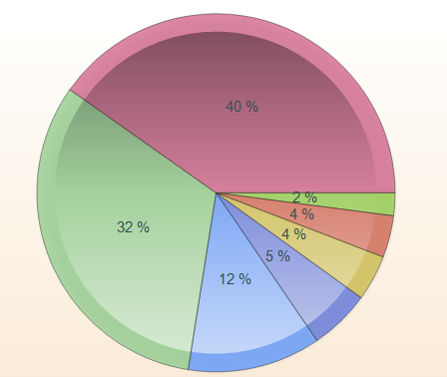

Table: from the December 2009 readership survey.

ISGTW now includes a background section for this influx of a new audience. It includes an
Introduction, Glossary, Technology Primer, Video Tutorials, Step-By-Step Guide and Directory of grid, cloud and supercomputer facilities.

There has also been an increase in the number of media subscribers, at 4-5% (up from 2% in 2008). This shows that previous marketing strategies targeting media have worked, including directly contacting science journalists, raising the profile of iSGTW through social media and notices of upcoming iSGTW stories in news services such as the American Association for the Advancement of Science (AAAS) and AlphaGalileo, the European press service. It has already results in several other news outlets have publicised iSGTW stories, such as “Ancient musical instrument comes back to life” and “The flat universe society” in publications such as the London Times.

Aims of the marketing strategy for iSGTW

The aims of the marketing strategy for iSGTW are as follows:

- Increase subscriber numbers
- Increase traffic to the website
- Broaden the demographics of readers eg new geographic regions, new subject areas, more scientists.
- Increase interaction with the website eg through blogs, polls, social media sharing etc.

There are two project milestones in PM18 and PM33 to increase subscriber numbers by 15% at each milestone point, with a total increase of 30% over the lifetime of the project.

The key target audiences for iSGTW are scientists who use grid computing, cloud computing, supercomputing or similar computing services and those who could potentially use these services, as well as the general public, particularly teachers and young people. In the past, iSGTW has had success in attracting media subscribers, and through this the computing facilities and scientific discoveries have gained greater coverage through other media outlets. We plan to continue these strategies. We also plan to increase our readership in Asia.

The marketing plans outlined in the following sections describe how these aims and target audiences will be addressed.

marketing strategies and tools

This section outlines the strategies and tools that are currently used to market iSGTW, based on the marketing techniques employed during the two years of the GridTalk project from May 2008 to July 2010. The work carried out to date is described, and plans for how to develop these techniques over the lifetime of e-ScienceTalk.

Conferences and Events

ISGTW targets delegates at conferences and events around Europe and beyond, in order to encourage subscriptions to iSGTW and to raise awareness of the project. ISGTW’s participation at these events includes booths in the exhibition areas for events, including e-ScienceTalk project booths, joint booths with other projects such as EGI-InSPIRE. ISGTW also partners with GridCast to blog live from the events and to source stories for articles. In addition, ISGTW also seeks media partnerships with the organisers of the events to increase subscriptions, as described in Section 4.2.

Major events attended by ISGTW and e-ScienceTalk to date include:

- Citizen Cyberscience Summit, 2-3 September 2010, London, UK

- EGI Technical Forum 2010, 14-17 September 2010, Beurs van Berlage, Amsterdam

- ICT 2010, 27-29 September 2010, Brussels, Belgium

- e-Challenges 2010, 27-29 October 2010, Warsaw, Poland

- 8th e-Infrastructure Concertation Meeting, 4-5 November 2010, CERN, Geneva, Switzerland

- Euro-Africa e-Infrastructures Conference, 9-10 December 2010, Helsinki, Finland

- LIFT11, 2-4 February 2011, Geneva, Switzerland

- Internal Symposium on Grid and Cloud Computing/OGF31, 22-25 March 2011, Taipei, Taiwan

- EGI User Forum 2011 & EMI Technical Conference, 11-14 April 2011, Vilnius, Lithuania

- FET’11 European Future Technologies, 4-6 May 2011, Budapest, Hungary

Different techniques are used to market iSGTW at these events. WP3 collaborates with WP2 to produce posters for the event, which are displayed at booths or at the venues such as FET’11 in Budapest and the EGI User Forum in Vilnius. These posters contain an image iconic of the location, as well as the location and date, the iSGTW logo, and the text: “Do you speak grid?” in the local language, with an English translation. The posters also include 3D QR bar codes that link directly to the iSGTW website from smart phones. These posters are put up at booths at the conferences and have proven to be particularly popular, with several people asking if they can take home a copy of the poster. Two recent posters are replicated below, with the complete list of posters available to download from the iSGTW website at: www.isgtw.org/content/posters-and-slides

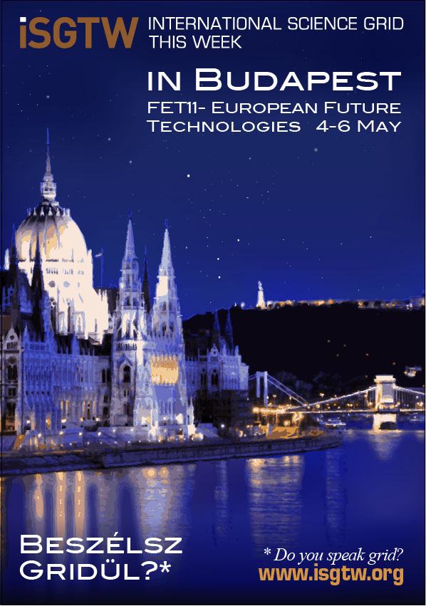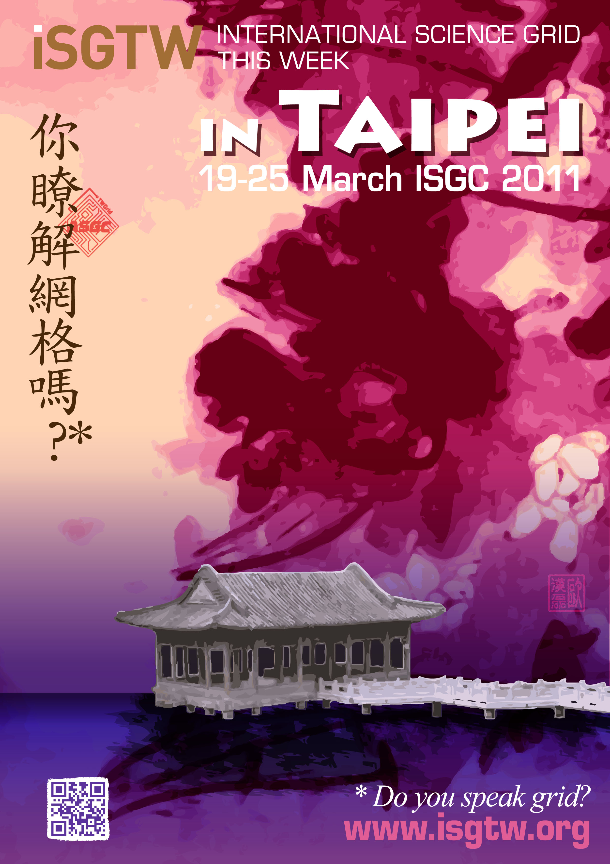
Images: iSGTW posters for FET11 in Budapest, Hungary and ISGC 2011 in Taipei, Taiwan.

Media Partnerships

The e-ScienceTalk project has negotiated a number of media partnerships with international conferences, whereby we post announcements for the conference in iSGTW, and in the calendar, and report on the science being presented at the conference through the GridCast blog and articles in iSGTW. In return, the conference provides a link to our website, which increases the rank of iSGTW in organic search engines. In some cases, the conference organisers also offer an option to delegates during the registration process to receive the weekly email newsletter. This has proven to be a great way to build an interested audience. Recent media partnerships have been with the Citizen CyberScience Summit, the EGI Technical Forum 2010 and the EGI User Forum 2011. iSGTW was also represented by Fermilab at the Supercomputing 2010 event in New Orleans in November 2010, attended by 10,000 delegates, where the new version of the website was previewed, and delegates given the opportunity to subscribe.

There are a few key projects that we will continue to monitor for potential partnerships. These include XD (the next stage of TeraGrid in the US), ESFRI and EUDAT.

Collaborating Projects

The e-ScienceTalk project has also signed a number of Memoranda of Understanding (MoU) with collaborating projects, including e-IRGSP2/3, European Middleware Initiative, EUIndiaGrid2, LinkSCEEM2, CHAIN, WeNMR and GISELA . In these MoUs, e-ScienceTalk aims to collaborate on dissemination activities with the collaborating projects, including:

- Disseminating new applications of relevance through the e-ScienceTalk dissemination channels, such as the GridCafé, GridCast, iSGTW and GridGuide;
- Disseminating the outputs of the project in e-ScienceTalk publications;
- Raising the awareness of other potential users and decision makers, through the presentation of the results of the project, about the usefulness of e-Infrastructures for e-Science;
- Featuring information about the projects on each other’s websites and dissemination materials where appropriate;
- Announcing each other’s events on websites and in publications where appropriate;
- The collaborating project will provide content and information about the project and applications of relevance to their community to e-ScienceTalk publications such as iSGTW and the policy documents, the e-ScienceBriefings;
- The project will promote e-ScienceTalk’s products to its communities and contacts, for example by offering to registrants at events the opportunity to subscribe to iSGTW.
- The project will offer e-ScienceTalk the opportunity to act as media sponsors for events that it organises, including adding the e-ScienceTalk logos and links to e-ScienceTalk products to the event website, in return for promotional activities for the event.

The e-ScienceTalk project is working to expand these MoUs to other projects in Europe and beyond including EGI-InSPIRE.

Online promotion

Almost all traffic to the iSGTW website comes from three sources: the newsletter, search engines (largely Google, but also Yahoo), and social media sites (Facebook, Twitter, etc). Each of these strategies are different and will be analyzed separately.

Newsletter

We continue to make slight modifications to the newsletter to engage readers. One strategy we are investigating is whether we can have giveaways, such as books, DVDs, or tickets to see speakers, etc, in the newsletter or on our website to increase the number of people opening the newsletter. Another strategy is to change the title of the newsletter from the date and name to short, catchy titles reflecting the content of the newsletter.

Search Engines

Currently, we work to increase out traffic from organic searches by increasing overall traffic to the site, by ensuring fast load times for web pages, and by link swapping with reputable organisations (events, conferences and research institutions). We also cross-post to GridCafé, and, when they launch, we plan to link to add from e-Science City and the New World Grid 3-D interactive environment.

After re-launching the website in early 2011, we noticed that the website was taking longer than usual to load pages. This is not good, as slow load times are penalised by search engines. Xenomedia, our Chicago-based web development team, installed the Boost module on Drupal (our content management system) in May 2011. Boost provides caching for static pages and significantly decreased page load times for anonymous users.

We are currently investigating even more ways to increase traffic from organic searches through sites such as Google and Yahoo. At least one strategy so far that we are in the process of implementing is improving image searches. This will include proving title text (displayed if you mouse over an image) and alternative text (for people who have images turned off). This also helps visitors who use only text browsers or who have screen readers to orient themselves to our contents and to explain the purpose of such additional elements in our web design. Google uses the words in alternative text to help display results in searches. This is a replacement of ‘metadata’ tags for images, which now have a much lower priority now in search engine algorithms.

Social Media sites

For the last year or so, there has been significant traffic from social media sites, including Facebook and Twitter, with it being the third largest traffic source to the website, after the newsletter and Google searches. However, there has been no social media strategy thus far in the project. We plan to increase our use of this environment by regularly posting stories to Facebook, Twitter, Reddit, StumbleUpon and to investigating other sites and blogs, such as Slashdot, Nature Networks, Digg, Wikipedia, and Buzz.

With Twitter (twitter.com), we can reach a greater audience for the website, by disseminating each of the articles posted on the site. Currently, with limited use of Twitter, iSGTW has 181 followers as of April 2011 and tweets are regularly retweeted to reach a larger audience. We plan to increase this to the point where there is at least one post on Twitter each day. On top of dissemination, we plan to use Twitter to engage our community through questions or inviting them to participate by, for example, inviting them to send us questions to ask interview subjects at conferences. This worked particularly well in the case of an interview with Tim Berners-Lee, the inventor of the World Wide Web.

Facebook (facebook.com) has 336 people following the international Science Grid This Week page, and we plan to increase the regularity of our postings on Facebook to try to build this audience.

We have been using Nature Networks and to date is has not delivered the audience we expected or wanted. In July 2010, iSGTW hosted an online real time discussion with grid experts and Nature readers. The iSGTW discussion forum has also featured on the home page of Nature Networks which receives many millions of hits We are working with the editors of Nature Networks to see if there is a better way to promote our site through their audience, instead of through our own.

iSGTW as a social media site

When the website relaunched in January 2011, interactive features, such as polls, were available. We have started experimenting with running polls with interesting questions, such as: “‘Web access is a universal human right.’ Do you agree?” This poll question linked back to a story about Tim Berners-Lee and Gordon Brown, who are campaigning for better web access in developing countries.

At the moment, the iSGTW site has the capability to allow people to create a profile on our site. So far 35 people have done so. This has had varied success, but it is definitely delivering a small amount of traffic, as people searching for a certain person’s name will land on our site. We recently decided to actively ask anyone who authors an article to fill out a profile in order to start growing this number .At this stage, we are investigating the possibility of creating profiles on our site of people that can start and maintain blogs through iSGTW. Depending on success, the next stage could be allowing companies or institutes to blog, such as EGI or TeraGrid.

SusTAINABILITY

We will work with WP1 to develop plans for making the newsletter and website sustainable, feeding into the annual impact and sustainability reports. Some areas that we will explore during the project include commercial sponsorship and in kind support from collaborating projects.

The Commercial Space

Due to a partnership with the Fermi National Laboratory in the US, iSGTW cannot currently accept advertising revenues. In addition, the commercial space covering high performance/supercomputing and grid computing is crowded at the moment, including:

- Scientific Computing (scientificcomputing.com)
- HPC Wire (hpcwire.com)
- SupercomputingOnline (supercomputingonline.com)
- VizWorld (vizworld.com/science)
- insideHPC (insidehpc.com)
- HPC in the Cloud (hpcinthecloud.com)
- Dr. Dobbs (drdobbs.com/high-performance-computing)
- Computing Now (computer.org/portal/web/computingnow/internetcomputing)
- BioIT World (bio-itworld.com)

Often, these publications cover press releases by the larger computing companies such as Intel. Because iSGTW is not funded by the computing industry, we can cover different material to these publications, such as the scientists who use these products to further scientific research. Beginning to cover these topics risks alienating the audience we have built so far. Instead, we plan to position iSGTW as the preferred channel for cyber/e-infrastructure and the research community represented by ESFRI, EUDAT, XD, etc.

In Kind Support

We are looking at adding an editor from other areas of the world, such as Asia. This new editor would be a new position, completed funded by a partner organisation such as Academia Sinica Grid Computing (ASGC) in Taiwan. We are currently developing a plan for an editorial process - for example, the new Asian editor might regularly contribute stories from their region of the world, or publish the issue on a regular basis, for example once a month.

Conclusion

The five major strategies to market iSGTW (conferences and events; media partnerships; collaborating projects; online promotion; iSGTW as a social media site) will be monitored in a variety of ways such as through Google Analytics, annual readerships surveys, the focus groups that feed into the impact and sustainability work of WP1, and reported in the quarterly and annual reports. Some of these strategies are simple yet expensive, while others are affordable but labour intensive. Therefore, we will continually monitor and report on these strategies and this feedback will be used to decide how to best allocate our resources and distribute workload.

iSGTW already has a loyal readership. By reaching out to previously neglected audiences, such as the youth or those based in Asia, and by paying close attention to its content, iSGTW can raise its profile further and expand beyond its core to a larger, more diverse readership.

References
R 1 | D3.2 Relaunch of iSGTW https://documents.egi.eu/document/265

www.gridtalk.org
www.gridcafe.org
www.gridcast.org
www.gridguide.org
www.isgtw.org/content/introduction
www.isgtw.org/content/glossary
www.isgtw.org/content/technology-primer
www.isgtw.org/content/video-tutorials
www.isgtw.org/content/get-started-step-step
www.isgtw.org/content/directory
www.isgtw.org/feature/isgtw-feature-ancient-musical-instrument-comes-back-life
www.isgtw.org/feature/flat-universe-society
www.e-irg.eu/about-e-irg/mission-and-vision.html
www.eu-emi.eu/
www.euindiagrid.eu
www.linksceem.eu
www.chain-project.eu
www.wenmr.eu
www.gisela-grid.eu
http://www.isgtw.org/feature/mobile-fast-track-developing-world

