Landscape Analysis
machine Learning

Authors | Ville Tenhunen, Elisa Cauhé, Andrea Manzi, Diego Scardaci, Enol Fernández del Castillo,
Technology | Machine learning
Last update | 17.12.2020
Status | Final version

DOCUMENT LOG
Issue | Date | Comment | Author
init() | 8.9.2020 | Initialization of the document | VT
The second version | 16.9.2020 | Content to the most of chapters | VT, AM, EC
Version for discussions | 6.10.2020 | Content to the chapter 3, 7 and 8 | VT, EC
Chapter 2 titles and bit more | 8.10.2020 | Chapter 2 titles and Acumos added to the frameworks | VT
Towards first full version | 16.11.2020 | Almost every chapter has edited | VT
First full version | 17.11.2020 | All chapters reviewed and edited | VT
Addition | 19.11.2020 | Added Mahout and H2O | VT
Fixes | 22.11.2020 | Bunch of fixes based on Diego’s comments | VT
Fixes based on discussions on previous day | 24.11.2020 | 2.4, 3.1.8, 6 | VT
Final draft | 27.11.2020 | Chapters 5 - 7, Executive summary | VT, EC
Final draft | 16.12.2020 | Some parts revised based on comments of Álvaro López García | VT
Final draft | 17.12.2020 | Structure in the chapter 3.2 updated and smoke libraries etc. added | VT
Final version | 17.12.2020 | Final version reviewed by Diego Scardaci | VT

TERMINOLOGY
For the purpose of this document, the following terms and definitions apply:
The key words "MUST", "MUST NOT", "REQUIRED", "SHALL", "SHALL NOT", "SHOULD", "SHOULD NOT", "RECOMMENDED", “MAY", and "OPTIONAL" in this document are to be interpreted as described in RFC 2119. For a complete list of term definitions see the EGI Glossary (http://wiki.egi.eu/wiki/Glossary).
Contents
Executive summary 6
Introduction 7
Demand, use cases and fields of applicability 7
Machine learning architectures in general 10
Use cases 11
Scientists and researchers create ML solutions 11
Scientists and researchers use ML solutions 12
Platforms and marketplaces 12
Available tools and services 13
Platforms 14
Acumos 14
AI4EU 14
DEEP Hybrid DataCloud 15
H2O 15
RapidMiner 15
FaaS services 16
Frameworks and libraries 16
Horovod 16
Keras 17
PyTorch 17
scikit-Learn 17
Spark MLib 17
TensorFlow 18
XGBoost 18
Applications and Softwares 18
IBM SPSS Modeler 18
Jupyter Notebook 19
Mathematica 19
Mahout 19
Neural Designer 20
R studio 20
SAS Enterprise Miner 20
STATISTICA Data Miner 20
Workflow tools 21
RCASE 21
Kubeflow 21
Apache Spark 21
Analysis on the current adoption and usage of the technology 22
Standardisation activities & policies 26
Standards 26
Ethical issues 27
Policy groups and documentation 28
AI Projects, Initiatives, partnerships and technology providers 29
General Overview 29
Projects 30
AI4EU project 30
StairwAI 32
AI4PublicPolicy 32
DIGITbrain 33
EGI-ACE 34
EOSC Future 34
EUHubs4Data 35
SoBigData++ 36
Initiatives 36
EurAI 36
AI DIH 36
National and institutional initiatives 37
Networks of excellence 38
Interested partners of the EGI Federation 38
Partners of the DEEP Hybrid DataCloud Project 38
UCC 38
Integration scenarios in the EGI Infrastructure 39
Current services 39
Extending offers 39

Executive summary
In this landscaping document has presented Machine Learning and Artificial Intelligence landscape beginning from general use cases (chapter 2), fields of applicability and available tools and services like platforms, applications, softwares, libraries and workflow tools (chapter 3) and analysis on the current adoption and usage of the technology (chapter 4). After these chapters this document focuses on standardisation activities & policies (chapter 5), AI Projects, Initiatives, partnerships and technology provider (chapter 6) and integration scenarios in the EGI infrastructure (chapter 7).
Even if the name of the document is machine learning (ML) landscape, artificial intelligence (AI) is a remarkable part of it. Partly because modern AI has its roots in machine learning technologies and concepts. Both of these have their interconnection to data science (DS) which offers a rich toolbox for machine learning and artificial intelligence applications.
It is possible to see in DS, ML and AI development similar routes than with any other innovation of the digital age. First developers make their applications manually based on technical skills, ideas and as craftsmanship logic. Next step is to build some tools to industrialise development and finally start to work with applications and other components via a business driven approach. We have seen this for example in the development of the WWW solutions; first developers created HTML pages manually with text editors, then HTML editors and www publishing systems came in to the market and now it is possible to build almost any kind of service by collecting services and applications from platforms build to the internet. It is important to notice that all these development eras still exist although new user groups do not start from the beginning.
Development of all data related technologies and approaches, like data science (DS), machine learning and artificial intelligence with all flavours of them, are developing very fast right now. There are a number of country level, regional and global initiatives. In Europe development is strong in many level of ecosystems like EC describe in the White paper:"Europe can combine its technological and industrial strengths with a high-quality digital infrastructure and a regulatory framework based on its fundamental values to become a global leader in innovation in the data economy and its applications as set out in the European data strategy".
This strategy has initiated a number of remarkable projects and where EGI is strongly involved.
Current offers of the EGI in this area are Cloud compute (incl. GPUs), Cloud Container Compute, High Throughput Compute, Online Storage and Notebooks. These are very valuable services for developers and service providers. There is potential to extend service catalog in the future in a few ways which are described in chapter 7. One area of the services which EGI have to look at is several platforms and marketplaces of AI tools and solutions.

Introduction
Machine learning (ML) is the study of computer algorithms that improve automatically through experience. It is seen as a subset of artificial intelligence. Machine learning algorithms build a mathematical model based on sample data, known as "training data", in order to make predictions or decisions without being explicitly programmed to do so. Machine learning algorithms are used in a wide variety of applications, such as email filtering and computer vision, where it is difficult or infeasible to develop conventional algorithms to perform the needed tasks.

Demand, use cases and fields of applicability
Machine learning is possible to see as a part of the data science landscape as described in figure 1.
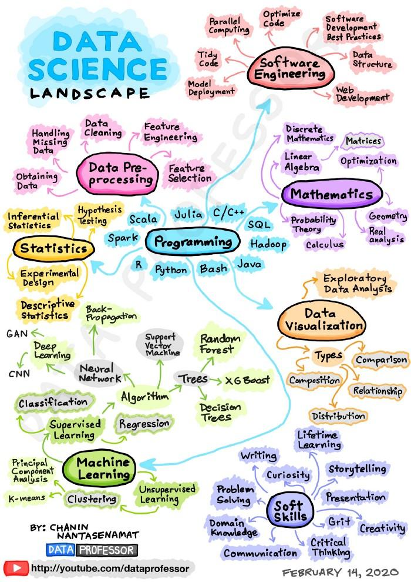
Figure 1. Data Science landscape
In the research communities machine learning use cases are strongly dependent on, for example, the research subject, project objectives, research group’s or discipline’s traditions and demands. Typically researchers create their own scripts using selected algorithms.
By the wikipedia machine learning approaches are traditionally divided into three broad categories, depending on the nature of the "signal" or "feedback" available to the learning system:
- Supervised learning: The computer is presented with example inputs and their desired outputs, given by a "teacher", and the goal is to learn a general rule that maps inputs to outputs.
- Unsupervised learning: No labels are given to the learning algorithm, leaving it on its own to find structure in its input. Unsupervised learning can be a goal in itself (discovering hidden patterns in data) or a means towards an end (feature learning).
- Reinforcement learning: A computer program interacts with a dynamic environment in which it must perform a certain goal (such as driving a vehicle or playing a game against an opponent). As it navigates its problem space, the program is provided feedback that's analogous to rewards, which it tries to maximize.
There are number of application areas for machine learning, including:
- Agriculture
- Anatomy
- Affective computing
- Bioinformatics
- Brain–machine interfaces
- Cheminformatics
- Citizen science
- Computer networks
- Computer vision
- Credit-card fraud detection
- Data quality
- DNA sequence classification
- Economics
- Financial market analysis
- Handwriting recognition
- Information retrieval
- Internet fraud detection
- Linguistics
- Machine perception
- Machine translation
- Medical diagnosis
- Natural language processing
- Natural language understanding
- Mathematical optimization
- Sentiment analysis
- Sequence mining
- Software engineering
- Speech recognition
- Structural health monitoring
- Syntactic pattern recognition
- Theorem proving
- Time series forecasting
- User behavior analytics
Additionally machine learning offers a number of commercial applications in various business areas.
Artificial intelligence (AI), machine learning and data science have deep connections between each other. Basically they are all based on the ideas of data science as it describes the following graph. Modern AI is based on machine learning methods and therefore it is not possible to separate them totally.

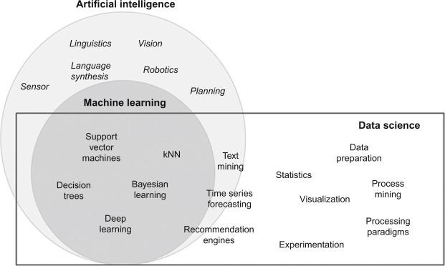
In this report the focus is on machine learning and artificial intelligence approaches. The latest has presented mostly via projects and general architectures when they include machine learning elements.

Machine learning architectures in general
Typically machine learning has been described with three key elements:

Available data
Computing power
Statistical methods

Machine learning and its methods are based on data and its quality. Data is used with computing power by statistical or data science methods.
In the machine learning architecture all these components are typically simultaneously evolved and used. Sometimes development and testing are made in smaller environments and then it moved to the large scale environment for the production use.
The process to create machine learning application from the data is normally as follows:
- Data capturing and collecting is the starting point of the process.
- Exploring and wrangling the data are process phases where data is prepared for use and the data quality is checked. This process phase is normally very time consumable but critical for machine learning product quality.
- When the data is ready the machine learning model is trained with part of the data.
- During the training, result model performance is evaluated.
- Based on the performance evaluation, the model is improved. After this phase it is possible to train the model again or continue to create machine learning products.

Collecting data
Data exploring and wranling
Training a model
Evaluating model performance
Improving the performance
Researchers’ methods and resource usage varies by process phase because different disciplines have different traditions and skills level of resource use.
Some researchers create their own tools and algorithms in their own IT infrastructure and some of them use preconfigured tools in global cloud infrastructures. Some use a lot of big data and some create data and results with small scale data sets. There is not only one model to work with machine learning or artificial intelligence applications or methods.

Use cases

Scientists and researchers create ML solutions
In this use case, researchers create their own tools or machine learning algorithms or other products for scientific use. Typically this use case is connected to the model training phase.
One side of this use case includes rather normal but modern software and application development. Additionally there are different frameworks and data sources in use.
Users also use the platforms which give opportunities to easily combine server sides services like Apache Flink, Apaches Spark, and H2O.
Machine learning applications are sometimes very scalable. Users make development in smaller environments and move to the scalable production environment later.
Machine learning and artificial intelligence products have to be published in some service. For this aim, EGI offers:
- Notebooks/RStudio
- Access to datasets (DataHub/Online Storage)
- Cloud Compute / GPU
- High Throughput compute (also with GPUs)

Scientists and researchers use ML solutions
In this use case researchers use some ML solution to solve practical problem like detecting and preventing plagiarism. Typically solutions are SaaS or FaaS services from some cloud platforms.
Scientists also use machine learning solutions to make science in their own research area or discipline. One example is about machine learning applications to review massive collections of research papers or patents.
Technical requirements of solutions depend strongly on application and/or research area and its traditions. Some need GUIs and some are satisfied with command line libraries. Also computing and storage requirements vary quite much case by case.
For this use case, EGI offers:
- Cloud compute / GPU
- Cloud Container Compute
- High Throughput Compute
- Online Storage
- Notebooks

Platforms and marketplaces
Platforms and marketplaces are an important part of the machine learning and AI ecosystems. The on-demand platforms offer matchmaking service for the automatic discovery of AI assets (tools, data sets, AI experts, consultants, papers, courses etc.) meeting the user business needs and provision hardware resources through a proper hardware provider (HPC, Cloud and Edge infrastructures).
In this area, the most relevant European Initiatives is the AI4EU project that is building the first European AI on-demand platform and ecosystem with the support of the European Commission under the H2020 programme.
The AI4EU platform enables researchers, developers, company users and others to engage with the community, collaborate, to exchange expertise and resources, and to make the most out of provided services solutions & AI resources to create AI applications and solutions in all kinds of AI with consideration of societal, scientific and technical dimensions.
Figure below shows the interconnection of the AI4EU marketplace stack (left part) with the one of Bonseyes (right part) by using smart integration and interoperability activities and techniques (center part).
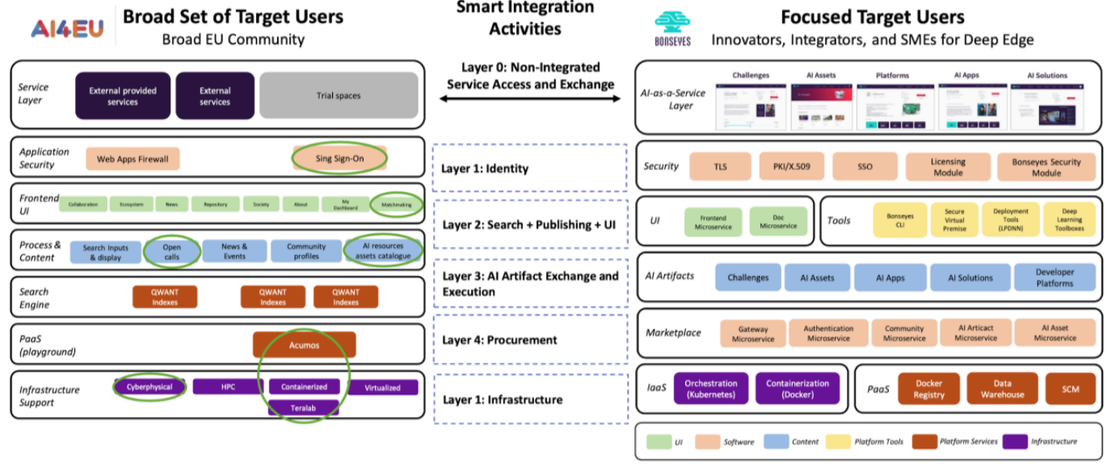
Other examples are the new project AI4PublicPolicy, planned to start in 2021, which will offer an open cloud platform for automated, scalable, transparent and citizen-centric policy management based on unique AI technologies to policymakers and Cloud/AI experts and the Bonseyes marketplace that will be interconnected with the AI4EU platform. Bonseyes is an open and expandable AI platform which transforms AI development from a cloud centric model, dominated by large internet companies, to an edge device centric model through a marketplace and an open AI laboratory.

Available tools and services
In this chapter, some widely used ML and AI platforms, applications, softwares and libraries are presented. Programming languages have been presented only where they are relevant for the nature of the application.
Machine learning is evolving very fast at the time of writing this document and, therefore, the following list of solutions cannot be considered exhaustive. Selection has been based on their adoption and the estimation of which are possibly the most relevant to the EGI in the near future.
More frameworks, platforms and libraries can be found in the LF AI & Data Foundation Interactive Landscape service.
As Nguyen et.al. has written, it is important to emphasize that there is no single tool suitable for every problem and often a combination of them is needed to succeed.

Platforms
Platforms provide comprehensive tools to develop and train AI and ML models.

Acumos
Acumos AI is a platform and open source framework that makes it easy to build, share, and deploy AI apps. It includes a federated AI Model Marketplace – a catalog of AI models contributed by the community that can be securely shared.
License: Open source. Applications in the marketplace use mostly Apache Licence 2.0, but also MIT, BSD and GPL licenses
Field of applicability: Generic. Environment for the full lifecycle of AI and ML application development
European solution: No, global

AI4EU
The AI4EU is a project to build the European AI on-demand platform and ecosystem with the support of the European Commission under the H2020 programme. The AI4EU Platform is designed to be accessible only by using a web browser, without requiring any client software installation. By the design principles AI4EU hosts workflows and algorithms for a wide range of AI symbolic and machine learning problems and the platform is fully scalable and interoperable in terms of data sources, programming languages, IT infrastructures, and third-party platforms.
In future releases, users will be invited to choose from desired resources in the catalogue and upload them in their own infrastructure or use AI4EU local resources or other partner platforms instances. This layer will include composition services that might be instantiated through a local ACUMOS instance.
License: NA
Field of applicability: Web based platform for AI and ML workflows and algorithms
European solution: Yes

DEEP Hybrid DataCloud
A comprehensive platform for machine learning, deep learning and artificial intelligence in the European Open Science Cloud. Developing, training, sharing and deploying your model has never been easier.
Platform offers services to:
- Browse models and publish new models on the marketplace.
- Develop models and train them with the JupyterLab environment and resources from the European Open Science Cloud.
- Deploy the model as a service.
License: Multiple (component based)
Field of applicability: A set of building blocks that enable the easy development of applications requiring these techniques: deep learning using neural networks, parallel post-processing of very large data, and analysis of massive online data streams . These services will be deployed in the project testbed, offered to the research communities linked to the project through pilot applications, and integrated under the EOSC framework, where they can be further scaled up in the future.
European solution: Yes

H2O
H2O is a fully open source, distributed in-memory machine learning platform with linear scalability. H2O supports the most widely used statistical & machine learning algorithms including gradient boosted machines, generalized linear models, deep learning and more. H2O also has an industry leading AutoML functionality that automatically runs through all the algorithms and their hyperparameters to produce a leaderboard of the best models.
License: Open Source; Apache License 2.0
Field of applicability: Generic ML platform, popular in both the R & Python communities.
European solution: No, Silicon Valley open source software company

RapidMiner
RapidMiner is a data science software platform developed by the company of the same name that provides an integrated environment for data preparation, machine learning, deep learning, text mining, and predictive analytics.
License: Proprietary and AGPL; Professional and Enterprise Editions are Proprietary; Free Edition (10,000 rows and 1 logical processor limit) is available as AGPL
Field of applicability: Generic data science software platform
European solution: No, HQ at Boston, MA, USA

FaaS services
Currently there are some commercial service providers which offer platforms and Function as a Service concepts for the machine learning users. Here is some examples:
- Microsoft Azure
- Google Cloud
- Machine Learning on AWS
- IBM; Data Science and Machine Learning Tools
OCRE project has presented that it will make selected commercial digital services. The project has organised calls for research projects to receive cloud adoption funding for use by research projects at individual institutions for cloud services (IaaS, PaaS, SaaS).

Frameworks and libraries
Frameworks are lower level architectures which offer tools to distributed training of AI and ML models. Nguyen et.al has made comprehensive analysis of these tools. Here has describe only some of the most important ones.

Horovod
Horovod is a distributed deep learning training framework for TensorFlow, Keras, PyTorch, and Apache MXNet.
License: Open Source; Apache License 2.0
Field of applicability: Originally developed by Uber to make distributed deep learning fast and easy to use, bringing model training time down from days and weeks to hours and minutes. With Horovod, an existing training script can be scaled up to run on hundreds of GPUs in just a few lines of Python code.
European solution: No, global

Keras
Keras is an open-source software library that provides a Python interface for artificial neural networks. Keras acts as an interface for the TensorFlow library.
License: Open Source, MIT
Field of applicability: Keras is a Python wrapper library that provides bindings to other DL tools such as TensorFlow, CNTK, Theano etc.
European solution: No, global

PyTorch
PyTorch is an optimized tensor library for deep learning using GPUs and CPUs.
License: Open Source, New BSD License
Field of applicability: PyTorch is an open source machine learning library based on the Torch library used for applications such as computer vision and natural language processing, primarily developed by Facebook's AI Research lab (FAIR).
European solution: No, global

scikit-Learn
scikit-learn is an open source machine learning library that supports supervised and unsupervised learning.
License: Open Source, New BSD License
Field of applicability: scikit-learn features various classification, regression and clustering algorithms including support vector machines, random forests, gradient boosting, k-means and DBSCAN. It is designed to interoperate with the Python numerical and scientific libraries NumPy and SciPy.
European solution: No, global

Spark MLib
Spark MLlib is a distributed machine-learning framework on top of Spark Core that exploits the distributed memory-based Spark architecture.
License: Open Source, Apache License 2.0
Field of applicability: Spark's scalable machine learning library.
European solution: No, global

TensorFlow
TensorFlow is a free and open-source software library for dataflow and differentiable programming across a range of tasks. It is a symbolic math library, and is also used for machine learning applications such as neural networks.
License: Apache License 2.0
Field of applicability: Generic ML platform; TensorFlow provides stable Python (for version 3.7 across all platforms) and C APIs and without API backwards compatibility guarantee: C++, Go, Java, JavaScript and Swift (early release). Third-party packages are available for C#, Haskell, Julia, MATLAB, R, Scala, Rust, OCaml, and Crystal. TensorFlow has been made especially for deep learning in GPU environments.
European solution: No, global

XGBoost
XGBoost is an optimized distributed gradient boosting library.
License: Open Source, Apache License 2.0
Field of applicability: XGBoost is an open-source software library which provides a gradient boosting framework for C++, Java, Python R, Julia, Perl and Scala.
European solution: No, global

Applications and Softwares

IBM SPSS Modeler
IBM SPSS Modeler is a data mining and text analytics software application from IBM. It is used to build predictive models and conduct other analytic tasks. It has a visual interface which allows users to leverage statistical and data mining algorithms without programming. SPSS is popular especially in social and humanistic sciences.
License: Proprietary
Field of applicability: Generic data mining and text analytics software application
European solution: No, global

Jupyter Notebook
Jupyter notebooks can be extended with a series of libraries and open source software for Machine Learning. The most used currently are Keras, TensorFlow, PyTorch. Notebooks running using GPUs instead of CPUs are the most common offerings now, with a performance gain of an order of magnitude for ML projects.
License: Open Source. Modified BSD License (also known as New or Revised or 3-Clause BSD)
Field of applicability: Generic; Jupyter Notebook (formerly IPython Notebooks) is a web-based interactive computational environment for creating Jupyter notebook documents.
European solution: No, global

Mathematica
Wolfram Mathematica (usually termed Mathematica) is a modern technical computing system spanning most areas of technical computing — including neural networks, machine learning, image processing, geometry, data science, visualizations, and others. The system is used in many technical, scientific, engineering, mathematical, and computing fields.
License: Proprietary
Field of applicability: Technical computing
European solution: Yes, Corporate Headquarters in Oxfordshire, United Kingdom

Mahout
Mahout is a distributed linear algebra framework and mathematically expressive Scala DSL designed to let mathematicians, statisticians, and data scientists quickly implement their own algorithms. Apache Spark is the recommended out-of-the-box distributed back-end (others are also possible). Mahout includes modular native solvers for CPU/GPU/CUDA Acceleration
License: Open Source, Apache License 2.0
Field of applicability: Mathematics, statistics, and data science
European solution: No, global

Neural Designer
Neural Designer is a software tool for data analytics based on neural networks, a main area of artificial intelligence research, and contains a graphical user interface which simplifies data entry and interpretation of results.
License: Proprietary
Field of applicability: Neural networks
European solution: Yes, Salamanca (Spain)

R studio
RStudio is an integrated development environment (IDE) for R, a programming language for statistical computing and graphics. It is available in two formats: RStudio Desktop is a regular desktop application while RStudio Server runs on a remote server and allows accessing RStudio using a web browser.
License: Open Source, Affero General Public License v3
Field of applicability: Generic; RStudio is IDE for application development (supported languages R, C++, Python, SQL, shell, Stan and D3.
European solution: No, HQ in Boston, MA, USA

SAS Enterprise Miner
SAS (previously "Statistical Analysis System") is a statistical software suite developed by SAS Institute for data management, advanced analytics, multivariate analysis, business intelligence, criminal investigation, and predictive analytics.
License: Proprietary
Field of applicability: Numerical analysis, software
European solution: No, HQ in Cary, NC, USA

STATISTICA Data Miner
Statistica is an advanced analytics software package originally developed by StatSoft. Statistica provides data analysis, data management, statistics, data mining, machine learning, text analytics and data visualization procedures.
License: Proprietary
Field of applicability: Numerical analysis
European solution: No, USA

Workflow tools

RCASE
Root Cause Analysis Solver Engine (informally RCASE) is a proprietary algorithm developed from research originally at the Warwick Manufacturing Group (WMG) at Warwick University. It has since been commercialised and made available for operating systems such as SAP, Teradata and Microsoft. RCASE originated from manufacturing and is widely used in applications such as Six Sigma, quality control and engineering, product design and warranty issues.
License: Proprietary
Field of applicability: Root cause analysis, the method of problem solving
European solution: Yes, HQ in Coventry, United Kingdom

Kubeflow
The Kubeflow project is dedicated to making deployments of machine learning (ML) workflows on Kubernetes simple, portable and scalable. The goal of the project is not to recreate other services, but to provide a straightforward way to deploy best-of-breed open-source systems for ML to diverse infrastructures. Anywhere users can run Kubernetes, Kubeflow is possible to use.
License: Apache License 2.0
Field of applicability: Machine learning workflow deployments on Kubernetes
European solution: No, global

Apache Spark
Apache Spark is an open-source in-memory distributed computing framework for large-scale data processing and analytics. It uses a memory-centric processing model to support performance for highly iterative tasks, such as query processing, data streaming, machine learning and graph analysis. Spark can be deployed both on-premises and in the cloud.
License: Apache License 2.0
Field of applicability: Query processing, data streaming, machine learning and graph analysis.
European solution: No, global

Analysis on the current adoption and usage of the technology
KDNugget annual surveys on Data Science and Machine Learning platforms shows some trends in the technology. Because KDNuggets mixes several different approaches like programming languages, libraries and applications in their surveys, it is not possible to make too detailed conclusions. Regardless of this instability, it is possible to make some rough estimations:
- Python is the most important programming language and technology ecosystem; Keras and Tensorflow are Python libraries
- GPU powered deep learning libraries are trending (Tensorflow, Keras)
- Platforms to support the complete ML development/training/exploitation are emerging
- Some long term solutions are still valid to use like Spark
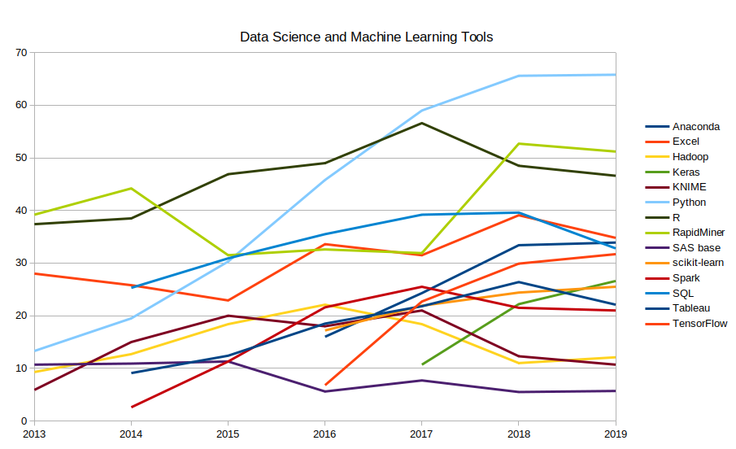

Additionally in this chapter, it has been reported the output of the analysis from the Gartner Hype Cycle for Data Science and Machine Learning and Hype Cycle for Artificial Intelligence.
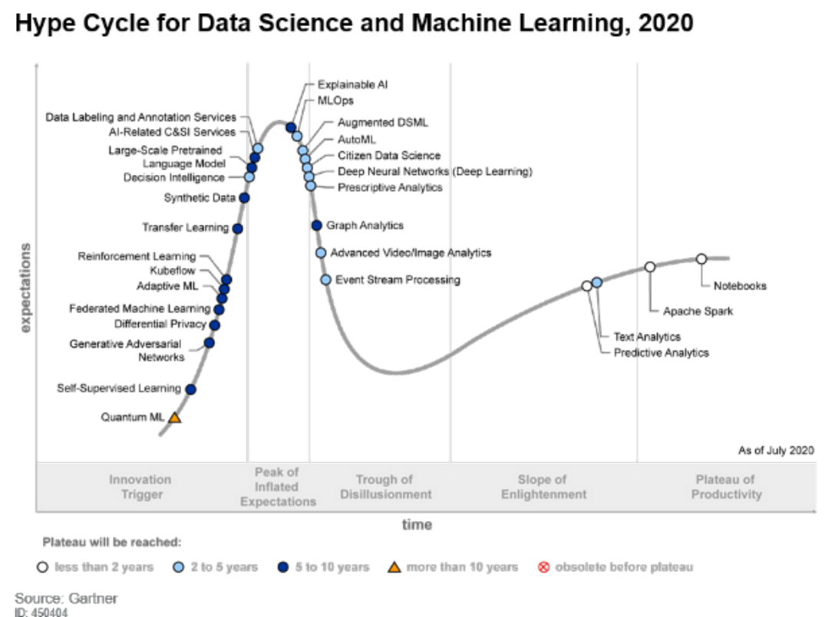
In the Hype Cycle for Data Science and Machine Learning 2020, Gartner estimates that following concepts has maximum 5 year to mainstream adoption and benefits are transformational or high: Notebooks, predictive analysis, advanced video/image analytics, augmented DSML, citizen data science, deep neural networks (deep learning), event stream processing, AutoML, Decision intelligence, MLOps, prescriptive analytics.
Which of these are valuable for the EGI Federation users? Is there something else which comes up later? Some estimations is possible to make:
- For example notebooks, predictive analytics and deep learning methodologies are already in wide use in research communities.
- MLOps i.e. Machine learning operationalization means AI and ML building, deploying and maintaining automation tools. It aims at streamlining the deployment, operationalization and execution of ML models. MLOps supports the release, activation, monitoring, performance tracking, management, reuse, update, maintenance and governance of ML models.
- Kubeflow: Gartner believes that this open-source MLOps platform will become an important enabler to manage multicloud and on-premises ML architectures.
- Decision intelligence: this provides a conceptual framework that includes decision management, decision support, continuous intelligence and process management.
- Large-scale pretrained language model: this includes models such as OpenAI GPT and BERT that are garnering a lot of hype for achieving outstanding performance on a variety of tasks.
Outside of this mainstream picture, in the research communities Quantum ML might arouse some interest even if Gartner estimates that it takes more than 10 years to mainstream adoption. In science this might be a very transformative technology.
Another noticeable report from Gartner is Hype Cycle for Artificial Intelligence, 2020. It presents the hype curve in the AI area. Gartner describes two megatrends for this year. These are
- Democratization of Artificial Intelligence
The democratization of AI means that AI is no longer the exclusive subject matter of experts. Now, organizations want to reach the next level by delivering AI value to more people. In the enterprise, the target for democratization of AI may include customers, business partners, business executives, salespeople, assembly line workers, application developers and IT operations professionals.
- Industrialization of AI platforms
The industrialization of AI platforms enables the reusability, scalability and safety of AI, which accelerates its adoption and growth. This industrialization aims at getting new adopters of AI on par with early adopters.
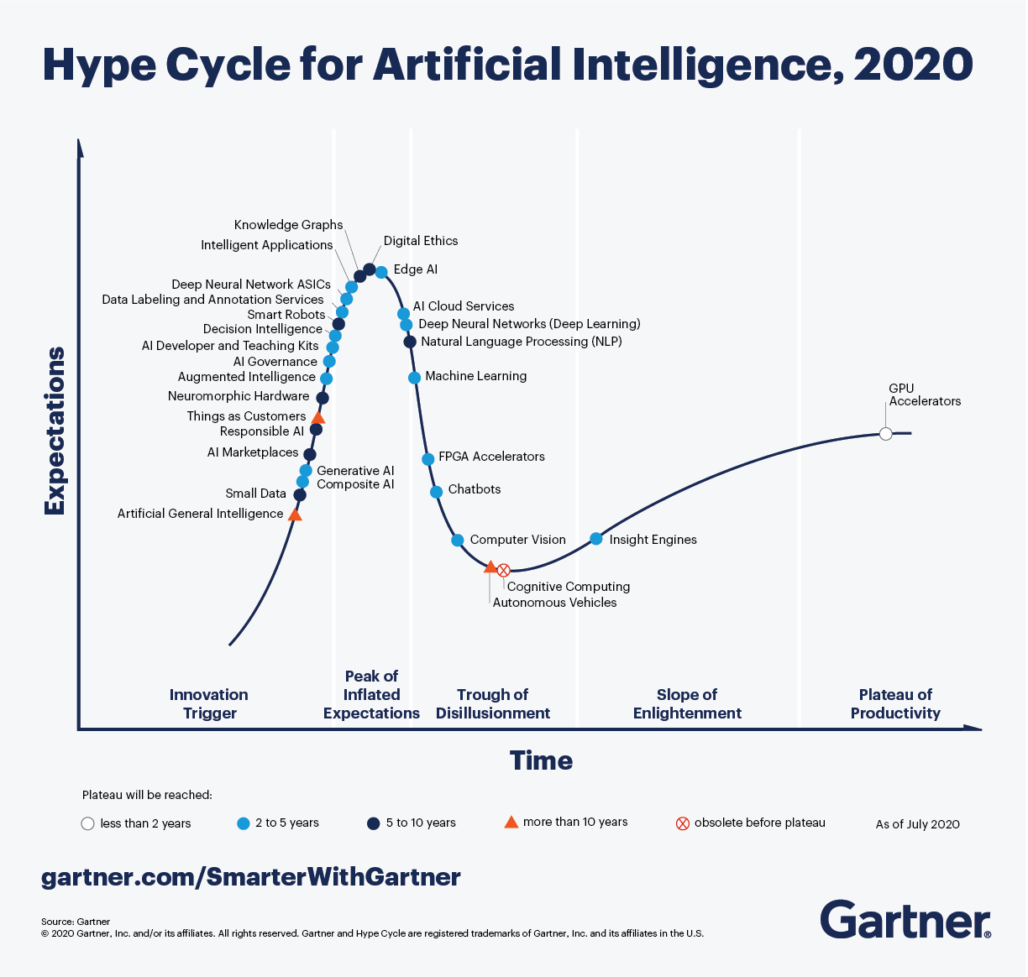
Gartner estimates that following AI concepts has maximum 5 year to mainstream adoption and benefits are transformational or high: GPU accelerators, augmented intelligence, chatbots, composite AI, deep neural networks (deep learning), edge AI, generative AI, intelligent applications, machine learning, AI cloud services, AI developer and teaching kits, AI governance, computer vision, decision intelligence, deep neural network ASICs and insight engines.
Here we can again see deep learning and machine learning. GPU accelerators are already in daily use. Other interesting aspects are edge AI and AI cloud services which are also familiar to research communities.
Outside this classification, as transformational but concepts which have more than 10 year to become mainstream are AI marketplaces, natural language processing (NLP) and neuromorphic hardware.
In the research communities AI marketplaces and especially NLP are already in use.
There are also five new entrants in the Gartner Hype Cycle; small data, generative AI, composite AI, responsible AI and things as customers. Perhaps the most interesting of these is small data.
By Gartner the concept of “small data” indicates both the issue and approach on how to train AI models when small amounts of training data are enough or there is insufficient or sparse training data. There are a variety of strategies and data augmentation techniques to overcome the problem such as simulation, synthetic data, transfer learning, federated learning, self-supervised learning, few-shot learning and knowledge graphs.
This kind of working models are possible in research communities.
Finally, short conclusion of previous concepts which can be considered to be of most interest:
Description | Concepts | Solutions, services or technologies
Advanced user experience and tools | AI developer and teaching kits, Notebooks | Jupyter Notebook, R studio, Mahout
Platforms to support the complete ML development / training / exploitation | AI cloud services, AI marketplaces | Acumos, DEEP Hybrid DataCloud, Horovod, H2O
Compute infrastructure is being tailored to enable further AI advances | Deep neural networks (deep learning), GPU accelerators, MLOps | Tensorflow, Kubeflow
Old and new innovations | Natural language processing (NLP), Small data | Jupyter Notebook, R Studio, Tensorflow

Standardisation activities & policies

Standards
In the area of machine learning or artificial intelligence standards are not very mature, they are mostly preparatory ones. Couple of examples from ISO standard family: ISO/IEC JTC 1/SC 42, Artificial intelligence.

Ethical issues
According to the High-level Expert Group On Artificial Intelligence set up By The European Commission, Trustworthy AI has three components, which should be met throughout the system's entire life cycle:
- It it should be lawful, complying with all applicable laws and regulations;
- it should be ethical, ensuring adherence to ethical principles and values; and
- it should be robust, both from a technical and social perspective, since, even with good intentions, AI systems can cause unintentional harm.
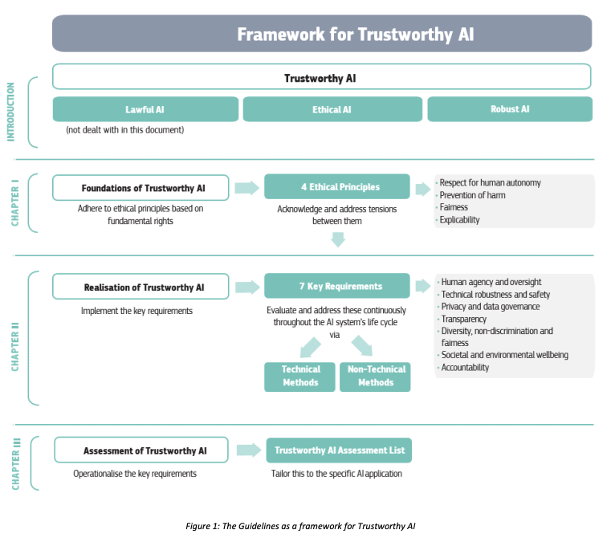
Also ISO has a standard on AI ethical issue, the ISO/IEC TR 24028:2020(en) Overview of trustworthiness in artificial intelligence. This document surveys topics related to trustworthiness in AI systems, including the following:
- approaches to establish trust in AI systems through transparency, explainability, controllability, etc.;
- engineering pitfalls and typical associated threats and risks to AI systems, along with possible mitigation techniques and methods; and
- approaches to assess and achieve availability, resiliency, reliability, accuracy, safety, security and privacy of AI systems.
The specification of levels of trustworthiness for AI systems is out of the scope of this document.

Policy groups and documentation
AI PPP: Artificial Intelligence Public Private Partnership (BDVA + EU ROBOTICS)
The Vision of the AI Public Private Partnership is to boost European industrial competitiveness and lead the world in developing and deploying value-driven trustworthy AI based on European fundamental rights, principles and values.
High Level Expert group on AI
It was appointed by the European Commission with the elaboration of recommendations on future-related policy development.
European AI alliance
The AI Alliance is a multi-stakeholder forum launched in June 2018 in the framework of the European Strategy on Artificial Intelligence.
White paper on AI
This White Paper presents policy options to enable a trustworthy and secure development of AI in Europe, in full respect of the values and rights of EU citizens. The areas for action set out in this White Paper are complementary to the plan presented in parallel under the European data strategy.
The main building blocks of this White Paper are:
- The policy framework setting out measures to align efforts at European, national and regional level. In partnership between the private and the public sector, the aim of the framework is to mobilise resources to achieve an ‘ecosystem of excellence’ along the entire value chain, starting in research and innovation, and to create the right incentives to accelerate the adoption of solutions based on AI, including by small and medium-sized enterprises (SMEs).
One part of the ecosystem of excellence is securing access to data and computing Infrastructure. The Commission has proposed more than €4 billion under the Digital Europe Programme to support high-performance and quantum computing, including edge computing and AI, data and cloud infrastructure. The European data strategy develops these priorities further.
- The key elements of a future regulatory framework for AI in Europe that will create a unique ‘ecosystem of trust’. To do so, it must ensure compliance with EU rules, including the rules protecting fundamental rights and consumers’ rights, in particular for AI systems operated in the EU that pose a high risk. Building an ecosystem of trust is a policy objective in itself, and should give citizens the confidence to take up AI applications and give companies and public organisations the legal certainty to innovate using AI. The Commission strongly supports a human-centric approach based on the Communication on Building Trust in Human-Centric AI and will also take into account the input obtained during the piloting phase of the Ethics Guidelines prepared by the High-Level Expert Group on AI.

AI Projects, Initiatives, partnerships and technology providers

General Overview
Machine learning and Artificial landscape is evolving rapidly in all areas such as projects, initiatives, architectures, services etc. The below picture shows the current landscape and the following chapters describe some of the most relevant initiatives closely.

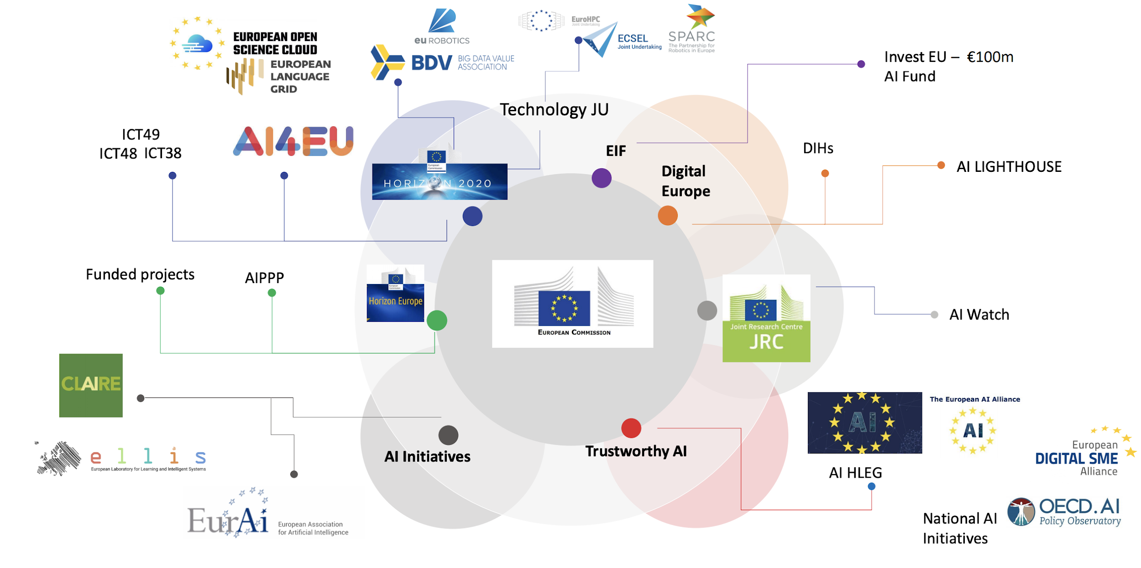

Projects
This section collects a description of the AI4EU project and other AI related projects where EGI participates.

AI4EU project
It will deliver the first European Artificial Intelligence On-Demand Platform and Ecosystem to lower barriers to innovation, to boost technology transfer and catalyse the growth of start-ups and SMEs in all sectors through Open calls and other actions. The platform acts as a broker, developer and one-stop shop providing and showcasing services, expertise, algorithms, software frameworks, development tools, components, modules, data, computing resources, prototyping functions and access to funding. Training enables different user communities (engineers, civic leaders, etc.) to obtain skills and certifications.
The AI4EU Platform establishes a world reference, built upon and interoperable with existing AI and data components (e.g. the Acumos open-source framework, QWT search engine..) and platforms. It mobilizes the whole European AI ecosystem and already unites 80 partners in 21 countries including researchers, innovators and related talents.
Eight industry-driven AI pilots will demonstrate the value of the platform as an innovation tool. In order to enhance the platform, research on five key interconnected AI scientific areas will be carried out using platform technologies and results will be implemented. The pilots and research will showcase how AI4EU can stimulate scientific discovery and technological innovation.
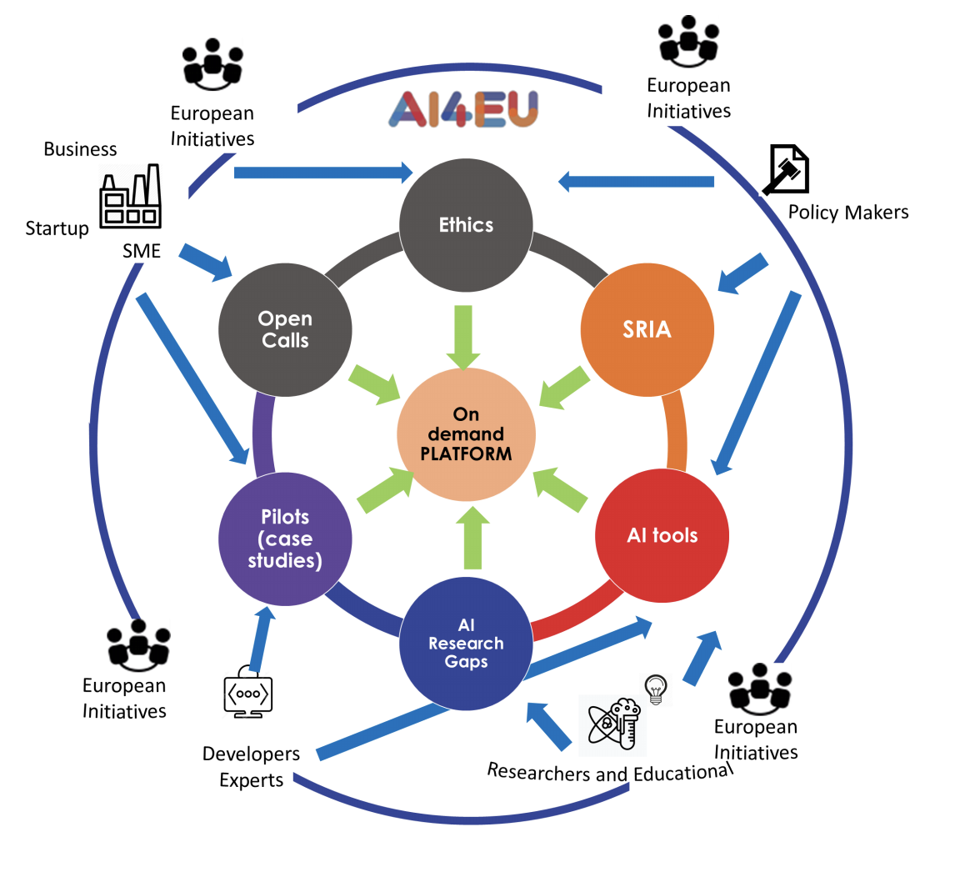
The AI4EU Ethical Observatory will be established to ensure the respect of human centred AI values and European regulations. Sustainability will be ensured via the creation of the AI4EU Foundation. The results will feed a new and comprehensive Strategic Research Innovation Agenda for Europe.
Period: Jan 2019 - Dec 2021
Overall budget: 20 719 689,78 €
Coordinator: Patrick Gatellier, Thales (FR)

StairwAI
The StairwAI project targets low-tech users with the goal of facilitating their engagement on the AI on-demand Platform. This will be achieved through a new service layer enriching the functionalities of the on-demand platform and containing:
- a multi-lingual interaction layer enabling conversations with the Platform in the user’s own language
- a horizontal matchmaking service for the automatic discovery of AI assets (tools, data sets, AI experts, consultants, papers, courses etc.) meeting the user business needs and,
- a vertical matchmaking service that will dimension and provision hardware resources through a proper hardware provider (HPC, Cloud and Edge infrastructures).
These services are designed and implemented by using techniques in an AI for AI fashion. The AI techniques deployed in the development of the services are natural language processing for the multi-lingual interaction, constraint solving, optimization and machine learning for horizontal and vertical matchmaking, knowledge representation for organizing the platform AI assets, reputation and fairness mechanisms to improve the matching results. StairwAI will have a tremendous impact on the sustainability, collaboration opportunities, accessibility and fairness of the AI on-demand Platform, enabling the definition of proper business models for the uptake of AI bringing new value for EU industry.
Period: Expected January 2021 - December 2023 (36 months)
Overall budget: 5 116 631 €
Coordinator: Michela Milano, UniBo (IT)

AI4PublicPolicy
AI4PublicPolicy is a joint effort of policymakers and Cloud/AI experts to unveil AI’s potential for automated, transparent and citizen centric development of public policies. To this end, the project will deliver, validate, demonstrate and promote a novel Open Cloud platform (i.e. AI4PublicPolicy platform) for automated, scalable, transparent and citizen-centric policy management based on unique AI technologies. The AI4PublicPolicy platform will be an Open Virtualized Policy Management Environment (VPME) that will provide fully-fledged policy development/management functionalities based on AI technologies such as Machine Learning (ML), Deep Learning (DL), NLP and chatbots, while leveraging citizens’ participation and feedback. It will support the entire policy development lifecycle, based on technologies for the extraction, simulation, evaluation and optimization of interoperable and reusable public policies, with emphasis on citizen-centric policies development and optimization through the realization of citizen-oriented feedback loops.
Period: Expected March 2021 - February 2024 (36 months)
Overall budget: 5 152 726 €
Coordinator: GFT (IT)
BD4NRG: Big Data for Next geneRation enerGy
The overall vision and main objective of BD4NRG is to deliver an innovative smart grid-tailored near real time energy specific open analytics modular framework which leverages an open source highly distributed interoperability reference architecture (Fig.1.3). BD4NRG will enable edge-level AI-based cross-sector analytics for integrated and optimised smart energy grid management (incl. operation and planning), based on seamless data-information-knowledge exchange under respective sovereignty and regulatory principles. BD4NRG aims at evolving, upscaling and demonstrating an innovative energy-tailored Big Data Analytics Toolbox (BD4NRG Toolbox) which will significantly contribute to achieve a techno-economic optimal management of Electric Power and Energy Systems (EPES) value chain. This will range from optimal risk assessment for energy efficiency investments planning, to optimised management of grid and non-grid owned assets, improved efficiency and reliability of electricity networks operation, while at the same time contributing to achieve fair energy prices to the consumers and laying the foundations for an EU-level energy-tailored data sharing economy
Period: Expected January 2021 - December 2023 (36 months)
Overall budget: 10 000 000 €
Coordinator: ENG (IT)

DIGITbrain
The DIGITbrain project aims to enable custom industrial products and to facilitate cost-effective distributed and localised production for manufacturing SMEs, by means of leveraging edge-, cloud- and HPC-based modelling, simulation, optimisation, analytics, and machine learning tools and by means of augmenting the concept of digital twin with a memorising capacity towards a) recording the provenance and boosting the cognition of the industrial product over its full lifecycle, and b) empowering the network of DIHs to implement the smart business model. The main objectives of this project are: implement the concepts behind the Digital Brain, in order to configure and orchestrate the data, models, algorithms, and resources available for the industrial products; boost the CloudiFacturing platform by integrating a new execution engine for co-simulation and the industrial platforms IDS and FIWARE; develop feasible business models for MaaS-empowered DIHs and accompany the adoption; augment the capabilities of the CloudiFacturing digital marketplace by supporting the operation of the Digital Brain and the nurture of MaaS-empowered DIHs; perform two Open Calls to acquire application experiments and validate the project results; and evangelize the manufacturing community on the benefits and impact of MaaS.
Period: July 2020 - December 2023 (42 months)
Overall budget: 9 392 812 €
Coordinator: CIAOTECH Srl (PNO Group) PNO IT

EGI-ACE
EGI-ACE empowers researchers from all disciplines to collaborate in data- and compute-intensive research across borders through free at point of use services. Building on the distributed computing integration in EOSC-hub, it delivers the EOSC Compute Platform and contributes to the EOSC Data Commons through a federation of Cloud compute and storage facilities, PaaS services and data spaces with analytics tools and federated access services.
The Platform is built on the EGI Federation, the largest distributed computing infrastructure for research. The EGI Federation delivers over 1 Exabyte of research data and 1 Million CPU cores which supported the discovery of the Higgs Boson and the first observation of gravitational waves, while remaining open to new members. The Platform pools the capacity of some of Europe’s largest research data centres, leveraging ISO compliant federated service management. Over 30 months, it will provide more than 82 M CPU hours and 250 K GPU hours for data processing and analytics, and 45 PB/month to host and exploit research data. Its services address the needs of major research infrastructures and communities of practice engaged through the EOSC-hub project. The Platform advances beyond the state of the art through a data-centric approach, where data, tools and compute and storage facilities form a fully integrated environment accessible across borders thanks to Virtual Access. The Platform offers heterogeneous systems to meet different needs, including state of the art GPGPUs and accelerators supporting AI and ML, making the Platform an ideal innovation space for AI applications. The data spaces and analytics tools are delivered in collaboration with tens of research infrastructures and projects, to support use cases for Health, the Green Deal, and fundamental sciences.
Period: January 2021 (expected) - June 2023 (30 months)
Overall budget: 12 380 165 €
Coordinator: EGI Foundation (NL)

EOSC Future
EOSC Future responds to INFRAEOSC-03-2020 call in order to integrate, consolidate, and connect e-infrastructures, research communities, and initiatives in Open Science to further develop the EOSC Portal, EOSC-Core and EOSCExchange of the European Open Science Cloud (EOSC).
EOSC Future will unlock the potential of European research via a vision of Open Science for Society by (1) bringing all major stakeholders in the EOSC ecosystem together under one project umbrella to break the disciplinary and community silos and consolidate key EOSC project outputs, (2) developing scientific use cases in collaboration with the thematic communities showcasing the benefits and societal value of EOSC for doing excellent and interdisciplinary research, (3) engaging the wider EOSC community and increasing the visibility of EOSC through communications campaigns, marketing strategies, and physical and online engagement events, and (4) including the EOSC community in developing the EOSC Portal (including the long tail of science, public and private sectors, and international partners) via co-creation open calls.
EOSC Future will integrate AI/ML algorithms in the EOSC Portal to make easier for scientists finding the best services
Period: Expected January 2021 - June 2023 (30 months)
Overall budget: 40 894 051 €
Coordinator: Technopolis Consulting Group Belgium sprl. (BE)

EUHubs4Data
The EUHubs4Data project will build a European federation of Data Innovation Hubs based on existing key players in this area and connecting with data incubators and platforms, SME networks, AI communities, skills and training organisations and open data repositories.
Based on the concept “European catalogue, local offer”, EUHubs4Data will establish a Europe-wide, sustainable ecosystem drawing upon local expertise and achievements of European initiatives and national/regional Big Data DIHs, with the threefold objective of: (1) creating a European catalogue of data sources and federated data-driven services and solutions; (2) making this offer accessible at the regional level so that European SMEs, AI communities, start-ups and web entrepreneurs have access to the most valuable assets and expertise on the continent; (3) fostering cross-border and cross-sector data-driven experimentation facilitated through data sharing, and data & service interoperability.
EUHubs4Data initially covers 12 EU regions in 9 countries, and plans to expand to more than 20 regions and 14 countries during the project, establishing a long-lasting sustainable ecosystem
Period: September 2020 - August 2023 (36 months)
Overall budget: 12 486 662
Coordinator: Instituto Tecnologico De Informatica (ES)

SoBigData++
SoBigData++ strives to deliver a distributed, Pan-European, multi-disciplinary research infrastructure for big social data analytics, coupled with the consolidation of a cross-disciplinary European research community, aimed at using social mining and big data to understand the complexity of our contemporary, globally-interconnected society. Becoming an advanced community, SoBigData++ will strengthen its tools and services to empower researchers and innovators through a platform for the design and execution of large-scale social mining experiments. It will be open to users with diverse backgrounds, accessible on project cloud (aligned with EOSC) and also exploiting supercomputing facilities. SoBigData++ will move forward from a starting community of pioneers to a wide and diverse scientific movement, capable of empowering the next generation of responsible social data scientists, engaged in the grand societal challenges laid out in its exploratories: Societal Debates and Online Misinformation, Sustainable Cities for Citizens, Demography, Economics & Finance 2.0, Migration Studies, Sport Data Science, Social Impact of Artificial Intelligence and Explainable Machine Learning. SoBigData++ will deliver an accelerator of data-driven innovation that facilitates the collaboration with industry to develop joint pilot projects, and will consolidate an RI ready for the ESFRI Roadmap and sustained by a SoBigData Association
Tools available in different VREs in order to execute ML model training, using also cloud resources from EGI (i.e. DataMiner service running on EGI cloud)

Period: January 2020 - December 2023 (36 months)
Overall budget: 9 997 170 €
Coordinator: CONSIGLIO NAZIONALE DELLE RICERCHE, CNR (IT)

Initiatives

EurAI
The European Association for Artificial Intelligence EurAI (formerly ECCAI) was established in July 1982 as a representative body for the European Artificial Intelligence community. Its aim is to promote the study, research and application of Artificial Intelligence in Europe. EurAI organises courses and conferences.
The main government bodies on AI in each country are members of this entity.

AI DIH
Under the Digitising European Industry initiative, 'Digital Innovation Hubs' (DIHs) have been designed as tools to support businesses (in particular SMEs and non-technological industry) in their digital transformation. Acting as a one-stop- shop, they provide a series of support services to companies in their region and beyond by allowing them to access knowledge, methods and software, technology platforms, prototyping solutions and testing facilities. As per today, 379 DIHs in EU 28 are listed in the European catalogue, 210 of which focus on Artificial Intelligence and cognitive systems. Selected DIHs are located across Europe and aim to create a network of supporting facilities to promote innovation and new technologies at European level.
AI DIHs are also presented in the S3platform where is a list and a map of DIHs with competences in AI.

National and institutional initiatives
Number of countries and research institutions have created their own data science, machine learning or AI initiatives. Here are some examples.
CRT AI

Ireland's national centre for PhD-level training in AI. Major areas of the DSML or AI: Personalisation, optimisation and constraint programming, NLP, ML, visual media processing; and ethics of data analytics and fair, accountable, transparent AI

Unibo Alam AI
The Alma Mater Research Center for Human-Centered Artificial Intelligence is an interdisciplinary hub that aims at aggregating and boosting AI-based research activities. Major areas of the DSML or AI: Foundations of AI, AI and hard sciences, humanistic AI, AI for industry, AI for health and well-being, AI for law and governance, AI and education, AI and high performance computing.
FCAI and HiData
Finnish Center for Artificial Intelligence (FCAI) is a community of experts that brings together top talents in academia, industry and public sector to solve real-life problems using both existing and novel AI. FCAI is one of the six Academy of Finland Finnish flagships. The overarching goal of Helsinki Centre for Data Science (HiDATA) is to leverage the synergies of the network in solving significant societal and industrial challenges related to data analysis. HiDATA is a joint hub of the two participating universities University of Helsinki and Aalto University.
Council of Europe has collected a visualisation about some national initiatives all over the Europe and European Commission has collected information to the AI Watch. Additionally OECD.AI has also listed global, regional and country level initiatives and projects.

Networks of excellence
There are four network of excellence plus a Coordination and Support action that are mainly devoted to AI research:
- TAILOR on trustworthy AI
- HumanE AI Net on human-centered AI
- ELISE on Machine Learning
- AI4MEDIA on AI solutions for the media and trusted AI

Interested partners of the EGI Federation
AI is a hot topic over the EGI Federation, there are many partners in the federation interested on this topic and projects where the EGI has involved (see previous sections). Here is a couple of additional examples:

Partners of the DEEP Hybrid DataCloud Project

The DEEP Hybrid DataCloud works in the areas of Catalogue and Marketplace of Machine Learning and Deep Learning models and Deep as a Service accessing HPC

UCC
The School of Computer Science and Information Technology, UCC, is heavily involved in the research of artificial intelligence, data analytics and algorithmics. Main areas of study are: artificial Intelligence, decision support, optimisation, data analytics, recommender systems, machine learning.

Integration scenarios in the EGI Infrastructure

Current services
EGI services to support ML or AI activities/initiatives in the service catalogue are
- Cloud compute / GPU
- Cloud Container Compute
- High Throughput Compute
- Online Storage
- Notebooks
These services are established services produced by the EGI federation.
Additionally EGI works in a number of AI/ML related projects as described in the chapter 6.1. In these projects EGI offers basically services from the catalogue, but also some other consultancy services (i.e. architecture planning).

Extending offers
Extending EGI offers in the ML / AI fits in to the EGI Federation strategy seamlessly. The strategy focuses also in evolving the service offer to meet the needs of research communities and, as it has been presented earlier, AI related issues are very popular within researchers at these times. Enriching the EGI service offer with ML/AI services is also in line with another strategic goal “improving skills of users/operators and maturity in service providers”.
Based on these choices in the strategy, it is possible to present a list of actions on how to extend EGI’s offering in ML and AI services. Following list of possibilities needs further analysis and discussions because some of them also contain strategic nature. Additionally the needs of the potential users groups should be properly verified.
The set of possibilities to extend offering follows:
- Facilitate the uptake of ML/AI services within the federation (collaborating with AI initiatives, develop ML/AI expertise within the federation)
  - this based on collaboration with the federation and projects
  - this means that some ML/AI platform services should be developed or deployed within the federation and added to the EGI service catalogue
  - the natural starting point in this context is cloud
- Offering a wide library of ML/AI analytics for researchers (datasets, models, algorithms)
  - this brings the triangle of the ML elements (see chapter 2.1) to the EGI’s service catalogue
  - new ML / AI services based on data, software and computing should be deployed
- Providing adequate resources to deploy ML/AI algorithms and platforms (storage, computing, CPU, GPGPU etc.)
  - this extends the current offering slightly but not strategically
  - researchers needs are important driver with this initiative because they know how much resources they need
  - additionally this might need some new services in computing and data
- Create a team of experts (a Competence Centre) on ML/AI in EGI
  - Depending on the definition of the competence center this might require totally new competencies in to the EGI’s organisation
  - Important question; how many competence centers there are in Europe in this area and how they are positioned themselves?
- Supporting the development of new ML/AI based services for researchers (“ready-to-use” ML/AI platforms, technical consultancy & training)
  - This extension is kind of combination of the competence center, adequate resources and wide library of ML/AI analytic presented earlier in this list
  - researchers needs are important driver with this initiative
  - additionally this might need some new services in consultancy, computing and data
- Onboarding industry/SME services within the federation
  - This initiative would be easy to organise via projects where industry and SMEs are presented
  - The challenge in this option could be the support from the federation (if this will be the only action) even if the industry and SMEs are central target groups in the EGI Federation strategy
EGI can start to extend the technology offering with AI cloud services, AI marketplaces and MLOps. These are clearly emerging solutions and include potential within user communities. Before strong changes in the service and technology portfolio, extending ideas should be tested in user communities.
Because ML and AI are important part of the science and research now and in the future, it is clear that EGI as a eInfrastructure have to take care of this fundamental challenge and therefore also strategy level measures would be justified.

Wikipedia, Machine Learning, https://en.wikipedia.org/wiki/Machine_learning, retrieved 8.9.2020
Chanin Nantasenamat, The Data Science Process, Towards Data Science, https://towardsdatascience.com/the-data-science-process-a19eb7ebc41b, retrieved 8.9.2020
Wikipedia, Machine Learning, https://en.wikipedia.org/wiki/Machine_learning, retrieved 8.9.2020
Wikipedia, Machine Learning, https://en.wikipedia.org/wiki/Machine_learning, retrieved 8.9.2020
https://en.wikipedia.org/wiki/Statistica, retrieved 6.10.2020
https://en.wikipedia.org/wiki/SAS_(software)#Components, retrieved 6.10.2020
https://en.wikipedia.org/wiki/RCASE, retrieved 6.10.2020
https://en.wikipedia.org/wiki/Neural_Designer, retrieved 6.10.2020
https://en.wikipedia.org/wiki/Wolfram_Mathematica, retrieved 6.10.2020
https://en.wikipedia.org/wiki/SPSS_Modeler, retrieved 6.10.2020
https://en.wikipedia.org/wiki/RapidMiner, retrieved 6.10.2020
https://www.acumos.org/, retrieved 8.10.2020
https://github.com/lfai/presentations/blob/master/Overview/LFAI%20Landscape%20Presentation%2008192020.pdf, retrieved 8.10.2020
RStudio: https://en.wikipedia.org/wiki/RStudio, retrieved 16.9.2020
Jupyter, https://jupyter.org/, retrieved 16.9.2020
For example https://urkund.com/
For example https://iris.ai/ , retrieved 13.10.2020
https://deep-hybrid-datacloud.eu/the-platform/, retrieved 15.10.2020
https://www.egi.eu/services/cloud-container/
https://www.ocre-project.eu/, retrieved 16.11.2020
Kubeflow, https://www.kubeflow.org/, retrieved 16.11.2020
Timothy Llewellynn, Jean-Marc Bonnefous, Bonseyes Marketplace Interoperability, 1.0 (01 Sept 2020)
Vijay Kotu, Bala Deshpande, in Data Science (Second Edition), 2019, https://www.sciencedirect.com/topics/physics-and-astronomy/artificial-intelligence, retrieved 16.11.2020
https://www.ai4eu.eu/ai4eu-platform, retrieved 16.11.2020
https://www.ai4eu.eu/technical-architecture, retrieved 16.11.2020
More information: https://www.ai4eu.eu/terms-use, retrieved 16.11.2020
KDnuggets 15th Annual Analytics, Data Mining, Data Science Software Poll: RapidMiner Continues To Lead, https://www.kdnuggets.com/2014/06/kdnuggets-annual-software-poll-rapidminer-continues-lead.html, retrieved 16.9.2020
R leads RapidMiner, Python catches up, Big Data tools grow, Spark ignites, https://www.kdnuggets.com/2015/05/poll-r-rapidminer-python-big-data-spark.html, retrieved 16.9.2020
R, Python Duel As Top Analytics, Data Science software – KDnuggets 2016 Software Poll Results https://www.kdnuggets.com/2016/06/r-python-top-analytics-data-mining-data-science-software.html, retrieved 16.9.2020
Python leads the 11 top Data Science, Machine Learning platforms: Trends and Analysis https://www.kdnuggets.com/2019/05/poll-top-data-science-machine-learning-platforms.html, retrieved 16.9.2020
Shubhangi Vashisth, Alexander Linden, Jim Hare, Pieter den Hamer; Hype Cycle for Data Science and Machine Learning, 2020, ID G00450404
Gartner Hype Cycle for Artificial Intelligence, 2020 https://www.gartner.com/smarterwithgartner/2-megatrends-dominate-the-gartner-hype-cycle-for-artificial-intelligence-2020/, retrieved 17.11.2020
https://azure.microsoft.com/en-us/services/machine-learning/
https://cloud.google.com/products/ai/
https://aws.amazon.com/machine-learning/
https://www.ibm.com/analytics/machine-learning
https://www.iso.org/committee/6794475/x/catalogue/, retrieved 17.11.2020
https://www.iso.org/obp/ui/#iso:std:iso-iec:tr:24028:ed-1:v1:en, retrieved 17.11.2020
https://www.eu-robotics.net/cms/upload/downloads/VISION_AI-PPP_euRobotics-BDVA-Final.pdf, retrieved 17.11.2020
https://ec.europa.eu/digital-single-market/en/high-level-expert-group-artificial-intelligence, retrieved 17.11.202
https://ec.europa.eu/digital-single-market/en/european-ai-alliance, retrieved 17.11.2020
https://futurium.ec.europa.eu/en/european-ai-alliance, retrieved 17.11.2020
https://ec.europa.eu/digital-single-market/en/news/white-paper-artificial-intelligence-european-approach-excellence-and-trust, retrieved 17.11.2020
https://digitbrain.eu/, retrieved 17.11.2020
https://euhubs4data.eu/, retrieved 17.11.2020
http://project.sobigdata.eu/, retrieved 17.11.2020
https://www.ai4eu.eu/about-project
https://cordis.europa.eu/project/id/825619
https://deep-hybrid-datacloud.eu/
https://www.ucc.ie/en/compsci/research/aitheme/
https://www.eurai.org/
https://bluebridge.d4science.org/web/analyticslab/home, retrieved 17.11.2010
https://www.egi.eu/services/cloud-compute/
https://www.egi.eu/services/cloud-container/
https://www.egi.eu/services/high-throughput-compute/
https://www.egi.eu/services/online-storage/
https://www.egi.eu/services/notebooks/
https://www.egi.eu/services/
https://bit.ly/3muFKF4, retrieved 17.12.2020
https://www.egi.eu/wp-content/uploads/2020/03/EGI-Engage-strategy-2020-2024.pdf
https://mahout.apache.org/
https://landscape.lfai.foundation/category=machine-learning&format=card-mode&grouping=category, retrieved 19.11.2020
https://centri.unibo.it/alma-ai/it
http://crt-ai.cs.ucc.ie/
http://crt-ai.cs.ucc.ie/programme.html
https://centri.unibo.it/alma-ai/it
https://fcai.fi/
https://ec.europa.eu/knowledge4policy/ai-watch_en#country
https://www.coe.int/en/web/artificial-intelligence/national-initiatives
https://ec.europa.eu/newsroom/dae/document.cfm?doc_id=60419, retrieved 17.11.2020
https://oecd.ai/
https://www.helsinki.fi/en/helsinki-centre-for-data-science/about-hidata
https://www.egi.eu/services/cloud-compute/
https://www.egi.eu/services/notebooks/
https://www.egi.eu/services/online-storage/
https://www.egi.eu/services/high-throughput-compute/
https://www.egi.eu/services/datahub/
https://horovod.ai/, retrieved 6.10.2020
Spark Mlib, https://en.wikipedia.org/wiki/Apache_Spark#MLlib_Machine_Learning_Library, retrieved 16.9.2020
Nguyen, G., Dlugolinsky, S., Bobák, M. et al. Machine Learning and Deep Learning frameworks and libraries for large-scale data mining: a survey. Artif Intell Rev 52, 77–124 (2019). https://doi.org/10.1007/s10462-018-09679-z
TensorFlow, https://en.wikipedia.org/wiki/TensorFlow, retrieved 16.9.2020
https://link.springer.com/article/10.1007/s10462-018-09679-z#Sec6
Keras, https://en.wikipedia.org/wiki/Keras, retrieved 17.12.2020
https://link.springer.com/article/10.1007/s10462-018-09679-z#Sec6, retrieved 17.12.2020
https://scikit-learn.org/stable/getting_started.html, retrieved 17.12.2020
https://en.wikipedia.org/wiki/Scikit-learn, retrieved 17.12.2020
https://pytorch.org/docs/stable/index.html, retrieved 17.12.2020
https://en.wikipedia.org/wiki/PyTorch, retrieved 17.12.2020
https://xgboost.ai/about, retrieved 17.12.2020
https://en.wikipedia.org/wiki/XGBoost, retrieved 17.12.2020
https://www.bonseyes.eu/, retrieved 16.10.2020
https://www.ai4eu.eu/platform-vision, retrieved 22.11.2020
https://liu.se/en/research/tailor, retrieved 17.12.2020
https://www.humane-ai.eu/, retrieved 17.12.2020
https://fcai.fi/news/the-european-commission-offers-significant-support-to-europes-ai-excellence, retrieved 17.12.2020
https://ai4media.eu/, retrieved 17.12.2020
https://ai-dih-network.eu/project.html, retrieved 17.12.2020
https://www.ai4eu.eu/technical-architecture
https://www.ai4eu.eu/pilot-experiments

