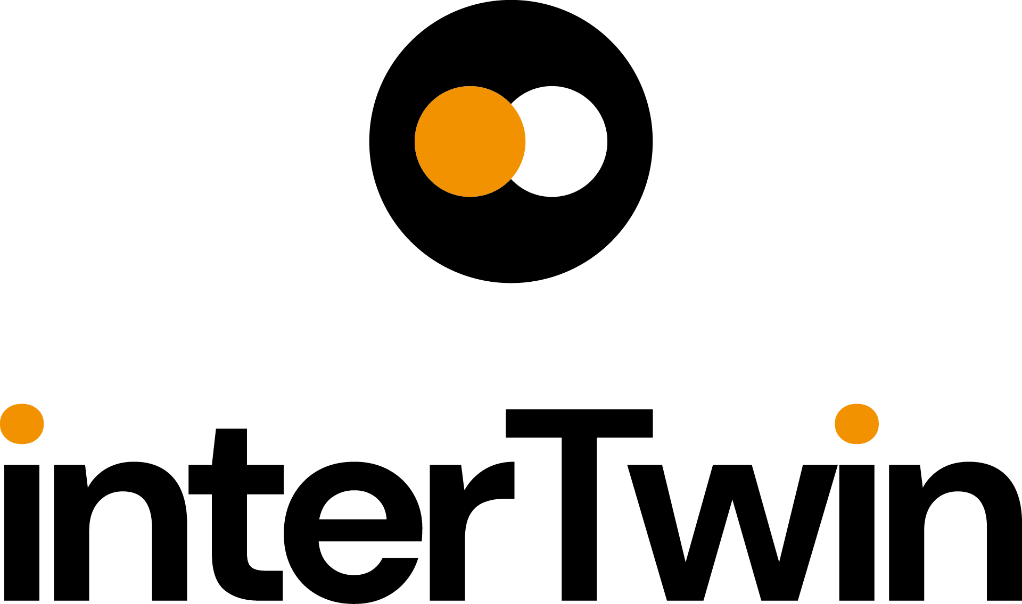

D2.1 Dissemination, Communication and Engagement Plan
Status: UNDER EC REVIEW
Dissemination Level: public
Abstract
Key Words | Communication, Dissemination, Engagement
This deliverable provides an overview on how project results, developments and branding will be communicated during the project, with emphasis on the activities planned and executed from M1 to M20.
Moreover, a strategy for dissemination towards the interTwin target audiences, with specific measures to maximise stakeholder engagement, is outlined. Additionally, the plan will map dissemination, communication, and engagement activities to the project objectives, including concrete targets and KPI’s.
This plan includes a toolbox with all available communication, dissemination and engagement channels and materials that are or will be available to the project for dissemination, communication, and engagement purposes.
As this document is a living document, updated in M20, a short overview of next steps is presented as the conclusion of the document.

Document Description
D2.1 Dissemination, Communication and Engagement Plan
Work Package number 2
Document type | Deliverable
Document status | FINAL | Version | 1
Dissemination Level | Public
Copyright Status | This material by Parties of the interTwin Consortium is licensed under a Creative Commons Attribution 4.0 International License.
Lead Partner | EGI
Document link | https://documents.egi.eu/document/3921
DOI | https://doi.org/10.5281/zenodo.7684878
Author(s) | - Gwen Franck (EGI)
Reviewers | - Charis Chatzikyriakou (EODC)  - Daniele Spiga (INFN)
Moderated by: | - Sjomara Specht (EGI)
Approved by | AMB

Revision History
Version | Date | Description | Contributors
V0.1 | 10/01/2023 | ToC and First Draft | Gwen Franck (EGI))
V0.2 | 26/01/2023 | First Draft revision | Smitesh Jain (EGI)  Xavier Salazar (EGI)  Malgorzata Krakowian (EGI)  Andrea Manzi (EGI)
V0.3 | 19/01/2023 | External review | Charis Chatzikyriakou (EODC)  Daniele Spiga (INFN)
V0.4 | 23/02/2023 | Approved by AMB
V1.0 | 24/02/2023 | Final

Terminology / Acronyms
Term/Acronym | Definition
DT | Digital Twin
DTE | Digital Twin Engine
KER | Key Exploitable Result
Terminology / Acronyms: https://confluence.egi.eu/display/EGIG

Table of Contents
1 Introduction 7
1.1 Purpose of the plan 7
1.2 Structure of the document 8
1.3 interTwin main expected outputs and impact 8
1.3.1 Key Exploitable Results 8
1.3.2 Outcomes and Impacts 9
2 Stakeholder analysis 10
2.1 Target Groups and their relation to the project objectives and expected results 10
2.2 Detailed Stakeholder Description 10
3 Specific measures per target group 12
4 DT Use Cases 14
5 Toolbox 15
5.1 Tools for internal communications 15
5.2 Channels 16
5.2.1 Project website 16
5.2.2 Social Media 16
5.2.3 Events 16
5.2.4 Consultations and surveys 17
5.2.5 One-on-one meetings 17
5.2.6 Repositories 18
5.2.7 Project Partners and Boards 18
5.2.8 External projects and EOSC Channels 18
5.3 Materials 19
5.3.1 Project Branding 19
5.3.2 Press 19
5.3.3 Newsletters 19
5.3.4 Scientific Publications 19
5.3.5 Visual materials 20
6 Measuring Progress and Impact 22
7 Next Steps 23
7.1 Project outcomes 23
7.2 Events 23
Annexes 25
Annex 1: Matchmaking: Horizon Results Platform Stakeholders 25
Annex 2: Internal Communication Tools 26
Annex 3: Full list of deliverables 27

Executive summary
interTwin is a project to co-design and implement the prototype of an interdisciplinary Digital Twin Engine (DTE), that offers the capability to integrate with application-specific Digital Twins (DTs).

In this deliverable, activities are outlined for communications, dissemination, and engagement with the project stakeholders, which will help widely communicate the project actions and results, relating them to broader societal challenges; as well as maximise engagement from concerned stakeholders.

This document contains information about main project stakeholders being targeted with Dissemination Communication and Engagement measures; the tools/channels that will be used by the project for these purposes; KPIs proposed to monitor impact and success along with the next steps planned during M5-20 of the project.

Introduction
interTwin co-designs and implements the prototype of an interdisciplinary Digital Twin Engine (DTE) - an open-source platform based on open standards that offers the capability to integrate with application-specific Digital Twins (DTs). Its functional specifications and implementation are based on a co-designed interoperability framework and conceptual model of a DT for research - the DTE blueprint architecture. The ambition of interTwin is to create consensus on a common approach to the implementation of DTs that is applicable across the whole spectrum of scientific disciplines that will facilitate developments and interoperability across different DTs.

Purpose of the plan
As part of WP2 (Innovation Management and Communications), T2.2 (led by EGI.eu) deals with Communications, Dissemination and Engagement activities. In this first deliverable, the overall plan for these activities is laid out, mapped to target audiences and stakeholders, set against a timeline where possible, and matched with a suitable set of indicators for success.

The activities outlined in this plan will help to widely communicate the project actions and results to the general public, and to the main project stakeholders - relating them to broader societal challenges. We plan to disseminate the project allowing for maximum accessibility and reuse of the results and hence to foster project outcomes, and we will maximise engagement of the concerned stakeholders. How the project results, including the Key Exploitable Results (KER) will be captured, monitored, and exploited, is the subject of the D2.2, Innovation and Exploitation Plan.

This plan is designed to be a living document and does not offer final plans/solutions for all dissemination, communication, and engagement elements of the project at this moment. During the course of the project, parts of this plan will be updated or amended, based on how the project evolves. This plan will be updated in M20 (D2.3) and concluded with a final report by M36 (D2.5).

This initial plan is based on the project proposal, augmented with findings and results from M1-5 of the project (including M2.1: organisation of the Kick-off event and M2.2: communication package and launch website). In close collaboration with T2.1, prospective target audiences will be outlined and mapped against the project KERs and other results. Specific outreach actions and engagement strategies for each of them will be developed, considering the needs and activities in all work packages, and the engagement levels we expect from them.

Structure of the document
This document contains a project introduction, an analysis of the main project stakeholders, and the specific Dissemination, Communication and Engagement measures they will be targeted with, and the ‘Toolbox’ - the set of tools, channels and materials that will be used by interTwin for these purposes. A set of KPIs will be proposed that will allow monitoring the impact and success of the plan. Finally, we’ll take a look at the next steps: what will happen during M5-20 of the project?

interTwin main expected outputs and impact
The project objectives and foreseen Key Exploitable Results (KERs) each have their own stakeholder engagement level associated. Here below the KERs, outputs and impact are introduced, and they will be further developed in D2.2. The KERs will serve as the basis to structure the concrete Dissemination, Communication and Engagement activities proposed further in this plan and in the following iterations (M20 and M36).

Key Exploitable Results
KER1: Interdisciplinary Digital Twin Engine
A software platform that provides generic and tailored functional modules for modelling and simulation to facilitate the development and deployment of Digital Twins that address scientific problems in different domains.

KER2: Interoperability Framework: Guidelines, Specifications, and Blueprint Architecture
The interTwin interoperability framework aligns technical approaches and foster collaboration in modelling and simulation application development across scientific domains.

KER3: Toolkit for AI workflow and method lifecycle management
AI-based methodologies to extract application sector specific information from research data at the exabyte-scale level in a real-time manner and increase the efficiency and accuracy of simulation and modelling outputs.

KER4: Quality Framework
Tools for automated quality measures and trust, development of standard quality mapping and indicators for appropriately communicating differences in qualities of inputs and outputs from digital twins, addressing issues such as data and model pedigree, accuracy, and lack of knowledge.

KER5: DTE federated infrastructure integrated with EOSC and EU Data Spaces
Federated distributed compute platform providing access to distributed data and integrating HTC, HPC, Cloud and Quantum Computing capabilities for processing.

KER6: interTwin Open-Source Community
The community of DT application developers, users and operators that is responsible for the design, development, and maintenance of the DTE code base.

The KERs above will contribute to the realisation of interTwin expected outcomes and impacts.

Outcomes and Impacts
Outcome 1: A pre-operational prototype of an interdisciplinary Digital Twin, using a combination of the latest digital technologies, relevant to addressing challenges where multidisciplinary is the defining element of complexity.

Outcome 2: Latest modelling and prediction technologies in several different areas widely serving research communities and supporting interoperability of data and software, integration, and collaboration.

Outcome 3: Framework to ensure the quality, reliability, verifiability of the data, information, and outputs of such Digital Twins and to exploit data made available through the Common EU Data Spaces and the EOSC.

Impact 1: Enhanced global competitiveness, technological excellence in a fast-moving environment and wider use of AI in research and enhanced data-based research across Europe.

Impact 2: Opening of new areas of research and development of new industrial applications/products.

Impact 3: Trans disciplinarity, cross-fertilisation and a wider sharing of knowledge and technologies between academia and industry.

Stakeholder analysis
To allow targeted dissemination, communication, and engagement measures, interTwin stakeholders are grouped into two larger ‘target groups’, each consisting of multiple, more specific, target audiences. To link these target audiences to the Horizon Europe Results Platform, a mapping exercise has been conducted by WP2.

Target Groups and their relation to the project objectives and expected results
DT Users: The (potential) users of the specific DTs will need to be aware of their existence (KER1) and use them and the supporting materials such as the Toolkit for AI Workflow (KER3) and the Quality Framework (KER4). As co-designers, they will have an interest in using the Toolkit and the Quality Framework, and they are expected to verify it. Some DT users will Liaise with the Open-Source Community (KER6) as interactions & technical support may be needed for the definition and deployment and use of DT in use cases.

DT Developers and Providers: The developers of the DT modules co-design and co-create the DTE modules (KER1), they are using the supporting tools and Quality Framework, interoperability framework (KER2). The providers will add applications and services to the specific DTs and to the DTE (KER1) and to the Toolkit for AI workflow and method lifecycle management (KER3). They will integrate them with EOSC and EU Data Spaces (KER5). As the software will be open source, these providers/operators will be part of our open-source community (KER6).

Detailed Stakeholder Description
- Scientific Collaborations: Users, Developers, Providers
Research communities in a certain field (formal or informal), including projects, such as DT-Geo, BioDT and ebrain-Health.
Scientific collaborations are engaged internally through the DT use cases and externally through collaborations. They need to be aware of the DTE and integrate it, and of the discipline specific options for modification. As co-designers, they will provide the necessary input and feedback to adequate the DT development to their technical needs.

- Research Infrastructures, e-Infrastructures and Data Space Providers: Developers, Providers
Providers or operators of computing resources or data. Examples are the future EU Data Space initiatives of the Digital Europe programme including DestinE, the DT of the Ocean, AI4EU and AI on-demand platform, and pan-European digital infrastructures for research, HPC/HTC, or Cloud computing providers.

- SMEs and Industry: Users, Developers, (Providers)
The private sector, from large industry R&D departments to SMEs. Includes industry collaboration schemes such as Digital Innovation Hubs (DIHs) and Platform industry 4.0. They need to be aware of the DTE and integrate it, and of the discipline specific options for modification.

- Individual Researchers (long tail of science): Users, (Developers)
Individual researchers and communities of practice are engaged by being employed by project partners or as external stakeholders. Scientific collaborations are engaged internally through the DT use cases and externally through collaborations.

- Evidence-based Policy Makers: Users
Decision makers/policy officers are an important stakeholder to be involved in co-design and adoption of the interTwin DTE and its interoperability framework, bringing knowledge and requirements from DT use cases that address the Green Deal strategy and European societal challenges. For example, the EuroGEO initiative is an effective multiplier that allows the project to engage at international, European, and national levels.

Specific measures per target group
This table lists the project objectives relevant for each target group, concrete project goals that are related to these objectives, the main actions the project will undertake to reach these objectives and the concrete tools, channels and materials that will be used to achieve this.

Table 1; Dissemination, Communication and Engagement Measures
interTwin Target group | Required type of engagement | Main Dissemination Actions by project | Communication Tools
DT Users | Awareness, access, and uptake of DTE (KER1); of the Toolkit for AI Workflow & Method Lifecycle Management (KER3) and of the Quality Framework (KER4) | Ensure online presence.  Promote as a service.  Inform and Update  Highlight importance/usability.  Create awareness on adaptability of the services  Engage with key stakeholder organisations. | Website  Social Media  Scientific Publications  Non-Scientific Publications Presentations, Webinars, Trainings & Workshops  EOSC Channels  One-on-One Meetings  Use Cases
 | Verification of the Quality Framework (KER4) | Promote quality framework as a service.  Create flow for validation | Consultations & Surveys  Workshops & Trainings  Events
 | Some DT users will Liaise with the Open-Source Community (KER6) | Collect user requirements and feedback. | Use Cases  Curation/Promotion of Software repository  Managing and building the OS community (through website, dedicated forum and github repository)
DT Developers and DT Providers | Co-design and co-creation of DTE thematic modules (KER1), Toolkit for AI workflow & method lifecycle management (KER3), and the Quality Framework (KER4), Interoperability framework (KER2) | Collect user requirements and feedback.  Foresee up-to-date Technical Updates  Facilitate co-design workflows | Consultations & Surveys  Technical Workshops  Technical Guidelines & Factsheets  Use Cases
 | Liaise with Open-Source Community (KER6) |  | Curation/Promotion of Software repository  Managing and building the OS community (through website, dedicated forum and github repository)
 | Providers add applications and services to DTE (KER1) and Toolkit for AI workflow and method lifecycle management (KER3) | Foresee up-to-date technical updates.  Availability of software and APIs  Facilitate co-design workflows. | Webinars  Technical Workshops  Consultations & Surveys  Technical Guidelines & Factsheets  Individual outreach (one-on-one meetings)  Use Cases
 | Integrate the DTE with EOSC and EU Data Spaces (KER5)

DT Use Cases
To evolve the concept in alignment with a growing community of DT experts, the project plans to engage with a growing portfolio of external use cases from scientific communities, researchers, industry, and SMEs. Collaboration with external stakeholders will be supported through open online consultations, use case analysis workshops and pilots. A more detailed approach on how to structure the public-facing elements of these use cases will be described and expanded upon in D2.3. This deliverable will also contain updates about the approach to engage with these new external use cases.

The project (WP4) has already planned several use cases to be created within the project, in close collaboration with the research communities concerned.

T2.2 will liaise with WP4 to make sure that this activity reaches beyond the project, use cases will not only be used internally for development purposes, but a reader-friendly version of each use case will be created and published, to showcase the variety of applications that the DTE will be useful for. These will be published individually on the website and might be bundled in a brochure. Additionally, a single page infographic-style visual might also be created for each use case.

Toolbox
Below is a description of the main tools & channels that are at the project’s disposal for internal and external communication towards its target groups, and for dissemination towards stakeholders. Some of these tools will be more specified as the project evolves.

During M1-5, the following materials and channels have been put in place.
- The project website;
- Social media accounts;
- The Communication Toolkit;
- Publication Guidelines;
- Branding kit with logo and colour scheme;
- Presentation and Document templates.

With the exception of the branding kit, priority was given to a speedy delivery. Certain adjustments and improvements are periodically planned (for example on the website) or are subject to input from project partners (if they find something is missing or inadequate). All materials are collected on the project confluence pages.

Tools for internal communications
Because a large number of stakeholders (scientific collaborators, RIs, …) are involved in the project as partners, many of our measures will be at the crossroads between internal and external measures. For these internal communications, measures will heavily rely on the specific activities conducted within the work packages - planning and support, and reach, could therefore be limited. The tools that will be used for internal communications, such as mailing lists, are managed by WP1 and can be found on Confluence. T2.2 will keep a close watch on activities reported during AMB and PMB meetings and will assess for each activity reported which action is required.

Additionally, all project partners are expected to report on their activities using the Google form and signalisation during the AMB. T2.2 will also be present during the technical F2F events to identify any opportunities. The Innovation and Exploitation Group will engage with T2.2 for engagement activities. Other bodies, such as the General Assembly and the Ethics Board, are expected to signal any interesting dissemination, communication, and engagement opportunities to T2.2, as well as to disseminate relevant project outputs in their own networks.

As the project activities are intensifying, other internal communication channels might come in use. For example, a Slack channel to facilitate quick chats is being considered.

Channels

Project website
The project website https://www.intertwin.eu/ is hosted as a mini site on the EGI main website, based on WordPress, in particular on a more secure version called BedRock. The project website will be the main source for outward-facing communication and dissemination - including project information, news & events, partner overview, and a section listing (links to) all results & outputs - including recordings, publications, and reports. In collaboration with the partners, we will also provide dedicated pages targeting specific audiences, for example a gateway page targeted at the Open-Source Community. The website analytics are being followed up monthly using Matomo.

Social Media
Currently, the project has a presence on Twitter and LinkedIn.
- Twitter: @interTwin_EU https://twitter.com/interTwin_EU
- LinkedIn; https://www.linkedin.com/company/intertwin/

Rather than focusing on absolute numbers for reporting social media activities, the project will base its social media ‘success’ on two parameters: regularity (as in: all relevant content advertised) and audience engagement rate (benchmarked against other, similar, accounts). Given the current uncertainty related to Twitter, the project is on the look-out for viable alternatives (such as Mastodon). No definite decision has been taken related to this.

Depending on the target audience, content and message will be adapted and published on the appropriate channel - considering each of the channels idiosyncrasies.

A dedicated YouTube playlist has been created from the main EGI YouTube account.

This channel will be used for publication of recordings of meetings, training, and workshops, and (if applicable) for dissemination of explainer clips. Comments will be disabled.

Events
All outreach activities need to be reported according to the following procedure:
Prior to the event, WP leads reports on the planned activity during the AMB (standing agenda item). Following the event, the partner OR the WP lead submits the activity through the provided google form. This will be the basis for reporting and will be followed up closely by the comms team. Event-related activities that are of interest for a wider audience (such as presentations, posters, and papers), will also be published on the website.
To support representation of interTwin at these events, T2.2 will
- Create visuals materials to support event presence (pintables)
- Provide logistical support for the organisation of the meetings and technical workshops (including venue support, administrative support, social activities, …)

Workshops (technical/non-technical)
Dedicated internal technical workshops for WP3-WP7 will be organised F2F by T2.2 three times per year. If possible, these meetings will be attached to larger events, such as Ibergrid or EGI Conference.

Additional workshops, webinars and trainings will be given to external stakeholders on a regular basis, for example about business models or to collect input for (new) use cases. A workshop & training calendar will be announced twice a year.

Kick-offs and Flagship Events
An internal kick-off has been organised as a co-located event of EGI2022. One flagship event, open for the public, will be organised co-located with EGI2024 or EGI2025.

Scientific Conferences, Industry and Policy Events
Project partners are encouraged to present interTwin at relevant scientific conferences, by submitting abstracts for presentations/posters. When relevant, participation in industry and policy events is encouraged, as well as participation in events focused on the Open-Source Community. The Communication Toolkit on Confluence contains a set of readymade templates for presentations, documents, and posters for partners to use on these occasions, as well as a branding toolkit so partners can create their own designs for flyers and posters. Partners are requested to share their material with T2.2 so it can be uploaded to Confluence when useful for the entire project. As the project evolves, additional materials (for example, materials to build conference booths) can be created upon request or when T2.2 sees an opportunity.

Consultations and surveys
Consultation and surveys with operators, providers, and developers, are essential to streamline the co-design and co-creation process of the DTE core and thematic modules. These will be run by the WPs concerned and T2.2 will assist with public dissemination (when relevant).

One-on-one meetings
One-on-one meetings are typically hard to plan or predict and will be run by senior project members on an ad-hoc basis. T2.2 can provide support materials. Project partners are expected to report on one-on-one meetings during the project AMB meetings.

Repositories

Publications
Zenodo is used as the catch-all repository for project publications, datasets, and other outputs that should be citable - uploading a document to Zenodo allows setting a DOI and an access level, also allowing for compliance with EC Open Science rules. While partners are expected to take care of the uploading themselves, PMO will be curating the community.

Software
To allow storage and sharing of code, as well as issue tracking, a software repository will be set up (under discussion). Additionally, a public-facing forum will be created (under discussion) to allow members of the open-source software community to communicate with the WPs.

Project Partners and Boards
Internally, T2.2 will make most use of the Activity Member Board (AMB) meetings to centralise communication and dissemination opportunities. It is the responsibility of the WP-leads to collect these opportunities among their WP-members.

The project also has several boards whose members can be considered as amplifiers of the project activities. In the first place, the project partners are all represented in the General Assembly (GA). All project partners are expected to amplify project information via their institution’s channels (such as social media, website, and newsletters). This information will be provided in communication packages, with all necessary tools included (such as text, images, and relevant links).
The external expert advisory board (EEAB), drawing members from Digital Twin innovators and adopters from different sectors, will also be an important channel to get information about interTwin out - like the project partners, they will receive ready-made communication packages about the project main results on a regular basis.

External projects and EOSC Channels

InterTwin has already started liaising on several levels with the other projects funded in the same call:
- DT-GEO
- BioDT
- ebrain-Health

In particular, DT-GEO and BioDT are quite related as they are also linked with DestinE. For this particular reason we have been already invited to participate and contribute to the DestinE Strategic Advisory Board meeting on the 16th of December 2022, to present our relation and links with DestinE.
Given the relation with DestinE and our expected architectural alignment we have also already had meetings with EUMETSAT (who also joined the meeting KoM). The project is also planning to liaise with ESA as partner implementing the frontend for DestinE.
interTwin will make use of the existing EOSC channels such as the EOSC Portal, EOSC Future project and the EOSC DIH. The latter will be used to drive early adopters for the usage of the DTE and DT Applications also from the SME side.

Other connections will be identified during the project’ runtime and might be acted upon ad-hoc.

Materials

Project Branding
A basic project branding kit has been available from the start of the project. A more elaborate style guide is available as well.

Press
While mainstream press is not a target channel of this project, some specialised news outlets might be targeted with relevant press releases, for example with relevant project Results, for example the Horizon Magazine.

Newsletters

Project
The project will not run a separate newsletter, but a mailing list will be compiled though for announcements (based on opt-in at on- and offline events)

Partner newsletters
Ready-made news items will be produced regularly for partners to include in their newsletters. These can be project-wide, but could also be on-demand, for example related to a specific use case.

Scientific Publications
T2.2 releases guidelines on Confluence on the proper dissemination of Scientific Publications:

Scientific Papers published by individual partner(s) need to acknowledge interTwin in the acknowledgements section and in the publication metadata. T2.2 is available for minimal proofreading, advice, and optimisation of visuals - but will not take any responsibility with regards to the content of the publication - nor will T2.2 prompt partners to write scientific publications, as this is part of their ongoing research activities.

Partners commit themselves to deposit a post-print version of their article in a repository, and to make the final version available as open access - in accordance with the ECs Open Science Policies. It is crucial that a permanent identifier (such as a DOI) is created for each publication or dataset. A Zenodo catch-all community, managed by the interTwin PMO, has been created for project partners who do not have a suitable repository at their disposal for their publications.

T2.2. will promote the open access versions of these publications by amplifying on social media and listing them on the project website.

Visual materials
The creation of visual materials will be done both centrally, by WP2, and by partner organisations. A branding kit has been disseminated for use by partners to create their own materials (e.g., using Canva), and a professional designer, employed by EGI Foundation, is available for more complicated tasks, or for partners that do not have in-house designing capacity. Partners are encouraged to share their own designs on the Communications Confluence pages for inspiration and reuse by other partners.

These materials will summarise a project activity, will provide explanations or be a tutorial, or can simply serve to improve the project’s visibility. As the project evolves, new types of materials can be created - some others that might not prove effective will be abandoned.

The creation of these materials will closely follow the timeline of deliverables and milestones. T2.2 will proactively reach out to other WPs to collect potentially interesting content that could benefit from a more (audio-)visual approach. Through the AMB, WPs also have the opportunity to reach out themselves to signal interesting opportunities or to request specific materials.

Table 2 – visual materials
Factsheet | Summary of activity or service
Guides, tutorial (print and/or clip) | Instructions
Flyer, cards | Informative, generic - serves as reference
Infographic | Overview of relevant numbers related to project activities
Poster | Topic depending on event topic

Measuring Progress and Impact
Relevant statistics for communication, dissemination, and engagement activities, will be collected by T2.2 on a monthly basis. Specific tools are being used for this (for example, Matomo analytics for the website, Hootsuite analytics for Social Media). If aggregated statistics cannot be collected via a tool, a manual count will take place once every quarter (this includes but is not limited to; publications, events, meetings, news items). This information will be collected centrally on a Confluence page under WP2.
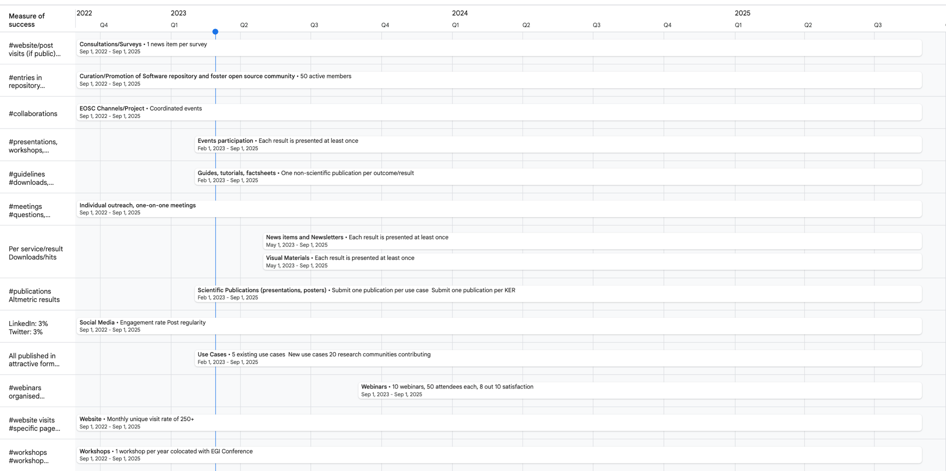

Next Steps

Project outcomes
In 2023, the following public-facing project outcomes, that require communication and dissemination support from T2.2, are being planned:
● Release of the Blueprint Architecture
● First releases of core and thematic DT modules
● Establishment of Open-Source Community
● Publication of use cases
● Publication of the first public deliverables
● F2F meeting at EGI2023, and other technical meetings (tbd)
● Webinar programme: in the first instance, some webinars related to the use cases will be set up in collaboration with WP4 - at a later stage other topics (such as concrete project results) will be presented.

If required, create dedicated communication packages for project partners with all necessary materials and tools bundled, will be sent out.

Events
Table 3 – Events 2022 - 2023
Event name | Location | Date | (Planned) activity
EGI2022 | Prague, Czech Republic | 19-23rd September 2022 | Kick-off  Poster
Ibergrid2022 | Faro, Portugal | 10-13 October 2022 | Plenary sessions on Digital Twins
AGU2022 | online | 16th December 2022 | CMCC Presentation: Generating accurate climate model realizations
Rucio Community Meeting | Lancaster University, UK | 10th November 2022 | WP5 Presentation:  Rucio and the interTwin project (Remote)
EOSC Symposium | Prague, Czech Republic | 17 November 2022 | WP2 Presentation: InterTwin: extending the technical capabilities of the EOSC with modelling and simulation tools (Digital Twin Engine) integrated with EOSC compute platform
EODC Forum | Vienna, Austria | 9th - 10th May 2023 | TBD
EGI2023 | Poznan, Poland | 19-23rd June 2023 | Plenary meeting  Poster  Presentation
ISGC2023 | Taipei, Taiwan | 23rd March 2023 | WP5 Presentation: Data Management for the interTwin Project
EGU2023 | Vienna, Austria | April 2023 | CMCC Poster: A machine learning-powered Digital Twin for extreme weather events analysis
CHEP2023 | Virginia USA | May 2023 | WP5 Presentation:  DTE Infrastructure in intertwin
Ibergrid 2023 | Spain

Annexes

Annex 1: Matchmaking: Horizon Results Platform Stakeholders
The Horizon Results Platform is essential for dissemination purposes in order to bridge the gap between research results and generating value for the economy and society. The target audiences as defined above can be matched to the Horizon Results stakeholders list. In order to optimise tracking of dissemination opportunities and measure their success, we have mapped interTwin stakeholders to those of the HR results platform.

Table 4 - Project Stakeholders matched against HE Results Platform
interTwin Target Group | interTwin  Specific Audiences | Matching Horizon Results Platform stakeholders
DT Users | Scientific collaborations  Individual researchers  SME / Industry  Evidence Based Policy Makers & Civil Society | Academia/ Universities  Research and Technology Organisations  Public or private funding institutions  EU and Member State Policymakers  International Organisations (if considered part of civil society)  Other Actors who can help us fulfil our market potential.  SMEs  Big Corporations
DT Developers  and Providers | Scientific collaborations  Individual researchers  SME / Industry  Research Infrastructures, e-infrastructures, and data space providers | Academia/ Universities  Research and Technology Organisations  Other Actors who can help us fulfil our market potential.  SMEs  Big Corporations

Annex 2: Internal Communication Tools
Purpose | Link
Project website | www.intertwin.eu
Knowledge db - project working space | https://confluence.egi.eu/display/interTwin/
Meetings agendas - conference and meeting planner | https://indico.egi.eu/category/347/
Document DB - storage server for large files | https://documents.egi.eu/
Video conferences | https://zoom.us/meeting/schedule (see also interTwin Zoom - restricted page)
Task and request tracker | https://jira.egi.eu/
Mailing list server | https://mailman.egi.eu/mailman/listinfo (see also interTwin mailing lists)
Effort reporting | https://eufin-projectmanagement.eu/EGI/

Annex 3: Full list of deliverables
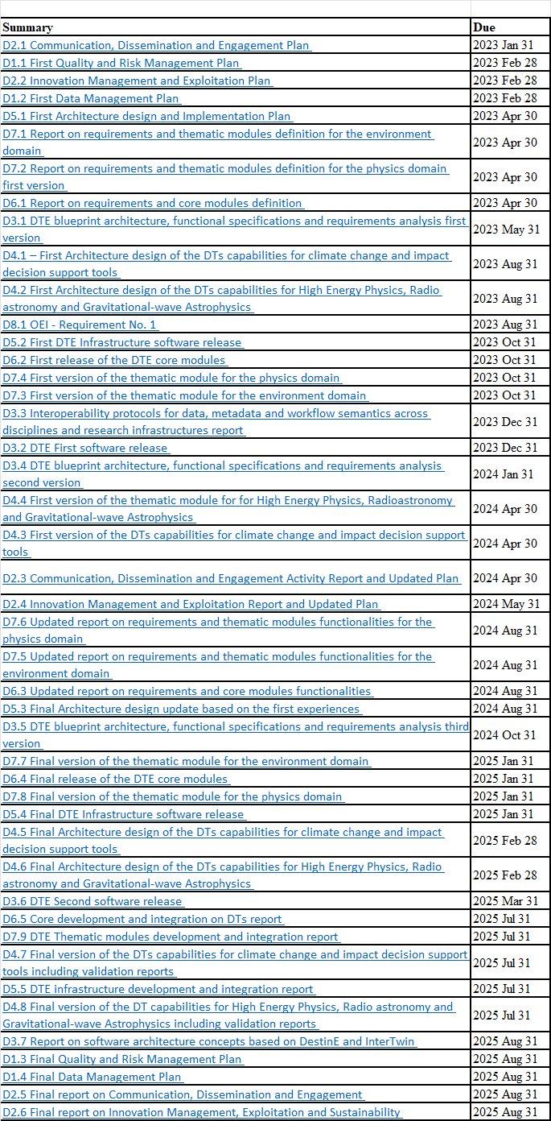

interTwin Project Objectives
interTwin Key Exploitable Results
See Annex 1
https://dtgeo.eu/
https://biodt.eu/
https://ebrains.eu/news/ebrain-health-project-awarded-funding-by-horizon-europe/
https://www.plattform-i40.de/IP/Navigation/EN/Home/home.html
Detailed description of tools: see Toolbox
https://www.intertwin.eu/use-cases
https://cdn.intertwin.eu/app/uploads/2023/02/intertwin-brandguide-2023-v0.95-2.pdf
See Annex 2
https://www.youtube.com/playlist?list=PL8MrRo-3u8httco7M9MifPJj59joDk4JF
https://www.egi.eu/article/egi2022-report/
https://confluence.egi.eu/display/interTwin/Communication+Toolkit
https://zenodo.org/communities/intertwin/
https://dtgeo.eu/
https://biodt.eu/
https://ebrains.eu/news/ebrain-health-project-awarded-funding-by-horizon-europe/
https://ec.europa.eu/research-and-innovation/en/horizon-magazine
https://zenodo.org/communities/intertwin
https://cdn.intertwin.eu/app/uploads/2023/02/intertwin-brandguide-2023-v0.95-2.pdf
A public platform that hosts and promotes research results thereby widening exploitation opportunities. It helps to bridge the gap between research results and generating value for economy and society.

