e-ScienceTalk

D2.2 Gridcafe

EU DELIVERABLE: D2.2

Document identifier: | e-ScienceTalk_D2.2_GridCafe_final
Date: | 28/09/2011
Work package: | WP2
Lead Partner: | EGI.eu
Document Status: | FINAL
Dissemination Level: | PUBLIC
Document Link: | https://documents.egi.eu/document/xx

Abstract
This report summarises the development of an updated version of the GridCafé and the launch of the e-ScienceCity website. The websites constitute the deliverable D2.2 and this document accompanies the deliverable to outline the development process. The e-ScienceCity website was launched at the 9th e-Infrastructure Concertation meeting on 22 September 2011 in Lyon. The website includes a new version of the GridCafé and a new area covering cloud computing, called the Cloud Lounge.

- Copyright notice
Copyright © Members of the e-ScienceTalk collaboration, 2011. See www.e-sciencetalk.eu for details of the e-ScienceTalk project and the collaboration. E-ScienceTalk is a project co-funded by the European Commission as a Support Action within the 7th Framework Programme. E-ScienceTalk began in September 2010 and will run for 33 months. This work is licensed under the Creative Commons Attribution-Noncommercial 3.0 License. To view a copy of this license, visit http://creativecommons.org/licenses/by-nc/3.0/ or send a letter to Creative Commons, 171 Second Street, Suite 300, San Francisco, California, 94105, and USA. The work must be attributed by attaching the following reference to the copied elements: “Copyright © Members of the e-ScienceTalk Collaboration, 2011. See www.e-sciencetalk.eu for details of the EGI-InSPIRE project and the collaboration”. Using this document in a way and/or for purposes not foreseen in the licence, requires the prior written permission of the copyright holders. The information contained in this document represents the views of the copyright holders as of the date such views are published.
- Delivery Slip
 | Name | Partner/Activity | Date
From | Andre-Pierre Olivier | APO/WP2 | 19/09/2011
Reviewed by | Moderator:  Reviewers: | Various | 28/09/2011
Approved by | AMB & PMB |  | 28/09/2011
- Document Log
Issue | Date | Comment | Author/Partner
1 | 19/09/2011 | ToC | C Gater / EGI.eu
2 | 27/09/2011 | First draft | C Gater / EGI.eu
3 | 28/09/2011 | Final draft | C Gater / EGI.eu
4
- Application area
This document is a formal deliverable for the European Commission, applicable to all members of the e-ScienceTalk project and its beneficiaries and collaborating projects.

- Document amendment procedure
Amendments, comments and suggestions should be sent to the authors.
- PROJECT SUMMARY

Over the last 10 years, the European Commission and governments have invested substantial funds in distributed computing infrastructures. Scientists have access to state-of-the-art computational and data resources located around the world, putting European research into a leading position to address the greatest challenges facing us today, such as climate change, pandemics and sustainable energy. The advent of the European Grid Infrastructure, combined with the blurring of boundaries between grids, clouds, supercomputing networks and volunteer grids, means that a clear consistent source of information aimed at non-experts is now more important than ever, through dissemination projects that cross national boundaries.

Objectives:

- e-ScienceTalk will build on the achievements of the GridTalk project in bringing the success stories of Europe’s e-Infrastructure to policy makers in government and business, to the scientific community and to the general public.

- e-ScienceTalk will work with EGI-InSPIRE and other collaborating projects to expand the scope of the existing GridTalk outputs, and to report on the interactions of grids with e-Infrastructures such as cloud computing and supercomputing.

- The project will explore options for the sustainability of e-ScienceTalk’s products.

- e-ScienceTalk will produce a series of reports aimed at policy makers to disseminate key policy issues underpinning grid and e-Infrastructure development in Europe. The project will also coordinate e-concertation activities.

- The GridCafé, GridCast and GridGuide suite of websites will cover new topics and explore novel web technologies; they will integrate closely with GridPP’s Real Time Monitor, combining live views of grid activity with the human aspects of computing.

- The growing weekly publication, International Science Grid This Week (iSGTW) will bring news and events to the existing and potential e-Science community.

- EXECUTIVE SUMMARY

This report summarises the development of an updated version of the GridCafé and the launch of the e-ScienceCity website. The websites constitute the deliverable D2.2 and this document accompanies the deliverable to outline the development process. The e-ScienceCity website was launched at the 9th e-Infrastructure Concertation meeting on 22 September 2011 in Lyon. The website includes a new version of the GridCafé and a new area covering cloud computing, called the Cloud Lounge.

The GridCafé website (www.gridcafe.org) was developed by the GridTalk project after being inherited from CERN. It aimed to explain to a non-expert audience in a simple and stimulating fashion “what grid computing is and what it could soon be.” During Year 1, the team has worked to develop links to demos, videos, games and online interactive tools. The content of the site has been expanded to cover the interactions between grid computing and clouds, with the launch of a new website, e-ScienceCity and an area dedicated to cloud computing called the Cloud Lounge.

When the GridCafé website was first developed, it was a novel form of science communication that was nominated for awards. However, in order to fulfill the objective of keeping the GridCafé at the cutting edge we needed to explore interactive environments and new web tools. The recommendations at the end of the GridTalk project were to create a simple virtual 3D GridCafé in the first twelve months of the e-ScienceTalk project on the OpenSim platform. Standard 3D tools would be used to create the content, so that it could be transferred to a different platform if OpenSim proved not to be a sustainable solution.

A second aim for Year 1 was to develop new content areas of the website that covered other areas of e-infrastructures and distributed computing. The Cloud Lounge was chosen as the first new area to be developed, drawing from the content and research for the e-ScienceBriefing on this subject. Development of parallel websites proved to be impractical and went counter to the feedback from the audiences, so a home website called the e-ScienceCity was developed. The structure and navigation for the 2D website ties in closely with the structure of the associated 3D virtual world. The GridCafé website main content areas were migrated to the e-ScienceCity template in PQ4. The common areas of the e-ScienceCity are still in development in the new format ie In Debate, People and Multimedia, so links back to the original areas are in place. The Cloud Lounge website is now available within the e-ScienceCity website. The main content areas include an Introduction, Cloud in 30”, How do clouds work?, Clouds in IT history, Clouds and grids and Cloud powered projects. Custom illustrations have developed for each of these areas.

Observing and comparing usage statistics prior and post e-ScienceCity launch will be especially important for Year 2. Virtual worlds are increasingly popular for social networking, gaming and learning. In developing a pilot 3D site, e-ScienceTalk has partnered with Virtus, a non-profit association and New World Grid. The e-ScienceTalk team is benefiting from technical help from the NWG team, and from the team and community spirit of the users. The expectation is to launch the virtual world version of the site in early PY2.

Table of Contents
1 Introduction 6
1.1 Background 6
1.2 Objectives and feedback 6
2 New Version of the Gridcafe 8
2.1 Developing the Concept 8
2.1.1 3-D virtual worlds 8
2.1.2 New content areas 9
3 E-scienceCity 10
3.1 Developing the e-ScienceCity 10
3.2 The GridCafé 12
3.3 The Cloud Lounge 13
4 Future Developments 15
4.1 Recommendations for Year 2 for Evaluation 15
4.2 The 3D Virtual World 15
4.3 Future Development of the e-ScienceCity 2D Website 16
5 Conclusion 17
6 References 18

Introduction

Background

The GridCafé website (www.gridcafe.org) was developed by the GridTalk project after being inherited from CERN. It was designed with the aim of explaining to a non-expert audience in a simple and stimulating fashion “what grid computing is and what it could soon be.” During Year 1, e-ScienceTalk has expanded GridCafé’s scope and appeal through new media channels, keeping it up-to-date and at the cutting edge of grid and e-Science dissemination. The team has also worked to develop links to demos, videos, games and online interactive tools. The content of the site has been expanded to cover the interactions between grid computing and clouds, with the launch of a new website, e-ScienceCity and an area dedicated to cloud computing called the Cloud Lounge.

Objectives and feedback

The objectives for the GridCafé during e-ScienceTalk are outlined below:

- Keep the GridCafé at the cutting edge of grid and e-Science dissemination by refreshing the look and feel;
- Keep the site constantly updated with new material;
- Expand the content to cover other forms of distributed and high performance computing;
- Explore interactive environments and new web tools to ensure that GridCafé has an impact on its audiences and is easy to use.

The impact of GridCafé on its audiences during its first year was summarised in D1.3 Annual Impact and Sustainability Report [R1]. According to the web statistics, GridCafé continues to be the second most referenced and visited e-ScienceTalk product after International Science Grid This Week. A Russian version of the website is in progress and an updated version of the site is available in Chinese, meaning that the global dissemination of the project has been extended to researchers in two of the world’s emerging economies.

In addition, feedback on the GridCafé was gathered through one to one interviews with scientists and science communicators, either face to face or by email, during Year One and was summarised in D4.3 Annual Report on Feedback and Metrics [2]. All interviewees shared the opinion that the images and animations were well-designed and the layout was constructed in an intuitive way. The grid-powered projects and grid debates section were highly rated amongst some interviewees. Most agreed that the content was well pitched for a lay-audience, and found the site straightforward to navigate. One section that was highly commended was the tutorial video section that provides practical and valuable information for those new to the grid.

New Version of the Gridcafe

Developing the Concept

3-D virtual worlds

At the start of e-ScienceTalk in Q1, the content of the GridCafé website was refreshed, with new projects and people profiles being added, finished projects removed if necessary and links added to new materials such as e-ScienceBriefings. The translated versions of the website in Spanish and Hungarian were updated at the same time as the original site, including the launch of French and Chinese versions of the site.

When the GridCafé website was first developed, it was a novel form of science communication that was nominated for awards. However, in order to fulfill the objective of keeping the GridCafé at the cutting edge we needed to explore interactive environments and new web tools. One of the aims for work package 2 was to produce a pilot 3D GridCafé in a virtual world, as discussed in one of the final GridTalk deliverables, GridCafé in a Virtual World [R3]. This report outlined some alternatives for platforms for a 3D version of the website, including Second Life and OpenSim.

A 3D adjunct to the GridCafé website was agreed by the GridTalk team and EC project reviewers to be worth exploring for a number for a number of reasons, including:

- A number of educational bodies, such as the Department of Energy, Open University and Artificial Intelligence Learning Centre have set up science-focused areas in 3D simulations including SecondLife or OpenSim.

- 3D environments can be a useful educational tool to engage a different subset of the public, and to give a greater depth of information and interactivity than possible with a standard website.

- Using a 3D environment to present scientific research reinforces the “e” aspect of today’s sciences and benefits the message of e-ScienceTalk.

- This solution could also offer e-scientists a new way to present their results, and hence encourage closer collaboration with projects such as EGI-InSPIRE and its users.

- Using a virtual world is also a way to move from passive viewing to interactivity, and hence develop new tools for e-learning about the grid and e-science.

- Visualisations can be an important way of introducing the public to science. A 3D virtual world gives viewers a new approach to scientific images, and hence has a positive impact on the perception of research by the general public and students.

- Learning how to use 3D technology to present and teach sciences in a virtual environment is of benefit even if the technology evolves; in the same way that graphic design skills remain even if graphic design software changes. This is the example set by Second Life users such as the Open University.

The GridTalk deliverable looked at different solutions for constructing a navigable 3D world, compared existing science and education-related content, and examined other issues such as social networks in virtual worlds and newsletters. Other issues, including moderation, the effort required to build the world, potential audience and the possibility of migrating to other technology later were also considered.

These led to the following recommendations:

- e-ScienceTalk would aim to create a simple virtual 3D GridCafé in the first twelve months of the project. The process and results of this would then be assessed before deciding whether to go further.

- The virtual GridCafé would be created in on the OpenSim platform. This uses similar tools and viewer to Second Life, but is without the charging and copyright issues associated with the commercial Second Life.

- Standard 3D tools would be used to create the content, so that it could be transferred to a different platform if OpenSim proved not to be a sustainable solution.

New content areas

A second aim for Year 1 was to develop new content areas of the website that covered other areas of e-infrastructures and distributed computing. WP1 produced an e-ScienceBriefing on cloud computing in March 2011. Given that cloud computing is of intense media interest and also has overlaps in application with grid computing, the Cloud Lounge was chosen as the first new area to be developed, drawing from the content and research for the e-ScienceBriefing on this subject.

However, it became clear that developing new areas of the GridCafé website to run in parallel to each other would lead to complications with overlapping common areas ie In Debate, News, People and Multimedia. Feedback from one to one interviews also showed us that our audiences preferred integrated websites, rather than an increased number of parallel but related websites.

This led to the need for an overall concept for the website that could include new areas of the website as they developed ie grid, cloud, volunteer computing, HPC and more but would remain easy to navigate and flexible enough to incorporate the areas common to each area. This concept was developed as the e-ScienceCity, outlined in the next section.

E-scienceCity

Developing the e-ScienceCity

The architecture for the e-ScienceCity website is outlined below:

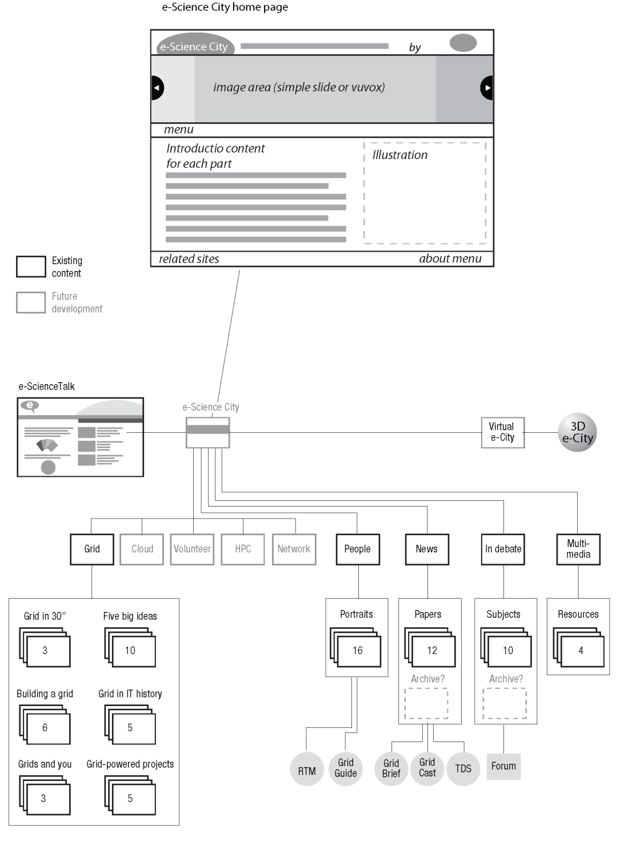
Fig 1. E-ScienceCity website architecture

This architecture illustrates how the different areas of the website relate to each other and to the common elements. The structure maintains the key elements of the well-known and appreciated GridCafé website, while introducing the new content areas and tying into the elements of the 3D virtual world being developed alongside the 2D website.

The new website also includes a new logo that reflects the different content areas that will be developed during future development phases.

Fig 2. E-ScienceCity logo

Navigation around the e-ScienceCity and its content areas is possible in two ways: via a scrolling image carrousel in the top banner, controlled by the visitor and through a roll-over map that ties in with the map of the virtual e-ScienceCity that is being developed in parallel.

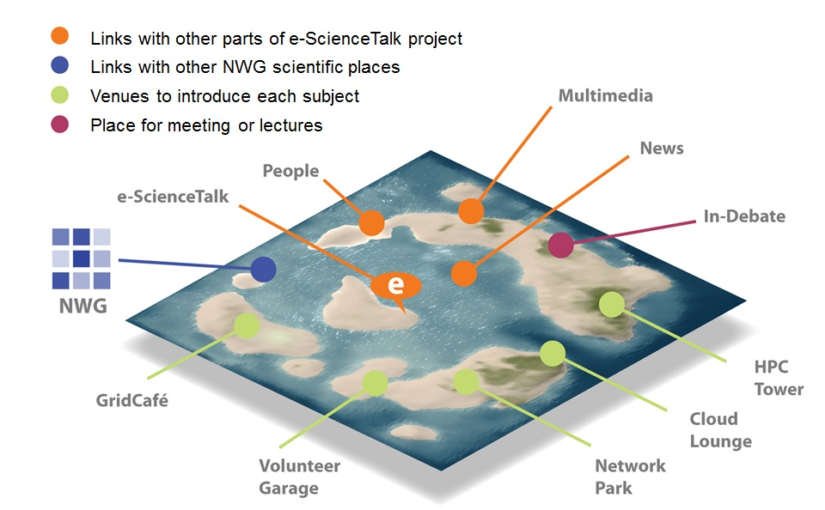
Fig 3. E-ScienceCity 3D and 2D navigation map

The GridCafé

The GridCafé website main content areas were migrated to the e-ScienceCity template in PQ4:

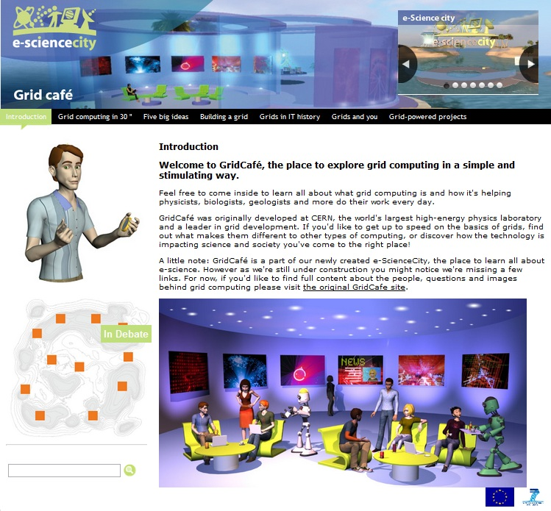
Fig 4. GridCafe website in the e-ScienceCity template

However, the common areas of the website are still in development in the new format ie In Debate, News, People and Multimedia. While these are populated, the links to these areas in the e-ScienceCity website point back to the corresponding areas in the original GridCafé website at www.gridcafe.org. The original version of the GridCafé website will remain in place alongside the new version while these areas are in development.

The Cloud Lounge

The Cloud Lounge website is now available within the e-ScienceCity website. The main content areas include an Introduction, Cloud in 30”, How do clouds work?, Clouds in IT history, Clouds and grids and Cloud powered projects. Custom illustrations have developed for each of these areas.

g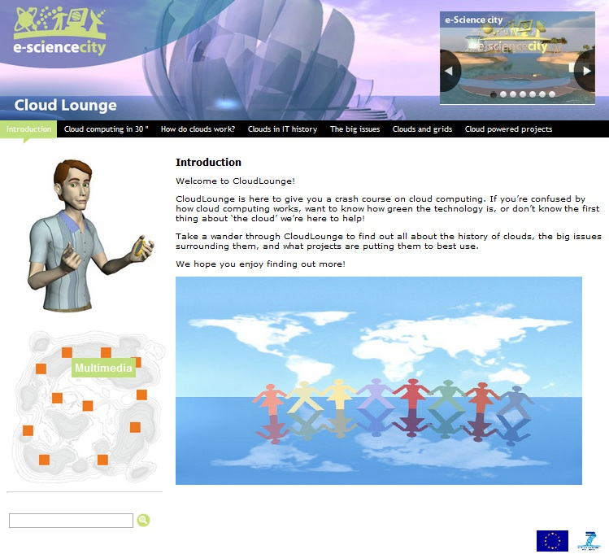
Fig 5. The Cloud Lounge home page

The e-ScienceCity and Cloud Lounge websites were launched at the 9th e-Infrastructure Concertation Meeting organised by e-ScienceTalk on behalf of the European Commission in Lyon on 22-23 September 2011. The content will be updated with new cloud related projects and new developments as these emerge. E-ScienceTalk will also work with collaborating partners on providing translated versions of the Cloud Lounge in a similar way to the translated versions of the GridCafé.

Future Developments

Recommendations for Year 2 for Evaluation

The sustainability and impact report [R1] and feedback report [R2] make a number of recommendations for Year 2 for the GridCafé and e-ScienceCity websites. The reports recommended gathering qualitative feedback and measuring usability and usefulness quantitatively. Criteria for usefulness could include attributes such as relevance and format. Surveying online users of the website would provide useful data for rating the ease of use, design and functionality. With the introduction of a new 3D interactivity a usability test could also be carried out prior to launching the 3D site, and an in world demo is planned for Q5 with the New World Grid community.

Year 1 GridCafé metrics included usage data analysing visitors and content. With Web2.0, the ‘page views’ are no longer sufficient to determine actual usage of a website. Measuring the time users spend in specific sections of the website will be more valuable as it could drive content development and give an indication of topics that people are more interested in. Comparing trends over time is preferable to absolute numbers as these can be too imprecise to provide statements and recommendations. Observing and comparing usage statistics prior and post the e-ScienceCity launch is also especially important for Year 2. These metrics are outlined in more detail in D4.3 [R2].

The 3D Virtual World

Virtual worlds are increasingly popular for social networking, gaming and learning. Waiting too long to introduce 3D technology as an adjunct to GridCafé will make the project appear as a “follower”, and we may find we have to move to a 3D solution in the long term anyway, just to keep up with technology.

However, there are issues to be addressed in launching a 3D version of the e-ScienceCity site. For example, if we are to develop any areas aimed at under 18s we will need to consider moderation, and how to ensure that the content remains appropriate. Any virtual world we develop could include the ability to ban problematic users. In general, users of virtual worlds need to be aware that avatars may not accurately represent the real person behind them, and to be wary of people met online.

The GridTalk report [R3] concluded that the commercial “packaged solution” is expensive, with poor flexibility. It can be considered as a very restricted version of Second Life or OpenSim. For e-ScienceTalk, the reported greater ease of use for Second Life does not counterbalance its limitations. In contrast, a “game engine” could give a very sophisticated visual environment and easy installation. However, we do not consider this a good solution for a collaborative environment. The time and difficulty of development may also have a negative impact on the project budget. WebGL is useful in principle, but is currently too uncertain and may not produce the necessary easy to use and inexpensive development tools during the duration of e-ScienceTalk. The development time after these tools become available is also difficult to evaluate.

For OpenSim, there is better control of budget and a real opportunity to develop something new. Second Life’s large community can partly be put down to ‘first mover’ advantage, as the first solution of this kind available, but this may erode as new products based on OpenSim are developed.

The choice of an OpenSource versus a proprietary solution gives the advantage of a lower price, ownership of the content, technical equivalence to Second Life and the 3D and scripting tools are included, giving in-world design. In developing a pilot 3D site, e-ScienceTalk has partnered with Virtus and New World Grid. Virtus is a non-profit association, with no “in-world money” and with content control. The e-ScienceTalk team is also benefiting from technical help from the NWG team, and from the team and community spirit of the users.

The team is working on the development of other sims to add content to the NewWorldGrid that is related to the e-ScienceCity. This includes the Worldwide LHC Computing Grid (WLCG), including a virtual visit of the CERN Computer Centre. The Citizen CyberScience Centre area promotes volunteer computing, including presentations of the project and guides to participation for the citizen science community, based on BOINC technologies. Also planned is an ATLAS experiment sim for high energy physics at CERN.

Future Development of the e-ScienceCity 2D Website

The 2D e-ScienceCity website includes scope for new content areas such as HPC, volunteer computing, data and networks. These areas will be developed during the e-ScienceTalk project alongside the Multimedia, News, In Debate and People sections. As these new sections are launched, the impact team will evaluate the usage and usability of the website through surveys, monitoring web statistics and face to face evaluations. Once the new site is well established with our audiences, the original version of the GridCafé website will be migrated completely to the new template.

Conclusion

Establishing the e-ScienceCity website represents a significant step forward for the GridCafé. The new site, while maintaining the best known and liked elements of the award winning GridCafé is now able to expand into new content areas covering the wider e-infrastructure landscape. The Cloud Lounge covering cloud computing has already been launched, and the team will work to publicise the new website through the other e-ScienceTalk channels and through social media. The traffic to the websites will be monitored through the metrics during Year 2 and new areas will be added during the year, covering topics such as HPC, volunteer computing and data. The 3D version of the GridCafé and e-ScienceCity in NewWorldGrid will be tested and piloted during Year 2 and launched alongside the 2D version of the site.

References
R 1 | D1.3 Annual Impact and Sustainability Report  https://documents.egi.eu/document/751
R 2 | D4.3 Annual Report on Feedback and Metrics  https://documents.egi.eu/document/792
R 3 | GridCafé in a Virtual World  https://documents.egi.eu/document/806

http://www.e-sciencecity.org/
http://www.e-sciencecity.org/EN/cloud-lounge/
http://www.e-sciencecity.org/
http://www.e-sciencecity.org/EN/cloud-lounge/
http://www.isgtw.org
http://www.gridcafe.org/index_FR.html
http://www2.twgrid.org/gridcafe/
http://www.e-sciencetalk.org/briefings/EST-Briefing-17-Cloud-Web.pdf
http://www.newworldgrid.com/

