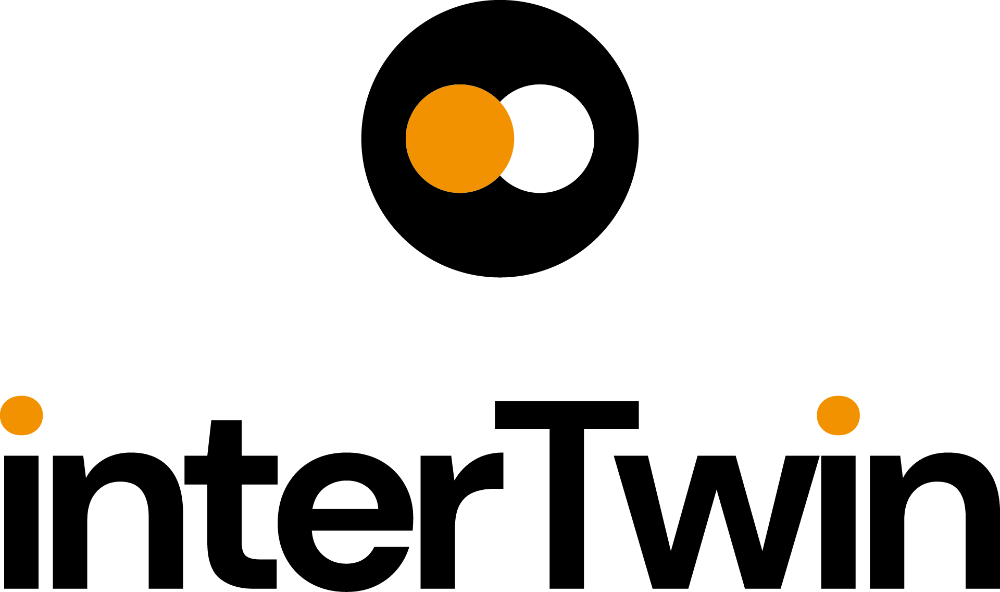

RP1 POLICY BRIEF
Status: FINAL
Dissemination Level: Public
Introduction: Project title and project objectives
RP1 POLICY BRIEF
CALL | HORIZON-INFRA-2021-TECH-01
TOPIC | HORIZON-INFRA-2021-TECH-01-01
PROJECT | An interdisciplinary Digital Twin Engine for science (interTwin)  https://www.intertwin.eu/
PROJECT: objectives | - Co-design, develop and provide a Digital Twin Engine that simplifies & accelerates the development of complex application-specific DTs that benefits researchers, business, and civil society  - Co-design a Digital Twin Engine blueprint architecture that provides a conceptual framework for the development of DTs supporting interoperability, performance, portability, and accuracy.  - Extend the technical capabilities of the European Open Science Cloud with modelling and simulation tools integrated with its compute platform  - Ensure trust and reproducibility in science through quality, reliability, and verifiability of the outputs of Digital Twins  - Demonstrate data fusion with complex modelling & prediction technologies  - Simplify DT application development with tools to manage AI workflows and the model lifecycle while reinforcing open science practices
Name and email address of the operational project coordinator. | - Malgorzata Krakowian: malgorzata.krakowian@egi.eu Project Manager  - Andrea Manzi: andrea.manzi@egi.eu  Technical Coordinator  - Xavier Salazar Forn: xavier.salazar@egi.eu  Innovation Manager
Dissemination Level | Public
DOI | https://doi.org/10.5281/zenodo.10692495
Copyright Status | This material by Parties of the interTwin Consortium is licensed under a Creative Commons Attribution 4.0 International License.

Policy Implications and Recommendations 4
Implementation of research infrastructures 4
Access to research infrastructures. 4
Funding of research infrastructures. 4
International co-operation of research infrastructures 5
Employment and skills in research infrastructures. 5
Greening of research infrastructures 5
Interaction of research infrastructures with industry. 6
ERIC legal framework. 6
Technology development, data and digital services, digitalisation. 6
Level of connection of your RI to EOSC. 7
Contribution to other research areas and to broader EU priorities. 7
Sustainability of research infrastructures. 7

Policy Implications and Recommendations

Implementation of research infrastructures
Research Infrastructures are key stakeholders for the adoption of interTwin key results, as interTwin aims at delivering generic solutions that are generically applicable in multiple scientific domains and which can be customised with community-specific components for delivering data-intensive AI/ML applications for data reduction, data processing and data analysis.
interTwin aims at designing and building a prototype of an interdisciplinary Digital Twin Engine (DTE) enabling seamless access to the necessary compute and data infrastructure and services in order to facilitate the development of Digital Twins across scientific disciplines. InterTwin focuses on the fields of physics (including High Energy Physics, Astroparticle Physics and Radio Astronomy) and environmental sciences (including Climate Change, Earth Sciences, Extreme Weather). Several interTwin key partners represent and are part of relevant Research Infrastructures on those domains such as HL-LHC with CERN and CSIC for high energy physics, ENVRI which includes IS-ENES represented by CMCC, CNRS-IPSL, UNITN, CERFACS, INFN contributing to the Einstein Telescope with their work on VIRGO. interTwin use cases are developing Digital Twins aiming to improve their operations, e.g. to prepare and bring infrastructures faster to production (HL-LHC, Einstein Telescope) or improve efficiency of the necessary compute operations for the data processing needs for RIs

Access to research infrastructures.
Several Digital Twins developed in use cases such as the environmental related (e.g. Early warning for Extreme events) will be able to become available as a service for broader communities (including industry, SMEs or other users beyond research such as policy makers or general public).

Funding of research infrastructures.
It is expected that the successfully demonstrated ability to implement a compute continuum in DT applications that can be adopted and shared among research infrastructures, will create economy of scales by allowing multiple infrastructure to rely on a shared compute continuum infrastructure. This approach can bring tangible cost reductions thanks to the more efficient and shared access to Cloud, HTC and HPC resources, and to a faster adoption of AI/ML in scientific software.

International co-operation of research infrastructures
Several of the Key Exploitable Results are expected to foster the collaboration across the different scientific domains, such as the KER2 Interoperability framework that ensures the alignment of Digital Twin Engine with existing data and infrastructure standards, and the KER6 open source community which facilitates the adoption of the different Software Components of the project. KER1 Digital Twin Engine is creating a service that will enable the digitalization of research infrastructures by facilitating the development of Digital Twins.
Scientific communities in the project are international initiatives that span out of the European domain involving researchers worldwide and contributing to overall mankind scientific progress (such as ENES, LHC, VIRGO, MeerKat). As such, interTwin is contributing to ensure the European significance within those international initiatives and enable bringing back to Europe the knowledge generated in them. There are specific collaborations with Switzerland (part of the cooperation with the Lattice QCD use case) and with the UK, as UKRI is infrastructure and technology provider for the project.
The subset of environmental science related use cases is developing Digital Twins that are being used as reference for the Digital Twin of the Earth initiative. In particular FloodAdapt is being used as a reference case by DestinE. Further use cases address global challenges deriving from the climate change emergence - such as extreme weather, floods, drought, or forest fires.

Employment and skills in research infrastructures.
Researchers involved in interTwin are broadening knowledge in AI, ML usage for Digital Twins. While contributing to better understanding, knowledge is being shared openly not only for the researchers in the project but also for the users and future users within the Research Infrastructures. As such several technical webinars and training material are being prepared. Indirectly the project is not only ensuring the employment of the researchers working in the project but broadening the opportunities of research infrastructures. Impact after the end of the project depends on the (economic) sustainability and the uptake after the project.
Recommendation for further impact, after the end of the project support will need to be granted to deliver training & capabilities to upskill RIs on the development of Digital Twins should be given via competence centres, EOSC nodes

Greening of research infrastructures
Several subsets of results are specifically aiming to optimise the energy consumption by compute infrastructures: The interTwin AI Orchestrator considers sustainability constraints on the resource allocation in order to facilitate a greener computing for RIs. ML algorithms are developed to speed up simulations (by substituting Montecarlo-based ones, which are very compute intensive). Pre-processing and processing of Data by the DTs will reduce the need for storage.

Interaction of research infrastructures with industry.
There are some SMEs linked the project (e.g. EODC) and there is an effort to engage with external industrial experts (e.g. via the external expert advisory board). At this point the main focus is on science related DT's. Activities in some domains (e.g. earth science and environmental related) - have direct societal impact and may arise opportunities among industrial players working in the domain. As such, activities to promote the project across broader audiences including industry, SMEs and public authorities have been kick-started, and collaboration with such as EOSC and EGI Digital Innovation Hubs or the DECIDO-EOSC Competence Center for Public Authorities. As a recommendation, specific funding to promote and support industry and SMEs’ access to the Digital Twin Engine to develop DT-related technologies, e.g. via open calls for prototyping would be useful to ensure crossing the chasm and raising the interest of industrial players.

ERIC legal framework.
Not applicable

Technology development, data and digital services, digitalisation.
A faster uptake of AI/ML thanks to common solutions is expected to boost data productivity in science promoting secondary use of data and with that the research data value chain. The role of AI in research infrastructures and the European Open Science Cloud is central to ESFRI, and a dedicated workshop was held in Milan during 23-24 Jan 2024. The outputs of the workshop are expected in ESFRI policy recommendations on future technology and innovation priorities. Hence, interTwin DTEblueprint and its technical components are well positioned to address the ESFRI research infrastructure needs. In the future Digital twins will become a commodity and interTwin contributes to this vision.
Recommendation from a policy point of view it is needed to upgrade the necessary (e-) infrastructures in order to tackle the future compute and data needs from RI’s. As such, proper case studies to understand what the future RI needs will look like and how the evolving technological landscape can be used to tackle those needs. In particular it is needed to incorporate HPC capabilities into data and compute federations that facilitate the adoption, deployment, and operations of Digital Twin-related services. As such there is no clear vision on European HPC resources can be federated with Cloud and HTC infrastructures to democratise the usage of HPC and avoid staying in silo. Access to HPC needs to be extended to enable not only specific closed-projects -but also to support the compute-intensive service-driven operations such as the ones needed by Digital Twins. For Quantum computing, a vision is still needed on how it will be made available to Research Infrastructures.

Level of connection of your RI to EOSC.
interTwin Digital Twin engine components are candidates to become horizontal enabling services for the support of AI/ML applications interested in reusing FAIR research data that is federated and accessed through EOSC.
interTwin close collaboration with EOSC is one of the key aspects of the project. As such the project is following European Commission Open Science best practices and FAIR principles for all the data and software components developed. Interoperability framework ensures the integration capabilities with EOSC infrastructure and final results will be incorporated into the EOSC Marketplace as the right maturity level is reached.
Recommendations: Services delivered keep relying on compute and data suppliers that need to provide the access to facilities. In order to ensure the sustainability of the operations. EOSC and EC should think about incorporating those services to be procured and made available via EOSC nodes - as it is done for other services.

Contribution to other research areas and to broader EU priorities.
interTwin is contributing to the realisation of DestinE initiatives by developing a compatible architecture so that Digital Twins in the project could be hosted in the future in the DestinE DTE and Infrastructure. ECMWF, responsible for the DestinE DTE is a partner in the project, and it’s responsible for this activity and one of the DT use cases in interTwin (FloodAdapt) is being used as one of the reference Digital Twin examples for describing initial DestinE Architecture. interTwin is also helping to federate EuroHPC facilities with Cloud and HTC infrastructures. Recommendation for further impact, institutional support to extend the federation is needed to ensure a broader use, especially those that can leverage exascale capabilities.

Sustainability of research infrastructures.
Not applicable

