EGI-Engage

Application of the simulation portals for scientific scenario in disaster mitigation
D6.20

Date | 10 April 2017
Activity | WP6
Lead Partner | Academia Sinica
Document Status | FINAL
Document Link | https://documents.egi.eu/document/3024

Abstract
The Disaster Mitigation Competence Centre (DMCC) of the EGI-Engage project designs, develops and makes available customised IT services for the support of climate and disaster mitigation research, This deliverable describes three scientific case study demonstrators that have been carried out by DMCC members with the use of the WRF and iCOMCOT simulation portals that had been published online by the same group in 2016. The demonstrators use e-infrastructure resources from the Asia-Pacific regional infrastructure of EGI. The case studies advance our understanding of three disastrous events that affected Asia recently: typhoon Haiyan in the Philippines in 2013, extreme floods in Malaysia in 2014-15, and forest fires in Southeast Asia in 2015.

COPYRIGHT NOTICE
This work by Parties of the EGI-Engage Consortium is licensed under a Creative Commons Attribution 4.0 International License (http://creativecommons.org/licenses/by/4.0/). The EGI-Engage project is co-funded by the European Union Horizon 2020 programme under grant number 654142.
DELIVERY SLIP
 | Name | Partner/Activity | Date
From: | Eric Yen and Simon Lin | Academia Sinica / WP6 | 27/02/2017
Moderated by: | Gergely Sipos | EGI.eu / WP6 coordinator
Reviewed by | Yin Chen,  Malgorzata Krakowian | EGI.eu / INDIGO-DataCloud  EGI.eu / WP1 | 10/03/2017
Approved by: | AMB and PMB

DOCUMENT LOG
Issue | Date | Comment | Author/Partner
v.1 | 27/02/2017 | Full draft for external review | Eric Yen/AS
v.2 | 24/03/2017 | Updated version based on external reviews | Eric Yen/AS
v.3 | 06/04/2017 | Updated content | Gergely Sipos/EGI.eu
FINAL | 10/04/2017 | Final version

TERMINOLOGY
A complete project glossary and acronyms are provided at the following pages:
- https://wiki.egi.eu/wiki/Glossary
- https://wiki.egi.eu/wiki/Acronyms

Contents
1 Introduction 5
2 Service architecture 5
2.1 The DMCC Collaboration 5
2.2 Technical architecture 7
3 Case studies 8
3.1.1 Typhoon Haiyan Case Study 8
3.1.2 Malaysia Flood Case Study 11
3.1.3 Long-Distance Forest Fire Dust Transportation Case Study 13
4 Plan for Exploitation and Dissemination 17
5 Conclusions and future plans 19

Executive summary
Hazard risk estimation and prediction by numerical simulation is crucial to the disaster mitigation studies and applications. Similar to weather forecast today has been playing a vital role in shaping societal decision-making, many critical decisions must be made in advance of potentially disruptive environmental conditions. The primary challenges lie on our knowledge to the earth system and how to achieve reliable and accurate simulations as early as possible. Consequently, the Disaster Mitigation Competence Centre (DMCC) of the EGI-Engage project is developing innovative simulation models and providing high performance simulation services from historical event studies, based on deeper understandings of target hazards. Meteorological disasters and hydrological disasters – such as flood, typhoon, extreme temperature, tsunami, and long-distance dust transportation – are in the main focus, because these caused tremendous social-economical losses to Asia Pacific Region in recent years.
This deliverable describes three scientific case study demonstrators that have been carried out by DMCC members with the use of the WRF and iCOMCOT simulation portals: typhoon Haiyan in the Philippines in 2013, extreme floods in Malaysia in 2014-15, and forest fires in Southeast Asia in 2015. The demonstrators used HTC compute and storage e-infrastructure resources from the Asia-Pacific regional Virtual Organisation of EGI. These resources allowed the simulations not only to scale in terms of geographical coverage and density, but also to conclude more swiftly. Allowing near real-time simulation of such events can bring enormous benefits to those who want to predict and react to similar disaster events in the future.
The case studies helped DMCC members to join forces with local communities and to build up the simulation facilities for specific disaster types following a common path: Identify case study; Collect of observation data and supporting materials; Develop and validate simulation model; Infrastructure integration and performance tuning; Deployment in simulation portal. The case studies used the fundamental weather (WRF) and tsunami (COMCOT) simulation models.
For the moment, while finishing these case studies and developing a fourth case study, a storm surge simulation model. All these case studies would be compiled into knowledge base of the DMCC collaboration framework and the simulation could be reproduced for education, training and further studies. Besides the simulation facilities, users could also access the observation data, archive of historical events, case studies, and knowledge base. The DMCC collaboration framework is thus increasing disaster mitigation capability as both the case studies and dissemination activities grows.

Introduction
The EGI-Engage Disaster Mitigation Competence Centre (DMCC) established analysis facilities on top of EGI-compatible regional e-infrastructures for selected environmental hazards. DMCC members validated the facilities by case studies, resulting in deeper understanding of causes and driving forces behind those natural hazards. Moreover the case studies resulted not only innovative and accurate simulation models, but also the data, tools, practices, knowledge and workflows that can be shared with research communities worldwide. The simulation model would be further enhanced and customized to other similar events happened in different time and location. Users could conduct their own case studies by taking advantages of the web portals. Through APAN (Asia Pacific Advanced Network) DMCC has attracted further countries to DMCC, for instance Nepal and Sri Lanka, who brought their case studies and work together with the core DMCC members on implementation.

Service architecture
This section describes the collaboration and the technical architectures that provide the platforms for disaster event simulation in EGI-Engage.

The DMCC Collaboration
DMCC investigates in-depth the mechanisms of the selected disaster events and develops the appropriate simulation models to reproduce the processes by case studies. The collaboration framework developed by DMCC aims at becoming an open science platform of disaster mitigation so that all the tools, data, resources and simulation facilities are sharable, and the simulations are reproducible. This knowledge base is enriched by the simulation models, portals, data and visualisation facilities that are contributed to by the DMCC members:
- Academia Sinica, Taiwan (Leading Partner, represented by Academia Sinica Grid Computing Centre (ASGC))
- Institute of Earth Science, Academia Sinica, Taiwan
- Research Centre of Environmental Changes, Academia Sinica, Taiwan
- National Central University, Taiwan
- Institute Teknologi Bandung (ITB), Indonesia
- Korean Institute of Science and Technology Information (KISTI), Korea
- Universiti Putra Malaysia (UPM), Malaysia
- Advanced Science and Technology Institute (ASTI), Philippine
- Thailand National Electronics and Computer Technology Centre (NECTEC), Thailand
- Leibniz Supercomputing Centre (LRZ), Germany
- University of St. Andrews, United Kingdom
The DMCC collaboration framework consists of the core multi-disciplinary taskforce and the technical platform that consists of online services for simulation, data and information management. These technical elements are connected to and use CPU and storage resources from the EGI-compatible Virtual Organisation in the Asia Pacific.
The taskforce (See Figure 1, right) covers scientific group, technical group, e-Infrastructure group and user support group. The taskforce identified case studies; collected observation data and supporting materials; developed simulation models; validated the models based on historical observation scenarios; integrated the model and data with e-infrastructures; performed performance tuning; deployed the scenarios and tools into online portals (Figure 1, left).
Leveraging the results of case studies, simulation model could be applied to similar disaster events of the same type at different location with customization. By deeper understandings of the hazards, the simulation models would be more accurate. Growing by the case studies, the simulation facilities would be more useful and robust for complicated or compound disasters.

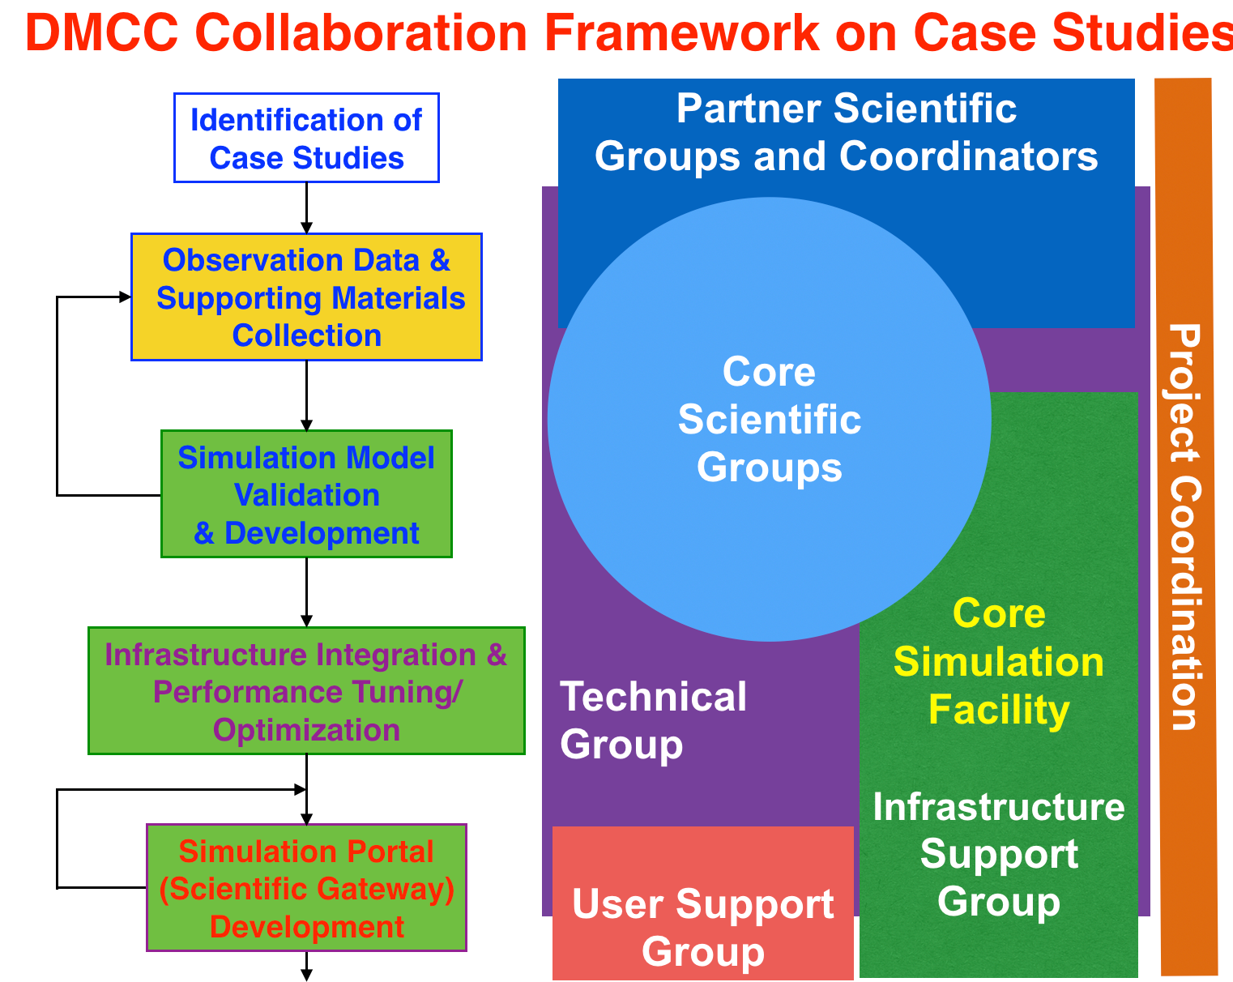
Figure 1. DMCC Case Study Workflow (left) and Collaboration Framework Architecture (right)

In EGI-Engage project, DMCC dedicates to carry out the proposed case studies and verify the collaboration architecture and workflow described above. The synergy of collaborations from user communities (e.g., scientists, information providers, disaster analysts, decision makers), scientific groups, technical groups, infrastructure support groups and user support groups in partner countries could be further exploited by the result case studies, simulation facilities and services, shared knowledge and resources, as well as the future open science platform.

Technical architecture
The case studies used the DMCC technical architecture to interact with e-infrastructure resources. This architecture consists of two simulation portals that were developed by DMCC during the first 18 months of EGI-Engage: tsunami wave propagation simulation portal (iCOMCOT) and weather simulation portal (gWRF). The two portals provide compact and ease-to-use simulation tools for the full cycle of a tsunami event and numerical weather prediction. D6.9, the previous DMCC deliverable provides a detailed description of the portals.
The portals are connected to the regional Virtual Organisation (VO) of EGI in Asia-Pacific. This VO gathers HTC compute and storage resources for diverse disciplinary science that’s conducted in that region. The VO resources are accessible with X.509 personal certificates issues by any CA recognised by EGI sites.

Case studies
DMCC targets meteorological disasters and hydrological disasters which caused principal social-economical losses in Asia Pacific Region in recent years. Weather Research and Forecasting (WRF) model developed by NCAR is used for meteorological event simulation and analysis. gWRF provides the web portal services for numerical weather predication by taking advantages of the regional e-Infrastructure. Cornell Multi-grid Coupled Tsunami Model (COMCOT) model is used for simulations of wave propagation and runup/rundown on coastal regions which is developed by Cornell University. iCOMCOT is the web portal services for COMCOT simulations. DMCC conducted three case studies on three types of disasters in three different partner countries by gWRF and iCOMCOT - storm surge, flood and long-distance forest fire dust transportation, as summarized in Table 1. Through case studies, mechanisms that trigger the hazards were identified. Together with considering whole lifespan of target disaster, the simulation model was enhanced, and the process and parameterization were improved to achieve more accurate simulations. New simulation web portal services for specific disaster type would be developed in the future.

Table 1. Summary of case studies conducted by DMCC
Disaster Event | Type | Partners (countries) | Simulation Facility | Future Extension | New Simulation Model and Simulation Portal
Typhoon Haiyan (2013) | Storm Surge | PH, TW | gWRF + modified iCOMCOT |  | Storm Surge simulation system based on the new model is available. The web portal development is underway.
Malaysia Flood (2014-2015) | Flood due to excessive rain | MY, TW | gWRF | Scouring, Landslide | gWRF + Scouring for souring risk estimation is planned.
Forest Fire Dust Transportation (2015) | Dust Transportation | ID, TW | gWRF  (WRF-Chem) | Biomass burning impact analysis | - The same simulation model is applicable to biomass burning impact analysis.  - Long-Distance Dust Transportation Simulation Portal would be developed.

Typhoon Haiyan Case Study
One of the most intense typhoon devastated Philippine was typhoon Haiyan in November 2013. (6,340 confirmed fatality and 1,061 missing people, $2.86 billion USD damage) Most of the life and economic losses of the event was caused by storm surge induced by typhoon. Accordingly, both the complete life cycle of typhoon and storm surge wave propagation have to be included. A New Storm Surge Model for Typhoon Haiyan by Coupling Atmospheric and Oceanic Models has been developed. Coupled WRF model and in-house COMCOT-based storm surge model incorporating pressure field and wind field analysis were implemented as described in Figure 2. Additionally, to accurately calculate the storm surge characteristics the COMCOT model also incorporates the essential features as below.
- Large computational domain is adopted covering the complete typhoon lifecycle and full storm surge propagation extent.
- The global TPXO tidal model is coupled.
- High-resolution storm surge inundation calculation is achieved.
- Support operational storm surge risk estimation by high performance simulation is achieved by the distributed computing infrastructure.
DMCC core scientific group is confident in typhoon forecast for 48 to 72 hours in advance in terms of track, intensity and pressure. Storm surge simulation thus could be finished in minutes once the weather conditions are available.
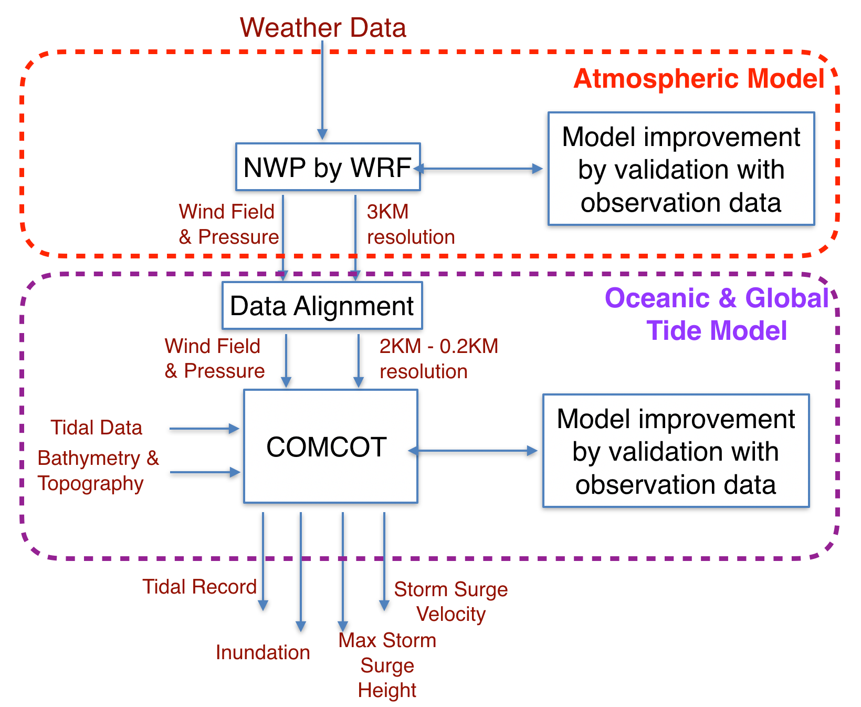
Figure 2. A New Storm Surge Simulation Model for Typhoon Haiyan by Coupling Atmospheric and Oceanic Models
With careful parameterization (especially on the initial condition, boundary condition and resolution) as well as observation data (especially Doppler radar data), the simulation results are very much coincident with the observation as compared by Figure 3(a), 3(b) and 3(c). The track, pressure field and wind field simulations of typhoon Haiyan by DMCC is depicted in Figure 3(d). For such strong typhoon as Typhoon Haiyan, there are still discrepancies in the lowest pressure and highest wind intensity by the current simulation model. Further studies on the physical processes and simulation model will be conducted based on this discovery.

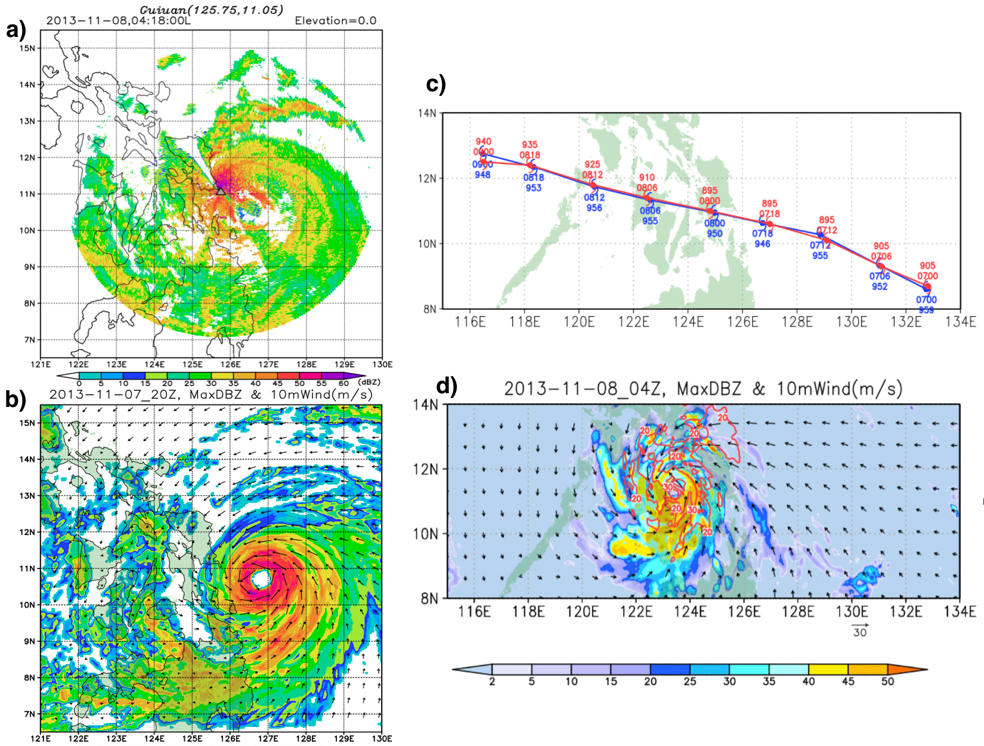
Figure 3. a) Doppler radar data snapshot of Typhoon Haiyan at 18:00, November 8, 2013 (local time). b) WRF simulation result on Typhoon Haiyan of the same time with a). c) Overlaps of Typhoon Haiyan tracks by WRF simulations (blue) and observation (red). d) Wind field and pressure field of WRF simulations on Typhoon Haiyan.
Leveraging the parallelized and optimized nonlinear COMCOT tsunami model, pressure gradient and wind shear stress calculations are included. Furthermore, non-linear interactions among tide, topography and surface friction are also analysed to attain inundation and run-up height. Validated by tidal gauge data, the bias is smaller than 0.1m and root mean square is smaller than 0.6m of storm surge simulations on Typhoon Haiyan by the devised storm surge model. High resolution and high accuracy storm surge propagation simulations on Typhoon Haiyan in offshore regions and in nearshore regions are depicted in Figure 4. The storm surge simulation/model is flexible to utilize to different countries by customized tidal boundary conditions bathymetric characteristics. In the end, a new storm surge simulation web portal will be provided by DMCC.
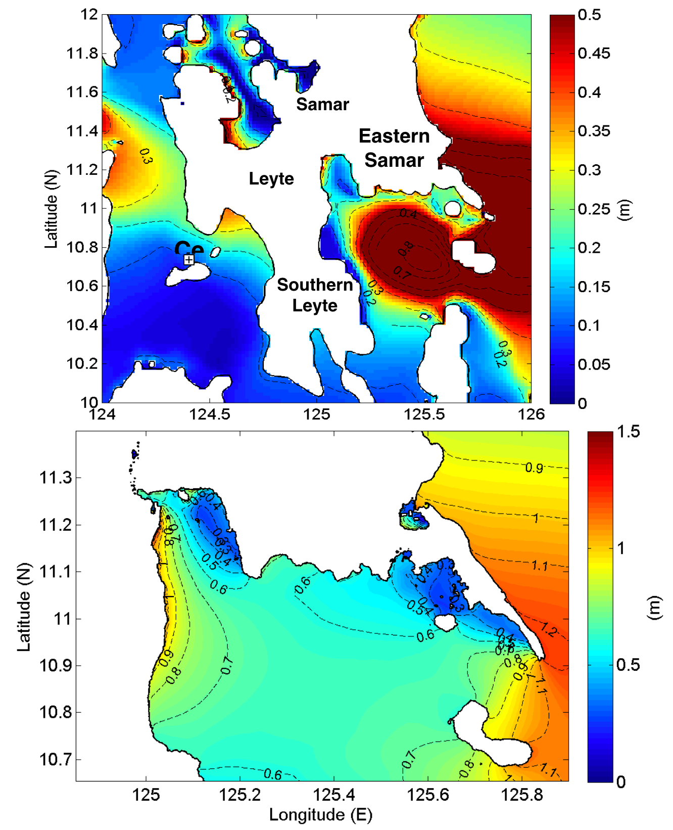
Figure 4. High resolution and high accuracy storm surge propagation simulation on Typhoon Haiyan in offshore regions a) and in nearshore regions b).

Malaysia Flood Case Study
This case study is about the 2014-15 Malaysia flood event during 15 December 2014 and 3 January 2015, 21 people died and more than 250,000 people were displaced from their homes. The economic cost of disaster relief, clean-up, infrastructure loss and rebuilding exceeded 9.4 billion US dollars. This area is subject to significant large scale and mesoscale interactions, such as: topographic feature induced distribution of deep convection; north-easterly cold surges dominate the low-level circulation patterns; quasi–stationary Borneo vortex; and Madden-Julian Oscillations (MJO) which occurs on intra-seasonal time scales peak amplitude during boreal winter over the Maritime Continent.

In this case, mechanism of the rainfall is mainly dominated by both the southwest monsoon and northeast monsoon which is not unusual. Flood was caused by excessive accumulated rainfall. Formation of the low pressure and its movement affected by the monsoon during the floods period from 12 December, 2014 to 3 January, 2015 was simulated by WRF facility as in Figure 5. Comparison of the weather conditions with the same period of time in 2013 is also provided. Multiple WRF schemes were implemented by gWRF portal facilities and need to verify by observation data which scheme is the best in terms of topographical features of different regions.

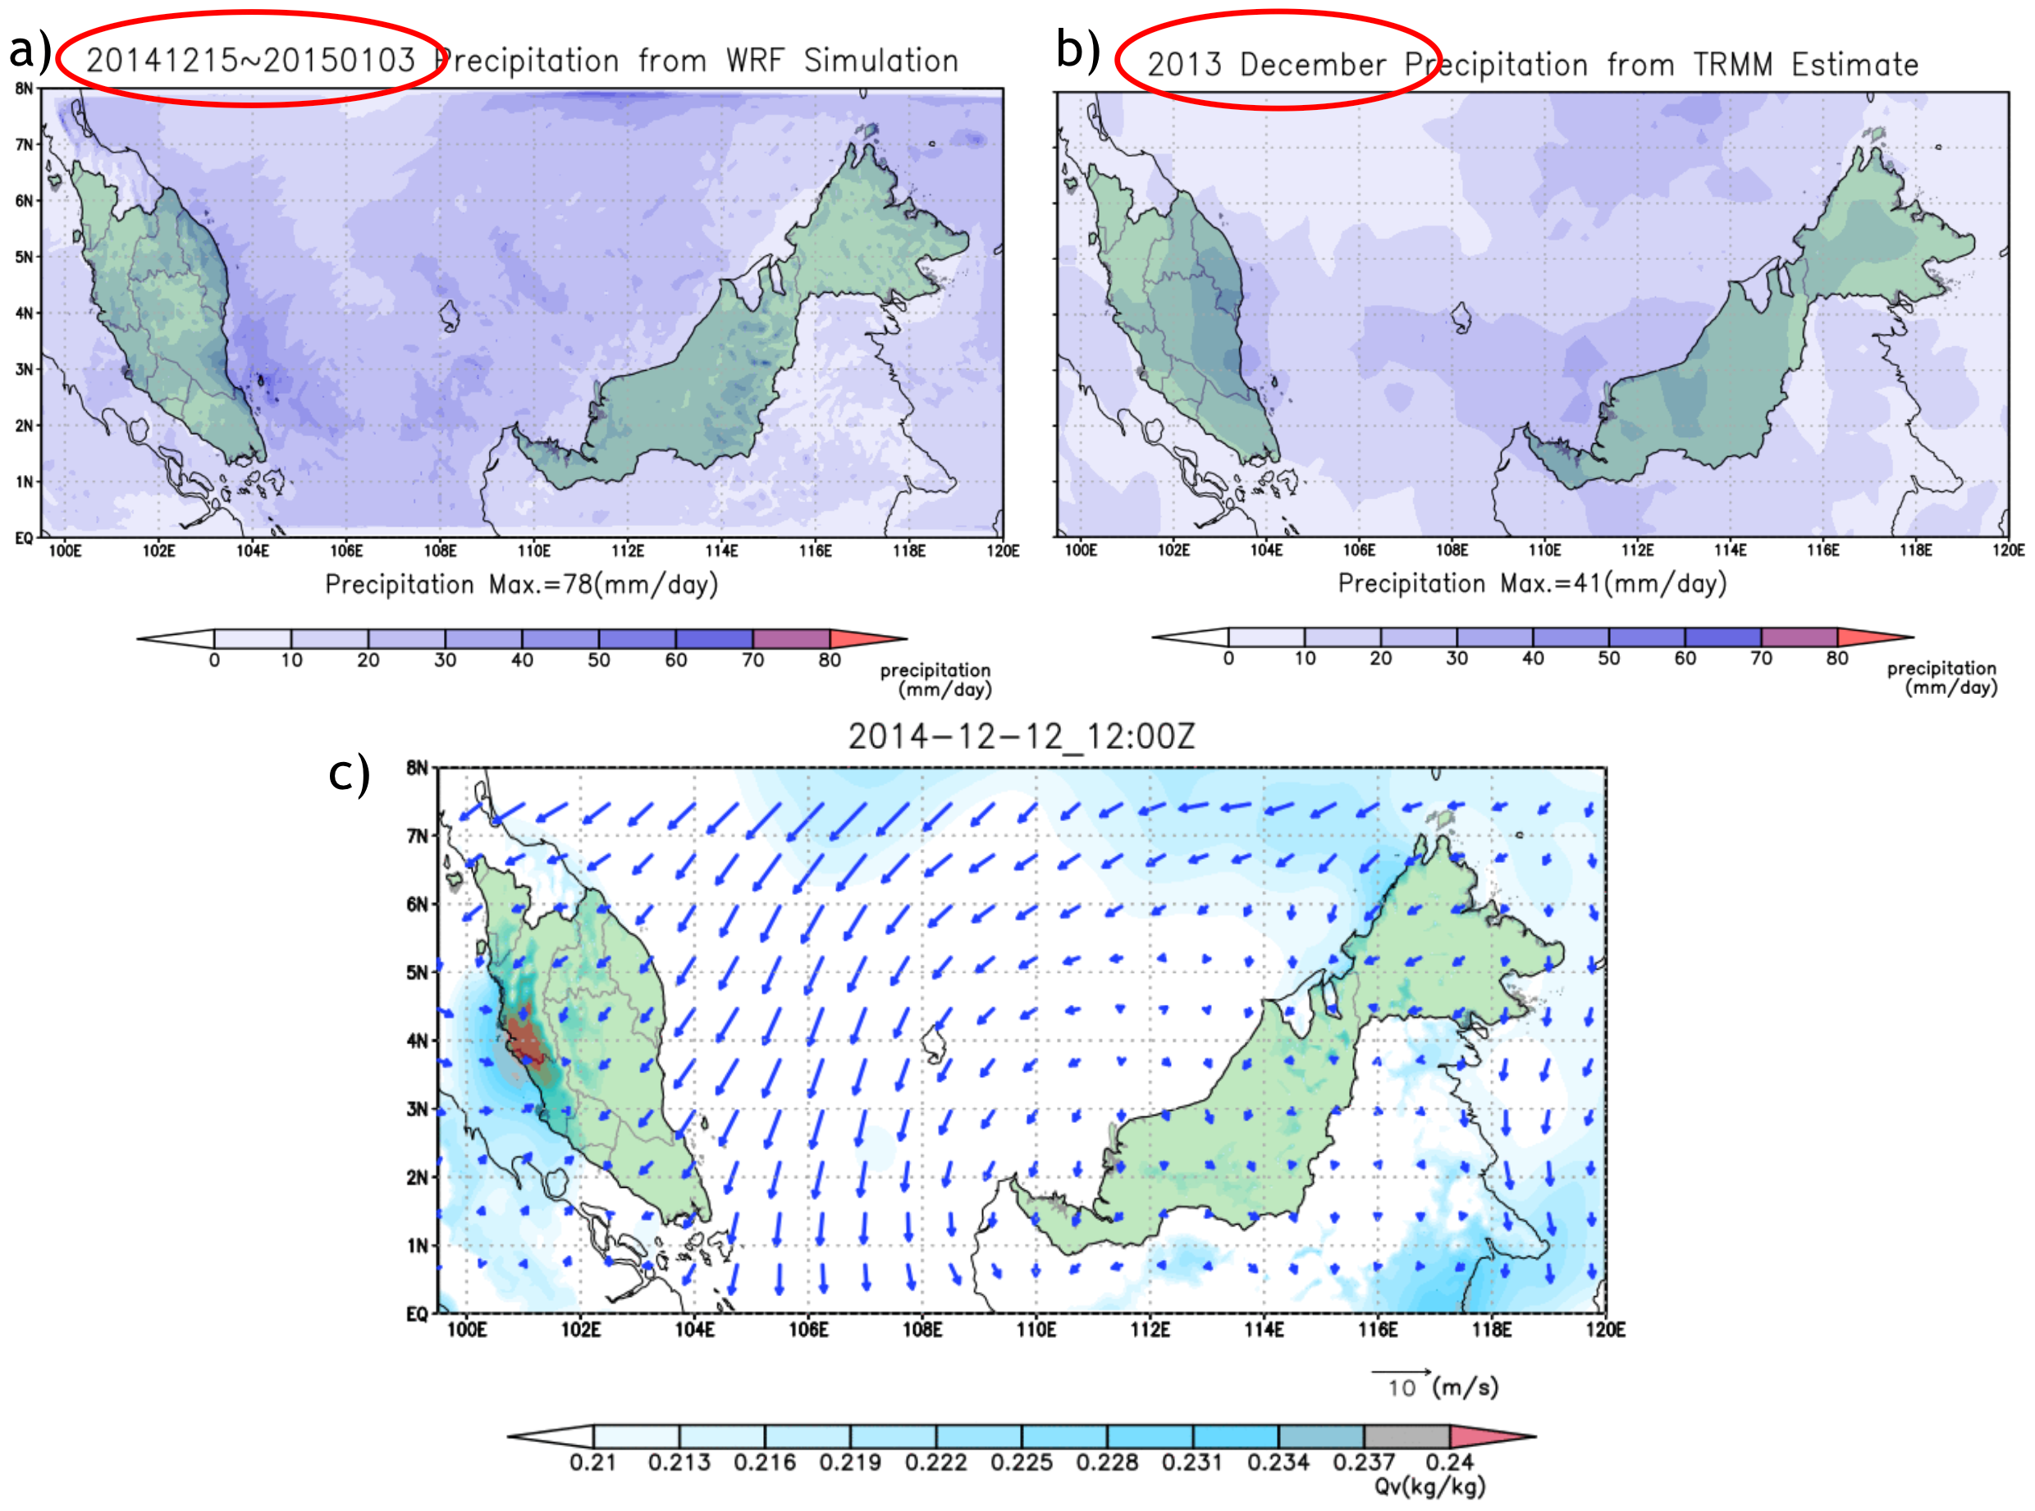
Figure 5. a) WRF simulations on precipitation in Malaysia during 15 December, 2014 and 3 January, 2015 in comparison with the same period of 2013 in b). Wind field simulations are also provided in c).
From the scientific group of Malaysia, it is confirmed that WRF model was able to predict the event considerably well both qualitatively and quantitatively with the right combination of cumulus parameterization as in Figure 6. The combination of Multiscale Kain Fritch for the outer domains and no cumulus scheme at the innermost domain gives the best agreement with the observation in terms of intensity and location. Various aspect of practical predictability examined are dependent on grid resolution, initial and boundary conditions, and cumulus schemes. Initial analysis and cumulus schemes gave large error to the forecast thus reveals the uncertainties in these parameters should be given utmost priority when simulating the event. In the future, the risk of scouring damages and landslides simulations could be integrated in association with excessive rainfall or flood events.
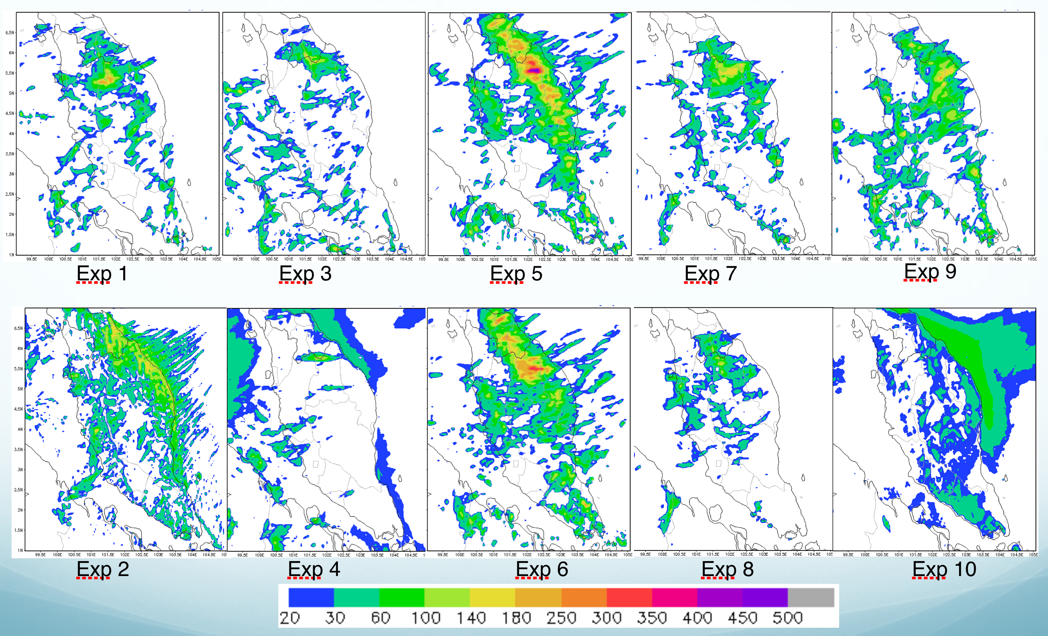
Figure 6. Studies of simulation schemes in capturing the mechanisms of rainfall prediction in WRF.

Long-Distance Forest Fire Dust Transportation Case Study
Long-distance dust transportation cases can be studied with the WRF-Chem model of the WRF simulation facility. Biomass burning is the burning of agricultural waste or forest wild fires which causes huge impact on not just local but also regional air quality, biogeochemical cycles, climate and the hydrological cycle. Biomass burning under specific weather conditions contributes a significant amount of air pollutants within a short period of time. During spring and summer (from February to September), fire hotspots could be found frequently all over the Indochinese peninsula, Indonesia and India. The biomass-burning aerosols over the Indian Ocean and Asia are one of the critical sources for the formation of atmospheric brown cloud in South Asia. It also has been confirmed to have a significant effect on the ozone concentration in Hong Kong and Taiwan. By improved monitoring on the dust sources and integrating with effective numerical simulation facility, impact of individual aerosol species (such as CO2, PM2.5, PM10, O3) on the climate could be provided. Recent advent of satellite monitoring systems, such as the Along-Track Scanning Radio-meter (ATSR), Advanced Very High Resolution Radiometer (AVHRR), and Moderate Resolution Imaging Spectroradiometer (MODIS), have provided useful information to identify fire events and the duration of burning as in Figure 7.

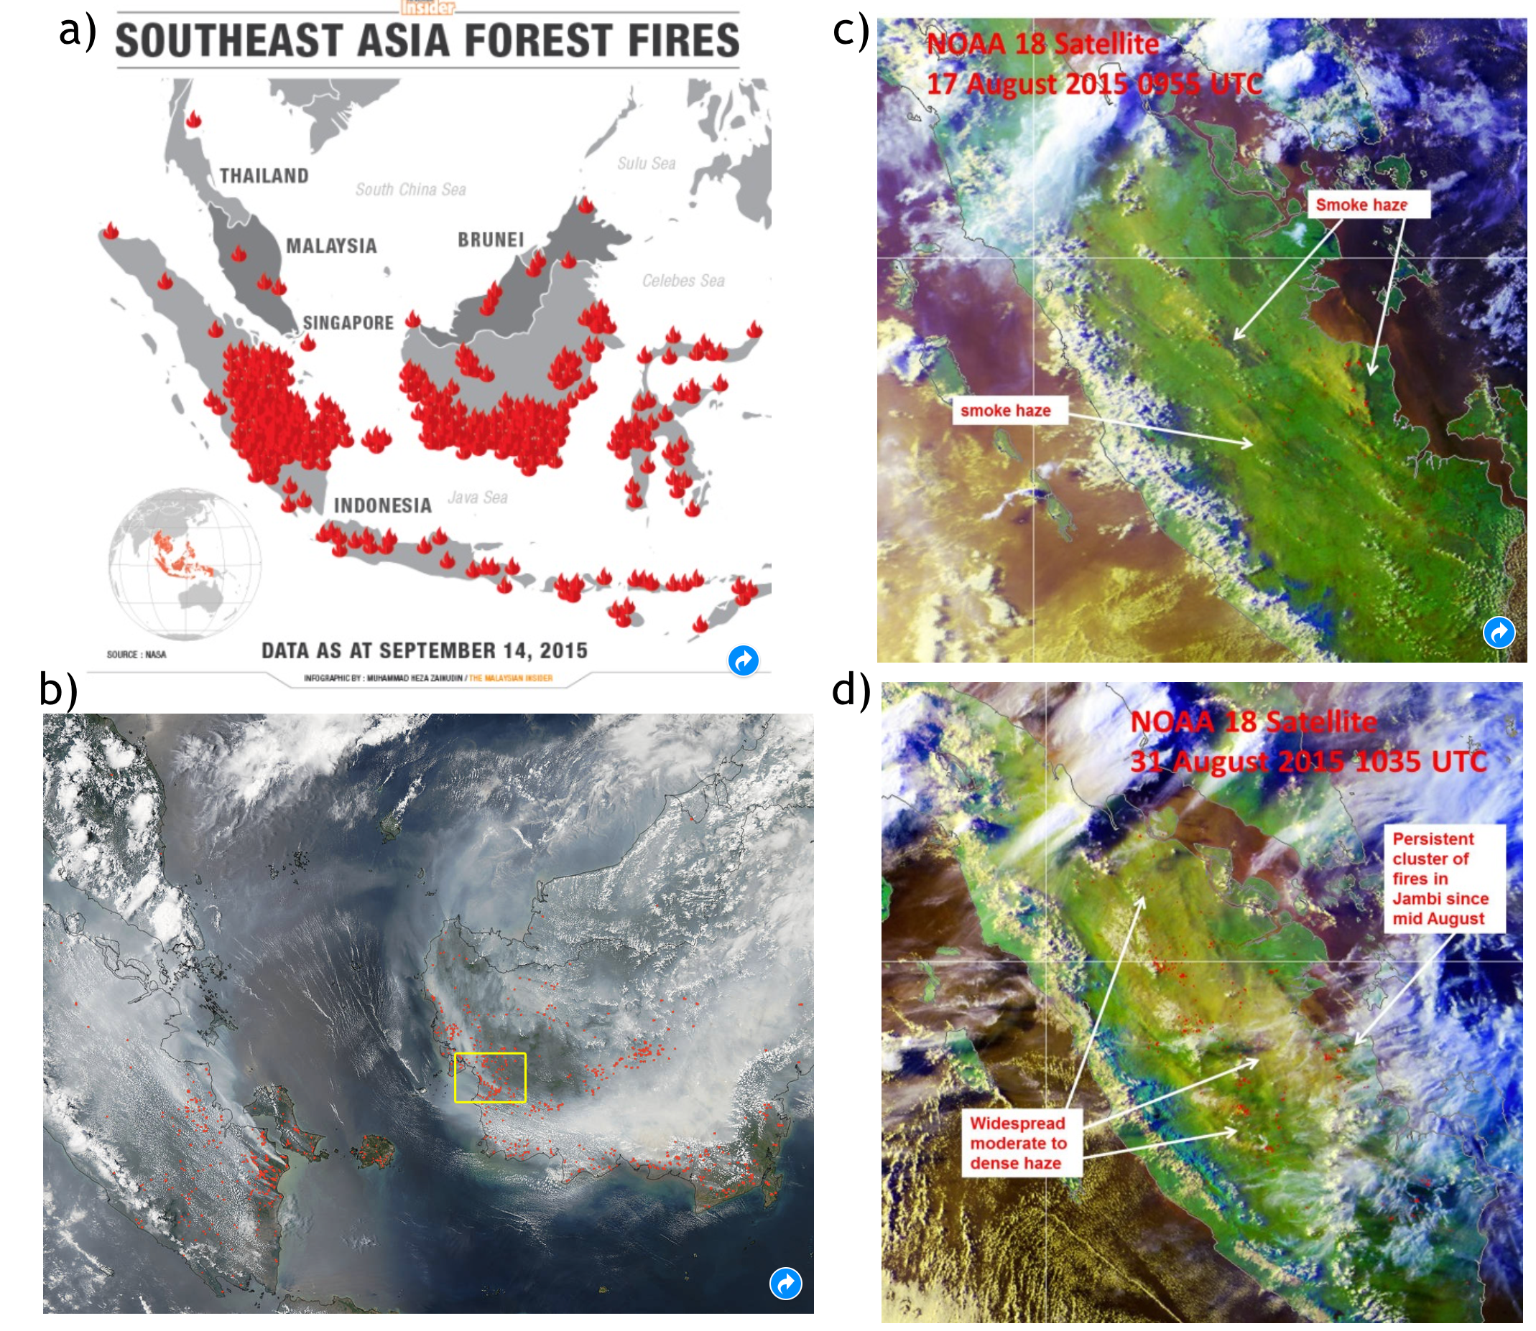
Figure 7. Forest fire hotspots identified from remote sensing surveillance. a) Southeast Asia Forest Fires in 2015 from the Malaysian Insider. b) NASA's Aqua satellite collected this natural-colour image with the Moderate Resolution Imaging Spectroradiometer, MODIS, and instrument on September 22, 2015. c) NOAA-18 satellite picture on 29 August 2015 shows deterioration of smoke haze situation in Kalimantan. d) NOAA-18 satellite picture on 31 Augusts 2015 shows widespread smoke haze from Sumatra spreading into the Strait of Malacca.
Previous studies of the DMCC core scientific group have already identified that both thermal effect and dynamic forcing resulting from mountain lee-side effect play important roles in enhancing the upward motion of biomass-burning products. Thus, aerosols and pollutants could be uplifted to above 3km and transported by strong westerly winds downwind to Taiwan and even the entire East Asia. Once the forest fire spot is identified from satellite monitoring, numerical modelling provides the effective approach to estimating the impact of individual aerosol species on the radiative forcing and the climate.

This case study analysed the seasonal variations of CO, O3 and PM10, which are related to biomass-burning emissions from Southeast Asia during the autumn time in 2015. From previous researches we learned that the long-range transport of biomass-burning products to Taiwan is mostly at the elevation of 2000 4000m. To evaluate the amount of pollutants transported from Indochina, a high-altitude sampling site, the Lulin Atmospheric Background Station (LABS) located at Lulin Mountain (23.478N, 120.878E; 2862 m above mean sea level) of central Taiwan was selected for this case study. Measurements of hourly particulate matter with a diameter less than 10 mm (PM), carbon monoxide (CO), ozone (O3) and meteorological parameters such as air temperature and wind field were analysed in this study.
In terms of tracer by WRF-Chem, the linkage between biomass burning in Indonesia and downwind Taiwan is identified and evaluated using the air mass trajectory model and air pollutant transport processes simulated by WRF simulation facility. The online coupled meteorology-chemistry model WRF-Chem (Ver. 3.6) was utilised to study the long-range transport of air masses associated with biomass burning in Indonesia as depicted in Figure 8.
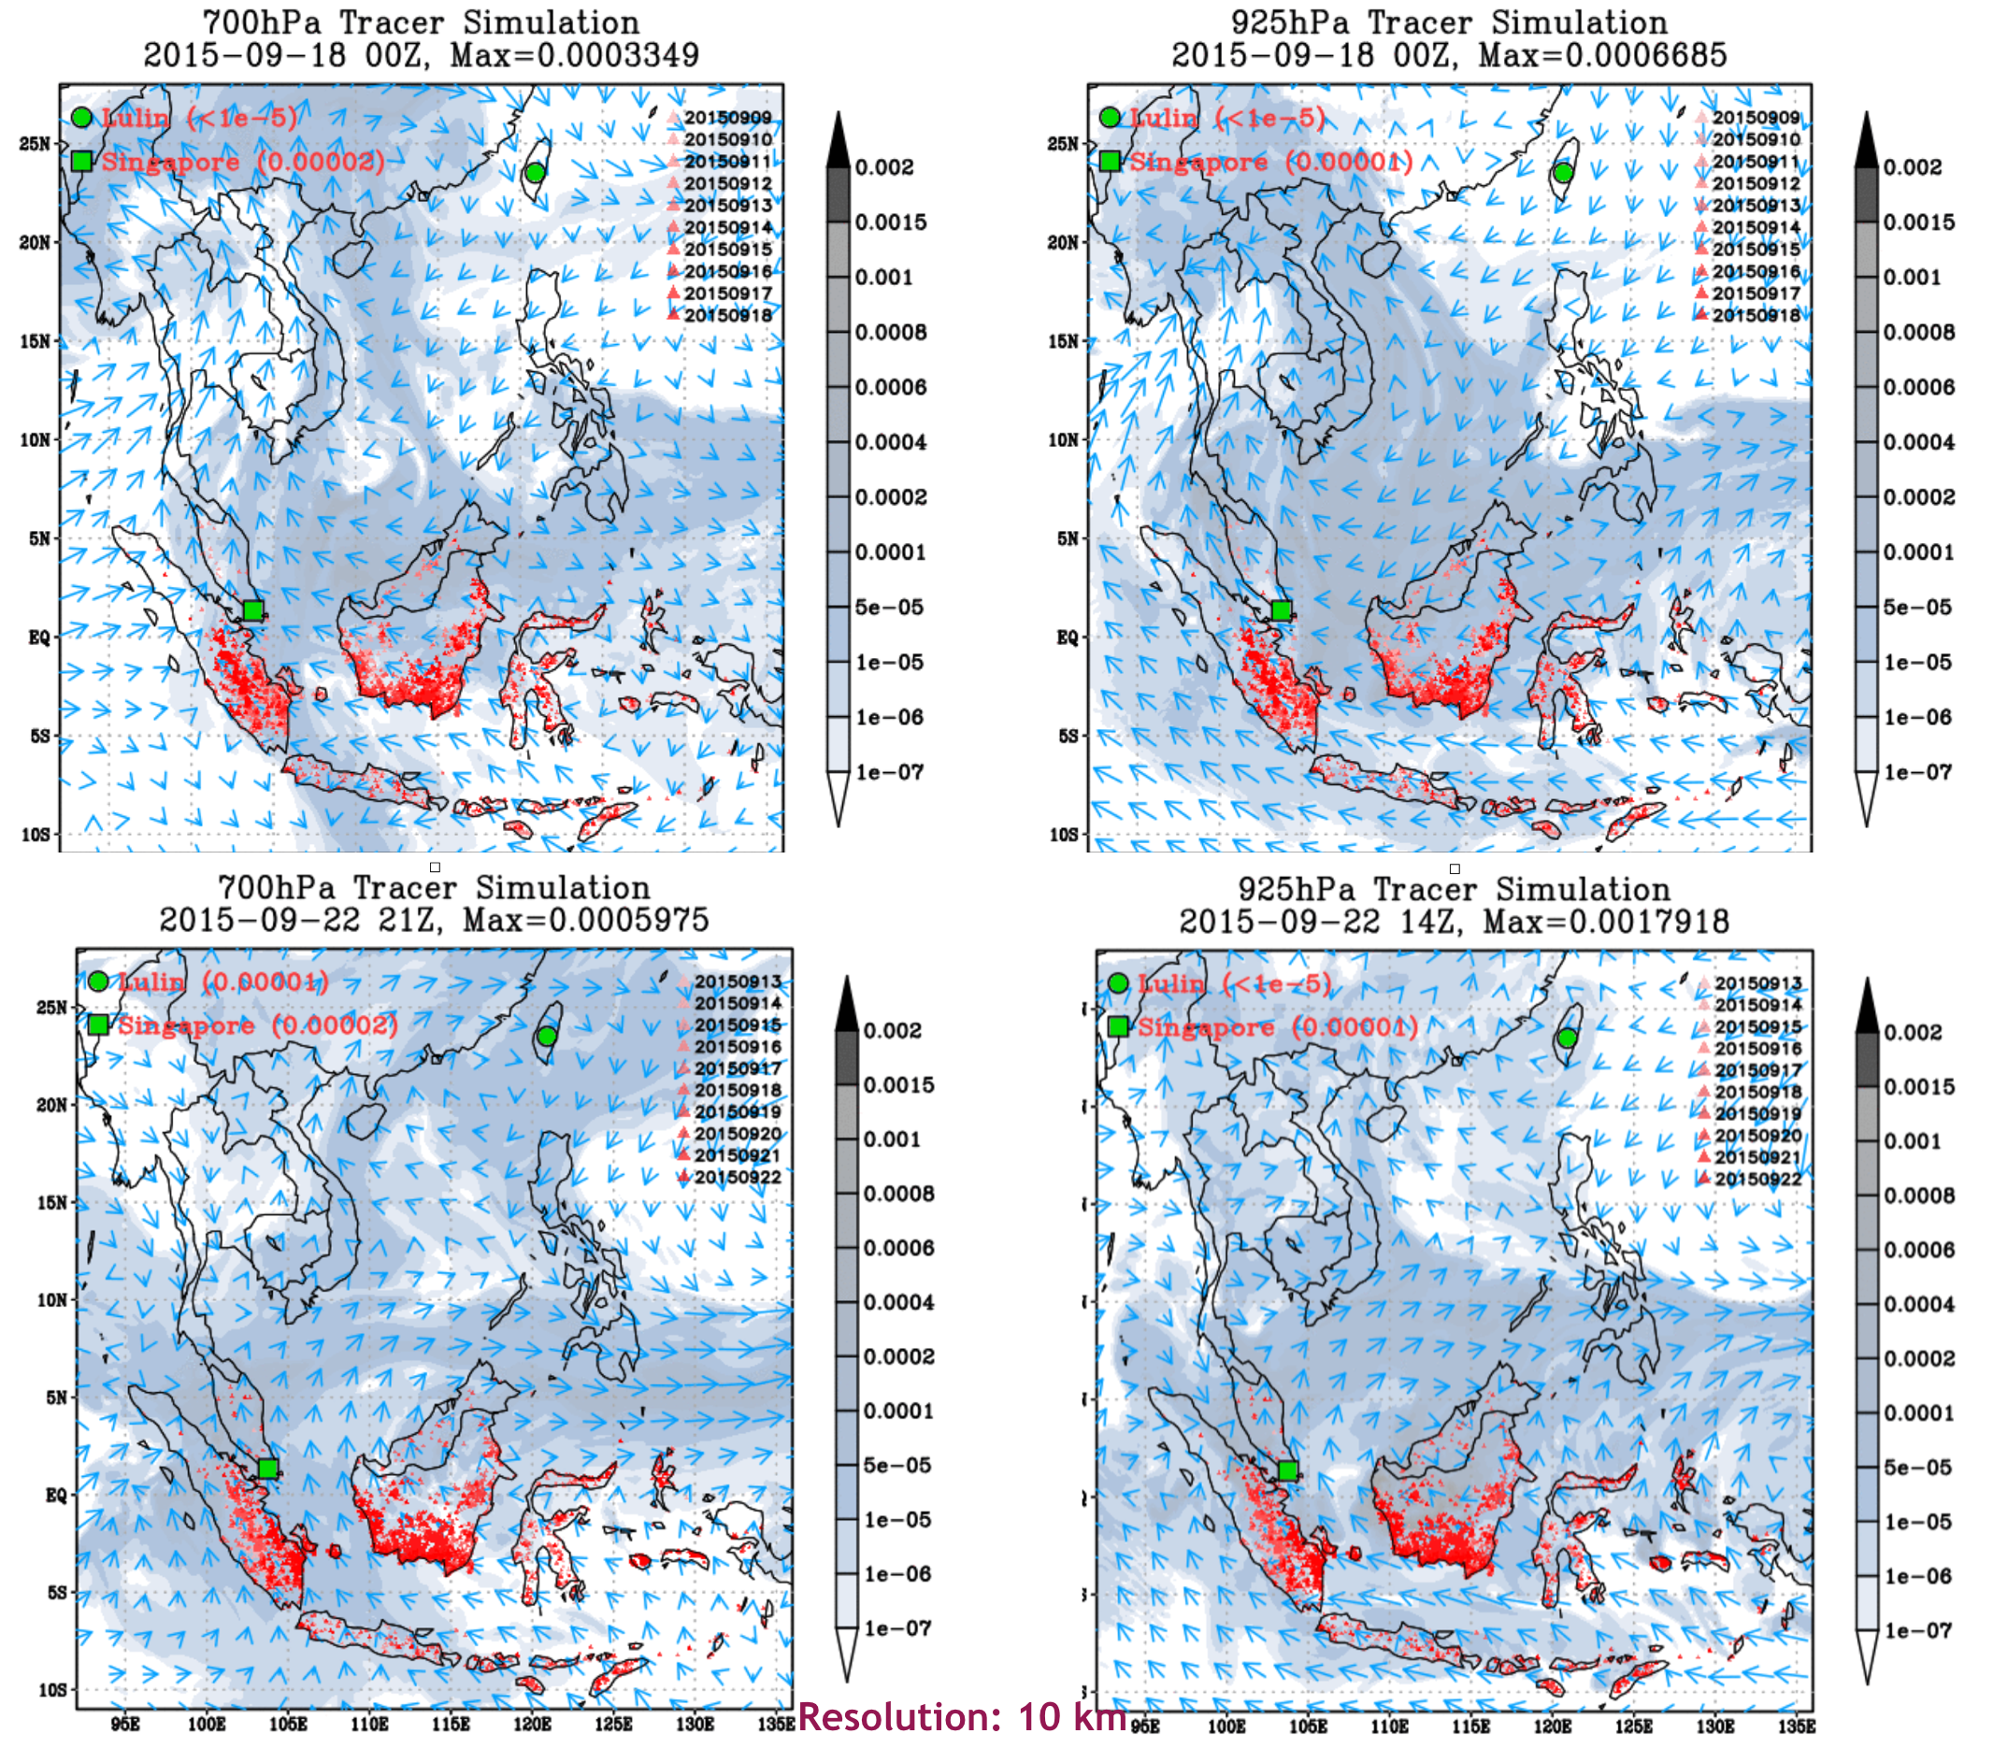
Figure 8. Snapshots of simulations on long-distance dust transport of forest fire burning in Indonesia by WRF simulation facility provided by DMCC during 18-22 September 2015 in 700hPa and 925hPa.

Plan for Exploitation and Dissemination
Name of the result | Social and technical platforms for disaster event simulation and mitigation.
DEFINITION
Category of result | Software and service innovation
Description of the result | A social network or ‘taskforce’ that provides online services (WRF, iCOMCOT), as well as consultancy and support to those who want to simulate, analyse and predict disaster events with the use of e-infrastructures.
EXPLOITATION
Target group(s) | - Scientists working in environmental disaster-related disciplines  - ICT engineers of disaster mitigation application supporters  - E-Infrastructure providers  - Governmental protection agencies who need to make decisions by the disaster risk prediction information  - Insurance and risk estimation agencies
Needs | From the DMCC point of view, collaboration on disaster case studies to enhance the deeper understandings of disasters, simulation facilities and the result knowledge base is first priority. User could make use of the web portals to achieve his own simulations with observation data and knowledge to the mechanism caused the disaster.
How the target groups will use the result? | Regional and multidisciplinary collaborations are of essential importance to disaster mitigation development in Asia Pacific countries. DMCC case studies exemplify how to make best use of the collaborating resources to solve the real problems and benefit the related communities in the world. Problems of DMCC all come from the real needs which the most effective are driving forces striving for the best solutions. As demands have been coming from countries beyond DMCC members, the DMCC collaboration framework has proven to be beneficial and could attract more cases and synergies.  The DMCC collaboration framework is extending these collaborations in disaster types, the associated impact activities, cooperation groups and countries and the understandings to the sciences. As an open collaboration, community or individual who can contribute to any of those fields is welcomed to join DMCC collaborations. More importantly, the collaboration framework would be extended distributed in any type of collaborations in different areas supported by the regional e-Infrastructure. Through open science and open service paradigm, the DMCC collaborations would be sustainable and much valuable.
Benefits | It is expected to have more and more applications making use of DMCC services to alleviate disaster losses or to gain useful risk estimation to support the mitigations of future disasters. DMCC minimizes the barriers to use the simulation facilities by web portals and provides consulting services by coordinating experts from the region for much accurate simulations based on investigating disaster mechanisms for future events.
How will you protect the results? | Open collaboration, open platform, open source and open technology are the fundamental strategy of DMCC. The collaboration framework and services are released under CC BY 4.0 license.
Actions for exploitation | DMCC services and simulation facilities are all designed to be ease-of-use by web portals and all case studies are reproducible in the collaboration framework.
URL to project result | All available available through https://wiki.egi.eu/wiki/CC-Disaster_Mitigation
Success criteria | As mentioned before, as demands have been coming from countries beyond DMCC members, the DMCC collaboration framework has proven to be beneficial and could attract more cases and synergies. To accurately simulate the case studies by devised simulation models than other similar simulations is one metrics. The number of uses of simulation portals is naturally the metrics of the web portals.
DISSEMINATION
Key messages | With the DMCC collaboration framework, people do not need to tackle disaster mitigation alone. The framework provides open collaborations for an expert of related disciplines to accomplish accurate simulation model based on deeper understandings of the mechanisms behind disasters. The earlier we could achieve accurate risk estimation, the more opportunity we could reduce more losses.
Channels | Regional collaboration framework such as Asia Pacific Advanced Network (APAN), conferences such as ISGC and IEEE/ACM hosted ones, and scientific publications, EGI web sites, EGI newsletter, etc.
Actions for dissemination | Disseminations at APAN meetings twice a year (usually held in January and August in different Asia countries) and ISGC (usually held in March in Taiwan) have been planned. Scientific groups and major disaster mitigation group a country are the primary user communities to approach at the planned events.
Cost | Around 8K Euros for a dissemination event in Asia is needed.
Evaluation | User communities engaged and case studies invited after each dissemination event is the basic evaluation criteria.

Conclusions and future plans
By means of case studies and root cause investigation of the disaster events, DMCC has achieved high-performance and accurate simulation facility to estimate the risks during the whole hazard lifecycle over the EGI-interoperable regional e-infrastructure. DMCC also demonstrated the effective collaboration model to incorporate end users, scientific groups, technical groups, infrastructure support group, user support groups and simulation facility in partner countries to accomplish the planned case studies by investigating the underlying causes. To extend DMCC collaborations to broader Asia countries with more various disaster types, DMCC has supported the formation of Disaster Mitigation Working Group at Asia Pacific Advanced Network (APAN, which has 17 Asian country members) in January 2016 and build up a new collaboration paradigm between EGI and APAN. Now the DMCC has enlarge the collaborations to India, Nepal, Sri Lanka and Korea. DMCC collaboration framework established a practical virtuous cycle to estimate disaster risks of similar future events while continuously improve the simulation model and services (from user experiences) by engagement of all necessary expert groups based on deeper understandings of the disasters.
Regional and multidisciplinary collaborations are of essential importance to disaster mitigation development in Asia Pacific countries. The DMCC collaboration framework is extending these collaborations in disaster types, the associated impact activities, cooperation groups and countries and the understandings to the sciences. As an open collaboration, community or individual who can contribute to any of those fields is welcomed to join DMCC collaborations. More importantly, the collaboration framework would be extended distributed in any type of collaborations in different areas supported by the regional e-Infrastructure. Through open science and open service paradigm, the DMCC collaborations would be sustainable and much valuable. Continuous investment to DMCC efforts is crucial to maintain the momentum and collaborations to move forward and benefit to not just Asia Pacific but also the rest of the world.
In relation to the described use cases the DMCC collaboration will work on the following items in the time remaining from EGI-Engage (until end of August 2017), and beyond the project:
- Expand the use of e-infrastructures into cloud resources. A cloud testbed has been recently deployed at Academia Sinica Grid Computing Centre in Taiwan recently, following the deployment recommendations of EGI Federated Cloud sites. The cloud will be assessed with various disaster simulation scenarios through the DMCC simulation portals.
- All the presented case studies will be compiled into knowledge base of the DMCC collaboration framework and the simulation could be reproduced for education, training and studies. Besides the simulation facilities, users could also access to observation data, archive of historical events, case studies, and knowledge base.
- New case studies of different disaster types in different places would be initiated while the collaboration is extended into additional countries. The first steps have been recently made with forming an expanded DMCC consortium for the recently closed EINFRA12a H2020 call.

APAN coordinates activities related to network technologies, services, and applications among its members and with its peer international organisations. APAN members are the entities representing research and education network interests in the countries/economies of Asia and Oceania.
EGI-Engage D6.9 Web portals for tsunami wave propagation simulations and for WRF-based weather simulation: https://documents.egi.eu/document/2784
http://lulin.tw/index_ en.htm

