EGI-Engage

Design Larger Scale Multi-Hazards Simulation Attempting to Reduce the Uncertainty of Climate Change Assessment
D6.22

Date | 28 August 2017
Activity | WP6
Lead Partner | Academia Sinica (AS)
Document Status | Draft
Document Link | https://documents.egi.eu/document/3034

Abstract
Leveraging fast-growing observation data and computing technologies, scientists today are able to uncover patterns in historical data and merge those with current observations to predict what might happen in the future by numerical simulations. Aiming on deeper understanding of natural hazards, the Disaster Mitigation Competence Centre of the EGI-Engage project built up a human network and online tools to simulate the whole life cycle of hazardous events. The collaboration verified the setup by historical cases – both single hazard and multi-hazard events (typhoon–storm surge and earthquake–tsunami) – using the Asia-Pacific regional e-Infrastructure of EGI. This report details the work performed and proposes future work to sustain and expand the disaster mitigation capacity in Asia through a regional, open collaboration.

COPYRIGHT NOTICE
This work by Parties of the EGI-Engage Consortium is licensed under a Creative Commons Attribution 4.0 International License (http://creativecommons.org/licenses/by/4.0/). The EGI-Engage project is co-funded by the European Union Horizon 2020 programme under grant number 654142.
DELIVERY SLIP
 | Name | Partner/Activity | Date
From: | Eric Yen and Simon Lin | Academia Sinica / WP6 | xx/08/2017
Moderated by: | Malgorzata Krakowian | EGI Foundation / WP1 quality man.
Reviewed by | Gergely Sipos  Yin Chen | EGI Foundation / WP6 coord.  EGI Foundation / ENVRIplus project | 29/08/2017  21/08/2017
Approved by:

DOCUMENT LOG
Issue | Date | Comment | Author/Partner
v.0.9 | 27/02/2017 | Full draft for external review | Eric Yen / AS
v.1 | 30/08/2017 | Improved draft after external review | Eric Yen / AS  Gergely Sipos / EGI Foundation

TERMINOLOGY
A complete project glossary and acronyms are provided at the following pages:
- https://wiki.egi.eu/wiki/Glossary
- https://wiki.egi.eu/wiki/Acronyms

Contents
1 Introduction 5
1.1 The DMCC collaboration framework 5
1.2 Simulation theory 7
1.3 Natural disasters covered in the report 9
1.3.1 Storm surge 9
1.3.2 Typhoon 9
1.3.3 Earthquake 10
1.3.4 Tsunami 10
2 Design of Multi-Hazards Risk Analysis 10
2.1 Typhoon and storm surge 11
2.2 Earthquake and tsunami 13
3 Conclusions 14
3.1 Lessons Learned 16
4 Future perspectives 18
4.1.1 Knowledge aspect: Disaster Mitigation Knowledge Base 18
4.1.2 Technical aspects 19

Executive summary
The vision of DMCC is to reduce the natural disaster risks by innovative high performance numerical simulations based on deeper understandings of the natural phenomena. Disaster Mitigation Competence Centre (DMCC) has developed analysis facilities using EGI-compatible regional e-infrastructure, the Asia-Pacific Virtual Organisation, for selected hazards such as storm surge, typhoon, tsunami, flood, and long-distance dust transportation. The facilities were validated by case studies that aimed at reproducing real natural hazard events from the past. Through these activities DMCC has demonstrated the effective collaboration model to engage end users, scientific groups, technical groups, infrastructure support groups, user support groups and simulation facilities in partner countries.
This deliverable focus on multi-hazards event risk estimation based on the DMCC architecture and deeper understanding strategy. Advancement in understanding of relationship between hazards, such as the pressure-wind relationships of typhoon and better analysis techniques support more accurate interpretation and prediction. The report describes a typhoon–storm surge and an earthquake–tsunami simulation case. The case studies have been implemented using the WRF and iCOMCOT portals that have been reported in the previous DMCC deliverable. The described demonstrator cases were presented at public forums, such as ISGC and APAN workshops and trainings.
The report also introduces the future roadmap of DMCC, including, the extension of the disaster types, partner countries, regional e-infrastructure, web portals, user communities, knowledge base, as well as application capacities for future hazard events in different countries. This extension will be carried out within the EOSC-hub H2020 project between 2018-2020.

Introduction
Asia bears the maximum impacts of natural disasters in terms of people affected as well as human and economic losses. Science and technology for disaster risk estimation has always been the highest priority and been benefitted to early warning systems, to identify risk and strengthen disaster response actions for different types of hazards. DMCC brings together existing initiatives (in local, regional and global scale such as research institutes and agencies of partner countries, UNESCO and APAN Disaster Mitigation Working Group, etc.) to deliver science and innovative practices contributing to the disaster mitigation by e-Science approach. This is very well in line with the recommendation of the Sendai Framework for Disaster Risk Reduction, endorsed by the UN General Assembly to “foster collaboration across global and regional mechanisms and institutions for the implementation and coherence of instruments and tools relevant to disaster risk reduction”.
Natural hazards already impose a huge strain on economies, societies, and the environment worldwide. With projected increases in intensity and frequency of extreme events due to environmental changes as well as growing exposure and vulnerability of populations, impacts of natural hazards are most likely worsening as highlighted by the United Nations Office for Disaster Risk Reduction (UNISDR). Changing climate leads to changes in the frequency, intensity, spatial extent, duration, and timing of extreme weather, and the probability to result in unprecedented extreme weather and meteorological disasters also increases. As it was pointed out in the ‘Special Report on Extreme Events and Disasters’ in 2012 by the Intergovernmental Panel on Climate Change (IPCC), a growing frequency of heat waves, rising wind speed of tropical cyclones, and increasing intensity of droughts are foreseeable in this century. Heavy precipitation events are also on the rise, potentially impacting the frequency of floods and almost certainly affecting landslides.

The DMCC collaboration framework
DMCC was established in the EGI-Engage ptoject in 2015 to investigate in-depth the mechanisms of selected disaster events and to develop appropriate simulation tools to reproduce and explain the processes observed during those events. The collaboration framework developed by DMCC aims at becoming an ‘open platform for disaster mitigation’ so that all the tools, data, resources and simulation facilities are sharable, and the simulations are reproducible. This platform – or with other words a knowledge base – is enriched by the simulation models, portals, data and visualisation facilities contributed by DMCC members:
- Academia Sinica, Taiwan (Leading Partner, represented by Academia Sinica Grid Computing Centre (ASGC))
- Institute of Earth Science, Academia Sinica, Taiwan
- Research Centre of Environmental Changes, Academia Sinica, Taiwan
- National Central University, Taiwan
- Institute Teknologi Bandung (ITB), Indonesia
- Korean Institute of Science and Technology Information (KISTI), Korea
- Universiti Putra Malaysia (UPM), Malaysia
- Advanced Science and Technology Institute (ASTI), Philippine
- Thailand National Electronics and Computer Technology Centre (NECTEC), Thailand
- Leibniz Supercomputing Centre (LRZ), Germany
- University of St. Andrews, United Kingdom
The DMCC collaboration platform consists of the core multi-disciplinary taskforce and the technical platform including online services for simulation, data and information management. These technical elements are connected to and use CPU and storage resources from ‘Asia Pacific’ Virtual Organisation of the EGI e-infrastructure.
The taskforce (See Figure 1, right) covers scientific group, technical group, e-Infrastructure group and user support group. The taskforce identified case studies; collected observation data and supporting materials; developed simulation models; validated the models based on historical observation scenarios; integrated the model and data with e-infrastructures; performed performance tuning; deployed the scenarios and tools into online portals (Figure 1, left).
Leveraging the results of case studies, simulation model could be applied to similar disaster events of the same type at different location with customization. By deeper understandings of the hazards, the simulation models would be more accurate. Growing by the case studies, the simulation facilities would be more useful and robust for complicated or compound disasters.

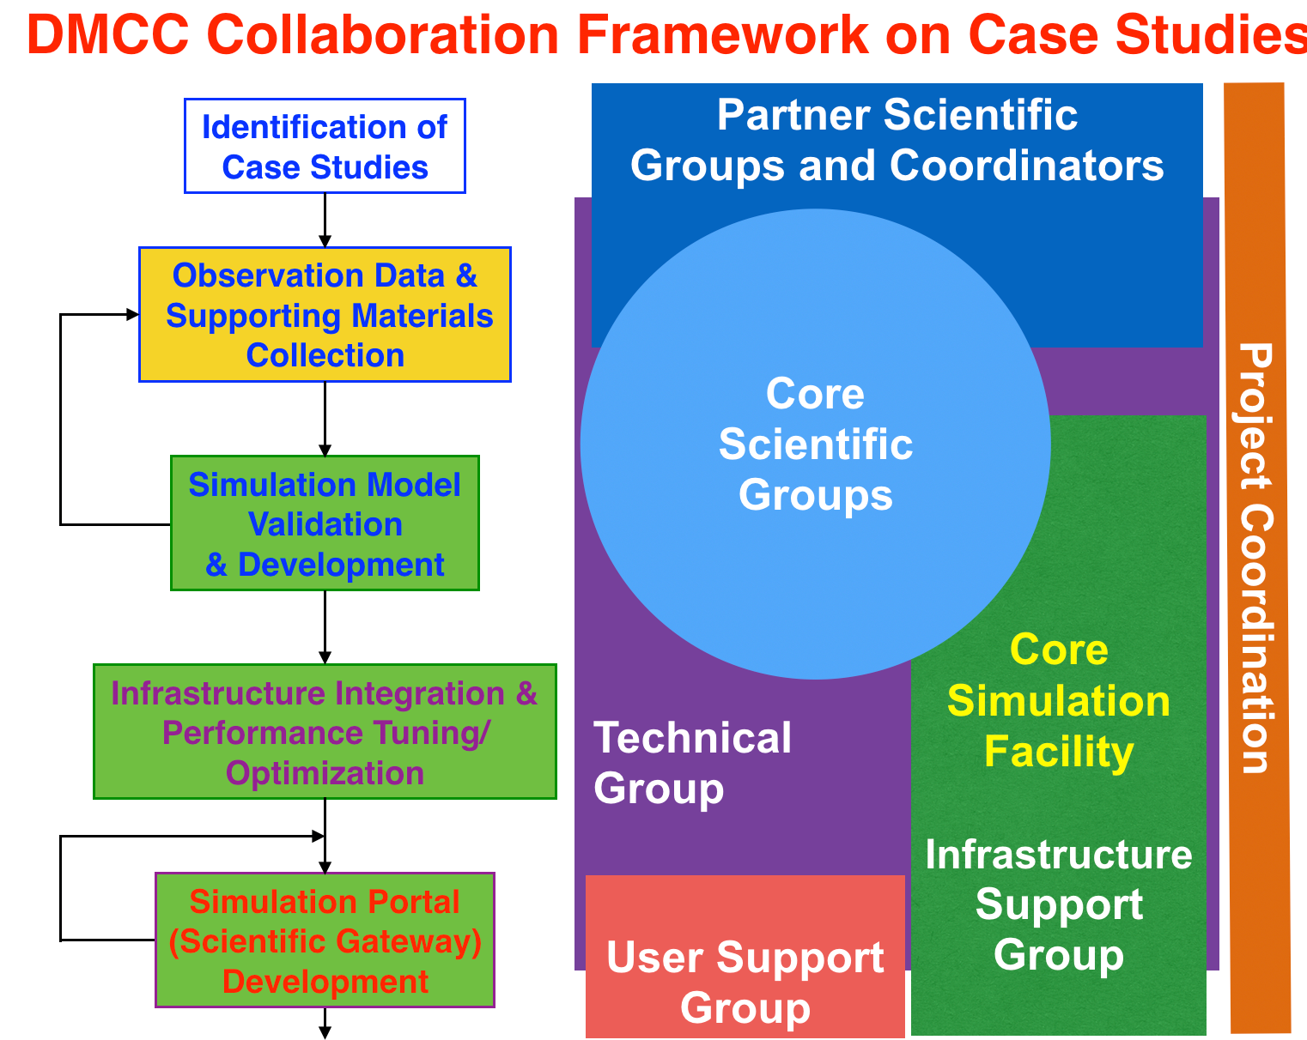
Figure 1. DMCC Case Study Workflow (left) and Collaboration Framework Architecture (right)
In the EGI-Engage project, DMCC dedicates to carry out the proposed case studies and verify the collaboration architecture and workflow described above. The synergy of collaborations from user communities (e.g., scientists, information providers, disaster analysts, decision makers), scientific groups, technical groups, infrastructure support groups and user support groups in partner countries could be further exploited by the result case studies, simulation facilities and services, shared knowledge and resources, as well as the future open science platform.

Simulation theory
The virtuous cycle of scientific discovery, numerical simulation and modelling, and hazard analysis by deeper understanding of disasters on case studies is depicted as Figure 2 below.
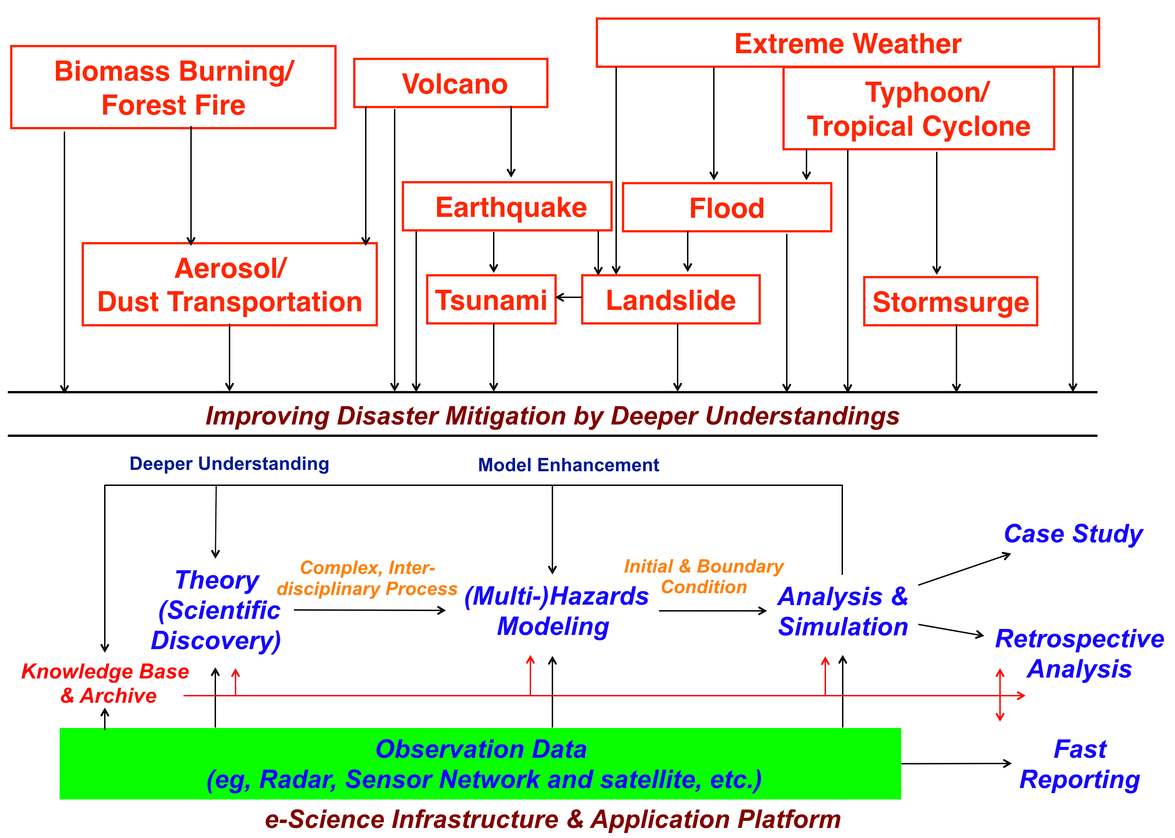
Two types of geophysical environmental factors influence the occurrence of natural hazards:
Figure 2. Generating advanced simulation services by deeper understanding of disasters on case studies while retaining open access and reuse of related data
- The fundamental geophysical characteristics, such as tectonic plate, landform and hilly terrain with poor water absorption capacity etc.
- The trigger, for instance, earth crust movement might result in an earthquake; water temperature, humidity, wind shear and disturbed weather might lead to a tropical cyclone.
Different combination of the two factors can induce different hazards. One single trigger might give rise to multiple various coupled hazards. One hazard is also possibly triggered by another hazard in series. In some areas, especially in Asia, a single hazardous event might trigger multiple disasters of various types. For example,
- when typhoon Haiyan (also known as super typhoon Yolanda) hit Philippine, widespread devastation from the storm surge in the island of Leyte and Samar with almost 6m high waves caused huge damages of local infrastructure, economic and life losses.
- the Tohoku-Oki Earthquake, also known as the Great East Japan Earthquake, was an extremely destructive tsunami in 2011, with a magnitude of 9.0 (Mw). It followed the earthquake that generated waves up to 40-meters height in Tohoku prefecture, and resulted in more than 18 thousand people loss. The inundated waves also caused a nuclear accident and the Fukushima radiation clouds quickly spread around the globe.
Geophysical environment would be changed by a disaster. Climate change would alter the trigger factors essentially. Through case studies, deeper understanding of the geophysical facts and the trigger mechanism could be achieved to advance our knowledge to potential hazard risks. On the other hand, with wealth knowledge from case studies and observations, the impact of environmental changes could be clearly investigated. Disaster Mitigation often focuses on the worst-case scenarios of natural disasters in order to protect the general public in case the worst might happen. Obviously, this is not the most optimized way to mobilize the mitigation resources and protect the loss of lives and property. Had we predicted the disasters much more accurately, then the society as a whole could be better protected. However, the non-linearity and inter-couplings of different forms of natural disasters deter us from improving accuracy easily.
Deeper qualitative understandings such as possible weather and disaster patterns are crucial for effective disaster mitigation. Multi-hazard scenarios are not negligible at all for a production disaster mitigation facility. The numerical simulation services have to cope with the practical workflows and are able to cover the whole lifecycle of a disaster. In addition, systematic classification of related hazards according to the geophysical environment facts and triggers are fundamental to multi-hazard risk estimation.

Natural disasters covered in the report
The next subsections provide short descriptions of the natural disaster event types that are used later in the report. The subsections were written based on Wikipedia.

Storm surge
A storm surge is a coastal flood or tsunami-like phenomenon of rising water commonly associated with low pressure weather systems (such as tropical cyclones and strong extratropical cyclones), the severity of which is affected by the shallowness and orientation of the water body relative to storm path, and the timing of tides. Most casualties during tropical cyclones occur as the result of storm surges.

Typhoon
A typhoon is a mature tropical cyclone that develops in the western part of the North Pacific Ocean between 180° and 100°E. This region is referred to as the Northwestern Pacific Basin, and is the most active tropical cyclone basin on Earth, accounting for almost one-third of the world's annual tropical cyclones. A typhoon differs from a cyclone or hurricane only on the basis of location. A hurricane is a storm that occurs in the Atlantic Ocean and northeastern Pacific Ocean, a typhoon occurs in the northwestern Pacific Ocean, and a cyclone occurs in the south Pacific or Indian Ocean.

Earthquake
An earthquake is the shaking of the surface of the Earth, resulting from the sudden release of energy in the Earth's lithosphere that creates seismic waves. The seismicity or seismic activity of an area refers to the frequency, type and size of earthquakes experienced over a period of time. When the epicenter of a large earthquake is located offshore, the seabed may be displaced sufficiently to cause a tsunami. Earthquakes can also trigger landslides, and occasionally volcanic activity.

Tsunami
A tsunami is a series of waves in a water body caused by the displacement of a large volume of water, generally in an ocean or a large lake. Earthquakes, volcanic eruptions and other underwater explosions (including detonations of underwater nuclear devices), landslides, glacier calvings, meteorite impacts and other disturbances above or below water all have the potential to generate a tsunami. Unlike normal ocean waves which are generated by wind, or tides which are generated by the gravitational pull of the Moon and Sun, a tsunami is generated by the displacement of water.

Design of Multi-Hazards Risk Analysis
From case studies, such as typhoon Haiyan, interactions of multi-hazards (typhoon, storm surge and near coast flooding) and their triggers could be investigated by deeper qualitative understandings to develop simulation facilities for future events. DMCC developed the storm surge simulation facility from typhoon Haiyan case study. Based on the wide range meteorological simulation models from WRF and the oceanic wave propagation simulation models from COMCOT, we are able to push the case studies further to investigate the multi-hazards behaviours.
According to the geophysical environment facts and triggers, the multi-hazards patterns initiated by typhoon and huge undersea earthquake are discussed in the following subsections, as depicted in Figure 3. Risk estimation by reproducing and pseudo global warming experiment by historical typhoons is also proposed to show a both a potential roadmap and the significance of deeper understanding for disaster mitigation.
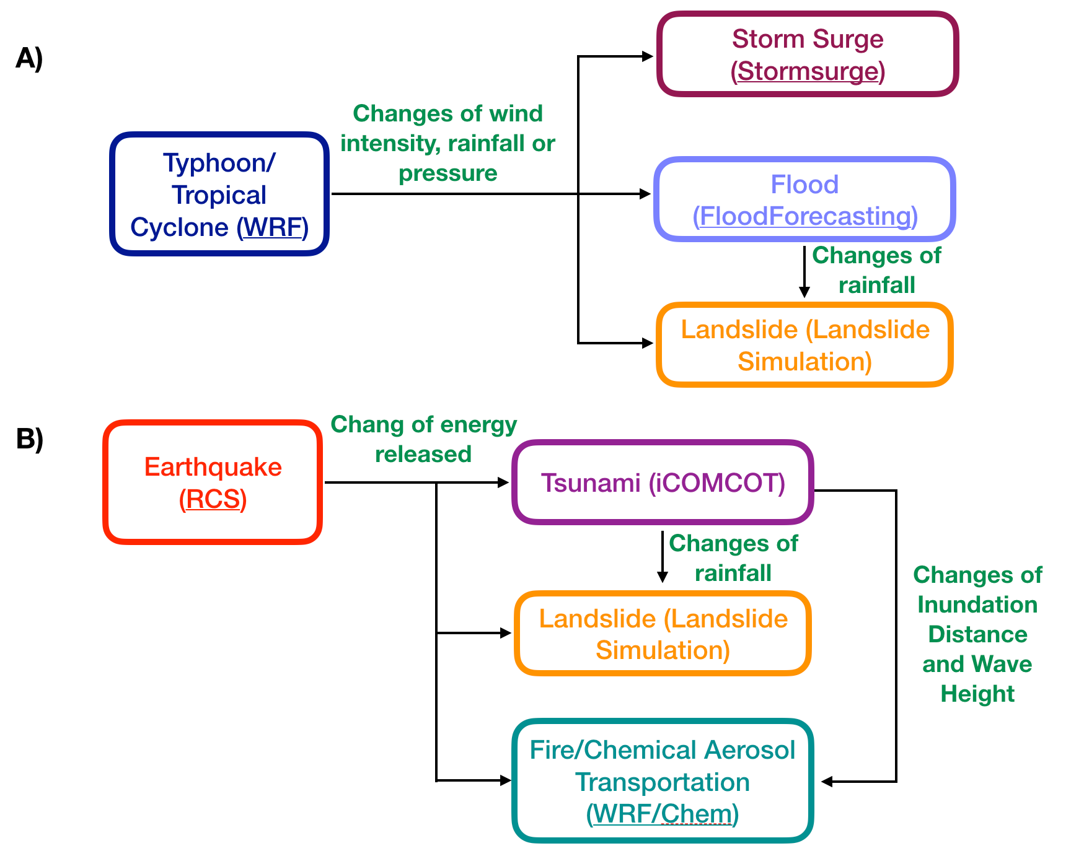
Figure 3. The relationship among multiple hazards initiated by typhoon (tropical cyclone) and earthquake

Typhoon and storm surge
Based on the weather simulation and tsunami simulation facility, DMCC demonstrated how the innovative storm surge simulation is developed by combining atmospheric model and ocean model to estimate the impacts of storm surge by the case study on typhoon Haiyan as in Figure 4. (details had been described in deliverable D6.20).
Storm surge is produced by a strong typhoon, and is a very complex phenomenon because it is sensitive to the slightest changes in storm intensity, forward speed, radius of maximum winds, angle of approach to the coast, central pressure, and the shape and characteristics of coastal features. This rise in water level can cause extreme flooding in coastal areas particularly when storm surge coincides with normal high tide, resulting in storm tides reaching up to 20 feet or more in some cases.

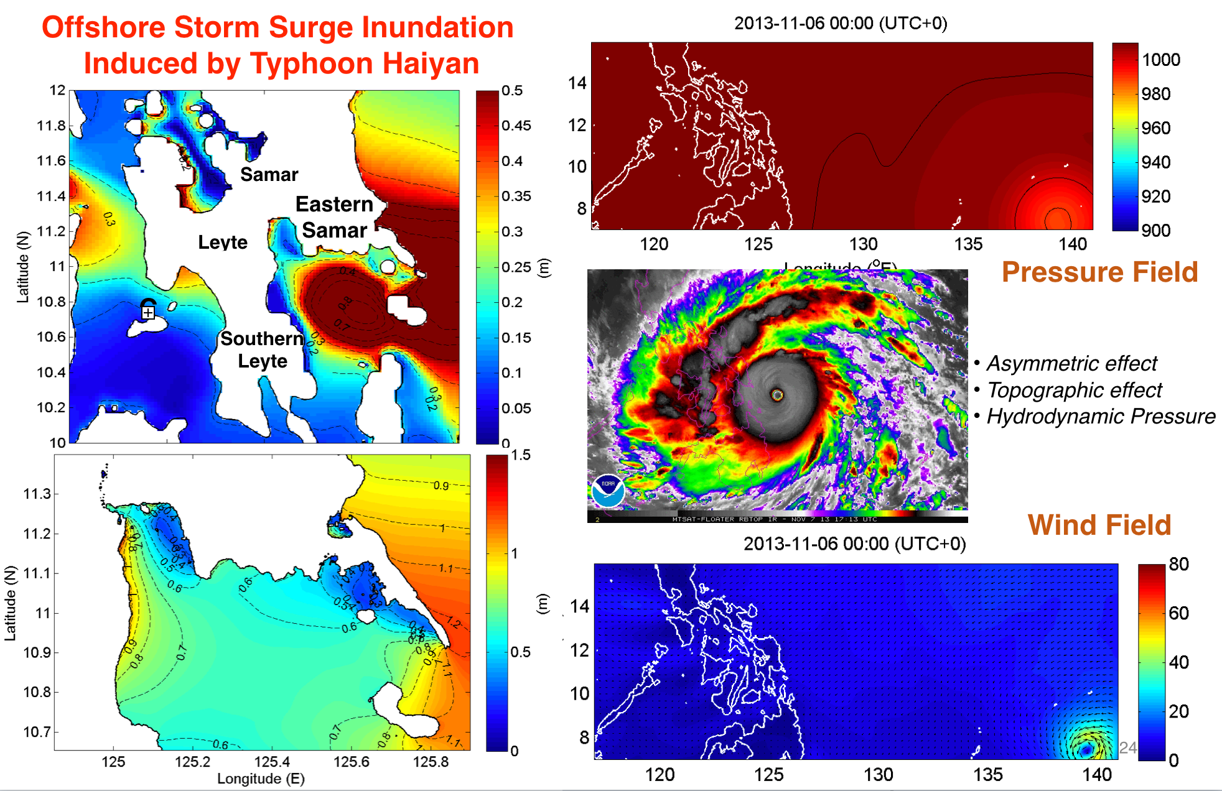
Figure 4. Storm Surge of Typhoon Haiyan simulations summarized from DMCC case studies

When a certain scale typhoon is predicted to hit, the COMCOT-based storm surge simulation would be initiated to estimate the wave height and its inundation depth to the target area by the input of meteorological force from the WRF simulation and the tidal boundary condition.
As described in Figure 3.A, the flood simulation system considering the discharge, water level, rainfall and inundation estimations from WRF and storm surge simulations should be also kicked off, according to the multi-hazard correlations. In the DMCC Open Collaboration Framework, the flood simulation system such as the one developed by the Thailand partner (Hydro and Argo Informatics Institutes, HAII) could be provided as one of the default simulation facility over the EGI infrastructure in the future.
Landslide simulation will be developed and integrated with the DMCC Open Collaboration Platform to extend the hazard type coverage of DMCC simulation facilities and support wider scope of potential disasters according to the multi-hazards scenarios.

Earthquake and tsunami
By integrating with real-time earthquake reporting system, iCOMCOT is able to provide the tsunami simulation and generates an inundation map within 5 minutes with an inundation resolution finer than 40 meters, which is sufficient for hazard mitigation. As verified by the case study on the 2011 Tohoku earthquake, a full tsunami life cycle simulation conducted with 4 arc-minute resolution at single layer spherical coordinate could be finished in less than 3 minutes by iCOMCOT, with quite well accuracy in comparison with observation data of gauges in Russia, Japan and Taiwan.
The tsunami not just caused huge casualties and economic losses but also lead to regional dispersal of fission nuclides due to reactor cores meltdowns of the Fukushima Daiichi Nuclear Power Plant. WRF/Chem tracer model has been employed to simulate the transportation of the fission from Japan to southeastern Asia region by the DMCC scientific group. The vapors and particles from the nuclear power plant were lifted up to the free troposphere to be transported easily by the Westerlies. It took only 4 days for the derived radioactive particles to travel across the Pacific Ocean. The northeast monsoon wind characteristics of that season in East Asia picked up momentum and switched the radioactive plume from Japan toward the southwest. The plume was transported mainly in the marine boundary layer over the open Pacific Ocean and hit Manila first without influencing other sites of this region, then flow to Okinawa, Taiwan, Hong Kong and Vietnam. The simulation coincided with the observation data collected from 9 monitoring sites in the southeastern Asia region as shown by Figure 5.
An accident like this is very valuable tracer experiment that can be used to test aerosol transport models and improve their applications to air quality and climate studies in both global and regional scales. The WRF/Chem will be included in the gWRF to support applications like this and also the long-distance dust transportation analysis.
Based on this multi-hazard case, those independent simulation services on earthquake, tsunami, and regional dispersal of aerosols should be integrated in some way according to the triggers status and together with supported indicators of related hazards in the DMCC Open Collaboration Platform in the future.
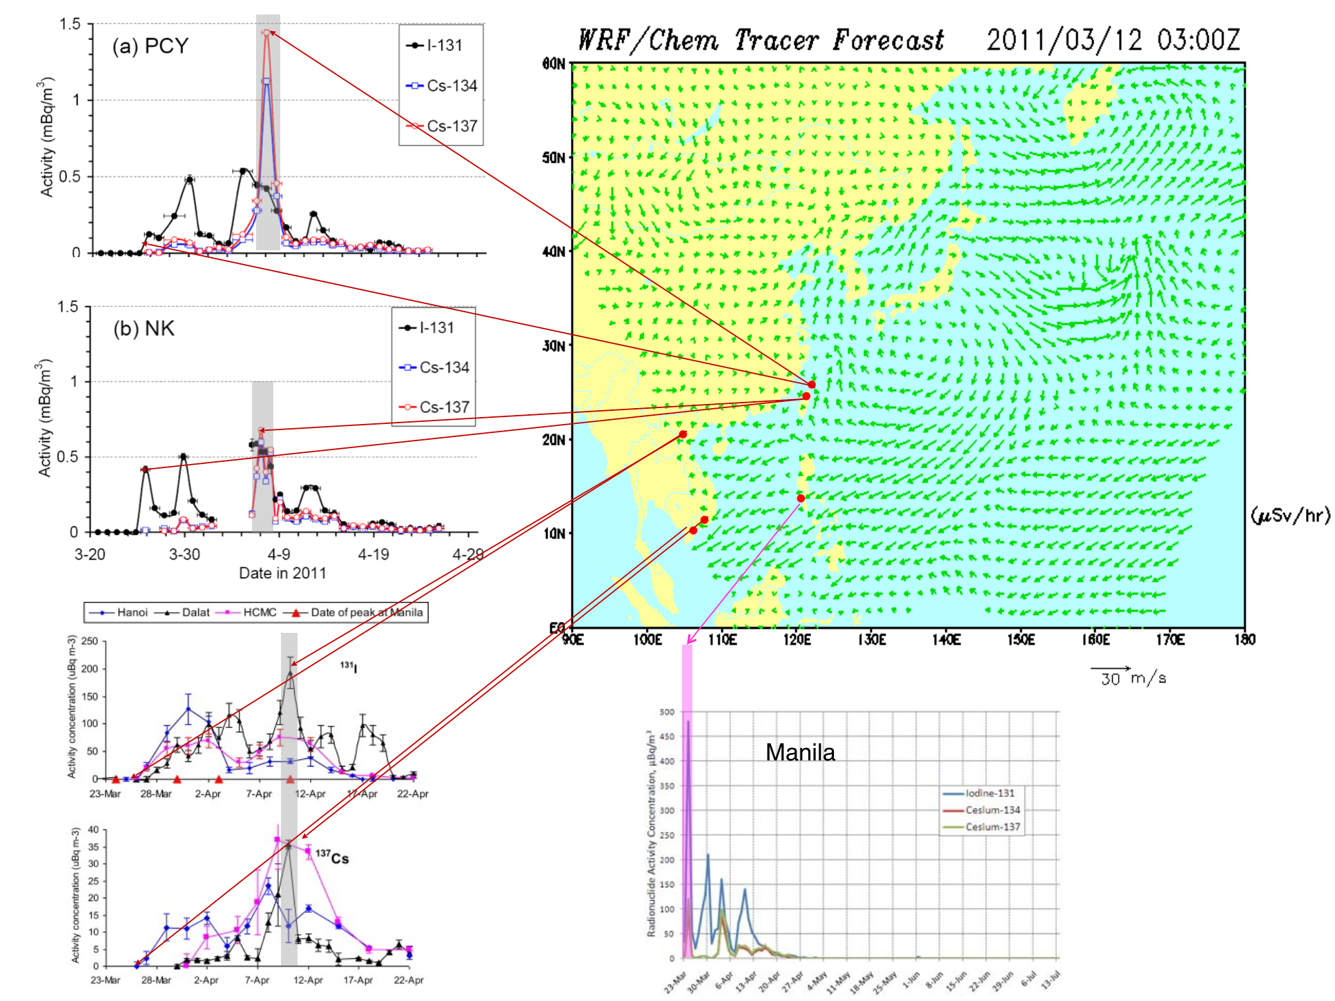
Figure 5. Simulation of the transportation of fission nuclide from Japan to southeastern Asia region by the DMCC scientific group using WRF/Chem Tracer

Conclusions
DMCC focuses on the use of a generative model to capture atmospheric and oceanic dynamics from numerical simulations. According to the examined root causes of the disasters, three dimensions of simulation outcomes were analysed:
- spatial dimension (path and impactful region of the hazard);
- temporal dimension (when); and
- magnitude dimension (what are the degree of the most important scale indicators).
Numerical simulations were developed using a wide range of models that accept measurements of current conditions and parameters for dominated earth systems as input and project the future state of the target disaster and its response to these forcing variables. Simulation models range in complexity from simple transformation equations to those based on mathematical representation of the complex interactions between land surfaces, ocean, and the atmosphere. Numerical models have been a cornerstone of weather prediction today and having been supporting a broad range of meteorological-oriented researches and applications. For example, numerical simulation is usually used to predict the atmospheric states or to simulate atmospheric phenomena. For scientist researches, it is very useful for physical process identification and analysis, and estimation of future climates, etc. Ability to forecast hydrometeorological hazards is highly developed in the past two decades. It is expected to have increasingly reliable simulations identifying the timing and location of future natural hazards.
Deeper understanding approach is to have systematic risk analysis and profiling on underlying causes, drivers of the risks. Simulation is conducted with optimal initial condition, boundary condition and parameterization with best knowledge, based on the observations. As exemplified by NWP, the substantial improvement in the past two decades is realized through advances of fundamental sciences, numerical models and high performance computing. Observation provides necessary description of the current stats of the dominant earth system (such as atmosphere, ocean, hydrology, land surface, etc.) so that the numerical simulation can start with the best estimation of initial conditions. The models capture the key atmospheric dynamics and use right physical parameterization so that samples of prediction can be generated accordingly. The whole processes have to be carried out efficiently by massive parallel computing schemes with scalability. Iteratively, new stage model simulations are executed based on updated observation data.
DMCC case studies (see Figure 6) demonstrated that science can be driven by the need to address the adverse effects of disasters on lives and societies. These case studies capture the complexity of disaster risk (e.g., the generation process in the disaster life cycle) by exploring the detail of a real case.
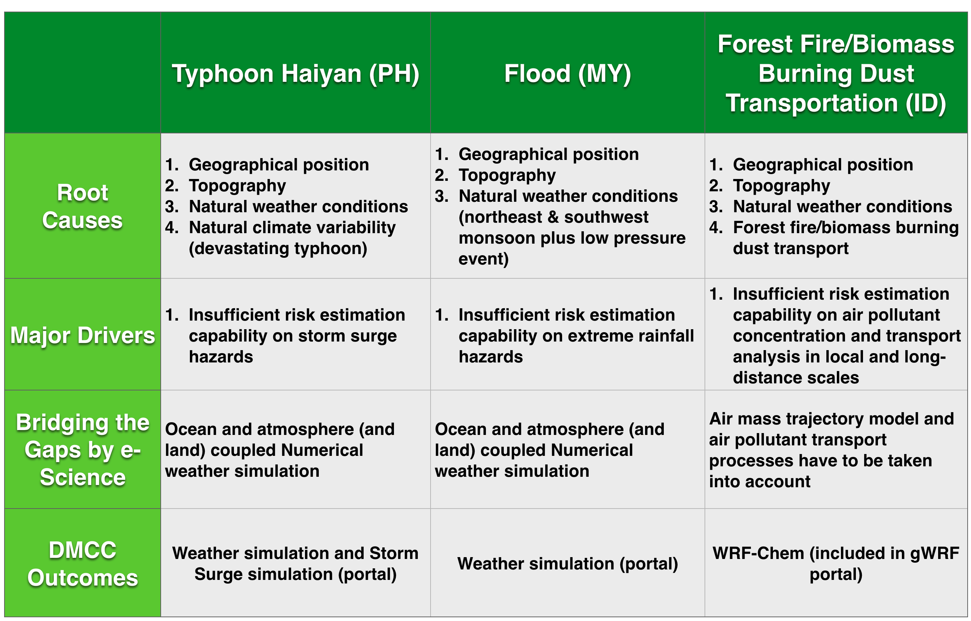
Figure 6. Summary of DMCC case studies by deeper understanding approaches

DMCC demonstrated that the EGI e-infrastructure ensures that resources meet community needs and aiding the scientific community in keeping up with the revolution in computing with better software tools, technical expertise, and flexible service models in delivering software and computing resources. DMCC makes use of the regional infrastructure to realize the case studies by deeper understanding approaches and revolutionary numerical simulations with higher accuracy and resolution. In the future, the new authentication and authorization infrastructure compatible with EGI and federated cloud technology are all necessary to engage resources and collaborations around the world. This and the next sections collects the lessons learnt from the 30 month-long DMCC project, and defines tasks for the future, for the DMCC+ which is expected to start in January 2018 in the EOSC-hub project.

Lessons Learned
- Real world physics is too complex. Validation of models requires accurate simulations, tools to compare simulations and data, and better ways to deal with complex and massive data sets. DMCC had demonstrated the collaboration model to develop a simple but innovative multi-hazard simulation service such as the typhoon induced storm surge. Extension of DMCC simulation facility to cover multi-hazards scenarios based on complicated case studies has been included in the next stage of DMCC, DMCC+ in EOSC-hub.
- Accuracy of simulating extraordinary damage-causing phenomena such as torrential rainfalls and local downpours is still far from sufficient. Simulation results are highly sensitive to slight perturbations in initial conditions. Scalability of computation is another issue in achieving higher resolution and higher efficiency of the simulation.
- Uncertainty issues: In addition to the sources of regional weather uncertainty, model and simulation uncertainty arises from five primary sources: 1) the chaos of the natural phenomena leads to initial condition uncertainty; 2) model error caused by both the systematic components or random components; 3) parameterization to transform between scales; 4) introduced by the computing environment from hardware, operating system, parallel topology and compiler options; 5) communication and interpretation uncertainty.
  - Practically, sensitivity test and analysis is conducted before the production simulation runs. Careful validation of the processes in determining IC, BC and resolution transformation (from parameterization) is the most essential. Through the minimization of differences between simulation and data, the simulation workflow and key configurations are finalized.
  - Model uncertainty arises mainly from imperfect knowledge of the real system such as the cloud microphyscis or turbulent diffusion. In weather forecasting, there has been a continuous drive to higher resolution (e.g, 3KM) for model performance and being able to capture the multi-scale nature of tropical convection of cloud system.
- In DMCC case studies, according to the scientific group, the dynamic downscaling scheme is commonly used to increase the accuracy of regional climate predictions in coping with the model resolution of local geographic and topographic forcing. However, the uncertainty issue of model may always be the issue for dynamic downscaling. For the long-distance dust transportation of biomass burning case study, initial atmospheric condition during spin-up period has significant effect on simulation results of CO and PM10. The uncertainty of biomass burning CO emission may also contribute to the underestimation, which can be improved by advanced spin-up period modelling.
- Interoperability issues: Ultimately, data should be discoverable, accessible, de-codable, understandable and usable. Data sharing should be legal and ethical for all participants. Partners should communicate with local authority to support the open data policy and collaborations across administrative boundary. The FAIR (Findable, Accessible, Interoperable, and Reusable) guiding principles proposed by FORCE11 will be a primary reference of DMCC+ to facilitate the larger values of the data and outcomes.

Future perspectives

Knowledge aspect: Disaster Mitigation Knowledge Base
A Knowledge Base is used to share all the materials and resources of DMCC case studies in an organized way. It is implemented over the DMCC Open Collaboration Platform to support the utilization of DMCC services and resources and provide the collective intelligence environment for partners to conduct new case studies or reproduce and reinvestigate existing cases.
Although, for basic disaster information we could always benefit from well-organized global or regional centers, such as the Pacific Tsunami Warning Centre for tsunami events and the International Best Track Archive for Climate Stewardship (IBTrACS) for tropical cyclones, and the Global Fire Monitoring Centre for forest fires. With case studies directly contributed/participated by the severely affected country, we have much a better opportunity to be able to require detailed data about the target hazard. The DMCC Open Collaboration Platform maintains the data federation that provides flexibility to check up the basic information of event from those reliable regional and global information centres (or related national resource centers). On the other hand, DMCC also collects detailed information from case studies and for future applications.
There are still many technological challenges in gathering event data and information for case studies and analysis. First, how to transform domain knowledge in a machine usable form while retaining the semantic relationship between various fragments of information. Second, how to extract semantic information from heterogeneous sources including unstructured texts. Last, the design and structure of such federated knowledge base to support applications from case studies and analysis. In our design, the DMCC Knowledge Base (DMCCKB) is a compiled collection of data, information, tools and services around an event or a theme to support scientific researches. Metadata and data format for the DMCCKB has to be defined first based on the schemes of primary local/regional/global data sources. APIs or Web Services to access those sources are needed to enhance the automation and flexible workflow. Similarly, APIs and data services should be delivered for DMCC users. Data harvesting services as well as data analysis services based on requirements from case studies and future applications should be developed. In the beginning, DMCCKB is built on an architecture of linked practices. A catalog of DMCC case studies by event/time/location/hazard type/etc. will be constructed that provides a list of actual data files with links for downloading. In addition to DMCCKB and the simulation services, open access and digital archives of all materials about the selected cases based on standard metadata schemes and access protocols are all maintained. Design of the whole architecture is as the Figure 7.
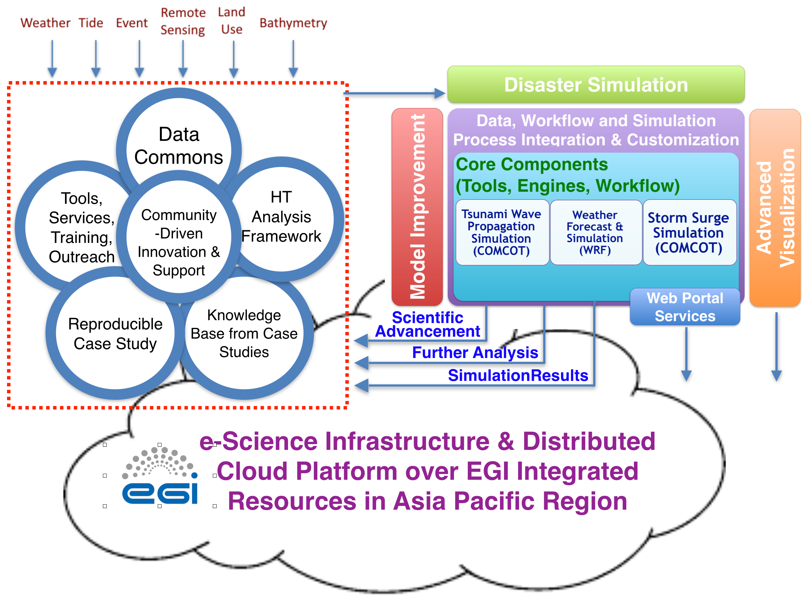
Figure 7. Moving Towards Open Science Platform from DMCC Collaboration Framework — Integrating Data, Simulation Portal & Innovative Modelling, and Knowledge base from case studies

Technical aspects
Deeper understanding of the disasters drives the development of innovative simulation facility on case studies. With the simulation portal, collaboration among partner groups could have coherent computing environment and the sharing of configurations of a complex model is much easier. Open collaboration platform supports the share of materials related to the target disasters, simulation and analysis facility integrated by the EGI-based distributed infrastructure and reproducible case studies. Reproduction of research findings enables transparency in the research methodology, increases the research’s social impact and saves money and time for researchers. Integrating with organized knowledge base from case studies, in next stage, DMCC is building an open science framework on disaster mitigation from this prototype, in addition to the following potential works.

- Building complex computer models of natural systems that can forecast impeding disasters has been one of the grand challenges for earth and environmental sciences in the early twenty-first century. E-Science is the unification of empirical, theoretical and computational approaches. DMCC has demonstrated the effective approaches to develop innovative and accurate simulation models on multi-hazards events. DMCC will keep extending the e-Science technology for the primary barriers in the areas of software, data management, visualization, and the coordination of diverse communities that combine efforts and resources to develop advanced models and algorithms.
- Extension of simulation capability to more complicated and multi-hazard events. As depicted in Figure 2, combining meteorological and hydrological modelling, the extreme weather event and its scouring or landslides impacts could be simulated. Combining seismic wave propagation and tsunami wave propagation processes, impacts of the high potential tsunami-causing faults in western pacific and Indian oceans could be investigated in details. By considering tracer advection and model chemistry parameterizations, new ways to evaluate atmospheric evolution with compositions such as aerosols and trace gases could be enhanced.
- Quantitative estimation of potential threat is important as it informs the appropriate strategies and measures to be taken. DMCC will support the advancement of simulation technology and facility by deep understanding approach (also with the up-to-date knowledge to the earth system) to enhance the capability and accuracy of disaster risk simulations. Identification of the types of interactions between hazards and the patterns of combination of geophysical environment and triggers are essential in dealing with practical multi-hazard scenarios.
- Deployment of data-oriented machine learning technology to understand the transformation process and it correlation with target event characteristics: Development of the disaster in its complete lifecycle is able to be captured in required resolution of time, location and magnitude, such as the precipitation, wind intensity and low pressure. Organization of the data has to characterize the hazards, their structures and their temporal changes. For example, the data organization has to contain the segmented precipitation objects and their associated attributes. Machine learning algorithms then could be applied for learning from the data.
- Advanced visualization is helpful to visualize the dynamic changes to the specific features of the disasters in time and space and enable empirical characteristics to be calculated for target event objects
- Enhancing the Open Collaboration Platform for reproducibility of case studies, better access to all collected materials, federated knowledge base and better collaboration support to regional multidisciplinary communities.
- Moving towards an Open Science Platform for disaster mitigation by sharing data, software, workflow, and details of computational environment that generate published findings in open trusted repositories. As more scientific disciplines are relying on computational methods and data-intensive exploration, it has become essential to develop software tools that help document dependencies on data products, methodologies and computational environments. To document, archive and share all data and the methodologies used makes scientists reproduce and verify scientific results and students learn how they were derived. Ability to rerun the same computational steps on the same data would be a dissemination standard, which includes workflow information that explains what raw data and intermediate results are input to which computations.
- Moving Towards Open Science Platform from DMCC Collaboration Framework — Integrating Data, Simulation Portal & Innovative Model, and Domain Knowledge

D6.9 Web portals for tsunami wave propagation simulations and for WRF-based weather simulation, available online at https://documents.egi.eu/document/2784
Sendai Framework for Disaster Risk Reduction, http://www.unisdr.org/we/coordinate/sendai-framework
UNISDR 2012, https://www.unisdr.org/we/inform/publications/33363
IPCC (2012a) In: Field CB, et. al (eds) Managing the risks of extreme events and disasters to advance climate change adaptation. A special report of working groups I and II of the Intergovernmental Panel on Climate Change (IPCC). Cambridge University Press, Cambridge, UK/New York, p 582
https://en.wikipedia.org/wiki/Typhoon_Haiyan
The WRF and iCOMCOT simulation portals by the DMCC were topics of a previous DMCC deliverable, D6.9: Web portals for tsunami wave propagation simulations and for WRF-based weather simulation. Available online at https://documents.egi.eu/document/2784
D6.20: Application of the simulation portals for scientific scenario in disaster mitigation, Available online at https://documents.egi.eu/document/3024
https://en.wikipedia.org/wiki/2011_T%C5%8Dhoku_earthquake_and_tsunami
https://www.egi.eu/news/eosc-hub-project-is-favourably-evaluated/
Peter Bauer et. al., Nature(525), 47-55, 2015.
The FAIR Data Principle, https://www.force11.org/group/fairgroup/fairprinciples
Pacific Tsunami Warning Center, http://ptwc.weather.gov
International Best Track Archive for Climate Stewardship (IBTrACS), https://climatedataguide.ucar.edu/climate-data/ibtracs-tropical-cyclone-best-track-data
Global Fire Monitoring Center, http://www.fire.uni-freiburg.de/index.html
From “Jim Gray on eScience: A Transformed Scientific Method” in Hey, Tansley and Tolle. 2009. The Fourth Paradigm: Data-Intensive Scientific Discovery. Ed.

