Instructions to access the EGI Training Infrastructure
This document describes the lightweight vetting process to allow users, not belonging to any production VOs, to register and get access to the EGI Training Infrastructure. The registration process is based on two steps.

Step 1: How to get a personal EGI ID.
Before to use any EGI training resources, you need to sign up for an account. As part of this process you will be assigned a personal EGI ID, which will then be used across all EGI tools and services.
To get your personal EGI ID account, please follow the instructions below:
- Enter the following URL in a browser: https://aai.egi.eu/signup
- Select your Identity Provider you belong to from the discovery page:
  - Browse through the list of Identity Providers to find your Home Organisation;
or, alternatively,
  - Type the name of your Home Organisation in the search box. Note that this filter only matches entries within the currently selected view (tab) of Identity Providers and is localised based on the selected language.
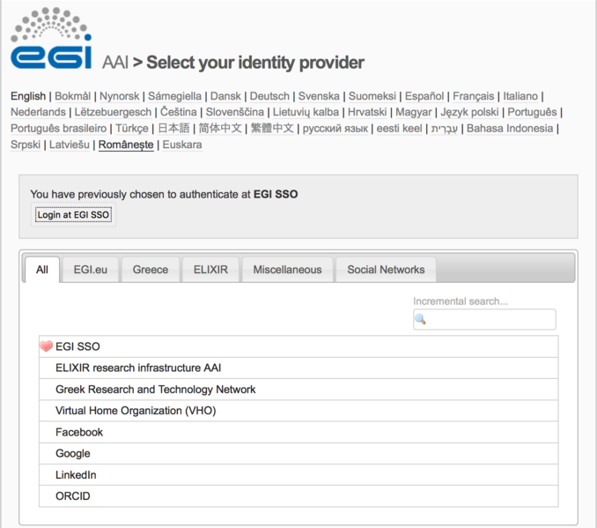
IMPORTANT: In case the Identity Provider of your home institution is not in the list, or your home organisation is not supporting any Identity Federation authentication mechanism yet, you can:
- Click on “Social Networks” (last tab) and use your social account of one of the supported social media. Currently Google, Facebook and LinkedIn social media are supported;
- Request for a personal EGI SSO account, filling the registration form available at: egi.eu/sso and use this account to authenticate and request your EGI ID.
  - Before to use the EGI SSO account you have to active the account following the instructions sent by e-mail.
- Enter your login credentials to authenticate with the selected IdP (e.g.: EGI SSO, Social Networks, ORCID, etc.)
- After successful authentication, you may be prompted by your Home Organisation to consent to the release of personal information to the EGI AAI Service Provider Proxy
- On the EGI AAI consent about releasing personal information page, click “Yes, continue” to consent to the release of personal information to the EGI User Account Registry.
  - If you select the Remember option, your browser will remember your choice unless you clear your cookies or restart the browser.
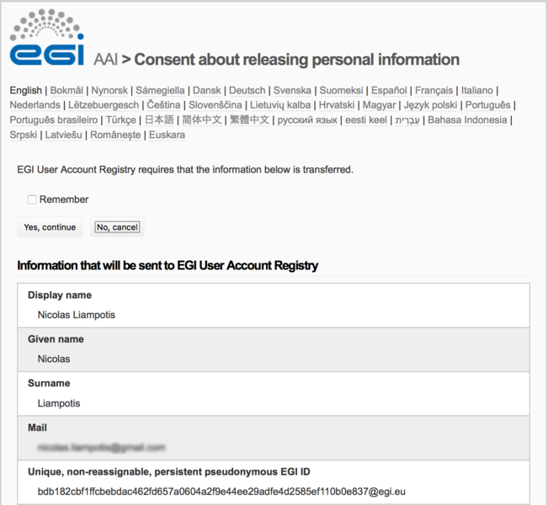
- After successful authentication, you will be redirected to the EGI account registration form. On the introductory page, click “Begin” to start the registration process.
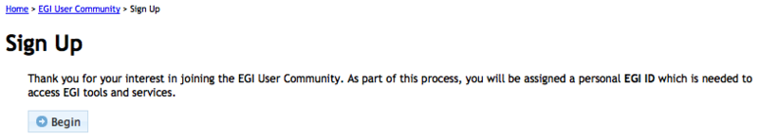
- Depending on the attributes released by your Identity Provider, you will need to go through one of the following account registration processes:
  - Self-service Sign Up: Allows you to join the EGI User Community without approval by an administrator if all the information below is asserted by your Home Organisation:
    - at least one of the following unique user identifiers:
    - your pseudonymous, non-reassignable identifier (eduPersonUniqueId attribute);
    - your name-based identifier (eduPersonPrincipalName attribute);
    - your pseudonymous identifier (eduPersonTargetedID attribute or SAML persistent identifier)
    - your first name (givenName attribute)
    - your surname (sn attribute)
    - your email address (mail attribute)
    - your role (affiliation) in your Home Organisation (eduPersonScopedAffiliation attribute)
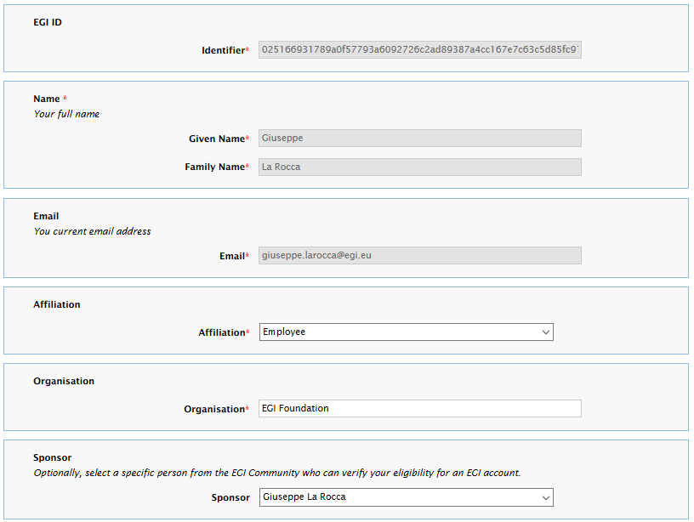
  - Sign Up: If any of the information above cannot be released by your Home Organisation, you will need to provide the values of the missing attributes yourself. Your request to join the EGI User Community must then be approved by an EGI User Sponsor. You may optionally select a particular individual to review your request through the Sponsor dropdown list.

- On the registration form, click Review Terms and Conditions (Acceptable Use Policy and Conditions of Use – EGI AUP).
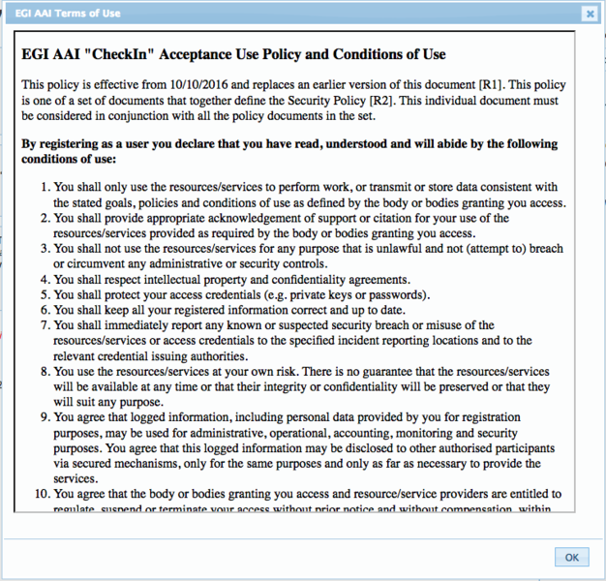
- If you agree to the EGI AAI Terms of Use, select the I Agree option.
  - Important: You will not be able to agree to the terms until you review them.
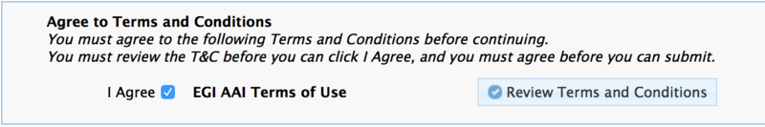
- Finally, click “Submit” to submit your request.
  - Important: You will not be able to submit your request until you agree to the terms.
- After submitting your request, EGI AAI will send you an email with a verification link in it. After you click that link, you'll be taken to the request confirmation page.

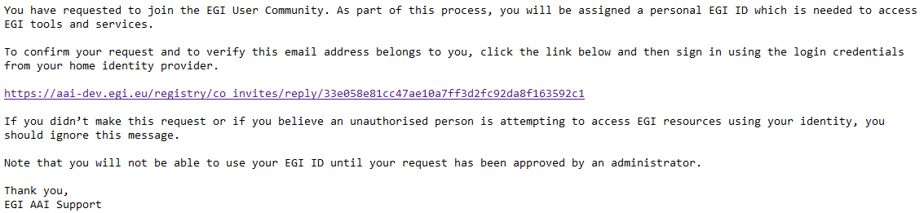

IMPORTANT:
- If you DO NOT find the email in your Inbox, please check your Spam or Junk folder for an email from "EGI AAI Notifications".
- If you DO find the email in these folders, mark the email as "safe" or "not spam" to ensure that you receive any future notifications about your EGI ID.

- After reviewing your request, click “Confirm” and re-authenticate yourself using the Identity Provider you selected in Step 2.
- In the case of the Sign Up registration, you need to wait for an EGI User Sponsor to approve your request to join the EGI User Community.
  - For this training event select Giuseppe La Rocca as Sponsor!
  - Upon approval, EGI AAI will send you a notification email.

Step 2: To join the training community.
Please follow the instructions below:
- Enter the following URL in a browser: https://aai.egi.eu/join-training
- Fill in the registration form and submit the request
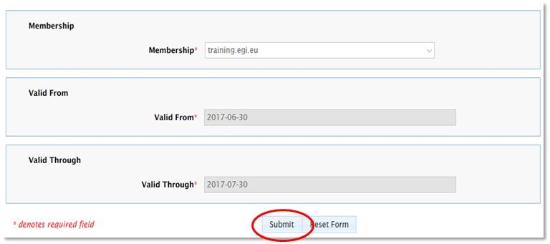
- The registration requires an approval from the EGI Sponsor.
- If your request to join the training community is approved, the EGI AAI service will notify you with the following e-mail:

Contact: Should you have comments, please contact us anytime at: giuseppe.larocca@egi.eu, gergely.sipos@egi.eu

