EGI-InSPIRE

MARKETING AND COMMUNICATIONS HANDBOOK

EU MILESTONE: MS238

Document identifier: | EGI-doc-1897
Date: | 30/08/13
Activity: | NA2
Lead Partner: | EGI.eu
Document Status: | Final
Dissemination Level: | Public
Document Link: | http://documents.egi.eu/document/1897

Abstract
This document gives an overview of the communications services offered by EGI-InSPIRE, including mailing lists, logos, branding, resources, workshops, events, marketing and publications. The handbook also outlines the mechanism for setting up a Virtual Team and a communications guide for NGI International Liaisons, as well as the core vision and key messages.

- Copyright notice
Copyright © Members of the EGI-InSPIRE Collaboration, 2010-2014. See www.egi.eu for details of the EGI-InSPIRE project and the collaboration. EGI-InSPIRE (“European Grid Initiative: Integrated Sustainable Pan-European Infrastructure for Researchers in Europe”) is a project co-funded by the European Commission as an Integrated Infrastructure Initiative within the 7th Framework Programme. EGI-InSPIRE began in May 2010 and will run for 4 years. This work is licensed under the Creative Commons Attribution-Noncommercial 3.0 License. To view a copy of this license, visit http://creativecommons.org/licenses/by-nc/3.0/ or send a letter to Creative Commons, 171 Second Street, Suite 300, San Francisco, California, 94105, and USA. The work must be attributed by attaching the following reference to the copied elements: “Copyright © Members of the EGI-InSPIRE Collaboration, 2010-2014. See www.egi.eu for details of the EGI-InSPIRE project and the collaboration”. Using this document in a way and/or for purposes not foreseen in the license, requires the prior written permission of the copyright holders. The information contained in this document represents the views of the copyright holders as of the date such views are published.
- Delivery Slip
 | Name | Partner/Activity | Date
From | Neasan ONeill | EGI.eu/NA2.2 | 30 August 2013
Reviewed by | Moderator: Catherine Gater  Reviewers: Kitti Varga  Damien Lacrapentier |  | 27 August 2013
Approved by
- Document Log
Issue | Date | Comment | Author/Partner
1 | 07 August 2013 | First draft | N.ONeill/EGI.eu
2 | 30 August 2013 | Final version comments included | N.ONeill/EGI.eu
3
- Application area
This document is a formal deliverable for the European Commission, applicable to all members of the EGI-InSPIRE project, beneficiaries and Joint Research Unit members, as well as its collaborating projects.
- Document amendment procedure
Amendments, comments and suggestions should be sent to the authors. The procedures documented in the EGI-InSPIRE “Document Management Procedure” will be followed:
https://wiki.egi.eu/wiki/Procedures
- Terminology
A complete project glossary is provided at the following page: http://www.egi.eu/about/glossary/.
- PROJECT SUMMARY

To support science and innovation, a lasting operational model for e-Science is needed − both for coordinating the infrastructure and for delivering integrated services that cross national borders.

The EGI-InSPIRE project will support the transition from a project-based system to a sustainable pan-European e-Infrastructure, by supporting ‘grids’ of high-performance computing (HPC) and high-throughput computing (HTC) resources. EGI-InSPIRE will also be ideally placed to integrate new Distributed Computing Infrastructures (DCIs) such as clouds, supercomputing networks and desktop grids, to benefit user communities within the European Research Area.

EGI-InSPIRE will collect user requirements and provide support for the current and potential new user communities, for example within the ESFRI projects. Additional support will also be given to the current heavy users of the infrastructure, such as high energy physics, computational chemistry and life sciences, as they move their critical services and tools from a centralised support model to one driven by their own individual communities.

The objectives of the project are:

- The continued operation and expansion of today’s production infrastructure by transitioning to a governance model and operational infrastructure that can be increasingly sustained outside of specific project funding.
- The continued support of researchers within Europe and their international collaborators that are using the current production infrastructure.
- The support for current heavy users of the infrastructure in earth science, astronomy and astrophysics, fusion, computational chemistry and materials science technology, life sciences and high energy physics as they move to sustainable support models for their own communities.
- Interfaces that expand access to new user communities including new potential heavy users of the infrastructure from the ESFRI projects.
- Mechanisms to integrate existing infrastructure providers in Europe and around the world into the production infrastructure, so as to provide transparent access to all authorised users.
- Establish processes and procedures to allow the integration of new DCI technologies (e.g. clouds, volunteer desktop grids) and heterogeneous resources (e.g. HTC and HPC) into a seamless production infrastructure as they mature and demonstrate value to the EGI community.

The EGI community is a federation of independent national and community resource providers, whose resources support specific research communities and international collaborators both within Europe and worldwide. EGI.eu, coordinator of EGI-InSPIRE, brings together partner institutions established within the community to provide a set of essential human and technical services that enable secure integrated access to distributed resources on behalf of the community.

The production infrastructure supports Virtual Research Communities (VRCs) − structured international user communities − that are grouped into specific research domains. VRCs are formally represented within EGI at both a technical and strategic level.
- EXECUTIVE SUMMARY
This document gives an overview of the practical elements relating to communications, design and branding for the EGI-InSPIRE project and is an update to MS228 Dissemination Handbook [R1]. Targeted at the central communications and marketing team, coordinated by EGI.eu under task TNA2U.2, it is also aimed at the partners providing effort to communications through the NGI International Liaisons. The communications task within EGI-InSPIRE falls into WP2, NA2-Community Engagement. This activity supports the development of policy, the coordination of standards, outreach to new communities, technical outreach, events and the communications and community building activities appropriate for the role that EGI.eu plays in coordinating the European e-Infrastructure. For task NA2U.2, the aim is to disseminate the work of the EGI and its user communities, both within the project and worldwide.

The document refers to the contributors to the EGI Global and EGI National Tasks and lists the participating partners. The document outlines the role of Virtual Teams in driving innovation in communications activities, and reviews the mechanism for setting up and participating in Virtual teams. Also discussed is the branding for EGI-InSPIRE, which was refreshed during the first year, including new logos and colour palettes. Appropriate usage of these logos, colours, fonts and additional logos, such as the EC logos is discussed.

The document also covers how internal communication are handled within the project, including the details of project mailing lists, an outline of the communications sections of the project wiki and the publication of deliverables and milestones on the Document Server. A number of resources are also available on the main project website. The use of social media channels such as Twitter and Flickr is also discussed. The document also covers the basic procedures for events, press releases and publicity and how these are updated. Also covered are guidelines for the working relationships and mutual expectations between the central EGI.eu Communications Team and the local dissemination teams within the NGIs and EIROs.

TABLE OF CONTENTS
1 Introduction 7
2 communications in EGI-inspire 8
2.1 Vision, Mission and Values 8
2.2 EGI Global Task 9
2.3 NGI International Liaisons 9
2.4 Champions 9
3 Branding In EGI-InSPIRE 10
3.1 Logos 10
3.2 Colour palettes 12
3.3 Fonts 12
3.4 EC logo usage 12
4 Internal Communication TOOLS 14
4.1 Mailing lists 14
4.2 Wiki 14
4.3 Document sharing 14
4.4 Project Management 14
4.5 Website 14
4.6 Social media and blogs 15
4.7 Press releases 15
5 Guides to communications 17
5.1 Deliverables and Milestones 17
5.2 Templates and “how to” guides 17
5.3 Copyright and Creative Commons 18
5.4 Approved notes for editors 19
5.5 Acknowledgement of EGI in scientific papers 20
5.6 Events 20
5.7 NGI and partner websites 20
6 services for NGIs and EIROs 22
6.1 Communications as a resource 22
6.2 Events and workshops 23
6.3 User support 24
6.4 Publications and case study collection 24
7 VIRTUAL TEAMS 25
7.1 What is a Virtual Team? 25
7.2 Setting up a Virtual Team 25
7.3 Running a Virtual Team 26
7.4 Examples of communications Virtual Teams 27
8 Champions 29
8.1 What is the Champions Scheme 29
8.2 Benefits of being a Champion 29
8.3 Recruiting/Becoming a Champion 29
8.4 Further informtaion 29
9 Conclusions 30
10 References 31

Introduction
This document gives an overview of the practical elements relating to communications, design and branding for the EGI-InSPIRE project and is an update to MS228 Dissemination Handbook [R1], based on D2.22 Communications and Marketing Plan [R2]. Targeted at the central communications and marketing team, coordinated by EGI.eu under task TNA2U.2, it is also aimed at the partners providing effort to communications through the NGI International Liaisons. The communications task within EGI-InSPIRE falls into WP2, NA2-Community Engagement.

The document also covers how internal communication is handled within the project, including mailing lists, the project wiki, document server and social media. The Handbook includes the basic procedures for events, press releases and publicity and how these are updated, as well as how the EGI.eu team works with the NGIs and EIROs through the Virtual Teams.

communications in EGI-inspire
The communications task within EGI-InSPIRE falls into WP2, NA2-Community Engagement. This activity supports the development of policy, the coordination of standards, outreach to new communities, technical outreach, events and the communications and community building activities appropriate for the role that EGI.eu plays in coordinating the European e-Infrastructure. For communications task NA2U.2, the aim is to disseminate the work of the EGI and its user communities, both within the project and worldwide.

All activities performed by the communications team aim to assist EGI’s core goal to expand and improve the European grid infrastructure by increasing both the number and diversity of end users and increase public awareness of the infrastructure and the work it supports.

To do this the communications team provides two core functions:

- A first point of contact
The communications team provides a presence for EGI at a wide range of events through presentations, materials, booths and social media to attract new users.

- Creation of content/materials
Leaflets, news stories, newsletters, articles all support the first contact but may also in some cases be the first encounter with the grid for potential users

The central communications team also provides a series of services to the NGIs and EIROs within the EGI-InSPIRE project and to the wider community outlined in Section 6.

The communications task of EGI-InSPIRE is covered in further detail in D2.22 Communications Plan [R2].

Vision, Mission and Values

A further key aim of the communications team is to promote EGI’s vision, mission and values as outlined in the EGI Strategic Plan [R 16]

Vision
To support the online European Research Area through a pan-European research infrastructure based on an open federation of reliable services, which provide uniform access to national computing, storage and data resources.

Mission
To connect researchers from all disciplines with the reliable and innovative ICT services they need to undertake their collaborative world-class research.

Core Values
Leadership: EGI is a leading pan-European infrastructure, integrating worldwide computing, storage and data resources to support an ecosystem built on innovation and knowledge transfer.

Openness: EGI operates collaboratively with a transparent governance structure that integrates the views and the requirements of all stakeholders, from research communities to resource providers.

Reliability: EGI provides a reliable infrastructure that research communities can depend on in order to collaborate with their peers and deliver innovation.

Innovation: EGI will continue to meet the needs of research communities operating at an unparalleled geographic and technical scale by partnering to bring new technologies into production.

EGI Global Task
The EGI Global task is coordinated by EGI.eu in Amsterdam, and contributes 96PM to task TNA2U.2. A Communications Manager manages the task through the coordination of the staff within EGI.eu and those located in the NGIs, assisted by professional science writers and a graphic designer. The EGI Global Task also administers a central dissemination budget for stands at major exhibitions, design and printing of posters, leaflets, booklets and other promotional materials and website design.

NGI International Liaisons (NILs)
Working together with teams in EGI.eu, the NILs link the strategic non-operational activities taking place in their own NGIs (e.g. outreach, marketing, communication, training, new community engagement) with the rest of the community. With the NIL acting as a spearhead, each country is able to demonstrate their added value at a European level and to share their skills with the whole community.

Teams in EGI.eu work with staff in the NGIs through the NGI International Liaisons (NILs), and with the broader EGI community through the Virtual Team (VT) framework, to develop EGI’s activities and to engage with research communities new to EGI. The VT framework allows interaction, knowledge transfer and cooperation within the community on non-operational activities, covering areas such as communications, policy and strategy, outreach and support and tailored events.

The work of the NILs through the Virtual Team structure is described in more detail in Section 7.

Champions
During 2012, EGI introduced a new role in the community – the EGI Champions. The EGI Champions are a network of subject and grid 'experts' available on the ground to provide help to individuals in their own research environment. They provide a more informal support role to both their community and EGI. They provide users and potential users with role models for grid usage that is relevant to their work.

As members of a particular research community, they are well placed to provide a communications channel for that community and provide the communications team with feedback on their material produce.

Branding In EGI-InSPIRE
The branding for the EGI-InSPIRE project was established during the first year of the project, including logos for EGI-InSPIRE, EGI and EGI.eu and a colour palette. The website was also reviewed for milestone MS220 Review of website content [R3].

Further EGI templates for documents, presentations and posters are discussed in Section 5.2. The section includes information on the circumstances under which EGI standard templates should be used.

The entire logo is designed to work as a whole on all primary communications, however the individual elements can be used as design elements supporting the full logo e.g. watermark (tint) of just the icon.

Logos
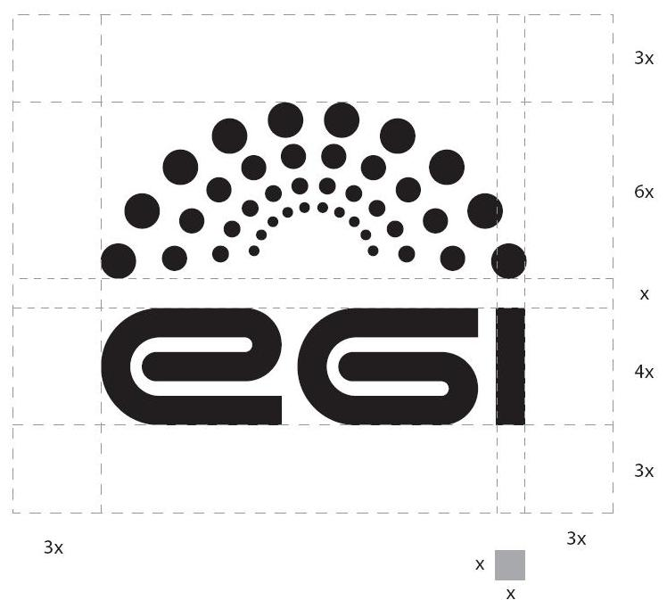
The spaces around the various logo elements and the entire logo itself play a part in ensuring its communication effectiveness. The clear space shown here represents the preferred proportional distance between the logo and any other design or graphic elements.

The EGI logo has been designed for use in two colours (discussed later). It is most effective
when used in these two colours against a white background.

The brand is completed by two other versions of the logo: EGI-European Grid Infrastructure and EGI-InSPIRE

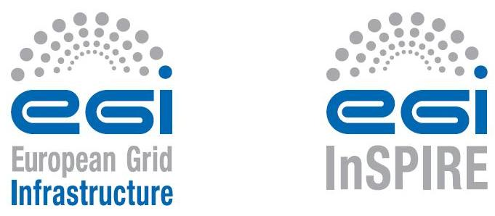

The logo is available for download from the website, for example for use on event websites, on joint publications and to accompany articles in the press.

Colour palettes
The corporate colours are listed below for pantone, CMYK and RGB values.
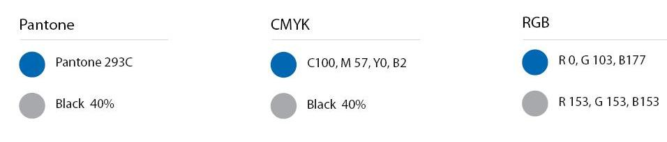

Fonts
The font used for the EGI logo is an adapted version of Helvetica Condensed Bold. The typography in the logo for the EGI (European Grid Infrastructure) and EGI-InSPIRE version should not be recreated. The fonts to be used with the logo (main title...) should be of the same family: Helvetica condensed (medium, roman, light, italic...).

For body text a standard Helvetica (roman, bold, italic) can be used. In the case of internet page Arial or Open Sans can also be used.

EC logo usage
Unless the Commission requests otherwise, any publicity, including at a conference or seminar or any type of information or promotional material (brochure, leaflet, poster, presentation etc), must specify that the project has received Community research funding, quote the contract number RI-261323 and display the European emblem. When displayed in association with a logo, the European emblem should be given appropriate prominence.

The following logos must be used with appropriate prominence together with the project logo:
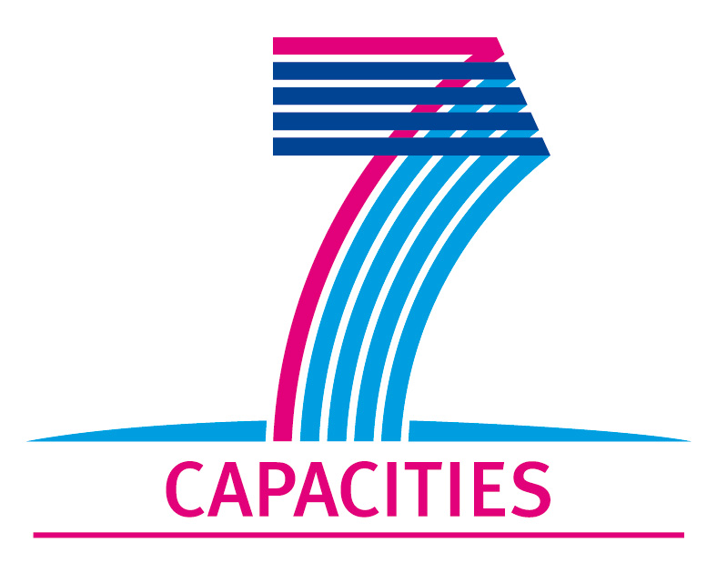

The e-Infrastructures Unit logo may also be used:

Internal Communication TOOLS
For effective communication, it was important that internal communication channels were established early in the project and were used for maximum impact. Dissemination relies on clear communication of success stories from other activities to the Communications Team, so that these can be communicated more widely outside the project to the user communities and beyond. Similarly, the work packages outside the communications activities should be kept up to date with current communications activities and the communications and outreach materials that are available for download, for distribution at events and so on. As the NGI International Liaison network is also a widely dispersed task geographically speaking, well supported central sources of information and means for sharing information are essential.

Mailing lists
There is a dedicated mailing list used by the NILs, ngi-international-liaisons@mailman.egi.eu.
Individual Virtual teams set up their own email aliases for communications purposes. The VT Team Leaders can be contacted on vt-leaders@mailman.egi.eu. Project members and also the general public and media can also contact the Communications Team at press@egi.eu. There is also a dedicated mailing list for communications with the nine Champions champions-discuss@mailman.egi.eu.

Wiki
A task-specific wiki site is available at https://wiki.egi.eu/wiki/TNA2.2_Dissemination. The wiki site includes information for project members about the objectives for the task, the description of work, the team and involved partners, links to the deliverables and milestones and also the links to the social media sites and partner dissemination projects, such as e-ScienceTalk. This area is maintained by the Communications Team but comments from external partners are welcome.

Document sharing
The key deliverables and milestones relating to communications are published in the EGI Document Server at http://documents.egi.eu. Once fully reviewed by the AMB and PMB, the documents are made publically available to project member, the EC, the Communications Team and the NILs.

Project Management
Many members of EGI.eu staff use the Asana project management tool to assign and track tasks within and across their teams. This is currently used only within EGI.eu making it simpler for teams to work together on shared activities and understand their responsibilities and expectations.

Website
The EGI website at www.egi.eu contains communications products (http://www.egi.eu/news-and-media/), which are available to all project partners as well as the general public. Included in the section are recent articles about EGI and EGI-InSPIRE, project newsletters, the monthly Director’s Letters and press releases, as well as a collection of success stories, describing scientific use cases of grid computing applications and PDFs of EGI's publications (Annual Report, Books of Abstracts, brochures). These are available for download by all EGI-InSPIRE partners, the NGIs and EIROs.

Presentation templates and poster templates are also available for use by project partners, for example when presenting EGI-InSPIRE funded work at conferences and meetings. The Communications Team also maintains the news feed on the website, providing content twice a week on average and posting events to the calendar regularly.

Traffic to the website is tracked using Google Analytics and reported quarterly as metric M.NA2.9, as described in D1.13 Quality Plan and Project Metrics [R14]. The project metric measures the number of unique visitors per month to the main EGI website, and additional metrics such as page views, the origin of traffic and referring sites.

Social media and blogs
EGI has set up a series of social media sites including Twitter, Facebook, Google+ and LinkedIn. These pull in the RSS news feed from the EGI website and also provides a channel for live reports on EGI events and meetings. By following feeds from participating partners, this helps to build a communications community around EGI’s online presence. In addition, it is now possible to follow feeds from EGI news, policy, technical and user community support separately, so that content e.g. news, announcements can be tailored to the particular audiences for these channels. These channels are managed by the Hootsuite platform making it easier to track and manage multiple channels and content.

EGI has also set up a Flickr photostream at http://www.flickr.com/european-grid for images and photos and a YouTube channel at http://www.youtube.com/europeangrid.

An EGI blog is also available for the community at http://www.egi.eu/blog/. Members of EGI-InSPIRE are invited to contribute blog posts covering their work for the project, and can access the blog using their EGI Single Sign On account. An introduction to the blog and some links to guides to blogging are included on the EGI wiki. Access can be requested by email to blog-admin@egi.eu. Traffic to the blog site and an analysis of the individual posts is also carried out on an ad-hoc basis using Google Analytics and reported through the annual report on external relations activities.

The full list of EGI’s communications channels can be found at: http://go.egi.eu/smc

Press releases
Press releases are issued by the central communications team at EGI.eu in the run up to events and in response to key achievements by the project, such as the publication of high impact scientific papers. These press releases issued on behalf of EGI-InSPIRE are approved through the PMB of the EGI-InSPIRE project, and are also sent for information to the Executive Board of EGI.eu.

Once approved, press releases are issued on behalf of EGI-InSPIRE by the central team to the EGI media mailing list, media@egi.eu and posted on the Alphagalileo and Cordis Wire press services. Press releases are also issued to the NILs list so that NGIs can translate them, redistribute them to their own mailing lists, and post them on local websites. The press releases are published in English on the EGI website at http://www.egi.eu/news-and-media/press/#press along with any translated press releases provided by partners.

EGI-InSPIRE partners are encouraged to issue press releases about the project and the EGI-InSPIRE template is available for use. The EGI central Communications Team and the PMB must approve any press releases using the official template. Press releases by partners issued on behalf of the local institution should use the approved ‘Notes for Editors’ about EGI, EGI.eu and/or EGI-InSPIRE as appropriate in the context of the press release. Local press releases can be sent to the central team for input on the text and can also be added to the press office website.

Approved text to be used in ‘Notes for Editors’ is included in Section 5.4.

Guides to communications
A number of guides for dissemination are available to project partners, both those participating directly in the communications task, but also partners and collaborating projects beyond NA2.

Deliverables and Milestones
A series of deliverables and milestones are planned throughout the project’s 4 years to keep project partners informed of progress in communications:

D2.1, D2.10, D2.16 EGI-InSPIRE Presentation [R4], [R5], [R15]
Using the project’s presentation template, a public presentation on the website that describes EGI-InSPIRE’s past, present and future planned activities. This will also include details on the consortium and infrastructure. The presentation will be updated each year.

D2.2, D2.9, D2.15, D2.22 Communications plan [R6], [R2]
These will outline EGI’s plan to disseminate EGI.eu and EGI-InSPIRE’s activities to the DCI community in Europe and Worldwide.

D2.3, D2.17 EGI-InSPIRE paper [R7]
A public white paper that describes in more depth the activities and plans taking place within EGI-InSPIRE. The paper will provide a reference that will be used by the community to describe the organisational structure, technical architecture and support model within the project. The paper will be updated after two years.

The deliverables will be supplemented by a number of milestones:

MS201 Basic website with key collaborative tools [R8]
MS202 Project presentation template [R9]
MS203, 217, 228, 238 Communications handbook [R1]
MS204, 211, 213, 215 EGI newsletter [R10], [R11], [R12], [R13] (no longer a milestone from PY2)
MS207, 220, 231, 242 Review of website content [R3]

All deliverables and milestones are published in the Document Server. In addition, the project presentations, project paper and newsletters are published on the EGI website.

Templates and “how to” guides
Project templates are available from the EGI Quality Assurance wiki site at https://wiki.egi.eu/wiki/Templates. These templates include the project presentation template, the deliverable and milestone template and the document review template. All these templates are also available from a direct link on the Wiki homepage at wiki.egi.eu. Further templates for posters and presentations are available for download on the website in a variety of formats including Powerpoint, and LibreOffice. A summary of when these templates should be used is given in the table below:

- Template | - Requested usage
- Project presentation | - By project members  - For use at EGI meetings  - For use at other meetings presenting EGI-InSPIRE funded work
- Poster (portrait and landscape) | - By project members  - For use at EGI meetings  - For use at other meetings presenting EGI-InSPIRE funded work
- Deliverable and milestone | - By project members  - For all formal project deliverable and milestone documents
Document review | - By project members and document reviewers  - For review of all formal project deliverable and milestone documents

As the dissemination areas of the website and wiki expand, further templates and ‘how to’ guides, such as advice for dealing with the media, using social media and tips for preparing materials are being made available online. Discussions from the face-to-face meetings are posted on the communications wiki pages.

Copyright and Creative Commons
In all EGI-InSPIRE official documents, such as Deliverables and Milestones, the following copyright notice should be added:

Copyright © Members of the EGI-InSPIRE Collaboration, 201x. See www.egi.eu for details of the EGI-InSPIRE project and the collaboration. EGI-InSPIRE (“European Grid Initiative: Integrated Sustainable Pan-European Infrastructure for Researchers in Europe”) is a project co-funded by the European Commission as an Integrated Infrastructure Initiative within the 7th Framework Programme. EGI-InSPIRE began in May 2010 and will run for 4 years. This work is licensed under the Creative Commons Attribution-Noncommercial 3.0 License. To view a copy of this license, visit http://creativecommons.org/licenses/by-nc/3.0/ or send a letter to Creative Commons, 171 Second Street, Suite 300, San Francisco, California, 94105, and USA. The work must be attributed by attaching the following reference to the copied elements: “Copyright © Members of the EGI-InSPIRE Collaboration, 201x. See www.egi.eu for details of the EGI-InSPIRE project and the collaboration”. Using this document in a way and/or for purposes not foreseen in the license, requires the prior written permission of the copyright holders. The information contained in this document represents the views of the copyright holders as of the date such views are published.

The guidelines regarding copyright and attribution should be followed by all EGI-InSPIRE partners producing materials related to the project, printed or online, and when using elements of the project’s branding, such as logos, graphics and colours.

Approved notes for editors

About the European Grid Infrastructure (EGI)
The European Grid Infrastructure (EGI) (www.egi.eu) is a federation of resource providers set up to deliver sustainable, integrated and secure computing services to European researchers and their international partners. EGI.eu is an organisation established in February 2010 to coordinate and manage the infrastructure (EGI) on behalf of its participants: National Grid Initiatives (NGIs) and European Intergovernmental Research Organisations (EIROs). EGI-InSPIRE (EGI-Integrated Sustainable Pan-European Infrastructure for Research in Europe) is a four-year project involving 50 partners in over 40 countries. The project is co-funded by the European Commission’s 7th Framework Programme (contract number: RI-261323) to help lay down the EGI operational and support processes, as well as to build a sustainable e-Infrastructure, independent from project cycles. By the time EGI-InSPIRE finishes in 2014, EGI will be a sustainable and dependable provider of computing resources for European scientists and researchers.

About EGI.eu
EGI.eu is a foundation established under Dutch law to create and maintain a pan-European Grid Infrastructure (EGI) in collaboration with National Grid Initiatives (NGIs) and European International Research Organisations (EIROs), to guarantee the long-term availability of a generic e-infrastructure for all European research communities and their international collaborators. Its mission is to enable access to computing resources for European researchers from all fields of science, from High Energy Physics to Humanities.

About EGI-InSPIRE
EGI-lnSPIRE (European Grid Infrastructure – Integrated Sustainable Pan-European Infrastructure for Researchers in Europe) is a collaborative effort involving more than 50 institutions in over 40 countries. The associated European Grid Infrastructure (EGI) includes in excess of 347 sites across 50 countries, offering around 333,000 processor cores, and more than 100 petabytes of tape and disk storage. The infrastructure is available to users around the clock achieving a sustained workload of half a million computer tasks, or jobs, every day.

Acknowledgement of EGI in scientific papers
In scientific papers, please reference EGI and EGI-InSPIRE with the following text:

The authors acknowledge the use of resources provided by the European Grid Infrastructure. For more information, please reference the EGI-InSPIRE paper (http://go.egi.eu/pdnon).

Events
EGI-InSPIRE runs two major events per year, the Technical Forum and the Community Forum, through the TNA2.4 task. These events are key opportunities to communicate directly with the distributed Communications Team, to keep them updated on progress within the project and provide opportunities for the team to share best practice.

The central Communications Team has hosted a face-to-face meeting at each of these events so far, in order to facilitate these discussions. In addition, the team aims to provide a more general communications session at each event, aimed at the wider project membership to communicate advice on dissemination, drawing on external speakers such as journalists and communications specialists. Outcomes from the meetings to date are available on the wiki site.

NGI and partner websites
Websites that are affiliated to EGI-InSPIRE should use elements of the new website design, depending on the closeness of the affiliation to the project.

Affiliation of the website | Branding elements requested
Websites loosely affiliated e.g. websites for collaborating projects | - EGI logo  - Link back to the main EGI site
Websites run independently by EGI-InSPIRE partners, that include pages about the project | - EGI-InSPIRE logo  - Link back to the main EGI site
NGI websites | - EGI logo  - EC logos  - Link back to the main EGI site
Websites run as part of a Global Task e.g. training site, applications database | - EGI style elements i.e. colours, fonts  - EGI website top banner and logo  - EC logos  - Link back to the main EGI site  - Only reproduce the left hand menu bar if it is synchronised automatically with the main site (to avoid the links becoming out of date)
Website directly affiliated to EGI-InSPIRE e.g. the main project website, the project intranet sites e.g. DocDB, SSO | - Use the EGI template in full i.e. top menu, logos, style sheets and side navigation bar.

services for NGIs and EIROs

Communications as a resource
The team at EGI.eu is a resource which is free at point of use for anyone in the community, including the NGI International Liaisons and Champions. The team can help the community in various ways:

- Publicising local success stories in suitable media
- Creating materials for various audiences; from politicians to scientists
- Providing speakers/presence at events
- Helping to write up success stories
- Pointing potential new users in the right direction
- Sourcing training e.g. media outreach

The team is happy to hear from anyone in the community from individual researchers to project heads who would like help in any of these areas, either by email to press@egi.eu or through the inspire-na2-dissemination mailing list.

English is the lingua franca of the EGI-InSPIRE community and the bridge that links all partners within the project. We are, however, committed to developing a global e-Infrastructure community, without language barriers. While we prepare our publications in English to guarantee maximum reach, we can facilitate the production of EGI's documents in local languages. If interested parties send a translation, the EGI.eu Communications Team commits to prepare a printable PDF with the original English text substituted by the appropriate language.

In summary, the central communications team is able to provide the following services to NGIs and EIROs and to the wider community. These services can either be provided directly the central team where resources allow, or can be delivered through contacts with third party providers.

- Consultancy – communications and media outreach general consultancy; copy proof reading; and impact assessment of communication tools such as websites. (The EGI Communication Plan is available for reference [R2])
- Print design – high quality and innovative print design for posters, postcards, brochures, leaflets, exhibition booth materials, banners. (Examples of publications are available on the EGI website)
- Web and graphic design – custom built web graphics and interactive web sites. (The team has produced the EGI flagship website and the EGI event websites for the User, Community and Technical Forums)
- Video creation – onsite filming at events, editing, sound design and promotion of video content. (EGI videos are online on YouTube)
- Social media – development of social media strategies, support in setting up and optimising social media feeds, management of the output through tools such as IFTTT (If This Then That) and measurement of impact using tools such as Klout. (A summary of EGI’s social media channels is posted on the website, including Twitter, Facebook, YouTube, Flickr)
- Blogging – consultancy on setting up blogs, managing blogging tools, expertise in organising volunteer contributions. (The EGI blog is online based on Pebble)
- Science writing - professional journalistic writing services including features, news, policy briefings and content optimised for print, web, blogs and social media. (Examples of the science writing in various publications are available on the EGI website)
- Newsletters – production of newsletter templates, consultancy on content writing. (The EGI Inspired newletter is issued quarterly by email and on the website)
- Event logistics and promotion – experience of organising the EGI annual meetings, the Technical Forum and Community Forum, attended by 400-600 delegates. (Details of EGI events are given on the websites for the User, Community and Technical Forums)
- Media outreach – contacts in trade publications such as International Science Grid This Week, HPCwire, HPCinthecloud and Datanami, outreach through the Alphagalileo press service, consultancy on press releases and news items. (EGI press cuttings and press releases are available from the press page)
- Media training – one day courses for communications professionals in press release writing, news values, social media tools and developing messages. (Examples of training delivered and organised by the EGI team are included on the wiki)

Events and workshops
A strong engagement by NGIs will help the team to both publicise success stories from across the grid but also to make strategic decisions on which events EGI should have a presence at. Partners can also get involved by providing people to be at these events, as the relatively small team based at EGI.eu is not able to cover every event in person, but can provide materials that locals can use at an event.

User support
Combining these two areas of expertise means that the users learn as much as they can about the potential of the grid for their community. It also means that they are being passed on to the best person possible to assist them. Once that community has established itself the Communications Team can use their story in various ways to increase awareness and attract new users.

Publications and case study collection
Recognising the need to raise the public profile of grid computing and its benefits to science and research, the EGI Communications team maintains an area on the website dedicated to case studies (http://www.egi.eu/case-studies/). Our goal is to add new articles frequently, covering research from a wide range of scientific fields and the work of researchers based in as many different countries as possible. These case studies form the basis of the Communications Team’s publications, such as leaflets, brochures, articles and videos.

The NILs and other NGI staff are welcome to use the case studies to promote the usage of grid computing in research, and to suggest topics for future stories and future publications

The Case study collection can be found (in Word *.doc and *.pdf format) at: https://documents.egi.eu/document/1173. This document will be updated frequently.

NILs and NGIs are welcome to:
- Translate the case study to their local language. The original version should be referenced and the press team should be notified of how the text will be used.
- Republish the case study on a website, in a newsletter, etc. A reference (and link back) to the original version should be added.
- Edit the case study for word count. The original message should remain intact.
NILs and NGI staff may not:
- Omit the attribution of the research mentioned in the case study to the scientists referred to in the text. The researchers should always be credited for their work.
- Change, edit, cut or add words to direct quotes in quotation marks. These words can only be edited with the explicit permission of the person quoted.
- Rewrite the case study entirely. Minor edits and trimming word count is acceptable.

VIRTUAL TEAMS
This section gives an overview of the Virtual Team structure, how to set up a Virtual Team and current proposals for future communications related Virtual Teams. Full details on setting up a Virtual Team, a list of NGI International Liaisons and the active Virtual Teams can be found on the EGI wiki site.

What is a Virtual Team?
The skills needed for EGI to successfully engage as a community with new users exist in many different organisations within EGI-InSPIRE and in the broader EGI ecosystem. It is foreseen that different members of EGI want to participate in different types of targeted activities that directly or indirectly relate to engagement with new users. The individuals needed to carry out such a targeted activity can be brought together by a Virtual Team in EGI. Virtual Teams provide a flexible and dynamic means to rapidly bring together certain members of the community for a well-defined series of tasks to meet a specific goal that needs to be achieved in a relatively short period of time (on the order of weeks or months) before being disbanded. The focus of these Virtual Teams is to either directly increase the number of EGI users (e.g. through integrating a new application) or indirectly (e.g. by raising the profile of EGI and an NGI through a NGI hosted event for its users). Virtual Teams have members from multiple NGIs and carry out a targeted action within the following activity domains:

- Marketing & Communication
- Strategic Planning and Policy Support
- Community outreach and events for new users
- Technical outreach and support to new communities

Virtual Teams can be established and used to enable the development of a strategy for the long-term evolution of EGI, or to significantly increase both the diversity and quantity of users and communities exploiting the infrastructure for world class research. The application of the framework is limited only by the scope and imagination of the NGIs to commit resources to any particular goal. EGI-InSPIRE NA2 members can and should use their NA2 project effort in TNA2.1N and TNA2.6N through Virtual Teams in order to efficiently contribute to the coordinated, pan-European activities carried out by EGI in engaging with new users.

Setting up a Virtual Team
1. The request to form a Virtual Team can come from any NGI or EGI.eu. The request must be sent to the vtc@egi.eu email address and it must describe:
- the title of the project
- the goal of the project (What is its expected output?)
- the resources being requested (What skillset does the Virtual Team aim to gather from NGIs?)
- the potential value of the project to EGI
- the expected duration of the project and effort required
- dates for the final and any intermediate outputs

2. The request is reviewed by the NA2 taskleaders of EGI-InSPIRE based on clarity, completeness and achievability. The request is rejected if it is not clear, not complete or not achievable. The technical content is not reviewed at this stage. Rejected requests can be resubmitted after modification and/or improvement.

3. After a project is accepted it gets an entry in the "Active Virtual Teams" section of EGI wiki and a request to join the project is sent to the NGI International Liaisons. The NGI International Liaisons make sure that the NGI as a whole or appropriate individuals or teams within the NGIs respond to the participation request. The NGI decision process is treated as a black box. Some NGI International Liaison may decide on their own on participation, others may need approval from NGI Coordinator or from NGI members. Note that because Virtual Teams have a relatively short lifetime (up to six month), the window of opportunity for NGIs to respond is expected to be short too.

4. The positive answer from at least two NGIs is enough to run a Virtual Team. Virtual Teams with one NGI cannot be active within the EGI-InSPIRE VT framework. The leader of the Virtual Team must be an individual from an NGI or from EGI.eu. If the team is led by an NGI member then an "EGI.eu buddy" is provided for the team to facilitate the integration into the EGI ecosystem.

Running a Virtual Team
- The Virtual Teams need to run themselves and can choose the management and meeting structure, methods and tools that are most suitable for them.
- The leader of the Virtual Team must be an individual from an NGI or from EGI.eu with support from his/her hosting organisation. If the team is led by an NGI member then an "EGI.eu buddy" is provided for the team to facilitate the integration into the EGI ecosystem.
- Each Virtual Team has an entry in the EGI Wiki where - following a pre-defined template - the team must provide information about its goals, members and progress.
- Each Virtual Team is provided with an email list under the mailman.egi.eu domain.
- Virtual Teams can use the EGI Requirements Tracker, Applications Database, Indico, Training Marketplace, Helpdesk and other user-facing services to track issues, applications, events, etc.
- The Ibergrid consortium within EGI-InSPIRE provides a CRM (Customer Relationship Manager) system for Virtual Teams and NGI International Liaisons called vTiger.
- The leader of each Virtual Team must send a weekly email report about "work achieved, work planned, overall progress, issues, additional support needed" to the inspire-na2-leaders@mailman.egi.eu address. The report should be succinct (a few lines of text)
- Each Virtual Team is expected to write blog posts in the EGI Blog based on its weekly reports.
- Virtual Teams will be reported in the NA2 section of EGI-InSPIRE Quarterly Reports by the activity management.
- Virtual Teams are expected and will be invited to contribute to EGI Newsletters, leaflets, workshops or other communications and marketing materials and events.

What is the Champions Scheme
This section gives a brief overview of the Champions scheme structure, and how to become one/nominate one.

What is the Champions Scheme
The EGI Champions scheme aims to create a group of knowledgeable and highly-motivated grid users with a mission to actively encourage and enthuse their peers into using the European Grid Infrastructure for their research.

The scheme was launched on 17 September 2012 during the EGI Technical Forum in Prague. The Champion role offers a flexible and practical mechanism that can be used by EGI to create and support enthusiastic individuals who will act as ambassadors for the European Grid Infrastructure. Through their technical knowledge and awareness of EGI's resources and services, these ambassadors will help, assist, encourage and nurture both current and potential new users to employ the resources of the grid.

Benefits of being a Champion
In return for promoting the benefits and value of the EGI as grid ambassador, Champions will be eligible for funding to attend additional meetings and conferences where they are relevant. EGI Champions will thus form a network of effective communicators and supporters who simultaneously raise the profile of EGI and also their own academic careers.

Recruiting/Becoming a Champion
Any member of the community may suggest someone as a potential champion but it is hoped that the NILs will provide many suggestions. Any prospective champion is asked to complete an application form and to send it with their CV to champions@egi.eu for consideration. The application will be strengthened by endorsement from the NIL of the candidate’s own country and EGI’s oversight committee will also be involved in the selection process.

Further informtaion
A general overview of the scheme is on the website at http://www.egi.eu/community/egi_champions/champions_network.html. The wiki has more in depth information at http://wiki.egi.eu/wiki/Champions. The current champions and their biographies can be found at http://www.egi.eu/community/egi_champions/.

Conclusions
This Communications Handbook is a work in progress and will be updated annually through the project in order to provide an up-to-date resource for project partners. The development of the Handbook is coupled to the milestones relating to the review of the website, and also the annual updates to the Communications Plan, D2.22 [R2].

References
R 1 | MS228 Dissemination Handbook  https://documents.egi.eu/document/1160
R 2 | D2.22 Communications and marketing plan  https://documents.egi.eu/document/1070
R 3 | MS242 Review of the website  https://documents.egi.eu/document/1904
R 4 | D2.1 EGI-InSPIRE presentation  https://documents.egi.eu/document/43
R 5 | D2.10 EGI-InSPIRE presentation  https://documents.egi.eu/document/506
R 6 | D2.2 Dissemination plan  https://documents.egi.eu/document/56
R 7 | D2.3 EGI-InSPIRE paper  https://documents.egi.eu/document/201
R 8 | MS201 Basic website with key collaborative tools  https://documents.egi.eu/document/126
R 9 | MS202 Project presentation template  https://documents.egi.eu/document/35
R 10 | MS204 EGI-InSPIRE newsletter  https://documents.egi.eu/document/146
R 11 | MS211 EGI-InSPIRE newsletter  https://documents.egi.eu/document/271
R 12 | MS213 EGI-InSPIRE newsletter  https://documents.egi.eu/document/365
R 13 | MS215 EGI-InSPIRE newsletter  https://documents.egi.eu/document/520
R 14 | D1.9 Quality Plan and Project Metrics  https://documents.egi.eu/document/1071
R 15 | D2.16 EGI-InSPIRE Presentation  https://documents.egi.eu/document/1145
R 16 | D2.30 EGI Strategic Plan  https://documents.egi.eu/document/1098

http://www.egi.eu/news-and-media/press/logo.html
http://asana.com/
http://www.egi.eu/about/egi-inspire/templates/index.html
http://hootsuite.com/
https://wiki.egi.eu/wiki/TNA2.2_Dissemination#Guide_to_Blogging
https://documents.egi.eu
http://www.egi.eu/news-and-media/newsletters/
http://www.egi.eu/about/egi-inspire/templates/index.html.
https://wiki.egi.eu/wiki/TNA2.2_Dissemination/Media_tips
https://wiki.egi.eu/wiki/TNA2.2_Dissemination/Social_media_tips
https://wiki.egi.eu/wiki/TNA2.2_Dissemination#Latestnews
http://www.egi.eu/news-and-media/publications/
http://www.egi.eu/
http://uf2011.egi.eu/
http://cf2012.egi.eu/
http://tf2011.egi.eu/
http://www.egi.eu/news-and-media/videos/
http://www.egi.eu/news-and-media/press/social_media.html
http://www.egi.eu/blog/
http://www.egi.eu/news-and-media/publications/
http://www.egi.eu/news-and-media/newsletters/
http://www.egi.eu/news-and-media/press/
https://wiki.egi.eu/wiki/TNA2.2_Dissemination
https://wiki.egi.eu/wiki/Virtual_Team_Projects

