EGI-Engage

Report on the evolution of the EGI Operations Infrastructure
D5.1

Date | 28 February 2016
Activity | SA1
Lead Partner | EGI.eu
Document Status | DRAFT
Document Link | https://documents.egi.eu/document/2670

Abstract

COPYRIGHT NOTICE
This work by Parties of the EGI-Engage Consortium is licensed under a Creative Commons Attribution 4.0 International License (http://creativecommons.org/licenses/by/4.0/). The EGI-Engage project is co-funded by the European Union Horizon 2020 programme under grant number 654142.
DELIVERY SLIP
 | Name | Partner/Activity | Date
From:
Moderated by:
Reviewed by
Approved by:

DOCUMENT LOG
Issue | Date | Comment | Author/Partner
v.1
...
...
v.n

TERMINOLOGY
A complete project glossary is provided at the following page: http://www.egi.eu/about/glossary/

Contents
1 Introduction 5
2 The EGI Production infrastructure 6
2.1 Resources distribution and available capacity 6
2.2 The HTC services 6
2.3 The Cloud services 6
2.4 Capacity consumption 6
2.5 Service level availability performances 6
3 Evolution in the operational coordination 7
3.1 Evolution of the operational procedures and processes 7
3.2 The EGI core activities 7
3.3 The UMD software provisioning 7
4 The evolution of the security operations 8
4.1 Security policies 8
4.2 Security procedures 8
4.3 Security risks assessment 8
5 Roadmap for the EGI production infrastructure 9
6 Figures and captions 10
6.1 Pictures 10
6.2 Tables 10
Appendix I. Appendix example 12

Executive summary

Introduction

The EGI Production infrastructure

Resources distribution and available capacity

The HTC services

The Cloud services

Capacity consumption

Service level availability performances

Evolution in the operational coordination

Evolution of the operational procedures and processes

The EGI core activities

The UMD software provisioning

The evolution of the security operations

Security policies

Security procedures

Security risks assessment

Roadmap for the EGI production infrastructure

Figures and captions

Pictures
- WRAP TEXT: “in line with text”
- The caption should go after the picture
- The figures should be centred and the caption as well
- Do not use expressions such as “the picture above” or the “figure below” when referring to figures (it may be wrong!)
- When referring to figures in the text, please follow one or the two options:
  - Inline / non-abbreviated: E.g.: “Figure 1 shows many examples of butterflies showing dragon heads.”
  - In brackets / abbreviated: E.g.: “We demonstrated that many butterflies have dragon heads (Fig. 1)”

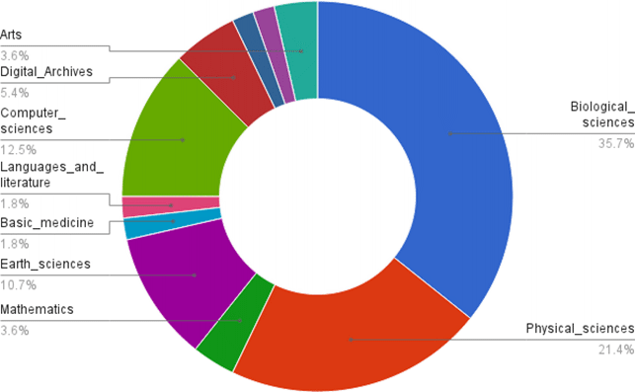
Fig.1 - The figures should be centred and the caption as well

Tables
- Keep the tables centred
- Use the preferred colour scheme when possible
- Use the ‘no spacing’ quick style or the ‘normal’ quick style for your tables
- Please place the caption above the tables.
- When referring to tables in the text please never abbreviate ‘Table’

Table 1 – Preferred colour scheme
 | Name | Partner/Activity | Date
From:
Moderated by:
Reviewed by
Approved by:

- Appendix example

