EGI-InSPIRE

User Support Contacts

EU MILESTONE: MS306

Document identifier: | EGI-MS306-V3
Date: | 29/06/2011
Activity: | NA3
Lead Partner: | INFN
Document Status: | DRAFT
Dissemination Level: | PUBLIC
Document Link: | https://documents.egi.eu/document/564

Abstract
The document provides contact information about teams and individuals who operate user support services in the EGI-InSPIRE project and in the broader EGI collaboration. These support teams and persons work within National Grid Infrastructure/Initiatives (NGIs) and/or discipline-specific user groups provide services for grid application developers and scientific end users of EGI. Through the EGI Helpdesk and through contact lists, maps and interfaces that are publicly available on the EGI website the clients of these service can locate and request support.

- Copyright notice
Copyright © Members of the EGI-InSPIRE Collaboration, 2010. See www.egi.eu for details of the EGI-InSPIRE project and the collaboration. EGI-InSPIRE (“European Grid Initiative: Integrated Sustainable Pan-European Infrastructure for Researchers in Europe”) is a project co-funded by the European Commission as an Integrated Infrastructure Initiative within the 7th Framework Programme. EGI-InSPIRE began in May 2010 and will run for 4 years. This work is licensed under the Creative Commons Attribution-Noncommercial 3.0 License. To view a copy of this license, visit http://creativecommons.org/licenses/by-nc/3.0/ or send a letter to Creative Commons, 171 Second Street, Suite 300, San Francisco, California, 94105, and USA. The work must be attributed by attaching the following reference to the copied elements: “Copyright © Members of the EGI-InSPIRE Collaboration, 2010. See www.egi.eu for details of the EGI-InSPIRE project and the collaboration”. Using this document in a way and/or for purposes not foreseen in the license, requires the prior written permission of the copyright holders. The information contained in this document represents the views of the copyright holders as of the date such views are published.
- Delivery Slip
 | Name | Partner/Activity | Date
From | Gergely Sipos | EGI.eu
Reviewed by | Moderator:  Reviewers:  <<To be completed by project office on submission to AMB/PMB>>
Approved by | AMB & PMB  <<To be completed by project office on submission to EC>>
- Document Log
Issue | Date | Comment | Author/Partner
1 | 07/06/2011 | Table of content | Gergely Sipos / EGI.eu
2 | 16/06/2011 | First draft | Gergely Sipos / EGI.eu
3 | 29/06/2011 | Updates after external review | Gergely Sipos / EGI.eu
- Application area
This document is a formal deliverable for the European Commission, applicable to all members of the EGI-InSPIRE project, beneficiaries and Joint Research Unit members, as well as its collaborating projects.
- Document amendment procedure
Amendments, comments and suggestions should be sent to the authors. The procedures documented in the EGI-InSPIRE “Document Management Procedure” will be followed:
https://wiki.egi.eu/wiki/Procedures
- Terminology
A complete project glossary is provided at the following page: http://www.egi.eu/about/glossary/.
- PROJECT SUMMARY

To support science and innovation, a lasting operational model for e-Science is needed − both for coordinating the infrastructure and for delivering integrated services that cross national borders. The EGI-InSPIRE project will support the transition from a project-based system to a sustainable pan-European e-Infrastructure, by supporting ‘grids’ of high-performance computing (HPC) and high-throughput computing (HTC) resources. EGI-InSPIRE will also be ideally placed to integrate new Distributed Computing Infrastructures (DCIs) such as clouds, supercomputing networks and desktop grids, to benefit user communities within the European Research Area.

EGI-InSPIRE will collect user requirements and provide support for the current and potential new user communities, for example within the ESFRI projects. Additional support will also be given to the current heavy users of the infrastructure, such as high energy physics, computational chemistry and life sciences, as they move their critical services and tools from a centralised support model to one driven by their own individual communities. The objectives of the project are:

- The continued operation and expansion of today’s production infrastructure by transitioning to a governance model and operational infrastructure that can be increasingly sustained outside of specific project funding.
- The continued support of researchers within Europe and their international collaborators that are using the current production infrastructure.
- The support for current heavy users of the infrastructure in earth science, astronomy and astrophysics, fusion, computational chemistry and materials science technology, life sciences and high energy physics as they move to sustainable support models for their own communities.
- Interfaces that expand access to new user communities including new potential heavy users of the infrastructure from the ESFRI projects.
- Mechanisms to integrate existing infrastructure providers in Europe and around the world into the production infrastructure, so as to provide transparent access to all authorised users.
- Establish processes and procedures to allow the integration of new DCI technologies (e.g. clouds, volunteer desktop grids) and heterogeneous resources (e.g. HTC and HPC) into a seamless production infrastructure as they mature and demonstrate value to the EGI community.

The EGI community is a federation of independent national and community resource providers, whose resources support specific research communities and international collaborators both within Europe and worldwide. EGI.eu, coordinator of EGI-InSPIRE, brings together partner institutions established within the community to provide a set of essential human and technical services that enable secure integrated access to distributed resources on behalf of the community.

The production infrastructure supports Virtual Research Communities (VRCs) − structured international user communities − that are grouped into specific research domains. VRCs are formally represented within EGI at both a technical and strategic level.
- Executive SUMMARY
The document provides contact information about teams and individuals who operate user support services in the EGI-InSPIRE project and in the broader EGI collaboration. These support teams and persons work within National Grid Infrastructure/Initiatives (NGIs) and/or discipline-specific user groups and provide services for grid application developers and scientific end users of EGI. Through the EGI Helpdesk and through contact lists and maps that are publicly available on the EGI website the clients of these service can locate and request support. To deal with exceptional support cases and for the efficient coordination of support processes, the User Community Support Team of EGI.eu also maintains information about managerial contacts of the various support teams. This document is an updated version of a similar document (MS301) that has been produced by the project one year ago.

TABLE OF CONTENTS
1 Introduction 6
2 USER SUPPORT CONTACTS 7
2.1 Contacts within the EGI Helpdesk 7
2.2 Contacts within NGI and community-specific support teams 8
2.3 Managerial contacts 11
3 Conclusion 13
4 References 14

Introduction
The services, the operational and support experts, and the user communities of the European Grid Infrastructure (EGI) are distributed across Europe and beyond, and therefore, collection of relevant information on support services for users is of paramount importance. This information is collected and periodically updated by EGI.eu, the central coordination centre located in Amsterdam, which was established in order to facilitate the cooperation among the various NGIs that provide support for users within the EGI ecosystem.
One of the main changes in the transition from EGEE-III to EGI-InSPIRE is related to the operations structures: the original Regional Operations Centres (ROCs) are being gradually replaced by an increasing number of NGI’s Operations Centres. Another major change is the lack of project funding to the end-user communities, as EGI-InSPIRE focuses on support services that can facilitate the establishment and expansion of Virtual Research Communities (VRCs). In the new user support landscape NA3 provides support services for EGI VRCs, while the SA3 work package supports the enhancement of a few key software services for the benefit of the largest EGI communities (called Heavy User Communities - HUCs).
These changes had a great impact on the support organisation since the new topology, and also the support groups, is far more distributed then it was in the past. For this reason it is important that:

- Information on where user support is located within NGIs and within user communities is gathered and kept up to date together with descriptions of expertise and responsibilities of the various support entities.
- The collected information is easy to find and is publicly accessible for existing and emerging user communities.

This document describes where information about the NGI, HUC and VRC user support groups can be found, and about how this information is maintained by EGI.eu and its partners inside and outside of the EGI-InSPIRE project.

USER SUPPORT CONTACTS

Contacts within the EGI Helpdesk
The EGI Helpdesk supports users and operations staff in their daily work with EGI. It is a distributed conglomeration of various ticketing systems, from which the central system is based on the “Global Grid User Support” (GGUS) technology and is provided by the German NGI on behalf of EGI.eu. Other ticketing systems operated by different NGIs are connected to this central instance and is specialised to users or operations staff from a single country. This network of ticketing systems supports structured communication between the various partners of EGI: ticket submitters and experts who capable of answering these tickets.
The way in which someone can access the EGI Helpdesk depends on the ticketing system he/she uses. The central EGI Helpdesk is accessible via the www.egi.eu website (or directly at http://helpdesk.egi.eu or www.ggus.org). Local ticketing systems are accessible from and via NGI web sites. While the different helpdesks may use different implementation technologies, the key services provided by these ticketing systems are roughly the same:

- Opening a new trouble ticket in order to request support or raise a question.
- Browsing and/or filtering tickets that exist within the system.
- Obtaining information on support experts of the Helpdesk.

The experts who answer tickets within the EGI Helpdesk are organised into “support units”. Each support unit is specialised to a different, specific topic (such as MPI applications, Services for Virtual Organisations, services in Hungary). These experts are responsible for answering support tickets that are allocated to the unit within the helpdesk.
Support Units are transparent to end-users, as a central team is responsible of triaging the ticket to the relevant area of expertise. However, knowing the support units and their areas of expertise can in some cases speed up the ticket resolution process. Therefore information about the support units of the EGI helpdesk is publicly available in the EGI Wiki at [R6]. Support units are responsible for keeping their descriptions on this page up to date. Such a support unit description is structured as:

- What is the purpose of the support unit?
- For which components does the unit provide support?
- Who will assign tickets to the support unit?
- Are tickets typically solved in this support unit or reassigned elsewhere?
- Who is responsible for the support unit?
- What documentation is available on the support unit?
- What to do if I have questions which are not dealt with by this description?

Further information on the EGI Helpdesk is provided in MS403 milestone document [R1]. An updated version of this milestone under the MS410 codename is under preparation and will be available soon at [R2].

Contacts within NGI and community-specific support teams
The EGI Helpdesk is the primary system to obtain support, however novice and/or non-technical users may prefer face-to-face interactions with grid experts, or may not know about the EGI Helpdesk at all. Such users should be able to find user support teams within their own countries (NGIs) or within their own scientific communities (VRCs or HUCs). Therefore the User Community Support Team of EGI.eu has collected contact information about NGI and VRC/HUC support teams during the first year of the project. This collection of information is publicly accessible at the “User Support” section of the EGI website: http://www.egi.eu/user-support (see Figure 1).

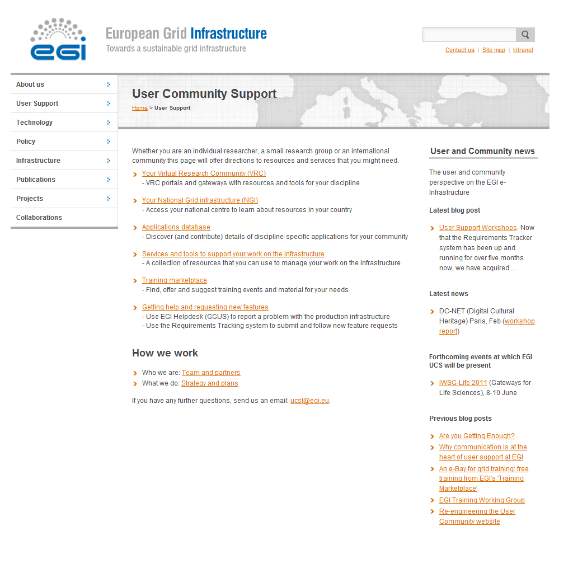
Figure 1. The “User Support” section of the EGI website (http://www.egi.eu/user-support/) provides information on support teams within scientific communities and within NGIs.

The largest user communities are established around scientific disciplines and have experts within them to help their members overcome difficulties related to EGI usage. The list of the large user communities known to EGI is publicly accessible on the website [R7], together with links to the portals or gateways these communities operate for their members to request support (see Figure 2). At the time of writing the page includes contact information for 9 communities. The list is updated by the User Community Support Team as part of the VRC accreditation process [R3].

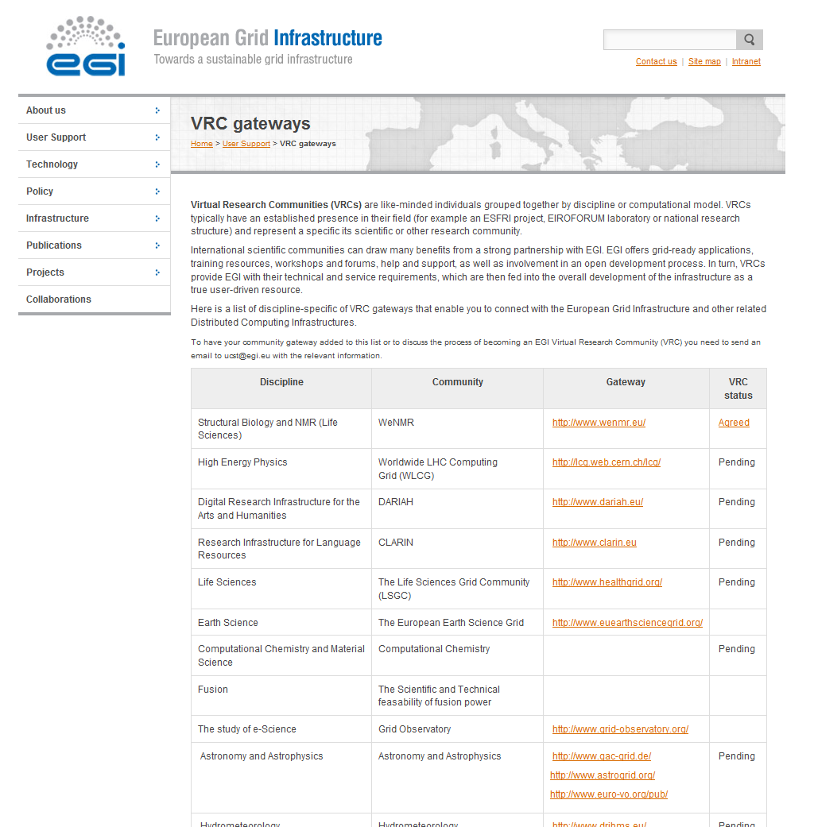
Figure 2. Information on user community-specific support on the EGI Website. Taken from [R7].

The major providers of user support services within EGI are the NGIs. Contact information for NGI User Support teams is presented on a map and in a table format at [R8] (see Figure 3). While the table provides key access information to request user support in the different countries (NGI Webpage and/or email address of NGI User Support team) the map also provides a short description of NGI support activities in English and in the local languages of the country. At the time of writing the page contains contact information to 38 countries and one region (Latin America). By following the link to an NGI website one can request support or can arrange face-to-face meeting/consultation with local grid experts.

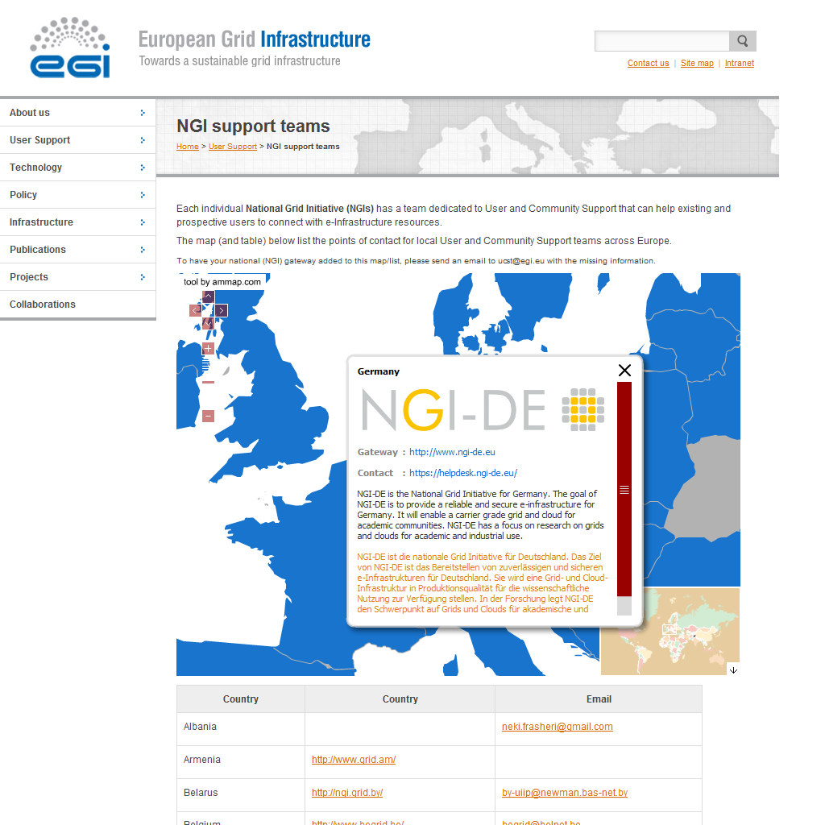
Figure 3. NGI User Support contact information on the EGI Website. Taken from [R8].
Details of NGI-DE is displayed as an example.

During the third project quarter (November 2010 – January 2011) the User Community Support Team has reviewed the NGI websites that are linked to this page from a user perspective. The review highlighted issues with some of these NGI User Support sites (such as lack of information about support services, contacts, EGI and EGI-InSPIRE). These reviews have been sent to the NGIs and triggered updates to many of the NGI user support web pages.

Managerial contacts
While the helpdesk and NGI/VRC contact map and lists are sufficient mechanisms to find support for regular user activities, in some exceptional cases the managers or user support teams may need to be contacted. For this reason, and also for project coordination purposes, EGI.eu established managerial contacts with VRCs and with NGI User Support Teams.
The contacts with VRCs are established during the VRC accreditation process. Managerial contacts for NGI User Support Teams have been collected by the User Community Support Team during the first project year. The names of these persons is publicly visible in EGI Wiki [R5] (see Figure 4.) Full contact details are stored within the Customer Relationship Management database of EGI.eu, and can be obtained from the User Community Support Team (ucst@egi.eu) or the Project Office (egi-inspire-po@egi.eu). To simplify and to archive communication with and among the NGI User Support Team managers, these persons are subscribed to an email list (ngi-ust-managers@mailman.egi.eu).

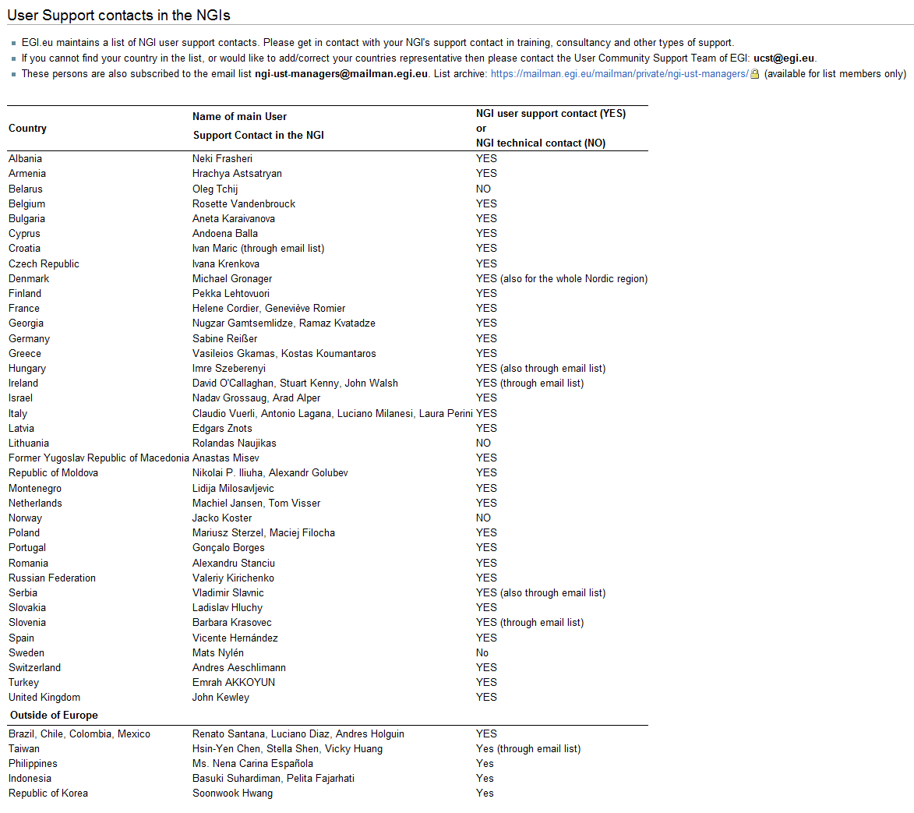
Figure 4. List of managerial contacts of NGI User Support Teams. Taken from [R5].

Conclusion
During the first year of EGI-InSPIRE the User Community Support Team of EGI.eu together with the relevant EGI partners within and outside of the project, have successfully gathered contact information for user support.
The EGI Helpdesk brings experts together from NGIs, and from user communities into support units that are described in the EGI Wiki.
The NGI and VRC contact map and lists that are accessible on the EGI website provide easy-to-access mechanisms to those who require support from specific geographical locations or scientific disciplines.
A Customer Relationship Management database and email lists with managerial contacts from NGI User Support Teams and from VRCs enable efficient coordination of support activities by EGI.eu. Contact information is kept up to date by the User Community Support Team of EGI.eu, and changes can be requested in email at ucst@egi.eu.

References
R 1 | MS403 - EGI Helpdesk and the NGI Support Units:  https://documents.egi.eu/document/49
R 2 | MS410 - EGI Helpdesk and the NGI Support Units:  https://documents.egi.eu/document/522
R 3 | D3.1 - User Community Support Process:  https://documents.egi.eu/document/106
R 4 | EGI.eu:  http://www.egi.eu
R 5 | List of managerial contacts of NGI User Support Teams: https://wiki.egi.eu/wiki/TNA3.3_NGI_User_Support_Teams#User_Support_contacts_in_the_NGIs
R 6 | List of support units of the EGI Helpdesk system:  https://wiki.egi.eu/wiki/Category:FAQ_Responsible_Units_(GGUS)
R 7 | List of Virtual Research Communities and their gateways for members:  http://www.egi.eu/user-support/vrc_gateways/
R 8 | NGI User Support contact information:  http://www.egi.eu/user-support/ngi_support/

