EGI-Engage

The website is reviewed
M2.6

Date | 16.03.2017
Activity | WP2
Lead Partner | EGI Foundation
Document Status | FINAL
Document Link | https://documents.egi.eu/public/ShowDocument?docid=2834

Abstract
This milestone describes the changes and revisions underwent by the EGI website throughout the second project year.

COPYRIGHT NOTICE
This work by Parties of the EGI-Engage Consortium is licensed under a Creative Commons Attribution 4.0 International License (http://creativecommons.org/licenses/by/4.0/). The EGI-Engage project is co-funded by the European Union Horizon 2020 programme under grant number 654142.
DELIVERY SLIP
 | Name | Partner/Activity | Date
From: | I. Popescu | EGI Foundation/WP2 | 15.03.2017
Moderated by: | Małgorzata Krakowian | EGI Foundation/WP1
Reviewed by | Małgorzata Krakowian | EGI Foundation/WP1 | 16.03.2017
Approved by: | AMB and PMB |  | 16.03.2017

DOCUMENT LOG
Issue | Date | Comment | Author/Partner
1.0 | 15.03.2017 | First draft | S.Coelho / I.Popescu, the EGI Foundation
FINAL | 16.03.2017 | Final version

TERMINOLOGY
A complete project glossary is provided at the following page: http://www.egi.eu/about/glossary/

Contents
1 Background information 4
2 The new EGI website 5
2.1 Aims 5
2.2 The new look & feel 5
2.3 The new content 6
2.4 Website analytics 7

Background information

The EGI website is the main communication channel of EGI and its management is part of the NA2.1 task (Communications & Events) of the EGI-Engage project.
In the deliverable M2.3 we identified a professional need of completely revamping the EGI website and described the process of restructuring it as well as how to accomplish this goal.
As such, we saw that the old EGI website needed a full overhaul because:
- The navigation structure of the website was out of line with current trends in online communication.
- The website was targeted at too many groups and tried to convey too many messages.
- The website was not structured in a way that allows comfortable browsing in mobile devices.
- The website content was burdened by five years of legacy that, in many cases, no longer reflected the current EGI community, nor the EGI strategy.
To address these problems, the Communications team decided in conjunction with the Managing Director to build a new website. Therefore, in late 2015, we chose a communication& design agency to help us renovate the EGI online presence. We worked together during 2016 to deliver a brand new website in September 2016.
This milestone will provide a current state of the art of the new website.

The new EGI website

Aims
The new website is very generic; it is about EGI, its services and supported users as a whole.
The main aims of the website are:
- To showcase our services
- To increase service awareness
- To establish EGI as a leading data and computing e-infrastructure for science
- To give visibility to the stakeholders
- To showcase what scientists are accomplishing using the EGI services
- To promote news & events from the EGI Community

The new look & feel
The Communications team suggested a new ‘look and feel’ that was further implemented in the the CMS platform Wordpress.
The new design is therefore clean, simple, eye-catching and mobile-friendly and it respects the EGI branding guidelines (colours, fonts, etc.). The navigation of the website is user-friendly and in line with current online trends.
All the functionalities and the available content are chosen with the clear purpose of establishing the EGI website as an efficient communication channel and focused on the service offer.
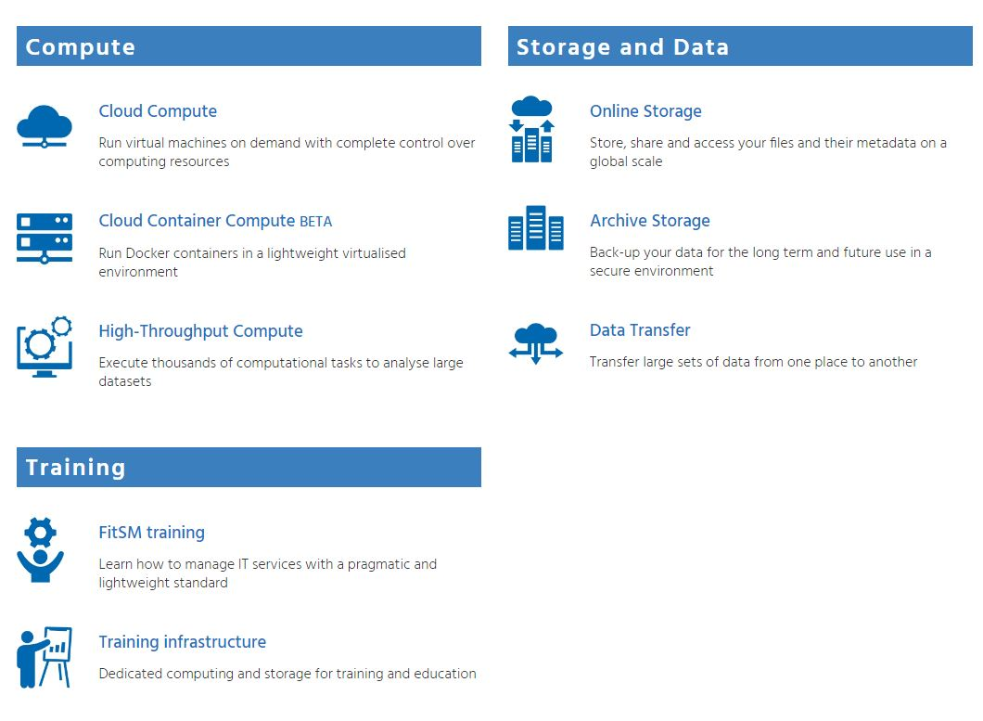

The new content
The new website has comparatively less content that the old website and it showcases the EGI service catalogue.
The content is structured as follows:
- Homepage
The homepage is the first point of contact with the EGI community and potential users.
It is focused on providing key information about the EGI organisation; it highlights the EGI services and how to access them; it gives visibility to the EGI Council and endorses news and events from the EGI community.
The main menu of the homepage is made of and leads to the following key webpages/areas:
- Services
- Federation
- Use cases
- Business
- About

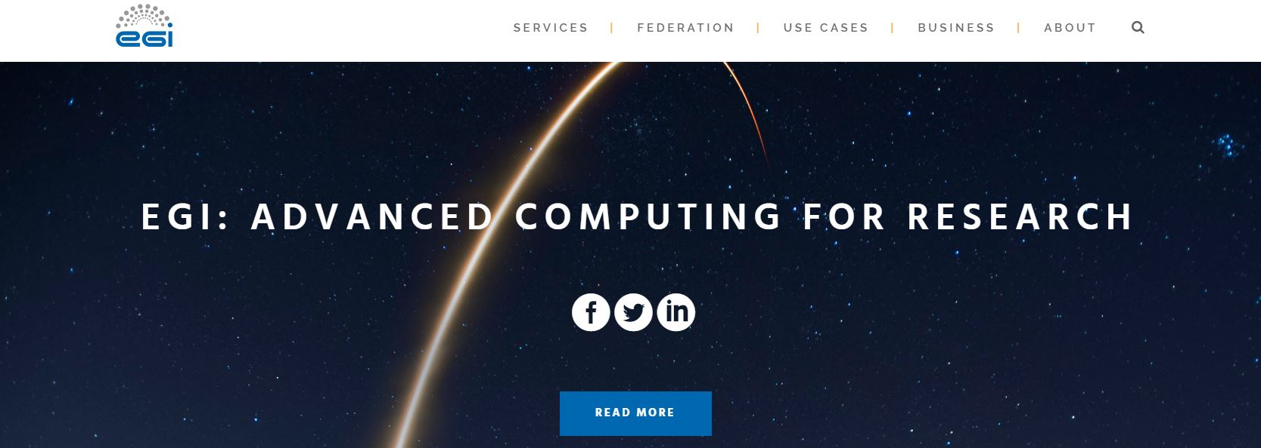

The Services webpage provides a clear overview of the EGI service catalogue. There are dedicated webpages for each service, where visitors can find service descriptions, information on providers and access policy and they can fill in forms to request a service or ask for more information. The Service Request form and the Ask for more information form are new communication tools on the EGI website and are both unique ways of interacting with readers.
The Federation webpage describes the EGI Federation as a whole and gives visibility to the EGI service providers: the EGI Federated Cloud and the EGI Federated data centres.
The Use Cases area is a place for showcasing the work and scientific accomplishments of researchers that use EGI services. It is made of several subpages dedicated to collaborations with RIs, scientific applications powered by EGI and research stories unveiling scientific work made possible via our services.

The Business webpage is dedicated to creating a close relationship with the business sector. Some of the EGI services can be used by businesses, especially SMEs, and so this area is entirely devoted to engaging with them and presenting them our service offer.
The About section is the EGI corporate area. It contains information about the EGI Foundation and the people behind it, the EGI Council and internal services and it represents a space to store news, publications and generic information about EGI projects and collaborations.
Overall, the new website is much better structured than the old one; it has a neat content and a fresh look & feel.

Website analytics
The EGI website reached a total of 37000 unique views since the launch of the website (September 2016 to March 2017). The most visited pages are the Homepage with around 9000 visits, the Services webpage with about 3000 visits and the About section with around 1500 visits.
The most viewed services are Cloud Compute with a total of 1000 unique views, the FitSM training service with 750 unique views and the High-Throughput Compute service with 350 unique views.
The Service Request form reached about 400 views since the website went live.
The Research stories webpage has had around 800 unique visits since the launch of the website, with the CTA story reaching 160 views and the HESS story attaining 120 views.

