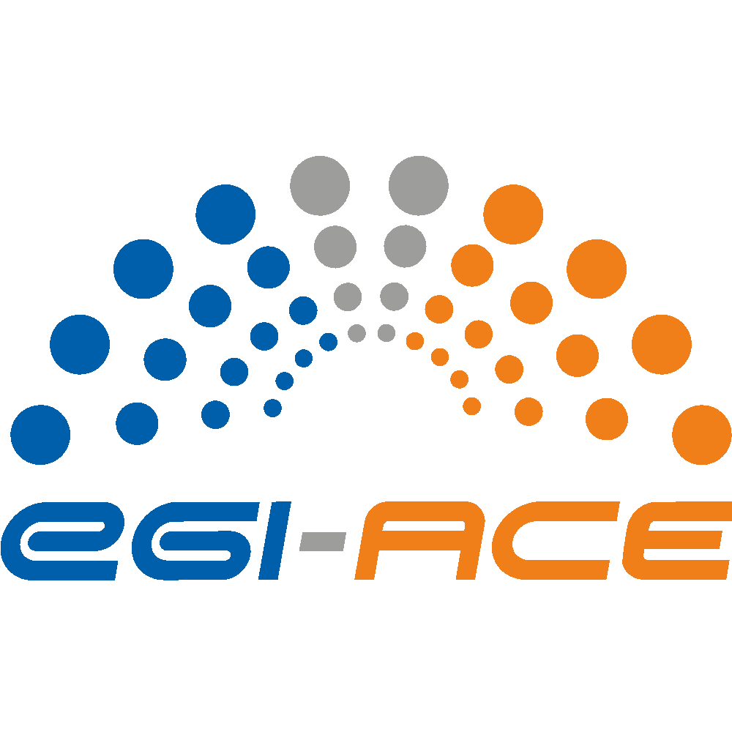
D2.2 EGI-ACE Strategic Plan

Lead partner: | EGI Foundation
Version: | v1
Status: | Under EC review
Dissemination Level: | Public
Keywords: | Strategy, federation, data spaces, EOSC Compute Platform
Document Link: | https://documents.egi.eu/document/3817

Deliverable Abstract
The document provides the strategic direction of the project in alignment with the EOSC SRIA and the EGI Federation strategy based on the learning and evolution of the external environment. The aim is to serve as guidance for the project and to provide inputs on the evolution of the EOSC and EGI strategies. At the end of the project, there will be a follow-up deliverable (D2.10) focusing on recommendations for the relevant EOSC stakeholders to ensure a lasting impact of the project results.

COPYRIGHT NOTICE
This work by parties of the EGI-ACE consortium is licensed under a Creative Commons Attribution 4.0 International License. (http://creativecommons.org/licenses/by/4.0/).
EGI-ACE receives funding from the European Union's Horizon 2020 research and innovation programme under grant agreement no. 101017567.

DELIVERY SLIP
Date | Name | Partner/Activity
From: | Sergio Andreozzi  Gergely Sipos | EGI Foundation/WP1/WP2
Moderated by: | Malgorzata Krakowian | EGI Foundation
Reviewed by: | Tiziana Ferrari  Giuseppe La Rocca  Sergio Maffioletti | EGI Foundation WP1  EGI Foundation WP5  EGI Foundation WP6
Approved by: | PMB, SDS, SFG

DOCUMENT LOG
Issue | Date | Comment |  | Author
v.0.1 | 27/08/2021 |  | Table of content: first draft | Sergio Andreozzi  (EGI Foundation)
v.0.2 | 01/10/2021 |  | Discussed ToC and scope of sections with SFG, annotated questions and actions in the document | EGI-ACE SFG Members
v.0.3 | 25/10/2021 |  | Updated ToC and drafted initial content | Sergio Andreozzi, Gergely Sipos,  Tiziana Ferrari  (EGI Foundation)
v.0.4 | 04/11/2021 |  | Reviewed current draft with SFG and annotated questions and actions | EGI-ACE SFG Members
v.0.5 | 17/11/2021 |  | Document in external review to EGI-ACE PMB, SDS and SFG | Sergio Andreozzi, Gergely Sipos,  Tiziana Ferrari,  Mark Dietrich  (EGI Foundation)
v.1 | 29/11/2011 |  | Addressed comments from the external review | Sergio Andreozzi, Gergely Sipos,  Tiziana Ferrari  (EGI Foundation)

TERMINOLOGY
https://confluence.egi.eu/display/EGIG
Terminology/Acronym | Definition
EOSC | European Open Science Cloud
ECP | EOSC Compute Platform
PMB | Project Management Board of the EGI-ACE project
SDS | Service Delivery and Support Board of the EGI-ACE project
SFG | Strategy and Foresight Expert Group of the EGI-ACE project
SRIA | Strategic Research and Innovation agenda of EOSC

Contents
Executive summary 5
1 Introduction 7
2 EOSC Compute Platform Architecture 8
2.1 Components 8
2.2 EOSC Compute Platform support to Data spaces 10
2.3 Support for users and providers 11
2.4 Usage, Capacity Plan and Financial Requirements 12
3 Relevant updates in the EOSC landscape 15
4 Strategic positioning of EGI-ACE outcomes in the EOSC landscape 21
4.1 Positioning the EOSC Compute Platform 21
4.2 Defining the ‘Minimum Viable EOSC Compute Platform’ 23
4.3 Positioning the EGI-ACE Data Spaces 24
5 Contribution to the EOSC objectives and groups 27
6 Contribution to the EGI Federation strategy 31
7 Strategic recommendations 33

Executive summary
EGI-ACE is a 30-month project (Jan 2021 - June 2023) with a mission to empower researchers from all disciplines to collaborate in data- and compute-intensive research through free-at-point-of-use services.
Building on the results of the EOSC-hub project, EGI-ACE delivers the EOSC Compute Platform (ECP), a system of federated compute and storage facilities to support processing and analytics for distributed data and compute use cases. EGI-ACE enables the efficient use of European Commission (EC) and national funds by integrating cross-border access with national access, maximising the return of investments for all stakeholders.
Thanks to this platform and integrated funding and resource allocation models, users can benefit from free at the point of use and easy access to different types of compute resources, dedicated support and consultancy to deal with complex use cases, relationship building with service providers committed to support research. Providers can benefit from a scalable resource allocation mechanism to support international research use cases, simplified integration with the EOSC, simplified order handling and customer relationship management, access to federation and interoperability best practices, financial incentives to open up resources for the benefit of research.
The project also delivers 13 data spaces, systems of data and applications from different scientific disciplines for easy and scalable analysis and exploitation of big datasets. The experience in building them will be a key value when discussing interoperability frameworks.
In the first nine months of activity, EGI-ACE services were used by more than 40,000 users. In particular, the data space services were used by over 37,000 users while the Compute Platform services by ~3,000 users via direct access (i.e., to manage virtual machines and job) and by 37,000 users via the hosted data spaces. The request for resources shows increasing use and predicts an exponential growth for the coming years.
As the project approaches the end of the first year, we have analysed the relevant changes in the broader landscape. Most notably, we have identified that the tripartite EOSC Partnership was signed, thus creating a long-term joint commitment from the EC, the Member States and Associated Countries, and the organisations represented by the EOSC Association. Also, several EOSC Task Forces were kicked off, thus creating community engagement contexts where to contribute EGI-ACE results or from where to extract key information. The EOSC Future project started, thus becoming the key stakeholder to interface with regards to the use of the EOSC Core.
Based on the current project results and of the evolved context, we confirm the identified project objectives as valid. Also, we propose 6 key recommendations and related desired outcomes as depicted in the following table. At the end of the project, there will be a follow-up deliverable (D2.10) focusing on recommendations for the relevant EOSC stakeholders to ensure a lasting impact of the project results.

# | Recommendation | Expected Outcome
1 | Promote the value proposition of the EOSC Compute Platform so that it is recognised as an official EOSC element and valued by both service providers and users. | Current and potential EOSC users and providers have easy access to the EOSC Compute Platform information, they understand the value of it and support its continuation. Also, official EOSC documents include the EOSC Compute Platform.
2 | Develop open and transparent processes and procedures for new providers and new services to join the EOSC Compute Platform. Also, define the requirements to be part of the EOSC Compute Platform (both technical and policy related) and its relationship with the EGI Federation governance and affiliation. | Current and potential providers have a clear understanding of how to join the ECP and how it differs from the EOSC Onboarding. The relationship between the EOSC Compute Platform and EGI membership and portfolio is well articulated and presented in relevant communication materials.
3 | Develop and sustain the researcher support network of the EOSC Compute Platform and link it with emerging EOSC user support networks. | There is an active support team in every country that participates in EGI-ACE to serve new users’ and providers’ joining requests.  The EGI-ACE network of providers is known and used by other thematic support networks for compute-related consultancy.
4 | Seek support for sustaining and scale out the delivery of the EOSC Compute Platform after the end of EGI-ACE. | The EC recognises the value of the ECP as an element of the EOSC and contributes to its delivery for the benefits of research. Also, the EOSC Steering Board representing the MSs/ACs support it as part of the in-kind contributions to the EOSC initiative.
5 | Contribute to the development of a data space reference model and support the definition of related financial and sustainability models. Build partnership with relevant data space initiatives to uptake and evolve the EGI-ACE data spaces and their approach. | The most successful data spaces can access new funding opportunities after the end of EGI-ACE. The EGI-ACE expertise and reference model is used beyond the project for the building of Data spaces.
6 | Contribute to the development of the EOSC Interoperability Framework, to the “Data Spaces Technical Framework” that will be created through the Digital Europe (DE) Work Programme, and to other relevant initiatives that work towards a single, European Data space. | Data spaces evolve within Europe without becoming data/application silos, using the EGI-ACE implementation approaches and tools in collaboration with industry and other academic solutions.

Introduction
EGI-ACE is a 30-month project (Jan 2021 - June 2023) with a mission to empower researchers from all disciplines to collaborate in data- and compute-intensive research through free-at-point-of-use services.
EGI-ACE delivers the ‘EOSC Compute Platform’, an integrated compute environment that federates compute and storage facilities with various platforms and access layers. The project also contributes to the EOSC Data Commons through the setup and provisioning of ‘Data Spaces’ that integrates scientific datasets and data analytics tools on top of the Compute Platform.
EGI-ACE is run by the EGI community, an international collaboration that federates the digital capabilities, resources and expertise of hundreds of national and international research communities in Europe and worldwide. With EGI-ACE the EGI Federation and research communities of pan-European relevance are joining efforts to deliver a distributed federated infrastructure that responds to the present and future needs of data-centric scientific computing in Europe through the EOSC.
The project was designed with the following main objectives:
- Deliver the European Open Science Cloud Compute Platform and expand the supply-side
- Contribute to the implementation of the EU Data Strategy and the EOSC Data Commons to support the Green Deal, Health, Fundamental Research and Social Sciences and Humanities
- Integrate the EOSC Compute Platform with the EOSC Portal and the EOSC Core
- Contribute to the realization of a global Open Science Cloud
- Expand the demand-side of EOSC across sectors and disciplines
After 10 months of operation, this document presents additional strategic recommendations that are identified as necessary for a lasting EGI-ACE success. They have been defined based on the following approach:
- The concept of EOSC Compute Platform and Data Spaces have been revised and updated based on the initial experience (Section 2)
- Relevant updates in the EOSC environment are identified (Section 3)
- The strategic positioning of both EOSC Compute Platform and Data Spaces in the wider EOSC landscape is defined (Section 4)
- The contribution to the EOSC Objectives and Groups are identified (Section 5)
- The contribution of the project to the implementation of the EGI Federation strategy is described (Section 6)
- The strategic recommendations are identified in terms of issues, recommendations, desired outcome and initiatives (Section 7).

EOSC Compute Platform Architecture

Components
The EOSC Compute Platform federates distributed compute and storage facilities to support processing and analytics via a set of services for distributed data and compute use cases. The EOSC Compute Platform architecture is organized in functional blocks as shown in Figure 1.
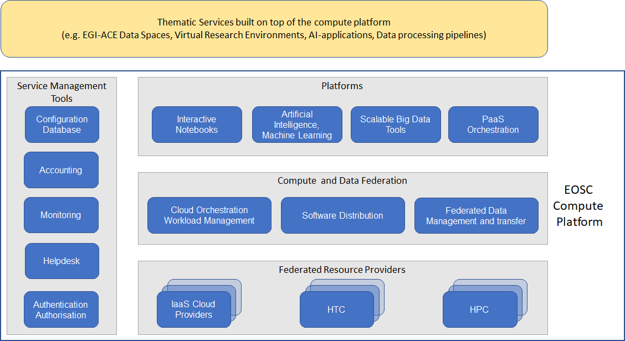
Figure 1 EOSC Compute Platform functional block diagram
Infrastructure layer
At the bottom of the architecture, the Federated Resource Providers deliver a hybrid infrastructure from academic and commercial providers for running/hosting research applications and data. Different types of providers are included in this layer:
- IaaS Cloud Providers provide access to Virtual Machine-based computing with associated Object and Block storage. These deliver a very flexible and customisable platform where users have complete control over the software and the supporting compute capacity. This flexibility of the computing platform enables the support of a variety of workloads: user gateways or portals, interactive computing platforms and almost any kind of data- and/or compute-intensive workloads.
- HTC (High Throughput Compute) provides access to large, shared computing systems for running computational jobs at scale. These allow researchers to analyse large datasets in an ‘embarrassingly parallel’ fashion, i.e., by splitting the data into small pieces, and executing thousands, or even more independent computing tasks simultaneously, each processing one piece of data. HTC means the execution and management of many independent tasks over longer times.
- HPC (High Performance Compute) (to be available in 2022) supports very optimised application of machines that have a lot of interconnected processing units. with many dependent tasks that need large amounts of parallel computing along with a low latency and high bandwidth interconnection network.

Federation layer
The Compute Federation services orchestrate the execution of user workloads in the Federated Resource Providers. They exploit data locality by moving computing near data and facilitate application portability with the support of a diverse range of computing platforms (Cloud IaaS, HTC, HPC) and the interaction with software distribution tools (as VM images, container images or binaries directly). There are three services in this layer of the architecture:
- Hybrid cloud orchestration for the deployment of custom virtual infrastructure over multiple IaaS cloud backends within academic and commercial clouds;
- Workload Manager for the scheduling and execution of jobs in the federated resource providers (both cloud and HTC/HPC);
- Software distribution, for making software available at the Federated Resource Providers (e.g., as VM images).
The Federated Data services support exposing discoverable datasets and staging data into/out of the EOSC Compute Platform Cloud. The Federated Data Management services control the raw storage capacity offered by the Federated Resource Providers to deliver data products that can be transferred among the EGI-ACE providers, and between EGI-ACE providers and external data repositories. The Federated Data Management function uses the Data Transfer service to perform the transfers.
Platforms layer
A Platforms service area provides generic added-value services for scientific communities to build thematic services for end-users (typically for researchers). The platforms rely on the existing Compute Federation and Data Federation services to access the Federated Resource Providers and deliver Interactive Notebooks, PaaS Orchestration to facilitate the deployment of complex applications, and Artificial Intelligence and Machine Learning and Scalable Big Data Tools that can be reused in several research disciplines.
Service Management Tools
The Service Management Tools pillar delivers the functionality for services of all other areas to be integrated in the Federation. They support the operation of the EOSC Compute platform and integrate and interoperate with the EOSC Core that is run and is further developed in the EOSC Future project. EGI’s Authentication and Authorisation service, called Check-in, is a key component of the architecture that enables using a common identity across all the layers and services of the EOSC Compute platform. Configuration Database, Monitoring, Accounting, and Helpdesk services are also included in this area alongside with other non-technical services and coordination activities like Operations Management, and Security and Incident Response.

EOSC Compute Platform support to Data spaces
The project contributes to the EOSC Data Commons through the setup and provisioning of ‘Data Spaces’ that integrates and hosts scientific datasets and data analytics applications on top of the Compute Platform. Data spaces are ‘thematic services’, i.e. they provide discipline specific capabilities for the end users. However, unlike other types of Thematic Services, Data Spaces host and integrate both data and applications into a single unit, enabling the scalable analysis of big datasets.
In contrast to simple “Publication of Open Data”, a Public Data Space manages issues of access and use, as well as provides related tools and infrastructure. The EC’s usage of the term “data space” assumes a public data space, so we interpret a public Data space as a “public collection of FAIR, quality data and related resources consumed, produced and provided by identified participants, each respecting societal values and operating within an explicit framework of trust and governance”.
EGI-ACE Data spaces are built by scientific communities, research infrastructures and projects. The EGI-ACE consortium includes 13 Data spaces (See Figure 2), and supports additional ones that contact EGI-ACE via its open calls with the intention to set up Data spaces on top of the EOSC Compute Platform. Data spaces and other thematic services share the EOSC Compute Platform as a common architecture. The rest of their setup is specific to their scientific domains and target user groups.
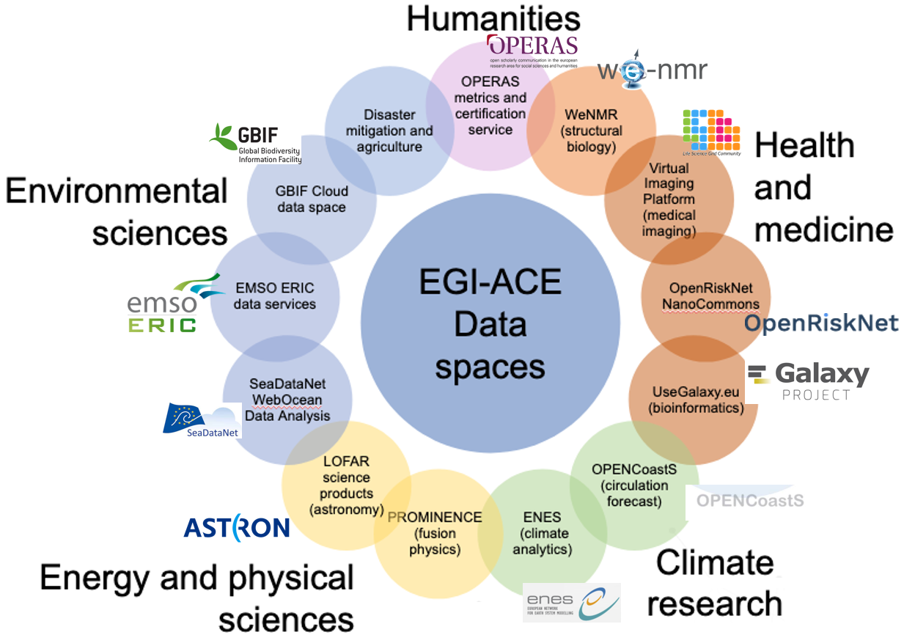
Figure 2 EGI-ACE Data Spaces included in the project consortium

Support for users and providers
Support for users and providers are integral parts of the project workplan. User support helps individual users and user communities in the uptake and use of the services, provider support helps new providers join the infrastructure, and existing providers in operating according to the EOSC and EGI standards. Without support there would be no (or much less) uptake as experience shows that e-infrastructure use and deployment are quite effort intensive activities where proper support can save a lot of time and effort for the customers.
The EGI-ACE user support is based on four pillars (see also Figure 3):
- Shepherds: those persons (experts) who are assigned to the use case that are served by the project and have the overall responsibility for mapping the use cases to providers, the implementation of the use cases, and reporting about achievements, lessons and other outcomes. Shepherds create ‘competence centres’, use case specific support groups that consist of service providers, technical experts and other interested parties providing assistance for a use case.
- Training programme: series of events (and the related materials) that the project delivers to educate users and providers about the services and their use. The training programme in 2021 were focussed on webinars and online workshops. In 2022 we aim to expand the scope with new event formats and to new audiences (e.g., compute service administrators).
- User documentation: docs.egi.eu serves as the online catalogue of service manuals for both users and providers.
- Site/service specific support teams: Service/resource specific support is provided by every provider and complements the first line support that shepherds and the EGI Foundation team are providing.
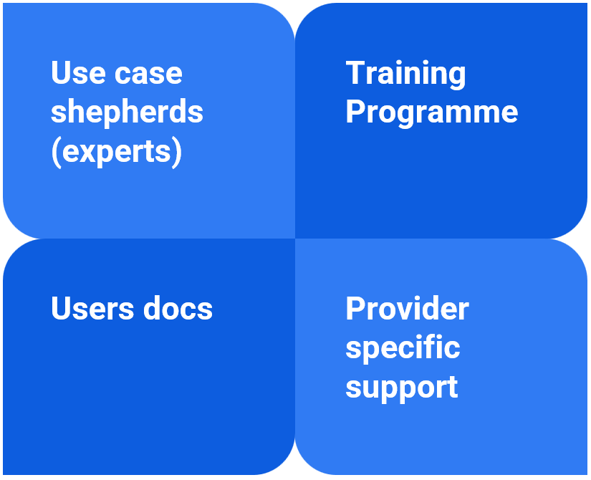
Figure 3. Pillars of user support in EGI-ACE
The EGI-ACE provider support is based on the following pillars:
- Provider documentation: The ‘for providers’ section at docs.egi.eu serves as the primary source of information on how to join the EGI federation. This is complemented by project specific documentation
- EGI.eu team and OMB: The Operations team at the EGI Foundation and the national ‘Operation Management Board’ members of every EGI member state are providing assistance for new sites that want to join the infrastructure.
- Onboarding support (WP2): Work Package 2 is organising events, and provides documentations that are specific to the project (e.g., how to onboard your service in EOSC.)
- Integration support (in WP7 and EOSC-Future): The providers of the Service Management Tools (See Figure 1) provide special assistance to new providers on how to integrate their service into the EGI-ACE operational backbone.
The structured and integrated support that EGI-ACE provides for users and service organizations is an important distinctive feature that sets the EOSC Compute Platform apart from commercial compute services.

Usage, Capacity Plan and Financial Requirements
Usage
In the first nine months of activity, EGI-ACE services were used by more than 40,000 users. In particular, the data space services were used by over 37,000 users while the Compute Platform services by ~3,000 users via direct access (i.e., to manage virtual machines and job) and by 37,000 users via the hosted data spaces.
The EOSC Compute Platform served 56 user communities in this period. These communities are either part of the consortium (data space providers), applied for access via the EOSC Portal, via the EGI-ACE Open Calls, or with EGI Foundation directly.
The total capacity requested by EGI-ACE use cases amounts to 105 million CPU hours. The requested capacity was made available by the EOSC Compute Platform by relying on:
- EC funding made available by the EC through EGI-ACE Virtual Access.
- National funding mobilised by the national e-Infrastructures participating in the EGI infrastructure.
- EGI participants’ funding supporting the cost of EGI federation services.
Purpose of this capacity allocation approach is to make optimal use of EC funding to support cross-border access by communities that are not in-house resourced, while at the same time maximizing the return of investment in national digital infrastructures. As a consequence, in the first 10 months of the project 47 million CPU hours were funded by the EC with Virtual Access (VA), 39 million CPU hours were allocated by national funding agencies, and 19 million hours were provided through external project funds (BD4NRG, PITHIA-NRF, DECIDO, AI4PublicPolicy, StarwAI, LETHE, DIGITbrain, Exprivia ESA - Benchmark, PolicyCLOUD, C-SCALE).
The 56 use cases are very diverse from their origin, type and disciplinary scope:
- The origin of the use cases ranges from long-tail of science users to H2020 projects, international scientific communities and ESFRI Research Infrastructures.
- The type varies from batch data analysis on High Throughput Servers to interactive analytics in the cloud, (Web) service hosting in the cloud, data spaces (hosting data, applications and front-end services in the cloud) and AI/ML analysis.
- The disciplinary coverage is very diverse and comprehensive: life sciences, physical sciences, environmental sciences, social sciences, agriculture, computer science and others.
The use cases can be classified into 5 categories:
- Hosting of services in the cloud
- Data processing in the cloud
- Data processing on HTC batch systems
- Data spaces (combining computing, storage and often also service hosting)
- Artificial intelligence (model training then exploitation through hosted services)
Capacity Plan and Financial Requirements
The EGI-ACE VA budget allows project members to deliver 80 million CPU hours in total over 30 months thanks to EC VA funds (see Column 1 in Table 1.)
Assuming a constant level of demand till July 2023 (i.e., a demand of about 47 million CPU hours over 9 months), the total VA CPU hours capacity demand is expected to be 160 million CPU hours during the entire 30 project months. This estimated capacity would require 13 million € EC funding, more than the amount currently available. (See Column 2 in Table 1.)
In fact, we estimate the future demand to grow even further than this by looking at the historical trend of CPU hours usage in the EGI Cloud infrastructure (Figure 4), the major element of the EGI-ACE Infrastructure layer. From the EGI Federated Cloud accounting data (Figure 4 below), we can observe a 60% annual increase of cloud capacity consumption between September 2020 and September 2021, reaching 43 million CPU hours consumed over 12 months. Assuming a comparable growth rate for 2022 and 2023, we can more realistically expect a total demand of 240 million CPU hours for the whole duration of the project: 62 in the 1st project year, 100 in 2nd project year, and 80 in the final 6 months. Such demand would require almost 20 million € EC funding in 30 months, as illustrated in Column 3 of Table 1.

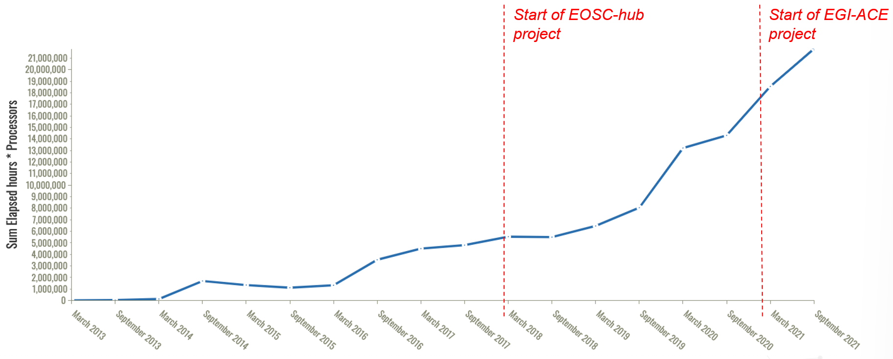
Figure 4. CPUh usage in the EGI Cloud infrastructure since March 2013. Source: EGI Accounting system (https://accounting.egi.eu/)

There is no sign that the current user demand would change for 2022. Therefore, even with the conservative scenario (Column 2 of Table 1) we can expect that EGI-ACE will run out of VA cloud capacity in the second half of 2022. Around mid-2022 the project will have to assess the situation (incl. how much of the allocated CPUhs have been eventually used), and take preventive actions, which can include:
- Claiming back unused CPUh from some of the use cases
- Apply stricter (or limited capacity) selection criteria for new use cases
- Encourage Compute Platform providers to offer more capacity from national funds
- Requiring future use cases to bring co-funding.

Table 1: CPUh and financial status and predictions.
Current situation  (after 9 months) |  | Prediction for the 30-month project based on 2021 demand |  | Prediction for the 30 months project with 60% annual CPUh growth
Allocated CPU hours with VA  (Million) | EC funding  for 30 months (Million €) | Required CPU hours in VA  (Million) | Required funding  (Million €) | Required CPU hours in VA  (Million) | Required funding (Million €)
47 | 8 | 160 | 13 | 240 | 20

Relevant updates in the EOSC landscape
This section provides an overview of the main changes in the EOSC landscape that took place after the project started and that are relevant to be considered when formulating additional recommendations for the project.

Launch of the EOSC PPP and EOSC SRIA
In June 2021, the European Commission (EC) and the newly formed EOSC Association started a co-programmed partnership until 2030 aiming to fortify the EOSC with European funding of almost €500 million and an in-kind contribution of the partners of also €500 million. The aim is to improve the storing, sharing and especially the combining and reusing of research data across borders and scientific disciplines. The progress is steered by a new EOSC tripartite governance partnership involving the EU represented by the European Commission, the participating countries represented in the EOSC Steering Board and the research community represented by the EOSC Association.
The signed MoU contains 3 general objectives (GOs), 9 specific objectives (SOs) and 14 operational objectives (OOs) that are taken by the EOSC Strategic Research and Innovation Agenda (SRIA) published in February 2021. The EGI-ACE project’s contributions to the EOSC SRIA and EOSC PPP objectives are highlighted in Section 5.

Setting up of EOSC AGs/TFs
The EOSC Association established advisory groups and task forces to engage stakeholders in the development of the EOSC. The EOSC Association Advisory Groups (AGs) are a structure to allow Association members and others to help steer the implementation of EOSC. The Advisory Groups provide an “umbrella” for a set of Task Forces (TFs) that are highly related and have the same Liaison person from the EOSC Association Board of Directors. The Task Forces address key areas of implementation. They will liaise with EOSC projects to offer feedback on developments, as well as identify strategic gaps and areas for investment to input to SRIA. After a consultation process to develop the topics and the charters, a call for members was launched. Approved members were nominated on 20 September 2021 and soon after the groups started operation with the nomination of the chairs. The EGI-ACE project’s contributions to the task forces are mentioned in section 5.

Shift of funding model for the EOSC Core and part of the EOSC Exchange
On 15th June 2021, the European Commission adopted the Work Programme 2021-2022 of the new EU framework programme for research and innovation Horizon Europe. Under Destination 5 (“Network connectivity in Research and Education - Enabling collaboration without boundaries (INFRANET)”), the action “Delivering the EOSC core infrastructure and services” aims to support the delivery of the EOSC Core and part of the EOSC Exchange after the end of the EOSC Future project.
In contrast to most of the actions which are published as grants, this action is published as public procurement, meaning that it will be subject to a competitive tender procedure in compliance with the applicable public procurement rules set out in the EU Financial Regulations. As the EOSC Core matures, with this shift, the intention of the EC is to better control the outcome of the delivery of the EOSC Core according to well defined requirements. This approach has been followed in the past with other core services, e.g. the European Data Portal, the European research publishing platform or the European IP Helpdesk
The current action description foresees two main elements: a) Deployment and operationalisation of the EOSC infrastructure for access to and exploitation of FAIR data and services; b) Provision of innovative, modular, customisable and composable services to serve a wide variety of users. The reserved budget is 35 M€ and the tender should be announced during the last part of 2022.
The current description of the two elements opens the possibilities for possible funding for EGI-ACE services after the end of the project (especially in element b). The evaluation of how EGI-ACE components could be positioned in this opportunity will be developed during the first part of next year as there will be more clarity on the scope and requirements of the future action.
Launch of the European Alliance for Industrial Data, Edge and Cloud
On 19th July 2021, the European Commission (EC) launched the European Alliance for Industrial Data, Edge and Cloud. The Alliance aims to foster disruptive cloud and edge technologies that are highly secure, energy and resource-efficient, fully interoperable and trusted by cloud users from all sectors. This development is a significant step towards achieving the EC’s goals set out in its data strategy, which forms part of its plans for shaping Europe’s digital future and accords with its Horizon 2020 research and innovation programme. The alliance will deliver the following tasks:
- bringing relevant actors together to prepare and update horizontal and technology specific investment roadmaps on cloud and edge;
- providing recommendations to ensure the coherent integration of investments with those foreseen for the deployment of common European data spaces in relevant areas;
- advising the Commission on requirements and standards for cloud services, including for public procurement.
Although EGI-ACE focuses on research data, the project develops a lot of relevant knowledge and expertise that could be useful for the alliance. In particular, it could offer: information on requirements and standards for cloud services, lessons learned in building data spaces, solutions for federating infrastructures.

Launch of the Data Spaces Business Alliance and other news related to Data Spaces
On 23rd September 2021, the collaboration “Data Spaces Business Alliance” (DSBA) was launched by Gaia-X AISBL, the Big Data Value Association (BDVA), FIWARE Foundation, and the International Data Spaces Association (IDSA). This initiative aims to bring together the necessary industry players to realise a data-driven future in which organizations and individuals can unlock the full value of their data.
In February 2021, the Joint Action “Towards the European Health Data Space” (TEHDAS) was launched by 25 European countries and co-ordinated by Sitra, the Finnish Innovation Fund. The main goal is to develop and promote concepts for the secondary use of health data to benefit public health and health research and innovation in Europe. TEHDAS is funded by the Health Programme of the European Union and the European countries involved.
The recently published Digital Europe Work Programme 2021-2022 FINAL document includes several calls that are targeting data spaces. Here we list all of them, and highlight those that are relevant for EGI-ACE:
- Call 1, with 43 million EUR in total (Opening 17/Nov 2021, Submission - 22/Feb/2022):
  - Preparatory actions for the Green Deal data space
  - Preparatory actions for the data space for smart communities
  - Preparatory actions for the data space for mobility
  - Preparatory actions for the data space for agriculture
  - Health data space - Federated European Infrastructure for Genomics data
  - Preparatory actions for the data space for manufacturing
  - Preparatory actions for the data space for skills
  - Preparatory actions for the data space for tourism
  - Data spaces Support Centre
- Call 2, with 50 million EUR in total (Opening Q1 2022, Submission Q2 2022):
  - Data space for cultural heritage (deployment)
  - Health data space – Federated European infrastructure for Cancer Images data
  - Data space for security and law enforcement
  - Open Data for AI
- Call 3, with 50 million EUR in total (Opening Q3 2022, Submission Q4 2022)::
  - Data space for mobility (deployment)
  - Data space for media (deployment)
  - Data space for smart communities (deployment)
  - Data space for manufacturing (deployment)

Upcoming EOSC-related EC projects
During the last part of 2021, a number of EOSC related calls for proposals closed. They covered topics such as skills, service delivery, EOSC partnership support and technical innovation. The results of the selection should be published by the end of 2021 or beginning of 2022. Following the results, the EGI-ACE project should evaluate the most relevant projects to engage with.
Towards a Global Open Science Cloud
Following the leadership of Europe in Open Science, other countries are discussing a similar policy. To exchange information and align at the policy and technology level, the discussion on a Global Open Science Cloud (GOSC) was kicked off. Through GOSC activities, EGI aims to strengthen its international collaborations, and support international scientific communities to have borderless access to global resources.
Back to 2020, together with CODATA and Computer Network and Information Center (CNIC) of Chinese Academy of Science (CAS), EGI organised the first GOSC workshop that gathered global policy makers, funders, e-Infrastructure providers and world-class international science communities, to jointly discuss the concepts and vision of GOSC. A report on GOSC landscape is published that describes the major outcomes from this workshop. This report is among the initial publications that document GOSC discussions with the aim to inform future developments.
The discussion triggered a lot of interest and attention, leading to the launch of CODATA GOSC working groups and case studies on 28th Jun 2021. EGI is involved in the CODATA GOSC Steering Group, also leads the GOSC Infrastructure Working Group and Radar Case Study Group.
Within EGI-ACE project, technical integration of Chinese CSTCloud with the EGI Federation has been completed. CNIC became the first EGI federated Cloud provider outside of Europe. It provides an initial GOSC testbed that enables opportunities for testing cross continental resource federation and service delivery.
Follow up the success of the first GOSC workshop 2020, the second GOSC workshop was organised, again, co-located with the EGI Conference 2021. The workshop included key contributions from the well-developed CODATA GOSC Working Groups and Case Studies Groups, also brought representatives of global advanced digital infrastructures practices Open Science including, OSG in US, Australian Research Data Common (ARDC), Chinese Science and Technology Cloud (CSTCloud), Malaysia Open Science Platform (MOSP), African Open Science Platform (AOSP), and South African Open Science Cloud (SAOSC).

Relevant landscape analysis
The report “Landscape of EOSC-related infrastructures and initiatives” released in Nov 2020 describes activities in the Member States (MS) and Associated Countries (AC) related to EOSC. It summarises existing policies and investments based on input from the MS and AC and using the expert knowledge of the WG members and delegates to the EOSC governing board, is complemented by information from Horizon 2020 research projects and from open sources.
Another relevant report is the “EOSC: Landscape Analysis”. This report, published in April 2021, provides an overview on Open Science actors, practices and policies at European level and beyond with the aim of supporting the EOSC governance board to take informed decisions in the design and implementation of EOSC.
Finally, the study “EOSC National Structures: an overview of the national EOSC coordination and engagement mechanisms in Europe” released in October 2021 examines what kind of arrangements European countries have made at national level to organise EOSC coordination and engagement activities in the country and analyses how these structures are positioned in the EOSC Partnership context.

EOSC Future Working Groups
The EOSC Future project launched an open call to set up Working Groups to engage its stakeholders in the definition of guidelines and standards to advance the EOSC Interoperability Framework. The project received four applications including one from the EGI-ACE project on the Compute Continuum. The communications of the approved groups should take place before the end of the year.

Strategic positioning of EGI-ACE outcomes in the EOSC landscape
The project has two main outcomes: the EOSC Compute Platform, and the Data Spaces. This section captures strategic recommendations to sustain them in EOSC.

Positioning the EOSC Compute Platform
The EOSC Compute Platform currently consists of 22 services that are delivered by 40 providers (some of the services consist of multiple installations/suppliers). The services are accessible via the EOSC Portal/Marketplace with ordering, and via the EGI-ACE Open Calls. The Service Order monitoring system of EOSC shows that the EGI-ACE services from the EOSC Compute Platform are dominating the EOSC demand side: 9 out of the top 10 ordered services of EOSC are in EGI-ACE, and since the start of the project the EGI-ACE services attracted 41% of all the orders that EOSC services received since January 2021 in total (58 orders out of 140).
The number of services will slightly grow in the remaining 18 months of the project, e.g. with the introduction of the HPC service in 2022. The number of providers in the EOSC Compute Platform is expected to increase even more, due to the outreach and engagement activities ongoing towards cloud providers and national infrastructures (Latvia, Hungary, Georgia, Ireland, etc.) and in 2022 towards HPC providers.
Through our interactions with users and providers we tried to capture the values that the EOSC Compute Platform provides on top of EOSC. These values are unique to EGI-ACE in the sense that they would not exist without a dedicated compute platform, not even if the exact same providers would participate in EOSC individually as separate services:
Values for users:
- Having a broad and growing spectrum of types of compute resources behind a single interface (EGI-ACE Open Call) and single allocation process.
- Streamlined support and communication through the use case shepherds and with access to experts for consultancy to select the most suitable types and combination of compute and related platform/data services to realise a use case.
- Build partnership with national providers for long-term usage of their compute resources.
- Free-at-point-of-use access to national and relevant international capacity.
Values for providers:
- A scalable resource allocation approach that considers local and European policies and the needs of national and international research communities.
- Simplified integration to EOSC (because of aggregating multiple providers behind a single service, because of the compute-oriented support given by the project)
- Simplified order handling and customer relationship management (because of the first line CRM team that pre-analyses and brokers orders to best fitting providers, because of the shepherd who liaises with the use cases).
- Being part of a compute community that advises each other on topics of shared interest (e.g. containers, green computing).
- Working with like-minded compute centres on harmonised policies, protocols, approaches for service operation, architecture and funding.
- Co-funding by the EC to deliver relevant services across national borders.
We should capitalise on these value propositions and strengthen our project communication activities for the remaining period.
Moreover, based on these values and the measurable attractiveness of the EOSC Compute Platform within EOSC, the role of the EOSC Compute Platform within the EOSC-Exchange should be further supported.
According to the definition of the EOSC Sustainability Working Group (See left side of Figure 1):
“EOSC-Exchange is a digital marketplace that builds on the EOSC-Core to offer a progressively growing set of services exploiting FAIR data and encouraging its reuse by publicly funded researchers. It is expected that services, such as those that store, preserve or transfer research data as well as those that compute against it, will be made available via EOSC-Exchange. Participation in EOSC-Exchange as a service provider is without registration fee but service providers will be required to conform to predefined Rules of Participation. While the technical requirements for participation in EOSC-Exchange will be the same for all services, there may be differences in the legal and policy requirements for freely available and payment-based services.
The EOSC-Core provides the functionality that is required to enable open science practices to occur across domains and countries according to the EOSC interoperability framework. To facilitate long-term sustainability, the EOSC-Core is based on FAIR data principles and includes the minimum set of components necessary to provide the means to discover, share, access and re-use data and services. EOSC-Core will provide the means to operate EOSC-Exchange as a digital marketplace of resources for publicly funded researchers.”

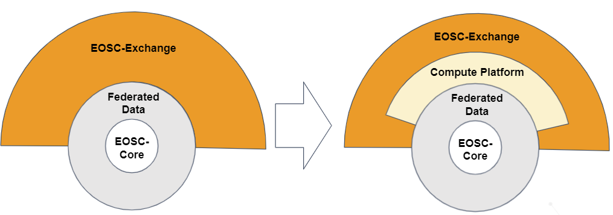
Figure 5. Architecture of the Minimum Viable EOSC (left - Source¹⁰), and positioning the EOSC Compute Platform as a distinctive element within the Exchange (right).

The right side of Figure 5 positions the EOSC Compute Platform as a subsystem of the EOSC-Exchange, acting as a scalable platform into which other services of the Exchange can tap into to perform compute intensive scenarios, including the hosting of thematic services. As we move forward with the project, we expect more and more Exchange services to build on the Compute Platform, gradually making the Compute Platform a crucial element in EOSC that, if goes down, would bring many Exchange services down too.
The distinctive presentation within the EOSC-Exchange expresses the ‘single platform nature’ of the EOSC Compute Platform, i.e.. that its services are held together by the integrated resource allocation, onboarding, order management, etc. processes. The platform should be sustained in such a way, as a single entity to keep all those values that have been listed earlier.
We expect a dedicated funding line within EOSC for the Compute Platform. The early drafts of the Horizon Europe 2023-2024 work programme already indicate a procurement action that is positioned to the EOSC Compute Platform. Further work is needed to ensure that this procurement call remains in the final work programme, and that it fits to the experiences gained in EGI-ACE.

Defining the ‘Minimum Viable EOSC Compute Platform’
The purpose of the EOSC Architecture diagram (left side of Figure 5) was to define the ‘Minimum Viable EOSC’ (MVE). If we position the Compute Platform within this, then we should also answer the question: “What is the Minimum Viable Compute Platform? (MVCP)”. The project will be able to confidently answer this question towards the end (around June 2023), but a few considerations can be already stated:
- The generic, free-at-point-of-use distributed compute facility, together with the interoperability standards, the back-end operational infrastructure, the user support, training is an essential element. This, together with the resource allocation process that ensures the most efficient combination and use of national and European funding (VA) should remain within the Compute Platform.
- The distributed compute facility includes different types of compute resources (HTC, Cloud, GPU, soon HPC), different platforms (orchestrators, Notebooks, workload managers), different data handling systems (transfer, caching, orchestration, product catalogue) that can be combined in ways to satisfy different types of users and use cases. Section 2.4 provides a summary of the current usage figures and forecasts. Towards the end of the project, we’ll have enough evidence to say which are the most demanded elements and combinations, where the sustainable funding should go.
- The EGI-ACE Data Spaces act as ‘users’ of the compute facility, which is similar to many of the communities that approached the project via the Open Call from outside the consortium. These data spaces therefore can be considered being outside the EOSC Compute Platform, alongside other thematic services of the Exchange. Consequently, these data spaces can work with a separate funding line than the Compute Platform.
- During 2022 the project will release its first guidelines on how to integrate HPC systems into the EOSC Compute Platform and will register the first few HPC systems and will run the first HPC applications based on these in EOSC. This work will open the door for a new wave of resource providers from the HPC community (e.g. EuroHPC), who can join the EOSC Compute Platform and deliver resources and support according to the allocation processes and policies of EGI-ACE, combining site level and international allocation decisions.
The project CRM continuously monitors the users and providers and gathers demands that are not satisfied by the current service portfolio. These additional services (e.g. edge computing) can be candidates for inclusion in the next phase of the EOSC Compute Platform.

Positioning the EGI-ACE Data Spaces
The project’s interest is to create a thriving collection of research data spaces that leverage the EOSC Compute Platform for capacity-intensive storage and analysis tasks. EGI-ACE has established the first examples of such data spaces as part of its consortium and is already working with several additional use cases that want to become data space providers, i.e. host scientific data and analytical services on the compute platform and expose them as integrated services towards EOSC (See Figure 6). The Data spaces federate data from multiple providers, cache/host those data on the EOSC Compute Platform resources (e.g. on Cloud compute) together with applications that understand and can process the data. The Data spaces make themselves visible in the EOSC-Exchange through the EOSC Portal and Marketplace, as Thematic services.

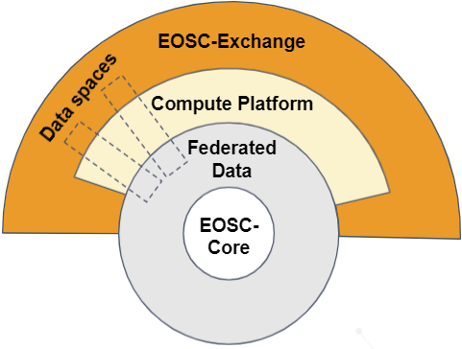
Figure 6. Positioning the Data Spaces in relationship to the EOSC MVE
and the EOSC Compute Platform.

These EGI-ACE achievements can be captured in two forms: (1) the data spaces that the project sets up and supports during its 30 months lifetime, (2) the best practice approaches gained from this about how to set up and operate data spaces.
The learning from this experience will be instrumental also towards developing a federation of national and institutional trustworthy data lakes offering a EU entry point for discovery, access and exploitation of data integrated, bringing data next to computing and analytics services with related educational tools and user support. Such an ecosystem could deliver a portfolio of data provisioning agreements with key data providers such as Research Infrastructures, scientific collaborations and research performing organizations, guaranteeing the delivery and support of core data resources and related tools in EOSC.
The project should perform the following activities to capture and position these outcomes for future funding and expansion:
- Work with the broader cloud, edge and data community to align the EGI-ACE/EOSC Technical Architecture with the “Data Spaces Technical Framework” to be developed through the Digital Europe (DE) Work Programme and which will underpin most of the sectoral data spaces to be funded by DE.
- Work with existing research data spaces within the EGI-ACE community to create a common technical and governance framework for data exchange and sharing and advance FAIR maturity, even for non-open research data. Promote this framework with the cloud, edge and data community to encourage alignment with frameworks being developed by current actors (e.g., IDSA, FIWARE, GaiaX) and to ensure consistency and maximize interoperability of essential research data sources with sectoral data spaces to be funded by DE. The first step started here with the writing of a community paper that features a few, representative Data Spaces of EGI-ACE to capture practices in Data space setup and operation. (The paper is expected for publishing in 2022). The first public document under this work will be the ‘FAIR compliance assessment of the Data Spaces’ within D2.4 in December 2021. The common framework can be documented in D2.7 in Aug 2022, or in a dedicated white paper towards the end of the project.
- Promote adoption of the developed technical and governance framework across the wider range of scientific communities supported by EOSC so that they can all establish accessible and interoperable research data spaces within EOSC and in concert with industrial data spaces from all sectors.
- Provide leadership to the research community in monitoring and responding to upcoming calls about Data Spaces in the Horizon Europe and Digital Europe programmes. These calls can fund the continued development and delivery of data spaces on top of the EOSC Compute Platform.

Contribution to the EOSC objectives and groups
The EOSC PPP and EOSC SRIA define 3 general objectives (GOs), 9 specific objectives (SOs) and 14 operational objectives (OOs). This section provides a brief overview of the most important contributions of the EGI-ACE project to the EOSC objectives mentioned in the PPP. The section also identifies the most relevant EOSC Task Forces and type of EGI-ACE contributions.
Table 2: EOSC Objectives defined in the PPP/SRIA and EGI-ACE contributions
EOSC Objective | EGI-ACE Contribution
GO1 Ensure that Open Science practices and skills are rewarded and taught, becoming the ‘new normal’ | Delivering groups of services that can implement fully reproducible, open science analysis. Training users and providers about these.
GO2 Enable the definition of standards, and the development of tools and services, to allow researchers to find, access, reuse and combine results | Integrated Data spaces and EOSC Compute Platform as key assets for EOSC
GO3 Establish a sustainable and federated infrastructure enabling open sharing of scientific results | EOSC Compute Platform providers are nationally mandated organisations for the storage and analysis of scientific data
SO1 Increase in the number of relevant research results that are made available as open as possible by researchers performing publicly funded research; | 13 data spaces are enabled and more will emerge via the open call for use cases
SO4 Increasing amounts of research data produced by publicly funded research in Europe are FAIR by design | Working on making all EGI-ACE data spaces FAIR
SO5 The EOSC Interoperability Framework supports an increasing range and quantity of FAIR digital objects including data, software and other research artefacts | Contribution to the definition of the EOSC Interoperability Framework based on experiences in compute-data integration
SO6 Provide an increased number of services and resources to ensure that European research is discovered and reused within and across disciplines to extract new knowledge | Onboarded 30 new services in the EOSC marketplace
SO7 EOSC is operationalised and provides a stable and valuable infrastructure supporting researchers addressing societal challenges | Delivered a production quality EOSC Compute Platform and data spaces
SO8 Essential additional functionalities for end users from the public and private sectors are implemented in EOSC (these developments are complementary to those of other European data spaces) | Delivery of easy access to different compute resources via the EOSC Compute Platform
SO9 EOSC increasingly establishes ties with related initiatives from regions around the world and becomes a partner in global cooperation frameworks for Open Science | Contributes to the GOSC workshops and activities
OO4 Co-develop domain-specific standards and adopt Open Science practices through the engagement with research communities during the lifespan of the Partnership | Running of a series of open calls and establishing Competence Centres to support them in implementing computing and Open Science
OO5 Provide the technical components of a FAIR ecosystem for uptake and customisation by the communities by 2023 (including open specifications, standards, schemas, application programming interfaces (APIs), metadata frameworks supporting FAIR digital objects and their automated processing); | EGI-ACE Data spaces become actors in the FAIR ecosystem and enable the sharing and analysis of research data
OO9 Implement and evolve the EOSC Rules of Participation and onboarding process for EOSC providers and increase the number of service providers and services offered progressively over the course of the Partnership | Onboarded EGI-ACE services according to the defined rules and provided feedback
OO10 Deploy and operate an authentication and authorisation infrastructure (AAI) framework to manage user identity and access by 2024 | Operate an EOSC-compatible AAI proxy to federate the Compute Platform and Data space providers and users
OO13 Continuously monitor and promote the increased uptake of core services and EOSC resources, access to EOSC Exchange tools and services and ensure a feedback loop with the users | Monitor the access to EGI-ACE data spaces and EOSC Compute Platform
OO14 Define models for availability and costing of services across borders by 2023 | Integrate national and European funding into a single resource allocation and delivery framework

Table 3: EGI-ACE contributions to EOSC Task Forces
EOSC Task Force | Relevance for EGI-ACE | WPs/Tasks
Financial Models | The EOSC Compute Platform and Data Spaces can be proposed as scenarios for financial modelling | WP2
Technical interoperability of data and services | The experience in implementing interoperability guidelines will be shared | T2.2
AAI Architecture | Ensuring the continued compatibility of the EGI Check-in service with the EOSC AAI requirements | T7.6
Researcher engagement and adoption | The uptake of EGI-AC services, the understanding of community needs, and areas of unmet demands can be fed into it | T2.3
Rules of Participation (RoP) compliance monitoring | The experience in onboarding EGI-ACE services can be fed back for improving the process | T2.2
FAIR metrics and data quality | The experience in conducting FAIR assessment of data and services can be shared with the TF | T2.2
Semantic interoperability | EGI-ACE data spaces can provide input, or take outputs for implementation | WP5
Upskilling countries to engage in EOSC | Working with Eastern Partnership, as well as non-European countries on getting them federated into the EOSC Compute Platform, therefore to EOSC | T7.4
Infrastructure for quality research software | Alignment with the EGI software provisioning infrastructure | T7.6
PID policy and implementation | N/A
Long-term data preservation | N/A
Data stewardship curricula and career paths | N/A
Research careers, recognition and credit | N/A

Contribution to the EGI Federation strategy
At the centre of the EGI Federation, there is the strong belief that all researchers should have seamless access to services, resources and expertise to collaborate and conduct world-class research and innovation. The EGI Federation entered the “Twenties” with a new 5-year strategy looking forward to 2024. With the strategy the federation reached full maturity as a key and reliable actor in the e-infrastructures landscape. For the 2020-2024 period the EGI Federation identified six Strategic Goals (SG1-SG6). This section lists these SGs, describes the contributions of the EGI-ACE project to these, and states the focus areas for the project to maximise its impact on the EGI strategy.

Table 4: EGI Federation Strategic Goals, contribution from EGI-ACE and priorities
EGI Strategic Goals (SGs) | EGI-ACE Contributions | Focus for the remaining period to maximise impact
SG1 Be a trusted service & technology partner for research and innovation  Improve promotion and engagement with target user groups to further solidify the EGI Federation as trusted long-term partner | - Expanded network of EOSC Compute Platform supporters within and beyond EU member states.  - EGI-ACE established Open Calls that attract diverse types of customers/users | - Run more promotion campaigns of the EGI-ACE Open Calls in 2022.
SG2 Evolve the service offering to meet the needs of researchers  Focus on innovation and harmonisation of services by working with user communities and with peer e-infrastructure organisations towards reliable research-enabling services | - EGI-ACE brings the EGI Services, a new infrastructure service (HPC), and several platform services (EC3, DEEPaaS, etc) into the EOSC Compute Platform.  - EGI-ACE liaises with the 07 projects (OpenAIRE, EUDAT) | - Bring the new infrastructure and platform services into the EGI service portfolio (either directly, or as a new ‘Community Services’ subcategory)
SG3 Improve skills of users/operators and maturity in service providers  Deliver dedicated training and consultancy to increase the knowledge and quality of work of users and operators;  Align service management and delivery across the federation to best practices and standards | - EGI-ACE created and runs a webinar program  - Establish a Training Management System (Moodle) for online and f2f courses.  - Delivery of online and f2f training for supporters and service operators from 2022. | - Intensify the training of user supporter and service operator staff within EOSC Compute Platform participant institutes
SG4 Align business models to better support cross-border service provision  Increase the efficiency in translating the needs of services and support from the target user groups to service providers of the EGI Federation in alignment with the national and community policies and business models | - The Virtual Access funding mechanism offered an opportunity to create an on-demand platform to deliver services for researchers and structure a central delivery channel with dedicated capacity | - Raise importance of continued funding and support with EC and EOSC Steering Board
SG5 Strengthen the governance and broaden European coverage  Ensure that the EGI Federation governance remain effective in the changing environment and grow the relationships with current and future EGI participants | - EGI-ACE established partnership with several countries and scientific communities that were/are not represented in the EGI Governance. | - Continue to demonstrate the value of EGI to consortium members and partners.  - Onboard non EGI members of EGI-ACE in the EGI Governance based.
SG6 Be a recognised foundation of the EOSC  Position the services and expertise of the EGI Federation as key assets for the EOSC, especially for the Federating Core | - EGI-ACE allowed to leverage the long experience in federating and integrating infrastructures at the EOSC level, delivering federated compute capacity and data | - Ensure success stories are captured and communicated  - Ensure the value of the EOSC Compute Platform and Data Spaces are properly understood at the various levels (funders, providers, users)

Strategic recommendations
This section identifies a number of key recommendations for the project and for other stakeholders. They are described in terms of issue to be addressed, recommendation for action, desired outcome of the action and practical initiatives to be put in place.

1 | Area: EOSC Compute Platform
Issue
The EOSC Compute Platform is a new concept promoted by the EGI-ACE project and it is not yet captured in the EOSC SRIA or other official documents about the EOSC. Also, many EOSC users or providers do not yet understand the value of it.

Recommendation
Promote the value proposition of the EOSC Compute Platform so that it is recognised as a distinctive EOSC element and valued by both service providers and users.

Desired outcome
Current and potential EOSC users and providers have easy access to the EOSC Compute Platform information, they understand the value of it and support its continuation. Also, official EOSC documents include the EOSC Compute Platform.

Initiatives
- Prepare a short policy brief about the EOSC Compute Platform and submit to the relevant EOSC Task Forces (EGI-ACE T2.1 + T2.2)
- The EOSC Compute Platform values are clearly described in the EGI-ACE website (EGI-ACE T2.4)
- The EOSC Compute Platform values are clearly explained in the communications and engagement campaigns (EGI-ACE T2.3 + T2.4)
- Newly approved Horizon Europe projects are monitored and relevant actions that can benefit from EOSC services are reached out to promote the use of the EGI-ACE services (EGI-ACE T2.3 + EGI-ACE T2.4)
2 | Area: EOSC Compute Platform
Issue
The EOSC Compute Platform started as a project-based initiative where providers were pre-selected during the preparation phase of the project. There is not yet a set of defined rules explaining how new providers and services can join, and how the EOSC Compute Platform membership and the EGI membership relate to each other.
Recommendation
Develop open and transparent processes and procedures for new providers and new services to join the EOSC Compute Platform. Also, define the requirements to be part of the EOSC Compute Platform (both technical and policy related) and its relationship with the EGI Federation governance and affiliation.

Desired outcome
Current and potential providers have a clear understanding of how to join the ECP and how it differs from the EOSC Onboarding. The relationship between the EOSC Compute Platform and EGI membership and portfolio is well articulated and presented in relevant communication materials.

Initiatives
- Define open processes and procedures to join the EOSC Compute Platform (EGI-ACE T2.2 + WP7)
- Clarify how being part of the EGI Federation relates to being part of the EOSC Compute Platform (EGI-ACE PMB + EGI Executive Board)
3 | Area: EOSC Compute Platform
Issue
The EGI-ACE project has bootstrapped an initial support network for the EOSC Compute Platform. This helps new users to be guided on the best way to use and combine services from the EOSC Compute Platform. On the other hand, these structures have different levels of maturity, and their level of expertise needs to be expanded as the platform evolves.
Recommendation
Develop and sustain the researcher support network of the EOSC Compute Platform and link it with emerging EOSC user support networks.

Desired outcome
- There is an active support team in every country that participates in EGI-ACE to serve new users’ and providers’ joining requests.
- The EGI-ACE network of providers is known and used by other thematic support networks for compute-related consultancy.

Initiatives
- Run internal training for the supporters within the consortium and for newly joining service providers so they can become professional in serving users and providers (EGI-ACE T2.3)
- Promote the value of research support networks within EOSC and link the EOSC Compute Platform network with those (EGI-ACE SFG + PMB)
4 | Area: EOSC Compute Platform
Issue
The EOSC Compute Platform is a project-based initiative currently supported via the Virtual Access funding mechanism. Without institutional mandate or viable business model, providers will cease to offer their services after the end of the project. Also, there is a demand for including further types of services in the EOSC Compute Platform (e.g. edge computing, HPC) for which additional funding would be needed.
Recommendation
Seek support for sustaining and scale out the delivery of the EOSC Compute Platform after the end of EGI-ACE.

Desired outcome
The EC recognises the value of the ECP as an element of the EOSC and contributes to its delivery for the benefits of research. Also, the EOSC Steering Board representing the MSs/ACs support it as part of the in-kind contributions to the EOSC initiative.

Initiatives
- The EOSC Compute Platform is promoted as a scenario within the EOSC Task Force on Financial Models (EGI-ACE SFG)
- The EOSC Compute Platform is promoted towards the EOSC Partnership for support in the context of the Multi Annual Roadmap (EGI-ACE SFG + PMB)
5 | Area: Data Spaces
Issue
There is no distilled learning from building Data spaces that could be reused by other initiatives. There is no sustainability plan for the EGI-ACE data spaces beyond the project.

Recommendation
Contribute to the development of a data space reference model and support the definition of related financial and sustainability models. Build partnership with relevant data space initiatives to uptake and evolve the EGI-ACE data spaces and their approach.
Desired outcome
The most successful data spaces can access new funding opportunities after the end of EGI-ACE. The EGI-ACE expertise and reference model is used beyond the project for the building of Data spaces.

Initiatives
- Provide leadership to the research community in monitoring and responding to upcoming calls about Data Spaces in the HE and Digital Europe programmes. These calls can fund the continued development and delivery of data spaces on top of the EOSC Compute Platform (EGI Foundation Project Management Office).
- Develop a data space reference model and implementation guidelines useful for developing financial models to be submitted to the related EOSC Task Force (EGI-ACE WP2+WP5)
- Liaise with emerging and existing Data space initiatives for future collaboration and the exchange of approaches and technologies. (EGI-ACE T2.2)
6 | Area: Data Spaces
Issue
The 13, and the other emerging data spaces of EGI-ACE solved data, application and compute interoperability and exploitation in their individual domains. At the same time the level of interoperability among them is low.

Recommendation
Contribute to the development of the EOSC Interoperability Framework, to the “Data Spaces Technical Framework” that will be created through the Digital Europe (DE) Work Programme, and to other relevant initiatives that work towards a single, European Data space.

Desired outcome
Data spaces evolve within Europe without becoming data/application silos, using the EGI-ACE implementation approaches and tools in collaboration with industry and other academic solutions.

Initiatives
- Capture lessons learned, best practices about Data space interoperability and bring this as input in the relevant EOSC task forces and other initiatives that work on Data spaces interoperability (EGI-ACE T2.2+WP5)
- Monitor the Data spaces landscape, identify and lift into EGI-ACE solutions that help the EGI-ACE data spaces be more interoperable with each other and with the broader landscape (EGI-ACE T2.3+WP5)

EGI Webinars: https://www.egi.eu/webinars/
News item: https://www.eosc.eu/news/towards-european-open-science-cloud-revolutionising-research-digital-age
See signed MoU on 30 July 2021: https://www.eosc.eu/sites/default/files/EOSC_Memorandum_30_July_2021.pdf
EOSC Steering Board page in the Register of Commission Expert Groups https://ec.europa.eu/transparency/expert-groups-register/screen/expert-groups/consult?lang=en&groupID=3756
EOSC SRIA V1.0: https://www.eosc.eu/sites/default/files/EOSC-SRIA-V1.0_15Feb2021.pdf
See page 122 in EU framework programme for research and innovation - Horizon Europe Work Programme 2021-2022 “Research Infrastructures” https://ec.europa.eu/info/funding-tenders/opportunities/docs/2021-2027/horizon/wp-call/2021-2022/wp-3-research-infrastructures_horizon-2021-2022_en.pdf
Title VII in Regulation (EU, Euratom) 2018/1046 of the European Parliament and of the Council of 18 July 2018 on the financial rules applicable to the general budget of the Union - https://op.europa.eu/s/tOIy
Call for tender “European Data Portal Managed Services - data.europa.eu“ https://etendering.ted.europa.eu/cft/cft-display.html?cftId=6585
Call for tender: “Open Research Europe - The European Commission Open Research Publishing Platform” https://etendering.ted.europa.eu/cft/cft-display.html?cftId=5034
Call for tender: “European Union Intellectual Property Helpdesk” https://etendering.ted.europa.eu/cft/cft-display.html?cftId=3518
Press release: https://ec.europa.eu/commission/presscorner/detail/en/IP_21_3733
https://digital-strategy.ec.europa.eu/en/policies/cloud-alliance
See news item: https://bdva.eu/node/1860
See main website: https://tehdas.eu/
Digital Europe Work Programme 2021-2022 (final): https://ec.europa.eu/newsroom/repository/document/2021-46/C_2021_7914_1_EN_annexe_acte_autonome_cp_part1_v3_x3qnsqH6g4B4JabSGBy9UatCRc8_81099.pdf
First GOSC Workshop 2020: https://indico.egi.eu/event/5255/
The Global Open Science Cloud Landscape, doi:10.5281/zenodo.5575275
CODATA GOSC Working Groups and Case Study Groups: https://codata.org/initiatives/decadal-programme2/global-open-science-cloud/gosc-introduction-event/
News about integration of CSTCloud with EGI Federation https://www.egi.eu/news/a-federation-of-cloud-resources-beyond-europe/
Second GOSC Workshop 2021: https://indico.egi.eu/event/5464/timetable/#20211022
https://op.europa.eu/en/publication-detail/-/publication/9c7f3c1e-2aea-11eb-9d7e-01aa75ed71a1/language-en
https://zenodo.org/record/4683278#.YZOFA73MKre
https://zenodo.org/record/5602949
https://eoscfuture.eu/newsfuture/eosc-future-launches-call-for-proposals-for-working-groups/
https://wiki.eoscfuture.eu/display/PUBLIC/Working+Group+Proposals
EOSC Service Order Metrics dashboard: https://opsportal.eosc-portal.eu/metricsEOSC/ServiceOrder/2018-11-01/2021-10-15/stats/off#stats
Solutions for a Sustainable EOSC - A FAIR Lady report from the EOSC Sustainability Working Group: https://op.europa.eu/en/publication-detail/-/publication/581d82a4-2ed6-11eb-b27b-01aa75ed71a1
This can be captured in the deliverable ‘D2.10 EGI-ACE Final Recommendations’
EGI Federation Strategy 2020-2024: http://go.egi.eu/strategy

