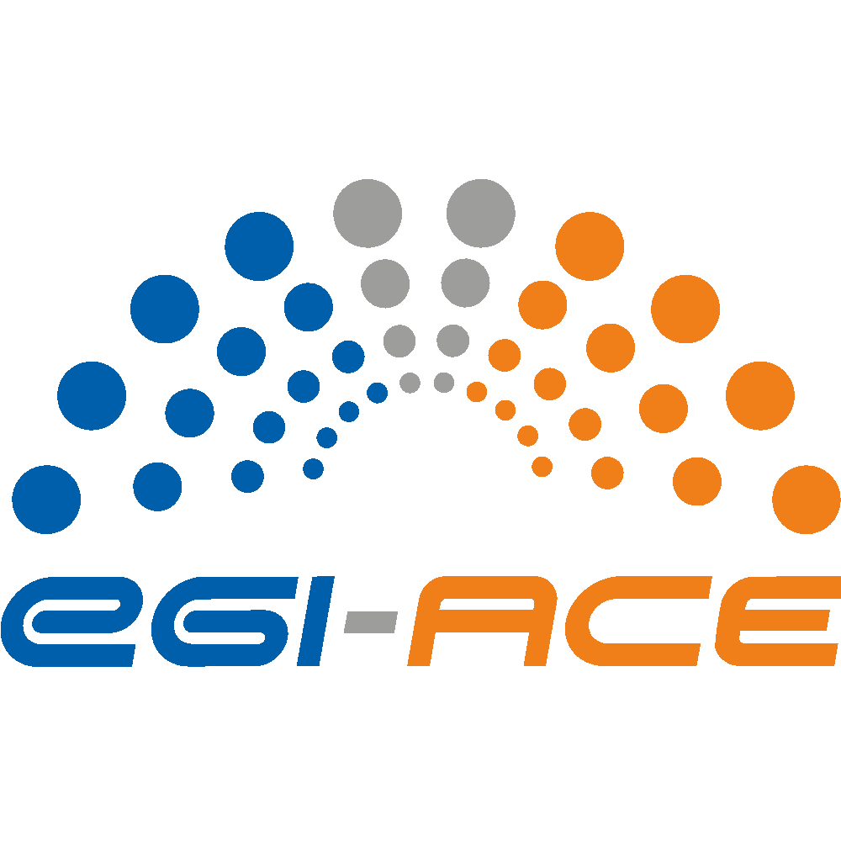
D5.5 Periodical assessment of Data space services
Lead partner: | EGI Foundation
Version: | 1
Status: | Under EC Review
Dissemination Level: | PUBLIC
Keywords: | EGI-ACE, Virtual Access, Data Spaces
Document Link: | https://documents.egi.eu/document/3795

Deliverable Abstract
The deliverable provides metrics and assessment about the EGI-ACE Data Space services provided under the Virtual Access (VA) mechanism in WP5.

COPYRIGHT NOTICE
This work by parties of the EGI-ACE consortium is licensed under a Creative Commons Attribution 4.0 International License. (http://creativecommons.org/licenses/by/4.0/).
EGI-ACE receives funding from the European Union's Horizon 2020 research and innovation programme under grant agreement no. 101017567.

DELIVERY SLIP
 | Name | Partner/Activity
From: | Giuseppe La Rocca | EGI Foundation/WP6
Moderated by: | Sjomara Specht | EGI Foundation/WP1
Reviewed by: | Gergely Sipos  Enol Fernandez | EGI Foundation/EGI-ACE Technical Coordinator  EGI Foundation / WP3, WP4
Approved by: | PMB, SDS, SFG

DOCUMENT LOG
Issue | Date | Comment | Author
v.0.1 | 27/06/2023 | Template | Hien Bui
v0.2 | 14/07/2023 | First version ready for review | Giuseppe La Rocca
v1 | 3/08/2023 | Addressed review comments | Giuseppe La Rocca

TERMINOLOGY
https://confluence.egi.eu/display/EGIG

Terminology/Acronym | Definition
VA | Virtual Access
EOSC | European Open Science Cloud

Contents
Executive summary 5
1 Introduction 8
1.1 Installations 8
1.2 Metrics definition 14
2 Installations 1
2.1 WeNMR: A worldwide e-Infrastructure for NMR spectroscopy and Structural biology 1
2.1.1 Metrics 2
2.1.2 Assessment 8
2.2 Virtual Imaging Platform (VIP) 10
2.2.1 Metrics 11
2.2.2 Assessment 12
2.3 OpenRiskNet/NanoCommons Virtual Environment 13
2.3.1 Metrics 14
2.3.2 Assessment 15
2.4 useGalaxy.eu 15
2.4.1 Metrics 16
2.4.2 Assessment 17
2.5 OPENCoastS 17
2.5.1 Metrics 19
2.5.2 Assessment 20
2.6 ENES Data Space 21
2.6.1 Metrics 22
2.6.2 Assessment 23
2.7 PROMINENCE 24
2.7.1 Metrics 25
2.7.2 Assessment 25
2.8 LOFAR Science Products 26
2.8.1 Metrics 28
2.8.2 Assessment 29
2.9 SeaDataNet WebOcean Data Analysis 29
2.9.1 Metrics 31
2.9.2 Assessment 31
2.10 EMSO ERIC data services 33
2.10.1 Metrics 34
2.10.2 Assessment 34
2.11 GBIF Cloud data space 35
2.11.1 Metrics 36
2.11.2 Assessment 37
2.12 Disaster mitigation and agriculture 38
2.12.1 Metrics 39
2.12.2 Assessment 40
2.13 OPERAS Metrics service and PRISM service 41
2.13.1 Metrics 42
2.13.2 Assessment 43
3 Satisfaction 44
3.1 The WeNMR Thematic Services 44
4 Service Orders 45
Appendix I - Status of the WP5 integration activities 46

Executive summary
This report provides an assessment at M30 of the WP5 Thematic Service installations from 19 providers provided by the EGI-ACE project under the Virtual Access (VA) mechanism (see Figure 1). The Thematic Services of WP5 contribute to EGI-ACE Key Exploitation Result 3 - Research Data Spaces and Processing Tools.
The assessment was made based on the metrics collected by the WP5 Thematic Services during the three periods of observations covering the following three periods: M16-M20, M21-M25 and M26-M30.
The Data Spaces and the Thematic services of WP5 in total served 77,000 users in 30 months, representing a 17.85% increase compared to the 15 months before.
The EOSC Compute Platform was instrumental to this scale up and delivered 77,652,658 Cloud CPU hours, more than 720 TB storage, 333,576 GPU hours, to the WP5 services.
By looking at the usage across the disciplines, the following can be observed:
- Within the Health and Medicine domain: WeNMR, VIP and UseGalaxy.eu served 60,317 users from structural biology, medical imaging and bioinformatics.
The solutions and the resources offered by the EOSC Compute Platform contributed to maintain the operation level of the portals on-boarded in EOSC at high level, and address the needs of the structural biology community. In this regard, the EGI Workload Manager based on DIRAC proved to be instrumental for the scientific community.
The level of operation of the Virtual Image Platform (VIP) Thematic Service was consolidated during the second part of the project and new scientific applications were rolled-out into production for serving the medical imaging community.
The exploratory phase of the useGalaxy.eu Thematic Service also continued during the second part of the project. Integration with EGI Check-in, EGI Workload Managers and EGI DataHub services will continue after EGI-ACE in the context of the EuroScienceGateway EC-funded project.
- Within the Climate research domain: OPENCoastS and ENES served 534 users from the Climate Change scientific domain. The assets offered by the EOSC Compute Platform allows scientists to run forecast simulations with the OPENCoastS service and predict a vast array of coastal dynamics variables. The ENES Data Space delivers a cloud-enabled data science environment for climate data analysis. The first release of the ENES Data Space was rolled out into production in Q3 2021. Since then, several dissemination and training events were organised in order to promote the service uptake.
- Within the Energy and Physical Sciences domain: PROMINENCE and LOFAR Science Products served 86 users from the Fusion and Astronomy domains. The EOSC Compute Platform contributed to open up the processing capabilities of the LOFAR Science Processing Data Space to a wider community of astronomers, and develop a service that in the PROMINENCE Data Space will be of use to run significant modelling and use existing experimental data to perform validation.
- Within the Environmental Sciences domain: SeaDataNet WebOcean Data Analysis, EMSO-ERIC data services, GBIF Cloud data space and the Disaster Mitigation Agriculture Thematic Services served 2,060 users from the Environmental scientific domain.
The SeaDataNet WebOcean Data Analysis Data Space completed the on-boarding in the EOSC Portal Marketplace in 2022. The Data Space provided access to several GB of ocean datasets from SeaDataNet, ARGO and other organisations.
The Disaster Mitigation and Agriculture completed the on-boarding of the iCOMCOT Tsunami Wave Propagation Simulation Portal in EOSC in 2022. The Portal provides to the end-users COMCOT (Cornell Multi-grid Coupled Tsunami Model), a tsunami modelling package, capable of simulating the entire lifespan of a tsunami, from its generation, propagation and runup/rundown in coastal regions.
- The 50% of the EMSO-ERIC Data Space services reached the production level in 2023 and served 1,245 users, the other 50% are currently in pre-production level. The plan for them is also to reach the production level soon.
- Within the Social Sciences and Humanities domain: the OPERAS Metrics service and the PRISM services are still under development.
To promote the uptake of new and existing services installations, a total of 30 domain-specific training and dissemination activities were organised during the second part of the project. These activities played an important role to reach a wider user base in Europe as demonstrated by the metrics reported during the three periods of observations. Overall, these domain-specific training and dissemination events were attended by more than 800 participants worldwide.
After the end of the EGI-ACE project:
- The WeNMR community and the Virtual Imaging Platform (VIP) will continue to operate the domain-specific portals and platform and support respectively the structural biology and the medical imaging communities relying on the funding from their national agencies. EGI will contribute to support the operation of the Thematic Services extending the current SLAs with the communities.
- The OpenTox/OpenRiskNet Thematic Service will be further developed in the context of the OpenTox Association and related projects. Also in this case EGI will contribute to the operation of the service providing access to the computing and storage resources with a dedicated pay-for-use SLA.
- The integration of the useGalaxy.eu Thematic Service with the solutions developed by the EOSC Compute platform will continue in the framework of the EuroScienceGateway project.
- The operational of the OPENCoastS Thematic Service will be guaranteed by the national funding from LIP.
- The ENES Data Space will be further extended and supported in the context of the EOSC Beyond project (HORIZON-INFRA-2023-EOSC-01-04).
- Access to the resources will be guaranteed by EGI for supporting the PROMINENCE Thematic Service.
- The LOFAR Science Processing Data Space will continue offering requested data processing services to end-users. The computational resources needed to maintain the service operational can for the time being be requested via dedicated infrastructure calls, or national funding agency.
- The EMSO-ERIC Data Portal and the SeaDataNet WebOcean Data Analysis Data Spaces will continue in the context of the BlueCloud 2026 EC-funded project.
- EGI will also support the collaboration with the Disaster and Mitigation and Agriculture Thematic Services scaling-up the computing resources requested for helping Asian researchers to run computing models to simulate the entire lifespan of a tsunami.
- The GBIF Portugal and GBIF Spain data portals will continue to operate, complementing the GBIF Global Portal for their respective national communities in the access to open biodiversity data. All services are integrated into the EOSC portal.
- The collaboration between OPERAS and EGI will continue beyond the EGI-ACE project. Recently a MoU was agreed between the partners to reaffirm the joint commitment and collaboration in key areas such as: mutual memberships, communication and engagement, and investigate new solutions to improve the overall infrastructure needs of the community.

Introduction
Virtual Access (VA) is financial instruments to reimburse the access provisioning costs to access providers. This instrument is provided by the European Commission to increase the sharing of research infrastructures and services that otherwise would not be available to international user groups.
In VA, the services – also called “installations” – must be made available ‘free of charge at the point of use’ for European or International researchers. VA access is open and free access to services through communication networks to resources needed for research, without selecting the researchers to whom access is provided.
Virtual Access to services of the EGI-ACE catalogue applies to the following four categories:
- Infrastructure Services WP3 - the Cloud Compute (IaaS) and High Throughput Compute services of the EGI portfolio supported by a set of 16 datacentres from the EGI Federation. The enabling components that support the Cloud Compute service: AppDB, for resource discovery and software catalogue; Dynamic DNS, for user-managed DNS provision of domain names for VMs and services running on the e-Infrastructure; and Infrastructure Manager (IM) for the basic orchestration of IaaS resources.
- Platform Services WP4 - mature software tools offering generic capabilities to facilitate the usage of the underlying infrastructure for EOSC users and Data Spaces.
- Federated data spaces WP5 - services provided by major European research collaborations, research infrastructures and research institutes, and are composed of mature software tools, datasets and services that offer science discipline specific processing and data analysis capabilities for EOSC users.
- Federated Access Services WP6 – services providing secure access to other services and enabling large-data analysis workloads in the distributed infrastructure. Included services are delivered by major European research institutions using mature open-source software with already established user communities from multiple scientific disciplines.
This document provides Virtual Access metrics and assessment for WP5 - Federated data spaces.

Installations
Within EGI-ACE project 17 installations are part of Virtual Access Work Package 5. The EOSC Compute Platform, delivered by WP3, WP4 and WP6 played a fundamental role to deliver infrastructure and platform services for the scalable and open delivery of the 17 Thematic Service installations shown in Figure 1.
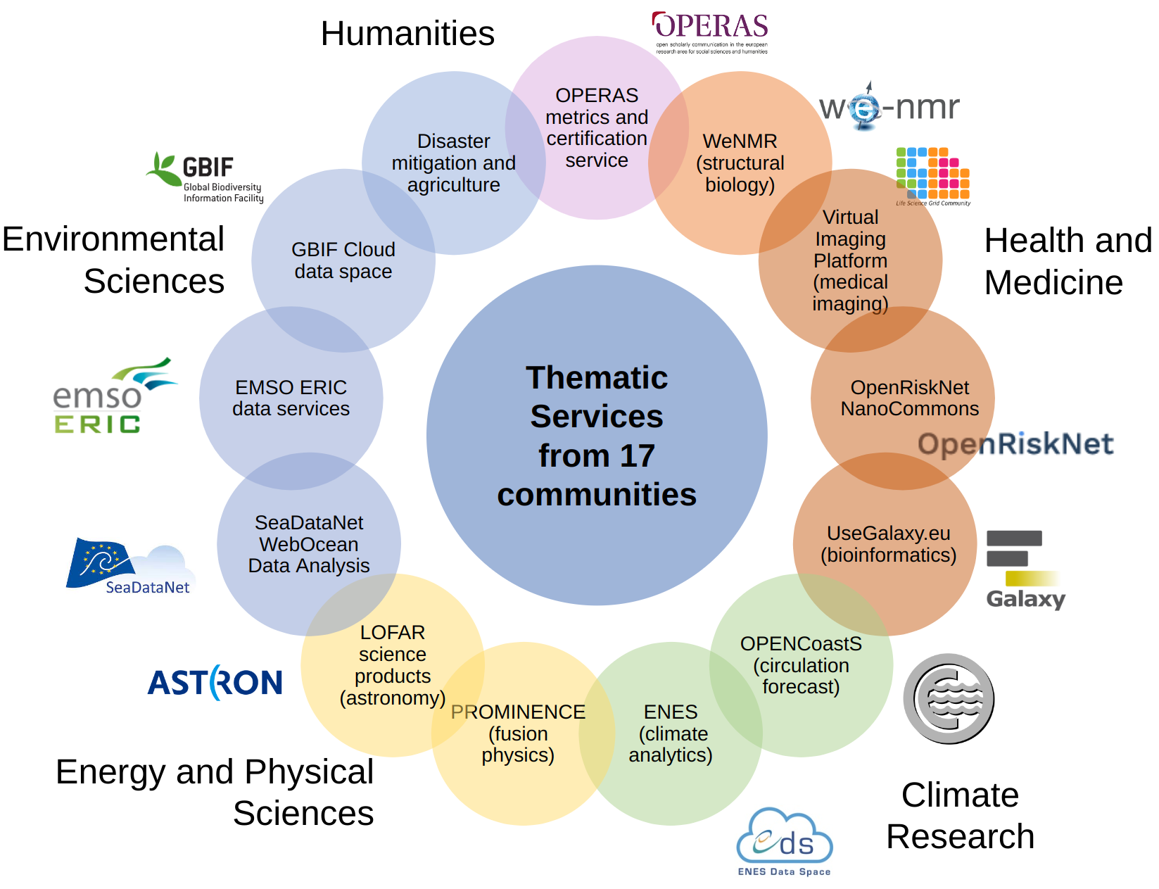
Figure 1 - The WP5 Data Spaces and Thematic services landscape (after 15 months)
The status of the integration activities of the WP5 Thematic Services and Data Space installations, and the EOSC Compute Platform services (WP3, 4, 6 and 7) is shown in Appendix I.
The distribution of the EGI-ACE Data Spaces and Thematic Services by scientific disciplines and the number of users served per disciplines are reported in the Figures below:

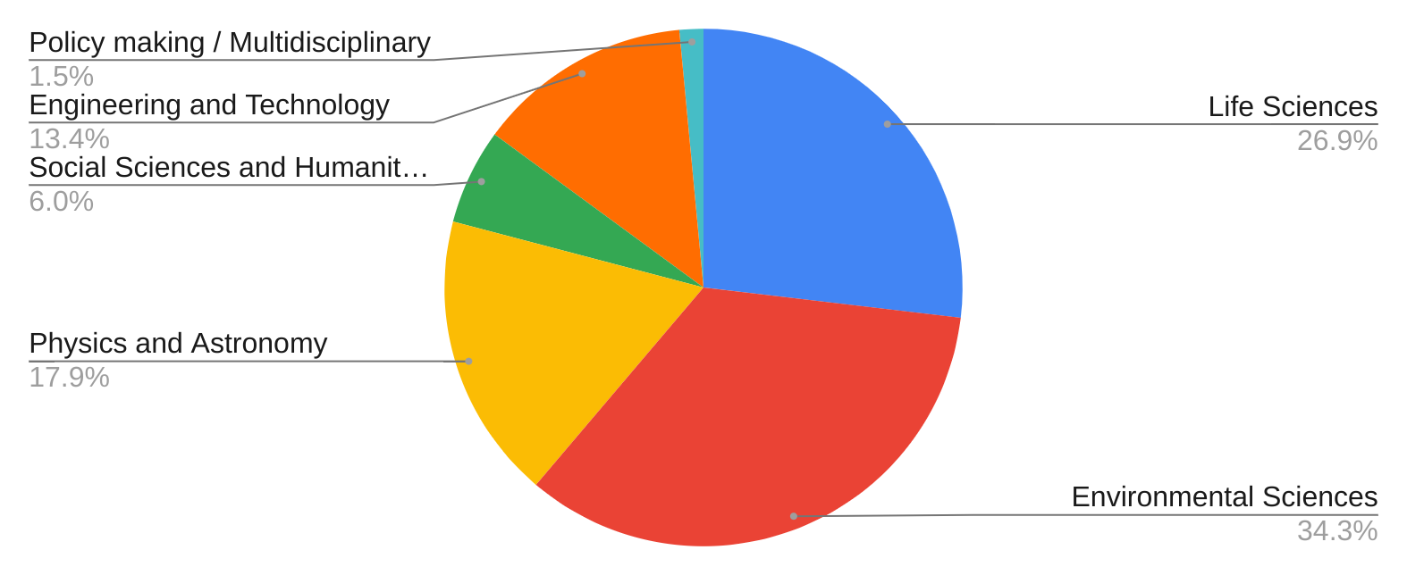
Figure 2 - Distribution of the supported Data Spaces / Thematic Services by scientific disciplines

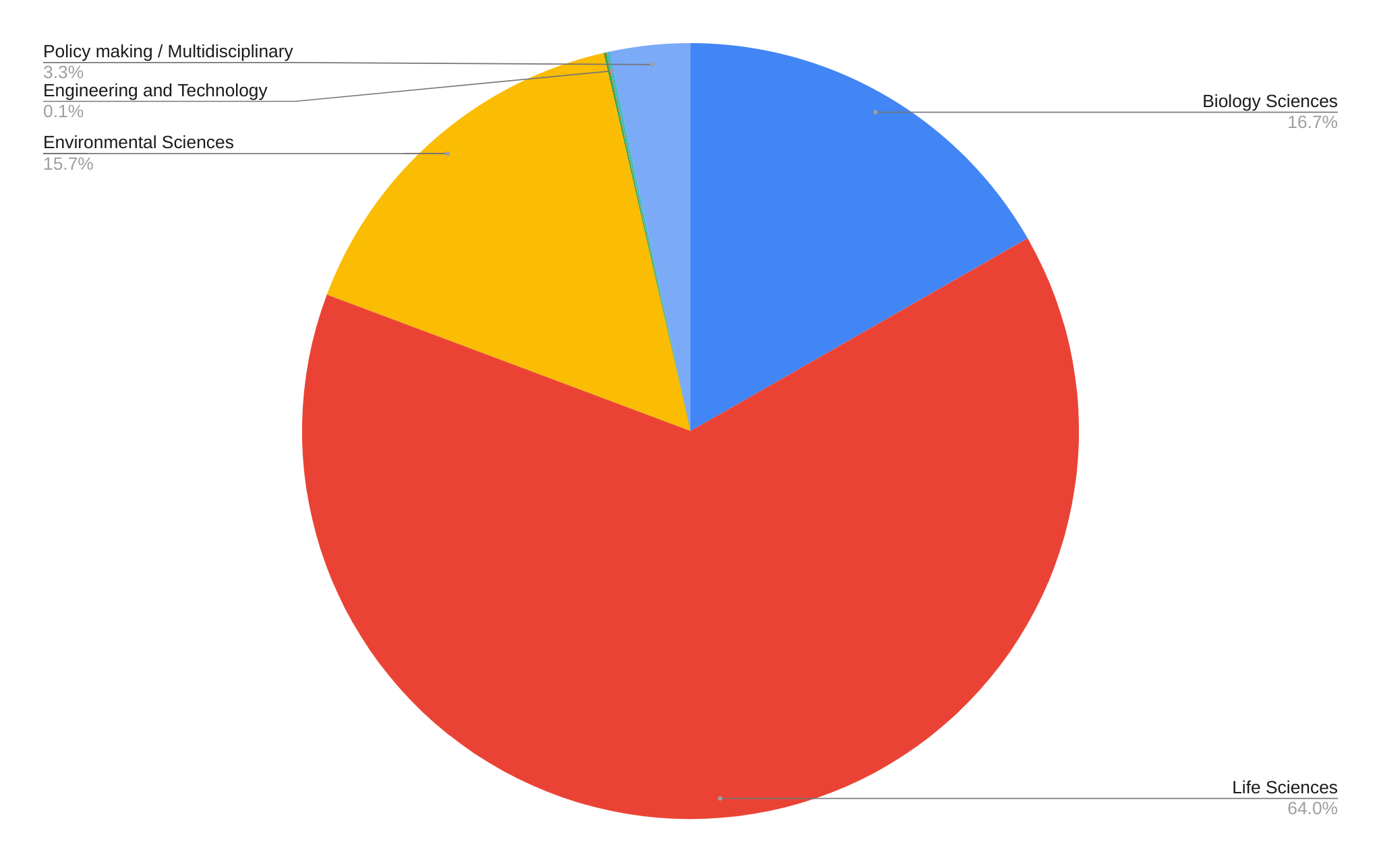
Figure 3 - Distribution of the supported users per scientific disciplines
In Figure 4 is shown the total amount of Open Research Data served by the EGI-ACE Data Spaces.
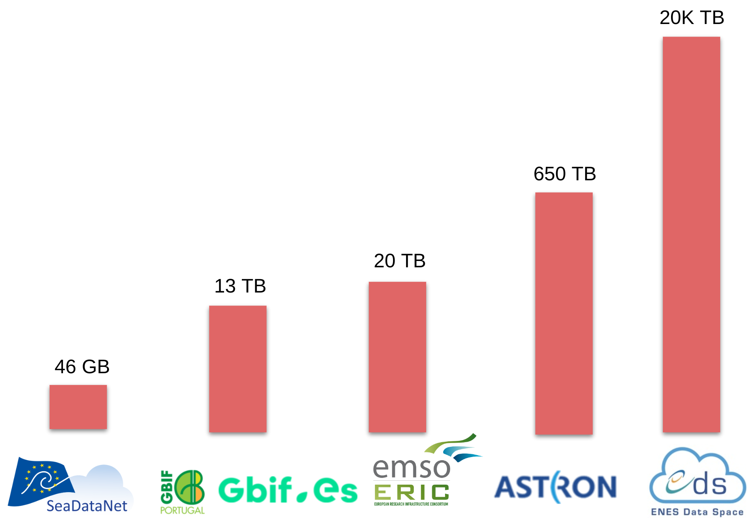
Figure 4 - Open Research Data served by the EGI-ACE Data Spaces
For SeaDataNet WebOcean Data Analysis, EMSO Data Portal and LOFAR Science Processing Data Spaces, the scientific datasets are replicated in the EOSC Compute Platform. For the remaining ones, only segments of datasets of interest are cached and stored in the EOSC Compute Platform.
The variation (in %) of the WP5 metrics after fifteen months project is summarised in the tables below.
 | WeNMR | VIP | useGalaxy.eu | OpenRiskNet/  NanoCommons Virtual Environment
Metric | No. of new registered users | No. of registered users | No. of registered users | No. of registered users
15 month before the project | 5,625 | 1,250 | 25,000 | 125
During M01-15 | 8,056 | 1,388 | 48,000 | N/A
During M16-M30 | 16,822 | 1,490 | 72,669 | N/A
Variation (%) | +230.5% | +19% | +190.6% | N/A
Explanation | Continuing the operation of the thematic portals.  Organised 6 events to promote the services. | Integrated 1 new application. Started to promote the platform.  Organised 4 events to promote the service. | Integration with the EOSC Compute Platform is in progress. | Unfunded partner in the project.
Table 1 - Status of the Health and Medicine Data Spaces (T5.1)

 | OPENCoastS | ENES Data Space
Metric | No. of registered users | No. of active users
15 month before the project | 312 | 0
During M01-15 | 378 | 16
During M16-30 | 478 | 56
Variation (%) | +53.8% | +250%
Explanation | Several dissemination and training events were organised during the second part of the project to reach out to new users. | Focus on a significantly new release that became available towards the end of the project. Promotion of the new platform started recently.  Service promoted in the framework of EU scientific conferences, national and institutional events.
Table 2 - Status of the Climate Data Spaces (T5.2)

 | PROMINENCE | LOFAR Science Product
Metric | No. of users requesting access | No. of users requesting access to LOFAR
15 month before the project | 3,75 | 0
During M01-15 | 2 | 41
Duration M16-M30 | 8 | 78
Variation (%) | +113.3 | +90.2%
Explanation | Increased pledged resources assigned to the Data Space.  Started the HPC pilot activities to run the JOREK non-linear MHD code. | First release rolled out into production in 2021 Q3.  Organised 3 events to promote the service.
Table 3 - Status of the Energy and Physical Sciences (T5.3)

 | SeaDataNet WebOcean Data Analysis | EMSO ERIC data services | GBIF Cloud Data Space | Disaster Mitigation and Agriculture
Metric | No. of new registered users | No. of new users | No. of unique users | No. of new registered users
15 month before the project | 125 | 250 | 10,038 | 187
During M01-15 | 0 | 1,977 | 6,858 | 0
During M16-M30 | 237 | 1,245 | 598 | 15
Variation (%) | +89.6% | +298% | -94.04% | N/A
Explanation | Integration of the Data Space with the EOSC Compute Platform is still in progress. | Integrated 1 new application. Started to promote the platform. | Integration in progress | Partner is unfunded
Table 4 - Status of the Environmental Sciences (T5.4)

 | Operas Metrics service and PRISM service
Metric | No. of requestered publishers
15 month before the project | 12
During M01-15 | 0
During M16-M30 | 38 (Metrics), 14 (PRISM)
Variation (%) | +300%
Explanation | Integration of the Data Space with the EOSC Compute Platform in progress.
Table 5 - Status of the Social Sciences and Humanities (T5.5)
Following installations have been subject to change since the beginning of the project:
- 1 service has been revoked from WP5 from the EOSC Portal (OpenRiskNet/NanoCommons Virtual Environment). A new service OpenRisk/OpenTox will be on-boarded as soon as it reaches production level. The integration plan of this unfunded Data Spaces underwent a delay due to the lack of human effort being available during the whole duration of the project.
- The first service from the Disaster Mitigation and Agriculture Data Space, the iCOMCOT Tsunami Wave Propagation Simulation Portal, and the first release of the SeaDataNet WebOcean Data Analysis Data Space were on-boarded in EOSC during the reporting period.

Metrics definition
For each installation several metrics have been defined between the provider and WP5 leader, taking into account following categories:
- Number of users – depending on the nature of installation, number could be defined based on accounts (if registration was required) or number of unique IPs (if registration is not needed to benefit of the service).
- Usage – the goal of this metric is to report how much the service is used. This metric depended on functionality provided by the service.
- Number and names of the countries reached – the goal of this metric was to report how broadly the service is used and how the geographical coverage is changing with time.
- Marketplace views – the goal of this metric is to provide information about how often the service is being viewed by the potential customers.
  - This metric is not applicable to federation services due to the nature of the service. Federation services are enabling federation and are supporting delivery of customer facing services. Thus, cannot be ordered.
- Marketplace orders – the goal of this metric is to provide information about how often the service is being ordered via EOSC Marketplace.
  - This metric is not applicable to federation services due to the nature of the service. Federation services are enabling federation and are supporting delivery of customer facing services. Thus, cannot be ordered.

Installations

WeNMR: A worldwide e-Infrastructure for NMR spectroscopy and Structural biology
Description | The WeNMR services consist of a suite of web portals, providing user-friendly access to complex computational workflows and tasks. The WeNMR data analytics platform consists of a collection of user-friendly portals serving a community of over 16’000 users world wide. The WeNMR services allow inexperienced and experienced structural biologists to use state-of-the-art software for their data analysis while benefiting from the EOSC computational infrastructure.  The services make use of high-throughput computing (HTC) resources, but some are also using GPGPU grid resources and cloud computing. The portals are already integrated with the EOSC AAI, present in the EOSC Portal and Marketplace, and use the EGI Check-in and DIRAC4EGI services to send ~10 millions jobs per year to HTC resources.  WeNMR has been successfully serving the structural biology community for over 10 years now. The community shows a sustained growth with > 3500 new users per year. The WeNMR services are fully operational, all available under the EOSC portal and marketplace.
Task | 5.1
URL | http://www.wenmr.eu/
Service Category | Data Spaces and Analytics
Service Catalogue | https://marketplace.eosc-portal.eu/services/eosc.wenmr.powerfit_web_portal  https://marketplace.eosc-portal.eu/services/spoton-c5db8fd5-a546-4342-8bae-2b2b4777b67e  https://marketplace.eosc-portal.eu/services/haddock2-4-web-portal  https://marketplace.eosc-portal.eu/services/disvis-web-portal-6eab178c-9bc5-4c62-b7ce-aeeb18d5cba9
Location | Utrecht (NL), Florence (IT)
Duration | M01-M30
Modality of access | Web interfaces
Support offered | The planned activities would encompass user support, training, and continuous operation of the various grid- and cloud-enabled web portals.
Operational since | Some of the services have been operational since June 2008
User definition | A user is a person making use of at least one of our thematic services. All portals except one (FANTEN) do require user registration. For FANTEN, users are identified by their IP address for collecting the various metrics.

Metrics
Metric name | Baseline | Define how measurement is done | Period 1  M01-M05 | Period 2  M06-M10 | Period 3  M11-M15 | Period 4  M16-M20 | Period 5  M21-M25 | Period 6  M26-M30
No of user runs submitted | 27,500 | Internal logs of the service / accounting | 41,884 | 42,783 | 41,250 | 51,955 | 42,923 | 47,682
No of grid/cloud jobs submitted | 1,440,000 | Internal logs of the service / accounting | 1,193,844 | 1,360,972 | 1,075,979 | 932,668 | 1,169,260 | 931,978
HS06 CPU Time/Wall Time hours consumed by job submitted to grid/cloud resources | 17,500,000 grid / 75,000 cloud | Internal logs of the service / accounting | 18,168,871 (grid) / 103,233 (cloud) | 24,907,699 (grid) / 52,613 (cloud) | 25,938,182 (HS06 CPU Time hours (grid+cloud)) | 21,507,398 | 29,454,301 | 36,613,067
No of countries reach | 110 | Internal logs of the service / accounting | 128 | 135 | 138 | 138 | 142 | 143
Names of countries reach | Worldwide | Internal logs of the service / accounting | Afghanistan  Albania  Algeria  Argentina  Armenia  Australia  Austria  Azerbaijan  Bahrain  Bangladesh  Belarus  Belgium  Belize  Bolivia  Bosnia and Herzegovina  Brazil  Brunei  Bulgaria  Cameroon  Canada  Chad  Chile  China  Colombia  Comoros  Costa Rica  Croatia  Cuba  Cyprus  Czech Republic  Czechia  Côte d'Ivoire  Denmark  Dominican Republic  Ecuador  Egypt  El Salvador  Estonia  Ethiopia  Finland  France  Georgia  Germany  Ghana  Greece  Greenland  Guatemala  Hong Kong  Hungary  Iceland  India  Indonesia  Iran  Iraq  Ireland  Israel  Italy  Japan  Jordan  Kazakhstan  Kenya  Kuwait  Latvia  Lebanon  Lithuania  Luxembourg  Macao  Macedonia  Malawi  Malaysia  Maldives  Malta  Mexico  Morocco  Nepal  Netherlands  New Zealand  Nigeria  Niue  Norway  Oman  Pakistan  Palestine  Panama  Papua New Guinea  Paraguay  Peru  Philippines  Poland  Portugal  Puerto Rico  Qatar  Romania  Russia  Rwanda  Réunion  Saint Lucia  Saudi Arabia  Senegal  Serbia  Singapore  Slovakia  Slovenia  South Africa  South Korea  Spain  Sri Lanka  Sudan  Sweden  Switzerland  Taiwan  Thailand  Timor-Leste  Togo  Tunisia  Turkey  Tuvalu  Uganda  Ukraine  United Arab Emirates  United Kingdom  United States  Uruguay  Uzbekistan  Venezuela  Virgin Islands  Vietnam  Zimbabwe | Afghanistan  Albania  Algeria  American Samoa  Argentina  Armenia  Australia  Austria  Azerbaijan  Bahrain  Bangladesh  Belarus  Belgium  Belize  Bolivia  Bosnia and Herzegovina  Brazil  Brunei  Bulgaria  Cameroon  Canada  Chad  Chile  China  Colombia  Comoros  Costa Rica  Croatia  Cuba  Cyprus  Czech Republic  Côte d'Ivoire  Denmark  Dominican Republic  Ecuador  Egypt  El Salvador  Estonia  Ethiopia  Finland  France  Gambia  Georgia  Germany  Ghana  Greece  Greenland  Guatemala  Haiti  Hong Kong  Hungary  Iceland  India  Indonesia  Iran  Iraq  Ireland  Israel  Italy  Japan  Jordan  Kazakhstan  Kenya  Kuwait  Laos  Latvia  Lebanon  Lithuania  Luxembourg  Macao  Macedonia  Malawi  Malaysia  Maldives  Mali  Malta  Mexico  Mongolia  Morocco  Myanmar  Namibia  Nepal  Netherlands  New Zealand  Nigeria  Niue  Norway  Oman  Pakistan  Palestine  Panama  Papua New Guinea  Paraguay  Peru  Philippines  Poland  Portugal  Puerto Rico  Qatar  Romania  Russia  Rwanda  Réunion  Saint Lucia  Saudi Arabia  Senegal  Serbia  Singapore  Slovakia  Slovenia  South Africa  South Korea  Spain  Sri Lanka  Sudan  Sweden  Switzerland  Taiwan  Thailand  Timor-Leste  Togo  Tunisia  Turkey  Tuvalu  Uganda  Ukraine  United Arab Emirates  United Kingdom  United States  Uruguay  Uzbekistan  Venezuela  Virgin Islands  Vietnam  Zimbabwe | Åland Islands  Afghanistan  Albania  Algeria  American Samoa  Argentina  Armenia  Australia  Austria  Azerbaijan  Bahrain  Bangladesh  Belarus  Belgium  Belize  Bolivia  Bosnia and Herzegovina  Brazil  Brunei  Bulgaria  Cameroon  Canada  Chad  Chile  China  Colombia  Comoros  Costa Rica  Croatia  Cuba  Cyprus  Czech Republic  Cote d'Ivoire  Denmark  Dominican Republic  Ecuador  Egypt  El Salvador  Estonia  Ethiopia  Finland  France  Gambia  Georgia  Germany  Ghana  Greece  Greenland  Guatemala  Haiti  Hong Kong  Hungary  Iceland  India  Indonesia  Iran  Iraq  Ireland  Israel  Italy  Japan  Jordan  Kazakhstan  Kenya  Kuwait  Laos  Latvia  Lebanon  Lithuania  Luxembourg  Macao  Macedonia  Malawi  Malaysia  Maldives  Mali  Malta  Mexico  Moldova  Mongolia  Morocco  Myanmar  Namibia  Nepal  Netherlands  New Zealand  Nigeria  Niue  Norway  Oman  Pakistan  Palestine  Panama  Papua New Guinea  Paraguay  Peru  Philippines  Poland  Portugal  Puerto Rico  Qatar  Romania  Russia  Rwanda  Reunion  Saint Lucia  Saudi Arabia  Senegal  Serbia  Singapore  Slovakia  Slovenia  South Africa  South Korea  Spain  Sri Lanka  Sudan  Sweden  Switzerland  Taiwan  Thailand  Timor-Leste  Togo  Tunisia  Turkey  Tuvalu  Uganda  Ukraine  United Arab Emirates  United Kingdom  United States  Ukraine  Uruguay  Uzbekistan  Venezuela  Virgin Islands  Vietnam  Zimbabwe | Åland Islands  Afghanistan  Albania  Algeria  American Samoa  Argentina  Armenia  Australia  Austria  Azerbaijan  Bahrain  Bangladesh  Belarus  Belgium  Belize  Bolivia  Bosnia and Herzegovina  Brazil  Brunei  Bulgaria  Cameroon  Canada  Chad  Chile  China  Colombia  Comoros  Costa Rica  Croatia  Cuba  Cyprus  Czech Republic  Cote d'Ivoire  Denmark  Dominican Republic  Ecuador  Egypt  El Salvador  Estonia  Ethiopia  Finland  France  Gambia  Georgia  Germany  Ghana  Greece  Guatemala  Haiti  Hong Kong  Hungary  Iceland  India  Indonesia  Iran  Iraq  Ireland  Israel  Italy  Japan  Jordan  Kazakhstan  Kenya  Kuwait  Laos  Latvia  Lebanon  Libya  Lithuania  Luxembourg  Macao  Macedonia  Malawi  Malaysia  Maldives  Mali  Malta  Mexico  Moldova  Mongolia  Morocco  Myanmar  Namibia  Nepal  Netherlands  New Zealand  Nigeria  Niue  Norway  Oman  Pakistan  Palestine  Panama  Papua New Guinea  Paraguay  Peru  Philippines  Poland  Portugal  Puerto Rico  Qatar  Romania  Russia  Rwanda  Reunion  Saint Lucia  Saudi Arabia  Senegal  Serbia  Singapore  Slovakia  Slovenia  South Africa  South Korea  Spain  Sri Lanka  Sudan  Sweden  Switzerland  Syrian Arab Republic  Taiwan  Thailand  Timor-Leste  Togo  Tunisia  Turkey  Tuvalu  Uganda  Ukraine  United Arab Emirates  United Kingdom  United States  Uruguay  Uzbekistan  Venezuela  Virgin Islands  Vietnam  Zimbabwe | Åland Islands  Afghanistan  Albania  Algeria  American Samoa  Argentina  Armenia  Australia  Austria  Azerbaijan  Bahrain  Bangladesh  Belarus  Belgium  Belize  Bolivia  Bosnia and Herzegovina  Brazil  Brunei  Bulgaria  Cameroon  Canada  Chad  Chile  China  Colombia  Comoros  Costa Rica  Croatia  Cuba  Cyprus  Czech Republic  Cote d'Ivoire  Denmark  Dominican Republic  Ecuador  Egypt  El Salvador  Estonia  Ethiopia  Finland  France  Gambia  Georgia  Germany  Ghana  Greece  Guatemala  Haiti  Hong Kong  Hungary  Iceland  India  Indonesia  Iran  Iraq  Ireland  Israel  Italy  Japan  Jordan  Kazakhstan  Kenya  Kuwait  Laos  Latvia  Lebanon  Libya  Lithuania  Luxembourg  Macao  Macedonia  Malawi  Malaysia  Maldives  Mali  Malta  Mexico  Moldova  Mongolia  Morocco  Myanmar  Namibia  Nauru  Nepal  Netherlands  New Zealand  Nigeria  Niue  Norway  North Korea  Oman  Pakistan  Palestine  Panama  Papua New Guinea  Paraguay  Peru  Philippines  Poland  Portugal  Puerto Rico  Qatar  Romania  Russia  Rwanda  Reunion  Saint Lucia  Saudi Arabia  Senegal  Serbia  Singapore  Slovakia  Slovenia  South Africa  South Korea  Spain  Sri Lanka  Sudan  Sweden  Switzerland  Syrian Arab Republic  Taiwan  Thailand  Timor-Leste  Togo  Tunisia  Turkey  Tuvalu  Uganda  Ukraine  United Arab Emirates  United Kingdom  United States  Uruguay  Uzbekistan  Venezuela  Virgin Islands  Vietnam  Yeman  Zimbabwe | Åland Islands  Afghanistan  Albania  Algeria  American Samoa  Argentina  Armenia  Australia  Austria  Azerbaijan  Bahrain  Bangladesh  Belarus  Belgium  Belize  Bolivia, Plurinational State of  Bosnia and Herzegovina  Brazil  Brunei  Bulgaria  Cambodia  Cameroon  Canada  Chad  Chile  China  Colombia  Comoros  Costa Rica  Croatia  Cuba  Cyprus  Czechia  Côte d'Ivoire  Denmark  Dominican Republic  Ecuador  Egypt  El Salvador  Estonia  Ethiopia  Finland  France  Gambia  Georgia  Germany  Ghana  Greece  Guatemala  Haiti  Hong Kong  Hungary  Iceland  India  Indonesia  Iran, Islamic Republic of  Iraq  Ireland  Israel  Italy  Japan  Jordan  Kazakhstan  Kenya  Kuwait  Laos  Latvia  Lebanon  Libya  Lithuania  Luxembourg  Macao  Macedonia  Malawi  Malaysia  Maldives  Mali  Malta  Mexico  Moldova, Republic of  Mongolia  Morocco  Myanmar  Namibia  Nauru  Nepal  Netherlands  New Zealand  Nicaragua  Nigeria  Niue  Norway  North Korea  Oman  Pakistan  Palestine, State of  Panama  Papua New Guinea  Paraguay  Peru  Philippines  Poland  Portugal  Puerto Rico  Qatar  Romania  Russian Federation  Rwanda  Réunion  Saint Lucia  Saudi Arabia  Senegal  Serbia  Singapore  Slovakia  Slovenia  South Africa  South Korea  Spain  Sri Lanka  Sudan  Sweden  Switzerland  Syrian Arab Republic  Taiwan, Province of China  Tanzania, United Republic of  Thailand  Timor-Leste  Togo  Tunisia  Turkey  Tuvalu  Uganda  Ukraine  United Arab Emirates  United Kingdom  United States  Uruguay  Uzbekistan  Venezuela, Bolivarian Republic of  Virgin Islands  Yeman  Zimbabwe
No of new registered users | 4,500 | Internal logs of the service / accounting | 2,660 | 2,720 | 2,676 | 2,620 | 2,622 | 3,524

Assessment
Also during the reporting period, EGI-ACE was instrumental in helping the WeNMR Thematic Services to guarantee the operational level of the domain-specific scientific portals on-boarded in EOSC, and serve the needs of the structural biology community as a whole. Specifically, in the last reporting period the Thematic Service registered a significant increase of the users accessing the portals, and the CPU Time/Wall Time hours consumed by jobs submitted to grid/cloud resources by the users. This is partially justified by the sound training programme organised by the community also during the last part of the project to further promote the uptake of these portals. Specifically, after 30 months of project, a total of 9 training events were organised by WeNMR. This training programme contributed to reach out new users and increase the user's base and meet the “No of new registered users” KPIs.
As a future outlook, the community will continue to operate the portals and support the needs of the structural biology community relying on the national and EC funding. Requests for specific training and workshops will depend on the funding available. The technical development of the HADDOCK web service will be officially supported in the the framework of the I-VRESSE EC-funded project. Plans to make the overall architecture of the web service modular are also foreseen. To support these future plans, EGI has already extended the Service Level Agreement (SLA) with the community with an opportunistic access until June 2024. In this new SLA, two additional HTC resource providers CIRMMP and IN2P3-CCPM, have been added. The INFN-PADOVA-STACK cloud provider has been removed as the site will be decommissioned by the end of 2023. A total of 54+ Million (HTC) CPU/h (opportunistic access), 740+ cloud CPU cores and 360TB of storage are provisioned to allow the structural biologist community to have a transparent access to computing facilities. This capacity allocation is officially supported by SARA-Matrix and NIKHEF (NL), TW-NCHC (TW), NCG-INGRID-LP (PT), CIRMMP (IT), IN2P3-CCPM (FR), INFN-LNL-2 (IT), CESNET-MCC (CZ), IFCA-LCG2 and CESGA (ES) and UA-BITP (UA). EGI will also continue to operate the EGI Workload Manager which represents a core and a central service for the structural biology community. Recently, the EGI Workload Manager service has been further extended to fully support the HTC and the Cloud computing resources of the EGI Federation and support token-based authentication.
As shown by the metrics collected during the six periods of observation (see table above), outreach and training activities actively contributed to promote the uptake of the WeNMR Thematic Services to reach a wider user base in Europe and worldwide. Most of the metrics have already met the target baseline. The benefits that EGI-ACE brought to the WeNMR Thematic services are more clear whether we consider the % of increment of the VA metrics reported at the beginning of the project and after 30 months. More specifically:
- No. of user runs submitted (before the project start): 34,375
- No. of user runs submitted at M15: 41,250, with an increment of +20%
- No. of user runs submitted at M30: 47,682, with an increment of +38%
- No. of new registered users (before the project start): 5,695⁶
- No. of new registered users at M15: 2,660+2,720+2,676=8,056, with an increment of +41.45%
- No. of new registered users at M30: 2,660+2,720+2,676+2,620+2,622+3,524=16,822, with an increment of +230.5%

Virtual Imaging Platform (VIP)
Description | VIP (Virtual Imaging Platform) is a web portal for the simulation and processing of massive data in medical imaging. VIP users can access applications as a service and significant amounts of computing resources and storage (provided by the biomed EGI Virtual Organisation) with no required technical skills beyond the use of a web browser. VIP is thus both a :  -- Service provider, in the sense that it provides users with applications as a service and various other services for FAIR data analysis through Boutiques (containers, publication to Zenodo, DOIs).  -- Consumer of resources, in the sense that applications available in VIP exploit HTC computing, storage and GPU resources provided by the biomed EGI VO.  Medical imaging applications have always been compute intensive. In the last few years, in addition to the usual CPU computing needs, GPU usage has become mandatory for the processing of (3D) medical data, as well as for efficient machine learning approaches such as deep learning. The service enables the life sciences medical imaging community to have a transparent access to such computing facilities, especially for collaborators with no specific computer science background. A typical use-case consists in:  - Training phase: researchers build and train deep learning algorithms and models (GPUs needed)  - Testing phase: medical doctors/specialists use these models to test their data (GPU or CPU)
Task | 5.1
URL | https://www.creatis.insa-lyon.fr/vip/
Service Category | Data Spaces and Analytics
Service Catalogue | https://marketplace.eosc-portal.eu/services/eosc.creatis.virtual_imaging_platform
Location | INSA, Lyon, France
Duration | M01-M30
Modality of access | Web interfaces and APIs
Support offered | Helpdesk,technical support will be provided for integration use cases. Training/workshops will be provided
Operational since | 2011
User definition | A user from life sciences medical imaging community, more specifically to the medical imaging research community

Metrics
Metric name | Baseline | Define how measurement is done | Period 1  M01-M05 | Period 2  M06-M10 | Period 3  M11-M15 | Period 4  M16-M20 | Period 5  M21-M25 | Period 6  M26-M30
No of registered users | 1,000 | Internal logs of the service / accounting | 1,300 | 1,366 | 1,388 | 1,422 | 1,460 | 1,490
No of use cases | 2 | Internal logs of the service / accounting | 1 | 0 | 1 | 1 NEW relevant use-case | 1 NEW relevant use-case | 1 NEW relevant use-case
No of countries reach | 75 | Internal logs of the service / accounting | 81 | 81 | 82 | 83 | 84 | 85
Names of countries reach | Worldwide | Internal logs of the service / accounting | Worldwide | Worldwide | Worldwide | Worldwide | Worldwide | Worldwide

Assessment
The main impacts of the EGI-ACE project on the Virtual Image Platform (VIP) Thematic Service during the second part of the project concerns (i) the roll-out in production of a new release of the Platform with a more informative welcome page (providing, among others, the list of available applications and publications), and (ii) the integration of three new scientific applications. Two of the applications, ct-tiqua and Freesurfer, are dedicated to the neuroimaging community (and thus available in the Neuroimaging VIP group). Ct-tiqua stands for “Computed Tomography based Traumatic Brain Injury Quantification” and is an application developed at the Grenoble Institut Neurosciences (GIN) in France. Freesurfer is a renowned open source software suite for processing, analysing and visualising human brain MR images. An old version of Freesurfer was already available on VIP, but during the last months we also integrated one of its latest versions (7.3.1). The third application integrated in VIP during the second half of the project is the STA (Synthetic Transmit Aperture) simulator for ultrasound simulations (within the VIP ultrasound group) developed at the CREATIS laboratory in France. Making such applications available in VIP as a service allows to easily share them with the community (providing them with a better visibility), but also fostering open and reproducible science.
From a technical point of view, VIP integrated with the DIRAC-based Workload Manager for efficient job submission and data management, HTC, Cloud Compute, Online Storage, Check-in, CVMFS and udocker. During the second part of the project, the Thematic Service explored the possibility to integrate with the EGI Notebooks service. The “How to evaluate and improve reproducibility? Lessons learnt and good practices with VIP and EGI” training organised at the EGI conference in June 2023 demonstrated the use of EGI Replay service for the execution of VIP applications. Additional outreach and dissemination activities organised during the reporting period contributed to promote the Thematic Service and increase the VA metrics during the periods of observation (see metrics table in Section 2.1.1).
After the end of EGI-ACE, CNRS and CREATIS will continue to operate and deliver the Virtual Image Platform to the medical imaging community. To contribute to support the operation of VIP, access to the federated computing and storage resources of the EGI Federation will be formalized through a Service Level Agreement (SLA). As a part of this agreement with EGI, a total of 440+ Million (HTC) CPU/h (opportunistic access), 350+ cloud CPU cores and 25TB of storage will be offered by the 13 EGI resources providers to allow the Life Sciences medical imaging community to have a transparent access to computing facilities. This capacity allocation is officially supported by BEIJING-LCG2 (CN), CESNET-MCC (CZ), CLOUDIFIN (RO), CREATIS-INRA-LYON (FR), GRIF (FR), IN2P3-CPPM (FR), IN2P3-IRES (FR), INFN-BARI (IT), INFN-CATANIA (IT), INFN-FERRARA (IT), INFN-PISA (IT), INFN-ROMA3 (IT), and NCG-INGRID-PT (PT).
During the last period of observation, the following % of increment was registered for the Thematic Service:
- No. of registered users (before the start of the project): 1,250
- No. of registered users at M15: 1,388, with an increment of +11%
- No. of registered users at M30: 1,490, with an increment of +19%

OpenRiskNet/NanoCommons Virtual Environment
Description | OpenRiskNet operates a reference infrastructure consisting of 45 services grouped into seven categories: 1) Toxicology, Chemical Properties and Bioassay Databases, 2) Omics Databases, 3) Knowledge Bases and Data Mining, 4) Ontology Services, 5) Processing and Analysis, 6) Predictive Toxicology and 7) Workflows, Visualisation and Reporting. This infrastructure will be ported to the EGI-ACE cloud platform and offered to EOSC users by the project who will be able to test their functionalities and their applicability to their own specific study requirements, then to apply for additional EOSC resources, including but not limited to the EGI-ACE platform to setup and operate private environments to perform the actual risk assessments or safe-by-design studies. The risk assessment infrastructure will be further optimized to better integrate with other services of EGI-ACE, including AAI, HPC, Jupyter for making the provided data sources more visible and interlinkable with data from other relevant communities.  OpenRiskNet and NanoCommons provide concepts and guidelines for data management and sharing, specialized databases and software as well as a standardized cloud setup for the core infrastructure, and guidelines for the deployment of data and compute services on top of this core. With the latter, it is possible to set up virtual environments, in which the user can deploy the needed tools in a harmonized and interoperable way and execute workflows using Jupyter notebooks or visual workflow managers like Squonk developed by one OpenRiskNet partner. The service integration also included the development of workflows to support the case study work by automating complex tasks only achievable by the combination of multiple services. Additional services are being integrated by NanoCommons and external partners to complete the portfolio to allow full risk assessment of chemical compounds and nanomaterials, including tools for image analysis to predict nanomaterials properties or ecotoxicity, a range of QSAR models, tools for prediction of molecular initiating events and adverse outcome pathways and more.
Task | 5.1
URL | NA
Service Category | Data Spaces and Analytics
Service Catalogue | N/A
Location | Johannes Gutenberg Universität Mainz Germany (this will be replace by an installation at EGI since the support is running out in 2021)
Duration | M01-M30
Modality of access | Web interfaces
Support offered | Technical support for use cases, integration policy. Training, user documentation will be offered.
Operational since | June 2020
User definition | Users for OpenRiskNet/nanoCommons services are typical industry and academic researchers, risk assessors, data managers, software developers

Metrics
Metric name | Baseline | Define how measurement is done | Period 1  M01-M05 | Period 2  M06-M10 | Period 3  M11-M15 | Period 4  M16-M20 | Period 5  M21-M25 | Period 6  M26-M30
No of new registered users | 100 | SERVICE STILL IN INTEGRATION PHASE | N/A | N/A | N/A | N/A | N/A | N/A
Workload of worker nodes | 0 | SERVICE STILL IN INTEGRATION PHASE | N/A | N/A | N/A | N/A | N/A | N/A
No of countries reach | 15 | SERVICE STILL IN INTEGRATION PHASE | N/A | N/A | N/A | N/A | N/A | N/A
Names of countries reach | European | SERVICE STILL IN INTEGRATION PHASE | N/A | N/A | N/A | N/A | N/A | N/A

Assessment
Even though the OpenRiskNet/NanoCommons Virtual Environment Data Space was unfunded in EGI-ACE, during the second part of the project, members of the consortium represented by the University of Birmingham and Edelweiss Connect managed to allocate transnational funding from another project (NanoCommons) to deploy a first release of the OpenTox/OpenRiskNet Data Space on the resources offered by the EOSC Compute Platform.
To support the community and facilitate the deployment of this Data Space, IFCA-LCG2, one of the cloud resource providers of the EGI Federation, contributed offering 60 vCPU cores, 122 GB of RAM and 2 TB of block storage. From a technical perspective, the OpenTox/OpenRiskNet Data Space was integrated with the EGI Cloud Compute and EGI Online Storage services of the EOSC Compute Platform. The cluster to operate the Data Space was installed on top of a Kubernetes cluster. The preliminary results, and resources achieved during the project's lifetime, will be promoted in July 2023, during the OpenTox Summer School 2023.
As a future plan, the cluster development and support initiated by Edelweiss Connect will continue beyond the EGI-ACE project, framed within the open science cloud developments of the OpenTox Association and related projects (e.g., OpenRiskNet, ASPIS). A new agreement with Edelweiss Connect is being formalised with EGI and the IFCA-LCG2 provider in order to support the further community resource development over the next year.
For what concerns the metrics, the status of the OpenTox/OpenRiskNet Data Space is still in an early stage and no data is available yet.

useGalaxy.eu
Description | The European Galaxy server (https://usegalaxy.eu) is the biggest Galaxy instance in Europe, and one of the biggest worldwide. This service provides access to underlying HPC and Cloud resources to more than 20.000 researchers. The service will make use of cloud compute, workload management and AAI services from EGI-ACE. The European Galaxy server is part of EOSC-Life, used by EOSC-Nordic and listed in the EOSC marketplace (https://marketplace.eosc-portal.eu/services/european-galaxy-server). In particular, UseGalaxy.eu provides: - compute and storage resource without any charge, - more than 2500 well-documented and constantly maintained tools, - 40.000 automatically built and tested containers, - 7 TB of reference data shared via CMVFS, - 250 GB quota per user (500 GB for ELIXIR members), - free registration, - Training Infrastructure as a Service (TIaaS).
Task | 5.1
URL | https://usegalaxy.eu/
Service Category | Data Spaces and Analytics
Service Catalogue | https://marketplace.eosc-portal.eu/services/eosc.uni-freiburg.european_galaxy_server
Location | Freiburg (Germany)
Duration | M01-M30
Modality of access | Web interfaces and APIs
Support offered | Service is open access upon registration. User documentation is in place. Technical support is provided upon requests
Operational since | 2013
User definition | Individual researchers and communities in genomics, proteomics, metabolomics, ecology, climate-science, material-science, machine learning and many more

Metrics
Metric name | Baseline | Define how measurement is done | Period 1  M1-M05 | Period 2  M6-M10 | Period 3  M11-M15 | Period 4  M16-M20 | Period 5  M21-M25 | Period 6  M26-M30
No of user jobs | 200,000 | Public monitoring under https://stats.galaxyproject.eu | 20,000,000 | 34,318,670 | 44,000,000 | 50,637,954 | 55,633,558 | 61,130,765
No of countries reach | 60+ | Public monitoring under https://stats.galaxyproject.eu | 80 | 90 | 92 | 93 | 94 | 94
Names of countries reach | Worldwide | Public monitoring under https://stats.galaxyproject.eu | worldwide | worldwide | worldwide | worldwide | worldwide | worldwide
No of registered users | 20,000 | Public monitoring under https://stats.galaxyproject.eu | 32,000 | 40,000 | 48,000 | 54,246 | 62,482 | 72,669

Assessment
Technical discussions to support the integration with the services of the EOSC Compute Platform, including EGI Check-in, EGI DataHub and the DIRAC-based Workload Manager services continued during the second part of the project. Specifically, technical integration with the EGI DataHub has started and, after the EGI-ACE project, it will continue in the context of the EuroScienceGateways EC-funded project. The configuration of EGI Check-in as IdP for UseGalaxy.eu has also started.
In terms of metrics, all of them met the proposed baselines. During the last period of observation, the following % of increment were registered for the Data Space:
- No. of registered users (before the start of the project): 25,000
- No. of registered users at M15: 48,000 new users, with an increment of +92%
- No. of registered users at M30: 72,669 new users, with an increment of +190.6%

OPENCoastS
Description | The OPENCoastS_PLUS EOSC service provides on-demand circulation and water quality forecast simulations for the coastal region selected by each user. It builds on OPENCoastS, an on-demand circulation forecast service already integrated in EOSC through the EOSC-hub project.  The improved version will include:  - The capacity to forecast water quality variables, namely 3 dimensional faecal contamination indicators or a generic tracer, in addition to the circulation variables from the basic OPENCoastS (water levels and 3D velocity, salinity and temperature)  - The capacity to generate unstructured grids for usage in the forecast simulations in OPENCoastS or any other modelling tasks outside the service, addressing a highly important capacity requested by the users in the last 5 years. Like for the setup of the forecast systems, the users have access to a well defined Web-based workflow for grid generation, duly supported for user-friendly, effortless use of the proposed service.  Like OPENCoastS, the enhanced service uses the efficiently parallelized modelling suite SCHISM. New modules are used, with the associated need to integrate with core eosc-hub services for computing and storage, as OPENCoastS_PLUS is more demanding of resources than the basic service.
Task | 5.2
URL | https://opencoasts.ncg.ingrid.pt/
Service Category | Data Spaces and Analytics
Service Catalogue | http://opencoasts.lnec.pt/  https://marketplace.eosc-portal.eu/services/eosc.lnec.opencoasts_portal
Location | Portugal
Duration | M01-M30
Modality of access | Web interfaces
Support offered | Several training activities are planned
Operational since | June 2018
User definition | Users can be individual researchers or organisations. They can set up deployments for their individual use or for shared purposes (some users will set up deployments while others may just access them).

Metrics
Metric name | Baseline | Define how measurement is done | Period 1  M01-M05 | Period 2  M06-M10 | Period 3  M11-M15 | Period 4  M16-M20 | Period 5  M21-M25 | Period 6  M26-M30
No of registered users | 250 | Internal logs of the service | 40 | 10 | 16 | 17 | 47 | 36
No of international deployments | 170 | Internal logs of the service | 6 | 3 | 21 | 15 | 14 | 74
No of requested extensions | 10 | Internal logs of the service | 0 | 7 | 2 | 4 | 6 | 3
No of use cases | 100 | Internal logs of the service | 38 | 9 | 21 | 15 | 41 | 93
No of countries reach | 20 | Internal logs of the service | 26 | 5 | 7 | 8 | 17 | 5
Names of countries reach | Portugal | Internal logs of the service | Australia, Croatia, Netherlands, Taiwan, France, India, Suécia, Brasil, Lithuania, China, USA, Turkey, Jersey, Jamaica, Spain, Iran, Romania, Germany, Martinique, New Zealand, Vietnam, Italy, Indonesia, Ukraine, Senegal, Saudi Arabia, South Korea | Brasil, Portugal, Indonesia, Germany, Chile | Netherlands, Spain, Portugal, Brasil, Austrália, Jordan, Maldives | Singapore, Portugal, Iran, Australia, France, Nigeria, Italy, China | Singapore, Italy, Netherlands, USA, China, France, Portugal, Morocco, Tunisia, Israel, Nigeiras, Oman, Malaysia, Chile, Algeria, Romania, Poland | China, New Zealand, Italy, France, Portugal

Assessment
The OPENCoastS Thematic Service provides a user-friendly, straightforward web platform to assemble and run operationally on-demand circulation forecast systems for user-selected coastal areas. At EGI-ACE the work focused primarily on consolidating the integration with the EOSC Compute Platform and improving the operational level of the service, and further evolving the main functionalities exposed to the scientific communities. The Thematic Service has been also extended in order to offer scientists to run from a forecast-only service to grid generation and forecast simulations for both hydrodynamic and water quality on the cloud-based resources offered by the EOSC Compute Platform.
In terms of metrics, all of them met the expected baselines even if some development activities were undertaken during the first part of the project, and limited opportunities for live dissemination and training events were organized due to COVID restrictions. However, as it is reported in the Metrics table above (section 2.5.1), a significant increase of the “No. of registered users” and “No. of international deployments” were registered in the last periods of observation, along with several training events at major conferences and workshops.
In particular, the following % of increment were registered for this service, relative to the starting point at the beginning of EGI-ACE:
- No. of registered users (before the start of the project): 312
- No. of registered users at M15: 378 with an increment of +21.25%
- No. of registered users at M30: 478 with an increment of +53.2%
- No. of international deployments (before the start of the project): 212¹⁵
- No. of international deployments at M15: 242 with an increment of +14.15%
- No. of international deployments at M30: 345 with an increment of +62.73%
During the reporting period, a total of 10 international dissemination and training activities were organised to reach out new potential users of the service.
As a future outlook, national funding from LIP will guarantee the operational computational resources for running the OPENCoastS Thematic Service for the next 1,5 years, although no funding is available for the personnel maintenance services. The NCG-INGRID-PT cloud provider is supporting the Thematic Service with the current resource pool: 92 vCPU cores, 184 GB RAM, and 8 TB of block storage. The Operational Level Agreement (OLA) with the cloud resource provider will be extended beyond the EGI-ACE project. To support maintenance activities and the technological evolution of the service, OPENCoastS will rely on additional satellite funding (from the European DIH call). The future evolution of OPENCoastS is closely linked with the on-going development of Coastal Digital Twins at LNEC through several international collaborations, as a relocatable, on-demand forecast engine (such as OPENCoastS) is a mandatory component of any Digital Twins.

ENES Data Space
Description | ENES data space will deliver a single entry point to an open and cloud-enabled data science environment for climate data analysis on top of the EOSC Compute Platform implemented in the project. The service brings a data science environment to the end users. It operates on top of the ENES Climate Analytics Service (ECAS), which is one of the EOSC-Hub Thematic Services in EOSC to deliver compute and analytics capabilities to the end users. Compute capacity will be allocated on demand by the EGI-ACE IM/EC3 tool. In addition to that, it will include “synda”, a community tool for data transfer and synchronization, which will be used to set up the climate data archive to be hosted in the ENES data space. Data collections will be shared via EGI DataHub. A JupyterLab front-end will provide the proper (from a data science perspective) entry point to such an environment, which will be enriched with a wide set of open source scientific Python libraries. The service will provide access to (open) data from the ESGF federated data archive related to large community projects like CMIP6.  The ENES data space will enable analytics capabilities on top of compute (and storage) capacity to support a wide range of data analyses. They include among others: trends, anomaly, climate change signal and extreme events analysis. Single and multi-model experiments will be supported either via interactive (exploratory) or batch data analysis to address different needs and requirements from the end-users. Moreover, the ENES data space is intended to address both data-intensive and data-driven compute scenarios, thus covering a wide spectrum of analytics needs from the community. From an open (data) science perspective, FAIR principles will be pursued; in particular openness and sharing of analytics applications (e.g. Jupyter Notebooks) will be fostered to increase their re-use among users.
Task | 5.2
URL | https://enesdataspace.vm.fedcloud.eu/
Service Category | Data Spaces and Analytics
Service Catalogue | https://portal.enes.org/  https://marketplace.eosc-portal.eu/services/enes-climate-analytics-service
Location | Hosted in EGI
Duration | M01-M30
Modality of access | Web interfaces
Support offered | Through a well defined access workflow for analysis and support, users should gain the required skills to effortlessly use the proposed service.  Support material (training, doc) will be provided in the access portal. General training activities are also foreseen.
Operational since | M7 (6 months at the beginning of the project will be used to set up the installation in EGI, in particular a preliminary set of relevant data collections, software ecosystem setup, test and validation)
User definition | Climate scientist/researcher running analytics tasks on the ENES Data Space

Metrics
Metric name | Baseline | Define how measurement is done | Period 1  M01-M05 | Period 2  M06-M10 | Period 3  M11-M15 | Period 4  M16-M20 | Period 5  M21-M25 | Period 6  M26-M30
No. of active users | 0 | Internal accounting | N/A | 11 | 5 | 9 | 8 | 39
No. of registered users | 0 | Internal accounting | N/A | 16 | 6 | 8 | 4 | 37
No. of use cases | 0 | Internal accounting | N/A | 4 | 2 | 1 | 2 | 5
No. of countries reach | 0 | Internal accounting | N/A | 4 | 5 | 7 | 2 | 13
Names of countries reach | - | Internal accounting | N/A | Spain, Italy, France, Greece | India, Indonesia, Netherlands, Spain, Italy | Egypt, Germany, Italy, Serbia, UK, France, Netherlands | Greece, Italy | France, Georgia, Greece, Iceland, Ireland, Italy, Latvia, Netherlands, Portugal, Serbia, Spain, Sweden, UK

Assessment
The ENES Data Space integrated into a single environment ready-to-use climate datasets, compute resources and tools, all made available through the Jupyter interface, with the aim of supporting the overall scientific data processing workflow. The solutions offered by the EOSC Compute Platform such as: the Infrastructure Manager (IM), EGI check-in, EGI Cloud Compute and EGI Online Storage, and the EGI DataHub, continued to play an active role to support the development of the climate data-science environment and serve the needs of the climate-change community.
During the second part of the project several releases were rolled out in production to enhance user experience and address different scientific use cases. These releases contributed to consolidate the operational status of the ENES Data Space which is now used to offer production quality solutions to serve the ENES scientific community. From a technical perspective, the federated computing resources offered by the project help researchers to perform data analysis experiments on large volumes of scientific data (more specifically NetCDF data format for the climate domain), and allow them to address some key challenges and practical issues related to large-scale multi-model data analysis.
In terms of metrics, all the metrics were met but we need to consider that the Data Space entered into operation at M07.
In terms of dissemination and outreach activities, several training events were organised by the community in key scientific conferences such as EGU GAs, EGI Conferences, TNC conference, and other institutional and national events. Also, a paper was submitted to the IEEE Computing in Science and Engineering (CiSE) journal. As reported in the metrics of the last reporting period, this dissemination programme contributed to reaching more users.
EGI will continue to support the operation of the ENES Data Space also after the end of the EGI-ACE project. Another cloud provider of the EGI Federation has been already identified to provide the resource capacity offered by TR-FC1-ULAKBIM. Migration of the ENES infrastructure in the new cloud provider (CESNET-MCC) has already started.
The ENES community was also invited to contribute as Thematic EOSC Node in the HORIZON-INFRA-2023-EOSC-01-04 call. In the context of this project, a closer integration of the ENES Data Space with EOSC is foreseen. In particular, ENES will participate in the co-design and piloting of the new EOSC Core components to both setup EOSC Thematic Nodes and test and validate the new integration and composability capabilities delivered by the EOSC Integration Suite and Execution Framework.

PROMINENCE
Description | The service will offer model validation based on both experimental and simulated results from any model or experiment where there is a suitable signal based on AI systems. The end goal is to provide a simulation verification service to EOSC users, allowing users to easily run HPC modelling codes and then use AI to compare the simulations to real experimental data. The service will offer access to actual fusion data from the MAST tokamak and possibly EPFL which are currently in the process of opening their data. The service will use the PROMINENCE system that is already available in EOSC and will build on the EGI-ACE HPC and GPU compute resources, OneData for storage, Check-in for AAI, INDIGO DEEPaas for carrying out the ML/DL training and inference, and SimDB for indexing the generated simulation data. It is anticipated that such a service will be of use to any community which performs significant modelling and uses existing experimental data to perform validation. Examples of such communities include astronomy and astrophysics, meteorology, environmental sciences, ecology and biosciences.
Task | 5.3
URL | NA
Service Category | Data Spaces and Analytics
Service Catalogue | https://marketplace.eosc-portal.eu/services/prominence
Location | UKAEA
Duration | M01-M30
Modality of access | Web interfaces
Support offered | Technical support for experiments, documentation for the simulation verification service, online tutorials and webinars, training sessions
Operational since | June 2019
User definition | A user from fusion community making use of the Prominence service to produce experimental data, papers, new diagnostic tools and new models describing the behaviour of the plasma  -- Community users will be largely those who have developed the code and already used it in simulations  -- AI experts within the community who are interested in this work and additional AI experts from other institutions

Metrics
Metric name | Baseline | Define how measurement is done | Period 1  M01-M05 | Period 2  M06-M10 | Period 3  M11-M15 | Period 4  M16-M20 | Period 5  M21-M25 | Period 6  M26-M30
No of users requesting access | 3 | Internal service monitoring | 0 | 2 | 2 | 8 | 1 | 0
No of jobs submitted | 280 | Internal service monitoring | 371 | 3,122 | 15,495 | 34,596 | 5,350 | 1,379
No of countries reach | 3 | Internal service monitoring | 1 | 1 | 1 | 2 | 4 | 2
Names of countries reach | UK, Korea | Internal service monitoring | UK | UK | UK | UK, Netherlands | UK, Italy, Finland, Netherlands | UK, Italy

Assessment
During the reporting period, the PROMINENCE Thematic Service was developed as a service for serving several user communities, including Astronomy and Astrophysics, Meteorology, Environmental Sciences, Ecology and Biosciences. During the first part of the project, the Thematic Service was supported by the following cloud resource providers of the EGI Federation: TÜBITAK (TR) and CESGA (ES), UNIV-LILLE (FR) and CESNET-MCC (CZ). These providers contributed to operate the Thematic Service offering a total of 513 vCPU cores, 1.7TB of RAM, 3 GPGPU cards and 60TB of block storage resources. With the end of the EGI-ACE project the Thematic Service will be further supported but with an update of the resource pool currently allocated to the service. Specifically, the pledged resources allocated by CESGA and UNIV-LILLE will be removed while the current allocation at CESNET-MCC will be maintained until September 2023. Finally, the storage capacity at TR-FC1-ULAKBIM will be removed, and the allocation of computing resources reduced to 32 vCPU cores, with upper limit to 64 vCPU cores in case of burst.
From a technical perspective, the integration of the PROMINENCE Thematic Service with the EGI AAI Check-in was completed during the second part of the project. Access to hybrid computing infrastructure was developed by integrating Cloud CPUs and GPUGPUs (as said previously) and the HPC resources of TÜBITAK (TR), while the access to the EGI DataHub was implemented both via oneclient (POSIX Based access) and via REST API. Last but not least, the integration of the Thematic Service with the ARGO Monitoring system is still in progress.
In terms of metrics, a considerable amount of jobs submitted were reported by the Thematic Service during the periods of observation. This is primarily justified by the use of the computing resources for running plasma simulations and generating datasets. During the second part of the project the PROMINENCE Thematic Service continued the integration of the HPC pilot, produced new documentation, and organized additional outreach and dissemination activities were organised to further promote the service uptake.
During the last period of observation, the following % of increment were registered for the Data Space:
- No. of jobs submitted (before the start of the project): 350
- No. of jobs submitted at M15: 15,495, with an increment of +44,27%
- No. of jobs submitted at M30: 1,379, with an increment of +3.94%

LOFAR Science Products
Description | This service will generate and make available science-ready data, first from LOFAR observational data but to be extended to other existing and future radio astronomical instruments and will provide essential operational experience for a European regional data center for the Square Kilometer Array. Moreover, the generated advanced data products are more easily accessible and usable for cross-domain science and will attract a much wider community than is currently served by the LOFAR Observatory. The service will build on HTC compute infrastructure of the project, and an advanced dataproduct repository and open source pipelines. The service is not operational yet. EOSC-Hub delivered the main software components at the end of 2020, integration into EGI-ACE to be undertaken early 2021. The baseline metrics provided here are for the existing LOFAR archive of observational data.
Task | 5.3
URL | NA
Service Category | Data Spaces and Analytics
Service Catalogue | https://marketplace.eosc-portal.eu/services/lofar-science-processing?q=LOFAR+Science+Processing
Location | SURFsara
Duration | M01-M30
Modality of access | Web interfaces
Support offered | The planned activities would encompass user support, training, manuals for the production and access of science ready data and pipelines on HTC infrastructure.
Operational since | N.A. (the service is to be integrated in 2020 from mature components, and will be outcome of EOSC-hub)
User definition | Researchers and communities, including RIs:  - Any (radio) astronomer with a need for high quality science-ready images for specific objects or fields observed by LOFAR.  - Advanced data products can be used for multi-frequency research by non-radio astronomers.  - Derived data products are of interest for completely other domains such as ionospheric and space weather research.

Metrics
Metric name | Baseline | Define how measurement is done | Period 1  M01-M5 | Period 2  M06-M10 | Period 3  M11-M15 | Period 4  M16-M20 | Period 5  M21-M25 | Period 6  M26-M30
No of researchers requesting access to LOFAR | 116 | Internal service database/accounting | N/A | N/A | 41 | 58 | 58 | 78
Amount of data accessed (PB) | 0.6 | Internal service database/accounting | N/A | N/A | 0.000096 | 0 | 1 | 0.656
CPU/hours used for science product generation | 0 | Internal service database/accounting | N/A | N/A | 167 | 306,425 | 360,975 | 650600
No. of countries reach | 23 | Internal service database/accounting | N/A | N/A | 15 | 16 | 16 | 19
Names of countries reach | Australia, Canada, China, Egypt, Finland, France,  Germany, India, Ireland, Israel, Italy, Latvia, Poland,  Russia, South Africa, South Korea, Spain, Sweden.  Switzerland, The Netherlands, Turkey, United  Kingdom, United States | Internal service database/accounting |  |  | Austria, Belgium, Bulgaria, China, Finland, France, Germany, Ireland, Italy, Latvia, Netherlands, Poland, Ukraine, United Kingdom, United States of America | Australia, Austria, Belgium, Bulgaria, China, Finland, France, Germany, Ireland, Italy, Latvia, Netherlands, Poland, Ukraine, United Kingdom, United States of America | Australia, Austria, Belgium, Bulgaria, China, Finland, France, Germany, Ireland, Italy, Latvia, Netherlands, Poland, Ukraine, United Kingdom, United States of America | Australia, Austria, Belgium, Bulgaria, Chile, China, Finland, France, Germany, Ireland, Italy, India, Latvia, Netherlands, Poland, South Africa, Ukraine, United Kingdom, United States of America

Assessment
During the last reporting period, the operation level of the LOFAR Science Processing Data Space supported by NWO-I and SURF providers has improved its operational status and consolidated the integration with the solutions offered by the EOSC Compute Platform. The positive trend registered in the past periods of observation is also reflected in the metrics collected. Specifically, during the last period of observation, the following % were registered for the Data Space:
- No of researchers requesting access to LOFAR (before the start of the project): 145
- No of researchers requesting access to LOFAR at M15: 41
- No of researchers requesting access to LOFAR at M30: 78, with a decrease of %46.2
The other two metrics: “Amount of data accessed (PB)”, and “CPU/hours used for science product generation” clearly met the targets.
From a technical perspective, the LOFAR Science Processing successfully integrated with the HTC resources and the Spider service operated by SURF. The integration with the EGI AAI Check-in, planned at the beginning of the project, has not been completed hence users need to access via ASTRON account service.
The LOFAR Science Processing Data Space will continue offering requested data processing services to end-users. The computational resources needed to maintain the service operational can for the time being be requested via dedicated infrastructure calls, or national funding agency. In the long-term the plan is also to set-up an ERIC. When this will happen, the computational resources will be provided by the partners.

SeaDataNet WebOcean Data Analysis
Description | An online version of the Ocean Data Analysis (ODV) software, which previously was only available as an offline software package. ODV is very popular worldwide among ocean researchers for analysing physical and chemical data collections. WebODV provides interactive exploration, analysis and visualization of oceanographic and other geo-referenced profile or sequence data. SeaDataNet is a successful network and innovator of dedicated data management standards, tools and services, and EGI is a successful partner in providing cloud hosting and computing services for the SeaDataNet research infrastructure. Deploying the online WebODV application at the EGI cloud infrastructure and mobilising its large scientific user basis, consisting of its existing offline users and new users, for trying out and adopting the WebODV cloud version for their science, will provide feedback for further improving the software and its success will have promotional impact on EOSC as an attractive platform for web-based science.
Task | 5.4
URL | https://webodv-egi-ace-portal.cloud.awi.de/
Service Category | Data Spaces and Analytics
Service Catalogue | https://webodv.awi.de/
Location | Alfred Wegener Institute (AWI), Germany
Duration | M01-M30
Modality of access | Web interfaces
Support offered | User access to the service via registration. Documentation, technical support, training webinars will be provided
Operational since | 2019
User definition | A user is a person in SeaDataNet community or oceanographers from research institutes, universities, and companies. They use the webbodv service to analyse physical and chemical data sets, which are collected at sea using a range of platforms, such as research vessels, small boats, floats, gliders, and others, and a range of instruments such as CTDs, salinographs, water and sediment samplers, ADCPs, and other for studies on marine ecosystems and climate change related analyses

Metrics
Metric name | Baseline | Define how measurement is done | Period 1  M01-M5 | Period 2  M06-M10 | Period 3  M11-M15 | Period 4  M16-M20 | Period 5  M21-M25 | Period 6  M26-M30
No of registered users | 100 | Via the EGI Check-in service | N/A | N/A | N/A | N/A | 83 | 237
No of sessions | 500 | Via the EGI Check-in service | N/A | N/A | N/A | N/A | 391 | 725
No of countries reach | 35 | Via the EGI Check-in service | N/A | N/A | N/A | N/A | 13 | 11
Names of countries reach | Mostly European | Via the EGI Check-in service | N/A | N/A | N/A | N/A | United States, United Kingdom, Germany, Spain, Australia, South Korea, China, Netherlands, France, Italy, Denmark, Portugal, Singapore | United States, Germany, Portugal, France, China, Sweden, Australia, Chile, Japan, Poland, Spain

Assessment
As expected, the SeaDataNet WebOcean Data Analysis Data Space was officially rolled out into production in 2022 and completed the on-boarding in the EOSC Portal Marketplace. From a technical point of view, WebODV is the online version of the Ocean Data View Software (ODV), a software package for the analysis, exploration and visualisation of oceanographic and other environmental data with almost 100,000 registrations since the 1990’s and more than 10,000 active users. In a nutshell the webODV Data Space facilitates the interactive generation of maps, surface plots, section plots, scatter plots, and much more for the creation of ready visualisations. In the EGI-ACE project, the Data Space provided access to 46 GB of curated ocean datasets from SeaDataNet, ARGO and other organisations.
The webODV Data Space is integrated with EGI Check-in and use the Indico PaaS Orchestrator to configure the service which is hosted in the INFN-CLOUD-BARI cloud infrastructure. To improve the overall performance and UX of users accessing the portal, the Data Space was migrated to a SSD based instance at INFN-CLOUD-BARI in Q3 2023. After EGI-ACE, the support of the Data Space will continue in the context of the BlueCloud 2026 project.
To promote the service uptake and adoption, several outreach and dissemination activities were organised during the second half of the project. For instance, as part of the EGI Webinar Programme, the Data Space was introduced in November 2022. During the webinar users learnt how to use the webODV Explorer and Extractor components in combination with the large validated Temperature & Salinity data collections as provided by SeaDataNet and EuroArgo – Argo and perform data analytics, extractions, and visualisations. The webinar was attended by 164 participants from 62 different countries. The Data Space was also show-cased in a live demo during the last EGI Conference 2023 in Poznan. Additional, video tutorials and user’s documentation were produced during the project’s lifetime and are now available online.
During the last period of observation, the following metrics were registered for the Data Space:
- No. of registered users at M30: 237
- No. of session at M30: 725

EMSO ERIC data services
Description | EMSO ERIC data services provide access to harmonized key ocean variables from 11 observatory nodes placed at key environmental sites across European seas, from the North Atlantic, through the Mediterranean, to the Black Sea. The EMSO ERIC data services are currently operated using EGI resources. These services include databases of harmonized EMSO ERIC data and metadata, data portal and dashboards supporting science-driven use case applications, machine-to-machine interfaces, data archive, DAP services, and virtual research environments.
Task | 5.4
URL
Service Category | Data Spaces and Analytics
Service Catalogue | http://emso.eu/data/
Location | EMSO-ERIC
Duration | M01-M30
Modality of access | Web interfaces
Support offered | The planned activities would encompass user support, training, and continuous operation of the cloud-enabled systems
Operational since | 2020
User definition | A user is a person making use of EMSO-ERIC data services.

Metrics
Metric name | Baseline | Define how measurement is done | Period 1  M01-M05 | Period 2  M06-M10 | Period 3  M11-M15 | Period 4  M16-M20 | Period 5  M21-M25 | Period 6  M26-M30
No. of new users | 200 | Internal service database/accounting | 644 | 844 | 489 | 925 | 488 | 1,245
No. of requests served | 15,000 | Internal service database/accounting | 25,414 | 19,255 | 22,653 | 75,116 | 78,096 | N/A
No. of countries reach | 30 | Internal service database/accounting | 95 | 90 | 86 | 110 | 87 | N/A
Names of countries reach | Worldwide | Internal service database/accounting | Top5: Spain, Italy, China, USA and UK | Top5: China, Italy, Spain, USA, France | Top5: China, Spain, Italy, France, Germany | top5: China, Italy, United States, Spain, Brazil | top5: Italy, Spain, United States, Germany, China | Top 5 countries: Italy, Spain, USA, Germany and France

Assessment
During the reporting period the 50% of the services of the EMSO-ERIC Data Space reached the production level, the other 50% are close to reaching that level. The mature infrastructure provides relevant information for defining environmental policies based on scientific data. The integration with the advanced solutions offered by the EOSC Compute Platform and resource pool of computing and storage resources offered with a dedicated Service level Agreement (SLA) have been instrumental to support the transition of the EMSO-ERIC data services from the pre-production to the production level. After the end of the project the support of the Data Space will continue in the context of the BlueCloud 2026 project.
In terms of metrics, as reported in the different periods of observation (see table above), most of them already met the target baselines. More specifically, a progressively increasing number of requests served by the EMSO ERIC Data Portal was registered over the periods of observations.
During the last period of observation, the following % of increment were registered by the Data Space:
- No. of new users (before the start of the project): 250
- No. of new users at M15: (644+844+489)=1,977, with an increment of +690%. If we analyse the metric in the last 2 periods of observations we notice a drop. This was primarily due to a significant reduction of use of the EMSO ERIC data services during the Christmas break and the lack of any important event during the last reporting period.
- No. of new users at M30: (644+844+489+925+488+1245)=4,635, with an increment of +1,754%.
Due to a disk failure in the resource provider, it was not possible to measure the other metrics in the last period of observation.

GBIF Cloud data space
Description | In the framework of EOSC-hub, a number of services of GBIF Spain have already been made available through the EOSC Portal. This installation will be an integrated platform hosting all the GBIF data from all Iberian GBIF publishers, plus data from other GBIF publishers for the Iberian region and integrated storage and data analytics capabilities to support researchers perform data processing and visualisation online. The service integrated biodiversity data and geospatial data (climate, soil, land use, environmental variables, etc.). The service will provide new facilities in 3 areas: Localization (serving national conservation strategies, EU directives); More advanced visualisation and analysis capabilities; Integration between biodiversity data and geospatial data. The platform will orchestrate all the necessary EOSC/EGI services (AAI, EGI Jyputer notebook), made available through the EOSC Portal, and will support researchers in the area of biodiversity by connecting those data, with a layer of advanced computing and storage services.
Task | 5.4
URL | NA
Service Category | Data Spaces and Analytics
Service Catalogue | https://marketplace.eosc-portal.eu/services/e-learning-platform-of-gbif-spain  https://marketplace.eosc-portal.eu/services/gbif-spain-occurrence-records  https://marketplace.eosc-portal.eu/services/gbif-spain-collections-registry  https://marketplace.eosc-portal.eu/services/gbif-spain-images-portal  https://marketplace.eosc-portal.eu/services/gbif-spain-regions-module  https://marketplace.eosc-portal.eu/services/gbif-spain-spatial-portal  https://marketplace.eosc-portal.eu/services/gbif-spain-species-portal  https://marketplace.eosc-portal.eu/services/gbif-portugal-occurrence-records?q=GBIF+Portugal+Occurrence+Records
Location | Madrid and Lisbon
Duration | M01-M30
Modality of access | Web interfaces
Support offered | It is planned to organise training events and workshops as needed. A set of manuals and video tutorials will be available for some of the services.
Operational since | Services are already available in datos.gbif.es since 2015
User definition | A user of GBIF service, who can be:  -- Researchers in biodiversity, and ecosystems in global change  -- Policy making in the framework of the EU Green Deal directives  -- Companies and the public sector working on land conservation and restoration, invasive species management, cultural ecosystem services

Metrics
Metric name | Baseline | Define how measurement is done | Period 1  M01-M05 | Period 2  M06-M10 | Period 3  M11-M15 | Period 4  M16-M20 | Period 5  M21-M25 | Period 6  M26-M30
No of unique users | 8,031 | Internal logs | 3,059 | 1,820 | 2,665 | 3,330 | 363 | 591
No of sessions opened | 13,605 | Google Analytics | 5,191 | 3,171 | 5,457 | 5,559 | 3,682 | 6,612
No of page views | 79,071 | Google Analytics | 32,912 | 23,315 | 45,643 | 28,941 | 26,765 | 43,347
Data stored (TB) | 34 | Internal logs | 9,4 | 3 | 11 | 14 | 3 | 3
No of downloads | 42,363 | Internal logs | 652 | 249 | 672 | 185 | 498 | 535
No of registries downloads | 426,795,567 | Internal logs | 60,567,713 | 14,456,047 | 42,502,362 | 82,004,500 | 27,477,587 | 79,941,794
No of registries visualized | 51,907,016 | Internal logs | 2,389,016 | 2,477,086 | 2,527,804 | 3,153,599 | 2,033,256 | 1,173,263
No of countries reach | 59 | Google Analytics | 115 | 42 | 56 | 146 | 10 | 10
Names of countries reach | Worldwide | Google Analytics | Spain 60 % , US 4.9 %, China 3.6 %, Ecuador 2 %, Germany 1.6 %, Brazil 1.6 %, Mexico 1.5 %, France 1.25 %, Colombia 1.1 %, Others 21.1 % | Spain 70.1%, USA 10 %, China 5.8 %, Colombia 1.8 %, Mexico 1.8 %, Argentina 0.8 %,Germany 0.8 %, Finland, 0.7 %, UK 0.7 %,Others 7.5 % | Spain 78.8%, USA 5.6%, China 2.4%, Mexico 1.5%, Others 11.7% | Spain 51.90%, USA 6.73%, China 5.17%, Mexico 1.84%, Others 34,36% | Portugal,China,Spain,United States,United Kingdom,Brazil,Germany,Italy,Australia,Ireland | Portugal, Germany, China, Finland, Spain, France, Netherlands, United States, United Kingdom, Austria

Assessment
Although the main goal of implementing an integrated Iberian Biodiversity Data Portal was not reached, GBIF Spain and GBIF Portugal consolidated the data national portals as onboard EOSC services, while increasing the number of datasets for their communities. One of the reasons why it was not possible to create the integrated portal is because that task coincided with an evolution of the Atlas of Living Australia platform technology towards greater integration (sharing of technologies and workflows) with GBIF.org. This led to hesitation in adopting the platform, between the well-established tools, but soon to be outdated, and the new, but not yet consolidated. Another reason is the effort required to implement the one-platform/multiple views (regions) solution, which overlaps with the previous reason.
GBIF Spain and GBIF Portugal data portals continued to serve national (and global) communities, with the Data Space supported by the two providers: LIP and CSIC. Both services are registered in the EOSC Portal. Post-project plans continue to consider the integration of GBIF Spain and GBIF Portugal data spaces in one unique data space, enabling end-users without potential breaks that political borders may impose on data.
During the last reporting period, the following % of variation were registered by the Data Space:
- No. of unique users (before the start of the project): 10,038
- No. of unique users at M15 (normalised): (3,059+1,820+2,665)=7,544. Compared to the baseline, the % of variation is still negative (-24,84%) however, a significant increase was reported compared to the second period of observation. The same analysis applies to other metrics reported in the table above.
- No. of unique users at M30 (normalised): (3,330+363+591)=4,284. Even though a drop was observed in the last two periods of observation, the baseline was reached for this metric.
- Other metrics reached and exceeded the corresponding baselines.

Disaster mitigation and agriculture
Description | As a result of EGI-Engage and EOSC-hub projects the disaster mitigation communities from the Asia-Pacific region developed and offered 2 simulation portals in EOSC (tsunami wave propagation simulations and for WRF-based weather simulation). These installations will continue and will be expanded with three simulation portals for fire/haze/smoke monitoring, flood, typhoon/cyclone, tsunami, storm surge and agriculture research - based on Asia-Pacific and European expertise, datasets and regional e-infrastructures. The user community has been extended from 6 core countries (TW, PH, VN, MY, TH, ID) to open participation via APAN, including agriculture, remote sensing, and biodiversity & ecological monitoring, also teamed up with Sentinel Asia and earth observation communities to support the quantitative hazard risk analysis and disaster management in Asia and Europe.
Task | 5.4
URL | NA
Service Category | Data Spaces and Analytics
Service Catalogue | http://icomcot.twgrid.org/
Location | Taiwan, AS(ASGC)
Duration | M01-M30
Modality of access | Web interfaces
Support offered | Helpdesk, Technical support, Training and Webinars
Operational since | 2018
User definition | Researchers working in disaster simulation, agricultural monitoring, land observation, civil protection.

Metrics
Metric name | Baseline | Define how measurement is done | Period 1  M01-M05 | Period 2  M06-M10 | Period 3  M11-M15 | Period 4  M16-M20 | Period 5  M21-M25 | Period 6  M26-M30
No. of new registered users | 150 | Internal service database/accounting | N/A | N/A | N/A | N/A | 7 | 15
No. of simulation jobs run | 800 | Internal service database/accounting | N/A | N/A | N/A | N/A | 52 | 33
No. of countries reach | 13 | Internal service database/accounting | N/A | N/A | N/A | N/A | 6 | 5
Names of countries reach | Taiwan, Philippines, Vietnam, Thailand, Myanmar, India, Japan, Malaysia, Bangladesh, Indonesia, Czech Republic, Italy, Germany | Internal service database/accounting | N/A | N/A | N/A | N/A | TW, ID | PH, ID, VN, AT, TW

Assessment
Hazard risk estimation and prediction by numerical simulation is crucial to disaster mitigation studies and applications. The Disaster Mitigation and Agriculture community investigates in-depth the mechanisms of the selected disaster events and develops the appropriate simulation models to reproduce the processes by case studies. The collaboration framework aims at becoming an open science platform of disaster mitigation so that all the tools, data, resources and simulation facilities are sharable, and the simulations are reproducible.
As reported in the previous periodic assessment, the Disaster Mitigation and Agriculture completed the on-boarding of the iCOMCOT Tsunami Wave Propagation Simulation Portal in EOSC in 2022. The Portal provides to the end-users COMCOT (Cornell Multi-grid Coupled Tsunami Model), a tsunami modelling package, capable of simulating the entire lifespan of a tsunami, from its generation, propagation and runup/rundown in coastal regions.
In terms of dissemination and outreach activities, the EGI Notebooks and Replay services to reproduce Open Science were introduced during APAN55 and during one of the co-located training events organised during the International Symposium Symposium on Grids & Clouds (ISGC) 2023 in Taipei. Additional dissemination events were also organised by the community in the Asian region.
Considering that metrics have been collected starting from 2022, all of them didn't meet the expected baselines. However, as reported in the first periodic report, this is one of the un-funded Thematic Services, so no EC funding was allocated to this community.

OPERAS Metrics service and PRISM service
Description | OPERAS Metrics is a usage and alt-metrics platform for Open Access publishers in the Humanities and Social Sciences. It collects usage and impact metrics related to published Open Access content from many different sources (monographs, journals, repositories) and allows their access, display and analysis from a single access point. Metrics are displayed not only for the publisher’s website, but are also aggregated with those of other sites that a book is known to be available at.  The OPERAS Certification service was renamed as Peer Review Information Service for Monographs (PRISM). The service, operated by DOAB, increases trust in Open Access book publishing by improving transparency around the quality assurance process (peer review procedure) by giving publishers the opportunity to display information about their peer review procedures in a standardised way and enabling inclusion of information as part of the book’s metadata. PRISM collects the variety of peer reviewing practices from hundreds of monograph publishing houses, categorises them, and provides a single access point to the list of certified peer reviewed monographs available in Open Access in the world. DOAB is a digital directory of peer-reviewed Open Access books and Open Access book publishers.
Task | 5.5
URL | https://operas-eu.org/services/metrics-service/  https://operas-eu.org/services/prism/
Service Category | Data Spaces and Analytics
Service Catalogue
Location | Metrics: Hosted by Google Cloud  PRISM: Hosted by Huma-Num at IN2P3 (France)
Duration | M01-M30
Modality of access | Web interfaces and APIs
Support offered | The planned activities would encompass user support, training, and continuous operation of the service and core EGI services (e.g. AAI).  The Metrics service will use the EGI Cloud Container Compute (Kubernetes). Technical and scientific staff directly working for the provision of virtual access (Ubiquity Press for OPERAS AISBL).
Operational since | June 2019
User definition | Metrics: Customers = Open Access publishers, university presses, university libraries; Users = Authors and readers of academic publications, managers of presses, librarians, managers of Higher Education Institutions. Essentially anyone interested in the usage and impact of published academic outputs.  PRISM: Customers = Publishers seeking to publicise the quality assurance processes of their (open access) book publications; Users = Publishers add the content, while Librarians and readers can see PRISM information and use it to make decisions about the authority of a work.

Metrics
Metric name | Baseline | Define how measurement is done | Period 1  M01-M05 | Period 2  M06-M10 | Period 3  M11-M15 | Period 4  M16-M20 | Period 5  M21-M25 | Period 6  M26-M30
No of registered publishers | 6 (Metrics) + 7 (PRISM) | Internal | Same as baseline | N/A | N/A | N/A | N/A | 38 (Metrics)  14 (PRISM)
No of API hits per day | 100,000 | Internal | Same as baseline | N/A | N/A | N/A | N/A | N/A
No of countries reach | 237 (Metrics) + 5 (PRISM) | Internal | Same as baseline | N/A | N/A | N/A | N/A | N/A
Names of countries reach | France, UK, Sweden, Germany, Greece | Internal | Same as baseline | N/A | N/A | N/A | N/A | N/A

Assessment
A technical and cost/benefit analysis was conducted for migrating the OPERAS Metrics service into an EGI cloud site, but was ultimately decided to leave it in its current operational environment (Google Cloud) for the medium-term, which is being addressed as part of OPERAS' cost analysis and transition planning towards becoming an ERIC (target 2027).
Though activities did not go exactly according to the original plan, the collaboration between OPERAS and EGI will continue beyond the EGI-ACE project. Recently, the Service Level Agreement (SLA) that guarantees the community a resource capacity allocation of 10 vCPU cores, 20GB of RAM and 1TB of block storage has been extended till June 2024. Additional resources will be added to this pool by IN2P3-IRES later this year. Moreover, a dedicated MoU was agreed between the partners to reaffirm the joint commitment and collaboration in key areas such as: mutual memberships, communication and engagement, and investigate new solutions to improve the overall infrastructure needs of the community.
Concerning the second Data Space, the technical support provided by the project also played a key role in extending the Authentication and Authorization layer of the Peer Review Information Service for Monographs (PRISM). From a technical point of view, the EGI AAI Check-in service was integrated by the service to manage users' authentication and authorization of the PRISM users.
In terms of metrics, the number of publishers in the OPERAS Metrics and PRISM services clearly met the expected baseline at M30. No data is available for the other metrics.

Satisfaction
In this section we report the customers’ satisfaction of the Data Space installations. In particular, those that are operating at pre-production/production level are taken into consideration.

The WeNMR Thematic Services
The WeNMR Thematic Services by design include a mechanism to constantly monitor the level of satisfaction of the services offered to their users. Customers' feedback is mainly used for improving the performance and the functionalities offered by the services. During the reporting period, 5 training events were organized by WeNMR. Overall, the level of satisfaction received by the WeNMR Thematic portal is shown in the Table below.

Thematic Services | User’s feedback
DisVis Portal | 4.7 (from 80 respondents)
HADDOCK2.4 | 4.85 (from 1,750 respondents)
PowerFit Portal | 4.79 (from 19 respondents)
SpotOn Portal | 4.7 (from 82 respondents)
Table 6 - WeNMR Thematic Services satisfaction (source https://wenmr.science.uu.nl/stats)

Service Orders
For the Data Space installations already registered in the EOSC Portal Catalogue and Marketplace, we report here the statistics of the service orders received during the last 15 months of the project. These statistics were collected from the EOSC Metric Portal.

WP5 Data Space installations | Service Orders
Haddock2.4 Web Portal | 4
iCOMCOT Tsunami Wave Propagation Simulation Portal | 1
SpotOn Portal | 1
OpenCoastS Portal | 1
Table 7 - Number of Service Orders (SOs) related to WP5 Data Space installations (during period April 2022 - June 2023)

Appendix I - Status of the WP5 integration activities
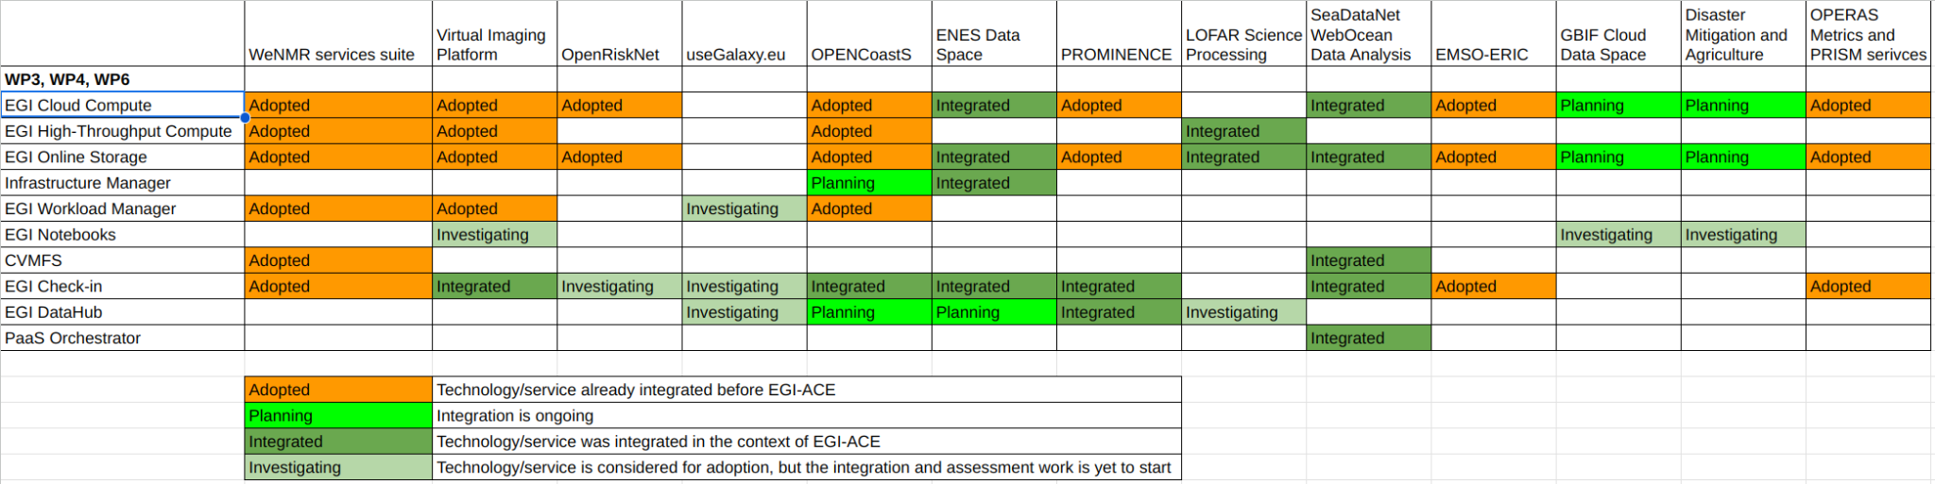

Figure 5 - Service adoption within the Data Space Installations

New name of the OPERAS Certification service
https://research-software-directory.org/projects/ivresse
https://documents.egi.eu/document/2751
https://www.egi.eu/services/workload-manager/
Normalised metric (considering the last 15 months)
https://marketplace.eosc-portal.eu/services/virtual-imaging-platform
https://www.egi.eu/service/replay/
Normalised metric (considering the last 15 months)
https://www.birmingham.ac.uk/index.aspx
https://www.edelweissconnect.com/
https://opentox.net/events/opentox-summer-school-2023/program
https://galaxyproject.org/projects/esg/
Normalised metric (considering the last 15 months)
The metrics reported in each period are achieved in that period on top of the baseline numbers at the start of the project.
Normalised metric (considering the last 15 months)
https://marketplace.eosc-portal.eu/services/enes-data-space
Normalised metric (considering the last 15 months)
Normalised metric (considering the last 15 months)
https://marketplace.eosc-portal.eu/services/eosc.seadatanet.webodv_-_online_extraction_analysis_and_visualization_of_seadatanet_and_argo_data
https://www.egi.eu/services/check-in/
https://marketplace.eosc-portal.eu/services/paas-orchestrator?q=PaaS+Orchestrator
https://blue-cloud.org/about-blue-cloud-2026
https://indico.egi.eu/event/5980/
https://webodv-egi-ace.cloud.ba.infn.it/webodv/videos
https://webodv-egi-ace.cloud.ba.infn.it/webodv/docs
Normalised metric (considering the last 15 months)
Normalised metric (considering the last 15 months)
https://marketplace.eosc-portal.eu/services/eosc.asgc.icomcot_tsunami_wave_propagation_simulation_portal
https://apan55.apan.net/
https://indico4.twgrid.org/event/25/
https://marketplace.eosc-portal.eu/services/eosc.operas.operas_metrics_service
https://documents.egi.eu/document/3712
The level of satisfaction is measured from 1 (min) to 5 (max).
https://marketplace.eosc-portal.eu/
https://opsportal.eosc-portal.eu/metricsEOSC/ServiceOrder/2021-01-01/2022-03-31/stats/on#

