EGI-Engage

GPGPU-enabled web portals for MoBrain

Date | 01 July 2016
Activity | SA2 Knowledge Commons – Task SA2.5 MoBrain
Lead Partner | CIRMMP
Document Status | FINAL
Document Link | https://documents.egi.eu/document/2842

Abstract
After having successfully benchmarked various tools of use in structural biology applications (D6.7), we implemented GPGPU-enable portals for some of them. Specifically, we implemented GPGPU-enabled web interfaces for the AMBER package for molecular dynamics simulations and for the DisVis tool for quantifying and visualizing the accessible interaction space of distance-restrained binary complexes. These new portals provide an enhanced service to the community, by exploiting the significantly faster performance achieved on a GPGPU computational infrastructure. They are based on the design developed during the WeNMR project, which was well received by the target community of researchers. For the AMBER package, the portal can automatically define the most appropriate computational infrastructure to dispatch the calculations, based on the protocol selected by the user. DisVis can however also run in multicore mode instead of GPGPU. In the future we will also investigate use of GPGPU-enabled cloud resources

COPYRIGHT NOTICE
This work by Parties of the EGI-Engage Consortium is licensed under a Creative Commons Attribution 4.0 International License (http://creativecommons.org/licenses/by/4.0/). The EGI-Engage project is co-funded by the European Union Horizon 2020 programme under grant number 654142.
DELIVERY SLIP
 | Name | Partner/Activity | Date
From: | Antonio Rosato | CIRMMP | 30/06/2016
Moderated by: | Małgorzata Krakowian
Reviewed by | Martin Winn  Michael Assfalg  Mario David | STFC / West-Life project  Uni. Of Verona  LIP / User support | 28/06/2016
Approved by:

DOCUMENT LOG
Issue | Date | Comment | Author/Partner
v.0.9 | 08/06/2016 | First draft | Antonio Rosato/CIRMMP
v.1 | 13/06/2016 | Adding DisVis section,  Updating section 1.1 | Mikael Trellet/Alexandre Bonvin/UU, Marco Verlato/INFN
v.2 | 30/06/2016 | Modified upon reviewers’ comments | Antonio Rosato/CIRMMP

TERMINOLOGY
A complete project glossary is provided at the following page: http://www.egi.eu/about/glossary/

Contents
1 Introduction 5
2 Infrastructures used 6
3 The AMBER web portal 8
3.1 Implementation with the AMPS-NMR portal 8
3.2 The current production portal 9
4 The DisVis web portal 11
4.1 Implementation of the DisVis portal 11
4.2 The production portal 12
5 Conclusions 16
6 Future work 17
7 References 18

Executive summary
In this work we focused on two types of tools extensively used by researchers in the field of structural biology:
- Molecular dynamics (MD) allows users to simulate the motions (i.e. local/global changes in 3D structure) of biological macromolecules (proteins, nucleic acids) over time and as a function of different environmental conditions. Simulations can also include experimental data in order to refine or improve the agreement with the data of 3D structural models.
- Docking of pairs of biological macromolecules to characterize higher-order structures of e.g. protein complexes. Such modelling efforts are greatly enhanced by the availability of low-resolution information in the form of distance restraints, which reduce the accessible interaction space of the complex (defined as the set of all the states where the macromolecular partners are in contact).
We previously benchmarked software packages for both MD simulations (AMBER, GROMACS) and for the quantification and visualization of the accessible interaction space of distance-restrained binary complexes (DisVis). In the benchmarks, described in Deliverable D6.7, we demonstrated that these tools had a great benefit from the availability of GPGPUs achieving a speedup of 20-30 with respect to a single core CPU; with respect to 32-core systems, the GPGPUs speedup ranged from a 2-fold (for DisVis) up to 8-fold for MD.
To leverage the above results and make them useful to the entire community, we implemented web portals to setup and launch calculations with AMBER, which is the MD simulation package mostly benefitting from GPGPUs, and DisVis. The portals are available online at http://py-enmr.cerm.unifi.it/access/index/amps-nmr and http://milou.science.uu.nl/servicesdevel/DISVIS, respectively.

Introduction
In order to understand how biological macromolecules (protein, nucleic acids) function one must know their 3D structure, i.e. the relative spatial position of all atoms in the system, and dynamics, i.e. how such positions change over time at a given temperature. Moreover, biological molecules do not work in isolation, which adds a further level of complexity to the problem. Indeed, a key aspect of cellular functioning is the recognition and physical interaction among proteins, nucleic acids and metabolites. Molecules interact among each other by coming into spatial proximity; thereby forming so-called molecular adducts or complexes. Complexes involving biological macromolecules (macromolecular complexes) are of particular interest and are involved in essentially all the crucial aspects of cell life. The characterization of macromolecular complexes is typically much more challenging than the structural study of individual macromolecules. Structural Biology (SB) is the scientific discipline that addresses all the above topics at the experimental and computational level.
The use of computational tools in SB is often hindered by their complexity, which is much higher than the complexity of many tools commonly used by biologists. For example, a typical MD protocol consists of almost a dozen of steps (in-vacuo energy minimization, solvation, ions addition, constrained equilibration etc.). Therefore, to set up MD simulations users must define an extensive set of parameters, which may have a significant effect on the usefulness and biological relevance of the data produced. In addition, when using experimental data in SB calculations trivial formatting inconsistencies and ambiguous definitions can result in insurmountable obstacles for non-expert users. For this reason, the WeNMR project endeavoured to provide the majority of its services via web-based interfaces (portals) that simultaneously hid the complexity of the underlying computational grid infrastructure and provide extensively tested protocols for typical applications. This approach has lowered the barrier for the usage of state-of-the-art tools in SB and consequently significantly extended the user basis of the services.
In the last few years, the use of accelerated computing has become relatively widespread also in the SB field as an efficient, cost-effective resource to push the limits of calculations. In particular, in our previous work within the present task we addressed GPGPUs (General-Purpose computation on Graphics Processing Units). MoBrain has demonstrated the usefulness of GPGPUs for MD applications by benchmarking (Deliverable 6.7) two popular MD software tools (AMBER; GROMACS) under typical, real application settings as well as two other recent Structural biology tools (DisVis; PowerFit). Subsequently, we implemented and now made available GPGPU-enabled portals for MD applications with the AMBER package, and for quantifying and visualizing the accessible interaction space of distance-restrained binary complexes formed by two partner proteins with the DisVis tool. The present report describes these two portals, which fulfil deliverable D6.12.

Infrastructures used
For the activities described here, we leveraged the work done in the context of JRA2 to enable GPGPU support in the EGI HTC platform (see Deliverable D4.6). For this, we implemented at the CIRMMP data centre a test-bed with three nodes (2x Intel™ Xeon™ E5-2620v2) each harbouring two NVIDIA™ Tesla™ K20m GPGPU cards. The test-bed was managed by the Torque 4.2.10 Local Resource Management System (LRMS, compiled with NVIDIA NVML libraries) with the Maui 3.3.1 scheduler, and was installed with CUDA 5.5 initially and then with CUDA 6.5. The last version of the EMI3 CREAM-CE was finally installed on top of the LRMS to enable remote grid access to enmr.eu VO members. For virtualization, the Docker platform was installed on the testbed to allow the use of “dockerized” applications.
The first prototype of GPGPU-enabled CREAM-CE featured two new JDL attributes (for info on what JDL attributes are, please visit https://wiki.italiangrid.it/twiki/bin/view/WMS/JDL; https://edms.cern.ch/document/592336/1): GPUNumber (number of GPUs in a single server requested by the job) and GPUMode (referring to the NVML COMPUTE mode, to define if exclusive or concurrent usage of the GPGPU is adopted). The glite-ce-submit client could successfully submit AMBER jobs remotely to this prototype, using the PMEMD tool of the AMBER package. Further tests involved the use of the Maui scheduler, which failed to define the NVIDIA compute mode. This issue was present also for other popular batch systems like LSF, Slurm, SGE and HTCondor. Therefore, the final GPGPU-enabled CREAM-CE release did not include the GPUMode JDL attribute any longer. A second prototype of the CREAM-CE was implemented for working with Slurm, LSF and HTCondor batch systems, allowing to specify also the model of the requested GPGPU card via the new JDL attribute GPUModel (the make/model of GPU). The possibility to select MIC co-processors, by using another new JDL attribute called MICNumber (number of Intel Phi co-processors in a single server requested by the jobs), was also introduced. It is necessary to define appropriately the GPGPU-related JDL attributes in order to be able to direct calculations to GPGPU working nodes. A description of these JDL attributes will be included in the next official release of the CREAM-CE. The overall work done in the context of JRA2.4 for the inclusion of GPU support in CREAM-CE is summarized here: https://wiki.egi.eu/wiki/GPGPU-CREAM.
Since November 2015 a number of servers with some NVIDIA™ Tesla™ K20m GPGPU cards was made available by the OpenStack based IISAS-GPGPUCloud production site which is part of the EGI Federated Cloud. Virtual Machines with appropriate flavour could therefore be instantiated by enmr.eu VO users in exclusive way with one or two GPGPU cards on board, via the PCI pass-through virtualisation technology. Both OCCI interface and native OpenStack Horizon web dashboard are available for managing the VM life-cycle. In April 2016 an EGI grid production site managed by the Academic and Research Network of Slovenia (ARNES) deployed the latest prototype of the CREAM-CE for testing with the dteam VO, and is currently negotiating its support to enmr.eu VO. The site is hosting 3 servers, each with 2 NVIDIA™ Tesla™ GPGPU cards (K40c, K20c and K10 models). Since May 2016 the OpenNebula based CESNET-MetaCloud site, another EGI Federated Cloud site, has provided to the enmr.eu VO a few servers with NVIDIA™ Tesla™ M2090 GPGPU cards via PCI pass-through virtualisation. Because PCI pass-through capability has been introduced only in the recent 4.14 OpenNebula release, the current implementation is still to be considered experimental. The DisVis application was deployed on both aforementioned cloud sites and executed on CentOS and Ubuntu based VMs, showing no loss of performance against the same GPGPU card models on the bare metal.

The AMBER web portal

Implementation with the AMPS-NMR portal
The AMBER (http://ambermd.org/) web portal exploits the PMEMD tool of the package. CIRMMP has acquired a license as computing center in order to provide this service to external users via its portal. The same application scenarios used in the benchmarking reported in D6.7 were implemented:
- Restrained MD (rMD), i.e. including experimental data that define the conformational space available to the molecule
- Unrestrained, also called free, MD simulations.
Besides their specific research purpose, the two types of simulations differ in the input data required. For free MDs only the atomic coordinates of the initial 3D structural model of the biological system of interest are needed. For rMD simulations, the experimental data are required as an additional input, in a suitable format. rMD simulations are enabled by the AMPS-NMR portal which was developed in the context of the WeNMR project [1;2]. AMPS-NMR uses experimental NMR data as its input. For the rMD implementation, it was necessary to modify the source code of PMEMD in order to harmonize the treatment of NMR experimental data to that implemented in AMPS-NMR. This implementation involved only one specific routine of the code, so it can be straightforwardly included also in future versions. No modifications in the code were instead needed for the free MD application.
We decided to directly integrate the new GPGPU functionalities in the existing portal, so that the modifications would not impact the interface presented to the users and thus would not disrupt the operations and pre-existing user basis of the AMPS-NMR portal. This includes in particular the management of user credentials and the authentication of new users based on their X509 certificates, which have been already described [1]. With this approach, the reference scientific community is able to take up immediately the advantages of the now available GPGPU infrastructure, without the need for any changes in their working habits. To achieve this goal, we modified the code underlying the portal to include the different commands for the submission and retrieval of jobs, based upon the APIs of the CREAM-CE (see 1.1).
At the user level, we introduced two new protocols in the list of pre-defined protocols, addressing the two usage scenarios mentioned above. In particular, for the rMD simulations we extended the number of steps in the protocol with respect to a similar implementation on the CPU-based infrastructure in order to benefit fully from the high performance of GPGPUs. We are in the process of developing guidelines for the best usage scenarios of the above protocols, also with respect to choosing between corresponding GPGPU- or CPU-based protocols.

The current production portal
Below we report a series of screen shots from the AMPS-NMR portal that is currently in production (i.e. available to users). Thanks to our implementation strategy, all pre-existing users (about 300) have immediate access to the newly available features with their already active credentials. However, only a few tens of test runs have been performed so far.

The current selection of protocols is shown in Figure 1. The GPGPU-enabled protocols are identified by the GPU prefix.
Figure 1 – Predefined calculation protocols currently available on the AMPS-NMR portal.
If a GPU-specific protocol is selected by the user, as in the example of Figure 1, by clicking on the submit calculation tab the portal prompts the user for a name to be assigned to the calculation directory and automatically defines GPGPUs as the target computational infrastructure. The latter choice is thus not shown to the user (Figure 2).

Figure 2 – Submission of calculations via the AMPS-NMR portal.
The calculation results are automatically retrieved after completion of the job and made available via the local storage space provided to the user by the portal, as previously implemented in AMPS-NMR [2]. An example output is shown in Figure 3 for a group of ten conformers of the same protein, with a flexible tail.
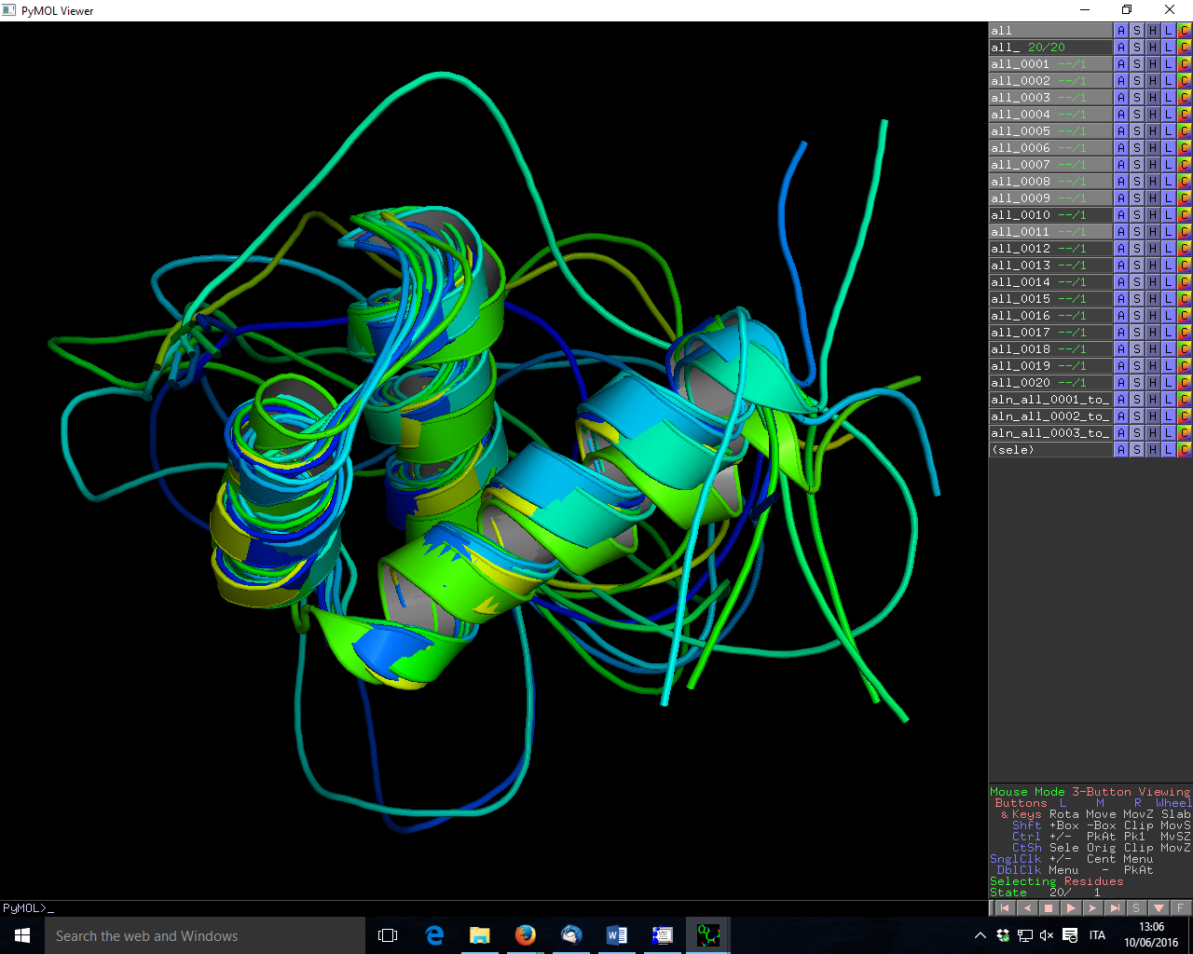
Figure 3 – A bundle of 10 conformers of a protein after rMD. The protein contains three well-defined helices and an extended unstructured tail.

The DisVis web portal

Implementation of the DisVis portal
DisVis is a software tool developed by Bonvin group, for the visualization and quantification of the accessible interaction space of distance restrained binary biomolecular complexes (Figure 4) [3]. Like PowerFit, DisVis is a Python package and a simple command-line program, with the ability of harnessing multiple CPUs and GPU. The inputs and outputs for DisVis are all text files. It is freely available from http://www.github.com/haddocking/disvis.
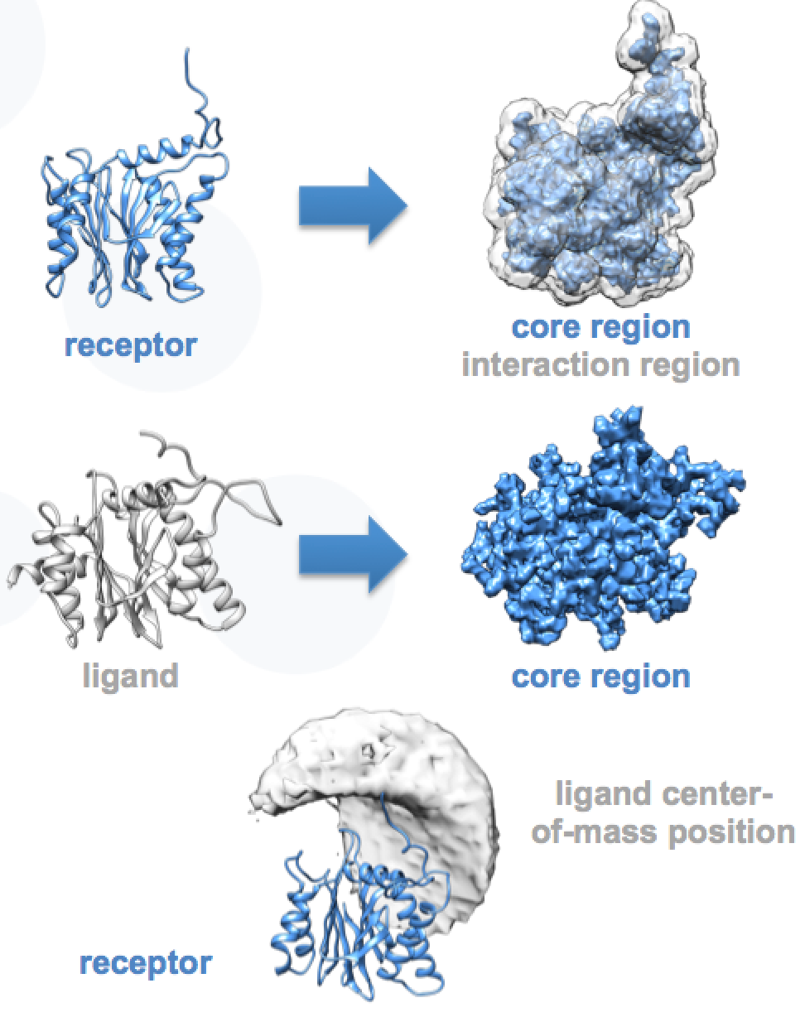
Figure 4. Visualization and quantification of the accessible interaction space for two proteins, using DisVis.
A new portal for DisVis has been developed and successfully tested. Its underlying computational setup follows the implementation benchmarked as reported in Deliverable 6.7. The current stable version of the portal is available from http://milou.science.uu.nl/servicesdevel/DISVIS for testing purposes only. A production version will be made available shortly at http://milou.science.uu.nl/enmr/services/DISVIS.
It has been developed from scratch and relies on the Flask framework. The DisVis portal uses different modules bundled specifically for this framework to handle the different components of the webserver:
- user/admin mailing system (Flask-Mail)
- authentication through SQL database usage (Flask-SQLAlchemy)
- forms creation and validation (Flask-WTF)
- html/css/js framework (Flask-Bootstrap)
- admin management (Flask-script)
The webserver is hosted on a machine at Utrecht University (UU) and communicates through password-less SSH communication with a UI for grid submission at the Utrecht LSG-BCBR grid site managed by the Dutch NGI via SURFsara (ui-enmr.lsg.bcbr.uu.nl). The latter handles the grid submission and retrieval process based on GLite commands whereas DisVis jobs pre- and post-processing are handled by the UU server.
We setup two specific protocols for DisVis as two sets of fixed parameters. One is based on a default and optimized set of parameter highlighted in the associated paper [3] and referenced as “complete scanning” mode and the second one is based on empirical values that speed up the computing time by reducing the research area sampling of DisVis and referenced as “quick scanning” mode.

The production portal
Registration of a new user is handled by the webserver through a registering form (current version at http://milou.science.uu.nl/cgi/servicesdevel/DISVIS/disvis/register) accessible from the home page (Figure 5). As the production portal is not available yet, currently there are no external registered users.
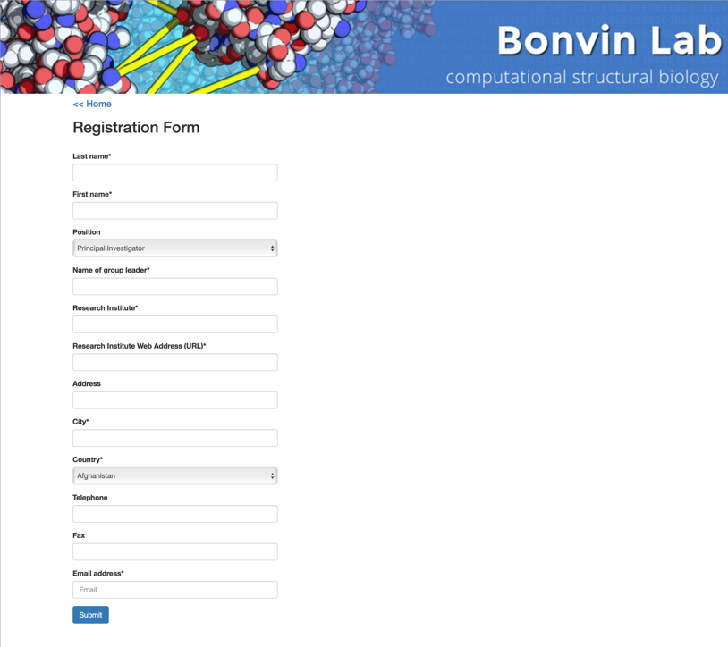
Figure 5. Screenshot of the DisVis webserver registration page.
This form follows the structure of the one used for the HADDOCK registration process. Any new user needs to be validated by one of the DisVis webserver admins. This process is explained to the user on the webserver but also in an email sent when he submits the registration form. Another email is sent to the DisVis webserver email account (disvis-server@gmail.com) with a summary of the user information for an easier information checking. Once the information is checked and if the admin agrees to, a simple command has to be issued by an administrator on the UU server where the DisVis webserver is hosted to validate the new registration. Once done, the user receives a confirmation email with some basic information on how to use the webserver. The above procedure allows the administrators to check manually that new users are legitimate. Eventually, the DisVis portal will integrate the AAI system of the West-Life VRE (see section 6).
The home page of DisVis contains a submission form with all the input parameters needed to run DisVis. The user is required to provide three input text files: Two PDB files (3D coordinates files - one for the receptor chain and one for the ligand chain) and a restraint file (TBL format). The format and syntax of these files are validated upon submission and a wrongly formatted file will trigger a submission error that will be displayed on the form page as a flash message to alert for an issue. This quick checking step takes place within seconds and prevent both any unnecessary processing of the files by the UU server and any email sending to the user. The user can switch between a “complete scanning” mode (Figure 6) or a “quick scanning” protocol. These two first modes do not allow the user to customize the parameters since these are specific and tuned protocols. However, a third option for the user lets him tune himself the parameters in a so-called “custom scanning” mode (Figure 7).
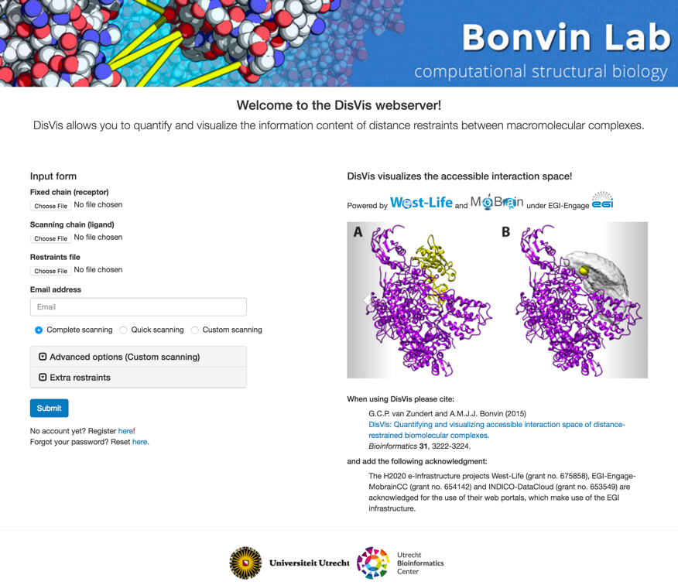
Figure 6. Screenshot of the DisVis webserver home page with default parameters as input.
Unlike the standalone version, we do not let the user control the number of CPU or whether DisVis will profit from GPU computations. As of today, these two parameters are fixed to match the setup made on the only distant site (at CIRMMP) on which the DisVis software is deployed.
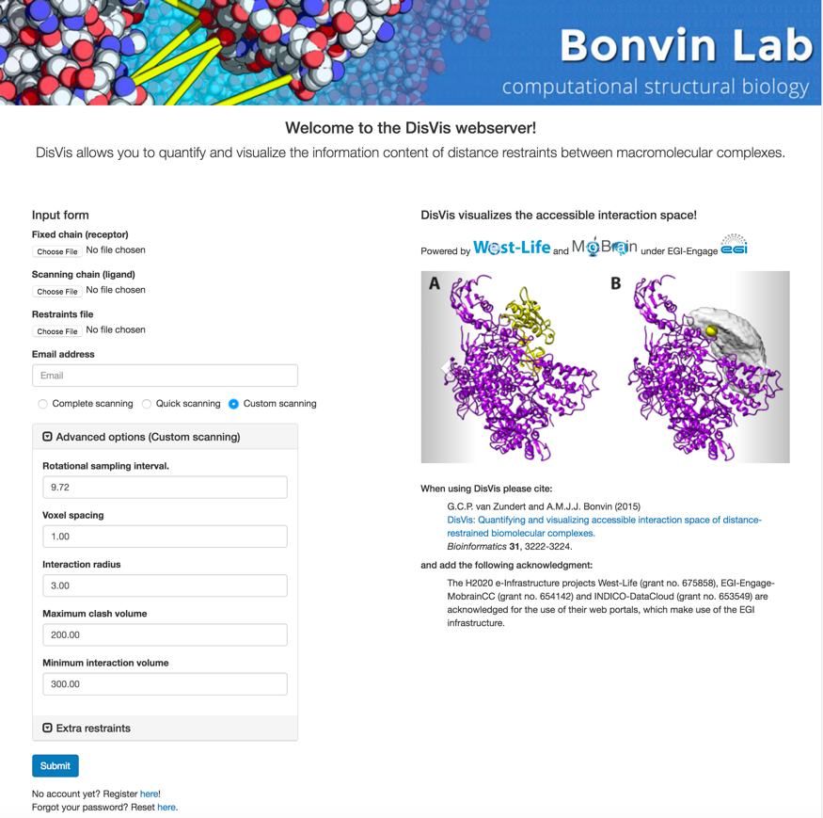
Figure 7. Screenshot of the DisVis webserver home page in “custom scanning” mode.
Once submitted, the form is processed and the ensemble of files are copied on the host server in UU. The user is redirected to a job-specific page updated every 30 seconds with a report of the current status of his job. The length of a job depends on several parameters, such as the size of the interacting protein partners and can take from a few minutes to a few tens of minutes. The reported status can be:
- Queued -> Job currently sent from UU server host to UI
- Submitted -> Job processed and submitted by the UI to the grid computational site (CE)
- Running -> Job currently running on the grid computational site
- Post-processing -> Job fetched back from the grid computational site and post-processed by the UI
- Done -> Results are available on the UU server for the user, the results page is displayed
After validation of the form, the link to this page, also used as results page, is sent to the user in a confirmation email. A JSON file with the different parameters provided by the user is available through a downloadable link present in both the email and the status page.
A template, tuned for grid submission to the GPGPU-enabled CE at the CIRMPP site in Florence, allows for the generation of a unique bash script containing the user files and parameters. It also contains the docker command to be performed on the remote working node (WN) and some GPGPU-specific commands specific to the computational site (currently on the CIRMPP site). Thanks to the docker technology, it should take a relatively minor effort to adapt the grid submission system for other computational sites where the docker platform has been deployed.
Once generated, the bash script and the input files are sent to the LSG-BCBR UI that handles the grid submission. On this machine, several cron jobs are setup to perform several grid-related tasks with the use of GLite:
- Create and renew a robot proxy certificate linked to DisVis
- Check for new jobs coming from UU webserver
- Create a JDL file for the grid submission process
- Submit the jobs to the grid queuing system
- Update webserver status of all submitted jobs by monitoring the status of the submitted jobs
- Fetch finished jobs and send them back to the UU webserver
The third and fourth steps above exploit the technology outlined in section 2. When a job has been submitted and fetched back by the grid submission machinery, even if it failed, the results directory is sent to the UU server and a post-processing script is triggered to handle it. A new email is sent to the user with the job status and the link to the results page where he can recover the data (Figure 8). The results are available as an archive file containing all the input and result files.
Figure 8. Screenshot of the DisVis webserver results page.

Conclusions
We implemented two GPGPU-enabled web portals, which are already available in “production mode” to users of the reference scientific communities of MoBrain and beyond. The portals are integrated/being integrated in the WeNMR gateway. As WeNMR is evolving into the West-Life Virual Research Environment (https://portal.west-life.eu/), there portals will eventually be accessible also via West-Life. As described in the next section, implementation of West-Life AAI mechanisms will be performed in due time.
The portals take advantage of and make useful to the scientific community the gains afforded by GPGPUs in terms of speeding up calculations and, consequently, opening up new scenarios for the use of scientific tools, both pre-existing (such as AMBER) or newly developed (such as DisVis). The current limiting factor for the usage of these portals is the availability of GPGPU resources on the grid. We have been actively working on this in the context of MoBrain and EGI-Engage, as described in Section 1.1, so this should improve in the near future. Cloud solutions are also being considered.

Future work
At the general level of all portals that are, in their different ways, linked to the MoBrain activities, the most important future work to be done is linking to a broad single sign-on (SSO) system. The majority of the presently available portals are using the specific SSO system previously developed for the WeNMR project. In the future, we will look into moving toward a broader system, which ideally should be common to the INSTRUCT and/or West-Life projects. The AAI mechanism of West-Life is still being developed. Its specifics will depend on the outcome of various other European projects, such as the AARC and INDIGO-DataCloud, which take into account also existing initiatives like EduGain.
For the AMPS-NMR portal, the future work will focus on the development of new protocols/functionalities that leverage the high performance of GPGPUs. As an example, the team at CIRMMP is already working on tools to extract order parameters from unrestrained MD simulations, which have been implemented already, for comparison with experimental NMR relaxation data.
For the DisVis portal, the next short-term efforts will be axed around two main parts: Registration and Results post-processing to offer users with some direct visualisation of their data. The developments around these two axes already started but are not yet implemented in the stable version. For the registration, we will integrate a centralized registration process for the ensemble of web tools provided by the Utrecht site. For the visualisation of the results, we started to automate the generation of illustrative images from the result files to provide a clear overview of the results to the users in the results web page already.

References
- T.A. Wassenaar, M. van Dijk, N. Loureiro-Ferreira, G. van der Schot, S.J. de Vries, C. Schmitz, J. van der Zwan, R. Boelens, A. Giachetti, L. Ferella, A. Rosato, I. Bertini, T. Herrmann, H.R.A. Jonker, A. Bagaria, V. Jaravine, P. Guntert, H. Schwalbe, W.F. Vranken, J.F. Doreleijers, G. Vriend, G.W. Vuister, D. Franke, A. Kikhney, D.I. Svergun, R. Fogh, J. Ionides, E.D. Laue, C. Spronk, S. Jurka, M. Verlato, S. Badoer, S. Dal Pra, M. Mazzucato, E. Frizziero and A.M.J.J. Bonvin WeNMR: Structural Biology on the Grid. J. Grid. Comp., 10, 743-767 (2012). doi: 10.1007/s10723-012-9246-z
- I. Bertini I, D.A. Case, L. Ferella, A. Giachetti, A. Rosato. A Grid-enabled web portal for NMR structure refinement with AMBER. Bioinformatics. 27, 2384-2390 (2011). doi: 10.1093/bioinformatics/btr415
- G.C.P. van Zundert, A.M.J.J. Bonvin. DisVis: Quantifying and visualizing accessible interaction space of distance-restrained biomolecular complexes. Bioinformatics. 31, 3222-3224 (2015). doi: 10.1093/bioinformatics/btv333

