

**EGI-Engage**

Final report on EGI Service Registry and Marketplace

D3.16

|  |  |
| --- | --- |
| **Date** | 22 June 2017 |
| **Activity** | WP3 |
| **Lead Partner** | SWING |
| **Document Status** | DRAFT |
| **Document Link** | https://documents.egi.eu/document/3030 |

Abstract

Lorem ipsum dolor sit amet, consectetur adipiscing elit. Integer nec odio. Praesent libero. Sed cursus ante dapibus diam. Sed nisi. Nulla quis sem at nibh elementum imperdiet. Duis sagittis ipsum. Praesent mauris. Fusce nec tellus sed augue semper porta. Mauris massa. Vestibulum lacinia arcu eget nulla. Class aptent taciti sociosqu ad litora torquent per conubia nostra, per inceptos himenaeos. Curabitur sodales ligula in libero. Sed dignissim lacinia nunc. Curabitur tortor. Pellentesque nibh. Aenean quam. In scelerisque sem at dolor. Maecenas mattis. Sed convallis tristique sem. Proin ut ligula vel nunc egestas porttitor. Morbi lectus risus, iaculis vel, suscipit quis, luctus non, massa. Fusce ac turpis quis ligula lacinia aliquet. Mauris ipsum. Nulla metus metus, ullamcorper vel, tincidunt sed, euismod in, nibh. (about 120 words)

**COPYRIGHT NOTICE**



This work by Parties of the EGI-Engage Consortium is licensed under a Creative Commons Attribution 4.0 International License (http://creativecommons.org/licenses/by/4.0/). The EGI-Engage project is co-funded by the European Union Horizon 2020 programme under grant number 654142.

**DELIVERY SLIP**

|  |  |  |  |
| --- | --- | --- | --- |
|  | ***Name*** | ***Partner/Activity*** | ***Date*** |
| **From:** |  |  |  |
| **Moderated by:** |  |  |  |
| **Reviewed by** |  |  |  |
| **Approved by:** |  |  |  |

**DOCUMENT LOG**

|  |  |  |  |
| --- | --- | --- | --- |
| ***Issue*** | ***Date*** | ***Comment*** | ***Author/Partner*** |
| **v.1** |  |  |  |
| **...** |  |  |  |
| **...** |  |  |  |
| **v.n** |  |  |  |

**TERMINOLOGY**

A complete project glossary and acronyms are provided at the following pages:

* <https://wiki.egi.eu/wiki/Glossary>
* <https://wiki.egi.eu/wiki/Acronyms>

**Contents**

1 Introduction 6

2 Concept of EGI Marketplace 7

2.1 Analysis of the landscape 7

2.2 Requirement gathering 7

2.3 Customer analysis 7

2.4 Service scenarios 7

3 Technology assessment 8

4 Service architecture 9

4.1 High-Level service architecture 9

4.1.1 Data Model 9

4.1.2 Workflows 9

4.1.3 Pay-for-use support 9

4.1.4 Technology customisation 9

4.2 Integration and dependencies 9

5 Prototypes 10

5.1 Prestashop prototype 10

5.2 Open IRIS prototype 10

5.3 Evaluation 10

6 Moving to production 11

7 Marketplace as tool to automate EGI IMS processes 12

7.1 Relationship between the EGI Service Catalogue and the marketplace 12

7.1.1 Service order management 12

8 Policies 13

8.1 Requirements to expose services in the marketplace 13

9 Future plans 14

10 Plan for Exploitation and Dissemination 15

Appendix I. Appendix example 18

**Executive summary**

Lorem ipsum dolor sit amet, consectetur adipiscing elit. Integer nec odio. Praesent libero. Sed cursus ante dapibus diam. Sed nisi. Nulla quis sem at nibh elementum imperdiet. Duis sagittis ipsum. Praesent mauris. Fusce nec tellus sed augue semper porta. Mauris massa. Vestibulum lacinia arcu eget nulla. Class aptent taciti sociosqu ad litora torquent per conubia nostra, per inceptos himenaeos. Curabitur sodales ligula in libero.

Lorem ipsum dolor sit amet, consectetur adipiscing elit. Integer nec odio. Praesent libero. Sed cursus ante dapibus diam. Sed nisi. Nulla quis sem at nibh elementum imperdiet. Duis sagittis ipsum. Praesent mauris. Fusce nec tellus sed augue semper porta. Mauris massa. Vestibulum lacinia arcu eget nulla. Class aptent taciti sociosqu ad litora torquent per conubia nostra, per inceptos himenaeos. Curabitur sodales ligula in libero.

# Introduction

Lorem ipsum dolor sit amet, consectetur adipiscing elit. Integer nec odio. Praesent libero. Sed cursus ante dapibus diam. Sed nisi. Nulla quis sem at nibh elementum imperdiet. Duis sagittis ipsum. Praesent mauris. Fusce nec tellus sed augue semper porta. Mauris massa. Vestibulum lacinia arcu eget nulla. Class aptent taciti sociosqu ad litora torquent per conubia nostra, per inceptos himenaeos. Curabitur sodales ligula in libero.

Lorem ipsum dolor sit amet, consectetur adipiscing elit. Integer nec odio. Praesent libero. Sed cursus ante dapibus diam. Sed nisi. Nulla quis sem at nibh elementum imperdiet. Duis sagittis ipsum. Praesent mauris. Fusce nec tellus sed augue semper porta. Mauris massa. Vestibulum lacinia arcu eget nulla. Class aptent taciti sociosqu ad litora torquent per conubia nostra, per inceptos himenaeos. Curabitur sodales ligula in libero.

# Concept of EGI Marketplace

The EGI Marketplace should provide functionalities necessary for bringing together offering and demand for making research.

These functions include basic services for registering business entities, publishing and retrieving offerings and demands, searching and discovering offerings according to specific research communities requirements as well as lateral functions like reviewing, rating and recommending.

The Marketplace would provide researchers with a uniform interface to discover and match application and service offerings from providers and sources (e.g. published by different stores) with demand of consumers.

Besides the core functions, the Marketplace may offer value because of its "knowledge" about the market in terms of market intelligence services, pricing support, advertising, information subscription and more.

How a marketplace functions in a legal, policy and business framework is an incredibly complex topic within a single country, let alone across national borders. There are two perspectives on this, that of the marketplace provider and that of a resource provider.

In many instances, a marketplace provider will act as a broker. For this, the option is to go with an offering of a “marketplace as a service” to complement the EGI marketplace business functions where needed. By offering a marketplace as a service, individual marketplace providers can determine the business model that fits best. The establishing marketplaces will also need to establish their own policies and terms of use.

[[Marketplace SDTP???]]

The challenge to provide a marketplace for research resources is not just a technical challenge, it also requires understanding the needs of researchers and resource providers, as well as developing a business model to make it sustainable. In this activity,

* A survey and several interviews were conducted to get the requirements from researchers and research resource providers.
* In addition service scenarios for resource usage and resource providers to develop detailed requirements were defined.
* Other related research marketplaces were examined to understand how our activity compares to them.

A Business Model to describe and classify an EGI marketplace and in an “open science commons” space was defined.

## Analysis of the landscape

Other marketplace activities in research were examined to understand their scope and functionalities. This is not a comprehensive list, but hopefully representative.

…

This document examines other electronic marketplaces targeted at the research sector or with the aim to facilitate innovation such as FI-WARE, GEANT, UberCloud, Science Exchange, Internet2, and Helix Nebula Marketplace. These activities are very diverse and can provide insight into this activity. It can be seen by this examination that there is a preference towards the brokerage model and the focus is solely on the pay-for-use concept[1]. We examined in the context of brokerage (broker intermediary involved), free services (ability to offer free resources), IT resources (offering research related IT Services), general science resources (such as core facilities), and local lab resources (sharing of local lab resources with or across groups).



Comparison of Related Activities

Based on this it can be observed that there is a gap for provisioning of local lab resources and general science resources. As well it can be seen that the current activities focus heavily on IT resources. There is an opportunity to create a marketplace that is comprehensive including instrumentation, data, ICT and knowledge to support the entire research lifecycle.

## Requirement gathering

## Customer analysis

## Service scenarios

## Recommendations

The platform planned will enable sharing and discovering of research resources, which in essence becomes a marketplace of marketplaces of free and fee-based research resources using a cloud model and adaptation of common e-marketplace models for cloud services.

### One-Shop-Stop Concept

The original goal of this activity is the establishment of an EGI marketplace of research related services for science, ideally applying the one-shop-stop concept. In order to develop a one-shop-stop concept, EGI must develop a solution that allows resource providers to register and provide any type of relevant research resource within the marketplace without any barrier of entry. Then tools within the system the resource providers can control visibility and access to these resources to create distinct views on their resources. These may be local to their organisation or from a community. In essence, a marketplace as a service model will need to be developed for resource providers, and for the user a personalised environment is provided to help discover and use these resources.

In academia, research resources are often provided free (e.g. internal facilities, national resources) or based on project funding. In some cases, resources are offered internally or externally for a charge, most times with a different cost structures for each. Therefore, using a brokerage model where a portion of the fees is used to fund a marketplace infrastructure is not always suitable. In addition, the goal would be to have as many participants in the marketplace as possible, and the expectation from users today is that an Internet based tool is offered free of charge. Different approaches can be used to allow the tool to be offered for free and with no brokerage fee. As there will be many different business models for resource providers, individual resource providers must be able to select which one they use or even use multiple types (e.g. free to a particular research community and pay for use to researchers outside a community). The marketplace should put no constraints on the business models used by resource providers.

### Legal, Policy and Business Framework for a Marketplace

This activity involved the analysis and development of a legal, policy and business framework for a marketplace. The legal, policy and business framework is an incredibly complex topic within a single country, let alone across country borders. In this context, it is best for the marketplace as a service platform to not set any restrictions in terms of policy, but let individual resource providers be responsible to comply to legal requirements and policies that may apply to them. This is already the case for services such as Booking.com, eBay, etc. However, the marketplace solution will need to provide tools to facilitate resource provider’s compliance to applicable policies and laws. This can be done by offering tools for handling requests, controlling access, controlling visibility of information, accepting usage guidelines before using resources, accounting, and billing functionality as needed for different cases. These functionalities can be developed with individual resource providers, and generalized so that other resource providers can take benefit from the solutions that are implemented.

### Allocation of Capacity to Research Communities in Collaborations

In discussion with various communities, the activity examined scenarios for allocating capacity to research communities in collaborations with pilot user communities (user-driven scenario development). In doing so, the activity has gathered a set of requirements that will be provided as input into the development of the solution. These mostly centred around visibility and access control, allowing for internal and external usage of research resources.

### Incentive Mechanisms for Resource Centres to Provide Capacity

All research organisations have resources they share or can share between research groups, as well as national and international research resources that are shared between institutions. However, researchers may not be aware of these resources or they are not shared more widely because the tools do not exist to easily share them. In order to facilitate and incentivise resource providers to share resources, the marketplace platform must be able to easily list research resources and provide tools to resource providers to facilitate providing resources. The tools must be optional so a resource provider can select those that are applicable for their use case. These tools can be such things as: visibility restrictions, access restrictions, custom portals, statistics reporting, usage restrictions, billing, etc. These tools must be flexible and simple enough for an individual lab to share resources internally and powerful enough for large pay for use resource providers to provide resources for a fee.

### Analysis of Revenue Streams for Resource Providers

Each resource provider will have different target audiences. However, there are many different approaches in how they generate a revenue stream to fund their activities. This is as diverse as being able to demonstrate the impact of the resource with citations, demonstrate usage and demand with statistics of usage, co-funding of research grants, and fully funded by paying for usage. The marketplace tool will need to support all these models and help different resource providers implement best practices to help them sustain or increase revenue streams.

### Integration with Other Marketplaces

It is of interest to allow users of the marketplace to discover resources from other marketplaces, and in some cases it may be of interest to have resources within the marketplace solution exposed to other marketplaces. However, as in most cases as demonstrated in the analysis of related projects these generally target large resource providers, so there is not a high degree of overlap. Therefore instead of focusing initially on this integration the marketplace to other marketplaces this will be done on an opportunity basis based on requests from resource providers or users of the system, or potential collaborations with other marketplaces. This can be done either by importing resource listings from other marketplaces (e.g. GEANT cloud) or providing tools to integration with others (e.g. Helix Nebula).

### Outputs of the Pay-for-Use Activity

The EGI Pay-for-Use project has demonstrated the heterogeneity and complexity of offering of research resources for a fee (e.g. sharing of nationally funded infrastructure to international participants). Resource providers have defined policies for their target audience, and in some cases they can extend to offer underutilised resources to people outside of that audience.

# Technology assessment

Several open source projects and solutions offered as SaaS were selected for closer examination in order to prepare for the running of a marketplace demonstrator.

A first analysis was performed to identify the most promising solutions that could be used. These have been assessed against the following requirements:

* Adequacy of the solution against the functional requirements identified in D2.3;
* Possible costs in terms of licenses and support;
* Solution supportable in terms of expertise within the EGI collaboration.

The evaluation has been done both within the TJRA1.2 and through the consultation of experts on developing, designing or operating user-facing tools and/or a marketplace. This work has been carried out by accessing live instances of the solutions (this was not possible in all cases) and available documentation on features, costs and licences. After shortlisting solutions, an additional evaluation will follow to consider aspects such as conformance to EGI policies, EU regulations and directives, terms of use and deployment models (internally operated services versus outsourced service), cost of maintenance and ownership. The EGI-Engage marketplace solution proof of concept (POC) is planned for delivery in 2016 (D 3.7, August 31 2016).

Based on the above considerations and on a study of the solutions currently available in the IT scenario, the following products were selected: AppDB, GOCDB, FIWARE Marketplace Generic Enabler, Open IRIS, PrestaShop, WooCommerce.

The tools selected for the evaluation represent well-known solutions for three different categories:

* EGI tools that could be adapted/extended to become a marketplace: GOCDB, AppDB
* Technologies to implement marketplace from other research activities: OpenIRIS, FIWARE

Generic web tools with feature to implement marketplaces: WooCommerce, WordPress

## Evaluation

An evaluation was performed of the above tools by eight experts on developing, designing or operating user-facing tools and/or a marketplace, representing different academic organizations. The experts were asked to rate the solutions in the following areas:

* Adequacy of the solution against requirements: to understand how each technology under evaluation fits with the EGI marketplace requirements;
* Possible costs in terms of licenses and support: the cost of the solution is another parameter that has to be taken into account in the final choice;
* Is the solution supportable in terms of expertise within EGI: the availability of expertise related to a technology within the EGI collaboration would allow developing a marketplace that could be more easily maintained in case of new future requirements?

The following sections report on the outcomes of the evaluation.

### Adequacy of the solution against functional requirements

In this first area, Open IRIS and AppDB obtained a consensus from all the evaluators as the solutions that are more complete in terms of features. Open IRIS has been recognized as the tools that provides the largest amount of features being already organised as a service catalogue. Although the AppDB was not designed as a marketplace, its existing features could be extended with some effort to satisfy the identified requirements.

The FIWARE MP Generic Enabler has been also well evaluated by a certain number of experts but the changes it requires to implement the requirements seem greater.

Evaluators assessed in very different ways PrestaShop and WooCommerce. For someone, they are excellent solutions to implement the marketplace, for others, they are structured to serve commercial companies with objectives very far from the EGI ones.

Table 2. Adequacy of the solution against requirements, 1 (poor) – 5 (complete)

|  |  |
| --- | --- |
| Solution | Score |
| Open IRIS | 33 |
| AppDB | 30 |
| FIWARE MP GE | 27 |
| PrestaShop | 24 |
| WooCommerce | 24 |
| GOCDB | 13 |

### Possible costs in terms of licenses and support

All the solutions under evaluation offer free use and access for service providers and users, for this reason the assessment in this categories mainly focussed on understanding the cost EGI may incur when adopting one of these solutions. Costs of operations and ownership may vary considerably considering these solutions support different deployment models: in some cases EGI.eu can be the service operators (e.g. AppDB), while in other cases the solution is only accessible as SaaS (e.g. Open IRIS).

EGI-based software, AppDB and GOCDB, are already co-funded by EGI and additional cost to support their extension to provide the capabilities of a marketplace as outlined in D2.3 should be low due to the existing integration with other EGI platforms like AAI.

Another important factor that has been identified to assess the sustainability and costs in terms of licenses and support is the size of the user base of each tool. Tools with extensive list of user groups and broad adoption across different sectors have larger chances of receiving community support compared to specific technologies adopted by few communities. On the other hand, in these cases integrating ad-hoc features and maintaining them over time may be expensive if these capabilities are not adopted for upstream release and software is not open source.

In relation to this, Open IRIS, with its increasing user base and the Swiss Federation support, PrestaShop and WooCommerce, with the large communities behind them, seem to meet requirement. FIWARE MP Generic Enabler seems to not give enough guarantees about its sustainability and the support that may be needed.

For some evaluators, adopting commercial tools (like PrestaShop and WooCommerce) could increase the cost of support since EGI should rely on negotiations and agreements with external organizations to achieve this.

Finally, one expert raised the point that none of the non-commercial solutions (AppDB, GOCDB, FIWARE MP Generator and Open IRIS) may be capable of guaranteeing the support of thousands or hundreds of thousands of users via high-availability (HA) configurations. Scalability of the short listed solutions will be evaluated in the coming months.

To conclude with, with regards to this metric, there is an agreement to give a slight preference to community open source projects. Commercial tools (PrestaShop and WooCommerce) received the lower evaluations since consultancy could be needed to extend some of their features and the licenses cost will need negotiation involving external organizations. Further investigations will be conducted for the shortlisted tools, to understand the applicable terms of use and service level agreements.

Table 3. Overall ranking of tools according to the envisaged costs in terms of licenses and support, 1 (high cost for EGI) – 5 (low cost for EGI)

|  |  |
| --- | --- |
| Solution | Score |
| AppDB | 32 |
| GOCDB | 29 |
| Open IRIS | 26 |
| FIWARE MP GE | 23 |
| WooCommerce | 22 |
| PrestaShop | 21 |

### Is the solution supportable in terms of expertise within EGI

Purpose of this assessment was to establish how easily EGI could support the prospective users of a marketplace in their usage of the service. In this category, the EGI tools (AppDB and GOCDB) received the best score as expected as the technical experts are from the EGI community. However, Open IRIS and FIWARE MP General Enabler were considered supportable in term of expertise within EGI by the evaluators. For the commercial tools, opinions among the experts varied greatly: some experts believe that they can be easily adopted as well-known solutions with a large user base, while others considered them far from the current level of expertise in the EGI Community.

Table 4. Is the solution supportable in terms of expertise within EGI, 1 (poor) – 5 (good)

|  |  |
| --- | --- |
| Solution | Score |
| AppDB | 37 |
| GOCDB | 31 |
| Open IRIS | 25 |
| FIWARE MP GE | 24 |
| WooCommerce | 20 |
| PrestaShop | 19 |

### Conclusions

Considering the three metrics defined and the evaluations of the experts, the solutions that better fits the EGI needs to implement a marketplace are AppDB (99) and Open IRIS (84).

According to their self-assessment, Open IRIS has a better match with the EGI marketplace requirements and currently offers many of the marketplace features envisaged.

AppDB needs extensions to become a marketplace and an allocation of resources to cover these costs, however the cost of ownership in this case would be lower as AppDB is already a production platform that will be supported through the EGI Core Activities funding mechanism as of May 2016, and no costs for providing an additional tool would be incurred in this case. Furthermore, AppDB is an in-house tool and negotiation and integration of new capabilities would be easy.

FIWARE MP Generic Enabler has to be extended too to meet the requirements but the knowledge of this solution in EGI is minor with respect to AppDB.

With regards to GOCDB, there is a consensus between evaluators about the fact that the extensions would be major; however, GOCDB is acknowledged to be an important source of information to be consumed by the future EGI marketplace.

Finally, experts have very different opinions on adopting PrestaShop or WooCommerce as tools to implement the marketplace. For some the capability of commercial platforms to be adapted to the needs of EGI requires negotiation; on the other hand, some reviewers believe that their large base would assure a low support cost and a long-term sustainability.

Taking into considerations all the points of the above analysis Open IRIS and AppDB seem the most promising solutions to implement the EGI marketplace demonstrator from a functional point of view. The first for its best match of the requirements, the second as well-known EGI tool (low entry-level for EGI) that could be extended to become a marketplace and would not generate additional operational and support costs.

Additional evaluations will be carried out for the shortlisted group of solutions taking into account the following aspects:

* Completeness of solutions and adequacy of the current features based on the evaluation of a live service instance in those cases where just documentation was used for the assessment.
* Compliance to the project open source policies and with the EGI security policies.
* Compliance with the AAI architecture of EGI.eu.
* Costs of development incurred to support a set of priority requirements.
* Costs of maintenance.
* Compliance with Data Protection Regulation (EC) No 45/2001 for the processing of personal data, for the protection of personal data and confidentiality, specifically in the case of SaaS solutions, EGI will have to be the sole controller of any processing of personal data performed on its behalf. In accordance with article 23 of Regulation (EC) No 45/2001, organizations contracted would be processors and shall only act on instructions of EGI with regard to the processing of personal data. The operators of the marketplace shall have measures and system tools in place to ensure that the data subjects can exercise their right of access, rectification, blocking and erasure in an easy manner.
* Compliance to data quality principles, meaning that personal data can be processed for a specified, explicit and legitimate purpose. The data processed must be adequate, relevant and not excessive in relation to the purpose for which they are collected and further processed. They also must be accurate, kept up to date in a form that permits for the identification of the data subjects for no longer than necessary for the purpose for which the data were collected and further processed.
* In the capacity of controller, EGI must be informed, and agree, in advance of any sub-processor that the contractor and its subcontractors wishes to use for the provision of its services and whether the sub-processing would be carried out within or outside the EEA. The sub-processor must commit to respect the same level of data protection, including security measures, as defined in the contract between the controller and the Cloud Service Provider. The contractor remains fully liable to the controller for the performance of the sub-processor’s obligations under a sub-processing agreement.
* EGI shall be allowed to carry out audits or let these be carried out by a third party to ascertain that the operator has the necessary technical and organisational measures in place, has the necessary competences and the efficiency of the control measures including vulnerability and penetration testing based on a commonly agreed audit plan.
* The operator shall at any time be able to promptly provide EGI with a comprehensive list of measures on back-ups as well as lists of logs and audit trails on the cloud system operations and management which the EU Agency in its capacity of Controller, should be empowered to monitor and audit without any restrictions.

In the case of SaaS solution, the contractor shall be ISO/IEC 27001:2013 certified or, at least, have a clear and sound Information Security system in place.

# Service architecture

The EGI marketplace prototype has been implemented adopting and customising technologies developed by third parties. In particular, two demonstrators have been established leveraging their existing architecture, one based on PrestaShop and the other based on Open IRIS.

## High-Level Service architecture

The high-level service architecture of the two demonstrators is based on the underlying technologies of PrestaShop and Open IRIS, please refer to the PrestaShop[2] and Open IRIS[3] documentation for more details.

This section focuses on the description of the data model and workflows that have been implemented into the two prototypes. In addition, different alternatives for the pay-for-use support in the marketplace are depicted.

Finally, PrestaShop and Open IRIS customisations needed to fully implement the specifications are described.

### Data Model

The data model of the marketplace reflects the EGI service catalogue structure (<https://www.egi.eu/services> & <https://www.egi.eu/internal-services>). It is made of a three-level hierarchy where the first level contains the EGI service areas (categories in the marketplace) and the second level maps to the EGI services (sub-categories in the marketplace). Furthermore, an additional level defines the EGI service options (products in the marketplace). The service options represent the products that the end user could access or purchase in the marketplace.

The marketplace data model has been already detailed in the D3.7 First release of the EGI Service Registry and Marketplace prototype. It has been updated and extended in this second release, defining service options for all the services in the external EGI service catalogue.

In the following, the data associated with a customer (customer/user profile) and to a service order are described. The complete data model is described in Appendix I.

#### Customer/User profile

Each customer/user of the EGI marketplace needs to be registered to submit service orders. Customers are required to register during their first login into the marketplace, the registration allows the marketplace to gather enough information to create and store a customer profile in its internal database. Part of the data is retrieved by the EGI CheckIn service, which provides user authentication, and additional data is gathered from the same customers completing a form.

The following table shows the attributes that comprises the customer profile, specifying the source of the information (CheckIn or the Marketplace) and if an attribute is mandatory or optional.

|  |  |  |
| --- | --- | --- |
| Attributes | From | Mandatory/Optional |
| Name | CheckIn service | Mandatory |
| Surname | CheckIn service | Mandatory |
| e-mail | CheckIn service | Mandatory |
| Display name | CheckIn service | Mandatory |
| EGI unique identifier | CheckIn service | Mandatory |
| Country | Marketplace | Mandatory |
| Institution | Marketplace | Mandatory |
| Department | Marketplace | Mandatory |
| Departmental web page | Marketplace | Optional |
| Linkedin profile | Marketplace | Optional |
| ResearchGate profile | Marketplace | Optional |
| Supervisor name | Marketplace | Optional |
| Supervisor profile | Marketplace | Optional |

#### Service order profiling

The EGI marketplace associates to each service order a set of customer information, which is gathered during the Check-Out phase. Such information, complemented with the customer profile and the order details (the service options), enables the marketplace to implement a service order profile, which allows for appropriate service order management, accordingly to the EGI Integrated Management System (IMS) processes and procedures.

The table below shows the customer information that is linked to a service order. Such information can be extended in the future according to emerging needs.

|  |  |  |
| --- | --- | --- |
| Attributes | Value | Note |
| Customer type | Dropdown: single user, research group/community/project, private company | The typical model will be to work within the context of a community/project or a private company. However, the single user case is also supported. |
| Reason to request access to the EGI services | free text | In order to determine if the resources requested are the best for the task. |
| Research group/project/ community or company name (only if the customer represents a research group/ community/project or a private company) | only in cases when not a “single user” | It maps to the VO name. In the case the customers is already using the EGI infrastructure (VO list not empty), the VO name could be chosen from a drop down menu listing all the customer VOs (retrieved during the authentication) plus the option to specify a new VO. |
| Additional Information on the project  (only if the customer represents a research group/ community/project or a private company) | Project name: text  Project web site: URL | To be expanded in the future. In some cases it can be automatically filled in querying the operations portal if the project is already using the EGI infrastructure |

### Workflows

This section describes the procedures or workflows implemented in the two marketplace prototypes. For each procedure, the following information is provided:

* Overview: short description of the workflow
* Trigger: events that start a workflow
* Involved entities: all the entities that play a role in the workflow
* Input: input data
* Output: output data
* Steps: step-by-step description of the workflow
* Integration with other EGI tools: list of the EGI tools involved in the workflow and description of their interfaces with the marketplace

The following workflows are currently implemented:

* **Authentication**: The login procedure including the user registration during the first access.
* **Discover and order services**: Finding and ordering services within the marketplace.
* **Check-Out**: Submitting a service order together with a set of information to profile it.

#### Authentication and user enrolment

**Overview:**

The customer logs into the EGI marketplace through the CheckIn service.

**Trigger:**

* The customer can decide to log in while they are visiting the marketplace.
* The customer starts the checkout process.

**Involved entities**

* Customer
* Marketplace
* CheckIn service

**Input**

* User credentials (federated or social login)

**Output**

* Personal customer information including the unique EGI identifier
* Customer’s VO membership list

**Steps**

|  |  |  |  |
| --- | --- | --- | --- |
| Step | Conditions | Tool | Action |
| 1 | N/A | Marketplace | Redirect the customers to the CheckIn service. Only required to complete the order process. |
| 2 | N/A | CheckIn service | Authenticate the customers and provide the Marketplace with personal customer information (including the unique EGI identifier) and VO membership list. |
| 3 | After successful authentication and during first login | Marketplace | Complements the personal customer information already provided by the CheckIn service. The Marketplace asks the customer to complete a form with the following attributes:   * Country (mandatory) * Institution (mandatory) * Department (mandatory) * Departmental web page (optional) * Linkedin profile (optional) * ResearchGate profile (optional) * Supervisor name (optional) * Supervisor mail (optional)   These additional attributes are stored in the Marketplace and the customer will not be required again to provide them.  Customers can update their profile at any time. |
| 4 | Successful authentication | Marketplace | After the customer has successfully logged in, the Marketplace shows their name on its web interface. |

**Integration with other EGI tools**

|  |  |
| --- | --- |
| Tool | Integration |
| CheckIn service | Perform the customer authentication on behalf of the marketplace and provide it with customer information (including the unique EGI identifier) and VO membership list. |

#### Discover and order services

**Overview:**

The customer navigates via the service catalogue exposed in the EGI Marketplace and selects one or more services. This can be done before or after authentication. The Marketplace exposes services according to the service catalogue structure:

* First level: service categories
* Second level: services
* Third level: service options

**Trigger:**

* The customer accesses directly the marketplace or through the EGI web site.

**Involved entities**

* Customer
* Marketplace

**Input**

* No input

**Output**

* List of services including service options.

**Steps**

|  |  |  |  |
| --- | --- | --- | --- |
| Step | Conditions | Tool | Action |
| 1 | N/A | Marketplace | The customer navigates through the service catalogue published in the marketplace. |
| 2 | N/A | Marketplace | The customer selects one or more services specifying a set of service options. |

**Integration with other EGI tools**

There are no dependencies from the EGI tools.

#### Check-Out

**Overview:**

Define or update the customer profile, and gather information on the user or research community/project/private company willing to exploit the EGI services and common options for the selected services. Forward all the information to a back end system that will take care of managing the service order.

**Trigger:**

* Customer starts the Check-Out process after he has selected one or more services.

**Involved entities**

* Customer
* Marketplace
* CheckIn service
* Operations Portal

**Input**

* Personal customer information including the unique EGI identifier.
* Customer’s VO membership list.
* Service list including options selected by the customers.

**Output**

* Personal customer information including the unique EGI identifier
* Customer type: single user or representing a research group/community/project/private company
* Reason to request access to the EGI services
* Only for customers representing a community:
  + Information on the project
  + VO information
    - New or existing
    - VO name

**Steps**

|  |  |  |  |
| --- | --- | --- | --- |
| Step | Condition | Tool | Action |
| 1 | Only if the customer is not authenticated. | Marketplace  CheckIn | Automatically starts the authentication process redirecting the customers to the CheckIn service. |
| 2 | Successful authentication. | Marketplace | Presents to the customers the selected service options and their profile, as gathered during the authentication process, and requests them to fill in a form with the following fields:   * Customer:   + single user   + representing a research group/community/project   + representing a private company * Reason to request access to the EGI services |
| 3 v1 | Only if the customer represents a research community/project or a private company | Marketplace  Ops Portal | Request to the customer to fill in an additional form with the following fields:   * User group name: It maps to the VO name. In the case the customers is already using the EGI infrastructure (VO list not empty), the VO name could be chosen from a drop down menu listing all the customer VOs (retrieved during the authentication) plus the option to specify a new VO. * Information on the project will be automatically filled in by querying the operations portal if the customer select an existing VO in the User group name field. |
| 3 v2 | Only if the customer is a single user | Marketplace | Check if the amount of resources requested by the customer is less than the threshold defined to access the applications on demand platform:   * If yes, mark the customer as user eligible for the applications on demand platform. * If no, mark the customer as a normal user. |
| 4 |  | Marketplace | Submit/record the service order and the customer profile to a backend system |
| 5 |  | Marketplace | Send a confirmation e-mail to the customers: “your order is being processed…” |

**Integration with other EGI tools**

|  |  |
| --- | --- |
| Tool | Integration |
| CheckIn | Authenticate the customer when needed. |
| Operations Portal | Provide the marketplace with information related to already existing projects (VOs). |
| Marketplace backend | Receive the service request and the customer profile from the marketplace backend. |

### Pay-for-Use support

An analysis on how to implement the pay-for-use support in the Marketplace has also been performed. As result, three different options have been defined.

* EGI acts as a broker / or individual provider offers listed separate, but aggregated on the service level: Under service level, differentiate each option according to the access mode, for free or for pay. Then, e.g., for Cloud Compute service, the Marketplace will expose the options “General purpose instance” and “General purpose instance for pay”, etc.
* EGI acts as a broker: Add the pay-for-use attributes directly in the service options (product in the marketplace). A flag “for pay” will be added as extra service option. If this option is selected the access policies will change accordingly.
* Direct contracts between customers and providers: An additional category, related to the pay-for-use providers, will be added in the first level of the data model hierarchy (service categories). Under this category, all the providers will be listed. Under each provider, all its products will be listed.

These three different options are currently in discussion within the Pay-for-Use working group. The Marketplace prototypes have implemented the first one for demonstration purposes. This will be updated according to the decision of the Pay-for-Use working group.

### Technology customisation

In order to satisfy the requirements and the specifications above described, both PrestaShop and Open IRIS technologies needed customisations.

This section summarises the changes applied.

#### PrestaShop

The basic PrestaShop tool was enriched with the following plugins to extend its functionalities:

* Additional Product Attributes/Custom Product Fields Module[4]: It allowed to add new fields on the product pages. It was essential to implement all the service options as specified in the data model.
* Custom Checkout and Customer and Address Fields manager Module[5]: It allowed to easily add new fields on checkout pages and collect more data about the customers with extra fields on the registration form and customer account area. It was needed to implement both the customer and service order profiles.
* Dynamic Product Price Module[6]: It allowed to define dynamic prices based on the values that customers defined for the service options. It was needed in order to implement the experimental pay-for-use support.
* Google Accounts login-in module for PrestaShop: It was needed in order to extend the login functionality of PrestaShop.

In addition, ad-hoc customisations were needed to implement the authentication and user enrolment, and the Check-Out workflows. In particular, to retrieve customer information from the CheckIn service, to prevent the service order submission before the customer profile is completed and to profile the service orders. Minor changes were also done to adjust the service options, the service list in the cart and the e-mail templates. All the changes were applied to both the PrestaShop basic code and the extra modules listed above.

#### Open IRIS

The main changes on Open IRIS were related to:

* Integration of the Open IRIS authentication mechanism with the EGI CheckIn service;
* Development of the user enrolment procedure according to the specifications;
* Development of a cart allowing the submission of multiple service orders:
* Implementation of the service hierarchy as described in the specification.

In particular, last point was particularly complex to achieve considering that Open IRIS were designed to show services in a flat mode and categorise them via keywords. The concept of a service hierarchy did not exist in Open IRIS and its introduction requested relevant changes.

## Integration and dependencies

Both prototypes have been integrated with the EGI CheckIn service and have a dependency on it for the user authentication.

# Prototypes

## Prestashop prototype

Customer can easily navigate to the service tree from the marketplace homepage.

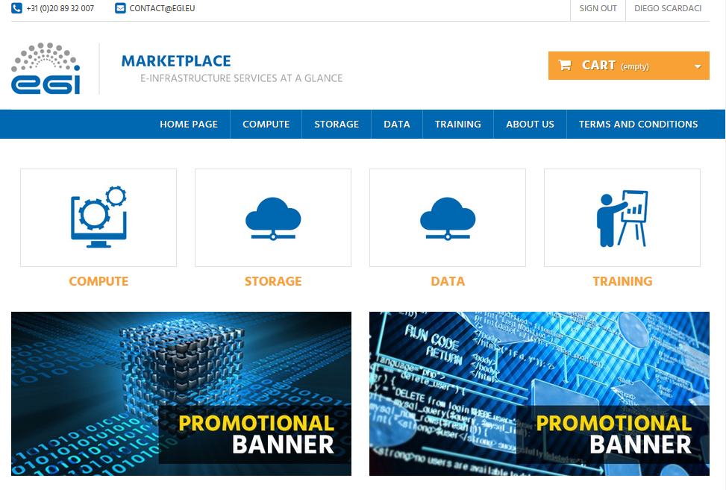

Figure 1. EGI Marketplace based on PrestaShop technology.

The login can be started on each page of the marketplace. During the first login, the customer is requested to register. Part of the customer information is collected by the CheckIn service, see grey fields in Figure 2, the other attributes are manually provided by the customer through the following form.

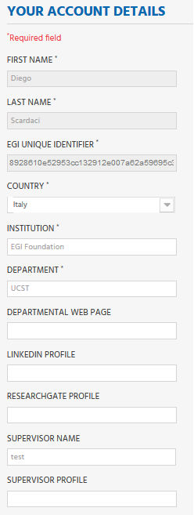

Figure 2. Form to gather the user profile. Fields in grey are filled in with values retrieved by the EGI CheckIn service and cannot be modified.

When a service category is selected, a new view showing all the services under the category is shown. Figure 3 shows the service view for the Cloud Compute service.

The customer can then select the service they would like to order.

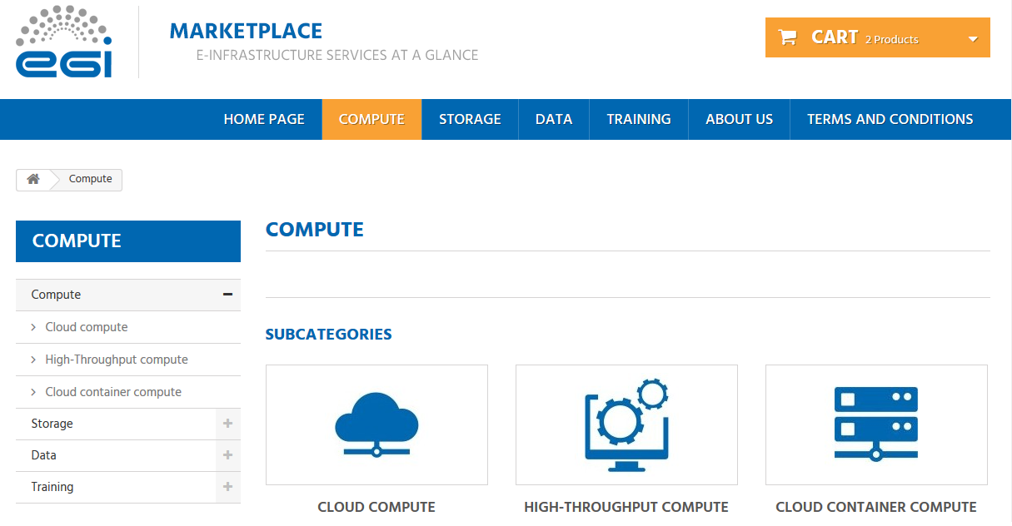

Figure 3. Service category view - Compute

Each service page shows a short description of the service and provide links to the terms of use, the default SLA and to a more detailed description. Figure 4 shows the Cloud Compute service page.

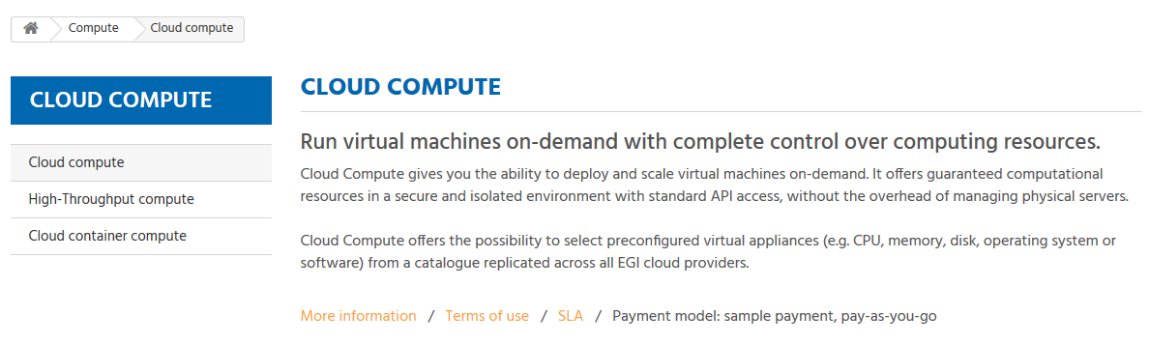

Figure 4. Service view - Cloud Compute

After a customer selects a service, a view listing all the options for such specific service is shown. As example, Figure 5 shows two options for the Cloud Compute service: Compute-intensive instance and High-memory instance.

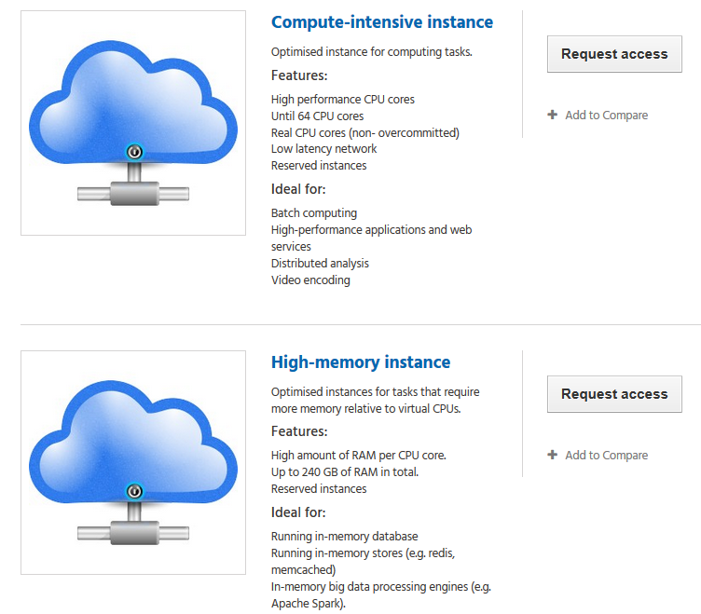

Figure 5. Example of service options - Cloud Compute

Selecting one service option, the customer is then forwarded to a view that allows them to add a service to the cart. They have to specify the additional attributes requested for the specific service option (see the data model in Appendix I).

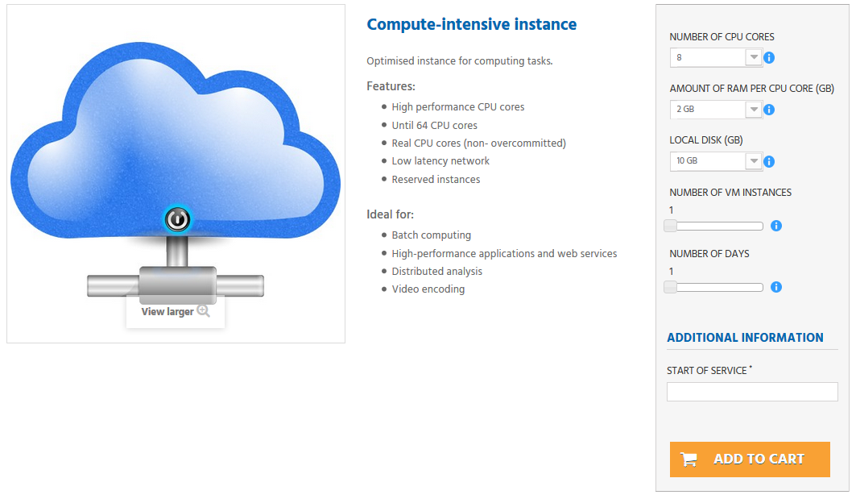

Figure 6. View to order a service. Compute-Intensive Instance in Cloud Compute service

After the customer has added to the cart all the services they want to order, they can start the Check-Out by going to the cart. The cart lists all the services and the related options selected, see Figure 7.

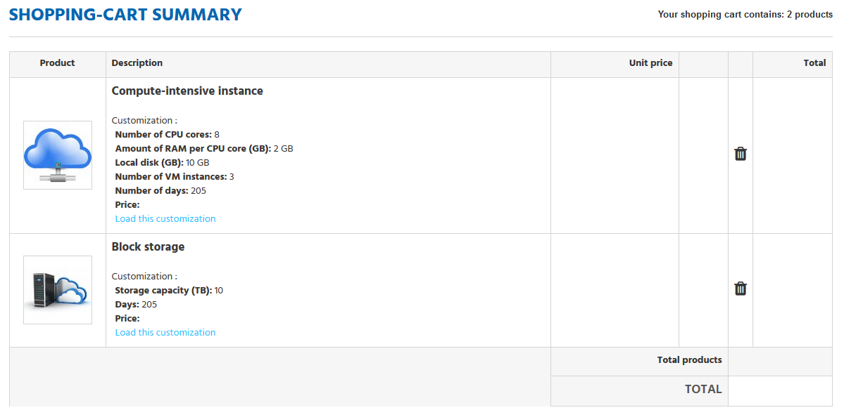

Figure 7. List of selected service options in the Cart

In the cart, the customer is asked to provide some additional information that allows the profiling of the service order, see Figure 8.

The order can only be submitted after the acceptance of the terms of service.

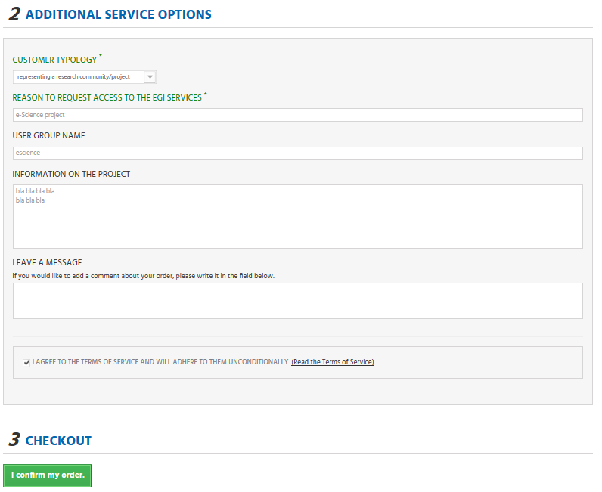

Figure 8. Service order profiling in the cart

## Open IRIS prototype

Customer can easily navigate to the service tree from the marketplace homepage.

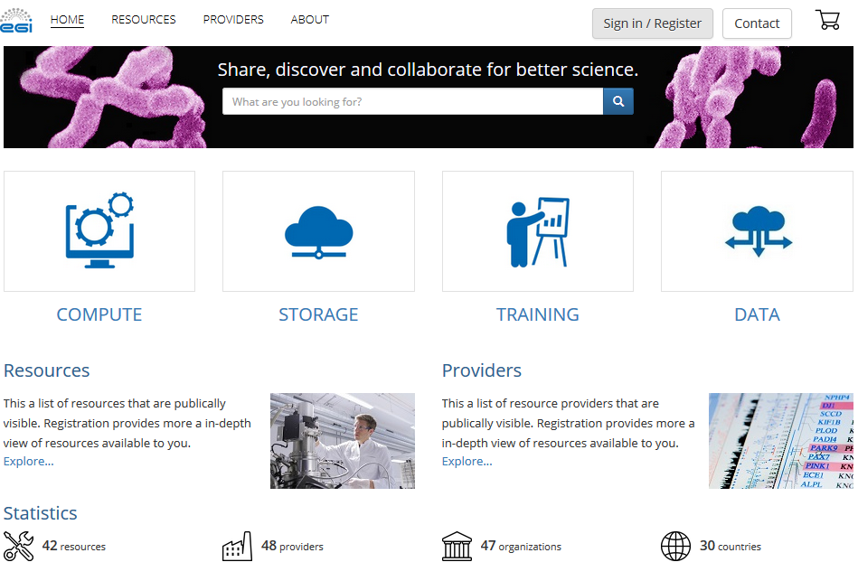

Figure 9. The EGI Marketplace based on Open IRIS technology.

The login can be started on each page of the marketplace. During the first login the customer is requested to register. Part of the customer information is collected by the CheckIn service, see read only fields in figure 10, the other attributes are manually provided by the customer through the form fields.

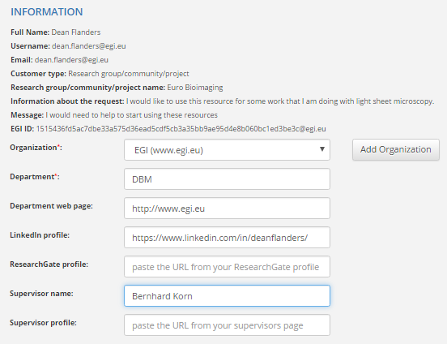

Figure 10. Form to gather the user profile. Fields in grey are filled in with values retrieved by the EGI CheckIn service and cannot be modified.

When a service category is selected, a new view showing all the services under the category is shown. Figure 11 shows the service view for the Cloud Compute service. The customer can then select the service they would like to order.

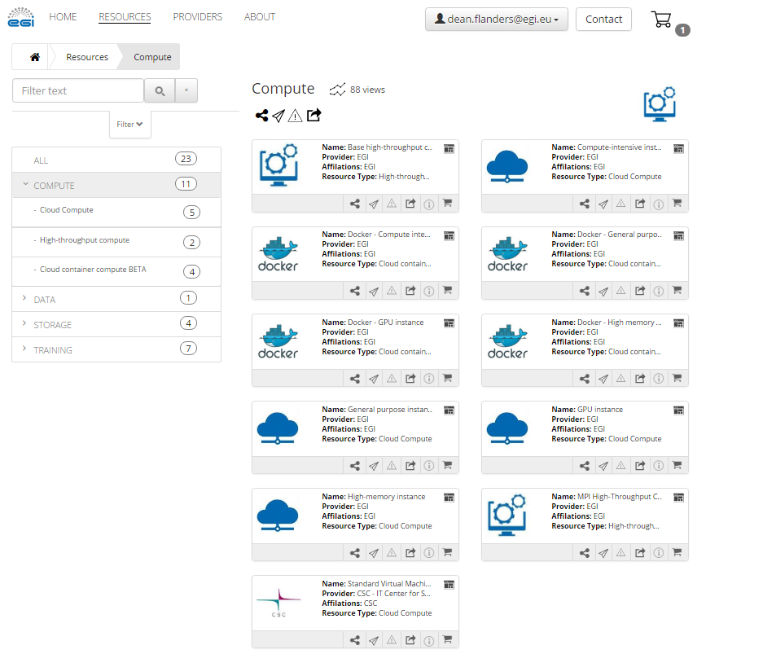

Figure 11. Service category view - Compute

Each service page shows a short description of the service and an overview of the items available. Figure 12 shows the Cloud Compute service page.

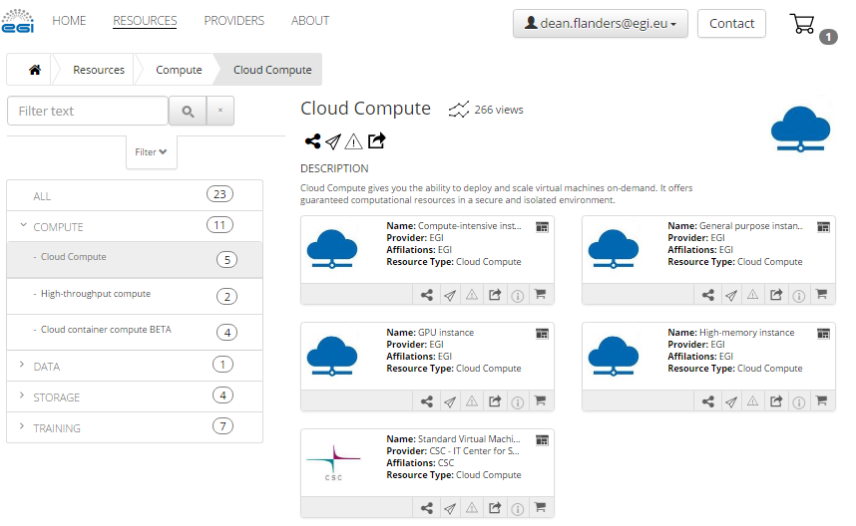

Figure 12. Service view - Cloud Compute

After a customer selects a service, a view listing all the options for the specific service is shown. As example, Figure 12 shows five options for the Cloud Compute service: Compute-intensive instance, High-memory instance, General purpose instance, GPU instance, Standard virtual machine.

When selecting a service option, the customer is then forwarded to a view that allows them to add a service to the cart. They have to specify the additional attributes requested for the specific service option as shown in Figure 13 (see the data model in Appendix I).

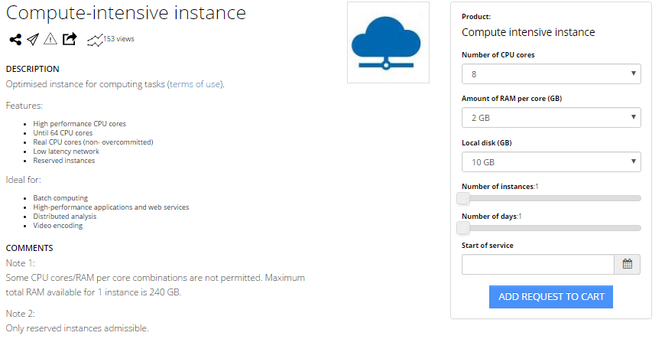

Figure 13. View to order a service. Compute-Intensive Instance in Cloud Compute service

After the customer adds to their cart all the services they want to order, they can start the Check-Out by clicking on the shopping cart icon. The cart lists all the services and the related options selected, see Figure 14.

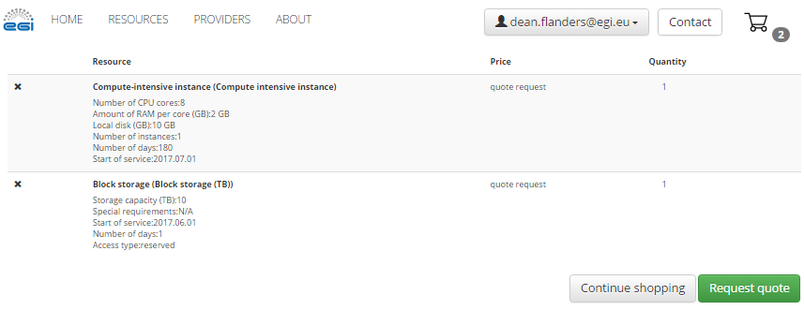

Figure 14. List of selected service options in the Cart

In the cart, the customer is asked to provide some additional information that allows the profiling of the service order, see Figure 15. The order can only be submitted after the acceptance of the terms of service.

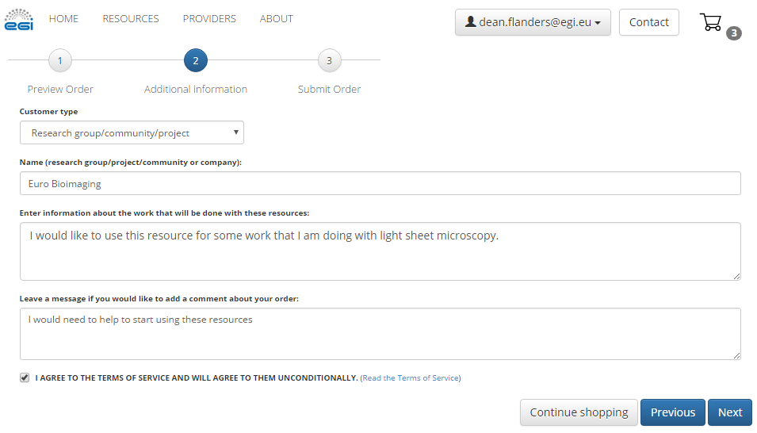

Figure 15. Service order profiling in the cart

## Evaluation

The above-mentioned workflows were evaluated in both systems. It was found that both systems adequately covered the defined workflows as well as supported the data model demonstrating that both could be adopted to implement the EGI Marketplace.

Then, other factors were considered to choose the technology such as its long-term sustainability, availability of expertise, ready-to-use features that could be helpful in the future. As final decision, PrestaShop was selected for the following reasons:

* Widely used by other Internet web stores
* Easy to maintain as it has a wide community of developers
* Expertise within the EGI collaboration
* Ready-to-use feature to implement the pay-for-use support.

# Moving to production

PrestaShop prototype will reach beta by the end of the project.

* **End of March / Mid of April:** platform to manage orders in PrestaShop → integration with the Prestashop Cart → it will manage the orders after the user submit it via PrestaShop Cart.
* **End of April:** integration with ticketing system. By end of March EGI needs to decide the ticketing system, define the queue with related attributes and how to group service orders.
* **End of April:** fixing the remaining open points in PrestaShop like the missing attributes in the Cart. Adding new products. Possible changes on the form in the Cart.
* **End of May:** implementation of the new LTOS platform workflow (to be integrated with the Marketplace) and changes on the admin portal. Replace Unity with CheckIn.
* **End of June:** Customise the Order History in the marketplace (<http://marketplace.egi.eu/order-history>) to become a Customer Dashboard:
* **End of June:** integration activities with LTOS platform. Operational integration with the CheckIn + SGs integrated in the platform. This requires also some changes on the SG integrated into the platform, the effort should be small (Giuseppe to confirm).
* **End of July:** sys-admin documentation
* **July and August:** test, verification, improvements and deployment to production in beta. Moving LTOS users to the new setup.

Integration with the EGI web-site

Customer dashboard

# Marketplace as tool to automate EGI IMS processes

## Relationship between the EGI Service Catalogue and the marketplace

When operational, the EGI marketplace will become the unique place where a new customer could discover a service (or group of services), get information about it by browsing the service catalogue, and submit an order, specifying quantity, quality and duration. It will expose all the live EGI services, following the same structure of the service catalogue, exposing service options to allow customers to properly define their orders.

Furthermore, the marketplace will partially automate the service order management implementing procedures to handle the customers’ requests and triggering related IMS processes. It will act as an orchestrator of the several EGI tools involved in such processes exploiting the customer and service order profile information collected through its workflows.

### Relationship and impact on the EGI tools

The introduction of the Marketplace on the EGI tool ecosystem implies changes on other tools to remove redundancies and implement new workflows. This is particularly relevant for tools that already offer features related to the service order management like e-Grant and the Applications on Demand service (AoDs). E-Grant had been implemented before the service catalogue was defined and since then has been providing a mechanism to support on-demand access to a subset of the services of the catalogue (Compute and Storage), while the AoDs partially implements a service discovery and a user profiling features to identify small research groups (the so-called Long Tail of Science).

To remove these redundancies, e-Grant will be converted to a backend service for SLA/OLA management, its logic will be extended to cover the whole service catalogue and will be integrated as plugin to the Operations Portal to benefit of already available interfaces towards other EGI tools (e.g. the monitoring system). Instead, the AoDs will entirely rely on the marketplace for the user profiling and for exposing its service options (the applications) to the customers.

About the relationship with other EGI tools, the marketplace will be integrated with the EGI AAI CheckIn service delegating to it the process to register, authenticate, authorise and profile the customers. Customers’ information retrieved by CheckIn could be integrated by the Marketplace as needed.

GOCDB could be used to automatically retrieve information about service instances and service providers.

An analysis is still on going to define the interface between the Marketplace and the AppDB. In particular, to understand how to expose the AppDB VMops dashboard to the EGI customers via the Marketplace.

## Service order management through the Marketplace

Once a customer submit an order via the Marketplace, it will be properly pre-processed by the same Marketplace and stored in a Service Order Management tool.

This pre-processing consists on an analysis of the ordered services. A customer could request services of different nature, in terms of both service type (e.g. Cloud Compute and a FitSM training) and amount of resources, which needs to be managed in different ways according to the EGI IMS. The Marketplace creates a service order for each sub-set of requested services that could be managed homogeneously. For example, if a customer orders some Cloud Compute and Online Storage resources and a FitSM training, the marketplace will create two service orders, one for the Cloud Compute and Online Storage services, the other for the FitSM training. In such way, the Service Order Management could trigger the right IMS process to deal with the specific customer’s request.

Currently, the Service Order Management tool was implemented via a dedicated queue in the EGI ticketing system based on RT technology. [[add something about the reason of this choice]

The Marketplace stores the following information in the Service Order Management tool:

* Customer profile: information allowing to identify the customer;
* Service order profile: information allowing to identify the service order typology;
* Service order: list of services ordered by the customer.

After a service order is recorded, it will be managed according to the EGI IMS processes with a series of manual and automatic actions. The following picture shows the interactions that happen during the management of a service order between the Marketplace, the Service Order management and the SLA/OLA management tools with the EGI IMS processes and databases.

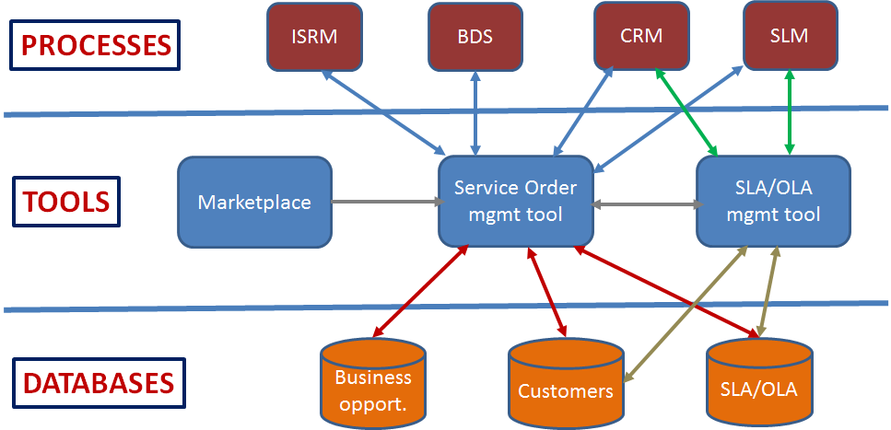

A detailed description of all the processes and steps to manage a service order according to the EGI IMS is showed in Figure 10. The complexity of such workflow requires the creation of as much automatisms as possible to make the customer support really effective. Currently, we already defined and implemented a workflow that, with a minimal human intervention, allows to serve orders for the AoDs.

Automatisms to serve other order typologies will be defined and implemented gradually with the final aim to…

### Serving AoDs orders

A customer that submit a service order through the marketplace could be identified as an eligible user for the AoDs if he/she is a single user and one of the following conditions will be respected:

* If he/she directly requests access to one or more applications hosted in the AoDs;
* If he/she requests access to one or more of the following services Cloud Compute, HTC Compute, Cloud Container Compute, Online Storage with an amount of resources lower than a predefined threshold;

In such case, the marketplace marks the service order as an order for the AoDs and store this information in the Service Order Management tool. This tool notifies AoDs administrators that will review the request and approve or reject it. This is the only manual step of the process. After that, the user will be notified about the outcome. In case his/her request was approved, Service Order Management tool will send to him/her the information on how to access the requested AoD applications. Direct links to access such applications are also available in the Marketplace AoDs section that will act as the front-end platform of the service.

### Tools to manage service orders

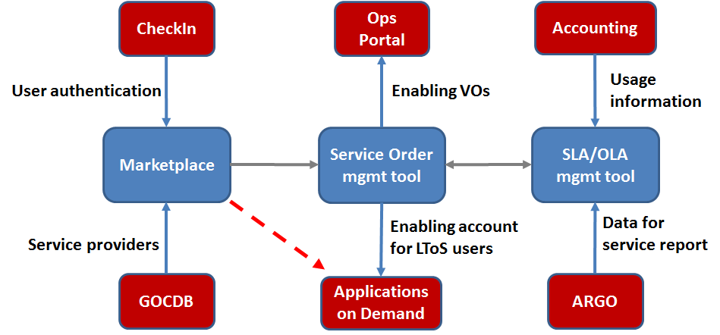

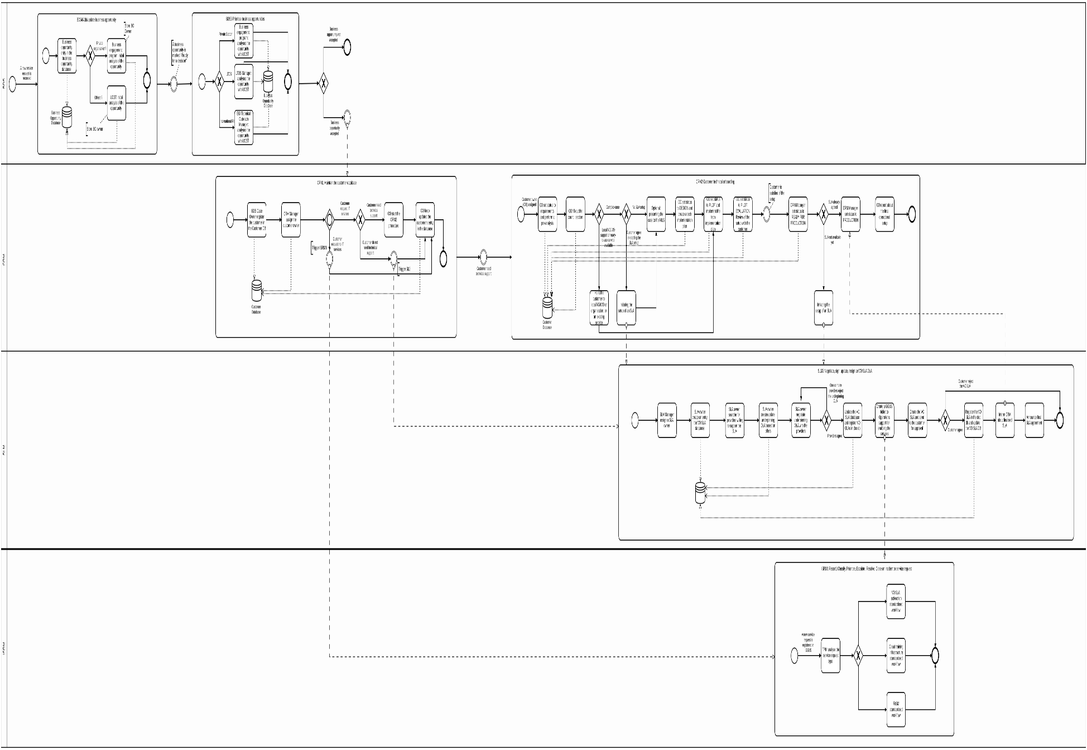

Figure 10. Service Order Management according to the EGI IMS.

# Policies

## Requirements to expose services in the marketplace

|  |  |  |
| --- | --- | --- |
| **Requirements** | **Conditions for production services in the EGI Catalogue**    **Applies to:**  **Services owned by EGI (from the EGI service catalogue)** | **Conditions for production services in the EGI marketplace**    **Applies to:**  **Services owned by partners (from external partner’s catalogues)** |
| **Belongs to EGI catalogue** | Yes (EGI is the provider) | No (Partner is the provider) |
| **Published in EGI marketplace** | Yes | Yes, if requirements in this table are met and if Partner agrees |
| **Agreement type** | EGI provider<->EGI supplier OLA | EGI.eu<->Service Provider   * Memorandum of Understanding * SLA defining EGI Service Components (where applicable) |
| **Readiness** | TRL 8 or higher | TRL 8 or higher |
| **Quality of Service** | Min Availability/Reliability (thresholds defined by EGI)    Service is monitored and registered in GOCDB | Min Availability/Reliability (thresholds defined by service provider)    Minimal monitoring in place by EGI (where possible) to ensure online services are up and running (for discussion) |
| **Support** | Mandatory (GGUS) | Mandatory (support channel defined by provider) |
| **Acknowledgement policy** | EGI acknowledgement mandatory | EGI acknowledgement mandatory if service relies on components provided by EGI |
| **Annual report on scientific publications and users** | Mandatory for services where it is applicable | Mandatory if service relies on components provided by EGI |
| **Service Performance Report** | Mandatory (requires report from supplier) | No (for discussion) |
| **Interoperation levels**  **Level 1: AAI**  **Level 2: AAI, accounting, monitoring, service registration** | Level 2 (mandatory) | Level 1 (mandatory where applicable) |
| **Compliance to EGI policies** | Mandatory | No (any applicable EGI policy?) |
| **Terms of use** | EGI defined    **Service**: Acceptable Use Policy and Conditions of Use  <https://documents.egi.eu/document/2623>    **Content** (where applicable):  <depends on service>    **Software** (where applicable): The service code software is licensed under <specify depending on service> and is available upon request. | Defined by Provider |
| **Anything to add?** |  |  |

# Future plans

# Plan for Exploitation and Dissemination

*This section should provide a plan for exploitation and dissemination (PEDR) of the project results documented in this deliverable. If a plan was already provided in an earlier deliverable, then this plan should provide an update. The content will be used to update the catalogue of project results (*[*http://go.egi.eu/egi-engage-results*](http://go.egi.eu/egi-engage-results)*) and to develop an overall PEDR for the whole project.* ***You can create as many tables as the number of results being described.***

|  |  |
| --- | --- |
| *Name of the result* | *Short name for the result (results generated under the project could be any tangible or intangible output, more particularly data, knowledge or information whatever its form or nature, whether it can be protected or not.)* |
| *DEFINITION* | |
| *Category of result* | * *Technical input to standards: Technical specifications or extensions to standards adopted within the project* * *Policy & Procedure developments: Technical procedures directed at users, service and infrastructure providers (for example to govern access and allocation to resources), policy reports and recommendations, and strategic analysis* * *Software & service innovation: Software developments: (e.g.: workflows, Virtual Machines, applications), new software services deployed for the direct benefit of researchers (e.g.: web portals, gateways), e-Infrastructure Commons such as accounting, AAI, and the Federated Cloud platform and the Open Data platform, demonstrators and prototypes.* * *Business model innovation: Business and sustainability-related outputs (the EGI Service Marketplace concept, the contribution to the Innovation space for the big data value chain, sustainability plans, pay-for-use models)* * *Know-how: Includes all results from fact-finding activities (e.g. surveys, requirement gathering), but also the results from internal exercises (e.g. security challenges) and outputs that can be used for knowledge transfer as training materials.* |
| *Description of the result* | *Description of the result* |
| *EXPLOITATION* | |
| *Target group(s)* | *Describe who will use those results. Es: RIs, international research collaborations and the long-tail of science, industry/SMEs, service providers, Funding agencies and decision/policy makers, Standardisation bodies"* |
| *Needs* | *What are the needs of the target groups that the results aims to fulfil?* |
| *How the target groups will use the result?* | *How the project result will be used? How are you going to achieve the best benefits from the project outcomes? How can you make sure the results they owned are used:*   * *in further research activities other than those covered by the project concerned* * *in developing, creating and marketing a product or process* * *in creating and providing a service* * *in standardisation activities*   *Note: The exploitation does not need necessarily to be done by participants, who may prefer to ensure its use by another entity. Such indirect exploitation can be performed by licensing the results or assigning them to third parties, in accordance with the requirements established in the grant agreement "* |
| *Benefits* | *What are the expected benefits of the result when this will be used by the target groups?* |
| *How will you protect the results?* | *Protection of results is indeed essential in Horizon 2020, since an effective exploitation depends on it. Thus, participants must assess the possibility of protecting their results once these are generated. Please, describe what IP protection approach will you put in place for this result. This can range from simple attribution via open source license to full copyright for commercially exploitable results. (For more information you can read “How to manage IP in Horizon 2020: project implementation and conclusion”* [*https://www.iprhelpdesk.eu/sites/default/files/newsdocuments/FS_IP_Management_h2020_implementation_0.pdf*](https://www.iprhelpdesk.eu/sites/default/files/newsdocuments/FS_IP_Management_h2020_implementation_0.pdf) |
| *Actions for exploitation* | *Please, describe the concrete actions that need to be executed to make the result reusable by the target group (e.g., for a software, this can include software packaging for distribution, documentation for the installation, etc). Once executed, the target groups should be able to use the results without barriers.* |
| *URL to project result* | *Link where the result will be made available* |
| *Success criteria* | *What are the success criteria in terms of adoption by the end of the project?* |
| *DISSEMINATION* | |
| *Key messages* | *What messages will you tell to the target groups when informing about the results?* |
| *Channels* | *What channels will you use to deliver the messages to the target? (e.g. Scientific publications, EGI web site, EGI newsletter, participation in conferences or trade fairs)* |
| *Actions for dissemination* | *Describe the concrete set of actions that will be put in place to disseminate this project output. When this result is ready, how will you reach to target group to ensure uptake of the result? (You can list the preliminary list of events where you plan to promote the results or material that will be produced or any other concrete actions that will be put in place during the project)* |
| *Cost* | *What is the expected cost of dissemination actions?* |
| *Evaluation* | *How will you evaluate the impact of the dissemination actions?* |

1. Appendix example

1. https://wiki.egi.eu/wiki/EGI_Pay-for-Use_PoC
2. <https://www.prestashop.com/en/documentation>
3. <http://iris.science-it.ch>
4. <http://addons.prestashop.com/en/20201-additional-product-attributes-custom-product-fields.html>
5. <http://addons.prestashop.com/en/19736-custom-checkout-and-customer-and-address-fields-manager.html>
6. <http://addons.prestashop.com/en/19389-dynamic-product-price.html>