Proofs of Concept
Executive report for Roadmap consideration

Scenario 1.6

Revision: 0.1 [draft]

Authors:

Andres Uueni (Estonian Ministry of Culture, Conservation Centre KANUT)

Project co-funded by the European Commission within the ICT Policy Support Programme
Dissemination Level
P | Public
C | Confidential, only for members of the consortium and the Commission Services | C

Revision History

Rev. | Date | Author | Organisation | Description
0.1 | 27 Aug 2013 | A. Uueni | EVKM, CC Kanut, Estonia | First draft

Table of Contents
1 EXECUTIVE SUMMARY 3
1.1 Grading 3
1.2 CONCLUSIONS AND Recommendations 3
2 Scenario overview 5
2.1 document structure 5
2.2 Scenario / Tool testing environment 5
3 IBM Tivoli Server Manager/Client Server Version 5, Release 5, Level 2.0 7
3.1 Data sets 7
3.2 Test description 7
3.3 Results 7
ANNEx 1 9

EXECUTIVE SUMMARY
This document describes the results of the tool that were tested in the context of Scenario 1.6. The ultimate goal of the tests was to grade the tool according to different aspects of usefulness. This document contains an overview of the results.
The tested tool was chosen as it is in daily use for a memory institution with high IT competence. The tool was suitable according to this criterion; in other cases it is highly unsuitable. However, if the tools were used and/or integrated in a cloud or grid environment, with much more tools, resources and IT competence at hand, the results and conclusions might be different.
The following tool was tested:
- IBM Tivoli Server Manager/Client

Grading
The grades given in this document and the grades given in may differ slightly, since no detailed descriptions or definitions of the grades were made previously. The grades in this document are the more accurate ones.
For an explanation and the definitions of the various aspects see Annex 1. the aspect “Simplicity of management” is also mentioned, but since that aspect has been deemed to be “Not applicable” for all tools, it is omitted here.
Simplicity of installation
Ease of use
Generality of solution
Quality of result
The score for each aspect is in the range of 1 (very bad) to 5 (very good).

CONCLUSIONS AND Recommendations
The tool test is one sample out of hundreds of other possibilities. During the test was possible to point out following conclusions :
- To set up the tool and to use it needs advanced IT expert knowledge's.
- Tool is usable only on the command line and needs (previous) experience. There aren't any live support for this tool for the client. Tool's manual is available in man page and updated version URL: http://publib.boulder.ibm.com/tividd/td/IBMTivoliDecisionSupportforOS3901.7.html
- Client side can be modified or upgrade with a great aware and needs previous experience.
- To provide this service the archive host should be accessible and very responsible, any minor changes or modifications (especially network and server side) can cause problems for end-user client.
- To log into the TSM server should be the connection speed is at least 60 Mb/s, preferably more. Slower connection causes lag and creates confusion when retrieving/restoring copy from archive
- The list of archived data is accessible but not as usable as modern tools with a GUI.
- The tool does not provide immediate response/feedback when errors occurred.
- Using ext4 file system neither server or client tool does not support file hash function.
The success of the archiving or restoring should be manually controlled using tool's log files.
- There is no limits of the file size or format, although the tool does not have also the format recognitions features - there is a need for separate tools to use that.

Scenario overview
Estonian memory institution (Conservation Centre Kanut) which digitises different content wants to make backup copy of files to another memory institutions tape library but needs proof that content is well preserved and it is possible to receive copy of files if needed. Therefore periodically (quarterly) will be carried out test data retrieving.

document structure
Chapter 3 and the following chapters (“X”) are structured in the following way:
In the beginning of Chapter X, a short description is given of the tool and how it works.
In sections X.1, the data set(s) that the tool will be tested on is described.
In sections X.2, the execution of the tests are described.
In sections X.3, the results of the tests (if any) are described. General comments are given about the tool and its usability for digital cultural heritage preservation, dissemination et c. (This section may be skipped if it was not possible to install and/or run the tool).

Scenario / Tool testing environment
The test environment was a server with Debian 5.0 processor Intel(R) 2,8 GHz, and 6 GB working memory (RAM).

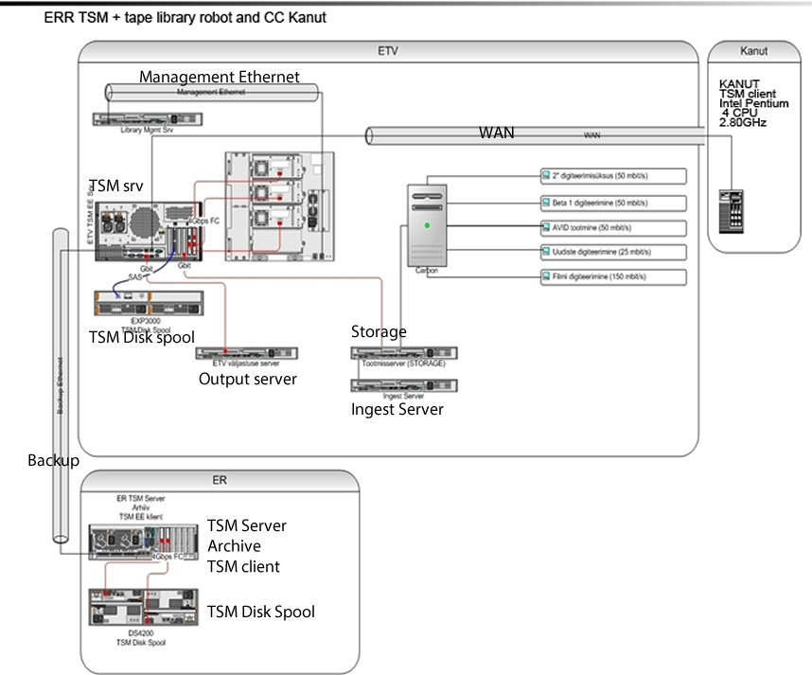

IBM Tivoli Server Manager/Client
Server Version 5, Release 5, Level 2.0
IBM Tivoli Storage Manager is a client-server licensed product that provides storage management services in a multiplatform computer environment. The backup-archive client program permits users to back up and archive files from their workstations or file servers to storage, and restore and retrieve backup versions and archive copies of files to their local workstations.

Data sets
The data set that was used to test IBM TSM is conservation work description and digitised object images. Conservation work report is represented in PDF and DOC format, images are in JPEG and TIFF format. There are 107 separate files in this set.

Test description
The purpose of the test was to get a proof that data stored several years ago (4 years) to another memory institution's tape library are preserved, accessible and copy from these files can be created to owners institution. After creating a copy all the files were checked.

Results
The tool behaved as expected and gave the correct results. However, there may be a problem with this program concerning usability and functionalities. Without previous experience with this tool it is rather difficult to set it up or to use it, especially there are some commands different than usual UNIX command line.
2009/06/26 was uploaded to the archive tape library (un-erasable LTO-4 Ultrium WORM) a data containing conservation work description and digitised object images (nr 07T019). The amount of the data: 736.24Mb, file formats: PDF, JPEG, TIF, DOC.
2013/08/27 data was searched and using a retrieving method were made a copy to the client server. All the files were complete and didn't had any errors.
When retrieving of the data (736.24Mb), it is relatively fast, in this test data transfer time: 67.75 sec and elapsed processing time: 00:02:47.

Connection details:
Using public broadband network of data communication between government institutions or simply EEBone. The connection is established through direct WAN VPN (ipsec) channel between IBM Tivoli client and server.
Network data transfer rate: 11,127.49 KB/sec
Aggregate data transfer rate: 4,511.00 KB/sec

Average client upload speed: 61.51 Mbit/sec
Average client download speed: 42.76 Mbit/sec

Equipment:
IBM Tivoli Server: Juniper SSG-550,
IBM Tivoli Client: Cisco router 1811
Server and Client OS: Debian 5.0

As it is a server - client tool, it is quite important to have trustful host-client relationship.
Although the tool is not very easy to use but based on this test this tool can is reliable, but needs some additional tools to control and see the whole archiving process.
Through this system is very difficult to make directly this data as open data and provide any public access.
Grades
Simplicity of installation: 2
Ease of use: 2
Generality of solution: 3
Quality of result: 5

ANNEx 1
This annex provides an extensive list of aspects that were assessed during the Proof of Concept reported in this document. For each discussed aspect a definition and the respective grading scale is provided.
Aspect: Simplicity of installation
Definition: How complicated was it to download the tool? Did you have to register to get the download? Was it obvious which download version you should choose? If the download was packaged in a compressed file, how easy was it to unpack it? Were there any installation instructions, either on the download site or in the download itself? Was it necessary to install databases or other large third-party tools? In all, how many separate programs were necessary to install? How many mandatory parameter values had to be given during installation? If the first installation try failed, was it easy to install the tool anew?
Grade | Description (only most important criteria listed)
1 | The tool is virtually impossible to install.
2 | The tool is very hard to install and/or depends of many third-party products.
3 | The tool is of medium difficulty to install and/or depends of some third-party products.
4 | The tool is relatively easy to install and/or depends on very few third-party products.
5 | The tool is extremely easy to install.

Aspect: Ease of use
Definition: Was there a user manual or in-built help? Was it obvious what to do without a user manual? Was the graphical user interface self-explanatory? Was it necessary to give initial values to any parameters? When browsing for input files/saving output files, did the tool “remember” the latest used input/output directory? Did the tool itself suggest suitable file names for output? Did the tool work reasonably fast, with respect to the complexity of the type of task it performed?
Grade | Description
1 | The tool is virtually impossible to use.
2 | The tool is very hard to use.
3 | The tool is of medium difficulty to use.
4 | The tool is relatively easy to use.
5 | The tool is extremely easy to use.

Aspect: Generality of solution
Definition: Was it possible to run the tool on several platforms, including the most common platforms? Were the file formats that the tool could use as input/output well-known and general formats? What languages could you choose for the graphical user interface? Were the “big” languages represented? Did you need a lot of less-well-known and/or obscure third-party software? Was it possible to do batch processing on large collections of files?
Grade | Description (only most important criteria listed)
1 | The tool is only relevant for the institution that developed it.
2 | The tool may be relevant for a few institutions in a few countries and/or some obscure third-party tools are needed.
3 | The tool can run on at least one common platform and/or some obscure third-party tools are needed.
4 | The tool can be run on the most common platforms, is relevant in many countries, and none or few obscure third-party tools are needed.
5 | The tool can be run on virtually any platform, is relevant in most countries, and no obscure third-party tools are needed.

Aspect: Quality of result (applicable when the tool does any kind of format conversion)
Definition: Were the converted items of the same quality as the corresponding input items? Were converted images of reasonably good quality to “the naked eye”? Was it possible to convert huge files? For huge input files, could the converted items be reduced in size with preserved quality?
Grade | Description (only most important criteria listed)
1 | Almost no items could be converted and/or converted items were of very bad quality.
2 | Most items could not be converted and/or converted items were of bad quality.
3 | A reasonable amount of the items could be converted and converted items were of acceptable quality.
4 | Most of the items could be converted and converted items were of good quality.
5 | Almost all items could be converted and converted items were of very good quality.

