EGI-Engage

Production portal for EISCAT_3D
D6.3
Date | 29/Feb/2016
Activity | SA2
Lead Partner | EISCAT
Document Status | FINAL
Document Link | https://documents.egi.eu/document/2663

Abstract
This report was produced by the EISCAT_3D Competence Centre of the EGI-Engage H2020 project with contributions from various external parties from the EISCAT_3D collaboration. EISCAT_3D is an environmental research infrastructure on the ESFRI (European Strategy Forum on Research Infrastructures) roadmap. Once assembled, it will be a world-leading international research infrastructure to study the atmosphere in the Fenno-Scandinavian Arctic and to investigate how the Earth's atmosphere is coupled to space. Researchers will be able to interact with EISCAT_3D data through a user portal. This portal will provide a web-based user interface for searching, retrieval and re-processing (visualisation, analysis) of EISCAT_3D data. This document describes the EISCAT_3D architecture, the envisaged data model and the role of the user portal. A timeline for implementing the EISCAT_3D portal is given, together with the description of the first portal implementation. This first implementation is currently under development within the DIRAC4EGI service and is planned to be made available to the EISCAT community by the end of May 2016. The portal will be further evolved by EGI-Engage towards a production portal in an iterative way, with review and feedback from the EISCAT_3D community.
COPYRIGHT NOTICE
This work by Parties of the EGI-Engage Consortium is licensed under a Creative Commons Attribution 4.0 International License (http://creativecommons.org/licenses/by/4.0/). The EGI-Engage project is co-funded by the European Union Horizon 2020 programme under grant number 654142.
DELIVERY SLIP
 | Name | Partner/Activity | Date
From: | Ingemar Häggström | EISCAT | 10/02/2016
Moderated by: | Małgorzata Krakowian | EGI.eu/WP1
Reviewed by | K. Koumantaros  M. Viljoen  Alexandre Bonvin | GRNET/PMB  EGI.eu/WP4  University of Utrecht | 26/02/2016
Approved by: | AMB and PMB |  | 3/03/2016

DOCUMENT LOG
Issue | Date | Comment | Author/Partner
v.1 | 10/Feb/2016 | First full draft | Ingemar Häggström/ EISCAT  Gergely Sipos / EGI.eu-SZTAKI
FINAL | 29/Feb/2016 | Final version after external review | Gergely Sipos / EGI.eu-SZTAKI

TERMINOLOGY
A complete project glossary is provided at the following page: http://www.egi.eu/about/glossary/

Contents
1 Introduction to EISCAT_3D 5
2 Data model 8
3 Towards a production portal – Roadmap 10
4 The first portal version 12
5 Draft architecture of the second portal version 14
Appendix I. Structure of EISCAT level 2 data 15
5.1 EISCAT level 2 data catalogue (MySQL database) 15
5.2 Directory structure 16
5.3 Level 2 data format 16
Appendix II. Snapshot of EISCAT_3D data model 17
5.4 Metadata objects 17
5.5 Organisations and contacts 17
5.6 Stations and sources 17
5.7 Experiment information 18

Executive summary
EISCAT_3D is a project that aims at constructing a new generation of ionospheric and atmospheric radar in the auroral zone in the Fenno-Scandinavian Arctic. The EGI-Engage Competence Centre facilitates the setup of the infrastructure by the development of a user portal. The portal will play a vital role in the EISCAT_3D system: it will provide services for researchers to discover, access and analyse (visualise, mine, etc.) data generated by the EISCAT_3D radar stations.
At the start of EGI-Engage the Competence Centre aimed at establishing the first version of the EISCAT_3D portal by the end of February 2016. This portal would have been a further developed version of the demonstrator version which was prepared by the ENVRI and EGI-InSPIRE projects in 2013-14. Unfortunately the technological landscape for the Competence Centre radically changed in early 2015: ESA stopped support for the OpenSearch GeoSpatial Catalogue, which was the fundamental technology in the demonstrator. The Competence Centre had to look for an alternative technology to establish the portal. DIRAC using its DIRAC4EGI production version was chosen as the target platform. In an ongoing pilot DIRAC will serve as the framework for data discovery portal (first portal version) and later also coupled with computing (second portal version) The portal will help the EISCAT_3D community refine its data model and data arrangement to be able to serve various data queries and data analysis requests.
In parallel with the CC activity a strongly related project, the ‘Supporting EISCAT_3D’ (E3DS) was started by the Nordic e-Infrastructure Consortium (NeIC). In the last 12 month the E3DS project refined the computing, storage and network architecture of the EISCAT_3D infrastructure. This new information was relevant for the CC to refine the role of the user portal and the timeline for development. The two project will continue working together on refining the EISCAT_3D data and computing model and architecture.
This report provides information about the CC development activities after one year of work:
- Describes the EISCAT_3D system architecture and the role of the user portal within it.
- Provides information about the data model that is emerging within EISCAT_3D. The data model is a critical element for the portal, required for both data discovery and use.
- Provides a roadmap for establishing the EISCAT_3D portal with an iterative approach, which consists of specification, development, assessment-feedback stages.
- Describes the purpose and architecture of the first portal implementation based on DIRAC4EGI. This version will be available for the EISCAT community by the end of May 2016.

Introduction to EISCAT_3D
EISCAT_3D is a project that aims at constructing a new generation of ionospheric and atmospheric radar in the auroral zone in the Fenno-Scandinavian Arctic. EISCAT_3D is included on the ESFRI (European Strategy Forum on Research Infrastructures) roadmap and will be a world-leading international research infrastructure to study the Earth's atmosphere and to investigate how it is coupled to space. The main scientific application is radio wave scattering from the ionosphere, which is useful to study plasma physics and upper atmospheric effects of space weather events and climate change. Other areas of research include space debris and near-Earth object studies.
The use of new radar technology, combined with state of the art digital signal processing, will achieve ten times higher temporal and spatial resolution than obtained by present radars, while also for the first time offering continuous measurement capabilities. The EISCAT_3D radar system will allow the study of atmospheric phenomena at both large and small scales unreachable by present systems.
EISCAT_3D will be operated by, and will be an integral part of, EISCAT Scientific Association (EISCAT for the rest of this text). The current EISCAT Associates are research funding organisations in China, Finland, Japan, Norway, Sweden, and the United Kingdom.
The EISCAT_3D radar system will be implemented in stages. The first stage will consist of three radar sites: transmitter and receiver at Skibotn (NO), and receivers in Karesuvanto (FI) and Bergfors (SE). These sites are separated geographically by approximately 130 km each. The second stage of the EISCAT_3D project will involve an upgrade to the transmitter site to reach 10 MW transmitting power. The third and fourth stages of the EISCAT_3D project add two additional receive sites, at distances 200-250 km from the transmit site, at Andøya (NO) and Jokkmokk (SE).
In addition to the above radar sites, EISCAT_3D will also have an operations centre, and two or more archives at data centres located in the Nordic area. Users will interact with EISCAT_3D data and related applications through a user portal. Figure 1 shows the architecture of the EISCAT_3D system.

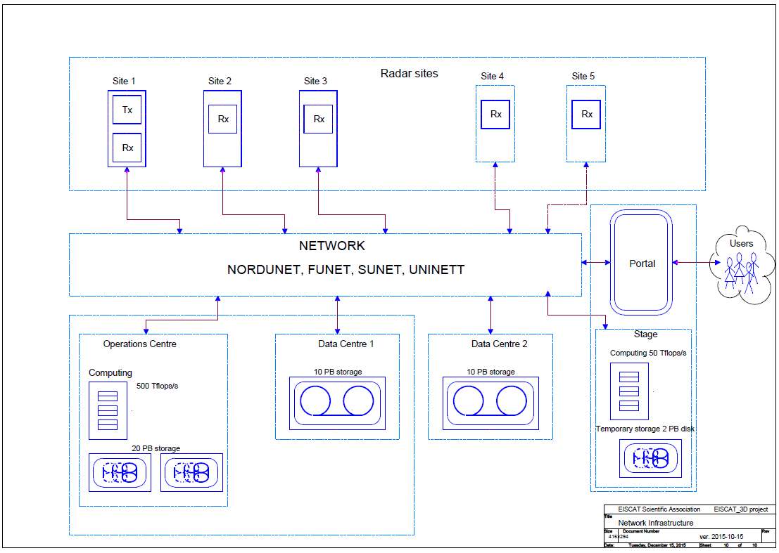
Figure 1. High-level infrastructure view of EISCAT_3D (v. 2015-10-15). Source
The size and complexity of EISCAT_3D necessitates a well-coordinated construction and implementation plan. The design of the EISCAT_3D system is facilitated by various interconnected projects. The prime concern of the EGI-Engage CC project is the user-facing functionalities of the portal.
A related project is the ‘Supporting EISCAT_3D’ (E3DS) by the Nordic e-Infrastructure Consortium (NeIC). E3DS started approximately at the same time than the EISCAT_3D Competence Centre project (Feb/March 2015). The goal of E3DS is to support the preparation of the implementation of EISCAT_3D for those aspects concerning e-infrastructure. Particular goals also include to develop solutions for locating the data archive within existing national e-infrastructures and to support EISCAT in planning the recruitment of e-science experts. Connection with this project is established through John White (E3DS project manager), who is involved in the CC project too.
Another related and ongoing project is the EUDAT - EISCAT_3D data pilot. The purpose of this data pilot is to use EUDAT services to establish a unified archival and data search system for the existing EISCAT incoherent scatter radars. The outcome will be used to explore whether and how EUDAT services can be customised for data archival and discovery for the future EISCAT_3D radar system. The second version of the EISCAT_3D portal should also use this system and connection with this project is ensured through CSC and EISCAT staff members who are involved in both the EGI CC and the EUDAT projects.

Data model
The prime purpose of the EISCAT portal is to provide a web-based user interface for searching, retrieval and re-processing (visualisation, analysis) of archived EISCAT_3D data. The EISCAT_3D data model is under development, and the portal development activities are expected to facilitate this activity.
EISCAT_3D data will be defined at different levels. (See table 1 below). Low level data are raw data at full instrument resolution; data at higher levels are converted into data products of reduced size (spectral data and physical parameters). The operations centre will receive the data from all EISCAT_3D radar sites, send processed data to be archived at the archives (the data centres) and will communicate with the sites for real-time control of the radar. It is planned that there will be two data centres within the Nordic countries. Each data centre will contain a full set of the EISCAT_3D data written from the operations centre, providing a simple redundancy. The portal should serve data from the redundant data centres to users.

Table 1. EISCAT_3D data levels. The operations centre will receive data from levels 1 to 3a and produce data level 3b. The 4 month data buffer is planned to be located at the operations centre. The data levels 2 and higher are transferred from the operations centre buffer to be archived at the data centres. Source: EISCAT_3D Wide-Area Network Plan, MA-3 of NeIC project.
Level | Type | Produced by | Storage | Format
1a | Ring buffer data | 1st stage beam formers (subarray) | 20 min  1% of the data for 4 months | TBD
1b | Beam-formed data | 2nd stage beam former (site) | 4 months  1% of the data to archive | TBD
2 | Time integrated correlated data | All sites | Archived | HDF5
3a | Physical parameters | All sites | Archived | HDF5
3b | 3D voxel parameters | Operations centre | Archived | HDF5
4 | Derived geophysical parameters | Users | TBD | Publications (DOI index, etc)  User data (several formats)

Real EISCAT_3D data is not expected to be available before 2020. The community is in the process of defining the structure and format of the EISCAT_3D data, based on experiences with handling data from existing EISCAT stations, and based on the feedback the EGI-Engage CC will bring through the setup and evaluation of EISCAT_3D portal. A current snapshot of the EISCAT_3D data structure is in Appendix 2. Between now and 2020 the CC can setup data portals that work with
- Existing data from the present EISCAT radar systems. The archive contains approximately 70 TB data which are handled using storage and catalogue solutions developed by EISCAT.
- Data to be generated by a prototype sub-array setup in the next few years. The sub-array can be considered as a small pilot radar site.
- Simulated data that may be produced during the next few years, possibly by the EUDAT data pilot.
Existing EISCAT data are also organised into levels, corresponding to levels 2 (correlated data) and 3 (analysed parameters), and to a limited extent level 1 (voltage domain samples). The archival, file catalogue and data retrieval systems are separate for levels 2(+1) and level 3. Level 2 data from the existing EISCAT data set will be used in the first portal setup (See section 4 for details).

Towards a production portal – Roadmap
Between Feb 2013 and Aug 2014 the ENVRI and EGI-InSPIRE projects established an EISCAT portal demonstrator. The demonstrator implemented basic data search and download services. The EISCAT_3D CC planned to expand this demonstrator into a production portal during EGI-Engage. Unfortunately the technological landscape was radically changed in early 2015: ESA stopped investment and support for the OpenSearch GeoSpatial Catalogue, which was the fundamental technology in the demonstrator. The continued use of the same technology would put the EISCAT_3D Research Infrastructure into the risk of building a completely custom solution and bearing the full cost of maintenance and training of developers/operators. The CC project decided to look for an alternative and more widely used solution, and modified its workplan. The new workplan is the following:
- Portal specification - March 2015 - Feb 2016:
  - Understand impact of ESA decision on CC workplan
  - Redefine new timetable and re-negotiate CC members’ role
  - Establish partnership with E3DS and EUDAT projects
  - Identify suitable portal technology
  - Define goals, architecture and capabilities of first portal implementation
  - Output: D6.3 deliverable, 29 Feb
- Portal implementation - Feb 2016 - March 2016:
  - Implement the first version of the portal (See section 8 for details)
  - Fine-tune portal capabilities based on progress of developments in the CC and in partner projects (NeIC, EUDAT)
  - Output: First portal ready for assessment, 31 March
- Portal assessment - April 2016 - June 2016:
  - Review and feedback of the portal by invited end users from the EISCAT community (Demonstration at EISCAT_3D User Meeting, 19 May
  - Review and feedback of the portal by representatives of partner projects (particularly NeIC, EUDAT)
  - Demonstration and feedback from users at EISCAT 3D User meeting (18-20 May)
  - Output: Review report (Internal milestone) - 15 June
- Specification of the second version of the portal - June 2016 - Sep 2016:
  - Define goals and services of second portal implementation
  - Re-allocate budget from the CC to the DIRAC team to cover the effort needed for the further development of the prototype.
  - Perform testing of visualisation/analysis tools for inclusion in the portal
  - Expected additions compared to version 1:
    - Finalise the data model and add initial visualisation and analysis capabilities (e.g., vector fields, plotting, etc).
    - Refine data portal capabilities (data search, browse, download)
    - Use simulated EISCAT_3D data instead of existing EISCAT data.
    - Introduction of Permanent Identifiers for data (PIDs) in the data model and make the portal capable of discovering data through PIDs. (EUDAT project is working on the use of PIDs for existing EISCAT data. This work would depend on progress in EUDAT2020. If this is uncompleted then this feature will not be part of the portal during EGI-Engage.)
  - Output: Portal specification (Internal milestone) - 30 September
- Implementation of second portal version - Oct 2016 - June 2017:
  - Implement second portal
  - Fine-tune portal capabilities based on progress of developments in the CC and in partner projects (NeIC, EUDAT)
  - Output: Second portal version, 30 June 2017.
- Final assessment - June 2017 - Aug 2017.
  - Review and feedback of the portal by invited end users from the EISCAT community
  - Review and feedback of the portal by representatives of partner projects (particularly NeIC, EUDAT)
  - Define a project for deploying a production portal based on the second portal version. The project may involve additional further developments of the second version of the portal. (This depends on feedback captured about this version.)
  - Output: Final report (Public document) - 30 Aug 2017. (Production data to arrive in EISCAT_3D in 2020.)

The first portal version
The first portal will focus on data management features. Computing services are not part of this version (they will be of the second portal version). The aims of the first portal implementation are:
- Assess the suitability of using DIRAC for the EISCAT portal purposes.
- Establish a baseline file structure to access the EISCAT files through the portal. The structure will be improved in the future to optimise access management (access control, PIDs, frequent queries, etc.).
- Establish a baseline metadata schema to discover EISCAT data through metadata via the portal. The schema will be improved in the future to optimise access management.
- Collect feedback about data organisation for the EISCAT_3D data model (for example on most suitable separation of data and metadata) for the data organisation activity of EISCAT_3D.
The CC performed a technology assessment and selected the DIRAC system as the baseline technology for the portal. DIRAC (Distributed Infrastructure with Remote Agent Control) INTERWARE is a software framework for distributed computing providing a complete solution to one (or more) user community requiring access to distributed resources. DIRAC builds a layer between the users and the resources offering a common interface to a number of heterogeneous providers, integrating them in a seamless manner, providing interoperability, at the same time as an optimized, transparent and reliable usage of the resources.
Among other existing users of the DIRAC service we can mention several large High Energy Physics (HEP) experiments like LHCb at CERN, Geneva, Belle II at KEK, Japan, BES III at IHEP, China; several Astrophysics experiments, e.g. Cherenkov Telescope Array (CTA), Glast; multiple user communities in the life science domain, e.g. Virtual Imaging Platform (VIP). The large user base of the DIRAC project ensures its sustainability in the long term.
DIRAC has a component, called ‘File and Metadata Catalog’ (DIRAC File Catalogue – DFC in short). This component provides logical name space for registration and description of data (files) together with the information of the location of physical copies. DFC is a central service to build eventual distributed data management systems which are exposed to the users in a form of a distributed file system. The Metadata part of the catalogue allows the setup of indexes describing the stored data files in order to quickly find those that are relevant for a particular analysis. Together with the tools to access data storage systems using different access technologies, DIRAC offers a complete solution for the data management tasks of a large user community. The emphasis is on bulk data operations, automation of recurrent tasks and ensuring integrity of the data.
A data management proof of concept that we are setting up for EISCAT as their first version of the portal will provide two key services for the user:
- Discover data through metadata (instead of file location or physical file name).
- Download batches of EISCAT files from the storages after these were discovered through the DIRAC server.
The proof of concept will be based on (See Figure 2) a DIRAC Storage Element (SE) service, which is a front-end server running at the EISCAT institute. The DIRAC SE makes EISCAT Level 2 data file system accessible to the File Catalogue and the users. The total EISCAT Level 2 dataset is 70-80 TB, out of which a subset will be deployed on the DIRAC SE server. This Storage Element service exposes the files to the DIRAC4EGI service portal. The key component in the setup is the EISCAT catalogue, a DB in the MySQL server component of DIRAC4EGI, hosted by CYFRONET in Poland.
The file structure on the server and the metadata schema in the catalogue will replicate those used in the EISCAT database for level 2 files (See Appendix 1). Current metadata (in SQL database) are location (site, start time, end time) and access rights. Other ‘metadata’ are embedded in the files themselves. In the first prototype only these SQL will be used in the DIRAC metadata catalogue. (In a second phase additional metadata can be extracted from the files.)
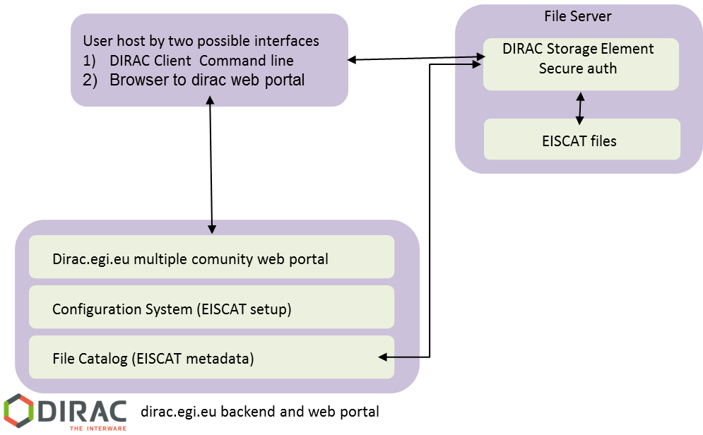
Figure 2. Architecture of the first EISCAT_3D portal version

Draft architecture of the second portal version
The first portal will validate the data management model and user access to data, but will not provide computing capabilities for data analysis. The second version will take a step towards this direction. An initial, high level architecture of this second version is shown in Figure 3. There are two new components compared with the previous version:
- In the top left a portal front-end is deploying an EISCAT web application, which can be faced with WebAppDIRAC technology completely integrated in DIRAC engine, in our case connecting dirac.egi.eu back-end. Alternatively, by a Scientific Gateway with other technology and necessary APIs connection to the dirac.egi.eu back-end.
- A computing infrastructure, which for testing purposes can be the fedcloud.egi.eu Virtual Organisation of the EGI Federated Cloud, and can be a dedicated EISCAT_3D Virtual Organisation during production operation. Analysis jobs from the front-end could process data from the EISCAT catalogue and files using resources from the Virtual Organisation.
The architecture and the exact capabilities of the second portal version will be refined after the first version is ready and assessed.
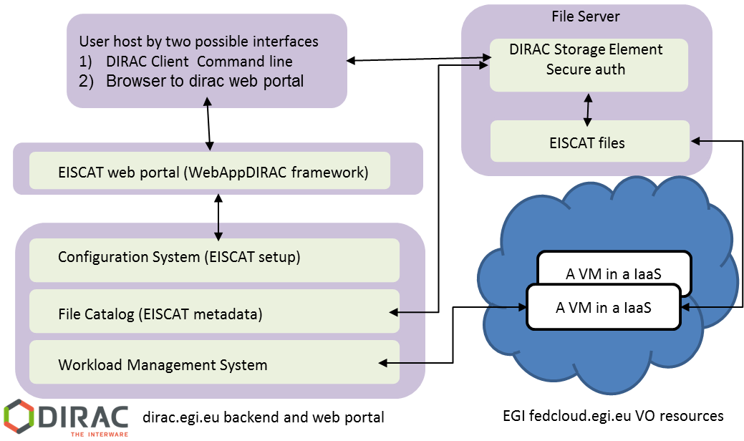
Figure 3. Initial architecture of second portal version

- Structure of EISCAT level 2 data
Level 2 data from 1981 until 2016 are archived on two redundant servers, which are synchronized at regular intervals. The total volume of data is on the order of 70 TB. This archive is indexed on the directory level in a MySQL database. A web-based search and retrieval system is implemented in Apache + Python CGI. Download is implemented through dedicated server software written in Python. This software checks that the IP address of the downloader belongs to an EISCAT associated country or affiliated institution.

EISCAT level 2 data catalogue (MySQL database)
The index of the level 2 data archive consists of three MySQL databases as follows.
- disk_archive, the currently active database of experiment data
- tape_archive, obsolete version of the above
- tape_archive_tapes, index of pre-2000 system data transferred from tapes to disk
The active database disk_archive indexes:
- experiments run: name, country and instrument
- start and stop times and time used
- directories at the hourly level.

The tables are organised as follows:

experiments
experiment_id | experiment_name | country | antenna | comment

resource
resource_id | experiment_id | start | end | comment | type | account

storage
location | resource_id | priority | bytes | comment

Here, Location is a URI-like specifier that points to the data directory at the hourly subdirectory level. Access to the data is controlled via the ‘account’ or ‘country’ fields as well as the timing fields.

Directory structure
The directories of the archive are sorted as a three-level tree:
- Year
  - Experiment name:string containing
  - pulse code name
  - antenna scan name
  - version
  - campaign code
  - @antenna name
- Date and hour

Level 2 data format
The data files in the hourly subdirectories are compressed mat files compatible with Matlab v4 and a large number of third party libraries for different programming languages such as C, Python and GNU R. The files are named nnnnnnnn.mat.bz2, where the number is time in seconds from new year (1 Jan 00:00 UT).
The files contain data in the autocorrelation domain, represented as so called lag profiles, and metadata (the parameter block) . The format of the parameter block has changed over time and is also somewhat different for the different stations. See https://www.eiscat.se/about/experiments2/description-of-eiscat-metadata-sources/view
for details.
Furthermore, the format of the lag profile is different for different pulse code experiments. EISCAT staff can provide routines to decode the parameter blocks and sort the lag profiles.

- Snapshot of EISCAT_3D data model
The data model for EISCAT_3D is currently under development within the RI community. The work of the EGI-Engage CC facilitates this by bringing feedback about data organisation and access experienced through the EISCAT_3D portals. This appendix provides a snapshot of the EISCAT_3D data model as of today (10/Feb/2016).

Metadata objects
NB. to the extent possible we should make sure that names of fields etc follow standards from DC, SKOS, ISO standards. All entries need identifiers, some of them should be PID, dates of creation and modification, version info and a description.

Organisations and contacts
Organisation | Eiscat3d members (and others?)
Various contact info
Authentication method? | For access to their data
Access control list | For access to their data

Contact | Contact person
Various contact info

Stations and sources
Platform | (Station or “radar site”?)
Name | Name of location (string)
Owner | -> Organisation
Location | Lat, Long, Alt
Instrument 1..N | -> Instrument

Instrument
Name | Name of instrument
Type | IS radar, guest instrument types￼￼
Owner | -> Organisation
Operator | -> Contact
Instrument description | -> Instrument description (type dependent)

Source specification | One of these must be non-null
Passive | -> Passive source / NULL
Active | -> Active source / NULL

Passive source | Either name or asc/dec must be non-null
Passive Source name | Catalogue name / NULL
Passive Right ascension | Hours / NULL
Passive Declination | Degrees / NULL

Active source | Some active transmitter, radar, satellite or other
Platform | -> Platform
Instrument | -> Instrument

Experiment information
Experiment specification
Name | Name of experiment
Owner | -> Organisation
Contact (may not be needed) | -> Contact
Start time | time
End time | time (continuous background experiment have end time = -1, experiment which has unknown end time should be set to 0 until end time is decided)
Number of experiment schedules | int (number of schedules so far)
Experiment schedule 1..N | -> Experiment schedule

https://wiki.egi.eu/wiki/EGI_ENVRI
https://wiki.neic.no/wiki/EISCAT_3D_Support
EISCAT Scientic Association, EISCAT 3D: The next generation international atmosphere and geospace research radar Technical Description" https://eiscat3d.se/content/eiscat3d-technical-description, 2014.
EISCAT_3D Wide-Area Network Plan, MA-3 of NeIC project. To be available online at https://wiki.neic.no/wiki/EISCAT_3D_Support#Documents
https://wiki.neic.no/wiki/EISCAT_3D_Support
http://www.eudat.eu/communities/unified-access-to-eiscat-radar-data
EISCAT_3D Wide-Area Network Plan, MA-3 of NeIC project. To be available online at https://wiki.neic.no/wiki/EISCAT_3D_Support#Documents
Each EISCAT_3D radar site will consist of 109 sub-arrays. Each array includes 91 antennas. Such a sub-array will be deployed in the near future as part of an EU-funded project (EISCAT3D_PfP) https://www.eiscat3d.se/project/pfp
https://wiki.egi.eu/wiki/EGI_ENVRI
http://diracgrid.org/

