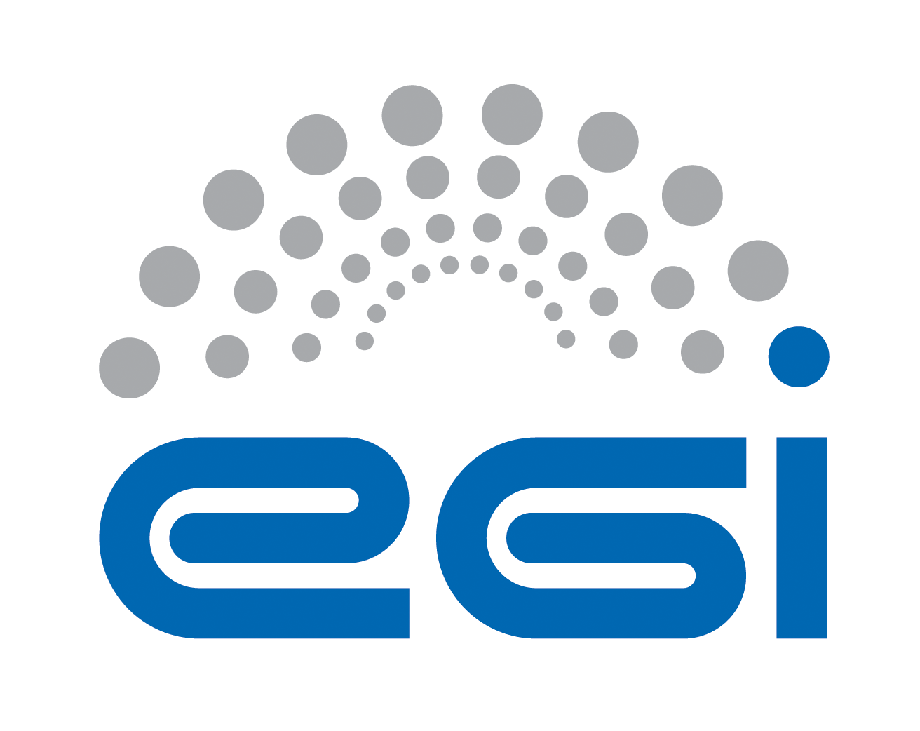

EGI P4U OLA Violation report
 | Audience: | EGI operations team operations@egi.eu
 | Report author: | Service provider
 | Service: | Which service does the report relate to, named as in OLA
 | Period: | What period does the report cover, what frequency with which is it released
 | Date of report: | When the report is issued
OLA agreement link: |  | Link to OLA agreement

Justification of violation
//please provide justification of violation

Plan for service enhancement
//please provide plan for service enhancement

