

D2.7 EOSC and ‘AI on Demand’ liaison and integration updated plan

30 January 2025

Abstract

The European Open Science Cloud (EOSC) and the AI on Demand (AIoD) are two large scale initiatives in Europe that are relevant for the scope of iMagine. EOSC provides a distributed environment where researchers, innovators, companies and citizens can publish, find, share and re-use data, tools, and services for research, innovation, education purposes. AIoD seeks to act as a resource to facilitate European research and innovation in AI. This deliverable provides an updated overview of these two initiatives, details the project assets registered or integrated within the EOSC and the AIoD platform, and outlines the plans for future integration to further enhance collaboration and interoperability.

Document Description

| D2.7 EOSC and AIoD liaison and integration updated plan | | | |
| --- | --- | --- | --- |
| WP2 | | | |
| Due date | 31/01/2025 | Actual delivery date: | 30/01/2025 |
| Nature of document | Report | Version | 1.0 |
| Dissemination level | Public | | |
| Lead Partner | EGI Foundation | | |
| Authors | Marco Rorro (EGI Foundation)  Smitesh Jain (EGI Foundation) | | |
| Reviewer | Gergely Sipos (EGI Foundation) | | |
| Public link | [**https://zenodo.org/records/14756503**](https://zenodo.org/records/14756503) | | |
| Keywords | Aquatic, Marine, EOSC, AIoD, AI4EU, AI4Europe, Integration, Plan | | |

Revision History

| Issue | Comments | Author/Reviewer |
| --- | --- | --- |
| V 0.1 | Structure with initial text | Gergely Sipos (EGI) |
| V 0.2 | EOSC Integration  AIoD Integration | Smitesh Jain (EGI)  Marco Rorro (EGI) |
| V 0.3 | Full draft for review | Marco Rorro (EGI) |
| V 1.0 | Updated version after review | Gergely Sipos (EGI) / Martin Laviale (Uni. of Lorainne) |

Copyright and license info

This material by Parties of the iMagine Consortium is licensed under a [Creative Commons Attribution 4.0 International License](https://creativecommons.org/licenses/by/4.0/).

Table of content

**1 Introduction 4**

1.1 Introduction to EOSC and AIoD 4

1.2 Liaisoning with EOSC and AIoD 5

**2 EOSC liaison and integration plan 7**

2.1 EOSC Overview 7

2.1.1. EOSC EU Node 9

2.2 EOSC Integration Status and Future Plans 11

2.3 EOSC Liaison Plan 12

**3 AIoD liaison and integration plan 13**

3.1 AIoD overview 13

3.2 AIoD Integration Status and Future Plans 14

3.3 AIoD Liaison Plan 16

**4 Acronyms 18**

List of Figures

Figure 1: EOSC Federated “System of Systems” 7

Figure 2: EOSC Platform concept from EOSC Future 8

Figure 3: The EOSC EU Node LOT1, LOT2, LOT3 structure 10

List of Tables

Table 1: First wave of potential candidate EOSC Nodes 10

# Introduction

iMagine has the overall objective to deploy, operate, validate, and promote a dedicated iMagine AI framework and platform. The platform connected to the EOSC and AIoD provides researchers in aquatic sciences with open access to a diverse portfolio of AI-based image analysis services and image repositories from multiple RIs. These services and repositories are relevant to the overarching theme of ‘Healthy oceans, seas, coastal and inland waters’.

The project concept revolves around three main working blocks:

* A common **iMagine AI framework and computing platform,** facilitating the development, testing, training, hosting, and operation of AI-based image analysis services, following FAIR practices.
* **Five operational and three prototype AI-based image analysis services** with image repositories were developed with the iMagine AI platform and opened for users in 2024 to provide open access and exploitation by researchers. They are instrumental in demonstrating value and fostering further uptake by a large community of target users and beneficiaries.
* **Best Practices,** consisting of documentation and training materials, compiled giving practical guidance and examples to end-users on exploiting image datasets and analysis applications offered by the iMagine portfolio and serving as an example to whoever wishes to develop and deliver similar AI-based image analysis services and image repositories.

This deliverable provides an updated plan for bringing these three groups of assets into the European Open Science Cloud (EOSC)[1], and into the ‘AI on Demand platform’ (AIoD)[2], two large-scale initiatives in Europe matching the topics of iMagine.

## Introduction to EOSC and AIoD

The European Open Science Cloud (EOSC) is evolving into a fully operational ecosystem through the establishment of the EOSC Federation[3], representing a significant milestone in achieving seamless access to scientific resources across Europe. The EOSC EU Node, officially launched at the EOSC Symposium in October 2024, now serves as a cornerstone of this ambitious federation, enabling interoperability and collaboration across diverse disciplines.

By federating data repositories, research infrastructures, e-infrastructures, and scientific service providers, the EOSC Federation will create a "system of systems" designed to foster collaboration, support FAIR principles, and provide researchers secure, interoperable digital resources. This environment enhances visibility, optimises resource sharing, influences policy and standardisation, and promotes sustainability in research across disciplines and borders.

The EOSC Federation Handbook[4] defines the governance, structure, and operational framework of this ecosystem, paving the way for a unified, trustworthy research infrastructure. Through this integration, the EOSC Federation aims to empower Europe's scientific community with advanced capabilities and opportunities in open science.

The first wave of Potential Candidate EOSC Nodes, such as Blue-Cloud[5], is being invited to participate in dialogue meetings as part of the sequencing process established by the EOSC Tripartite Governance. These nodes are expected to integrate with the EOSC EU Node in the first half of 2025, initiating the federation of thematic, national, and organisational nodes.

The AI-on-demand (AIoD) is also transitioning into a decentralised ecosystem of community-driven services, designed to serve as a collaborative resource for the research community. This evolution aims to enhance accessibility, integration, and collaboration across the European AI landscape.

The AI4Europe project[6], funded under the Horizon Europe programme, currently leads the management, development and facilitation of the AIoD Platform. Its main objective is to establish a sustainable digital platform and experimentation environment by creating open research channels and mechanisms supporting European AI academic and industrial research. AI4Europe seeks to maximise the academic, social, and industrial impact of AI while seamlessly integrating other projects, platforms, and solutions. In parallel, the DeployAI project[7] focuses on fostering collaboration between the industrial community, public sector, and AI product developers to propel trustworthy innovation in the European market.

## Liaisoning with EOSC and AIoD

The task of liaisoning with EOSC and AIoD initiatives in the iMagine project falls under T2.3 with the objective of:

* Lead technical and procedural integration with EOSC and AIoD initiatives to use these initiatives best.
* Integrate these services with the EOSC Authentication-Authorisation Infrastructure (Federated identity management), Monitoring infrastructure (deployment of test probes), and Accounting system (deployment of accounting log parsers for image data).
* Participate in relevant AIoD and EOSC Working Groups and Task Forces and assess EOSC and AIoD services for adoption within the WP3 activities.
* Coordinate the work of the E-Infrastructure Consultation Panel for the long-term sustainability of the service setups.

This document is an important step in this liaison. It

* Provides updates on the ongoing evolution of the EOSC and AIoD initiatives, highlighting potential engagement opportunities for iMagine.
* Explores how iMagine has benefited from the EOSC and AIoD initiatives and outlines the opportunities presented by their evolution.

# 

# EOSC liaison and integration plan

## EOSC Overview

As previously mentioned, EOSC aims to establish a “Web of FAIR Data and Services” to support scientific research across Europe. EOSC envisions a multidisciplinary environment where researchers can seamlessly publish, discover, and reuse data, tools, and services, enhancing their ability to conduct and advance research.

This vision is being realised through the development of the EOSC Federation - a network of interconnected, autonomous nodes forming a “system of systems” architecture (**Figure 1**). Each node operates independently while adhering to a unified framework of standards, policies, and best practices, ensuring interoperability, collaboration, and consistency throughout the federation.

EOSC Nodes operate at local, national, regional, thematic or European levels and contribute services, datasets, and other resources to the Federation. Each Node:

* Maintains its own governance model.
* Operates its own platform while complying with the Federation's technical framework.
* May offer additional services and resources accessible via the Node but not shared with the EOSC Federation.

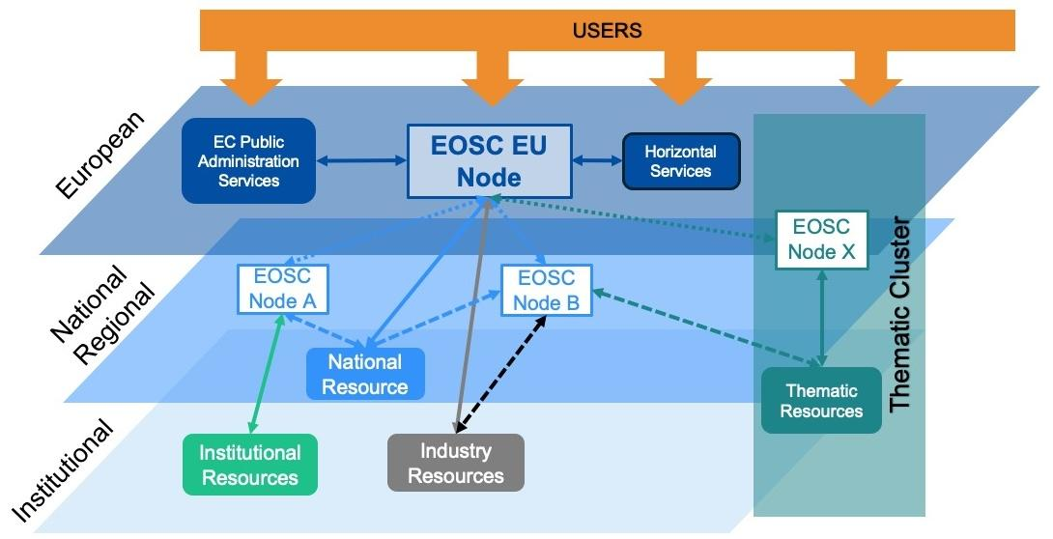

#### Figure 1: EOSC Federated “System of Systems”

The EOSC technical architecture, envisioned as a Federation of Nodes, will be defined by the EOSC Beyond[8] project. It builds on the EOSC Platform architecture introduced by the EOSC Future[9] project, which established an integrated operational environment delivering the EOSC Core and a customizable portfolio of horizontal services. This architecture, implemented in the EOSC EU Node, is structured into four main layers (**Figure 2**):

1. **EOSC Core** (green) provides the enabling services required to operate a node within the EOSC Federation. These services include, for example, a catalogue of services and/or research products, a helpdesk, authentication and authorization infrastructure (AAI), monitoring, accounting, and other coordination functions.
2. **EOSC Exchange** (blue) represents the collection of services and resources that EOSC Nodes share with the EOSC Federation, making these federated resources accessible to researchers and other stakeholders across the EOSC ecosystem.
3. **EOSC Interoperability Framework** (light green) defines the guidelines, standards, and best practices that ensure interoperability and composability of resources across the Federation. It acts as the "glue" that connects diverse nodes, enabling seamless collaboration.
4. **EOSC Support activities** (yellow) encompass training, user engagement, and other human-centric activities designed to make EOSC more accessible, user-friendly, and impactful for the research community.

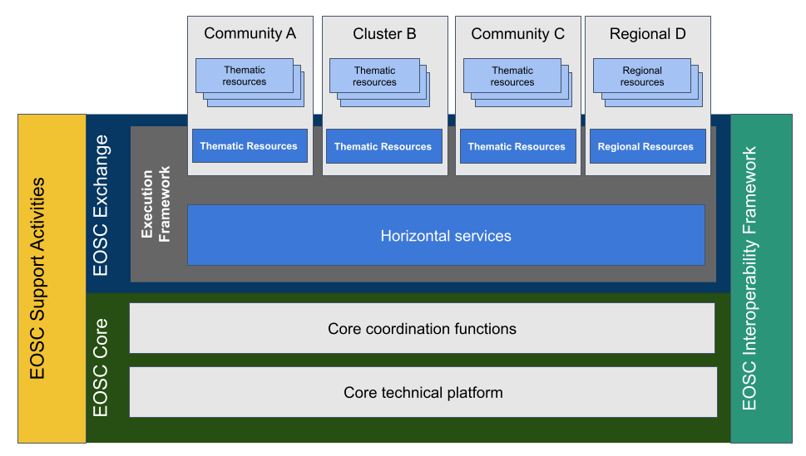

#### Figure 2: EOSC Platform concept from EOSC Future

### EOSC EU Node

The EOSC EU Node serves as a blueprint within the emerging EOSC Federation, inspiring the development of future EOSC Nodes and laying the framework for a unified and federated European Open Science Cloud ecosystem. Officially unveiled at the EOSC Symposium in October 2024, the EOSC EU Node is the first operational node within the Federation, providing a comprehensive suite of services, technical capabilities, and federating functions designed to support European researchers and scientific communities, in line with the principle of FAIR data and open science. Owned by the European Commission, the EOSC EU Node is hosted and implemented by third-party sub-contractors selected through a public procurement tender titled “Managed Services for the European Open Science Cloud Platform”[10]. The tender was organised in three lots (**Figure 3**):

1. Core Federation Services for the EOSC EU Node: provide managed services for the core components of the EOSC EU Node including functions such as: the Web Portal Front Office, the Resource Catalogues and Registry Services, the Application Workflow Management engine, the Federated Identity Management, the Monitoring and Accounting function, and the overall Service Management System and service integration.
2. Exchange Infrastructure Services for the EOSC EU Node: provide fully managed services for the infrastructure services component of the EOSC EU Node including Managed Container service, Managed Compute (Virtual Machine) service and Managed Bulk Data Transfer service.
3. Exchange Application Services for the EOSC EU Node: provide fully managed services for the application services component of the EOSC EU Node, including Managed File Synchronisation and Sharing service, Interactive Notebooks service, and Managed Large File Transfer service for end-users.

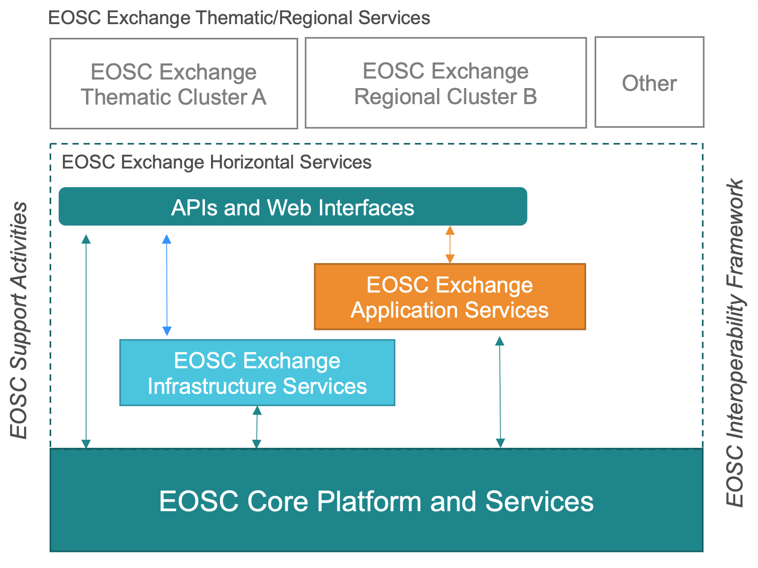

#### Figure 3: The EOSC EU Node LOT1, LOT2, LOT3 structure

The EOSC Tripartite Governance has initiated a process for the sequencing of the first wave of potential candidate EOSC Nodes (**Table 1**). The final selection, comprising approximately ten nodes, is expected to be announced in the first half of 2025. This integration, which includes thematic, national and organisational nodes, such as Blue-Cloud, will mark the formal establishment of the EOSC Federation.

Meanwhile, the purpose, structure, governance, architecture and operations of the EOSC Federation are being collaboratively addressed through open consultations, meetings, events and sprints. The resulting insights will be documented in the EOSC Federation Handbook[11], serving as a comprehensive reference for the ecosystem’s future development.

##### Table 1: First wave of potential candidate EOSC Nodes[12]

| First-stage dialogue Meeting 1 | First-stage dialogue Meeting 2 | First-stage dialogue Meeting 3 | First-stage dialogue Meeting 4 |
| --- | --- | --- | --- |
| ACTRIS ERIC  ARIADNE RI  CERN  CLARIN ERIC  CNR (Blue-Cloud)  CNRS-LAPP (ESCAPE)  ESRF (PaNOSC) | BITP  CNRS (Data Terra)  CVTI SR  Foundation ICSC  HUN REN  Lux NDS  NCN  NFDI | ACOnet / EOSC Support Office Austria  ARNES  CSC – IT Centre for Science  DeiC  EUDAT  NRIS  SND  SRCE  SURF | BBMRI ERIC  Elixir Hub  EMBL  Euro-BioImaging ERIC  Instruct ERIC |

## EOSC Integration Status and Future Plans

The EOSC landscape has undergone significant changes since the publication of D2.3[13], the first version of this deliverable. The former EOSC portal and its onboarding process have been discontinued. Recently, as outlined in the previous sections, the European Commission launched a fully operational EOSC infrastructure node, the EOSC EU Node. Organisations interested in making their resources available within and across the EOSC Federation can do so by either creating and operating their own EOSC Node or including their resources in an EOSC Node operated by another organisation.

While practical guidelines defining the purpose, structure, governance, architecture and operations of the EOSC Federation are still under development -with only a draft of the initial chapters of the EOSC Federation Handbook currently available- the selection process for the first wave of potential candidate EOSC Nodes has already begun. These nodes, expected to integrate with the EOSC EU Node in the first half of 2025, will initiate the formal federation of thematic, national, and organisational nodes. Among these, the project is exploring integration opportunities with Blue-Cloud, one of the invited potential EOSC nodes participating in first-stage dialogue meetings.

Despite these evolving integration opportunities, and although direct deposition of research output into the EOSC EU Node is not currently possible, resources previously onboarded into the EOSC portal or uploaded to repositories like Zenodo[14] remain discoverable through the EOSC EU node Resource Hub[15]. Below is the current status of the assets envisioned for onboarding in D2.3:

1. The iMagine AI platform for aquatic science was onboarded as a service by IFCA before the discontinuation of the EOSC portal. It is now discoverable through the EOSC EU Node Resource Hub[16].
2. The integration of the five mature and operational marine services was planned to occur after their external user phase began (the exact timelines are presented in D3.1 “Technical development roadmap for the AI image analysis use cases”[17]). However, by that time, the EOSC portal was offline, and these services had not yet been onboarded.
3. iMagine deliverables, publications and other similar outputs are made available through Zenodo. As Zenodo continues to be onboarded as a Data Source, all iMagine research products from Zenodo are automatically accessible through the EOSC Resource Hub.
4. iMagine dataset available for each use case. All thirteen datasets have been uploaded to Zenodo and are automatically discoverable through the EOSC Resource Hub.

## EOSC Liaison Plan

The iMagine project will continue to actively engage with the evolving EOSC ecosystem to ensure its resources, services, and outputs align with the emerging opportunities and requirements. This engagement is supported by the strong involvement of the project coordinator and partners in this large-scale initiative. The updated liaison plan reflects the recent development in EOSC, including the launch of the EOSC EU Node, the ongoing establishment of the EOSC Federation with the enrollment of additional EOSC nodes, new funding opportunities under the Horizon Europe program, and activities from the newly formed EOSC Task Forces.

The development and operation of the EOSC EU Node Core have benefited from the contribution of EGI and GRNET under LOT 1 “Core Federation Services for the EOSC EU Node”. This work provides the backbone of the EOSC EU Node Core services, including the Authentication and Authorisation Infrastructure (AAI). These efforts will help iMagine align its platform and associated services with new functionalities, ensuring their sustainability and relevance.

Both EGI and Blue-Cloud have responded to the eligibility questionnaire as the first step toward contributing to a testbed of potential EOSC Nodes. EGI focuses on providing a node with core computing and storage services, while Blue-Cloud aims to establish a marine-themed ecosystem of application services. As Blue-Cloud has been invited to participate in first-stage dialogue meetings, it presents a key opportunity for thematic integration.

The EOSC Beyond project[18], coordinated by EGI, aims to advance the EOSC Core and implement a network of EOSC Nodes. By integrating use cases from initiatives such as LifeWatch[19], a research infrastructure also represented in iMagine, EOSC Beyond constitutes another opportunity for alignment. iMagine will actively engage with EOSC Beyond to identify integration pathways and potential collaborations that enhance its contribution to the EOSC Federation.

iMagine will also explore opportunities in the upcoming INFRAEOSC calls under Horizon Europe Research Infrastructures Work Programme 2025, which emphasises improving the sustainability of the RIs while expanding the EOSC Federation. Participation in this programme will help iMagine align its contributions with user needs and support the development of a European web of FAIR data and services.

The EOSC Association Task Forces[20] continue to shape the implementation and governance of EOSC. iMagine will prioritize engagement with the Technical and Semantic Interoperability Task Force, co-chaired by EGI, which directly impacts the integration of iMagine services and resources into EOSC.

The project has already showcased its contribution to EOSC at the EOSC Symposium 2023 and at the EOSC Tripartite Event in Belgium in April 2024. It will continue this effort by actively participating in future events, including the EOSC Symposium 2025.

These activities will ensure that iMagine remains at the forefront of EOSC developments, fostering collaboration and maximising its impact within the European research ecosystem.

# AIoD liaison and integration plan

## AIoD overview

The AI on-demand (AIoD) platform and ecosystem is a relatively newer initiative compared to EOSC. It began with AI4EU[21], a three-year EU project that concluded at the end of 2021, delivering two main tools:

1. Contribution Gateway[22]: A Content Management System (CMS) enabling the uploading, discovery, and access of AI research assets.
2. AI4EU experiments[23]: A tool designed to facilitate AI experimentation.

Building on the foundation of AI4EU, the AI4Europe project[24] started in 2022. Currently responsible for the management, development and facilitation of the AIoD Platform, its primary objective is *“to support and facilitate a sustainable digital platform and experimentation environment through the creation of open research channels and mechanisms that foster the European AI research ecosystem, academic and industrial, and that maximise the academic, social, and industrial impact while it seamlessly integrates other projects, platforms, and solutions.”[25]*

Similar to EOSC, the AI4Europe project has designed a decentralised architecture composed of interconnected AIoD nodes. This architecture is supported by a core API that ensures interoperability, provides uniform metadata across all resources, and offers interfaces for developing new services. As part of this transition, the Contribution Gateway is set to be replaced by a new metadata catalogue[26] based on the core API. While migration of previously uploaded content to the new metadata catalogue is ongoing, both systems coexist. The AIoD Contribution Gateway and its onboarding process, as outlined in D3.2 (the first version of this deliverable), remain operational, with further details available in the AIoD documentation[27].

The AI4Experiment framework is evolving within the AI4Europe project under a new name, AI-Builder. Based on an open-source project, Graphene[28], and hosted by the Eclipse Foundation, AI-Builder provides a framework for creating, publishing and deploying general cognitive architectures using reusable AI building blocks. These building blocks, implemented as Docker containers, can be visually composed into pipelines via a design studio. A Kubernetes deployer generates configuration files from the pipeline definitions, enabling deployment on Kubernetes clusters. The AI-Runner complements this framework by offering a public Kubernetes cluster where users can quickly deploy and test their pipelines. AI-builder includes its own marketplace for AI building blocks and pipelines. It is expected that these assets will also become accessible through the new AIoD metadata catalogue, aligning with the minimum requirements for a node within the AIoD federation. However, a similar document to the EOSC Federation Handbook, defining the governance, structure, and operational framework of the AIoD federation, has not yet been made available.

## AIoD Integration Status and Future Plans

Below is the current status of the assets envisioned for onboarding via the Contribution Gateway in D2.3:

1. The iMagine project[29] has been onboarded by the EGI Foundation
2. The iMagine AI platform is currently being onboarded by CSIC as a service, along with the user guide as educational content.
3. Twelve use cases, exceeding the original plan of eight outlined in D3.2, have been onboarded by their respective use case owners with support from the EGI Foundation, as “Case studies”[30] in the ‘Maritime sector’:
   * Zooscan[31]
   * Underwater Noise Identification[32]
   * Satellite-derived Bathymetry[33]
   * Oil Spill Detection[34]
   * Freshwater Diatoms Identification[35]
   * FlowCam Phytoplankton Identification[36]
   * EyeOnWater[37]
   * Fish Otoliths[38]
   * Ecosystem Monitoring at EMSO Sites by Video Imagery[39]
   * Cold Water Coral Reefs[40]
   * Beach Monitoring[41]
   * Aquatic Litter Drones[42]

The use cases have not been onboarded as “Research bundles", as originally envisioned in D3.2, since “Research Bundles” are not planned for migration to the new metadata catalogue. Instead, they have been onboarded as “AI services”, as planned:

* Litter Assessment Service[43]
* ZooProcess Multiple Separator[44]
* ZooProcess Multiple Classifier[45]
* Smartbay prawn burrow detection[46]
* Deep Species Detection[47]
* Smartbay species detection[48]
* Real-time fish detection at EMSO sites[49]
* WITOIL Cloud for iMagine[50]

1. The open call for new use cases[51] to support the iMagine platform has been onboarded by the EGI Foundation.
2. iMagine good practice guides for the development/adoption of AI/ML in aquatic sciences[52],[53] have been onboarded by EGI Foundation.

While the above-onboarded assets of the project will be migrated to the new metadata catalogue, datasets uploaded to Zenodo are already automatically harvested and made discoverable via the AIoD core API. Once this functionality is extended to include publications, references to deliverables, and other similar outputs of the project available on Zenodo will also be included in the AIoD platform.

In the coming months, the project will focus on achieving closer integration with the new AIoD platform. This represents a significant opportunity for this project to position itself as one of the AIoD nodes, and be ready once the rules of participation are established.

## AIoD Liaison Plan

The AI4EU project established an Open Distributed Development Process to enable interested parties to contribute to the platform by implementing valuable features. Several working groups, open to communities beyond AI4EU, have been working on various topics, such as technical governance and ontology. Building on this approach, the AI4Europe project has adopted a similar process to drive the development of the AIoD platform, and plans to establish four working groups with the following objectives:

* Identify, in collaboration with the community, further technical developments of the platform.
* Support the community in uploading content to the platform.
* Engage with the community and provide support for using the platform.
* Ensure ethical AI practices align with regulations such as GDPR and AI act.

Currently, only the Technical Coordination Board[54] (TCB) is active. The TCB oversees the progress of technical contributions, moderates discussions on technical issues and facilitates connections between technical platform experts and contributors. iMagine is actively participating in the TCB and plans to engage with the relevant working groups once they are established. Additionally, iMagine will participate in activities that promote its role as a potential stakeholder while closely monitoring the evolution of the AIoD platform and its development process, including sustainability mechanisms intended to support external projects. This engagement is further facilitated by the EGI Foundation, the coordinator of the iMagine project, which is also contributing to the AIoD platform, as a participating member of the AI4Europe project. This involvement ensures that iMagine receives first-hand information about new features, and opportunities as they become available.

The liaisons will also extend to the Digital Europe project, DeployAI, which started at the beginning of 2024. DeployAI targets the AI innovation community, particularly SMEs and public administrations, and will take over responsibility for the management, development and facilitation of the AIoD platform once the AI4Europe project is over. Through these connections, iMagine aims to strengthen its presence within the AIoD community, ensuring visibility, alignment with ongoing developments, and opportunities for exploitation.

# Acronyms

| AI | Artificial Intelligence |
| --- | --- |
| AAI | Authentication and Authorisation Infrastructure |
| AIoD | AI-on-demand |
| API | Application Programming Interface |
| CMS | Content Management System |
| EU | European Union |
| EOSC | European Open Science Cloud |
| FAIR | Findable Accessible Interoperable Reusable |
| GDPR | General Data Protection Regulation |
| RI | Research Infrastructure |
| SME | Small Medium Enterprise |
| TCB | Technical Coordination Board |
| WP | Work Package |

1. <https://open-science-cloud.ec.europa.eu/>
2. <https://aiod.eu/>
3. <https://eosc.eu/building-the-eosc-federation/>
4. <https://eosc.eu/eosc-federation-handbook/>
5. <https://www.blue-cloud.org/>
6. <https://ai4europe.aiod.eu/>
7. <https://deployaiproject.eu/>
8. <https://www.eosc-beyond.eu/>
9. <https://eoscfuture.eu/>
10. <https://ted.europa.eu/en/notice/-/detail/712679-2023>
11. <https://eosc.eu/eosc-federation-handbook/>
12. <https://eosc.eu/eosc-about/building-the-eosc-federation/contributing-to-the-build-up-phase-of-the-eosc-federation/>
13. <https://zenodo.org/records/7793950>
14. <https://zenodo.org/>
15. <https://open-science-cloud.ec.europa.eu/resources/all>
16. <https://open-science-cloud.ec.europa.eu/resources/services/21.11166%252FdMw0K1>
17. <https://zenodo.org/records/7760413>
18. <https://www.eosc-beyond.eu/>
19. <https://www.lifewatch.eu/>
20. <https://eosc.eu/eosc-task-forces/>
21. <https://cordis.europa.eu/project/id/825619>
22. <https://www.ai4europe.eu/>
23. <https://aiexp.ai4europe.eu/>
24. <https://ai4europe.aiod.eu/>
25. <https://www.ai4europe.eu/ai-community/projects/ai4europe>
26. <https://api.aiod.eu/docs>
27. <https://aiondemand.readthedocs.io/>
28. <https://gitlab.eclipse.org/eclipse/graphene>
29. [ai4europe.eu/ai-community/projects/imagine](http://ai4europe.eu/ai-community/projects/imagine)
30. <https://www.ai4europe.eu/business-and-industry/case-studies>
31. [ai4europe.eu/business-and-industry/case-studies/zooprocess](http://ai4europe.eu/business-and-industry/case-studies/zooprocess)
32. [ai4europe.eu/business-and-industry/case-studies/underwater-noise-identification](http://ai4europe.eu/business-and-industry/case-studies/underwater-noise-identification)
33. [ai4europe.eu/business-and-industry/case-studies/satellite-derived-bathymetry](http://ai4europe.eu/business-and-industry/case-studies/satellite-derived-bathymetry)
34. [ai4europe.eu/business-and-industry/case-studies/oil-spill-detection](http://ai4europe.eu/business-and-industry/case-studies/oil-spill-detection)
35. [ai4europe.eu/business-and-industry/case-studies/freshwater-diatoms-identification](http://ai4europe.eu/business-and-industry/case-studies/freshwater-diatoms-identification)
36. [ai4europe.eu/business-and-industry/case-studies/flowcam-phytoplankton-identification](http://ai4europe.eu/business-and-industry/case-studies/flowcam-phytoplankton-identification)
37. [ai4europe.eu/business-and-industry/case-studies/eyeonwater](http://ai4europe.eu/business-and-industry/case-studies/eyeonwater)
38. [ai4europe.eu/business-and-industry/case-studies/fish-otoliths](http://ai4europe.eu/business-and-industry/case-studies/fish-otoliths)
39. [ai4europe.eu/business-and-industry/case-studies/ecosystem-monitoring-emso-sites-video-imagery](http://ai4europe.eu/business-and-industry/case-studies/ecosystem-monitoring-emso-sites-video-imagery)
40. [ai4europe.eu/business-and-industry/case-studies/cold-water-coral-reefs](http://ai4europe.eu/business-and-industry/case-studies/cold-water-coral-reefs)
41. [ai4europe.eu/business-and-industry/case-studies/beach-monitoring](http://ai4europe.eu/business-and-industry/case-studies/beach-monitoring)
42. [ai4europe.eu/business-and-industry/case-studies/aquatic-litter-drones](http://ai4europe.eu/business-and-industry/case-studies/aquatic-litter-drones)
43. [ai4europe.eu/research/ai-catalog/litter-assessment-service](https://www.ai4europe.eu/research/ai-catalog/litter-assessment-service)
44. [ai4europe.eu/research/ai-catalog/zooprocess-multiple-separator](http://ai4europe.eu/research/ai-catalog/zooprocess-multiple-separator)
45. [ai4europe.eu/research/ai-catalog/zooprocess-multiple-classifier](http://ai4europe.eu/research/ai-catalog/zooprocess-multiple-classifier)
46. [ai4europe.eu/research/ai-catalog/smartbay-prawn-burrow-detection](http://ai4europe.eu/research/ai-catalog/smartbay-prawn-burrow-detection)
47. [ai4europe.eu/research/ai-catalog/deep-species-detection](http://ai4europe.eu/research/ai-catalog/deep-species-detection)
48. [ai4europe.eu/research/ai-catalog/smartbay-species-detection](http://ai4europe.eu/research/ai-catalog/smartbay-species-detection)
49. [ai4europe.eu/research/ai-catalog/real-time-fish-detection-emso-obsea](http://ai4europe.eu/research/ai-catalog/real-time-fish-detection-emso-obsea)
50. [ai4europe.eu/research/ai-catalog/witoil-cloud-imagine](http://ai4europe.eu/research/ai-catalog/witoil-cloud-imagine)
51. [ai4europe.eu/business-and-industry/open-calls/imagine-open-call-use-cases](http://ai4europe.eu/business-and-industry/open-calls/imagine-open-call-use-cases)
52. [ai4europe.eu/education/education-catalog/best-practices-and-guidelines-developers-and-providers-ai-based-image](http://ai4europe.eu/education/education-catalog/best-practices-and-guidelines-developers-and-providers-ai-based-image)
53. [ai4europe.eu/education/education-catalog/best-practices-producers-and-providers-image-sets-and-image-analysis](http://ai4europe.eu/education/education-catalog/best-practices-producers-and-providers-image-sets-and-image-analysis)
54. <https://github.com/ai4eu/Technical-Contributors-Board>