Post-EMI/IGE  
Software Provisioning

Collaboration with Technology Providers of varying levels of commitment

Michel Drescher (Michel.Drescher@egi.eu)

05 December 2012

Version 1

Copyright notice

Copyright © 2012 EGI.eu. This work is licensed under the Creative Commons Attribution-NonCommercial-NoDerivs 3.0 Unported License. To view a copy of this license, visit <http://creativecommons.org/licenses/by-nc/3.0>/ or send a letter to Creative Commons, 171 Second Str]eet, Suite 300, San Francisco, California, 94105, USA.

The work must be attributed by attaching the following reference to the copied elements: “Copyright © EGI.eu (www.egi.eu). Using this document in a way and/or for purposes not foreseen in the license, requires the prior written permission of the copyright holders. The information contained in this document represents the views of the copyright holders as of the date such views are published.

# Introduction

With the EMI and IGE projects ending in Spring 2013, EGI.eu needs to plan and prepare for Software provisioning and collaboration with product teams and platform integrators that do not benefit from the pre-EGI coordination activities currently being undertaken by EMI and IGE.

The TCB members discussed this topic at the last F2F meeting [TCB-14], based on the document [EMIPlan]. This document drills into the technical details of Software Provisioning, and how the various activities will contribute to, and be published in the UMD.

# Technology Providers & Platforms

With the demise of the EMI and IGE projects, EGI.eu is expecting a stronger partitioning of the Technology Provider landscape into a larger numbers of providers, each with stronger focus on their particular area of interest. What’s more, each of these providers will have their own sustainability plans and Ideas on the level of commitment to collaboration and integration with EGI provisioning processes.

Recapturing EGI’s move towards a platform-oriented architecture we expect that Technology Providers will align their scope of activity with specific Community Platforms. Figure 1 repeats a high-level overview of the EGI Platform model taken from [MS510].



Figure 1: The EGI Platform model

However this is not always true. For example, according to the current roadmap, EGI.eu maintains ownership on the Core Infrastructure Platform, and the Cloud Infrastructure Platform (with some exceptions). The Collaboration platform is foreseen as a collection of fairly independent services, either provided externally, or centrally by EGI.eu through its members.

The EGi Core Infrastructure platform serves as a placeholder for the two other platforms (Cloud Infrastructure and Collaboration platform) as all three are by definition generic and thus applicable to all supported research communities: EGI.eu operates all of the services included in the Core Infrastructure Platform, but only a subset of them are currently maintained and actively developed by EGI.eu (through the EGI-InSPIRE project’s JRA1 work package). Even though this may change in detail in the future (i.e. with the EGI-InSPIRE project ending), it still will hold true that EGI will not be its own Technology Provider of that platform.

Therefore EGI needs to collaborate with Technology Providers on different levels; using different names for Technology Provides will help separating the requirements and responsibilities.

**Platform Integrator**

A Platform Integrator takes the lead role in a group of Product Teams that together produce a well-defined Community Platform. This lead role particularly includes ensuring that the included services provided by Product Teams work well with each other. Platform Integrators are the main contact point of communication and collaboration for EGI.eu.

**Product Team**

Product Teams provide a well-defined service that EGI.eu is going to include into the platforms EGI.eu has ownership of (e.g. Core Infrastructure Platform). Integration work might have to be ensured by EGI.eu, or secured through replacing services with alternatives that require no integration work.

# Technology Provider commitment levels

Recapturing the proposals made in [EMIPlan], EGI.eu expects its Technology Providers to fall into three categories, integrated, contributing and community providers as summarised in Table 1 below.

|  |  |  |  |  |  |  |  |
| --- | --- | --- | --- | --- | --- | --- | --- |
| **TP type** | **MoU** | **SLA** | **TP QA** | **EGI.eu QA** | **URT** | **3rd line support** | **EGI.eu benefits** |
| **Integrated** | Y | Y | Y | Y | Y | Y | Y |
| **Contributing** | Y | Expected | Y | Equivalent | Y | Expected | Limited |
| **Community** | N | N | Optional | Optional | N | Optional | N |

Table 1: High-level categorisation of EGI Technology Providers

It is important to note that these terms – integrated, contributing, community – do *not* describe EGI.eu’s expectation of what type of platform a Technology Provider may provide. These terms rather describe the level of process integration and collaboration between EGI.eu and the specific Technology Provider.

However, EGI.eu may implement a policy that ties the criticality of a given platform to EGI.eu’s business success with the level of commitment of a Technology Provider for candidate software. This may translate into EGI.eu considering only integrated Technology Providers for services included in the Core Infrastructure Platform, or considering aligning its business and support for research communities based on the offered commitment levels for specific community platform technology providers – if a research community is critical to EGI.eu, then the supporting community platform should be subject to a QA process that is at least equivalent to QA shared between integrated TPs and EGI.eu in the current model.

Choosing a commitment level therefore has impact not only on how EGI.eu and the respective Technology Provider are collaborating, but also how the affected software will be received and perceived in the EGI community. Essentially, the relationship between Technology Provider and EGI.eu is characterised as “tit for tat”: The higher the commitment of a Technology Provider, the higher EGI.eu’s commitment will be, too.

This includes not only the amount of benefits a Technology Provider may receive through other EGI.eu activities (e.g. Dissemination, priority access to slots in EGI community and technical fora), but also access to specific services EGI.eu provides in the area of Technology Provisioning.

# Software Provisioning and (re)presentation in UMD

The Software Provisioning process needs to improve and adapt to the foreseen changes in EGI/eu’s relationships with Technology Providers. This ultimately also affects the UMD, its contents, and how it is presented to its main customers, the Resource Providers federated into EGI.eu’s member NGIs. The classification of Technology Providers into three categories (integrated, contributing, and community) will be reflected in the process of provisioning software into the UMD, where the integrated and community TPs form the two ends on a scale of Software Provisioning activities.

## Quality assurance and the provisioning process

The software provisioning process for *Integrated Technology Providers* will be identical to the process that is currently used. Integrated Technology Providers will conduct their own independent Quality Assurance and make software available for EGI to provision. The EGI.eu Software Provisioning teams will pull the software; it will verify it against its Quality Criteria and test in in a Staged Rollout phase before it is made available in an integrated UMD “main” repository. The quality of the software will be monitored against the number of bug reports, post mortems of production infrastructure failures, vulnerability reports, and other KPI and KQI that are available for metrication.

The provisioning process for *Contributing Technology Providers* is expected to be similar to the process for integrated technology providers except that the Technology Provider conducts the complete software quality assurance. Individual TPs may choose to use the existing EGI Software Provisioning process and tools, which EGI.eu is planning to offer as a service to those TPs that are interested in it. Otherwise, EGI.eu will audit the Quality Assurance documents, processes and artefacts on a regular basis to build its trust in the respective Technology Provider. Once this trust and agreement to operate as a contributing Technology Provider is in place, contributing Technology Providers will be given access to a tool that allows them to upload any number of software packages and corresponding release information, which will be used to update the technical repository and the release announcement system that is in place for integrated technology providers. EGI.eu will monitor the quality of the software in the production through regular reviews of KPIs and KQIs that are also used for reviews of integrated technology providers.

The provisioning process for *Community Technology Providers* is very simple, in that they will be allowed to upload any number of software packages to the repository at any point in time, without any expectation or constraints on quality assurance or even release timing formulated by EGI.eu.

Furthermore, the releases of integrated and contributing Technology Providers will be coordinated through regular meetings of the UMD Release Team, in which each Contributing Technology Provider will be represented along with the Integrated Technology Providers. This UMD Release Team will ensure that releases of Integrated Technology Providers are well coordinated, and that releases of the Contributing Technology Providers are synchronised accordingly to ensure a consistent set of software across Integrated and Contributing Technology Providers.

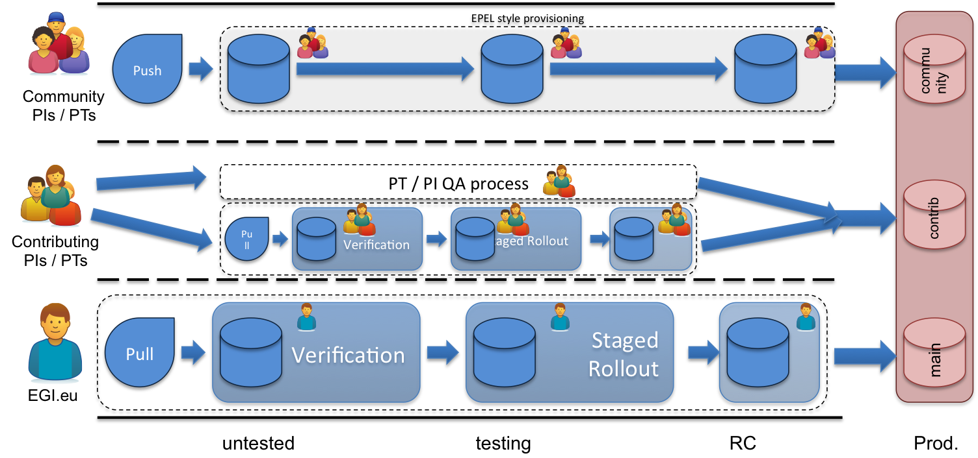

Figure 2: Overview of the UMD software provisioning

## Changes to the UMD

The changes to the UMD are expected to be fairly significant in that it will no longer be a concise, integrated repository containing all software from all Technology Providers. Instead, the UMD may become a distribution of software that is deployed in EGI on various levels. Arguably, this would be the scope of an EGI distribution hosted in the EGI Software repository, and the authors wouldn’t object to this notion.

Either way (whether the system will remain publishing under the UMD “brand”, or in a renamed service), the following describes the technical layout of the repositories that will serve the Resource Providers with new and updated software.

In this context, it is worth noting that the term “repositories” has two meanings. Firstly, the term “repository” refers in a technical context (i.e. a *package repository*) to a specific service that serves RPM or DEP packages with associated DB-like functionality – it is more than a directory with some binary files in it. As opposed to these, *software repositories* describe a service from which a client can fetch new or updated software independent of the actual architecture (32/64 bit, and OS). This document will discuss software repositories when using the term “repository”, unless otherwise specified.

The UMD will be composed of three software *domains*, reflecting the three different levels of QA and release coordination. Each of these domains may contain arbitrary numbers of repositories. The UMD “main” domain will contain exactly one repository – the integrated UMD repository, as it exists today.

The UMD “contributed” domain is likely to contain many repositories, providing each contributing Technology Provider with their individual repository. This scenario serves well when contributing Technology Providers are providing complete platforms. It does not, when Contributing Technology Providers provision individual products or worse, libraries that need to be integrated in e.g. Community Platforms. In this case a mix of integrated repositories for several contributing Technology Providers, and individual repositories for individual Technology Providers may be explored further.

The UMD “community” domain will simply contain as many repositories as there are Community Technology Providers associated with EGI, and each Technology Provider will update their

# Service offerings

In order to implement the changes to UMD and the software provisioning processes, a number of services will have to be made available to Technology Providers to be able to participate in this framework. The following subsections describe the various services available.

## Services for Community Technology Providers

Community Technology Providers need very few services in order to participate in this software provisioning framework. Their entire work is uncoordinated, and releases are allowed to be made at any point in time in their respective repository.

The set of services for Community is currently proposed as:

**Basic package** (free of charge):

1. Access to one software repository; including as many package repositories as there are supported platforms (typically two package repositories, base and update, per supported platform)
2. Access to a package uploading service; this service will support uploading binary packages for multiple platforms, and a free-form text field (HTML text editor) allowing to provide release announcement information published at <http://repository.egi.eu> in an appropriate channel
3. Common AAI of all services using EGI SSO (subject to availability)

**Optional services** (subject to compensation):

1. One discussion forum at the EGI discussion forum service (<https://forum.egi.eu/>) for developers and users to connect and share. This forum will be in a “Community Software” group.
2. One GGUS support unit including access to basic reporting and statistics
3. Access to EGI Staged Rollout coordination services including participating sites
4. Access to the EGI blog facility with one user account
5. Other, non-technical services, such as dissemination events, access to EGI community and technical for a may be available, but are out of scope for this document

## Services for Contributing Technology Providers

Contributing Technology Providers commit to and demonstrate considerable more collaboration and support to EGI.eu (and its federated members).

Technically, with regard to the UMD repositories, there are no differences to the requirements for Community Technology Providers provided that Contributing Technology Providers strategically align with the boundaries of Community Platforms (which EGI.eu desires).

The only exception to this is the alignment with major UMD versions: Contributing Technology Providers will receive access to as many individual software repositories as EGI is supporting major UMD versions. The current policy states that EGI will support major UMD versions for 2 years, with an overlap of one year between any 2 subsequent UMD major versions. This translates to two repositories for a Contributing Technology Provider, for any two UMD major versions being supported. If this policy will change in the future, the provisioning of repositories for Community Technology Providers will have to adapt as well.

EGI.eu expects from Contributing Technology Providers an end-to-end quality assurance programme that is equivalent to the programme undertaken together by Integrated Technology Providers and EGI.eu according to section 3. This QA programme is expected to be entirely covered by the respective technology provider’s efforts and resources. However, there are EGI.eu services that cover essential tools and activities in a QA programme that Contributing Technology Providers may make use of, if they wish to do so.

The set of services for Community is currently proposed as:

**Basic package** (free of charge):

All of the basic package for Community Technology Providers, except that software repositories will be aligned with major UMD releases (including the upload service), plus:

1. Access to the EGI Software Provisioning process and tools (optional, only if requested).
   1. This includes StagedRollout coordination, but not early access site effort
2. One or more GGUS support units (in case of more, one “head” SU will be included)
3. One or more discussion fora (organised as sub-forums) at the EGI discussion board at <https://forum.egi.eu/>.
4. Software release coordination in a UMD Release Team (URT) together with Integrated Technology Providers.

**Optional services** (subject to compensation):

1. Access to Early Access sites participating in Staged Rollout
2. Access to the EGI blog facility with one or more user accounts.
3. Other, non-technical services, such as dissemination events, access to EGI community and technical for a may be available and need to be specified here.

## Services for Integrated Technology Providers

TBC.

# References

|  |  |
| --- | --- |
| [TCB-15] | 15th TCB meeting (F2F), 14 December 2012, <http://go.egi.eu/TCB-15> |
| [TCB-14] | 14th TCB meeting (F2F), 6 November 2012, Amsterdam, NL, <http://go.egi.eu/TCB-14> |
| [EMIPlan] | Plan around EMI - <https://indico.egi.eu/indico/getFile.py/access?sessionId=5&resId=0&materialId=1&confId=1170> |
| [MS510] | MS510: EGI Platform Roadmap, <https://documents.egi.eu/document/970> |