**EGI-InSPIRE**

Annual Report 2013-2014

**EU DELIVERABLE: D1.16**

|  |  |
| --- | --- |
| Document identifier: | D1.16 Annual Project Report |
| Date: | 19/06/2014 |
| Activity: | **NA1** |
| Lead Partner: | **EGI.eu** |
| Document Status: | **FINAL** |
| Dissemination Level: | **PUBLIC** |
| Document Link: | <https://documents.egi.eu/document/2224> |

|  |
| --- |
| Abstract  This document summarises the achievements of the EGI Collaboration during the Project Year 4 (May 2013 – April 2014). |

1. Copyright notice

Copyright © Members of the EGI-InSPIRE Collaboration, 2010-2014. See [www.egi.eu](http://www.egi.eu) for details of the EGI-InSPIRE project and the collaboration. EGI-InSPIRE (“European Grid Initiative: Integrated Sustainable Pan-European Infrastructure for Researchers in Europe”) is a project co-funded by the European Commission as an Integrated Infrastructure Initiative within the 7th Framework Programme. EGI-InSPIRE began in May 2010 and will run for 4 years. This work is licensed under the Creative Commons Attribution-Noncommercial 3.0 License. To view a copy of this license, visit <http://creativecommons.org/licenses/by-nc/3.0/> or send a letter to Creative Commons, 171 Second Street, Suite 300, San Francisco, California, 94105, and USA. The work must be attributed by attaching the following reference to the copied elements: “Copyright © Members of the EGI-InSPIRE Collaboration, 2010-2014. See [www.egi.eu](http://www.egi.eu) for details of the EGI-InSPIRE project and the collaboration”. Using this document in a way and/or for purposes not foreseen in the license, requires the prior written permission of the copyright holders. The information contained in this document represents the views of the copyright holders as of the date such views are published.

1. Delivery Slip

|  |  |  |  |
| --- | --- | --- | --- |
|  | Name | Partner/Activity | Date |
| From | Sara Coelho | EGI.eu/NA2 | 01 June 2014 |
| Reviewed by | Tiziana Ferrari  Sergio Andreozzi | EGI.eu/NA1  EGI.eu/NA2 | 15 June 2014 |
| Approved by | AMB & PMB |  | 16 June 2014 |

1. Document Log

|  |  |  |  |
| --- | --- | --- | --- |
| Issue | Date | Comment | Author/Partner |
| 1 | 18 May 2014 | ToC | Neasan O’Neill |
| 2 | 01 June 2014 | First draft | Sara Coelho |

1. Application area

This document is a formal deliverable for the European Commission, applicable to all members of the EGI-InSPIRE project, beneficiaries and Joint Research Unit members, as well as its collaborating projects.

1. Document amendment procedure

Amendments, comments and suggestions should be sent to the authors. The procedures documented in the EGI-InSPIRE “Document Management Procedure” will be followed:  
<https://wiki.egi.eu/wiki/Procedures>

1. Terminology

A complete project glossary is provided at the following page: <http://www.egi.eu/about/glossary/>. PROJECT SUMMARY

To support science and innovation, a lasting operational model for e-Science is needed − both for coordinating the infrastructure and for delivering integrated services that cross national borders.

The EGI-InSPIRE project will support the transition from a project-based system to a sustainable pan-European e-Infrastructure, by supporting ‘grids’ of high-performance computing (HPC) and high-throughput computing (HTC) resources. EGI-InSPIRE will also be ideally placed to integrate new Distributed Computing Infrastructures (DCIs) such as clouds, supercomputing networks and desktop grids, to benefit user communities within the European Research Area.

EGI-InSPIRE will collect user requirements and provide support for the current and potential new user communities, for example within the ESFRI projects. Additional support will also be given to the current heavy users of the infrastructure, such as high energy physics, computational chemistry and life sciences, as they move their critical services and tools from a centralised support model to one driven by their own individual communities.

The objectives of the project are:

* The continued operation and expansion of today’s production infrastructure by transitioning to a governance model and operational infrastructure that can be increasingly sustained outside of specific project funding.
* The continued support of researchers within Europe and their international collaborators that are using the current production infrastructure.
* The support for current heavy users of the infrastructure in earth science, astronomy and astrophysics, fusion, computational chemistry and materials science technology, life sciences and high energy physics as they move to sustainable support models for their own communities.
* Interfaces that expand access to new user communities including new potential heavy users of the infrastructure from the ESFRI projects.
* Mechanisms to integrate existing infrastructure providers in Europe and around the world into the production infrastructure, so as to provide transparent access to all authorised users.
* Establish processes and procedures to allow the integration of new DCI technologies (e.g. clouds, volunteer desktop grids) and heterogeneous resources (e.g. HTC and HPC) into a seamless production infrastructure as they mature and demonstrate value to the EGI community.

The EGI community is a federation of independent national and community resource providers, whose resources support specific research communities and international collaborators both within Europe and worldwide. EGI.eu, coordinator of EGI-InSPIRE, brings together partner institutions established within the community to provide a set of essential human and technical services that enable secure integrated access to distributed resources on behalf of the community.

The production infrastructure supports Virtual Research Communities (VRCs) − structured international user communities − that are grouped into specific research domains. VRCs are formally represented within EGI at both a technical and strategic level.

1. EXECUTIVE SUMMARY

EGI is a European-wide federation of national computing and storage resources, to support cutting-edge research, innovation and knowledge transfer in Europe. Building on over a decade of investment by national governments and the European Commission, EGI supports more than 35,000 researchers across many fields of research with a wide range of technical and infrastructure services.

EGI is coordinated by EGI.eu, a not-for-profit foundation supported by the EGI-InSPIRE project and governed by the national stakeholders and early-adopting international research communities.

In EGI’s vision researchers from all disciplines have easy and open access to the digital services, data, knowledge and expertise they need to collaborate and perform excellent science.

As part of its mission to be part of the ERA's backbone as a key provider of open access to transnational compute, storage, data and expertise, EGI, during project year 4:

* Developed its **vision** of an Open Science Commons and strengthened cooperation with European and international e-Infrastructures.
* Defined a **strategy** to deliver a secure, federated data-analysis capability for the European Research Area.
* Developed a **portfolio of four solutions**: Federated Cloud, Federated Operations, High-Throughput Data Analysis, Community-driven Innovation and Support.
* Developed the **EGI Platform Architecture**, where the EGI production infrastructure is conceptualised as a collection of Core Infrastructure, Cloud, Collaboration and Community Platforms of services.
* Developed a cloud strategy and launched the **EGI Federated Cloud** into production in May 2014.
* Developed the **EGI Engagement Strategy** that allowed the strengthening of engagement and support actions towards Research Infrastructures and large European research collaborations.
* Developed the concept of **Distributed Competence Centres** involving NGI support teams, technology providers and user communities.
* Started a **business development** function leading activities exploring the provisioning of pay per use services.
* Strengthened relationships with **SMEs and industry**.
* Organised four **events**: the EGI Technical Forum 2013 and the EGI Community Forum 2014 – hosting a wealth of workshops and training events, as well as two large thematic workshops in December and March
* Published **case studies** describing how grid computing is helping European scientists, news items, newsletters, white papers and brochures
* Led the **EGI-InSPIRE** and the **e-ScienceTalk** projects, organized the EGI-InSPIRE extension, and participated in other 8 projects.

TABLE OF CONTENTS

1 EGI: an e-infrastructure for the European Research Area 6

2 What does EGI Do? 7

3 Solutions and Platform Architecture of EGI 8

3.1 EGI Solutions 8

3.1.1 Federated Cloud 8

3.1.2 Federated Operations 8

3.1.3 High-Throughput Data Analysis 9

3.1.4 Community-driven Innovation and Support 9

3.2 The EGI Platforms Architecture: Core – Cloud – Collaboration – Communities 10

3.2.1 Cloud strategy 11

3.3 Communications and community engagement 12

3.3.1 Engagement strategy 12

3.3.2 Distributed Competence Centre 13

3.3.3 Events for the community 14

3.3.4 Publications 16

4 EGI’s european Impact 18

4.1 In science and society 18

4.1.1 Case studies 18

4.2 In Europe 21

4.2.1 Added value for Europe 21

4.2.2 EGI Vision: An Open Science Commons 21

5 Strategy for the future 25

5.1 Objectives 25

5.2 Impact 27

6 Other European projects 29

6.1 e-ScienceTalk 29

6.2 BioMedBridges 29

6.3 BioVeL 29

6.4 CloudWATCH 30

6.5 DCH-RP 30

6.6 ENVRI 30

6.7 Helix Nebula 31

6.8 ER-Flow 31

6.9 FedSM 31

# EGI: an e-infrastructure for the European Research Area

E-Infrastructures include geographically distributed computing resources and data storage facilities, and the high-performance networks that link them. They allow scientists to share information securely, analyse data efficiently and collaborate with colleagues worldwide. They are an essential part of modern scientific research and a driver for economic growth. By 2020, e-Infrastructures need to be deployable on demand to provide a foundation for the digital European Research Area (ERA).

The European Grid Infrastructure (EGI) is the result of pioneering work that has, through the federation of national resource providers over the last decade, built a collaborative production infrastructure of uniform services, which supports multi-disciplinary science across Europe and around the world. Through this initiative an ecosystem of national and European funding agencies, research communities, technology providers, technology integrators, resource providers, operations centres, resource centres, coordinating bodies and other functions has emerged to serve over 20,000 researchers and their intensive data analysis.

The EGI ecosystem provides a common foundation upon which the digital ERA can be established by building upon the strengths that have been developed over the last decade.

# What does EGI Do?

The European Grid Infrastructure (EGI) was established in 2010 as a European-wide federation of national computing and storage resources, to support cutting-edge research, innovation and knowledge transfer in Europe. Building on over a decade of investment by national governments and the European Commission, EGI supports more than 35,000 researchers across many fields of research with a wide range of technical and infrastructure services. EGI’s services are distributed across Europe and beyond over 355 resource centres, supporting in excess of 1.52 million computing jobs (excluding operational and infrastructure jobs) per day, as well as data storage, transfer and open access.

EGI is coordinated by EGI.eu, a not-for-profit foundation supported by the EGI-InSPIRE project and governed by the national stakeholders and international research communities.

**Vision**

Researchers from all disciplines have easy and open access to the digital services, data, knowledge and expertise they need to collaborate and perform excellent research.

**Mission**

To be part of the ERA's backbone as a key provider of open access to compute, storage, data, knowledge and expertise available in Europe and worldwide.

**Core Values**

***Leadership***: EGI is a leading pan-European infrastructure, integrating worldwide computing, storage and data resources to support an ecosystem built on innovation and knowledge transfer.

***Openness***: EGI operates collaboratively with a transparent governance structure that integrates the views and the requirements of all stakeholders, from research communities to resource providers.

***Reliability***: EGI provides a reliable infrastructure that research communities can depend on in order to collaborate with their peers and deliver innovation.

***Innovation***: EGI will continue to meet the needs of research communities operating at unparalleled geographic and technical scale by partnering to bring new technologies into production.

***Commitment***: EGI is committed to provide the best possible outcome of its activities and initiatives in order to have a positive impact on the research community, the scientific work they do, and society as a whole.

***EGI in numbers[1]***

|  |
| --- |
| * EGI Council participants: 40 * EGI-InSPIRE project partners: 48 * 355 Resource Centres distributed across 54 Resource Providers in 4 continents * ~35,000 users in 212 VOs * 490,000 CPU cores (EGI-InSPIRE partners and integrated infrastructures) * Computing capacity (EGI-InSPIRE partners): 4.054 million HEPSPEC06 * Storage capacity: 286.0 PB (disk) and 117.6 PB (tape) * Usage: 1.52 million jobs per day * Availability of NGI services: 99.0%; Reliability of NGI Services: 99.63% [2] |

# Solutions and Platform Architecture of EGI

## EGI Solutions

### Federated Cloud

*Do you need an infrastructure to deploy on-demand IT services for managing and processing your research data?*

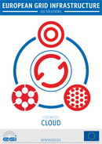

The Federated Cloud solution (White Paper[3]) is targeted at researchers and research communities that need to access digital resources on a flexible environment, using common standards to support their data- and computing intensive experiments.

With this solution, researchers can expand their access to computing capacity without modifying the applications they already use and trust. Researchers will be able to migrate from one service provider to another with minimum effort and resource usage.

Resource Centres also benefit from this solution, as they can offer their computing resources to a broader base of research-users. Ultimately, a more effective usage of the available resources benefits not only research community but also European society as a whole.

The solution is built on a combination of services already provided by the EGI.eu organisation, such as operational methods and tools, standards-based technologies, security coordination, helpdesk facilities, technical consultancy among others. It also uses the computational resources of the European Grid Infrastructure.

### Federated Operations

*Do you need operational services and tools to run a distributed IT infrastructure for research?*

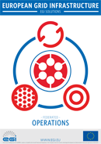

The Federated Operations solution (White Paper[4]) is primarily aimed at Research Infrastructures and Resource Centres already within the EGI community or wishing to become part of it. It can also help other IT service providers that are geographically and/or structurally dispersed, and wish to organise themselves for federated service provision.

This solution provides the tools, services and expertise required to run services smoothly and seamlessly.

The solution is built over a combination of services already provided by expert teams within the EGI community coordinated by the organisation EGI.eu. It covers areas such as helpdesk support, coordinated management of operations, security coordination, and the centralisation of typical operation capabilities such as monitoring and accounting. The solution relies as well on the FitSM standard family, tailored for federated IT service provision.

### High-Throughput Data Analysis

*Do you need to analyse large datasets, or to execute thousands of computational tasks?*

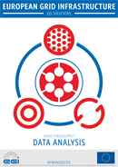

The High-Throughput Data Analysis solution (White Paper[5]) is aimed to help individual researchers, and research communities that have large scale data management and computational capacity requirements.

With this solution users gain access to EGI’s distributed resources (in excess of 500,000 cores as of May 2014[6]), allocated via a central process and made accessible with uniform interfaces. EGI provides a single entry point to a federated pool of resources that can be allocated to new or existing user communities who need resources to perform their research activity. User communities are enabled to perform their investigations in an effective, cost-efficient collaborative way, which otherwise would not have been possible.

The solution is built with a combination of services already provided by the EGI.eu organisation, such as Operations, Technology and Security Coordination, and Technical Consultancy and Support, but also using the resources provided by the federation that comprises the European Grid Infrastructure.

### Community-driven Innovation and Support

*Do you want to discover the best approach or develop new ways to your data or compute-intensive research?*

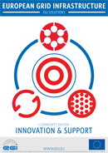

The Community-driven Innovation and Support solution (White Paper[7]) is aimed at helping the individual researchers and the research teams that have problems in accessing and using computational services for their research activity. A considerable number of European researchers may experience the complexity of a computational infrastructure as a barrier for benefiting from this powerful tool in their research. This may result in a depletion of their normally scarce resources, or worse in a rejection of the facilities on offer. With this solution they are helped to bridge the knowledge gap in accessing the services so they can focus on their core research activity, resulting in a more efficient use of their research budgets.

The solution is built on a combination of services already provided by the EGI.eu organisation, such as Project and Programme Management, Technical Consultancy and Support, but also using the resources located in the federation that comprises the European Grid Infrastructure.

The solution provides multiple entrance points for help requests, which enhances the possibility of a higher number of potential users being attended to. The requests are channelled to a single point of processing, the Distributed Competence Centre (DCC) with proven expertise in helping users and a network of experts, and experienced users located across the whole EGI Community. The DCC receives, processes and provides a solution to the problem that is based on previously existing methods or a brand new, innovative solution. This practice not only ensures a very high effectiveness in solving problems, but also the generation of innovation by the community with benefits for the whole community.

## The EGI Platforms Architecture: Core – Cloud – Collaboration – Communities

The EGI production infrastructure is conceptualised as a number of platforms, as illustrated in Figure 1.

Fig.1 – The EGI Platform Architecture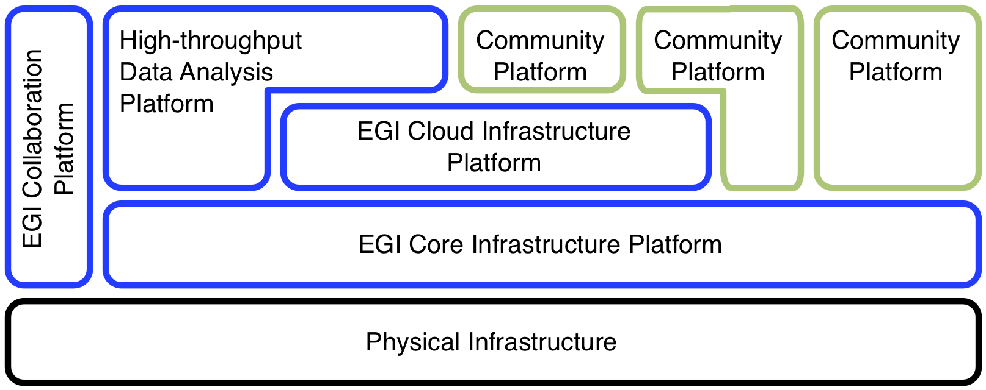

The colour coding in Figure 1 is schematised as follows[8]:

* **Black** denotes direct legal and financial ownership of the physical infrastructure as exerted by the Resource Infrastructure Provider within the EGI production infrastructure (typically NGIs and EIROs).
* **Blue** platforms are owned by EGI, i.e. EGI is the Platform Owner, and offers these for integration and use by its research communities.
* **Green** platforms are not owned by EGI; the mapping of stakeholders to actors varies across these.

In more detail, the platforms are:

**EGI Core Infrastructure Platform**

The EGI Core Infrastructure Platform (EGI CIP) consists of the services that are necessary to operate a federated distributed computing infrastructure. These services are:

* Messaging
* Federated Authentication and Authorisation Infrastructure (AAI)
* (Service Availability) Monitoring
* Accounting
* Central Services Catalogue
* Information Discovery Service
* Metrics visualisation

The EGI CIP is deployed directly on top of the physical hardware and it is owned, deployed, packaged and operated by the Resource Infrastructure Providers federated into EGI.

These activities are coordinated through management and collaboration boards and groups that are part of the EGI IT Service Management domain.

**EGI Cloud Infrastructure Platform**

The EGI Cloud Infrastructure Platform (EGI CLIP) provides consistent access to federated IaaS Cloud resources. It directly supports EGI’s strategic alignment with the European Commission’s Horizon 2020 strategy (more details in chapter 3.2.1)

The EGI Cloud Infrastructure Platform is conceptualised as an abstract Cloud Management stack subsystem integrated with components of the EGI Core Infrastructure Platform

The main interaction points of the EGI CLIP are:

* Integrate with the EGI Core AAI
* Integrate with the EGI Core Accounting system
* Integrate with the EGI Core Monitoring system
* Provide a standardised Cloud Computing interface (OCCI)
* Provide a standardised Cloud Storage interface (CDMI)
* Provide a standardised interface to an Information Service

Additionally, by means of using the Appliance Repository and the VM Marketplace from the EGI Collaboration Platform (COP) the EGI CLIP is providing VM image sharing and re-use across EGI Research Communities.

**EGI Collaboration Platform**

The EGI Collaboration Platform (EGI CoP) offers services to enable collaborations across EGI’s research communities. It facilitates synergies between research communities by encapsulating services common to multiple communities, but not critical to the operation of the EGI and therefore outside of the Core and Cloud platforms.

**Community Platforms**

The Community Platforms consist of tailored service portfolios customised for and owned by specific scientific communities.

The *EGI High-Throughput Data Analysis Platform* is a Community Platform sustained by its user community stakeholders under permanent stewardship of EGI, as the successor of the series of EMI platforms deployed via the UMD in the EGI production infrastructure.

### Cloud strategy

Over the last three years, EGI has brought together European resource providers (mostly already members of EGI) and User Communities to build a federated, standards-based IaaS Cloud platform that offers advanced ICT capabilities for research, virtualised resources to run any environment chosen, cloud storage for easier sharing of data, and a number of support services to ensure applications run as efficiently as possible. Firmly embedded in the EGI Platform architecture, EGI’s Cloud Infrastructure Platform has been integrated into EGI’s production infrastructure in May 2014.

EGI’s Cloud Infrastructure Platform is modelled into a Service Oriented Architecture (SOA), focusing on services provided by bespoke providers and integrated into the platform. This fundamental shift away from tight technical integration with strong software dependencies that are hard to manage in day-to-day operational duties, towards a much more flexible contractual service dependency allowing EGI to build much more agile service and solution portfolios has yet to be firmly established and worked out in all its necessary details across the entire EGI federation.

The EGI Cloud Infrastructure Platform allows for unprecedented flexibility in EGI supporting much more versatile user communities than ever before. The EGI Cloud solution will continue evolving towards giving its users an ever better experience. This includes integrating and strengthening Virtual Organisation support services such as Perun (provided by CESNET), VO Administration Portal (VAPOR, provided by CRNS) and Application deployment factory services (provided by CESGA). Operational security services will be integrated to provide users with a safe, protected and secure environment.

EGI’s Cloud services play a key role in EGI’s engagement strategy. Working closely with the User Community Support Team and being actively involved in the creation and support of distributed competence centres in Europe (coordinated through EGI.eu), EGI intends to use the Cloud Infrastructure Platform as a matrix for developing new services that might be integrated into EGI’s solution portfolio in the future. EGI is actively pursuing promising cross-community activities that have the potential of being offered by EGI at scale, such as a preservation platform as a service for all its user communities.

## Communications and community engagement

### Engagement strategy

Engagement is a key element of EGI’s aim of connecting researchers with its reliable and innovative ICT services.

During Project Year 4 EGI developed a new EGI Engagement Strategy[9] to help create and foster relationships with existing and potential users.

The strategy has two main targets, Research Infrastructures (RIs) from the ESFRI and national roadmaps and smaller research collaborations and research networks.

The goals of the strategy are to:

* Identify scientific communities that can benefit from the solutions provided by the EGI community.
* Reach out and engage with communities about ICT technologies to capture their requirements.
* Help communities to address scientific challenges with existing or new solutions as needed.
* Support scientific communities to become self-sufficient users of the EGI e-Infrastructure services.

The strategy uses a three-stage workflow that helps EGI to reach new users, and support them through the use of EGI services. This workflow consists of three phases:

1. ***Outreach*** - Using marketing and communication to identify and inform ERA members whose work could benefit from EGI’s e-Infrastructure services.
2. ***Scoping*** - Deepening engagement with potential users by collecting detailed requirements and translating these into focussed support project plans.
3. ***Implementation*** - Using the workplan created in the scoping phase to bring a new community or group into the EGI user community.

### Distributed Competence Centre

One of EGI’s most important assets is the experience acquired through years of testing, integrating and using distributed federated services. This expertise is distributed throughout the EGI ecosystem and is provided by NGIs, Resource Centres, Technology Providers and user communities.

During Project Year 4, EGI introduced the Distributed Competence Centre (DCC) mechanism to make the most of these experts and their experience. By pooling this technical knowhow, the DCC strengthens EGI’s technical support to new user communities and Research Infrastructures and therefore plays an important role in the implementation of the EGI Engagement Strategy.

The DCC workflow can be described as follows (Fig. 2):

1. A research infrastructure, or a user community, approaches EGI with a specific storage or compute challenge.
2. A panel of experts from the DCC assesses the challenge and documents the technical requirements.
3. There are two possibilities at this stage:
   1. The DCC recommends an implementation plan using existing solutions.
   2. A Virtual Team is created to define a technical work programme which will create a custom solution in collaboration with the users and tailored to their requirements.
4. A new research infrastructure or user community starts benefitting from the services and resources of EGI.

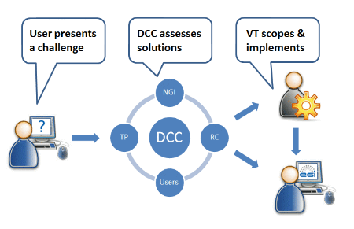

Fig.2 – Stages of the Distributed Competence Centre (DCC) workflow. NGI – National Grid Initiative; RC – Resource Centre; TP – Technology Provider.

This system allows the DCC to federate EGI’s distributed technical support skills and offer expertise on many areas that affect researchers, including:

* Core e-Infrastructure services that provide the foundations for community-specific services, such as authentication, authorisation, accounting and information discovery;
* Grid and cloud platform technology;
* Community-specific platforms, such as compute-intensive parallel applications, visualisation, science gateways and workflows.

### Events for the community

**Technical Forum 2013**

The EGI Technical Forum 2013[10] was held in Madrid, Spain from 16 to 20 September 2013. The event was hosted by EGI.eu and IBERGRID, a partnership between the Spanish and Portuguese National Grid Initiatives that represents the Iberian Peninsula in EGI.

In total, 471 participants registered for the forum, which featured 238 contributions organised in 96 sessions. The Technical Forum website[11] was viewed by 2,264 unique visitors that led to 19,087 page views. The two (iPhone & android) free applications developed for the event were downloaded-updated by 161 users.

The Technical Forum hosted five co-located events:

* IBERGRID 2013 (19-20 September)
* Cloud PlugFest (18-20 September)
* Open Grid Forum 39 (16-18 September)
* GlobusEUROPE2013 (19 September)
* EU-Brazil OpenBIO (18-19 September)

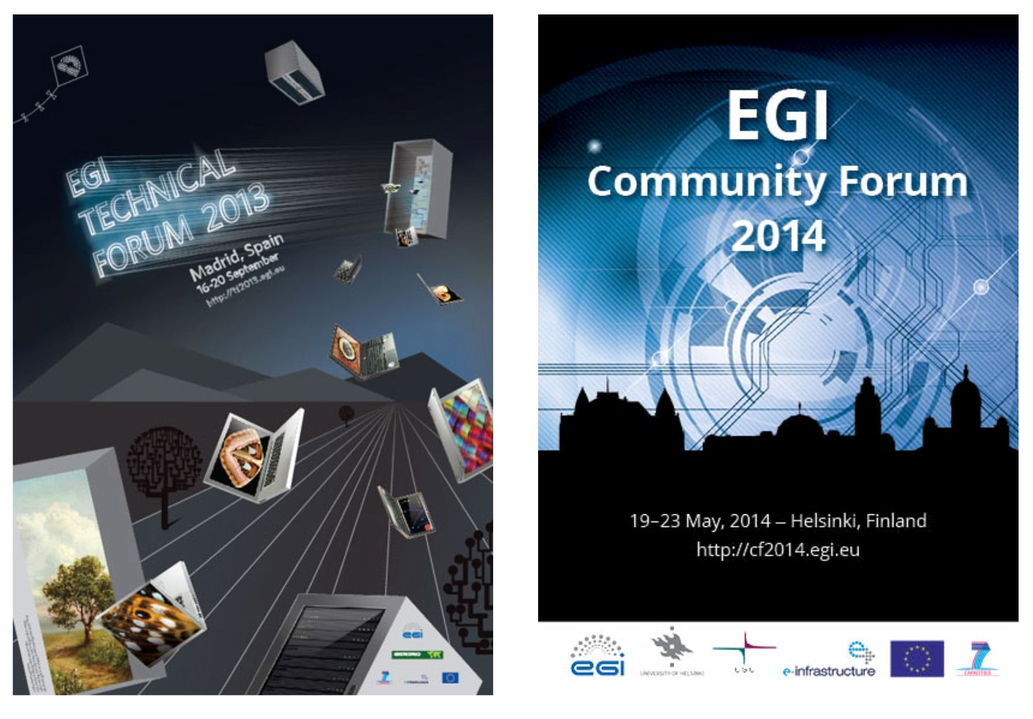

Fig.3 – Posters of the two EGI flagship events of Project Year 4: The Technical Forum 2013 in Madrid, and the Community Forum 2014 in Helsinki.

**Community Forum 2014**

The EGI Community Forum 2014[12] was held from 19-23 May in Helsinki, Finland. The event was hosted by EGI.eu in collaboration with Helsinki University and CSC - IT Center for Science Ltd.

With the theme of “Advancing excellent science”, the event focused on the EGI contribution to advance excellent science in the European Research Area through the use of innovative services for data and computing.

In total, 373 delegates registered for the event that featured more than 200 scheduled contributions distributed across sessions, workshops and tutorials. The forum featured, for the first time in EGI events, lightning talks by researchers as well as networking sessions and hackathons designed to maximise the interaction between delegates. The Community Forum website[13] received 11,329 unique pageviews. Two (iPhone & android) free applications were also developed for the event.

The Community Forum was held in conjunction with the following co-located meetings:

* Research Data Alliance Europe (RDA), EUDAT, OpenAIRE & TTA
* NorduGrid Conference 2014
* Nordic e-Infrastructure Collaboration (NeIC)
* European Globus Community Forum 2014

### Publications

During 2013/2014, the EGI.eu communications team produced several publications designed to convey the goals and achievements of the EGI community to wider audiences. These included:

* **Four issues of *Inspired***, the EGI newsletter[14]
* **50 news items**, on community announcements, milestones, events, agreements, use cases and success stories[15]
* ***Why EGI?***, a publication summarising the added value of EGI to Europe and the ERA[16]
* **The EGI brochure**, aimed at introducing EGI to a general audience
* **The CF2104 Book of Abstracts**, with an overview of the talks presented at the EGI Community Forum[17]
* ***EGI Case Studies***, a collection of use cases showing how EGI is supporting scientists in their day-to-day work[18]
* **Four solution White Papers[19]**

The communications team also prepared printed materials (e.g. posters) for and represented EGI at major scientific events, including:

* Supercomputing 2013 (computer science)
* European Conference on Computational Biology 2013 (Bioinformatics)
* European Geosciences Union General Assembly 2014 (Earth Sciences)
* 9th European Biophysics Congress (Biophysics)

EGI and the work done on the infrastructure featured in a wide range of articles and press cuttings including the *Financial Times* magazine[20], *ZeeNews[21]*, *Forbes[22]* and *The Register[23]*, alongside *International Innovation*, *Digital Meets Culture*, the e-IRG newsletter and GÉANT’s CONNECT, for example.

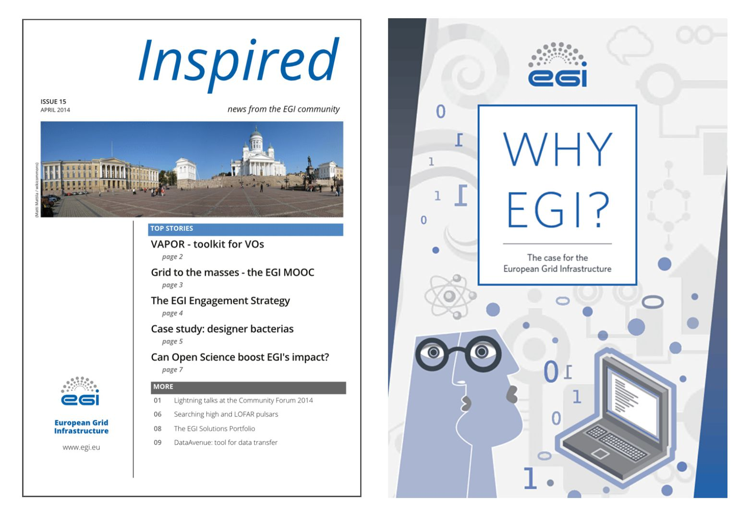

Fig.4 – Cover pages of the latest issue of the *Inspired* newsletter (left) and the *Why EGI?* brochure. The full catalogue of EGI Publications is available on the EGI website at: <http://www.egi.eu/news-and-media/publications/>

# EGI’s european Impact

EGI’s vision, mission and core values ensure that it continues to build on its added value, supporting world-class research and innovation in the European Research Area. The overarching goal is to tackle today’s societal challenges with innovative solutions developed by talented researchers supported by a top-notch e-Infrastructure.

Some examples of EGI’s impact on science and society are presented here.

|  |
| --- |
| Number of scientific papers published in 2013, related to results obtained thanks to EGI’s services and resources: **430** |

## In science and society

The distributed computing services provided by the EGI federation are helping scientists and researchers across Europe to drive innovation with excellent science results.

### Case studies

**Making sense of seismic noise***How grid computing helps scientists to correlate data from millions of calculations to unveil the rock structure of an oil field under the North Sea.*

Oil and mining companies use seismic waves to figure out the structure and type of rocks underground, so they can plan their work. Because they can't wait for earthquakes, they artificially induce seismic waves with explosions. This is however expensive and has severe environmental consequences.

Aurélien Mordret, a seismologist based in France, is working on an alternative that puts the background seismic noise to good use. Thanks to a mathematical method called cross-correlation and grid computing, it is possible to collect meaningful seismic data from the rumble of waves as they travel across the seafloor.

When applied to the Valhall oil field in the North Sea, the method revealed a structure crisscrossed with old riverbeds and the tell-tale signs of a depleted oil reservoir.

ReferencesA. Mordret et al. (2013) doi:10.1190/geo2012-0303.1A. Mordret et al. (2013) doi:10.1002/grl.50447<http://www.egi.eu/case-studies/natural-sciences/seismic_noise.html>

**3D liver maps using magnetic resonance imaging***How grid computing helps to develop alternative, non-invasive techniques to diagnose and monitor liver fibrosis.*

Chronic liver disease is never good news but in about 20 percent of the cases the condition escalates to severe inflammation and fibrosis, a kind of scarring of the liver's tissue.

When this happens, it is very important to follow the progression of the disease and monitor the onset of fibrosis to guarantee the best treatment. Liver fibrosis is usually diagnosed with a biopsy – an invasive surgical procedure to remove liver cells for lab testing.

Olivier Beuf believes that we can do better and has put together a team to develop an imaging technique that can be used in a clinical examination. Using the European grid, they developed a 3D map showing how fibrosis affects blood flow in a diseased liver.

The 3D maps will be a reliable alternative to the usual biopsy procedure and will contribute both to patient's well-being and to improve our understanding of liver disease.

ReferenceB. Leporq et al. (2013) doi:10.1155/2013/471682 [open source]http://www.egi.eu/case-studies/medical/3d_liver_maps.html

**Tracking a biomarker for Alzheimer’s disease**

*How grid computing can be used to test the software packages tracking a diagnostic biomarker for Alzheimer’s disease.*

Alzheimer’s disease starts slowly and patients may not show symptoms for many years. Yet subtle physical changes will already be occurring, as their brain cells begin to die and the brain atrophies. The key to early diagnosis is to find a reliable ‘biomarker’ for Alzheimer’s that researchers can use to monitor the disease and decide on treatments.

One useful clue is the volume of the hippocampus - the region in the brain associated with memory that starts to shrink at the onset of Alzheimer’s. Many software programs have been developed to measure changes in hippocampus size from imaging scans. Now researchers at Vrije Universiteit Amsterdam have used grid computing to compare the performance of several software programs by analysing thousands of MRI scans taken from Alzheimer’s patients.

The study produced a valuable benchmark to evaluate Alzheimer’s biomarkers. Better biomarkers from brain scan data open the door to earlier diagnosis, effective monitoring, and being able to quickly test new drugs for the disease.

ReferenceGB Frisoni et al. (2010) doi:10.1038/nrneurol.2009.215<http://www.egi.eu/case-studies/medical/alzheimers_biomarkers.html>

**On the double: metabolic rates accelerate evolution**

*How grid computing helps to show how new species of cold-blooded animals appear faster in warmer climates.*

Some animals live their lives faster than others. These differences are captured by a measure known as metabolic rate. Mice and small birds have high metabolism and live highly active but short lives. Whales and elephants, on the other hand, have lower metabolic rates, live longer and slower, and produce less offspring.

An animal’s metabolic rate, how fast and long they live, can be influenced by climate. Cold-blooded animals that cannot regulate body heat by themselves, have a metabolic rate that depends on their environment's temperature.

But does this also influence how fast new species appear?

Antonin Machac and colleagues from the Czech Republic looked into the history of salamander evolution. Using grid computing resources provided by Metacentrum, they analysed data related to many different salamander species across the world. They concluded that new species were being created at a faster rate in tropical climates, where the cold-blooded animals have higher metabolic rates.

ReferenceA. Machac et al. (2012) doi:10.1111/jeb.12019<http://www.egi.eu/case-studies/natural-sciences/evol_metabolism.html>

**How current flows in organic semiconductors**

*Grid computing is helping material scientists to understand how electric charges are transmitted through organic materials.*

Organic semiconductors (such as naphthalene) hold great promise for innovation as an alternative to silicon, the dominant material in conventional electronics. First, because they are easy and cheap to produce. Second, they can be bent and moulded, while retaining their electrical characteristics.

The practical applications of organic semiconductors can be found in solar cells, transistors or light-emitting diodes (LEDs). But the electronic properties of these devices are still lagging behind conventional materials.

Nenad Vukmirović, a material scientist based at the Institute of Physics Belgrade, studies how electrical current flows in organic materials. His goal is to under-stand the relationship between current and crystalline structure and see how they can be improved.

His recent work, published in the Physical Review Letters, used grid computing to calculate how electrons carrying electrical current interact with phonon waves (formed by oscillations within the material). This deter-mines the properties of the electric current: the stronger the interaction, the weaker the current flow.

Reference

N. Vukmirović et al. (2012) doi:10.1103/PhysRevLett.109.126407

<http://www.egi.eu/case-studies/eng_tech/semiconductor.html>

**Where do African fish parasites come from?**

*Scientists use grid computing to trace the tapeworms infecting Northern African fish back to Europe.*

When tapeworms of the species *Ligula intestinalis* infect fish, the consequences are gory. The parasites grow to fill the host's body cavity, leading to behavioural changes and high mortality rates. It's unpleasant for the fish and a problem for the fish farming industry, and this is why scientists keep an eye on where the parasites live and how their geographical distribution evolves.

Recent genetic studies showed that tapeworms in Northern Africa belong to two different families, or lineages: one of them is local, the other is an invasive newcomer. Where do they come from?

Jan Štefka, a biologist based in the Czech Republic, used grid computing to run a comprehensive analysis on genetic data from tapeworms to find where the invasion comes from. The results, published in the journal Biological Invasions, show that the tapeworms arrived in Africa from Europe, hitching a ride with the fish introduced to improve the local lakes.

Reference

W. Bouzid et al. (2013) doi: 10.1007/s10530-013-0418-y

<http://www.egi.eu/case-studies/natural-sciences/parasites.html>

## In Europe

### Added value for Europe

In the wider context of Europe 2020 and funded in future through the Horizon 2020 programme, EGI offers a range of added value for Europe:

* EGI ensures that researchers have access to uniform and reliable computing resources, enabling faster scientific results and avenues of multi-disciplinary research otherwise not possible.
* EGI allows researchers to focus on their research rather than managing their e-Infrastructures needs.
* EGI’s monitoring and operational services guarantee an integrated, reliable and uniform service provided across organisational and national boundaries.
* EGI’s transnational integration provides effective use of resources and ensures the most effective return on Europe’s e-Infrastructure investments.
* EGI enables knowledge transfer and sharing of solutions through community events, an application database and a training marketplace.
* EGI promotes open science through the availability, accessibility and reuse of scientific data and results, the provision of web-based tools that facilitate scientific collaboration and by ensuring public access to research.

### EGI Vision: An Open Science Commons

**What is a Commons?**

The idea of ‘commons’ stems from what the Romans called *res communes* – the common ‘things’, or resources that are owned by the collective, such as air, rivers or the sea. In modern times, the concept of commons may be extended to include Nature, the Social and Digital Sphere and Culture as “resources that can be collectively used [and that] constitute the inner structure of a functioning society. In this sense, shared resources constitute the infrastructure, inheritance, identity and culture of a community or nation.”[24]

A commons is a combination of collectively-owned resources, the people who make use of them and the regulations that govern the commons itself. In this sense, the concept can be explored to enhance the quality of life, to enable participation and to provide platforms for creativity and cooperation.[25]

The e-Infrastructures Reflection Group (e-IRG) took this idea and adapted it to the needs of the ERA. The result was a call for an “e-Infrastructure Commons for knowledge, science and innovation, [which] should be open and accessible, and continuously adapting to the changing requirements of research and to new technological opportunities.”[26]

**The Open Science Commons**

Taking the idea one step further, EGI developed the idea of *Open Science Commons* based on its vision for a better ERA:

*Researchers from all disciplines have easy and open access to the digital services, data, knowledge and expertise they need to collaborate and perform excellent research.*

This vision is held on three pillars: ICT services, data and knowledge. By 2020, European researchers will be able to:

* Access **ICT services** through a single point of contactto makethe most of the (integrated and interoperable) capacity and support provided by the various e-Infrastructures (including commercial providers).
* Freely discover, share, use and re-use **data,** including research outputs, publications, databases, software or workflows.
* Tap the body of **knowledge and expertise** existing within the community to understand the services they need or to support developing new solutions to perform their digital research

Within the context of the Europe 2020 vision for an open ERA, ICT services, data and knowledge are all interconnected assets that can be collectively explored to advance the goals of Horizon2020. The Open Science Commons is a framework to structure these relationships.

The Open Science Commons (Fig.5) has three main pillars:

* *e-Infrastructure Commons*: a flexible and dynamic ecosystem providing integrated services through interoperable infrastructures.
* *Open Data Commons*: where observations, results, applications of scientific activities available for anyone to use and reuse.
* *Knowledge Commons*: where collaborations and communities can harvest shared expertise to address challenges in education and research.

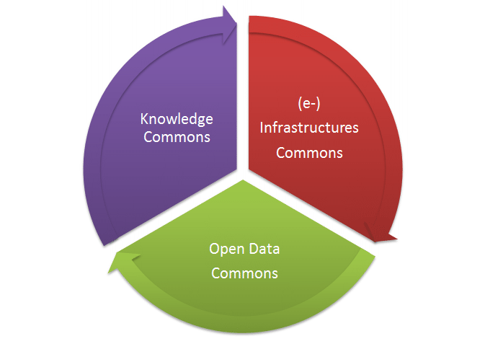

Fig.5 –The three key elements of an Open Science Commons

**Strategy for an Open Science Commons**

The strategy to take the Open Science Commons off the drawing board and into the ERA will be focused on building:

* *A common backbone of federated services*, to strengthen the relationship between e-Infrastructures
* *Joint capacity planning*, to define policies, processes, access models and business models.
* *An open and integrated marketplace*, to manage provisioning of and access to resources provided by academic and commercial partners.

Specifically this will achieved by:

* Defining an open access policy, to enable sharing of current and future research outputs and easy access control
* Developing OpenAIRE integration, to guarantee that research outputs are clearly labelled and available to every researcher in ERA
* Designing a plan to guarantee that open data can be shared, curated and preserved in the long term
* Creating Distributed Competence Centres (DCCs), grounded on strong user engagement, that can facilitate knowledge transfer in areas such as
  + connectivity, compute and data services
  + data management and planning
  + data archives certification
* Collaborating with Centres of Excellence in the HPC sector to complement the HTC and Cloud services provided by the EGI community
* Facilitate knowledge transfer to private sector to maximise competitiveness

**DG-Connect, e-Infrastructure Unit: towards the ERA**

How does EGI help the EC in implementing its policies for a European Research Area?

***GOAL (computational infrastructure): Europe leads in the supply and use of computational infrastructure and services in industry and academia, generating new knowledge and industrial innovation***.

🡪 EGI he portfolio of EGI solutions for computing will be expanded by complementing the existing High Throughput Data Analysis solution with a standards-based Federated Cloud solution

🡪 Indicators:

* Computing cycles available for open transnational access
* Number of EGI users
* Percentage of transnational usage: percentage of foreign resources (CPU normalized wall time hours) used by users of a given country aggregated across the whole of EGI.   
  BASELINE (DATE): 28% (May 2014). TARGET 2016: 35%

***GOAL (data centric science and engineering): Europe leads in the supply and use of computational infrastructure and services in industry and academia, generating new knowledge and industrial innovation***.

🡪 Indicators:

* Number of open access scientific publications that benefited from EGI
* Number of interoperable distributed data storage services available in EGI: ESCRIPTION: number of user interfaces to storage services providing capacity for data ingestion and management, registered in the EGI service catalogue . BASELINE (DATE): 358 service end-points . TARGET 2015: 370 (2015)

**GOAL (Virtual Research Communities): *Researchers across disciplines are digitally empowered through e-Science environments and tools tailored to their specific needs, resulting in better collaboration and higher efficiency and creativity in research***

**🡪**Indicators:

* Number of international virtual research communities that use EGI services: number of active international research collaborations supported yearly by EGI. BASELINE (DATE): 105 (April 2013-May 2014 . TARGET 2015: 125
* Number of applications and platforms that are integrated with EGI computing services: number of user applications and user-community gateways integrated with the EGI compute and data services. These are provided by the Application Database of EGI. BASELINE (DATE): 495 , TARGET 2015: 530

# Strategy for the future

As part of its mission to be part of the ERA's backbone as a key provider of open access to transnational compute, storage, data and expertise, EGI has developed a strategy to tackle society’s grand challenges by providing a powerful, secure, efficient and scalable research infrastructure and associated support services for leading-edge data analytics[27].

## Objectives

The main objectives are to:

***1) Provide Enabling Services to Researchers***

By adopting a defined service portfolio and a user-centric approach to its development, EGI will expand current service offering from EGI.eu and affiliated NGIs to retain its current research communities and attract new research communities.

*Current Status*: EGI has over the last two years been defining its technical service portfolio provided centrally through EGI.eu and its affiliated resource providers to clearly define the capabilities it provides to the different research personas which respectively represent the needs of large global research infrastructures (e.g. WLCG and Research Infrastructures), small/medium research collaborations (e.g. WeNMR, DRIHM) and enterprises, and finally the individual researchers in the long-tail (e.g. supported by the European Science Foundation).

*Future Plans*: With further funding EGI will continue to evolve its solutions portfolios by establishing user boards to manage the definition and development of requirements, roadmaps, whitepapers, metrics, training and promotional material. Each solution will have a dedicated manager providing the ‘voice of the user’ who will drive change through the introduction into production of technical innovations with relevant service and technology providers.

***2) Operate an Unprecedented European Capability for High Throughput Data Analysis***

EGI will expand its federated cloud infrastructure to 10M computing cores and 1Exabyte of storage by 2020. EGI will build on its current collaborative resource allocation model based on the resources coming from the NGIs and other organisations to also support peer-reviewed or pay-for-use access for researchers undertaking excellent science.

*Current Status*: For over a decade, EGI has been operating a reliable secure federated infrastructure composed of computing and storage resources contributed by NGIs, EIROs and other organisations consisting in May 2014 of 593,424 computing cores and over 400PB of disk and tape storage[28]. This production infrastructure operates 24/7 and through its redundant and distributed architecture delivers 100% availability to the major research communities that depend on it for their data analysis needs. Access to this capacity is currently driven from the bottom up by the research collaborations and their associated resource providers from within the NGIs.

*Future Plans*: EGI.eu will continue to operate a set of core services while providing the operational and technical coordination needed to reliably and uniformly federated distributed resources from across EGI’s resource centres. In a federated infrastructure, national funding bodies will continue to fund and manage access to the resources coming from the NGIs. With further European funding, EGI will build on its existing resource allocation mechanisms to establish a European level peer-review process that will enable research collaborations undertaking ‘excellent science’ to access pooled resources. For those research collaborations able to pay-for-use resources, EGI.eu will coordinate access to both public sector resources able to provide payment based access and integrated private sector resources.

***3) Provide Flexible Virtual Research Environments***

EGI will simplify access to its resources and accelerate the ability of researchers to undertake excellent science by leveraging the expertise and connections of the NGIs to introducing technical innovations into production across Europe.

*Current Status*: Members of the EGI community have been working with their NGIs and affiliated technology experts, service providers and research communities in Europe to establish the virtual research environments needed by research collaborations to effectively exploit the distributed computing and storage resources. These are presented to researchers as web portals, or as mobile or desktop applications customised to meet their specific research needs. The current software services provided by EGI are currently being used by over 21,000 researchers as the foundation of their own domain specific virtual research environments.

*Future Plans*: To deliver high-quality solutions that will reliably scale to the environments presented by a distributed computing and data infrastructure, further European and national funds are needed to co-develop software through a user-centric model. EGI will facilitate bringing together service providers and technologists within the NGIs and researchers with challenging requirements to co-develop new services that will increase the capability of researchers to undertake excellent science.

***4) Identify and Develop EGI’s Human Capital***

EGI will help its research communities supported by establishing, within the NGIs, national centres of excellence that can transfer skills from within EGI to tomorrow’s data scientists.

*Current Status*: In recent years, EGI has developed and grown its human networks from just the NGI operations centres to also include other NGI non-operational activities (e.g. policy, communications, promotions, events, technical outreach, etc.), and leading young researchers who are already using EGI. These human networks are coordinated by EGI.eu centrally to provide communication channels and the human capital within these networks is currently being developed through webinars and F2F meetings. Social media tools are used to strengthen communication within and between these different human networks.

*Future Plans*: With funding EGI will continue to develop and grow the human networks based in the member states through the NGIs, research disciplines through the EGI Champions and experts from the technology teams that produce the software used by EGI, and developing other human networks as they are recognised.

## Impact

***For the researchers and research communities within the ERA***

* *Supporting Excellent Science*: Researchers will have access to their local and affiliated NGI resources through their existing access mechanisms. This is currently achieved through the researcher’s own research collaborations but in the future additional resources allocated by peer-review, or by pay-for-use using integrated commercial or public sector resources could also be made available. The peer-review allocation process of EGI’s resources is currently being prototyped[29] and the integration with commercial cloud resources was explored through the HelixNebula initiative.
* *Making every Researcher Digital*: EGI provides coordination of the human capital distributed across Europe (in its affiliated NGIs) that can be used to co-develop new technology with researchers, and to transfer these technology skills to the applied research community through national competency centres.
* *A Scalable Computational and Storage Research Infrastructure*: EGI provides a service infrastructure using integrated NGIs that allows researchers to transparently and uniformly access and use resources, data and knowledge across Europe wherever they are located, from both the public and commercial sectors. Further investment will increase the automation and reduce the central (EGI.eu) and national (NGI) operating costs of EGI while enabling cloud and other resources to be fully integrated into Europe’s production infrastructure.

***For NGIs and other organisations participating in EGI.eu***

* *Growing and developing a national e-Infrastructure*: EGI through EGI.eu provides a focus point for integration and collaboration at a European level of comparable European activities (PRACE, GÉANT, EUDAT, HelixNebula) and that can complement closer integration and development taking place at a national level within NGIs. Such integration can provide a single point for researchers to access e-Infrastructure nationally and EGI will explore with other stakeholders how a single point of access and integration can be provided for researchers at a European level.
* *NGI Virtual Centres of Excellence*: NGIs are able to help transfer these new technologies and techniques (e.g. training, application development and consultancy) from the EGI community to their national research communities through NGI virtual centres of excellence. Such activity will develop the human capital across Europe within EGI and export these skills to the research communities within the ERA.

***For the European Commission and European citizens***

* *European Coordination and Governance*: In addition to providing technical and political coordination and governance EGI.eu federates national activities into a European whole allowing researchers of all disciplines to have transnational access to resources through their ability to undertake excellent science regardless of the researcher’s location, discipline and nationality. Proposals to explore a Digital Research Infrastructure European Research Infrastructure Collaboration (DRI ERIC) were recently endorsed by the EGI-InSPIRE project review and seen as driving greater European and national integration of e-Infrastructures that could both improve service quality from a user perspective and sustainability.
* *A Distributed Open Computing and Data Infrastructure for Europe*: The provision of computing and data capacity in Europe resides in NGIs and other organisations, yet increasingly needs to be delivered at a European level to meet the needs of European Research Infrastructures (e.g. ESFRIs) and the global collaborations in which they participate to deliver excellent science. As a European coordination body, EGI.eu provides the means to integrate uniformly the new technical computing, storage and data innovations needed to provision these resources across Europe for the benefit of the ERA and its researchers thereby preventing the emergence of an e-Infrastructure digital divide and to represent Europe worldwide in providing e-Infrastructure.
* *High Utilisation of Public Sector Investments*: Member states continue to make significant independent national investments in their own physical e-Infrastructure resources (e.g. clouds, grids, desktops, data, networks, HPC), yet increasingly their researchers work in European wide collaborations. EGI’s production infrastructure allows researchers to use capacity from across Europe to meet their data analysis needs that could be delivered through EGI using the existing collaborative resource allocation model or additionally by a peer-reviewed allocations process or by an internal market with public and commercial sector resource supporting pay-for-use. This will ensure that NGIs fully utilise their national infrastructure and could by supporting pay-for-use on excess capacity also see a financial return on these investments if so desired.

# Other European projects

## e-ScienceTalk

The e-ScienceTalk project[30] was funded by the European Commission under the FP7 work programme as a CSA and ran from September 1st 2010 to July 31st 2013. EGI.eu was the lead partner in the project.

The project aimed to bring the success stories of European e-Infrastructures to a wider audience through a number of key dissemination activities including:

* *The e-Science Briefings*, reports for policy makers[31];
* *International Science Grid This Week*, a weekly online publication[32];
* *e-Science City*, a website with information on various ICT areas[33];
* *GridCast*, a blog reporting from events with video and written blog posts[34].

e-ScienceTalk was successful in reaching a wide audience through various channels and collaborated with many European projects and developed spin-off training and consultancy in areas such as blogging, science writing, event logistics, media outreach and newsletters. The project organised three e-Infrastructure concertation meetings in collaboration with the European Commission in Geneva, Lyon and Brussels as well as their e-ScienceBriefings widening coverage of e-Infrastructure and e-Science policy-related issue.

The team also built on success of the previous GridTalk project improving the content and readership of the various products while also innovating and broadening their appeal. The e-ScienceTalk team also developed a Guide to Dissemination for European projects[35], and published a peer-reviewed paper on measuring the impact of e-science and e-Infrastructure outreach[36].

## BioMedBridges

<http://www.biomedbridges.eu/>, RI-284209, ends December 2015

BioMedBridges will construct an e-infrastructure to allow interoperability between data and services in the biological, medical, translational and clinical domains and thus strengthen biomedical resources in Europe.

EGI.eu contributes to BioMedBridges’ Technical Watch work package, which brings together experts to monitor technical developments. In 2013-2014 EGI.eu contributed to the events organised by BioMedBridges advising research infrastructures on the use of relevant e-infrastructure services and capabilities, and started technical collaborations with ELIXIR and BBMRI.

## BioVeL

<http://www.biovel.eu/>, RI-283359, ends August 2014

BioVeL is a virtual e-laboratory that supports biodiversity research using large amounts of data from cross-disciplinary sources. BioVeL offers researchers the possibility of using computerised ‘workflows’ (series of data analysis steps) to process data, be that from one's own research and/or from existing sources.

In 2013-2014 EGI.eu provided technical support and consultancy to project partners on porting web services and the BioVeL virtual research environment to the EGI Federated Cloud platform. These cloud based services improve the sustainability and scalability of the workflows and tools offered by BioVeL for biodiversity research.

## CloudWATCH

<http://www.cloudwatchhub.eu>, RI-610994, ends August 2015

CloudWATCH is a coordination and support action set out to accelerate uptake and boost innovation of cloud computing through establishing a continued dialogue between all stakeholders (business users, providers,

governments, researchers and consumer associations) and evaluate ways to improve commitment to transparency, openness and compliance. CloudWATCH sets out to facilitate a strong, coordinated, European cloud ecosystem.

EGI.eu coordinates the technical work necessary to identify commonly used standards in the European cloud ecosystem, ranging from technical interface and API-level standards to security, privacy and data protection standards. Part of this work is to identify and disseminate Standards profiling activities where necessary, and chart the landscape of business and legal compliance frameworks for Cloud services in Europe and worldwide.

## DCH-RP

<http://www.dch-rp.eu/>, RI-312274, ends September 2014

Digital Cultural Heritage - Roadmap for Preservation (DCH-RP) is a coordination created to harmonise data storage and preservation policies in the DCH sector at European and international level and to progress with the dialogue among DCH institutions, e-infrastructures, research and private organisations.

EGI.eu is coordinating a set of Proof of Concept experiments focusing on integrating existing building block tools and services into a Preservation-as-a-Service solution EGI may offer with select expert partners to a wide variety of end user communities, including Digital Cultural Heritage.

## ENVRI

<http://envri.eu/>, RI-283465, ends October 2014

The ENVRI project, 'Common Operations of Environmental Research Infrastructures' is a collaboration in the ESFRI Environment Cluster, with support from ICT experts, to develop common e-science components and services for their facilities. The results will speed up the construction of these infrastructures and will allow scientists to use the data and software from each facility to enable multi-disciplinary science.

During PY4, EGI has been working in collaboration with EUDAT under the ENVRI project to identify existing services and new services that can tackle the EISCAT_3D big data challenge. As a result of the work Data Catalogue and Dissemination Platform-as-a-Service has been provided by EGI to EISCAT, which integrates Cloud Computing (Infrastructure-as-a-Service) and Cloud Storage (Storage-as-a-Service) as a solution for large data volumes.

## Helix Nebula

<http://www.helix-nebula.eu/>, RI-312301, ended May 2014

Helix Nebula aimed to pave the way for the development and exploitation of a cloud computing infrastructure in Europe, initially based on the needs of European IT-intense scientific research organisations, while also allowing for other stakeholders’ needs (governments, businesses and citizens).

Within the initiative involving large commercial suppliers in Europe, EGI.eu played the role of representing e-Infrastructures to define an interoperability and integration roadmap for ensuring a single marketplace of services in Europe composed of both publicly funded and private providers. EGI.eu also supported the technical integration of the EGI Federated Cloud within the Helix Nebula Marketplace (HNX).

## ER-Flow

<http://www.erflow.eu/>, RI-312579, ends August 2014

The ER-flow project aims to build a European Research Community through interoperable workflows and data sharing. The project targets major research communities that use workflows to run their experiments on a regular basis, especially Astrophysics, Computation Chemistry, Heliophysics and Life Sciences.

In 2013-2014 EGI.eu contributed to the ER-flow dissemination activities by organising events, workshops and providing online materials for new communities on the ER-flow community website. These helped the project establish and deepen technical collaborations with communities from the hydro-meteorology and seismology research domains.

## FedSM

<http://www.fedsm.eu/>, RI-312851, ends August 2015

The FedSM project was set up to help introduce professional IT service management (ITSM) in Federated e-Infrastructures by adapting existing standards and best practices to fit the special situations and circumstances experienced by EGI and other e-Infrastructures. This approach is based on the international standard, ISO/IEC 20,000 and takes input from other approaches such as the ITIL best practice framework and COBIT governance framework.

From this background, the FedSM project created "FitSM", a standards family offering the basic requirements for a managed IT service as well as concrete support for implementation including documents, templates and management tools. FitSM supports both federated models and other situations where ITSM is not well established and existing approaches are too heavyweight or make invalid assumptions. This standard was codeveloped with e-Infrastructure organisations, including EGI.eu, and is being adopted by a wide range of organisation in the e-Infrastructure sector.

FedSM also includes consultancy for project partners, including EGI.eu and two NGIs that are part of the EGI community. It provides active support to help EGI.eu support transit fo the EGI community from a research mode to a service delivery model based on a clear idea of customer needs and value delivered, and so supported EGI sustainability efforts.

In 2013-2014 EGI.eu adopted FitSM to shape the Operational Level Agreement and Service Level Agreement framework that regulates the future provisioning of EGI Core Services.

1. EGI in numbers (EGI website): <http://www.egi.eu/infrastructure/operations/egi_in_numbers/index.html>
2. *Availability* of a service or a site is defined as: the time the service/site was up and running, divided by a given period (during which the service was tested), expressed as a percentage. *Reliability* of a service or a site is defined as: the actual time the service/site was up and running, divided by its expected run time, in a given period (during which the service was tested), expressed as a percentage.
3. EGI Solutions: Federated Cloud <http://go.egi.eu/2197>
4. EGI Solutions: Federated Operations <http://go.egi.eu/2196>
5. EGI Solutions: High-Throughput Data Analysis <http://go.egi.eu/2198>
6. EGI in numbers (EGI website): <http://www.egi.eu/infrastructure/operations/egi_in_numbers/index.html>
7. EGI Solutions: Community-driven Innovation and Support <http://go.egi.eu/2199>
8. EGI Platforms Roadmap (MS518) <https://documents.egi.eu/document/2232>
9. EGI Engagement Strategy: <http://documents.egi.eu/document/2079>
10. Final event report: EGI Technical Forum 2013 (MS243), <https://documents.egi.eu/document/1981>
11. Event website: <http://tf2013.egi.eu>.
12. Final event report: EGI Community Forum 2014 (MS248), <https://documents.egi.eu/document/2242>
13. Event website: <http://cf2014.egi.eu>
14. *Inspired* archive: <http://www.egi.eu/news-and-media/newsletters/>
15. EGI newsfeed: <http://www.egi.eu/news-and-media/newsfeed/>
16. *Why EGI?* <https://documents.egi.eu/public/RetrieveFile?docid=1825&version=1&filename=WhyEGI_web.pdf>
17. Book of Abstracts EGI Community Forum 2014, ISBN 978 90 816927 3 1, <http://go.egi.eu/CF14-BoA>
18. EGI Case Studies: <http://www.egi.eu/news-and-media/publications/Case_studies_v2.pdf>
19. Links and references available in chapter 3.1
20. The sounds of science: how physics and music can help each other. <http://www.ft.com/cms/s/2/5a8ff636-36be-11e3-8ae3-00144feab7de.html>
21. Super-telescope LOFAR finds two new pulsars. <http://zeenews.india.com/news/space/super-telescope-lofar-finds-two-new-pulsars_891209.html>
22. Here's a Cloud Marketplace That Makes Sense Built For European Scientific Research. <http://www.egi.eu/news-and-media/press/HelixNebula-EGI-Forbes-May2014_x1x.pdf>
23. European Grid Infrastructure project condenses shared cloud. <http://www.theregister.co.uk/2014/05/22/egi_launches_federated_cloud/>
24. Helfrich et al. 2010. The Commons - Prosperity by Sharing. *Heinrich Böll Stiftung*. <http://www.boell.de/sites/default/files/assets/boell.de/images/download_de/20101029_Commons_Prosperity_by_Sharing.pdf>
25. Id.
26. e-IRG. 2013. e-IRG White Paper 2013. <http://www.e-irg.eu/images/stories/dissemination/white-paper_2013.pdf>
27. EGI Strategy 2013: Secure, federated data-analysis capability for the European Research Area. <http://www.egi.eu/news-and-media/publications/EGI-GrandVision-V6.pdf>
28. EGI in numbers (EGI website): <http://www.egi.eu/infrastructure/operations/egi_in_numbers/index.html>
29. e-GRANT Portal: <http://e-grant.egi.eu/>
30. http://www.e-sciencetalk.org/
31. http://www.e-sciencetalk.org/briefings.php
32. iSGTW – http://isgtw.org
33. http://www.e-sciencecity.org/
34. http://gridtalk-project.blogspot.co.uk/
35. http://documents.egi.eu/document/1846
36. C. Gater and Z. Qadir (2012) e-ScienceTalk: Measuring the Impact of Online Outreach for e-Infrastructures. *eChallenges e-2012 Conference Proceedings*. ISBN:978-1-905824-35-9. (Full text: <http://go.egi.eu/2245>)