**EGI-InSPIRE**

User Community Support Process

**EU DELIVERABLE: D3.1**

|  |  |
| --- | --- |
| Document identifier: | EGI-D3.1-final |
| Date: | 04/10/2010 |
| Activity: | **NA3** |
| Lead Partner: | **EGI.eu** |
| Document Status: | **FINAL** |
| Dissemination Level: | **PUBLIC** |
| Document Link: | https://documents.egi.eu/document/106 |

|  |
| --- |
| Abstract  This document describes the user community support process within the EGI collaboration and how it is implemented and delivered by EGI stakeholders, particularly by the partners involved in the WP3 (NA3) work package (titled User Community Coordination) of the EGI-InSPIRE project. The document captures the various aspects of user support using a top-down approach. The document describes the characteristics of users who are expected to request support from EGI, the support mechanisms that are provided by EGI for these users and the technical services that facilitate user support activities. The document aims to serve as an important asset for potential users of the European Grid Infrastructure, who can understand the scope and level of support that they can expect from EGI. The document is also to be used as a handbook for NGIs who wish to provide support services for users and would like to join their national efforts with the complex landscape of EGI user support mechanisms. |

Copyright notice

Copyright © Members of the EGI-InSPIRE Collaboration, 2010. See www.egi.eu for details of the EGI-InSPIRE project and the collaboration. EGI-InSPIRE (“European Grid Initiative: Integrated Sustainable Pan-European Infrastructure for Researchers in Europe”) is a project co-funded by the European Commission as an Integrated Infrastructure Initiative within the 7th Framework Programme. EGI-InSPIRE began in May 2010 and will run for 4 years. This work is licensed under the Creative Commons Attribution-Noncommercial 3.0 License. To view a copy of this license, visit http://creativecommons.org/licenses/by-nc/3.0/ or send a letter to Creative Commons, 171 Second Street, Suite 300, San Francisco, California, 94105, and USA. The work must be attributed by attaching the following reference to the copied elements: “Copyright © Members of the EGI-InSPIRE Collaboration, 2010. See www.egi.eu for details of the EGI-InSPIRE project and the collaboration”. Using this document in a way and/or for purposes not foreseen in the license, requires the prior written permission of the copyright holders. The information contained in this document represents the views of the copyright holders as of the date such views are published.

1. Delivery Slip

|  |  |  |  |
| --- | --- | --- | --- |
|  | **Name** | **Partner/Activity** | **Date** |
| **From** | Gergely Sipos | EGI.eu/NA3 | 01/10/2010 |
| **Reviewed by** | **Moderator:** Steven Newhouse  **Reviewers:**  Vangelis Floros, Claudio Vuerli | SA3 | 11/10/10 |
| **Approved by** | **AMB & PMB** |  | 22/10/10 |

1. Document Log

|  |  |  |  |
| --- | --- | --- | --- |
| **Issue** | **Date** | **Comment** | **Author/Partner** |
| 1 | 15/07/2010 | First draft and revision | S.Keuchkerian/HealthGrid  Y.Legre/HealthGrid |
| 2 | 21/07/2010 | First draft for distribution to NA3 | S.Keuchkerian/HealthGrid |
| 3 | 30/07/2010 | Second draft | S. Brewer/EGI.eu |
| 4 | 27/08/2010 | Major changes and improvements.  Draft for review.  Internal review by SB, KE (EGI.eu) | G. Sipos/EGI.eu |
| 5 | 06/09/2010 | Update after internal review | G. Sipos/EGI.eu |
| 6 | 04/10/2010 | Update after 1st external review | G. Sipos/EGI.eu |
| 7 | 11/10/2010 | Update after 2nd external review and review by Nuno Ferreira (EGI.eu) | G. Sipos/EGI.eu |

1. Application area

This document is a formal deliverable for the European Commission, applicable to all members of the EGI-InSPIRE project, beneficiaries and Joint Research Unit members, as well as its collaborating projects.

1. Document amendment procedure

Amendments, comments and suggestions should be sent to the authors. The procedures documented in the EGI-InSPIRE “Document Management Procedure” will be followed:  
<https://wiki.egi.eu/wiki/Procedures>

This document is the first version of four deliverable documents to be produced by the EGI-InSPIRE project: D3.1, D3.3, D3.5, D3.7. Updates of the current deliverable will take place at months 15 (D3.3), 27 (D3.5) and 39 (D3.7). This report will be also complemented by information made available from the publicly available Annual Report on EGI’s user communities (month 11, 23, 35 and 47).

1. Terminology

A complete project glossary is provided at the following page: <http://www.egi.eu/about/glossary/>.

Acronyms and terminologies frequently used throughout the document:

| ***Acronym, terminology*** | ***Description*** |
| --- | --- |
| **NGI UST – NGI User Support Team** | A group of support persons whose primary focus is on the support of users within their country, within their own NGI. Their other goal is to integrate these support activities with the effort of other NGI USTs in order to serve large, multi-national user communities with coordination support from EGI. |
| **UCST (or EGI.eu UCST)** | A central group at EGI.eu in Amsterdam which coordinates the work of NGI USTs. Their primary focus is on capturing the requirements of large, multi-national user communities and matching these with the services provided by NGI USTs. |
| **EGI User Community Support** | Those members of the EGI collaboration who provide support services for users of the European Grid Infrastructure. The UCST and the NGI USTs are the two most important stakeholders in this respect. |
| **EGI (European Grid Infrastructure)** | In the context of this document, EGI refers to the collaboration of NGIs and EGI.eu on the provision of a pan-European grid infrastructure and related support services. It is made explicit when the document uses EGI to refer to the physical infrastructure provided by the collaborating parties. |
| **EGI-InSPIRE** | EGI-InSPIRE is a four year project (that started on the 1st of May, 2010) which lays down the EGI operational and support processes and defines a framework for EGI which is sustainable and independent from project cycles. |
| **Heavy User Communities (HUCs)** | User communities that are advanced and experienced in terms of grid usage, operate (at least to some extent) support services for their own members and therefore are less dependent on EGI user support services. |
| **Self-sustainable user communities** | User communities that are capable of porting new applications to the EGI infrastructure, of extending the infrastructure according to their members’ needs and of expanding their user base without depending on user support services of EGI. |
| **Virtual Research Communities (VRCs)** | Groups of researchers, typically residing in more than one country, working together effectively through the use of information and communications technology (ICT) and having an effective coordination model that can articulate prioritised requirements and other needs on behalf of the community. |
| **Technical services** | Software-based services that are common to many of the user support processes within the NGIs. Such services are implemented and provided centrally for the community whenever possible and appropriate. These services are used primarily by NGI USTs to serve new users. |
| **Shared services** | Software services common to many of the Heavy User Communities. Some of these services are operated centrally, others have multiple local installations. These services are used primarily by experienced grid user communities. |

1. PROJECT SUMMARY

To support science and innovation, a lasting operational model for e-Science is needed − both for coordinating the infrastructure and for delivering integrated services that cross national borders.

The EGI-InSPIRE project will support the transition from a project-based system to a sustainable pan-European e-Infrastructure, by supporting ‘grids’ of High-Performance Computing (HPC) and High-Throughput Computing (HTC) resources. EGI-InSPIRE will also be ideally placed to integrate new Distributed Computing Infrastructures (DCIs) such as clouds, supercomputing networks and desktop grids, to benefit user communities within the European Research Area.

EGI-InSPIRE will collect user requirements and provide support for the current and potential new user communities, for example within the ESFRI projects[1]. Additional support will also be given to the current heavy users of the infrastructure, such as high energy physics, computational chemistry and life sciences, as they move their critical services and tools from a centralised support model to one driven by their own individual communities.

The objectives of the project are:

1. The continued operation and expansion of today’s production infrastructure by transitioning to a governance model and operational infrastructure that can be increasingly sustained outside of specific project funding.
2. The continued support of researchers within Europe and their international collaborators that are using the current production infrastructure.
3. The support for current heavy users of the infrastructure in earth science, astronomy and astrophysics, fusion, computational chemistry and materials science technology, life sciences and high energy physics, as they move to sustainable support models for their own communities.
4. Build interfaces that expand access to new user communities including new potential heavy users of the infrastructure from the ESFRI projects.
5. Develop mechanisms to integrate existing infrastructure providers in Europe and around the world into the production infrastructure, so as to provide transparent access to all authorised users.
6. Establish processes and procedures to allow the integration of new DCI technologies (e.g. clouds, volunteer desktop grids) and heterogeneous resources (e.g. HTC and HPC) into a seamless production infrastructure as they mature and demonstrate value to the EGI community.

The EGI community is a federation of independent national and community resource providers, whose resources support specific research communities and international collaborators both within Europe and worldwide. EGI.eu, coordinator of EGI-InSPIRE, brings together partner institutions established within the community to provide a set of essential human and technical services that enable secure integrated access to distributed resources on behalf of the community.

The production infrastructure supports Virtual Research Communities (VRCs) − structured international user communities − that are grouped into specific research domains. VRCs are formally represented within EGI at both a technical and strategic level.

1. EXECUTIVE SUMMARY

This document describes the user community support process within EGI and how it is implemented and delivered by the EGI stakeholders, particularly by the partners involved in the WP3 (NA3) work package (User Community Coordination) of the EGI-InSPIRE project. The purpose of this document is to capture the various aspects of user support following a top-down analysis. The analysis starts with the identification of users who are expected to request support from EGI, then followed by the specification of user support mechanisms and how these mechanisms are implemented by EGI and EGI‑InSPIRE stakeholders. The document aims to serve as an important asset for potential users of the European Grid Infrastructure, who can understand from this material the scope and level of support that they can expect from EGI. The document is also aimed to be used as a handbook by NGIs who wish to provide support services for users and would like to join their national efforts with the complex landscape of EGI user support mechanisms. This document will be formally reviewed and re-issued every twelve months during the course of the project but will exist as a living document in between these times to allow a continual process of community comment and feedback.

Table of contents

1 Introduction 8

1.1 User Support in EGI and EGI-InSPIRE 8

1.2 User support services within the EGI ecosystem 10

1.3 Providers of EGI User Support services 13

2 TEChnical services FOR User support 17

3 Shared Services for Heavy User Communities 19

4 Managing user support processes and service 19

4.1 User Community Board (UCB) and User Services Advisory Group (USAG) 20

5 Mechanisms for new Community Integration: Virtual Research Communities 21

5.1 The benefits of VRC membership 22

5.2 Definition 22

5.3 Joining an existing VRC 23

5.4 Registering a new VRC 23

5.5 How are new communities being supported 23

6 support activities in EGI-INSPIRE 24

7 conclusion and steps for the future 24

8 Appendix A – description of Technical services for user support 26

8.1 GGUS (Global Grid User Support) System 26

8.2 Training event registry 27

8.3 Repository of training materials 29

8.4 Registry of trainers 29

8.5 Application database 30

8.6 CIC operation portal 31

8.7 Dashboards and other services for VO monitoring and operation 32

8.8 Web pages 32

8.9 Email lists 32

8.10 Training infrastructure 33

9 Appendix B – Procedure for Virtual Research Community accreditation in EGI 33

9.1 Procedure 34

9.2 Step 0: Before submitting a request for a new VRC 34

9.3 Step 1: Initial request 34

9.4 Step 2: Approval 36

9.5 Step 3: Response 36

9.6 Step 4: Memorandum of Understanding 36

10 References 37

# Introduction

## User Support in EGI and EGI-InSPIRE

The stated goal of EGI is to provide significant added value for existing and new user communities. The growing user demands have provided, and will continue to provide, the necessary push for development and extension of the grid infrastructure. Therefore, the active support for these communities is a primary concern for the EGI.eu / NGI ecosystem as the users are the *raison d’être* of the grid [R1].

*User support activities of EGI must define, implement and operate services and tools that enable existing and new users to access and use infrastructure services, and to develop themselves into self-sustainable grid communities. Self-sustainable communities are capable of some or all of the following: porting new applications to the infrastructure, extending the infrastructure according to their members’ needs and expanding their user base without depending (heavily) on user support services of EGI. Self-sustainability of user communities guarantees permanent usage of the grid infrastructure, continuous flow of scientific results from applications, and as an overall result, a European-wide interest in sustaining the EGI collaboration.[2]*

EGI-InSPIRE is a four year project which lays down the EGI operational and support processes and defines a framework for EGI which is sustainable and independent from project cycles. An important part of this work is establishing support for the existing heavy users and for the emerging new communities of the European Grid Infrastructure. The latter focuses on ESFRI international research collaborations, on Virtual Research Community Projects of the European Commission and also on less structured and smaller research groups, teams and collaborations. Partners within the EGI-InSPIRE project, specifically within WP3 (User Community Coordination) and WP6 (Services for Heavy User Communities), are the key stakeholders for defining and providing user support processes in EGI.

The pool of potential beneficiaries of EGI’s resources is huge: both European researchers and non-European researchers who collaborate with European colleagues can use the services and resources of the European Grid infrastructure. EGI is expected to attract research communities of different sizes, backgrounds and scopes. For this reason the user support activities within EGI-InSPIRE must act as a bridge that allow heterogeneous communities to reach infrastructure services and then become confident and sustainable users of these services (See Figure 1). The bridge assures that people who made contact with EGI perhaps through its dissemination activity, reading the EGI newsletters, being present at EGI related events, visiting the EGI Web page, etc. are continuously supported up to the point when they are confident users of the infrastructure and are members of self-sustainable grid user communities.

As part of the service provisioning process, EGI user support must capture feedback, experiences, success stories and failures from the users. This information will be stored and analysed and fed back to the project, where the various activities can use this information and knowledge to improve their services, operations and to improve their future impact.



Figure 1. EGI User Support helps research communities become   
confident grid users and develop into self-sustainable grid user communities.

User Support in EGI provides information and assistance for users to access, use, operate, customise or extend the services of the grid infrastructure. In order to define what services EGI User Support should provide, we must know what services users need to be able to establish confident and autonomous communities on the infrastructure. Based on the experiences of the EGEE and other large e-Infrastructure projects, EGI User Support should be prepared to serve the following four types of users (See Table 1.). These four user categories represent the clients of EGI User Support.

Table 1. Categorisation of users of the European Grid Infrastructure – clients of EGI User Support.

|  |  |
| --- | --- |
| **User category** | **User characteristics** |
| **End users (scientists)** | Would like to gain new scientific results by using established EGI applications, or by porting new scientific applications to the European Grid Infrastructure. These persons typically do not know grids or other types of distributed computing infrastructures, and do not have computing background. |
| **Grid application developers (supporters of end users)** | Work together with scientific groups/communities and help them achieve “better science” by the usage of distributed computing infrastructures. Such users typically want to grid-enable scientific applications on EGI, and/or want to develop visualisation or access services (such as portals) to simplify the usage of grid-enabled applications. |
| **System administrators (supporters of end users and grid application developers)** | Want to operate core grid infrastructure services and high level grid application services for the previous two types of users. Administrators are often experienced with management of distributed systems, but not necessarily of grid systems, and especially not of the software services used in EGI. |
| **Representatives of scientific communities** | Look for strategic collaboration with EGI on behalf of (large) scientific communities. They want to understand how the high level goals of the communities they represent could be met by using the tools, services and resources of the European Grid Infrastructure. Often they are not technical persons and do not have computing background. |

Whilst the main focus of EGI is on sustainable operation through the establishment of self-sustainable user communities, it is also expected that some of the EGI users – especially some of the scientific end-users – will not see the establishment of self-sustainable communities as their primary goal. Their primary goal of some communities is to use and benefit from the grid infrastructure over a relatively short period of time (e.g. to perform a calculation using larger data sets, smaller data granularity). While these users will not join or will not establish self-sustainable communities, EGI and especially the user support services of EGI must serve these users too, because the impact they can make within their scientific domains (through results and publications achieved with EGI) can catalyze interest to self-sustainable grid user groups within these domains.

## User support services within the EGI ecosystem

EGI and its support teams must be prepared for different sized user communities. These may range from the individual scientist and small international research collaborations to large internationally funded research labs and research projects. *Because these users have very different goals, expectations and requirements regarding grid usage, the services provided by EGI user support are flexible and adaptable for various needs. Furthermore, sufficient procedures have been established to monitor and modify these services as new requirements arise.*

The EGI provides a rich set of software and human services that can be accessed and exploited in various different ways. Furthermore, new components, emerging technologies, innovative methods of service integration and service access will continuously broaden the possibilities for users. *Because the uptake of grid infrastructure services by a particular individual or by a particular community depends on various factors (background of the individual/community, goals of the individual/community, etc.) a single support path that this individual/community can follow to become a self-sustainable user cannot be defined. Each community, each type of user require slightly different services than others; each community, each type of user may want to use services in slightly different order than others.*

Wherever possible EGI User Support services should be customisable. Earlier experiences of e‑Infrastructure support projects shows that the previously described four categories of user can be successfully served by a core portfolio of customisable services. *This portfolio – described in* Table 2 *– provides a set of services that EGI User Support can offer to its clients, to any individual or to any user community who would like to benefit from the EGI infrastructure and/or want to develop or join a self-sustainable grid community.*

Table 2. Portfolio of EGI User Support services

|  |  |  |
| --- | --- | --- |
| **Service** | **Description of service** | **Potential beneficiaries** |
| **Consultancy** | After the initial contact is made with users and communities, EGI User Community Support assesses the users’ needs. Once an assessment is made the most appropriate services from the service portfolio can be advised and can be provided. | * Every user |
| **Training** | EGI User Community Support provides training courses for users through trainers in the NGIs to introduce the components, interfaces, operation or any other aspect of EGI. The courses are provided with the scope and level which is most appropriate to the audience. | * End users * Developers of grid applications (applications that interact with grid middleware services) * Grid system administrators |
| **Porting scientific applications** | Scientific communities benefit from EGI by enabling their own applications on the middleware. This process is called application porting (or grid-enabling) and requires technical knowledge of the grid infrastructure, the middleware and developer environments. EGI User Community Support can identify the NGI User Support teams best able to help new scientific applications in the infrastructure. | * End users * Developers of grid applications |
| **Accessing scientific applications** | EGI’s User Community Support fosters the reuse of already grid-enabled scientific applications by documenting and sharing existing applications with user communities through the Applications Database. | * Members of established communities (High energy physics, life sciences,...) * Members of new, emerging user communities of EGI |
| **Virtual Organisation (VO) support** | A VO is a collection of sites and users from the infrastructure that come together into a collaboration to achieve some common goal (e.g. to perform a simulation, to run an application, etc.). EGI User Community Support enables the setup, registration and deregistration of VOs, allocation of resources, installation and operation of dashboards that monitor VO activities. | * Emerging communities * Established user communities with new applications and expanding user base |
| **Development of new software services** | EGI User Community Support will facilitate the reuse of community specific services across disciplines, and provides help for communities to develop and integrate new types of services into the infrastructure. | * Scientific end users * Grid application developers |
| **Collecting feedback and requirements** | EGI User Community Support gathers and forwards requirements and feedback from users to the developers and operators of the infrastructure. This process assures that the infrastructure development roadmap is in line with the users’ expectations. | * Every user |
| **Documentation** | EGI User Community Support strives to ensure that the documentation being presented to users is complete and matches their experiences when they use the infrastructure or operate any infrastructure component. | * Grid application developers * Scientific end users (on grid applications) * For system administrators (on installation and operation of software services) |
| **Helpdesk** | EGI User Community Support operates a helpdesk where users can report day-to-day hardware, software and configuration issues of the infrastructure, and where they can request support services. | * Every user |
| **Integration of new communities** | EGI User Community Support helps scientific user communities become robust and self-sustainable users of EGI through the VRC mechanism. VRCs represent structured user communities for EGI and have strong representation in EGI bodies and have bigger influence on its evolution. | * Representatives of scientific communities |

Operating and providing a portfolio of customisable services integrates the benefits of unified support mechanisms and the benefits of flexibility. Users and communities require different level and nature of support to become affiliated with the infrastructure and they can choose those services from the portfolio that will best meet their needs.

## Providers of EGI User Support services

User support in EGI – just like other EGI support activities – is provided by National Grid Initiatives (NGIs), under the coordination of a central body, the EGI.eu organisation. NGIs are national legal entities charged with taking care of the grid infrastructure related matters within their countries. NGIs govern the central body of EGI.eu, which in turn coordinates the NGIs’ efforts resulting high quality grid infrastructure with coherent support services for multi-national communities.

*The services of EGI User Community Support are delivered by the User Support Teams (UST) of NGIs and the User Community Support Team (UCST) of EGI.eu.* While the primary responsibility of the NGI USTs is to foster the development of user communities inside their own countries through these services, the EGI.eu UCST assures that these national efforts fit together at the European level and satisfy the needs of multi-national, large scientific collaborations. NGIs will be able to integrate EGI services into their own collections of available resources. Where necessary, EGI.eu contributes to national support by brokering services between countries, requesting services from external projects or allocating effort to NGIs from its own UCST.

Novice grid user communities rely heavily on the support from NGI and the EGI.eu UCST and services. More advanced and experienced communities are less dependent on EGI and will operate user support services for their own members. These advanced communities are referred to as the “Heavy User Communities” (HUCs) of EGI and the support services they provide internally for their own members are typically specific to given scientific fields and assist with the usage of domain specific grid applications, grid tools and services.

User support services are implemented by NGI, EGI.eu and HUC support teams as a mixture of human services, software services and feedback mechanisms (See Figure 2). While users are mostly served by human services (e.g. trainers who provide courses, consultants who provide consultancy or technicians who help porting of applications) software services allow remote interactions with experts (e.g. a helpdesk systems) or facilitate the provision of human oriented services (e.g. a training event registry enables the organisation of training courses). Feedback mechanisms in EGI User Support collect, organise, prioritise requirements from users and feed this back into infrastructure operation and development. Moreover, this information is fed into user support processes such that support activity itself can evolve according to user needs.



Figure 2. Provision of EGI User Support Service

### NGI User Support Teams

The main actors of EGI are the National Grid Initiatives (NGIs). These ensure the operation of the grid infrastructures in each country as well as a transparent representation of the requirements of all their scientific communities together with resource providers and all e‑Infrastructure-related institutions. To ensure the feasibility of the user support mechanisms, the NGIs operate User Support Teams that contribute effort to the distributed user-support services. The portfolio of services that NGIs offer has been introduced in Table 2. *The responsibility of NGIs is to provide as many of these services as possible for the users within their own country.* While NGIs can customise these services according to the local needs within their countries, it is assumed that any user (or group) requires a mixture of these services otherwise cannot achieve the planned goal on the infrastructure:

* **Consultancy**: NGI USTs provide technical advice on the infrastructure and support services available to users and on the various DCI technologies that EGI could provide access to in order to support their research activities. NGIs are expected to engage with national scientific communities and catalyze grid uptake within the country. After the first contact is made with a new community, consultancy is typically the next service required.
* **Training**: Many NGIs provide their own training team and facilities for users. These NGI teams provide courses at various levels and with different scopes. While short events only give a brief introduction for new users, longer courses include hands-on sessions and provide attendees with a deep knowledge on specific services and tools.
* **Porting scientific applications**: Experts within the NGIs are available to support users in the integration of new applications into the production infrastructure. This activity involves an analysis of the existing software, an analysis of the users’ expectations and needs, defining porting scenarios, then coding, testing and finally documenting the application. For the sake of other users, NGI teams also assist with sharing the grid-enabled applications with the EGI community through the application database. (See Section 8.5 for further details on the Application Database)
* **Accessing scientific applications**: The fastest and easiest way to use the grid is to access the already grid-enabled applications. NGIs can help users access and use applications from other communities, applications that are available in the EGI application database.
* **Virtual Organisation (VO) support**: Virtual Organisations represent the collaboration of people and computers on the grid. VOs can be setup for the purpose of a single grid application, to support scientists from the same field or for researchers who work in the same geographic region. NGIs can provide users with information about existing VOs, about the processes of joining VOs, or setting up a new VO if the scope of existing VOs is not in line with the users’ scientific goals. NGIs can also assist in the allocation of computing, storage and other types of resources into VOs.
* **Development of new software services**: Some scientific collaborations and VOs require additional elements in the infrastructure to fully exploit the capabilities of their scientific applications. The integration of new infrastructure services, new portal interfaces, new programming frameworks or toolkits require deep knowledge of the existing architecture. NGIs can help users during this process, by allocating experts who can assist these users during the development, testing and integration of the components.
* **Collecting feedbacks and requirements**: NGI USTs engage with user communities within their countries, monitor their development and collect feedback from them on the services and features of EGI. This feedback is collected and prioritised by EGI.eu than forwarded to the middleware developer and infrastructure operator teams, who incorporate the requested changes into the EGI roadmap.
* **Documentation**: Documentation on the infrastructure, its components and services are available for users at various levels. Experts in NGIs help users to find appropriate documentation and they contribute to new documentation as new technologies and procedures become available, or when gaps in current documentation are found.
* **Helpdesk**: NGIs provide support personnel who can answer and deal with day-to-day issues that users find and experience while using the infrastructure. This helpdesk is available for users through a central Web portal where requests and answers can be accessed.
* **Integration of new communities**: The integration of scientific communities is carried out by establishing Virtual Research Communities (VRCs). VRCs represent sustainable, key customers for EGI. The VRC accreditation process is managed by EGI.eu UCST and is introduced in Section 5.



Figure 3. Portfolio of support services provided by NGI User Support Teams.

### EGI.eu User Community Support Team

NGIs are heterogeneous in terms of the size and composition of their user communities, the size and expertise of their USTs. Consequently, NGIs are not equally active and strong in all the previously described user support fields. As an example, a NGI UST which is very experienced with application porting may have less experience and interest in developing grid portals. Understanding the strengths and weaknesses of each of the NGI USTs and which services they provide is an important aspect of the coordination of EGI.eu UCST. The intelligent mapping of requirements from international user communities to NGI USTs can integrate user services from the various countries and can help EGI identify missing services. This mapping activity is perform by EGI.eu UCST in TNA3.1 and TNA3.2 tasks of EGI-InSPIRE and consists of the following subtasks:

1. Monitoring the status of NGI USTs and assist them in case their users’ requirements exceed the locally available expertise and capacity. The monitoring of NGIs is currently done through face to face meetings, telephone interviews, online and email questionnaires, but EGI.eu UCST aims to put a more efficient mechanism in place. The goal is to simplify this monitoring process and to allow NGIs to “broadcast” relevant information about their user support status and services in an intelligent way to EGI.eu and other NGIs. The assistance that EGI.eu UCST can allocate to NGIs comes primarily from USTs of other countries. The discovery and brokering of effort across NGIs is an important task of EGI.eu UCST. Secondly, the UCST of EGI.eu can contact support personnel in other projects with which EGI-InSPIRE collaborates, and can inquiry whether these projects have available expertise and capacity to serve EGI users.
2. Setup and operate reporting and feedback mechanisms to collect requirements and needs from user communities. These mechanisms allow EGI to assess developments made either by national and international communities, as well as to recognize their new, emerging needs. After prioritisation the EGI.eu UCST communicates these requirements through the EGI management channels to the EGI infrastructure operations and middleware provider teams who reallocate, reconfigure existing services, or when necessary, develop new services.
3. Specify software tools and coordinate the provisioning of these tools that facilitate the work of NGI USTs. These are the so called “technical services” and they simplify the work of NGI USTs, e.g. the processes of provisioning support services to users. Just to mention a few available technical services, there is a training event database, an application database, a helpdesk infrastructure, etc. Without these technical services, NGI USTs would need to invest much bigger effort to operate their support service portfolios for users. Most of the technical services are physically provided by NGI USTs through their effort in TNA3.4 of EGI-InSPIRE. Section 2 introduces the current set of technical services and the mechanism how this set is kept up to date to follow the changing requirements of user communities.

### HUC support teams

“Heavy User Communities” are scientific collaborations that are more structured, more advanced in terms of grid usage; they use EGI routinely and already operate support services specifically for their members. These support teams focus on domain specific issues, such as how to access High Energy Physics applications on EGI, how to enable new physics experiments on EGI, and so on. On one hand, these teams are operated by external projects such as WLCG, on the other hand, they are also involved in the EGI-InSPIRE project (in the WP6, or also called SA3 work package). The efforts of the distributed WP6 team of EGI-InSPIRE are focused on the provision of shared services that will ease the porting of new applications from these scientific domains to the wider grid. These services are described in more detailed in Section 3.

# TEChnical services FOR User support

The NGI USTs and the EGI.eu UCST provide generic services for any user of the EGI infrastructure. One of the main responsibilities of the EGI.eu UCST is to assure the proper operation of technical services for NGI user support teams. These technical services provide functionalities that are common to many of the user support processes that exist within the NGIs, so implementing them at the European level simplifies the work of national teams. Through the usage of these facilitator tools, NGI USTs can achieve and deliver more high quality, more standardised and more efficient services for their customers, for the EGI users. The services also help EGI better use its resources, as these central tools eliminate the need of developing similar software within multiple member countries. These services are important assets for small NGIs because the software tools provide a significant contribution to the user support processes of small support teams (See Figure 4).



Figure 4. Technical services facilitate the work of NGI User Support Teams,   
which is coordinated and extended by the EGI.eu User Community Support Team   
to meet the requirements of international user communities.

The set of technical services to be provided by EGI-InSPIRE has been defined during the preparation of the project proposal, based on the experiences of EGEE and previous e-Infrastructure projects. The set includes software services that can be provided centrally, that do not (or rarely) need customised local installations inside communities or NGIs. The current list of technical service is:

* GGUS (Global Grid User Support) System
* Training event registry
* Repository of training materials
* Registry of trainers
* Application database
* CIC Operation Portal
* Services for VO setup, management and monitoring
* Web pages
* Email lists

These technical services are all available, either to every NGI and UST, as well as to all their users. Generally, providers of the service are responsible for the maintenance and further development , and for the daily support of their users. Appendix A briefly details these technical services, in order to make them widely known, encouraging thus their use by the EGI community, particularly by the NGI USTs.

# Shared Services for Heavy User Communities

The list of shared services for Heavy User Communities is reported in the MS601 milestone document (Titled “HUC Contact points and the support model”) [R11].

# Managing user support processes and service

The user community support process is focussed on a number of key areas delivered by NGI and HUC support teams, under the coordination of the EGI.eu. The particular activities carried out by these support teams include the provision of services for users (consultancy, training, etc.) and the provision of software services and technical solutions to facilitate the NGIs work. All this is made accessible to the community in GGUS (Global Grid User Support) in the form of support units.

These activities, processes and services will be managed by WP3 through a number of mechanisms. They include internal management arrangements within the work package that take into account the fact that the WP has a team based in Amsterdam working alongside a distributed team based at a small number of partner institutions across Europe. In addition to this, the WP has to coordinate support processes with the 36 partners that are committing effort to this activity in EGI‑InSPIRE.

In addition to internal management processes across EGI-InSPIRE, such as the weekly Activity Management Board meetings, three important groups will feed the WP3. These are:

1. The External Advisory Committee (EAC);
2. The User Community Board (UCB);
3. The User Services Advisory Group (USAG).

Figure 5 illustrates these groups from the perspective of WP3.

USAG manadate diagram v0.3.wmf

Figure 5. Groups and committees that monitor EGI user support processes and activities.

The EAC will have representation from the leader of these WP together with representation from a number of VRCs. The UCB is the formal channel whereby the user communities in the form of all of the VRCs connect with EGI. USAG, on the other hand, is an advisory group providing the detailed technical and process information to UCB as required. The full terms of reference for these committees are available elsewhere [R12][R13].

## User Community Board (UCB) and User Services Advisory Group (USAG)

The UCB is an advisory body responsible for coordinating the collection of feedback from the user communities on the human or technical services that they use from EGI. It includes high-level representatives from structured user communities VRCs (e.g. ESRFI, WLCG), NGIs and collaborating projects who:

* Advise the EGI.eu Director on strategic and managerial issues concerning the evolution of EGI.eu’s user facing services and production infrastructure. In practice, the UCB decides about the services that EGI provides for users and have the power to change the portfolio of user support services (described in Section 1.2), the set of technical services (described in Section 2) and the set of shared services (described in 3).
* Gather feedback from the user community relating to the quality of the production infrastructure and prioritise issues requiring management attention for resolution through the OMB (Operations Management Board).
* Gather, define and prioritise requirements relating to new functionality in the production infrastructure or the user facing operational tools. These requirements to be passed on to the OMB and TCB (Technology Collaboration Board) for their integration into their respective roadmaps and eventual delivery.
* Improve the cohesion of the VRC activities through coordination between the different projects and VRCs.

The UCB is tasked with and the broader support offered by EGI to the user communities. It has no involvement in the day-to-day activities of the user-community services (NA3 & SA3). The detailed technical discussions are delegated to the User Services Advisory Group (USAG).

* USAG is formally lead by the Task Leader for NA3.
* The USAG mandate is to provide feedback on the user-facing tools and services provided to the EGI user community.
* The remit within USAG is on the delivery of software services (i.e. are they available from the NGIs with the required reliability?) as opposed to their functionality which is a matter for the UCB.
* USAG will guide the evolution of the EGI Helpdesk and also collect broader requirements and feedback relating to the services offered through NA3 (i.e. documentation, training database, application database, etc.) and the processes provided for user support in EGI.
* USAG will have representation from the User Community Board (including both small and large user communities) and from the operational staff responsible for managing the EGI Helpdesk.

The role of USAG is primarily as a management body. It meets to discuss which features and fixes are most needed to meet the organisational needs. The prioritisation of such needs will also be agreed for recommendation to the UCB. The required input for making such decisions is collated in advance of the meetings.

# Mechanisms for new Community Integration: Virtual Research Communities

Scientific research is no longer conducted within national boundaries. Scientists are becoming increasingly dependent on large-scale analysis of data generated from instruments or computer simulations housed in trans-national facilities using distributed computing and storage resources linked by high-performance networks. Such facilities are collectively known as e-Infrastructure.

EGI is a partnership between National Grid Initiatives (NGIs) and a coordinating body, named EGI.eu to operate a sustainable, pan-European Grid infrastructure for international scientific communities. NGIs are national legal entities charged with taking care of grid infrastructure related matters in their own countries. EGI.eu is seen as the glue enabling coherence between the NGIs for the benefit of their users and members of Virtual Research Communities or VRCs.

VRCs are groups of researchers, possibly widely dispersed, working together effectively through the use of information and communications technology (ICT). With the help of EGI the VRC researchers can collaborate, communicate, share resources, access remote computers or equipment and produce results as effectively, as if they, were physically co-located.

## The benefits of VRC membership

VRC membership in EGI offers the following key benefits for researchers, scientists and the developers of distributed scientific applications:

1. VRCs can access computing, data storage and other types of resource made available by EGI stakeholders through software solutions. VRC members can store, process and index large datasets and can interact with partners using the secured services of the EGI infrastructure.
2. The user support units of the NGIs and EGI.eu help VRC members during the routine usage of the systems and provide assistance to access and utilise the largest multi-disciplinary grid in the world.
3. VRCs will have the ability to establish their own Virtual Organisations (VOs) as collections of hardware, software and human resources configured in order to share capacities, to collaborate with partners and to run data intensive simulations. The VOs can benefit from the resources provided by NGIs and other VRCs.
4. NGIs provide trainers and technology specialists for VRCs to support them during the integration and adaptation of their legacy applications and datasets to the EGI infrastructure. The combination of VRC’s own training resources together with EGI’s infrastructure-related modules can provide comprehensive packages for VRC members in an efficient and timely manner.
5. VRCs can influence the evolution of EGI’s services through representation in the User Community Board and the User Support Advisory Group. Based on requirements collected from its members, VRCs can advise EGI on its planning and operational priorities.

## Definition

The following diagram (Figure 6) illustrates the purpose of the Virtual Research Community (VRC) within the EGI ecosystem. The VRC is defined as an organisational grouping that brings together transient Virtual Organisations within a persistent and sustainable structure. A VRC must be a self-organising group that collects and represents the interests of a focussed collection of researchers across a clear and well defined field. Named contacts are agreed upon by the VRC to perform specific roles and these then form the communication channel between the VRC and EGI.



Figure 6. Integration of Virtual Research Communities with EGI

## Joining an existing VRC

Existing VRCs run applications for research domains as diverse as high energy physics, life sciences, astronomy, astrophysics, computational chemistry, earth sciences, fusion. The current list of active VRCs and their VOs can be found on the User Support section of the EGI website, together with information on how to join: [www.egi.eu/user-support](http://www.egi.eu/user-support).

## Registering a new VRC

EGI invites international scientific communities to establish new VRCs. The proposal must demonstrate that it represents a community of researchers that has an established existence outside of the VRC, i.e. that it has structure (such as an ESFRI project, EIROFORUM laboratory, national research structure, professional organisation or affiliation, etc.) and that this body represents this particular community. The VRC must also show that it has an established governance model and open mechanisms for new participants to enter (or leave) the organisation, and that all members of this organisation will have access to all the services offered by the VRC, i.e. beyond those who are just part of the proposal. These conditions enable EGI.eu to recognise the VRC as being the ‘voice’ of a particular community of users within the infrastructure. EGI can also provide help and advice on suggested best practices for such organisational models if needed. All communication should be through the Chief Community Officer [cco@egi.eu](mailto:cco@egi.eu).The procedure for VRC accreditation in EGI is described in Appendix B.

## How are new communities being supported

VRCs are initiatives which seek to bring research communities together and support their use of DCI production infrastructures. Their driving force is often a research project, such as WeNMR or GISELA, but sometimes they cover several projects that are interested in the same scientific domains. As the research communities using the European e-Infrastructures continue to grow, scalable support models need to be developed that will support both large and small communities.

Within EGI, the focus of this scalable user support model will be the Virtual Research Community (VRC), which provides a focus for large structured research communities to interact with EGI – both in obtaining support and for expressing their requirements. Direct support for user communities relating to their use of the infrastructure will be provided through the NGI support teams within EGI-InSPIRE. Domain specific support is one of the services that will be provided through the VRC, alongside training, dissemination and general community coordination activities. It is envisaged that some VRCs will be initially funded through EC projects, but will migrate to self-sustaining entities supported by their own communities over the next few years.

Once accredited, a VRC will be formally represented on the User Community Board (UCB) and therefore indirectly on the User Services Advisory Group (USAG) and these two will provide a formal channel for capturing and prioritising their requirements and feeding them into the development of EGI services. Smaller collaborations will continue to make direct use of EGI‘s support mechanisms without going through a VRC.

# support activities in EGI-INSPIRE

User support in EGI-InSPIRE spans across several work packages:

* The NA3 work package is responsible for the support of new users, for the support of emerging communities.
* The SA3 work package is responsible for the domain specific support of heavy user communities.
* The SA1 work package is responsible for resolving infrastructure-related problems, and thus indirectly involved in the support (mainly the helpdesk-style support) of both new and heavy users.

New users are expected to be engaged with EGI from two directions: NGIs catalyze national research communities; EGI.eu engages with international research communities. Engagement with user communities is done by the dissemination teams within NGIs and within EGI.eu.

After contact is made with users, the next step is to capture, process and understand their requirements (through consultancy). This is done by NGI USTs within the TNA3.3 task, and by EGI.eu UCST within the TNA3.2 task. One outcome of this requirement gathering process is the list of actions that need to be taken by NGI user support teams to serve the users: provide training; develop new training content; port application; arrange access to application; update documentation; setup VO; etc. These actions are accomplished by NGI USTs within the TNA3.4 task. Another outcome of requirement gathering process is feedback that is collected and forwarded to USAG. USAG can advise the update of user support services, technical services or shared services in order to meet these requirements. The capture, collection and analysis of feedback is done within the TNA3.2 task by both the NGI USTs and by EGI.eu UCST. Changes of the technical services are implemented within the TNA3.4 task, within SA3 or SA1 work packages. Changes of the user support processes are implemented by NGIs within the TNA3.3 task.

# conclusion and steps for the future

This document, produced three months into a four year project presents a detailed but broad overview of the user and community support processes within EGI and their governance mechanisms which will steer them towards the overarching goal of EGI, to provide a sustainable research infrastructure for Europe. We have presented the key components of the NA3 – User Community Coordination work package as being: the User Community Support Team (UCST) based in EGI.eu, Amsterdam, the NGI Support Teams (NGI UST) distributed across the partners but coordinated from Amsterdam and the Technical Services coordinated by IASA (Greece) and undertaken by partners in Greece, UK, Spain and Portugal. The key focus of UCST is to support sustainable international research groups through the Virtual Research Community (VRC) model. The key focus of NGI UST is to contribute materials, ported applications, training material and training sessions, portal and dashboard components as required by the community. Finally, a collection of Technical Services will be provided for users of the EGI infrastructure. These will comprise: a training events calendar, a training repository for training related material from and for the community, a database of ported applications from and for the community and finally a collection of Virtual Organisation (VO) services made available through easy to use portals and dashboards.

All of the above will be promoted and delivered from within the EGI web site, which will evolve over the duration of the project as we gather and assimilate more of the community’s needs and requirements. NA3 will lead and participate in a number of committees including the User Community Board (UCB, as leader), User Services Advisory Board (USAG, as leader) as well as the Technology Coordination Board (TCB).

Whilst the goal for the first quarter of the project has been to establish the staff and other organisational resources the goal for the next quarter and indeed the remainder of the first year is to get the process up and running. To achieve this as swiftly as possible we need to focus on the following activities:

* Finalise the definitions relating to all aspects of NA3. These include: terms of reference for the committees, Memoranda of Understanding (MoU) between EGI and the candidate initial VRCs.
* Agree and sign MoUs with the first 2-3 VRCs within weeks in to the second quarter.
* Establish and convene the USAG and UCB committees.
* Finalise the process and plan for redesigning the delivery of all of the web-based resources based on a formal usability study-based approach, to initiate this process and to deliver the first iteration of improvements within the second quarter.
* Continue the outreach programme by attending at least three more specialist subject meetings of candidate VRCs.
* Continue establish links between UCST and NGI USTs, create a knowledge base about the capabilities and services of NGI USTs.

This document will be revised annually. It is envisaged that the next iteration will deliver a more detailed and integrated plan and process description for a cohesive and tightly integrated collection of services and resources that will both serve communities needs and deliver back to EGI a detailed set of prioritised requirements from the new and established user communities. The document will also report on the broader user requirements in a fully analysed and prioritised manner in terms of need and economic viability.

# Appendix A – description of Technical services for user support

## GGUS (Global Grid User Support) System

The GGUS system is a helpdesk and request tracker service used by all the activities of the EGI-InSPIRE project. In User Support, GGUS is used as a helpdesk to record tickets from users in which they request support, or report a problem. The GGUS system creates a trouble ticket to record the request and tracks the ticket from creation through to solve. The user of the system should not need to know any of the details of what happens to the ticket in order to get it from creation to solve.

Tickets can be submitted into GGUS using its main Web interface that is available at [R5], one of its local Web interfaces (such as the one which soon will be integrated into the EGI.eu User Support webpage [R2]), or by sending an e-mail to [helpdesk@ggus.org](mailto:helpdesk@ggus.org). Such e-mails are converted into tickets by the GGUS server automatically.

GGUS tickets are processed and answered by “GGUS support units”. A GGUS support unit is a group of people who are specialised to answer problems and requests that are related to a specific field of grid usage. Support teams of EGI are implemented within GGUS in the terms of support units and these units can answer tickets, and can delegate tickets to other support units within the system (See Figure 7). EGI User Support aims to establish one support unit for EGI.eu UCST, one for the NGI USTs, and one unit for each of the technical services that have significant number of users. Such a structure would result a robust and effective mechanism to answer users’ request independently of the users’ and the experts’ physical location, nationality or institutional role. Should any of the user support units become a bottleneck additional ones can be established. (E.g. large NGIs can establish their own NGI UST support units.)



Figure 7. User Support Units within the GGUS system.

While the experienced users know and can use the official Web interface of GGUS [R5], new users – especially representatives of scientific communities – should be given with a more simple way of opening support tickets and receiving answers. For them the EGI.eu UCST aims to open a simplified Web form on the EGI.eu webpage. This form would enable non-technical persons to ask for specific support services, primarily consultation. The requests submitted through the EGI.eu webpage are directed to the EGI.eu UCST, who can then either answer it directly, or forward the request to an NGI which is the most appropriate to answer it. Additional interfaces to GGUS are expected to be set up also by some NGIs. These interfaces provide customised access for users, and can direct tickets to specific support teams faster, with less, or ideally without any delegation, speeding up the solution.

The GGUS portal with its central portal and email interfaces are operated by the SA1 work package of EGI-InSPIRE for the whole project.

## Training event registry

This registry allows trainers to advertise their training events and to be made aware of other training events being run within the community. It also provides potential attendees with information about events within their local area and globally. The registry consists of a registration maker (See Figure 8) – that can be used by trainers to add new events - and a Webpage with the registered events (See Figure 9). This view is moderated by a moderator. Both views of the registry are accessible through the User Support section of the EGI.eu webpage [R2]. Further details on the registry are given in the MS302 EGI-InSPIRE milestone document [R3].

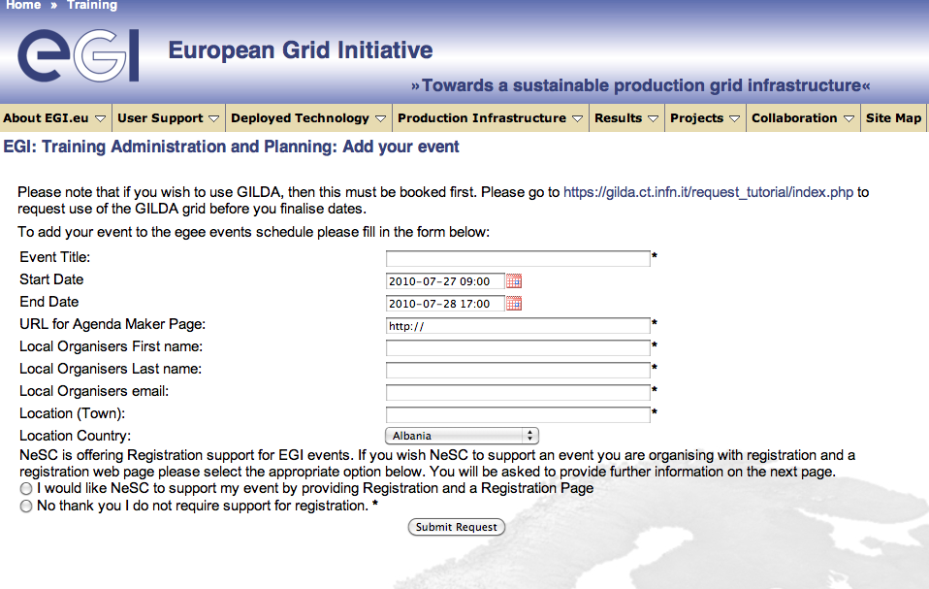

Figure 8. Event registration page for trainers.



Figure 9. List of training events in the event registry.

## Repository of training materials

This repository provides access to a digital library which holds all forms of training related materials. This acts as a resource allowing trainers to share, find and re-purpose materials. The content of the library can be reused by NGIs to run courses, all the files are under Creative Commons licence. The registry is accessible through the User Support section of the EGI.eu webpage [R2]. A screenshot of the digital library is shown in Figure 10. Further details on the repository is given in the MS302 EGI-InSPIRE milestone document [R3].

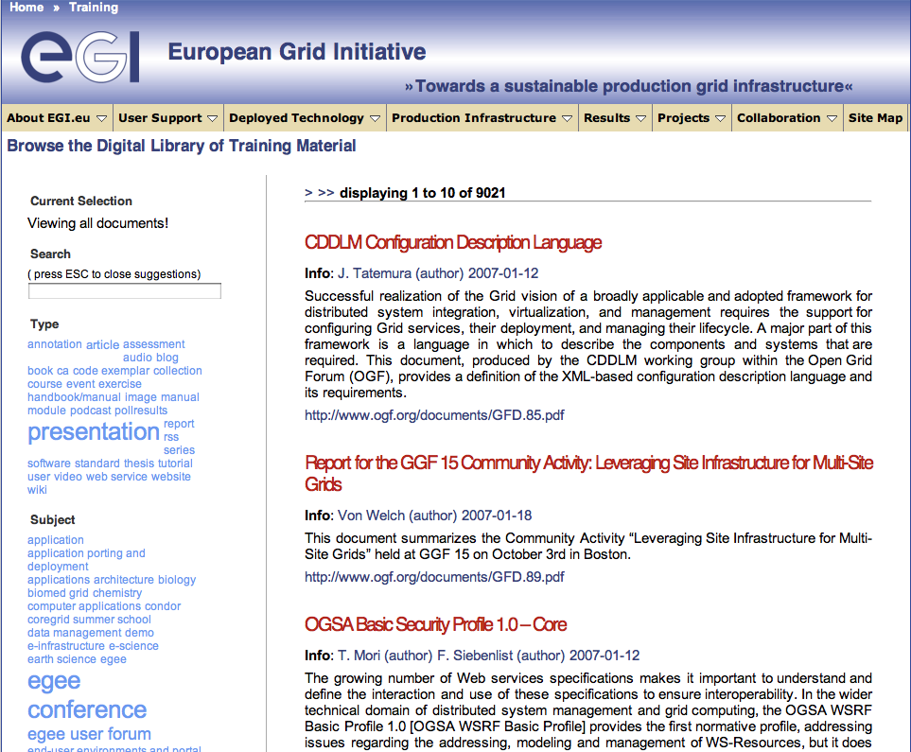

Figure 10. Library of training materials.

## Registry of trainers

This registry holds information about trainers across the EGI area. It allows trainers to register themselves and setup a profile which includes basic contact information and experience of various topics of grid computing and EGI. The purposes of the registry is to allow trainers to contact each other and solicit expertise to help support their training activities, help EGI.eu find trainers for events requested by users through their helpdesk, and allow clients of the infrastructure to identify experts in different countries or domains. A screenshot of the Web interface of the registry is shown in Figure 11. Further details on the registry is given in the MS302 EGI-InSPIRE milestone document [R3].

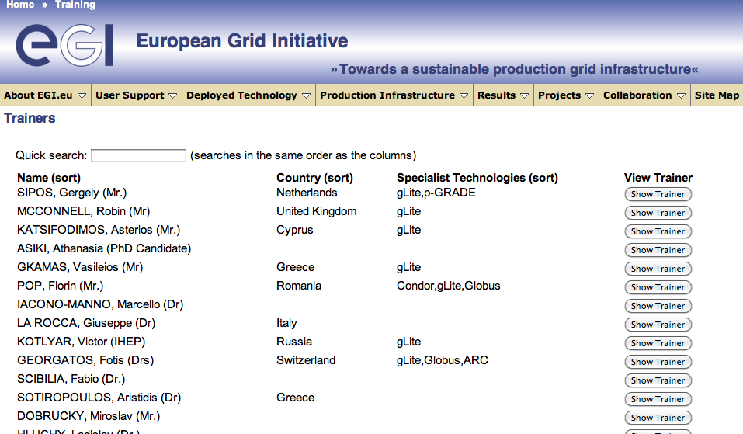

Figure 11. Registry of trainers.

## Application database

The EGI Applications Database (shortly called *AppDB*) [R15] is the descendant of the EGEE Applications Registry portal and it provides a catalogue of applications that have been ported, or are being ported, within the EGI infrastructure. As such it enables new communities to discover and reuse EGI applications, thus avoiding duplication of effort. By the reuse of ported applications one of the main barriers of grid adoption is eliminated.

People can search for applications in AppDB matching a pattern (such as scientific domain). The developers and scientific users of applications are also registered in AppDB and can be contacted for guidance on application usage or further developments. Currently, AppDB provides, among other information, the name, description, discipline and sub-discipline of applications, status, useful websites, abstract, scientific contact list, related publications and associated VOs. Moreover, besides scientific applications the AppDB also stores the so called “RESPECT tools” (Recommended External Software for EGI Communities), which are high level tools that provide useful functionalities for the development of grid applications. Furthermore, during the EGEE to EGI transition process, the concept of storing personal profiles for each individual application developer and researcher was introduced in AppDB, a feature that aims at simplifying the search for application developer experts who possess specialised knowledge. A screenshot of AppDB is shown in Figure 12.

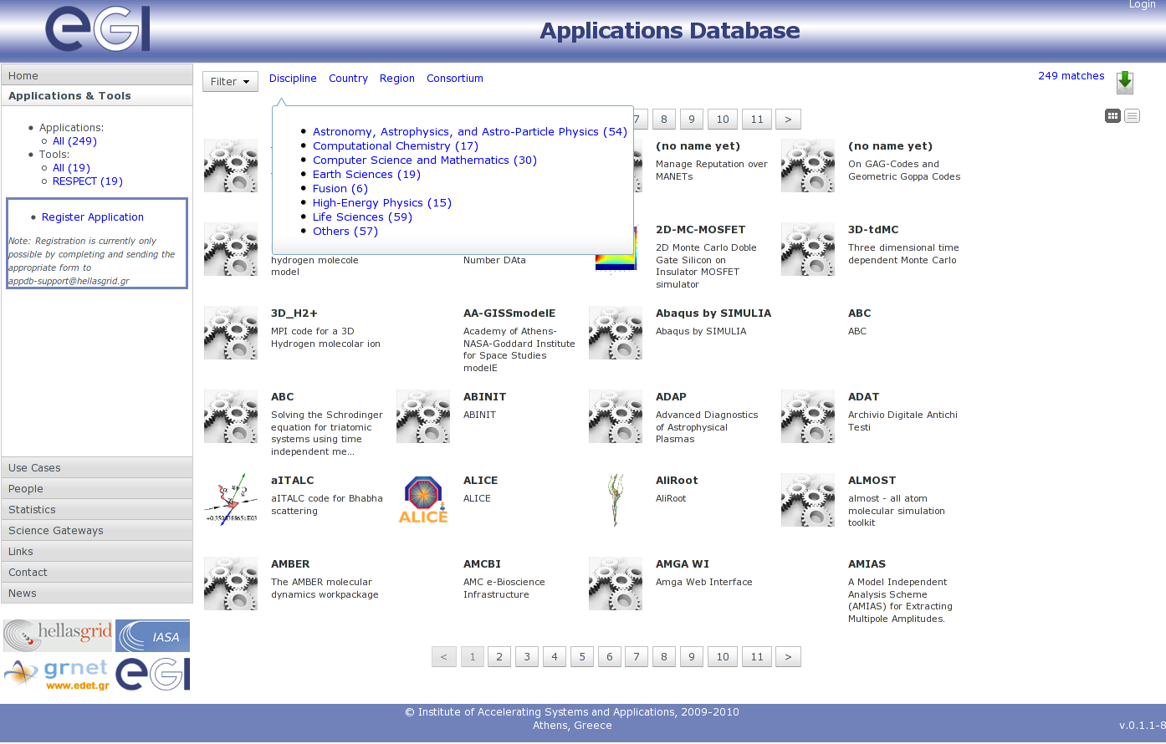

Figure 12. EGI Application Database

At the time of writing, the first release of the EGI Applications Database portal is in production, and it provides read-only access to the hosted applications and people data. The next step is provide write mode for application developers using the authentication mechanism of the EGI Single Sign On (SSO) system. The next release of the AppDB with this features is expected to be in production autumn 2010. Further details on AppDB is given in the MS303 EGI-InSPIRE milestone document [R4] and online [R15].

## CIC operation portal

Virtual Organisations are the physical representation of scientific collaborations at the grid infrastructure level. A VO on EGI consists of computing and storage sites, other types of distributed and grid services, and the people who are sharing and have access to these resources. New and expanding communities very often want to enable new VOs on the infrastructure in order to serve the needs of a new experiment, application or group. The CIC operation portal is a Web page which is available at [R6].

The CIC portal is used on one hand by representatives of scientific communities to register new VOs, and on the other hand by end users, who look for a VO that they can join to access particular services or applications on the grid.

UCSTs are expected to make the users aware of this service and train them on how to use it, how to search for VOs and how to interpret the information found about them.

The VOs that are registered on the CIC portal must be first approved before they appear publicly for users. This approval process is currently managed by the EGI.eu UCST, but the project will consider of delegating this tasks to VRCs.

## Dashboards and other services for VO monitoring and operation

The CIC Operations Portal allows the registration of new VOs on the infrastructure. To lower the barriers of the setup of new VOs, EGI also offers VOMS hosting for new VOs. VOMS hosting means that EGI can provide VOMS server for any new VO, given that the VO is multi-national or its host NGI cannot provide a VOMS server for it. Broadening the set of central services that EGI can offer for VOs (e.g. LFC, WMS, etc) could lower the barrier for VOs, resulting in a larger number of VOs and users on the infrastructure. At the time of writing (September 2010) the NA3 activity is performing an analysis of VO’s requirements, EGI’s resource to see what services and under what circumstances could be provided for VOs by EGI. This set can include services for VO setup (such as LFC, WMS), services for VO management, monitoring, operation (such as Dashboard, application-specific monitoring), and services for VO de-registration.

Through the processes that are described in Section 4 NA3 will ensure that the services evolve in such a manner as to meet the needs of new communities as they engage with the infrastructure.

## Web pages

In order to guarantee sufficient information flow between user support teams, and between user support teams and users, EGI operates two web pages that are dedicated for this purpose. One is the User Support section of the EGI.eu webpage [R2]. This is for the general public and introduces the concept and services of User Support in EGI, as well as serves as a directory from which other services can be accessed. At the time of writing, this public webpage provides a form where users can submit support requests using the GGUS ticketing system. The EGI.eu UCST is currently performing a usability inspection of this webpage in order to identify the content that would most satisfy the visitors’ needs.

The second webpage is the WP3 section of the EGI-InSPIRE Wiki [R7]. This can be accessed by members of the EGI-InSPIRE collaboration, using their personal SSO account name-password pairs. This page is used to keep the partners of the collaboration updated with the progress of the WP3 work package, as well as a scratchpad, where UCSTs can note web pages, useful resources, ideas and any other item that can foster the user support activity. NGI USTs are expected to continuously contribute to this Wiki site, so the EGI.eu UCST can exploit and integrate content from it into the overall support roadmap and activities.

## Email lists

Another important way of keeping partners up to date with the user support services and processes are the three WP3-related email lists operated by EGI.eu:

1. [inspire-na3@mailman.egi.eu](mailto:inspire-na3@mailman.egi.eu): has one subscriber from each of the NGIs that are involved in the User Support activity of EGI-InSPIRE. This list has been setup as part of the establishing confirmed user support contacts from NGIs (fully reported in the MS301 milestone document [R8]). Because the WP3 activity of EGI-InSPIRE does not include every NGI, and because user support is an essential service which assumed to exist in every NGI, the EGI.eu UCST aims to extend this list with user support contacts from every partner country, irrespectively if they are in WP3 of EGI-InSPIRE or not.
2. [inspire-na3-leaders@mailman.egi.eu](mailto:inspire-na3-leaders@mailman.egi.eu): the leaders of WP3 tasks (TNA3.1-TNA3.4) and the providers of technical services are subscribed on this list. The reason of having this list is that the providers of technical services as well as the coordinators of tasks must be more connected to each other as well as to EGI.eu, because their services are used by the whole community. Besides having an email list, the members of the list also have bi-weekly teleconferences chaired by the manager of WP3 from EGI.eu. The agendas and minutes of these meetings are available under the EGI Indico [R10].
3. [ucst@mailman.egi.eu](mailto:ucst@mailman.egi.eu): this list collects the members of the EGI.eu UCST. As this group coordinates the work of NGI UCSTs, easy accessibility of the group is required.

The activity-wide mailing list is used primarily to inform NGIs about developments and events that is everybody’s concern and to communicate strategies, mid and long term goals with partners. The taskleaders’ list is used to coordinate operational work, to manage daily operational processes. The EGI.eu UCST list serves the same purpose, but at an even lower level, inside the central support team in Amsterdam.

## Training infrastructure

The training infrastructure (t-Infrastructure) provides a pool of infrastructure sites and services that can be used by NGIs to deliver hands-on tutorials for users. This t-infrastructure is called GILDA and it physically resides as a VO on the EGI production infrastructure [R9]. Although the operation of this t‑infrastructure is not part of EGI-InSPIRE, this service proved to be valuable for trainers in EGEE and expected to be used by many of the NGIs in EGI. This is especially true since the GILDA infrastructure has been successfully used at summer schools with UNICORE and Globus middleware besides its regular gLite configuration.

As part of the EGEE-EGI transitioning the GILDA infrastructure has been integrated into the EGI production infrastructure as a normal VO. NGIs with sites in the production infrastructure can now support GILDA, making GILDA a more reliable enabler of training courses. The GILDA VO operates its training Certification Authority, which can issue short term, but reusable certificates for trainers and trainees who wants to use GILDA for grid courses.

# Appendix B – Procedure for Virtual Research Community accreditation in EGI

The following steps provide detailed information on the VRC accreditation process for EGI. Within EGI the model for scalable user support is the Virtual Research Community (VRC). This model will serve both large and small communities by offering structured research communities a sustainable mechanism with which to interact with EGI. This will allow the VRC to access EGI services and provide a point through which EGI can gather objectives and requirements from a defined set of users. The following section defines the purpose and benefits of the VRC as well as an accreditation process which involves a set of evaluation criteria for examining potential new VRCs to determine whether EGI should formally recognise them as appropriate and effective representatives of a given research community. Once this initial process is complete and contact points have been established more detailed discussions will take place to establish the technical and contractual agreements.

## Procedure

All communication should be through the Chief Community Officer (CCO) [cco@egi.eu](mailto:cco@egi.eu) with an email subject of "Request for new VRC called [your_VRC]"

## Step 0: Before submitting a request for a new VRC

Please check the current list of active Virtual Research Communities [R14]. This is accessible from the User Support section of the EGI website. This list also enumerates the the currently active Virtual Organisations (VOs) together with the VRC to which they are associated if applicable. The following questions can then be asked:

* Is there an existing VRC that could meet the needs of all or part of the proposed community? The scope of the proposed VRC should not overlap to any significant degree with any existing VRC;
* Are there existing VOs whose needs could be met by the proposed community? These may or may not already be part of an existing VRC;

## Step 1: Initial request

The VRC proposal must demonstrate that it represents a community of researchers that has an established existence outside of the VRC, i.e. that it has structure (such as an ESFRI project, EIROFORUM laboratory, national research structure, professional organisation or affiliation, etc.) and that this body represents this particular community. This community must also show that it has an established governance model and open mechanisms for new participants to enter (or leave) the organisation, and that all members of this organisation will have access to all the services offered by the VRC, i.e. beyond those who are just part of the proposal. These conditions enable EGI.eu to recognise the VRC as being the ‘voice’ of a particular community of users within the infrastructure. EGI can provide help and advice on suggested best practices for such organisational models if needed.

The proposal should also describe how the VRC organisational structure will become sustainable over time. For example will it adopt a formal legal structure or will it rely on committed services from a few dominant partner organisations in the field. There is no right or wrong answer as long as the potential for persistence can be demonstrated. The proposed VRC should respond to the following points:

1. Which ESFRI Roadmap projects (if any) are affiliated to the proposed VRC?
2. How would your community structure and organise itself in order to present a unified view as a VRC?
3. Which NGIs/EIROs endorse the proposed VRC by committing to provide access to resources (compute/data), VO services (e.g. VO monitoring frameworks through dashboards, VOMS for VO membership registration etc.) and generic user support services (e.g. application porting, training, etc.)?
4. How will the proposed VRC have the ability, capability and commitment to provide domain-specific support including training, dissemination and general community coordination activities?
5. How will the proposed VRC work with EGI to collect and prioritise requirements from within the communities they represent?
6. Any required interactions with resource providers outside of Europe should also be noted in terms of requirements and opportunities.

The application should also include the following information:

* A succinct description of the scope of the proposed VRC in terms of research discipline and the NGIs (if any) that are supporting the proposal.
* Details of the named representatives of the proposed VRC (together with a current email address and telephone number):
  + Coordinator: providing strategic and managerial input on the VRC’s activity to the CCO and Director of EGI.eu;
  + Technical contact: representing the VRC within EGI on the User Community Board (UCB) and possibly on other groups within EGI (e.g. User Support Advisory Group);
  + Policy contact: providing input and feedback on the non-technical policies (e.g. security and usage) being developed by EGI;
  + Dissemination contact: providing a bi-directional contact point between the EGI Dissemination Manager (and their staff) and the VRC relating to dissemination activities
  + Training contact: providing requirements to evolve the training services (i.e. digital library, registry of trainers, training calendar) and as contact point for training needs and services within their community;
  + User Support contact: route for integrating community-based support units with the associated Support Unit in EGI;
  + Security contact: communication point for liaising with the EGI’s Computer Security and Incident Response Team (CSIRT) for issues relating to activities of the VRC’s users;
  + Operations contact: the communication point for any VRC-specific services needed by the VRC;

These contact points may be the same person. These representatives (or additional people) may be invited to participate in other EGI bodies depending on the interests of the VRC.

* A justified estimation of the size of the VRC at a European level in terms of users, Virtual Organisations (VOs) and services and resources (compute & data) that already exist within the VRC and which are or could be integrated with the EGI infrastructure[3];
* A summary of the applications that the proposed VRC would need together with information about who would support these applications.

Note:

1. The VRCs must agree to name a technical representative (with deputy) for the EGI User Community Board;
2. The VRC may be asked to nominate a representative for EGI-InSPIRE’s External Advisory Committee;
3. The VRC may be asked to nominate representatives to serve on other advisory groups as appropriate; The VRC will accept and enforce EGI’s acceptable use and security policies;
4. The VRC’s named dissemination contact will work with EGI’s dissemination team to share and coordinate dissemination activities and materials;
5. The VRC’s named training and user support contact will work with the EGI User Community Support Team to integrate services;

## Step 2: Approval

VRC proposals are reviewed and approved by the EGI User Community Board. This process may take up to a month.

## Step 3: Response

Within one month of submission, a letter confirming or rejecting support for the proposed VRC will be provided to the requestor by EGI.eu. After this, the process of creating the VRC and aligning its associated VOs within the infrastructure will commence.

## Step 4: Memorandum of Understanding

The relationship between EGI and the VRC must be captured within an agreement that documents the bi-directional expectations between EGI (as a representative of the service providers) and the VRC (as a representative of the community).

# References

|  |  |
| --- | --- |
| R 1 | EGI blueprint:  <http://web.eu-egi.eu/documents/other/egi-blueprint> |
| R 2 | User Support section of the EGI.eu webpage:  <http://www.egi.eu/user-support/> |
| R 3 | MS302 Milestone document (Training Website):  <https://documents.egi.eu/document/104> |
| R 4 | MS303 Milestone document (Ported Applications Website): <https://documents.egi.eu/document/92> |
| R 5 | GGUS system Web interface:  [www.ggus.org](http://www.ggus.org) |
| R 6 | CIC Operations Portal:  <http://cic.gridops.org/> |
| R 7 | WP3 section of the EGI-InSPIRE Wiki:  <https://wiki.egi.eu/wiki/EGI-InSPIRE:Main_Page#WP3:_User_Community_Coordination> |
| R 8 | MS301 Milestone document (User Support Contacts): <https://documents.egi.eu/document/60> |
| R 9 | GILDA Training VO:  <https://gilda.ct.infn.it/> |
| R 10 | Fortnightly NA3 task leaders meetings (agendas, minutes): <https://www.egi.eu/indico/categoryDisplay.py?categId=10> |
| R 11 | MS601 HUC Contact points and support model:  <https://documents.egi.eu/document/91> |
| R 12 | User Community Board: <http://www.egi.eu/policy/internal/User_Community_Board_UCB.html> |
| R 13 | User Services Advisory Group: <http://www.egi.eu/policy/internal/User_Services_Advisory_Group_USAG.html> |
| R 14 | Virtual Research Communities of EGI:  <http://www.egi.eu/user-support/user_communities/> |
| R 15 | EGI Application Database: <http://appdb.egi.eu/> |

1. ESFRI: European Strategy Forum on Research Infrastructures, <http://ec.europa.eu/research/esfri/>
2. Important sentences, paragraphs of the document are typeset in italic.
3. Integrating existing VRC services into the EGI infrastructure does not mean that they will be freely available to all but rather they will be accessible to the VRC across the broader infrastructure.