**EGI-InSPIRE**

User Community Support Process

**EU DELIVERABLE: D3.3**

|  |  |
| --- | --- |
| Document identifier: | **EGI-doc-661-v3** |
| Date: | 19/08/2011 |
| Activity: | **NA3** |
| Lead Partner: | **EGI.eu** |
| Document Status: | **Version 3** |
| Dissemination Level: | **PUBLIC** |
| Document Link: | https://documents.egi.eu/document/661 |

|  |
| --- |
| Abstract  The document aims to serve as an important asset for potential users of the European Grid Infrastructure to understand the scope and level of support that they can expect from EGI. This also constitutes a handbook for NGIs that wish to provide support services for users and that would like to join their national efforts to the complex landscape of EGI user support mechanisms. |

Copyright notice

Copyright © Members of the EGI-InSPIRE Collaboration, 2010. See www.egi.eu for details of the EGI-InSPIRE project and the collaboration. EGI-InSPIRE (“European Grid Infrastructure: Integrated Sustainable Pan-European Infrastructure for Researchers in Europe”) is a project co-funded by the European Commission as an Integrated Infrastructure Initiative within the 7th Framework Programme. EGI-InSPIRE began in May 2010 and will run for 4 years. This work is licensed under the Creative Commons Attribution-Noncommercial 3.0 License. To view a copy of this license, visit http://creativecommons.org/licenses/by-nc/3.0/ or send a letter to Creative Commons, 171 Second Street, Suite 300, San Francisco, California, 94105, and USA. The work must be attributed by attaching the following reference to the copied elements: “Copyright © Members of the EGI-InSPIRE Collaboration, 2010. See www.egi.eu for details of the EGI-InSPIRE project and the collaboration”. Using this document in a way and/or for purposes not foreseen in the license, requires the prior written permission of the copyright holders. The information contained in this document represents the views of the copyright holders as of the date such views are published.

1. Delivery Slip

|  |  |  |  |
| --- | --- | --- | --- |
|  | **Name** | **Partner/Activity** | **Date** |
| **From** | Richard McLennan/NA3 | EGI.eu/NA3 | 21/07/2011 |
| **Reviewed by** | **Moderator:** Sy Holsinger  **Reviewers:** John Kewley  Pekka Lehtovuori/Kimmo Mattila | NA2.3  UK NGI  SA1, SA3, NA3 | 19/08/2011 |
| **Approved by** | **AMB & PMB** |  | xx/xx/2011 |

1. Document Log

|  |  |  |  |
| --- | --- | --- | --- |
| **Issue** | **Date** | **Comment** | **Author/Partner** |
| 1 | 21/07/2011 | Revision – Version 1 for distribution to NA3 | R McLennan/EGI.eu |
| 2 | 28/07/2011 | Revision – Version 2 | R McLennan/EGI.eu |
| 3 | 19/08/2011 | External Review – Version 3 | R McLennan/EGI.eu |
| 4 | xx/xx/2011 | AMB Review |  |
|  |  |  |  |
|  |  |  |  |
|  |  |  |  |

1. Application area

This document is a formal deliverable for the European Commission, applicable to all members of the EGI-InSPIRE project, beneficiaries and Joint Research Unit members, as well as its collaborating projects.

1. Document amendment procedure

Amendments, comments and suggestions should be sent to the authors. The procedures documented in the EGI-InSPIRE “Document Management Procedure” will be followed:  
<https://wiki.egi.eu/wiki/Procedures>

1. Terminology

A complete project glossary is provided at the following page: <http://www.egi.eu/about/glossary/>.

Acronyms and terminologies frequently used throughout the document:

| ***Acronym, terminology*** | ***Description*** |
| --- | --- |
| **NA3** | Networking Activity 3 is the User Community Coordination activity. Details are covered in the EGI-InSPIRE project Description of Work as |
| **NGI UST – NGI User Support Team** | A group of support persons whose primary focus is on the support of users within their country, within their own NGI. Their other goal is to integrate these support activities, through the coordination work of EGI.eu, with the effort of other NGI USTs in order to serve the multi-national user communities at large. |
| **UCST (or EGI.eu UCST)** | A central group at EGI.eu in Amsterdam which coordinates the work of NGI USTs. Their primary focus is on capturing the requirements of large, multi-national user communities and ensuring that these communities become self-sustainable user communities of EGI. |
| **Heavy User Communities (HUCs)** | User communities that are advanced and experienced in terms of grid usage, operate (at least to some extent) support services for their own members and therefore are less dependent on EGI user support services. |
| **Self-sustainable user communities** | User communities that are capable of porting new applications to the EGI infrastructure, of customising the infrastructure according to their members’ needs and of expanding their user base without depending on user support services of EGI. |
| **Virtual Organisations (VOs)** | A VO is a collection of sites and/or users within the infrastructure that come together into a collaboration to achieve a common research goal (e.g. to perform a simulation, to run an application, analyse results, etc). |
| **Virtual Research Communities (VRCs)** | Groups of researchers, typically residing in more than one country, working together effectively through the use of information and communications technology (ICT). These are true research communities that operate as fully established organisations with an effective coordination model that can articulate and prioritise requirements and other needs. |
| **Technical services** | Software-based services that are common to many of the user support processes within the NGIs and within the user communities. Such services are implemented and provided centrally for the community whenever possible and appropriate. |
| **Shared services** | Software services common to many of the Heavy User Communities. Some of these services are operated centrally, others have multiple local installations. These services are used primarily by experienced grid user communities. |

1. PROJECT SUMMARY

To support science and innovation, a lasting operational model for e-Science is needed − both for coordinating the infrastructure and for delivering integrated services that cross national borders.

The EGI-InSPIRE project will support the transition from a project-based system to a sustainable pan-European e-Infrastructure, by supporting ‘grids’ of High-Performance Computing (HPC) and High-Throughput Computing (HTC) resources. EGI-InSPIRE will also be ideally placed to integrate new Distributed Computing Infrastructures (DCIs) such as clouds, supercomputing networks and desktop grids, to benefit user communities within the European Research Area.

EGI-InSPIRE will collect user requirements and provide support for the current and potential new user communities, for example within the ESFRI projects[1]. Additional support will also be given to the current heavy users of the infrastructure, such as high energy physics, computational chemistry and life sciences, as they move their critical services and tools from a centralised support model to one driven by their own individual communities.

The objectives of the project are:

1. The continued operation and expansion of today’s production infrastructure by transitioning to a governance model and operational infrastructure that can be increasingly sustained outside of specific project funding.
2. The continued support of researchers within Europe and their international collaborators that are using the current production infrastructure.
3. The support for current heavy users of the infrastructure in earth science, astronomy and astrophysics, fusion, computational chemistry and materials science technology, life sciences and high energy physics, as they move to sustainable support models for their own communities.
4. Build interfaces that expand access to new user communities including new potential heavy users of the infrastructure from the ESFRI projects.
5. Develop mechanisms to integrate existing infrastructure providers in Europe and around the world into the production infrastructure, so as to provide transparent access to all authorised users.
6. Establish processes and procedures to allow the integration of new DCI technologies (e.g. clouds, volunteer desktop grids) and heterogeneous resources (e.g. HTC and HPC) into a seamless production infrastructure as they mature and demonstrate value to the EGI community.

The EGI community is a federation of independent national and community resource providers, whose resources support specific research communities and international collaborators both within Europe and worldwide. EGI.eu, coordinator of EGI-InSPIRE, brings together partner institutions established within the community to provide a set of essential human and technical services that enable secure integrated access to distributed resources on behalf of the community.

The production infrastructure supports Virtual Research Communities (VRCs) − structured international user communities − that are grouped into specific research domains. VRCs are formally represented within EGI at both a technical and strategic level.

1. EXECUTIVE SUMMARY

This document describes the user community support process within the European Grid Infrastructure (EGI) and how it is implemented and delivered by the EGI stakeholders, particularly by the partners involved in the work package NA3 (User Community Coordination Activity) of the EGI-InSPIRE project. The purpose of this document is to capture the various aspects of user support following a top-down analysis. The analysis starts with the identification of users who are expected to request support from EGI.eu, then followed by the specification of user support mechanisms and how these mechanisms are implemented by EGI and EGI‑InSPIRE stakeholders. The document aims to serve as an important asset for potential users of EGI, who can understand from this material the scope and level of support that they can expect from EGI. The document is also aimed to be used as a handbook by NGIs who wish to provide support services for users and would like to join their national efforts with the complex landscape of EGI user support mechanisms. Though this document will be formally reviewed and re-issued every twelve months during the course of the project, it will continue as a living document to allow a continual process of community comment and feedback. This update of the document reflects work completed in the run-up to the first Technical Review (conducted by the EC’s appointed reviewers on 30 June/1 July 2011). As a consequence, there are a number of emerging recommendations from that review that could not be included at this stage but will be incorporated in the next iteration of the Deliverable. This document is the updated version of D3.1 [R12]. It will be formally updated as D3.5 and D3.7 in project months 27 and 39.

Table of contents

1 INTRODUCTION 9

2 USER support 10

2.1 User Support in EGI and EGI-InSPIRE 10

2.2 Overview of the User Support Process 12

2.3 User support services within the EGI ecosystem 15

2.4 Providers of EGI User Support services 18

3 TEChnical services FOR User support 20

4 Shared Services for Heavy User Communities 22

5 Managing user support 23

5.1 Technology Coordination Board (TCB) 24

5.2 User Community Board (UCB) and User Services Advisory Group (USAG) 24

6 new Community Integration: Virtual Research Communities 26

6.1 Definition of VRC 26

6.2 The benefits of VRC membership 27

6.3 Registering a new VRC 28

6.4 New communities 29

7 support activities in EGI-INSPIRE 30

8 conclusion and steps for the future 31

9 References 33

10 Appendix A – description of Technical services for user support 35

10.1 EGI helpdesk 35

10.2 Requirements Tracker (RT) 36

10.3 Training Marketplace 37

10.4 Application database 39

10.5 EGI Operations Portal 40

10.6 Web pages 41

10.7 Email lists 42

Table of figures

Figure 1. Communication flow is two way, multi-tiered and takes place between a wide range of users and support providers 11

Figure 2. EGI User Support helps research communities become confident grid users and develop into self-sustainable grid user communities. 11

Figure 3. EGI Learning Cycle for Self Improvement 14

Figure 4. Continual service improvement lies at the heart of ITIL 15

Figure 5. EGI Collaboration - Provision of EGI User Support Service 18

Figure 6. Portfolio of support services provided by NGI User Support Teams. 20

Figure 7. Technical services facilitate the work of NGI User Support Teams 21

Figure 8. Processing EGI Requirements through to the implementation of solutions 23

Figure 9. MoUs in the EGI Ecosystem – Relative Status for July 2011 26

Figure 10. Integration of Virtual Research Communities with EGI 27

Figure A1. Schematic view of the architecture of the GGUS helpdesk system 35

Figure A2. EGI Request Tracker (RT) – Creating a new Requirement 36

Figure A3. The Training Marketplace home page (version 2) 38

Figure A4. The events map view of the Training Marketplace 38

Figure A5. The EGI Applications Database (AppDB) which is accessed via the EGI website. 39

Figure A6. Central Operations Portal – Existing VO description page. 40

Figure A7. Central Operations Portal – VO registration 41

Figure A8. EGI UCST Web site – User services. 42

# INTRODUCTION

A principal goal of EGI.eu is to provide significant added value for existing and new user communities. Growing user demands have provided, and will continue to provide, the necessary push for development and extension of the grid infrastructure. Therefore, the active support for these communities is a primary concern for the EGI ecosystem as the users are the *raison d’être* of the grid.

The core process within the User Support function is that of continual self-improvement - to date this has been based on a continuous cycle that incorporates three elements: ‘Discover’, ‘Design’ and ‘Deliver’. The effects achieved by EGI User Support activities are continuously monitored (metrics reported separately in MS307 [R9]) and the emerging areas for improvement (evaluations are documented in EGI Quarterly and Periodic reports [R10][R11]) have been acted upon throughout the year. All User Services have undergone comprehensive revisions over the year, in some cases to the point of a fundamental redesign and reissue (e.g. the Training Marketplace).

Most significantly, there has been a gradually accelerating impetus to explore the ITIL®[2] philosophy and where appropriate and relevant, to embrace some of the Model’s functions and processes. This is seen as an important development for EGI as a whole as the adoption of ITIL methodology does not only bring ‘best practices’ to the forum, but also marks the start of a ‘common standard’ with a common set of professional terms, functions and processes that can be understood and shared with support teams across all NGIs.

# USER support

## User Support in EGI and EGI-InSPIRE

User support activities of EGI must define, implement and operate services and tools that enable existing and new users to access and use infrastructure services, and to develop themselves into self-sustainable grid communities. Self-sustainable communities are capable of some or all of the following: porting new applications to the infrastructure, extending the infrastructure according to their members’ needs and expanding their user base without depending (heavily) on user support services of the EGI.eu organisation and of NGIs. Self-sustainability of user communities guarantees permanent usage of the grid infrastructure, continuous flow of scientific results from applications, and as an overall result, a European-wide interest in sustaining the EGI collaboration.

EGI-InSPIRE is a four-year project that lays down the EGI operational and support processes and defines a framework for EGI, which are to be sustainable and independent from project cycles. An important part of this work is establishing support for the existing Heavy User Community and for the emerging user communities of the European Grid Infrastructure. The latter work focuses on ESFRI international research collaborations of the European Commission, on Virtual Research Communities (VRCs) and also on less structured and smaller research groups, teams and collaborations. Partners within the EGI-InSPIRE project, specifically within NA3 (User Community Coordination) and SA3 (Services for Heavy User Communities), are the key stakeholders for defining and providing user support processes in EGI.

The pool of potential beneficiaries of EGI’s resources is huge: both European researchers and non-European researchers who collaborate with European colleagues can use the services and resources of the European Grid infrastructure. EGI is attracting research communities of different sizes, backgrounds and scopes. For this reason, the user support activities within EGI-InSPIRE must act as a bridge that allows heterogeneous communities to reach infrastructure services and then become confident and sustainable users of these services (See Figure 1). The bridge assures that people who make contact with EGI, perhaps through its dissemination activity, reading the EGI newsletters, being present at EGI related events, visiting the EGI Web page, etc. are continuously supported up to the point when they are confident users of the infrastructure and are members of self-sustainable grid user communities. Figure 1a attempts to demonstrate how effective communication lies at the heart of any support system and for a multi-tiered organisation such as that embraced by the EGI ecosystem - communication flows occur at many levels, in a multitude of directions and these need to cater for numerous outcomes. On the one hand the term ‘User’ has to embrace individuals ranging from scientific researchers through to application developers and organisational clusters from Virtual Organisations (VOs) to VRCs and NGIs. On the other, there are various elements of the support activity that need to be addressed by national and specialist support services, a number of NGIs working together or ultimately through EGI in an overarching coordination role.

**NA3**



Different user types collaborate within a research group

Research leader

Researchers and scientists

Application

developers

Local System administrators

VRC with many research groups (and one VRC representative)

**Research group**

**User Community Support team**

**of EGI.eu**

**VRCs** communicate with EGI through the **User Community Board**



EGI dissemination

**EGI User Community**

**Support Services**

**Application Database, Training Marketplace, VO Services, Requirements Tracker**

**National and specialist support & services**

**NGI User Support coordination**

**Support teams available across 50 NGIs**

Figure 1. Communication flow is two way, multi-tiered and takes place between a wide range of users and support providers

As part of the service provisioning process, EGI user support must capture new requirements, usage incidents, feedback, experiences, success stories and failures from the users. This information is stored and analysed and fed back to the project, where the various activities can use this information and knowledge to improve their services, operations and to improve their future impact (Figure 2).

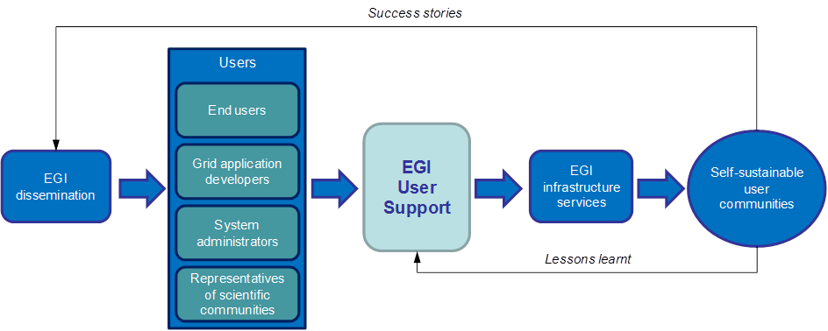

Figure 2. EGI User Support helps research communities become   
confident grid users and develop into self-sustainable grid user communities.

User Support in EGI provides information and assistance for users to access, use, operate, customise or extend the services of the grid infrastructure. In order to define what services EGI User Support should provide, we must know what services users need to be able to establish confident and autonomous communities on the infrastructure. Based on the experiences of EGEE and other large e-Infrastructure projects, EGI User Support should be prepared to serve the following four types of users (See **Table 1**.). These four user categories represent the ‘clients’ of EGI User Support.

|  |  |
| --- | --- |
| **User category** | **User characteristics** |
| **End users (scientists/researchers)** | Would like to gain new scientific results by using established EGI applications, or by porting new scientific applications to the European Grid Infrastructure. These persons may not know grids or other types of distributed computing infrastructures, and may not have computing backgrounds. |
| **Grid application developers (supporters of end users)** | Work together with scientific groups/communities and help them achieve “better science” by the usage of distributed computing infrastructures. Such users typically want to grid-enable scientific applications on EGI, and/or want to develop visualisation or access services (such as portals) to simplify the usage of grid-enabled applications. |
| **System administrators (supporters of end users and grid application developers)** | Want to operate core grid infrastructure services and high-level grid application services for the previous two types of users. Administrators are often experienced with management of distributed systems, but not necessarily of grid systems, and especially not of the software services used in EGI. |
| **Representatives/Leaders of scientific communities** | Look for strategic collaboration with EGI on behalf of (large) scientific communities. They want to understand how the high level goals of the communities they represent could be met by using the tools, services and resources of the European Grid Infrastructure. Often they are not technical persons and do not have computing background. |

**Table 1. Categorisation of users – clients of EGI User Support**

Whilst the main focus of EGI is on sustainable operation through the establishment of self-sustainable user communities, it is also expected that some of the EGI users – especially some of the scientific end-users – will not see the establishment of self-sustainable communities as their primary goal. The primary goal of most communities is to use and benefit from the grid infrastructure over a relatively short period of time (e.g. to perform a calculation using larger data sets or finer data granularity). While these users will not join or will not establish self-sustainable communities, EGI and especially the user support services of EGI must serve these users too, because the impact they can make within their scientific domains (through results and publications achieved with EGI) can catalyse interest to self-sustainable grid user groups within these domains.

## Overview of the User Support Process

Under the EGI federated model, user support is primarily delivered by support teams associated with the NGIs. In addition to this support, research communities, both large and small, often provide support to their users, particularly so in the area of specialist help. The purpose of the EGI.eu User Community Support Team (UCST) is to help coordinate all of these efforts in order that their effectiveness can be maximised. This coordination and high-level support is as much concerned with communication as the technical services that can be consumed and re-used by the NGIs and VRCs for their own communities. In this way, EGI.eu support can be considered as business-to-business (B2B) operation. Whilst UCST does give help to individuals, this is not the primary goal of the team.

The primary goal of the UCST at EGI.eu, which underpins the justification for all of the activities described in this document, is the continual improvement of EGI’s user facing services. Therefore, the key process for user support defines the activities and actions that must take place to achieve this. The Description of Work describes this process as “the integration of the user communities’ current and future use of the infrastructure”. In other words, not only must we make the infrastructure easier to use, but also the path to this goal must be smooth.

The processes involved in this overarching goal are mapped out in Table 2. The fact that we are both delivering and evolving is indicated by the overarching banners of ‘provisioning’ and ‘planning’.

|  |  |  |  |
| --- | --- | --- | --- |
|  | **Planning** | | |
| Provisioning | | |
| **Process** | **Objective** | **Activities** |
| Reactive | Process user support tickets from the EGI help desk | Resolve all user and community-related tickets effectively and efficiently | Process all user-related tickets, monitor efficiency of help desk, improve process |
| Monitor grid access enquiries and simplify process | Make the infrastructure easy to access (both for new and existing users) | Ensure requests for access to the infrastructure are answered; improve new user processes |
| Proactive | Capture and analyse requirements | Ensure continual improvement to EGI user services and user experience | Promote, provide & maintain requirements system; process requirements to resolution |
| Coordinate VRC activity | Ensure that communities of all sizes are supported across the infrastructure | Identify and motivate communities to become VRCs; support and nurture VRCs |
| Coordinate NGI support team contributions to EGI | Coordinate NGI support teams’ integration with EGI in supporting users | Maintain effective communication with NGI support teams; share opportunities & news |
| Provide applications and tools information | Provide comprehensive information about grid-enabled applications for users | Provide & promote an efficient application database to support users & developers |
| Provide training information | Maximise the availability and impact of training across the EGI community | Coordinate supply and demand for training by NGIs through the Training Marketplace |
| Provide VO services | Ensure that VO managers and VRC representatives can manage their VOs | Provide and support tools for the efficient management of VOs across sites and NGIs |
| Improve documentation availability | Ensure and improve the quality of documentation available to EGI users | Evaluate documentation-related requests, identify gaps, report omissions to partners |

Table 2. User Community Support – map of processes

Throughout the first year of the project, all of these processes have been running successfully with a good degree of coordination and evaluation. Thus far, this learning cycle has been described using the Discover, Design and Deliver philosophy (Figure 3 below) for all of the user-facing services in question, be they human, technical or infrastructure based.



Figure 3. EGI Learning Cycle for Self Improvement

This approach has worked well and has enabled the development of the technical support services – Applications Database, Training Marketplace and VO services – to establish a firm footing and also for the communication channels needed for efficient coordination to emerge. The process has been reinforced through the establishment of solid interactions with all of the other work packages within the project. The next phase of this process is to reinforce and formalise the integration of this cyclical learning process across all of the user-facing and therefore user-supporting areas of EGI. One method for achieving this is to look to the Information Technology Infrastructure Library (ITIL). ITIL is a widely used and successful framework for IT service management that has been in use for twenty years and is now in its third version. Work has already started through the recognition that many core ITIL functions can be mapped to EGI.eu functions. Staff training in the concepts of ITIL will further embed the philosophy and encourage the adoption of common standards, practices and processes, which can more readily be shared across EGI and its federated NGIs. This will be progressed further over the next year in conjunction with other work packages and the UCS processes will evolve accordingly. (Note that an MoU between EGI.eu and gSLM was also formalised in July 2011.) The advantage of using this approach for the identification, planning, delivery and support of all of the elements of the infrastructure is that it transforms all aspects of the infrastructure into user-focused services. User support is not a process added at the end of the engineering activity, it is the overarching philosophy.

A natural progression from the existing Discover, Design and Deliver cycle that is currently in place for user support services, the ITIL model comprises the following five elements: Service strategy, Service design, Service transition, Service operation and, Continual service improvement.

As we move towards a more comprehensive, integrated user-focused, service-oriented approach, this continual service improvement process (Figure 4) will be applied to all of the existing processes including the requirements gathering process itself.

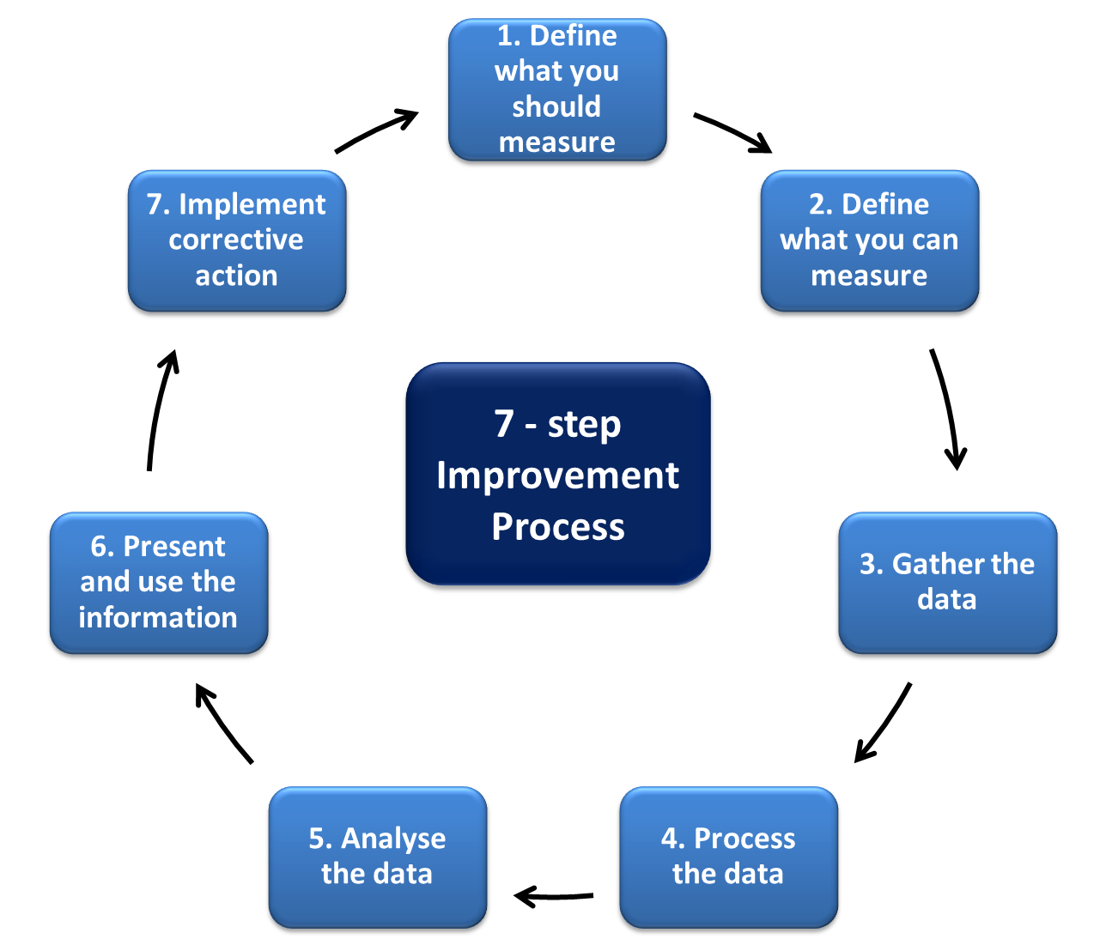

Figure 4. Continual service improvement lies at the heart of ITIL

and also the current EGI User Community Support process.

## User support services within the EGI ecosystem

EGI and its support teams must be prepared for different sized user communities. These may range from the individual scientist and small international research collaborations to large internationally funded research labs and research projects. Because these users have very different goals, expectations and requirements regarding grid usage, the services provided by EGI user support are flexible and adaptable for various needs. Furthermore, sufficient procedures have been established to monitor and modify these services as new requirements arise.

EGI provides a rich set of software and human services that can be accessed and exploited in various different ways. Furthermore, new components, emerging technologies, innovative methods of service integration and service access will continuously broaden the possibilities for users. Because the uptake of grid infrastructure services by a particular individual or by a particular community depends on various factors (background of the individual/community, goals of the individual/community, etc.) a single support path that this individual/community can follow to become a self-sustainable user cannot be defined in advance. Each community and each type of user requires slightly different services to others; equally, each community and each type of user will want to use services in different ways and with differing purposes compared to others.

Wherever possible, EGI User Support services should be customisable. Earlier experiences of e‑Infrastructure support projects show that the previously described four categories of users can be successfully served by a core portfolio of customisable services. This portfolio – described in Table 3 beneath – provides a set of services that EGI User Support can offer to its clients, to any individual or to any user community who would like to benefit from the Infrastructure and/or want to develop or join a self-sustainable grid community.

|  |  |  |
| --- | --- | --- |
| **Service** | **Description of service** | **Potential beneficiaries** |
| **Consultancy** | After the initial contact is made with users and communities, EGI User Community Support assesses the users’ needs. Once an assessment is made the most appropriate services from the service portfolio can be advised and can be provided. | * Every user |
| **Training** | EGI User Community Support provides the means by which organisations and trainers can promote training events courses and secondly, for users in the NGIs and beyond to identify training events being provided by other users of the grid that may be relevant to their own individual or collective needs. | * End users * Developers of grid applications (applications that interact with grid middleware services) * Grid system administrators |
| **Porting scientific applications** | Scientific communities benefit from EGI by enabling their own applications on the middleware. This process is called application porting (or grid-enabling) and requires technical knowledge of the grid infrastructure, the middleware and developer environments. EGI User Community Support can identify the NGI User Support teams best able to help new scientific applications in the infrastructure. Application developer tools from the EGI Applications Database can simplify the process. | * End users * Developers of grid applications |
| **Accessing scientific applications** | EGI’s User Community Support fosters the reuse of already grid-enabled scientific applications by documenting, promoting and sharing existing applications with user communities by publishing key details of these through the EGI Applications Database. | * Members of established communities (High energy physics, life sciences, etc.) * Members of new, emerging user communities of EGI |
| **Virtual Research Community (VRC) and Virtual Organisation (VO) support** | EGI User Community Support enables the setup, registration and deregistration of VRCs and VOs, the allocation of resources to such organisations, and the installation and operation of dashboards that enable monitoring and reporting of community service usage. | * Emerging communities * Established user communities with new applications and expanding user base |
| **Development of new software services** | EGI User Community Support will facilitate the reuse of community specific services across disciplines, and provides help for communities to develop and integrate new types of services into the infrastructure. | * Scientific end users * Grid application developers |
| **New Requirements** | EGI User Community Support gathers and forwards requirements and feedback from users to the developers and operators of the infrastructure. This process assures that the infrastructure development roadmap is in line with the users’ expectations. | * Every user |
| **Documentation** | EGI User Community Support strives to ensure that the documentation being presented to users is complete and matches their experiences when they use the infrastructure or operate any infrastructure component. | * Grid application developers * Scientific end users (on grid applications) * For system administrators (on installation and operation of software services) |
| **Helpdesk** | EGI User Community Support operates a helpdesk service where users can report day-to-day hardware, software and configuration incidents affecting the infrastructure, and where they can request support services. | * Every user |
| **Requirement tracking** | EGI User Community Support operates a requirement tracker system where NGIs, users and user communities can register requirements concerning the further development, improvement of the infrastructure and related services. The registered requirements are processed and resolved by EGI.eu staff, involving NGIs, user communities and external technology providers where needed. | * Every user |
| **Integration of new communities** | EGI User Community Support helps scientific user communities become robust and self-sustainable users of the EGI through the VRC mechanism. VRCs represent structured user communities for EGI and have strong representation in EGI bodies and have bigger influence on its evolution. | * Representatives of scientific communities |

**Table 3 Portfolio of EGI User Support services**

Operating and providing a portfolio of customisable services integrates the benefits of unified support mechanisms and the benefits of flexibility. Users and communities require different level and nature of support to become affiliated with the infrastructure and they can choose those services from the portfolio that will best meet their needs.

## Providers of EGI User Support services

User support in EGI – just like other EGI support activities – is provided mainly through the resources that exist within NGIs, under the coordination of a central body, the EGI.eu organisation. NGIs are national legal entities charged with taking care of the grid infrastructure related matters within their countries. NGIs govern the central body of EGI.eu, which in turn coordinates the NGIs’ efforts. This results in high quality grid infrastructure with coherent support services implemented for and through multi-national communities. Additionally, there are further resources that exist within European Intergovernmental Research Organisations (EIROs) through which support services are also provided, albeit with a distinct focus on their own specialist user communities.

While the primary responsibility of the NGI User Support Teams (USTs) is to foster the development of user communities inside their own countries through these services, the EGI.eu UCST assures that these national efforts fit together at the European level and satisfy the needs of multi-national, large scientific collaborations. NGIs will be able to integrate EGI services into their own collections of available resources. Where necessary, EGI.eu contributes to national support by brokering services between countries, requesting services from external projects or allocating effort to NGIs from its own UCST.

User support services are implemented by support teams working collaboratively (See Figure 5). While users are mostly served by human services (e.g. trainers who provide courses, consultants who provide consultancy or technicians who help porting of applications), software services allow remote interactions with experts (e.g. helpdesk systems) or facilitate the provision of human oriented services across and through the boundaries of their own NGIs and EIROs (e.g. a training event registry enables the collaborative sharing of training courses). Feedback mechanisms in EGI User Support collect, organise and prioritise requirements from users and feed this back into infrastructure operation and development. Moreover, this information is fed into user support processes such that support activity itself can evolve according to user needs.

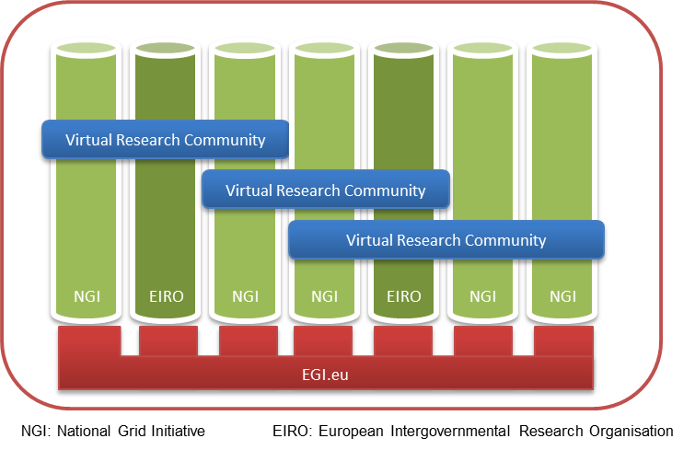

Figure 5. EGI Collaboration - Provision of EGI User Support Service

### EGI.eu User Community Support Team

NGIs are heterogeneous in terms of the size and composition of their user communities, the size and expertise of their USTs. Consequently, NGIs are not equally active and strong in all the previously described user support fields. As an example, a NGI UST, which is very experienced with application porting, may have less experience and interest in developing grid portals. Understanding the strengths and weaknesses of each of the USTs and which services they provide is an important aspect of the coordination of EGI.eu UCST. The intelligent mapping of requirements from international user communities to NGI USTs can integrate user services from the various countries and can help EGI identify missing services. This mapping activity is performed by EGI.eu UCST in Activity Management (TNA3.1) and User & Community Support Team (TNA3.2) tasks of EGI-InSPIRE and consists of the following subtasks:

1. Monitoring the status of NGI USTs and assist them in case their users’ requirements exceed the locally available expertise and capacity. The monitoring of NGIs is currently done through face-to-face meetings, telephone interviews, online and email questionnaires, but EGI.eu UCST aims to put a more efficient mechanism in place. The goal is to simplify this monitoring process and to allow NGIs to “broadcast” relevant information about their user support status and services in an intelligent way to EGI.eu and other NGIs. The assistance that EGI.eu UCST can allocate to NGIs comes primarily from USTs of other countries. The discovery and brokering of effort across NGIs is an important task of EGI.eu UCST. Secondly, the UCST of EGI.eu can contact support personnel in other projects with which EGI-InSPIRE collaborates, and can inquiry whether these projects have available expertise and capacity to serve EGI users.
2. Setup and operate reporting and feedback mechanisms to collect requirements and needs from user communities. These mechanisms allow EGI to assess developments made either by national and international communities, as well as to recognize their new, emerging needs. After prioritisation the EGI.eu UCST communicates these requirements through the EGI management channels to the EGI infrastructure operations and middleware provider teams who reallocate, reconfigure existing services, or when necessary, develop new services.
3. Specify software tools and coordinate the provisioning of these tools that facilitate the work of NGI USTs. These are the so-called “technical services” and they simplify the work of NGI USTs, e.g. the processes of provisioning support services to users. Just to mention a few available technical services, there is a training event database, an application database, a helpdesk infrastructure, etc. Without these technical services, NGI USTs would need to invest much bigger effort to operate their support service portfolios for users. Most of the technical services are physically provided by NGI USTs through their effort in TNA3.4 of EGI-InSPIRE. Section 3 introduces the current set of technical services and the mechanism how this set is kept up to date to follow the changing requirements of user communities.

### NGI User Support Teams

The main actors of EGI are the National Grid Initiatives (NGIs). NGIs ensure the operation of the grid infrastructures in each country as well as a transparent representation of the requirements of all their scientific communities together with resource providers and all e‑Infrastructure-related institutions. To ensure the feasibility of the user support mechanisms, the NGIs operate User Support Teams that contribute effort to the distributed user-support services. The portfolio of services that these organisations offer has been introduced in Figure 6. The responsibility of NGIs is to provide as many of these services as possible for the users within their own country. While NGIs can customise these services according to the local needs within their countries, it is assumed that any user (or group) requires a mixture of these services otherwise its users cannot achieve their planned goals on the infrastructure:



Figure 6. Portfolio of support services provided by NGI User Support Teams.

### Other Support Teams

In addition to the support teams present in EGI.eu and in the NGIs, support teams are also implemented in the EIROs, these being focused on supporting the specialist needs of their own communities, for example the requirements of the Heavy User Communities (HUCs). HUCs are scientific collaborations that are more structured, more advanced in terms of grid usage; they use EGI routinely and already operate support services specifically for their members. These support teams focus on domain specific issues, such as how to access High Energy Physics applications on EGI, how to enable new physics experiments on EGI, and so on. On one hand, these teams are operated by external projects such as WLCG; on the other hand, they are also involved in the EGI-InSPIRE project. The efforts of the distributed WP6 team of EGI-InSPIRE are focused on the provision of shared services that will ease the porting of new applications from these scientific domains to the wider grid. These services are described in more detailed in Section 4.

# TEChnical services FOR User support

The NGI USTs and the EGI.eu UCST provide generic services for any user of the EGI infrastructure. One of the main responsibilities of the EGI.eu UCST is to assure the proper operation of technical services for NGI user support teams. These technical services provide functionalities that are common to many of the user support processes that exist within the NGIs, so implementing them at the European level simplifies the work of national teams. Through the usage of these facilitator tools, NGI USTs can achieve and deliver more high quality, more standardised and more efficient services for their customers, for the EGI users. The services also help EGI better use its resources, as these central tools eliminate the need of developing similar software within multiple member countries. These services are important assets for small NGIs because the software tools provide a significant contribution to the user support processes of small support teams (See Figure 7).

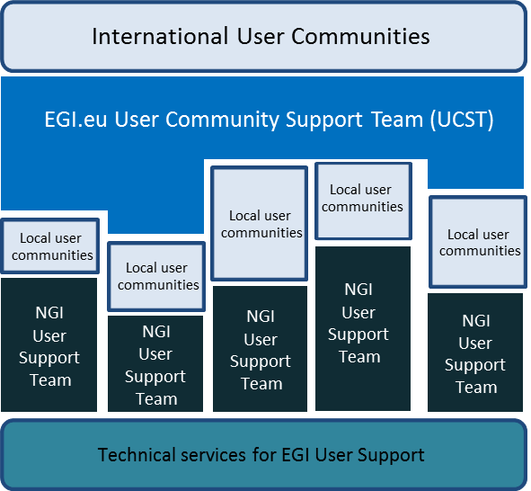

Figure 7. Technical services facilitate the work of NGI User Support Teams

The set of technical services to be provided by EGI-InSPIRE was initially defined during the preparation of the project proposal, based on the experiences of EGEE and previous e-Infrastructure projects. Experience gained subsequently over the first year of the project has nevertheless seen some of those technical services evolve while the requirement for others has disappeared or been overtaken by other solutions. Furthermore, there is a growing impetus to provide solutions (known as ‘gadgets’) that enable the services to be tailored and embedded into specialist community web pages. The current set of user-focused and well-supported services and tools comprises:

* EGI Helpdesk – using GGUS (Global Grid User Support) System [R13]
* Requirements Tracking (RT) System [R14]
* Training Marketplace [R15]
* Application Database (AppDB) [R16]
* Operations Portal [R17]
* VO Services (for VO setup, management and monitoring) [R18]
* EGI website [R19] and Wiki (Web pages and user focused Wiki) [R20]
* Email lists (mailman.egi.eu) [R21]

These technical services are all available to every NGI and UST, as well as to all their users. Generally, providers of the service are responsible for their maintenance and further development, as well as for providing daily support to their users. These technical services are briefly described in the following paragraphs in order to make them widely known and to encourage their use by the EGI community, particularly by the NGI USTs. Additional detail on the Helpdesk and for the RT system is provided in the Milestone document “EGI Helpdesk and the NGI Support Units” [R1] for the Helpdesk and in Appendix A for the RT system.

# Shared Services for Heavy User Communities

There is considerable overlap in the reporting of shared services for Heavy User Communities – firstly MS609 [R2] details “HUC Contact points and the support model” while as importantly, D6.1 [R3] (soon to be reissued as D6.4) provides a detailed description of the “Capabilities Offered by Heavy User Communities”. There is no value in repeating these reports again herein but brief overview and summaries of the subject services in the first instance followed by their relevance in the key HUCs are detailed below (Table 4 and Table 5).

|  |  |  |
| --- | --- | --- |
| **Tool / Service** | **Description** | **Communities** |
| Dashboards  TSA3.2.1 | Experiment Dashboards used by LHC VOs – single schema and application. Mini-dashboard – to be used with Ganga – also by ES | HEP, ES |
| Ganga / DIANE  TSA3.2.2 | Both distributed analysis frameworks (ATLAS, LHCb) and general gridification tools | Wide range of diverse communities and applications |
| Hydra / GRelC  TSA3.2.3 | Encryption service for LS; Grid-access to DBs and catalogues | LS, A&A, ES |
| SOMA2 / Taverna / Kepler  TSA3.2.4 | Advanced workflow orchestration services | Fusion (F), LS, ES |
| MPI  TSA3.2.5 | Handles parallel execution in grid environments | CCMST, A&A, F |

Table 4. Shared Tools & Resources

|  |  |
| --- | --- |
| High Energy Physics  TSA3.3 | The LHC experiments use grid computing for data distribution, processing and analysis. Strong focus on common tools and solutions. Areas supported include: Data Management, Data Analysis and Monitoring. Main VOs: ALICE, ATLAS, CMS, LHCb but covers many other HEP experiments and related projects. |
| Life Sciences  TSA3.4 | Focuses on medical, biomedical and bioinformatics sectors to connect worldwide laboratories, share resources and ease access to data in a secure and confidential way. Supports 4 VOs (Biomed, lsgri, vlemed and pneumogrid) across 6 NGIs via the Life Science Grid Community. |
| Astronomy &  Astrophysics  TSA3.5 | Covers the European Extremely Large Telescope (E-ELT), the Square Kilometre Array (SKA), the Cerenkov Telescope Array (CTA) and others. Activities focus on visualisation tools and database/catalogue access from the grid. Main VOs: Argo, Auger, Glast, Magic, Planck, CTA, plus others (total 23) across 7 NGIs. |
| Earth Sciences  TSA3.6 | Large variety of ES disciplines. Provides also access from the grid to resources within the Ground European Network for Earth Science Interoperations - Digital Earth Community (GENESI-DEC); assists scientists working on climate change via the Climate-G testbed. Main VOs: esr, egeode, climate-g, env.see-grid-sci.eu, meteo.see-grid-sci.eu, seismo.see-grid-sci.eu- support by ~20 NGIs |

Table 5. Heavy User Community focal areas

# Managing user support

The user community support process is focussed on a number of key areas delivered by NGI and other support teams, under the coordination of the EGI.eu. The particular activities carried out by these support teams include the provision of services for users (consultancy, training, etc.) and the provision of software services and technical solutions to facilitate the NGIs work. Management of the delivery process is achieved mainly through the use of two systems; ‘incidents’[3] are recorded, tracked and pursued through the EGI Helpdesk using the GGUS (Global Grid User Support) system while ‘new requirements’[4] (often arising from problems) are input to the Requirements Tracker (RT) system and are progressed by the EGI.eu User Community Support Team (Figure 8).

These activities, processes and services are managed under WP3 through a number of mechanisms. They include internal management arrangements within the work package that take into account the fact that the WP has a team based in Amsterdam working alongside a distributed team based at a small number of partner institutions across Europe. In addition to this, the WP has to coordinate support processes with the 36 partners that are committing effort to this activity in EGI‑InSPIRE.

In addition to internal management processes across EGI-InSPIRE, such as the routine Activity Management Board meetings, three important groups exist to oversee the work undertaken under WP3. These are:

1. Technology Coordination Board (TCB);
2. User Community Board (UCB);
3. User Services Advisory Group (USAG).

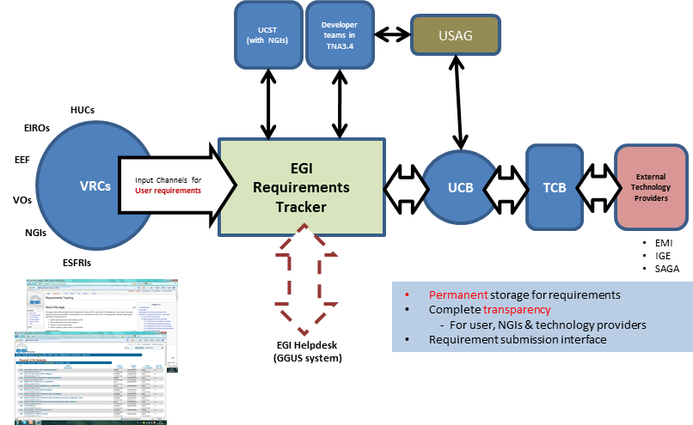

Figure 8. Processing EGI Requirements through to the implementation of solutions

## Technology Coordination Board (TCB)

The TCB provides the focus for the technologies that are used within the EGI production infrastructure to deliver distributed computing services for the research communities. To support this goal the TCB provides the vehicle by which EGI.eu, its user community and its operational mangers reach consensus with Technology Providers on implementation of improvements to the production infrastructure. In practice, with the support and advice of both the UCB and the OMB, the TCB will perform the following key functions:

* Prioritise requirements from the operations and end-user communities relating to their functional needs and behaviour of the EGI production infrastructure.
* Develop a technology roadmap for EGI that will be implemented through its Unified Middleware Distribution (UMD).
* Source in components UMD through bi-lateral relationships with technology providers in the community.
* Define generic or component specific criteria relating to the acceptance of new software releases from these technology providers.
* Ensure a supply of software components that meet the needs of the operations and end-user communities within EGI.

TCB does not formally approve or adopt policies or advice; this is the responsibility of the EGI.eu Executive Board and the appropriate management bodies of the NGIs.

## User Community Board (UCB) and User Services Advisory Group (USAG)

The UCB is an advisory body responsible for coordinating the collection of feedback from the user communities on the human or technical services that they use from EGI. It includes high-level representatives from structured user communities VRCs (e.g. ESRFI, WLCG), NGIs and collaborating projects who:

* Advise the EGI.eu Director on strategic and managerial issues concerning the evolution of EGI.eu’s user facing services and production infrastructure. In practice, the UCB decides about the services that EGI provides for users and has the power to change the portfolio of user support services, the set of technical services (described in Section 3) and the set of shared services.
* Gather feedback from the user community relating to the quality of the production infrastructure and prioritise issues requiring management attention for resolution through the OMB (Operations Management Board). The principal vehicle for collecting such feedback is through users reporting their new requirements using the EGI RT system.
* Gather, define and prioritise requirements relating to new functionality in the production infrastructure or the user facing operational tools. These requirements are coordinated with the OMB and are then passed on to the TCB for their integration into their respective roadmaps and eventual delivery.
* Improve the cohesion of the VRC activities through coordination between the different projects and VRCs.

The UCB is tasked with and the broader support offered by EGI to the user communities. It has no involvement in the day-to-day activities of the user-community services (NA3 & SA3). The detailed technical discussions are delegated to the User Services Advisory Group (USAG).

* USAG is formally led by the Task Leader for TNA3.3 (NGI User Support Teams).
* The USAG mandate is to provide feedback on the user-facing tools and services provided to the EGI user community.
* The remit within USAG is on the delivery of software services (i.e. are they available from the NGIs with the required reliability?) as opposed to their functionality, which is a matter for the UCB.
* USAG will guide the evolution of the EGI Helpdesk and also collect broader requirements and feedback relating to the services offered through NA3 (i.e. documentation, training database, application database, etc.) and the processes provided for user support in EGI.
* USAG will have representation from the User Community Board (including both small and large user communities) and from the operational staff responsible for managing the EGI Helpdesk.

The role of USAG is primarily as a management body. It meets to discuss which features and fixes are most needed to meet the users’ requirements and the organisational needs. The prioritisation of such needs will also be agreed for endorsement by the UCB. The required input for making such decisions is collated in advance of the meetings.

# new Community Integration: Virtual Research Communities

Scientific research is no longer conducted within national boundaries. Scientists are becoming increasingly dependent on large-scale analysis of data generated from instruments or computer simulations housed in trans-national facilities using distributed computing and storage resources linked by high-performance networks. Such facilities are collectively known as e-Infrastructure.

NGIs are national legal entities charged with taking care of grid infrastructure related matters in their own countries. EGI.eu is seen as the glue enabling coherence between the NGIs for the benefit of their users and members of Virtual Research Communities or VRCs.

VRCs are groups of researchers, possibly widely dispersed, working together effectively through the use of Information and Communications Technology (ICT). With the help of EGI the VRC researchers can collaborate, communicate, share resources, access remote computers or equipment and produce results as effectively as if they were physically co-located. The agreement for such collaborative arrangements is formalised initially with a Letter of Intent (LoI) and subsequently through a Memorandum of Understanding (MoU) [R4] between EGI.eu and the participating VRC. Whilst the procedures for the accreditation process are formally detailed [R5], each new case is very individual and experience to date has shown that both parties need to be pragmatic as arrangements progress to the final agreement. An overview of the status of MoUs as of June 2011 (both signed and in course of development) can be seen in Figure 9. Additional to those MoUs whose relative progress is charted, discussions have already started for collaborative work that will result in MOUs with ScalaLife, SIENA and VRCs for Digital Cultural Heritage, Humanities, Computational Chemistry, Astrophysics, Seismology and Fusion.

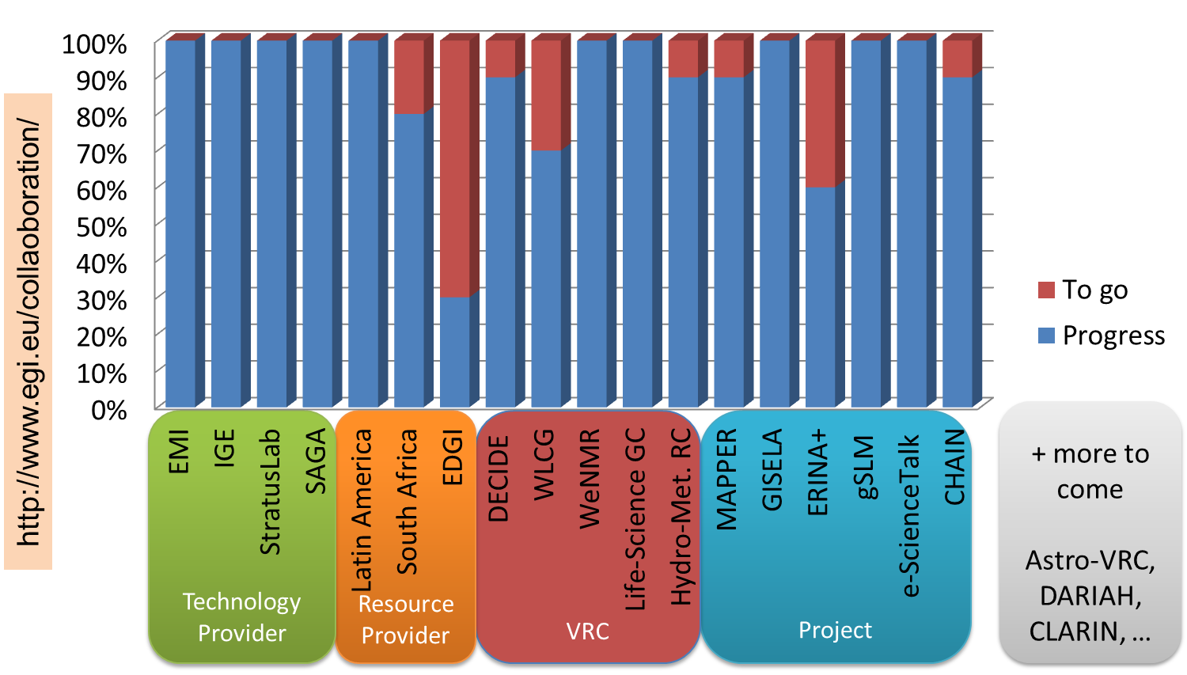

Figure 9. MoUs in the EGI Ecosystem – Relative Status for July 2011

## Definition of VRC

The following diagram (Figure 10) illustrates the purpose of the Virtual Research Community (VRC) within the EGI ecosystem. The VRC is defined as an organisational grouping that brings together transient Virtual Organisations within a persistent and sustainable structure. A VRC must be a self-organising group that collects and represents the interests of a focussed collection of researchers across a clear and well-defined field. Named contacts are agreed upon by the VRC to perform specific roles and these then form the communication channel between the VRC and EGI.

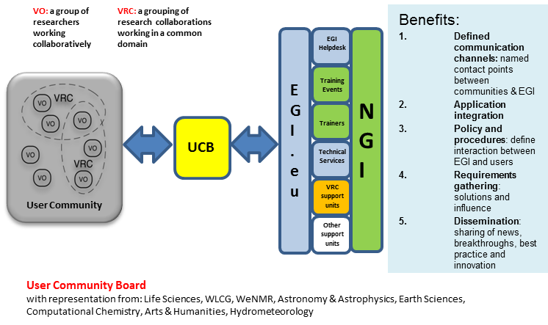

Figure 10. Integration of Virtual Research Communities with EGI

## The benefits of VRC membership

The motivation and value of establishing a VRC under the EGI model for a given research community will depend on the maturity, size and activity of that community. These benefits have been summarised within the text of the EGI VRC Memorandum of Understanding [R4] template and are as follows:

1. **User support:** EGI offers users within a VRC a range of services that integrate and extend the existing support services provided by their own community or within their own country. There are two clear advantages to this: firstly users can navigate their way around a wealth of related material, resources and activities from the EGI community that can enhance their own research; secondly, the EGI requirements gathering process can extract strategic meaning from the detail of day-to-day problem solving and thereby accelerate the development of new features for the VRC.
2. **Application integration:** The support services that EGI provides can typically be customised by the VRC, the NGIs and even the individual user. The services include: the applications database which guides and informs users about existing resources; the training market place which promotes and enables the sharing of training resources across the wider EGI community; the VO services which simplify the process of managing the process of working on the infrastructure and the community repository which is available for handling the distribution of applications if required. Whilst some communities and countries will have their own versions of these resources, sharing information across EGI enables greater take-up and reuse of resources.
3. **User Community policy and procedures:** The VRC exists fundamentally to act as a communication channel between a community of users with common interests and the EGI organisation representing the community of resources providers. This communication takes place in both directions; both as a dissemination channel and as a clear voice for the needs of the community. The EGI management committee structure is the formal mechanism for this and the VRC entry point into this is through participation in the User Community Board (UCB). The policies and procedures exist to ensure that this happens in a fair and efficient manner.
4. **Requirements gathering:** Day-to-day problems will continue to be resolved through the preferred channels of the VRC. However, the EGI Requirements Gathering process provides a transparent and interactive system for extracting the needs of the community from these and other channels that may be provided by EGI or the VRC itself. These requirements may reflect needs for applications, tools, infrastructure or services and will be channelled appropriately. Many of these needs however can be resolved by better documentation, improved knowledge about available resources and adoption of best practices.
5. **Dissemination:** The coordination of dissemination between the VRC and EGI offers an opportunity to maximise the impact of the collaboration. The VRC will benefit from information from the wider EGI community tailored to their needs meanwhile the EGI dissemination team can help achieve benefits of scale by promoting the achievements from within the VRC in a wider context than their own field. This is increasingly important as breakthroughs and tools in one discipline are exploited in others.

## Registering a new VRC

In addition to the existing user communities already known to EGI, various channels are monitored to identify new communities that present opportunities to expand the use of the grid. The emerging picture provides leads and contacts, which gradually form the basis for negotiations and ultimately result in the formation of a new VRC. Contributors to this emerging picture include:

* Monitoring VOs through the Operations portal – VOs are created by users connecting to NGI and other resources. As these become international they should be evaluated for their suitability to be added to existing VRCs or for the creation of new VRCs.
* Monitoring /notification of new EU projects including the ESFRI roadmap projects.
* NGIs notify EGI of new international research initiatives.
* Attendance at formal international events including EGI Forums.

EGI invites international scientific research communities to establish new VRCs and the path to registration is laid down in policy [R5]. Any proposal for the formation of a VRC must demonstrate that it represents a community of researchers that has an established existence, i.e. that it has structure (such as an ESFRI project, EIROFORUM laboratory, national research structure, professional organisation or affiliation, etc.) and that this body represents this particular community. The VRC must also show that it has an established governance model and open mechanisms for new participants to enter (or leave) the organisation, and that all members of this organisation will have access to all the services offered by the VRC, i.e. beyond those who are just part of the proposal. These conditions enable EGI.eu to recognise the VRC as being the ‘voice’ of a particular community of users within the infrastructure. EGI can also provide help and advice on suggested best practices for such organisational models if needed. All communication should be through the Chief Community Officer [cco@egi.eu](mailto:cco@egi.eu).

## New communities

The purpose of the VRC model is to encourage scientific researchers to coalesce into recognisable international communities so that EGI can support them in their use of DCI production infrastructures. The driving force in establishing such communities is often a research project, such as WeNMR or DECIDE, but sometimes it covers several projects that are interested in the same scientific domains. As the research communities using the European e-Infrastructures continue to grow, scalable support models need to be developed that support both large and small communities.

Within EGI, the focus of this scalable user support model is the VRC, which provides a focus for large structured research communities and their resources to interact with EGI – both in obtaining support and for expressing new requirements. Direct support for user communities relating to their use of the infrastructure is provided through the NGI support teams within EGI-InSPIRE. Domain specific support is one of the services that is provided through the VRC, alongside training, dissemination and general community coordination activities. It is envisaged that some VRCs will be initially funded through EC projects, but will migrate to self-sustaining entities supported by their own communities over the next few years.

Once accredited, a VRC formally participates on the User Community Board (UCB) and thus gains a formal channel for capturing and prioritising its requirements and feeding them into the development of EGI services and infrastructure. For those communities that have the intention to establish a VRC but, for a variety of specific reasons, are not yet ready to do so, the Letter of Intent exists to bridge the gap. A template letter is available when necessary and has been used, for example, by the CLARIN and DARIAH projects who want to wait until they achieve ERIC status before committing to fully supporting the Humanities VRC. Finally, smaller collaborations will continue to make direct use of EGI‘s support mechanisms without going through a VRC.

Support for communities can take various forms depending on available resources and the specific needs of that community:

* EGI Chief Community Officer or other representative from the UCST to attend a VRC conference or other major event to present benefits and objectives of collaborating with EGI to this community. This is always a priority for the first year of the VRC as an EGI entity.
* Sponsorship of a conference or other similar event for a VRC. This could take the form of a booth, a display table or a prize for posters or demonstrations for example.
* Financial support for the VRC representative to attend meetings or other events such as the EGI Technical or Community Forums on behalf of their community and to support the VRC process in the wider context.

# support activities in EGI-INSPIRE

User support in EGI-InSPIRE spans across several work packages:

* The NA3 work package is responsible for the support of new users, for the support of emerging communities.
* The SA3 work package is responsible for the domain specific support of services for the ‘Heavy User Communities’.
* The SA1 work package is responsible for resolving infrastructure-related problems, and thus indirectly involved in the support (mainly the helpdesk-style support) of both new and heavy users.

New users are expected to be engaged with EGI from two directions: NGIs catalyse national research communities; EGI.eu engages with international research communities. Engagement with user communities is done by the dissemination teams within NGIs and within EGI.eu.

After contact is made with users, the next step is to capture, analyse and understand their requirements (often through consultancy). This is done by NGI USTs within the TNA3.3 task, and by EGI.eu UCST within the TNA3.2 task. One outcome of this requirement gathering process is the list of actions that need to be taken by NGI user support teams to serve the users: provide training; develop new training content; port application; arrange access to application; update documentation; setup VO; etc. These actions are accomplished by NGI USTs within the TNA3.4 task. Another outcome of requirement gathering process is feedback that is collected and forwarded to USAG. USAG can advise the update of user support services, technical services or shared services in order to meet these requirements. The capture, collection and analysis of feedback is done within the TNA3.2 task by both the NGI USTs and by EGI.eu UCST. Changes of the technical services are implemented within the TNA3.4 task, within SA3 or SA1 work packages. Changes of the user support processes are implemented by NGIs within the TNA3.3 task.

# conclusion and steps for the future

As with the last report (D3.1 [R12]), we have presented the key components of the NA3 User Community Coordination work package as being: the User Community Support Team (UCST) based in EGI.eu, Amsterdam, the NGI Support Teams (NGI UST) distributed across the partners but coordinated from Amsterdam and the Technical Services coordinated by IASA (Greece) and undertaken by partners in Greece, UK, Spain and Portugal. The key focus of UCST remains to support sustainable international research groups through the Virtual Research Community (VRC) model. To complement this, the key focus of NGI USTs is to contribute materials, ported applications, training material and training sessions, portal and dashboard components as required by the community. The road ahead requires effort to be applied to developing and coordinating all of these areas. This is summarised in the following outline plan which is also available in its most up to date form on the User Support website.

The UCST contributes actively to the development of the EGI user-driven strategy through a ten-point, result-oriented plan:

1. **Website.** Continuously improve the User Community Support section of the EGI.eu webpages, to aid all of those involved in EGI, from NGI and VRC staff to researchers and those involved in delivering EGI services.
2. **Intelligence.** Gather and exploit intelligence on metrics, data, trends and usage to optimise the support services and steer further developments towards a user-driven direction.
3. **Requirements.** Investigate key requirements emerging from the user and operation communities; analyse and group them within the EGI Requirements Tracking system and prepare reports for the National Grid Infrastructures (NGIs), the User Community Board (UCB) and the Technical Coordination Board (TCB). All information and knowledge emerging from this work is made public in order to maximise dissemination and to speed up the resolution of community needs.
4. **Discussion.** Contribute actively to the EGI Blog to stimulate discussions on all aspects of user and community support, to generate feedback and a sense of community.
5. **Workshops.** Organise workshops to bridge the gap and stimulate discussions and feedback between the application developers who design software and the scientists who put the programmes to good use.
6. **EGI Community Roadshow.** In conjunction with NGIs, adapt the model developed by the UK National Grid Service (NGS) and other NGIs to organise a series of roadshows tailored to the needs of research institutions, to attract new communities to the grid.
7. **Training.** The training marketplace provides a one-stop shop for trainers and trainees to organise, announce and find training courses and other training-related capabilities. The marketplace is in continuous evolution in order to meet new community demands.
8. **Advice.** Provide help and advice on how to produce the best training material and provide the support and tools for developing online resources and video material.
9. **Champions.** Support and promote ‘champion’ users to advertise the benefits that EGI can bring to the scientific communities.
10. **Customisation.** Develop customisable and embeddable technical services for NGI and VRC portals.

The evolving Technical Services will continue to play an important role in user community support coordination and hence will both underpin and integrate all of the above objectives. The plans for the objectives and the Technical Services will be visible through the RT system and the EGI web site itself and is routinely monitored and reviewed through internal work package, VRC and other meetings and also publicly at the EGI forums.

In terms of the User Support Process, the focus will remain on Continual Self Improvement but the year ahead will see greater adoption of the ITIL philosophy and promotion of this as a core set of standards that EGI.eu and its federated NGIs can work to.

# References

|  |  |
| --- | --- |
| R1 | EGI Helpdesk and the NGI Support Units:  <https://documents.egi.eu/secure/ShowDocument?docid=522> |
| R2 | MS609 HUC Contact points and support model:  <https://documents.egi.eu/secure/RetrieveFile?docid=419&version=4&filename=EGI-MS609-final.pdf> |
| R3 | CAPABILITIES OFFERED BY HEAVY USER COMMUNITIES - D6.1  <https://documents.egi.eu/public/RetrieveFile?docid=154&version=8&filename=EGI-D6.1-final.pdf> |
| R4 | EGI / VRC MoU  <https://documents.egi.eu/secure/ShowDocument?docid=215> |
| R5 | Virtual Research Community accreditation in EGI – policy document  <https://documents.egi.eu/public/RetrieveFile?docid=253&version=1&filename=VRC_accreditation_v1.0.2.pdf> |
| R6 | Documentation collection on the GGUS portal  <https://www.ggus.eu/pages/docu.php> |
| R7 | EGI Operations Portal:  <http://operations-portal.egi.eu/vo> |
| R8 | WP3 section of the EGI-InSPIRE Wiki:  <https://wiki.egi.eu/wiki/EGI-InSPIRE:Main_Page#WP3:_User_Community_Coordination> |
| R9 | MS307 User Support Metrics:  <https://documents.egi.eu/document/675> |
| R10 | D3.2 Annual Report on the status of EGI’s User Services and Community Coordination:  <https://documents.egi.eu/document/386> |
| R11 | EGI-InSPIRE Periodic Report, Project Year 1:  <https://documents.egi.eu/document/606> |
| R12 | D3.1 User Community Support Process:  <https://documents.egi.eu/document/106> |
| R13 | EGI Helpdesk:  <http://helpdesk.egi.eu/> |
| R14 | Requirements Tracker:  <https://wiki.egi.eu/wiki/Requirements_Tracking> |
| R15 | Training Marketplace:  <http://www.egi.eu/user-support/training_marketplace/> |
| R16 | Applications Database:  <http://appdb.egi.eu> |
| R17 | Operations Portal:  <http://operations-portal.egi.eu/> |
| R18 | VO Services:  <http://www.egi.eu/user-support/services/> |
| R19 | EGI Website:  <http://www.egi.eu> |
| R20 | EGI Wiki:  <http://wiki.egi.eu> |
| R21 | EGI email lists:  <https://mailman.egi.eu/mailman/listinfo> |

# Appendix A – description of Technical services for user support

## EGI helpdesk

The central tool for user support is the EGI helpdesk provided by GGUS [R1]. It is hosted within the German NGI-DE and operated by a team at KIT (Karlsruhe Institute of Technology).The main components of the helpdesk are (Figure A1):

* A web front end that allows ticket creation and modification. It includes a search engine to effectively find tickets, by timeframe, category and lots of other options. The query results can be saved for further processing in various formats. The web front-end has different views for users and support staff, each tailored to the specific needs of these groups.
* An interface that can be used to connect other ticket systems to the central helpdesk. There are two variations of the interface, one based on web services and one based on messaging.
* A workflow engine, in which the workflows for the ticket handling process are implemented. These workflows can vary significantly depending on the specific ticket categories or areas of support.
* A user database in which support staff is registered and the different access rights are documented.
* A ticket database containing the actual status and the complete history of all tickets created or having passed through the GGUS helpdesk.

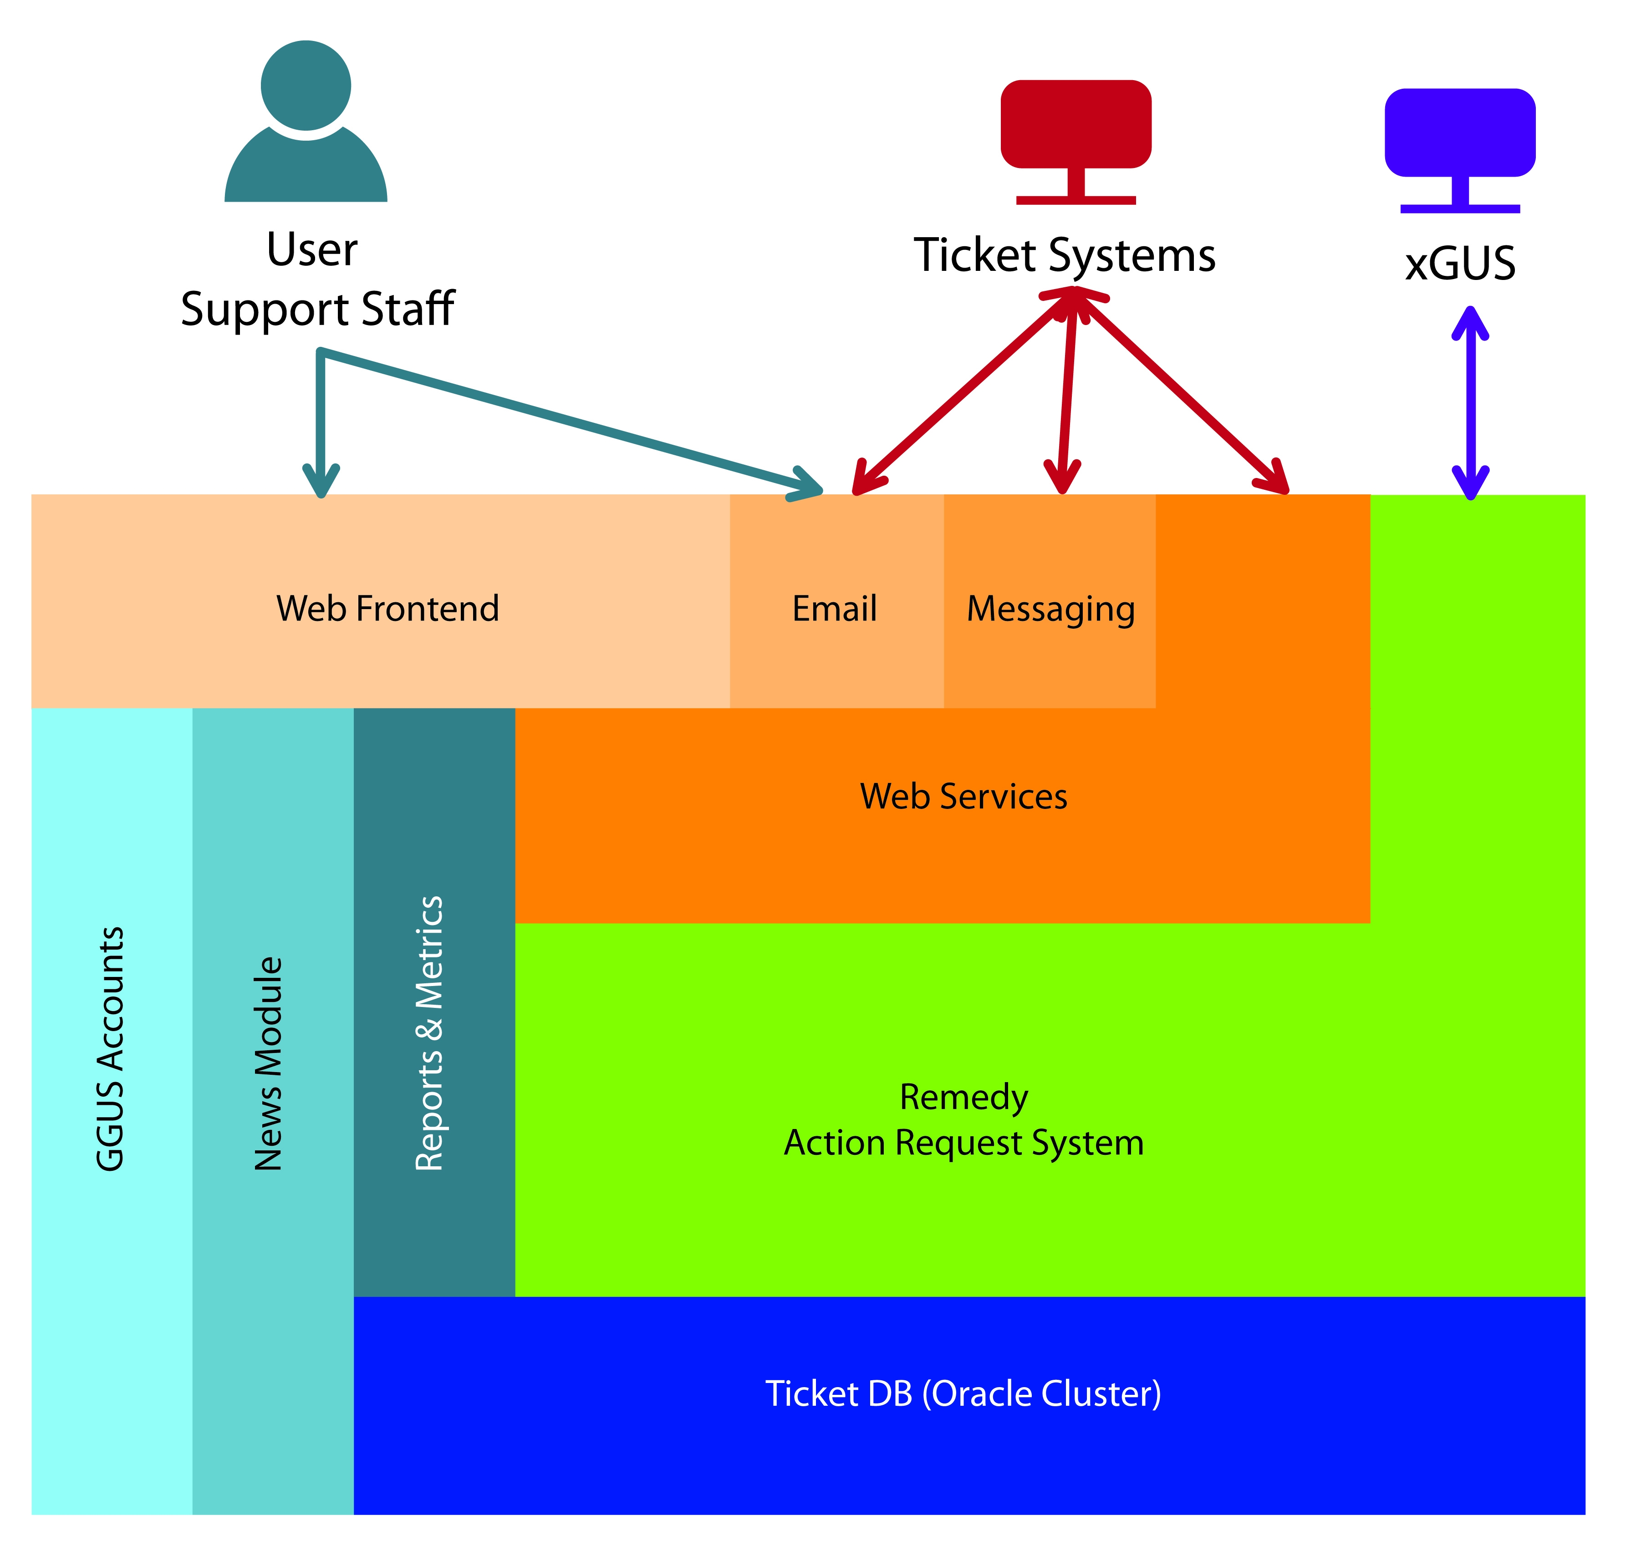

Figure A1. Schematic view of the architecture of the GGUS helpdesk system

The full functionality of the GGUS system is described in detail in the GGUS User Guide and the GGUS Helpdesk System Tutorial, both of which can be found in the documentation collection on the GGUS portal [R6].

All support units (a group responsible for a specific type of problem or area of support) with a project-wide responsibility are listed in the GGUS system and workflows have been defined and implemented steering what happens when a ticket is assigned to a specific support unit. These workflows vary depending on the scope of the support units and on the technical solution in place for the support unit.

## Requirements Tracker (RT)

The evolution of the European Grid Infrastructure is driven by the users. Therefore, capturing and communicating feedback from users to the infrastructure, as well as to technology operators and providers, is a key goal for the User Community Support Team (UCST; NA3 activity of EGI-InSPIRE) and for the project as a whole. The EGI-InSPIRE project has established and runs a [well-defined process](https://wiki.egi.eu/wiki/Requirements_gathering_details#The_requirement_gathering_and_processing_workflow_-_What_happens_with_requirements.3F) to collect, capture, progress, and resolve user requirements and recommendations. Requirements and recommendations are collected from users through various [electronic channels](https://wiki.egi.eu/wiki/Requirements_gathering_details#Requirement_channels_-_How_to_communicate_requirements_to_EGI.3F) and face-to-face communication mechanisms. A queue called "Requirements" has been setup in [EGI’s implementation of the Request Tracker[5] (RT) system](https://rt.egi.eu/rt/index.html" \o "https://rt.egi.eu/rt/index.html) to store requirement tickets, to monitor user demands and to resolve problems. The term "Requirement Tracker" and the acronym "RT" refer to the "requirements" queue of the EGI Request Tracker system and the terms are used extensively by User Support Teams.

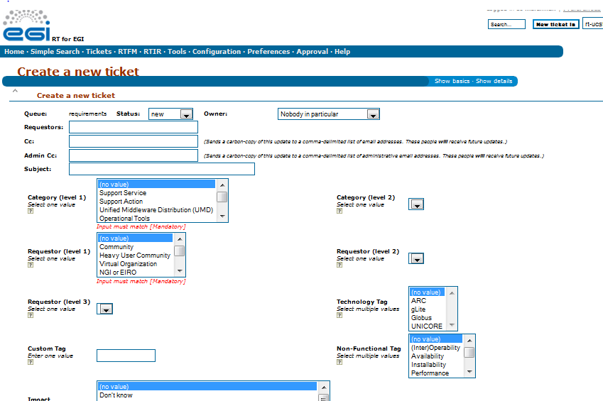

Figure A2. EGI Request Tracker (RT) – Creating a new Requirement

Anyone can submit requirements to EGI through the RT system (Figure A2), as long as they have an [EGI SSO account](https://www.egi.eu/sso/). After [login in](https://rt.egi.eu/rt/index.html) into the RT system, the user must choose the "Requirements" queue, the place where all requests are stored and analysed. The ticket requestor needs to specify both mandatory and optional fields, while providing a detailed description of the requirement. If this step is properly done, the requirement is tagged in such a way that the solution providers can be called to take an action upon the ticket in an easy and timely manner.

Pre-defined queries, "Dashboards", are available for users to browse the RT system in order to track requirement tickets and to monitor progress. All the dashboards are public and thus associated tickets are also publicly visible as well. The RT system can host any number and type of Dashboards. Should a community require a customized view of the ticketed requirements, then these can be established upon request to the EGI [User Community Support Team](mailto:ucst@egi.eu).

## Training Marketplace

The training services exist to enable the coordination and sharing of training across communities, projects and national teams. In March 2011, the task of hosting the service was reallocated to the Science and Technology Facilities Council (STFC) in the UK and a newly designed Training Marketplace was launched to replace the old EGEE inherited tool. In order to make access to the service as straight forward as possible, this Training Marketplace gateway is embedded into a frame in the EGI website. It offers views of the training events registry and to a resources/materials repository. It also offers users the ability to rate training events and provide feedback that is visible to the community. Functionality includes:

* Map view of NGI training events, local gateways and NGI support teams
* Training wish list – web form for users to specify their needs and published list view of these requirements
* Advertise expertise and ideas – web form input for people to advertise their expertise, ideas and resources and published list view of these. For example, NGIs may wish to advertise a training resource, training VO, or a trainer may wish to advertise an idea for a course to gauge interest
* Advertise relevant MSc, PhD and other taught courses
* Integration of the existing 9000 Digital Library training repository materials
* Integration of advanced search functionality across all objects in the Training Marketplace. For example a search on the term gLite would find events and materials relating to the term.

The Training Marketplace is fundamentally a tool that enables the collaborative sharing of training amongst users of the EGI ecosystem and as such, it can to a large extent be compared to the functionality offered by e-Bay to users of the Internet. In turn, this means that the success of the Training Marketplace depends absolutely on full and dynamic participation of all trainers and users of the EGI production infrastructure. Figure A3andFigure A4beneath demonstrate the straightforward simplicity of the new Marketplace; the service is being actively promoted by the UCST and usage will be monitored routinely using Google Analytics.

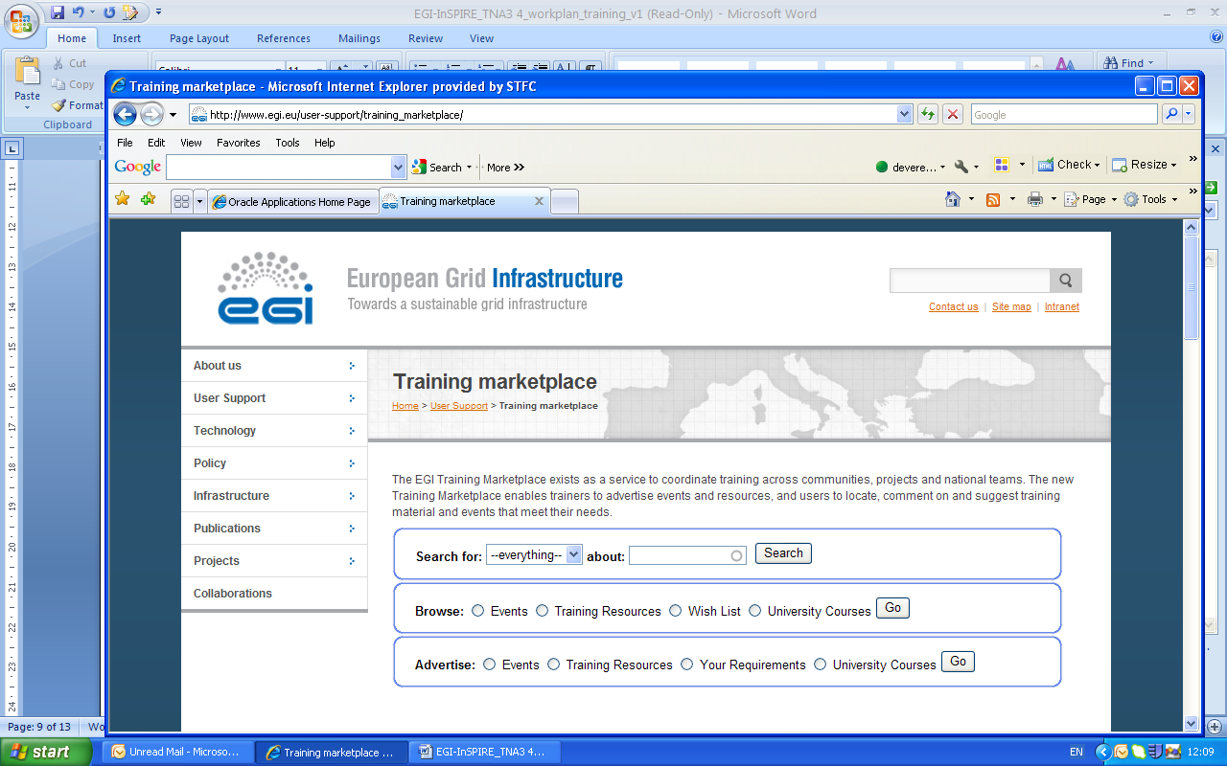

Figure A3. The Training Marketplace home page (version 2)

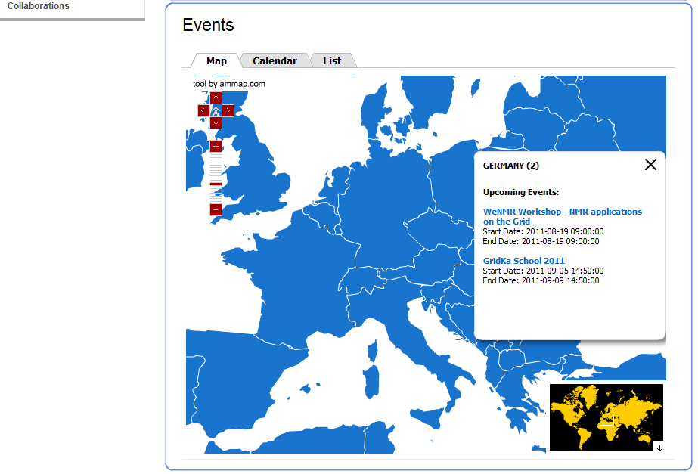

Figure A4. The events map view of the Training Marketplace

## Application database

The [EGI Applications Database (AppDB)](http://appdb.egi.eu/) stores information about grid-based computing tools for scientists to use. The scope of the database embraces all scientific fields, from resources to simulate exotic excitation modes in physics, to applications for complex protein sequences analysis.

The applications filed in AppDB are finished products, ready to be used. Using applications already enabled for EGI means that scientists have to spend less of their own research time developing and adapting software to the grid. The goal for the AppDB therefore is to inspire scientists less familiar with programming to use the grid and its resources in a more flexible and less intrusive way. The database is also meant to avoid duplication of effort across the user community (Figure A5)

The database has been online since 1 July 2011 and is the natural successor to EGEE’s database, which was developed by Italian and Greek teams during that project’s third and final phase. During the transition to the EGI, the AppDB came under sole Greek responsibility and it is now hosted by the [Institute of Accelerating Systems and Applications](http://www.iasa.gr/) (IASA) in Athens. In order to make access to the service as straight forward as possible, this Training Marketplace gateway is embedded into a frame in the EGI website.

Additionally, in order to create more personalised instances of the AppDB such that they can be tailored to the needs of any specific community, IASA has developed a gadget that can be readily included in local sites or portals. The new EGI AppDB Gadget Editor is conveniently available at <http://appdb.egi.eu/gadgets/editor>.

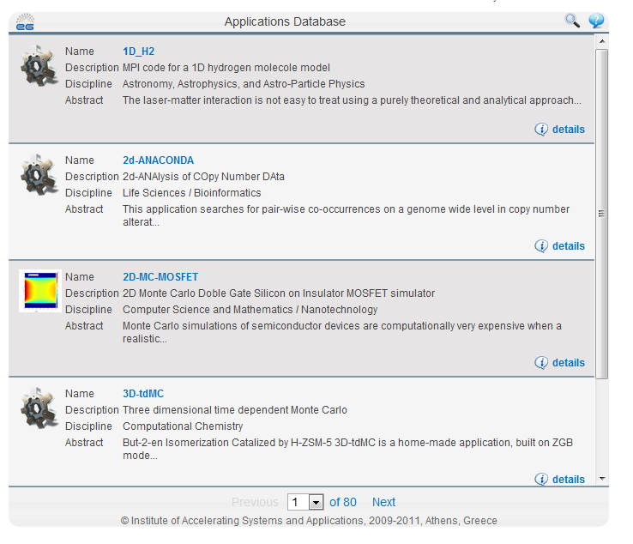

Figure A5. The EGI Applications Database (AppDB) which is accessed via the EGI website.

## EGI Operations Portal

Virtual Organisations are the physical representation of scientific collaborations at the grid infrastructure level. A VO on EGI consists of computing and storage sites, other types of distributed and grid services, and the people who are sharing and have access to these resources. New and expanding communities very often want to enable new VOs on the infrastructure in order to serve the needs of a new experiment, application or group. The EGI Operations portal is a Web page/site [R7] that is available on the one hand to end users who look for a VO that has similar areas of interest and expertise (Figure A6) that they can join in order to access particular services or applications on the grid, while on the other hand the webpages are used by representatives of scientific communities to register new VOs (Figure A7).

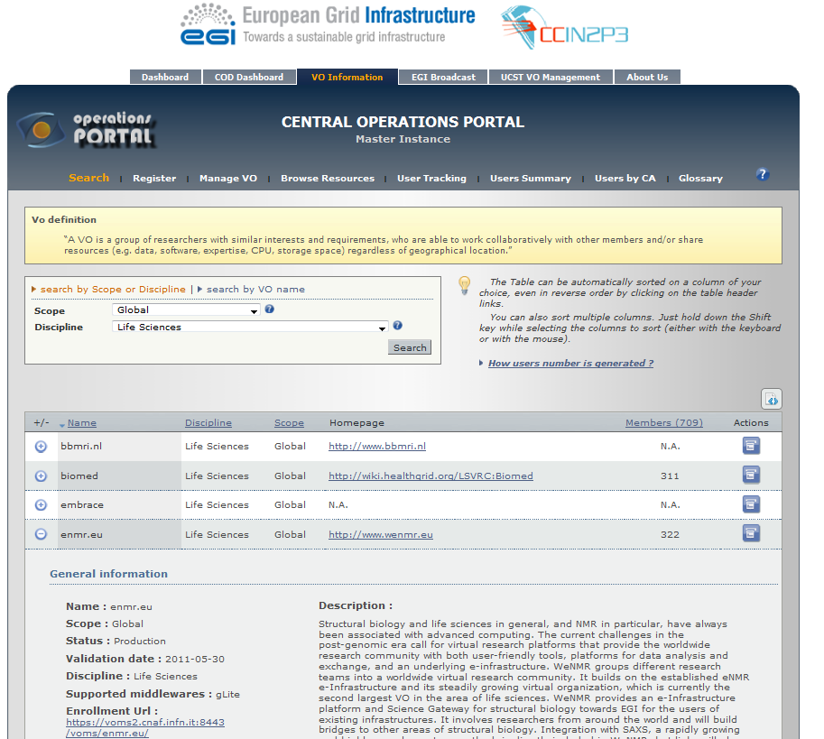

Figure A6. Central Operations Portal – Existing VO description page.

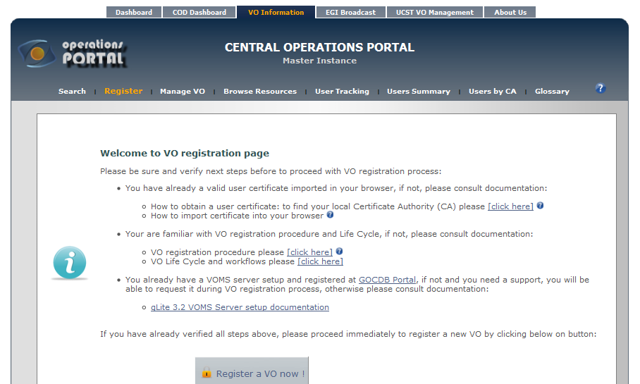

Figure A7. Central Operations Portal – VO registration

User support teams are expected to make their users aware of this service and train them on how to read, interpret and use the contents.

The Portal allows the registration of new VOs on the infrastructure. To lower the barriers of the setup of new VOs, EGI also offers VOMS (Virtual Organisation Membership Service) hosting for new VOs. VOMS hosting means that for VOs that are multi-national or hosted by NGIs that cannot provide a VOMS server, EGI can provide the requisite service. Broadening the set of central services that EGI can offer for VOs (e.g. LFC, WMS, etc.) could lower the barrier for VOs, thus giving access to a larger number of VOs and users on the infrastructure. UCST continues ensure that services evolve in such a manner as to meet the needs of new communities as they engage with the infrastructure.

## Web pages

In order to guarantee sufficient information flow between user support teams and users, EGI operates two web sites that are dedicated for this purpose. One is the EGI.eu website where the user support section ([www.egi.eu/user-support](http://www.egi.eu/user-support)) is specifically focused on the needs of the users of the production infrastructure. The website is open to the general public and introduces the concept and services of EGI overall. More importantly from a user perspective, the UCST section (Figure A8) provides a succinct description of the available services and links each of these directly to the service itself. Considerable effort has been expended over the 1st year of the EGI-InSPIRE project in examining the user needs and tailoring the web pages so that the needs are met as efficiently as possible.

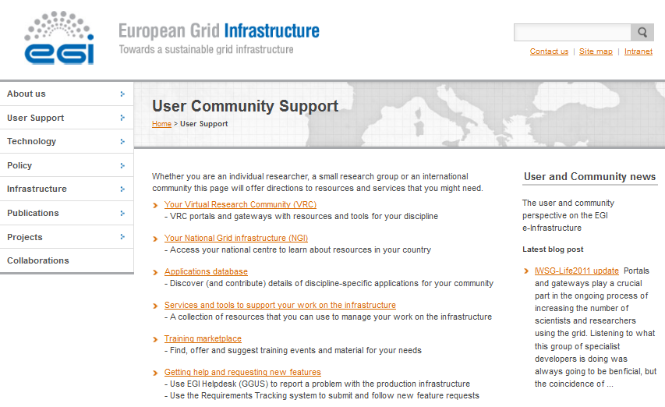

Figure A8. EGI UCST Web site – User services.

The second website is the NA3 section of the EGI-InSPIRE Wiki [R8]. This can be accessed by members of the EGI-InSPIRE collaboration, and can be edited by SSO account holders. The website’s aim is to keep the partners of the collaboration updated with the progress of the NA3 activity, as well as to provide a scratchpad where support teams can develop web pages, publish useful resources, ideas and any other item that can foster the user support activity.

## Email lists

Another important way of keeping partners up to date with the user support services and processes is through the use of email distribution lists using ‘Mailman’, the GNU Mailing List Manager. These are operated by EGI.eu on behalf of any user community or grouping of users that has a clear requirement for such a mail list. Initially there were few of these mail lists and their use was restricted but their value is becoming increasingly recognised and with that the range of mail distribution lists grows consistently (by Jul 2011 there are over 120 mail lists operated by EGI).

1. ESFRI: European Strategy Forum on Research Infrastructures, <http://ec.europa.eu/research/esfri/>
2. ITIL® – Information Technology Infrastructure Library (Note ITIL is a registered Trade Mark of the UK Office of Government Commerce) : V3.1 superseded V3 in mid 2011 (www.itil-officialsite.com).
3. ‘incidents’: In ITIL, Incident management processes aim to restore a normal service as quickly as possible.
4. ‘new requirements’: in ITIL, a ‘problem’ is a condition often identified as a result of multiple incidents that exhibit common symptoms. Problems can also be identified from a single significant incident, indicative of a single error, for which the cause is unknown, but for which the impact is significant. EGI ‘requirements’ are thus comparable to ITIL ‘problems’
5. [Request Tracker](http://bestpractical.com/rt/) is the leading enterprise-grade open source issue tracking system (http://bestpractical.com/)