

M6.8 B2NOTE-OpenAIRE Integration Report

|  |  |
| --- | --- |
| **Lead Partner:** | CINECA |
| **Version:** | 1 |
| **Status:** | FINAL |
| **Dissemination Level:** | Public |
| **Document Link:** | <https://documents.egi.eu/document/3698> |

**COPYRIGHT NOTICE**



This work by Parties of the EOSC-hub Consortium is licensed under a Creative Commons Attribution 4.0 International License (<http://creativecommons.org/licenses/by/4.0/>). The EOSC-hub project is co-funded by the European Union Horizon 2020 programme under grant number 777536.

**Contents**

1 Introduction 3

1.1 Heading 2 **Error! Bookmark not defined.**

2 Another example of heading 1 **Error! Bookmark not defined.**

2.1 Heading 2 **Error! Bookmark not defined.**

3 Now for the lists and etc. **Error! Bookmark not defined.**

3.1 Bullet lists **Error! Bookmark not defined.**

3.2 Numbered lists **Error! Bookmark not defined.**

4 Figures and captions **Error! Bookmark not defined.**

4.1 Pictures **Error! Bookmark not defined.**

4.2 Tables **Error! Bookmark not defined.**

5 References **Error! Bookmark not defined.**

Appendix I. Appendix example **Error! Bookmark not defined.**

# Introduction

B2NOTE is a data annotation service developed in the context of the EUDAT project and integrated within the EOSC-Hub Portfolio. This service enables users of data services to enrich the description of accessible content without modifying the underlying databases or data model. Based on the W3C Web Annotation model, this service enables the linking of uniquely and unambiguously identified resources with various kinds of annotations. In particular, it provides means to associate the content with semantic models (i.e. ontologies, controlled vocabularies) or simply with textual comments or keywords. This service has been designed to be easily integrated as a widget within the User Interface of any data service.

OpenAIRE offers a large number of services and we are focusing on three main services: the data repository Zenodo, the search engine OpenAIRE Explore and the Community Gateway (Research Community Dashboard, RCD). The data repository is an element used to build the OpenAIRE Knowledge Graph while the two other services are providing dedicated interfaces to the Knowledge Graph: a search engine and a community specific facet builder. The aim of this project is to integrate annotations with these different services to provide added-value for the user.

# Service Overview

|  |  |
| --- | --- |
| **Service/Tool name** | B2NOTE |
| **Service/Tool url** | [https://b2note.](https://b2note.bsc.es/)eudat.eu (production version) |
| **Service/Tool information page** | [https://b2note.bsc.es](https://b2note.bsc.es/) (latest information) |
| **OpenAIRE integration** | <http://mpagasas.di.uoa.gr:4200/search/publication?articleId=userclaim___::1f42f8945fcf34cc70ea390b3b352121> (sample from development version) |
| **Description** | B2NOTE is the EUDAT and EOSC-Hub annotation service |
| **Value proposition** | This service enables users of data services to enrich the description of accessible content without modifying the underlying databases or data model. Based on the W3C Web Annotation model, this service enables the linking of uniquely and unambiguously identified resources with various kinds of annotations. |
| **Customer of the service/tool** | Research Communities |
| **User of the service/tool** | Researchers |
| **User Documentation** | Included in the tool |
| **Technical Documentation** | https://e-sdf.github.io/b2note-docs |
| **Product team** | e-Science Data Factory |
| **License** | MIT |
| **Source code** | <https://github.com/e-sdf> (latest version)  <https://github.com/EUDAT-B2NOTE/b2note> (production version) |
| **Testing** | The low-level testing is significantly alleviated by advanced use of strong typing. Acceptance tests, regression tests and integration tests are performed. |

# Service architecture

The B2NOTE service consists of an API server that handles REST requests and a small Widget server that provides the Widget UI to integrate services. The integration of the Widget is currently done through IFRAME, which imposes minimal requirements and work on the side of the integrating service and enables fully transparent Widget version updates.

## Annotation format

B2NOTE annotations format follows the [Web annotation model](https://www.w3.org/TR/2017/REC-annotation-model-20170223/)(W3C Recommendation):

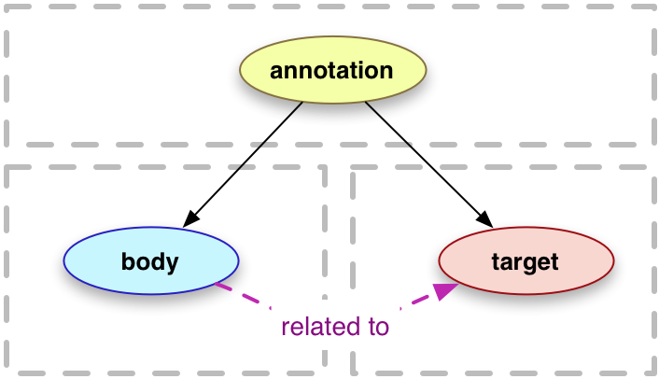

Where:

* **Target**is the annotated resource on OpenAIRE identified by URL/PID. Next, the `source` part of the target points to the downloadable content of the resource.
* **Body** is the tag/keyword used to annotate the resource.
* **Annotation** contains (apart from *body* and *target*) other attributes, such as purpose, creation timestamp, provenance (creator), etc.

We distinguish 3 types of annotations:

1. **Semantic tag** -- represents a precise term from an ontology (or several ones, in case the term is defined in multiple). Annotation using semantic tags is preferred, as it is best aligned with machine-actionability and FAIR principles.
2. **Free-text keyword** -- used generally in cases where the required term is not found in any of the ontologies indexed by B2NOTE.
3. **Comment** -- a free-style text, generally used to attach notes.

## API

The API server responds through REST and provides the possibility to work with annotations and the user profile. The API documentation is <[https://b2note.docs.apiary.io](https://b2note.docs.apiary.io/)>. For integrating services, it is used mostly for querying about existing annotations of a target.

## Widget integration

The widget integration into the web page of a service is described at <<https://e-sdf.github.io/b2note-docs/widget-integration.html>> and an example is provided. The integration consists generally of three pieces at the side of the integrating service:

1. Providing an IFRAME for the widget (typically hidden initially).
2. Including the “Annotate” button for the provided resources. On pressing the button, PID and Source of the annotated resource are sent in HTTP POST request to the Widget server to load the Widget.
3. Getting information about the annotations to display badges with a number of annotations of the resource. This information is gathered from the API and the hosting page also gets notified about annotation changes through the JavaScript postMessage functionality.

# Current State of Integration

We present the current state of integration on a simplified user scenario that begins with logging into OpenAIRE sample record page with B2NOTE integration:

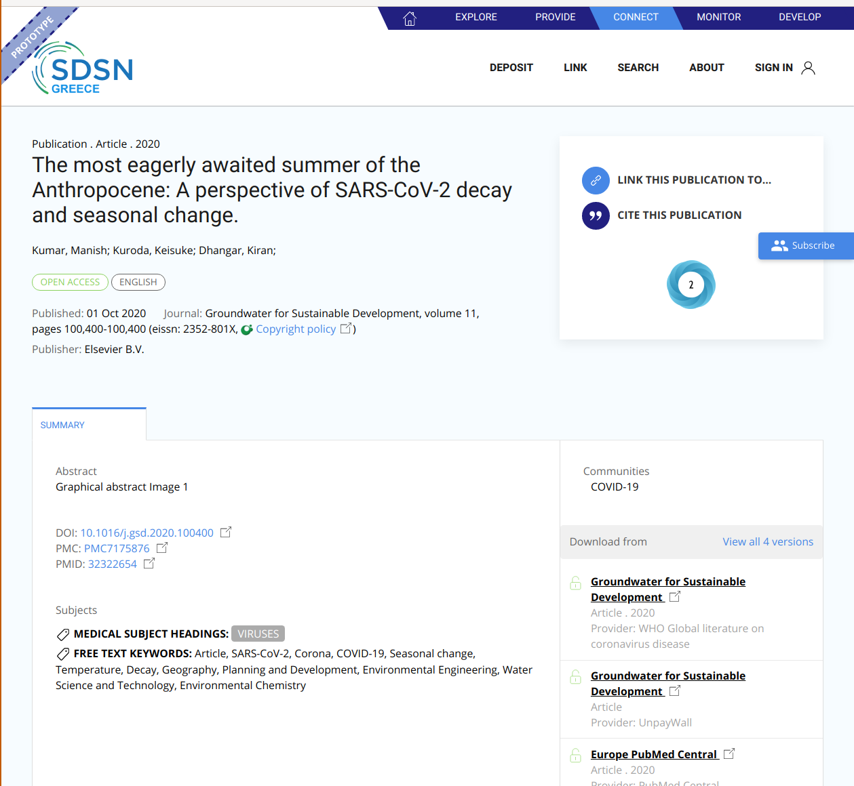

After logging, the “ADD ANNOTATION” button becomes active and the user can annotate the record using B2NOTE. Clicking on this button invokes the B2NOTE widget interface and initializes the service with the URL/PID and Source of the record/node. The user can then annotate using the above-explained annotation types.

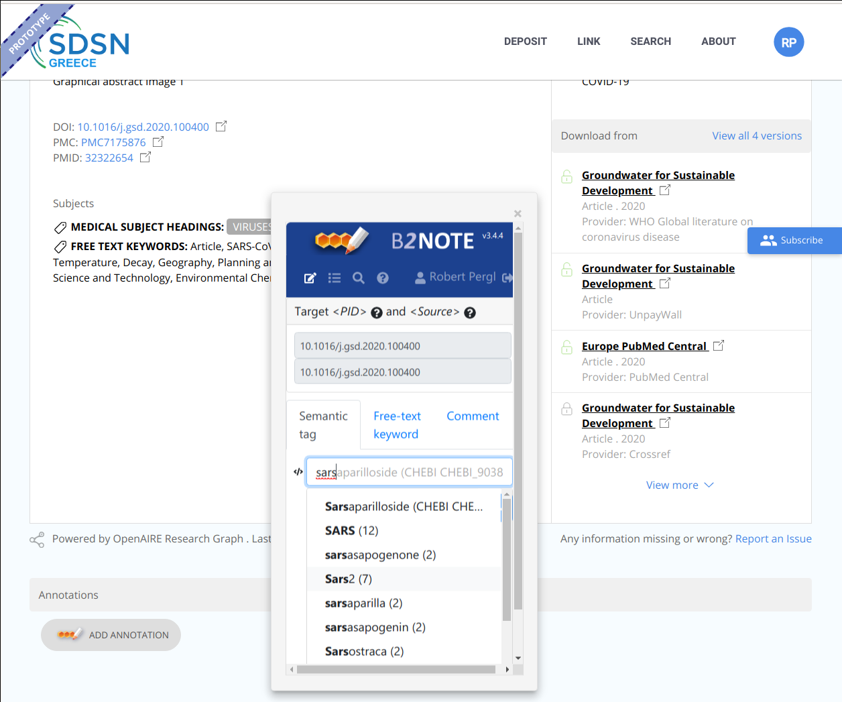

In case the user is already previously logged in OpenAIRE Explore, the login token is transferred into the Widget and the user is automatically logged in B2NOTE through OpenAIRE AAI, as can be seen in the screenshot. At the same time, the user may log out in the Widget and log into their different account on OpenAIRE or even some other account provided by B2ACCESS:

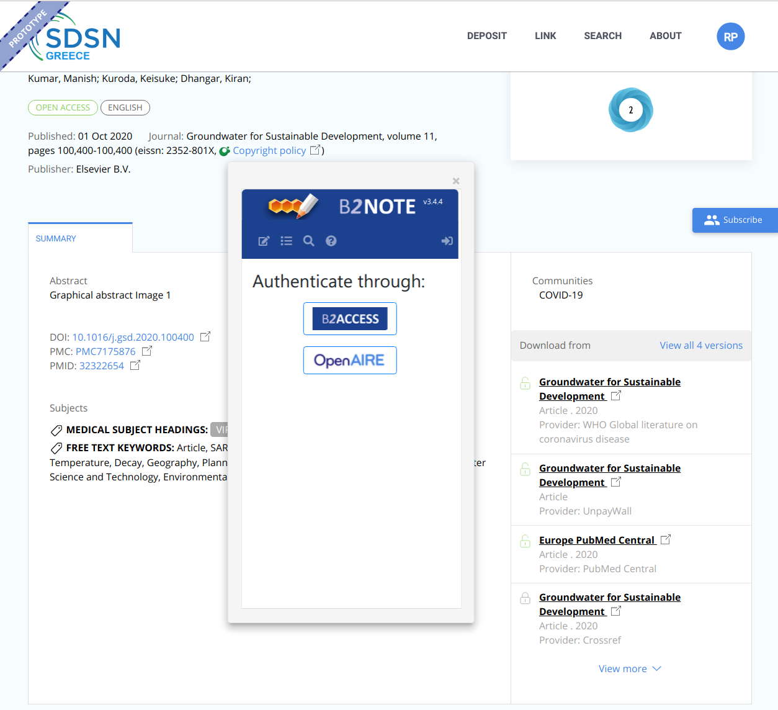

The user is able to see their annotations for this file in the B2NOTE interface. However, it is more convenient for them to see in advance, whether this record has been annotated before. For this purpose, OpenAIRE uses the B2NOTE API to show the user the annotations associated with the record:

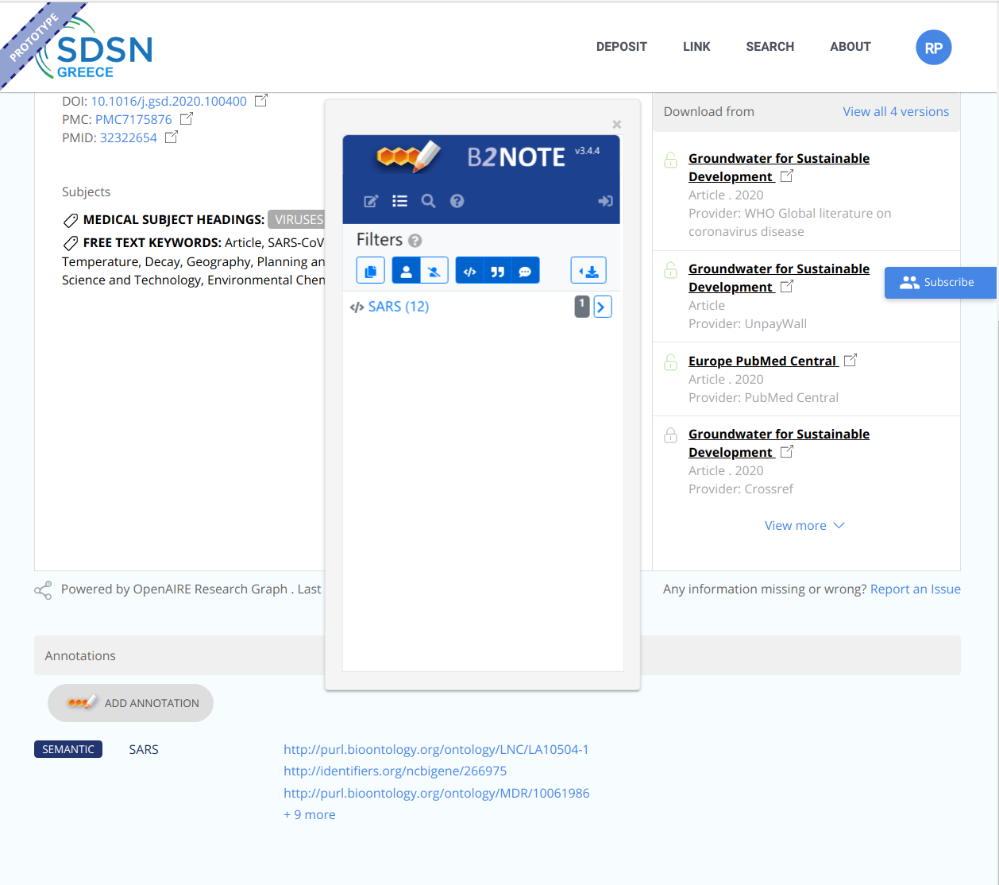

# Integration Process

First meetings of B2NOTE and OpenAIRE teams were focused on planning and specifying the user scenarios, followed by technical meetings. The last meetings were focused on technical tunings, release plans and dissemination plans. We also organised one workshop to present the integration to user communities and gather their feedback.

# Conclusions

The collaboration with the OpenAIRE team is lively and productive. The current integration consists of:

* Integration of the B2NOTE Widget into OpenAIRE Explorer.
* Transfer of login token from OpenAIRE to the Widget.
* Annotation of the record in the B2NOTE Widget.
* Management of annotations in the B2NOTE Widget.
* Visualisation of the B2NOTE annotations on the record page, including the type of annotations and links to ontologies of the semantic ones.

In production, the integration within the OpenAIRE explore service will be available for the Research Community Dashboard (RCD) and all associated OpenAIRE services.

Currently, all the functionality required at the side of B2NOTE is ready. However, the integration is still blocked at the level of the development services due to delays in providing the Data Privacy Statement (DPS) for B2NOTE, which is under the responsibility of BSC and EUDAT ltd. (Should be provided by the end of October). The lack of the DPS prevents us from integrating the widget with production AAI services which are required for migrating this integration into production environments. The same applies for the migration of new B2NOTE version 3 into the BSC production servers.

As for the dissemination, we are currently working together with the OpenAIRE team to discuss with user communities using the RCD that would test and evaluate B2NOTE service into their community workflows and usage.