

**EGI Pay-for-Use Proof of Concept**

**Final Report 2014**

**Abstract:**

The purpose of this document is to describe all information related to implementing pay-for-use mechanisms in to EGI resulting from the dedicated EGI Pay-for-Use Proof of Concept. The contents of this document provides a final record of activities over 2014 and will ultimately serve as the starting point for future actions in 2015.

**Table of Contents:**

1 Snapshot Summary 3

1.1 Main Achievements 3

1.2 Future Recommendations 4

2 Introduction 5

2.1 Motivation 5

2.2 Mandate 5

2.3 Objectives 5

2.4 Roles and Functions 5

2.5 Value Proposition 6

3 Business Processes 7

3.1 Steps/Instructions 7

3.1.1 Publish pricing information per service (Provider) 7

3.1.2 Customer service discovery 9

3.1.3 Customer service selection and request submission 13

3.1.4 Customer agrees and signs an SLA 14

3.1.5 Broker creates a VO per contract 14

3.1.6 Allocating capacity 15

3.1.7 Customer adds/enables users 15

3.1.8 Customer usage and accounting 15

3.1.9 Customer receives an invoice and pays 16

3.2 IT Service Management 17

3.2.1 FitSM Standard 17

3.2.2 SLAs, OLAs, and Contracts 17

3.2.3 Service Catalogue Record 17

4 Business Models 18

4.1 Pricing Schemes 18

4.2 Broker Models 18

4.3 Joint Development Projects 21

4.4 Consultancy 21

5 Business Engagement 22

5.1 Collaborations 22

5.1.1 Helix Nebula Marketplace (HNX) 22

5.1.2 100% IT 23

5.1.3 IFCA-CSIC Industrial Use Cases 23

5.2 Opportunities 25

5.2.1 European Space Agency 25

5.2.2 Cloud for Europe pre-commercial procurement (PCP) tender 26

5.2.3 Others 27

5.3 EGI Federated Cloud Task Force 28

5.4 EGI Business Engagement Programme 29

6 NGIs and Resource Centres: Pay-for-Use Status Overview 31

7 Conclusions and Future Recommendations 32

Annex 1 – Service and Price Overview by Provider 33

Annex 2 – NGI and Resource Centre: Motivation, Feedback, Plans 37

Albert Einstein Center, Univ. of Bern 37

Bulgaria NGI 37

CESGA-IBERGRID 38

CSC 38

Cyfronet (PL-GRID) 38

German NGI (Fraunhofer SCAI, LRZ) 39

IFCA-IBERGRID 39

Institute of Informatics of the Slovak Academy of Sciences (II SAS) 40

Latvian Grid 40

Lithuania NGI 41

MASTER-UP Srl. 41

NGI_GRNET 41

NGI_IT 42

TUBITAK ULAKBIM 43

UIIP-NASB (Belarus) 43

Annex 3 – EGI User SLA Template 44

Annex 4 – Provider Service Catalogue Record Template 49

# Snapshot Summary

The Pay-for-Use Proof of Concept group[1] launched in January 2014 on a best effort basis with formal funding activities starting in May 2014 as a dedicated tasks within EGI-InSPIRE PY5 NA5 WP. This activity was also closely linked to TNA5.1 Strategy, Policy and Business Development; SA5.2: Federated Cloud and JRA2 Tool development.

Overall, the group consisted of more than 40 Members and Observers from EGI.eu (Lead), Resource Centers, NGI NILs, and Commercial Companies. In total, 16 regularly scheduled phone conferences were held[2] with formal minutes produced[3] as well as two dedicated sessions at the EGI Community Forum in Helsinki[4] and the EGI Big Data workshop in Amsterdam (Sept)[5].

The following sections provide a high-level view of the main activities, results achieved, and recommendations moving forward. Further details of each are provided throughout the rest of the document.

## Main Achievements

* Complete business processes defined and system tested and approved by resource providers:
  + Providers to publish pricing information; customers to discovery services and prices; request submission; negotiation and SLA; VO set-up; accounting of consumed resources; invoicing (Section 3).
* Tools adaptation
  + GOCDB extensions added to set pricing: cloud compute and storage, grid compute and storage, VAT.
  + Accounting Portal extended for price information accounting.
  + e-GRANT developed to offer both a user-facing interface and enable providers to receive requests, negotiate the service and price and allocate resources.
* Sites Publishing Pricing Information
  + 20 Organisations across 13 Countries
  + 20 Grid Sites: Belarus; Bulgaria; Germany; Greece; Italy; Latvia; Poland; Spain; Switzerland; Turkey
  + 10 Cloud Sites: Finland; Greece; Italy; Poland; Slovakia; Spain; Turkey; UK
  + 15 Storage sites: Bulgaria; Greece; Italy; Spain
* Price Ranges (incl. support)
  + Grid (HEPSPEC/hr): €0.01-€0.15 (Avg. €0.05; Median €0.05)
  + Cloud (wallclock/hr): €0.03-€0.11 (Avg. €0.05; Median €0.05)
  + Storage (€/GB/month): €0.01-€0.14 (Avg. €0.04; Median €0.04)
  + +/- VAT 8%-24% (where applicable)
    - Taxation report available at[6]
  + Prices to be valid for one year once in production
* Assurance of service management best practices based on FitSM (Section 3)
  + Links to EGI’s overall ITSM service management system.
  + Reuse of agreements: SLAs, OLAs
  + Development of a proposed Service Catalogue Record defining provider service offerings and capabilities.
* Business models and pricing schemes defined: selling of physically resources (pay-per-use; packaged), joint development projects, and consultancy. (Section 4)
  + Legal and Policy solutions emerging for institutions not fully able to engage in commercial activities: e.g. research-only purpose statements; charging for human services with resources offered for free (however, monetary value of those services is now able to be calculated).
* Business opportunities being explored (Section 5).
  + Helix Nebula Marketplace (HNX); Engineering SpA (Large Italian IT company); European Space Agency; Pre-commercial procurement (PCP) / Public procurement of innovative solutions (PPI) (e.g. Cloud for Europe; PICSE - Procurement Innovation for Cloud Services in Europe); 100% IT (UK SME cloud provider); Charity Engine (UK Desktop Computing Company); Arctur (Slovenian SME HPC/Cloud provider); Zenotech (UK SME Marketplace).
  + Others being explored through formal Business Engagement Programme (Section 5).
* National exposure and initiatives underway and there are already examples of success stories with various levels of pay-for-use capabilities (Section 6).
  + Ready for production (8): CESGSA (ES), IFCA-CSIC (ES), 100% IT (UK), Albert Einstein Center Univ. of Bern (outside CH users only), MASTER-UP (IT) (limited capacity); TUBITAK (TR); II SAS (BG); INFN-Bari (IT).
  + Ability through joint development projects (1): GRNET (GR).
  + In development (2): CSC (FI) (organisationally ready, finalising FedCloud testing), UIIP-NASB (BY)
  + Internal decisions on-going (4): Bulgaria Grid; PL-Grid (for outside PL users only); Fraunhofer SCAI/LRZ (DE); Latvia Grid.

## Future Recommendations

* User-facing graphical interface – all technical development is complete and a design mock-up created (screenshot in Section 3) – will be ready by end of Jan 2015 (based on e-GRANT).
* Increase automation of varying pricing schemes beyond pay-for-use and packaged services (e-GRANT terminology of “pools”).
* Integrate an automated billing function
* Mature EGI.eu's role as a full central broker
  + Contractually: EGI.eu currently does not have a VAT number and potentially needs a separate business entity
  + Pricing model: Registration fee, % of transaction, etc.
* Align closely with future ‘Marketplace’ activities, which have a very large crossover with the P4U PoC.

# Introduction

## Motivation

EGI currently operates within a publicly funded research and academic environment providing services free at point of delivery with resources bought from grants dedicated to certain groups or disciplines either by direct allocation or by peer review. With the advent of cloud computing, business models and user expectations are shifting towards on-demand and pay-per-use service provision increasing flexibility and agility. This new paradigm provides motivation for EGI to explore new service definitions by enabling the possibility to provide ICT services that can be paid based on usage, along with the more traditional procurement of resources to be managed and offered for free to the owners.

This approach also allows researchers, resource providers and funding agencies to better understand the costs of accessing individual services and would enable the creation of innovative business models and pricing schemes (e.g. pay-per-use) and adds potential revenue stream capabilities to EGI for increasing sustainability,

## Mandate

In early 2013, the EGI Council approved a policy to explore business models for pay-for-use service delivery to couple with the traditional method of free-at-point-of-use. The goal of this activity is to support the implementation of this policy in collaboration with NGIs, through the definition and execution of proof of concepts. The mandate of the group is to create a proof of concept pay-for-use prototype.

## Objectives

The objectives are the group are to:

1. Articulate appropriate business and responsibility models through defined business cases.
2. Define prices for services from the participating sites (both compute and storage).
3. Define agreements and service management processes and procedures.
4. Identify the tools required and necessary development to facilitate pay-for-use service provisioning (e.g. billing function).
5. Analyse the changes within a pre-production environment that would be needed to support and roll out the new functionalities in the production environment.
6. Evaluate legal, policy, and organisational issues around the full implementation of the pay-for-use model.
7. Submit a report covering the overall activities and final output as part of the final EGI-InSPIRE periodic report.

This activity is closely linked to TNA5.1 Strategy, Policy and Business Development; SA5.2: Federated Cloud; and JRA2.2 Accounting.

## Roles and Functions

Within a pay-for-use business model, it is important to distinguish between who is consuming the service, who is paying for the service and who is providing the service. Upon clarifying these definitions then the required relationship and supporting services can be defined.

A ‘consumer’ is the person actually using the service (user). A ‘customer’ is the person or entity that negotiates the level of services and commissions the service provider or broker and may pay, doing so on behalf of a number of consumers (users). Although these two actors need to be treated the same from an IT service point a view, it is important to distinguish these two roles. A ‘service provider’ is an organisation supplying services to one or more consumers. In our scenario, we distinguish two main types of service providers: a ‘resource provider’ that is an organisation offering access to ICT resources through service abstractions (e.g., computing power, storage) and a ‘broker’ that is an organisation facilitating or arranging transactions and agreements between a customer and one or more resource providers.

As EGI operates in a distributed environment, services are provided by a variety of different organisations spread across Europe and beyond. Within this environment, EGI.eu is playing the role of a ‘federator’, providing the necessary technology, processes and governance to enable users to access an integrated set of services from autonomous organisations. The NGIs play a similar role on a national level.

However, regarding pay-for-use activities EGI.eu will initially serve as a “facilitator” with each contract running directly through the resource providers. The investment made presents to main opportunities 1.) offer value to resource providers for membership fees paid and support provider sustainability 2.) add a potential future revenue stream to support the sustainability of EGI.eu.

## Value Proposition

One of the most important aspects when looking at adding pay-for-use mechanisms is to understand the value proposition and determine the differentiating factors from current market solutions. It is clear that there are a number of commercial cloud offerings available, such as Amazon Web Services or Microsoft Azure. In fact, the goal of EGI pay-for-use is not to be a replica of current solutions and in direct competition. However, in order to do so, it is essential to outline the value provided.

1. Focus on research and development activities.
2. Support pre-commercial applications and innovation.
3. Offer dedicated consultancy (e.g. application porting) and high-levels of support rather than bare bones cloud.
4. Ensure competitive pricing to avoid undercutting market.

The vast number of Resource Centres have years of experience in supporting researchers to run distributed computing applications and a mandate to do so. Whether or not individual prices are higher or lower, by coupling tailored research support and consultancy with the access to high-quality IT resources through flexible open-source interfaces, EGI can easily differentiate itself and demonstrate the value for researchers who receive funds to purchase services and the funding agencies who support them. Hence the core value proposition is:

***Access to on-demand IT resources with tailored research support and consultancy to accelerate scientific results.***

# Business Processes

The following processes were defined to understand the basic workflow that pay-for-use options present in order to understand what information, tools and management processes would need to be put in place.

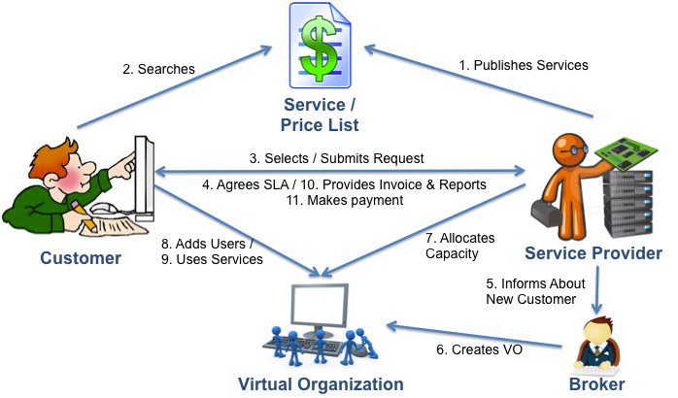

*In the future, as the broker model matures, it will take a more central role in this process.*

## Steps/Instructions

### Publish pricing information per service (Provider)

GOCDB is the EGI component that stores semi-static information about sites and services. Among other things, it acts as a simplified configuration database (CMDB in service management terms) that other tools can use to gather information about sites and services.

In order to gather the prices that sites were charging, a new feature in GOCDB V5 was used. This is called ‘extensions’. Any number of arbitrary key-value pairs can be added to a site or service. GOCDB has a subsidiarity access control model where control of the database is devolved to the appropriate level. For sites, this is the set of sys admins defined within the GOCDB. So, charging rates are a ‘folksonomy’ bottom up definition by consenting sites. No central control, just an agreement within the pilot. The sites define their charging rates and other tools like the accounting portal (see table below) can pull the information and apply it.

An initial set of keys was defined. Once proven in the pilot, the set can be extended indefinitely to cover a richer set of charging/pricing schemes. The only limitation is that what one is charging for must be recorded or measured and published in the accounting.

The values are real numbers with the meaning shown below. Sites defining these keys and values are de facto members of the pilot.

|  |  |  |
| --- | --- | --- |
| Charge Type | Key Name | Pricing |
| Grid CPU | P4U_Pilot_Grid_CPU | Euros/HEPSPEC06 Hour |
| Cloud CPU | P4U_Pilot_Cloud_Wall | Euros/Hour |
| Storage | P4U_Pilot_Storage_Use | Euros/GB*month |
| Cloud Storage | P4U_Pilot_Storage_Use_Cloud | Euros/GB*month |
| VAT | P4U_Pilot_VAT | Optional VAT rate to be applied to above |

**Instructions for Providers:**

If you do not have access rights to change features of your site please ask the site manager or a site admin to do it for you.

1. Go to GOCDB https://goc.egi.eu;
2. Navigate to your site. (My Sites) at the top of the left hand sidebar.
3. Just above the list of Services you should see a new box called 'Site Extension Properties'
4. At the bottom of this box there is a big green plus titled 'Add Properties' – click on it
5. This should show a window with two fields 'Property Name' and 'Property Value'
6. For 'Property Name' insert the 'Key Name' according to your desired 'Charge Type' (see table above) e.g. P4U_Pilot_Grid_CPU
7. For 'Property Value' insert a real number, which will be interpreted as shown in the Price Calculation column in the table above, e.g. Euros per HEPSPEC06 Hour.
8. Click the button 'Add Site Property'
9. If you go back to the site view you will see the 'Key Name' listed. You can edit or delete it.
10. Then add other properties from the table above as appropriate for your site.

Once you have done this we will query GOCDB to pull the values for the pilot sites and the accounting portal will join them with usage data to produce a charging report.

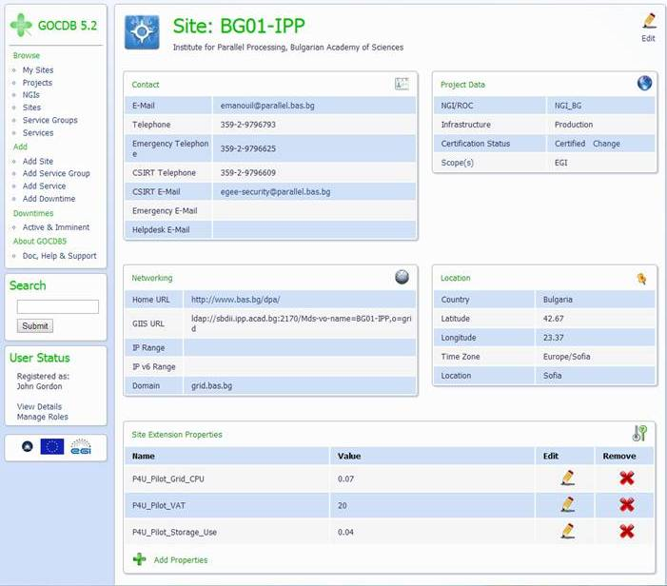

### Customer service discovery

e-GRANT is a service that simplifies managing capacities for providers and enables negotiation of SLAs both for customers and providers. Currently, within EGI e-GRANT is used for brokering offers from NGIs and sites in order to compose satisfactory allocation (element of customer SLA) based on the customer request and available resources – it is a tool for EGI Resource Allocation Process. Offers from providers, called resource pools, are collected and managed. Each pool description contains the offered capacity, common technical specification of resources, model of allocation, levels of guarantee and customer acceptance policies. From the customers perspective e-GRANT is a single point of contact for allocation of resources.

When creating a system for Pay-for-Use Activity, many of the functionalities developed for the Resource Allocation Process were used with slight modifications in the P4U system to maintain compliance between the two processes.

Implementing the Pay-for-Use process in e-GRANT started with engaging Pay-for-Use resource providers in the creation of resource pools. According to its definition a Resource Pool is the specific resource capacity available for allocation. Every pool needs to be described in detail so the resources requested by Customer can be matched properly to capacities available.

To achieve this, the Pay-for-Use Resource Provider logs in to the system, enters the 'Pools' section and starts the 'Create Pool' action by clicking on the green button. This initiates a form where the provider should describe the newly created pool.

The first step requires defining general information about pool management:

1. Enabled/Disabled

Provider decides if a Pool is available for the Customer at the moment.

1. Quality of service:

For computing resources a Resource Provider can offer different types of access to resources according to its local policies and the user requirements:

* [Level C1: Opportunistic](https://wiki.egi.eu/wiki/Resource_Allocation_Terminology#Level_C1:_Opportunistic). Resources are not guaranteed and are subject to local availability.
* [Level C2: Time allocation](https://wiki.egi.eu/wiki/Resource_Allocation_Terminology#Level_C2:_Time_allocation). Resources are available in fair share-like mode for a fixed time period.
* [Level C3: Reserved allocation](https://wiki.egi.eu/wiki/Resource_Allocation_Terminology#Level_C3:_Reserved_allocation). Resources are exclusively reserved to the VO and the job will be executed immediately after submission.

1. Pool Types:

For the resources offered to the EGI Pool, the Resource Provider can play different roles in the resource brokerage process according to its local requirements.

* **Free hands:** the broker, responsible for matching demand and offer, is free to allocate the resources from one RP Pool according to local criteria which aim to optimize usage of available resources and user demand. The Resource Provider delegates the responsibility of accepting a proposed resource allocation to the Broker.
* **Right to revoke:** the broker matches demand and offer and defines a resource allocation proposal. The RP Pool Manager is responsible of accepting or rejecting the resource allocation proposal of the Broker (EGI.eu), in case of no reply to a Broker's proposal after a default time, the resource allocation proposal is considered to have been accepted.
* **Negotiation:** the broker matches demand and offer and defines a resource allocation proposal. The RP Pool Manager is responsible of accepting or rejecting the resource allocation proposal of the Broker (EGI.eu) and to explicitly accept or reject

1. Local policies:

Provider describes any additional requirements/ capabilities (e.g. information about accepting only particular VOs)

1. Select Entity:

Provider chooses a site, from the list available for him, which will deliver resources.

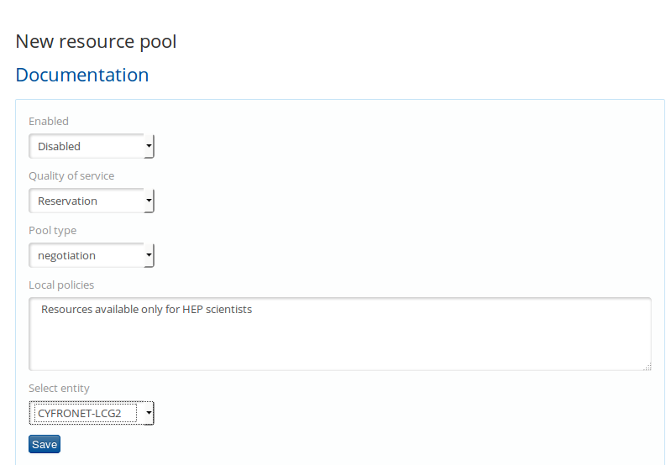

The second step involves resource description. The provider declares which resources will be available for Pay-for-Use Customer along with their technical specification and price for a specific resource type. Default pricing is taken from GOCDB, where providers specify fixed prices for resource types using the ‘extensions’ feature. However, the Provider can choose to change it regarding special offers for customers that qualify for them or prices that are subject to individual negotiation. Prices for resources defined in the Pool description will be used for creating an offer for the customer's Resource Allocation Request.

Every resource kind can be described with a set of dedicated metrics. Every metric has a detailed description to help the Provider in engaging a new resource pool.

The resource types supported by e-GRANT are:

* HTC Computing
* HTC Storage
* EGI FedCloud Computing
* EGI FedCloud Storage

The full list of resource metrics with descriptions is available on the EGI wiki page: <https://wiki.egi.eu/wiki/Resource_Allocation_Metrics_Description>

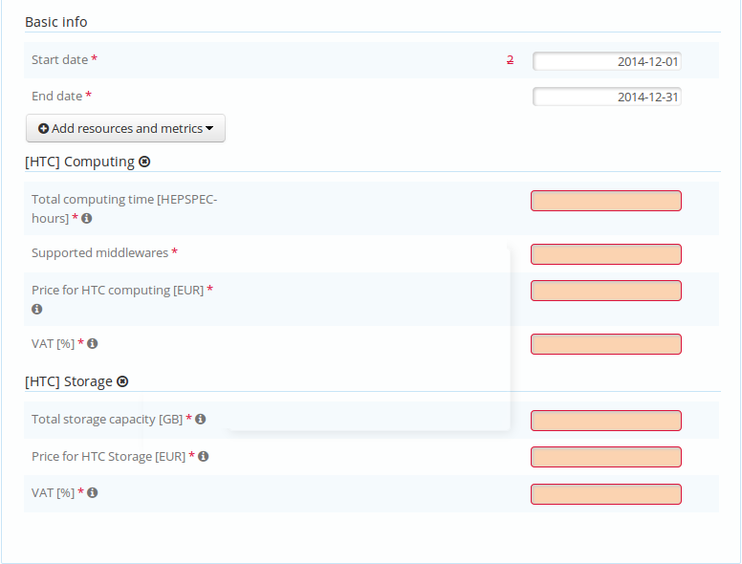

Filling in all required information (red boxes) enables the provider to save the Pool and make it visible for Pay-for-Use Customers (the 'Enabled' option must be set).

Enabled resources offered by Pay-for-Use providers are presented to the Customer on their dashboard. The Customer discovers the services, which are categorized by resource types offered (example shown for 2 types of resources: HTC Computing and HTC Storage).

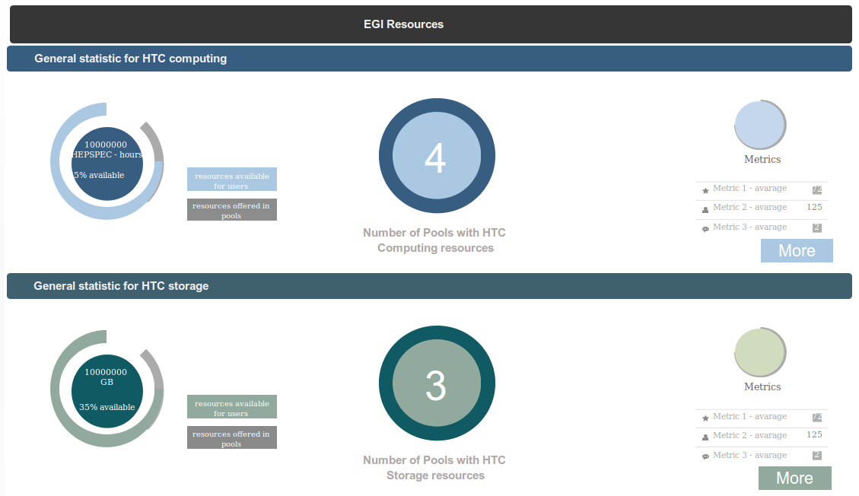

For a specific resource type, the Customer finds out the following general information:

* Total amount of resources offered in EGI
* Amount of resources available for customers at the moment
* Number of pools supporting given resource type
* Average numbers for metrics describing given resource type

For more information, the Customer clicks on 'More' button, which directs them to a separate Pool view (also available from 'Pools' tab). From this point the Customer can investigate specific pools available for a resource type that Customer is interested in.

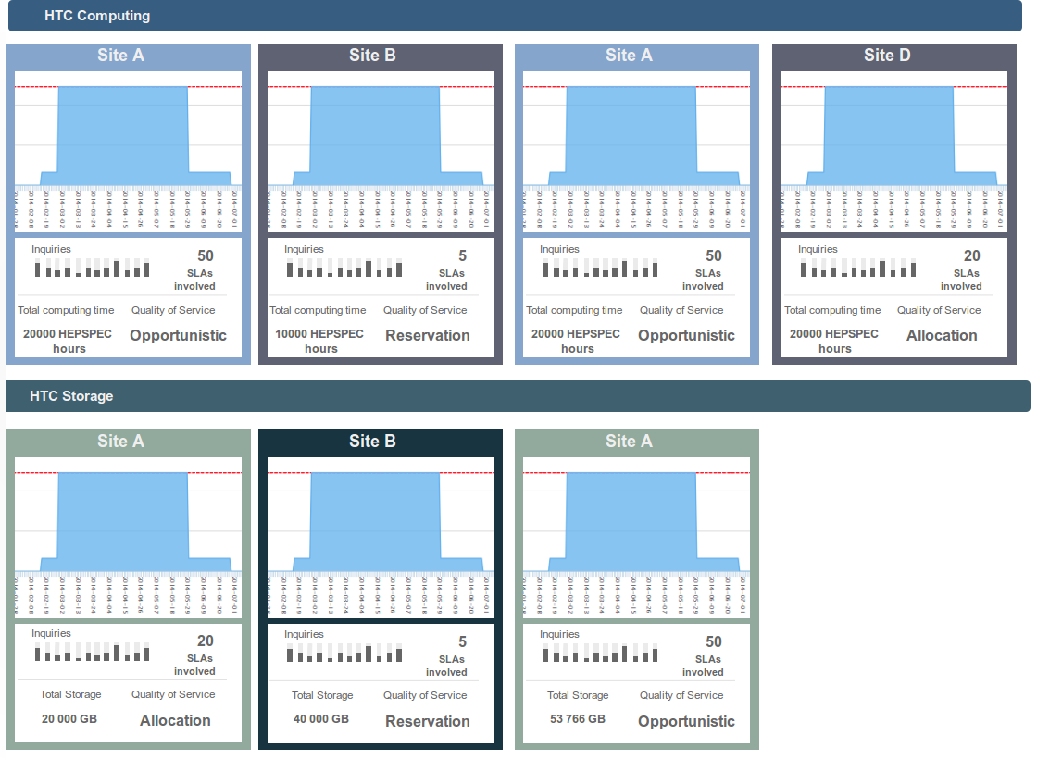

Clicking on a specific Pool box enables them to see detailed information about the Pool:

* Period when the Pool is available for Customers and Users
* Metrics describing the resources offered by the Pool (different set for every resource type)
* Information on pool management (Quality of Service, Pool Type, Local policies)
* Graphs for resources already allocated for this Pool (Pool capacity)

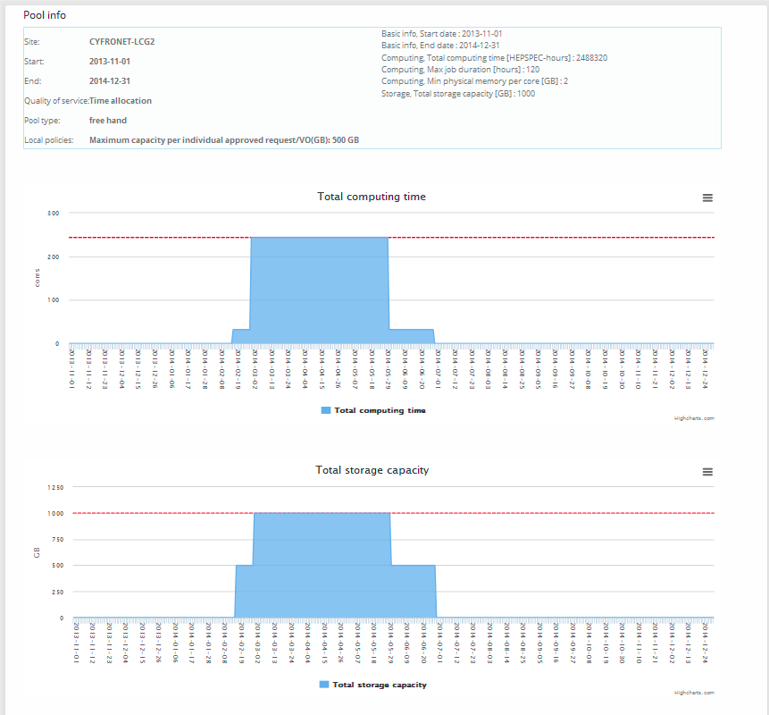

After service discovery the Customer is ready to prepare a Resource Allocation Request, which will include specification for the resources sought by the Customer.

### Customer service selection and request submission

Submitting a request for resources is a simple procedure that the Customer needs to follow in order to start the process of Pay-for-Use resources negotiation.

Actions to be taken are congenial to steps required in Pool creation.

The Customer clicks on a 'Create new RA Request' button, which initiates Resource Allocation Request form. The from is divided into 2 parts:

1. First, 'Basic Info' specifies the general information about the request and the Customer (period for requested resources, name of the VO that Customer is affiliated with, name of the Project that will use allocated resources, what kind of computations will be performed).
2. Second, 'Resources and Metrics' contains the technical description of the requested resources. Metrics that the Customer needs to fill in are either adequate to those specified in Resource Pool or have their equivalents.

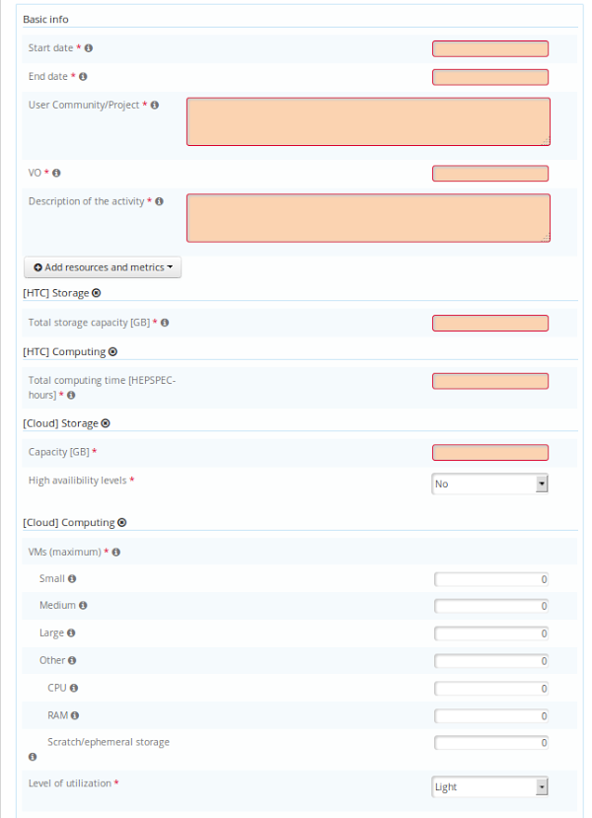

After completing the form Customer can:

* Send it to the EGI Broker, who will look for resources available for Customer's RA Request,
* Use the 'Find Pools' function, which will show Resource Pools Adequate for specified resources.

The second option allows Customer to browse Pools available for his RA Request, assess their adequacy as there is numeric indicator (Score) showing compatibility of a Pool with the given Request and choose the Pools which will contribute to Customer's RA Request.

The numeric indicator takes into account if the resource parameters in the Pools match the metrics specified in the RA Request and the calculated price for requested resources. Better offers will rank higher in the Pool list. Maximum value for a Pool score is 1.

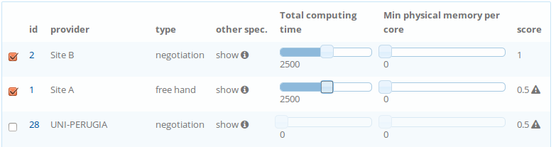

Selecting a Pool creates an OLA with the Resource Provider containing the specified parameters for requested resources and the total price for them.

After the Customer chooses the appropriate Pools, he can send an RA Request with underpinned initial OLAs to the EGI Broker to start negotiation process.

### Customer agrees and signs an SLA

Negotiating and agreeing on resources involves all three stakeholders (Customer, Broker, Provider). Negotiation includes the amount of resources to be allocated, their technical parameters and price setting which might vary according to defined by Provider different resource offers. After agreeing on resource specification and price, the SLA can be signed. The Pay-for-Use negotiation process is consistent with the negotiations taking place in Resource Allocation Process.

The SLA is based on the FitSM service management standard. See Annex 3 – SLA template.

The whole process is supported by relevant e-mail notifications.

### Broker creates a VO per contract

A Virtual Organisation is a group of people (e.g. scientists, researchers) with common interests and requirements, who need to work collaboratively and/or share resources (e.g. data, software, expertise, CPU, storage space) regardless of geographical location. They join a VO in order to access resources to meet these needs, after agreeing to a set of rules, Policies and SLAs that govern their access and security rights (to users, resources and data). The Broker will create one or more Virtual Organisations (VOs) in a primary and a backup VO management system, according to the requirements specified by the customer. The procedure to create and deploy a VO in the EGI infrastructure is described in Proc14[7].

Regarding pay-for-use, we envisage two different scenarios depending on the requirements of the customer.

* **Scenario A:** The broker may create a VO per contract when the contract covers all the associated Resource Providers. Different levels of SLAs may be supported as needed by using VO groups associated with different priority queues and/or quotas.
* **Scenario B:** The broker may create a VO per customer or use case when the customer creates one contract per resource provider. In this case, the Broker will create one VO for the customer that may cover more than one contract with Resource Providers.

### Allocating capacity

On the basis of the signed OLA, the Provider receives notification that between given dates, machines needs to be appropriately reconfigured. Reconfiguration will consist of enabling a specific VO to access the machines and allocate resources accordingly to the signed OLA (resource metrics) and local policies.

Provider can manage allocation using system notifications, a list of currently binding OLAs (which will tell Provider about specific OLAs, their parameters and dates for allocation so adequate changes of enabling or disabling access to machines can be made) or Pool information view. From the Pool, one can discover what resource capacity is left for allocation for the Customers at that moment, how future allocations will look (based on signed OLAs) and how many resources were used by the customers in the past.

### Customer adds/enables users

The Customer should appoint a contact person and deputy that will be allocated the VO manager role in the corresponding VOs in order to manage the user registration/deregistration using the VO management system (VOMS). The VO manager may create one more VO groups in order to allocate users into different SLA Levels.

### Customer usage and accounting

#### The consumer uses the services and receives a monthly usage report. However, users will have access to the Accounting Portal for their VO (updated once a day).

The Accounting Portal is the central tool to visualize the computation time and jobs that are run in the infrastructure, their site, VO, date, efficiency, etc. The portal has many specialized views and reports. For the pay-for-use activity, the general, cloud and restricted user data views were supplemented with a new Computation Cost metric. This metric estimates the cost incurred in computations.

In order to do these computations, the Portal needs to know the price in euros for normalized HEPSPEC06 hour (for Grid jobs) or euros per Wall clock hour (for Cloud jobs) for each site, GB/month (for storage) and the current applicable VAT. This data is pulled from the GOCDB extension data for each site in the PoC. With this, the portal can convert normalized or wall hours to estimated prices in euros. Sites can also formulate special prices for individual users.

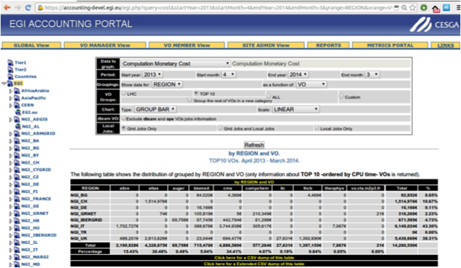

SLA reporting will be part of e-GRANT. If needed, regular accounting reports can be generated based on the agreed SLA.

### Customer receives an invoice and pays

The advantage of integrating invoicing with e-GRANT is that SLA may contain information about the valid final price. For example, an SLA can have data on the active allocation period or level of guarantees or fixed/special price for the contract. Additionally, pricing schemes need to be implemented in e-GRANT to give at least an estimate of the price for the customer before an SLA is signed. Generated e-invoices can be available in e-GRANT together with all other documents related to SLA.

Initially, the customer will directly pay the service provider(s). Future work will be on describing a more integrated Broker role with EGI.eu serving as an intermediary between customers and providers to reduce many-to-many relationships, with an associated business model e.g. percentage of transactions, per contract fee. See section 4.2.

This work will be part of 2015 activities.

## IT Service Management

### FitSM Standard

In order to deliver services to the quality and level of professionalism required for paid use, some form of formal management approach is required. EGI selected the FitSM standard, created by the FP7 FedSM project (in which EGI.eu is a partner). FitSM is based on the international standard, ISO/IEC 20,000 and takes input from other approaches such as the ITIL best practice framework and COBIT governance framework. It is a standards family offering the basic requirements for a managed IT service as well as concrete support for implementation including documents, templates and management tools. FitSM supports both federated models and other situations where ITSM is not well established and existing approaches are too heavyweight or make invalid assumptions.

Participating in FedSM also provided EGI.eu with consultancy on how to introduce formal service management, which benefitted the Pay-for-Use PoC, especially as key partner Cyfronet (who develop the e-GRANT tool) are also implementing FitSM and are part of the FedSM project. Consultancy provides active support to help EGI.eu support transit of the EGI community from a research mode to a service delivery model based on a clear idea of customer needs and value delivered, and so supported EGI sustainability efforts.

Pay-for-use implementation will re-use EGI’s overall ITSM processes and procedures, only revising as necessary e.g. SLAs, OLAs (see following section).

### SLAs, OLAs, and Contracts

EGI has been working over the last year to restructure its SLA and OLA framework with a service-oriented approach using FitSM to implement better business practices and to understand the types of agreements between the various providers. Also, the individual content of the current SLAs were reviewed to ensure appropriate language is included regarding liabilities. A new user SLA has been developed and is provided as part of Annex 3.

Contracts are still handled on an individual provider level according to the organization terms and conditions. An EGI.eu broker contract will be created as the business model develops in 2015.

### Service Catalogue Record

A Service Catalogue Record (SCR) was produced for specifying the minimum required information any resource provider will need to provide for being included in pay-for-use service provision that includes the organisation general information, service offering and service level capabilities. The structure takes input from fields required in e-GRANT, information provided by the Helix Nebula Marketplace, and common technical requirement requests from external organisations looking to partner with EGI (e.g. Engineering, Zenotech). This can be completed by current or new providers through an easy to use Google Form, which automatically collates information within a Google Spreadsheet. The SCR template is provided in Annex 4.

# Business Models

## Pricing Schemes

The EGI pay-for-use activity started to look at pricing starting with HEPSPEC/hr. (Grid), Wallclock/hr. (Cloud) and GB*month (Storage). However, it will be important to offer flexibility to resource providers to create service packages. There are a number of pricing schemes available (see table), however pricing schemes and service packages are not unlimited, as it will depend on the technical functionality and capabilities to account for the usage.

The GOCDB offers a flexible solution in that, extensions are almost unlimited and various columns can be added and formulas created that could allow any service provider to dictate their own pricing and service packages. Pricing schemes can also be handled directly through e-GRANT.

|  |  |
| --- | --- |
| Variables | Description |
| Subscription | Pay for X number of resources from the price calculated from the GOCDB, which is already associated to a resource type for a given time. Billing can be done at end of cycle to adjust for unused resources or can be stimulated as “use or lose” as you had to reserve the resources. |
| Usage | Usage Volume 1: First X amount is Y; anything over N decreases to Z.  Usage Volume 2: Up to X amount is Y based on availability; anything over N increases to Z to lean on a third party supplier. |
| Freemium | First X amount is free; anything over N decreases to Z (probably more for storage). |
| Overage | Price changes if exceeding the original allotted amount. |
| Pay-you-go | No or minimum limitations are given on the number of resources that can be consumed. Billing is done on a periodic basis (e.g. monthly) based on actual consumption. Probably not until later or with only trusted users. |

Other option being explored is the concept of “Flavours”, which is being used in the EGI Federated Cloud as well as at CSC. This potentially presents the easiest implementation option moving forward. However, even if it allows providers flexibility to apply prices to specific customer and potentially increases customer appreciation with tailored pricing, it also requires more understanding of specific customer needs (overhead) and results in less automation (difficulty for long-tail).

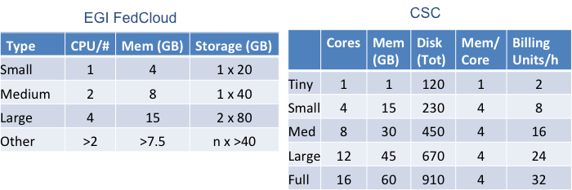

## Broker Models

As EGI operates in a distributed environment, services are provided by a variety of different organisations spread across Europe and beyond, it considered and proposed different roles, models and plans for applying those within EGI. EGI.eu could play the role of a ‘federator’, providing the necessary technology, processes and governance to enable users to access an integrated set of services from autonomous organisations. The NGIs could also play a similar role on a national level.

Three main models were presented that could apply within the EGI ecosystem: The ‘Independent Advisor’ model, the ‘Matchmaker’ model and the ‘One Stop Shop’ model. In the ‘Independent Advisor’ model, the federator provides a general listing of services, facilitates relationships between customers, consumers and resource providers while playing only a support role if required during the service lifecycle. Through the federator, resource providers can promote their services to customers, while retaining the direct dialogue concerning the resource allocation, contracts and financial transactions. This model requires the customer to interact within individual (potentially multiple) resource providers to obtain the services it requires. Therefore, interactions are decentralised leading to higher overheads for the number of relationships that customers/resource providers must maintain. The federator is able to fund the services it provides through a membership model, which restricts the customers and resource providers that can use them. This is the current model used by EGI.eu.

Figure 1 - The Independent Advisor model



In the ‘Matchmaker’ model, the resource allocation is managed by the federator. The customer discusses requirements and receives a resource allocation from the federator with a resource provider. The contractual agreement is established by the federator with the customer on behalf of the resource provider but any financial transaction is handled directly between the customer and resource provider with the resource provider paying the federator for establishing the contractual agreement. This model is more suitable for customers who need access to many resource providers.

Figure 2 - The 'Matchmaker' Model



The ‘One Stop Shop’ model fully relies on the federator to handle the service publication, matchmaking, contract and agreement negotiation, as well as financial transactions. The resource provider receives payment for the resources used by the consumer collected by the federator from the customer. Reliance on such a service reduces organisation overhead on both customers and resource providers by offering them a single point-of-contact to many independent counter-parts.

Figure 3 - The ‘One Stop Shop’



Currently, the ‘Matchmaker’ model will be used, which has been given the name of ‘Trusted Third Party’ in a finer grain business model overview (see table below). This includes all the characteristics of the One-Stop-Shop except for the invoicing, which could be implemented by a few members that have shown interest in a longer term 2015-2016.

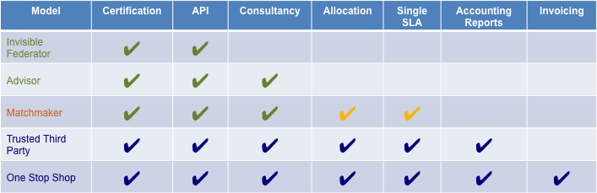

EGI.eu does/can fulfill most models, however several question need to be answered moving forward:

* Do current legal structures support a one-stop shop?
  + VAT required; legal status to support commercial activities
* Need to define pricing scheme and price for service
  + % of transaction; Subscription from providers within marketplace?
  + Ensure model does not distort market (e.g. en/discourages providers changing customer pricing)
* Can EGI realistically serve both indirect and direct payment models?
  + Clear process needed to define when and where applied (e.g. user location; provider preference)

## Joint Development Projects

Some of the participants indicated that they have a non-for-profit legal status and as such they are not able to issue invoices for the consumption of resources. One of the ideas that was proposed to circumvent this issue was to formulate joint development projects where shareholders participate equally in the project and the Resource providers offer the required resources. Within this model, it would be possible to exchange services including monetary support, whether for the consultancy (human) effort and/or resources provided.

## Consultancy

In a typical business model, services are offered to customers with a price imposed by the market, as is the case of major private resource providers. On top of that, additional limitations imposed by the private resource providers are related to:

* Limitation of liability
* No guaranteed services
* Loss of product property

They do not offer a capillary user support aimed at achieving the particular requirements and needs addressed continuously by the research communities EGI is dealing with.

For such reasons EGI provides not only a privileged channel with the computational resources providers and a set of dedicated user support services for the already consolidated Grid users but also consultancy, application porting and training support for new users and new communities that would like to exploit the Grid and Cloud infrastructure. User Support activities are carried out in close collaboration with the support teams of the National Grid initiatives that, operating locally, can address needs and requests of the users.

The vast expertise from the community to support potential customers is a high added value that should not be underestimated when considering pay-for-use mechanisms and look to diversify revenue streams beyond “€/CPU”. These activities are already embedded in EGI.eu and NGI service portfolios.

# Business Engagement

Additionally, several real world business opportunities have presented or will present themselves over the next year. These specific cases are allowing the group to answer specific questions when it comes to understanding what additional information needs to be understood and provided or technical work to be developed.

## Collaborations

### Helix Nebula Marketplace (HNX)

The Helix Nebula Marketplace (HNX) was launched in May 2014 and represents an opportunity for EGI resource centres to offer their resources through the marketplace. The technical integration of the EGI Federated Cloud sites is an on-going process with 5 EGI cloud sites tested or is under testing (CESGA; CESNET; GRNET; IFCA; INFN-Bari). This relies on the development of an OCCI connector for the SlipStream broker technology that has been funded by the EGI-InSPIRE project and released as open source.

From the organizational viewpoint, two main business models have been identified:

1. Private integration of owned resources for free access: the EGI providers would be enabled and visible from the marketplace only to those user communities who have received a grant for the use of EGI resources free of charge and whom have made an explicit request to HNX to reach commercial providers; EGI.eu in collaboration with the EGI providers needs to define an agreement with the Helix Nebula Marketplace operator on the business model for access to EGI resources (e.g., free for the volume of activities on the EGI sites if the revenue from the commercial providers exceed a certain threshold; fixed fee).
2. Public integration of resources for paid access: the EGI providers that aim to offer paid services through HNX will sign the commercial agreement with the marketplace operator and are allowed to list their resources on the service catalogue for all potential customers.

Discussion is on-going as to whether resource providers within the EGI Federated Cloud are requested to sign the Helix Nebula Marketplace (HNX) Memorandum of Understanding. The marketplace operator is transitioning after CGI decided to quit this role. At the moment, HNX is managed by a consortium of commercial providers that signed the MoU and a new setting will be discussed in early 2015 to have an operator that is independent from the suppliers.

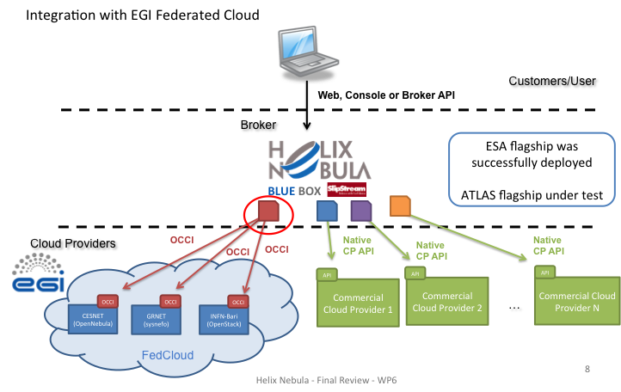

In order for a Service Provider to join HNX, the following steps are needed:

* Complete the HNX service catalogue record
* Integrate with SlipStream connector
* Sign a commercial contract agreement with the Marketplace Operator
* Integrate with the support structure of the Marketplace Operator

### 100% IT

100% IT is a UK based SME Resource Provider that has been participating within the EGI Federated Cloud. The EGI pay-for-use proof of concept allows 100% IT to collaborate on the development of sustainable business models that are both suitable for, and easy to understand by the range of publicly funded research and academic groups who act as consumers while also being commercially viable. The development of a consistent Service Level Agreement allows consumers to more easily compare the offerings from multiple suppliers. This in turn has the potential to increase the size of the marketplace by making it easier for consumers to purchase from European suppliers.

As a commercial supplier, they are comfortable with the concept of pay-for-use as it has been widely accepted by commercial customers and is now seen by them as the preferred billing model. This change has not occurred to the same extent in publicly funded research groups. They have seen issues around taxation when working with public groups that cross international borders and have also seen that some consumers currently have organisational difficulty paying for resources on a per-hour basis as opposed to paying a fixed capital cost for a resource. Developing best practices in the pay-for-use models and encouraging them to be widely used by providers and consumers will help to highlight any potential issues and allow them to be avoided. Increasing uptake of pay-per-use as a way of obtaining infrastructure will also streamline organisational payment mechanisms.

The best-case scenario beyond the end of the proof of concept is the creation of a lasting competitive marketplace with academic consumers easily able to access resources elastically to meet their changing needs.

### IFCA-CSIC Industrial Use Cases

IFCA data centre at the University of Cantabria in Spain installed new computing resources in 2012 oriented to promote innovation. Since then, pay-per-use services are offered to researchers in the academy and also in private companies.

The following table lists some of the different initiatives on-going, representative of different use cases (small/large companies, open/licensed software, software as a service/infrastructure as a service, Windows/Linux based framework).

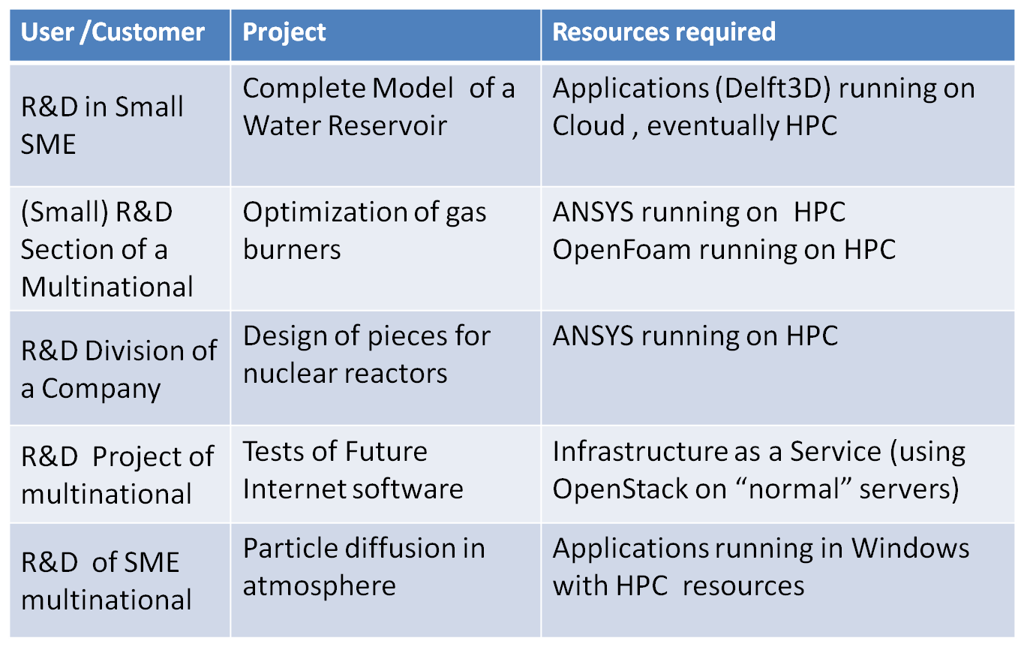

Some of the basic facts that our group has learned are the following:

* **Publicity is a key first step**
  + Most companies do not know this service is feasible
  + Transparency (public fares) is appreciated
* **Not all projects are feasible**
  + They only work for R&D (& innovation)
  + They did not support a company addressing bitcoin generation
* **It is not so easy to engage/convince everybody**
* **Communication is the key factor**
* **Administrative problems can be solved**
  + Publication of fares is a good first step
  + Direct Billing is a bit more flexible than Contracting
* **They do not believe on business cases and sustainability analysis**
  + If it makes sense, let’s do it.

This last point is that within their experience many times the success of collaboration in research/innovation projects, even if under a pay-for-use umbrella, is based on the interest and competence of both sides, as this defines the potential impact of the project and finally the business results.

Regarding the structure required to support this effort in their site:

* **A support team is key**
  + An excellent team means simply that you will offer excellent solutions
  + Combine R&D and service or it will not work
* **Infrastructure for R&D is not for “critical services”** 
  + They inform clearly about this, they do not offer such services
  + But we keep a high level of support (and information)
* **R&D services are yet services**
  + Yes, they are part of the University Research Services
* **User support**
  + They use the same ticket service than for Academy/EGI
* **Infrastructure/Middleware configuration must be flexible**
  + Users ask for dedicated large machines, for Windows images...
  + Want “Dropbox” like, TeamViewer, do not use certificates...

It must be clear since the start to both sides that we do not aim to make “money”, but to collaborate on innovation/research, with adequate funding, which should cover all costs.

Finally, some very clear messages that they have learnt:

* **You should care about your customers** 
  + Know them, learn what they may want
  + Offer extra support when possible
  + Participate in joint meetings, workshops, initiatives
* **They have put their confidence on you** 
  + Be proud and Make them be proud of the collaboration
* **So, avoid commenting details, problems, etc. both in public and privately**

## Opportunities

### European Space Agency

The European Space Agency (ESA) is an international organisation spread across 20 Member States. It has a mission to “shape the development of Europe’s space capability”.

It has a dedicated procurement department that prepares Invitations-To-Tender (ITT), Requests-For-Quotation (RFQ), Contracts and Purchase Orders and then manages contracts with successful applicants.

All contracts must be transparent and fair to all parties and not cause any distortion of competition in relation to private economic operators. They must be the most economic and effective use of the Agency’s resources and must distribute work among the Member States.

Tendering is an open, completive process as standard. Procurements are open to all Economic Operators with some exceptions to the rules such as limitations aimed at supporting SME and R&D entities. Any ITT will have precise details on the rules that apply to that procurement. The ESA Industrial Ombudsman acts to guarantee that ESA procurements are transparent, impartial and non-discriminatory.

The ESA has an online portal allowing potential bidders to review upcoming ESA procurements. This system is known as EMITS (Electronic Mail Invitation to Tender System) and can be accessed at http://emits.esa.int/emits/owa/emits.main The EMITS system provides a brief overview of intended ITTs which issued at the beginning of the year and subsequently updated at least once per month. Full tender details can only be viewed by registered users. Registration to obtain these details is compulsory but just involves a simple questionnaire and agreement to their standard terms and conditions. The ESA will manually check that the applicant qualifies as a potential ESA supplier and then provides their username and password.

Procurement is designed to achieve the best possible trade-off between the objectives of technical excellence, economy and the ESA’s industrial policy. It tries to ensure that tenders will be evaluated impartially and fairly and consists of the following phases:

1. The Planning and Preparatory Phase
2. The Initiation Phase
3. Preparation of the Invitation to Tender / Request for Quotation (ITT/RFQ)
4. Distribution of ITT/RFQ
5. The Tendering Phase: Preparation and Submission of an Offer
6. Admission and Evaluation of Offers
7. Award and Placing of Contracts
8. Debriefing of unsuccessful Tenderers
9. Control of the execution of the contract
10. Closure of the contract

Full details of phases 1-8 can be viewed in the Tender Evaluation Manual on EMITS.

ITTs are often very demanding in terms of requirements for international co-operation due to industrial policy and geographical distribution requirements. The SME initiative encourages tenders from consortia, which include SMEs. As such this represents a significant opportunity for the EGI resource centres who, by definition, are widely geographically distributed and include SME organisations.

The pricing model for tenders frequently request either a Firm Fixed Price or a Maximum Ceiling Price. Where the ESA foresees a multitude of similar procurements being placed with a company or group of companies, the ESA sets up a “Frame Contract”, which acts as a global agreement outlining the standard contract terms, management and financial conditions to allow each individual action to be contracted with little paperwork e.g. via a work order. This again works well with the EGI model as the EGI could negotiate the Frame Contract and act as a broker distributing smaller individual work orders to the Resource Centres.

### Cloud for Europe pre-commercial procurement (PCP) tender

The Cloud for Europe project[8] aims to "enable public sector cloud adoption in open dialogue between public sector and industry". It started in June 2013 and runs until November 2016. It is co-funded by the European Commission under the Framework Programme for Research and Innovation (FP7).

The public sector is supposed to provide industry with the list of cloud services that don't fit their requirements coming from data protection, security and legal issues and contractual aspects. Industry should use those find innovative solutions for cloud services to overcome those obstacles.

PCP (Pre-Commercial Procurement) is one particular approach for procuring R&D services only, which enables public procurers to develop common solutions towards concrete public sector needs.

The Cloud for Europe tender for the joint PCP of research and development on cloud computing services, launched 15 Dec 2014. The purpose of the tender is to research and demonstrate solutions to overcome obstacles for the adoption of cloud computing by the public sector.

Public Universities and Public Research Institutions are eligible to participate to the tender as individually or collectively suitable economic operators. Economic operators are entitled to submit offers either individually or by way of a consortium or association comprising several Tenderers or Groups of economic operators. For each Phase, at least the 70% of Research and Development services shall be performed within the European Member States.

The entire PCP procedure will be carried out under Italian law, see 1.4 of the Tender Regulation document[9].

The main contact point for the tendering process is the lead procurer in the Cloud for Europe project – Agenzia per l’Italia Digitale (Italy), acting on behalf of the project’s other procurement partners – Ministerie van Financiën Directoraat-generaal Belastingdienst (the Netherlands), Entidade de Serviços Partilhados da Administração Pública (Portugal), The National Institute for Research & Development in Informatics - Ministry for Information Society (Romania), and Ministry of Finance of the Slovak Republic (Slovakia).

The PCP procedure is divided into 3 (three) lots and each lot will provide a Framework Agreement

for the realization of research and development services:

* LOT 1: ”Federated Certified Service Brokerage (FCSB)”
* LOT 2: ”Secure, Legislation–Aware Storage (SLAS)”
* LOT 3: ”Legislation Execution (LE)”

The Tenderer of each lot will provide:

* Phase I -> the solution design (2 months);
* Phase II -> the development and integration of a prototype (7 months);
* Phase III -> the original development of a limited volume of first products or services in the form of a test series (5 months).

Each Tenderer can participate in one, two or all the three lots for which it meets the requested requirements. The maximum overall amount available for the realization of the project is equal to 4 million euro:

* Lot1: € 40.000 for Phase I; € 197.333 for Phase II; € 333.000 for Phase III;
* Lot2: € 40.000 for Phase I; € 197.333 for Phase II; € 333.000 for Phase III;
* Lot3: € 30.000 for Phase I; € 138.667 for Phase II; € 234.000 for Phase III.

For each lot, several bids will be awarded a framework agreement. After each phase, results will be evaluated and bids will compete with each other for assignments in the subsequent phase.

The challenges the C4U wants to address through the Tender are described here[10] (see especially 1.2).

The tenderer must submit strictly by no later than the 20th of February 2015.

For further information including the tender specifications, please refer here[11] and to the tender web page[12].

Within EGI, Cloud Resource Centres indeed can be interested in having the public sector as a particular customer; the PCP gives the opportunity to the industry (large corporations, SMEs and non-profit organisations) to offer they services to develop brand new solutions to address the PA use case.

Also, this might be a good opportunity for EGI and/or those EGI members that look for additional sources of income. The main objective is developing new solutions, that is R&D.

Later it can also generate commercial benefits through the exploitation of the IPRs, but it can also be negotiated with the procurer to keep the IPRs, if the bidder is not in the position of exploiting them.

Given the publication date of 15 Dec 2014, further activities will be carried out during 2015.

### Others

In addition each of the previously mentioned area, EGI has also been in discussion with several other organisations to explore potential areas of collaboration. The following table summarizes these:

|  |  |  |
| --- | --- | --- |
| Company | Collaboration Area/Opportunity | Website |
| Engineering SpA | Looking for resource providers to support large contract for processing research data. | www.eng.it |
| Charity Engine | Desktop computing (BOINC) - revenue sharing model (1/3 provider, 1/3 charity, 1/3 company); Broker agreement available for € based on users brought. | www.charityengine.com |
| Arctur | Provides cloud and HPC services; Already serving Alice LHC. Interested in joining the EGI "marketplace” as a provider. | www.arctur.si |
| Zenotech | Runs a marketplace via their “Epic” product for aerospace, automotive, civil engineering and renewables – contacted EGI to have providers visible in marketplace to serve their customers. | www.zenotech.com |

Several others are coming through the newly defined, but not yet published/marketed EGI Business Engagement Programme (see Section 5.4 below).

## EGI Federated Cloud Task Force

The EGI Federated Cloud recognises and supports the requirement of providing Cloud resources in a pay-for-use relationship with its users/customers. The FedCloud team has not yet identified users and collaborations that would be eligible for pay-for-use Cloud resources, however dedicated discussions have started to take place between the two groups to refine a general strategy and approach as these use cases present themselves. One specific use case has expedited this necessity in the area of RNA-sequencing. This has been recently strengthened by the requests of many user communities to know the rules of the future pay-for-use EGI Federated Cloud.

The technical roadmap foreseen for integrating Cloud resources into pay-for-use business-relationships is, broadly speaking:

1. Settle on a definitive set of resources that are or will be accounted for (current set of accounted resources is not conclusive) with resource providers publishing pricing information (currently 10 cloud sites).
2. Agree on common resource templates across federated Cloud providers (e.g. SCR).
3. Define whether pricing will be per resource type (e.g. CPU, RAM), per template, both or a mixed model (e.g. the price for resources consumed per template would be discounted from the mere sum of the individual resource prices).
4. Extend accounting model and infrastructure to accommodate pricing requirements defined through the pay-for-use group.
5. Align on-going activities within e-GRANT to properly allow reservation/allocation of Cloud resources according to defined resource and template model.
6. Integrate with a yet to be conceived billing infrastructure.

In the last months, the EGI Federated Cloud Task Force analysed these points and relevant steps forward were made in the following areas:

1. A first version of common resource templates across the FedCloud was defined. This version is currently under review to improve its flexibility. Final templates should be agreed in early 2015.
2. The accounting usage record was revised to include additional parameters that could change the resource prices (e.g. number of IP addresses assigned to a VM). The new usage record will be rolled-out to production during the first quarter of 2015.
3. The accounting portal is now able to compute a cost according to the usage of cloud resources applying a billing function.
4. The e-GRANT resource allocation process was extended to fully support cloud resources. The next e-GRANT, release, foreseen for the end of January 2015, will allow associating a price to the cloud resources. Furthermore, users will be able to consult a catalogue listing all cloud resources available.

The pay-for-use model is considered critical for the future sustainability of the EGI Federated Cloud and much effort will be devoted to have this model up and running in a near future.

## EGI Business Engagement Programme

The Business Engagement VT was launched in April the 1st as an additional effort of the EGI-InSPIRE project due to in order to strengthen the collaboration and knowledge transfer between EGI and industry. There are more than 20 million SMEs in the EU representing 99% of businesses. SMEs are considered one of the key drivers for economic growth, innovation, and employment, and have been put in the lead for the delivery of innovation to the market. EGI recognises that the collaboration with industry is essential for enhancing its own performance and sustainability.

The objective was to define a suitable Business Engagement Programme for SMEs, and identify a number of companies with interest to start collaborating with EGI. The VT recognised the complexity of the EGI environment and diversity of the legal status and strategic objectives of the Resource Providers and NGIs integrating EGI. Much effort and discussion time have gone to identify these issues and in creating a document with a proposal that would avoid potential conflicts.

The main output of the VT was the delivery of the aforementioned document, which proposes a suitable framework for engagement, while respecting the strategic, legal, and organisational issues identified. This document can be found in the EGI DocDB[13]. It outlines the opportunities and benefits for a wide type of private organisations to work with EGI and defines the varying levels of collaboration, proposing a three-layer structure for engagement. The first one would have a low barrier of entry to facilitate the engagement; the other ones would allow the creation of tailored agreements for collaboration.

According to the observations done by the Business Engagement VT, not all the SMEs should be targeted for the pay-for-use activities, but only those that can benefit most from the use of computational and data resources. Targeting a broader segment would simply not be cost-effective. The targeted SME can be characterised as local but with high internationalisation potential, highly technical and innovative. The segmentation is still a matter of discussion, but a first approach identifies a few, which are described as follows:

1. SMEs running or planning to run computational jobs for their commercial activity.
2. SMEs providing and or facilitating computational services.
3. SMEs that can and will in the future develop added value information services based on scientific data produced by research infrastructures.

The first is a consumer of relatively small volume, punctual in time, of computing capacity. They also typically need technical on-boarding for access. They are consulting and engineering companies that develop algorithms, or produce simulations for design and manufacture their own products, or as technical services for third parties.

The second are the enablers. This category includes those companies offering added value services for accessing computational services. They can offer to their own clients a specific PaaS for specific industry sector or discipline. Eventually this category could also include resellers or brokers for this EGI capacity that is willingly offered on a pay-for-use basis. They need specific technical support that on a professional, business-to-business basis, and a privileged channel of access and communication.

The third category is the most underdeveloped so far, but it also has the biggest potential. They are those companies that (will) offer specialised data services. They would made use of the data from research infrastructures, which is made available to them, and process it to offer to other parties for further processing or direct consumers (public institutions, researchers, broader public).

A marketing strategy including product packages, adequate pricing, well-developed distribution channels and promotion activity to well defined segments is needed for a successful launching of the pay-for-use activities.

# NGIs and Resource Centres: Pay-for-Use Status Overview

One the main activities of the Pay-for-Use Proof of Concept is to evaluate legal, policy, and organisational issues around the full implementation of the pay-for-use model. As initial input, each provider described the following:

* What is the motivation for participating?
* What are the main activities happening within your own country and institution resulting from participating in the Pay-for-Use PoC?
* Are you in a position to be “in production” regarding pay-for-use service provision? If not, remaining issues need to be solved?
* What are your plans beyond this initial Proof of Concept?

The individual responses can be found in Annex 2 of this document. Below is a summary of the responses.

|  |  |  |  |  |  |
| --- | --- | --- | --- | --- | --- |
| NGI/Resource Centre | Production Ready | In dev. | Internal discussions | | Comment |
| 100% IT | X |  | |  | Commercial organisation (also involved in the EGI Federated Cloud |
| AEC UoB | X |  | |  | Outside CH users only |
| CESGA | X |  | |  | Also submitted SCR for HNX Marketplace |
| CSC | X |  | |  | State owned private organisation |
| GRNET | X |  | |  | Within joint development projects only |
| IFCA-CSIC | X |  | |  | 5 local use cases of working with industry |
| II SAS | X |  | |  | Customer specific |
| Master-Up | X |  | |  | Limited capacity |
| NGI_IT | X |  | |  | Cloud resources |
| TUBITAK | X |  | |  | Already have experience in running pay-for-use offerings for Turkish projects |
| UIIP-NASB |  | X | |  | During next 2 years, P4U will be integrated into national system of project funding for supercomputing and grid infrastructure |
| Bulgaria NGI |  |  | | X | Non-profit organization; national regulations hinder direct payment for computing time |
| Cyfronet |  |  | | X | Policy and legal aspects in discussion, but if anything, will probably be for non-Polish based users |
| Fraunhofer SCAI/LRZ |  |  | | X | German policy and laws restricting publicly funded/procured resources (being reviewed) |
| Latvia Grid |  |  | | X | Lack of demand/interest, focus on free delivery, but want to be prepared for future policy changes and increased demand |

# Conclusions and Future Recommendations

The Pay-for-Use Proof of Concept group and its more than 40 Members and Observers have been actively engaged over the last year of activities, which has led to the number of results achieved. However, there is recognition that there are still areas of further development to which each participant is committed to continuing into 2015. This report serves as a snapshot of activities carried out and will be used as the starting point for kicking off activities in the new year.

The main areas to focus on can be summarized as:

* User-facing graphical interface – all technical development is complete and a design mock-up created (screenshot in Section 3) – will be ready by end of Jan 2015 (based on e-GRANT)
* Increase automation of varying pricing schemes beyond pay-for-use and packaged services (e-GRANT terminology of “pools”)
* Integrate an automated billing function
* Mature EGI.eu's role as a full central broker
  + Contractually: EGI.eu currently does not have a VAT number and potentially needs a separate business entity
  + Pricing model: Registration fee, % of transaction, etc.
* Align closely with future ‘Marketplace’ activities, which have a very large crossover with the P4U PoC.

# Annex 1 – Service and Price Overview by Provider

The following table provides an overview of the technical details of the resource and technology providers for the PoC.

|  |  |  |  |  |  |  |  |  |  |  |
| --- | --- | --- | --- | --- | --- | --- | --- | --- | --- | --- |
| NGI/RC | GOCDB Name | Contact | Service Type | Services and Resources | Preferred Payment Direct/Indirect | Grid Compute Price [HEPSPEC06/hr] | Cloud Compute Price [wallclock/hr] | Grid Storage Price [€/GB/Month] | Cloud Storage Price [€/GB/Month] | VAT [%] |
| 100 % IT | 100IT | David Blundell | Cloud (Open  stack) | - Intel Xeon X5670 @ 2.93GHz  - Cloud via OpenStack | Both | N/A | €0.07 + VAT | TBD |  | 20% |
| Albert Einstein Center, Univ. of Bern | UNIBE-LHEP | Sigve Haug | Batch via CENTOS 5/6 ARC CE | - 500 cores (approx. 2 mo.) on highest priority;  - Consumption preferably in one go, but distributed in time also possible  - 10-20 TB disk on local SE for consumption period via DPM SRM interface + two weeks | Both | €0.03/hr | N/A | No long-tem storage offered. Disk up to 20 TB for CPU usage period plus to weeks for free. |  | 8% |
| CESGA-IBERGRID | CESGA | Ivan Diaz  Ruben Diez | Batch + Cloud | - 720 cores (Batch) AMD Opteron(tm) Processor 6174 2.2Ghz  - 240 cores (Cloud) Intel(R) Xeon(R) CPU E5520 2.27GHz  - MPI jobs  RAM from 1GB to 32GB per core | Direct | €0.02/core/HEPSPEC06 hour | €0.04/core+2GB RAM/hour (+VAT) e.g.:  - small: 1 core & 2GB €0.04/hr  - medium: 2 cores & 4GB €0.08/hr  - large: 4 cores & 8GB €0.16/hr | €0.055/GB/month (+VAT) | €0.055/GB/month (+VAT) | 21% |
| CSC  IT Center for Science, Ltd. | CSC-cloud | Janne Ignatius  Luís Alves | Cloud (Open stack) | Intel Xeon E5-2670 @ 2.6 GHz | Direct | N/A | TBC Soon | TBD |  | 24% |
| Fraunhofer SCAI | SCAI | Horst Schwichtenberg | Cloud (Openstack) + Grid (gLite) | Cloud: - Intel Xeon X5570 @ 2.93GHz  - Non-blocking QDR InfiniBand interconnect (40GBps)  Grid: - AMD Opteron  DDR Infiniband | TBC | €0.02 | TBC | TBD |  | 19% |
| IFCA-IBERGRID | IFCA-LCG2 | Jesus Marco | Batch (SLURM, SGE) + Cloud | - Batch via CREAM CE  - Cloud via OpenStack  - Up to 2500 cores in servers with 4, 8, 16, 40 physical cores  - Infiniband access to other nodes and storage possible for MPI jobs  - RAM from 4GB to 256GB/core (max 1TB) | Both, Direct preferred | €0.05/core/hour for usual instances, <0.01/core/HS06 hour (+ VAT)  €0.04/core/hour for multicore use (>128 cores) | €0.03 | Minimal storage free, requests up to 100 TB high performance storage possible |  | 21% |
| Institute of Informatics of the Slovak Academy of Sciences (II SAS) | IISAS-FedCloud | Ladislav Hluchý Viet Tran | Cloud (Openstack) | - 120 cores (Cloud) Intel(R) Xeon(R) CPU E5570 2.93GHz  - 1, 2, 4, 8 cores VMs  RAM up to 4GB per core | Both | N/A | ﻿€0.06/core/h +VAT | TBD |  | 20% |
| Latvian Grid | IMCSUL | Kaspars Krampis | Cloud: OpenStackGRID: ARC + SLURM | CPU: Up to 256 cores, RAM up to 4GB per core | TBC | €0.07/core/hr + VAT | N/A | TBD |  | 21% |
| MASTER-UP Srl | UNI-PERUGIA | Alessandro Costantini Antonio Lagana | EMI1/2, CEs, WNs, SE | - EMI1 middleware (phasing to EMI2) - CE's, WN's and SE.  - 10 nodes to start (intel 4 core, ethernet)  - Long experience in Molecular Science and Comp Chem, can provide support for such innovative applications and in the field of R&D for combustion, energy and material science.  - Managing a computer farm of 200 cores and 4TB of storage part of those resources are supporting EGI. | Direct | €0.05 | N/A | €0.01/GB per month |  | 22% |
| NGI_  GRNET | All HG-* | Kostas Koumantaros | Cloud and Grid | TBC | TBC | €0.05/hr + VAT | €0.05 + VAT | TBD |  | 23% |
| NGI_BG | BG01-IPP | Todor Gurov Emanouil Atanassov | Batch & Grid: EMI-2/EMI-3 | - 16 NVIDIA Tesla M2090 6 GB + 48 core Intel Xeon E5679 @ 2.53GHz with 4 GB of RAM per core  - 576 cores Intel Xeon X5560 @ 2.8GHz with 1.5 GB of RAM per core  - MPI jobs  - Non-blocking InfiniBand interconnect  - 132 TB of storage provisioned through Lustre FS (/home and /scratch systems), EMI dCache | Both | €1.00/GPU/hr. + VAT (GPU-enabled servers)  €0.02/core/HEPSPEC06/hr. + VAT (CPU only Intel Xeon X5560-based cluster) | N/A | €0.04/GB/month (+VAT) via dCache. Maximal capacity 30TB. |  | 20% |
| NGI-IT | INFN-BARI PRISMA-INFN-BARI (cloud)  INFN-XX | Vincenzo Spinoso | EMI, OpenStack | - gLite MW stack: Cream CE, LFC, Storm SE, WMS+LB, BDII.  Cloud: OpenSTACK | Both | €0.07/hr + VAT | €0.05 + VAT | €0.02 + VAT |  | 22% |
| PL-Grid | CYFRONET-LCG2 | Mariusz Sterzel | Cloud + Batch via Cream / EMI | - Computing power, storage, and human support  - Batch processing via Cream CE/EMI  - Cloud access  Non-grid, local access to queue system | Both | €0.03 + VAT | €0.04 + VAT | TBD |  | 23% |
| TUBITAK ULAKBIM | TR-10-ULAKBIM | Onur Temizsoylu Feyza Eryol | Cloud + Batch | - Batch processing via Cream CE  - VM Management using OpenNebula / OCCI Infiniband connected Linux computing resources | Both | €0.15/hour  core  24 GB instance | TBC | TBD |  | 18% |
| UIIP NASB | BY-UIIP | Serge Salamanka | Cloud + Batch | - Batch processing via UNICORE or QCG-Computing  - Intel Xeon E5472 (3,0 GHz, 4 Cores) 50 nodes / 100 physical CPUs  - 400 virtual CPUs  - 400 Gb memory  - 8TB Disk storage – 9-12TB Storage servers Infiniband DDR 20Gbit/sec] | Indirect | $0.077/hr  1 Core | $0.015/hr | $0.055/GB/month | $0.055/GB/month | 20% |

# Annex 2 – NGI and Resource Centre: Motivation, Feedback, Plans

One the main activities of the Pay-for-Use Proof of Concept is to evaluate legal, policy, and organisational issues around the full implementation of the pay-for-use model. As initial input, each provider described the following:

* What is the motivation for participating?
* What are the main activities happening within your own country and institution resulting from participating in the Pay-for-Use PoC?
* Are you in a position to be “in production” regarding pay-for-use service provision? If not, remaining issues need to be solved?
* What are your plans beyond this initial Proof of Concept?

The individual responses can be found in the following sections.

## Albert Einstein Center, Univ. of Bern

The Albert Einstein Center for Fundamental Physics (AEC) has been founded in 2011. Its aim is to foster high-level research and teaching in fundamental physics at the University of Bern. The main focus is on experimental and theoretical particle physics and its applications (e.g. medical physics), as well as on the related spinoff and outreach activities.

The motivation for participating is to investigate the possibility of easily getting reimbursed by research partners or research projects we would like to support with usage of our resources and the possibility of alternative hardware financing.

One issues is that resources are dedicated due to research grant funding or allocations subject to scientific review models not foreseeing payment and there are currently no customers able to pay for usage of resources.

One mechanism to solve this issue is to establish experience and facts by offering moderate AEC resources as pay for usage, i.e. participate in this project.

The best case scenario by the end of the PoC would be a broker (EGI.eu) bringing customers interested in paying for using our resources in contact with us. The interest is based on information from GOCDB and other sources the broker has available.

## Bulgaria NGI

The Institute of Information and Communication Technologies of Bulgarian Academy of Sciences (IICT-BAS), who lead the Bulgarian NGI, is oriented towards development, deployment and support of advanced scientific applications that run efficiently on high performance computing resources. Those applications that require medium-size clusters run on our own resources or on the EGI Grid and Cloud resources.

One of the IICT-BAS priorities is the improvement of existing research infrastructure by upgrading the systems for high-performance and distributed computations and the development of "smart" peripherals to them. Our main investments are in heterogeneous systems using accelerators like GPUs or Xeon Phi, interconnected with Infiniband, which are expensive for acquisition and maintain.

This is why we have interests in participating in the EGI Pay-for-Use activity. As a result, we obtain new knowledge and abilities for efficient and sustainable utilization of our computer and storage resources.

Due to the energy efficiency requirements we acquire systems with high density of computational and storage resources, e.g., servers with 16 GPU cards, servers with 8 Xeon Phi cards, storage systems with large HDD. Our data center has since 2010 576 CPU cores and 132 TB storage. In the first quarter of 2015 it will be expanded with 150 servers, 2400 CPU cores, 300 Xeon Phi cards, FDR Infiniband, reaching total peak performance of 410 TFlops. We invest in the training of researchers and Ph.D. students to use and operate these systems effectively. The aim is to use the Cloud as a means to distribute resources among their users in efficient way. By involving these resources in the EGI infrastructure we aim to increase the peak capacity that is subjectively available to the Bulgarian researchers, when they need to accomplish high amount of computations in short time period.

IICT-BAS is a non-profit organization. The national regulations hinder the direct payment for computing time. We are interested in the correct and objective measurement of used resources that should enable the sharing and exchange of resources with other centres, which would enable researchers from our institute and from Bulgaria to use efficiently resources in other countries when necessary.

## CESGA-IBERGRID

The CESGA-IBERGRID site offers Grid services for some communities in the Ibergrid context, including Computational Chemistry and Argos. These communities are supported by universities and the government branches, which in a regional basis consign some of their budget to support our HPC services.

CESGA also virtualized many of its internal and local services, and developed important technical competences. This was realized, for example, in the software verification testbed for EGI.eu that supports the reliable and repeatable testing of the middleware and utilities. This testbed is part of a contract with EGI.eu, so it is another example of a specialized pay-for-use scenario.

In that spirit, our participation is included on an interest to enter collaborations with scientific or business ventures that are mutually beneficial.

We have a cloud capabilities in the order of ~320 cores with 16GB of memory, so we can support many use cases, but perhaps not some very specialized ones.

Our best case scenario would be to have new long lasting relationships with users of our computing capabilities and technical expertise.

## CSC

CSC — IT Center for Science, Ltd. is a private non-profit company owned by the Ministry of Education and Culture of Finland. It is part of the Finnish national research structure providing IT support and resources for academia, research institutes and companies and it’s the Finnish partner on several EU projects.

The main motivation behind CSC’s participation on Pay-for-Use Proof of Concept project is to understand the viability and exploitability of different business models to support CSC’s Cloud Computing Service (cPouta) sustainability.

As a partner in this project, CSC staff carried out several activities, namely, attending EGI Pay-for-Use Proof of Concept regular meetings and discussions, customer requirements' feedback assessment, creation of GOCDB Cloud site entry and extensions and e-Grant tool testing and feedback.

The above activities have triggered several internal reflexions on CSC's Cloud Computing service compliance to a federated Pay-for-Use poll of resources model and to have a better understanding of its position between services provided by similar organizations. Being able to evaluate the requirements of potential costumers was also considered a very valuable exercise.

CSC – IT Center for Science, Ltd. Is looking forward to support EGI's Pay-for-Use Proof of Concept project follow up activities beyond EGI-InSPIRE.

## Cyfronet (PL-GRID)

Cyfronet is the largest supercomputing centre in Poland. It coordinates the PLGrid Infrastructure, which is the federation of all five multi-domain supercomputer centres in Poland.

Cyfronet sees the pay-for-use activity as an important preparation to the change in funding model of supercomputing services. The new model might potentially bring more transparency and competency on the market. However, we believe that the research infrastructure is its core offer and different from the open market cloud offer and needs to be both a separate market and specific in its construction. More work on realising this difference would be needed.

Cyfronet appreciates and supports EGI.eu effort to explore these new models. We recognised that, to make the model fully work, new policies on both EU and national levels should be in place.

We appreciate the final outcome of pay-per-use activity within EGI-Inspire. Cyfronet recognizes many similarities to between EGI.eu integrator/federator role in EU and Cyfronet role in Poland, therefore outputs can be reused to progress similar works needed in PLGrid.

## German NGI (Fraunhofer SCAI, LRZ)

Achieving sustainability becomes ever more important, not only in European projects and their follow-up organizations but it is also an important topic for every innovative computing centre that wants to offer modern, additional services to its customers. It is clear that grants are not a viable, long-term means to ensure sustainability. Commercial Cloud providers like Amazon showed by example that a pay-for-use model can support sustainability.

LRZ would like to learn how to successfully implement such a model, which pitfalls exist, and how to avoid them. Such knowledge will prove valuable also outside EGI. Most of the stumbling blocks are likely of a legal nature, as pay-for-use is not (yet) common practice for neither German customers nor service providers: resources get funded for a specific purpose and their usage time can't be sold. Taxation issues, especially in a multi-national environment, are another source of difficulties.

Fraunhofer SCAI works on computer simulations for product process development in industry and research and provides IT solutions for both. Fraunhofer SCAI is heavily interested in pay-for-use models for Cloud services as a provider and user. One of the missions of SCAI is supporting SMEs and the transition from research results to products, as a cloud service in trusted environments is an important objective today. The participation in the EGI pay-for-use offers an opportunity to work with both SMEs and research where the complex questions of legal aspects are not excluded. Moreover, pay-for-use delivers highly interesting and useful reports and documentation reflecting the experience and knowledge from renowned institutions and companies.

Through participation in the EGI pay-for-use task we can exchange solution strategies with other participants and gain valuable knowledge of obstacles and solutions in other counties. The best case scenario is to have a workable solution that enables us to perform pay-for-use services.

## IFCA-IBERGRID

We want to support research and innovation both with research teams from SMEs and other companies and with teams from other academic institutions. We have top of line infrastructure that can be very useful, but overall excellent IT experts that can help to develop new results.

The main issue is the lack of a culture for collaboration with industry within our basic research context and the administrative and legal issues that we may find. Support personnel are very hard to keep given the salaries we can pay, so we have a high risk that they could move to industry. But that possibility can be also considered a social benefit.

We have full support for the academic authorities, and a strong position at national and international level, which makes us credible. Our experience starts to get us in a more comfortable position.

We are already offering pay-for-use services at the national level and would very much like to be able to participate in larger initiatives within Europe with the help of EGI.

The work from IFCA has been centred on contributing to establish a pay-for-use scheme under FedCloud. IFCA team has reported the experience they have working with different companies in Spain, in particular supporting execution of applications related to engineering modelling. The different ways to interact and the agreements established have been discussed and reported at EGI CF and at the different meetings of this activity within NA2.5

As IFCA has already approved public rates for computing, it has been easy to translate them to the new scheme, although the definition of the different flavour instances for VM will require further tuning. IFCA team has provided input to participate in different opportunities, although these possibilities have not been concluded yet. Also we have reported on the difficulties to support applications running on MS, although got it ready (with substantial effort).

At national level as indicated we have provided support to several companies to test and try FedCloud use at IFCA. Launching for example very large memory (128-256 GB RAM), or requiring licenses (ANSYS, COMSOL, MATLAB).

IFCA will go ahead with pay-for-use activities beyond the end of EGI-INSPIRE. We are right now estimating the best way to provide HPC pay-for-use instances re-using our supercomputing resources. We have two applications, one on genetics, and another one on hydro-engineering, both using MPI and up to 128 cores, that are being ported to FedCloud.

The experience with these applications has been reported at internal meetings, and presented at EGI CF and at EGI meeting on FedCloud in September in Amsterdam.

## Institute of Informatics of the Slovak Academy of Sciences (II SAS)

The main motivation of IISAS in participating on pay-for-use proof of concept taskforce is to strengthen collaboration with industry in the cloud computing areas. We are strongly interested in provide services and supports for applications from all areas, partly for dissemination and exploitation of our work in cloud computing area and partly for getting additional funds for further research and developments. Collaboration with industry is especially attractive from both perspectives and is considered at strong complement to (national, European) research grants. The taskforce would help us to make clear legal and technical framework for providing services and also popularize our services to larger extend.

There are some minor issues: some parts of resources are funded by national grants and could not be the subject of charge for use directly. That could be solved by providing complex solutions with value-added services and supports for customers or establishing joint-research projects. If this solution is not possible for some customers, we are able to transfer requests from these customers to the part of resources where we can charge.

The best scenarios could be providing platform/software as a service. By that we can distinguish our services from already crowded IaaS service market and provide clearly value-added services for customers beside the hardware.

## Latvian Grid

Our mission in participating in the pay-for-use proof of concept is based on the belief that grid computing should always be available to our scientists even in times when there is no huge immediate demand for it. The Pay-for-Use PoC seemed like an interesting activity to participate and to look into this idea.

The main issue currently is the lack of strong demand for grid resources from our local scientific group. Therefore, it could prove to be quite hard to implement pay-for-use mechanisms. However, this can be solved by trying to attract more scientists by showing them what could be done using grid resources and how it can benefit their research.

We would be glad to always offer computing resources for scientists free of charge. If someday it won’t be possible anymore then pay-for-use could prove to be viable solution for continuing to provide it and we would therefore like to be ready.

Although we have limited means to support and maintain Latvian Grid cluster, currently we don't have any specific plans on implementing pay-for-use any time soon because of lack of demand for such service. Our local community currently is reluctant to use such model. Most of current users are working for the same organization as infrastructure provider of Latvian Grid and most likely in case of pay-for-use model it would be virtual accounting between various departments of the same organization. Even if it means that we will be able to provide only limited support we will strive to provide computing resources free of charge at least in foreseeable future.

## Lithuania NGI

The main motivation for participating is two-fold: resource providers the possibility to sell resources that are not occupied; and for customers (scientists) to use programs for research that is necessary only for some very specific problem resolved (once per carrier) or train research program to know which of them must be bought for own using of NGI community. Indirect benefits include new knowledge and integration of some common services.

The main issues are around bureaucracy and taxation issues, the difference in the legal systems in multi-national environments. To solve these issues, it will be essential to communicate with the scientists, politicians, businessmen and education of new a generation.

## MASTER-UP Srl.

MASTER-UP is a University spin-off (Italy) dealing with advanced computer science activities aimed at designing products and services for technological innovation. These services are mainly linked to molecular modelling simulations and computing calculations thanks to in-house experts, technologies (software and computing resources) and connections with other SMEs as well as research centres.

Within the activities of MASTER-UP there is also the building of innovative solutions in molecular and materials research, education and technology training and definition of proper communication strategies aimed at attracting more users into a common endeavour offering the possibility of assembling higher level of complexity applications and services.

As service provider, MASTER-UP is providing technical consultancy for HW and SW purchasing, web services development, education and training courses and editorial work.

MASTER-UP is also supporting research and innovation in the field of Grid computing and participating to this PoC is an opportunity to collaborate with other SMEs and institutions and be part of large computing initiatives across Europe.

One of the main issues is to attract new users and user communities and for such reason a proper point-of-contact with the final users is needed in order to address their requirements.

## NGI_GRNET

The Greek Research and Technology Network (GRNET) is leading the Greek NGI and with the cooperation of our partners/stakeholders striving to provide added value services to a plethora of user communities. As GRNET is the national research and educational network we have the task to support all Greek users communities irrespective of their size. Since 2003, GRNET, through the Hellasgrid project and extra resources offered by individual Greek universities, has set the seed in order to create a cooperative infrastructure in order to assist research. GRNET is currently planning to double the capacity of the Infrastructure-as-a-Service “~Okeanos” (IaaS). It has been operating since 2010 via large data centres (22 racks, 400+ servers, 8500 Virtual Machines active, 4 Petabytes of storage), and is involved in a number of core pan-European cloud projects such as StratusLab, CELAR, etc. Our interest in the pay-per-use proof of concept is to investigate the possible scenarios that may help reduce our operating cost or enhance/evolve the shared resources paradigm via a token exchange system. As GRNET is a non-for-profit organisation we are quite limited on the type of invoices we can issue thus through this task force we expect to exchange know-how and discuss concepts and business scenarios that will help us elevate possible legal barriers.

GRNET plans to participate in the regular PoC meetings and follow-up any pending actions that may arise.

## NGI_IT

Recently, thanks to the national infrastructure project ReCaS, the NGI-IT has experienced, alongside the traditional INFN computing infrastructure, the growth of a network of computer centres in southern Italy dedicated primarily to scientific research, but also, in lesser extent, to the public administration and SMEs.

The main problem is to achieve long-term sustainability of such centres: a model such as Pay-For-Use seems to offer a potential solution. The Italian NGI has therefore shown interest in offering Cloud resources following the Pay-For-Use model. No major issues were encountered in getting a clear recipe to sell cloud services (both computing and storage).

Within EGI-InSPIRE the Italian NGI contributed to the definition of the model for the EGI Pay-for-Use PoC, to the preparation of the PoC deliverable and finally configured its interested sites accordingly.

NGI_IT contributed to the review of the Cloud for Europe PCP tender, also by presenting the relevant information in a talk at the EGI Amsterdam Conference in September 2014, and providing continuous feedback during the whole P4U task force activity; this contribution can continue in 2015. Two important national Italian projects (PRISMA and OCP), funded by the Ministry of Research and Education, are currently developing and implementing cloud solutions for the public sector in Italy. These activities are on the same line as the Cloud for Europe project, which aims at building a clear view on cloud computing requirements and usage scenarios for the public sector. For this reason the Italian contribution to the Cloud for Europe project is important; it would be desirable that EGI participate to Cloud for Europe too because this could represent an enabling factor for other NGIs or Resource Providers.

NGI_IT also contributed to the creation of a summary document containing the requirements coming from potential big cloud customers, as a result of the combination of the analysis of the requirements proposed by Helix Nebula, Engineering and e-Grant. The document represents a reference point for every big resource provider, and a target to reach. This study represented a chance also to review those use cases with respect to NGI_IT regulations and local Resource Centre policies.

The Italian NGI contributed also to the Business Engagement Programme, a framework underlying the specific future joint activities between EGI members and the different representatives of the business sector. The tasks performed during this activity are: definition of EGI Business Engagement Programme to be presented to the EGI Council (Nov 2014); interactions with the P4U activities for the definition of the related PoC; status update presentations for various related EGI meetings.

All the mentioned activities have been important to define proper engagement strategies between public and private actors and create preliminary contacts with SMEs and public administrations; this activity is still on-going, and NGI_IT intends to keep supporting it. In addition the Italian NGI confirms its interest in assisting and supporting communities in the definition of pilot architectures and services aimed at the preparation of new EC funded proposals (e.g. computational chemistry, structural biology).

## TUBITAK ULAKBIM

TRUBA (Turkish Science e-Infrastructure) is operated and coordinated by TUBITAK ULAKBIM since 2003. It is one of the two high-performance computing centres in Turkey, which is supported by the Ministry of Development. The ministry expects not only leveraging the research but also significant income or national financial benefit from these two centres. Although the Ministry of Development is providing the hardware budget, personnel support is provided by TUBITAK.

TRUBA resources are committed to the national research communities except collaborated projects. Due to the researchers or projects that would like to have privileged or dedicated services, TUBITAK ULAKBIM is performing public pay-per-use method for national projects since 2011.

Although the grid infrastructure of NGI_TR with all regional core services will be supported by TUBITAK ULAKBIM in the next years, operational expenses will not be supported by EC funding. The main motivation of TUBITAK ULAKBIM is providing minimum operational expenses at least by this approach for a sustainable infrastructure.

TUBITAK ULAKBIM is already using per-pay-use methods for national research projects with the model that includes operational, power, cooling and space costs. According to the literature cost model of a data centre must capture the following salient points:

* Cost of space
* Recurring cost of power
* Maintenance, amortization of power delivery, conditioning and generation
* Power required by the cooling resources
* Maintenance and amortization of the cooling resources
* Utilization of critical space

The major drawback is not being able to put every factor in a calculation model due to legal reasons. This can cause problems of commercial competition if any company intends to give similar services in the position of TUBITAK ULAKBIM for public use. In addition to that, VAT is the main problem of pay-per-use in international scene for TUBITAK ULAKBIM.

As a proof of concept, TUBITAK ULAKBIM has signed 15 national contracts with the value of 265.000 Euro with their cost model, which is also used for pay-per-use cost calculation method.

In addition to following the activities and setting the price according to the agreed processes, the know-how which are developed in the project period and documented as deliverables and information is used to define engagement strategies.

## UIIP-NASB (Belarus)

UIIP NASB has been communicating with business associations and government bodies to promote ideas of creating business oriented grid infrastructures in several domains (i.e. gas and oil industry, nano industry); UIIP NASB was also solving organisational issues around the full implementation of the pay-for-use model in the grid infrastructure of the National Academy of Sciences.

Main achievements have been two large Grid/Cloud infrastructure state projects initiated during the reporting period. The pay-for-Use concept and models during next two years will be integrated into national system of funding of the projects using supercomputing technologies as well as into national grid infrastructure information systems. UIIP NASB is welcoming further development of this activity beyond EGI-InSPIRE project and will be participating in such activity implementing the results on the national level.

# Annex 3 – EGI User SLA Template

This agreement is made between EGI.eu (the Provider) and [VO name] (the Customer) to cover the provision and support of the service as described hereafter. The relevant contacts and representatives may be found in section 8.1.

[VO name] is a consortium represented by:

* [Institute name]

This SLA is valid from **[START DATE]** to **[END DATE]**.

The SLA is a document discussed and approved between the customer, and the provider.

Amendments, comments and suggestions must be addressed tothe Customer contact given to the Provider (see section 8.1).

If Customer needs to use resources outside above the mentioned dates, a new SLA must be requested.

The Agreement can be terminated at any time if parties agree to end the Agreement.

The Provider retains right to introduce changes to the infrastructure. If Customer does not accept the changes, the SLA can be terminated.

**1. Scope and description of the services**

This SLA applies to High-Throughput Computing Platform/Cloud Computing Platform services.

This service is provided with following parameters:

* Virtual Machines:
* CPU's:
* Memory:
* Virtual Organization:

**2. Service hours and exceptions**

The service operates during the following hours:

Twenty four hours a day, seven days a week, 365 days a year.

The following exceptions apply:

* Planned maintenance windows or interruptions.

To be communicated (e-mail notification) in a timely manner i.e. 24 hours before, through the declaration of the maintenance in GOC DB [GDB].

Typical duration is up to 24 hours otherwise needs to be justified.

**3. Services components and dependencies**

The basic components of the service are:

* Cloud compute
* Cloud storage
* Grid compute
* Grid storage
* Accounting Portal
* Accounting Repository
* Monitoring (operational only)

Note: Please note that following components are provided by third parties outside of control of EGI.eu:

* Monitoring of [VO name]

**4. Support**

The services covered by the scope of this SLA are provided with the following level of support.

Support is provided via the GGUS portal [GGUS], which is the single point of contact for infrastructure users to access the EGI Service Desk. The EGI Service Desk within GGUS is organized in Support Units. Every Support Unit is responsible for one or more services. The number and definition of the EGI Support Units in GGUS is not regulated by this SLA and can change at any time to fulfil the EGI Incident and Problem Management requirements.

Support is available between:

* Monday and Friday
* 9:00 and 17:00 hosting organizations’ timezone

This excludes public holidays at the same time in all hosting organizations.

**4.1 Incident handling**

Disruptions to the agreed service functionality or quality will be handled according to an appropriate priority based on the impact and urgency of the incident. In this context, the following priority guidelines apply:

* Three service prioritiesare defined and the incidents handled related to them through the GGUS system. These are base, medium and advanced.
* The following support priority applies to the service: Medium

Medium support component priority is as follow:

|  |  |
| --- | --- |
| **Ticket Priority** | **Response time** |
| Less urgent | 5 working days |
| Urgent | 5 working days |
| Very Urgent | 1 working day |
| Top Priority | 1 working day |

Response time is provided as service level target (see section 6).

**4.2 Fulfilment of service requests**

In addition to resolving incidents, standard service requests (e.g. change or information request, documentation) will be fulfilled through the defined support channels in section 5 in the same way as incidents but with the “Less urgent” priority.

**5. Service level targets**

The following are the agreed service level targets for the service:

* Minimum availability is 80% (as a percentage per month)
* Minimum reliability is 85% (as a percentage per month)
* Support priority: Medium (as defined in 5.1)

Note: Metrics are calculated based on operational monitoring results.

**6. Limitations & constraints**

The provisioning of the service under the agreed service level targets is subject to the following limitations and constraints:

* Support is provided in following language: English
* Availability and reliability is calculated based on OPS VO monitoring results.
* Failures in [VO name] monitoring are not considered as SLA violations.
* Downtimes caused due to upgrades for fixing critical security issues are not considered SLA violations.
* Force Majeure. A party shall not be liable for any failure of or delay in the performance of this Agreement for the period that such failure or delay is due to causes beyond its reasonable control, including but not limited to acts of God, war, strikes or labor disputes, embargoes, government orders or any other force majeure event.

**7. Communication, reporting & escalation**

**7.1 General communication**

The following contacts will be generally used for communications related to the service in the scope of this SLA.

|  |  |
| --- | --- |
| **Customer contact for the Provider** | [name]  [email]  [title] |
| **Provider contact for the Customer** | [name]  [email]  [title] |
| **Contact for service users** | According to defined support channels |

**7.2 Regular reporting**

As part of the fulfilment of this SLA and provisioning of the service, the following reports will be provided:

|  |  |  |  |
| --- | --- | --- | --- |
| Report title | Contents | Frequency | Delivery |
| Service Performance Report | The document provides the overall assessment of service performance (per month) and SLA target performance achieved during last 6 months | Every six months | Email to customer contact |

**7.3 SLA violations**

The Provider commits to inform the Customer, if this SLA is violated or violation is anticipated. The following rules are agreed for communication in the event of SLA violation:

In case of violating the service targets specified in this document for two consecutive months the provider will provide justifications and a plan for service enhancement. The provider must provide to the Customer contact(see section 8.1) a status report and a plan for the improvement of the service within one month from the date of notification. The Customer will be notified of this situation.

The Customer should notify the provider of suspected/actual SLA violation by creating a ticket in EGI Helpdesk. The case will be analysed to identify the cause and verify the violation.

**7.4 Escalation & complaints**

For escalation and complaints, the defined Provider contact (see section 8.1) point shall be used, and the following rules apply:

* In case of violating the service targets for four consecutive months, review of the Agreement will be taken by provider contact(see section 8.1) and reported to parties of the Agreement.
* Initial complaints or concerns about the overall service should be directed to the Provider contact for the Customer, who will try and address these concerns. Should the customer still feel dissatisfied, either with the result of the initial response or with the behaviour of the provider contact, the Provider contact for the Customer should be informed and the issue will be escalated. (see section 8.1).

**8. Information security & data protection**

The following rules for information security and data protection apply:

* Assertion of absolute security in IT systems is impossible. EGI is making every effort to maximize security level of users’ data and minimalize possible harm in the event of an incident.
* The Provider will define and abide by an information security and data   
  protection policy related to the service being provided.
* This must meet all requirements of any relevant EGI policies or procedures [POL] and also must be compliant with the relevant national legislation.

**9. Additional responsibilities of the provider**

Additional responsibilities of the Provider are as follow:

* Adhere to all applicable operational and security policies and procedures defined in [POL] and to other policy documents referenced therein;
* Use communication channel defined in the agreement;
* Provide monitoring to measure fulfilment of agreed service level targets

ADDITIONAL TEXT as needed

**10. Customer responsibilities**

The responsibilities of the customer are:

* Customer must not share their access credentials with anyone else.
* The data stored in the system by Customer must not cause any legal violation due to the content type (such as copyright infringement, dual use, illegal material).
* The use of EGI Infrastructure resources should be consistent with predeclared objective of the service.
* The Customer should estimate the needed resources carefully as over- or under-estimation will be reviewed. The Customer is advised to renegotiate SLA metric values as soon as it is clear that resources are not needed.
* The Customer is obliged to keep information about Virtual Organization in Operations portal up to date.

ADDITIONAL TEXT as needed

**11. Review**

There will be reviews of the service performance against service level targets and of this SLA at planned intervals with the Customer according to the following rules:

* This SLA will be annual review until the end date of the SLA.

**12. Glossary of terms**

For the purpose of this SLA, the following terms and definitions apply:

[The key words "MUST", "MUST NOT", "REQUIRED", "SHALL", "SHALL NOT", "SHOULD", "SHOULD NOT", "RECOMMENDED", “MAY", and "OPTIONAL" in this document are to be interpreted as described in RFC 2119. For a complete list of term definitions see the EGI Glossary (<http://wiki.egi.eu/wiki/Glossary>).

**13. References**

|  |  |
| --- | --- |
| [EGDB] | EGI.eu Operations Centre hosting EGI central operations tools  <https://goc.egi.eu/portal/index.php?Page_Type=NGI&id=4> |
| [GDB] | GOC DB  <http://goc.egi.eu/> |
| [GGUS] | EGI Helpdesk  <http://helpdesk.egi.eu/> |
| [GLO] | EGI Glossary  <http://wiki.egi.eu/wiki/Glossary> |
| [POL] | EGI policies and procedures  <https://www.egi.eu/about/policy/policies_procedures.html> |

**Copyright notice**

Copyright © EGI.eu. This work is licensed under the Creative Commons Attribution-NonCommercial-NoDerivs 3.0 Unported License. To view a copy of this license, visit http://creativecommons.org/licenses/by-nc/3.0/ or send a letter to Creative Commons, 171 Second Street, Suite 300, San Francisco, California, 94105, USA.

The work must be attributed by attaching the following reference to the copied elements: “Copyright © EGI.eu (www.egi.eu). Using this document in a way and/or for purposes not foreseen in the license, requires the prior written permission of the copyright holders. The information contained in this document represents the views of the copyright holders as of the date such views are published.

This SLA is based on a template that forms part of the FitSM family – a lightweight standard for IT Service Management that supports federated infrastructures. For more information on FitSM visit [www.fitsm.eu](http://www.fitsm.eu) or contact [info@fitsm.eu](mailto:info@fitsm.eu). The template this document is based on was licensed with a [Creative Commons Attribution 4.0 International License](http://creativecommons.org/licenses/by/4.0/deed.en_US).

This SLA is based on FitSM Template: SLA v1.0.

# Annex 4 – Provider Service Catalogue Record Template

A Service Catalogue Record (SCR) was produced for specifying the minimum required information any resource provider will need to provide for being included in pay-for-use service provision that includes the organisation general information, service offering and service level capabilities. The structure takes input from fields required in e-GRANT, information provided by the Helix Nebula Marketplace, and common technical requirement requests from external organisations looking to partner with EGI (e.g. Engineering, Zenotech). This can be completed by current or new providers through an easy to use Google Form, which automatically collates information within a Google Spreadsheet.

This should be completed by resource providers within the EGI federation to participate in pay-for-use service provision. The fields are defined by the minimum information required for the various tools supporting pay-for-use functionality coupled with additional capabilities.

The following information has not been finalised and final revisions are expected early 2015.

|  |  |  |
| --- | --- | --- |
| General Information - Provider | | Description |
| 1 | Organisation Name |  |
| 2 | Completed By (First Last Name) |  |
| 3 | Version |  |
| 4 | Date |  |

|  |  |  |  |  |  |  |  |  |
| --- | --- | --- | --- | --- | --- | --- | --- | --- |
| General information - Resources | | Description | | | | | | |
| Baremetal resources: specify the minima and maxima you can offer for each specification: | | | | | | | | |
| 5 | Total number of CPU cores |  |  | |  | | |  |
| 6 | Size of CPU core (GHz) |  |  | |  | | |  |
| 7 | Type of CPU (Manufacturer and model) |  |  | |  | | |  |
| 8 | Total RAM |  |  | |  | | |  |
| 9 | Total Storage (GB) |  |  | |  | | |  |
| 10 | Other |  |  | |  | | |  |
| Cloud resources: specify the minima and maxima you can offer for each specification: | | | | | | | | |
| 11 | Total number of CPU cores |  |  | |  | | |  |
| 12 | RAM available per VM |  |  | |  | | |  |
| 13 | Total Storage (TB) |  |  | |  | | |  |
| 14 | Volatile Storage (tipically locally-attached to disk, GB) |  |  | |  | | |  |
| 15 | Persistent Storage (Type of storage and TB) |  |  | |  | | |  |
| 16 | Other |  |  | |  | | |  |
|  |  |  |  | |  | | |  |
| Grid resources provisioning | | | | | | | | |
| 17 | CPU cores (physical, virtual) |  |  | |  | | |  |
| 18 | RAM (Min per core) |  |  | |  | | |  |
| 19 | Supported middlewares |  |  | |  | | |  |
| 20 | Storage (Min per core - GB) |  |  | |  | | |  |
|  |  |  |  | |  | | |  |
| Prices | | | | | | | | |
| 21 | Computing capacity | (HEPSPEC/hour - Euro) | | Vat (%) | |  |  | |
| 22 | Storage capacity (GB) | Price (GB/day - Euro) | | Vat (%) | |  |  | |

|  |  |  |  |  |  |
| --- | --- | --- | --- | --- | --- |
| Service levels provided | |  |  |  |  |
| 24 | Computing Resource allocation* | Select | CPU time |  |  |
| 25 | Computing Resource allocation* | Select | CPU time |  |  |
| 26 | Computing Resource allocation* | Select | CPU time |  |  |
| 27 | Storage Resource allocation* | Select | GB |  |  |
| 28 | Storage Resource allocation* | Select | GB |  |  |
| *https://wiki.egi.eu/wiki/Resource_Allocation_Terminology#Resource_Allocation | | | | | |
|  |  |  |  |  |  |
| Cloud resources provisioning | |  |  |  |  |
| 29 | Virtual Machine** | Select |  |  |  |
|  | Virtual Machine** | Select |  |  |  |
|  | Virtual Machine** | Select |  |  |  |
|  | Virtual Machine** | Select |  |  |  |
| 30 | Allowed level of oversubscription (0% - 50%) |  |  |  |  |
| 31 | Specify the maximum of VLANs available for use. |  |  |  |  |
|  |  |  |  |  |  |
| Cloud storage | |  |  |  |  |
| 32 | Capacity (Maximum available per request - GB) | GB |  |  |  |
| 33 | Type of storage |  |  |  |  |

|  |  |  |  |  |  |
| --- | --- | --- | --- | --- | --- |
| Service Levels Agreement Provisioning | |  |  |  |  |
| IaaS level provisioning | |  |  |  |  |
| 34 | Provide virtualised servers; | Select |  |  |  |
| 35 | Change characteristics (CPU, RAM, storage) of a server; | Select |  |  |  |
| 36 | Provide virtualised servers equipped with at least 2 and up to 8 CPU cores, at least 2 and up to 24GB RAM and at least 40 and up to 1000GB storage | Select |  |  |  |
| 37 | Provide servers running MS SQL; | Select |  |  |  |
| 38 | Provide virtualised servers capable of running Microsoft Windows Server 2008 R2 and 2012 and Linux using a hypervisor (e.g. VMWare vSphere, Citrix XenServer, KVM or Microsoft Hyper-V); | Select |  |  |  |
| 39 | Provide the ability for the customer to upload virtual machine images; these images being loaded into the platform either by the customer directly or by the provider; | Select |  |  |  |
| 40 | Provide multiple internal VLANs with private IPv4 ranges and an external VLAN with public IPv4 addresses; | Select |  |  |  |
| 41 | Provide backup space in a secondary data center; | Select |  |  |  |
| 42 | Provide an automatic backup in a remote data center which is accessible by <CUSTOMER> through FTP and/or a backup management tool, and which includes snapshots of the virtual images and incremental file-based backups; | Select |  |  |  |
| 43 | Provide virtual private networks between <CUSTOMER>’s offices and the hosted servers (incl. the backup server(s)); this must be a continuous and automatic network (no soft client / manual actions required); | Select |  |  |  |
| 44 | Provide assistance in setting up the synchronization between the Active Directory environment (hosted in IaaS environment) and the domain controllers at the different <CUSTOMER> offices; | Select |  |  |  |
| 45 | Provide virtual private networks between the hosted servers and the SaaS/UCaaS environments in cooperation with the SaaS/UCaaS providers; this must be a continuous and automatic network (no soft client / manual actions required); | Select |  |  |  |
| 46 | Provide assistance in setting up the access to the Active Directory environment hosted in the IaaS environment from the SaaS/UCaaS environments in cooperation with the SaaS/UCaaS providers; | Select |  |  |  |
| 47 | Provide a pooled bandwidth per month (traffic) that can be shared between servers; | Select |  |  |  |
| 48 | Provide a web-based interface to manage the complete virtual infrastructure; | Select |  |  |  |
| 49 | Provide firewall capabilities for both internal and external VLANs. | Select |  |  |  |
| 50 | High-level architecture overview of the provided solution | Select |  |  |  |
| 51 | All servers location in Europe | Select |  |  |  |
|  |  |  |  |  |  |
| IasS Flexibility and Scalability | |  |  |  |  |
| 52 | Customer is able to create virtualised servers through a control panel without the intervention of the provider; | Select |  |  |  |
| 53 | Customer can change characteristics (CPU, RAM, storage) of a server through a control panel without the intervention of the provider; | Select |  |  |  |
| 54 | Provider is able to offer Microsoft Windows Server 2008 R2 and 2012 template images that can be loaded with a newly provisioned server; | Select |  |  |  |
| 55 | Provider is able to offer Linux template images that can be loaded with a newly provisioned server; | Select |  |  |  |
| 56 | Provider offers SSL certificates; | Select |  |  |  |
| 57 | Provider offers licenses for the OS and database (rent or buy); | Select |  |  |  |
| 58 | Provider can assist in setting up a clustered Active Directory (multiple domains) environment; | Select |  |  |  |
| 59 | Provider can assist in setting up a clustered MS SQL database environment; | Select |  |  |  |
| 60 | Provider can help install SSL certificates; | Select |  |  |  |
| 61 | Provider offers unlimited bandwidth (Traffic); | Select |  |  |  |
| 62 | Are there limits to the internal and external IP addresses that can be used? If yes, please specify. | Select |  |  |  |
| 63 | The management interface supports multiple users that can have different roles (and thus different levels of access within the interface). | Select |  |  |  |
| 64 | It is possible to move a volume from 1 server to another. | Select |  |  |  |
| 65 | It is possible to create an image of a virtual server without needing to shut down / deactivate that virtual server | Select |  |  |  |
| 66 | The provider shall list the Linux distributions of the readily available virtual machine images (templates); | Select |  |  |  |
| 67 | The provider shall give an overview of any other readily available virtual machine images (templates); | Select |  |  |  |
|  |  |  |  |  |  |
| Availability and Service Levels | |  |  |  |  |
| 68 | Be able to calculate the costs based on a pricing model between a minimum and a maximum units of time | Select | Select |  |  |
| 69 | Send invoices that reflect the actual usage of the previous period; | Select |  |  |  |
| 70 | Guarantee the uptime for all servers (as part of the offered SLA); | Select |  |  |  |
| 71 | Guarantee the uptime for the internal network (as part of the offered SLA); | Select |  |  |  |
| 72 | Provide support for servers that require high availability (as part of the offered SLA); Language used; Time elapsed for an initial (non-automated) response after receiving the support request; | Select | Select |  |  |
| 73 | Ensure that if a server goes down, it can be restarted on a different machine either automatically or by manual intervention of the provider; | Select |  |  |  |
| 74 | Provide access to detailed and real-time network & server monitoring tools; | Select |  |  |  |
| 75 | Provide a detailed overview of the standard SLA (applicable to all servers). | Select |  |  |  |
| 76 | Describe the customer’s capabilities in managing the solution. | Select |  |  |  |
|  |  |  |  |  |  |
| # | **Availability and Service Levels: Items (Yes/No) or (Describe)** |  |  |  |  |
| 77 | Provide another pricing model more applicable for long-term hosting (versus a Pay-Per-Use model) – <CUSTOMER> being able to opt for the most economical model for long-term hosting of its core solutions. | Select |  |  |  |
| 78 | Calculate the costs based on a pricing model where the maximum unit of time is 1 day; | Select |  |  |  |
| 79 | Give advice and assistance in setting up the servers / environment, installing and configuring the servers (at least) up to the OS level, and testing and improving the security of the servers, as part of the standard SLA or a higher (custom) SLA and/or based on a fee per hour; | Select |  |  |  |
| 80 | Provide a detailed overview of one advanced SLA recommended for <CUSTOMER> (if applicable). | Select |  |  |  |
| 81 | Provide 24/7 telephone + e-mail support for servers that require high availability (as part of the standard SLA) in French and/or Spanish; | Select |  |  |  |
| 82 | Give credit on the next invoice that is equal to 1 month’s cost if SLAs/uptime are not met on a monthly basis; | Select |  |  |  |
| 83 | Give an overview of maintenance works done in the past year that resulted in downtime for your customers. Describe the procedure that is used to announce these maintenance windows; | Select |  |  |  |
| 84 | Describe the compensation that is given if the offered SLA is not met; | Select |  |  |  |
| 85 | Demonstrate the uptime of your services in the past year; | Select |  |  |  |
| 86 | Explain how the uptime is calculated (is it based on “On” [service available] or “Off” [service unavailable] or based on other KPIs?); | Select |  |  |  |
| 87 | Describe any KPIs that are available to measure service levels; | Select |  |  |  |
| 88 | Provide which failover/backup scenarios are available; | Select |  |  |  |
| 89 | Provide a description of the hardware used in your Datacenter and discuss your approach to 'shared hardware'; | Select |  |  |  |
| 90 | Explain the scalability of your services discussing the IaaS architecture & technologies used; | Select |  |  |  |
| 91 | Discuss your datacenter setup (location, connectivity, security / firewall); | Select |  |  |  |
| 92 | Detail which parts of the setup are your responsibility & ownership & which parts are other companies’ responsibility & ownership. | Select |  |  |  |

** Small Virtual Machines

- Number of virtual cores < 2

- RAM [GB] < 2

- Scratch/ephemeral storage [GB] < 20

** Medium Virtual Machines

- Number of virtual cores < 4 (AND)

- RAM [GB] < 4 (AND)

- Scratch/ephemeral storage [GB] < 40

** Large Virtual Machines

- Number of virtual cores < 8 (AND)

- RAM [GB] < 32 (AND)

- Scratch/ephemeral storage [GB] < 80

** Extra Large Virtual Machines

- Number of virtual cores >= 8 (OR)

- RAM [GB] >= 32 (OR)

- Scratch/ephemeral storage [GB] >= 80

1. https://wiki.egi.eu/wiki/EGI_Pay-for-Use_PoC
2. https://wiki.egi.eu/wiki/EGI_Pay-for-Use_PoC:Meetings
3. https://documents.egi.eu/document/2088
4. https://indico.egi.eu/indico/sessionDisplay.py?sessionId=29&confId=1994#20140521
5. https://indico.egi.eu/indico/sessionDisplay.py?sessionId=2&confId=2160#20140925
6. https://documents.egi.eu/document/1391
7. https://wiki.egi.eu/wiki/PROC14
8. http://www.cloudforeurope.eu
9. http://www.agid.gov.it/sites/default/files/documentazione/tender_regulation_09_12_2014_11_00_publish_ega_0.pdf
10. http://www.agid.gov.it/sites/default/files/documentazione/annex_iv_a_-_challenges_and_general_requirements_v103_publish_0.pdf
11. http://ted.europa.eu/udl?uri=TED:NOTICE:424518-2014:TEXT:EN:HTML&src=0
12. http://www.agid.gov.it/cloudforeurope
13. <https://documents.egi.eu/document/2339>