**EGI-InSPIRE**

User Community Support Process

**EU DELIVERABLE: D3.1**

|  |  |  |
| --- | --- | --- |
|  | Document identifier: | UserCommunitySupportProcess_v0.1 |
|  | Date: | 27/08/2010 |
|  | Activity: | **NA3** |
|  | Lead Partner: | **EGI.eu** |
|  | Document status: | **DRAFT** |
|  | Dissemination Level: | **PUBLIC** |
|  | Document link: | <https://documents.egi.eu/document/26> |

|  |
| --- |
| Abstract:  This document describes the user community support process used within the EGI-InSPIRE project. This process is focussed on delivering an excellent user experience for existing and new users of the infrastructure and comprises the EGI help desk and support team, the NGI help desks and support teams together with various services including a ported application database, a community and VO management portal and a training calendar with a register of materials and accredited trainers. |

Copyright notice:

Copyright © Members of the EGI-InSPIRE Collaboration, 2010. See www.egi.eu for details of the EGI-InSPIRE project and the collaboration.

EGI-InSPIRE (“European Grid Initiative: Integrated Sustainable Pan-European Infrastructure for Researchers in Europe”) is a project co-funded by the European Commission as an Integrated Infrastructure Initiative within the 7th Framework Programme. EGI-InSPIRE began in May 2010 and will run for 4 years.

This work is licensed under the Creative Commons Attribution-Noncommercial 3.0 License. To view a copy of this license, visit http://creativecommons.org/licenses/by-nc/3.0/ or send a letter to Creative Commons, 171 Second Street, Suite 300, San Francisco, California, 94105, USA. The work must be attributed by attaching the following reference to the copied elements: “Copyright © Members of the EGI-InSPIRE Collaboration, 2010. See www.egi.eu for details of the EGI-InSPIRE project and the collaboration”.

Using this document in a way and/or for purposes not foreseen in the license, requires the prior written permission of the copyright holders.

The information contained in this document represents the views of the copyright holders as of the date such views are published.

**Delivery Slip**

|  |  |  |  |
| --- | --- | --- | --- |
|  | **Name** | **Partner/Activity** | **Date** |
| **From** | Y. Legre | CNRS/NA3 |  |
| **Reviewed by** | **Moderator:**  **Reviewers:** |  |  |
| **Approved by** | **AMB & PMB** |  |  |

**Document Log**

|  |  |  |  |
| --- | --- | --- | --- |
| **Issue** | **Date** | **Comment** | **Author/Partner** |
| 0.1 | 2 July 2010 | Created document from template and added TOC and draft abstract | S. Brewer/EGI.eu |
| 0.2 | 5 July 2010 | Revised TOC | S.Keuchkerian/HealthGrid  J.Montagnat |
| 0.3 | 15 July 2010 | First draft and revision | S.Keuchkerian/HealthGrid  Y.Legre/HealthGrid |
| 1.0 | 21 July 2010 | First draft for distribution to NA3 | S.keuchkerian/HealthGrid |
| 2.0 | 30 July 2010 | Second draft | S. Brewer/EGI.eu |
| 3.0 | 27 August 2010 | Major changes and improvements.  Draft for review. | G. Sipos/EGI.eu |
| 4.0 |  |  |  |

**Table of contents**

1. Introduction 5

1.1. Purpose 5

1.2. Application area 5

1.3. References 5

1.4. Document amendment procedure 5

1.5. Terminology 6

2. rational for user support 7

3. Overview of egi User Community Support Processes 9

3.1. User Support in EGI and EGI-InSPIRE 9

3.2. User support services within the EGI ecosystem 11

3.3. Providers of EGI User Support services 13

3.3.1. NGI User Community Support Teams 14

3.3.2. EGI.eu User Community Support Team 16

3.3.3. HUC support teams 17

4. Facilitator services FOR User support 17

4.1. GGUS (Global Grid User Support) System 18

4.2. Training event registry 19

4.3. Repository of training materials 21

4.4. Registry of trainers 22

4.5. Application database 23

4.6. Dashboards and other services for VO monitoring and operation 24

4.7. CIC operation portal 24

4.8. Web pages 25

4.9. Email lists 25

4.10. Training infrastructure 25

5. Shared Services for Heavy User Communities (NEED IMPROVEMENTS) 26

5.1. The Dashboard 26

5.1.2. User Community Support on Services for HEP (TSA3.3) 27

5.1.3. User Community Support on Services for LifeScience (TSA3.4) 28

5.1.4. Services for Astronomy & Astrophysics (TSA3.5) 29

5.1.5. Services for Earth Science (TSA3.6) 29

6. Managing and Monitoring user support processes 29

6.1. User Community Board (UCB) 30

6.2. User Services Advisory Group (USAG) 31

6.3. Anything else to mention here? 31

7. Mechanisms for new Community Integration: Virtual Research Communities 31

7.1. The benefits of VRC membership 32

7.2. Definition 32

7.3. Joining an existing VRC 33

7.4. Registering a new VRC 33

7.5. How are new communities being supported 33

8. conclusion MUST BE WRITTEN 34

9. Appendix A – Procedure for Virtual Research Community accreditation in EGI 35

9.1. Procedure 35

9.2. Step 0: Before submitting a request for a new VRC 35

9.3. Step 1: Initial request: 35

9.4. Step 2: Approval 37

9.5. Step 3: Response 38

9.6. Step 4: Memorandum of Understanding 38

# Introduction

## Purpose

This document describes the user community support process within EGI and how it is implemented and delivered by the EGI stakeholders, particularly by the partners being involved in the WP3 work package (User Community Coordination) of the EGI-InSPIRE project. The purpose of this document is capture the various aspects of user support, starting from the identification of users who should be served, through the specification of most suitable support mechanisms, down to the level of actual implementation by the EGI stakeholders. The document aims to serve as an important asset for potential users of the European Grid Infrastructure, to know and understand what kind and level of support can they expect from EGI. The document is also to be used as a handbook by NGIs to know how to integrate their support efforts into the complex landscape of EGI user support.

## Application area

This document is a formal deliverable for the European Commission, applicable to all members of the EGI-InSPIRE project, beneficiaries and Joint Research Unit members, as well as its collaborating projects.

## References

**Table 1: Table of references**

|  |  |
| --- | --- |
| R 1 | EGI blueprint: <http://web.eu-egi.eu/documents/other/egi-blueprint> |
| R 2 | User Support section of the EGI.eu webpage: <http://www.egi.eu/user-support/> |
| R 3 | MS302 Milestone document (Training Website): <https://documents.egi.eu/document/104> |
| R 4 | MS303 Milestone document (Ported Applications Website): <https://documents.egi.eu/document/92> |
| R 5 | GGUS system Web interface: [www.ggus.org](http://www.ggus.org) |
| R6 | CIC Operations Portal: <http://cic.gridops.org/> |
| R7 | WP3 section of the EGI-InSPIRE Wiki:  <https://wiki.egi.eu/wiki/EGI-InSPIRE:Main_Page#WP3:_User_Community_Coordination> |
| R8 | MS301 Milestone document (User Support Contacts): <https://documents.egi.eu/document/60> |
| R9 | GILDA Training VO: <https://gilda.ct.infn.it/> |

## Document amendment procedure

Amendments, comments and suggestions should be sent to the authors. The procedures documented in the EGI-InSPIRE “Document Management Procedure” will be followed:  
<https://wiki.egi.eu/wiki/Procedures>

This document is the first version of three documents, updates taking place during the project at month 15, 27 and 39, evolutions and new supporting tasks and mechanisms being reported in the latest version, according to the EGI inspire project advancements and the partners projects. This report will be also complemented by information made available from the publicly available Annual Report on EGI’s user communities (month 11, 23, 35 and 47).

## Terminology

A complete project glossary is provided in the EGI-InSPIRE glossary:

<http://www.egi.eu/results/glossary/>.

# rational for user support

Scientific research is becoming increasingly cross boundaries and trans-disciplinary between scientific communities. It generates larger sets of data and necessitates larger-scale use and analysis of data, consequently increasing the need for larger e-infrastructure to support the applications generated to make use of these data.

EGI.eu through several initiatives and the project EGI-inspire continues its transition toward a sustainable e-infrastructure which started with the EGEE series of projects. EGI therefore support grids for high performance and high throughput computing resources and also seeks to integrate new DCIs[1] as interoperability and agility are prerequisites from the Users Communities.

The focus of the EGI-InSPIRE project is an **In**tegrated **S**ustainable **P**an-European **I**nfrastructure for **R**esearchers in **E**urope. This will be achieved through:

* The continued operation and expansion of today’s production infrastructure by transitioning to a governance model and operational infrastructure that will be increasingly sustained beyond specific project funding.
* The continued support for researchers within Europe and their international collaborators that are using the current production infrastructure.
* The support for current heavy users of the infrastructure in Earth Science, Astronomy & Astrophysics, Fusion research, Computational Chemistry and Materials Science, Life Sciences and High Energy Physics as they move to sustainable support models for their own communities.
* Interfaces that expand access to new user communities including new potential heavy users of the infrastructure from the ESFRI projects.
* Mechanisms to integrate existing infrastructure providers in Europe and around the world into the production infrastructure so as to provide transparent access to all authorised users.
* Establishment of processes and procedures to allow the inclusion of new DCI technologies and resources (e.g. Cloud infrastructures, volunteer desktop grids, etc.) into the production infrastructure as they mature and demonstrate value to the European community.

EGI.eu, as the central coordinating organisation will support the collaborations with the NGIs throughout Europe, thus allowing the integration and interoperation with individual National Grids Infrastructures. Further to this vision’s implementation, EGI.eu will be the coordinating hub for European DCIs, bringing existing technologies into a single integrated production Infrastructure for Researchers in the European Research Area and beyond, with the international collaborations initiated by and for the VOs.

EGI-InSPIRE collects requirements and provide user-support for the current and new (e.g. ESFRI) users. Support will also be given for the current heavy users as they move their critical services and tools from a central support model to ones driven by their own individual communities. The project will define, verify and integrate within the Unified Middleware Distribution, the middleware from external providers needed to access the e-Infrastructure. The operational tools will be extended by the project to support a national operational deployment model, include new DCI technologies in the production infrastructure and the associated accounting information to help define EGI’s future revenue model.

The stated goal of EGI is to provide significant added value for the existing and new user communities of DCIs [R1]. The growing user demands have provided, and will continue to provide, the necessary push for development and extension of the grid infrastructure. Therefore the active support for these communities is a primary concern for the EGI.org / NGI ecosystem, as the users are the raison d’être of the grid.

This document presents the supporting mechanisms that were put in place in EGI and within the NGIs for supporting user’s communities when creating, using and sharing their applications, providing the ground for further collaboration between the grid infrastructure represented by EGI.eu and the user communities.

# Overview of egi User Community Support Processes

## User Support in EGI and EGI-InSPIRE

The stated goal of EGI is to provide significant added value for existing and new user communities. The growing user demands have provided, and will continue to provide, the necessary push for development and extension of the grid infrastructure. Therefore the active support for these communities is a primary concern for the EGI.org / NGI ecosystem, as the users are the raison d’être of the grid [R1].

*User support activities in EGI must define, implement and operate services and tools that enable existing and new users to access and use infrastructure services, and to develop themselves into self sustainable grid communities. Self sustainable communities are capable of porting new applications to the infrastructure, extending the infrastructure according to their members’ needs and expanding their user base without depending (heavily) on user support services of EGI. Self-sustainability of user communities guarantee permanent usage of the grid infrastructure, continuous flow of scientific results from applications, and as an overall result, a European-wide interest in sustaining the EGI collaboration.*

EGI-InSPIRE is a four year long project which lays down the EGI operational and support processes and defines a framework for EGI which is sustainable and independent from project cycles. An important mission of EGI-InSPIRE is to provide support for the existing heavy, and emerging new communities of the European Grid Infrastructure, with special focus on ESFRI, international research collaborations. Partners of the EGI-InSPIRE collaboration, more precisely of its WP3 (User Community Coordination) and WP6 (Services for Heavy User Communities) are therefore the key providers and stakeholders of EGI user support processes.

The pool of potential beneficiaries, users of EGI is huge – European researchers, non-European researchers who collaborate with European colleagues can all use the services and resources of the European Grid infrastructure. EGI is expected to attract research communities with different sizes, background and scope. User support must provide a bridge for communities to reach infrastructure services, to reach confident and sustainable usage of distributed computing infrastructures. This bridge assures that people, who got in contact with EGI (typically through dissemination: reading the EGI newsletters, being present at EGI related event, visiting the EGI Web page, etc.) are continuously supported up to the point when they are confident users of the infrastructure and are members of self sustainable grid user communities. This bridging role of EGI User Support is presented in Figure 1.



Figure . EGI User Support helps research communities become   
confident grid users and develop into self-sustainable grid user communities.

User Support in EGI provides information and assistance for users to access, use, operate, customise or extend the services of the grid infrastructure. In order to define what services EGI User Support should provide, we must know what services users need to become confident and autonomous communities on the infrastructure. Based on the experiences of the EGEE and other large e-Infrastructure projects, EGI User Support should be prepared to serve the following four types of users (See Table 2.), and *these four user categories represent the clients that EGI User Support must serve*.

Table . Categorisation of users of the European Grid Infrastructure – clients of EGI User Support Services.

|  |  |
| --- | --- |
| User category | User characteristics |
| End users (scientists) | Would like to gain new scientific results by using established EGI applications, or by porting new scientific application to the European Grid Infrastructure. These persons typically do not know grids or other types of distributed computing infrastructures, and do not have computing background. |
| Grid application developers (supporters of end users) | Work together with scientific groups/communities and help them achieve “better science” by the usage of distributed computing infrastructures. These persons typically want to gridify (enable) scientific applications on EGI, and/or want to develop visualization or access services (such as portals) to simplify the usage of gridified codes. |
| System administrators (supporters of end users and grid application developers) | Want to operate core grid infrastructure services and high level grid application services for the previous two types of users. Administrators are often experienced with management of distributed systems, but not necessarily of grid systems, and especially not of the software services used in EGI. |
| Representatives of scientific communities | Look for strategic collaboration with EGI on behalf of (large) scientific communities. They want to understand how the high level goals of the communities they represent could be met by using the tools, services and resources of the European Grid Infrastructure. Often they are not technical persons and do not have computing background. |

Despite the main focus of EGI is on sustainable operation and the establishment of self-sustainable user communities is a key mechanism for this, it is also expected that some of the users that EGI will attract – especially some of the scientific end users – will not see the establishment of self-sustainable communities as their primary goal. They want instead use and benefit from EGI for a rather short period of time e.g. to perform a calculation using larger data sets, smaller data granularity or more users than before. While these users will not join or establish self-sustainable communities, EGI and especially the User Support services of EGI must serve them too, because the impact they can make within their scientific domains (through results and publications achieved with EGI) can catalyse interest to self-sustainable grid user groups within these domains.

## User support services within the EGI ecosystem

The European Grid Infrastructure and its support teams must be prepared for different sized user communities – ranging from individual scientist to small international research collaborations, to large internationally funded research labs and research projects. *Because these users have very different goals, expectations and requirements concerning grid usage, the services provided by EGI user support must be flexible and customisable for various needs. On top of that, sufficient procedures must also be in place to monitor and modify these services in case new requirements arise.*

The EGI e-Infrastructure provides a rich set of software and human services that can be accessed and exploited in various different ways. Furthermore new components, emerging technologies, innovative ways of service integration and access continuously broadens the possibilities for users. *Because the uptake of grid infrastructure services by a particular individual or by a particular community depends on various factors (the background of the individual/community; goals of the individual/community, etc.) a single support path that an individual/community can follow to become from a newbie to a self sustainable user cannot be defined. Each community, each type of user require slightly different services than others; each community, each type of user may want to use services in slightly different order than others.*

Despite EGI User Support services must be customisable to a large extent, earlier experiences of e‑Infrastructure support projects show that the above described users can be successfully served by a core portfolio of customisable user support services. This portfolio – described in Table 3 – provides a set of services that EGI User Support can offer to its clients, to any individual or to any user community who would like to benefit from the EGI infrastructure and/or want to develop or join a self-sustainable grid community.

Table . Portfolio of EGI User Support services

|  |  |  |
| --- | --- | --- |
| Service | Description of service | Potential beneficiaries |
| Consultancy | EGI User Support makes initial contact with users and communities to assess their needs. Once a assessment is made the most appropriate services of the service portfolio can be advised and can be provided. | * Every user |
| Training | EGI User Support provides training courses for users to introduce the components, interfaces, operation or any other aspect of EGI. The courses are provided with the scope and level which is most appropriate to the audience. | * End users * Developers of grid applications (applications that interact with grid middleware services) * Grid system administrators |
| Porting scientific applications | Scientific communities benefit from EGI by enabling their own applications on the middleware. This process is called application porting (or gridification) and requires technical knowledge of the grid infrastructure, the middleware and developer environments. EGI User Support provides help for communities to enable new scientific applications in the infrastructure. | * End users * Developers of grid applications |
| Accessing scientific applications | EGI User Support fosters the reuse of already gridified scientific applications by documenting and sharing existing applications with user communities. | * Members of established communities (High energy physics, life sciences,...) * Members of new, emerging user communities of EGI |
| Virtual Organisation (VO) support | A VO is collections of sites and users from the infrastructure that come together into a collaboration to achieve some common goal (e.g. to perform a simulation, to run an application, etc.). EGI User Support the setup, registration and deregistration of VOs, the allocation of resources, the installation and operation of dashboards that monitor VO activities. | * Emerging communities * Established user communities with new applications and expanding user base |
| Development of new software services | EGI User Support facilitate the reuse of community specific services across disciplines, and provides help for communities to develop and integrate new types of services into the infrastructure. | * Scientific end users * Grid application developers |
| Collecting feedbacks and requirements | EGI User Support gathers and forwards requirements and feedback from users to the developers and operators of the infrastructure. This process assures that the infrastructure development roadmap is in line with the users’ expectations. | * Every user |
| Documentation | EGI User Support ensures that the documentation being presented to users is complete and matches their experiences when they use the infrastructure or operate any infrastructure component. | * Grid application developers * Scientific end users (on grid applications) * For system administrators (on installation and operation of software services) |
| Helpdesk | EGI User Support operates a helpdesk where users can report day-to-day hardware, software and configuration issue of the infrastructure, and where they can request support services. | * Every user |
| Integration of new communities | EGI User Support helps scientific user communities become robust and self sustainable users of EGI through the “Virtual Research Community” (VRC) mechanism. VRCs represent strategic user communities for EGI and have strong representation in EGI bodies and have bigger influence on its evolution. | * Representatives of scientific communities |

Operating and providing a portfolio of customisable services integrates the benefits of unified support mechanisms and the benefits of flexibility. Users and communities require different level and nature of support to become affiliated with the infrastructure and they can choose those services from the portfolio that maximally satisfy their needs.

## Providers of EGI User Support services

User support in EGI – just like other EGI support activities – is provided by National Grid Initiatives (NGIs), under the coordination of a central body, the EGI.eu organisation. NGIs are national legal entities charged with taking care of the grid infrastructure related matters within their countries. NGIs govern the central body of EGI.eu, which in turn coordinates the NGIs’ efforts resulting high quality grid infrastructure with coherent support services for multi-national communities.

*The services of EGI User Support are delivered by the User Community Support Teams (UCST) of NGIs and of EGI.eu.* While the primary responsibility of the NGI UCSTs is to foster the development of user communities inside their own countries through these services, the EGI.eu UCST assures that these national efforts fit together at the European level and satisfy the needs of multi-national, large scientific collaborations. Although NGIs should be capable of serving their national users, it can happen that they require extra service through EGI.eu. Where necessary, EGI.eu contributes to national support by brokering services between countries, requesting services from external projects or allocating effort to NGIs from its own UCST.

Novice grid user communities rely heavily on the support of NGI and EGI.eu UCSTs. On the other hand, more advanced and experienced communities are less dependent on EGI UCSTs and can operate (at least to some extent) user support services for their own members. These advanced communities are called “Heavy User Communities” (HUCs) of EGI and the support services they provide internally for their own members are typically specific to given scientific fields, and assist with the usage of domain specific grid applications, grid tools and services.

The above described user support services are implemented by NGI, EGI.eu and HUC support teams as a mixture of human services, software services and feedback mechanisms (See Figure 2.) While users are mostly served by human services (e.g. trainers who provide courses, consultants who provide consultancy or technicians who help porting of applications), software services allow remote interactions with experts (e.g. a helpdesk systems) or facilitate the provision of human oriented services (e.g. a training event registry enables the organisation of training courses). Feedback mechanisms in EGI User Support collect, organise, prioritise requirements from users and feedback this to infrastructure operation and development, moreover, feed this information into user support processes so the support activity itself can evolve according to its clients’ needs.



Figure . Provision of EGI User Support Service

### NGI User Community Support Teams

The main actors of EGI are the National Grid Initiatives (NGIs), which ensure the operation of the grid infrastructures in each country, as well as a transparent representation of the requirements of all their scientific communities together with resource providers and all e‑Infrastructure-related institutions. To ensure the feasibility of the user’s support mechanisms, the NGIs operate User Community Support Teams that contribute efforts to the distributed user-support services. The portfolio of services that NGIs should offer have been introduced in Table 3. The responsibility of NGIs is to provide as many of these services as possible for the users within their countries. NGI UCSTs are particularly expected to deliver the following services to user as part of their contribution to the TNA3.2 and TNA3.3 tasks of the EGI-InSPIRE project:

* Consultancy: NGI UCSTs provide technical advice on the infrastructure and support services available to users and on the various DCI technologies that EGI could provide access to in order to support their research activities.
* Training: Many NGIs provide their own training team and facilities for users. These NGI teams provide courses at various levels and with different scope. While short events typically give brief introduction for new users, longer courses include hands-on sessions and provide attendees with a deep knowledge on specific services and tools.
* Porting scientific applications: Experts within the NGIs are available to support users in the integration of new applications into the production infrastructure. This activity involves an analysis of the existing software, an analysis of the users’ expectations and needs, defining porting scenarios, then coding, testing and finally documenting the application. For the sake of other users NGI teams also assist with sharing the gridified applications with the EGI community through the application database.
* Accessing scientific applications: The fastest and easiest way to use the grid is to access the already gridified applications. NGIs can help the users access and use applications from other communities, applications that are available in the EGI application database.
* Virtual Organisation (VO) support: Virtual Organisations represent the collaboration of people and computer on the grid. VOs can be setup for the sake of a single grid application, to support scientists from the same field, or for researchers who work in the same geographic region. NGIs can provide users with information about existing VOs, about the processes of joining VOs, or setting up a new VO if the scope of existing VOs is not in line with the users’ scientific goals. NGIs can also assist in the allocation of computing, storage and other types of resources into VOs.
* Development of new software services: Some scientific collaborations, some VOs require additional elements in the infrastructure to fully exploit the capabilities of their scientific applications. The integration of new infrastructure services, new portal interfaces, new programming frameworks or toolkits require deep knowledge of the existing architecture. NGIs can help users during this process, by allocating experts who can assist these users during the development, testing and integration of the components.
* Collecting feedbacks and requirements: NGI UCSTs engage with user communities within their countries, monitor their development and collect feedback from them on the services and features of EGI. This feedback is collected and prioritised by EGI.eu than forwarded to the middleware developer and infrastructure operator teams, who incorporate the requested changes into the EGI roadmap.
* Documentation: Documentations on the infrastructure, its components and services are available for users at different level. Experts in the NGI help users find appropriate documentation and contribute to new documentation as new technologies and procedures become available, or gaps in current documentation is found.
* Helpdesk: NGIs provide support personals who can answer and deal with day-to-day issues that users find and experience during using the infrastructure. This helpdesk is available for users through a central Web portal where requests and answers can be accessed 24/7.
* Integration of new communities: The integration of scientific communities is carried out by establishing Virtual Research Communities (VRCs) on EGI. VRCs represent sustainable, key customers for EGI. The VRC accreditation process is managed by EGI.eu UCST and is introduced in Section .



Figure . Portfolio of support services provided by NGI User Community Support Teams.

### EGI.eu User Community Support Team

NGIs are heterogeneous in terms of the size and composition of their user communities, the size and expertise of their UCSTs. Consequently, NGIs are not equally active and strong in all the previously described user support fields: while an NGI UCST can be very experienced with e.g. application porting, can have less interested in e.g. the development of grid portals for end users. The UCST of EGI.eu has the following tasks and it covered by the TNA3.1 and TNA3.2 tasks of EGI-InSPIRE:

1. Monitor the status of NGI UCSTs, and assist them in case their users’ requirements exceed the locally available expertise and capacity. This extra assistance comes primarily from UCSTs of other NGIs, who are found and asked by EGI.eu to serve foreign communities. Secondly, the UCST of EGI.eu can contact support personals in external projects with which EGI-InSPIRE collaborates, and inquiry if they have expertise and capacity to serve EGI users. Lastly, EGI.eu also has a limited number of persons in its UCST who can be allocated for direct user support.
2. Setup and operate reporting and feedback mechanisms to collect requirements and needs from user communities. These mechanisms allow EGI to have a view of on the development of national and large international communities and recognize their new needs. After prioritization the EGI.eu UCST prioritizes and reports these requirements to the EGI management, to the EGI infrastructure operation and to the EGI middleware provider teams who reallocate, reconfigure existing services, or when necessary, develop new services.
3. Specify those software tools and coordinate the provisioning of these tools that facilitate the work of NGI UCSTs. These facilitator services are important components for EGI UCSTs and simplify the provision of their services for end users. Such facilitator service is the training event database, the application database, the helpdesk infrastructure, etc. Without these services NGI UCSTs would need to invest much bigger effort to operate their support service portfolios. Although these facilitator services are specified by EGI.eu UCST, they are physically provided by NGI UCSTs through their effort in TNA3.4 of EGI-InSPIRE. Section 4 introduces these facilitator services.

### HUC support teams

As it has been mentioned above, Heavy User Communities are scientific collaborations that are more structured, more advanced in terms of grid usage, use EGI routinely and already operate support services specifically for their members. These support teams focus on domain specific issues, such as how to access High Energy Physics applications on EGI, how to enable new physics experiments on EGI, and so on. These teams are on one hand operated by external projects, such as WLCG, but also have effort in WP6 of EGI-InSPIRE. The efforts of the distributed WP6 team of InSPIRE is focused on the provision of shared, services that ease the porting of new applications from these scientific domains to the grid. These services are detailed in Section 5.

# Facilitator services FOR User support

As it has been mentioned earlier, the NGI and EGI.eu UCSTs provide generic services, for any user of the EGI infrastructure. In Section 3.3.2 it has been also mentioned, that one of the main responsibilities of the EGI.eu UCST is to assure the proper operation of shared, facilitator services for NGI user support teams. These shared services provide functionalities that are common to many of the user support processes that exist within the NGIs, so implementing them at the European level simplifies the work of national teams. By building on the facilitators, NGI UCSTs can achieve and deliver more high quality services, more efficiently for their customers. The services also help EGI better use its resources, as they eliminate the need of developing similar software within the member countries. These service are highly important assets for small NGIs because these software tools give significant contribution to the user support processes of small support teams (See Figure 4).



Figure . Shared services facilitate the work of NGI User Community Support Teams.

Most of these services are implemented and provided by a few designated NGIs as their contribution to TNA3.4 of EGI-InSPIRE. Some of the services are provided by EGI.eu. All the services are available for every NGI, for every UCST and for all of their clients. This section details the facilitator services with the goal to make them more widely known and used by the EGI community.

## GGUS (Global Grid User Support) System

The GGUS system is a helpdesk and request tracker service used by by all the activities of the EGI-Inspire project. In User Support, GGUS is used as a helpdesk to record tickets from users in which they request support, or report a problem. The GGUS system creates a trouble ticket to record the request and tracks the ticket from creation through to solve. The user of the system should not need to know any of the details of what happens to the ticket in order to get it from creation to solve.

Tickets can be submitted into GGUS using its main Web interface that is available at [R5], one of its local Web interfaces (such as the one connected to the EGI.eu User Support webpage [R2]), or by sending an e-mail to [helpdesk@ggus.org](mailto:helpdesk@ggus.org). Such e-mails are converted into tickets by the GGUS server automatically.

GGUS tickets are processed and answered by “GGUS support units”. A GGUS support unit is a group of people who are specialised to answer problems and requests that are related to a specific field of grid usage. Support teams of EGI are implemented within GGUS in the terms of support units and these units can answer tickets, and can delegate tickets to other support units within the system (See Figure 5). EGI User Support aims to establish one support unit for each of the UCST of the member countries, as well of one unit for each of the tools and applications that have significant number of users. Such a structure would result a robust and effective mechanism to answer users’ request independently of the users’ and the experts’ physical location, nationality or institutional role.

While the experienced users know and can use the official Web interface of GGUS [R5], new users – especially representatives of scientific communities – should be given with a more simple way of opening support tickets and receiving answers. For them the EGI.eu UCST aims to open a simplified Web form on the EGI.eu webpage. This form would enable non-technical persons to ask for specific support services, primarily consultation. The requests submitted through the EGI.eu webpage are directed to the EGI.eu UCST, who can then either answer it directly, or forward the request to an NGI which is the most appropriate to answer it.

Additional interfaces to GGUS are expected to be set up also by some NGIs. These interfaces provide customised access for users, and can direct tickets to specific support teams faster, with less, or ideally without any delegation, speeding up the solution.



Figure . User Support units within the GGUS system.

## Training event registry

This registry allows trainers to advertise their training events and to be made aware of other training events being run within the community. It also provides potential attendees with information about events within their local area and globally. The registry consists of an registration maker (See Figure 6) – that can be used by trainers to add new events - and a Webpage with the registered events (See Figure 7). This view is moderated by a moderator. Both views of the registry are accessible through the User Support section of the EGI.eu webpage [R2]. Further details on the registry is given in the MS302 EGI-InSPIRE milestone document [R3].

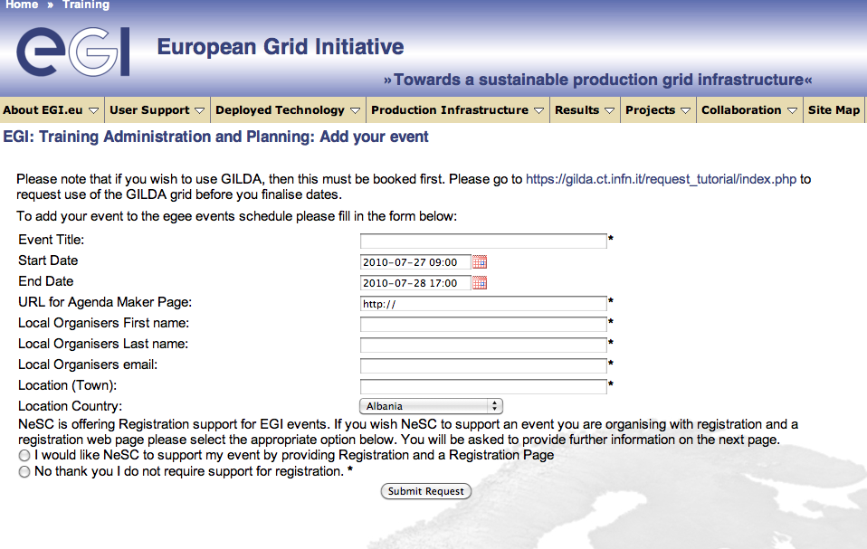

Figure . Event registration page for trainers.



Figure . List of training events in the event registry.

## Repository of training materials

This repository provides access to a digital library which holds all forms of training related materials. This acts as a resource allowing trainers to share, find and re-purpose materials. The content of the library can be reused by NGIs to run courses, all the files are under Creative Commons licence. The registry is accessible through the User Support section of the EGI.eu webpage [R2]. A screenshot of the digital library is shown in Figure 8. Further details on the repository is given in the MS302 EGI-InSPIRE milestone document [R3].

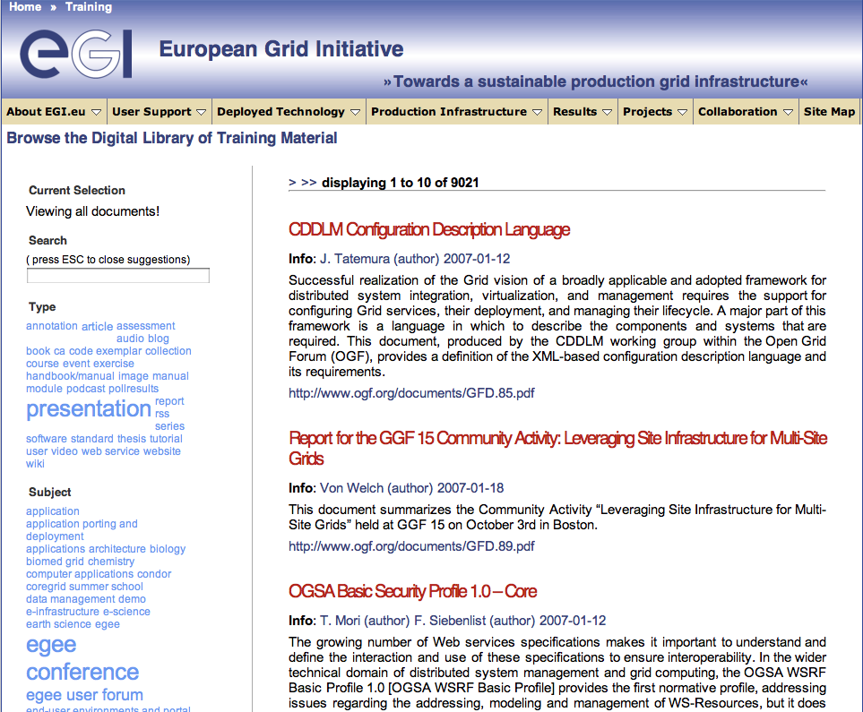

Figure . Library of training materials.

## Registry of trainers

This registry holds information about trainers across the EGI area. It allows trainers to register themselves and setup a profile which includes basic contact information and experience of various topics of grid computing and EGI. The purposes of the registry is to allow trainers to contact each other and solicit expertise to help support their training activities, help EGI.eu find trainers for events requested by users through their helpdesk, and allow clients of the infrastructure to identify experts in different countries or domains. A screenshot of the Web interface of the registry is shown in Figure 9. Further details on the registry is given in the MS302 EGI-InSPIRE milestone document [R3].

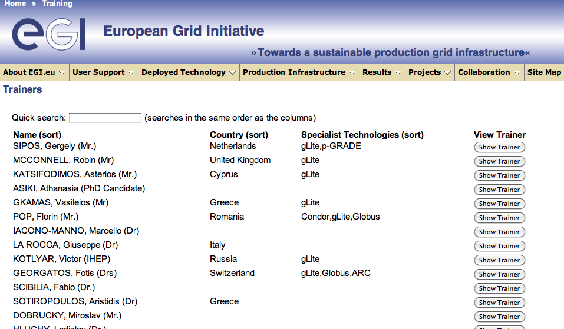

Figure . Registry of trainers.

## Application database

The EGI Applications Database (shortly called *AppDB*) is the descendant of the EGEE Applications Registry portal and it provides a catalogue of applications that have been ported, or are being ported, within the EGI infrastructure. As such it enables new communities to discover and reuse EGI applications, thus avoiding duplication of effort. By the reuse of ported applications one of the main barriers of grid adoption is eliminated.

People can search for applications in AppDB matching a pattern (such as scientific domain). The developers and scientific users of applications are also registered in AppDB and can be contacted for guidance on application usage or further developments. Currently, AppDB provides, among other information, the name, description, discipline and sub-discipline of applications, status, useful websites, abstract, scientific contact list, related publications and associated VOs. Moreover, besides scientific applications the AppDB also stores the so called “RESPECT tools” (Recommended External Software for EGI Communities), which are high level tools that provide useful functionalities for the development of grid applications. Furthermore, during the EGEE to EGI transition process, the concept of storing personal profiles for each individual application developer and researcher was introduced in AppDB, a feature that aims at simplifying the search for application developer experts who possess specialised knowledge. A screenshot of AppDB is shown in Figure 10.

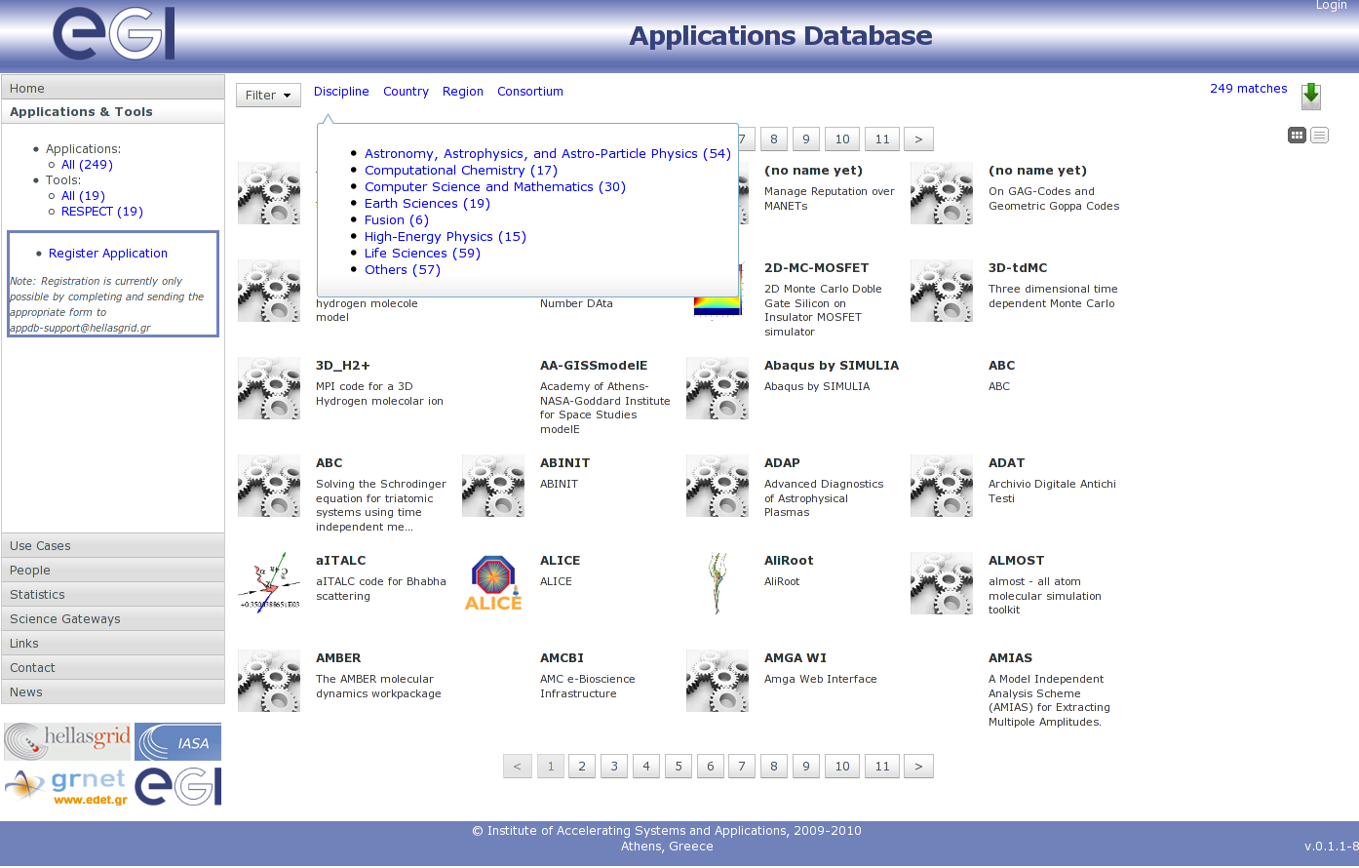

Figure . EGI Application Database

At the time of writing, the first release of the EGI Applications Database portal is in production, and it provides read-only access to the hosted applications and people data. The next step is provide write mode for application developers using the authentication mechanism of the EGI Single Sign On (SSO) system. The next release of the AppDB with this features is expected to be in production autumn 2010. Further details on AppDB is given in the MS303 EGI-InSPIRE milestone document [R4].

## Dashboards and other services for VO monitoring and operation

Insert agreements made with LIP on their role in TNA3.4

## CIC operation portal

Virtual Organisations are the physical representation of scientific collaborations at the grid infrastructure level. A VO on EGI consists of computing and storage sites, other types of distrusted and grid services, and the people who are sharing and have access to these resources. New and expanding communities very often want to enable new VOs on the infrastructure in order to serve the needs of a new experiment, application or group. The CIC operation portal is a Web page which is available at [R6].

The CIC portal is used on one hand by representatives of scientific communities to register new VOs, and on the other hand by end users, who look for a VO that they can join to access particular services or applications on the grid.

UCSTs are expected to make the users aware of this service and train them on how to use it, how to search for VOs and how to interpret the information found about them.

The VOs that are registered on the CIC portal must be first approved before they appear publicly for users. This approval process is currently managed by the EGI.eu UCST, but the project will consider delegating this tasks to one or more NGIs.

## Web pages

In order to guarantee sufficient information flow between user support teams, and between user support teams and users, EGI operates two web pages that are dedicated for this purpose. One is the User Support section of the EGI.eu webpage [R2]. This is for the general public and introduces the concept and services of User Support in EGI, as well as serves as a directory from which other services can be accessed. At the time of writing this public webpage provides a form where users can submit support requests using the GGUS ticketing system. The EGI.eu UCST is currently performs a usability inspection of this webpage in order to identify the content that would most satisfy the visitors’ needs.

The second webpage is the WP3 section of the EGI-InSPIRE Wiki [R7]. This can be accessed by members of the EGI-InSPIRE collaboration, using their personal SSO account name-password pairs. This page is used to keep the partners of the collaboration updated with the progress of the WP3 workpackage, as well as a scratchpad, where UCSTs can note web pages, useful resources, ideas and any other item that can foster the user support activity. NGI UCSTs are expected to continuously contribute to this Wiki site, so the EGI.eu UCST can exploit and integrate content from it into the overall support roadmap and activities.

## Email lists

Another important way of keeping partners up to date with the user support services and processes are the two WP3-related email lists:

1. One list (insert address) is for those NGIs that provide facilitator service for the community. The providers of these technical services must be more connected to EGI.eu, as the services they provide is used by the whole community. Besides the email list these NGIs also have bi-weekly teleconferences chaired by the manager of WP3 from EGI.eu.
2. The other list (insert address) has one subscriber from each of the NGIs that are involved in the User Support activity of EGI-InSPIRE. This list has been setup as part of the establishing confirmed user support contacts from NGIs (fully reported in the MS301 milestone document [R8]). Because the WP3 activity of EGI-InSPIRE does not include every NGI, and because user support is an essential service which assumed to exist in every NGI, the EGI.eu UCST aims to extend this list with user support contacts from every partner country, irrespectively of they are in WP3 in InSPIRE or not.

## Training infrastructure

The training infrastructure (t-Infrastructure) provides a pool of infrastructure sites and services that can be used by NGIs to deliver hands-on tutorials for users. This t-infrastructure is called GILDA and it physically resides as a VO on the EGI production infrastructure [R9].

Although the operation of this t-infrastructure is not part of EGI-InSPIRE, this service proved to be a valuable one for trainers in EGEE and expected to be used by many of the NGIs in EGI. This is especially true are the GILDA infrastructure has been successfully used at summer schools with UNICORE and Globus middleware besides its regular gLite configuration.

As part of the EGEE-EGI transitioning the GILDA infrastructure has been integrated into the EGI production infrastructure as a normal VO. NGIs with sites in the production infrastructure can now support GILDA with these sites, making GILDA a more reliable enabler of training courses. The GILDA VO operates its training Certification Authority, which can issue short term, but reusable certificates for trainers and trainees who wants to use GILDA for grid courses.

# Shared Services for Heavy User Communities (NEED IMPROVEMENTS)

## The Dashboard

Dashboards provide a generic framework to monitor sites and their services within a VO

using tests specific to that community. Dashboards have emerged from within the HEP community, and are now being adopted by the LS community, to monitor their resources

The above is extracted from DoW. Reword and expand as in this section, the tools must be described with the background of community support and how the tools contribute to that goal

The Dashboard system provides multiple applications. Depending on the information source, some of them are shared by several virtual organizations (VOs) whereas others are VO-specific.

Bugs and feature requests are tracked through [Savannah](https://savannah.cern.ch/bugs/?group=dashboard).

There are 16 different categories, 1 for the Dashboard framework and 15 for various Dashboard applications. As for the status for the 13th of June 2010 there are 200 open bugs and feature requests and 1135 closed ones.

In addition to the Savannah system there is a dashboard support list where users can ask their questions or request help.

The dashboard team organizes regular tutorials for users of the dashboard applications and takes part in the VO tutorials for Grid users.

The link to the material of the user tutorial sessions can be found [here](http://dashboard.cern.ch/tutorials/)

the above in yellow is extracted from draft MS601, check if possible to improve

#### Applications

**GANGA : insert description and how it is included in the user support mechanism**

New feature and development requests for Ganga are tracked via Savannah (items called “Feature Requests”). This is also used to do a basic prioritization of new features and following up the evolution of the tool. The priorities are discussed during the weekly Ganga [meetings](http://indico.cern.ch/categoryDisplay.py?categId=504). This [link](http://savannah.cern.ch/bugs/index.php?go_report=Apply&group=ganga&func=browse&set=custom&msort=0&report_id=218&advsrch=0&assigned_to=0&submitted_by=0&custom_sb1=102&priority=0&status_id=1&history_search=0&history_field=0&history_event=modified&history_dat) points to the open feature requests in Savannah.

Presently there are ~60 open feature requests and ~260 closed ones logged in the system (for reference: there are currently ~70 open bug reports and ~960 closed ones). Some special views (display forms) have been developed by the Ganga project in order to track the “originator” of a request (user community) and map them against a given (or future) release.

In this [view](http://savannah.cern.ch/bugs/index.php?go_report=Apply&group=ganga&func=browse&set=custom&msort=0&report_id=136&advsrch=0&assigned_to=0&bug_id=&resolution_id=0&category_id=0&priority=0&status_id=1&summary=&history_search=0&history_field=0&history_event=mod) one can see bug reports (with corresponding fixes for closed reports) and feature requests alike. N.B. the “originator” of a feature request is only an approximate indication of the request's area of impact. For example, certain functionalities prototyped in ATLAS or LHCb may be re-factored into the Core. The same applies to bug fixes: for example, a bug found in ATLAS may become critical because of a potential big impact on LHCb.

The above in yellow is extracted from MS601, correct and demonstrate the user support in here

**DIANE Same as above**

**Glite PLATFORM: Samuel as above**

**Other applications not in the DoW? Gateway from HeC or should it be in services. workflows etc?**

#### Services

**GReIC**

**HYDRA**

Other services?

#### Workflows and Schedulers

**SOMA2: Description and how it supports communities to be inserted here ( Person in charge?)**

**TAVERNA: Same as above**

**MD/RAS/KEPLER: Same as above**

**GRIDWAY: Same as above**

#### Parallel Computing (MPI)

Integration and improvement of core services to support MPI

Engaging with CCMST & Fusion to meet their requirements

### User Community Support on Services for HEP (TSA3.3)

LHC experiments generate large amount of data and metadata

Need for optimisation of long-term production data acquisition

CERN manages the Grid Support Group for HEP community

Scalable solutions to the experiments needs for data distribution, detector conditions and access

Reconstruction and analysis of physics data

Automation of the management of experiment specific services

Development and deployment of efficient monitoring tools essential to the tasks of the shifts operators

GRG to expand from HEP use to other communities

I extracted the above from the DoW and putted it in bullet points/short sentences. Important here to explain mechanisms for community support with these tools

The support model for High Energy Physics will be described in the document MS603 – Services for High Energy Physics and made available in the next version of the present deliverable.

### User Community Support on Services for LifeScience (TSA3.4)

LifeScience communities include Biomedical, bio informatics and medical communities. The synergy between these interlinked communities has been demonstrated in publications, white papers[2] and roadmaps[3] and whitepapers[4] in relation with the use of grid technologies for medical bio-informatics and biomedical applications, namely the healthgrids. Healthgrids are now the reference for all medical applications using the grids.

Life Science communities are currently experiencing a long term structural problem due to scarce funding, and lack of investment in new technologies, rendering difficult new experiences and projects.

The EGI-Inspire project, conscious that Life Science communities have been a key driver for e-science before and during the EGEE project, is therefore engaging further with the LifeScience larger community as a key partner for enhancing the capacities of the community to reach beyond the lines through innovative supporting mechanisms. While parts of policy making supporting the LSVRC (Life Science Virtual Research Community) will be done in coordination with EGI.eu, a strong community based engagement is necessary. The supporting mechanisms for accessing the grid infrastructures and the tools developed, which are mainly supported by the communities themselves under the technical support of the NGIs and the mandated organisations, will be developed jointly, taking the emerging needs into account for defining user’s needs based supporting mechanisms.

To that level, the LSVRC is currently getting structured in link with the EGI objectives and will develop stronger relationships during the lifespan of the EGI-inspire, promoting the existing tools for a use in other communities, widening to other new communities such as the ESFRI[5] projects on LifeScience. The strong links created will therefore help in designing a better ecosystem coherent within the landscape of the e-infrastructures and promote participation in innovation with tools and services usability being the key driver. EGI-inspire, through the NGIs and communities, is to become part of the gluing mechanism to federate new porting of applications on the grids, clouds and other infrastructures.

The following applications are therefore e-marked as supporting services:

**Distributed Medical Data Management:**

**Integration of Molecular Biology Core Resources on the Biomed VO:**

**Middleware for Grid Integration and Deployment of Bioinformatics and Biomedical Services and Data:**

**WIDSDOM PRODUCTION ENVIRONMENT (WPE)**

the above applications are the applications described in the DoW. Can we insert a description and how it will be supporting user communities?

**Other?**

### Services for Astronomy & Astrophysics (TSA3.5)

MPI-based computational simulations the A&A community

VisIVO

HPC (DEISA/PRACE) and HTC resources integrated as proof of concept

### Services for Earth Science (TSA3.6)

Implement, deploy and maintain the EGDR service to provide access from the grid to resources within

GENESI-DR.

From DoW. To be developed how this community will be supported and what will the mechanisms me for supporting them.

# Managing and Monitoring user support processes

As has been described previously, the user community support process is focussed on a number of key areas delivered by NGI and HUC support teams, under the coordination of the EGI.eu UCST. The particular activities carried out by these support teams include consulting, training, application porting, documentation, etc, all brought together and accessible in GGUS in the form of support units. Technical services provided by some of the NGIs facilitate community interaction and all the NGIs work.

These activities, processes and services will be managed by WP3 through a number of mechanisms. They include internal management arrangements within the work package which take into account the fact that the WP has a team based in Amsterdam working alongside a distributed team based at a small number of partner institutions across Europe. In addition to this the WP has to coordinate support processes with the 36 partners that are committing effort to this activity in EGI-InSPIRE.

In addition to internal management processes across EGI such as the weekly Activity Management Board meetings there also exists three important groups that will feed into the WP. These are:

1. The External Advisory Committee (EAC);
2. The User Community Board (UCB);
3. The User Services Advisory Group (USAG).

The following diagram illustrates these from the perspective of WP3.

USAG manadate diagram v0.3.wmf

Figure . Groups and committees that monitor EGI user support processes and activities.

The EAC will have representation from the leader of these WP together with representation from a number of VRCs. The UCB is the formal channel whereby the user communities in the form of all of the VRCs connect with EGI. USAG, on the other hand is an advisory group providing the detailed technical and process information to UCB as required. The terms of reference for these committees are available elsewhere.

## User Community Board (UCB)

The UCB is an advisory body responsible for coordinating the collection of feedback from the user communities on the human or technical services that they use from EGI. It includes high-level representatives from structured user communities VRCs (e.g. ESRFI, WLCG), NGIs and collaborating projects who:

* Advise the EGI.eu Director on strategic and managerial issues concerning the evolution of EGI.eu‘s user facing services and production infrastructure.
* Gather feedback from the user community relating to the quality of the production infrastructure and prioritise issues requiring management attention for resolution through the OMB.
* Gather, define and prioritise requirements relating to new functionality in the production infrastructure or the user facing operational tools. These requirements to be passed on to the OMB and TCB for their integration into their respective roadmaps and eventual delivery.
* Provide high-level objectives to the appointed programme committee chair and selected local organising committee chair on the format and content of the meeting.
* Improve the cohesion of the VRC activities through coordination between the different projects and VRCs and SSCs.

The UCB is tasked with and the broader support offered by EGI to the user communities. It has no involvement in the day-to-day activities of the user-community services (NA3 & SA3). The detailed technical discussions are delegated to the User Services Advisory Group (USAG).

* USAG is formally lead by the Task Leader for NA3.
* The USAG mandate is to provide feedback on the user-facing tools and services provided to the EGI user community.
* The remit within USAG is on the delivery of software services (i.e. are they available from the NGIs with the required reliability?) as opposed to their functionality which is a matter for the TCB.
* USAG will guide the evolution of the EGI Helpdesk and also collect broader requirements and feedback relating to the services offered through NA3 (i.e. documentation, training database, application database, etc.) and the processes provided for user support in EGI.
* USAG will have representation from the User Forum (including both small and large user communities) and from the operational staff responsible for managing the EGI Helpdesk.

The role of USAG is primarily as a management body. It will meet to discuss which features and fixes are most needed to meet the organisational needs. The prioritisation of such needs will also be agreed for recommendation to the UCB. The required input for making such decisions will be collated in advance of the meetings

## User Services Advisory Group (USAG)

Copy text from USAG Terms of reference here.

## Anything else to mention here?

# Mechanisms for new Community Integration: Virtual Research Communities

Scientific research is no longer conducted within national boundaries. Scientists are becoming increasingly dependent on large-scale analysis of data generated from instruments or computer simulations housed in trans-national facilities using distributed computing and storage resources linked by high-performance networks. Such facilities are collectively known as e-Infrastructure.

EGI is a partnership between National Grid Initiatives (NGIs) and a coordinating body, named EGI.eu to operate a sustainable, pan-European Grid infrastructure for international scientific communities. NGIs are national legal entities charged with taking care of grid infrastructure related matters in their own countries. EGI.eu is seen as the glue enabling coherence between the NGIs for the benefit of their users and members of Virtual Research Communities or VRCs.

VRCs are groups of researchers, possibly widely dispersed, working together effectively through the use of information and communications technology (ICT). With the help of EGI the VRC researchers can collaborate, communicate, share resources, access remote computers or equipment and produce results as effectively as if they, and the resources they require, were physically co-located.

## The benefits of VRC membership

VRC membership in EGI offers the following key benefits for researchers, scientists and the developers of distributed scientific applications:

1. VRCs can access computing, data storage and other types of resource made available by EGI stakeholders through open source middleware software solutions. VRC members can store, process and index large datasets and can interact with partners using the secured services of the EGI infrastructure.
2. The user support units of the NGIs and EGI.eu help VRC members during the routine usage of the systems and provide assistance to access and utilise the largest multi-disciplinary grid in the world.
3. VRCs will have the ability to establish their own Virtual Organisations (VOs) as collections of hardware, software and human resources configured in order to share capacities, to collaborate with partners and to run data intensive simulations. The VOs can benefit from the resources provided by NGIs and other VRCs.
4. NGIs provide trainers and technology specialists for VRCs to support them during the integration and adaptation of their legacy applications and datasets to the EGI infrastructure. The combination of VRC’s own training resources together with EGI’s infrastructure-related modules can provide comprehensive packages for VRC members in an efficient and timely manner.
5. VRCs can influence the evolution of EGI’s services through representation in the User Community Board and the User Support Advisory Group. Based on requirements collected from its members, VRCs can advise EGI on its planning and operational priorities.

## Definition

The following diagram illustrates the purpose of the Virtual Research Community (VRC) within the EGI ecosystem. The VRC is defined as an organisational grouping that brings together transient Virtual Organisations within a persistent and sustainable structure. A VRC must be a self-organising group that collects and represents the interests of a focussed collection of researchers across a clear and well-defined field. Named contacts are agreed upon by the VRC to perform specific roles and these then form the communication channel between the VRC and EGI.



Figure . Integration of Virtual Research Communities with EGI

## Joining an existing VRC

Existing VRCs run applications for research domains as diverse as high energy physics, life sciences, astronomy, astrophysics, computational chemistry, earth sciences, fusion. The current list of active VRCs and their VOs can be found on the User Support section of the EGI website, together with information on how to join: [www.egi.eu/user-support](http://www.egi.eu/user-support).

## Registering a new VRC

EGI invites international scientific communities to establish new VRCs. The proposal must demonstrate that it represents a community of researchers that has an established existence outside of the VRC, i.e. that it has structure (such as an ESFRI project, EIROFORUM laboratory, national research structure. professional organisation or affiliation, etc.) and that this body represents this particular community. The VRC must also show that it has an established governance model and open mechanisms for new participants to enter (or leave) the organisation, and that all members of this organisation will have access to all the services offered by the VRC, i.e. beyond those who are just part of the proposal. These conditions enable EGI.eu to recognise the VRC as being the ‘voice’ of a particular community of users within the infrastructure. EGI can also provide help and advice on suggested best practices for such organisational models if needed. All communication should be through the Chief Community Officer [cco@egi.eu](mailto:cco@egi.eu).

The procedure for VRC accreditation in EGI is described in Appendix A.

## How are new communities being supported

VRCs are initiatives which seek to bring research communities together and support their use of DCI production infrastructures. Their driving force is often a research project, such as WeNMR or GISELA, but sometimes they cover several projects that the same scientific domain. interest but and others As the research communities using the European e-Infrastructures continue to grow, scalable support models need to be developed that will support both large and small communities.

Within EGI, the focus of this scalable user support model will be the Virtual Research Community (VRC) which provides a focus for large structured research communities to interact with EGI – both in obtaining support and for expressing their requirements. Direct support for user communities relating to their use of the infrastructure will be provided through the NGI support teams within EGI-InSPIRE. Domain specific support is one of the services that will be provided through the VRC, alongside training, dissemination and general community coordination activities. It is envisaged that some VRCs will be initially funded through EC projects, but will migrate to self-sustaining entities supported by their own communities over the next few years.

Once accredited, a VRC will be formally represented on the User Community Board and therefore indirectly on the User Services Advisory Group (USAG) and these two will provide a formal channel for capturing and prioritising their requirements and feeding them into the development of EGI services. Smaller collaborations will continue to make direct use of EGI‘s support mechanisms without going through a VRC.

# conclusion MUST BE WRITTEN

# Appendix A – Procedure for Virtual Research Community accreditation in EGI

The following steps provide detailed information on the VRC accreditation process for EGI. Within EGI the model for scalable user support is the Virtual Research Community (VRC). This model will serve both large and small communities by offering structured research communities a sustainable mechanism with which to interact with EGI. This will allow the VRC to access EGI services and provide a point through which EGI can gather objectives and requirements from a defined set of users. The following section defines the purpose and benefits of the VRC as well as an accreditation process which involves a set of evaluation criteria for examining potential new VRCs to determine whether EGI should formally recognise them as appropriate and effective representatives of a given research community. Once this initial process is complete and contact points have been established more detailed discussions will take place to establish the technical and contractual agreements.

## Procedure

All communication should be through the Chief Community Officer (CCO) [cco@egi.eu](mailto:cco@egi.eu) with an email subject of "Request for new VRC called [your_VRC]"

## Step 0: Before submitting a request for a new VRC

Please check the current list of active Virtual Research Communities. This is accessible from the User Support section of the EGI website. This list also contains a list of the currently active Virtual Organisations (VOs) together with the VRC to which they are associated if applicable. The following questions can then be asked:

* Is there an existing VRC that could meet the needs of all or part of the proposed community? The scope of the proposed VRC should not overlap to any significant degree with any existing VRC;
* Are there existing VOs whose needs could be met by the proposed community? These may or may not already be part of an existing VRC;

## Step 1: Initial request:

The VRC proposal must demonstrate that it represents a community of researchers that has an established existence outside of the VRC, i.e. that it has structure (such as an ESFRI project, EIROFORUM laboratory, national research structure. professional organisation or affiliation, etc.) and that this body represents this particular community. This community must also show that it has an established governance model and open mechanisms for new participants to enter (or leave) the organisation, and that all members of this organisation will have access to all the services offered by the VRC, i.e. beyond those who are just part of the proposal. These conditions enable EGI.eu to recognise the VRC as being the ‘voice’ of a particular community of users within the infrastructure. EGI can provide help and advice on suggested best practices for such organisational models if needed.

The proposal should also describe how the VRC organisational structure will become sustainable over time. For example will it adopt a formal legal structure or will it rely on committed services form a few dominant partner organisations in the field. There is no right or wrong answer as long as the potential for persistence can be demonstrated. The proposed VRC should respond to the following points:

1. Which ESFRI Roadmap projects (if any) are affiliated to the proposed VRC?
2. How would your community structure and organise itself in order to present a unified view as a VRC?
3. Which NGIs/EIROs endorse the proposed VRC by committing to provide access to resources (compute/data), VO services (e.g. VO monitoring frameworks through dashboards, VOMS for VO membership registration etc.) and generic user support services (e.g. application porting, training, etc.)?
4. How will the proposed VRC have the ability, capability and commitment to provide domain-specific support including training, dissemination and general community coordination activities?
5. How will the proposed VRC work with EGI to collect and prioritise requirements from within the communities they represent?
6. Any required interactions with resource providers outside of Europe should also be noted in terms of requirements and opportunities.

The application should also include the following information:

* A succinct description of the scope of the proposed VRC in terms of research discipline and the NGIs (if any) that are supporting the proposal.
* Details of the named representatives of the proposed VRC (together with a current email address and telephone number):
  + Coordinator: providing strategic and managerial input on the VRC’s activity to the CCO and Director of EGI.eu;
  + Technical contact: representing the VRC within EGI on the User Community Board (UCB) and possibly on other groups within EGI (e.g. User Support Advisory Group);
  + Policy contact: providing input and feedback on the non-technical policies (e.g. security and usage) being developed by EGI;
  + Dissemination contact: providing a bi-directional contact point between the EGI Dissemination Manager (and their staff) and the VRC relating to dissemination activities
  + Training contact: providing requirements to evolve the training services (i.e. digital library, registry of trainers, training calendar) and as contact point for training needs and services within their community;
  + User Support contact: route for integrating community-based support units with the associated Support Unit in EGI;
  + Security contact: communication point for liaising with the EGI’s Computer Security and Incident Response Team (CSIRT) for issues relating to activities of the VRC’s users;
  + Operations contact: the communication point for any VRC-specific services needed by the VRCI;

These contact points may be the same person. These representatives (or additional people) may be invited to participate in other EGI bodies depending on the interests of the VRC.

* A justified estimation of the size of the VRC at a European level in terms of users, Virtual Organisations (VOs) and services and resources (compute & data) that already exist within the VRC and which are or could be integrated with the EGI infrastructure[6];
* A summary of the applications that the proposed VRC would need together with information about who would support these applications.

Note:

1. The VRCs must agree to name a technical representative (with deputy) for the EGI User Community Board;
2. The VRC may be asked to nominate a representative for EGI-InSPIRE’s External Advisory Committee;
3. The VRC may be asked to nominate representatives to serve on other advisory groups as appropriate; The VRC will accept and enforce EGI’s acceptable use and security policies;
4. The VRC’s named dissemination contact will work with EGI’s dissemination team to share and coordinate dissemination activities and materials;
5. The VRC’s named training and user support contact will work with the EGI User Community Support Team to integrate services;

## Step 2: Approval

VRC proposals are reviewed and approved by the EGI User Community Board. This process may take up to a month.

## Step 3: Response

Within one month of submission, a letter confirming or rejecting support for the proposed VRC will be provided to the requestor by EGI.eu. After this, the process of creating the VRC and aligning its associated VOs within the infrastructure will commence.

## Step 4: Memorandum of Understanding

The relationship between EGI and the VRC must be captured within an agreement that documents the bi-directional expectations between EGI (as a representative of the service providers) and the VRC (as a representative of the community).

1. Distributed Computing Infastructures: Clouds,supercomputing, Desktop grids etc…
2. HealthGrid White Paper 2005 <http://initiative.healthgrid.org/fileadmin/whitepaper/HealthGrid_whitepaper_full.pdf>
3. SHARE project roadmap2008 <http://www.healthgrid.org/documents/pdf/eHealth-SHARE-A4.pdf>
4.
5. insert ELIXIR and other ESFRI here
6. Integrating existing VRC services into the EGI infrastructure does not mean that they will be freely available to all but rather they will be accessible to the VRC across the broader infrastructure.