

D3.1 Exploitation, Dissemination and Communication Plan v.1.0

30/09/2024

Abstract

The document serves three purposes. First, it describes the proposed Innovation Management System and its implementation plan. This will enable and support the development of activities related to the management of Intellectual Property, project results, exploitation and sustainability of Key Exploitable Results, as well as project impact. The second purpose is to provide an overview of the project's communication and dissemination activities, as well as a plan for executing them. Lastly, it outlines and plans activities for promoting the services, supporting the user community, and coordinating the feedback loop engagement.

# Document Description

| D3.1 Exploitation, Dissemination and Communication Plan v.1.0 | | | |
| --- | --- | --- | --- |
| Work Package 3 | | | |
| Due date | Date | Actual delivery date: | 27.09.2024 |
| Nature of document | [Report] | Version | 1.0 |
| Document status | Under EC Review | Dissemination level | Public |
| Lead Partner | EGI | | |
| Authors | Montserrat González Ferreiro & Federico Drago & Elisa Cauhé (EGI)  Androniki Pavlidou & Maja Dolinar (OpenAIRE AMKE), Franziska Krauss (UNIVIE), Pedro Príncipe & André Vieira (UMINHO) | | |
| Reviewers | Roksana Wilk, Katarzyna Lechowska-Winiarz (CYFRONET), Athanasios Mantes (ARC) | | |
| Public link | <https://zenodo.org/records/13850354> | | |

## Description

| Abstract | The document serves three purposes. First, it describes the proposed Innovation Management System and its implementation plan. This will enable and support the development of activities related to the management of Intellectual Property, project results, exploitation and sustainability of Key Exploitable Results, as well as project impact. The second purpose is to provide an overview of the project's communication and dissemination activities, as well as a plan for executing them. Lastly, it outlines and plans activities for promoting the services, supporting the user community, and coordinating the feedback loop engagement. |
| --- | --- |
| Keywords | Innovation Management, Intellectual Property Management, Results Management, Key Exploitable Results, Exploitation Management, KERs sustainability, Dissemination, Communication |

## Revision History

| Issue | Date | Comments | Author/Reviewer |
| --- | --- | --- | --- |
| V 0.1 | 19.06.2024 | First ToC and structure | Federico Drago (EGI), Montserrat González Ferreiro (EGI), Androniki Pavlidou (OpenAIRE AMKE) |
| V 0.2 | 03.07.2024 | First draft | Abstract (MGF), Introduction (MGF), Innovation Management (MGF), Acronyms and abbreviations (MGF & FD), Exploitation Management process Activity 6 (EC), User Engagement (MD), User support (UMINHO), Coordination activities (AP) |
| V 0.3 | 07.08.2024 | Second draft | Communication and Dissemination (FD) |
| V 0.4 | 26.08.2024 | Third draft | Service promotion, user community support and feedback loop coordination (MD, PP, AP, AV, FK) |
| V 0.5 | 26.09.2024 | Final version | Update based on the feedback from reviewers (MG, FD, AP) |
| V 1.0 | 27.09.2024 | Submitted version |  |

Copyright and licence info

This material by Parties of the EOSC Beyond Consortium is licensed under a [Creative Commons Attribution 4.0 International License](https://creativecommons.org/licenses/by/4.0/).

# Table of content

Document Description 2

Description 2

Revision History 2

Table of content 4

Figures 5

Tables 5

**Executive Summary 6**

1. Introduction 7

1.1. The EOSC Beyond project 7

1.2. Scope and purpose of the deliverable 8

1.3. Structure of the deliverable 8

1.4. Contributions to the deliverable and outcomes 9

**2. Innovation Management 10**

2.1. InnoMS Governance roles and responsibilities 10

2.2. InnoMS Process structure 12

2.3. IP Asset Management process 13

2.4. Results management 14

2.5. KERs management 15

2.6. Exploitation management 16

2.7. KERs sustainability management 18

2.8. Impact management 18

2.9. Procedures 19

2.10. Work plan 20

**3. Communication and Dissemination 23**

3.1. Target stakeholders 23

3.2. Communication and dissemination activities 26

3.3. Communication and Dissemination work plan 34

**4. Service promotion, user community support and feedback loop coordination 36**

4.1 Services promotion activities and user engagement 36

4.2 Support activities 44

4.3 Coordination activities 51

4.4 Work plan 52

**5. Conclusions and next steps 55**

**6. Acronyms and abbreviations (All) 57**

# 

# Figures

| List of figures   * Figure 1. The EOSC Core components overview shows new capabilities in blue and improved capabilities in green that will be developed by EOSC Beyond. * Figure 2. EOSC Beyond D3.1 inputs and outputs * Figure 3. EOSC Beyond InnoMS processes and their relationship * Figure 4. Main steps of PROC05-1: Creation/Update of entries in the Project Results Catalogue * Figure 5. Main steps of PROC05-2: Creation/Update of entries in the Project KERs Catalogue * Figure 6. Different versions of the EOSC Beyond logo * Figure 7. Video background and sticker design from the Communication package * Figure 8. EOSC Beyond A5 flyer * Figure 9. Homage of the EOSC Beyond website * Figure 10. Promotional image for the first newsletter issue * Figure 11. eBook pages template in progress * Figure 12. Pitch (slide) deck template in progress |
| --- |

*Table 1.*

# Tables

| List Of Tables   * Table 2. Generic roles and responsibilities for the Innovation Management System * Table 3. IP Asset management process definition * Table 4. Results management process definition * Table 5. KERs management process definition * Table 6. Exploitation management process definition * Table 7. Sustainability management process definition * Table 8. Impact management process definition * Table 9. Work plan for the Innovation Management System activities * Table 10. EOSC Beyond stakeholders * Table 11. Stakeholders influence and interest quadrant analysis * Table 12. EOSC Beyond SWOT analysis * Table 13. Website structure * Table 14. Communication KPIs * Table 15. Formal activity breakdown * Table 16. Learning materials * Table 17. Delivery of learning material * Table 18. Learning resources, target group, benefits * Table 19. Work plan of Task 3.2 * Table 20. Acronyms and abbreviations |
| --- |

# Executive Summary

This document contains the overall plan for tasks related to innovation management, communication and dissemination, service development, user support, engagement, and feedback loop coordination. In other words, it offers a plan to develop the following tasks for the duration of the project: ‘T3.1 and T4.1 Innovation Management’ led by EGI, T3.3 and T4.3 Communication and Dissemination’ led by EGI, and ‘T3.2 and T4.2 Service promotion, user community support and coordination' led by OpenAIRE. These tasks are part of 'Work Package 3: Innovation Management, Exploitation, Sustainability and Support I' and 'Work Package 4: Innovation Management, Exploitation, Sustainability and Support II'. This initial plan is based on the project proposal and is expanded with findings and results that came up in the first five months of the project.

The first part of the document, with the main contribution from ‘T3.1: Innovation Management’ describes the Innovation Management System (InnoMS) governance roles and responsibilities, as well as the structure and processes for Intellectual Property (IP) assets, and results management, exploitation and sustainability. It also includes the plan for the InnoMS implementation.

The second part of the document, with the main contribution from ‘T3.3: Communication and Dissemination’ outlines the target stakeholders for communication and dissemination activities, as well as activities such as defining the visual identity, branding, communication package and materials, and establishing an online presence including social media. It also features a work plan to carry on the activities described.

The third part consists of activities defined by ‘T3.2: Service promotion, user community support and coordination’ and presents a comprehensive strategy to advance EOSC by effectively promoting EOSC Beyond’s Core Services and engaging with various stakeholders. It details the primary goals, including increasing awareness, fostering collaborations, and developing diverse learning resources, such as factsheets, guides, tutorials, and webinars/workshops. Furthermore, it includes the creation of important material for services promotion, the eBooks, slide decks, and posters that will accompany the activities of Task 3.3. These are integral to the project’s promotional efforts, which encompass organising events and workshops to support and onboard new users. This part also includes a systematic collection and analysis of user feedback, which is vital for refining learning materials and service offerings. Importantly, the section emphasises the internal coordination of feedback loops between users and the project, aligning with WP15, WP7 and WP10 to ensure continuous improvement and effective integration of user insight.

Finally, the document ends with conclusions and next steps that tie together the three previous sections that address work related to exploitation, promotion, support and engagement, dissemination and communication.

# Introduction

To better understand the purpose of this deliverable and how it contributes to the project objectives, this section will summarise the EOSC Beyond objectives and expected results. Moreover, it will provide an overview of the deliverable's structure, its tasks and contributions, and the impact of the deliverable on the overall project.

## 1.1. The EOSC Beyond project

The European Open Science Cloud (EOSC) is developing as a federation of services, tools, data and other resources from hundreds of providers at local, national, regional and European with the aim of increasing discovery, access, and reuse of Open Science resources from European research communities in order to accelerate discovery times and improve science excellence in Europe.

The EOSC Beyond project aims to support the growth of EOSC in terms of integrated providers and active users by providing new EOSC core technical solutions. Therefore, developers of scientific application environments will be able to compose a diverse portfolio of EOSC resources and offer them to researchers.

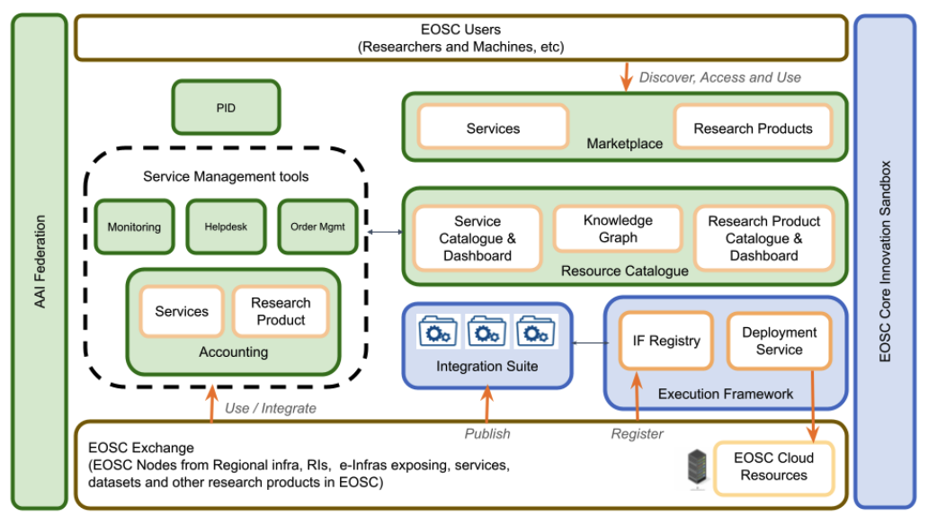

*Figure 1. The EOSC Core components overview shows new capabilities in blue and improved capabilities in green that will be developed by EOSC Beyond.*

To achieve the project's ambition, existing EOSC core solutions are improved and new core services are added through these Key Exploitable Results (KER):

1. Improved existing EOSC Core services and framework (EB Core Services).
2. EOSC Core Innovation Sandbox with automation tools for testing and validating new EOSC Core services, and allowing providers to validate integration with the EOSC Platform before deploying services.
3. EOSC Integration Suite as a portfolio of software adapters to the EOSC Core and horizontal services of the EOSC Exchange.
4. EOSC Execution Framework for composability and deployment of multi-supply resources, which will interoperate with relevant dataspaces.
5. EOSC-SIMPL interoperability technical guidelines.
6. Piloting EOSC Thematic and Regional/National Nodes.
7. Sustainability and exploitation plans for the EOSC Core and horizontal services.

Development will be driven by co-design, gathering requirements, and software validation in collaboration with a portfolio of diverse use cases representing the needs of EOSC nodes and initiatives operating at national level (e-Infra CZ in Czechia, NFDI in Germany), regional level (NI4OS in South East Europe), and thematic European nodes (CESSDA, CNB-CSIC, ENES, LifeWatch ERIC, METROFood-RI, and Instruct-ERIC).

The results of EOSC Beyond will support Open Science for modern data-intensive and multidisciplinary science, enabling scientists, organisations, and countries to discover, access, and reuse an increasing number of resources. As part of the emerging EOSC Federation of Nodes, which will start its existence with the launch of the EU Node, as an integrated operational environment delivering selected horizontal services and the EOSC Core, EOSC Beyond will expand the EOSC Core with additional components and capabilities as an integrated operational environment delivering selected horizontal services and the EOSC Core, EOSC Beyond will expand the EOSC Core with additional components and capabilities.

## 1.2. Scope and purpose of the deliverable

The scope of the work described in the deliverable is:

* The management and planning of Intellectual Property (IP) and other assets, project results, exploitation and sustainability of Key Exploitable Results (KERs), project impact during the project lifecycle and reporting impact even one year after project conclusion in compliance with Horizon Europe framework requirements.
* The management and planning of communication and dissemination activities during the project's life. As part of these activities, target groups will be informed of the achievements of the project, events will be organised, EOSC brand and EOSC Core services will be promoted, and complementary material will be created to assist in the promotion of the service and user engagement and adoption.

## 1.3. Structure of the deliverable

The document is structured in the following way:

* The first part of the document, with the main contribution from ‘T3.1 Innovation Management’ describes the Innovation Management System (InnoMS) governance roles and responsibilities, as well as the structure and processes for Intellectual Property (IP) assets, and results management, exploitation and sustainability. It also includes the plan for the InnoMS implementation.
* The second part of the document, with the main contribution from ‘T3.3 Communication and Dissemination’ outlines the target stakeholders for communication and dissemination activities, as well as activities such as defining the visual identity, branding, communication package and materials, and establishing an online presence including social media. It also features a work plan to carry on the activities described.
* The third part of the document outlines the ‘T3.2 Service promotion, user community support and coordination’ strategy for promoting EOSC Core Services and engaging stakeholders. It focuses on raising awareness, fostering collaborations, and creating learning resources like factsheets, guides, and webinars. These efforts include organising events to onboard new use cases and systematically collecting and analysing feedback to refine materials and services. Crucially, it highlights the internal coordination of feedback loops with WP15 to ensure continuous improvement and effective use case integration and with WP7 and WP10 to successfully translate new scientific and technical use cases into technical requirements relevant to EOSC Beyond.
* Finally, the document ends with conclusions and next steps that tie together the three previous sections that address work related to exploitation, promotion, support and engagement, dissemination and communication.

## 1.4. Contributions to the deliverable and outcomes

Different tasks contribute to D3.1, which is used by other tasks as input. This diagram summarises the contribution to the deliverable and how it contributes to other EOSC Beyond tasks.

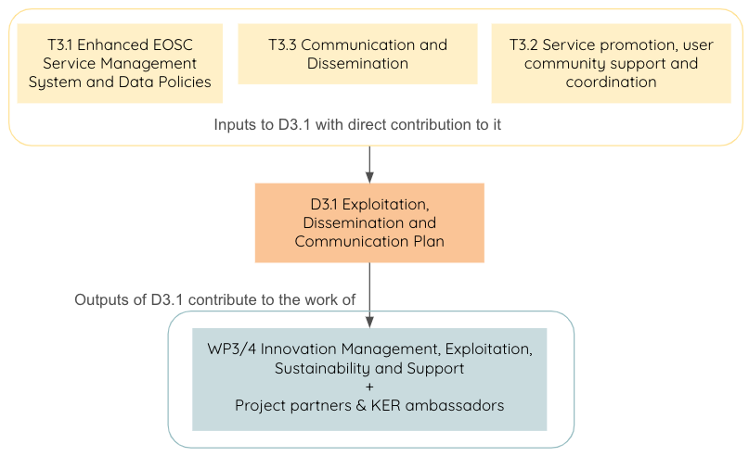

*Figure 2. EOSC Beyond D3.1 inputs and outputs*

# Innovation Management

The EOSC Beyond Innovation Management System has three layers: Governance (Roles and responsibilities), Control (Processes and activities), and Operations (Procedures). It defines the governance, processes and procedures to manage and plan IP, project results, exploitation and sustainability of KERs, project impact during the project lifecycle and reporting of impact one year after the project life in compliance with Horizon Europe framework requirements. It is mainly developed by T3.1 and with the collaboration of T3.3 to establish collaboration channels with other EOSC projects, the EOSC Association, and the procurement consortia to identify exploitation opportunities.

## 2.1. InnoMS Governance roles and responsibilities

EOSC Beyond project participants are responsible for managing and developing the Innovation Management System (InnoMS), i.e., the processes and activities that are part of the processes.

| InnoMS Governance roles and responsibilities | | |
| --- | --- | --- |
| Role | Tasks | Staff assigned |
| InnoMS manager | * Serve as the primary contact point for questions and concerns regarding the entire InnoMS from a governance and tactical perspective. * Define scope and goals for the entire InnoMS, propose the process manager nomination, and agree with them on how to collaborate and how the system should be developed. * Determine the InnoMS implementation plan, in collaboration with the process managers, and keep track of its development. * Coordinate the InnoMS process managers in regular InnoMS meetings. * Inform the Work Package Leader Group (WPLG) of the InnoMS implementation plan. * Propose changes for the entire InnoMS after monitoring and reviewing, in collaboration and agreement with the process managers, and inform the project WPLG. * Report and, if necessary, escalate any issues impeding the InnoMS implementation to the project WPLG. * Participate in internal and external meetings to represent the InnoMS. | 1 for the InnoMS, the project Innovation Manager |
| Process manager | * Serve as the primary contact point for questions and concerns regarding an InnoMS process from a governance and operational perspective. * Defines scope and goals for a process, nominate the process staff and identify collaborators, and agree with them on how the process should be developed. * Determine the process implementation plan, in collaboration with the InnoMS manager, process staff managers, and keep track of its development. * Coordinate the process staff in regular meetings. * Propose changes for the process after monitoring and reviewing, in collaboration and agreement with the process staff, and request approval by the InnoMS manager. * Report and, if necessary, escalate any issues impeding the process implementation to the InnoMS manager. * Participate in internal and external meetings to represent the process. | 1 per process |
| Process activity leader | * Serve as the primary contact point for questions and concerns regarding an InnoMS process activity from an operational perspective. * Define scope and goals for an activity and identify collaborators in collaboration with the InnoMS process manager. * Report and, if necessary, escalate any issues impeding the activity progress to the InnoMS process manager. | 1 per activity |
| Process staff | * Perform activities following the Activity leader's instructions and, if applicable, the procedures defined (e.g. how to document a project result) * Report to the activity leader. | As needed |
| Project result contact | Process staff who perform the following tasks:   * Appointed by the WPLG. * Individuals that serve as the primary contact for a project result, encouraging its adoption, exploitation and dissemination. * Support the Results Management process manager in collecting the information related to the results and bridge the gap between technical outputs and their practical implications by promoting uptake. | 1 per result |
| KER ambassador | Process staff who perform the following tasks:   * Appointed by the WPLG. * Serve as the primary representative of a KER, encouraging its adoption, exploitation and dissemination. * Support the KERs Management process manager in collecting the information related to the results and bridge the gap between technical outputs and their practical implications by promoting uptake. | 1 per KER |

*Table 2. Generic roles and responsibilities for the Innovation Management System*

## 2.2. InnoMS Process structure

The InnoMS includes the following processes:

* **Process 1. Intellectual Asset Inventory Management (IAIM)**: This process records and manages IP that existed before the project started (relevant to the execution and exploitation of the project and called Background IP) as well as IP generated during the project (which includes Sideground, Third-Party and Foreground IP).
* **Process 2. Results Management (RM)**: This process records and manages all the results generated during the project duration, with priority being given to the KER-related results.
* **Process 3. KERs Management (KERM)**: This process records and manages all the information related to Key Exploitable Results, results which have a high potential for exploitation.
* **Process 4. Exploitation Management (EM)**: This process defines an exploitation methodology that can be used by project partners to create their exploitation plans, especially for Key Exploitable Results. In this process, exploitation opportunities are identified that can be pursued during or after the project to increase its impact. Exploitation activities can include commercial exploitation, developing, creating, manufacturing and marketing products and processes, providing services, or standardising.
* **Process 5. KERs Sustainability Management (KERSM)**: This process defines a sustainability analysis methodology that can be used by the project partners to create their sustainability plans, especially for KERs. It also identifies sustainability opportunities that can be pursued during or after the project to increase its impact. For example by analysing potential funding opportunities, considering the work of the EOSC SB, EOSC-A TFs, and EOSC projects, analysing data on user experience and the EOSC's value proposition. Finally, this process will provide support for analysing legal and regulatory barriers and developing recommendations for minimising or avoiding them.
* **Process 6. Impact Management (IM)**: This process records information that will be used to assess the impact of the project in accordance with Horizon Europe recommendations. Impact is considered from three complementary perspectives: scientific, societal and economic. These different views are recorded in pathways to impact and a brief impact canvas report.

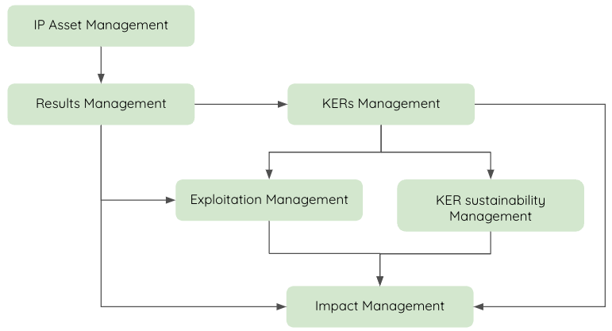

*Figure 3. EOSC Beyond InnoMS processes and their relationship*

## 2.3. IP Asset Management process

| Process 1: Intellectual Asset Inventory Management (IAIM) | | |
| --- | --- | --- |
| Description | | |
| This process records and manages Intellectual Property (IP) that existed before the project started (relevant to the execution and exploitation of the project and called Background IP) as well as IP generated during the project (which includes Sideground, Third-Party and Foreground IP). | | |
| Goals | | |
| * Identify and record Background IP, Third-party IP, Sideground IP, and Foreground IP. * Make sure enough rights are in place for Background IP, Third-party IP, and Sideground IP. * Utilise appropriate methods to protect the Foreground IP and contribute to the resolution of any IP conflicts that may arise. * Develop any IP agreements related to the generated IP (e.g. joint ownership, licensing, etc.). | | |
| Inputs | | |
| * Work programme, Grant Agreement, DoA, Consortium Agreement. * Deliverables, Milestones, Periodic Reports and WP reports. * Discussions with WP leaders, task leaders, consortium members, and different project boards. * Project results and Key Exploitable Results (KERs). | | |
| Outputs | | |
| * Templates and usage instructions for recording Background IP, Third-party IP, Sideground IP, and Foreground IP. * List of project Background IP, Third-party IP, Sideground IP, and Foreground IP. * Joint ownership and licensing agreements. | | |
| Activities for the process setup | | |
| * Activity 1: Document process and assign roles & responsibilities.   For everyone to stay informed and updated on innovation work, as well as for reporting the outputs and work related to the activities, all processes are documented in the project Confluence space.   * Activity 2: Create templates and instructions to record Background IP, Third-party IP, Sideground IP and Foreground IP. | | |
| Activities for the ongoing process execution | | |
| * Activity 3: Record Background IP, Third-party IP, Sideground IP, Foreground IP, in addition to iteratively reviewing and updating information and templates as needed. * Activity 4: Analyse the need for joint ownership and licensing agreements. * Activity 5: Draft and propose joint ownership and licensing agreements as needed. | | |

*Table 3. IP Asset management process definition*

## 2.4. Results management

| Process 2: Results Management (RM) | | |
| --- | --- | --- |
| Description | | |
| This process records and manages all the results generated during the project duration, with a priority being given to the KER-related results. The results of a project may include tangible or intangible effects of the project, such as data, know-how, algorithms, prototypes, new products or services, roadmaps, policy recommendations, lessons learned, reports, publications, and other information, whether or not it can be protected, as well as any rights attached to them, including intellectual property rights. | | |
| Goals | | |
| * Ensure that innovation developed or enhanced by the project is well-documented. * Provide a strong source of information for all other Innovation Management processes. * Identify, record, and manage project results in a template compatible with the Horizon Europe Results ownership list. | | |
| Inputs | | |
| * Grant Agreement, DoA, Consortium Agreement. * Deliverables, Milestones, Periodic Reports and WP reports. * Discussions with WP leaders, task leaders, consortium members, and different project boards. | | |
| Outputs | | |
| * Procedure and template to identify, record, and manage project results. * List of project results. | | |
| Activities for the process setup | | |
| * Activity 1: Document process overview and assign roles & responsibilities. * Activity 2: Define procedure and template to identify, record, and manage results with entities (WPs) responsible for the template’s instances. * Activity 3: Make sure project result contacts are appointed by the WPLG and provide them guidelines for a successful collaboration. | | |
| Activities for the ongoing process execution | | |
| * Activity 4: Identify, record and manage results, in addition to iteratively reviewing and updating information and templates as needed. | | |

*Table 4. Results management process definition*

## 

## 2.5. KERs management

| Process 3: KERs Management (KERM) | | |
| --- | --- | --- |
| Description | | |
| This process records and manages all the information related to Key Exploitable Results (KERs), results which have a high potential for exploitation. | | |
| Goals | | |
| * Designate KERs ambassadors and lay out guidelines for collaboration. * Identify, record, and manage KERs together with KERs ambassadors. | | |
| Inputs | | |
| * Grant Agreement, DoA, Consortium Agreement. * Deliverables, Milestones, Periodic Reports and WP reports. * Discussions with WP leaders, task leaders, consortium members, and different project boards. * Project results. | | |
| Outputs | | |
| * Procedure and template to identify, record, and manage KERs. As part of the template, the value proposition and stakeholders for KER communications will be collected. Information in this template will also allow for the later filling in of the Horizon Europe Results ownership and Results lists. * Guideline for KER ambassadors. * List of KERs ambassadors * List of KERs and related information. It will be refined and extended, when the project results are more concrete. Similar related project results will be grouped under a single KER. | | |
| Activities for the process setup | | |
| * Activity 1: Document process overview and assign roles & responsibilities. * Activity 2: Define procedure and template to record, and manage KERs. * Activity 3: Identify KERs (assess the KER in the project proposal and add more if necessary) and start filling the KER template. * Activity 4: Make sure KER ambassadors are appointed and provide them guidelines for a successful collaboration. | | |
| Activities for the ongoing process execution | | |
| * Activity 5: Record and manage information about KERs in collaboration with the KERs ambassadors, in addition to iteratively reviewing and updating information, guidelines, and templates as needed. | | |

*Table 5. KERs management process definition*

## 2.6. Exploitation management

| Process 4: Exploitation Management (EM) | | |
| --- | --- | --- |
| Description | | |
| This process defines an exploitation methodology that can be used by project partners to create their exploitation plans, especially for Key Exploitable Results (KERs). In this process, exploitation opportunities are identified that can be pursued during or after the project to increase its impact. Exploitation activities can include commercial exploitation, developing, creating, manufacturing and marketing products and processes, providing services, or standardising. | | |
| Goals | | |
| * Propose a high-level exploitation strategy for the project results. * Formulate a methodology and template to create partner-specific KERs exploitation plans. * Support the creation of partner-specific KERs exploitation plans. * Establish collaboration channels with other EOSC projects, the EOSC Association, and the procurement consortia. * Establish collaboration with the EOSC Digital Innovation Hub (DIH) and explore exploitation possibilities. | | |
| Inputs | | |
| * Project results. * KERs. * Discussions with KERs ambassadors. | | |
| Outputs | | |
| * High-level exploitation strategy for the project results. * Partner-specific KERs exploitation plans. | | |
| Activities for the process setup | | |
| * Activity 1: Document process overview and assign roles & responsibilities. * Activity 2: Define a high-level exploitation strategy for the project results. * Activity 3: Formulate a methodology, guidelines and a template to create partner-specific KERs exploitation plans. | | |
| Activities for the ongoing process execution | | |
| * Activity 4: Support creation of partner-specific KERs exploitation plans, in addition to iteratively reviewing and updating information and templates as needed. * Activity 5: Establish collaboration channels with other EOSC projects, the EOSC Association, and the procurement consortia to identify exploitation opportunities.   + Participation in interview led by EOSC Focus to populate the [Macro-Roadmap](https://eosc.eu/eosc-macro-roadmap/?_macroroadmap_area=fair-metrics-certification&_mrm_catalogue=roadmap), the aim of which is to show how the outcomes of the Horizon Europe EOSC-related projects (including projects from the INFRAEOSC calls as well as some others in other funding schemes) contribute to creating the EOSC and to fulfilling the objectives of the [EOSC Co-Programmed Partnership](https://eosc.eu/partnership/). * Activity 6: Investigate collaboration and exploitation options for project results through the EOSC DIH.   + Explore the business options of KERs, analyse the exploitation scenario and paths for the private sector (mainly by SMEs and startups)   + Facilitate the engagement of these companies via the EOSC DIH with the participation in community regular meetings or via dissemination activities in social media and other EOSC DIH channels. | | |

*Table 6. Exploitation management process definition*

## 2.7. KERs sustainability management

| Process 5: KERs Sustainability Management (KERSM) | | |
| --- | --- | --- |
| Description | | |
| This process defines a sustainability analysis methodology that can be used by the project partners to create their sustainability plans, especially for KERs. It also identifies sustainability opportunities that can be pursued during or after the project to increase its impact. For example by analysing potential funding opportunities, considering the work of the EOSC SB, EOSC-A TFs, EOSC projects, analysing data on user experience and the EOSC's value proposition. Finally, this process will provide support for analysing legal and regulatory barriers and developing recommendations for minimising or avoiding them. | | |
| Goals | | |
| * Formulate a methodology and create a template for partner-specific KERs sustainability analyses. * Partner-specific KERs sustainability analyses. * EOSC Core and horizontal services sustainability analysis. Validating sources and opportunities for funding EOSC Core and horizontal services will ensure their exploitation beyond the project and support their future development cycles. | | |
| Inputs | | |
| * Work programme, Grant Agreement, DoA, Consortium Agreement. * Deliverables, Milestones, Periodic Reports and WP reports. * Key Exploitable Results (KERs). * Discussions with project partners. | | |
| Outputs | | |
| * Partner-specific KERs sustainability analysis * EOSC Core and horizontal services sustainability analysis. | | |
| Activities for the process setup | | |
| * Activity 1: Document process overview and assign roles & responsibilities * Activity 2: Define a methodology and template to do a partner-specific KERs sustainability analysis. | | |
| Activities for the ongoing process execution | | |
| * Activity 3: Support project partners in preparing partner-specific sustainability analyses, and review and update templates iteratively as well as request updates as necessary. | | |

*Table 7. Sustainability management process definition*

## 

## 2.8. Impact management

| Process 6: Impact Management (IM) | | |
| --- | --- | --- |
| Description | | |
| This process records information that will be used to assess the impact of the project in accordance with Horizon Europe recommendations. Impact is considered from three complementary perspectives: scientific, societal and economic. These different views are recorded in pathways to impact and a brief impact canvas report. | | |
| Goals | | |
| * Document and update record the pathways to impact. * Document and update the impact canvas reporting template. The purpose of this template is to track and monitor the impact of different actions. It will include: Specific needs, Expected results, D&E&C measures, Target groups, Outcomes, Impacts, following the Horizon Europe recommendations. * Define a reporting template compatible with the Horizon Europe Results table * Follow up exploitation activities after the end of the project. The first year after the end of the project, and if no exploitation takes place, beneficiaries must use a platform, (e.g. Horizon Results Platform) for making their exploitable results visible. | | |
| Inputs | | |
| * Work programme, Grant Agreement, DoA, Consortium Agreement. * Deliverables, Milestones, Periodic Reports and WP reports. * Project results and Key Exploitable Results (KERs). * Discussions with project partners and KERs ambassadors. | | |
| Outputs | | |
| * Project pathways to impact. * Project impact canvas. * Impact metrics. * Impact reports. | | |
| Activities for the process setup | | |
| * Activity 1: Document process and assign roles & responsibilities * Activity 2: Define the pathways to impact and the impact canvas report. | | |
| Activities for the ongoing process execution | | |
| * Activity 3: Continuously populate and update the project impact canvas in collaboration with project partners. * Activity 4: Continuously follow up impact and exploitation activities and report them as needed. | | |

*Table 8. Impact management process definition*

## 2.9. Procedures

In the operational layer, as an overall procedure for results monitoring and exploitation, T3.1 created the project procedure number 5 ‘Results for Monitoring and Exploitation’ described in the project Confluence space as two procedures and outlined in the diagrams below. These procedures will be reviewed and updated as necessary.

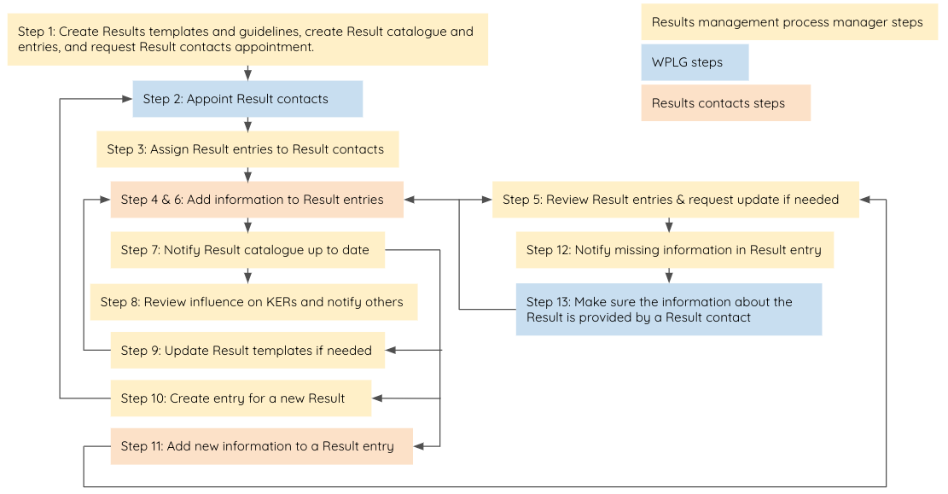

*Figure 4. Main steps of PROC05-1: Creation/Update of entries in the Project Results Catalogue*

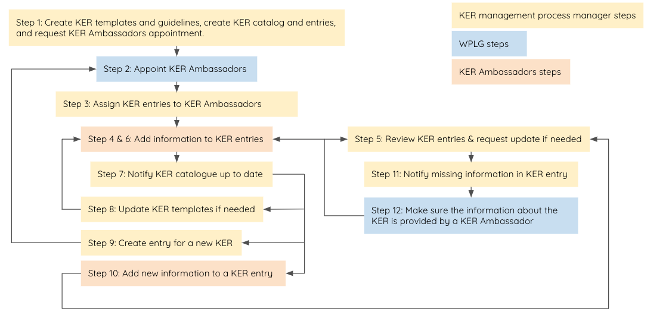

*Figure 5. Main steps of PROC05-2: Creation/Update of entries in the Project KERs Catalogue*

## 2.10. Work plan

The InnoMS work plan describes the timelines for developing processes, their activities, and the roles and responsibilities of the staff. Project months 1 to 36 will be considered in the timeline for the development of the activities, even if the activities within months 19 to 36 are developed as part of the tasks in WP4. In D4.1 IP Management and Exploitation Report, a report on the work performed from months 1 to 36 will be provided.

| InnoMS Work plan | | | |
| --- | --- | --- | --- |
| Process 1: Intellectual Asset Inventory Management (IAIM) | | |  |
| Activity | | Timeline | Staff assigned |
| Activity 1: Document process overview and assign roles & responsibilities. | | M4 (Jul-24) to M5 (Aug-24) | T3.1/4.1 Androniki Pavlidou (OpenAIRE) as Process and activity lead for all the activities  + Project partners |
| Activity 2: Procedure and templates to record Background IP, Third-party IP, Sideground IP and Foreground IP. | | M6 (Sep-24) to M10 (Jan-25) |
| Activity 3: Record Background IP, Third-party IP, Sideground IP, Foreground IP, in addition to iteratively reviewing and updating information and templates as needed. | | M9 (Dec-24) to M12 (Mar-25) |
| Activity 4: Analyse the need for joint ownership and licensing agreements. | | M13 (Apr-25) to M34 (Jan-27) |
| Activity 5: Draft and propose joint ownership and licensing agreements as needed. | | M16 (Jul-25) to M36 (Mar-27) |
| Process 2: Results Management (RM) | | |  |
| Activity | | Timeline | Staff assigned |
| Activity 1: Document process overview and assign roles & responsibilities. | | M4 (Jul-24) to M5 (Aug-24) | T3.1/4.1 Androniki Pavlidou (OpenAIRE) as Process and activity lead for all the activities  + Project partners |
| Activity 2: Define procedure and template to identify, record, and manage results. | | M6 (Sep-24) to M11 (Feb-25) |
| Activity 3: Make sure project result contacts are appointed by the WPLG and provide them guidelines for a successful collaboration. | | M8 (Nov-24) to M12 (Mar-25) |
| Activity 4: Identify, record and manage results, in addition to iteratively reviewing and updating information and templates as needed. | | M11 (Feb-25) to M36 (Mar-27) |
| Process 3: Key Exploitable Results Management (KERM) | | |  |
| Activity | | Timeline | Staff assigned |
| Activity 1: Document process overview and assign roles & responsibilities. | | M4 (Jul-24) to M5 (Aug-24) | T3.1/4.1 Montserrat Gonzalez Ferreiro (EGI) as Process and activity lead for all the activities  + KER Ambassadors |
| Activity 2: Define procedure and template to record, and manage KERs. | | M4 (Jul-24) to M8 (Nov-24) |
| Activity 3: Identify KERs (assess the KER in the project proposal and add more if necessary) and start filling the KER template. | | M9 (Dec-24) to M10 (Jan-25) |
| Activity 4: Make sure KER ambassadors are appointed and provide them guidelines for a successful collaboration. | | M9 (Dec-24) to M12 (Mar-25) |
| Activity 5: Record and manage information about KERs in collaboration with the KERs ambassadors, in addition to iteratively reviewing and updating information, guidelines, and templates as needed. | | M13 (Apr-25) to M36 (Mar-27) |
| Process 4: Exploitation Management (EM) | | |  |
| Activity | | Timeline | Staff assigned |
| Activity 1: Document process overview and assign roles & responsibilities. | | M4 (Jul-24) to M5 (Aug-24) | T3.1/4.1 Montserrat Gonzalez Ferreiro (EGI) as process lead |
| Activity 2: Define a high-level exploitation strategy for the project results. | | M6 (Sep-24) to M12 (Mar-25) | T3.1/4.1 Androniki Pavlidou (OpenAIRE) |
| Activity 3: Formulate a methodology, guidelines and a template to create partner-specific KERs exploitation plans. | | M6 (Sep-24) to M12 (Mar-25) | T3.1/4.1 Montserrat Gonzalez Ferreiro (EGI)  + Project partners |
| Activity 4: Support creation of partner-specific KERs exploitation plans, in addition to iteratively reviewing and updating information and templates as needed. | | M13 (Apr-25) to M36 (Mar-27) |
| Activity 5: Establish collaboration channels with other EOSC projects, the EOSC Association, and the procurement consortia to identify exploitation opportunities. | | M1 (Apr-24) to M36 (Mar-27) | T3.1/4.1 Montserrat Gonzalez Ferreiro (EGI)  T3.3/4.3 Federico Drago (EGI) |
| Activity 6: Investigate collaboration and exploitation options for project results through the EOSC DIH. | | M3 (Jun-24) to M36 (Mar-27) | T3.1/4.1 Elisa Cauhé (EGI) |
| Process 5: KER Sustainability Management (KERSM) | | |  |
| Activity | | Timeline | Staff assigned |
| Activity 1: Document process overview and assign roles & responsibilities. | | M4 (Jul-24) to M5 (Aug-24) | T3.1/4.1 Androniki Pavlidou (OpenAIRE) as Process and activity lead for all the activities  + Project partners |
| Activity 2: Define a methodology and template to do a partner-specific KERs sustainability analysis. | | M5 (Aug-24) to M10 (Jan-25) |
| Activity 3: Support project partners in preparing partner-specific sustainability analyses, and review and update templates iteratively as well as request updates as necessary. | | M11 (Feb-25) to M36 (Mar-27) |
| Process 6: Impact Management (IM) | | |  |
| Activity | | Timeline | Staff assigned |
| Activity 1: Document process overview and assign roles & responsibilities. | | M4 (Jul-24) to M5 (Aug-24) | T3.1/4.1 Montserrat Gonzalez Ferreiro (EGI) as Process and activity lead for all the activities  + Project partners |
| Activity 2: Define the pathways to impact and the impact canvas report. | | M10 (Jan-25) to M12 (Mar-25) |
| Activity 3: Continuously populate and update the project impact canvas in collaboration with project partners. | | M13 (Apr-25) to M36 (Mar-27) |
| Activity 4: Continuously follow up impact and exploitation activities and report them as needed. | | M13 (Apr-25) to M36 (Mar-27) |

*Table 9. Work plan for the Innovation Management System activities*

# Communication and Dissemination

This section mainly covers activities related to Task 3.3 Communication and dissemination, also in relation to its collaboration with Task 3.2 Service promotion, user community support and coordination, in support of other tasks and WPs across EOSC Beyond.

## Target stakeholders

EOSC Beyond engages with a diverse range of stakeholder groups to ensure comprehensive collaboration and effective dissemination of its outcomes. Understanding and addressing the needs of each stakeholder group is crucial for the project's success and sustainability. This section provides an analysis of each stakeholder group and their relevance to the EOSC Beyond project.

| Stakeholder groups | Description |
| --- | --- |
| EOSC EU Node | A reference node for EOSC, provided by the European Commission, offering access to a diverse range of research outputs, services, and tools. |
| EOSC Community | It represents key EOSC-related actors such as the EOSC Association and its Task Forces, other EOSC-related projects in Horizon Europe, and the EOSC Steering Board. |
| National and International RIs | This group covers national and international facilities that provide resources and services for research communities to conduct research and foster innovation like ERIC Forum, ESFRI and others. |
| Content and Service Providers | This group represents service providers involved in developing and providing services for research that are going to be onboarded in EOSC along with data providers. |
| EOSC Nodes | National, Regional and Thematic infrastructures which will be connected to the EOSC EU Node and among themselves to share data, services and other resources. |
| EOSC End Users | Group representing the end user of EOSC services including (i) Researchers and Research communities; (ii) SMEs/Industry; (iii) Local, regional, thematic and national service managers; (iv) European and International non-EOSC projects, networks and agencies; (v) Public sector. |
| Funders & Policymakers | This group represents EU funders, Member States, National funding bodies, Private Investors, Regulatory bodies on data privacy, competition and research, Research policy organisations. |
| Other initiatives | Initiatives such as GAIA-X, EuroHPC, SIMPL, EU Data Spaces, and UN agencies. |

*Table 10. EOSC Beyond stakeholders*

### Quadrant analysis

The quadrant analysis is a strategic tool used to categorise stakeholders based on their level of influence and interest in a project. It divides stakeholders into four quadrants: High Influence, High Interest; High Influence, Low Interest; Low Influence, High Interest; and Low Influence, Low Interest. By mapping stakeholders into these quadrants, we can tailor engagement strategies to effectively address each group's needs and expectations.

This analysis is particularly useful for EOSC Beyond as it helps prioritise which stakeholders require the most attention and resources. By identifying critical groups, we can develop specific communication and engagement strategies, enhancing overall project efficiency and stakeholder satisfaction. Furthermore, it assists in efficiently allocating resources by focusing efforts on stakeholders with high influence and interest, ensuring optimal use of the project's time and budget.

Additionally, quadrant analysis aids in risk management by understanding the needs and potential impact of each stakeholder group. This allows the project to anticipate and mitigate risks associated with stakeholder disengagement or opposition. In summary, quadrant analysis provides a clear framework for EOSC Beyond to manage stakeholder relationships strategically, ensuring that relevant parties are adequately informed, involved, and supportive of the project’s objectives.

| High Influence, Low Interest | High Influence, High Interest |
| --- | --- |
| **Strategy**: Maintain regular communication, involve in high-level planning, and keep informed about key developments.  **Stakeholders**: Content and Service Providers, Funders & Policymakers, UN Agencies | **Strategy**: Prioritise engagement, involve in requirements gathering, ensure regular updates, and closely collaborate.  **Stakeholders**: EOSC Community, EOSC EU Node, EOSC Nodes |
| Low Influence, Low Interest | Low Influence, High Interest |
| **Strategy**: Monitor engagement levels, provide essential information, and facilitate periodic updates to maintain awareness.  **Stakeholders**: EOSC End Users, Other Initiatives | **Strategy**: Engage through targeted communications, provide opportunities for feedback, and ensure access to relevant resources.  **Stakeholders**: National and International RIs, SIMPL |

*Table 11. Stakeholders influence and interest quadrant analysis*

### SWOT Analysis

The SWOT (Strengths, Weaknesses, Opportunities, Threats) analysis is a vital strategic tool for assessing the EOSC Beyond project within the broader context of EOSC. It enables the project to evaluate both internal factors, such as broad stakeholder engagement across research infrastructures, policymakers, and service providers, and external factors like dynamic technological and regulatory landscapes.

By identifying strengths, such as robust stakeholder collaboration, EOSC Beyond can effectively leverage resources and foster synergies among diverse stakeholders. Addressing weaknesses, such as potential challenges in resource allocation, allows the project to proactively improve efficiency and operational effectiveness.

Moreover, recognising opportunities, such as forming strategic partnerships with initiatives like SIMPL, can enhance the project's visibility, expand its impact, and access additional resources crucial for achieving its goals. Conversely, understanding threats, such as rapid changes in technology and policies, enables EOSC Beyond to adopt strategies to mitigate risks and maintain relevance in a constantly evolving environment.

In essence, the SWOT analysis equips EOSC Beyond with insights to strategically navigate complexities, capitalise on opportunities, and mitigate challenges, thereby contributing effectively to advancing EOSC.

| Strengths | Weaknesses |
| --- | --- |
| **Strong Network**: The involvement of diverse stakeholders such as the EOSC Community, EOSC EU Node, and Future EOSC Nodes provides a robust support network.  **High Expertise**: Collaboration with National and International RIs and Content and Service Providers brings significant expertise and resources.  **Strategic Support**: Funders & Policymakers may offer strategic guidance. | **Resource Allocation**: Balancing the needs of high-interest but low-influence groups with those of other stakeholders can be challenging.  **Communication Challenges**: Ensuring effective communication across a diverse stakeholder base requires significant effort and resources. |
| Opportunities | Threats |
| **Enhanced Collaboration**: Increased engagement with high-interest stakeholders can lead to innovative solutions and enhanced project outcomes.  **Funding Opportunities**: Strengthening relationships with Funders & Policymakers can help allocate future funding and resources.  **Strategic Partnerships:** Forming collaborations with key stakeholders and initiatives such as SIMPL can enhance project visibility and access to additional resources. | **Stakeholder Disengagement**: Lack of sustained interest from key stakeholders can hinder project progress.  **Resource Constraints**: Limited resources may affect the ability to engage effectively with all stakeholder groups.  **Ever-changing Landscape**: The rapid evolution of technology and policies in EOSC poses challenges in maintaining project relevance and alignment with changing standards and regulatory landscapes. |

*Table 12. EOSC Beyond SWOT analysis*

### Engagement strategies

The different stakeholder groups will be engaged, involved, and informed via a range of activities and channels that are detailed in the following dedicated sections. This strategic approach ensures that each stakeholder's unique needs and interests are addressed effectively, fostering collaboration and maximising the impact of the EOSC Beyond project.

## Communication and dissemination activities

Task 3.3 focuses on communication activities aimed at informing target groups about the project’s achievements and coordinating related events and activities. These efforts are designed to increase awareness of EOSC Beyond and EOSC among users and highlight the value of EOSC Core services.

Additionally, Task 3.3 will create complementary materials to support Task 3.2, which focuses on service promotion, user community support, and coordination. By working together, these tasks will ensure effective dissemination of information and foster a strong user community.

### Visual identity

#### Logo

The EOSC Beyond logo adheres to the newly established coordinated EOSC branding, as promoted by the EOSC Association starting in 2022[1]. This approach responded to the need for a more consistent identity across the EOSC community in Horizon Europe compared to the previous efforts in Horizon 2020, and it has been widely adopted since the first batch of funded projects such as FAIR-IMPACT and FAIRCORE4EOSC.

The only visual addition is a fast-forward icon at the end of the word “Beyond”, to signal that the project mainly focuses on future developments instead of the production of the current EOSC environment. Aside from the horizontal and vertical versions of the logo, a square one only featuring the infinity sign was also produced to act as a website favicon and other similar usages.

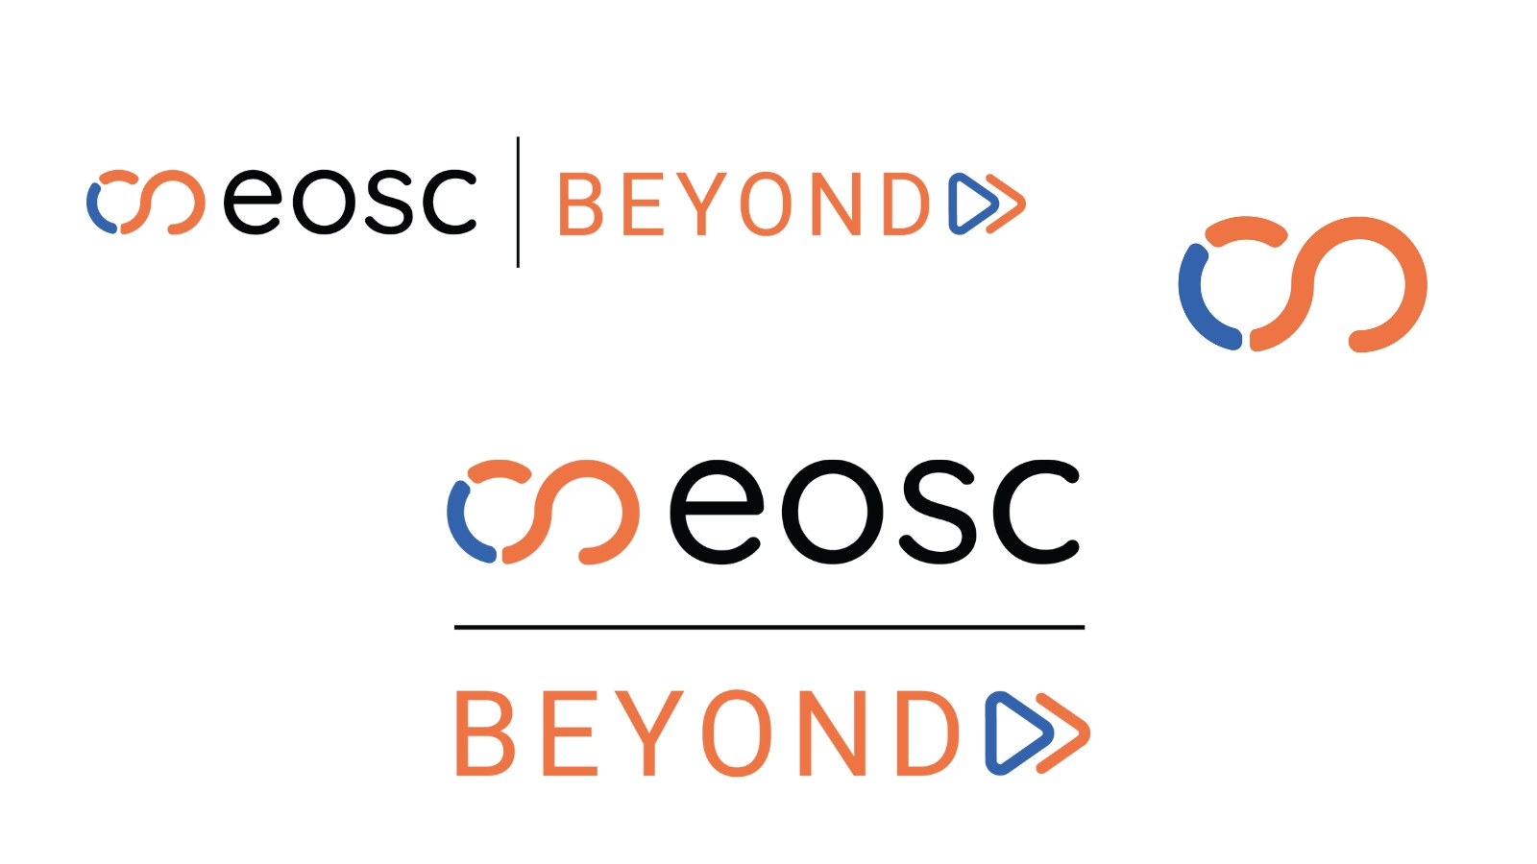

*Figure 6. Different versions of the EOSC Beyond logo*

#### Branding

A brand manual was produced in M0 and provided to the consortium via Confluence, including information on the correct colours, fonts and logo usage, to allow all project partners to align and produce their project-related content.

The three colours (orange #EE7444, blue #3463AC, and black #040204) were chosen from the list indicated in the EOSC Association Corporate Design Manual[2], and the two font styles (Quicksand for titles and Roboto for body) also follow the overall style implemented by the EOSC Association and a majority of EOSC-related projects.

### Communication package and materials

Based on the established visual identity, the communication team proceeded to provide the following items as part of the Communication package for the benefit of the consortium by M3 as requested by Milestone MS3.

* Presentation template - Google Slides and PPT
* Video conference background
* Letterhead template
* Deliverable template
* Stickers
* A5 Flyer
* Rollup banner

In particular, the A5 flyers were first featured and distributed at the EGI booth at TNC24[3]. A range of extra gadgets have already been designed and used in the first few months of the project, such as USB sticks. A6 Notepads will be distributed at EGI2024, taking place in Lecce, Italy.



*Figure 7. Video background and sticker design from the Communication package*

New material will be produced as the project progresses, including project posters for exhibitions and conferences.

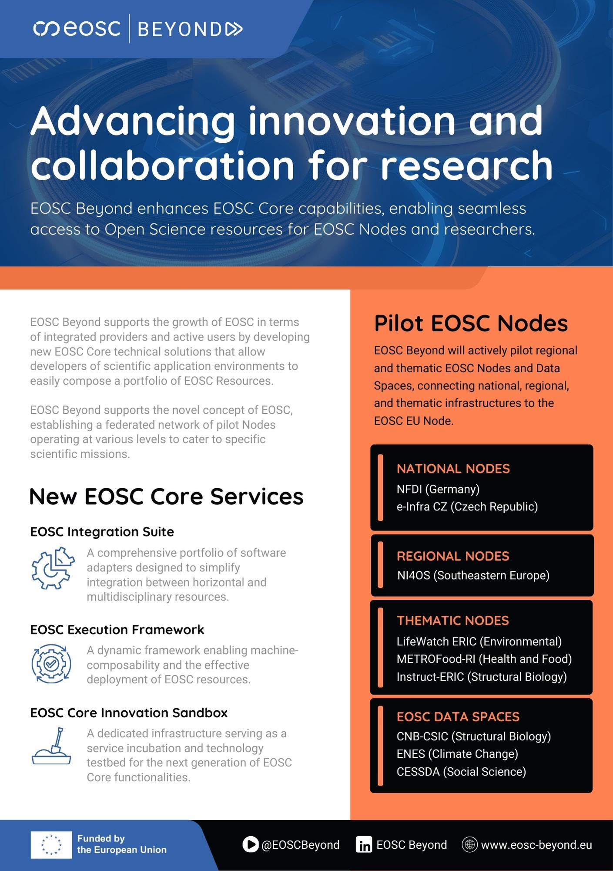

*Figure 8. EOSC Beyond A5 flyer*

#### Dissemination of promotional material of EOSC Core services

For the whole duration of the project, there is a series of promotional materials through the activities identified by T2.3 and listed as milestones. All information will be made available through the project communication channels that are identified in this section, monitored with analytics and reported back to the project partners. More details on the materials are included in Section 4 “Service promotion, user community support and feedback loop coordination”.

### Online presence

#### Website

The EOSC Beyond website is the central piece of the project’s online presence, and it was designed in line with the general EOSC branding for better consistency.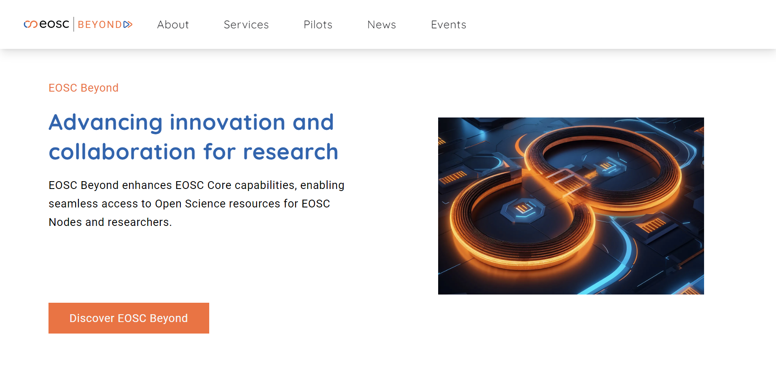

*Figure 9. Homage of the EOSC Beyond website*

It was launched in M1 (Apr-24) and has been expanded to include key project information such as partners, services, news and events, by M4 (Jul-24) as requested by Milestone MS4. New content is expected to be created through the second half of 2024, including pages for the Pilot Nodes.

| Main page | Children pages | Comment |
| --- | --- | --- |
| **About** | Work Packages  EOSC  Project Deliverables | Main information about the project's overall structure. |
| **Services** | EOSC Core Innovation Sandbox  EOSC Execution Framework  EOSC Integration Suite | The range of technical solutions and resources developed by EOSC Beyond.  A dedicated page for enhanced EOSC Core services will also be published through Year 1 of the project. |
| **Pilots** |  | A dedicated page for each Pilot node will be built through the summer, to be ready by the EOSC Symposium 2024. |
| **News** | Newsletter | The latest announcements, developments, and success stories. |
| **Events** |  | Past and upcoming events, workshops, and conferences related to EOSC Beyond and the broader EOSC community. |

*Table 13. Website structure*

The EOSC Beyond website utilises Matomo analytics to enhance user experience and improve site performance. Matomo is a secure, open-source web analytics platform that respects user privacy while providing detailed insights into website traffic and user behaviour. By analysing these metrics, EOSC Beyond can optimise content, ensure user engagement, and make data-driven decisions to better serve the needs of our visitors.

The EOSC Beyond website news section features articles and blog posts that accompany major updates and highlight key project activities. This content will serve as a vital outreach tool, enabling us to share detailed insights and progress with the EOSC community. By regularly publishing engaging and informative posts, we aim to keep our stakeholders informed, stimulate discussions, and foster a deeper understanding of our project's impact and contributions to EOSC.

#### Social media

LinkedIn serves as the primary social media channel for EOSC Beyond[4], offering a professional platform to share project updates, engage with stakeholders, and foster a growing community of followers. Through LinkedIn, we disseminate key information, highlight achievements, and facilitate networking opportunities, ensuring our project reaches a broad and relevant audience within the research and innovation sectors.

LinkedIn is also the main channel adopted by other key initiatives in the community, such as the EOSC Association and other relevant Horizon Europe projects (e.g. OSCARS).

The project has decided not to use Twitter/X due to its downward trend in user engagement and the increasing limitation of features to paid accounts. Instead, we focus our efforts on LinkedIn, which provides a more stable and feature-rich platform for professional networking and project communication in our target communities.

We also utilise YouTube[5] to publish various multimedia content, including video interviews, webinar recordings, tutorials, and other educational materials. This platform allows us to visually engage with our audience, providing valuable insights and resources in an accessible format. By sharing our content on YouTube, we aim to enhance the visibility of our project and support the broader community with high-quality, informative videos.

#### Newsletter

The Mailerlite platform was chosen to manage and distribute the EOSC Beyond project newsletter. It is published quarterly with its first issue distributed at the end of M3, featuring comprehensive updates on KERs, project milestones, upcoming events, and community opportunities. Through the newsletter, stakeholders will be informed and engaged with the latest developments and opportunities within the EOSC Beyond project.



*Figure 10. Promotional image for the first newsletter issue*

### Collaborations and events

#### Collaborations

EOSC Beyond is actively involved in discussions and activities in collaboration with the EOSC Association and other EOSC-related projects in Horizon Europe. In particular, EOSC Beyond representatives participate in the three collaboration groups facilitated by EOSC Focus.

* Communication & Engagement Working Group
* Technology Working Group
* Impact Working Group

This involves participating in recurring online meetings, where the projects can share relevant information and opportunities for further collaboration such as consultations or joint activities at events.

The project has also participated in the 2024 Coordination meeting of EOSC-related projects funded under Horizon Europe, organised by the European Commission in June 2024[6].

#### Project events

EOSC Beyond is committed to organising a range of project events to foster collaboration, share knowledge, and enhance the impact of our work. EOSC Beyond workshops will bring together key stakeholders, including researchers, industry partners, and policymakers, to discuss critical topics, exchange ideas, and develop solutions that advance EOSC.

These interactive sessions are expected to facilitate networking and partnership opportunities with relevant initiatives, ensuring that participants can directly contribute to and benefit from the project’s objectives.

A first example of this was the EOSC Pilot Nodes Workshop[7] held in June 2024 in Kraków, Poland, which, aside from consortium partners, also featured invited representatives from OSCARS, FAIRCORE4EOSC, ENVRI-Hub NEXT and EOSC Focus.

Furthermore, EOSC Beyond will host a series of webinars and tutorials aimed at providing in-depth training and practical insights into the technical solutions and resources we offer. These online events will cover a range of topics, from utilising new EOSC Core technical solutions to integrating diverse EOSC Resources into scientific applications. By offering accessible and informative sessions, we aim to empower our community with the knowledge and skills needed to effectively engage with and leverage the capabilities of the EOSC Beyond project.

#### Third-party events

EOSC Beyond is dedicated to actively participating in key third-party events to showcase project's progress and engage with the broader scientific and research community. The project’s involvement will include delivering presentations, presenting posters and demonstrations, taking on speaking roles, and hosting booths at exhibitions. This multi-faceted approach ensures that results and advancements can effectively be communicated, valuable feedback can be gathered, and new collaborations can be forged.

Key events on the project calendar include the annual EOSC Symposium, the annual EGI Conference, and the annual TNC organised by GÉANT. Additionally, EOSC Beyond aims to be present at the biannual Open Science FAIR and EUDAT Conference, among other relevant events identified by the consortium. These platforms provide invaluable opportunities to connect with stakeholders, share insights, and highlight the innovative solutions and resources developed by EOSC Beyond. Active participation in these events underscores the project’s commitment to fostering an inclusive and dynamic EOSC ecosystem.

One such example is the session “Empowering Open Science: EGI’s community impact on EOSC” taking place at EGI2024[8], which is going to feature an EOSC Beyond presentation.

### KPIs

| Item | M5 (Aug-24) Stat | M36 Target |
| --- | --- | --- |
| Monthly website visits | 288 | 350 |
| **Newsletter**  Subscribers  Average open rate | *1 issue in M3*  57  57% | 300  35% |
| **LinkedIn**  Followers  Monthly impressions  Monthly engagement rate | 388  4090  13.28 | 1000  3500  6.5 |
| **YouTube**  Total views | 134 | 700 |
| **Third-party events**  Presentations, panels, posters, demonstrations, booths | 2 | 20 |

*Table 14. Communication KPIs*

## 3.3. Communication and Dissemination work plan

| Formal activity breakdown | | |
| --- | --- | --- |
| Activity | Timeline | Owner |
| **Activity 1: Provide a visual identity and ensure it remains consistent throughout the project**  Production of logo and brand manual - oversee the creation of new materials for consistency. | M3 (Jun-24) | Federico Drago, EGI Foundation |
| **Activity 2: Provide the basic communication package and materials**  Creation of general materials for the project and inclusion on Confluence | M3 (Jun-24) | Federico Drago, EGI Foundation |
| **Activity 3: Create and maintain project website**  It was launched in M1 and was expanded to include key project information such as partners, services, news and events by M4 (Jul-24) as requested by MS4. New content to be created when needed. | M1 (Apr-24) -M36 (Mar-27) | Federico Drago, EGI Foundation |
| **Activity 4: Set up and manage social media presence**  Setup and management of LinkedIn and YouTube channels. | M1 (Apr-24) -M36 (Mar-27) | Federico Drago, EGI Foundation |
| **Activity 5: Create and manage quarterly project newsletter**  Maintain newsletter subscriber community on Mailerlite, produce and send quarterly newsletters starting in June 2024**.** | M3 (Jun-24) -M36 (Mar-27) | Federico Drago, EGI Foundation |
| **Activity 6: Contribute to relevant deliverables**  Draft together with T3.1, T3.2 and other relevant tasks the exploitation, dissemination and communication deliverables D3.1 and D3.2. | 3M4 (Jul-24)-M6 (Sep-24)  M16 (Jul-25) - M18 (Sep-25) | Federico Drago, EGI Foundation  Androniki Pavlidou, OpenAIRE |
| **Activity 7: Production of Promotional material of EOSC Core services**  This includes eBooks, Slide decks, videos, to be created in collaboration with T3.2 and relevant partners. | M6 (Sep-24)-M36 | Androniki Pavlidou, OpenAIRE  Franziska Krauss, OpenAIRE |
| **Activity 8: Facilitating project workshops and supporting presence at third-party events**  Especially related to the MS7 “Promotion of 7 support activities per communities/stakeholder”, in collaboration with T3.2 and relevant partners. | M1 (Apr-24) - M36 (Mar-27) | Androniki Pavlidou, OpenAIRE  Franziska Krauss, OpenAIRE  Federico Drago, EGI Foundation |
| **Activity 9: Collaboration with Horizon Europe EOSC Projects on comms**  Participation in monthly meetings and activities with other comms representatives from Horizon Europe EOSC Projects. | M1 (Apr-24) - M36 (Mar-27) | Federico Drago, EGI Foundation |
| **Activity 10: Monitoring and reporting of activities**  Ensure communication and dissemination KPIs and activities are monitored every month via the dedicated channels. Contribute to official progress reports. | M1 (Apr-24) - M36 (Mar-27) | Federico Drago, EGI Foundation  Androniki Pavlidou, OpenAIRE |

*Table 15. Formal activity breakdown*

# 

# 4. Service promotion, user community support and feedback loop coordination

This section describes the approach by Task 3.2 and the plan for user engagement and support through activities during the first half of the project duration M1-M18. There is a milestone that is part of the process, ‘MS5 - Promotional material of EOSC Core services (eBooks, Slide decks)’. That material would be used to assist the uptake of the services and inform new stakeholders on the value and impact of the services of the project. EOSC Core services will be accompanied by an eBook and a slide deck and more learning materials and informative posters. All will be available on the dissemination channels of the project; website (MS4), social media, Zenodo, and will make use of the delivered communication package material (MS3) through task Task 3.3. Task 3.2 material will be driven by deliverable D15.1 (M4, Jul-24), where definitions of the services, descriptions, stakeholders, and user stories are presented. Internal coordination activities are driven by the TCB meetings, milestones, deliverables and project roadmap.

## 4.1 Services promotion activities and user engagement

The EOSC Beyond project aims to significantly enhance EOSC by developing and integrating a range of innovative services and resources. Central to the project's success is its commitment to promoting these services and engaging with a diverse range of stakeholders. This chapter details the strategies and activities designed to support service promotion, user community engagement, and feedback mechanisms throughout the project's lifecycle.

The primary objectives of the services promotion and user engagement activities within the EOSC Beyond project are to:

1. **Promote EOSC Core Services:** Increase awareness and utilisation of the EOSC Core services among target audiences.
2. **Establish and Strengthen Collaborations:** Build robust partnerships with relevant stakeholders.
3. **Develop Comprehensive Learning Materials:** Provide users with educational resources that facilitate the effective use of EOSC Core services.

### 4.1.1. Promotion of EOSC Core Services

Promotion of EOSC Core services is integral to achieving the project's objectives of increasing awareness and utilisation among target audiences. By leveraging a multi-faceted approach that combines the creation of targeted learning materials, effective use of communication channels, and active engagement with stakeholders, the EOSC Beyond project ensures that the services are well-promoted and widely adopted. This strategic promotion not only enhances the visibility of EOSC Core services but also supports their integration into the broader open science ecosystem.

### 4.1.2. Establishment of Collaboration Channels

Collaboration is a cornerstone of the EOSC Beyond project. The project team will actively engage with:

* **INFRA-2023-EOSC projects**: Establishing collaboration channels with other Horizon Europe projects related to EOSC to share knowledge and best practices.
* **EOSC Association, EOSC Procurement and SIMPL Consortia**: Collaborating with these entities to align activities and enhance the project's impact within the broader EOSC ecosystem.

### 4.1.3. Development of Learning Materials

Effective promotion of EOSC Core services employs a multi-faceted approach that integrates the creation and dissemination of valuable learning materials with active engagement across various channels. Important learning resources will be developed to guide users through the EOSC Core services, leveraging best practices from previous EU-funded H2020 projects and established expertise. These materials will be designed for online sharing, enhancing user support and contributing significantly to the project's overall engagement efforts.

To effectively promote services delivered by the Project and achieve **MS7: Promotion of 7 Support Activities per Community/Stakeholder**, a series of targeted activities will be implemented. These activities include organising specialised webinars and workshops tailored to diverse stakeholder groups, creating and disseminating a suite of educational materials such as eBooks, slide decks, and tutorials, and actively participating in relevant conferences and third-party events to showcase EOSC Core services. Each activity is designed to engage different communities, from researchers and industry partners to policymakers and service providers, ensuring that the promotional efforts resonate with their specific needs and interests. By aligning these initiatives with **MS7**, the project aims to enhance service uptake and foster meaningful interactions across all stakeholder groups, thereby driving greater adoption and impact of EOSC Core services.

The following table provides a comprehensive overview of the different types of learning resources created for this purpose. Each entry outlines the characteristics, aims, and learning goals of the materials, ensuring clarity on how they contribute to the overall training and promotional strategy.

By offering a range of formats—from concise factsheets to detailed webinars—these resources aim to address different learning preferences and needs. The following table serves as a guide to understanding the specific objectives of each type of material and how they align with the project's goals of increasing awareness, enhancing user competence, and fostering effective engagement with EOSC Core services.

|  | Characteristics | Aim | Learning goals |
| --- | --- | --- | --- |
| Factsheets | Display key information with visuals  Include the What-Why-How-For Who  1-2 pages maximum | Demonstrate the services’ main value, introduce them to audiences during events, conferences  Easy to save for later read | Individual introduction to the EOSC Core services. |
| Guides | Clear  Comprehensive  Simple  Concise (2 pages per service/topic) | Explain how to use the core services of EOSC-Beyond | Individual accomplishments and assistance on EOSC Core services |
| Introductory Tutorials | Clear  Comprehensive  Simple  Step-by-step guidance  Short (3-5 minutes)  Real-life examples | Explain how to use the core services of EOSC-Beyond | Broad and open demonstration of how to use the EOSC Core services, to users. Understanding the concepts covered, encouraging users to engage |
| Advanced Tutorials - Modules | Clear  Comprehensive  Case studies approach  Real-life examples  Longer form (10-15 minutes per session) | Explain how to use the core services of EOSC-Beyond, with more details and functionalities | Deeper understanding of the EOSC Core services, and development of necessary skills |
| Webinars/Workshops | Recorded interactive sessions (online) or face-to-face presentation and audience participation in conferences. Presenter’s answer questions in real time, receive feedback via polls, and provide downloadable material to attendees | Introduce the EOSC Core services | Broad and open to audience full coverage videos about the EOSC Core services. Explanatory and helpful FAQs answered live. Direct interaction with stakeholders |

*Table 16. Learning materials*

**Delivery of material**

| Learning resources | Platform of delivery | Timeline |
| --- | --- | --- |
| Factsheets | EOSC Beyond website  Zenodo | M14 (May-25) - M36 (Mar-27) |
| Guides | EOSC Beyond website  OpenPlato | M14 (May-25) - M36 (Mar-27) |
| Posters | Zenodo and conferences websites, EOSC Beyond dissemination channels | M4 (Jul-24)-M36(Mar-27) |
| Introductory Tutorials | EOSC Beyond YouTube Channel  EOSC Beyond website | M14 (May-25) - M36 (Mar-27) |
| Advanced Tutorials - Modules | EOSC Beyond YouTube Channel  OpenPlato  EOSC Beyond website | M14 (May-25) - M36 (Mar-27) |
| Webinars/Workshops (recording and materials) | EOSC Beyond YouTube Channel  Zenodo  EOSC Beyond website | M24 (Mar-26) - M36 (Mar-27) |

*Table 17. Delivery of learning material*

Learning materials will be proposed to be onboarded in the EOSC EU Node Resource Hub - Training Catalogue (<https://open-science-cloud.ec.europa.eu/resources/training>).

Learning and training resources developed for the EOSC Beyond project are tailored to address the needs of various target communities. Each type of resource offers specific benefits to different user groups and will be prepared and promoted in ways that maximise their effectiveness.

The table below outlines the benefits of each type of learning and training material developed for the EOSC Beyond project, illustrating how these resources are tailored to address the needs of various target groups and will be prepared and promoted to maximise their impact.

| Learning resources | Target Group | Benefit(s) |
| --- | --- | --- |
| Factsheets, Posters | EOSC EU Node | Provides quick, visual overviews of EOSC Core services, aiding in the efficient dissemination of service highlights and updates. |
| EOSC Community | Offers concise, easy-to-read summaries of EOSC Core services, helping with quick reference and updates during meetings and consultations. |
| National and International RIs | Presents essential service information in a digestible format, useful for integrating EOSC services into existing infrastructures. |
| Content and Service Providers | Highlights key services and data available through EOSC, supporting service onboarding and integration efforts. |
| EOSC End Users | Simplifies complex service offerings into easy-to-understand visuals, aiding quick understanding and adoption of new tools and resources. |
| EOSC Nodes | Assists in aligning regional and thematic infrastructures with EOSC Core services through clear, targeted information. |
| Funders & Policymakers | Communicates the strategic value and impact of EOSC services, facilitating informed decision-making and support. |
| Other Initiatives | Provides quick insights into the relevance and benefits of EOSC services, fostering cross-initiative collaboration. |
| Guides | EOSC EU Node | Offers detailed explanations of service usage, supporting the integration of new tools and resources into the node’s operations. |
| EOSC Community | Provides comprehensive guidance on EOSC Core services, enhancing the ability to coordinate and align with other EOSC-related projects. |
| National and International RIs | Delivers practical information on how to leverage EOSC services for research and innovation, aiding in their effective utilisation. |
| Content and Service Providers | Details on service functionalities and usage, supporting the development and enhancement of service offerings. |
| EOSC End Users | Guides users through service applications, helping them to efficiently utilise EOSC resources for their specific needs. |
| EOSC Nodes | Ensures consistent application and use of EOSC Core services across different nodes through detailed instructions. |
| Funders & Policymakers | Provides insights into service benefits and use cases, helping to justify funding and policy decisions. |
| Other Initiatives | Facilitates understanding of how EOSC services complement other initiatives, promoting collaborative opportunities. |
| Introductory Tutorials | EOSC EU Node | Offers step-by-step guidance on service applications, helping to onboard and train users within the node. |
| EOSC Community | Engages stakeholders with practical examples of service use, fostering broader community engagement and knowledge sharing. |
| National and International RIs | Introduces RIs to EOSC Core services with real-life examples, demonstrating practical benefits and applications. |
| Content and Service Providers | Provides foundational knowledge on EOSC services, aiding in the development and support of integrated solutions. |
| EOSC End Users | Offers hands-on tutorials for new users, simplifying the learning curve and enhancing engagement with EOSC resources. |
| EOSC Nodes | Supports node integration with EOSC services through practical demonstrations and use cases. |
| Funders & Policymakers | Demonstrates the practical impact of EOSC services through clear examples, assisting in stakeholder engagement. |
| Other Initiatives | Facilitates understanding of EOSC services through practical use cases, promoting synergy with other initiatives. |
| Advanced Tutorials - Modules | EOSC EU Node | Delivers in-depth training on complex service functionalities, enhancing the node’s capabilities and service utilisation. |
| EOSC Community | Provides detailed modules on advanced service features, supporting knowledge exchange and collaboration among EOSC-related projects. |
| National and International RIs | Offers comprehensive training on advanced service functionalities, aiding in the effective application of EOSC services in diverse research settings. |
| Content and Service Providers | Supports advanced service integration and optimisation through detailed tutorials, promoting high-quality service provision. |
| EOSC End Users | Equips users with advanced skills for utilising EOSC services, enhancing their ability to leverage complex features and capabilities. |
| EOSC Nodes | Assists in the advanced application of EOSC services across nodes, promoting effective resource sharing and integration. |
| Funders & Policymakers | Provides detailed insights into advanced service functionalities, supporting strategic funding and policy decisions. |
| Other Initiatives | Enhances understanding of how advanced EOSC services can be applied in conjunction with other initiatives, fostering collaboration. |
| Webinars/Workshops (recording and materials) | EOSC EU Node | Facilitates real-time training and interaction on EOSC services, enhancing practical knowledge and application within the node. |
| EOSC Community | Offers opportunities for live discussions and Q&A on EOSC services, promoting community engagement and feedback. |
| National and International RIs | Provides interactive sessions for deep dives into service functionalities, supporting collaborative learning and networking. |
| Content and Service Providers | Engages providers with live demonstrations and feedback sessions, aiding in the refinement and enhancement of services. |
| EOSC End Users | Provides direct access to expert knowledge and support, enhancing user experience and adoption of EOSC services. |
| EOSC Nodes | Supports real-time training and problem-solving across nodes, fostering a collaborative approach to service integration. |
| Funders & Policymakers | Engages stakeholders with live updates and discussions on service impacts, supporting informed decision-making. |
| Other Initiatives | Facilitates cross-initiative collaboration and knowledge sharing through interactive sessions and discussions. |

*Table 18. Learning resources, target group, benefits*

These materials are meticulously crafted to address the unique needs of each target group, ensuring effective promotion and utilisation of EOSC Core services.

### 4.1.4. External Feedback Loop Coordination

A robust feedback mechanism is crucial for the continuous enhancement of EOSC Core services and their associated learning materials. To ensure that the services and resources effectively meet the needs of diverse users and stakeholders, the EOSC Beyond project has implemented a comprehensive feedback loop coordination strategy. This strategy involves three key components: collecting feedback, analysing feedback, and adjusting strategies based on insights gained.

That strategy is further split into two parts; internal (analysed in the next session) and external.

1. **Collecting Feedback**

The first step in the feedback loop is the systematic collection of input from users and stakeholders. This process is multi-faceted, incorporating several methods to capture a wide range of perspectives:

* Surveys: Regular surveys will be distributed to users and stakeholders to gather quantitative and qualitative data on their experiences with the EOSC Core services and learning materials. These surveys are designed to assess various aspects, including usability, content clarity, and overall satisfaction.
* Feedback Forms: Feedback forms will be made available on the EOSC Beyond website and during training sessions and events. These forms provide users with a straightforward way to offer insights and suggestions on specific aspects of the services and materials.
* Direct Interactions: Engaging with users and stakeholders directly during workshops, webinars, and conferences offers valuable real-time feedback. Interactive sessions, Q&A segments, and informal discussions will be leveraged to gather immediate reactions and opinions.

1. **Analysing Feedback**

Once feedback is collected, it must be thoroughly analysed to derive actionable insights. This analysis involves several key steps:

* Data Aggregation: Feedback from various sources will be aggregated to identify common themes and trends. This includes compiling survey results, summarising feedback form responses, and noting recurring issues or suggestions from direct interactions.
* Feedback Evaluation: Detailed evaluation of the aggregated data will help in understanding user needs and preferences. Analysis will focus on identifying gaps in the current learning materials, understanding areas of difficulty, and recognising the strengths and weaknesses of the EOSC Core services.
* Impact Assessment: Assessing the impact of the feedback on the effectiveness of the current materials and services is crucial. This involves determining how well the existing resources align with user expectations and whether they adequately support users in achieving their goals.

1. **Adjusting Strategies**

The final step is to adjust strategies based on the feedback analysis. This iterative process ensures that promotional materials, learning resources, and service offerings continuously evolve to better meet user needs:

* Refinement of Materials: Feedback will be used to refine and update learning materials, including factsheets, guides, tutorials, and webinars. Adjustments may involve clarifying content, enhancing visual elements, or expanding on topics that users find challenging.
* Service Enhancements: Insights gained from feedback will inform improvements to the EOSC Core services. This may include modifying service features, improving usability, or addressing any issues identified by users.
* Strategy Adjustment: Overall promotion and engagement strategies will be adapted based on feedback. This could involve changing communication approaches, adjusting the frequency of updates, or exploring new channels for reaching target audiences.
* Ongoing Monitoring: Continuous monitoring will be established to evaluate the effectiveness of implemented changes. Regular follow-up surveys and feedback mechanisms will help ensure that adjustments have the desired impact and that the project remains responsive to user needs.

**Importance of a Feedback Loop**

The feedback loop is vital for ensuring that EOSC Core services and learning materials remain relevant and effective. By actively seeking and incorporating user input, the project can:

* Enhance User Satisfaction: Addressing user concerns and improving materials based on feedback increases user satisfaction and engagement with the EOSC Core services.
* Ensure Relevance: Regularly updating materials and services ensures that they remain relevant in a dynamic research environment, adapting to new developments and user requirements.
* Foster Continuous Improvement: A structured feedback mechanism supports a culture of continuous improvement, allowing the project to evolve and refine its offerings over time.
* Build Trust and Credibility: Demonstrating responsiveness to feedback builds trust with users and stakeholders, reinforcing the credibility and value of the EOSC Core services.

In conclusion, the feedback loop coordination strategy is a fundamental component of the EOSC Beyond project’s approach to promoting EOSC Core services. By systematically collecting, analysing, and acting on feedback, the project ensures that its services and learning materials are effectively tailored to meet the needs of its diverse user base, thereby maximising their impact and utility.

## 4.2 Support activities

To support the project's activities, Milestone MS5 (Month 12) will deliver key materials, including eBooks and pitch decks. These resources are currently being developed with templates in progress. The eBooks and slide decks will serve complementary purposes: the slide decks will provide a top-down, explanatory overview, while the eBooks will offer detailed insights into the EOSC Core services. If external statistics or quotes are unavailable at the milestone, they will be incorporated in subsequent updates. The following sections outline the structure and content of these materials.

### 4.2.1. eBooks

The following image illustrates the initial eBooks template, featuring a specific structured storyline designed to introduce users to the services effectively.

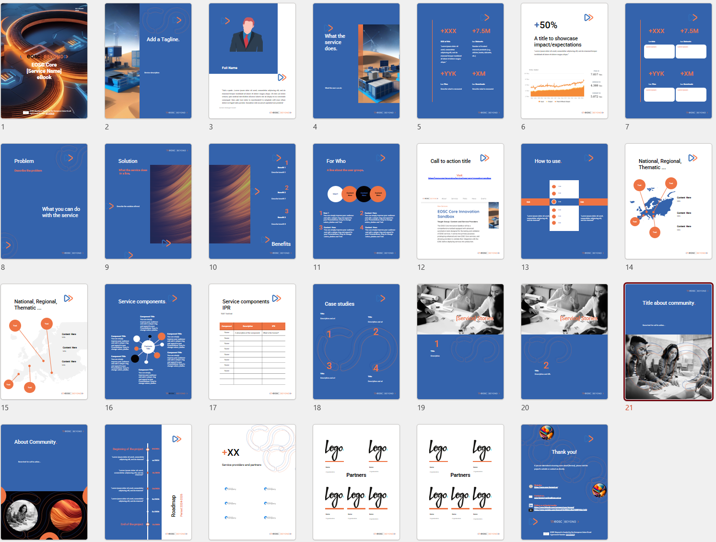

*Figure 11. eBook pages template in progress*

The eBooks are designed to cater to both new and existing users of EOSC Core services. New users, unfamiliar with the EOSC Core services and the project, as well as current users seeking updated information, can download and access key details relevant to their needs. The content covered in the eBooks includes:

* Funding information, EU flag, logo of the project, images of the services and project
* Name of the service
* Tagline of the service
* Description of the service
* A quote from the service owner/creator that could be compiled form the CORE services videos available on project website
* WHAT the service does with important KPIs
* WHY to select this service - its Benefits
* HOW the service solves the problem - the Solution
* WHO is this service for, with a short description of the user groups
* WHERE to find the service with a call to action to visit a url
* HOW to use the service - any steps that should be competed
* Information on service position within the ecosystem - National, Regional, Thematic, and some descriptive information
* The components of the service for transparency
* The service components IPR
* Case studies of the service throughout the project that showcase the value and impact to users
* Service user stories, depicted from users experiences during workshops and usage (input could be added by D15.1)
* Information about the community that supports the service and an engagement path that can initiate new users to use the service and be part of the community
* The service roadmap that includes the important milestones on the service development
* The logos of service providers as partners
* A closing informative page with the service url, contact email, and a call to action to follow the project latest news on social media

For a closer view of the eBook template, three very important sample pages are copied below. The first is about KPIs of the service, the second is about the benefits and the third is on the service components and IPR.

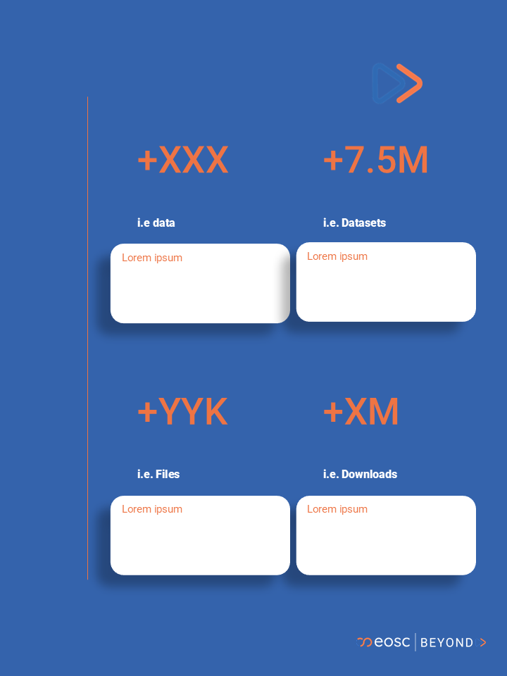

*Figure 12.*

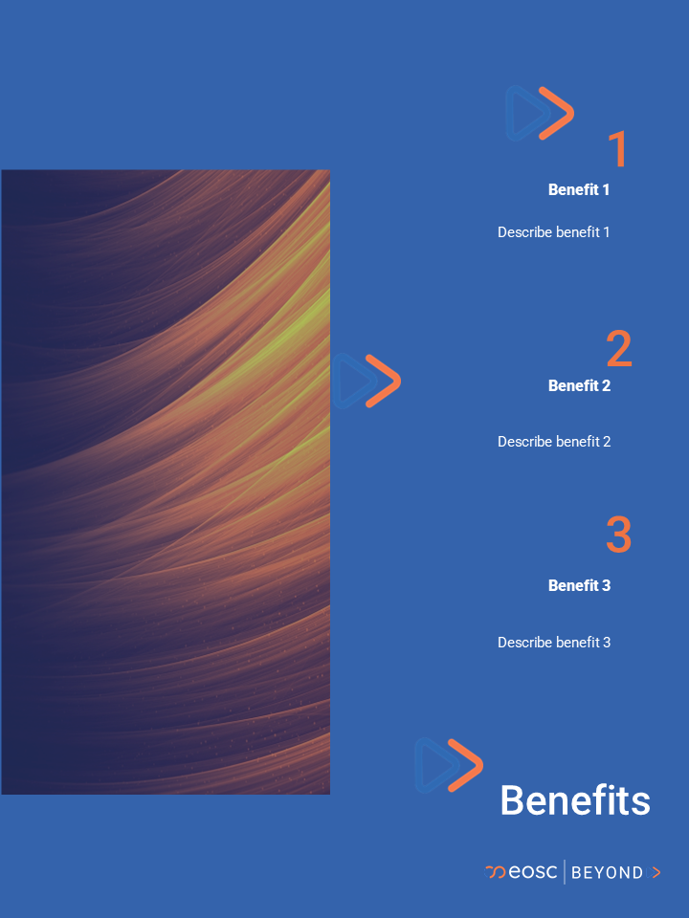

*Figure 13.*

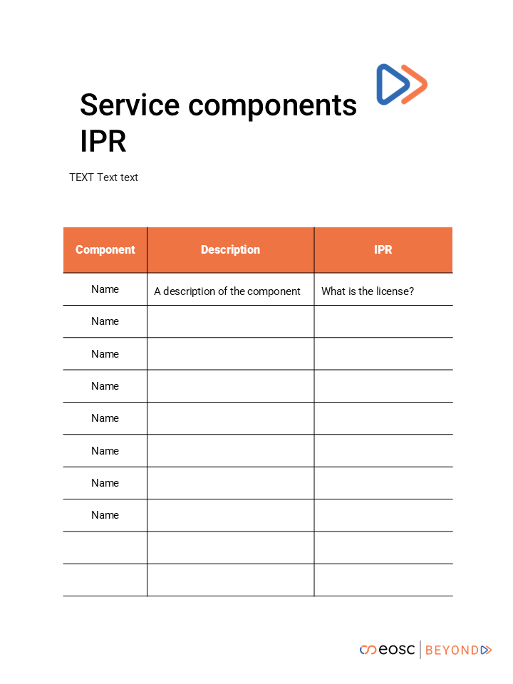

*Figure 14.*

One of the key advantages of eBooks is their flexibility in content updates. As new enhancements or functionalities are added to the services, the eBooks can be revised accordingly. Each eBook includes a version number and date to indicate its current state, ensuring that readers are always aware of the latest information. Additionally, eBooks can be downloaded for offline use, providing readers with convenient access to the material at any time.

### 4.2.2. Pitch (Slide) Decks

Drawing from established practices used by startups to effectively communicate their products and services, we have developed a pitch deck template designed to clearly convey the value of EOSC Core services. This template aims to be easily understandable, memorable, and useful for future reference. The next image displays a preview of the slides currently in development. The completed pitch decks for all services will be finalised and available for download by March 2025.

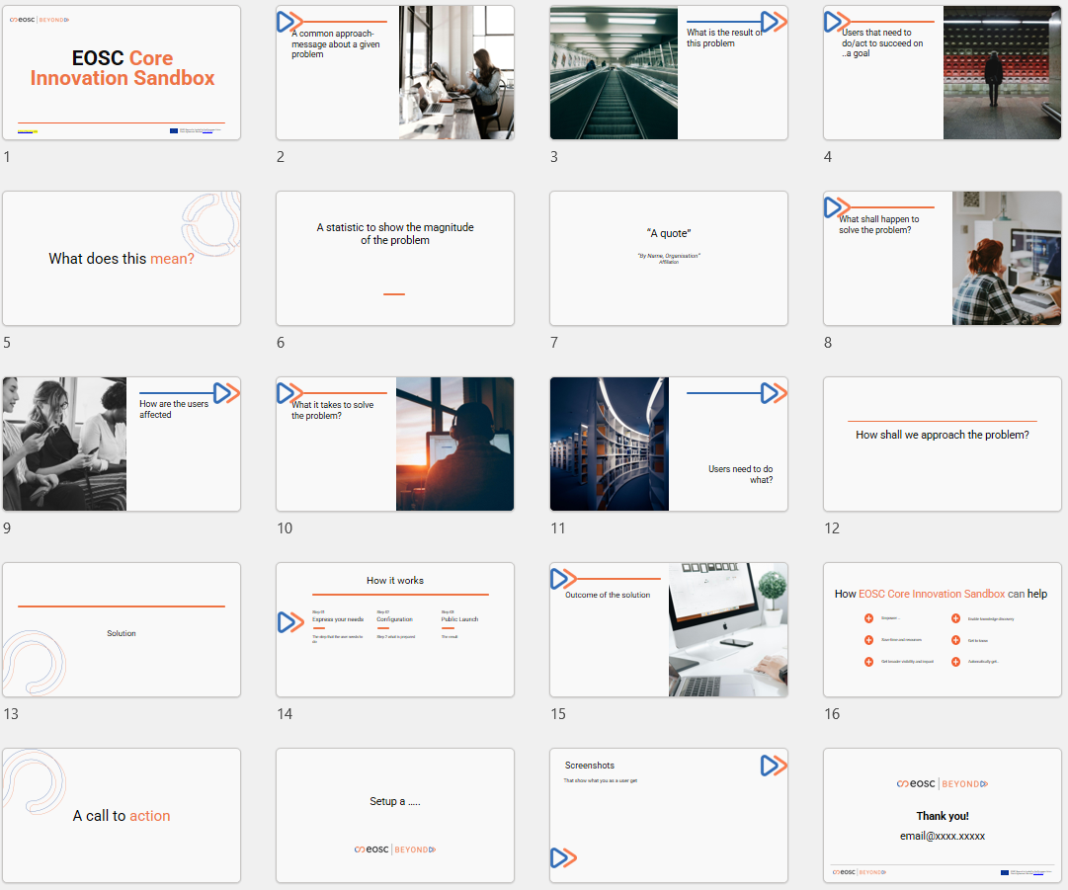

*Figure 15. Pitch (slide) deck template in progress*

The structure of the file includes the following and is based on a narrative around the service and users:

* Funding information, EU flag, logo of the project
* Service name
* Service URL
* Problem statement within the domain of research
* What is the result, the issue that the problem creates
* What users do to succeed on a goal that relates to the issue
* A call to action (if needed)
* A statistical value to show the magnitude of the problem (if publicly available)
* A quote from an expert that expresses concern, accompanied by name and affiliation (if possible)
* Actions that need to happen to solve the problem
* How would the users/stakeholders be affected
* What it takes to solve the problem
* What do users need to do
* The approach to solve the problem
* The solution (via the service)
* How users can reach to the solution (in simple steps)
* What is the expected outcome of the solution
* How the solution helps users solve the problem (max. 6 benefits)
* A call to action i.e. Register now!
* The result of the call to action i.e. activation of the account
* Screenshots of the solution
* Contact email for further information (support system)

Please note that the slides will avoid including technical details that might overwhelm or deter non-technical readers, such as product managers and decision-makers. If a reader is interested in more technical aspects, they can request further investigation from the technical team, and the detailed service documentation will be available to address those needs.

## 4.3 Coordination activities

The primary aim of this activity is to internally coordinate feedback loops to support WP15 efforts. As outlined in D15.1, this involves managing the development and evolution of pilot nodes, incorporating internal feedback, and aligning with project milestones. Figure 1 of D15.1 illustrates these feedback loops, which encompass user stories (also detailed in eBooks), requirements, service integrations, updates to the technical roadmap, pilot implementations, and subsequent testing and validation.

Within WP7 (Design the next generation of EOCS Core services), WP10 (Design of the EOSC Integration Suite and Execution Framework), WP13 (EOSC Execution Framework), WP5 (Task 5.6 EOSC Core Innovation Sandbox) the new Core Services will be defined and designed, feeding the information of all communication and promotion material.

Following also the lessons learnt by previous project EOSC-FUTURE, noted in D10.2 - EOSC Future Stakeholder Engagement & Communication Final Report, on the requirement for strong project internal coordination, the suggested actions are:

* The WP3 leader is the representative of Task 3.2, to participate as an observer in the TCB meetings, held weekly by the technical coordinator and the project manager of the project.
* The same representative also follows the official EOSC Beyond Project Governance and Management team, by participating in Work Package Leaders Group (WPLG) monthly meetings.

This approach fosters internal cross-work packages interactions and coordination, enhancing communication and collaboration. By integrating insights from Tasks 3.1, 3.3, and 3.4 within WP3, it benefits the consortium through improved knowledge sharing and feedback exchange.

## 4.4 Work plan

The following table summarises the activities of Task 3.2 during the project duration and is aligned with activities of Task 3.3 on communication and dissemination and follows the roadmap of the project.

| Formal activity breakdown | | |
| --- | --- | --- |
| Activity | Timeline | Owner |
| **Activity 1: Suggest good practices of material - eBooks, Pitch Decks adopted by OpenAIRE-Nexus H2020 funded project**  Follow the same narrative that could be adjusted to the needs of the project and EOSC Core services. | M4 (Jul-24) | Androniki Pavlidou, OpenAIRE |
| **Activity 2: Suggest good practices of training material - Factsheets, Guides, Tutorials, for the EOSC Core services**  Creation of a list of material that could be useful as good practices out of experience with H2020 projects and users requirements, feedback | M3 (Jun-24) | Andre Vieira, Pedro Príncipe /OpenAIRE-UMINHO  Federico Drago, EGI Foundation |
| **Activity 3: Templates of eBook, Pitch Decks (Slide decks) available for review and final version, for the EOSC Core services.**  Creation of the templates that would be used later on for services and would be disseminated through the communication and dissemination channels. The structure of the information should be clear. | M4 (Jul-24)-M7 (Oct-24) | Androniki Pavlidou, OpenAIRE |
| **Activity 4: Prepare EOSC Core services and Pilots promotion, user engagement and liaison activities**  Suggest activities with high impact, value, and user engagement. Suggest activities among the other EOSC related projects. | M3 (Jun-24) - M6 (Sep-24) | Maja Dolinar, OpenAIRE |
| **Activity 5: Prepare templates of support materials for the EOSC Core services, i.e. factsheets, guides, tutorials, posters**  Material should be made easy to comprehend and downloadable via the project website. Could be updated as services evolve. Factsheets are mainly portable PDF documents that can be accessed online but can be used at in-person events; the guides are essentially web pages with basic information on the service (What it is, What it does, How can I use it?, Technical Requirements); and the tutorials are short videos that can be embedded in guides or made available individually on a video channel. | M4 (Jul-24)-M8 (Nov-24) | Andre Vieira, Pedro Príncipe /OpenAIRE-UMINHO |
| **Activity 6: Create a list of events, workshops to attend as part of T3.3 and T3.2 user engagement activities. Name the targeted groups of stakeholders.**  The list can include suggested events by the consortium. | M4 (Jul-24)-M6 (Sep-24) | Maja Dolinar, OpenAIRE  Federico Drago, EGI Foundation |
| **Activity 7: Deliver eBooks, Pitch decks (slide decks) of the EOSC Core services (Milestone MS5)**  Provide the finalised templates with information on the new EOSC Core services of the project. | M12 (Mar-25) | Androniki Pavlidou, OpenAIRE |
| **Activity 8: Publish eBooks, Pitch decks on website (T3.2 ted) and update the files when the EOSC Core services develop**  Ongoing process, that should be communicated via Task 3.3 to inform users. | M12 (Mar-25)-M36 (Mar-27) | Federico Drago, EGI Foundation  Androniki Pavlidou, OpenAIRE |
| **Activity 9: Liaison among HORIZON-INFRA-2023-EOSC projects and other EOSC related funded projects**  Promote project value, through its services, pilots, outcomes, and receive feedback. | M6 (Sep-24)-M36 (Mar-27) | Maja Dolinar, OpenAIRE |
| **Activity 10: Delivery of supportive material of EOSC Core services; factsheets, guides, tutorials, and update the files when services develop, new UX, UI issues are fixed**  Material should be clear to users, comprehensive, and memorable to users, made available via a multi-channel approach.  The templates will be also reviewed by the consortium. | M14 (May-25) - M36 (Mar-27) | Andre Vieira, Pedro Príncipe /OpenAIRE-UMINHO |
| **Activity 11: Publish supportive material of EOSC Core services of activity 10 on project website**  Allow users to find the information and download it. | M14 (May-25) - M36 (Mar-27) | Federico Drago, EGI Foundation |
| **Activity 12: Prepare the template and content of the EOSC Core services promo videos**  Create a template of the structure and information for the EOSC Core services, with all the content, visualisations (images, logos, graphics), audio files, animations, textual information (key messages, informative messages), frames setup.  The templates will be also reviewed by the consortium. | M18 (Sep-25) - M19 (Oct-25) | Androniki Pavlidou, OpenAIRE |
| **Activity 13: Delivery of promo videos of EOSC Core services (milestone MS6)**  Videos should demonstrate the value of EOSC Core services to users, with visual graphics, key messages and call to actions. | M24 (Mar-26) | Androniki Pavlidou, OpenAIRE |
| **Activity 14: Publish promo videos on EOSC Core services on project website**  Videos should be published on the YouTube channel of the project. | M24 (Mar-26) | Federico Drago, EGI Foundation |
| **Activity 15: Promotion of 7 support activities per communities/stakeholder (milestone MS7)**  Support, propose and organise workshops, webinars where the targeted stakeholders (defined in Grant Agreement and Task 3.3) would engage with EOSC Core services and value of the project. Work closely with partners that would present, support and provide metrics and feedback. | M24 (Mar-26) - M36 (Mar-27) | Andre Vieira, Pedro Príncipe /OpenAIRE-UMINHO  Maja Dolinar, OpenAIRE  Support by Task 3.3 Franziska Krauss, OpenAIRE/UNIVIE |
| **Activity 16: Internal feedback loops - Follow up internal activities and progress useful for the coordination feedback loops among other WPs sharing information during WPLG, and TCB**  Information is critical for the whole WP3 progress as it affects dissemination, support material, IPR and services communicated to external stakeholders. | M6 (Sep-24)-M36 (Mar-27) | Androniki Pavlidou, OpenAIRE |
| **Activity 17: External feedback loops - Organise, Collect and analyse feedback from external stakeholders**  Follow up activities focusing on external users, organise the method to receive feedback, collect it and analyse it. Provide insights to Task 3.2, Tas 3.3, to improve support materials and if critical, to WP3 and consortium.  The templates will be also reviewed by the consortium. | M12 (Mar-25)-M36 (Mar-27) | Maja Dolinar, OpenAIRE |
| **Activity 18: Publish external feedback activities**  Make publicly available the forms, surveys, questionnaires and other feedback tools on the project communication channels. | M12 (Mar-25)-M36(Mar-27) | Federico Drago, EGI Foundation |

*Table 19. Work plan of Task 3.2*

# 5. Conclusions and next steps

This document contains the overall plan for tasks related to innovation management, communication and dissemination, service development, user support, engagement, and feedback loop coordination. This initial plan is based on the project proposal and includes findings and results from the first five months.

Regarding the work to be developed by ‘T3.1 Innovation Management’: InnoMS presented contains a clear governance structure that facilitates understanding of roles and responsibilities. The process and activity descriptions make it easier to follow and produce the work briefly described in the project proposal but now outlined in detail and translated into practical activities. In combination with the governance structure and the process and activity definition, this document formulates a plan that, roughly speaking, considers the first year to be for preparatory work, while the second and third years will be for managing IP assets, results, exploitation of KERs, sustainability, and impact. Next steps are guided by the work plan and if any adjustments are needed will be performed. This is because, as stated throughout the activity description, activities will need to be reviewed, updated, and developed iteratively as updated information, insights, and changes are available. Every six months, project reports will provide regular updates on task progress. When the end of the activities is reached, a 'D4.1 IP Management and Exploitation Report' will be produced documenting the project's intellectual property management and exploitation activities.

Regarding T3.2, focus would be given to create material and run the activities that will support internally the feedback from services side, and externally, to interested stakeholders. Furthermore, the information from T3.1, the innovative dimension of the services, value, important information and Intellectual Properties, would be clearly demonstrated via the material of T3.2 and through the Communication and Dissemination activities in T3.3.

Concerning T3.3, intermediate progress and lessons learned toward the second half of the project will be reported in D3.2 due at M18 'Exploitation, Dissemination and Communication Plan v.2', with updates on the Key Performance Indicators and the road ahead. Also for communication and dissemination, Years 2 and 3 will be critical for ensuring project results reach their intended targets, and the community can be involved directly.

# 6. Acronyms and abbreviations (All)

| Term | Definition |
| --- | --- |
| DoA | Description of Activities |
| EB Core Services | EOSC Beyond Core Services |
| EOSC | [European Open Science Cloud](https://research-and-innovation.ec.europa.eu/strategy/strategy-2020-2024/our-digital-future/open-science/european-open-science-cloud-eosc_en) |
| EOSC-A | [EOSC Association](https://eosc.eu/) |
| EOSC-A TFs | [EOSC Association Task Forces](https://eosc.eu/eosc-task-forces/) |
| EB Core Services | Core services being developed by EOSC Beyond |
| EOSC DIH | [EOSC Digital Innovation Hub](https://eosc-dih.eu/) |
| EOSC SB | [EOSC Steering Board](https://ec.europa.eu/transparency/expert-groups-register/screen/expert-groups/consult?lang=en&groupID=3756) |
| Exploitation Management (EM) process | This process defines an exploitation methodology that can be used by project partners to create their exploitation plans, especially for Key Exploitable Results. In this process, exploitation opportunities are identified that can be pursued during or after the project to increase its impact. Exploitation activities can include commercial exploitation, developing, creating, manufacturing and marketing products and processes, providing services, or standardising. |
| Impact Management (IM) process | This process records information that will be used to assess the impact of the project in accordance with Horizon Europe recommendations. Impact is considered from three complementary perspectives: scientific, societal and economic. These different views are recorded in pathways to impact and a brief impact canvas report. |
| Innovation Management System (InnoMS) | Management System for the Innovation activities within EOSC Beyond. |
| Intellectual Asset Inventory Management (IAIM) process | This process records and manages IP that existed before the project started (relevant to the execution and exploitation of the project and called Background IP) as well as IP generated during the project (which includes Sideground, Third-Party and Foreground IP). |
| Intellectual Property (IP) | Unique, value-adding creations of the human intellect that result from human ingenuity, creativity and inventiveness.  source: [ISO 56005:2020](https://www.iso.org/obp/ui/en/#iso:std:iso:56005:ed-1:v1:en) |
| Key Exploitable Result (KER) | An identified main interesting result, which has been selected and prioritised due to its high potential to be “exploited” – meaning to make use and derive benefits- downstream the value chain of a product, process or solution, or act as an important input to policy, further research or education.  source: [Horizon Europe Results Platform publication on Making Results Matter](https://intellectual-property-helpdesk.ec.europa.eu/system/files/2022-02/HEU%20Results%20platform.pdf) |
| KERs Management (KERM) process | This process records and manages all the information related to Key Exploitable Results, results which have a high potential for exploitation. |
| KERs Sustainability Management (SM) process | This process defines a sustainability analysis methodology that can be used by the project partners to create their sustainability plans, especially for KERs. It also identifies sustainability opportunities that can be pursued during or after the project to increase its impact. For example by analysing potential funding opportunities, considering the work of the EOSC SB, EOSC-A TFs, EOSC projects, analysing data on user experience and the EOSC's value proposition. Finally, this process will provide support for analysing legal and regulatory barriers and developing recommendations for minimising or avoiding them. |
| MS | Milestone |
| MS3 | Communication package |
| MS4 | Website of the project |
| MS5 | Promotional material of EOSC Core services (eBooks, Slide decks) |
| MS6 | Promotional material of EOSC Core services (Promo videos) |
| MS7 | Promotion of 7 support activities per communities/stakeholder |
| Procedure | Specified set of steps or instructions to be carried out by an individual or group to perform one or more activities of a process.  source: [FitSM-0 Overview and Vocabulary](https://www.fitsm.eu/download/748/?tmstv=1721729095) |
| Process | Structured set of activities, with clearly defined responsibilities, that bring about a specific objective or set of results from a set of defined inputs.  source: [FitSM-0 Overview and Vocabulary](https://www.fitsm.eu/download/748/?tmstv=1721729095) |
| Research Infrastructures (RIs) | Facilities that provide resources and services for the research communities to conduct research and foster innovation in their fields.  source: [EC Research Infrastructures](https://research-and-innovation.ec.europa.eu/funding/funding-opportunities/funding-programmes-and-open-calls/horizon-europe/research-infrastructures_en) |
| Results Management (RM) process | This process records and manages all the results generated during the project duration. The results of a project may include tangible or intangible effects of the project, such as data, know-how, algorithms, prototypes, new products or services, roadmaps, policy recommendations, lessons learned, reports, publications, and other information, whether or not it can be protected, as well as any rights attached to them, including intellectual property rights. |
| SIMPL | Open source, smart and secure middleware platform that supports data access and interoperability among European data spaces.  source: [Simpl: Cloud-to-edge federations empowering EU data spaces](https://digital-strategy.ec.europa.eu/en/policies/simpl) |
| TCB | Technical Coordination Board |
| WP | Work Package |
| WP7 | Design the next generation of EOSC Core services |
| WP10 | Design of the EOSC Integration Suite and Execution Framework |
| WP15 | Co-design and initial integration of EOSC Nodes and Data Spaces |
| WPLG | Work Package Leader Group at EOSC Beyond |

*Table 20. Acronyms and abbreviations*

1. <https://eosc.eu/news/new-logo-eosc/>
2. <https://eosc.eu/wp-content/uploads/2023/12/EOSC-Corporate-Design-Manual_HR.pdf>
3. <https://www.linkedin.com/feed/update/urn:li:activity:7206215297937084416>
4. <https://www.linkedin.com/company/eosc-beyond/>
5. <https://www.youtube.com/@EOSCBeyond>
6. <https://www.eosc-beyond.eu/event/2024-coordination-meeting-of-eosc-related-projects-funded-under-horizon-europe>
7. <https://www.eosc-beyond.eu/article/workshop-eosc-pilot-nodes>
8. <https://indico.egi.eu/event/6441/sessions/5188/#20241002>