interTwin logo


**D3.6 DTE Second software release**

**Status: Under EC Review**

**Dissemination Level: public**

|  |  |
| --- | --- |
| Abstract | |
| **Key Words** | Software, Quality, Release, Assessment |
| The document describes the second interTwin DTE software release along with all the necessary steps implemented to achieve it. It includes updates regarding the initial Software release procedure. The document details the release itself alongside some statistics about the number of components and their status. | |

|  |  |  |  |
| --- | --- | --- | --- |
| Document Description | | | |
| **DTE Second Software Release** | | | |
| **Work Package number 3** | | | |
| **Document type** | Deliverable | | |
| **Document status** | UNDER EC REVIEW | **Version** | 1.0 |
| **Dissemination Level** | Public | | |
| **Copyright Status** | This material by Parties of the interTwin Consortium is licensed under a [**Creative Commons Attribution 4.0 International License**](http://creativecommons.org/licenses/by/4.0/). | | |
| **Lead Partner** | LIP | | |
| **Document link** | [**https://documents.egi.eu/document/3935**](https://documents.egi.eu/document/3935) | | |
| **DOI** | [**https://zenodo.org/records/15092715**](https://zenodo.org/records/15092715) | | |
| **Author(s)** | * Mario David (LIP) * Joao Pina (LIP) | | |
| **Reviewers** | * Andrea Manzi (EGI Foundation) * Christoph Reimer (EODC) | | |
| **Moderated by:** | * Andrea Anzanello (EGI Foundation) | | |
| **Approved by** | AMB | | |

|  |  |  |  |
| --- | --- | --- | --- |
| Revision History | | | |
| **Version** | **Date** | **Description** | **Contributors** |
| V0.1 | 15/01/2025 | ToC | Mario David, Joao Pina (LIP) |
| V0.2 | 21/02/2025 | Update several sections | Mario David (LIP) |
| V0.3 | 18/03/2025 | Complete draft | Mario David (LIP) |
| v0.4 | 19/03/2025 | Internal Review | Andrea Manzi (EGI Foundation) |
| v0.5 | 25/03/2025 | Internal Review | Christoph Reimer (EODC) |
| **V1.0** | 27/03/2025 | **Final** |  |

|  |  |
| --- | --- |
| Terminology / Acronyms | |
| **Term/Acronym** | **Definition** |
| CI/CD | Continuous Integration/Continuous Delivery |
| DT | Digital Twin |
| DTE | Digital Twin Engine |
| QCA | Quality Criteria Attributes |
| SQAaaS | Software Quality Assurance as a Service |
| SW | Software |

Terminology / Acronyms: [**https://confluence.egi.eu/display/EGIG**](https://confluence.egi.eu/display/EGIG)

Table of Contents

1 Introduction 7

1.1 Scope 7

1.2 Document Structure 7

2 Software and Services Quality Assurance 8

2.1 Mandatory Criteria: Update 8

3 interTwin Second DTE Release 9

3.1 Overview 9

3.2 Software management 10

3.3 DTE infrastructure modules 12

4 Summary 16

References 17

List of Figures

Figure 1 - High level interTwin architecture 9

Figure 2 - Web page describing the interLink component 10

Figure 3 - Example of a Jira ticket for one of the components 11

Figure 4 - List of components not yet validated for the release 11

Figure 5 - Pie chart with the status of all components, both first and second release 12

List of Tables

Table 1 - DTE infrastructure modules 12

Table 2 - DTE core modules 13

Table 3 - DTE thematic environment modules 13

Table 4 - DTE thematic physics modules 14

**Executive summary**

This Deliverable describes the update of Software Quality Assurance (SQA) for the second interTwin DTE release and the SQA assessment of all DTE components.

This is the work performed by Task 3.3 during the second project period. Namely, the update of the documentation about the Software release procedure in a Confluence Wiki page to include the automated artifact build and publishing. Statistics on the Software release and management, is also assessed here.

The complete procedure was detailed in Deliverable D3.2 [**R1**].

# Introduction

## 1.1 Scope

This Deliverable describes the work done in the second period regarding the update of the Software (SW) release management procedure in the project. This procedure has been described and implemented in the first period and detailed in Deliverable D3.2 [**R1**].

As was done in the first release, the SQA assessment is done for all DTE component’s source code Version Control System repositories with the “*Software Quality Assurance as a Service*” (SQAaaS) from the EOSC-Synergy project[1], executing CI/CD pipelines using a Jenkins service.

The procedure and guidelines are described in Confluence Wikis, and the DTE components for the interTwin release are tracked in Jira tickets under the control of Task 3.3.

The second interTwin DTE release is also detailed in this Deliverable, it includes the platform architecture and the description and status of the components in the release.

## 1.2 Document Structure

This document is structured as follows: **Section 2** updates the SQA criteria. **Section 3** describes the assessment of all DTE components, and the second release contains some statistics. **Section 4** draws a summary.

# 2 Software and Services Quality Assurance

In the framework of Task 3.3, we have updated the mandatory Quality Criteria Attributes (QCA).

The full set of QCAs is documented in a confluence page:

* [**https://confluence.egi.eu/display/interTwin/Software+and+Services+Quality+Assurance+%28SQA%29+guidelines**](https://confluence.egi.eu/display/interTwin/Software+and+Services+Quality+Assurance+%28SQA%29+guidelines) (internal)

## 2.1 Mandatory Criteria: Update

The initial QCA, described in D3.2 [**R1**], was updated to incorporate the Automatic Delivery quality criteria. The following criteria have been added to the list of mandatory QCA:

**Automated Delivery [QC.Del]**

Automated delivery comprises the build of Software into an artifact, its upload/registration into a public repository of such artifacts and notification of the success of the process.

* **[QC.Del01]** Production-ready code **MUST** be built as a Docker container image that can be efficiently executed on a system.
  + **[QC.Del01.1]** The Docker container image **SHOULD** be as minimal as possible, including no more than the precise runtime environment and dependencies required for the execution of the software.
* **[QC.Del02]** The Docker container image **MUST** be uploaded and registered into a public Docker container registry.

There are SW components where building docker container images is not applicable, and for these components this criteria is not necessary.

On the other hand there are several Python components that are built and published in PyPI, and in Julia and published in Juliahub. As such these components are considered to pass the QC.Del criteria, since the artefacts are built and published in public repositories.

# 3 interTwin Second DTE Release

## 3.1 Overview

The release procedure is the same as the first release described in D3.2 [**R1**], thus, it will not be repeated here.

There are three main categories of DTE components that fulfil the interTwin platform architecture shown in **Figure** **1**, c.f. the web page:

[**https://www.intertwin.eu/intertwin-digital-twin-engine/**](https://www.intertwin.eu/intertwin-digital-twin-engine/).

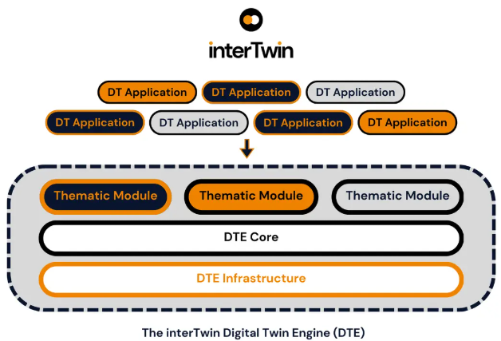

Figure - High level interTwin architecture

The 3 DTE categories are:

1. The **Digital Twin Engine infrastructure modules**: The interTwin Deliverable D5.4 [**R3**], contains a description and status of all infrastructure modules for the current release.
2. The **Digital Twin Engine core modules**: The interTwin Deliverable D6.4 [**R2**], contains a description and status of all core modules for the current release.
3. The **Digital Twin Engine thematic modules:**
   1. **Environment domain**: The interTwin Deliverable D7.7 [**R4**], contains a description and status of all environment modules for the current release.
   2. **Physics domain**: The interTwin Deliverable D7.8 [**R5**], contains a description and status of all physics modules for the current release.

The website exposes, for each component, a dedicated webpage (see example in **Figure 2**) where the information about the software is displayed (Description, Documentation link to source code, etc). The website has been updated to reflect the information about the component in the second release.

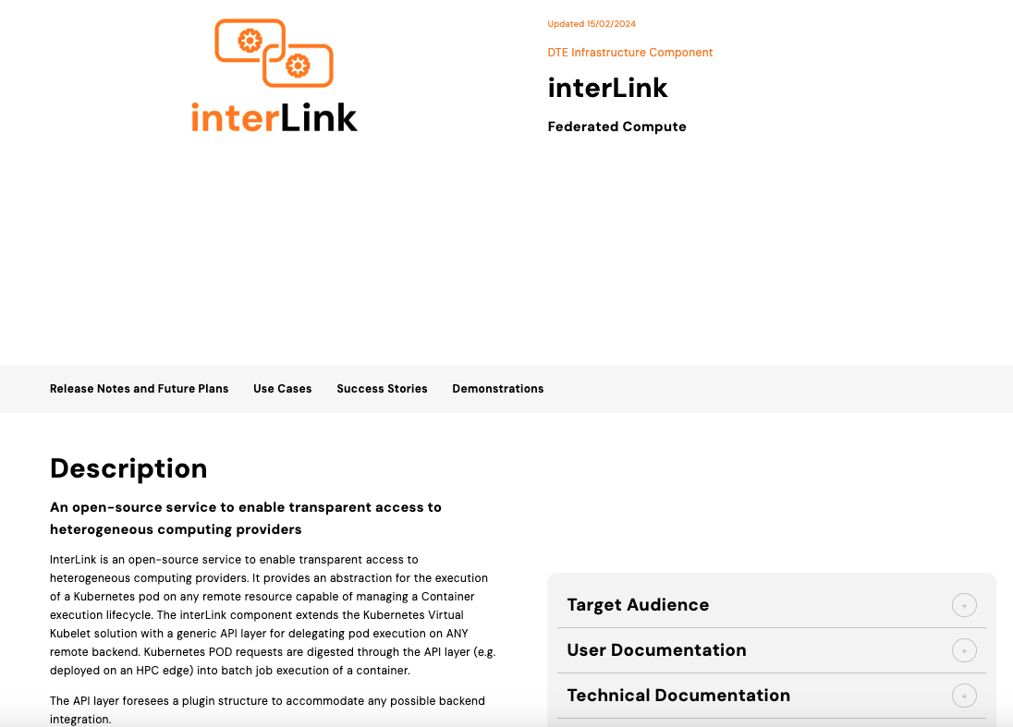

Figure - Web page describing the interLink component

The components that have been included in the second release are the results of the final DTE internal release described in the Deliverables D5.4 [**R3**], D6.4 [**R2**], D7.7 [**R4**] and D7.8 [**R5**] and which have passed the mandatory Quality Criteria defined in the procedure described in D3.2 and **Section 2**.

## 3.2 Software management

As previously described, the status of each component is tracked in a Jira ticket, an example is shown in **Figure 3**. The ticket contains the name of the component and interTwin release target, also shown other information such as the “Release Number” (component version) and attached the SQA assessment reports so that the developers can check.

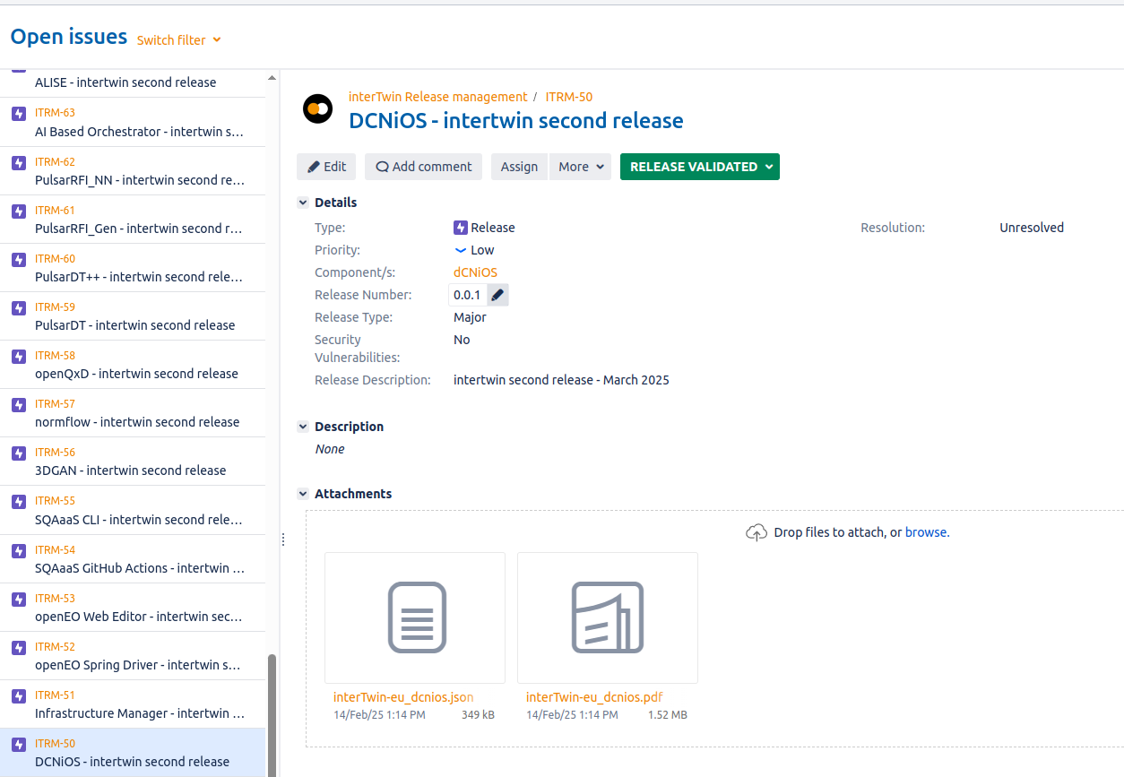

Figure - Example of a Jira ticket for one of the components

The Jira dashboard shown in **Figure 4**, contains the list of the six DTE components not yet ready (“*Release in preparation*”) for the second release. Further details in the next subsections.

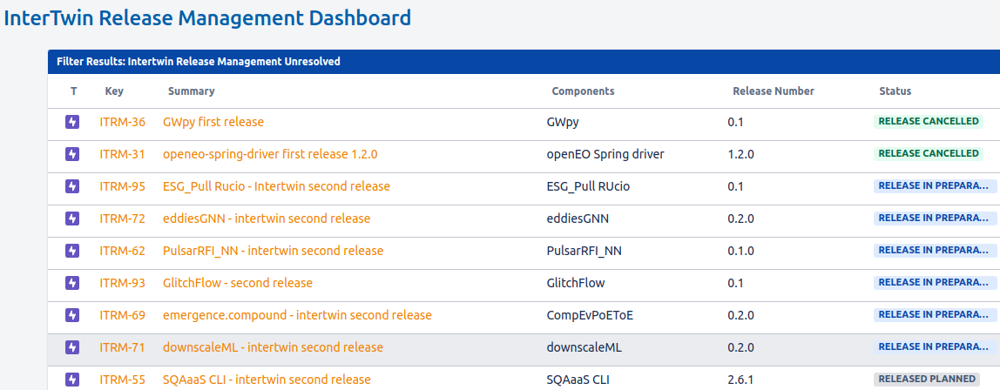

Figure - List of components not yet validated for the release

The pie chart in **Figure 5**, shows all Jira tickets, both from the first and for the second release. Overall, there are a total of 78 validated components from which 39 are ready for the second interTwin release and 6 are in preparation.

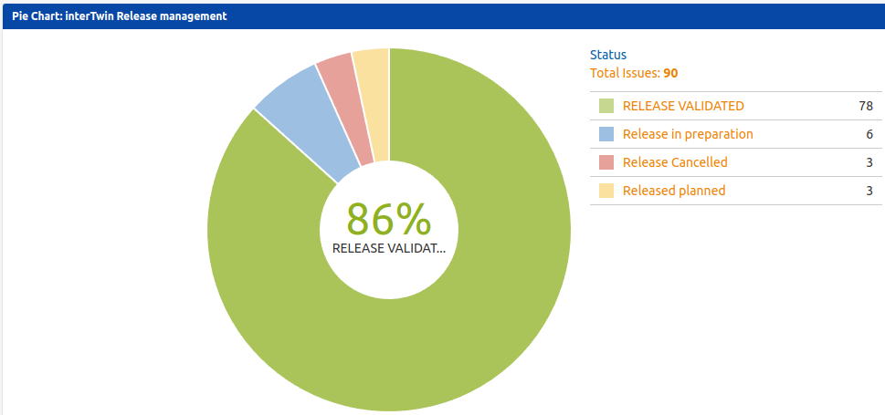

Figure - Pie chart with the status of all components, both first and second release

A detailed overview of the status of the DTE components is given in the following sections.

## 3.3 DTE infrastructure modules

The 7 components in this category are shown in **Table 1**. Two have EOSC-Synergy Silver badges and two have Bronze badges. The definition/description of each type of badge has been done in Deliverable D3.2 [**R1**]. Most of the components are packaged as Docker container images, one is a Python package and one is packaged as RPM.

Table - DTE infrastructure modules

|  |  |  |  |  |  |  |  |  |  |  |  |  |  |  |  |  |  |
| --- | --- | --- | --- | --- | --- | --- | --- | --- | --- | --- | --- | --- | --- | --- | --- | --- | --- |
| **SW Comp** | **Acc01** | **Acc02** | **Wor01** | **Man01** | **Ver01** | **Lic01** | **Doc03** | **Doc04** | **Doc05** | **Doc06.1** | **Doc06.5** | **Doc06.6** | **Doc06.7** | **Del01** | **Del02** | **Badge** | **Status** |
| **AI Based Orchestrator** | **y** | **y** | **y** | **y** | **y** | **y** | **y** | **y** | **y** | **y** | **y** | **y** | **y** | **Docker** | **Dockerhub** |  | **Ready** |
| **ALISE** | **y** | **y** | **y** | **y** | **y** | **y** | **y** | **y** | **y** | **y** | **y** | **y** | **y** | **pypack** | **pypi** | **Silver** | **Ready** |
| **APEL Kubernetes accounting** | **y** | **y** | **y** | **y** | **y** | **y** | **y** | **y** | **y** | **y** | **y** | **y** | **y** | **Docker** | **n** |  | **Ready** |
| **FTS3** | **y** | **y** | **y** | **y** | **y** | **y** | **y** | **y** | **y** | **y** | **y** | **y** | **y** | **Docker** | **gitlab** |  | **Ready** |
| **interlink** | **y** | **y** | **y** | **y** | **y** | **y** | **y** | **y** | **y** | **y** | **y** | **y** | **y** | **Docker** | [**ghcr.io**](http://ghcr.io/) | **Bronze** | **Ready** |
| **Rucio** | **y** | **y** | **y** | **y** | **y** | **y** | **y** | **y** | **y** | **y** | **y** | **y** | **y** | **Docker** | **Dockerhub** | **Bronze** | **Ready** |
| **teapot** | **y** | **y** | **y** | **y** | **y** | **y** | **y** | **y** | **y** | **y** | **y** | **y** | **y** | **rpm** | **n** | **Silver** | **Ready** |

3.4 DTE core modules

The 10 components in this category are shown in **Table 2**. One has an EOSC-Synergy Gold badge and three have Silver badges. Most of the components are packaged as Docker container images and one is a Python package.

Table - DTE core modules

|  |  |  |  |  |  |  |  |  |  |  |  |  |  |  |  |  |  |
| --- | --- | --- | --- | --- | --- | --- | --- | --- | --- | --- | --- | --- | --- | --- | --- | --- | --- |
| **SW Comp** | **Acc01** | **Acc02** | **Wor01** | **Man01** | **Ver01** | **Lic01** | **Doc03** | **Doc04** | **Doc05** | **Doc06.1** | **Doc06.5** | **Doc06.6** | **Doc06.7** | **Del01** | **Del02** | **Badge** | **Status** |
| **Big Data Analytics TOSCA templates, Configuration artefacts** | **y** | **y** | **y** | **y** | **y** | **y** | **y** | **y** | **y** | **y** | **n/a** | **n** | **n** | **n.a.** | **n.a.** |  | **Ready** |
| **DCNiOS** | **y** | **y** | **y** | **y** | **y** | **y** | **y** | **y** | **y** | **y** | **n/a** | **y** | **y** | **Docker** | [**ghcr.io**](http://ghcr.io/) | **Silver** | **Ready** |
| **IM** | **y** | **y** | **y** | **y** | **y** | **y** | **y** | **y** | **y** | **y** | **y** | **y** | **y** | **Docker** | **Dockerhub** | **Gold** | **Ready** |
| **itwinai** | **y** | **y** | **y** | **y** | **y** | **y** | **y** | **y** | **y** | **y** | **y** | **y** | **y** | **Docker** | [**ghcr.io**](http://ghcr.io/) | **Silver** | **Ready** |
| **openEO Spring Driver** | **y** | **y** | **y** | **y** | **y** | **y** | **y** | **y** | **y** | **y** | **y** | **y** | **y** | **n.a.** | **n.a.** |  | **Ready** |
| **openEO Web Editor** | **y** | **y** | **y** | **y** | **y** | **y** | **y** | **y** | **y** | **y** | **y** | **y** | **y** | **n** | **n** |  | **Ready** |
| **OSCAR** | **y** | **y** | **y** | **y** | **y** | **y** | **y** | **y** | **y** | **y** | **y** | **y** | **y** | **Docker** | **Dockerhub** |  | **Ready** |
| **PyOphidia** | **y** | **y** | **y** | **y** | **y** | **y** | **y** | **y** | **y** | **y** | **y** | **y** | **y** | **pypack** | **pypi** |  | **Ready** |
| **SQAaaS GitHub Actions** | **y** | **y** | **y** | **y** | **y** | **y** | **y** | **y** | **y** | **y** | **y** | **y** | **y** | **Docker** | **n** |  | **Ready** |
| **yProv** | **y** | **y** | **y** | **y** | **y** | **y** | **y** | **y** | **y** | **y** | **y** | **y** | **y** | **Docker** | **n** | **Silver** | **Ready** |

3.5 DTE thematic environment domain

The 20 thematic components in this domain are shown in **Table 3**. There are three EOSC-Synergy Bronze badges. Some components are Python packages published in PyPI, one is packaged as a Docker container image published in Dockerhub and one is Julia published in Juliahub.

Four components are not yet ready for release since they are missing the release tag in the VCS repository, and one is missing the open-source license file. These issues are expected to be solved before their final release.

Table - DTE thematic environment modules

|  |  |  |  |  |  |  |  |  |  |  |  |  |  |  |  |  |  |
| --- | --- | --- | --- | --- | --- | --- | --- | --- | --- | --- | --- | --- | --- | --- | --- | --- | --- |
| **SW Comp** | **Acc01** | **Acc02** | **Wor01** | **Man01** | **Ver01** | **Lic01** | **Doc03** | **Doc04** | **Doc05** | **Doc06.1** | **Doc06.5** | **Doc06.6** | **Doc06.7** | **Del01** | **Del02** | **Badge** | **Status** |
| **Delft-FIAT** | **y** | **y** | **y** | **y** | **y** | **y** | **y** | **y** | **y** | **y** | **y** | **y** | **y** | **pypack** | **pypi** |  | **Ready** |
| **downscaleML** | **y** | **y** | **y** | **y** | **n** | **y** | **y** | **y** | **y** | **y** | **n.a.** | **y** | **y** | **n** | **n** |  | **Not ready** |
| **eddiesGNN** | **y** | **y** | **y** | **y** | **n** | **n** | **y** | **y** | **y** | **y** | **n.a.** | **y** | **y** | **n** | **n** |  | **Not ready** |
| **emergence.compound** | **y** | **y** | **y** | **y** | **n** | **y** | **y** | **y** | **y** | **y** | **n.a.** | **y** | **y** | **n.a.** | **n.a.** |  | **Not ready** |
| **ESG_Pull RUcio** | **y** | **y** | **y** | **y** | **n** | **y** | **y** | **y** | **y** | **y** | **n.a.** | **y** | **y** | **n** | **n** |  | **Not ready** |
| **FloodAdapt** | **y** | **y** | **y** | **y** | **y** | **y** | **y** | **y** | **y** | **y** | **n.a.** | **y** | **y** | **n** | **n** |  | **Ready** |
| **HydroMT** | **y** | **y** | **y** | **y** | **y** | **y** | **y** | **y** | **y** | **y** | **n.a.** | **y** | **y** | **pypack** | **pypi** | **Bronze** | **Ready** |
| **HydroMT-FIAT** | **y** | **y** | **y** | **y** | **y** | **y** | **y** | **y** | **y** | **y** | **y** | **y** | **y** | **pypack** | **pypi** |  | **Ready** |
| **HydroMT-SFINCS plugin** | **y** | **y** | **y** | **y** | **y** | **y** | **y** | **y** | **y** | **y** | **y** | **y** | **y** | **pypack** | **pypi** |  | **Ready** |
| **HydroMT-WFLOW plugin** | **y** | **y** | **y** | **y** | **y** | **y** | **y** | **y** | **y** | **y** | **y** | **y** | **y** | **pypack** | **pypi** |  | **Ready** |
| **Hython Wflow_SBM Hydrological Model** | **y** | **y** | **y** | **y** | **y** | **y** | **y** | **y** | **y** | **y** | **y** | **y** | **y** | **n** | **n** |  | **Ready** |
| **ML4Fires** | **y** | **y** | **y** | **y** | **y** | **y** | **y** | **y** | **y** | **y** | **y** | **y** | **y** | **n.a.** | **n.a.** | **Bronze** | **Ready** |
| **ML TC detection** | **y** | **y** | **y** | **y** | **y** | **y** | **y** | **y** | **y** | **y** | **n.a.** | **y** | **y** | **n** | **n** |  | **Ready** |
| **openeo-pg-parser-networkx** | **y** | **y** | **y** | **y** | **y** | **y** | **y** | **y** | **y** | **y** | **y** | **y** | **y** | **pypack** | **pypi** |  | **Ready** |
| **openeo-processes- dask** | **y** | **y** | **y** | **y** | **y** | **y** | **y** | **y** | **y** | **y** | **y** | **y** | **y** | **pypack** | **pypi** | **Bronze** | **Ready** |
| **RA2CE** | **y** | **y** | **y** | **y** | **y** | **y** | **y** | **y** | **y** | **y** | **y** | **y** | **y** | **pypack** | **pypi** |  | **Ready** |
| **raster-to-stac** | **y** | **y** | **y** | **y** | **y** | **y** | **y** | **y** | **y** | **y** | **y** | **y** | **y** | **pypack** | **n** |  | **Ready** |
| **SFINCS** | **y** | **y** | **y** | **y** | **y** | **y** | **y** | **y** | **y** | **y** | **y** | **y** | **y** | **Docker** | **Dockerhub** |  | **Ready** |
| **Wflow.jl** | **y** | **y** | **y** | **y** | **y** | **y** | **y** | **y** | **y** | **y** | **y** | **y** | **y** | **Juliapack** | **Juliahub** |  | **Ready** |
| **xtclim** | **y** | **y** | **y** | **y** | **y** | **y** | **y** | **y** | **y** | **y** | **n.a.** | **n.a.** | **y** | **n.a.** | **n.a.** |  | **Ready** |

3.6 DTE thematic physics domain

The 8 components in this domain are shown in **Table 4**. One has an EOSC-Synergy Silver badge and two have Bronze badges. Four components are Python packages.

Two components are not yet ready for the release since they are missing the release tag in the VCS repository. These issues are expected to be solved before their final release.

Table - DTE thematic physics modules

|  |  |  |  |  |  |  |  |  |  |  |  |  |  |  |  |  |  |
| --- | --- | --- | --- | --- | --- | --- | --- | --- | --- | --- | --- | --- | --- | --- | --- | --- | --- |
| **SW Comp** | **Acc01** | **Acc02** | **Wor01** | **Man01** | **Ver01** | **Lic01** | **Doc03** | **Doc04** | **Doc05** | **Doc06.1** | **Doc06.5** | **Doc06.6** | **Doc06.7** | **Del01** | **Del02** | **Badge** | **Status** |
| **3DGAN** | **y** | **y** | **y** | **y** | **y** | **y** | **y** | **y** | **y** | **y** | **y** | **n.a.** | **y** | **n** | **n** | **Bronze** | **Ready** |
| **GlitchFlow** | **y** | **y** | **y** | **y** | ***n*** | **y** | **y** | **y** | **y** | **y** | **y** | **n.a.** | **y** |  |  |  | **Not ready** |
| **normflow** | **y** | **y** | **y** | **y** | **y** | **y** | **y** | **y** | **y** | **y** | **y** | **y** | **y** | **pypack** | **n.a.** | **Silver** | **Ready** |
| **openQxD** | **y** | **y** | **y** | **y** | ***y*** | **y** | **y** | **y** | **y** | **y** | **y** | **y** | **y** | **n.a.** | **n.a.** | **Bronze** | **Ready** |
| **PulsarDT** | **y** | **y** | **y** | **y** | **y** | **y** | **y** | **y** | **y** | **y** | **y** | **n/a** | **y** | **pypack** | **n** |  | **Ready** |
| **PulsarDT++** | **y** | **y** | **y** | **y** | **y** | **y** | **y** | **y** | **y** | **y** | **y** | **n/a** | **y** | **pypack** | **n** |  | **Ready** |
| **PulsarRFI_Gen** | **y** | **y** | **y** | **y** | **y** | **y** | **y** | **y** | **y** | **y** | **y** | **n/a** | **y** | **pypack** | **n** |  | **Ready** |
| **PulsarRFI_NN** | **y** | **y** | **y** | **y** | ***n*** | **y** | **y** | **y** | **y** | **y** | **y** | **n/a** | **y** | **n.a.** | **n.a.** |  | **Not ready** |

# 4 Summary

During the second period of the project, Task 3.3 updated the procedure for software release of the interTwin DTE, by extending the software release procedure and activities to include artifact release management.

It has successfully used the SQAaaS from EOSC-Synergy to assess the mandatory attributes of the Quality Criteria needed for any given component to be part of the second release. Furthermore, several components have passed optional criteria, thus earning badges resulting from the assessment.

A total of 45 SQAaaS assessments were done (and attached to the corresponding Jira ticket). At the time of writing, there are 39 components that are validated to be part of the release, while it is expected that the 6 remaining will also be ready in the next few weeks.

At the time of writing, not all components are in public artifacts repositories, but this will be accomplished in the near future.

About one third of the components (14) have earned EOSC-Synergy badges, one Gold, six Silver and seven Bronze badges.

The tracking of the individual components through Jira tickets, has proven to be an appropriate way for developers to work their components towards inclusion in the release. Not all criteria are possible to be verified automatically with the CI/CD Jenkins pipelines, namely the type of documentation, accordingly the developer teams have performed this manual step.

The second interTwin DTE release was described, with a large fraction of the components as part of the release and some statistics about the software management process through Jira tickets.

# 

# References

|  |  |
| --- | --- |
| **References** | |
| **No** | **Description / Link** |
| **R1** | David, M., Pina, J., & Manzi, A. (2024). interTwin D3.2 DTE First software release (1 Under EC Review). Zenodo. [**https://doi.org/10.5281/zenodo.10793026**](https://doi.org/10.5281/zenodo.10793026) |
| **R2** | Campos, I., Moltó, G., Jacob, A., Orviz, P., Caballer, M., Bunino, M., Lappe, A. E., Saether, J. S., Sarma, R., Fiore, S., Parcero, E., & Elia, D. (2025). interTwin D6.4 Final release of the DTE core modules (1 Under EC Review). Zenodo. [**https://doi.org/10.5281/zenodo.14778361**](https://doi.org/10.5281/zenodo.14778361) |
| **R3** | Spiga, D., Millar, P., Atherton, L., Coveney, A., Donvito, G., Costantini, A., Garcia, E., Orzechowski, M., Sustr, Z., & Vrbanec, D. (2025). interTwin D5.4_V1_Public_Under EC Review (1 Under EC Review). Zenodo. [**https://doi.org/10.5281/zenodo.14727089**](https://doi.org/10.5281/zenodo.14727089) |
| **R4** | Elia, D., Donno, D., Donno, E., Fiore, S., Fronza, M., Backeberg, B., Tromp, W., Jacobs, A., Claus, M., Ferrario, I., Pagé, C., Ben Asser, A., & Vrac, M. (2025). interTwin D7.7 Final version of the thematic module for the environment domain (1 Under EC Review). Zenodo. [**https://doi.org/10.5281/zenodo.14918025**](https://doi.org/10.5281/zenodo.14918025) |
| **R5** | Sinha Ray, G., Komijani, J., Campos, I., Pidopryhora, Y., Vallero, S., Sarandrea, F., Asprea, L., Vallecorsaq, S., & Tsolaki, K. (2025). interTwin D7.8 Final version of the thematic module for the physics domain (1 Under EC Review). Zenodo. [**https://doi.org/10.5281/zenodo.14931996**](https://doi.org/10.5281/zenodo.14931996) |

1. <https://sqaaas.eosc-synergy.eu/>