

Technical development roadmap for the AI image analysis use cases (update)
iMagine Deliverable D3.2

31/01/2024

Abstract
iMagine is a 36-month-long project to serve aquatic researchers with a suite of high-performance image analysis tools empowered with Artificial Intelligence (AI). This document describes the status of the 8 use cases that are included in the project. The document is a snapshot of the development and delivery process after 16 months of work. It highlights the progress made so far, as well as plans towards service operation to various target groups, as well as the feedback of use cases about the common iMagine platform that serves as a common layer to support the overall AI application lifecycle.

Document Description
Document title
Work Package number WP3
Due date | Date 31/01/2024 | Actual delivery date: | 31/1/2024
Nature of document | [Report] | Version | 1
Dissemination level | Public
Lead Partner | KIT
Authors | K. Alibabaei (KIT), V. Kozlov (KIT)
Reviewers | G. Moltó (UPV), D. Schaap (MARIS), G. Sipos (EGI)
Public link | https://doi.org/10.5281/zenodo.10619470
Keywords | AI image, Analysis, Technical Roadmap

Revision History
Issue | Item | Comments | Author/Reviewer
V 0.1 | Draft version | Early draft | K. Alibabaei / V. Kozlov (KIT
V 0.2 | Draft version | Contribution from the use cases | C. Leluschko (DFKI),  J-O. Irisson (SU),  M. Walker (SU),  E. Martinez (UPC),  A. Lebeaud (Ifremer),  V. Tosello (Ifremer),  D. Smyth (MI),  I. Atake (CMCC),  G. Accarino (CMCC),  S. Fiore (UNITN),  R. Lagaisse (VLIZ),  W. Decrop (VLIZ),  J. Soriano (SOCIB),  M. Laviale (UL-LIEC)
V 0.3 | First Draft | First version for review | K. Alibabaei / V. Kozlov (KIT)
V 0.4 | Revision | Feedback from the reviewers | G. Moltó (UPV),  D. Schaap (Maris),  G. Sipos (EGI)
V 0.5 | Revised version based on comments | Consolidated Comments | K. Alibabaei / V. Kozlov (KIT)
V1 | Final

Copyright and license info
This material by Parties of the iMagine Consortium is licensed under a Creative Commons Attribution 4.0 International License.

Table of content
Document Description 2
Table of content 4
Figures 5
Tables 6
Introduction 7
Purpose of the document 8
Scope of the document 8
Structure of the document 8
Summary of the development progress 9
AI image analysis use cases 10
UC1 Marine litter assessment 10
Description 10
Use case status 11
Development plans towards service operation 12
Updated development roadmap 12
UC2 Zooscan - EcoTaxa pipeline 13
Description 13
Use case status 14
Development plans towards service operation 15
Updated development roadmap 15
UC3 Marine ecosystem monitoring at EMSO sites (OBSEA, Azores, SmartBay) 15
Description 15
Use case status 16
Development plans towards service operation 22
Updated development roadmap 23
UC4 Oil spill detection 24
Description 24
Use case status 24
Development plans towards service operation 27
Updated development roadmap 27
UC5 Flowcam plankton identification 28
Description 28
Use case status 28
Development plans towards service operation 29
Updated development roadmap 30
UC6 Underwater noise identification 30
Description 30
Use case status 31
Development plans towards validation 32
Updated development roadmap 32
UC7 Beach monitoring 32
Description 32
Use case status 33
Development plans towards validation 35
Updated development roadmap 35
UC8 Freshwater diatoms identification 35
Description 35
Use case status 36
Development plans towards validation 37
Updated development roadmap 37
Updated requirements for the platform 38
General feedback on the platform 41
Conclusion 43
Acronyms 44

Figures
List Of Images
Figure 1 - General timeline of the project (“Update of the development roadmap” is this deliverable D3.2) 9
Figure 2 UC1.1 - Example of plastic litter detection (PLD) and plastic litter quantification (PLQ) in the provided input image 11
Figure 3 UC1.2 - Updated development timeline of UC1 13
Figure 4 UC2.1 - Example of over-segmentation: first on the left is the input image, followed by five proposed masks. Only two objects should have been segmented, not five. 14
Figure 5 UC2.2 - Updated development timeline of UC2 15
Figure 6 UC3s.1 - Example of “label studio” configured with Machine learning backend suggesting annotations 17
Figure 7 UC3o.1 - left: old dataset with missing labels, right: high-resolution image from the new 4K camera 17
Figure 8 UC3o.2 - Precision-recall curve for the latest version of EMSO-OBSEA dataset. 19
Figure 9 UC3a.1 - An image labelled by citizens (left), and the scheme to convert labels provided by citizens into regular bounding boxes (right). 20
Figure 10 UC3a.2 - An image with overlapping bounding boxes (left) and resulting unique boxes (right). 20
Figure 11 UC3.1 - Updated development timelines of UC3a, UC3o, UC3s 23
Figure 12 UC4.1 Proposed workflow to evaluate the effectiveness of the Bayesian Optimization framework for automatically selecting simulation parameters through their parameter space. Parameters such as wind drift, wind angle, and horizontal diffusivity are sampled to assess how the Fractions Skill Score improves or decreases in quality. 25
Figure 13 UC4.2 - Fraction skill for 96 different oil spill simulations with different setups. It is possible to observe that results are better when the oil spill model grid resolution is coarser 26
Figure 14 UC4.3 - Updated development timeline of UC4 27
Figure 15 UC5.1 - Workflow for the three FlowCam user stories defined in UC5. The red diagrams are plans for M13-24. 29
Figure 16 UC5.2 - Updated development timeline of UC5 30
Figure 17 UC6.1 - Prototype dataflow to process underwater acoustic data. M13-24 Plans are shown in this figure. 31
Figure 18 UC6.2 - Updated development timeline of UC6 32
Figure 19 UC7.1 - Examples of image quality control, repository clustering, and dense annotation of images. 34
Figure 20 UC7.2 - Updated development timeline of UC7 35
Figure 21 UC8.1 - GUI interface for diatom detection and taxonomic classification. 36
Figure 22 UC8.2 - Updated development timeline of UC8 37
Figure 23 Fb.1 - Current usage of the platform components. 41
Figure 24 Fb.2 - Planned usage of the platform components. 41

Tables
List Of Tables

Table 1 Req.1 - Platform common requirements of use cases for the AI-model development installation. In summary columns: light blue: values decreased, yellow: values increased, compared to D3.1 39
Table 2 Req.2 - Platform common requirements of use cases for the AI-application serving installation. In summary columns: light blue: values decreased, yellow: values increased, compared to D3.1 40
Table 3 Fb.1 - What users find Good, Difficult, missing on the platform, and possible improvements to resolve Difficult and Missing issues 42

Introduction
iMagine, an EU-funded project contributes to the overarching mission of the EU of 'Healthy Oceans, Seas, Coastal and Inland Waters'. It does so by working towards the following project objectives:

- Establish a robust IT infrastructure for image analysis: create and maintain a scalable iMagine AI platform using the AI4OS software stack. Also, improve accessibility through federation to ensure a seamless environment for aquatic researchers. (WP4)
- Further develop existing image analysis services: The aim is to improve research performance and provide virtual access to external researchers. (WP3)
- Prototyping of new image analysis services: Development and testing of prototypes on the iMagine AI Platform with a focus on training image labelling, model migration, and validation. The goal is to accelerate progress towards healthier oceans, seas, and coastal and inland waters. (WP3)
- Capture and disseminate best practices: Systematically capture best practices from iMagine AI Platform providers (WP4) and use case developers (WP3). Promote the AI platform in the European Open Science Cloud and AI4EU initiatives.
- Provide a portfolio of scientific image and image analysis services aimed at researchers in the marine and aquatic sciences: Develop trained models and FAIR images to create a diverse portfolio of scientific image and analysis services. (WP5)

To effectively achieve the objectives of the project, eight use cases (WP3) in different areas of aquatic science collaboratively engage with the iMagine AI Platform providers (WP4). This partnership involves concerted efforts to leverage the capabilities of the iMagine AI Platform, foster innovation, and increase the collective impact on the advancement of image analysis tools and services for environmental monitoring and management in the field of aquatic research. The projects include collecting, storing, analysing, and processing various types of imagery, including drone imagery for waste monitoring, images from zooscan instruments for taxonomic identification of seawater samples, underwater video images for ecological research, satellite imagery for oil spill detection, flowcam images for phytoplankton composition analysis, underwater acoustic recordings for marine animal identification, video images from beach cameras for seagrass bed monitoring and microscope images for diatom-based bioindication in freshwater environments.

Purpose of the document
This document serves as a comprehensive report that provides a detailed status update on the eight use cases of the iMagine project. The primary focus is on reporting the progress and achievements of each use case in relation to fulfilling the overall objectives of the project. The following sections cover the individual descriptions, current status, development plans, and updated roadmaps for each use case. The document aims to provide a transparent and insightful overview of how these use cases contribute to the successful delivery of the defined project objectives.

Scope of the document
This D3.2 document covers the status and updated plans of use cases in the iMagine project. This is the second deliverable after we performed the initial analysis of use cases and worked on the development roadmaps in D3.1. It also provides a ground for the next deliverable, D3.3, which will be about application upgrade, deployment, and operation plan.

Structure of the document
The document is structured as follows:
- Summary of the development progress: This section provides a comprehensive overview of the progress made in each use case, highlighting the associated challenges involved and presenting the general timeline of the project.
- AI Image Analysis Use Cases: This section is further subdivided into eight subsections, each dealing with one of the eight use cases of the iMagine project. Each use case includes a detailed description of the current status and results referring to the identified in D3.1 user stories, reports on development plans, and updated roadmaps.
- Feedback to the platform:
  - Updated requirements for the AI development and AI Application Serving installations: explores the latest user requirements based on the monitoring means set up for the project.
  - General feedback on the platform: Provides overarching feedback from UCs on the platform resulting from the feedback forms completed by users.
- Conclusion: Summarizes the current state of use cases development.
- Acronyms: Contains a reference list of acronyms used in the document.

Summary of the development progress

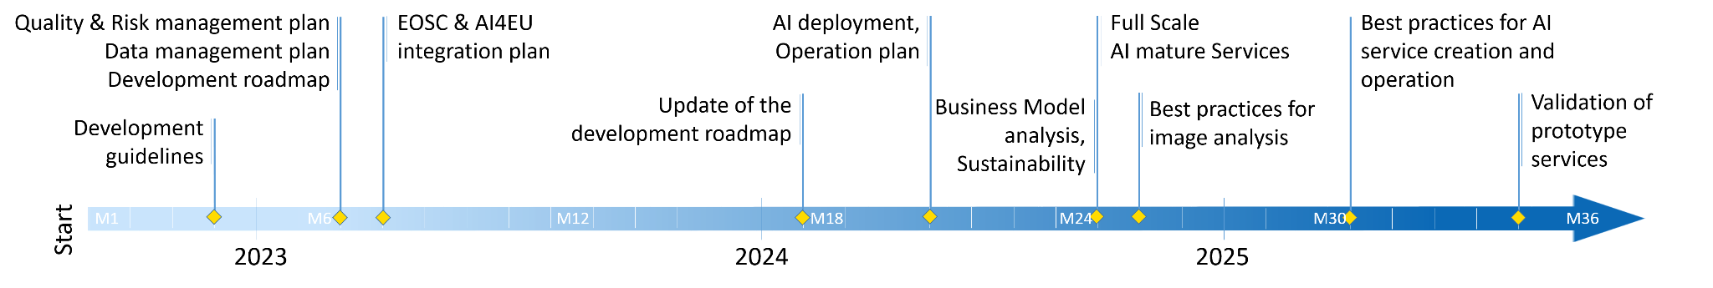
Figure 1 - General timeline of the project
(“Update of the development roadmap” is this deliverable D3.2)
There are five operational (UC1-5) and three prototype (UC6-8) image analysis services which develop new AI-based components for their services in line with the general timeline of the project (Figure 1):

- UC1 - Marine litter assessment - refined its processing methodology, advanced model development and validation, advanced user interface development and successfully integrated into the iMagine platform. The mapping of the previously used (and very generic) litter classification to the ‘Official Joint List of Categories’ (very specific codes) brought additional challenges in the course of the year.
- UC2 - Zooscan - EcoTaxa pipeline - has made significant progress in developing and building an end-to-end AI-powered identification pipeline and improving the instance segmentation model. This improvement is particularly focused on the effective separation of touching organisms, which has been achieved through the use of a carefully curated training dataset.
- UC3 - Marine ecosystem monitoring - OBSEA - Has demonstrated promising results in fish classification, despite the challenges associated with the labelled dataset. A new high-resolution training dataset, derived from a recently deployed 4K camera, is currently being created. This dataset will enable the training of the prototype model with YOLOv8.
- UC3 - Marine ecosystem monitoring - Azores - have made significant efforts to improve the training data originally labelled by citizens to ensure the compatibility and high quality of the externally sourced YOLOv8 detection model.
- UC3 - Marine ecosystem monitoring - Smartbay explored labelstud.io and prototyped machine-learning-based backends to auto-suggest annotations using YOLOv8 trained with the publicly available "Brackish underwater" dataset. It also progressed on video data drift and Quality Control event detection.
- UC4 - Oil spill detection - established the framework to evaluate the effectiveness of the Bayesian search on model parameters for Oil Spill forecast and curated a dataset of oil spill incidents in the Mediterranean Sea.
- UC5 - Flowcam plankton identification - has optimised current in-house data pipelines, added new manually validated images to the image library, and worked on the prototype module of the FlowCAM phytoplankton identification service with a top-one accuracy of 84.2 and top-five accuracy of 98.2%.
- UC6 - Underwater Noise - has worked on developing an in-house data pipeline to process raw sound data, looked into tools for manual validation of spectrogram data, annotated a first set, and trained a prototype neural network.
- UC7 - Beach Monitoring - explored image repository quality control procedures, image metadata standardisation and enrichment, and Deep Learning approaches for beach monitoring-specific tasks. Various annotation tools were evaluated, and the annotation process is ongoing.
- UC8 - Diatoms identification - focused on the development of an end-to-end pipeline for diatom detection and taxonomic classification. The classification network achieves an accuracy of 94%. The training dataset is being expanded, and the annotation workflow is established for both taxonomic classification, detection, and segmentation.

One common task for all use cases before going into operation is to address possible data biases. Training datasets should represent today’s real-world data distribution. This can be affected, for example, by a bias in data collection, by a bias in the data annotation done by humans or the representation may change in time, known as data drift. Any unintentional bias may lead to unreliable outcomes, which can affect, e.g. decisions of policymakers.

AI image analysis use cases

UC1 Marine litter assessment

Description
The aim of the use case is to establish an operational service on the iMagine platform for the collection, storage, analysis, and processing of drone imagery used to observe waste floating on the surface of seas, rivers, and lakes and lying on beaches and coasts, and to provide standardised, classified waste datasets suitable for environmental management and indicators. The expected impact is significant, contributing to environmental management, clean-up operations, and supporting EU directives on marine strategy and the Green Deal.

Use case status
UC1 focused on refining the processing methodology by restructuring the already existing code and integrating it with the DEEPaaS API for basic inference calls. The result of the plastic waste classification can be processed in different ways which will be available to users. For classification, a CNN architecture as described in Wolf et al. 2020 is used for the detection and classification of plastic litter. The original image is broken down into tiles with the size of 128 x 128 pixels, with each tile being classified individually. The result of this classification can subsequently be merged into an overall image. This helps a better understanding, especially for new users. Furthermore, the plots are well suited as a demonstrator result, where the litter classification algorithm is motivated. An example of the results of the detection and quantification of plastic waste is shown in Figure 2 UC1.1
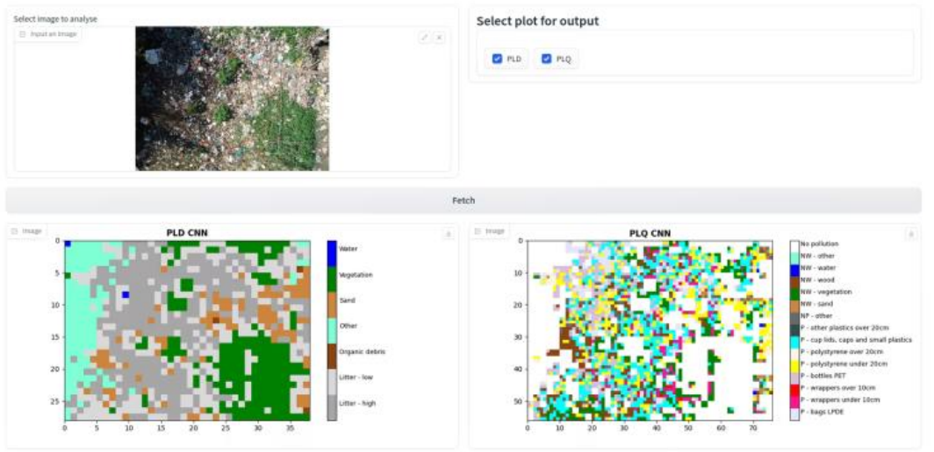
Figure 2 UC1.1 - Example of plastic litter detection (PLD) and plastic litter quantification (PLQ) in the provided input image
The other part of the result, which will be available to the users, is the indication of how many items of each litter category are present in the input image. This corresponds to user stories UC1.E1.US1 and UC1.E1.US2 (Figure 2). The results are saved as pandas DataFrame and can be provided as a .csv file. To make the service easier to use and more appealing, a minimal graphical user interface based on Gradio was developed and built on top of the raw API. The integration of the litter assessment service and the DEEPaaS API was additionally set up as a Docker container, which starts the API and provides access to the classification functionality of the service. In addition, some initial tests to adapt the litter classification system to the official monitoring reference list of categories for marine litter in place in Europe (Joint List) have been made. The mapping of the used litter objects classification (that is very generic) and the Official Joint List of Categories (that uses very specific codings) is very challenging. Whereas most of the waste items are (probably) identifiable in field surveys, this is unfortunately not the case in the drone imagery, where plastics being heavily weathered, fragmented, and overlapped by other objects hinder the identification of specific litter item types as required by the Joint List of Categories. The Joint List of Litter Categories has a basic hierarchical structure that might allow finding a compromise to map the identifiable categories using drone imagery techniques to general levels of the Joint List of Categories. In the future, the list could be upgraded, allowing the identification of more intermediate levels.

Achieved results
- Processing methodology is updated and refined
- Application is coupled with DEEPaaS API
- The AI model is updated and trained
- Created a minimal GUI interface
- Published MVP on the iMagine marketplace

Development plans towards service operation
- Couple model and image processing pipeline with OSCAR for migration to delivery environment
- Develop training material for end-users
- Further tests for adaptation of initial litter categories to EUs’ categories

Updated development roadmap
- No more focus on UC1.E2.US1 (“Retrain models on individual data”) and UC1.E2.US2 (“Provide test dataset for benchmarking”) because potential end-users stated they would not be interested in retraining the model. Additionally, the mapping of the initial categories to the EUs’ litter categories requires more time than expected. End-users stated they are more interested in mapping to achieve standardized categories than in retraining their own model.

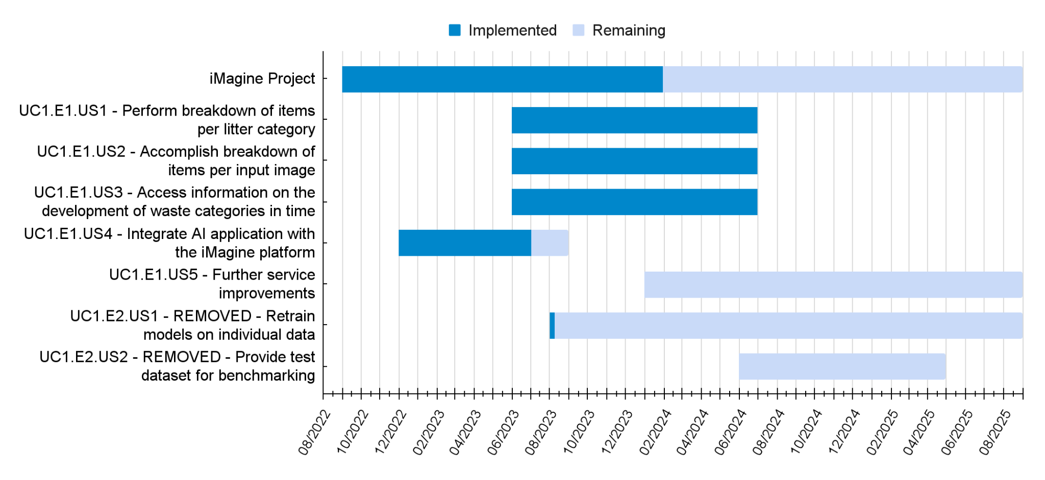
Figure 3 UC1.2 - Updated development timeline of UC1

UC2 Zooscan - EcoTaxa pipeline

Description
This use case aims to set up an operational image processing service on the iMagine platform focusing on the processing of zooplankton images acquired with the ZooScan instrument. The ZooScan is a waterproof flatbed scanner used to digitise zooplankton samples. It is used to process samples taken at sea in current oceanographic cruises and historical samples from long-term collections, stored in formalin. After an initial development in a research laboratory, it is now a commercially available instrument with over 300 units worldwide and many active users.
The overall objective is to create a workflow that acquires, stores and processes images of marine water samples, together with the associated metadata, and uploads the resulting regions of interest to the EcoTaxa platform for taxonomic identification. By using classical image segmentation and measurement methods, together with AI techniques (deep segmentation) on the iMagine platform, the project aims to accelerate manual handling and processing and increase efficiency. The development activities include updating the ZooProcess software, setting up an operating environment on iMagine, and connecting to the EcoTaxa database. The expected impact is significant, as the streamlined process will contribute to more numerous and interoperable zooplankton data, which is crucial for understanding marine ecosystem dynamics, food availability, and responses to climate change, and supports the indicators of the Marine Strategy Framework Directive and the Water Framework Directive (for example, indicators PH1, PH2, PH3, FW5 and NIS3 of the MSFD can all be linked to plankton; McQuatters-Gollop et al 2022).

Use case status
UC2 has focused on two areas: (1) the specification and construction of the pipeline (UC2.E1.US2, see Figure 5) and (2) the investigation of instance segmentation in the AI core, to help separate organisms in images where several are still connected after the classical segmentation step (UC2.E1.US1, Figure 5).

Within (1) we now have complete specifications, decisions on the technologies used, and a prototype for the initial processing of metadata, image processing, and data output. Some pieces are functional and, in addition, generic enough to be reused with other instruments (the CytoSense and the CPIS are currently investigated). Each step still needs to be refined to achieve complete backward compatibility with existing data.

In the area (2), we have created a training dataset of images of multiple plankton objects touching each other but manually separated, to train an instance segmentation model to reproduce the manual separation process. The set now contains about 20,000 images with manual masks. We have trained two separate MaskRCNN implementations and a panoptic segmentation model using this dataset. The initial results were decent with a tendency to over-segment (as shown in the example below, where only two elements need to be separated – a fish larva and a copepod near its tail – but five masks are suggested). The panoptic model gives better results with ~85% recall and ~75% precision. Tests are currently being carried out to improve the results and are expected to be finished at the end of January 2024, and the selected model is expected to be implemented as a new module on iMagine by the end of the first quarter of 2024.
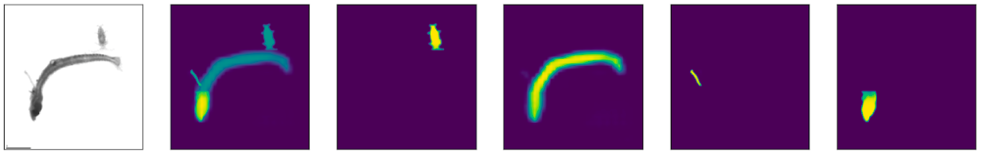
Figure 4 UC2.1 - Example of over-segmentation: first on the left is the input image, followed by five proposed masks. Only two objects should have been segmented, not five.
Achieved results
- Finished specifications for the pipeline to import processed data into EcoTaxa
- Created a prototype for the initial processing of metadata, image processing, and data output
- Prepared a training dataset for the instance segmentation model
- Trained several instance segmentation models and a panoptic segmentation model
- Published the Minimum Viable Product (MVP) on the iMagine marketplace

Development plans towards service operation
- Create a GUI for the new pipeline
- Finish testing the panoptic segmentation model and improve it
- Publish the selected instance segmentation model as a new module on the iMagine platform

Updated development roadmap
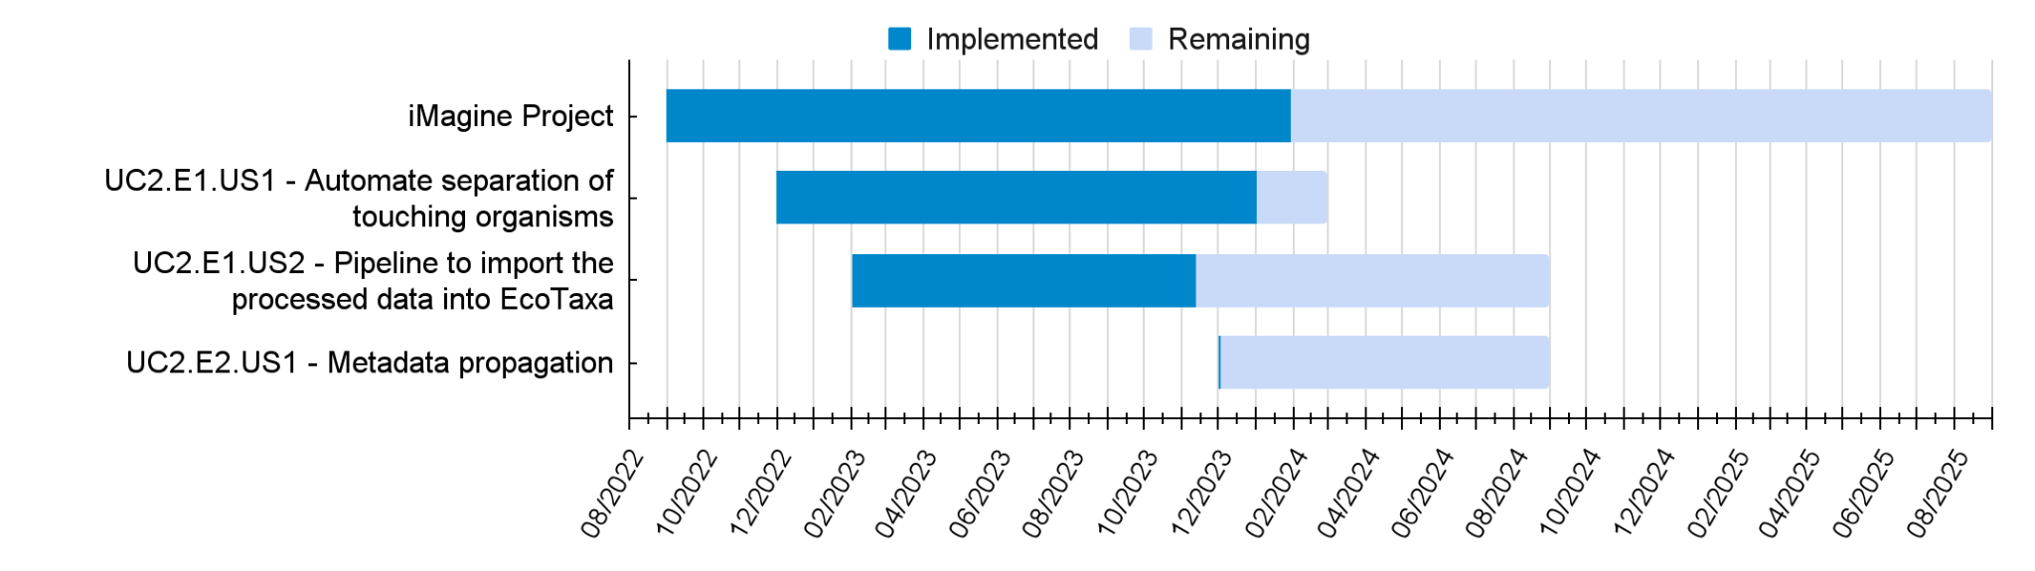
Figure 5 UC2.2 - Updated development timeline of UC2

UC3 Marine ecosystem monitoring at EMSO sites (OBSEA, Azores, SmartBay)

Description
The project aims to use the iMagine platform and implement AI models to automate and improve the analysis of underwater video imagery at the EMSO sites, namely EMSO-Obsea, EMSO-Azores and EMSO-SmartBay. The objective is to automate the extraction of valuable biological content from extensive datasets to facilitate scientific research and ecological understanding.
At EMSO-Obsea, the focus is on training a Deep Learning service to obtain species abundance data from underwater camera images to provide insight into the impact of climate change on the local fish community.
At EMSO-Azores, the project aims to develop AI models that automatically annotate and validate submarine images, improving the efficiency and accuracy of data validation.
In EMSO-SmartBay, AI will be used to detect and flag low-quality video footage in real-time, enabling efficient data management and analysis. EMSO-SmartBay will also be looking at underwater video and imagery for marine species detection and evaluating labelling tools and Machine Learning to assist in Nephrop (prawn) burrow complex surveys.
Development activities include using the iMagine platform for AI pre-selection and analysis, setting up EMSO workflows and providing guidance on data management practices. The expected impact is the creation of a common capacity for all EMSO sites that contributes to the generation of relevant data for biodiversity and ecosystem studies.

Use case status
UC3-Smartbay has initially focused on identifying useful labelling and annotation environments for image and video data drift and Quality Control (QC) event detection, Species detection, and enumeration.
An initial containerized labelling environment was set up using the open-source framework "Label studio" and a YOLOv8 "Machine Learning backend" that auto-suggests labels.
UC3-Smartbay is currently training YOLOv8 Machine Learning models using existing Marine Labelled datasets and will supplement these with its own prepared and labelled data from the Smartbay web archive. UC3-Smartbay lacks resources for data labelling tasks and is investigating approaches to semi-automate labelling and maximize the utilisation of such taxonomic and species labelling staff resources when these become available. UC3-Smartbay is also looking at Label Studio with a view to help a fisheries survey team evaluate new labelling and Machine learning tools for burrow counting surveys. A number of labelled in-house unpublished Nephrop (Prawn) Survey datasets exist that UC3-Smartbay is currently investigating reformatting for Label Studio.
UC3-Smartbay is also looking at Video Quality Assessment approaches. Initially, it was hoped to use YOLOv8 and build a labelled dataset that identifies various poor-quality video events. It was also suggested that maybe Frouros could be used to detect dataset drift over time e.g. with fouling of the underwater camera. However, UC3-Smartbay has staff resourcing issues i.e. insufficient available staff to dedicate to dataset labelling. UC3-Smartbay is currently rethinking the video Quality Assessment approach and investigating if video quality assessment algorithms like DOVER or FAST-VQA (see Video Quality Assessment | Papers With Code) could be useful for automated video and image quality assessment and identifying relatively good data in the Smartbay video archive.
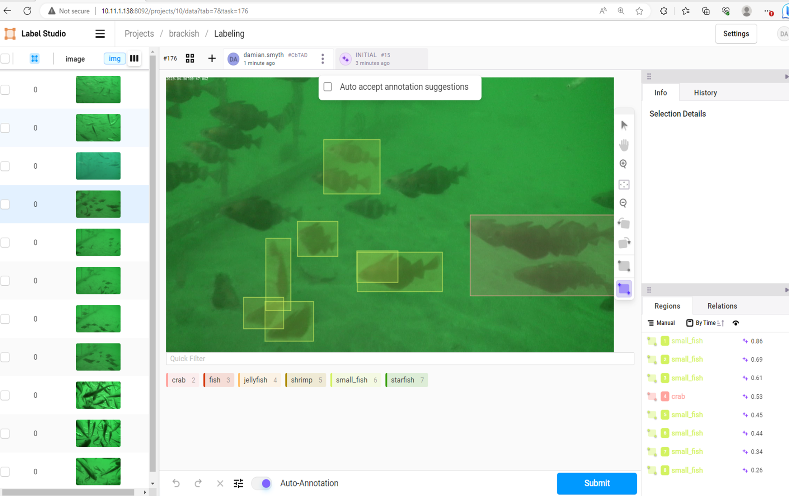
Figure 6 UC3s.1 - Example of “label studio” configured with Machine learning backend suggesting annotations
The main objective of the use case UC3-OBSEA is to provide AI tools to automatically assess the biodiversity at the EMSO OBSEA underwater observatory. It is envisioned to develop an AI-based service that automatically analyses pictures/videos and provides biodiversity estimates. Scientists can use these estimates to have a better understanding of the macro-fauna (e.g. fish) behaviour patterns and seasonality. In the long term, this could also be used to assess the impact of climate change on biodiversity.

The dataset available at the beginning of the project had several limitations, such as missing labels, low-quality pictures, and biofouling issues. Additionally, at OBSEA, a new 4k camera with much better resolution was deployed in spring 2023. Thus, it has been decided to produce a new dataset with high-resolution images and better labels. Figure 7 (right) shows an example of the new pictures, with much better resolution.
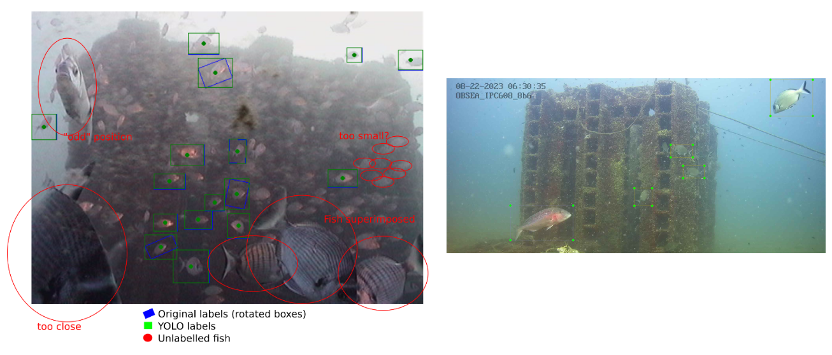
Figure 7 UC3o.1 - left: old dataset with missing labels, right: high-resolution image from the new 4K camera
During this period of the project, two object detection and classification algorithms were tested: Faster-RCNN and YOLOv8,. Some initial tests were carried out with the old OBSEA dataset and other public datasets, such as Fish in the wild. YOLOv8 outperforms Faster-RCNN in all metrics.

Preliminary results with YOLOv8: from September 2023 we focused on preparing a new dataset. Although it is a provisional small dataset with around 2000 images, some initial model training was performed with 150 epochs. The results are quite promising and have been published on YouTube and as iMagine project news. Some of the classes have correct predictions up to 98%, and the overall mAP@0.5 is 0.865. Figure 8 shows some of the metrics for the trained model.

Due to the biological nature of the environment that is being monitored, some fish species are less abundant. Although it is normal that some species are much more abundant than others, it leads to a lack of training data, and the model performs poorly on those taxa. To tackle this issue, we are currently balancing our dataset with third-party pictures from the MINKA repository

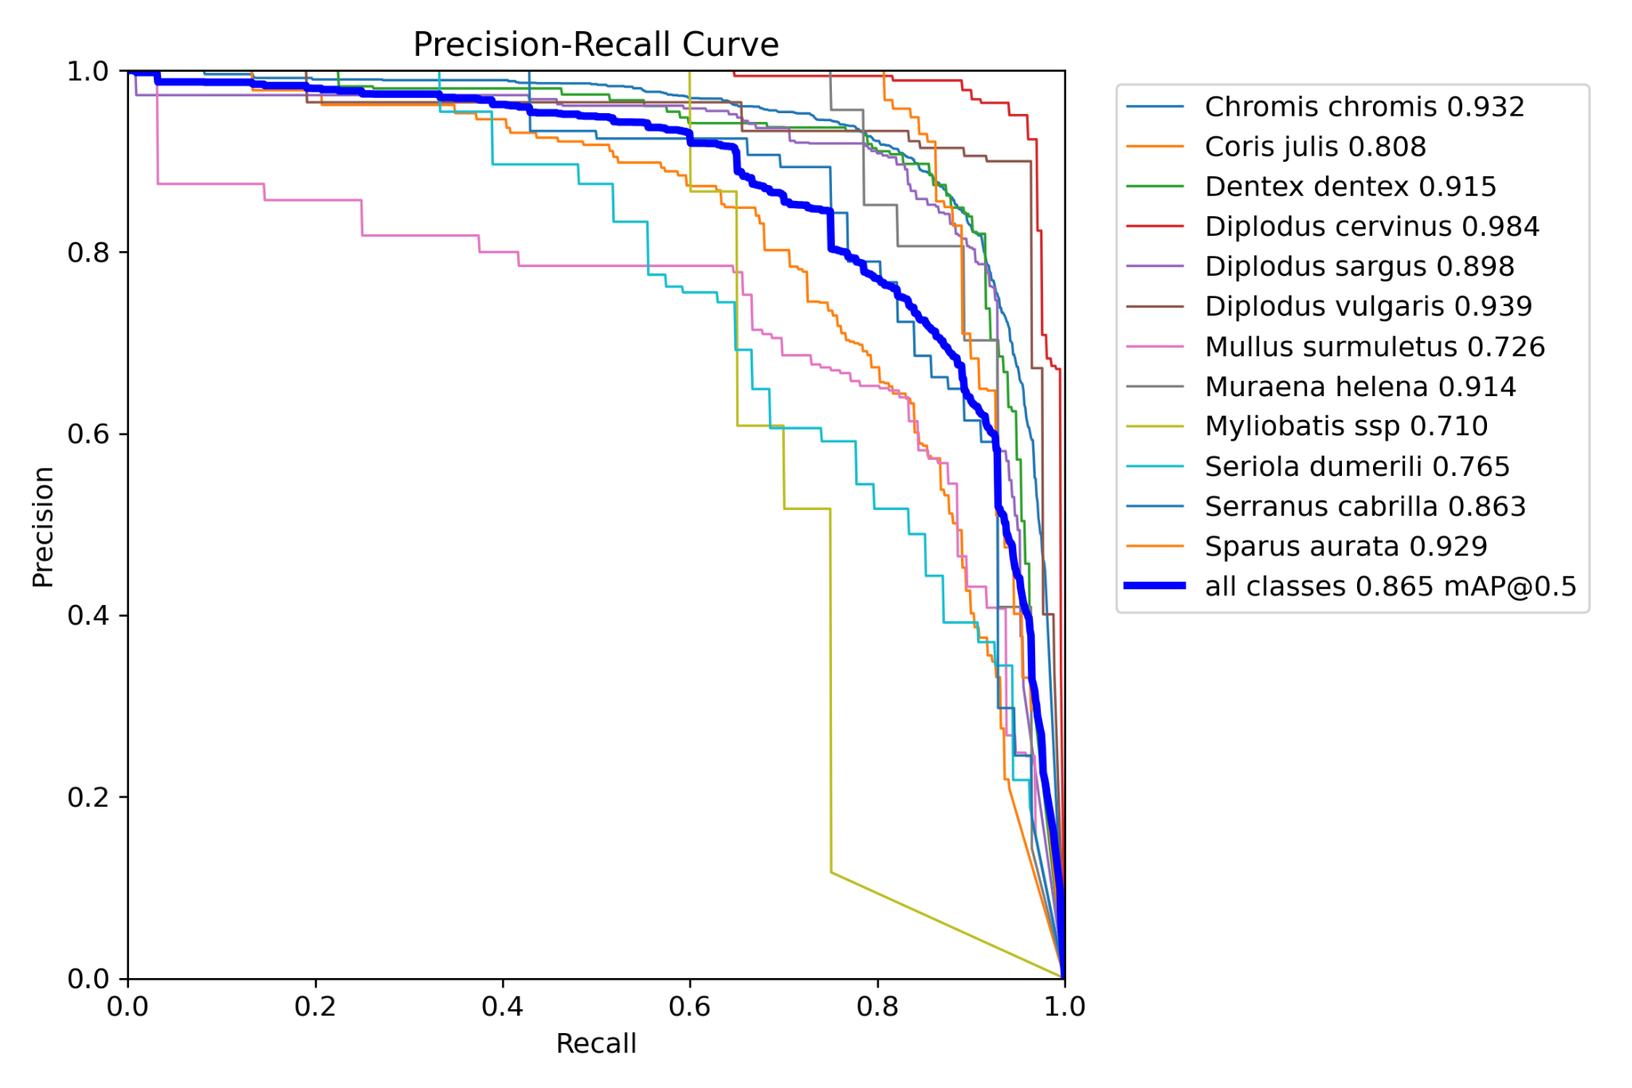
Figure 8 UC3o.2 - Precision-recall curve for the latest version of EMSO-OBSEA dataset.
For UC3-Azores (EMSO Azores), the aim is to use Deep Sea Spy data from EMSO-Azores and apply the YOLOv8 object detection algorithm to automatically identify our species present on the images. Since May 2023, significant efforts have been made to prepare the data for automatic identification, which has been challenging due to the diversity of species and the variable methods used for labelling the data. The annotations were made by citizen scientists, which resulted in varying levels of accuracy and consistency in the labelling of the different species. The data were labelled differently depending on the species (polygons, straight lines, points). This has required additional effort to standardise and clean the data in order to make it suitable for use with the YOLOv8 model.
The main goals for the preparation of data are to convert the data into YOLOv8 format and to perform data cleaning and pre-processing to ensure optimal performance and accuracy of the machine learning model during deployment.

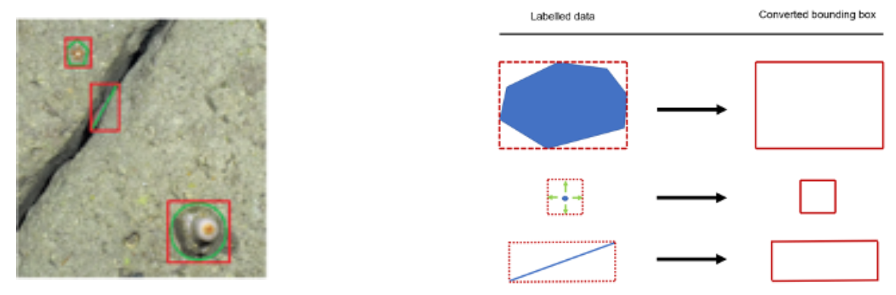
Figure 9 UC3a.1 - An image labelled by citizens (left), and the scheme to convert labels provided by citizens into regular bounding boxes (right).
The first step in the process was to convert the three types of annotations (polygons, straight lines, points) into regular bounding boxes (see Figure 9). This was achieved by taking the lowest and highest X and Y values for the polygons and straight lines and adding padding to the X and Y axes for the points, allowing for adjustment based on the specific species and the user's needs.

Data cleaning is also necessary to address redundancy resulting from the citizen annotation process. A Python function has been created to unify overlapping bounding boxes, so that redundant information can be used to ensure that an object has been correctly labelled. This function takes the maximum X and minimum Y of the overlapping bounding boxes and combines them into a unique box that englobes all the other ones that the function considers to be the same label.
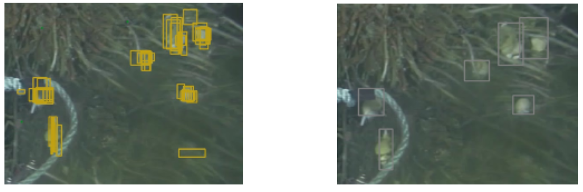
Figure 10 UC3a.2 - An image with overlapping bounding boxes (left) and resulting unique boxes (right).
This process helps to reduce the number of wrong annotations. Additionally, a function has been created that makes snapshots with the resulting bounding boxes, allowing a user to verify them before proceeding with the YOLOv8 model. This serves as a final verification step to ensure the accuracy of the data before it is used for machine learning. Then, a Python function converts the bounding boxes coordinates into YOLOv8 format bounding boxes and splits our dataset so that the training can easily be done after. There are also a lot of functions that were developed to help the user visualise and control the quality of their data. For instance, a function to create a catalogue of thumbnails from all the bounding boxes of a dataset was developed. This way, the user can delete the thumbnails to discard, which then deletes the bounding boxes from the dataset.
The pipeline will include a markdown to guide the users through and to explain how, depending on their needs, they can use the developed functions to better clean, visualise and control the quality of their datasets.

Achieved results
- UC3-Azores:
  - Developed a data cleaning pipeline, which converts Deep Sea Spy data/citizen science data into training YOLOv8 ready data.
  - The implemented pipeline is designed to ensure a user-friendly experience (markdown/notebook) and can be modified depending on the user’s needs.
  - Easy-to-use tools have been developed to ensure better control over the composition of the dataset (catalogue of bounding boxes, exports of images, etc.).
  - Trained YOLOv8 on a clean dataset of buccinidae (5k images, 17k labels), using the YoloV8_api on iMagine’s dashboard. Although the initial results were mixed, there is potential for improvement through further refinement and optimization of the model.
- UC3-Smartbay contributed to an initial evaluation of dataset Annotation tools
- UC3-Smartbay setup local Image Labelling Environments using Label Studio
- UC3-Smartbay Prototyped the use of a Label Studio Machine Learning backend using YOLOv8 to suggest annotations to new unlabelled data
- UC3-Smartbay trained an initial YOLOv8 model on the "Brackish Dataset"
- UC3-Smartbay has been working with Nephrops Fisheries survey staff to reformat labelled data for use in Label studio.
- UC3-OBSEA compared different models for fish detection, selecting YOLOv8 as the one with better performance.
- UC3-OBSEA trained several models with an existing dataset. However, several issues were found in the dataset such as low-quality pictures, biofouling issues and missing labels. Thus, this dataset is not suitable for use.
- UC3-OBSEA Produced a new dataset with HD cameras and better labelling. Although currently we have 2000 pictures, the dataset is still evolving as new pictures are constantly being collected and labelled.
- UC3-OBSEA will publish the HD dataset as soon as at least one year of data is archived in an open repository such as Zenodo.
- UC3-OBSEA trained a YOLOv8 (xlarge) with the latest version of the new HD dataset, achieving a mAP@0.5 of 0.865, which is quite promising.
- UC3-OBSEA also trained a YOLOv8 (nano) for real-time video inference. Currently, tests to process real-time video are being performed.
- UC3-OBSEA added the “OBSEA Fish Detection” module to the marketplace for fish detection with both YOLOv8 models in their current status.

Development plans towards service operation
- UC3-Azores:
  - Assess the performance of trained models and establish one that identifies buccinidae with good performances.
  - Depending on the quantity of data, train a model to identify other species (mainly Pycnogonida, Rimicaris exoculata).
  - Tune hyperparameters and use MMYolo to better understand the impact of our data/the learning of the model and improve its results.
  - Incorporate more statistical criteria, to further clean/correct our data.
  - The raw data/images and training datasets will be made available on the Seanoe (SEA scieNtific Open data Edition) repository with a DOI assigned.
  - Use the catalogue function to validate the predictions of the AI model by citizens and improve the model’s results.
- UC3-Smartbay to continue reformatting annotated Nephrop Survey Burrow data for re-use in Label studio.
- UC3-Smartbay to assist Nephrop Fisheries survey team in evaluating Label Studio for annotating data.
- UC3-Smartbay to publish an annotated Nephrop Burrow Dataset (currently discussing the best medium for this).
- UC3-Smartbay Currently rethinking the video quality assessment use cases. There are a number of existing “Video Quality Assessment” algorithms (VMAF, DOVER, FAST-VQA). Smartbay will evaluate if these automated approaches to Video Quality Assessment are suitable for the use case and if these need to be supplemented with locally labelled training data.
- UC3-Smartbay will continue to investigate using public marine species datasets to train Machine Learning "Auto suggest" backends to assist with dataset labelling, we may also publish any useful trained model.
- UC3-Smartbay will investigate additional resources for species labelling and also video quality assessment
- UC3-Smartbay Resourcing is quite challenging for EMSO Smartbay, Labelling is quite time-consuming, UC3-Smartbay refocusing investigation on semi-automated and automated approaches to building labelled training datasets so that at least one useful model can be developed and deployed on the iMagine marketplace by April 2024.
- UC3-OBSEA will keep acquiring and labelling pictures from the HD cameras until a year of data is obtained. At least one year of data is required to cover the seasonality of the fish abundance.
- UC3-OBSEA will also add third-party images to the dataset to balance underrepresented classes.
- UC3-OBSEA will retrain the fish detection module at the marketplace with the final dataset.
- UC3-OBSEA will deploy a slow but precise model (YOLOv8 xlarge) for inference of individual pictures. The aim of this model is to generate accurate fish abundance time-series for scientific purposes.
- UC3-OBSEA will deploy a fast model (YOLOv8 nano) for real-time video inference. The aim of this model is to be able to stream video with real-time predictions for both scientific and dissemination purposes.

Updated development roadmap

- UC3-Azores:
UC3a.E1.US2 (“AI-based service for validating images annotated by citizens”) removed, preliminary results suggest that validation of citizen datasets by AI might not be feasible with our data. The AI model should have excellent performance metrics, to the extent that its predictions are considered as accurate as those of an expert.
It would be preferable to first validate the performances of the model by citizens, allowing to improve the model’s performance.
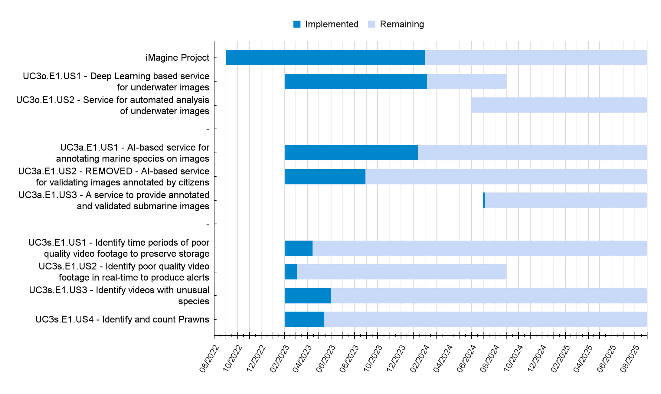
Figure 11 UC3.1 - Updated development timelines of UC3a, UC3o, UC3s

UC4 Oil spill detection

Description
The project aims to enhance the OKEANOS oil spill monitoring service by establishing an iMagine platform for the automatic processing of satellite imagery. Through the use of AI, the service improves oil spill detection accuracy and forecasting, addressing the challenges of quantifying uncertainties. The expected impact is optimised monitoring results for professional users and increased accessibility for researchers.

Use case status
Over the past year, UC4 has conducted an extensive literature review focused on oil spill modelling and the application of machine learning tools in this field. We encountered an initial challenge in obtaining real-world oil spill data, prompting us to consider UC4's approach to address this hurdle.

As a solution, an experimental laboratory centred on the Baniyas Oil Spill Case was established, which was explored in other studies by demonstrating the coupling between satellite observations and modelling (Keramea et al, 2022). Within this framework, a series of simulations were conducted to evaluate how various physical parameter configurations influence model skill scores systematically. This approach allowed us to gain insights into how proper parameter selection can significantly impact the accuracy of numerical oil spill simulations. In Figure 12, the framework for automatically searching the optimal parameter configuration through the parameter space is displayed in detail.

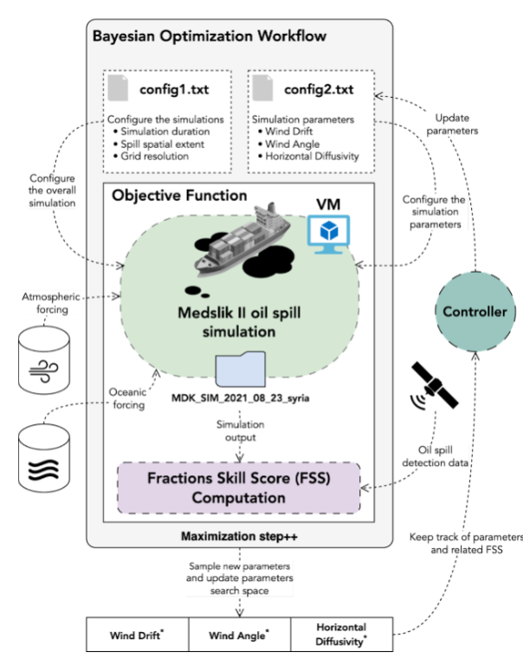
Figure 12 UC4.1 Proposed workflow to evaluate the effectiveness of the Bayesian Optimization framework for automatically selecting simulation parameters through their parameter space. Parameters such as wind drift, wind angle, and horizontal diffusivity are sampled to assess how the Fractions Skill Score improves or decreases in quality.
The workflow integrates satellite observations, the Medslik-II oil spill model used in UC4 and Bayesian Optimization for maximizing the Fraction Skill Score (FSS) by sampling optimal configurations of model simulation parameters in an iterative fashion. Therefore, parameters such as wind drift, wind angle and horizontal diffusivity are changed through Bayesian Optimization, to find the optimal parameters configuration without the need to try a large amount of different combinations, which would result in a computationally intensive and time-consuming procedure.

This workflow was applied to a set of 96 oil spill simulations, in which the setup was determined by Bayesian Optimization, and the model grid resolution was also modified (see Figure 13). These simulations allowed two main insights for the current development phase in UC4.
- The accuracy of the forecasts increases by reducing the oil spill model grid resolution. The highest resolution is 150 m.
- Implementation of an appropriate oil spill model setup could increase the FSS up to 60%
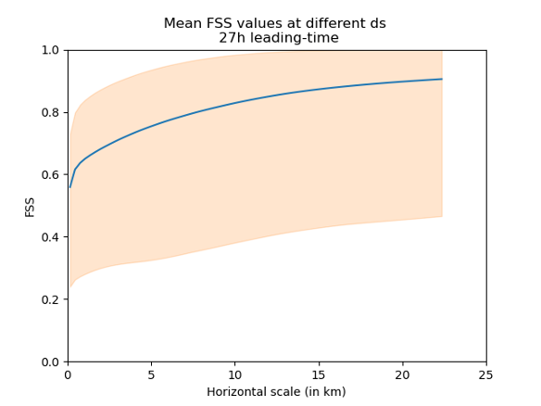
Figure 13 UC4.2 - Fraction skill for 96 different oil spill simulations with different setups. It is possible to observe that results are better when the oil spill model grid resolution is coarser
However, the proposed framework relies on satellite observations and Medslik-II simulations to optimise the FSS through Bayesian Optimization. Therefore, in recent months, a collaborative effort with Orbital EOS allowed the curation of a dataset of oil spill incidents in the Mediterranean Sea. These incidents were captured using satellite imagery and Orbital EOS's proprietary technology. This dataset includes around 340 observations (worldwide), and it now serves as a resource for conducting experiments that bridge the domains of physical oil spill modelling and Machine Learning models. A data catalogue has been set up at UNITN by leveraging a specific data publication procedure to index all the relevant metadata within an ElasticSearch service. The service enables search & discovery of the data stored (both forecast and observations), and it has been set up on a dedicated node connected to the HPC cluster at UNITN, to easily redirect the output of forecast simulations on the data repository. The overall infrastructure is aimed at building a benchmark dataset of forecast and observations data that will serve as a baseline and a reference for research activities in the area; it will be made available to the community as one of the outcomes of this case study.

Achieved results
- Improved oil spill detection from satellite imagery
- Definition of the Bayesian Optimization workflow
- Results demonstrated that for the single use case, the workflow provides metrics better than the standard model tuning process
- End-to-end architecture is already running on in-house cluster solutions
- Received 300+ oil spill satellite observations that are being treated to be displayed into image platform

Development plans towards service operation
- Test the Bayesian optimization workflow in other oil spill incidents and validate the methodology applied
- Improve FSS and score and time efficiency of the Bayesian framework
- Migrate the modelling infrastructure to the iMagine platform
- Make available all data received for consulting oil spill incidents within the iMagine platform

Updated development roadmap
UC4.E1, “Improve overall oil spill monitoring & forecasting system accuracy” - Main changes involve the manner that UC4 has aimed to tackle the solution with AI. Due to the scarcity of oil spill identified events through satellite imagery and the technical challenges to downscale environmental fields, UC4 focused on using AI to find the best parameters possible, by performing a bayesian search during calibration events, in other words, where oil spill scenarios contain 2 or more oil spill observation, the framework searches the optimum values in order to reproduce the oil spill dispersion pattern with more fidelity. Even though the US drifted from the original proposition, development is on track to deliver the framework into iMagine infrastructure.
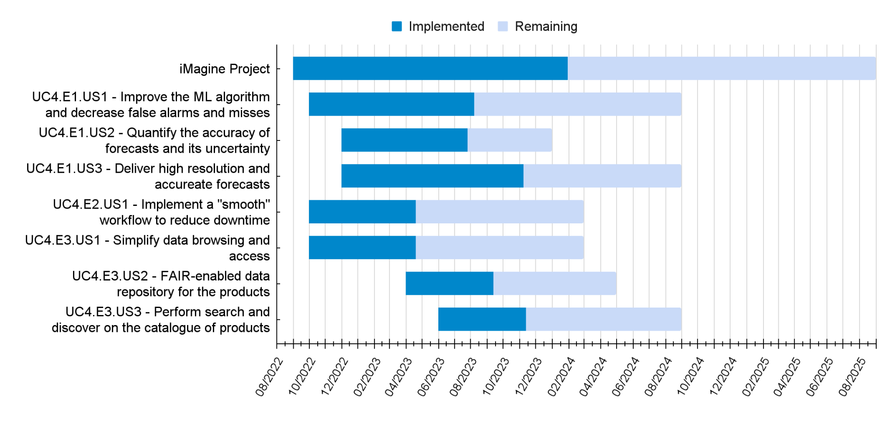
Figure 14 UC4.3 - Updated development timeline of UC4

UC5 Flowcam plankton identification

Description
The aim is to establish an iMagine platform service for processing Flowcam (Sieracki et al., 1998) images to determine the taxonomic composition of phytoplankton samples. The objectives include setting up an operational environment, refining the AI tools for taxonomic identification, and improving the FAIRness of the data. The result will be an understanding of phytoplankton communities, which is essential for assessing the state of marine ecosystems. It is expected that the Flowcam processing pipeline in iMagine will attract more users and image providers and contribute to efficient biomonitoring. So far the pipeline of the module is up and running, and a prototype module is available via the iMagine marketplace.

Use case status
UC5 has optimized current in-house data pipelines for ingestion from sensor to database. Developing an in-house uploader tool makes database uploads more standardized and includes various quality control checks. The tool also standardizes data aggregations to the R Shiny explorer and makes the biological result data available as open access. In-house Python packages to process and format raw data have been adapted to facilitate non-standard data, and we were able to accommodate three PhD students and one postdoc researcher for custom raw data processing, database upload, image data prediction with pre-trained classifiers, use of the in-house image validation tool and data exports tailored to their research.

The standardised LifeWatch biomonitoring added 361 670 new manually validated images to the internal VLIZ image library. Taxonomists revised the full image library and sorted rest groups, leading to fewer errors in the training data set and a higher number of classes to train on but which are more homogenous, leading to better overall model performance. Based on this total Image library consisting of over 2.1 million images, a training-set consisting of 337 613 Images spread over 95 classes is made available on Zenodo.

A module of the Flowcam phytoplankton identification service has been built on the iMagine platform and is being tested and further optimized before becoming public. The current dataset was uploaded from the internal database to NextCloud and will be updated throughout the course of the project by semi-automated data export as more validated data becomes available.
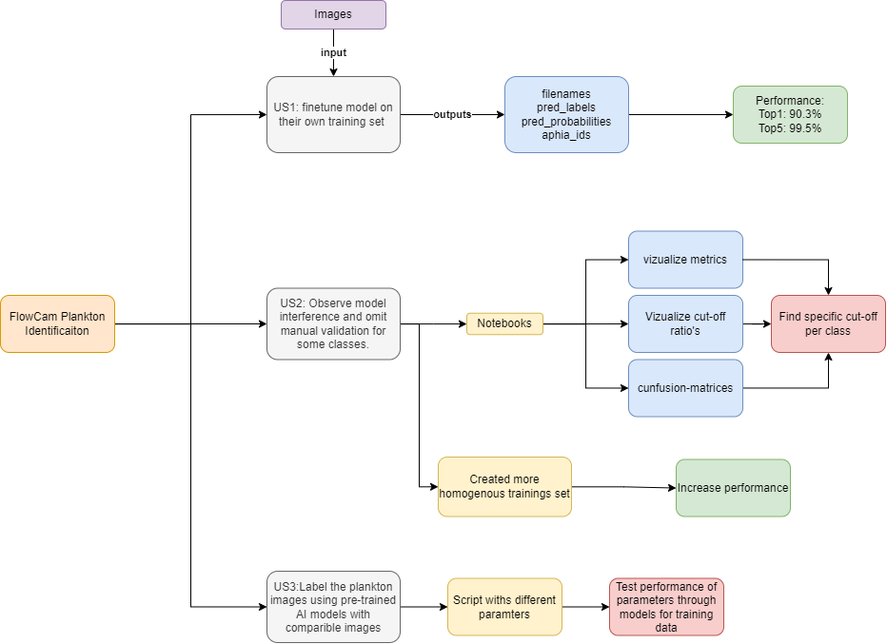
Figure 15 UC5.1 - Workflow for the three FlowCam user stories defined in UC5. The red diagrams are plans for M13-24.
Achieved results
- Taxonomic review of the image library, increase of number of recognize taxa from 55 to 140+, less taxonomic errors and more homogenous classes for model training
- Updating of internal data processing pipelines
- Facilitation of marine 3 PhD and 1 postdoc researchers through the internal data systems
- Connection of the VLIZ internal data systems to the iMagine platform
- Prototype module on iMagine marketplace available
- Prototype notebooks for post-hoc analysis of model performance
- Extension of the image library with over 300k newly manually validated images coming from the LifeWatch monitoring in the Belgian part of the North Sea
- Prototype script for image transformations, targeting different FlowCam devices, prototype script for image augmentation to deal will class imbalance in image library

Development plans towards service operation
- Publishing annotated image dataset in Zenodo repository that allows tracking of usage
- Testing model performance of training on 95 classes and over 300k images.
- Fine-tuning of model and training set to archive optimal performance
- Further explore community-based standards
- Connect Flowcam service to OSCAR cluster
- Make module operational for public
- Provide user documentation and training
- Collect user feedback and integrate
- Mixed model training including sampling metadata
- Continuous extension of the current image library by monthly LifeWatch monitoring and manual validations of newly predicted images

Updated development roadmap
US1: The model is deployed and ready. The dataset is about to be published on Zenodo, and service will be connected to the OSCAR soon (80% finalized).
US2: Notebooks to assess model performance have been created. However, a specific cut-off function per class still has to be defined (60% finalized).
US3: Notebooks for data augmentation have been created with the possibility of using data augmentation during model training as well. Still have to do further testing on lower-quality dataset and the most appropriate parameters for transformation need to be selected (50%). This US is a little delayed (10%), but the delay will be resolved soon.

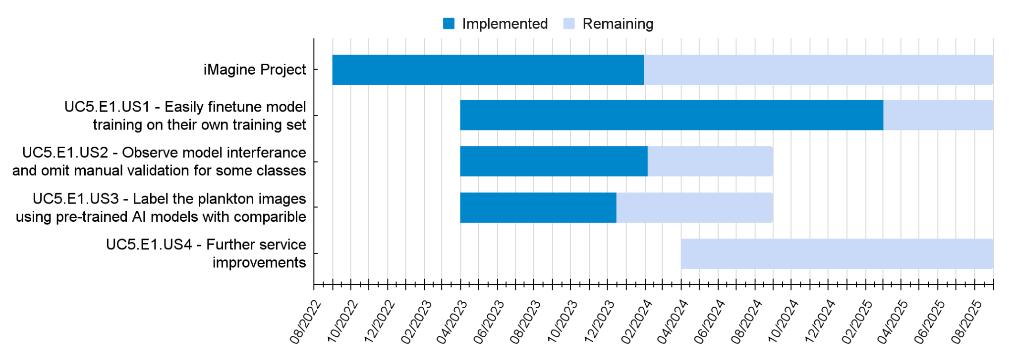
Figure 16 UC5.2 - Updated development timeline of UC5

UC6 Underwater noise identification

Description
The project aims to develop a prototype for a service on the iMagine platform to analyse underwater acoustic recordings to detect and classify marine vessels. Development activities include developing a data pipeline from the sensor to the database, building a validated sound database, training models on underwater sound, connecting the database to the iMagine platform, and building the service. The database is established through the integration of AIS (Automated Identification System) data and passive acoustic hydrophone recordings, obtained from North Sea stations. The hypothesis is that it’s possible to create a ground-truth database based on the GPS location of bypassing marine vessels and the distance to the recording from the vessel AIS data. Unfortunately, vessels don’t turn on their AIS system during illegal activities, and this could possibly interfere with the data quality.

By using state-of-the-art machine learning methods, two Convolutional Neural Networks (CNNs) are being created. A first neural network is used to predict absence/presence of a vessel in the vicinity of the hydrophone and a second to predict at which distance the vessel is situated. Through these CNNs, a domain scientist will have the necessary tools to process acoustic underwater recordings in order to identify the presence, distance, and type of vessel detected. In this learning process, the final end goal is that classifiers could be used as a reliable autonomous monitoring system in maritime environments.

Use case status
UC6 has worked on developing an in-house data pipeline to process raw hydrophone sound data and ingest it into the in-house database together with the required metadata. Since sound recordings are continuous, we are using AIS vessel tracking data to determine if a vessel was in the vicinity during the time of recording. Based on the presence/absence of a vessel, .wav files are created. The .wav files are then trained on a pre-trained model on the 527 high-level classes from the AudioSet dataset .
Currently, two models are being developed. The first prototype neural network is trained to predict the presence or absence of a vessel for newly ingested data within a 7 km range. The second model divides the presence range into seven intervals: 0-1 km, 1-2 km, ..., 6-7 km.
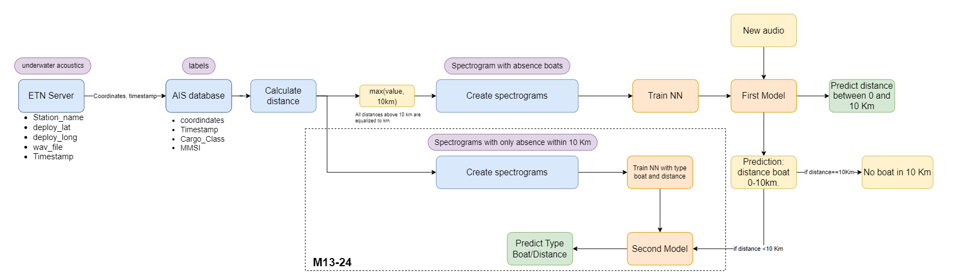
Figure 17 UC6.1 - Prototype dataflow to process underwater acoustic data. M13-24 Plans are shown in this figure.
Achieved results
- Internal data processing pipelines set-up
- Created plots supporting the hypothesis for 116 days of recording. Gives insight into sound data.
- Connection of the internal database to NextCloud for semi-automatic data exchange, upload of 15.8k data points (20GB) to NextCloud
- Prototype module available on iMagine marketplace
  - Binary module to detect boat presence in 7km range.
  - Multi-classification module to detect presence range boat
  - Plots being made to show confusion matrices when developing plot

Development plans towards validation
- Possibly publishing training dataset to Zenodo repository that allows tracking of usage
- Fine-tuning of model and training set
- Further explore community-based standards
- Make module operational for public
- Connect service to OSCAR cluster
- Compile user documentation
- Collect user feedback and integrate

Updated development roadmap
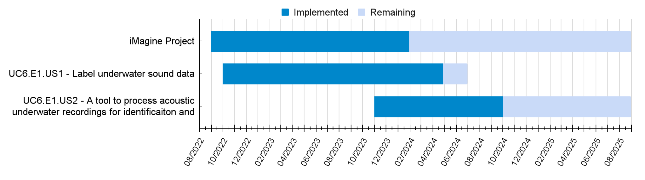
Figure 18 UC6.2 - Updated development timeline of UC6

UC7 Beach monitoring

Description
The aim of the project is to develop a prototype for a service on the iMagine platform to process images from beach imaging systems to automate the extraction of important coastal features. This includes determining the shoreline position, monitoring Posidonia oceanica berms (Pberms) formation, and detecting rip currents. The current challenge is that processing images from existing fixed systems, namely SIRENA -sets of cameras mounted at rooftops overlooking the beach-, and CoastSnap -smartphone holders, positioned at easily accessible beach vantage points for public use-, require substantial manual intervention due to varying conditions (e.g. light) and complex features (e.g. amorphous rip currents and Pberms). This limits their effectiveness in continuous monitoring.

To address these challenges, we propose using Deep Learning techniques for image segmentation and object detection. This approach aims to reduce human intervention, allowing for more consistent and detailed monitoring of beach dynamics, crucial for understanding beach changes and ensuring the safety of beachgoers. The development activities involve annotating datasets, setting up a training environment, and selecting and training DL models. This prototype is expected to enhance the efficiency of beach imaging systems and provide valuable insights for beach monitoring and management.

Use case status
Tasks have been primarily focused on exploring image repository quality control procedures, image metadata standardisation and enrichment, and Deep Learning approaches for beach monitoring-specific tasks. A pivotal aspect has been the generation of training datasets, including the meticulous removal of invalid images, the selection of images covering varying scenarios (e.g., field of view, lightning, beach, and meteoceanic conditions), experimentation with diverse labelling methodologies, labels definition, and the subsequent annotation of images. Training datasets consist of RGB images from different beach imaging systems and their purpose-specific masks (e.g. dense annotation, polygons). Data quality control, management, and annotation (Figure 19) correspond to “Create a training dataset” Epic UC7.E1 stories.

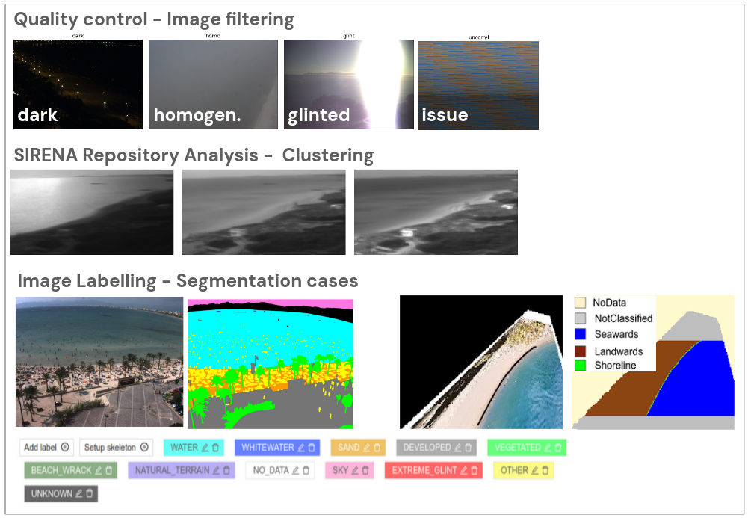
Figure 19 UC7.1 - Examples of image quality control, repository clustering, and dense annotation of images.
Currently, we are annotating four distinct datasets, each containing a different number of images (ranging from 500 to 2500). These images are instrumental in developing DL models designed to automatically extract key coastal features (UC7.E2 stories, see Figure 19). However, the completion of the dataset’s publication has been delayed. This delay is primarily due to the time-intensive nature of dense annotations (per pixel) using CVAT and the challenges involved in selecting images that accurately depict rip currents. To counter these issues, we are considering reducing the initial size of one of the datasets, and we will use a database of rip currents field observations from the Directorate of Emergencies of the Balearic Islands Government.
Achieved results
The results and plans below are categorised for two Epics: Epic 1 (E1) - Create a training dataset and Epic 2 (E2) - Implement image segmentation and object detection based on deep learning.
- E1. Quality control of RGB images and SIRENA repository analysis: Image selection.
- E1. Operative local and online Computer Vision Annotation Tool (CVAT).
- E1. One student trained on CVAT for dense annotation of SIRENA images.
- E1. More than 3000 images labelled.
- E1. CoastSnap dataset published in Zenodo.
- E2. Defined a DL approach for automatic shoreline extraction (Bi-LSTM network).
- E.2 Two student internships confirmed for the development of DL models (Jan/Feb-Jun/Jul 2024).
- E.1 In collaboration with the Emergencies Directorate of the Balearic Islands Government, they have provided us with the official ‘rip currents presence database’ gathered by lifeguard services from 2020 and on.

Development plans towards validation
- E1. Publishing annotated datasets in OA repositories, including images, masks, metadata, and user documentation.
- E2. Selecting Deep Learning methods for image segmentation and object detection.
- E2. Implementing methodology for splitting the datasets (training, validation, and testing), ensuring the inclusion of a diverse range of scenarios.
- E.2. Model development and testing applications.

Updated development roadmap
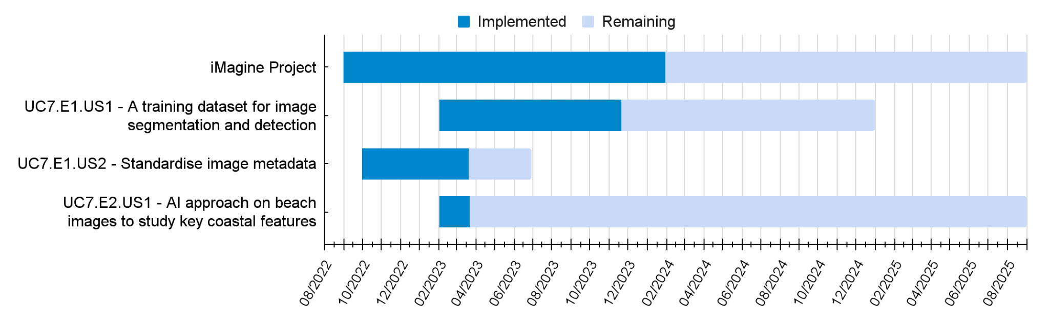
Figure 20 UC7.2 - Updated development timeline of UC7

UC8 Freshwater diatoms identification

Description
The use case aims to develop a diatom-based bioindication service on the iMagine platform using automatic pattern recognition algorithms for individual microscope images from freshwater environments. Diatoms, essential bioindicators of freshwater ecological health, are traditionally identified through laborious microscopic examinations. The prototype will utilize AI, specifically Convolutional Neural Networks (CNNs), to automate diatom classification based on morphological features. Development activities include setting up the iMagine platform, building a database of labelled images, training AI models, and developing a user-friendly GUI for interaction. The expected impact is the streamlining of diatom identification, addressing the labour-intensive nature of the process required by the EU Water Framework Directive (WFD) and facilitating wider use by stakeholders and educators.

Use case status
UC8 has mainly focused on the development of an end-to-end pipeline for diatom detection and taxonomic classification using a probabilistic approach (UC8.E1.US1, see Figure 22). A first GUI prototype has been developed in-house (Figure 21) and is ready to be deployed on the iMagine platform. For taxonomic classification, the current dataset consists of 20,000 individual diatom images representing 197 diatom species. The classification network achieves an accuracy of 94%. Regarding the approach for morphological analysis (UC8.E1.US2), a first pipeline based on instance segmentation has been developed thereby enabling the quantification of handcrafted size-related descriptors (major axis, minor axis). In parallel to this pipeline, a first approach to quantify diatom deformations has been explored. It is based on Generative Adversarial Networks (GAN) models (StyleGAN3+encoder4editing ) for unsupervised estimation of the variation of morphological features.
Since all the above approaches are based on relatively limited image datasets, the acquisition of high-quality training datasets (more species, more microscope images) has been initiated (UC8.E2.US1). An annotation workflow was set up to use the same microscope images (ca. 800 microscope field of views, 5-10 segmented objects/image) for both taxonomic classification (rotated bounding boxes using Biigle) and detection (instance segmentation masks with LabelBox).

Regarding the pre-screening approach (UC8.E1.US3, “Pre-screeening approach for diatom-based biomonitoring”), a first prototype was developed, using a content-based image retrieval (CBIR) approach aiming at integrating visual and semantic similarity using hierarchies.
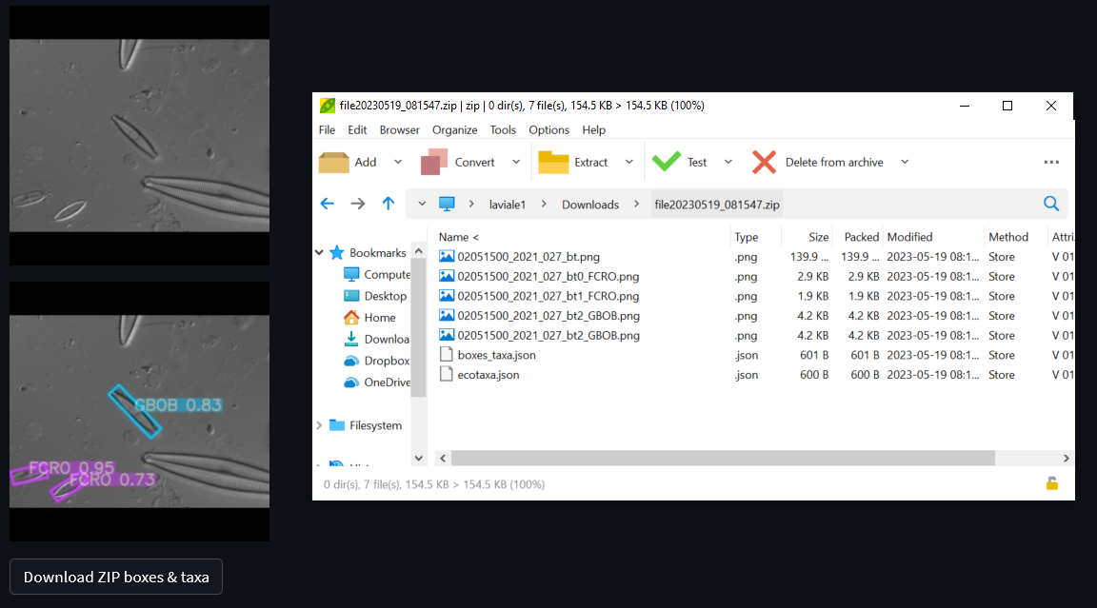
Figure 21 UC8.1 - GUI interface for diatom detection and taxonomic classification.

Achieved results
- E2.US1: Release of a first dataset for diatom taxonomic classification (20,000 individual diatom images representing 197 diatom species)
- E1.US1: Development of a first end-to-end pipeline for diatom detection and taxonomic classification, including a user-friendly GUI using Streamlit
- E1.US2: Development of a first end-to-end pipeline for diatom instance segmentation
- E1.US3: Development of a first pipeline for content-based image retrieval

Development plans towards validation
- Completion of training sets for diatom taxonomic identification (detection) and morphological analysis (instance segmentation)
- Fine tuning of existing prototypes using new training sets
- Deployment of existing GUI for diatom taxonomic identification

Updated development roadmap
Our development roadmap was updated in order to be in line with recent model developments:
- A new user story is now dedicated to the diatom morphometric analysis, which will rely on instance segmentation models (UC8.E1.US2). Original user story (UC8.E1.US1) will remain but it will focus on diatom taxonomic identification, which relies on bounding box detection models.
- A significant step forward is expected for both models developed in UC8.E1 as soon as training datasets is available (UC8.E2.US1)
- The initial user story dedicated to the pre-screening approach has been renamed (formerly UC8.E1.US3, now UC8.E3.US1)

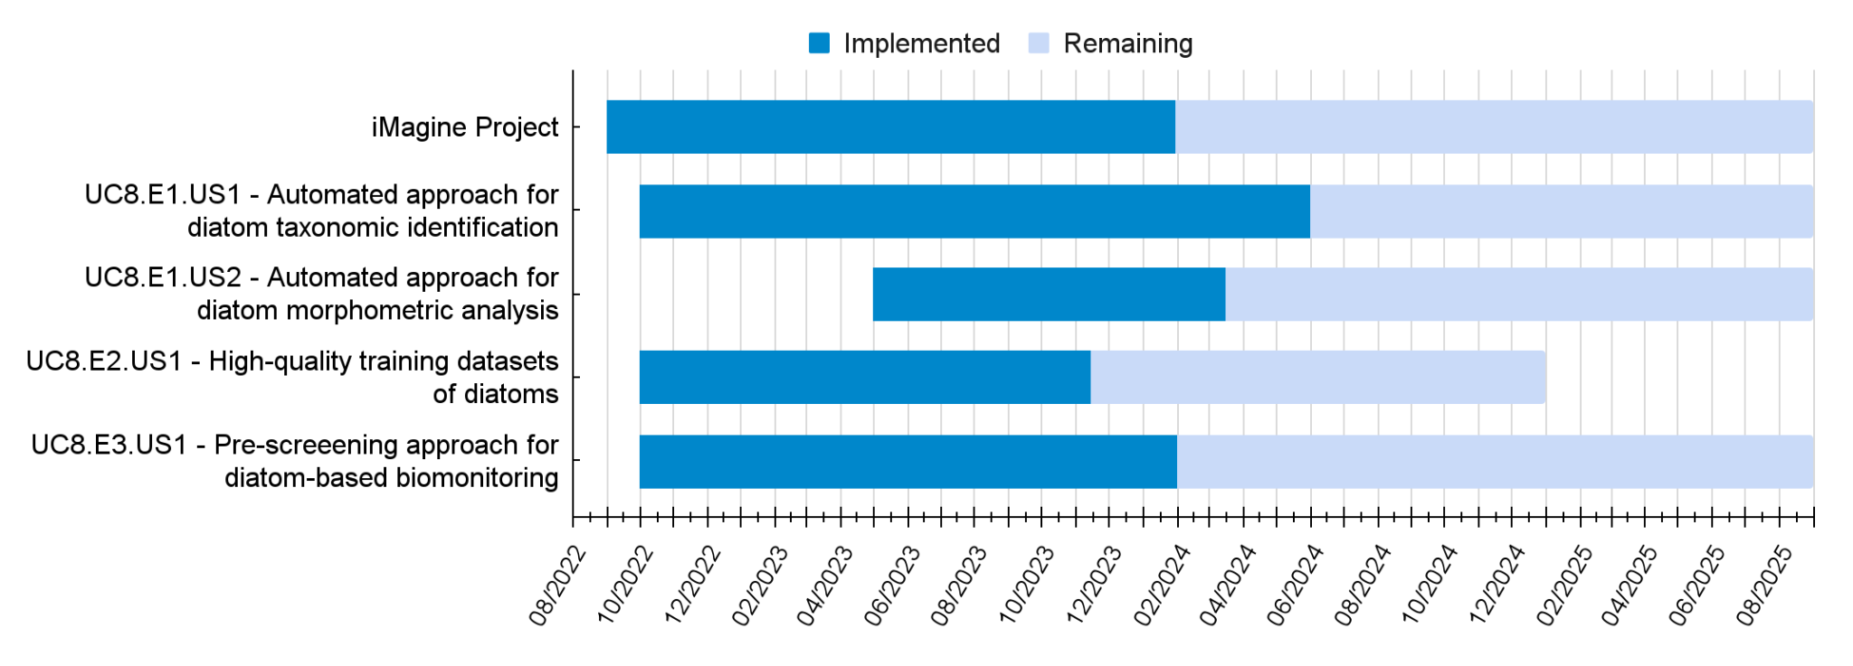
Figure 22 UC8.2 - Updated development timeline of UC8

Updated requirements for the platform
In the beginning of the project, the monitoring of user requirements for two installations: T4.1 - AI Application Development and T4.2 - AI Applications as a Service, was setup. The iMagine use cases can continuously update their requirements, and the AI platform providers monitor them. Table 1 and Table 2 represent updated requirements. They did not change much compared to D3.1, mainly more RAM requested and slightly less storage as one of the use cases re-evaluated how many scans they need to store on the platform towards a smaller amount.

Table 1 Req.1 - Platform common requirements of use cases for the AI-model development installation. In summary columns: light blue: values decreased, yellow: values increased, compared to D3.1
CID | Use Case: | UC1 | UC2 | UC3o | UC3a | UC3s | UC4 | UC5 | UC6 | UC7 | UC8 | Total | Average | Median
CD.Req001 | Storage space (dev) (GB) | 1 | 5 | 100 | 1024 | 1024 | 10 | 100 | 20 | 200 | TBD | 2484 | 276 | 100
CD.Req002 | Access bandwidth (dev) (Mbps) | 25 | 25 | 25 | 25 | 300 | 1000 | 25 | TBD | 25 | TBD | 1450 | 181.25 | 25
CD.Req003 | CPU usage (dev) (GB) | 18 | 20 | 20 | 15 | 168 | TBD | 40 | 20 | 20 | 20 | 341 | 37.89 | 20
CD.Req004 | RAM required (dev) (GB) | 8 | 16 | 32 | 32 | 16 | TBD | 8 | 8 | 8 | 16 | 144 | 16.00 | 16
CD.Req005 | GPU usage (dev) (h/week) | #N/A | 10 | 20 | 10 | 24 | TBD | 20 | 10 | 10 | 10 | 114 | 14.25 | 10
CD.Req006 | Nr. GPUs per training task (dev) | #N/A | 1 | 1 | 1 | 1 | 4 | 2 | 1 | 1 | 1 | 13 | 1.44 | 1
CD.Req007 | GPU memory per card (dev) (GB) | #N/A | 24 | 32 | 16 | 8 | 16 | 4 | 8 | 8 | 8 | 124 | 13.78 | 8
 | Information about available resources | yes | yes | yes | yes | yes | yes | yes | yes | yes | yes

Table 2 Req.2 - Platform common requirements of use cases for the AI-application serving installation. In summary columns: light blue: values decreased, yellow: values increased, compared to D3.1
CID | Use Case: | UC1 | UC2 | UC3o | UC3a | UC3s | UC4 | UC5 | UC6 | UC7 | UC8 | Total | Average | Median
CS.Req001 | Permanent Storage (srv) (GB) | 100 | 2 | 100 | 1024 | 1024 | 100 | 50 | 20 | TBD | TBD | 2420 | 302.50 | 100
CS.Req002 | Access bandwidth (srv) (Mbps) | 25 | 500 | 25 | 25 | 300 | 1024 | 25 | TBD | TBD | TBD | 1924 | 274.86 | 25
CS.Req003 | Estimated CPU usage (srv) (h/week) | 1214 | TBD | TBD | 1 | 168 | 15 | 40 | 20 | TBD | TBD | 1458 | 243.00 | 30
CS.Req004 | RAM required (srv) (GB) | 8 | TBD | TBD | 16 | 16 | 32 | 8 | 8 | TBD | TBD | 88 | 14.67 | 12
CS.Req005 | Estimated GPU usage (srv) (h/week) | #N/A | TBD | #N/A | 1 | 24 | TBD | 20 | 10 | TBD | TBD | 55 | 13.75 | 15
CS.Req006 | Service scalability | TBD | TBD | TBD | TBD | TBD | Yes | TBD | TBD | TBD | TBD

General feedback on the platform
In order to understand better the feedback of users about the iMagine platform, the survey was conducted with the following questions:
- What platform components do you already use?
- What platform components do you plan to use?
- What do you find GOOD about the platform?
- What do you find DIFFICULT on the platform?
- What do you find MISSING on the platform?
The results are summarised in Figure 23 Fb.1 - Current usage of the platform components. Figure 23, Figure 24 and Table 3.
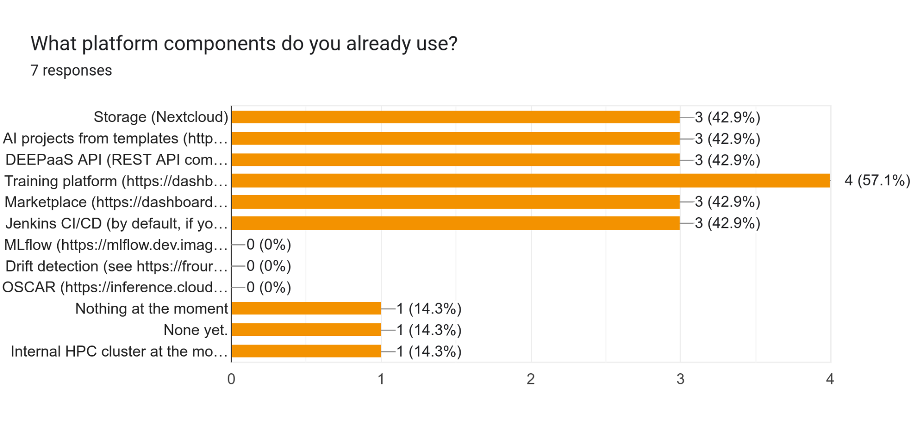
Figure 23 Fb.1 - Current usage of the platform components.
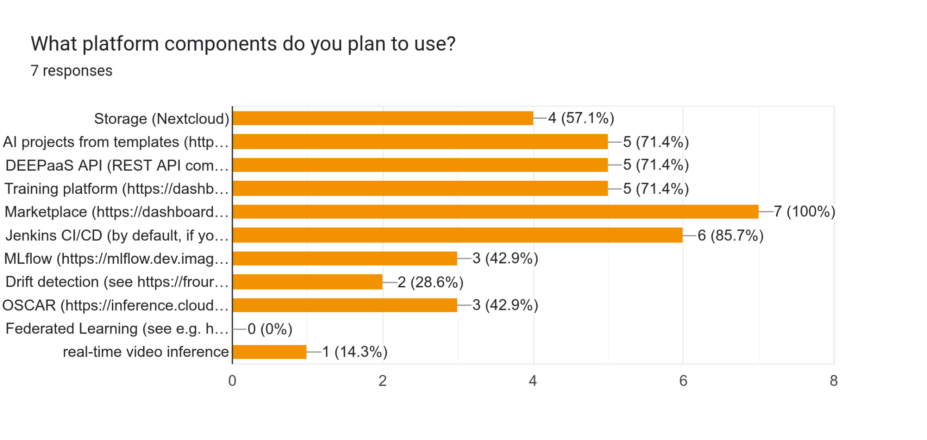
Figure 24 Fb.2 - Planned usage of the platform components.

Table 3 Fb.1 - What users find Good, Difficult, missing on the platform, and possible improvements to resolve Difficult and Missing issues
Good | - Useful to train, deploy modules  - Sandbox module for development  - Availability of turn-key AI models  - Good documentation  - Reactive helpdesk  - Offer of computing resources not available otherwise  - Container-based approach
Difficult | - GPU deployment may take a long time  - Possible bugs in the off-the-shelf modules  - Not always easy debugging  - A big variety of tools available, need time to learn | Planned/ongoing actions
- Adding more resources and cloud providers according to the WP4 plans
- Improving module automatic testing (CI/CD)
- Extend tutorials and documentations
Missing | - Real-time inference on video streams  - Ability to try available for inference models by everyone  - Image annotation tools | Planned/ongoing actions
- A study to use Kafka with Flink for live video streaming with object detection
- Using OSCAR to preload all modules for basic inference
- Offer annotation tools on the platform, e.g. CVAT

As survey shows, the use cases mainly use components related to the development of AI models. Tools such as OSCAR, MLflow and Drift Detection, which are more for activities after data preparation and model establishment, are not yet integrated into the workflows of the use cases. However, they are planned to be included in future work. The survey also suggests where the platform can be improved (Table 3.). This information is especially important for the next updates of the platform and the AI Platform developers and providers. Table 3 indicates possible actions as a response to what users find Difficult or Missing on the platform.

Conclusion
The document describes the status of iMagine use cases, their achievements, and plans towards operation, and updates the technical implementation roadmaps originally developed in D3.1. The feedback provided by the users about the Platform is collected and analysed. The results show that most of the platform components are either used by the use cases or are going to be used, especially if users do not have internal computing resources. At this stage of the project, all use cases are still in the development phase, and worked mainly on data preparation and annotation, and AI model training. Several use cases published their training datasets in public repositories. The experiences gained in this work are summarised in the best practices document, “Tips for AI-based image processing”, which is available publicly online and being continuously updated by the project community.

Acronyms
AI | Artificial Intelligence
AI4EU | (project) AI on-demand platform to support research excellence in Europe
API | Application Programming Interface
CBIR | Content-Based Image Retrieval
CC | Competence Centre
CI/CD | Continuous Integration and Continuous Delivery/Continuous Deployment
CNN | Convolutional Neural Network
CPU | Central Processing Unit
DL | Deep Learning
DOI | Digital Object Identifier
EOSC | European Open Science Cloud
FAIR | Findable Accessible Interoperable Reusable
FSS | Fraction Skill Score
GA | General Assembly
GAN | Generative Adversarial Model
GPU | Graphics Processing Unit
GUI | Graphical User Interface
HPC | High-Performance Cluster
mAP | mean Average Precision
ML | Machine Learning
(EU) MSFD | EU Marine Strategy Framework Directive
MVP | Minimum Viable Product
NGO | Non-governmental organization
QC | Quality Control
TB | Terabyte
UC | Use Case
US | User Story

https://ai4os.eu/ , https://github.com/ai4os
https://marketplace.eosc-portal.eu/services/imaging-ai-platform-for-aquatic-science
D3.1 Technical development roadmap for the AI image analysis use cases, https://doi.org/10.5281/zenodo.7760412
User stories are cited as UCx.Ex.USx, which stands for the User Story (US) within the Epic (E) identified for a particular Use Case (UC)
Fleet, D., Vlachogianni, T. and Hanke, G., A Joint List of Litter Categories for Marine Macrolitter Monitoring, EUR 30348 EN, Publications Office of the European Union, Luxembourg, 2021, ISBN 978-92-76-21445-8, doi:10.2760/127473, JRC121708.
https://vap.aau.dk/the-brackish-dataset/
ACM Computing Surveys, Volume 54, Issue 6, Article No.: 115, pp 1–35, https://doi.org/10.1145/3457607
https://commission.europa.eu/strategy-and-policy/priorities-2019-2024/european-green-deal_en
https://docs.ai4os.eu/projects/deepaas/en/stable/
Wolf, Mattis, Katelijn van den Berg, Shungudzemwoyo P. Garaba, Nina Gnann, Klaus Sattler, Frederic Stahl, and Oliver Zielinski. 2020. ‘Machine Learning for Aquatic Plastic Litter Detection, Classification and Quantification (APLASTIC-Q)’. Environmental Research Letters 15 (11): 114042. https://doi.org/10.1088/1748-9326/abbd01.
https://www.gradio.app/docs/interface
https://dashboard.cloud.imagine-ai.eu/marketplace/modules/uc-dfki-ni-deep-oc-litter_assessment_service
https://docs.ai4os.eu/en/latest/user/overview/inference-oscar.html
A. McQuatters-Gollop et al., (2022). Assessing the state of marine biodiversity in the Northeast Atlantic. Ecological Indicators, 141, 109148. https://doi.org/10.1016/j.ecolind.2022.109148
He, K., Gkioxari, G., Dollár, P., & Girshick, R. (2017). Mask R-CNN. In 2017 IEEE International Conference on Computer Vision (ICCV) (pp. 2980-2988). Venice, Italy. doi:10.1109/ICCV.2017.322
https://paperswithcode.com/task/panoptic-segmentation
https://dashboard.cloud.imagine-ai.eu/marketplace/modules/uc-emmaamblard-deep-oc-multi_plankton_separation
https://labelstud.io/
https://frouros.readthedocs.io/en/latest/
https://paperswithcode.com/paper/disentangling-aesthetic-and-technical-effects
https://paperswithcode.com/paper/fast-vqa-efficient-end-to-end-video-quality
https://github.com/sovit-123/fasterrcnn-pytorch-training-pipeline
https://github.com/ultralytics/ultralytics
https://www.fisheries.noaa.gov/west-coast/science-data/labeled-fishes-wild
https://www.youtube.com/watch?v=SEw79Gd6m5o
https://www.imagine-ai.eu/article/trials-for-detecting-and-classifying-fish-with-the-help-of-ai-at-obsea/
https://minka-sdg.org/
https://www.deepseaspy.com/en/Project-overview
https://vap.aau.dk/the-brackish-dataset/
https://www.marine.ie/site-area/areas-activity/fisheries-ecosystems/nephrops-under-water-tv-surveys
https://dashboard.cloud.imagine-ai.eu/marketplace/modules/uc-enocmartinez-deep-oc-obsea-fish-detection
https://github.com/open-mmlab/mmyolo
https://www.seanoe.org/
https://parsec-accelerator.eu/portfolio-items/okeanos/
Keramea, P. et al., Oil spill modeling assessment of the 2021 Syrian oil spill using SAR imagery and multi-forcing forecasts, EGU General Assembly 2023, Vienna, Austria, 23–28 Apr 2023, EGU23-1573, https://doi.org/10.5194/egusphere-egu23-1573
http://www.medslik-ii.org/
https://rmets.onlinelibrary.wiley.com/doi/full/10.1002/met.296
https://www.orbitaleos.com/
https://www.fluidimaging.com/
https://rshiny.lifewatch.be/flowcam-data/
https://zenodo.org/records/10554845
https://dashboard.cloud.imagine-ai.eu/marketplace/modules/uc-lifewatch-deep-oc-phyto-plankton-classification
AIS: The Automatic Identification System (AIS) is a short-range coastal tracking system currently used on ships. It was developed to provide identification and positioning information to both vessels and shore stations.
https://research.google.com/audioset/
https://dashboard.cloud.imagine-ai.eu/marketplace/modules/uc-lifewatch-deep-oc-underwater-noise-classification
https://zenodo.org/records/10159978
https://environment.ec.europa.eu/topics/water/water-framework-directive_en
https://doi.org/10.48550/arXiv.2106.12423
https://doi.org/10.48550/arXiv.2102.02766
https://labelbox.com/
https://dorel.univ-lorraine.fr/dataset.xhtml?persistentId=doi:10.12763/UADENQ
https://streamlit.io/
WP3 - AI Platform Requirements Tracking: https://docs.google.com/spreadsheets/d/1P1NBEzdQGlmOxcb0gN7fd6D6eEaNeUSL-BK9OAuPtwM/ (internal document)
Tips for AI-based image processing: https://confluence.egi.eu/display/IMPAIP/Tips+for+AI-based+image+processing

