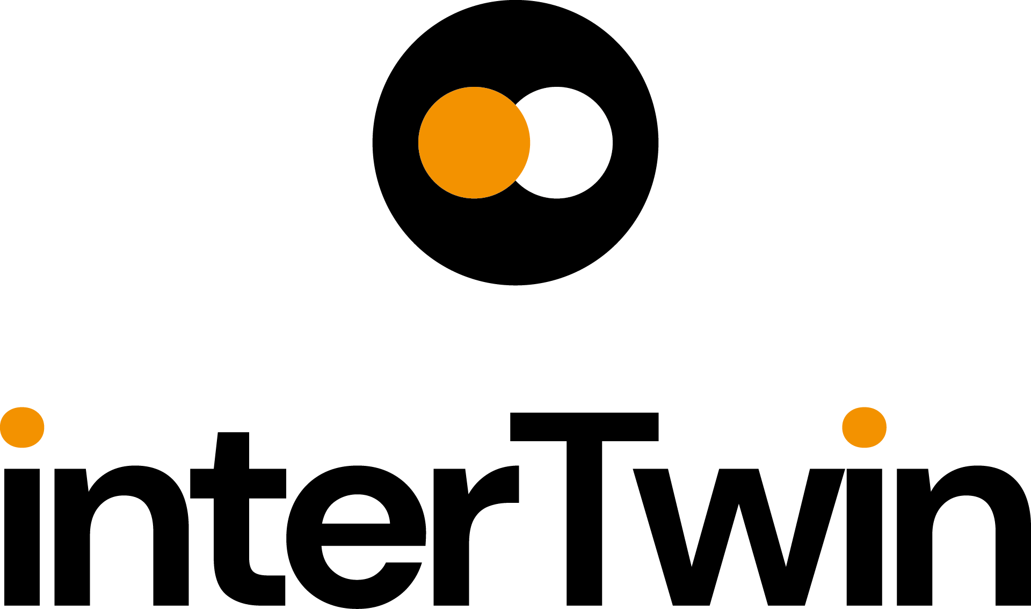

D2.5 Final Communication, Dissemination and Engagement Activity Report
Status: Under EC Review
Dissemination Level: public

Abstract
Key Words | Communication, dissemination, engagement, target users, measures, impact
This document summarizes T2.2's (Dissemination, Communication, and Engagement) activities in the interTwin project from M1 to M36. Led by EGI.eu under WP2, T2.2 focuses on disseminating Key Exploitable Results (KERs) to diverse audiences, aiming to boost project visibility, user engagement, and stakeholder collaborations. Through refined stakeholder targeting and strategic partnerships, the interTwin DCE activities enhanced project impact by effectively communicating outcomes and fostering valuable connections within the research and industry domains.

Document Description
D2.5 Final Communication, Dissemination and Engagement Activity Report
Work Package 2
Document type | Deliverable
Document status | Under EC Review | Version | 1
Dissemination Level | Internal
Copyright Status |   This material by Parties of the interTwin Consortium is licensed under a Creative Commons Attribution 4.0 International License.
Lead Partner | EGI
Document link | https://documents.egi.eu/document/3923
DOI | https://zenodo.org/records/17120237
Author(s) | - Gwen Franck (EGI)
Reviewers | - Charis Chatzikyriakou (EODC)  - Mariana Velho (CERN)  - Diego Ciangottini (INFN)
Moderated by: | - Andrea Anzanello (EGI)
Approved by | AMB

Revision History
Version | Date | Description | Contributors
V0.1 | 14/08/2025 | First draft | Gwen Franck
V0.2 | 02/09/2025 | Reviewed draft | Charis Chatzikiriakou  Mariana Velho
V0.3 | 15/09/2025 | Contents finalisation | Gwen Franck
V1.0 |  | Final

When the terminology/acronyms are available via the link below, please remove this table.
Terminology / Acronyms
Term/Acronym | Definition
AMB | Activity Management Board
DCE | Dissemination, Communication and Engagement
DT | Digital Twin
DTE | Digital Twin Engine
EAB | Ethics Advisory Board
EEAB | External Expert Advisory Board
KER | Key Exploitable Result
WP | Work Package
https://confluence.egi.eu/display/EGIG

Table of Contents
1 Introduction 8
2 Overview of activities 9
2.1 Branding 9
2.2 Website 9
2.2.1 Home 9
2.2.2 News and Events 9
2.2.3 Digital Twin Engine 10
2.2.4 Results 10
2.2.5 Impact 10
2.2.6 Deliverables and Publications 10
2.2.7 Magazine 11
2.2.8 Statistics 11
2.3 Audiovisual Materials 11
2.3.1 Printables 11
2.3.3 Gadgets 12
2.3.4 Videoclips 12
2.3.5 Demonstrations 13
2.3.6 Module logo’s 14
2.3.7 Diagrams 14
2.4 Social Media 14
2.4.1 LinkedIn 14
2.4.2 YouTube 16
2.4.3 Other channels 17
2.5 Events 17
2.5.1 Booths 17
2.5.2 Partner Presentations 18
2.5.3 Internal workshops and meetings 18
2.5.4 Spotlight: Thematic Events in PY3 19
2.5.5 Webinars 23
2.6 Publications 24
2.6.1 Scientific Publications 25
2.6.2 Press and non-scientific publications 26
2.7 Deliverables and Milestones achieved 26
2.8 Budget 26
3 Summary of Dissemination Outputs 28
3.1 Status Review 28
3.2 Collaborations and partnerships 30
3.2.1 Integration of Helix @ ML and interLink 30
3.2.2 interLink Entered the CNCF Sandbox - Cloud-Native HPC Integration 30
3.2.3 OSCAR and DT Flood in the DISCOVER-US project 31
3.2.4 Collaboration between interTwin and AI4EOSC 31
3.2.5 Digital Twin Factory Project 31
4 Stakeholder engagement 32
4.1 DT Users 32
4.2 DT Developers and Providers 33
5 Final conclusions 35
6 Annexes 37
Annex – Webinars 37
Annex 1 – 2022 events 41
Annex 2 – 2023 events 42
Annex 3 – 2024 events 44
Annex 4 - 2025 Events 48
Annex 5 - Module Icons 52
Annex 6 - Online Brochure (mock-up) 53

List of Figures
Figure 1 Overall website visits (22 -09-2022 / 31-08-2025) 11
Figure 2 Diego Ciangottini (INFN) and interTwin Technical Coordinator Andrea Manzi (EGI) recording the first podcast in the ‘interTwin Talks’ series 12
Figure 3 interTwin video 13
Figure 4 interTwin demo’s on YouTube 13
Figure 5 Example of a diagram illustrating the use cases 14
Figure 6 LinkedIn advertisement example 15
Figure 7 Image: engagement rate last 12 months and effects of advertising campaign on impressions of the page 16
Figure 8 YouTube Analytics 16
Figure 9 Event booths at EGU 2025 and HiPEAC 2026 18
Figure 10 interTwin Policy Workshop in Ghent (June 8 2025) 20
Figure 11 interTwin coffee breaks at EGU 2025 22
Figure 12 interTwin last in-person Technical Meeting during EGI2025 in Santander, Spain 23
Figure 13 interTwin webinar branding 23
Figure 14 Deliverable fact sheet for D5.2 24
Figure 15 Zenodo statistics 25
Figure 16 Self-reporting: target audiences reached through interTwin attended external events 34

List of Tables
Table 1 internal project workshops 19
Table 2 Status review of planned T2.2 activities 28

Executive summary
The interTwin project, co-funded under Horizon Europe, aims to co-design and implement a prototype for an interdisciplinary Digital Twin Engine (DTE). This D2.5 Final Communication, Dissemination and Engagement Activity Report summarizes the progress and outcomes of T2.2 (Dissemination, Communication, and Engagement) from M1 to M36, led by EGI.eu under WP2.
The project focused on disseminating the project’s Key Exploitable Results (KERs) to diverse audiences. A structured Dissemination, Communication, and Engagement (DCE) strategy (D2.1) was implemented, leveraging branding, digital platforms, events, and strategic partnerships to maximize visibility and stakeholder engagement.
Key T2.2 activities included:
- Branding and website development
- Audiovisual materials
- Social media campaigns
- Event participation
- Promotion of Publications and Deliverables
- Collaborations

Introduction
interTwin is a project to co-design and implement the prototype of an interdisciplinary Digital Twin Engine (DTE), that offers the capability to integrate with application-specific Digital Twins (DTs).
As part of WP2 (Innovation Management and Communications), T2.2 (led by EGI.eu) deals with interTwin Communication, Dissemination and Engagement activities.
This deliverable reports on the entire project period, updating the numbers and activities mentioned in D2.1 and D2.3. The main objectives of WP2 have been to ensure that project results are captured, disseminated, and exploited for maximum impact, to manage both internal and external communication and dissemination, to liaise with stakeholders from both research and industry, and to organise project events and support participation at external events. T2.2 aligned closely with the activities in T2.1 (Innovation Management and Exploitation) as outlined in the Innovation Management Plan (D2.2) and Innovation Management Progress report D2.4.

The project has identified 6 Key Exploitable Results, which are also the core of the project DCE strategy:
- Interdisciplinary Digital Twin Engine
- Interoperability Framework: Guidelines, Specifications, and Blueprint Architecture
- Toolkit for AI workflow and method lifecycle management
- Quality Framework
- DTE federated infrastructure integrated with EOSC and EU Data Spaces
- interTwin Open Source Community
The core activities of T2.2 have focused on the dissemination of these KERs to the various target audiences. For this purpose, the activities are mapped to the stakeholder analysis (see section 4).
This interTwin DCE report intends to give an overview of all activities that have been conducted to increase awareness, engagement and collaborations.

Overview of activities
It is not the intention of this deliverable to describe again in detail the activities conducted between M1 and M18, to which we refer in D2.3. The report will focus on M19-36, complemented by a project-wide overview of activities.
The project ending on August 31st, 2025, provided a less-than-ideal timing with regard to the promotion of the final results. With regard to some activities, such as the final project brochure (online), updates of the website, success stories, social media campaigns, and animated clips, the numbers provided will therefore be as up to date as possible, but not final. If this is the case, this will be mentioned in the description.

Branding
At the start of the project, a large part of the interTwin visual identity, such as the logo, branding elements and document/presentation templates, was developed quickly and distributed amongst partners via the Communications Toolkit and the Project Brandguide. For extended documentation about the interTwin branding, see Deliverable 2.1.
A key element of the branding has been developed in the second half of the project: every DTE software module has received a dedicated branding (See annex 4).

Website

Home
The project website intertwin.eu was set up by the end of M1, allowing for quick communication of the project's essential information, such as contact details, team and governance, and overall project goals.

News and Events
The News, Events (and Webinar) section offers a chronological overview of all articles published on the website. These include event announcements and reports, deliverable fact sheets, and blog posts about partner activities and project developments.

Digital Twin Engine
40+ DTE software modules, matching the work done in the technical work packages, were published on the website, organised in 4 different categories: ‘Core Modules’, ‘Infrastructure Modules’, ‘Environment Modules’ and ‘Physics Modules’. As part of the project branding, each of these modules has received a logo in line with the interTwin branding for communication and dissemination purposes (with some of the more mature products, the owners were allowed to use the existing logo).
Each module page includes a description, including Release Notes and Future Plans, links to related publications and deliverables, user and developer information (such as links to github environment, license and source code, and contact information).
Linked Use Cases and Success Stories are also shown, if applicable.
While most of the module information pages have received an update based on the final deliverables, it is expected that updating this information will continue after the project ends.

Results
The results section lists the overview of all Key Exploitable Results, linking to an overview page including detailed information about target audiences, exploitation and dissemination activities, and related deliverables, success stories and use cases. While most of KER pages have received an update by August 31, it is expected that updating this information will continue after the project ends.

Impact
The impact section contains both the use cases and success stories.
Use Cases
Throughout the project, 10 use cases have been developed in collaboration with the relevant partners. These use cases are focused on the two main research domains interTwin is targeting: environment and physics. Every use case has a description detailing challenge and solution, associated workflows and modules, background information, and a detailed diagram, developed by interTwin, to show where the interTwin DTE and the interTwin modules are part of the solution.
Success Stories
The success stories section lists examples and stories on how interTwin modules have played a role in the workflow of external challenges. Updating this section with new emerging success stories will continue after the project ends.

Deliverables and Publications
The outputs section lists and links to all publicly available deliverables, as well as to publicly available presentations, articles, and visuals created by project partners, standardly archived on the Zenodo interTwin community.

Magazine
The interTwin final brochure (see Annex 6) will also be added to the website.

Statistics
At the end of M36, the website had a total of 16,460 visits (of which 5221 were returning visits) and 33,626 page views.
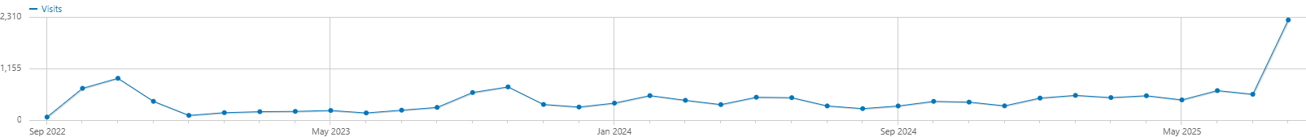
Figure 1 Overall website visits (22 -09-2022 / 31-08-2025)
The most visited pages were ‘Home’ (8538 visits), ‘About interTwin’ (1696), ‘Use Cases’ (1726) and the ‘interTwin Digital Twin Engine’ landing page (2841).
As discussed under section 2.4.1, the net impact on the visitor statistics of a LinkedIn advertising campaign, run during the last weeks of the project, has been quite remarkable. During these weeks, almost 700 visitors were directed to the website from LinkedIn.

Audiovisual Materials
For images illustrating these materials, see Deliverable 2.3.

Printables
While it is often tempting to produce mass printed materials for dissemination purposes, as a project we have decided that this is not the right approach for us. Not only because of the environmental impact (not only printing, but also shipping), but also because the project information was updated so regularly that this would require frequent reprints and redesigns. We have therefore chosen to limit the number of printed materials to moo cards and flyers, redirecting the receiver to our website, and to host our final brochure online only.

Moo cards and Stickers
At the very beginning, a small square formatted card with a QR code and a set of stickers was printed and distributed among partners for quick handouts at events.

Flyers
A set of flyers, linking to the various modules overview pages, was produced for targeted distribution at events.

Final Brochure
An online brochure, highlighting the main project results, is under preparation and will be published at the end of M36 (after the publication of this deliverable). It will be accessible via the following URL: http://intertwin.eu/finalbrochure
See annex 6 for the mock-up brochure.
    - Podcast series: interTwin talks
As a result of the Final Event Dissemination Workshop, it turned out that a project partner is an experienced podcast maker. As we had an opportunity to have most partners present during the project closing at EGI2025, we produced a series of podcasts focused on specific partner activities. These podcast episodes are published as part of the SciGeeks podcast series (available on YouTube and other platforms) and are shared via the project’s social media platforms and website.
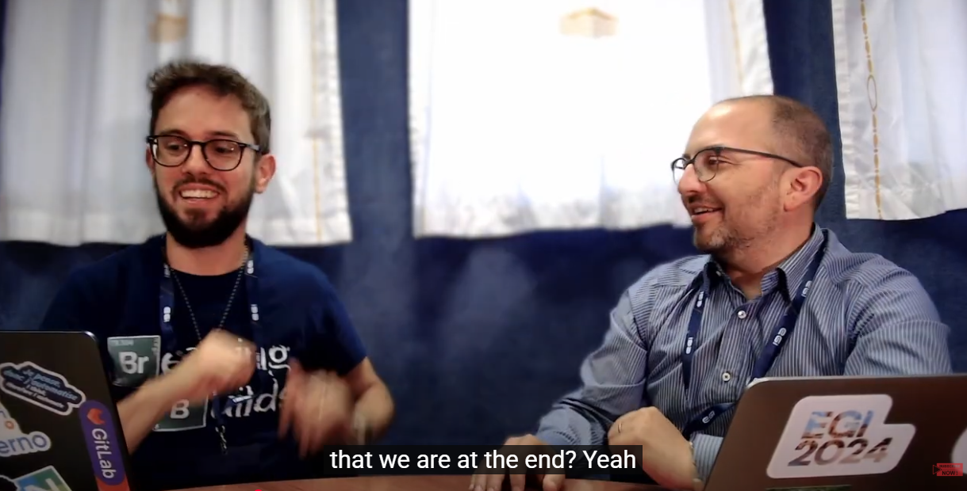
Figure 2 Diego Ciangottini (INFN) and interTwin Technical Coordinator Andrea Manzi (EGI) recording the first podcast in the ‘interTwin Talks’ series
All podcasts will appear on the SciGeeks YouTube channel and will be added to our interTwin Talks playlist.

Gadgets
During the project, a couple of high-quality gadgets were produced to act as "aide-mémoire” for partners and interested audiences. A power bank was distributed among partners and used for targeted distribution at event booths at the start of the project, and a series of branded water bottles was used to promote the project amongst attendees of the interTwin coffee breaks at EGU 2025 and two policy workshops organised in summer 2025.

Videoclips
While a very basic video clip, developed internally, introduced the project on the website and in event booths for the first two years of the project, a significant improvement was made with the production of two new video clips, produced externally, around M30: one generic and one focused on the environment modules.
- General Video
- Environmental Modules
- interTwin Results
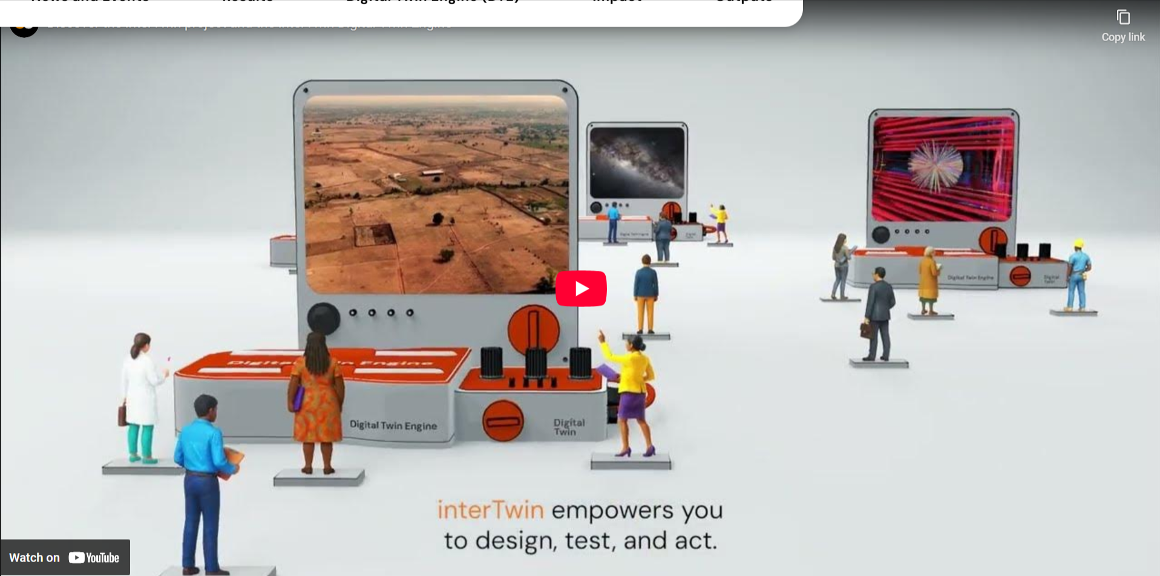
Figure 3 interTwin video

Demonstrations
As the project is ending, some stand-alone demonstration videos have been produced and published on YouTube. They are added to the website as illustrations of the modules.
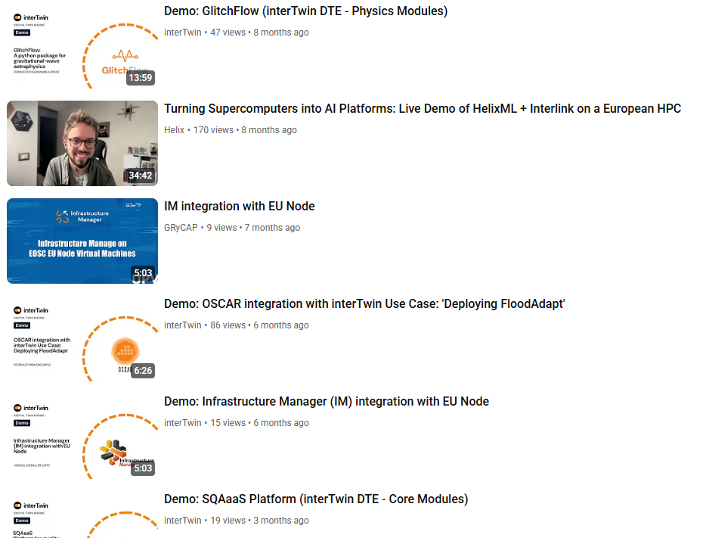
Figure 4 interTwin demo’s on YouTube

Module logo’s
As part of the project branding, each of these modules has received a logo in line with the interTwin branding for communication and dissemination purposes (with some of the more mature products, the owners were allowed to use the existing logo). See Annex 4.

Diagrams
At the request of project partners, a set of diagrams illustrating the use cases (making use of the module logo designs) was created.
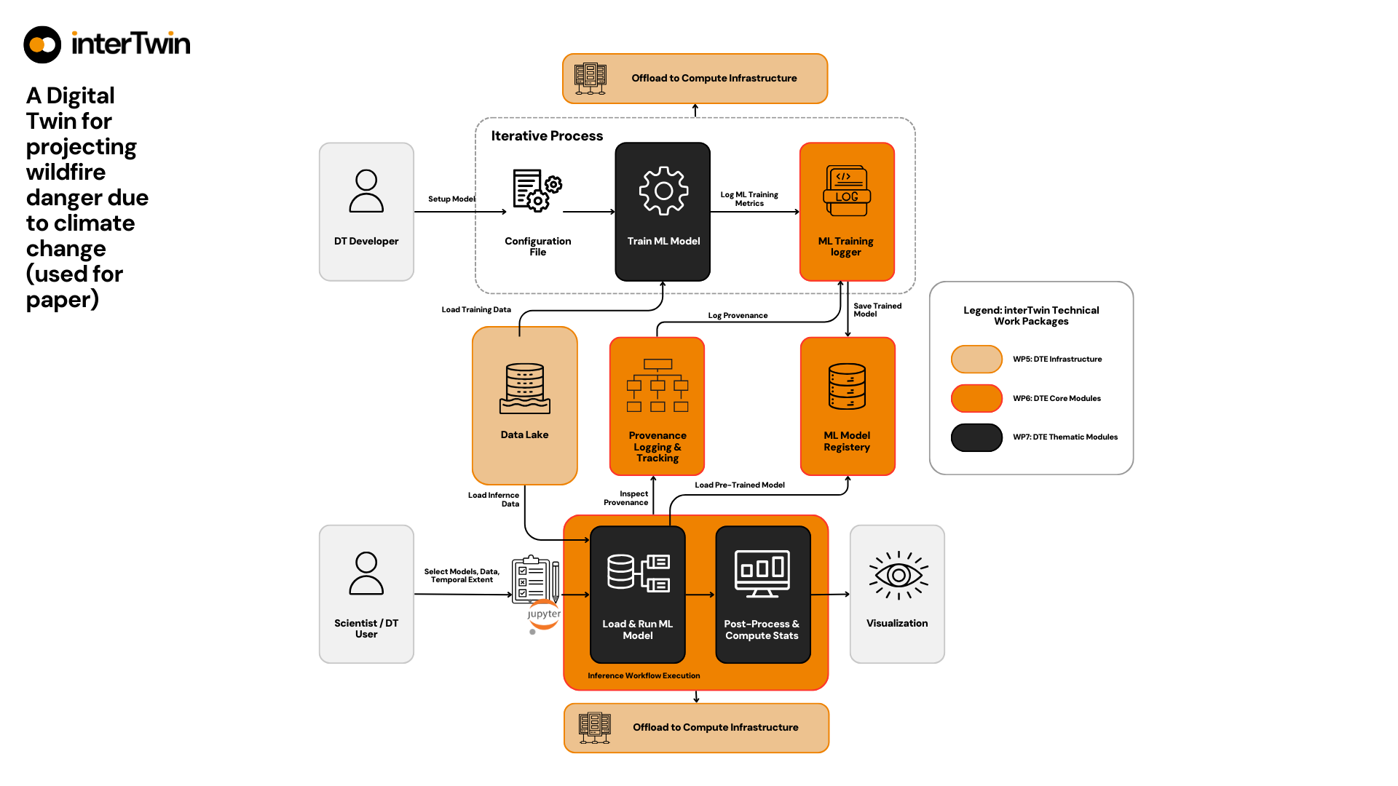
Figure 5 Example of a diagram illustrating the use cases

Social Media

LinkedIn
With the demise of Twitter, LinkedIn has become the main social media channel for the project. The project’s strategic approach to amplify the LinkedIn reach focused on leveraging partner engagement: by consequently tagging partner organisations, and actively encouraging partners to post about interTwin (and tag the project while doing it), we managed to increase the page reach to more than 600 followers, with a consistent engagement rate between 6 and 6.5% (this rate having decreased slightly with the audience growth). In addition, during the final weeks of the project we ran several advertising campaigns to make the project and its final outputs more visible.
One of the key actions during the last week of the project was to increase the reach of the LinkedIn page to lay the groundwork for further dissemination of the final project results. With this in mind, we ran a paid campaign in the last week of the project (22-31 August 2025), with some impressive results. We promoted one of the clips and the Digital Twin Engine page to a selected audience of (European Union and national) policy makers, SMEs, and technical profiles across Europe.
Overall, the campaign ‘ads’ received 723,487 (!) impressions and 95 reactions. While it is hard to analyse the ‘quality’ of these interactions (LinkedIn target audiences are a bit of a black box), there are some positive spill-over effects that can be logged:
- In two weeks, the interTwin page gained 100+ followers to 708
- This increase in activity has resulted in a spike in ‘members’ (followers) engagement (see Figure 6)
- While the campaign ran on LinkedIn, the website saw an increase in traffic coming from LinkedIn (see Figure 7)
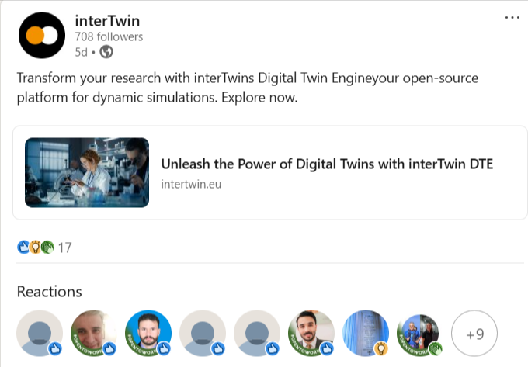
Figure 6 LinkedIn advertisement example

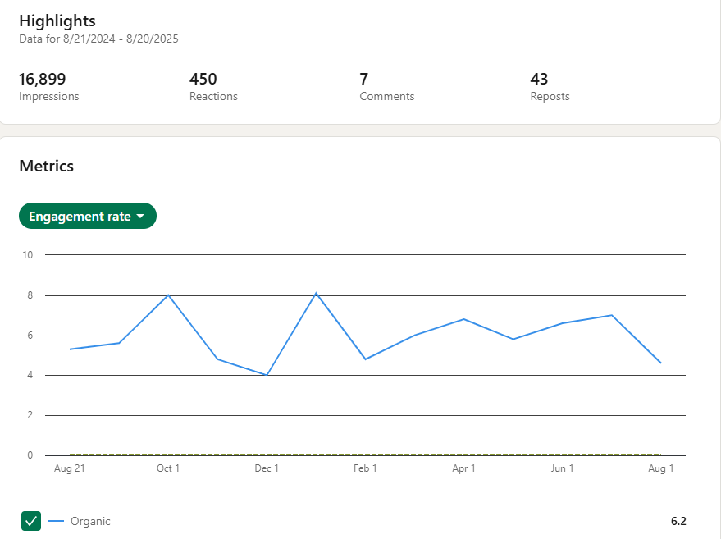
Figure 7 Image: engagement rate last 12 months and effects of advertising campaign on impressions of the page

YouTube
At the recommendation of the project reviewers after the end of RP1, the project has, in M16, launched its own YouTube channel. Currently, the channel has 35 subscribers and 1.4K views
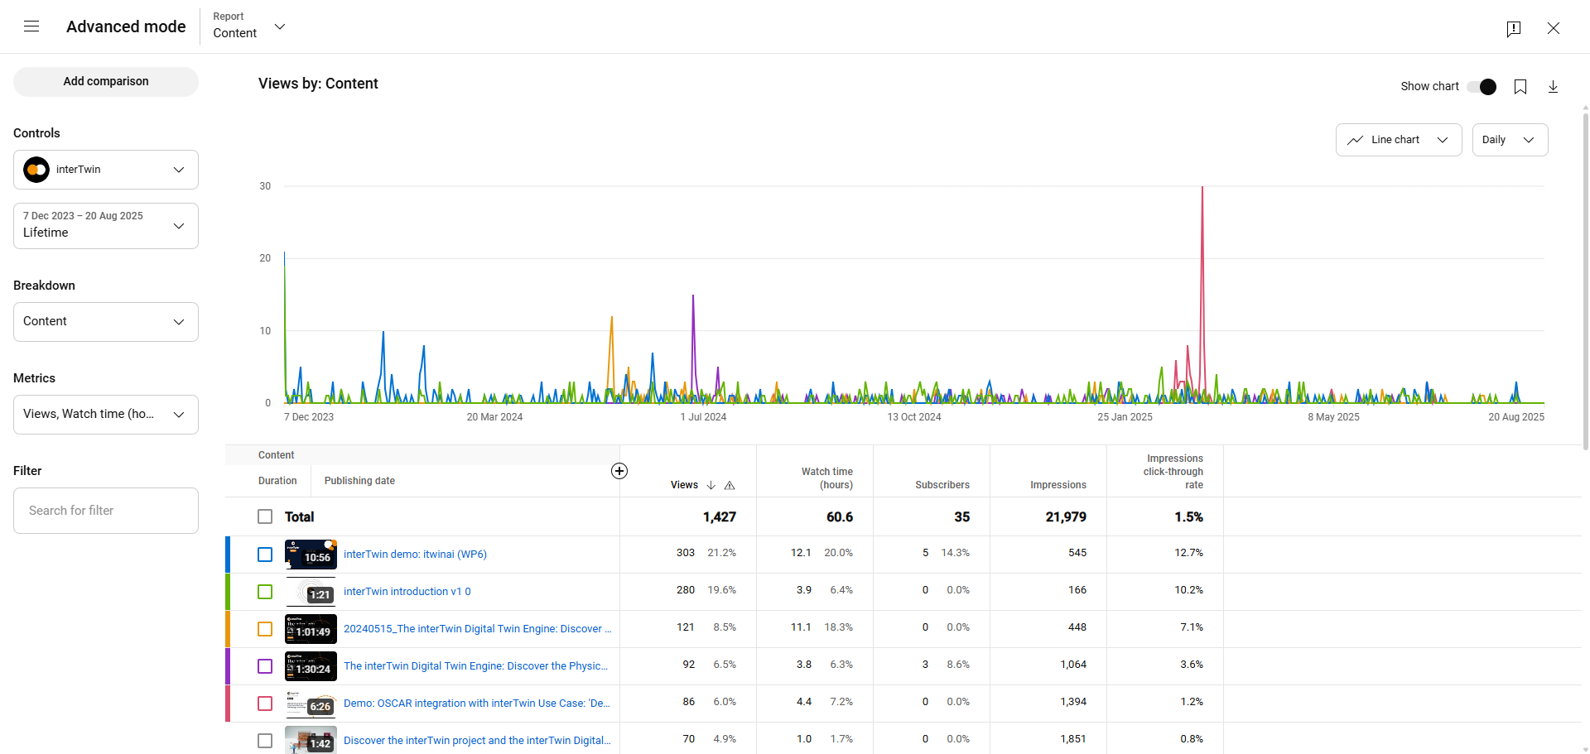
Figure 8 YouTube Analytics

Other channels

Newsletter
The project did not intend to release a public newsletter, but as the first outputs started to be released the need for an internal newsletter became clear - if only as an overarching communication channel towards all partners outside of WP meetings.

Github
Although the interTwin Github community is not managed by T2.2, it is an important dissemination channel for project software development.

X (Twitter)
With the transformation of Twitter into X (and the accompanying policy changes), interTwin has decided halfway through the project not to actively engage on the platform anymore. We decided however (in line with project coordinator EGI Foundation social media policy) not to remove the account, to remove any opportunity for scammers to usurp the profile.

Bluesky
As an alternative to Twitter, a Bluesky account was created. However, activity on the platform remained very little and the focus remained on LinkedIn as the best value-for-effort when it comes to project social media.

Events

Booths
From the start, interTwin has been present at every event booth hosted by project coordinator EGI, for example at the EGI202x conferences. During the second half of the project, interTwin has had a (shared) booth presence at more domain-specific events, for example EGU and Living Planet Symposium 2025 (environment), Teratec and HiPEAC 2025 (HPC and business) and CHEP (physics). At the end of the project, 15 booth presences have been recorded.
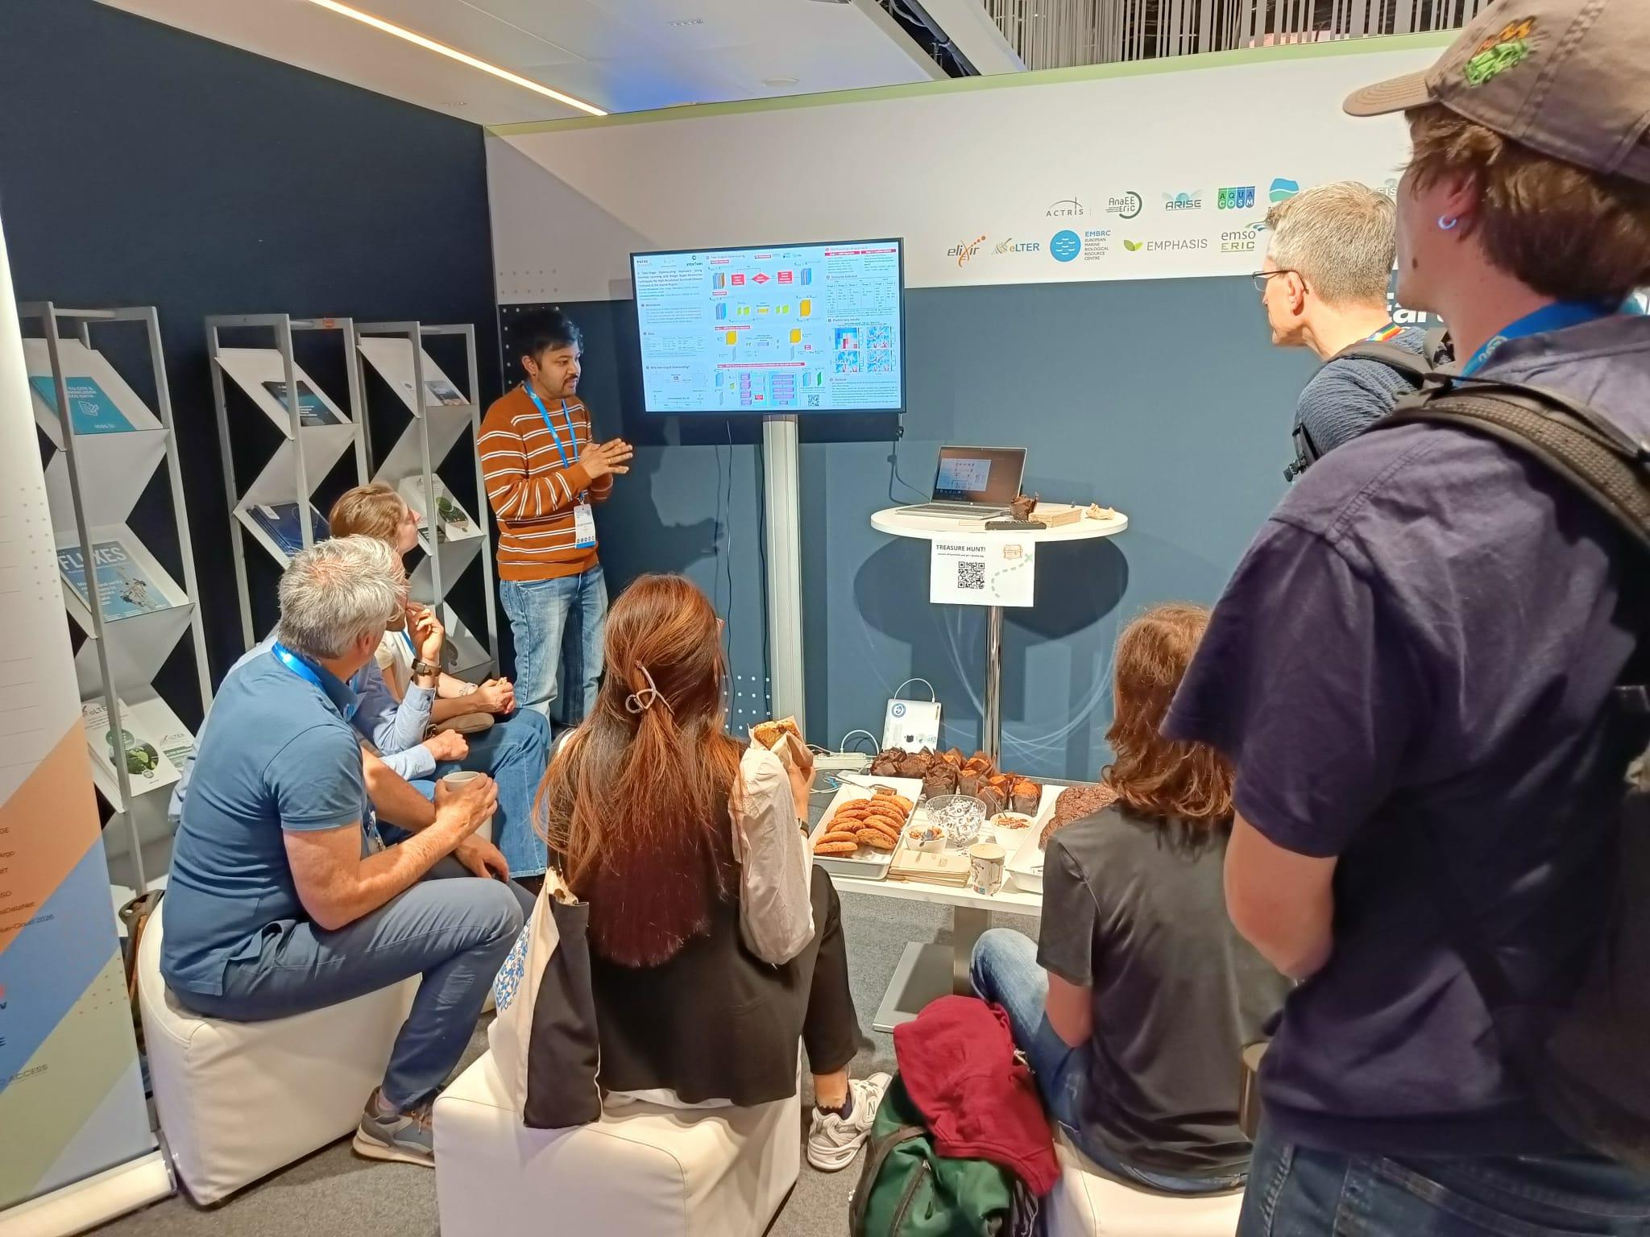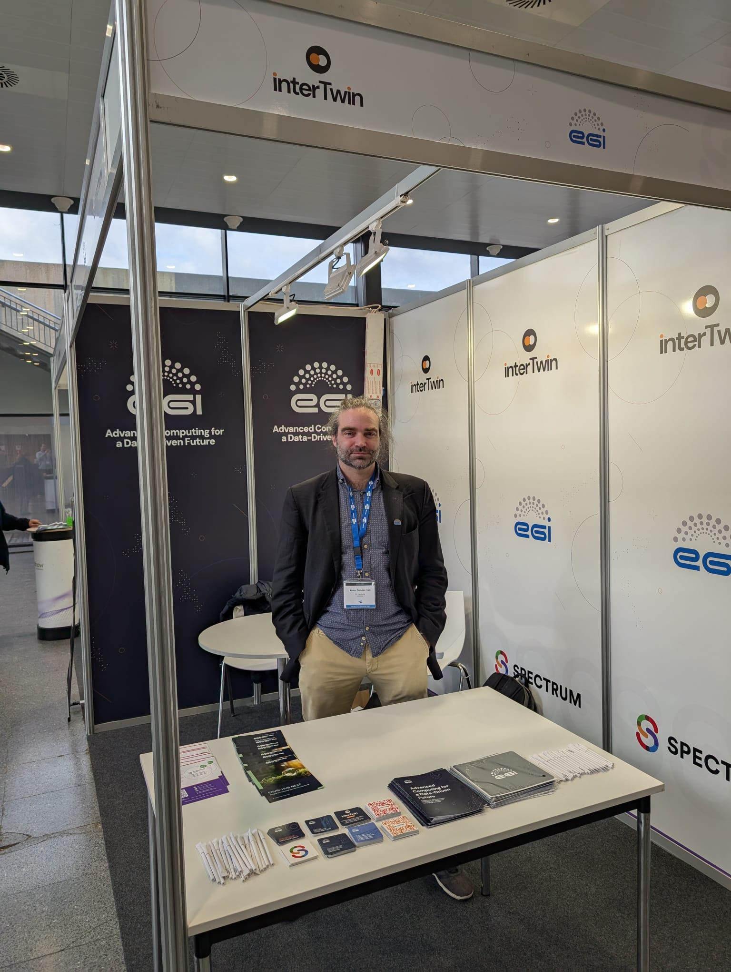
Figure 9 Event booths at EGU 2025 and HiPEAC 2026

Partner Presentations
Overall, partners have reported 75+ in-person events where interTwin was presented one or multiple times, either in a talk, through a poster, or in a workshop/interactive session. Based on self-reporting, an estimated reach of these presentations for M1-M36 exceeds 10,000 persons (number corrected for exhibition booths at mass events such as EGU and ISC - we asked people to report people in the room or passing by the booth only).
Partners have been requested to both inform the AMB when they plan to attend an event through an event list on Confluence, and to report afterwards through a reporting form. Using this dual approach, the project intended to catch all - including events that are signalled beforehand but not reported on afterwards and vice versa.
Example of events where interTwin has been presented include: EGI Conference, Ibergrid, EOSC Symposium, EBDVF, Data Spaces Symposium, CHEP, ISGC, EGU, EODC Forum, IEEE eScience and ISC High Performance. A full overview of events where partners have presented is provided in annex 2-5.

Internal workshops and meetings
T2.2 has supported the organisation (including technical support and catering) for 8 internal workshops (including pre-kick off meeting).

Table 1 internal project workshops
Date | Name | Description | Who | Link
9-sep-2022 | 9-sep-2022 | 9-sep-2022 | 9-sep-2022 | https://indico.egi.eu/event/5923/
19-sep-2022 - 20-sep-2022 | EGI Conference | Kick-Off | All work packages | https://indico.egi.eu/event/5924/
25-jan-2023 - 26-jan-2023 | interTwin F2F meeting | Technical meeting + IEG | All technical WPs | https://indico.egi.eu/event/6004/
22-jun-2023 - 23-jun-2023 | interTwin F2F meeting (EGI 2023) | Technical meeting + EEAB | All technical WPs | https://indico.egi.eu/event/6095/
24-jan-2024 - 25-jan-2024 | interTwin 3rd tech meeting (online) | Technical meeting + IEG | All technical WPs | https://indico.egi.eu/event/6350/
12-jun-2024 | interTwin 4th Technical meeting | Technical meeting | All technical WPs | https://indico.egi.eu/event/6436/
18-feb-2025 - 19-feb-2025 | interTwin 5th Plenary meeting (online) | Plenary meeting | All work packages | https://indico.egi.eu/event/6606/
06-jun-2025 | interTwin 6th Plenary meeting | Plenary meeting | All work packages | https://indico.egi.eu/event/6722/

Spotlight: Thematic Events in PY3

Final Event Dissemination Workshop (internal)
In M28, T2.2 organised an in-person meeting hosted by Deltares in Delft, Netherlands. Selected partners from organisations with an active interest in the project communication and dissemination activities (CERN, INFN, CMCC, EGI, EODC and Deltares) came together for a day-long brainstorm focusing on the dissemination of the final project results. Although the main outcomes were a finetuning of the planned project dissemination plan (final brochure was decided to host online, diagrams for use cases have been developed, …), some new ideas came forward that have been executed since (mainly the SciGeeks podcast series with interTwin project partners). interTwin would recommend attaching a D&C update meeting to every Horizon Europe project, halfway in. In the current landscape, where communication channels and the available tools are evolving so quickly, the plans as laid out in the first CDEE plan delivered at the start of the project, require frequent updates - including changes in effort and budget allocation.

Policy Workshops
With the project results in their final phases (suitable for dissemination among policy makers), the project organised several workshops focused on policy makers at the European and national/local level.
- EOSC Symposium Workshop: EOSC and the Digital Twins co-located workshop about DT initiatives in Europe during EOSC Symposium 2024
- In M35, two workshops oriented at policy makers have been organised by project partners. One took place in Ghent, Belgium at the request of the VVSG (Flemish organisation for cities and communities). EGI and Deltares gave a workshop on how Digital Twins can help to tackle climate emergencies (in the case of Belgium, mainly flooding).
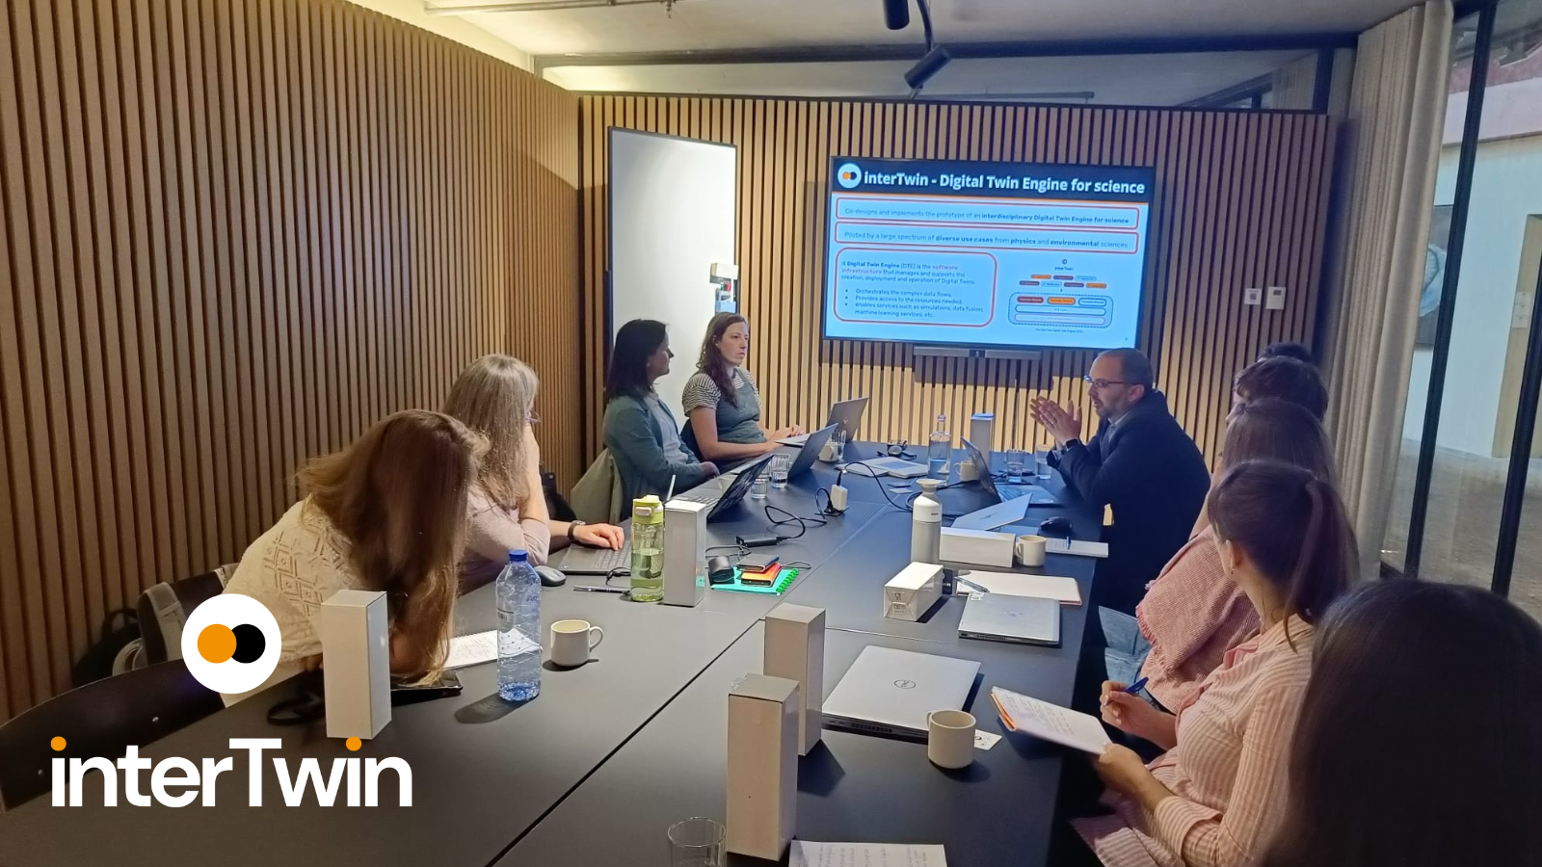
Figure 10 interTwin Policy Workshop in Ghent (June 8 2025)
- EODC organised a workshop targeted at policy makers at their office in Vienna. The event brought together EODC partners and stakeholders to align on key concepts, share project insights, and explore how they could collectively shape the future of Digital Twin infrastructure and applications in Austria and beyond.

Industry Workshop

At HiPEAC 2025 in January 2025, interTwin organised a workshop aimed at industry and SMEs. HiPEAC is the community of Advanced Computing experts accounting for over 2000 members in the areas of HPC, Embedded, Cloud and Compute Continuum in general performing academic and industrial research. HiPEAC conference brings together over 500 participants every year and it is an outstanding opportunity to present interTwin developed modules and technologies to experts.

Business Model Workshops
T2.2 logistically supported the organisation of 6 Business Model Workshops organised by T2.1 (see Deliverable 2.6 for details).
- 1st Internal Business Model Webinar - interTwin Innovation Management System (Webinar)
- 2nd Business Model Webinar - Introduction to IPR and SW Open-source licensing (Webinar)
- 3rd Business Model Workshop - F2F Hands-on session on SW Open-source licensing (in person)
- 4th Business Model Webinar - How the interTwin Innovation Management System is used to foster projects' Exploitation and Sustainability (webinar)
- 5th Business Model Workshop - Closing the gap on SW Open-source licensing (in person)
- 6th Business Model Workshop - Impact Driven Workshop - Assessment of impact across projects (in person)

interTwin at EGU 2025
A major dissemination opportunity for the environmental modules happened at EGU 2025 in Vienna, Austria (April 2025). As part of a shared booth, interTwin made use of the opportunity of the many partners presenting the work on the environmental modules at this conference. We hosted a series of ‘interTwin coffee breaks. Every day, an interTwin partner presented their work to an audience passing by the booth. Overall, more than 50 people stayed and watched a presentation.
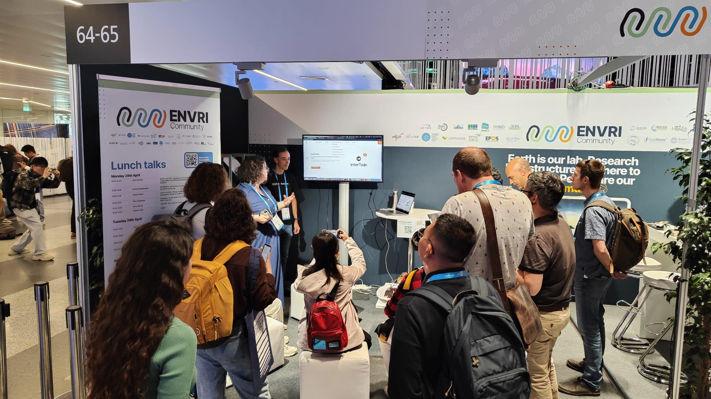
Figure 11 interTwin coffee breaks at EGU 2025

interTwin at EGI2025
EGI2025 was the official closing event of the project. As a major contributor to the conference, interTwin branding was omnipresent. Not only did we host a plenary session focused on Digital Twins, but we also hosted one of the breakout sessions. As most partners were present, we also had our last (closed) technical meeting. And finally, we made use of the presence of project partners to record 12 episodes of the interTwin Talks podcast series, as well as a video clip where project coordinator Andrea Manzi discusses the project.

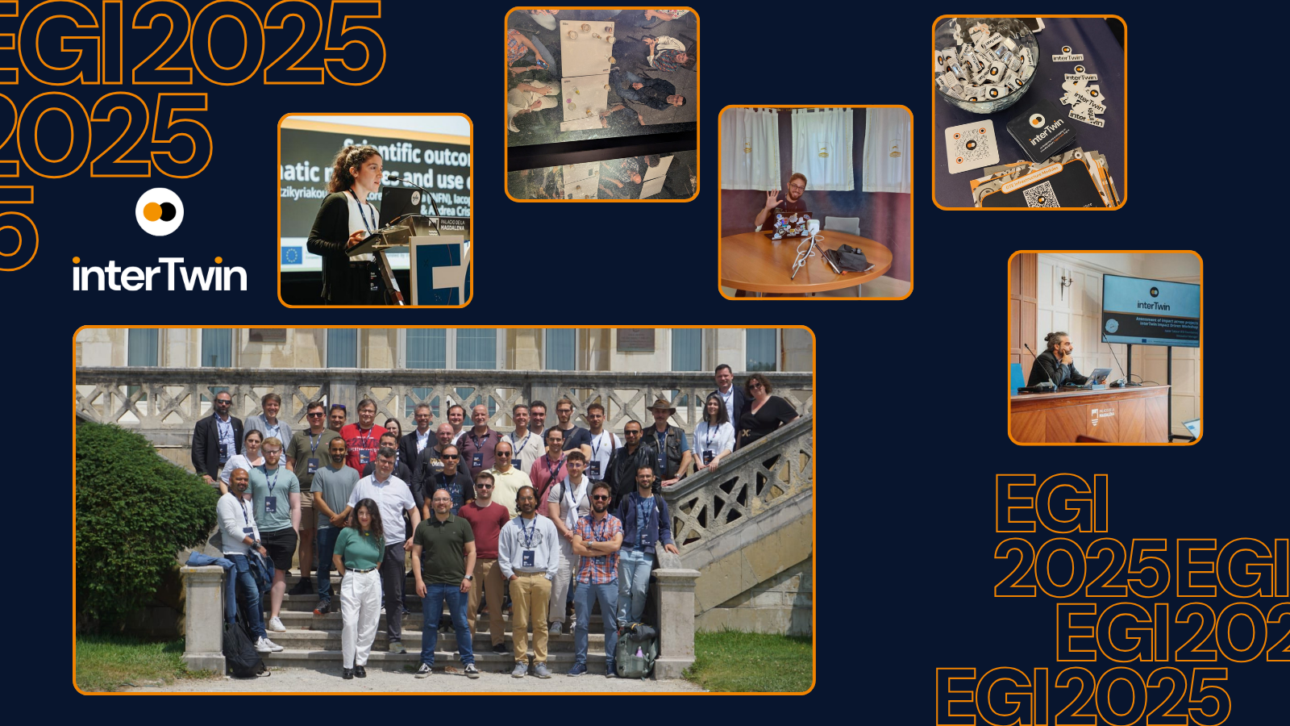
Figure 12 interTwin last in-person Technical Meeting during EGI2025 in Santander, Spain
Together with the iMagine project (also coordinated by EGI), EGI innovation management organised an interactive workshop ‘Assessment of impact across projects (interTwin Impact Driven Workshop) at EGI2025. See Deliverable 2.6 for details.

Webinars

Organised by interTwin
WP2 organised 6 public webinars (overview see annex), focusing on the project results (modules, Use Cases and DTE), 1 public webinar on exploitation and sustainability in Horizon Europe (with interTwin as example project) and 2 internal webinars (one about Business Modelling and one about the Horizon Europe ethics appraisal procedure). The total number of attendees was 280. All (public) webinars are available on YouTube, with more than 400 views in total at the time of reporting.
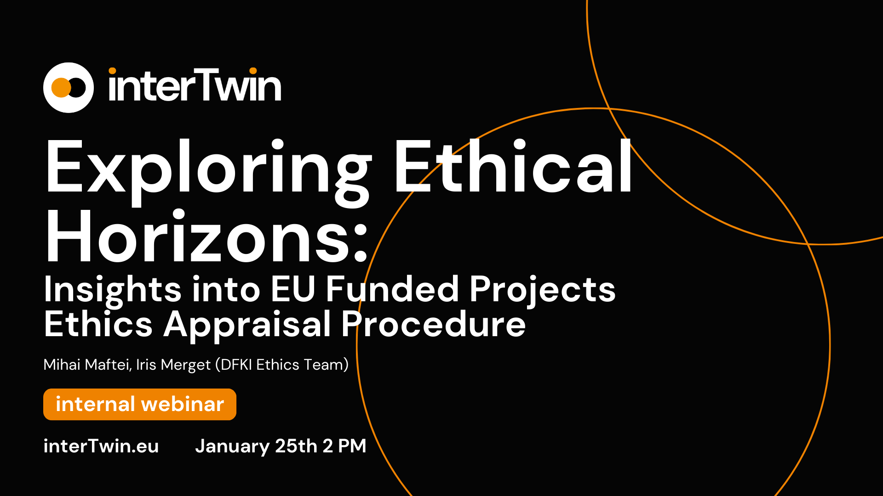
Figure 13 interTwin webinar branding

Hosted by others
- 23rd October 2023 Artificial Intelligence for Sustainability: What is the Role of AI in Advancing Targets for Sustainability (hosted by TEMA)
- 25th October 2024 Interoperability architectures for Digital Twins of the Ocean (TURTLE Project)
- 13ht February 2025 AI in Action: How Researchers Leverage AI (itwinai) (hosted by Research Data Alliance)
- 27th February 2025 BioDT Webinar: How can cross-use digital modelling tools help in nature protection? (hosted by BIODT)

Publications
From the start, the project policy has been to archive all project outputs, such as deliverables, presentations and peer-reviewed publications on the interTwin community page on Zenodo. With more than 7000 downloads and 8000 views, the importance of Zenodo in dissemination is not to be underestimated. See Figure 15 Zenodo statistics
.
On our website and social media, each deliverable is accompanied by a ‘fact sheet’ highlighting the key elements of each deliverable, a reference to the partner and to the location of the deliverable on Zenodo.
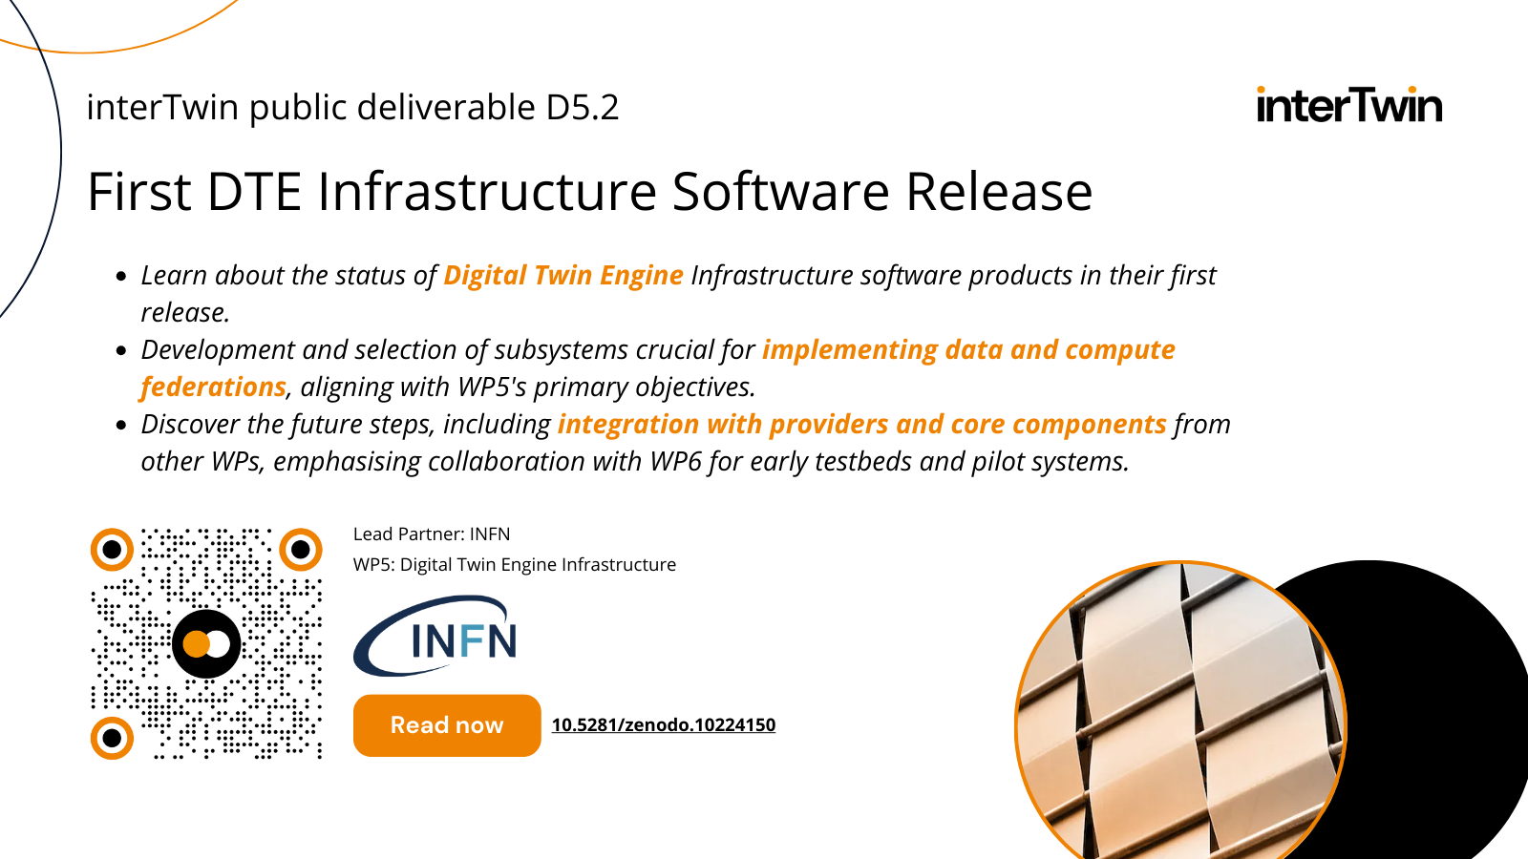
Figure 14 Deliverable fact sheet for D5.2
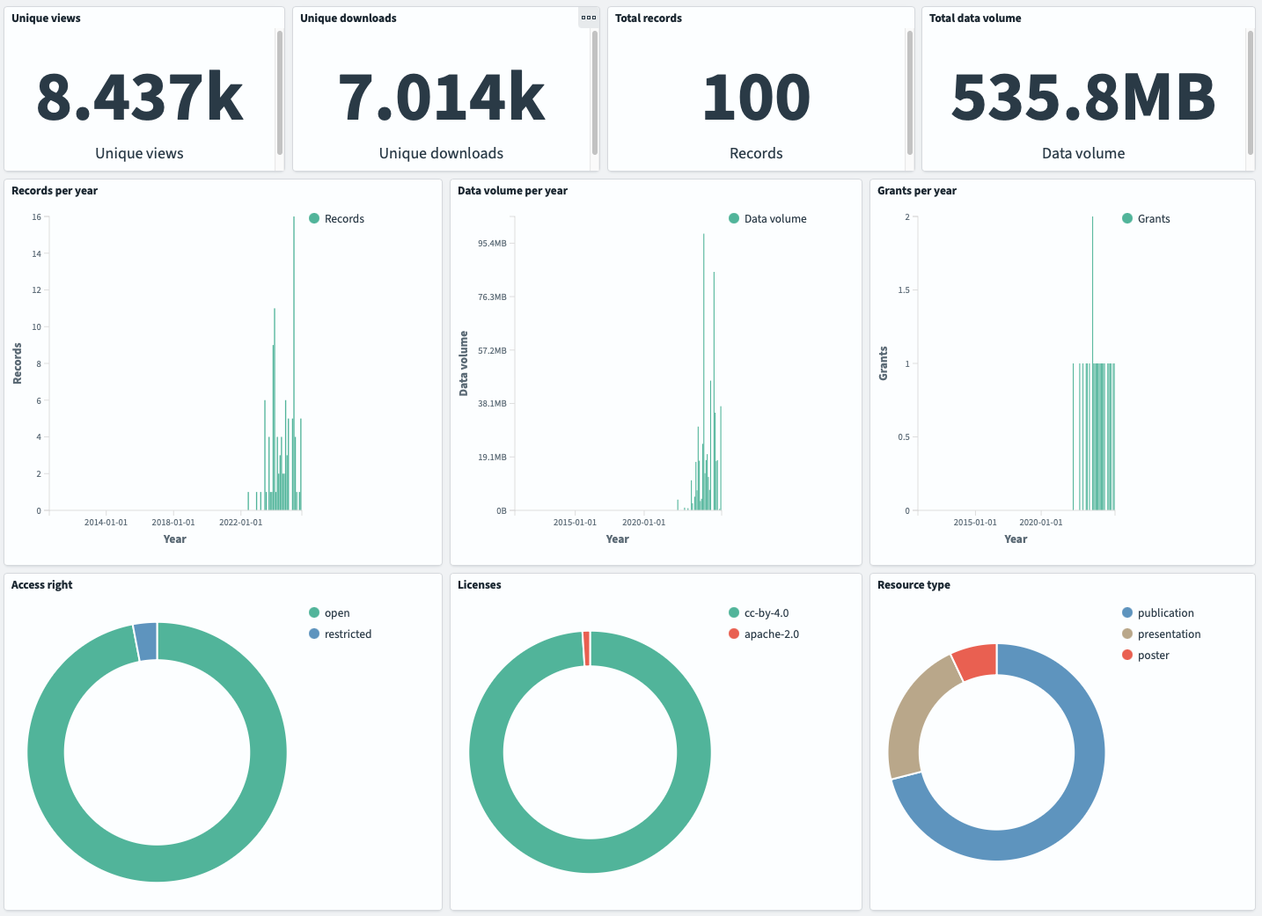
Figure 15 Zenodo statistics

Scientific Publications
- Accarino, G., Donno, D., Immorlano, F., Elia, D., & Aloisio, G. (2023). An Ensemble Machine Learning Approach for Tropical Cyclone Localization and Tracking from ERA5 Reanalysis Data. Earth and Space Science, 10. https://doi.org/10.1029/2023EA003106
- Pondi, B., Appel, M., & Pebesma, E. (2024). OpenEOcubes: an open-source and lightweight R-based RESTful web service for analyzing earth observation data cubes. https://doi.org/10.1007/s12145-024-01249-y
- S. Fiore, M. Rampazzo, D. Elia, L. Sacco, F. Antonio and P. Nassisi, "A Graph Data Model-based Micro-Provenance Approach for Multi-level Provenance Exploration in End-to-End Climate Workflows," 2023 IEEE International Conference on Big Data (BigData), Sorrento, Italy, 2023, pp. 3332-3339, doi: 10.1109/BigData59044.2023.10386983.
- Nica, R., Götz, S. & Moltó, G. CMK: Enhancing Resource Usage Monitoring across Diverse Bioinformatics Workflow Management Systems. J Grid Computing 22, 62 (2024). https://doi.org/10.1007/s10723-024-09777-z
- CMCC publication Preprint: https://doi.org/10.5194/egusphere-2025-461

Press and non-scientific publications
- FACILITATING THE DEVELOPMENT OF DIGITAL TWIN APPLICATIONS ACROSS THE COMPUTE CONTINUUM WITH INTERTWIN, HiPEAC info 74 p44 (January 2025) https://www.hipeac.net/magazine/7170.pdf
- interTwin: An Engine for Scientific Digital Twins, ERCIM News (January 2025) https://ercim-news.ercim.eu/en140/special/intertwin-an-engine-for-scientific-digital-twins (919 views)
- Connecting Continents: Dynamic Deployment of Transatlantic Computational Testbeds via the Infrastructure Manager, Chameleon Blog (July 28) https://chameleoncloud.org/blog/2025/07/28/connecting-continents-dynamic-deployment-of-transatlantic-computational-testbeds-via-the-infrastructure-manager/
- ETP4HPC Association Handbook of HPC-related projects https://etp4hpc-handbook.online/intertwin/

Deliverables and Milestones achieved
Halfway through the project, at the end of M18, T2.2 has achieved the following milestones:
- Organisation of a kick-off event (MS2.1)
- Website launched (M2.2)
- Communication package available (M2.2)
- (First) Business Model workshop held (M2.3)
The first deliverable, D2.1, has been submitted in M5.
The second deliverable, D2.3, has been submitted in M20.

Budget
The working budget for dissemination and communication activities, including the organisation of internal meetings, was set at 95,000 EUR.
With these funds, the following activities were funded:
- Organisation of opening and closing events, as well as interTwin-themed workshops and meetings, as part of the EGI2023, EGI2024 and EGI2025 conferences
- Participation in external event booths at events such as EGU 2024 and EGU 2025, CHEP 2024, Teratec Forum and HiPEAC 2025. In most cases, these booth costs have been shared with other projects.
- Various materials for events such as goodies (power bank, water bottles), printables such as stickers, flyers and ‘Moo cards’, posters, and shipping costs.
- Support for online activities such as the project website building and maintenance, the online final project brochure, the event platform for EGI2024 and EGI2025, LinkedIn advertising, small publication costs and contribution to design tools used for the project such as Figma.
- Hosting technical workshops: catering and technical/venue support (when needed)
- Hosting policy and business model workshops: catering and technical/venue support
Overall, the budget requested turned out to be sufficient for the project activities, if not slightly overestimated. However, given the volatility of the international political and economic climate, the aftermath of the pandemic, and a growing sensitivity in the ecosystem of our European projects to not overproduce printed materials (such as brochures and flyers), the leftover funds should rather be considered as proof of prudence and caution, rather than actual underspending.

Summary of Dissemination Outputs

Status Review
Table 3 offers a final status review of T2.2 activities
Table 2 Status review of planned T2.2 activities
Description | Target | M36 Status | Comments
Website | Monthly unique visit rate of 250+✅ | Website pageviews M1-M35 = 30,051  Website visits M1-M35 = 14,226 | Website published and regularly updated
Social media | LinkedIn engagement rate 3% ✅  Post regularity ✅ | Linkedin:  - 604 followers  - 16,355 impressions  - 6.2% engagement  - 75 posts  YouTube  - 35 followers  - 1.4K views  (Twitter deprecated) | LinkedIn is published and regularly updated  YouTube: started up in M20  Bluesky: accounts exist but are not actively used  Results listed before the final advertising campaign (see Chapter 2.6)
Technical Workshops |  | 6 internal meetings (online or in person)  6 Business Model Workshops (online or in person)  3 Policy Workshops (EOSC Symposium 2024, Ghent, Vienna) | Refer to  Table 1
Kick-off |  | ✅ | Organised at EGI2022 (see section 2.4.3)
Event participation |  | ~75 in-person events  15 event booths (shared)
Consultations and Surveys |  |  | consultations were run at WP4 level to identify needs and requirements for the use cases
Repository for publications | ✅ | 8000+ views  7000+ downloads | Zenodo
Repository for Software | 50 active members | 18 repositories  48 followers | Github
Project Partners and Boards |  | ✅ | Team, EEAB, EAB added to website
Project branding |  | ✅ | Branding guide delivered
Press and non-scientific news outlets |  |  | HiPEAC  ERCIM  Chameleoncloud blog  [more to come: Horizon Magazine, …]
Scientific Publications |  |  | 4 peer-reviewed publications added to Zenodo, one preprint in pipeline for publication
News items and Blog Posts | One news item per result/deliverable | 47 | More to come after project end date
Visual materials | Each result is presented at least once | ✅ | Guides, Factsheets, Web Pages  Use Cases Diagrams  Goodies: bottles, powerbanks  Moo Card, stickers  Roll-Ups  Posters and Roll-ups  Clips

Collaborations and partnerships
For an overview of existing and ongoing collaborations, see Deliverable 2.3. Below we list some success stories achieved in the last year of the project.

Integration of Helix @ ML and interLink
Both Interlink and HelixML are available for organizations looking to explore running GenAI workloads on their HPC infrastructure. The integration requires minimal changes to existing supercomputer setups, primarily needing just a container runtime like Apptainer or Enroot on the compute nodes.
This integration represents a significant step forward in making advanced AI capabilities accessible to organizations with existing HPC investments, potentially accelerating scientific discovery through the combination of traditional supercomputing and modern AI techniques. The ability to add proper multi-tenant isolation on top of traditional HPC infrastructure is particularly valuable for organizations looking to provide AI services across multiple teams or departments.

interLink Entered the CNCF Sandbox - Cloud-Native HPC Integration
The challenge of bridging cloud-native technologies with high-performance computing infrastructure has long been a barrier for organizations seeking to leverage their existing HPC investments for modern containerized workloads. Traditional HPC systems, optimized for batch processing through schedulers like Slurm, operate fundamentally differently from the dynamic, orchestrated environments that modern cloud-native applications expect. This architectural divide has prevented many research institutions and organizations from fully utilizing their substantial supercomputing resources for contemporary AI and cloud-native workflows.
The interLink project has successfully addressed this challenge, as confirmed by the recent milestone. It joined Cloud Native Computing Foundation (CNCF) Sandbox, marking a significant step toward democratizing access to HPC resources through cloud-native interfaces.

OSCAR and DT Flood in the DISCOVER-US project
By integrating the interTwin DTE core module Infrastructure Manager (IM) with Chameleon, a transatlantic testbed composed of OSCAR clusters in Europe and the USA was deployed. Using Common Workflow Language (CWL), we achieved seamless execution of scientific workflows for flood assessment.

Collaboration between interTwin and AI4EOSC
interTwin collaborated with the Horizon Europe project AI4EOSC to demonstrate how AI inference, a core step in many scientific workflows, can be seamlessly offloaded to High Performance Computing (HPC) clusters, paving the way for scalable, data-driven Digital Twin applications.

Digital Twin Factory Project
The Digital Twin Factory project led by CNES In France, the initiative started in June 2024 with the aim of building a platform to develop Digital Twins of the Earth. After a first discussion during the Destination Earth 3rd User Forum, the project coordinator organized a meeting with interTwin technical partners in December 2024 to discuss synergies and the reuse of interTwin components in their implementation.
The discussions held on the project reusing and adapting the component for computing offloading (interLink) into their architecture with already some contribution from CNES engineers being included in the interTwin repositories. The project by design was also planning to reuse the openEO component in some of the data pipelines as interTwin is doing.

Stakeholder engagement
As described in D2.1 and D 2.3, all interTwin stakeholders have been categorised in three broad Target Groups, each to be reached in different ways:
- DT Users: Scientific Collaborations, SMEs and Industry, Individual Researchers from the long tail of science, Policy Makers (and funders)
- DT Developers: Scientific Collaborations, Research Infrastructures, e-Infrastructures and Data Space Providers, SMEs and Industry, (individual researchers)
- DT Providers: Scientific Collaborations, Research Infrastructures, e-Infrastructures and Data Space Providers, (SMEs and Industry)
Below, we list the main activities conducted by the project to reach these different stakeholder groups. Of course, in practice, most activities have served multiple purposes and reached different target audiences.

DT Users
The (potential) users of the specific DTs will need to be aware of their existence (KER1) and use them and the supporting materials such as the Toolkit for AI Workflow (KER3) and the Quality Framework (KER4). As co-designers, they will have an interest in using the Toolkit and the Quality Framework, and they are expected to verify it. Some DT users will liaise with the Open-Source Community (KER6) as interactions & technical support may be needed for the definition and deployment and use of DT in use cases.
To reach this target group, interTwin conducted the following activities:
Increase awareness and drive uptake:
- Public Webinars,
- Participation (talks, posters, booths, workshops) at dedicated events
- Podcast interTwin Talks
- Social Media (LinkedIn, Youtube,...)
- Animated clips
- Demonstrations
- Deliverable Factsheets
- Non-Scientific articles (ERCIM, HiPEAC, …)
- Module Webpages with practical information
Facilitate verification and input
- Policy Workshops
- Business Model Workshops
- Industry Workshop
- Consultations and Surveys run by WPs
Foster a liaison/contact channel
- Personal contacts at via events and workshops
- Published Use Cases and Success Stories
- Github/DTE Testbed
- Module Webpages with technical information
In addition, the project attempted to reach evidence-based policy makers through:
- Policy Workshops
- One-on-one meetings and conversations at targeted events (e.g. EGU, EOSC Symposium)
- Targeted LinkedIn advertising (see Section 2.4.1)

DT Developers and Providers
The developers of the DT modules co-design and co-create the DTE modules (KER1), they are using the supporting tools and Quality Framework, interoperability framework (KER2).
The providers will add applications and services to the specific DTs and to the DTE (KER1) and to the Toolkit for AI workflow and method lifecycle management (KER3). They will integrate them with EOSC and EU Data Spaces (KER5). As the software will be open source, these providers/operators will be part of our open-source community (KER6).
To reach this target group, interTwin conducted the following activities:
Facilitate co-design and verification
- Business Model Workshops
- Internal Technical Workshops
- Industry Workshop
- Demonstrations on YouTube
- Webinars
Foster a liaison/contact channel - add applications and services
- Published Use Cases and Success Stories
- Demonstrations on YouTube
- Github/DTE Testbed
- Module Webpages with technical information
Integrate the DTE with EOSC and EU Data Spaces
- Published Use Cases and Success Stories
- Collaborations with other projects and initiatives (DT-GEO, BIODT, DestinE, …)
- Participation (talks, posters, booths, workshops) at dedicated events
- Webinars
From the self-reporting of dissemination activities, we can see that our key stakeholders have been reached extensively through the project activities (Scientific Collaborations, Researchers, RIs and e-infras, SMEs/Industry, and Policy Makers).
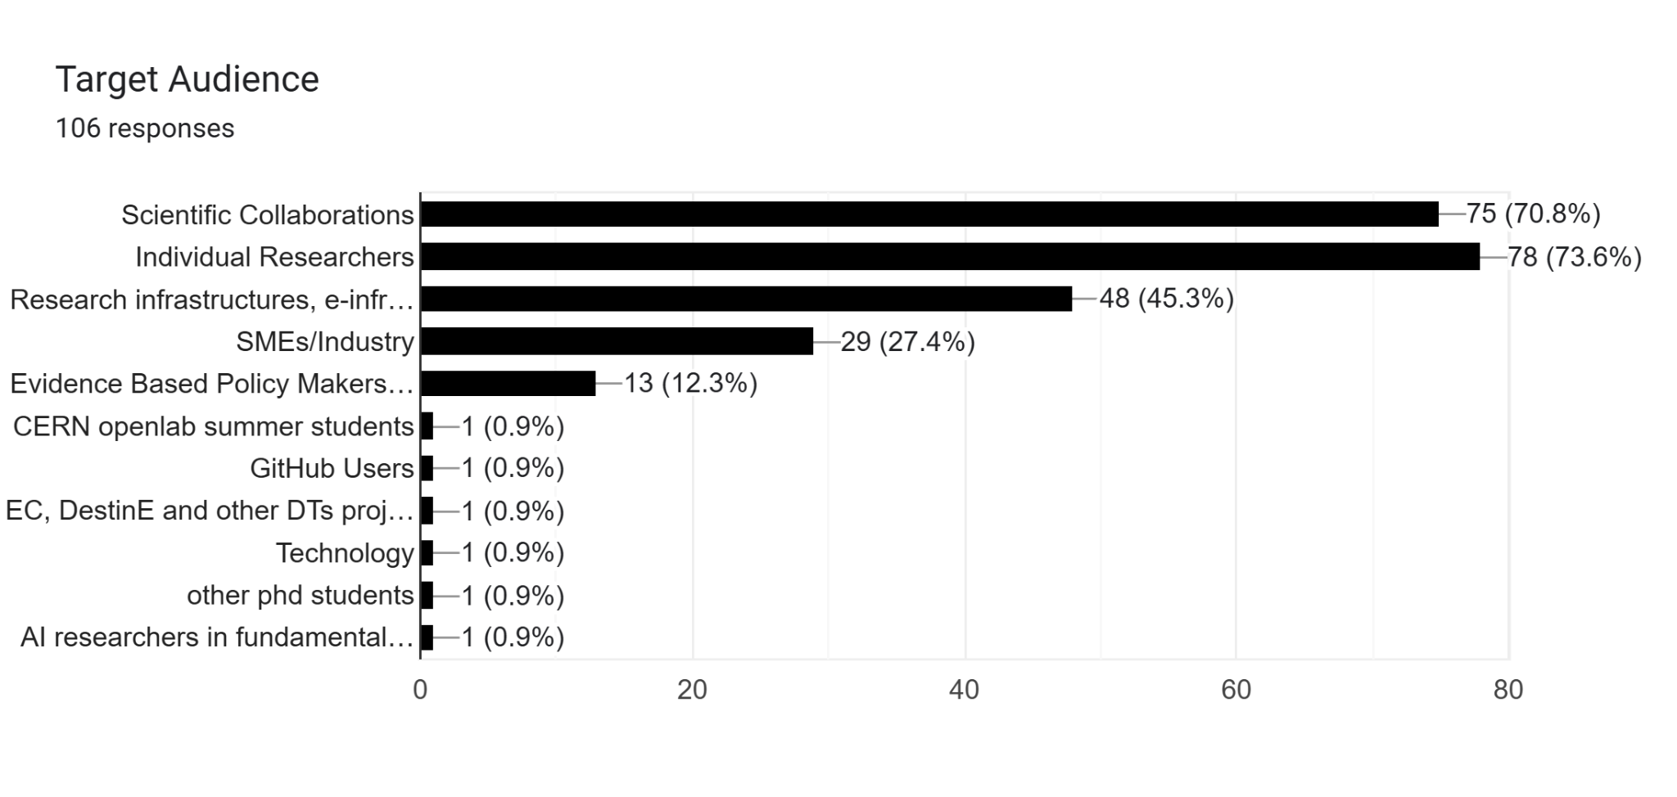
Figure 16 Self-reporting: target audiences reached through interTwin attended external events

Final conclusions
The interTwin project’s Dissemination, Communication, and Engagement (DCE) activities, led by EGI.eu under T2.2, successfully established a structured approach to promoting the project’s Key Exploitable Results (KERs) and fostering engagement across diverse stakeholder groups. Over the course of M1 to M36, the project developed a comprehensive DCE strategy that aligned with the Innovation Management Plan and leveraged both digital and in-person channels to maximize visibility and impact. The creation of a cohesive visual identity, a dynamic project website, and targeted audiovisual materials provided a solid foundation for communication, while strategic partnerships and collaborations such as those with DT-GEO, BIODT, DestinE, and HiPEAC, expanded the project’s reach within research and industry domains.
The project’s dissemination outputs, including 40+ software module pages, 10 use cases, and a series of webinars, workshops, and policy events, ensured that interTwin’s technical advancements and use cases were accessible to a broad audience. The decision to prioritize digital dissemination over printed materials reflected both environmental considerations and the need for agility in updating project information. Social media, particularly LinkedIn, emerged as the primary platform for engagement, with consistent activity and targeted advertising campaigns amplifying the project’s presence. The use of Zenodo for archiving deliverables and publications further supported transparency and accessibility, resulting in over 7,000 downloads and 8,000 views.
While the project achieved or even surpassed its overall targets for website traffic, social media engagement, and event participation, the reliance on self-reporting for event and dissemination data led to potential inconsistencies in tracking and measuring impact, particularly for in-person events where attendance numbers were estimated.
Stakeholder engagement was systematically addressed through tailored activities for DT Users, Developers, and Providers, with self-reported data indicating strong participation in events, webinars, and collaborative workshops. The mapping of interTwin stakeholders to the Horizon Results platform facilitated tracking and measurement of dissemination efforts, ensuring alignment with project objectives and external expectations.
The project demonstrated several strengths in its DCE activities. The early development of branding and communication tools, such as the interTwin logo, module icons, and document templates, ensured a unified and professional presentation across all materials. The project website, with over 15,000 unique visits and 33,000 pageviews, served as a central hub for information, while the production of high-quality audiovisual content—including video clips, podcasts, and animated clips—enhanced engagement and accessibility. The decision to host the final brochure online, rather than in print, aligned with sustainability goals and allowed for real-time updates.
Collaborations with external initiatives and projects, such as the Digital Twin of the Oceans and national Digital Twin efforts, not only broadened interTwin’s network but also positioned the project as a key player in the evolving Digital Twin landscape. The organization of policy workshops and business model sessions provided valuable opportunities for knowledge exchange and alignment with broader European priorities, such as the Green Deal and EOSC integration.
The project’s adaptability was evident in its response to changing social media landscapes, notably the shift from Twitter to LinkedIn and the exploration of Bluesky, though the latter saw limited uptake. The use of LinkedIn advertising and the production of short, engaging content for final outputs demonstrated a proactive approach to promoting results in the project’s closing phase.
Despite its successes, the project faced challenges that impacted the effectiveness of some DCE activities. The timing of the project’s ending in late August created logistical difficulties in promoting final results, as some planned campaigns and updates—such as the LinkedIn advertising for the final brochure and video clips—could not be fully captured in this report. The decision to de-emphasize Twitter/X and the limited traction on Bluesky highlighted the difficulty of maintaining a presence on emerging platforms.

Annexes

Annex – Webinars
23-nov-2023 | Business Model Workshops - The Innovation Management System at interTwin | Internal consortium | This webinar aimed to refresh interTwin partners on the innovation management processes established within the project, providing examples on how the project is addressing the collection of Results, Key Exploitable Results, and emerging Innovations, and how it is expected to interact with the related exploitation and sustainability plans. | 23-nov-2023
24-jan-2024 | Exploring Ethical Horizons: Insights into EU Funded Projects Ethics Appraisal Procedure | Internal consortium | Webinar hosted by DFKI Ethics Team | 24-jan-2024
15-may-2024 | The interTwin Digital Twin Engine: Discover the Environment Use Cases | Public | Introduction: Charis Chatzykyriakou (EODC)  Use Case Leads:  Donatello Elia (CMCC)  Christian Pagé (CERFACS)  Björn Backeberg (Deltares)  Iacopo Ferrario (EURAC) | (32 participants/121 views on YT)  https://www.intertwin.eu/article/webinar-the-intertwin-digital-twin-engine-discover-the-environment-modules
25-jun-2024 | The interTwin Digital Twin Engine: Discover the Physics Use Cases | Public | Introduction to the project and the Digital Twin Engine: Andrea Manzi (EGI) - 15’  Use Cases:  A Digital Twin for Fast Particle Detector Simulation, speaker: Kalliopi Tsolaki, CERN - 15’ including questions  GlitchFLow: a Digital Twin for the Virgo Gravitational Wave Interferometer, speaker: Lorenzo Asprea, INFN - 15’ including questions  ML-PPA: a Digital Twin for Pulsar Studies in Radio Astronomy, speaker: Yurii Pidopryhora, MPG - 15’ including questions  A Digital Twin for Lattice QCD Simulations, speaker: Javad Komijani ETHZ, 15’ including question | (27 participants/92 views on YT)  https://www.intertwin.eu/article/webinar-the-intertwin-digital-twin-engine-discover-the-physics-use-cases
12-dec-2024 | Foster Exploitation and Sustainability in your Horizon Europe Project. The case of interTwin | Public | Xavier Salazar (EGI), interTwin Innovation Manager | 45  https://www.intertwin.eu/article/foster-exploitation-and-sustainability-in-your-horizon-europe-project-the-case-of-intertwin
10-apr-2025 | Webinar: Discover the DTE Infrastructure Modules | Public | Intro to the interTwin project and the DTE infrastructure – Daniele Spiga (INFN)  Federated Computing with interLink – Diego Ciangottini (INFN)  Federated Data Management components – Dijana Vrbanec (DESY)  Q/A – 10 min | (25 attendees/53 views on YT)  https://www.intertwin.eu/event/webinar-discover-the-dte-infrastructure-modules
07-may-2025 | Webinar: Discover the DTE Core Modules | Public | Intro to project/DTE Core subsystem: Isabel Campos (CSIC), 10 min  Itwinai: AI on Cloud and HPC for Science: Matteo Bunino (CERN) and Rakesh Sarma (FZJ) 20 min  IM, OSCAR, and DCNiOS: Event Driven serverless computing and data processing flows: Estibaliz Parcero (UPV) and Miguel Caballer (UPV) 20 min  Data fusion with OpenEO: Alexander Jacob (EURAC) 15 min  SQAasS: Platform for quality assessment and awarding of multiple digital objects: Ivan Palomo (CSIC) 15 min  QA – 10 | (22 attendees/61 views on YT)  https://www.intertwin.eu/event/webinar-discover-the-dte-core-modules
25-jun-2025 | Webinar: The interTwin Digital Twin Engine: Discover the Physics DT Applications and their thematic modules | Public | Introduction to the project and the Digital Twin Engine: Andrea Cristofori, EGI  Physics DT Applications:  Digital Twins for Fast Calorimeter Simulation, speaker: Vera Maiboroda, CNRS  GlitchFLow: a Digital Twin for the Virgo Gravitational Wave Interferometer, speaker: Lorenzo Asprea, INFN  ML-PPA: a Digital Twin for Pulsar Studies in Radio Astronomy, speaker: Yurii Pidopryhora, MPG  A Digital Twin for Lattice QCD Simulations, speaker: Gaurav Sinha Ray, CSIC | (18 attendees/12 views on YT)  https://www.intertwin.eu/event/webinar-discover-the-dte-physics-dt-applications-and-their-thematic-modules
01-jul-2025 | Webinar: The interTwin Digital Twin Engine: Discover the Environment DT Applications and their thematic modules | Public | Introduction to the project and the Digital Twin Engine: Charis Chatzikyriakou, EODC  Environment DT Applications:  Digital Twins for projecting the occurrence of tropical cyclones and wildfire dangers due to climate change, speaker: Donatello Elia, CMCC, and Extreme rainfall, temperature and wind weather event changes in response to climate change, speaker: Christian Pagé, CERFACS  Integrated Modules for Post-Flood Assessment and Future Planning, speakers: Willem Tromp, DELTARES and Martin Schobben, TUW  Digital Twin for Drought Early Warning in the Alps, speaker: Iacopo Ferrario EURAC | (39 attendees/31 views on YT)  https://www.intertwin.eu/event/webinar-discover-the-environment-dt-applications-and-their-thematic-modules

Annex 1 – 2022 events
Event Name | Link | (start) Date | Partner | Reach
IBERGRID 2022 | https://www.ibergrid.eu/2022-ibergrid-faro/ | 10-okt-2022 | EGI | 100
EGI2022 |  | 19-sep-2022 | EGI, all | 250
5th RUCIO community workshop | https://indico.cern.ch/event/1185600/ | 7-nov-2022 | DESY | 60
AGU Fall Meeting 2022 | https://agu.confex.com/agu/fm22/meetingapp.cgi/Session/170965 | 16-dec-2022 | CMCC | 50
EOSC Symposium 2022 | https://events.eoscfuture.eu/symposium2022/programme | 14-nov-2022 | EGI | 30 (+ 250 booth visitors)

Annex 2 – 2023 events
Event Name | Link | (start) Date | Partner | Reach
2023 CERN openlab Technical Workshop | https://indico.cern.ch/event/1225408/ | 16-mrt-2023 | CERN | 100
Data Spaces Symposium | https://internationaldataspaces.org/data-spaces-symposium/ | 21-mrt-2023 | EGI | 150
ISGC 2023 | https://indico4.twgrid.org/event/25/ | 23-mrt-2023 | DESY | 25
XRootD and FTS workshop | https://indico.cern.ch/event/875381/ | 27-mrt-2023 | EGI | 40
DIH World | https://dihworld.eu/event/digital-twins-what-how-why/ | 19-apr-2023 | EGI | 50
EGU2023 | https://meetingorganizer.copernicus.org/EGU23/session/45429 | 23-apr-2023 | CMCC | 50
ASFPM Conference 2023 | https://www.floods.org/conference/2023-asfpm-conference/ | 7-mei-2023 | Deltares | 30
CHEP2023 | https://www.jlab.org/conference/CHEP2023 | 8-mei-2023 | EGI | 100
EODC Forum 2023 | https://events.eodc.eu/event/9/overview | 9-mei-2023 | EGI, CMCC, EODC, EURAC, DELTARES | 60
L International Meeting on Fundamental Physics and XV CPAN days | https://indico.cern.ch/event/1283224/ | 2-jun-2023 | CSIC
EGI2023 | https://whova.com/portal/webapp/egi_202305/ | 21-jun-2023 | EGI, CMCC | 25 (+ 250 booth visitors)
EOSC Symposium 2023 | https://symposium23.eoscfuture.eu/ | 20-sep-2023 | EGI, EODC | 250
IBERGRID 2023 | https://www.ibergrid.eu/ibergrid-2023-benasque/ | 25-sep-2023 | CERN, EGI, CSIC, UPV | 186
EuroGEO Workshop 2023 | https://egw2023.eurac.edu/ | 2-okt-2023 | EGI | 70
IEEE eScience 2023 | https://www.escience-conference.org/2023/ | 9-okt-2023 | CERFACS | 150
Interoperability architectures for Digital Twins of the Ocean | https://www.eventbrite.de/e/interoperability-architectures-for-digital-twins-of-the-ocean-tickets-732174171657?aff=oddtdtcreator | 25-okt-2023 | EGI | 15
Big Data in Space 2023 | https://bigdatafromspace2023.org/ | 6-nov-2023 | EURAC | 300
2nd Destination Earth User eXchange | https://destination-earth.eu/event/2nd-destination-earth-user-exchange/ | 13-nov-2023 | EGI, Deltares | 200
Radio 23 | https://events.mpifr-bonn.mpg.de/indico/event/324/overview | 14-nov-2023 | MPG | 30
AI 4 Sustainability: TEMA webinar | https://tema-project.eu/articles/artificial-intelligence-sustainability-what-role-ai-advancing-targets-sustainability | 14-nov-2023 | EGI | 35
AGU23, San Francisco, US | https://www.agu.org/fall-meeting-2023 | 11-dec-2023 | CERFACS | 100

Annex 3 – 2024 events
Event Name | Link | (start) Date | Partner | Reach
EGU24 | https://www.egu24.eu/ | 14-apr-2024 | Vienna, Austria | EODC, EGI, INFN, CMCC, CERFACS, | + talks  + booth
Workshop on Open-Source key areas for Digital Autonomy | https://digital-strategy.ec.europa.eu/en/events/workshop-open-source-key-areas-digital-autonomy | 1-feb-2024 | Brussels, Belgium | CSIC | talk
TERATEC Forum | https://www.forumteratec.com/ | 29-may-2024 | Paris, France | EGI, CERFACS | booth  Francophone audience - HPC and AI
ACAT2024 | https://indico.cern.ch/event/1330797/abstracts/ | 11-mar-2024
EuroHPC 2024 | https://www.eurohpcsummit.eu/ | 18-mar-2024 | Antwerp, Belgium | EGI | networking
Kubecon/CloudNative cohosted AI day | https://events.linuxfoundation.org/kubecon-cloudnativecon-europe/co-located-events/cncf-hosted-co-located-schedule/ | 19-mar-2024 | Paris | INFN | talk
ISGC 2024 | https://indico4.twgrid.org/event/33/ | 24-mar-2024 | Taipei | DESY
ACAT | https://indico.cern.ch/event/1330797/ | 11-mar-2024 |  | CERN, INFN | Posters
NVIDIA GTC 24 | Enabling Digital Twins for Science: A Perspective from CERN openlab [S62354] | 20-mar-2024 | San Jose, CA | CERN | Talk
EuCAIFCon 24 | https://indico.nikhef.nl/event/4875/  https://www.aanmelder.nl/eucaifcon24 | 30-apr-2024 | Amsterdam | CERN, INFN | Poster+Flashtalks
ISC High Performance 2024 | https://www.isc-hpc.com/ | 12-may-2024 | Hamburg, Germany | EGI (presenting), CMCC. UNITN  CERN | Poster  Presentation
BONN neutron star workshop | https://events.mpifr-bonn.mpg.de/indico/event/389/ | 16-may-2024 | Bonn, Germany | MPG | Presentation
IX Meeting of Doctoral Students of the UPV | https://www.upv.es/contenidos/ENCDOC/ | 23-may-2024 | Valencia, Spain | UPV | Presentation
Workshop sul Calcolo nell'I.N.F.N. | https://agenda.infn.it/event/40160/ | 20-may-2024 | Palau, Italy | INFN | Poster
8th ENES HPC workshop - High Performance Computing for Climate and Weather | https://www.esiwace.eu/events/8th-enes-hpc-workshop | 22-may-2024 | Lecce, Italy | CMCC | Presentation
DTO-INTEROP 2024 | https://imdis.seadatanet.org/Registration | 30-may-2024 | Bergen, Norway | Deltares
PASC24 | https://pasc24.pasc-conference.org/ | 3-jun-2024 |  | CERN
15th International Meeting  on Statistical Climatology | http://www.meteo.fr/cic/meetings/2024/IMSC/ | 24-jun-2024 | Toulouse, France | CERFACS | Presentation
Institut für Energie- und Klimaforschung Seminar (internal) | 10.5281/zenodo.13253918 | 08-jul-2024 | Juelich | FZJ | Presentation
EOSC Symposium 2024 | https://eosc.eu/events/eosc-symposium-2024/ | 21-oct-2024 | Berlin, Germany | EGI | Conference Session, Booth
IBERGRID 2024 | https://www.ibergrid.eu/2024-ibergrid-porto/ | 28-oct-2024 | Porto, Portugal | EGI, CSIC, DESY, UPV | Talks
EGI2024 | https://www.egi.eu/event/egi2024/ | 30-sep-2024 | Lecce, Italy |  | F2F, booth, session
ICHEP | https://indico.cern.ch/category/11404/ | 18-jul-2024 | Prague, Czech Republic
BDVBF | https://european-big-data-value-forum.eu/ | 2-oct-2024 | Budapest, Hungary
CHEP24 | https://indico.cern.ch/event/1338689/ | 16-oct-2024 | Krakow, Poland |  | talks
Data Spaces Symposium | https://www.data-spaces-symposium.eu/ | 12-mrt-2024 | Frankfurt, Germany |  | booth (federico)
EODC Forum | https://eodc.eu/5636-2/ | 10-jun-2024 | Vienna, Austria | EGI, CERFACS, DELTARES, EODC, EURAC | F2F, Talks
TNC24 | https://tnc24.geant.org/ | 10-jun-2024 | Rennes, France |  | booth
ICOS | https://www.icos-cp.eu/news-and-events/science-conference/icos2024sc | 10-sep-2024 | Versailles, France
3rd Destination Earth User eXchange | https://destination-earth.eu/event/3rd-destination-earth-user-exchange/ | 15-oct-2024 | Darmstadt, Germany | Deltares, TU Wien, EGI | Session, Panel discussion, Poster, Presentation
Hydrology Software Days (Day 1) - User Day wflow and HydroMT | https://softwaredays.deltares.nl/-/hydrology-suite-user-days-day-1-2024 | 19-nov-24 | Delft, Netherlands | Deltares | Presentation
SOSC 2024 Sixth International School on Open Science Cloud | https://agenda.infn.it/event/40829/ | 2-dec-2024 | Bologna, Italy | INFN | Presentations, Hands-on-sessions

Annex 4 - 2025 Events
Event Name | Link | (start) Date | Partner | Reach
HIPEAC 2025 | https://www.hipeac.net/2025/barcelona/#/ | 20-jan-2025 | Barcelona | EGI, INFN, CSIC, UPV | Posters, Technical Workshops, Booth
ESA Digital Twin Earth Components:  Open Science Meeting | https://nikal.eventsair.com/esa-digital-twin/#introduction | 3-feb-2025 | Frascati, Italy | EURAC | talk
2025 CLIVAR Annual Workshop | https://www.clivar.org/news/clivar-climate-dynamics-panel-5th-annual-workshop | 24-feb-2025 | Lorne, Victoria, Australia | CERFACS | Poster
CERN Openlab Technical Workshop 2025 | https://indico.cern.ch/event/1440389/ | 4-mar-2025 | Geneva, Switzerland & Online | CERN, EURAC | Presentation
Data Spaces Symposium |  | 12-mar-2025 |  | EGI | Shared booth
KubeCon | https://kccnceu2025.sched.com/event/1tx7o/testing-ai-containers-for-digital-twins-in-science-a-cloud-hpc-workflow-matteo-bunino-cern-diego-ciangottini-infn | 4-april-2025 | London, UK | CERN, INFN | Presentation
EGU25 | https://www.egu25.eu | 27-apr-2025 | Vienna, Austria | CERFACS, CMCC, EURAC, DELTARES, TU Wien | Sessions, posters, talks, short course, booth
X Meeting of Doctoral Students of the UPV | https://www.upv.es/contenidos/ENCDOC/index-en.html | 22-may-2025 | Valencia, Spain | UPV | presentation
EGI2025 |  | 2-jun-2025 | Santander, Spain | all | booth  sessions
ISC 2025 | https://isc-hpc.com | 10-jun-2025 | Hamburg, Germany | CERFACS, CERN | BoF session
ESA Living planet 2025 | https://lps25.esa.int/ | 23-jun-2025 | Vienna, Austria | EODC, TU Wien, EURAC (pending abstract acceptance) | booth from EODC, talk, poster
PASC Conference | https://pasc25.pasc-conference.org/ | 16-jun-2025 | Brugg, Switzerland | CERN, CSIC, Juelich | poster
EuCAIFCon 2025 | https://agenda.infn.it/event/43565/overview | 16-jun-2025 | Cagliari, Sardinia, Italy | CERN | Poster
PASC25 | https://pasc25.pasc-conference.org/ | 16-jun-2025 | Geneva, Switzerland | CERN | Presentations
Big Data From Space 2025 | https://www.bigdatafromspace2025.org/ | 22-jun-2025 | Riga, Latvia | TU Wien | Workshop before conference
Living Planet Symposium |  |  |  | EURAC, CERN, UPV
CERN OpenLab | https://indico.cern.ch/event/1545046/ | 28-jun-2025 | Geneva, Switzerland | CERN | Lecture
#IGARSS2025 |  |  | Brisbane, Australia | EURAC

Annex 5 - Module Icons
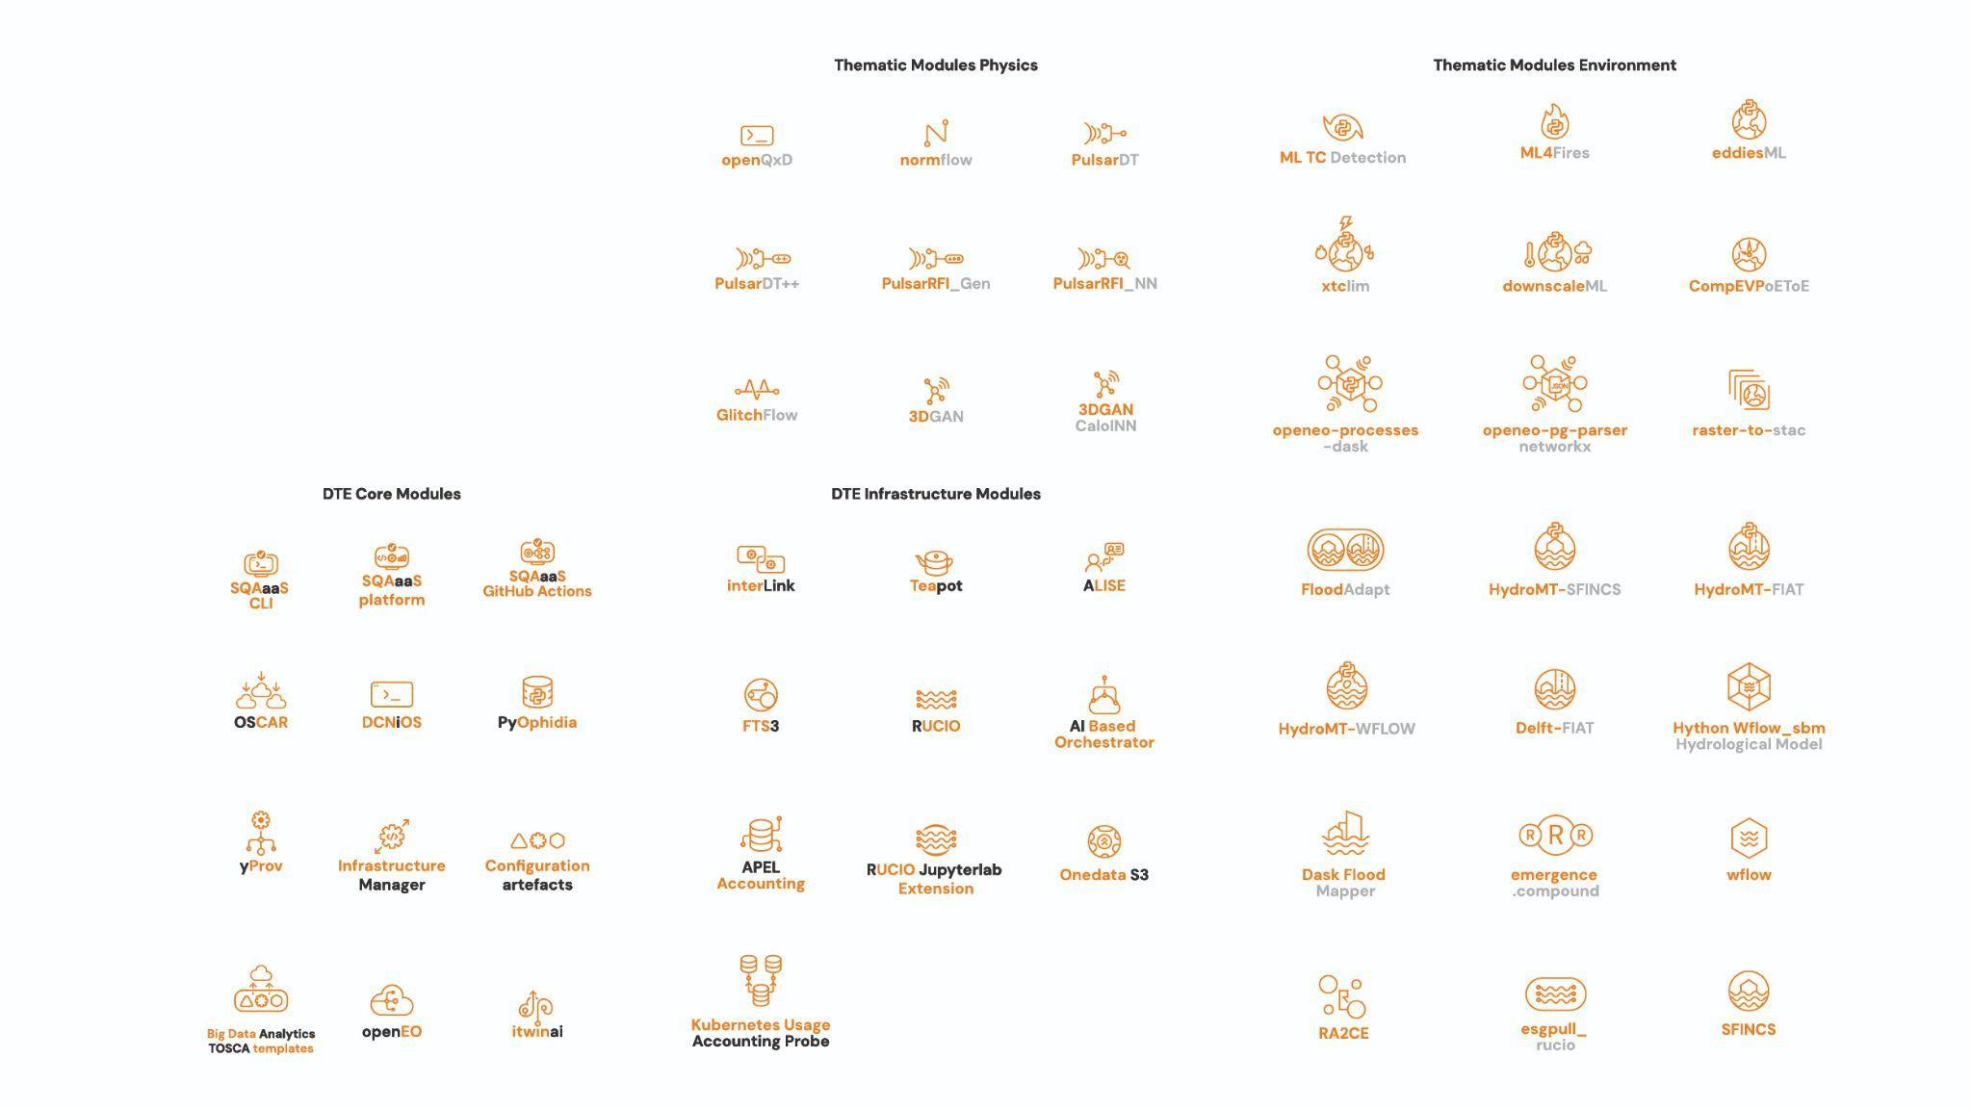

Annex 6 - Online Brochure (mock-up)
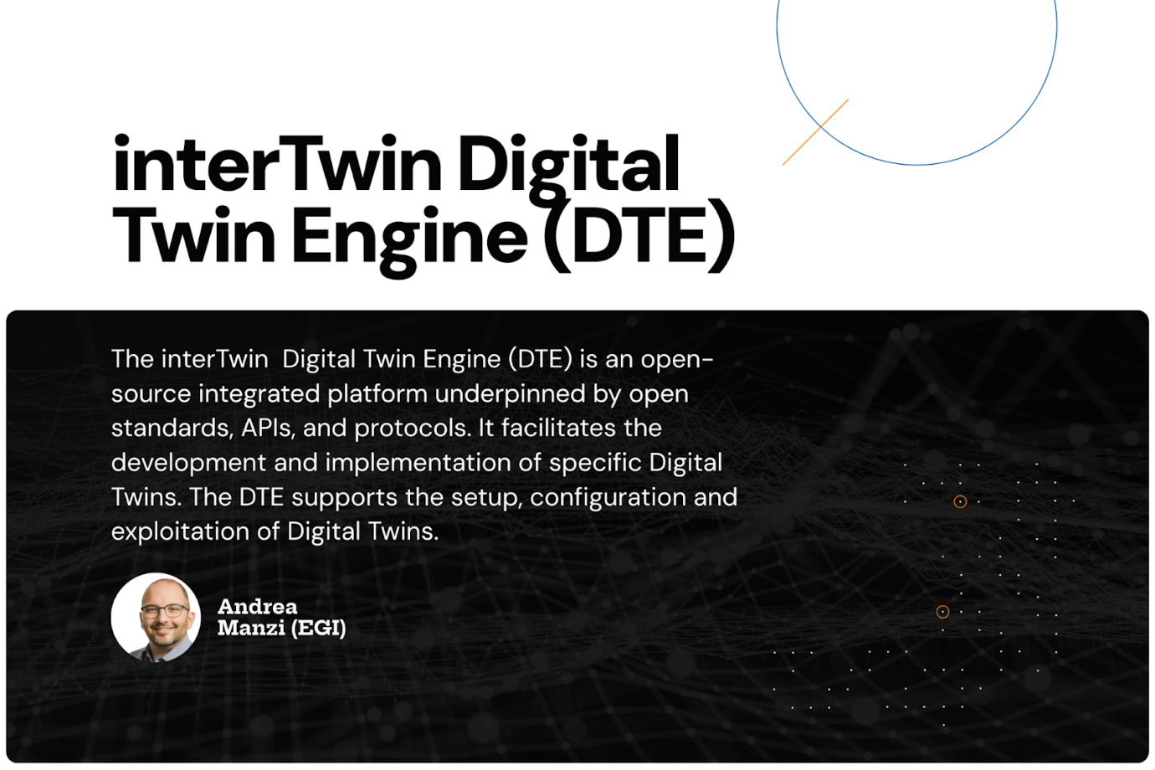

interTwin D2.1 Dissemination, Communication and Engagement Plan, https://www.intertwin.eu/intertwin-key-exploitable-results-kers/
interTwin D2.3 Communication, Dissemination and Engagement Activity Report and Updated Plan, https://doi.org/10.5281/zenodo.14973942
interTwin D2.2 Innovation Management and Exploitation Plan, https://doi.org/10.5281/zenodo.10721988
interTwin D 2.4 Innovation Management and Exploitation Progress Report, https://doi.org/10.5281/zenodo.14974012
interTwin Key Exploitable Results, https://www.intertwin.eu/intertwin-key-exploitable-results-kers/
Project Brandguide.
https://zenodo.org/records/10417116
https://zenodo.org/records/14973942
Access to the confluence is restricted to the project consortium.
https://zenodo.org/records/17086699
https://zenodo.org/records/17086699
https://tema-project.eu/articles/artificial-intelligence-sustainability-what-role-ai-advancing-targets-sustainability
https://www.eventbrite.de/e/interoperability-architectures-for-digital-twins-of-the-ocean-tickets-732174171657?aff=oddtdtcreator
https://www.intertwin.eu/article/ai-in-action-how-researchers-leverage-ai
https://www.intertwin.eu/article/biodt-webinar-how-can-cross-use-digital-modelling-tools-help-in-nature-protection
https://zenodo.org/records/10417116
https://zenodo.org/records/14973942
See D2.3: https://zenodo.org/records/14973942
https://zenodo.org/records/14973942
https://www.intertwin.eu/case-study/success-story-running-genai-on-supercomputers-thanks-to-interlink
https://www.intertwin.eu/case-study/success-story-interlink-entered-the-cncf-sandbox-cloud-native-hpc-integration#looking-forward
https://www.intertwin.eu/case-study/success-story-transatlantic-computational-testbeds-enabling-seamless-workflow-executions-of-flood-simulations
https://www.intertwin.eu/case-study/success-story-collaboration-between-intertwin-and-ai4eosc-for-ai-inference-offloading-from-the-cloud-to-hpc
https://cnes.fr/en
Please note that ‘Reach’ is self-reported. In some cases, presentations take place at large events - in that case only an estimate of the participants in the session(s) where interTwin was presented and/or the event booth reached at the exhibition is given.
Please note that ‘Reach’ is self-reported. In some cases, presentations take place at large events - in that case only an estimate of the participants in the session(s) where interTwin was presented and/or the event booth reached at the exhibition is given.
Please note that ‘Reach’ is self-reported. In some cases, presentations take place at large events - in that case only an estimate of the participants in the session(s) where interTwin was presented and/or the event booth reach at the exhibition are given.
Please note that ‘Reach’ is self-reported. In some cases, presentations take place at large events - in that case only an estimate of the participants in the session(s) where interTwin was presented and/or the event booth reached at the exhibition is given.

