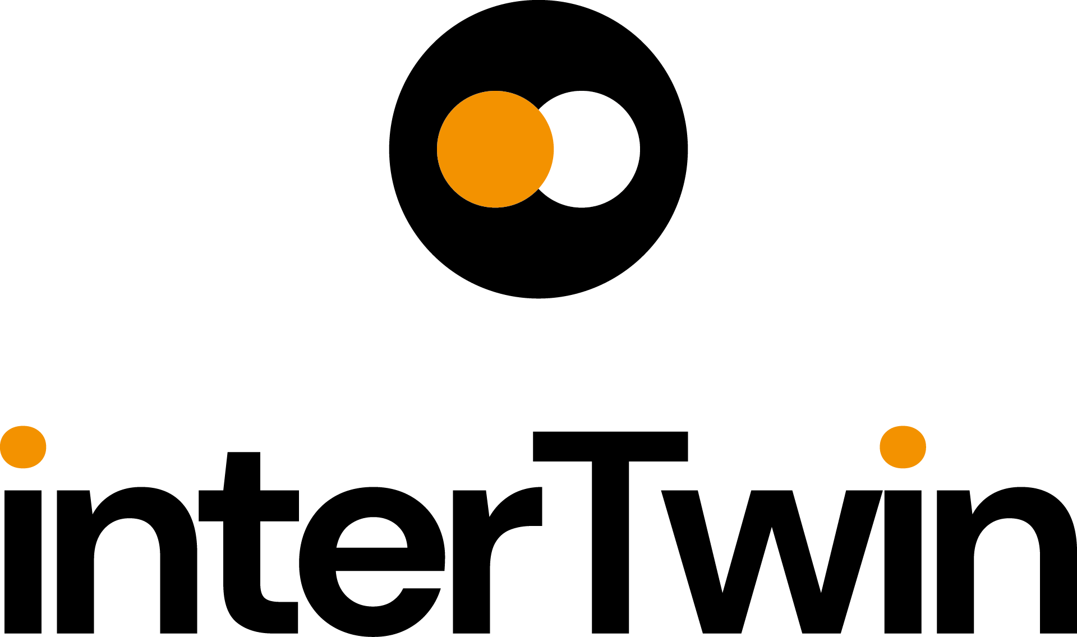

RP2 POLICY BRIEF
Status: UNDER EC REVIEW
Dissemination Level: Public
Introduction: Project title and project objectives
RP2 POLICY BRIEF
CALL | HORIZON-INFRA-2021-TECH-01
TOPIC | HORIZON-INFRA-2021-TECH-01-01
PROJECT | An interdisciplinary Digital Twin Engine for science (interTwin)  https://www.intertwin.eu/
PROJECT: objectives | - Co-design, develop and provide a Digital Twin Engine that simplifies & accelerates the development of complex application-specific DTs that benefits researchers, business, and civil society  - Co-design a Digital Twin Engine blueprint architecture that provides a conceptual framework for the development of DTs supporting interoperability, performance, portability, and accuracy.  - Extend the technical capabilities of the European Open Science Cloud with modelling and simulation tools integrated with its compute platform  - Ensure trust and reproducibility in science through quality, reliability, and verifiability of the outputs of Digital Twins  - Demonstrate data fusion with complex modelling & prediction technologies  - Simplify DT application development with tools to manage AI workflows and the model lifecycle while reinforcing open science practices
Name and email address of the operational project coordinator. | - Malgorzata Krakowian: malgorzata.krakowian@egi.eu Project Manager  - Andrea Manzi: andrea.manzi@egi.eu  Technical Coordinator  - Xavier Salazar Forn: xavier.salazar@egi.eu  Innovation Manager
Dissemination Level | Public
DOI | https://doi.org/10.5281/zenodo.13384839
Copyright Status |   This material by Parties of the interTwin Consortium is licensed under a Creative Commons Attribution 4.0 International License.

Policy Implications and Recommendations 4
Implementation of research infrastructures 4
Access to research infrastructures 5
Funding of research infrastructures 5
International co-operation of research infrastructures 6
Employment and skills in research infrastructures 6
Greening of research infrastructures 7
Interaction of research infrastructures with industry 7
ERIC legal framework 7
Technology development, data and digital services, digitalisation 8
Level of connection of your RI to EOSC 8
Contribution to other research areas and broader EU priorities 9
Sustainability of research infrastructures 9

Policy Implications and Recommendations
Summary of interTwin Key Exploitable Results:
- KER 1: Interdisciplinary Digital Twin Engine. (Objective 1).
- KER 2: Interoperability Framework: Guidelines, Specifications, and Blueprint Architecture. (Objective 2)
- KER 3: Toolkit for AI workflow and method lifecycle management (Objective 6)
- KER 4: Quality Framework (Objective 4)
- KER 5: DTE federated infrastructure integrated with EOSC and EU Data Spaces ( Objective 3 and 5)
- KER 6: interTwin Open Source Community (All objectives)

Implementation of research infrastructures
KERs involved: All KERs, especially KER1
interTwin achievements: interTwin is developing a Digital Twin Engine to support the development and operations of Digital Twins in various scientific fields.
In particular High Energy Physics, Radio Astronomy and Astrophysics Use Cases, such as
- Lattice QCD Simulations
- Detector Simulation
- Noise simulation for radio astronomy and Virgo Noise Detector
contribute to ESCAPE-related research infrastructures (Astronomy & Particle Physics cluster) including HL-HLC, for High Energy Physics, VIRGO, Einstein Telescope for Astrophysics and future SKAO for Radio Astronomy.
Environmental and Climate related use cases such as
- ​​Climate Change Future Projections of Extreme Events (storms & fire)
- Early Warning for Extreme Events (floods & droughts)
- Climate Change Impacts of Extreme Events (storms, fire, floods, drought)
targeting ENVRI community related research infrastructures, including IS-ENES.

Keeping evolving and supporting Digital Twins and common components such as the Digital Twin Engine, are paramount to lower the costs of innovation, remove duplication of efforts and encourage collaboration. We recommend the EC to increase funding in international cooperation within and between research infrastructures and their scientific communities.
Recommendations for further impact:
We recommend the EC and Member State provide funds for the upgrade of national and European e-Infrastructures in order to boost European capacity, reduce dependency on hyperscalers, ensure data sovereignty in Europe and tackle the future compute and data needs from RI’s, long term access to federated HPC capabilities and data are necessary.
In order to plan appropriate investments, we also recommend that case studies are conducted to understand future RI requirements and how the evolving technological landscape can be used will be beneficial to tackle those needs.
The provisioning of HTC, HPC and data assets need to be integrated and federated for a faster adoption, deployment, and operations of Digital Twin-related services.
Access to HPC needs to be democratised and extended to enable not only specific closed-projects -but also to support the compute-intensive service-driven operations such as the ones needed by Digital Twins.

Access to research infrastructures
KERs involved: All KERs, especially KER5
interTwin achievements: Several Digital Twins are being developed from use cases such as the environmental related (e.g. Early warning for Extreme events) which will be able to become available as a prototype service for broader communities (including industry, SMEs or other users beyond research such as policy makers or general public). Data produced by the use cases will be made available following FAIR principles, to own scientific domain communities or to broader audiences, such as curated outputs for policy makers.
In addition, KER2 Interoperability framework and Blueprint Architecture ensures the alignment of Digital Twin Engine with existing data, infrastructure and domain specific standards. KER6 open source community will facilitate the adoption of the different Software Components of the project. KER1 Digital Twin Engine is creating a service that will improve the digitalization of research infrastructures by facilitating the development of Digital Twins . The communities in the project are international initiatives that span out of the European domain involving researchers worldwide and contributing to overall mankind scientific progress (such as ENES, HL-LHC, VIRGO, MeerKat). As such, interTwin is contributing to ensure the European significance within those international initiatives and enable bringing back to Europe the knowledge generated in them.
Recommendations for further impact:
Joint computer e-Infrastructures enabling transnational access to the scientific communities to compute resources and AI services, facilitate international cooperation and support coordinated investments in digital infrastructures within and between research infrastructures and their scientific communities. Transnational access for cross-institute and cross-border access are paramount for a coordinated European access to such capabilities. Political and financial support is needed to keep the services available and operational.

Funding of research infrastructures
KERs involved: All KERs, especially KER1
interTwin achievements: DTE is demonstrating the capability for deploying successfully Digital Twin services of research infrastructures. These enable the creation of services around them that can be valorized by research infrastructures, such as consulting, support, education and training or offering DT-capabilities as-a service for external customers. Hence, it is an opportunity to create alternative ways of funding by delivering value added services over the created DTs.
Recommendations for further impact:
Define business models to sustain transnational access as a mechanism to operate AI/ML of cross-domain cross-infrastructure relevance such as Digital Twin Applications and the Digital Twin Engine.

International co-operation of research infrastructures
KERs involved: All KERs, especially KER2 and KER6
interTwin achievements: KER2 Interoperability framework and Blueprint Architecture ensures the alignment of Digital Twin Engine with existing data, infrastructure and domain specific standards. KER6 open source community will facilitate the adoption of the different Software Components of the project. KER1 Digital Twin Engine is creating a service that will improve the digitalization of research infrastructures by facilitating the development of Digital Twins. The communities in the project are international initiatives that span out of the European domain involving researchers worldwide and contributing to overall mankind scientific progress (such as ENES, HL-LHC, VIRGO, MeerKat). As such, interTwin is contributing to ensure the European significance within those international initiatives and enable bringing back to Europe the knowledge generated in them.
Recommendations for further impact:
Continue investments in joint R&D programmes in AI, support collaboration and co-design of AI solutions relevant for adoption across multiple disciplinary domains, such as the Digital Twin Engine.

Employment and skills in research infrastructures
KERs involved: All KERs, especially KER6 and KER3
interTwin Achievements: Researchers involved in interTwin are broadening knowledge in AI, ML usage for Digital Twins. While contributing to better science, knowledge is being shared openly not only for the researchers in the project but also for the users and future users within the Research Infrastructures. An open source community is being created supporting all the technologies and tools, for which several technical webinars and training material are being prepared. The project is not only ensuring the employment of the researchers working in the project but broadening the opportunities of research infrastructures. Impact after the end of the project depends on the (economic) sustainability and the uptake after the project.
Recommendation for further impact,

Fund a European-wide AI competence centre to provide technical support and consultancy about technical AI/ML solutions of common interest across RIs and different scientific domains. A distributed network of experts should be established, addressing the shortage of knowhow in research communities and the lack of expertise and funding sometimes experienced by RIs when adopting novel solutions in their digital infrastructures.

Greening of research infrastructures
KERs involved: KER1, and subset of infrastructure modules of the Digital Twin Engine
interTwin Achievements: The interTwin AI Orchestrator considers sustainability constraints on the resource allocation in order to facilitate a greener computing for RIs. Generative-AI algorithms are developed to speed up simulations (by substituting Montecarlo-based ones, which are very compute intensive). Pre-processing and processing of Data by the DTs will reduce the need for storage.
Recommendation for further impact:
Support funding programmes supporting the adoption of AI/ML in data-intensive science with the purpose of increasing the efficiency and accuracy in the processing of very large volumes of data generated by RI observatories, resulting in a more efficient usage of data centres.

Interaction of research infrastructures with industry
KERs involved: All KERs, especially KER1, KER3, KER5 and KER6
interTwin achievements: While Digital Twins developed in interTwin are targeting multidisciplinary scientific communities (and therefore, SMEs are not one of the main targets of the projects), several subset of technologies have attracted attention from SMEs (such as interLink which has been evaluated by Nunet.io or Itwinai). EODC (partner in the project) is an SME in the earth science domain in close collaboration with the ENVRI community. Further links with industrial players are being sought in industrial events
Recommendation for further impact:
Allocate funding to promote and support industry and SMEs’ access to the Digital Twin Engine to develop DT-related technologies, e.g. via open calls for prototyping would be useful to ensure crossing the chasm and raising the interest of industrial players.

ERIC legal framework
Not applicable.

Technology development, data and digital services, digitalisation
KERs involved: All KERs, especially KER2, KER3 and KER4
interTwin achievements: A faster uptake of AI/ML thanks to common solutions is expected to boost data productivity in science promoting secondary use of data and with that the research data value chain. interTwin DTE blueprint and its technical components are well positioned to address the ESFRI research infrastructure needs. In the future Digital twins will become a commodity and interTwin contributes to this vision. interTwin use cases are demonstrating the potential of the Digital Twin Engine to build and deploy Digital Twins that help to improve the implementation and development of services of Research Infrastructures and with that accelerating the adoption of innovative solutions in research infrastructure projects and landmarks.
Recommendation for further impact:
It is recommended that the EC depends on investments supporting research collaborations and projects to further invest in AI, support collaboration and co-design of AI solutions of common interest across multiple disciplinary domains, such as the Digital Twin Engine.

Level of connection of your RI to EOSC
KERs involved: All KERs, especially KER2 and KER3
interTwin achievements: interTwin close collaboration with EOSC is one of the key aspects of the project. Interoperability framework ensures the integration capabilities of interTwin DTE components with EOSC infrastructure. Some of them will be re-used in EOSC related projects and implementations and, in general, they are candidates to become horizontal enabling services for the support of AI/ML applications interested in reusing FAIR research data that is federated and incorporated into EGI service offering, and accessible through EOSC as part of a future EOSC node as explained in the EGI Contribution to the EOSC Federation white paper (https://zenodo.org/records/11128540). Furthermore, some interTwin developed components will be incorporated into EOSC related EU projects boosting Data and AI valorisation.
Recommendations for further impact:
The EOSC Multi-Annual Roadmap and funding opportunities need to be aligned and focused on grand challenges that require the integration of research data, computing, storage, services and tools, knowledge and user support from multiple disciplines (i.e. above individual existing research infrastructures and e-Infrastructures).

Contribution to other research areas and broader EU priorities
KERs involved: All KERs, especially KER1
interTwin achievements: interTwin's Digital Twin use cases are addressing global challenges stemming from climate change, including extreme weather events, floods, droughts, and wildfires, aligning with the EU's priorities in climate action and environmental protection.
interTwin is developing an architecture for digital twins that aligns with the Destination Earth (DestinE) initiative, potentially allowing these twins to be hosted on DestinE's infrastructure in the future. For this, the project is collaborating closely with the European Centre for Medium-Range Weather Forecasts (ECMWF), which is responsible for the DestinE Digital Twin Engine, and is using the FloodAdapt use case as a reference example for the initial interoperability activities between interTwin and DestinE.
On the computing side, interTwin is working to federate EuroHPC facilities with Cloud and High-Throughput Computing infrastructures, aiming to demonstrate capabilities to compute continuum. Moreover the project has established international collaborations, in the framework of the International Lattice Data Grid initiative (https://hpc.desy.de/ildg/) to bring up to speed the tools for data management of the community by exploiting the data lakes technology.
Recommendations for further impact:
On the Computing side institutional support to extend the federation is needed to ensure a broader use in other research areas and domains, especially those that can leverage exascale capabilities (e.g. initiatives like HE SPECTRUM project aiming to expand capabilities to tackle needs from High Energy Physics and Radio Astronomy domains). Based on this interTwin interdisciplinarity could be extended to broader domains (such as Health or Bio) or Smart Cities or GovTech.

Sustainability of research infrastructures
KERs involved: All KERs, especially KER1
interTwin achievements: The successfully demonstrated ability to implement a compute continuum in DT applications adopted and shared among research infrastructures, has the potential to create economy of scales by allowing multiple infrastructure to rely on a shared compute continuum infrastructure, hence resulting in tangible cost reductions thanks to the more efficient and shared access to Cloud, HTC and HPC resources, and to a faster adoption of AI/ML in scientific software.
Recommendations for further impact:
Research infrastructures should explore the cost-benefit for the use of shared resources to compute continuum over proprietary solutions for the development of Digital Twin Applications.
Research Infrastructures and e-Infrastructures need EU support to continuously serve European research communities in a coordinated manner, and require stable EU instruments for long-term support cross-institute and cross-national access that overcome the current limitations experienced in short-lived projects.

