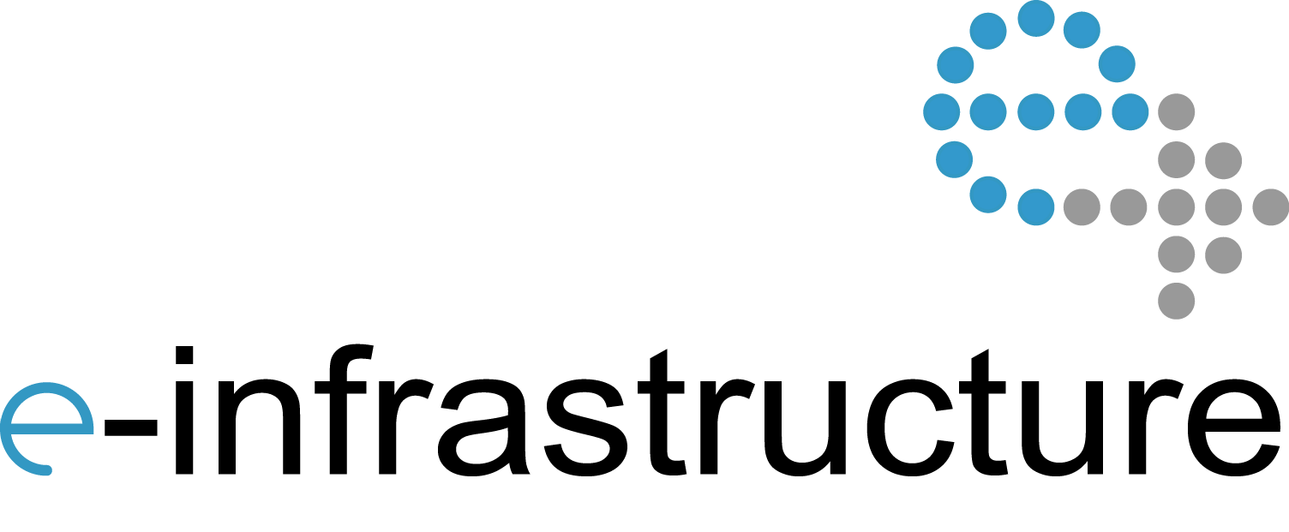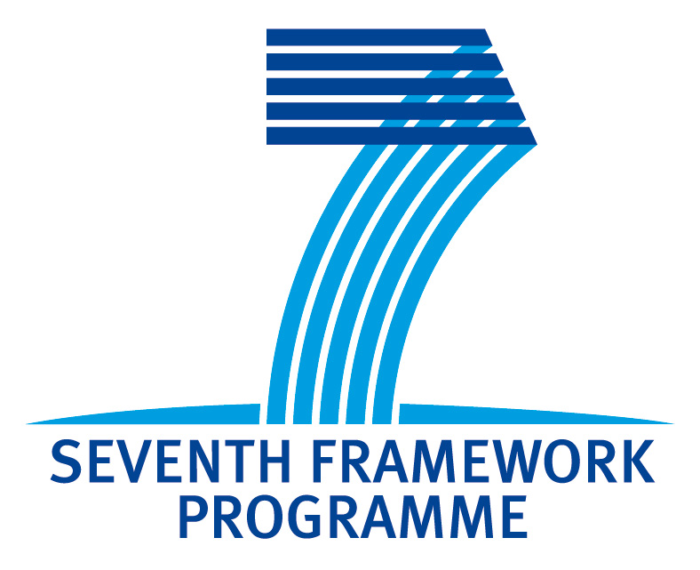

3rd Helix Nebula Workshop on Interoperability among

e-Infrastructures and Commercial Clouds

Madrid, 17 September 2013

Meliá Castilla Convention Centre, Madrid

Room: Patio 3

Event co-located with the EGI Technical Forum 2013

**Brochure:** <http://go.egi.eu/hnws3-brochure>

**Online agenda:** <http://go.egi.eu/hnws3>

**Helix Nebula**: <http://www.helix-nebula.eu>

**EGI.eu**: <http://www.egi.eu>

**Twitter hashtag**: #hnws3

**Feedback Survey -** <http://go.egi.eu/hnws3-feedback>

#hnws3

The Helix Nebula project is partially funded by the European Commission under Grant Agreement 312301

11:00-11:40 Interoperability Roadmap (S. Andreozzi/C. Asero, EGI.eu)

11:40-12:10 Business models for publicly funded e-Infrastructures in Helix Nebula (J. Doll, SAP)

12:10-12:30 Connecting Helix Nebula to the Research & Education Network (R. Sabatino, DANTE)

12:30-14:00 Lunch Break

14:00-14:30 Deploying Helix Nebula flagship applications in a hybrid scenario (S. Pinto, EGI.eu)

14:30-14:55 FitSM: lightweight standards for service management in federated cloud (Owen Appleton, Emergence Tech Ltd.)

14:55-15:20 Security policies (CSA or CGI)

15:20-15:30 Discussion/Wrap up/Conclusion

# Convener: S. Andreozzi

The EC-funded Helix Nebula project is a step towards a European cloud‐based scientific e‐Infrastructure composed of resources and services from commercial and publicly owned providers. This is the third workshop addressing the topic of interoperability and integration among the various suppliers of cloud services.

The workshop will provide the opportunity to review the initial interoperability roadmap published last May and to discuss the related implementation actions (<http://go.egi.eu/hnd61>).

The latest formulation of business models will also be presented to support the identification of the best roles and principles that could enable both commercial and publicly funded e-Infrastructures to operate together sustainably.

Another activity that will be tackled during the workshop is the plan for deploying Helix Nebula flagship applications in a hybrid scenario where resources from both commercial providers and publicly-funded infrastructure are involved.

The FedSM project will introduce FitSM, a lightweight standard family for aligning service management in federated IT service provision.

CSA will present the results of the activity in the area of a common service catalogue to support users in understanding and comparing service offer towards the creation of a common marketplace for cloud services.

Both commercial providers and publicly funded e-Infrastructures have their own security policy. When moving to a federated service provision, common rules need to be defined. An initial presentation from CSA in collaboration with the EGI Security Policy Group will depicts the areas of work.

This is the final workshop on interoperability within the Helix Nebula EC Project. Its results will feed into the interoperability roadmap planned for spring 2014.

Program

http://go.egi.eu/hnws3

Overview

**Connecting Helix Nebula to the Research & Education Network**

[ABSTRACT]

**Roberto Sabatino**

Roberto Sabatino joined DANTE in July 1997 and since 2002 he is Chief Technical Officer.

Roberto has a degree in Computer Science from the University of Turin and prior to joining DANTE he worked for two years at the University of Cambridge Computer Laboratory as a Research Associate. Prior to that, he worked in Italy in the telecommunications industry and at the University of Turin.

**FitSM: lightweight standards for service management in federated cloud**

Managing services across federated communities, especially those involving a mix of academic, public sector and commercial organisations, is complex. The FitSM Standard requirements are aimed at harmonizing service management across federate computing infrastructures.

**Owen Appleton**

Owen Appleton began in the life sciences before moving into management, communication, exploitation and policy issues around science and technology. He has worked in a range of roles, from PR to journalism and communications strategy, as well as working on entrepreneurial projects, at CERN and on numerous EC funded research initiatives. More recently Owen has been dealing with service management issues around large-scale federated infrastructures. He is ITIL certified and has played prominent roles in the gSLM and FedSM projects as well as providing service management consultancy to infrastructure providers and working with IT management training organisations.

**Security policies**

[ABSTRACT]

**Speaker**

[TBD, CGI]

**Interoperability Roadmap**

Integration and interoperation of Commercial Cloud resources with e-infrastructures is a crucial aspect for the success of the Helix Nebula project. Following the Helix Nebula report on Interoperability requirement published in spring 2013, recommendations and next steps on interoperability will be discussed to gather feedback and help shaping the Interoperability Roadmap

**Sergio Andreozzi**

Sergio has been involved in grid computing since 2002, when he joined INFN to work on interoperability aspects. Since 2007, he has co-chaired the GLUE Working Group in OGF and contributed to several standard activities. In June 2010, he joined EGI.eu as the Strategy and Policy Manager to steer policy development process and support strategic planning of the European Grid Infrastructure. Sergio holds a PhD in Computer Science from the University of Bologna and a MSc in Computer Science Engineering from the University of Pisa.

**Business models for publicly funded e-Infrastructures in Helix Nebula**

The subject of this presentation is the business model innovation for Helix Nebula integrating public and commercial providers. It will show the results of the business model innovation workshops and corresponding surveys and interviews conducted by SAP with the supplier and demand side of Helix Nebula. 7 potential business models with specific and overarching broker roles have been identified. These broker roles can create opportunities for public providers to enter the field of Helix Nebula by creating a win-win situation for all involved parties by lowering risks and costs for the supplier side.

**Julia Doll**

Julia holds a Master of Science majoring in Management Information Systems from the University of Mannheim and a Master of Business majoring in Marketing from the University of Queensland, Australia. Julia has been working at SAP since 2007 in several areas comprising: Product Management, Business Development and Business Model Innovation Research. Since 2012 she joined SAP Switzerland as Project Lead for Business Model Innovation. She has coached several projects regarding analysis, design and evaluation of business models. Her current research focuses on business model elements and their correlation.

**Deploying Helix Nebula flagship applications in a hybrid scenario**

This presentation will provide a general overview of the Blue Box architecture and the main technical interoperability aspects that should be considered when evaluating Blue Box implementations. An update on the discussion about interoperability with e-Infrastructure and the EGI Federated Cloud Initiative will also be provided. The goal is to support the discussion on identifying requirements for technical interoperability

**Salvatore Pinto**

Salvatore graduated in Electronic Engineering at the University of Salerno, Italy. He started working on Grid operations in July 2009 for the European Space Agency in Rome. He first faced Cloud Technologies in September 2010, using them as a new way to support scientists algorithms development and data processing needs. He joined the EGI Operations Team as Cloud Technology specialist in July 2013.

3rd Helix Nebula Workshop on Interoperability

Abstracts & Biographies

3rd Helix Nebula Workshop on Interoperability

Abstracts & Biographies