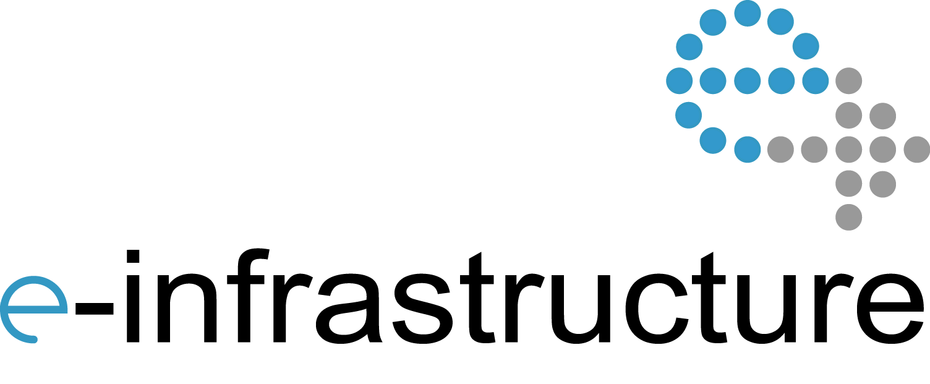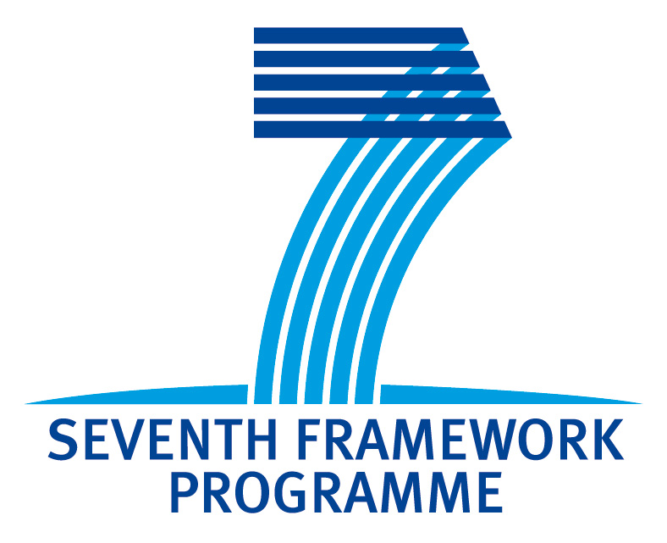

## Helix Nebula-The Science Cloud has launched its open-survey: Have your say!

Helix Nebula is conducting a survey to understand the general perception of the Helix Nebula initiative and to help us improve the way we inform people about its work.

**https://www.surveymonkey.com/s/NBY3SSF**

3rd Helix Nebula Workshop on Interoperability among

e-Infrastructures and Commercial Clouds

Madrid, 17 September 2013

Meliá Castilla Convention Centre, Madrid

Room: Patio 3

Event co-located with the EGI Technical Forum 2013

**Brochure:** <http://go.egi.eu/hnws3-brochure>

**Online agenda:** <http://go.egi.eu/hnws3>

**Helix Nebula**: <http://www.helix-nebula.eu>

**EGI.eu**: <http://www.egi.eu>

**Twitter hashtag**: #hnws3

**Feedback Survey -** <http://go.egi.eu/hnws3-feedback>

#hnws3

The Helix Nebula project is partially funded by the European Commission under Grant Agreement 312301

11:00 -11:10 Introduction (S. Andreozzi, EGI.eu)

11:10 -11:40 Interoperability Roadmap (C. Asero, EGI.eu)

11:40 -12:10 Business models for publicly funded e-Infrastructures in Helix Nebula (J. Doll, SAP)

12:10 -12:30 Connecting Helix Nebula to the Research & Education Network (R. Sabatino, DANTE)

12:30 -14:00 Lunch Break

14:00 -14:20 Deploying Helix Nebula flagship applications in a hybrid scenario (S. Pinto, EGI.eu)

14:20 -14:50 FitSM: lightweight standards for service management in federated cloud (Owen Appleton, Emergence Tech Ltd.)

14:50 -15:10 Sponsor presentation “Fujitsu: HPC Simplicity for Cloud and Grid providers” (Adriano Manuel Galano Díez, Fujitsu)

15:10 -15:30 Discussion/Wrap up/Conclusion

# Convener: S. Andreozzi

The EC-funded Helix Nebula project is a step towards a European cloud‐based scientific e‐Infrastructure composed of resources and services from commercial and publicly owned providers. This is the third workshop addressing the topic of interoperability and integration among the various suppliers of cloud services.

The workshop will provide the opportunity to review the initial interoperability roadmap published last May and to discuss the related implementation actions (<http://go.egi.eu/hnd61>).

The latest formulation of business models will also be presented to support the identification of the best roles and principles that could enable both commercial and publicly funded e-Infrastructures to operate together sustainably.

Another activity that will be tackled during the workshop is the plan for deploying Helix Nebula flagship applications in a hybrid scenario where resources from both commercial providers and publicly-funded infrastructure are involved.

The FedSM project will introduce FitSM, a lightweight standard family for aligning service management in federated IT service provision.

A sponsor presentation by Fujitsu, will highlight its state-of-the-art solutions across a wide range of applications in the area of HPC and cloud.

Both commercial providers and publicly funded e-Infrastructures have their own security policy. When moving to a federated service provision, common rules need to be defined. An initial presentation from CSA in collaboration with the EGI Security Policy Group will depicts the areas of work.

This is the final workshop on interoperability within the Helix Nebula EC Project. Its results will feed into the interoperability roadmap planned for spring 2014.

Program

http://go.egi.eu/hnws3

Overview

**Connecting Helix Nebula to the Research & Education Network**

The talk will centre on the support provided by GEANT to the Helix Nebula initiative. It will examine the current status of the connections of the entities, how it may evolve during the remainder of the initiative. Thoughts on a long term business model will also be presented.

The talk will introduce the work GEANT is performing in the area of SDN for cloud services and the collaboration with Helix nebula on the same topic.

**Roberto Sabatino**

Roberto is Business Solutions Consultant at DANTE, where his work focuses on working with international users and scientific collaborations. His work involves developing network solutions to meet the needs of the collaborations, in consultation with NRENs and the users.

**FitSM: lightweight standards for service management in federated cloud**

Federated clouds impose more complex management challenges than single-supplier cloud solutions. Existing IT Service Management (ITSM) approaches such as ISO/IEC 20000 and ITIL include useful approaches but can be heavyweight and difficult to implement across federated communities. FitSM is a lightweight standard for service management tailored to federated communities, aimed at addressing this need for federated clouds and other federated e-Infrastructures. It offers simple, achievable approaches to ITSM as well as a common basis for interaction between suppliers on service management topics.

**Owen Appleton**

Owen Appleton has worked in a range of roles, from PR to journalism and communications strategy, as well as working on entrepreneurial projects, at CERN and on numerous EC funded research initiatives. More recently Owen has been dealing with service management issues around large-scale federated infrastructures. He is ITIL certified and has played prominent roles in the gSLM and FedSM projects as well as providing service management consultancy to infrastructure providers and working with IT management training organisations.

**Fujitsu: HPC Simplicity for Cloud and Grid providers**

Fujitsu is very active in developing next-generation high-performance distributed and grid computing platforms to bring answers to many of current business and societal challenges. In the area of HPC and cloud, Fujitsu is delivering state-of-the-art solutions across the widest range of applications lineup with a full service and support portfolio.

Fujitsu is currently collaborating with Atos in building the Second Most Powerful Supercomputer infrastructures in Spain, also prefigured to provision Cloud services in the European Scientific Community network.

**Adriano Manuel Galano Díez**

Adriano Galano is Director of HPC and Big Data at Fujitsu Spain. Member of Fujitsu HPC Global Competence Center. Lead the infrastructure area of x86 and SPARC Servers in addition to value added solutions: Virtualization and Cloud for a wide range of customers in different sectors.

**Interoperability Roadmap**

Integration and interoperation of Commercial Cloud resources with e-infrastructures is a crucial aspect for the success of the Helix Nebula project. Following the Helix Nebula report on Interoperability requirement published in spring 2013, recommendations and next steps on interoperability will be discussed to gather feedback and help shaping the Interoperability Roadmap

**Sergio Andreozzi**

Sergio has been involved in grid computing since 2002, when he joined INFN to work on interoperability aspects.. In June 2010, he joined EGI.eu as the Strategy and Policy Manager. Sergio holds a PhD in Computer Science from the University of Bologna and a MSc in Computer Science Engineering from the University of Pisa.

**Carmela Asero**

Carmela holds a degree in Economics an MA in Diplomatic Studies and an MSc in eBusiness. Before joining EGI, as Senior Strategy and Policy Officer, Carmela worked as Scientific Officer and Communication Officer within different EU Institutions where she was involved in innovation strategy and management of projects in the e-Infrastructures area.

**Business models for publicly funded e-Infrastructures in Helix Nebula**

The subject of this presentation is the business model innovation for Helix Nebula integrating public and commercial providers. It will show the results of the business model innovation workshops and corresponding surveys and interviews conducted by SAP with the supplier and demand side of Helix Nebula. 7 potential business models with specific and overarching broker roles have been identified. These broker roles can create opportunities for public providers to enter the field of Helix Nebula by creating a win-win situation for all involved parties by lowering risks and costs for the supplier side.

**Julia Doll**

Julia holds a Master of Science majoring in Management Information Systems from the University of Mannheim and a Master of Business majoring in Marketing from the University of Queensland, Australia. Julia has been working at SAP since 2007 in several areas comprising: Product Management, Business Development and Business Model Innovation Research. Since 2012 she joined SAP Switzerland as Project Lead for Business Model Innovation. She has coached several projects regarding analysis, design and evaluation of business models. Her current research focuses on business model elements and their correlation.

**Deploying Helix Nebula flagship applications in a hybrid scenario**

This presentation will provide a general overview of the Blue Box architecture and the main technical interoperability aspects that should be considered when evaluating Blue Box implementations. An update on the discussion about interoperability with e-Infrastructure and the EGI Federated Cloud Initiative will also be provided. The goal is to support the discussion on identifying requirements for technical interoperability

**Salvatore Pinto**

Salvatore graduated in Electronic Engineering at the University of Salerno, Italy. He started working on Grid operations in July 2009 for the European Space Agency in Rome. He first faced Cloud Technologies in September 2010, using them as a new way to support scientists algorithms development and data processing needs. He joined the EGI Operations Team as Cloud Technology specialist in July 2013.

3rd Helix Nebula Workshop on Interoperability

Abstracts & Biographies

3rd Helix Nebula Workshop on Interoperability

Abstracts & Biographies