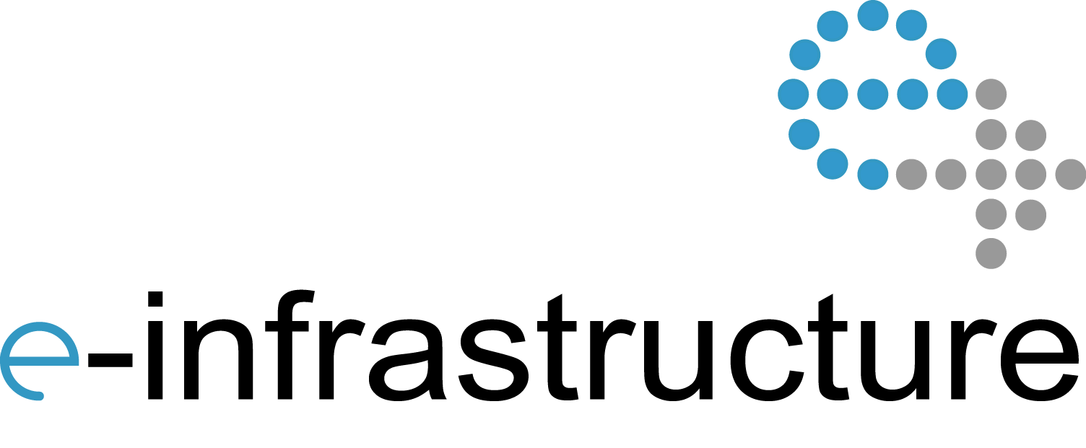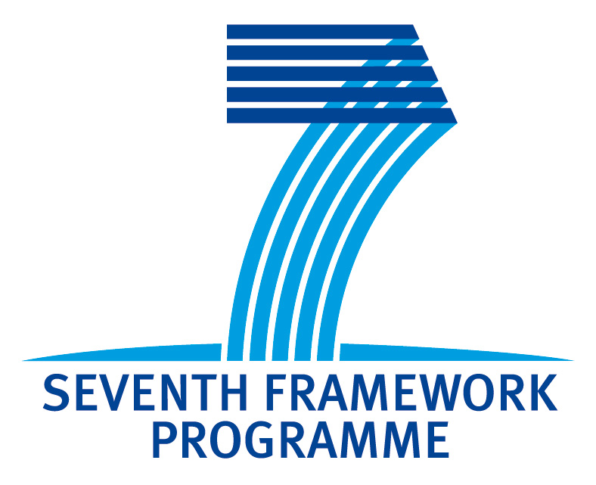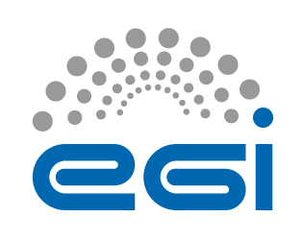

2nd Helix Nebula Workshop on Interoperability among

e-Infrastructures and Commercial Clouds

Frascati, 16 January 2013

Event co-located with the 2nd Helix Nebula General Assembly

http://indico.cern.ch/conferenceDisplay.py?confId=216509

**Brochure:** <http://go.egi.eu/hnws2-brochure>

**Online agenda:** <http://go.egi.eu/hnws2>

**Helix Nebula**: <http://www.helix-nebula.eu>

**EGI.eu**: <http://www.egi.eu>

**Twitter hashtag**: #hnws2

**Feedback Survey -** <http://go.egi.eu/hnws2-feedback>

#hnws2

The Helix Nebula project is partially funded by the European Commission under Grant Agreement 312301

12:00-12:10 Introduction and Goals (S. Andreozzi, EGI.eu)

12:10-12:30 Service Management in Helix Nebula (Mick Symonds, Atos)

12:30-12:50 Minimal requirements for service management in federated infrastructure (Owen Appleton, Emergence Tech Ltd. & FedSM project)

12:50-13:30 Discussion/Wrap up/Conclusion

The EC-funded Helix Nebula project is a step towards a European cloud‐based scientific e‐Infrastructure composed of resources and services from commercial and publicly owned providers. In September 2012, the first workshop on interoperability was organised in Prague during the EGI Technical Forum week.

The first workshop (<http://go.egi.eu/hnws1>) focused on three thematic areas: 1) Technical interoperability, to understand similarities and differences among the technical choices of Helix Nebula and the EGI Federated Cloud architectures; 2) Networking connectivity, to explore solutions to provide the suitable network connectivity among e-Infrastructures and commercial clouds;

3) Business models and legal aspects, necessary to create a sustainable integration between the two contexts.

This second workshop is structured in two sessions to address in-depth analysis of the technical interoperability for the Blue Box and to introduce the topic of service level management for federated infrastructures. The Blue Box is the Helix Nebula Service Enabling Framework, a complex component providing API services and a Web Portal that will enable users to interact in a central and transparent manner with all the Cloud Providers (<http://go.egi.eu/hn-techarch>).

The first session aims to discuss the conceptual framework to discuss requirements that will be the basis for the related deliverable. Furthermore, it will be the context to report on the technical interoperability discussion between the Helix Nebula TechArch team and the EGI Federated Cloud task force. The session will offer the opportunity to stimulate the discussion to ensure that the technical interoperability requirements from both commercial clouds and e-Infrastructures are well understood and priorities agreed.

The second session will kick-off with a presentation from the ServArch team describing the current status of the service architecture being defined within Helix Nebula. Following this, a representative from the FedSM project (<http://www.fedsm.eu/>) will report on the minimal set of requirements for service management needed in a federated infrastructure context. This session will help identifying the minimal set of requirements for service management needed in a federated infrastructure context and to understand the implications for the technical and organizational aspects.

A third workshop on interoperability will be organised also in summer 2012. All this work will feed into two main documents: interoperability requirements planned for summer 2013 and interoperability roadmap planned for spring 2014.

10:00-10:10 Introduction and Goals (Sergio Andreozzi, EGI.eu)

10:10-10:30 Interoperability requirements framework (Carmela Asero, EGI.eu)

10:30-10:50 Technical interoperability and the Blue Box (Marc-Elian Bégin, SixSq)

10:50-11:30 Discussion/Wrap Up/Conclusion

# Service Level Management for Federated Infrastructures (convener: S. Andreozzi)

# Technical Interoperability (convener: S. Andreozzi)

Program

http://go.egi.eu/hnws2

Overview

**Defining the Helix Nebula Service Architecture**

This presentation will describe the current outcome of the ServArch group defining the architecture of services, processes and organisation to be established between Helix Nebula demand side and supply side for a lean effective and efficient service management.

**Mick Symonds**

Principal Solutions Architect for Atos, based in The Netherlands. He has worked in the IT services business for over 30 years and has held a wide range of roles, from technician to marketing, from general management to consulting. A particular focus has been on the on-going management of IT infrastructure services and their development. He has been responsible for the development of Atos’ global data centre and cloud strategies, and as a by-product has produced comprehensive White Papers on these and other subjects, downloadable from the Atos web site. Most of his time recently has been devoted to Helix Nebula (http://www.helix-nebula.eu/), an emerging European consortium to deliver cloud services to public organisations, starting with the scientific research community.

**Minimal requirements for service management in federated infrastructure**

Managing services across federated communities, especially those involving a mix of academic, public sector and commercial organisations, is complex. Approaches vary from tightly controlled management based on financial bottom lines and legal contracts through to best-effort approaches based on undocumented agreements and informal collaboration. The FedSM project is developing a set of minimal requirements for federated service management that allow ‘management interoperability’ between different kinds of organisation. Based on international standard ISO/IEC 20000, these requirements are intended to be achievable for organisations unused to formally managing services as well as compatible with frameworks used in the commercial sector such as ITIL or eTOM.

**Owen Appleton**

Owen Appleton began in the life sciences before moving into management, communication, exploitation and policy issues around science and technology. He has worked in a range of roles, from PR to journalism and communications strategy, as well as working on entrepreneurial projects, at CERN and on numerous EC funded research initiatives. More recently Owen has been dealing with service management issues around large-scale federated infrastructures. He is ITIL certified and has played prominent roles in the gSLM and FedSM projects as well as providing service management consultancy to infrastructure providers and working with IT management training organisations.

2nd Helix Nebula Workshop on Interoperability

2nd Helix Nebula Workshop on Interoperability

Abstracts & Biographies

**Interoperability Requirements Framework**

Integration and interoperation of Commercial Cloud resources with e-infrastructures is a crucial aspect for the success of the Helix Nebula project. The presentation will depict the approach towards the first official report on Interoperability requirement expected in spring. The report is in progress to analyse interoperability issues across technical, policy and operation area. Participants to the workshop are expected to provide their views and comments for the further development of this document.

**Carmela Asero**

After graduating in Economics at University of Catania, Carmela obtained an MA in Diplomatic Studies and an MSc in eBusiness.She combines a solid expertise in Research, Innovation and ICT policy with a keen interest in communication and science. Before joining EGI, Carmela worked as Scientific Officer and Communication Officer within different EU Institutions where she was involved in innovation strategy and management of projects in the e-Infrastructures area.

**Technical interoperability and the Blue Box**

This presentation will provide a general overview of the Blue Box architecture and the main technical interoperability aspects that should be considered when evaluating Blue Box implementations. An update on the discussion about interoperability with e-Infrastructure and the EGI Federated Cloud Initiative will also be provided. The goal is to support the discussion on identifying requirements for technical interoperability

**Marc-Elian Bégin**

Following studies in Mechanical and Aerospace engineering, Marc-Elian worked in the space business for 10 years, in Canada, the UK and Germany. He specialised in real-time system simulation and testbeds development. In 2004 he joined the Grid Deployment Group at CERN, working on projects such as EGEE and ETICS. In 2007 he founded SixSq, an SME based in Geneva, specialised in agile development, cloud technologies and process automation. Marc-Elian is a core contributor to the StratusLab IaaS distribution, as well as SlipStream, a cloud system provisioning and image factory engine. He also chairs the Technology and Architecture Group in the Helix Nebula collaboration. His latest passions include the Clojure programing language; building cloud based vertical applications and helping teams embrace agile practices and tooling.