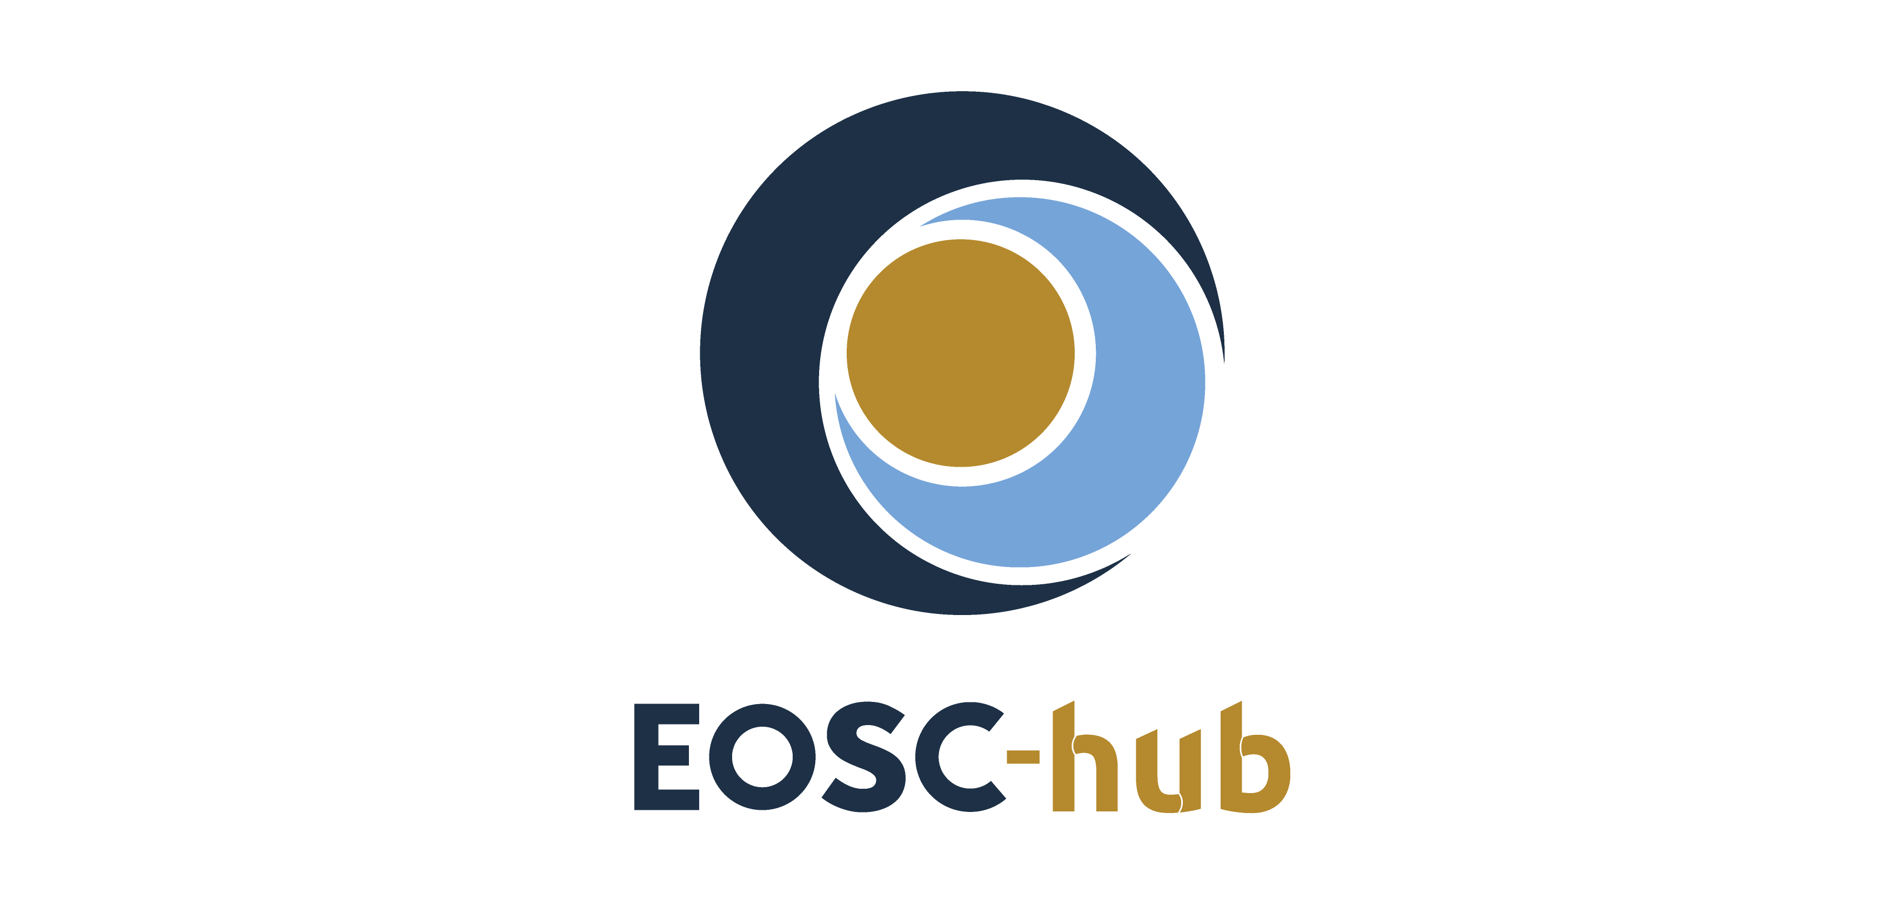

D2.1 First EOSC-hub Strategy Plan
Lead Partner: | CSC
Version: | 1
Status: | Final
Dissemination Level: | Public
Document Link: | https://documents.egi.eu/document/3354

Deliverable Abstract
The EOSC-hub project, funded by the European Commission (EOSC-hub Grant Agreement no. 777536 2017), contributes to the development of the European Open Science Cloud, as described in the EC Communication on European Cloud Initiative. The scope of the project is to create the integration and management system (the Hub) of the European Open Science Cloud in such a way that it complies with the FAIR principles, and hence accelerates the generation of research and innovation products. The Hub brings together major European research infrastructures and e-Infrastructures, national e-Infrastructure providers, SMEs and academic institutions, and delivers a catalogue of services, software and data in collaboration with them.
This document represents Deliverable 2.1 of the EOSC-hub project: The First EOSC-hub Strategy Plan. It is a high-level description of the strategic direction and ambition of EOSC-hub, serving as strategic guidance for the project as a whole. Additionally, it makes the project’s intentions publicly available in a transparent way. Based on consultative interviews with e-Infrastructure and research infrastructures representatives and thematic service providers contributing to the project, the deliverable presents the strategic positioning of EOSC-hub within EOSC and outlines the first set of strategic goals to be pursued within the period of 2018-2019.

COPYRIGHT NOTICE
This work by Parties of the EOSC-hub Consortium is licensed under a Creative Commons Attribution 4.0 International License (http://creativecommons.org/licenses/by/4.0/). The EOSC-hub project is co-funded by the European Union Horizon 2020 programme under grant number 777536.
DELIVERY SLIP
 | Name | Partner/Activity | Date
From: | Tiina Kupila-Rantala  Damien Lecarpentier  Jesse Oikarinen  Marjut Andler  Magchiel Bijsterbosch  Tiziana Ferrari  Sergio Andreozzi | CSC / WP2  CSC / WP2  CSC / WP2  CSC / WP2  SURFsara / WP2  EGI.eu / WP2  EGI.eu / WP2 | 03.09.2018
Moderated by:
Reviewed by | Franciska de Jong  Matthew Dovey  Yannick Legre | CLARIN ERIC  JISC  EGI.eu
Approved by:

DOCUMENT LOG
Issue | Date | Comment | Author
v.1 | 23.02.2018 | ToC | EGI.eu
v.2 | 28.03.2018 | Initial stakeholder analysis and scenario discussion | CSC, SURFsara
v.3 | 11.04.2018 | Added initial set of strategic goals | EGI.eu
v.4 | 07.05.2018 | Addressing comments regarding strategic goals, added initial versions of introduction, cornerstones of EOSC-hub and strategic positioning | CSC
v.5 | 25.05.2018 | Added revised stakeholder analysis and revised strategic positioning, based on interviews with the EOSC-hub Strategy Board members | CSC
v.6 | 31.05.2018 | Addressing comments of the EOSC-hub Strategy Board, revising scenario and gap analysis, deducing the revised strategic goals | CSC
v.7 | 11.06.2018 | Harmonization of the document, added Appendices I and II 2, added executive summary and abstract | CSC
v.8 | 01.07.2018 | Addressing comments of the EOSC-hub Project Management Board and WP2 T2.1 members, revising strategic goals and actions, and adding Figure 8 | CSC, EGI.eu
v.9 | 16.07.2018 | Added section of EOSC-hub roles and contribution to the EOSC Implementation Roadmap | EGI.eu, CSC
v.10 | 03.09.2018 | Addressing the comments of the Reviewers | CSC

TERMINOLOGY
https://wiki.eosc-hub.eu/display/EOSC/EOSC-hub+Glossary
Terminology/Acronym | Definition
Capability | In IT service provisioning, is a feature, ability, faculty or process that allows a service to provide the related utility and warranty.
Capacity | In IT service provisioning, it is intended as the maximum extent to which a certain element of the infrastructure can be used to provide a service.
CESSDA | Consortium of European Social Science Data Archives
CLARIN | European research infrastructure for language resources and technology
CORBEL | Coordinated Research Infrastructures Building Enduring Life-Science Services
CSIRT | Computer Security Incident Response Team
DIH | Digital Innovation Hub
DKRZ | Climate computing centre, Germany
EDI | European Data Infrastructure
eInfraCentral | European E-Infrastructure Services Gateway
EGI | Federated e-Infrastructure to provide advanced computing services for research and innovation
ELIXIR | Intergovernmental organisation that brings together life science resources from across Europe
EMBL | European Molecular Biology Laboratory
ENVRI | Community of the environmental research infrastructures, projects and networks
EPOS | European Plate Observing System
ESFRI | European Strategy Forum on Research Infrastructures
ESRF | The European Synchrotron Radiation Facility
EUDAT CDI | EUDAT Collaborative Data Infrastructure
EuroHPC | Joint collaboration between European countries and the European Union about developing and supporting exascale supercomputing
FAIR | Guiding principles to make data Findable, Accessible, Interoperable, and Reusable
GEANT | Pan-European data network for the research and education community
GDPR | General Data Protection Regulation
HPC | High-performance computing
INAF | Research institution in astronomy and space sciences, Italy
INDIGO-DataCloud | INtegrating Distributed data Infrastructures for Global ExplOitation
INFN | National Institute for Nuclear Physics, Italy
OpenAIRE | Initiative to support the implementation of Open Access in Europe
PRACE | Partnership for Advanced Computing in Europe
SKA | Square Kilometre Array
WLCG | Worldwide Large Hadron Collider Computing Grid

Contents
1 Introduction 8
2 Cornerstones of EOSC-hub 11
3 Stakeholders´ expectations 13
4 Strategic positioning of EOSC-hub within EOSC 16
5 Contribution of EOSC-hub to the EOSC Implementation Roadmap 20
6 Scenarios and ensuing development needs 24
7 Strategic goals and recommended actions 27
8 References 35
Appendix I. Stakeholder consultation – Interviews 36
Appendix II. Scenario analysis – EOSC-hub’s multiple futures 38

Executive summary
The European Open Science Cloud (EOSC), supported by the European Commission, aims to provide all European researchers with seamless access to a wide range of open science services across disciplines. It seeks to support knowledge creation and economic prosperity in Europe by removing technical and policy fragmentation and by enhancing digital capabilities at all stages of research and innovation processes. While the European Open Science Cloud provides the framework in which innovative services coming from both the public and commercial sectors can grow and blossom, the EOSC-Hub project a key instrument to implement it.
The EOSC-hub project contributes to the development of EOSC by joining forces of major European research infrastructures and e-Infrastructures, national e-Infrastructure providers, SMEs and academic institutions. It builds on recent public investment in scientific infrastructure – experimental facilities, high-performance computing and networking, data repositories, high-throughput computing grids – by connecting the different national and international pieces together to create a common platform for research and innovation. The Hub will enable discovery, access, use and reuse of a broad spectrum of resources for advanced data-driven research. For researchers, this will offer a broader access to data resources, data management services, compute capabilities and analytic tools, thus supporting their scientific discovery and collaboration across disciplinary and geographical boundaries.
This document presents the strategic positioning of EOSC-hub within the EOSC framework and suggests strategic directions to be followed to achieve the desired progress. The document has a bi-directional purpose: on one hand, it provides strategic guidance for the project as a whole; on the other hand, it aims to help the EOSC-hub consortium to engage with research communities, funders and other relevant stakeholders by articulating the project’s intentions publicly.
The deliverable structure complies with characteristic steps of a strategy process. It proceeds from the current state analysis to future state design, and finally to setting of goals and actions that activate the implementation. Both current state analysis and future state design capitalize on valuable information that was received from six interviews with the members of the EOSC-hub Strategy Board - an advisory body that represents the major European research infrastructures and e-Infrastructures. The features and challenges residing in the prevailing and desired landscapes were further studied in six complementing interviews with representatives of research infrastructures involved in EOSC-hub. Five fundamental roles that the EOSC-hub project should take to ensure a stable implementation of EOSC were identified. Scenario work and gap analysis were eventually utilized to deduce the actual strategic goals for EOSC-hub.
Based on the key ingredients from the interviews and recent authoritative documents from the EC on the topic, we formulate strategic positioning to EOSC-hub within EOSC as: EOSC-hub as a shared hub for accessing open data and services. Six strategic goals are set to move the needle on this direction, each of them being aligned with the vast previous input for the project and reflecting the opinions of the stakeholders. The goals aim to encourage the communities involved to:
- Organise and operationalise an inclusive EOSC-hub (EOSC federating core)
- Strengthen digital capabilities, expertise and adoption of the FAIR principles
- Co-create and integrate open and user-driven services and solutions
- Facilitate exploitation of research data and decrease service fragmentation
- Prototype a EOSC business model and procurement
- Build a sustainable and participatory mode of operations for stakeholder dialogue
Apart from guidance, the goals provide lenses through which to observe changing circumstances. Therefore, the goals and consequent actions serve as a template for making prudent adjustments within the EOSC-hub project and they help staying optimally attuned to the stakeholders’ needs.
This deliverable constitutes The First EOSC-hub Strategy Plan. The second version of the Strategy Plan will be produced by June 2019. The Strategy Plan will be annually checked, thereafter, and updated when necessary - however at the least at intervals of three years.

Introduction
Open science is a key driver, not only of scientific progress, but also of economic and societal innovation. To harness its full potential and leverage public investments in research data production, scientific communities need to be empowered to increase uptake of open science and its instruments and outcomes. Non-interoperable services as well as fragmented access across scientific domains and governance models impedes especially interdisciplinary research that often sows seeds for scientific breakthroughs and novel innovations. The European Open Science Cloud (EOSC), supported by the European Commission, addresses this challenge by aggregating existing and emerging thematic data infrastructures and scientific clouds.
The EOSC-hub project, funded by the European Commission, contributes to the development of the European Open Science Cloud, as described in the EC Communication on European Cloud Initiative. A consortium of 100 partners from 53 countries will develop the integration and management system of the EOSC. This integration and management system (the Hub) provides a contact point for European researchers and innovators to discover, access, use and reuse a broad spectrum of resources for advanced data-driven research. It delivers a common catalogue of services, software and research data in partnership with the major European research communities, research infrastructures and e-Infrastructures. The Hub will build upon mature processes, policies and tools from the leading European federated e-Infrastructures, such as the EGI Federation, EUDAT CDI and INDIGO-DataCloud (EOSC-hub Grant Agreement no. 777536 2017).
The EOSC-hub project is instrumental in implementing six strategic action lines presented in The Commission Staff Working Document of the Implementation Roadmap of the European Open Science Cloud, released in March 2018. The action lines cover the following themes: (a) architecture, (b) data, (c) services, (d) access and interfaces, (e) rules and (f) governance. The EOSC-hub project already contributes to strategic directions with the tacks presented in Figure 1. The input of EOSC-hub to the EOSC implementation roadmap will be further discussed in Chapter 5.
This document constitutes the First EOSC-hub Strategy Plan (EOSC-hub project deliverable D2.1). It presents the strategic positioning of EOSC-hub within the EOSC framework and outlines strategic goals to be pursued within the period of 2018-2019. The document has two audiences: internal and external. The internal purpose of the deliverable is to offer strategic guidance for decision making in individual project tasks as well as for the EOSC-hub project as a whole. At the same time, the document aims at communicating the strategic goals of the Hub to all stakeholders, especially to the research communities as future customers of EOSC-hub.
Action line
Architecture | Provides a framework to manage services sourced from a number of service providers and plays the role of service integrator.
Data | Through the EOSC-hub Marketplace, provides a discovery and access channel to FAIR-accredited datasets
Services | Contributes to the definition of a participatory and lightweight service portfolio management process in collaboration with the participating service providers.
 | Engages with the demand and supply side of the EOSC, and will co-develop and operate a marketplace as one entry point to EOSC.
Rules of Participation | Collaborates with partners and external projects/initiatives to establish and maintain a corpus of policies that is attractive and provides value for both service providers and service users.

Fig. 1 − The contribution of the EOSC-hub project to the strategic action lines of the EOSC Implementation Roadmap.
The First EOSC-hub Strategy Plan rests upon recent declarations concerning open science and related principles. It also owes to earlier planning work towards EOSC-hub. Especially the following documents govern the plan:
- the Commission Staff Working Document: Implementation Roadmap for the European Open Science Cloud (European Commission 2018a),
- the EOSC Strategic Implementation Roadmap 2018-2020 (European Commission 2018b),
- the EOSC Declaration (European Commission 2017),
- the EOSC Rules of Participation,
- the FAIR data principles and
- the deliverables of the EOSCpilot project concerning the EOSC governance

Whilst these documents are highly acknowledged, it is of the utmost importance that the strategy responds to and resonates with the needs and expectations of the future users, customers and other key stakeholders of EOSC-hub, such as service providers and funding agencies. Therefore, attentive and open dialogue with them as well as seamless collaboration with the EOSC-hub Strategy Board (SB) representatives (see Appendix I) and the Project Management Board (PMB) form the only possible basis for a viable strategy. Constant responsiveness to the stakeholder expectations must be the Pole Star throughout the lifespan of EOSC-hub, and the strategy must evolve accordingly. The First EOSC-hub Strategy Plan will be updated in June 2019 and checked annually, thereafter, in consultation with the key stakeholders.
The structure of the deliverable follows the normal strategy preparation procedure. The cornerstones, i.e., the mission and vision statements of EOSC-hub are laid out first and shortly discussed. These considerations are succeeded by a current state analysis, based on a stakeholder review and interviews with the EOSC-hub Strategy Board members and some representatives of research infrastructures. It forms a necessary step prior to define the strategic positioning of EOSC-hub within EOSC, as well as the role of EOSC-hub in regard to the EOSC Implementation Roadmap (European Commission 2018a). Effects of possible future change drivers and related scenarios are then analysed as they help identifying potential gaps and setting far-reaching yet viable strategic goals. Finally, the goals are split into actions, thus activating the implementation. Figure 2 illustrates the procedure.
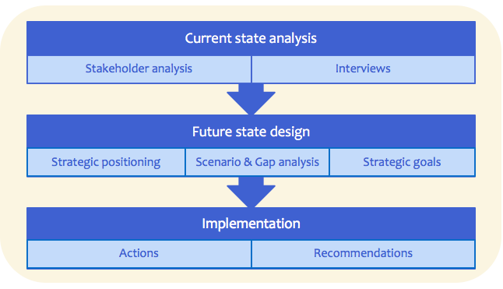
Fig. 2 − Procedure of the strategy preparation reflecting to the structure of the deliverable.

Cornerstones of EOSC-hub
The raison d´être for EOSC-hub, as set in the Grant Agreement no. 777536, states that
Mission:
The EOSC-hub project mobilises providers from the EGI Federation, EUDAT CDI, INDIGO-DataCloud and major research e-infrastructures offering services, software and data for advanced data-driven research and innovation. These resources are offered via the Hub - the integration and management system of the European Open Science Cloud (EOSC-hub Grant Agreement no. 777536 2017)
The Grant Agreement continues the mission statement by suggesting that the Hub should be acting as a single-entry point for all stakeholders. This idea of a single-entry point, however, is met with reservation since the EOSC-hub users, i.e., researchers, research groups, collaborative research organisations and even industry, would expect to be able to access services (e.g. data, computing and thematic services) using their existing tools and methodologies. The fact that the current practices of the user communities should not be disrupted was also highlighted in conversations with the EOSC-Hub Strategy Board members. The EOSC Strategic Implementation Roadmap 2018-2020 (European Commission 2018b) suggests that EOSC should aim at a federated model offering a universal entry point ('EOSC portal') which did not exclude other access channels. The positioning of EOSC-Hub will therefore be revisited on this basis in Chapter 4.
The fundamental principles and values to be honoured and pursued within EOSC-hub are articulated in the EOSC Declaration (European Commission 2017). It puts across a strong commitment, expressed by the EOSC-hub participants, to the common culture of data stewardship and FAIR principles, e.g. to make data Findable, Accessible, Interoperable, and Reusable. It also displays a firm dedication to develop user driven data infrastructure commons, determined by emerging use cases and needs of the research communities. Therefore, the spirit of the EOSC Declaration and the FAIR principles strongly guide all strategic goals setting and permeate through all subsequent implementation actions.
The vision of EOSC-hub, as stated in the Grant Agreement, aspires the following future:
Vision:
Researchers from all disciplines have easy, integrated and open access to the advanced digital services, scientific instruments, data, knowledge and expertise they need to collaborate to achieve excellence in science, research and innovation. (EOSC-hub Grant Agreement no. 777536 2017)
The vision pursues interoperability and removal of fragmentation while also demanding widening and simplification of access to services to all user groups, including researchers, higher education and business organizations. Reaching the vision definitely requires technical integration and adoption of common standards, but also the human factors must be seriously taken into account. The vision calls for making data and infrastructure sharing the default. This means that building and nurturing common data stewardship, e.g. via training activities and commonly accepted policies, has a pivotal role and is a key prerequisite for success.

Stakeholders´ expectations
A concrete, executable strategy must always be grounded in the complexities that form the current state. Current state analysis is a critical step on the way towards strategic goals and towards necessary actions to achieve the vision. The current state analysis of the First EOSC-hub Strategy Plan utilised two complementary methods:
- individual interviews with all six representatives of the EOSC-hub Strategy Board (SB) nominated by the project in May 2018, and with additional six representatives from research infrastructures involved in EOSC-hub, and
- a review of stakeholder landscape based on available public data.

The interviews covered in outline the questions presented in Appendix I. The appendix also details the names and affiliations of the interviewees and the dates of the interviews. While 12 interviews can represent only an initial stakeholder engagement, they provided a lot of valuable input for shaping the EOSC-hub positioning.

Because the EOSC-hub Strategy Board only recently has started its work, and since the multiformity of the European research landscape offers many facets to be explored, the analysis at this point does not seek to detail the whole of the prevailing circumstances. It is also out of the scope of this document to undertake a full stakeholder analysis - this has already been done elsewhere in the project and documented as part of D3.1 Communications and Stakeholder Engagement Plan. Instead, we want to focus here on prime issues raised by those stakeholders who are expected to federate part of their infrastructures and resources to EOSC, as well as on those who will use and fund EOSC.
Research communities and their practises and ultimately individual users of the EOSC-hub services must take centre stage, although research infrastructures and e-Infrastructures tend to be the most perceptible parties of the Hub. Users are any individuals that primarily benefit from and use the EOSC services, provided by the service providers. Users can be researchers, research groups, collaborative research organisations or industry. They are generally interested in seamless access to resources, but they also require domain-specific expertise and advice for using most services. Many users are being served by their local, institutional, regional or national service provider where they get the best tailored expertise (for example when they want to access an institutional repository or perform some simulations on a high-performance computing platform). Only a few go to the European level, though this greatly varies according to the type of resources that are being looked for. Some resources such as telescopes, synchrotrons, or radars only exist as shared resources at European level. Despite heterogeneity of users, the Hub must seek means for a participatory bottom-up dialogue with the communities to serve them the best.
Research infrastructures (RI) are a key stakeholder group of EOSC. They may be based at a single location (single-sited), scattered across numerous sites and organisations (distributed), or provided via a virtual platform. They are rooted in an organised scientific community for which they have been built over the years. National and European projects, thematic platforms constituted of services, tools and various resources support their community. They are generally positive towards EOSC but want also to make sure that the investment they have made to establish practices and standards within their own community will not be overwritten by EOSC developments or that the integration into EOSC will be done at a reasonable cost. Many research infrastructures (e.g. in the fields of climate science, astrophysics, etc.) are operating at a global level and cannot easily change standards or abide to technical constraints that are mostly decided at European level. Research infrastructures’ expectations with regard to EOSC significantly vary across initiatives. Some expect new services from EOSC, while others see it as a way to expose their data and services to new users. Several research infrastructures participate in EOSC-related projects, including EOSC-hub.
e-Infrastructures, here mostly understood as the pan-European infrastructures, have been established following projects funded by the European Commission over the two last decades in the area of networking (GEANT), high throughput computing (EGI), high performance computing (PRACE), and data management (EUDAT, OpenAIRE). E-infrastructures have been operating largely in silos, each focusing on a specific part of the e-Infrastructure stack (network, computing, data, and storage), with limited interoperability and cross-infrastructure collaboration (with the notable exception of specific technical topics, such as security). EOSC is pushing for more collaboration between e-Infrastructures and these have been very present in the EOSC discussion from the very beginning, often trying to position themselves in a driving role within the emerging EOSC by organising workshops, writing papers and various other contributions. E-Infrastructures generally embrace the EOSC idea, hoping that it will ultimately benefit their community of users and strengthen their role and position within the ecosystem via the provision of services and resources for the future EOSC. EUDAT and EGI play a key role in EOSC-hub, while OpenAIRE drives the OpenAIRE-Advance initiative, and the two initiatives are often presented as the two pillars of EOSC. GEANT and PRACE are contributing to EOSC through their own projects and also from the European Data Infrastructure discussion. GEANT also has a role in EOSC-hub, contributing, e.g., to the area of procurement. All five e-infrastructures mentioned above are represented in the EOSCpilot project.
While it is very common to make the distinction between e-Infrastructures and research infrastructures, this dichotomy is not always relevant, as e-Infrastructures and research infrastructures share many common characteristics and also face similar problems. It is too simplistic to view their relationship through a mere customer / provider relationship as it is sometimes presented. In fact, both e-Infrastructures and research infrastructures serve a particular community of users and are therefore service providers. Many research infrastructures are also distributed - a feature commonly associated with e-Infrastructures - and federates various service providers which also need to be taken into account since their interests might not always coincide with those of the federation. By service providers we refer to any organisation that is providing a specific service. This service can be delivered as part of a pan-European infrastructure, or separately; or both. Service providers are interested in taking part in EOSC for many reasons, and it is generally expected that they will bring in or “open up” their services as part of the new EOSC framework. However, they will only do so if they can see a clear benefit in investing time and effort in EOSC, and some compensation with regards to the costs involved.
Governmental and funding agencies have a direct financial stake in EOSC as ultimate funders of the resources being created. Over the years they have been pushing for greater interoperability of services and data to optimise the use of resources and foster interdisciplinary research as a catalyst of scientific breakthroughs and innovations. Several countries and funding agencies are active in pushing the open science agenda and find in EOSC a natural outcome of this agenda. However, for the funders to adopt EOSC, the questions around business models and governance need to be resolved.

Strategic positioning of EOSC-hub within EOSC
The EOSC-hub strategy needs to adapt to the constantly changing landscape of EOSC and the interests of its stakeholders. The consolidation of ESFRI clusters as EOSC thematic platforms, funded through the INFRAEOSC-04-2018 Connecting ESFRI infrastructures through Cluster projects topic, will be a major element to take into account when designing the project’s strategy. To a large extent, it will be necessary that the clusters endorse the EOSC-hub strategy for it to be successful. Research infrastructures have spent decades building strong thematic platforms and organising their community of users, and are rightfully expecting that EOSC supports this effort and will add value to what already exists. Thus, the question of how to best connect the community platforms with the EOSC-hub framework is perhaps the most important one to address.
On 14 March 2018, the European Commission released a staff working document entitled the EOSC Implementation Roadmap which presents EOSC as “a pan-European federation of data infrastructures built around a federating core and providing access to a wide range of publicly funded services supplied at national, regional and institutional levels, and to complementary commercial services” (European Commission 2018). The document, which takes into account the concerns of some stakeholders over the idea of a monolithic, centralised EOSC, envisages a gradual process of federation of resources. Data infrastructures (the term is being used to include both e-Infrastructures and research infrastructures) would enter the federation on a voluntary basis and would define the extent of their own involvement in the federation, in terms of the data sets and services they would contribute to the EOSC. The Roadmap also calls for giving users the choice between multiple entry points for accessing EOSC services, and states that data infrastructures that already have the capacity, capability, commitment and added value to facilitate or coordinate EOSC operations at a geographical or thematic level could seek to become EOSC federated centres.
These elements must be taken into account by the EOSC-hub project whose positioning in the overall EOSC (and with regards to the research infrastructures and the emerging EOSC thematic platforms) needs to be further clarified.
Strategic vision – EOSC-hub as a shared hub for accessing open data and services
Providing seamless access to all the data and services that researchers might need in order to pursue their research should be an overall objective of EOSC. Yet, there are various ways to achieve this objective.
We propose here a vision where the EOSC stakeholders, in particular data and service providers, collaborate to establish the Hub as an access channel to data and services - coming both from research infrastructures and e-Infrastructures - which are made “open” to the entire research community. The Hub would be used by researchers, research communities and service providers in a bi-directional way:
- to open up data and services to new users
- to discover and use new generic and thematic services

This bi-directional mode of operations is illustrated in Figure 3. For the sake of simplicity, Figure 3 omits those cases where research infrastructures and e-Infrastructures interact with each other directly outside EOSC-hub.
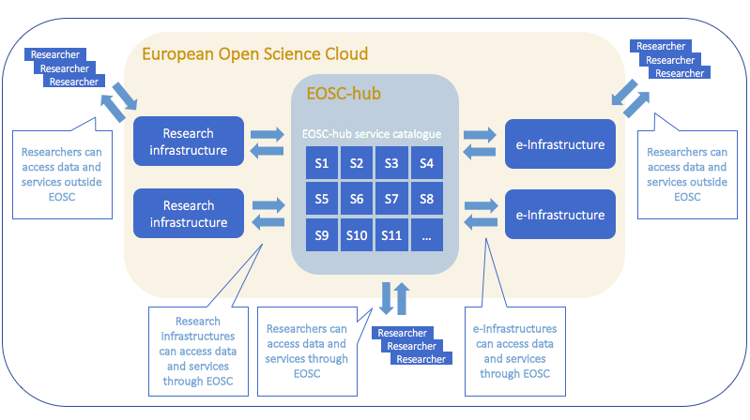
Fig. 3 − EOSC-hub as a shared hub for accessing open data and services. For the sake of simplicity, the figure omits those cases where research infrastructures and e-Infrastructures access each other’s services directly outside EOSC-hub.
Thus, the Hub will make available a wide set of services to a broad range of research communities and support access to these resources.
This direction is currently being pursued by the project which integrates several generic services and a few thematic ones brought by research communities’ providers willing to bring in some of their services as part of the Hub and its marketplace. For it to succeed, the positioning of the Hub with regard to other thematic platforms (such as those being operated by the research infrastructures or emerging as part of the ESFRI clusters or research communities that do not currently contribute to the EOSC-hub thematic services) will need to be further spelled out, in particular the division of roles and responsibilities as well as the business model for contributing thematic platforms to the Hub. It is likely that the research infrastructures will want to remain in control of their own delivery and access channel to serve their organised user base. Indeed, it is the best way to ensure that users optimally make use of the resources provided by the infrastructures, which often come with strong, tailored support requiring very domain-specific knowledge.
EOSC-hub must be able to articulate a clear value proposition to these platforms, which may be different according to the community. Mature research infrastructures and service providers might be interested in opening up some of their services and data beyond their constituted community. Indeed, the Hub would be the right place to promote these resources and facilitate their access, by providing the necessary underlying services (e.g. storage, computing) for the new user to efficiently manage these resources. For less organised research communities, the Hub will offer a unique platform to promote (and potentially manage) services, thereby enhancing the efficient use of infrastructure.
The extent to which services and data which are not “open” should also be in the focus of the Hub is still under discussion. Should the Hub primarily give access to services that are being made open and available beyond the initial community, i.e. to new users, or should the Hub include all sorts of services including closed services without asserting any preference for one or the other group? This deliverable states that the primary function of the Hub should be to give access to open services and data and that there would be little value for now for the Hub to advertising services which are closed or cannot be used outside the community of origin. In fact, we assume that there would be little value for communities to access their services through the Hub. However, this may change over time, with the Hub becoming a mature platform which provides capacities for scaling out existing services. In this case, communities could see more interest in accessing their services through the Hub rather that their usual thematic platform.
For the EOSC-hub vision to happen, the following development areas need to be in the focus of the project:
Architecture: The project shall collaborate with the other EOSC-federated centres to establish a common EOSC platform including a set of rules and principles for managing services and research data across the EOSC ecosystem. Initial discussions are taking place within the EOSCpilot project and are expected to be implemented as part of the future EOSC governance. The EOSC-hub project could use the project’s Strategy Board to initiate discussions with ESFRI clusters over the establishment of an EOSC federating core supporting the EOSC federated centres.
Data capabilities: According to the Implementation Roadmap for the European Open Science Cloud (European Commission 2018a), the capability to describe a dataset and/or a service using common metadata will be a prerequisite for being referenced in the EOSC catalogues of datasets and services. The project shall nurture common data stewardship, e.g. via training, education and capability building activities, to ensure a proper oversight of data assets and to help providing users with high-quality data that is easily accessible in a consistent manner. These activities should have a specific focus on next generation research communities.
Services: At technical and policy level, the project shall make sure that the existing instruments that will be used to publish services and data (e.g. marketplace, software and metadata catalogues) as part of the Hub are fully operational and fit for purpose, and that the rules of participation for publishing data sets or services are clearly understood. Promoting a service or dataset through EOSC-hub should be done with very little effort for the service providers.
Access and interfaces: The project shall take an active role in the discussion on access and interfaces. In particular, the project should prioritise the discussion about and the promotion of metadata standards, in collaboration with the EOSCpilot, ESFRI clusters and Research Data Alliance. The project should also address the development needs of services (in collaboration with the EOSCpilot and eInfraCentral project) to facilitate data and service findability, cross-reference and interoperability between data catalogues across disciplines.
Business model: The project shall also address the question of business models for opening up services. The current instruments in use (e.g. Virtual Access) only compensate a minor fraction of the costs involved in providing a service and, in the absence of better models, the project should create incentives to attract services in the Hub. Furthermore, the value proposition of the Hub needs to be clearly spelled out. It must be based on a review and analysis of the benefits, costs, and value that EOSC-hub can deliver to its prospective customers, and other constituent stakeholders within and outside the Hub.
Stakeholder engagement: The project shall pursue an active engagement strategy with all stakeholder groups (e.g. ESFRI clusters, other user communities, service providers, governmental and funding agencies) to discuss concrete requirements, operational agreements and governance, in the spirit of co-creation, reuse and adaptation. It is crucial to create a genuine feeling of ownership of the discussion and of the common future. While it is agreed that EOSC will be made of several federations, the operational model to run these federations in a coordinated way still need to be invented.

Contribution of EOSC-hub to the EOSC Implementation Roadmap
The Commission Staff Working Document on the Implementation Roadmap of the European Open Science Cloud released in March 2018 (European Commission 2018a), presents the outcome of the exploration of appropriate governance and financing mechanisms for EOSC in the form of an implementation roadmap. It is based on six strategic action lines: (a) architecture, (b) data, (c) services, (d) access and interfaces, (e) rules, and (f) governance.
As already remarked in Chapter 1, EOSC-hub is a key instrument to achieve advancements in these action lines. The Hub contributes to the action lines through the following roles:
- [Architecture] Role 1 EOSC Service Integrator. EOSC-hub provides a framework to manage services sourced from a number of service providers, and plays the role of service integrator.
- [Data] Role 2 Facilitator of FAIR Data Discovery. EOSC-hub provides a discovery and access channel to FAIR-accredited datasets. (Development of FAIR data accreditation / certification scheme for repositories by Q4/2019 is suggested in European Commission 2018a, p. 13).
- [Services] Role 3 Service portfolio manager. EOSC-hub contributes to the definition of a participatory and lightweight service portfolio management process in collaboration with the participating service providers.
- [Access and Interface] Role 4 Aggregator of demand and supply. EOSC-hub engages with the demand and supply side of the EOSC, and co-develops and operates a marketplace as one entry point to EOSC.
- [Rules of Participation] Role 5 Maintainer of a corpus of Rules of Participation. EOSC-hub collaborates with partners and external projects / initiatives to establish and maintain a corpus of policies that is inclusive and provides value for both service providers and service users.
Role 1. EOSC Service Integrator
With its service providers, EOSC-hub defines and provides an initial set of EOSC federating core services, processes and policies that altogether aim at enhancing the management of the end-to-end supply chain, and provides governance, management, integration, assurance and coordination to maximize the value received.
The service integrator role is delivered in a collaborative fashion by EGI and EUDAT, involving customer organizations and service providers.
This role responds to the EOSC requirement that it should be a “federation of existing and planned research data infrastructures, adding a soft overlay to connect them and making them operate as one seamless European research data infrastructure” (European Commission 2018a, p. 9).
The service integrator acts as a single logical entity which provides end-to-end delivery of services and the business value that the customer receives. The service integrator is accountable for end-to-end service governance, management, integration, assurance and coordination.
The service integrator has a management relationship with customer organizations, and manages the relationships with service providers through a number of processes like business relationship management, service portfolio management, quality assurance etc.
The service integration capabilities are supported by services and activities, such as the Service Portfolio Management Tool for portfolio management, accounting for service capacity management, monitoring for end-to-end service level reporting, the marketplace and for SLA management and order management, the helpdesk for multi-supply service order and incident management, the CSIRT for IT security management. These contribute to the EOSC federating core.
Role 2. Facilitator of FAIR Data Discovery
Data resources and products from participating providers will be discoverable and accessible through EOSC-hub. As FAIR data certification schemes become available, EOSC-hub will provide the capability of onboarding new data providers that are available “to operate in the EOSC according to FAIR data principles and seek to become FAIR-accredited/certified entities” (European Commission 2018a, p. 8).
Data discovery and access capabilities will rely on EUDAT B2FIND metadata catalogue and other registries of repositories, as well as community-specific data discovery and access tools that are part of the EOSC-hub catalogue. Generic data management and compute services will be made available to end users to access, stage and analyse data from FAIR-compliant sources. By doing so, the project will respond to the need of supporting on-demand “data sharing, management and computing” and tracking user demand.
Through this EOSC-hub will facilitate findability through “catalogues of data/services and metadata” (European Commission 2018a, p. 13).
Role 3. Service Portfolio Manager
It is envisaged that EOSC will pool national/regional/international facility providers and provide access to a large range of resources and services. In collaboration with the participating providers, EOSC-hub will define and adopt a service portfolio management process that defines the policies and procedures to:
- Maintain the service portfolio so that all services are specified, including the planning, the design and transition of new or changed services, including timescales, responsibilities, new/changed technologies, communication and service acceptance criteria, through a service roadmap that is updated annually.
- Survey user communities to identify their current and potential needs in terms of services.
- Collect, assess and document services currently provided by e-Infrastructures and research infrastructures, map offer against demand, identifying gaps, i.e. needs that are partly or not covered at all.
- Identity the organizational structure supporting the delivery of the services, including the EOSC federation structure as well as contact points for all parties involved.
- Monitor and assess service use, review/adapt delivery model, call for integration of new services; prototype and test new services in a collaborative manner with research communities.
- Review the service provider performance and conformance to the EOSC Rules of Participation for providers.
- Define procurement and delivery model(s) for services, and identify actors and resources needed.
Role 4. Aggregator of demand and supply
EOSC-hub will engage with the demand and supply side of the EOSC, and will co-develop and operate a marketplace as one entry point to EOSC, supporting customer and supplier relationship management and other customer and supply based processes, and will co-develop with research communities the policies and tools that enable federated access and supply.
The marketplace is a component of the “common platform” called for by the EOSC Implementation Roadmap, which will include several components, tools, services, policies, agreements and the business processes needed to deliver and consume services and resources in EOSC, through different access models. The common platform will be further defined together with a number of other projects and collaborating infrastructures defined in the roadmap, in particular with other infrastructures already providing community-specific access channels.
Different access policies (e.g. sponsored access, policy-based access and pay for use access) will be supported to enable different business models.
Role 5. Maintainer of a corpus of Rules of Participation
With input from collaborating projects and initiatives, EOSC-hub will collectively gather and maintain a corpus of Rules of Participation to the Hub. This will be a collaborative effort involving data and service providers, with a major role expected from initiatives responsible for defining FAIR certification guidelines and frameworks. EOSC-hub will provide a framework of service/resource-specific procedures for lightweight quality assurance, for example through the periodic auditing of conformance of the participating providers.
This activity responds to the EOSC need to establish “good practices of multi-stakeholder governance of large-scale scientific infrastructures” (European Commission 2018a, p. 15).
EOSC-hub aims to establish a Hub that is inclusive and provides value for both service providers and service users. At the same time, the Hub must ensure that providers meet certain level of quality and guarantee a service interoperability in order to provide added value for end users.
The Rules of Participation will define the conditions for service providers to offer services through the Hub. They will take into account different perspectives, for example technical, operational, legal and financial:
- Operational rules: Requiring service providers to implement a certain level of Service Management.
- Technical rules: Requiring service providers to meet certain functional capabilities.
- Legal and financial rules: Requiring the providers to meet compliance requirements (e.g. GDPR) and to guarantee the sustainability/continuity of the service.
The Rules of Participation will foresee different levels of integration with the Hub. Requirements to join the Hub with the lowest level of integration should be minimal to attract diverse providers from different disciplines and stakeholders.

Scenarios and ensuing development needs
The strategic positioning of EOSC-hub, as described in Chapters 4 and 5, is likely to be impacted by several factors and phenomena that are out of the control of the project. We take advantage of scenario analysis in order to identify such factors and to anticipate potential issues and risks they might entail. Scenario analysis follows a systematic process to create a set of plausible and vividly contrasting narratives that describe possible evolutions of uncertainties. They are neither dependent on past results, e.g., they are not prognoses, nor are they variants that EOSC-hub can pick and choose. They are defined by external factors outside the Hub’s circle of influence and we just need to deal with them.
Scenario analysis can be adapted to enhance strategic planning at a number of stages. In this connection, we use the method to provide plain conditions to investigate macro-environmental forces and their impact on the EOSC-hub positioning and its viability. These forces can originate from social (S), political (P), economic (E), legal (L), and technological (T) impulses. When viewing the suggested strategic positioning of EOSC-hub through the prism of macro-environmental forces, distinct scenarios emerge as colours of a spectrum. These scenarios provide insight for understanding gaps between the current state and the aspired future, and thus, assist in deducing well-reasoned strategic goals and actions to fulfil the EOSC-hub strategic vision as outlined in Chapters 4 and 5. Figure 4 illustrates this approach.
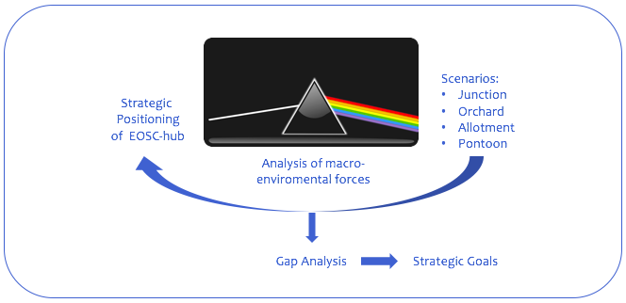
Fig. 4 − Scenarios to help identifying gaps and deducing the strategic goals (Picture: CC0 Creative Commons, Pixabay 2018)

There are two key variables that greatly qualify the macro-environment of EOSC-hub, and thus are of particular interest:
- The extent to which interdisciplinary practices will develop
- The extent to which commitment to European approach exists

When these variables change from non-existent to high extent, four distinctive scenarios result, reflecting different scenes and effects on EOSC-hub. We call them Junction, Orchard, Allotment and Pontoon and present their key characteristics in Figure 5. In Allotment and Orchard scenarios the interdisciplinary practices appear fairly mature vis-à-vis the two other scenarios, but Allotment emphasises national approach over European approach which is more characteristic to Junction. At the same time, Orchard and Junction scenarios demonstrate firmer commitment to pan-European services than the two other scenarios, meaning that Pontoon represents the most isolated future state.
The scenarios suggest different needs of progress (gaps) that must be addressed in order to reach the strategic positioning described in Chapters 4 and 5. While representing the world of big disciplinary flagships and strong commitment to European approach, the Junction-like future highlights the importance of solving access and interface issues as well as the stakeholder-driven development of services. Being strongly committed to FAIR principles and removal of inter-disciplinary fragmentation, the Orchard-like future still raises the question of how to build sustainable business models, rules of participation and governance models. In the Allotment-like future national or regional approach would be favoured which means that consolidation of data capabilities and common data stewardship would become an issue. In the Pontoon-like future both disciplinary and geographical isolation predominates, urging attention to the development of common architecture and services. Figure 5 presents the gaps respective to scenarios.
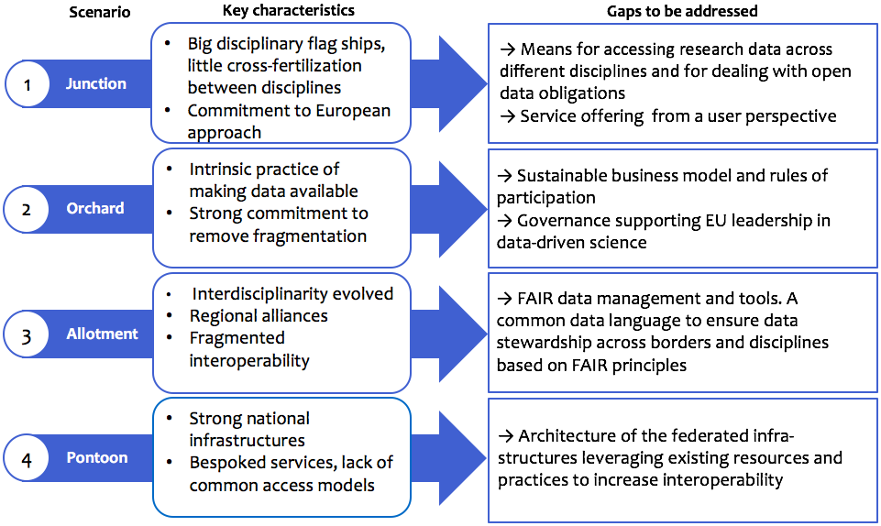
Fig. 5 − Scenarios and identified gaps to be addressed.
While scenarios always emphasise distinctive features of possible futures, it is conceivable that the real future to come true will simultaneously contain elements from every scenario. Therefore, the strategic goals and actions to be set in the next Chapter need to consider how to respond to all of them and how to address each of the identified gaps:
- Development of common architecture and services
- Consolidation of data capabilities and common data stewardship
- Stakeholder-driven development of services
- Access and interface issues
- Sustainable business models, rules of participation and governance models

The full scenario analysis supporting the reasoning above is presented in Appendix II.

Strategic goals and recommended actions
The analysis of the current state in Chapter 3, the discussion on the positioning of EOSC-hub within EOSC in Chapter 4, the discussion on the EOSC-hub contribution to the EOSC Implementation Roadmap in Chapter 5, and the analysis of the issues inherent in different futures in Chapter 6 were all carried out to eventually help developing well-reasoned and far-reaching, yet achievable strategic goals for EOSC-hub. In order to be sound, the goals must fulfil three specific requirements:
First, they shall reflect and pursue the EOSC-hub strategic vision, as outlined in Chapter 4. They shall also support the fundamental roles that the EOSC-hub project should take to ensure a stable implementation of EOSC, as presented in Chapter 5. With respect to this, the goals should address the following development areas, also identified in the scenario and gap analysis in Chapter 6:
- Architecture
- Data capabilities
- Services
- Access and interfaces
- Business model
- Stakeholder engagement

Secondly, they shall reflect the vast previous input for the project, including the Implementation Roadmap for the European Open Science Cloud (Commission 2018a), EOSC Strategic Implementation Roadmap 2018-2020 (Commission 2018b), the EOSC Declaration (European Commission 2017), the Rules of Participation for the access to the EOSC, the FAIR data principles and the deliverables of the EOSCpilot project concerning the EOSC governance as well as the objectives laid in the Grant Agreement (EOSC-hub Grant Agreement no. 777536 2017).
Thirdly, they shall carefully reflect the opinions of the stakeholders, particularly those of the research communities as future customers of EOSC-hub.
The following six strategic goals, qualifying for these requirements and supported by the analyses, are set to move the needle on the strategic vision (see also Figure 6):
- Organise and operationalise an inclusive EOSC-hub (EOSC federating core)
- Strengthen digital capabilities, expertise and adoption of the FAIR principles
- Co-create and integrate open and user-driven services and solutions
- Facilitate exploitation of research data and decrease service fragmentation
- Prototype a EOSC business model and procurement
- Build a sustainable and participatory mode of operations for stakeholder dialogue
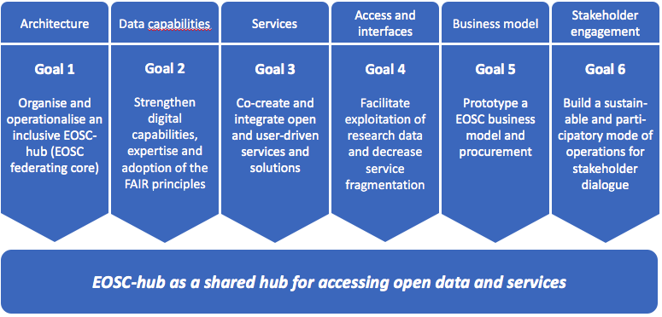
Fig. 6 − Strategic goals for EOSC-hub project to achieve its vision.
Splitting the strategic goals into tangible actions is necessary to initiate implementation, keep the right course and to mitigate deviation. A portfolio of recommended actions, that concretises the goals and clarifies the respective actors and stakeholders, is presented in Figure 7. Furthermore, Figure 8 aligns the actions into a timeline. These actions serve as a communication tool and acts as a focusing device that marshals efforts to achieving the goals.
SG1  Architecture  Organise and operationalise an inclusive EOSC-hub (EOSC federating core) | Recommended actions | Actors and stakeholders
 | A1.1 We federate existing data infrastructures and resources, i.e. data storage, management and analytics services, simulation and visualisation services, distributed computing services, discipline-specific thematic services and scientific products from national and community infrastructures at European scale and beyond. We define and provide an initial set of EOSC federating core services (e.g. accounting, monitoring, service portfolio management tool, marketplace, help desk, processes and policies). We implement EOSC-hub as a standard-compliant integrated service management system and make sure that the existing instruments used to publish services and data (e.g. marketplace, software and metadata catalogues) are fully operational and fit for purpose as part of the Hub. | Actors: WP4, WP5, WP6, WP10  Stakeholders: e-infras, RIs, Service providers
 | A1.2 We adopt a unified service management standards in IT service provision, encompassing service planning, delivery, operation and control across all services of the EOSC-hub catalogue. We lower operational costs by joining or removing duplicates in operational and support processes. | Actors: WP4, WP5, WP6, WP10  Stakeholders: Service providers
 | A1.3 We operate services on top of the federated infrastructures to the benefit of research communities and contribute research/scientific products to EOSC Hub. | Actors: WP7, WP8  Stakeholders: Service providers
 | A1.4 We define open and collaborative EOSC-hub governance leveraging existing service management practices and EOSCpilot guidelines. Furthermore, we ensure that the rules of participation are clearly understood, and the service provisioning and access policies are harmonized across major services and resource providers. | Actors: WP2, WP10  Stakeholders: e-Infras, RIs, Service providers
SG2  Data capabilities  Strengthen digital capabilities, expertise and adoption of the FAIR principles | Recommended actions | Actors and stakeholders
 | A2.1 We enhance common specifications and tools to make data FAIR and solutions to ensure legal compliance (in particular GDPR and cybersecurity laws). We facilitate adaptation and integration toward the goal of FAIR data and solutions. | Actors: WP2, WP10, WP11, WP13  Stakeholders: RIs, user communities
 | A2.2 We organise training, education and capacity building with a specific focus on next generation research communities. We support the networking of experts and form dedicated competence centres, when appropriate, to support the research communities. | Actors: WP8, WP11  Stakeholders: User communities
SG3  Services  Co-create and integrate open and user-driven services and solutions | Recommended actions | Actors and stakeholders
 | A3.1 We provide and manage an initial EOSC Service Portfolio. We support thematic services for opening up existing services to new communities. We define and provide an initial catalogue of services and datasets via the EOSC. We define delivery and access model(s) for services, and identify gaps, i.e. needs that are partly or not covered at all. We set up regular monitoring and assessment of service used. | Actors: WP2, WP6, WP7  Stakeholders: Service providers
 | A3.2 We provide non-discriminatory access to common core services and building blocks for developing new, added value services with research communities and technology providers. We co-design services and co-develop technologies that enable the delivery of solutions on top of the federated infrastructure. Solutions are open in the sense that open standards are adopted when possible and re-use is facilitated. | Actors: WP7, WP9, WP10  Stakeholders: Service providers, e-Infras
 | A3.3 We run a Digital Innovation Hub to provide industry partners with access to the latest knowledge, expertise and technology to support their customers with piloting, testing and experimenting with digital innovations. | Actors: WP9  Stakeholders: Service providers
 | A3.4 We mainstream Open Access to research results. We offer services for research data discoverability, an application store where cloud virtual appliances can be freely registered and shared as research objects linked to publications, to be executed on a distributed cloud environment for reproducibility of science. These will be achieved in collaboration with OpenAIRE. | Actors: WP8, WP11, WP13  Stakeholders: RIs, user communities
 | A3.5 We enable data-intensive research in secured virtual environments for Open Science. We enable big data solutions in secured virtual environments to generate smart solutions for analysing complex data from different sources. | Actors: WP6, WP9, WP10 Stakeholders: RIs, user communities
SG4  Access and interfaces  Facilitate exploitation of research data and remove service fragmentation | Recommended actions | Actors and stakeholders
 | A4.1 We pursue common metadata specifications and catalogues to agree on common, minimal, rigorous and machine-readable metadata specifications for the description of: a) services and b) datasets, federated to the EOSC. We make them available on a common federated catalogue of services / datasets. We co-work with eInfraCentral, EOSCpilot, Research Data Alliance (RDA) and the ESFRI clusters in this. | Actors: WP2, WP7, WP10, WP11  Stakeholders: RIs, user communities
 | A4.2 We provide an access point and routing system towards the resources of the EOSC that complements the access mechanisms in use at different data infrastructures. We develop the marketplace that serves as online platform to the future EOSC to experiment approaches and processes to the implementation of the EOSC business delivery channels. We co-work with EOSCpilot and the ESFRI clusters in this. | Actors: WP6, WP10, WP13, EOSCpilot project  Stakeholders: RIs, e-Infras
 | A4.3 We support a universal entry point (the EOSC portal) to the EOSC service and data gateways, accessible by all potential users via a full-fledged functional/comprehensive user interface, irrespective of geographic location or scientific affiliation. We co-work with eInfraCentral to support the future work of INFRAEOSC-06(a) project. | Actors: WP6, WP10, WP13  Stakeholders: RIs, e-Infras
 | A4.4 We help major data infrastructures to become available for dissemination and exploitation in Open Science. | Actors: WP13, WP10  Stakeholders: RIs, e-Infras, user communities
SG5  Business model  Prototype a EOSC-hub business model and procurement | Recommended actions | Actors and stakeholders
 | A5.1 We develop the know-how and prototype procurement and purchasing framework that interested organisations can use to acquire digital services from either publicly funded infrastructures or commercial providers. | Actors: WP12, WP8  Stakeholders: RIs, e-Infras, service providers
 | A5.2 We create incentives to attract services in the Hub and to facilitate access to new users to resources and services. | Actors: WP12, WP3  Stakeholders: RIs, e-Infras, service providers
 | A5.3 We define the value proposition of the Hub, based on a cost-benefits analysis, and value that EOSC-hub can deliver to its prospective customers, and other constituent stakeholders within and outside the Hub. | Actors: WP12, WP3  Stakeholders: RIs, e-Infras, service providers, funding agencies
SG6  Stakeholder engagement  Build a sustainable and participatory mode of operations for stakeholder dialogue | Recommended actions | Actors and stakeholders
 | A6.1 We establish and maintain an active engagement strategy with ESFRI clusters and other user communities to discuss concrete requirements, operational agreements and governance, in the spirit of co-creation, reuse and integration. | Actors: WP2, WP3  Stakeholders: SB, PMB, e-Infras, RIs, user communities
 | A6.2 We build practical communication modes with service providers to discuss concrete requirements and operational performance and to leverage technological roadmaps in the spirit of co-creation, reuse and integration. | Actors: WP2, WP3, WP4  Stakeholders: SB, PMB, e-Infras, service providers
 | A6.3 We set up regular consultation scheme of funding bodies to ensure that the EOSC-hub strategies and the expected return on investment are aligned. | Actors: WP2, WP3  Stakeholders: SB, PMB, gov. and funding agencies

Fig. 7 − Strategic goals and recommended actions for the EOSC-hub project. The notification WP[number] refers to the respective work package of the EOSC-hub project.

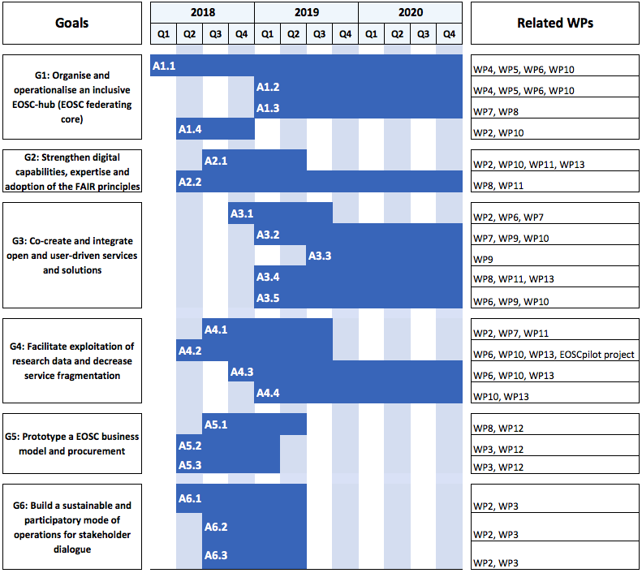
Fig. 8 − The strategic goals and recommended actions aligned into project’s timeline.
While the strategic goals give clear directions towards the vision, they should also be understood as lenses through which to observe changing circumstances and make prudent adjustments. In this way, the strategic goals become a template for decision making within the EOSC-hub project and a way to help staying optimally attuned to the stakeholders’ needs. Strategic planning, as a rule of thumb, is not so much to be right, as to be ready. Therefore, the recommended actions will be reviewed and updated regularly in compliance with what the stakeholders expect EOSC-hub to become.

References

No | Description/Link
R1 | EOSC-hub Grant Agreement (2017), grant no. 777536, 2018-2020.
R2 | European Commission (2018a), Commission Staff Working Document: Implementation Roadmap for the European Open Science Cloud, 83 final. Available: https://ec.europa.eu/research/openscience/pdf/swd_2018_83_f1_staff_working_paper_en.pdf
R3 | European Commission (2018b), EOSC Strategic Implementation Roadmap 2018-2020. Available: https://ec.europa.eu/research/openscience/pdf/eosc_strategic_implementation_roadmap_large.pdf
R4 | European Commission (2017), EOSC Declaration. Available: https://ec.europa.eu/research/openscience/pdf/eosc_declaration.pdf

- Stakeholder consultation – Interviews
Interviews with EOSC-hub Strategy Board members

Interviewee | Affiliation | Date of the interview
Niklas Blomberg | ELIXIR and Life Sciences RIs participating in CORBEL (and EOSC-life project proposal, if positively evaluated) | 21.5.2018
Serge Bogaert | PRACE e-Infrastructure | 31.5.2018
Ron Dekker | CESSDA (and RIs participating in the future Social Sciences and Humanities project proposal cluster, if positively evaluated) | 23.5.2018
Andrew Gotz  Jean-Franҫois Perrin | ESRF and Neutron and Photon Research Infrastructures (and RIs participating in the PaNOSC project proposal, if positively evaluated) | 25.5.2018
Giovanni Lamanna | CTA and Astronomy, Astrophysics and Astro-particle Physics RIs participating in ASTERICS (and future Astronomy and Physics clsuter project proposal, if positively evaluated) | 25.5.2018
Andreas Petzold | Environments Research Infrastructures, ENVRI community and ENVRI-FAIR project proposal consortium | -

Six additional interviews were carried out in March – April 2018 with the following representatives from research infrastructures involved in EOSC-hub:

- INFN: Davide Salomoni
- EPOS: Massimo Cocco
- INAF: Fabio Pasian
- EMBL-EBI: Steven Newhouse
- CLARIN: Dieter van Uytvanck
- DKRZ: Hannes Thiemann

These discussions dealt with the EOSC-Hub value proposition, what motivates the stakeholders, and what kind of EOSC-hub these stakeholders would see as attractive to them.

We are aware that this small number of interviews represents only an initial stakeholder engagement, given EOSC ambition to serve all EU researchers. Fulfilling the strategic goal 1 seek to remedy the situation.

Questions for the EOSC-hub Strategy Board

MISSION & VISION:

- Given the mission and vision stated for EOSC-hub in the EOSC-hub Grant Agreement no. 777536 2017, what benefits do you foresee from EOSC-hub for the research communities?
- What risks or challenges do you identify in the way that the mission and vision are currently stated?

CURRENT STATE

- Which elements of the current state should be protected if/when the key resources of your community were offered via EOSC-hub?
- Which elements require most urgently development? Which development needs could be addressed by EOSC-hub and which not?
- How could EOSC-hub the best articulate the community platforms? What would it require from each side?

OPTIONS

- What benefits and challenges do you foresee in each of the presented strategic options for EOSC-hub within EOSC? (Two options were presented at that point.)
- Which enablers / prerequisites do you see critical for the success of Options 1 and 2?
- How would you shape the Options 1 and 2 to better meet the demands of the user communities? Which elements should be emphasized?
- Please, give your comments about the preliminary set of the strategic goals.
- Any other feedback?

- Scenario analysis – EOSC-hub’s multiple futures
The future may appear in many different forms for EOSC-hub and some of the alternatives may contain parallel and overlapping features and many uncertainties. Some of the uncertainties can be impacted by the project, some of them not. As part of the strategy work and risk management, an analysis of EOSC-hub’s future scenarios will be conducted. Scenarios as used here, are describing potential futures given the unfolding of key uncertainties surrounding EOSC-hub. By defining scenarios, we thus make explicit that there is not a singular future that we can predict, but that the future is uncertain on which we, however, can anticipate. It should be noted that the scenarios are not variants that EOSC-hub as a project or organisation can pick and choose, but are defined by external factors outside its circle of influence that we have to deal with. As an organisation, we have options that are valid in certain scenarios, while in other scenarios these options may not work.
The two key external factors that will greatly impact the way that the EOSC - and by that EOSC-hub - will develop are:
- The extent to which interdisciplinary practices will develop
- The extent to which commitment to European exists (Figure 9).

Examining the effects of the macro-environmental forces, such as social (S), political (P), economic (E), legal (L), and technological (T) forces, on EOSC-hub as these factors change from one extreme to another provides us four scenarios with distinctive characteristics. We call them Junction, Orchard, Allotment and Pontoon and present them here below. The central strategic questions to be posed in regard to these different scenarios are:
- How do we implement the de facto EOSC?
- How do we bring the current e-infrastructure landscape into the EOSC paradigm?
- How do we build the EOSC our users need?
- How do we build the EOSC that we want?

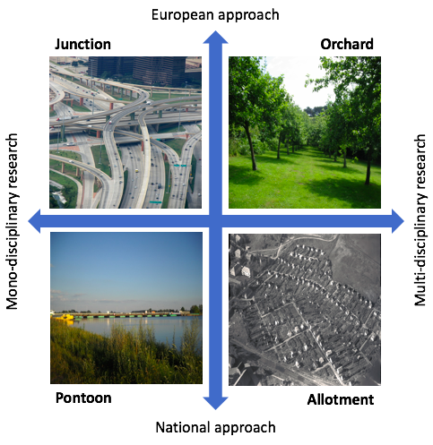
Fig. 9 - EOSC-hub scenarios. (Pictures: Wikimedia Commons)
Scenario 1: Junction
(S) Research is organised in big disciplinary flag ships aimed at generating breakthrough innovations. Research output is available in line with Open Science policies, however only really usable within communities. Between the flag ships there is virtually no cross-fertilisation.
(P) Member states are committed to a European approach and national research priorities are aligned with the European level. National e-Infrastructures are given the mandate to supply within the context of the European Open Science Cloud.
(E) Research infrastructures are procuring services from the pan-European infrastructures that provide a mix of federated resources funded at the member state level and commodities supplied by the commercial sector. A transaction mechanism exists that compensates service providers for services rendered consistently across publicly funded and commercial service providers, and is transparent to the end user.
(L) The European Open Science Cloud has evolved into a true Single Digital Market for research services. Legal and regulatory obstacles with regard to cross-border funding, ownership and liability have been overcome by the establishment of an ERIC. There are hard requirements for service providers that ensure both allocative and productive efficiency from public service providers as well as potential erosion by commercial offering, e.g. predatory pricing, market monopolisation and Open Science principles.
(T) Technological developments with the EOSC are focussed on service interoperability allowing seamless connectivity between compute and data processing junctions. This has led to a fairly solid core allowing for seamless service provisioning to researchers and deduplication of enabling services.

Scenario 2: Orchard
(S) Interdisciplinary research is the norm. An intrinsic practice of making data available exists allowing for the reuse of data outside its origins and data-driven science. Data is abundant and flows freely. In this environment, for a researcher the reuse of data for the application of his or her specific research is as smooth as is gathering or generating it.
(P) There is a strong belief amongst policy makers both in Brussels as well as at the member state level, that Europe can only be competitive by tackling knowledge circulation at the European level and remove any compartmentalisation, whether it being disciplinary, academic, public or private.
(E) The core good in the European Open Science Cloud is data. It is considered a public good in sense that all data is open and non-exclusive. All others, e.g. research projects, services, etc. are considered derivatives in the ambition to establish a rich and open data landscape. Research funding models include budgets to cover the marginal costs to properly disseminate data and ingest as part of further research. However, the market-driven funding model is insufficient to sustainably fund the data orchard. To this end, the foundation layer is funded by a large public-private partnership (3P) complementing the development of EuroHPC.
(L) The 3P is, however, not set up as an ERIC as the focus is outside research. All data part of the EOSC is safeguarded against monopolisation - whether by academia or commercial parties.
(T) Technological developments are focused on data interoperability. Compute and network services have been moved to the utility layer. The focus is on eScience applications and expertise.

Scenario 3: Allotment
(S) While interdisciplinary research has matured, it has not yet taken off in the way it was envisaged. Collaboration is dependent on personal commitment of key players. Benefits of collaborations are mostly tacit or indirect, and big breakthroughs in the grand societal challenges have not yet been achieved.
(P) Member states consider the investment in services and data as a strategic asset to help support their industry and profile their knowledge economy. A European divide exists. There are several regional alliances that have formed resulting in three power blocks with a unified research policy: the Nordic Countries; Greece, Italy and Spain; and finally, Germany and The Netherlands with special arrangements with the UK. Access to research facilities and data outside these blocks is complex through incompatible policies and lack of political mandate to engage.
(E) Data management is a core component in any research funding call. Publicly funded research is dependent on private sector collaborations. The resulting data is used as currency in these public-private partnerships. Several long-term preservation facilities exist to achieve economy of scale for the data that are not catered for by an organised discipline. However, funding mechanisms vary and it is often unclear for research projects how to apply data access.
(L) Conditions and regulations have not been harmonised. For interdisciplinary research projects, this means a complex choreography.
(T) Data interoperability is fragmented. The organised disciplines (High Energy Physics, Astronomy, Life Sciences) have been able to agree on standards across the allotted European landscape. Other disciplines rely on ad hoc standards and market forces, as the public investments lack the scale to tackle the interdisciplinary interoperability.

Scenario 4: Pontoon
(S) While some successful examples of data sharing practices across disciplines and outside academia have been established, ultimately the investment required to achieve the necessary scale of reusable data was too far removed from everyday research practice, means and rigors to gain sufficient traction.
(P) The European Research Area (ERA) has been abandoned. Research infrastructure that already had a commitment of member states as part of their ERIC mandate, have been able to transfer this mandate into a post-ERA commitment.
On the e-infrastructure side, several strong national infrastructures have emerged (i.e. in Finland, Germany, Iberian area, the Netherlands, Switzerland, Italy and Poland) with the ambition to sustain some of the former e-infrastructure services for specific communities, e.g. WLCG, SKA, ELIXIR.
EOSC has fallen prey to the multitude of political ambitions that have been attached to it. Without realising the benefits of interdisciplinary research, public-private partnerships and efficient e-infrastructure organisation, member states have ultimately blocked the development of EOSC that was deemed to have a too centralized approach. Instead, the above-mentioned countries have re-allocated funds to reinforce their national infrastructures in line with their research priorities. Researchers who are not affiliated with communities or institutes that have good relationships with strong national infrastructures either build up their own infrastructure or partner with the market.
(E) Services are always developed bespoke and provisioning is part of temporary arrangements. E-infrastructure services are often provided in-kind under a political mandate. While this relieves the burden on research budgets for the use of facilities, it also makes for a brittle foundation of research infrastructures.
Access models to public e-infrastructures are unclear and without European access mechanisms, the threshold is often too high for foreign research to make use of infrastructures. Researchers making use of commercial services are reliant on PR and marketing budgets which are only available to the likes of Google, Microsoft, Amazon and Facebook. While these companies have the scale in terms of computational and data resources, for many research applications the eScience support is required. Sometimes this is provided by local universities or research institutes, but more often than not this burden is placed on a PhD student resulting in hidden costs for e-infrastructure support. This makes for a big gap for many of the mid tail applications.
(L) Not much has changed in the legal landscape. Harmonisation of rules and regulations has stagnated. Many of the data mandates have disappeared from funding criteria.
(T) Through the bespoke nature of many of solutions, very little standardisation has taken place. Standards that have emerged are result of market forces, where winner takes all comparable with the domination of Microsoft Office in the office productivity domain. In a few cases, national infrastructures have teamed up to share the burden of development costs and achieve productive efficiency.

More information: http://ec.europa.eu/programmes/horizon2020/en/h2020-section/open-science-open-access
Available: http://www.eosc-hub.eu
Available: https://ec.europa.eu/digital-single-market/en/european-cloud-initiative
Available: https://ec.europa.eu/research/openscience/pdf/swd_2018_83_f1_staff_working_pafper_en.pd
Available: https://ec.europa.eu/research/openscience/pdf/swd_2018_83_f1_staff_working_pafper_en.pd
Available: https://ec.europa.eu/research/openscience/pdf/eosc_strategic_implementation_roadmap_large.pdf
Available: https://ec.europa.eu/research/openscience/pdf/eosc_declaration.pdf
Available: https://www.force11.org/group/fairgroup/fairprinciples
Available: https://eoscpilot.eu/media/deliverables
More information: https://www.eosc-hub.eu/about-us
Available: https://ec.europa.eu/research/openscience/pdf/eosc_strategic_implementation_roadmap_large.pdf
Available: https://ec.europa.eu/research/openscience/pdf/eosc_declaration.pdf
Available: https://ec.europa.eu/research/openscience/pdf/swd_2018_83_f1_staff_working_paper_en.pdf
Available: https://ec.europa.eu/research/openscience/pdf/swd_2018_83_f1_staff_working_paper_en.pdf
More information: https://www.rd-alliance.org/rda-europe
Available: https://ec.europa.eu/research/openscience/pdf/swd_2018_83_f1_staff_working_paper_en.pdf
Available: https://ec.europa.eu/research/openscience/pdf/eosc_strategic_implementation_roadmap_large.pdf
Available: https://ec.europa.eu/research/openscience/pdf/eosc_declaration.pdf
Available: https://www.force11.org/group/fairgroup/fairprinciples
High Five By austrini [CC BY 2.0], via Wikimedia Commons. Gardîn à pommièrs Hamptonne Jèrri By Man vyi [Public domain], from Wikimedia Commons. Pontoon bridge in Sobieszewo By Karina Jarzyńska [CC BY-SA 3.0], from Wikimedia Commons. Lerkendal hagekoloni flyfoto By Unknown / NTNU UB (NTNU Universitetsbiblioteket) [CC BY-SA 3.0], via Wikimedia Commons.

