EGI-Engage

Risk analysis and risk response for Period 2
D 1.4

Date
Activity | NA1
Lead Partner | EGI.eu
Document Status | FINAL
Document Link

Abstract
The document describes result of risks registry review after one year of the project.

COPYRIGHT NOTICE
This work by Parties of the EGI-Engage Consortium is licensed under a Creative Commons Attribution 4.0 International License (http://creativecommons.org/licenses/by/4.0/). The EGI-Engage project is co-funded by the European Union Horizon 2020 programme under grant number 654142.
DELIVERY SLIP
 | Name | Partner/Activity | Date
From: | Małgorzata Krakowian | EGI Foundation/NA1
Moderated by: | Sy Holsinger | EGI Foundation/NA2
Reviewed by
Approved by: | AMB and PMB

DOCUMENT LOG
Issue | Date | Comment | Author/Partner
v.1 | 12/10/2016 | First version | Małgorzata Krakowian/EGI Foundation
v.2 |  | Version after external review
v.3 |  | Applying recommendations from Project review
FINAL |  | Final version with KPI and metrics review

TERMINOLOGY
A complete project glossary is provided at the following page: http://www.egi.eu/about/glossary/

The following definitions are used in the EGI-Engage Risk management process:
Risk: a risk is defined as an uncertain event or condition that if it occurs, has a negative (threats) or positive (opportunities) effect on a Project's Objectives. (Source: PMBOK) In EGI-Engage the risk management process has been limited to threats.

Risk Registry: a database of identified risks with the associated analysis and response planning as well the estimation of risk occurrence and the history of their treatment.

EXCUTIVE SUMMARY
Project Risk management process includes conducting risk management planning, identification, analysis, response planning and control. The objective is to detect threats and decrease their likelihood and impact by proper treatment as well as to collect lessons learned from risks occurrence to facilitate continuous learning of project management team.
Benefits of a risk management include:
- Increase focus and attention on risks
- Proactive approach for preventing risks from becoming issues
- Provide a consistent approach for analysing, prioritizing, communicating and managing risks
- Provide an approach to efficiently and effectively mitigate risks
- Save cost and time by identifying, prioritizing, and managing risks
- Increase the impact and success of the project
The Risk registry has been reviewed by the Work Package leaders and the Project Management Board during project lifetime three times: 10.2015, 3.2016 and 9.2016. The risks are under control of AMB and currently there is no threat requiring PMB attention. The trend is that identified risks with each risk registry review are decreasing its risk level in most of the cases and new risks are being identified continuously, what give us assurance that risk management process is working properly.

Contents
1 Introduction 5
2 Risk management process 6
2.1 Changes 7
3 Results of the risk registry review for Period 2 8
3.1 Risk level distribution 8
3.2 Work package risk distribution 9
4 Conclusions 10
Appendix I. 11

Introduction
The Risk registry has been executed three times during project lifetime: 10.2015, 3.2016 and 9.2016, and last risk review will help project management team in project period 2 to plan necessary actions to avoid or mitigate threats.
In this deliverable section 2 describes changes in Risk management process applied in PY1.
Section 3 describes provides the results of the first re-assessment of the probability and impact of risks identified during the project proposal phase and proposed response, as well as the results of new risk identification performed within the Work Packages.
The Risk registry is kept confidential, with access restriction to PMB and AMB members only, it is an excel table attached to the deliverable (appendix I).

Risk management process
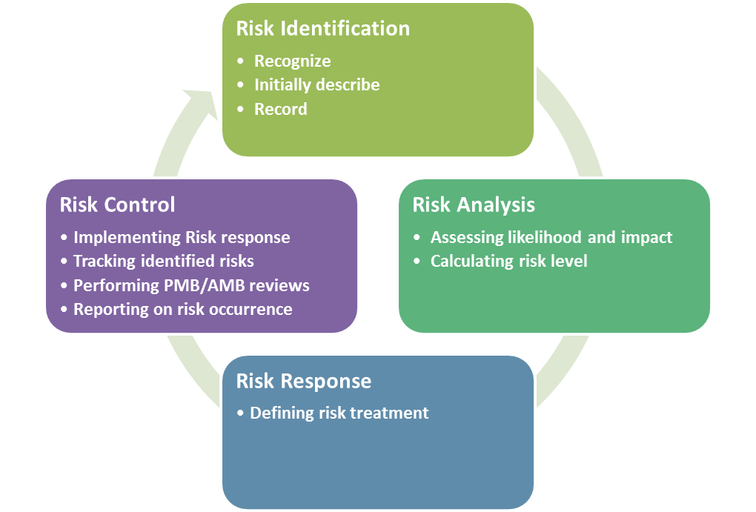
Risk management process as defined in D1.2 contains four sub processes:
Risk identification
- goal: determining which risks can affect the project and documenting it in the Risk registry
- description: a process that is used to find, recognize, and describe the risks that could affect (prevent or undermine) the achievements of objectives.
Risk analysis
- goal: assessing likelihood and impact , evaluate the risk level
- description: a process that is used to understand the nature, sources, and causes of the risks that have been identified and to estimate their level. It will also study impact and consequences and examine the controls (an activity that prevents or detects issues to mitigate risks) that currently exist.
Risk response
- goal: defining the actions to be taken in order to avoid the risks or to minimize their impact (risk response plan) for each risk
- description: a process of developing options and actions to reduce threats to project objectives
Risk control
- goal: improve success of risk management activities through continuously monitoring and adjustment
- description: a process for implementing the risk response plan, tracking identified risks, performing risk status review
Whole process is defined in D1.2 as well as under https://wiki.egi.eu/wiki/EGI-Engage:Risk_Plan

Changes
Based on experience from project year 1, following changes has been agreed:
- Risk registry review is executed every 6 months instead of every 3 months.
  - It appears frequency of 3 months is not efficient in terms of either applying treatment either conducting time consuming risk review.
- Risk management process defined for EGI Engage process has been applied to EGI Foundation as part of ISO certification activity. Same procedure will be reused to maintain EGI Infrastructure.
- A clear procedure regarding risk registry review has been defined https://wiki.egi.eu/wiki/PROC04_Risks_review to clearly define responsibilities and communication.

Results of the risk registry review for Period 2
Risk analysis has been performed by Work Package leaders with the support of the Quality and Risk Manager between June and September 2016.
All risks have been reviewed according to the following questions:
- Are the risks still relevant to the project?
- Have the risk levels changed?
- Are the proposed countermeasures still valid and being applied?
- Are the consequences of the risk occurrence still valid?
In addition, for each risk an owner has been assigned, the Work Package leader responsible for coordinating the treatment application, as well as the trend in comparison to the risk level defined during the project proposal phase.
Each Work package leader has also been responsible to identify new risks during the period.
In Risk registry following types of risks are recorded:
- Foreseen – identified during project proposal phase
- Unforeseen – identified during project execution phase
After one year of the project in Risk registry there are
- 9 foreseen risks out of 20 identified during project proposal phase
- 29 unforeseen out of 38 identified in total during project execution phase

Risk level distribution

Figure 1 Risk level distribution
Figure 1 shows that most of risks identified for EGI Engage project are not high risk level
During risk review from September 2016 (comparing to risk review from March 2016):
- 8 risks decrease their risk level, mainly reaching low risk level
- 12 risks remain low risk level
- 3 new have been identified
- No risks have been identified as requiring a contingency plan.

Work package risk distribution

Figure 2. Work package risk distribution
Each risk is assigned to work package which is primarily responsible for applying agreed treatment for given risk. Figure 2 shows distribution of current risks for each work package. As showed all work packages are covered by risk management process. Number of risks, for each work package, changes during project lifetime, type of activities and advancement of work.

Conclusions
Risk management process is part of Activity Management Board and Project Management Board activities. Quality and Risk Manager is in charge of coordinating and controlling the process.
Any issues related to the process will be reported to Work Package 1 leader.
The risk registry review will be conducted during project report for period 2 as well as final project report.

Risk registry (access restricted to AMB and PMB): https://documents.egi.eu/document/2795

